
Received: 1 May 2018|Revised: 18 July 2018|Accepted: 23 July 2018
DOI: 10.1111/hel.12538
ORIGINALARTICLE
RoleofHelicobacterpyloriinfection incancer-associatedfibroblast-inducedepithelial-mesenchymaltransitioninvitro
Gracjana Krzysiek-Maczka¹|Aneta Targosz¹
Zbigniew Sliwowski¹|Tomasz Brzozowski¹
|UrszulaSzczyrk¹
|Jarosław Czyz²
Malgorzata Strzałka¹|
AgataPtak-Belowska¹
|
|
1Department of Physiology, The Faculty of Medicine, Jagiellonian University Medical College, Cracow, Poland
2Department of Cell Biology, The Faculty of Biochemistry, Biophysics and Biotechnology, Jagiellonian University, Cracow,Poland
Correspondence
Tomasz Brzozowski, Department of Physiology, The Faculty of Medicine, Jagiellonian University Medical College, Cracow, Poland.
Email:mpbrzozo@cyf-kr.edu.pl
Funding information
Jagiellonian University Medical College, Grant/Award Number: K/ZDS/005736
This is an open access article under the terms of theCreative Commons AttributionLicense, which permits use, distribution and reproduction in any medium,
provided the original work is properly cited.
© 2018 The Authors.HelicobacterPublished by John Wiley & Sons Ltd
|
Helicobacter.2018;23:e12538. https://doi.org/10.1111/hel.12538
wileyonlinelibrary.com/journal/hel 1 of15
Abstract
Background: Major human gastrointestinal pathogenHelicobacter pylori(H. pylori) colonizes the gastric mucosa causing inflammation and severe complications includ- ing cancer, but the involvement of fibroblasts in the pathogenesis of these disorders inH. pylori-infected stomach has been little studied. Normal stroma contains few fi- broblasts, especially myofibroblasts. Their number rapidly increases in the reactive stromasurroundinginflammatoryregionandneoplastictissue;however,theinterac- tion betweenH. pyloriand fibroblasts remains unknown.Wedetermined the effect ofcoincubationofnormalratgastricfibroblastswithaliveH.pylori(cagA+vacA+)and
H. pylori(cagA−vacA−) strains on the differentiation of these fibroblasts into cells possessing characteristics of cancer-associated fibroblasts (CAFs) able to induce epithelial-mesenchymal transition (EMT) of normal rat gastric epithelial cells(RGM-1).
MaterialsandMethods:ThepanelofCAFsmarkersmRNAwasanalyzedinH.pylori(cagA+vacA+)-infectedfibroblastsbyRT-PCR.Afterinsertcocultureofdifferentiated fibroblastswithRGM-1cellsfrom24upto48,72,and96hours,themRNAexpres- sionforEMT-associatedgeneswasanalyzedbyRT-PCR.
Results: The mRNA expression for CAFs markers was significantly increased after 72 hours of infection withH. pylori(cagA+vacA+) but notH. pylori(cagA−vacA−) strain. Following coculture with CAFs,RGM-1cells showed significant decrease in E-cadherinmRNA,andtheparallelincreaseintheexpressionofTwistandSnailtran- scription factors mRNA was observed along with the overexpression of mRNAs for TGFβR, HGFR, FGFR, N-cadherin, vimentin,α-SMA,VEGF,andintegrin-β1.
Conclusion:Helicobacterpylori(cagA+vacA+)straininducesdifferentiationofnormalfibroblastsintoCAFs,likelytoinitiatetheEMTprocessinRGM-1epithelialcellline.

K E Y WO R D S
cancer-associated fibroblasts, E-cadherin, epithelial-mesenchymal transition,Helicobacterpyloriinfection

2 of 15|

KRZYSIEK-MACZKA_{EtAl}.
1|INTRODUCTION
of the Wnt pathway.^{23,24}Many EMT-inducing transcription factors(EMT-TFs)suchasTwist1,Snail1,Snail2,Zeb1,andZeb2canrepress E-cadherin both directly orindirectly.²³⁻²⁶
Interestingly, the eradication ofH. pylorileads to the reduction intheexpressionofTGF-β1,Twist,Snail,Slug,andvimentinmRNAs, whileenhancingtheexpressionofE-cadherin.Thissuggeststhat
H. pyloriinfection may trigger the TGF-β1-induced EMT pathway andthatH.pylorieradicationmayinhibittheGCprogressionbyat-tenuation of thispathway.^{27,28}
The activated myofibroblasts accompanying tumors known as cancer-associated fibroblasts (CAFs) belong to the principal constit- uents of the tumor stroma, playing important role in the tumor mi- croenvironment.²⁹The CAFs were shown to mediate cancer-related inflammation by expressing proinflammatory and tumor-promoting factors and promotion of the cancer cell invasion and ECM remodel- ing.^{30,31}Moreover,underthecontrolofavarietyofstroma-modulating factors,thecancercellsthemselvesgenerateapermissivemicroenvi- ronmentfavoringfurthertumordevelopmentandinvasion.³²⁻³⁴
TheproinflammatoryfactorsreleasedbyCAFs,suchasIL-6,COX-2and CXCL1, FSP1,CXCL9,CXCL10(IP-10),and CXCL12(SDF-1stro-
malcell-derivedfactor1),wereimplicatedinthemechanismoftumor growth and neoplastic cell invasion.³⁵⁻³⁹The CAFs secrete proangio- genicfactors,suchasIL-8,SDF-1,vascularendothelialfactor(VEGF), and fibroblast growth factor (FGF), into an environment of other stromal cells including endothelial cells to promote tumor angiogen- esis.^{30,35,38,39}CAFs may enhance invasion of the cancer cells through expression of TGFβ, potent EMT inducer, andHGF,which has been shown to promote breast tumorigenesis.^{39,40}Since fibroblasts may alter the mRNA expression of structural and cell cycle-associated genesinthepresenceofH.pylori,^{9,41}wehaveattemptedtodetermine whetherH. pylorican interact with fibroblasts by changing them not only into myofibroblasts, but also into CAFs, further being capable of inducingEMTprograminnormalRGM-1epithelialcellline.
Despitetheincidenceandmortalityofgastriccancer(GC)havebeen decreasing, this disorder still remains one of the leading causes of cancer-relateddeathrateworldwide.¹⁻⁴Despitethefactthattheadju- vant chemotherapy and surgical resection are the only curativether-apiesnowadays,mostpatientsarediagnosedwithanadvancedstage ofdiseaseduetolackofspecificearlysymptoms.Furthermore,some patients lose the opportunity of curative resection resulting from the aggressive nature of GC. Although chemoradiotherapy and targeted therapy have confirmed an improvement in host response rates, the cancer recurrences and metastases are frequently observed.²⁻⁶The bacteriaHelicobacter pylori(H. pylori)is one of the major risk factors for GC development. Epidemiology ofH. pyloriindicates that this bug colonizes the human stomach of about 50% of the world’s popula- tion.AlthoughallH.pylori-infectedsubjectsdevelopgastritis,approx- imately 80% of these individuals remain asymptomatic.^{7,8}Besides GC,H. pylorican also induce the gastric and duodenal ulcers and the mucosa-associated lymphoid tissue (MALT) lymphomas affecting about1%,15%,and0.1%ofthepopulation,respectively.^{7,8}H.pyloricolonizesmainlygastricepitheliumbutmayalsopenetratethemucus layerreachingpitsofgastricglands.⁹Wehavepreviouslyshownthat fibroblasts may constitute a direct target forH. pylori¹⁰next to epi- thelial cells.^{11,12}H. pyloricolonization may directly and indirectlyinter-act with fibroblasts, connective tissue, and other extracellular matrix components. Necchi et al¹³have identified the presence ofH. pylorinot only in epithelial cells and intraepithelial intercellular spaces, but alsointheunderlyinglaminapropriaandstromaltumor.Thissuggests that bacteria can alter the tight junctions and penetrate the deeper intercellularspacesdowntheunderlyinglaminapropria.Moreover,the
H. pyloriinfection increased theMMP-7expression, the number of myofibroblasts, and their proliferation and migration.^{14,15}High MMP7 expression facilitated cancer invasion and angiogenesis bydegrading extracellular matrix macromolecules and connective tissues in vivo. Recently, the direct interaction between this bacterial pathogen and fibroblasts has been proposed¹⁶suggesting thatH. pylorican interact with several components of connective tissue components including fibroblasts. The most virulentH. pyloristrains have been shown to harbor the cag pathogenicity island encoding the type IV secretion system,^{3,17}allowing the delivery of bacterial cytotoxins into gastric epithelialcells,inducingphenotypicalterationsreminiscentofanepi- thelialtomesenchymaltransition(EMT).^{3,17-19}
The EMT is a biological process in which polarized epithelial cells lose the adherence and tight cell-cell junction, enhance their migratory capacity, and become resistant to apoptosis.²⁰Moreover, the EMT increased the production of components of extracellular matrix (ECM) and gained the invasive properties to become mesen- chymal cells known to play an essential role in cancer progression and metastasis.²¹⁻²⁴EMT allows the tumor cells to acquire invasive properties and to develop metastatic growth characteristics.^{21,23}These events are facilitated by the reduction in cell-cell adhesion molecule E-cadherin, the upregulation of more plastic mesenchymal proteins such as vimentin, N-cadherin, andα-SMA andderegulation
2|MATERIAL S AND METHODS
2.1|BacterialH. pyloristrains and their characterization
TheH.pyloristrainexpressingCagAandVacAcytotoxins(43504H.py-lori cagA+vacA+(s1/m1))was purchased from AmericanTypeCulture Collection. TheH. pyloristrain negative for CagA and VacA (H. pyloricagA−vacA−(s2/m2)⁴²originatedfromourbacterialbankofisolationsfrom gastric biopsy specimens of the patients with gastric ulcer who underwentupperendoscopy.ThegenomicDNAwasisolatedfrom
H. pyloristrains using Genomic mini (A&A Biotechnology, Gdynia, Poland).ForeachsinglePCR,20μgofDNAwasused.Specificprimers forthedetectionofcagAandvacAwereused(Sigma-Aldrich,Poznan, Poland).ThesequencesofprimersarelistedinTablesA1andA2(see AppendixI).Stockculturesweremaintainedat−70°CinBrucellabroth (BectonDickinson,Sparks,MD,USA)supplementedwith10%fetal
bovine serum and 10% glycerol.

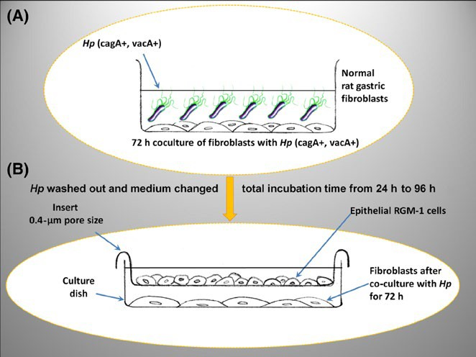
|
KRZYSIEK-MACZKA_{EtAl}.
3of15
The cultures of bacteria were grown on Columbia agar with 5%
fresh horse blood (BioMerieux, Warsaw, Poland). The plates were incubated under microaerophilic conditions at 37°C for 3-5 days.
isolatedasmentioned above. Expression of 18s,α-SMA, collagenI,col- lagenIII,tenascinC(TNC),FAP,FSP,IL-6,IL-8,SDF-1,HGF,TGFβ,and
COX-2transcripts in the rat gastric fibroblastswere determinedbyRT-
PCR using specific primers (Sigma-Aldrich; Table A1, Appendix I).
2.2|Technique of rat gastric fibroblast
isolationandtheinfectionofisolatedfibroblastswith
H. pylori
Gastric samples were harvested from 8-week-old Sprague-Dawley rats and extensively washed with sterile PBS to remove contami- nating debris. Primary fibroblast culture was established by minc- ing gastric biopsy into1-to 2-mm³pieces with scissors and placing it in tissue culture flasks under sterile conditions. Growth medium DMEM containing 10% FBS and antibiotics were added and gently mixed with minced tissue. The flasks were maintained in a humidi- fied atmosphere of 5% CO2at 37°C, and the medium was changed every 2 days. When the cells grew up to 70% of confluence, they were passaged using standard trypsinization techniques to establish asecondarycellcultureasreportedbefore.^{9,43,44}
Before the coincubation with fibroblasts,H. pyloristrains were first suspended in sterile PBS and immediately transferred to the dishes containing fibroblasts. The 70% confluent fibroblasts were infected with 1 × 10⁹of liveH. pyloriper dish and incubated in hu- midified atmosphere for 72hours.
2.5|Coculture of epithelial cells (RGM-1) withfibroblasts after 72 hours of their incubation with
H. pylori (cagA+vacA+)
After72hoursoffibroblastcoculturewithH.pylori(cagA+vacA+),the
H.pyloriwaswashedoutfromfibroblastsandthemediumwaschanged intoDMEMwith10%FBSandantibiotics.Theculturedishwasmain- tainedinahumidifiedatmosphereof5%CO2at37°Cfor4hours,and then, the incubatory fluid was again replaced with fresh portion fthe medium.Onthelayeroffibroblastsandmedium,0.4-μmporesizecell cultureinserts(BectonDickinson)wereplaced(Figure1A,B).
Trypsinized RGM-1 cells were then seeded on the insertssur-face, the medium was filled up to the volume of 5mL,and the cells were coincubated in humidified atmosphere for 24, 48, 72, and 96 hours (Figure 1B). After incubation period, the total cellular RNA fromRGM-1cellswasisolatedasdescribedabove.⁴⁵
2.6|DeterminationofmarkersofepithelialtomesenchymaltransitioninRGM-1cells
The expression of 18s,α-SMA, N-cadherin, vimentin, E-cadherin,β1-integrin, COX2, VEGF, TGFBR, HGFR, FGFR, Snail, Twist, Ki67, Bax, Bcl-2 transcripts in the rat gastric fibroblasts were deter- mined by RT-PCR, using specific primers (Sigma-Aldrich; Table A1, Appendix I).
2.3|DeterminationofmRNAexpressionbyRT-PCR
After incubation period, total cellular RNA was isolated according toChomczynskiand Sacchi method⁴⁵using Trizol reagent (Invitrogen, Carlsbad,CA,USA). First-strand cDNA was synthesized from total cellular RNA (2μg) using Reverse Transcription System (Promega, Mannheim, Germany). The PCR wascarriedout in an automatic DNA thermal cycler, using 1μg cDNA and Promega PCR reagents. Expression of transcripts in the rat gastric fibroblasts and RGM-1 cell line (RickenBank,Tsukuba, Ibaraki, Japan) was determined by RT-PCR using specific primers (Sigma-Aldrich). Amplification of control rat 18s RNA wasperformedon the same samples to verify the RNA integrity. PCRproductswere separated by electrophoresis in 2% agarose gel containing0.5μg/mL ethidium bromide and then visualized under UV light. Location of predicted PCR product was confirmed by using O’Gene Ruler 50-bp DNA ladder (Fermentas, Life Sciences, Waltham,MA,United States) asstandardmarker.
2.4|MarkersoffibroblasttoCAFtransdifferentiation
TheinfluenceofH.pylori(cagA−vacA−)strainselectedfromourbankofninedifferentsamplescollectedfromH.pylori-infectedpatientson fibroblasts wasdeterminedby theanalysis of expression ofβ-actin,α-SMA,collagenI,HIF-1α,andHSP-70mRNA.TheeffectsofH.pylori(cagA−vacA−)strainwere comparedwith thoseexertedbyH.pylori(cagA+vacA+)strain.After72hoursofcocultureofH.pylori(cagA+vacA+)withfibroblasts,thecellswereharvestedandtotalcellularRNAwas
FIG U R E 1The insert coculture of fibroblasts with epithelial RGM-1 cells. After 72 h of fibroblast coculture withHelicobacterpylori(cagA+vacA+)(A),theH.pyloriwaswashedoutandmedium changed into RPMI with 10% FBS and antibiotics. The 0.4-μm pore size cell culture inserts (Becton Dickinson) were placed on thelayeroffibroblastsandmedium.TrypsinizedRGM-1cellswere thenseededontheinsertssurface,themediumwasfilledupto
5 mL and the epithelial cells were subsequently coincubated with fibroblasts in humidified atmosphere for 24, 48, 72, and 96 h (B)

4 of 15|

KRZYSIEK-MACZKA_{EtAl}.
2.7|Contrast-phase microscopy
Formicroscopic examination,thetrypsinizedfibroblastswere seededon coverglassesandcoculturedwith andwithoutpres- enceofH.pylori(cagA+vacA+)for72hoursinantibiotic-free DMEM.Then,the medium withH.pyloriwas removed and thefreshDMEM with10%FBSandantibioticswasadded.After3hours,medium has been changedagainforthefreshone andleftfor96hours.After the endof 96hoursofincubation,the medium fromfibroblastscoculturedwithorwithoutH.pyloriwascollected.TrypsinizedRGM-1cells wereseededon coverglassesand thenculturedinthepresenceofthecollected supernatantfromH.pylori-infectedfibroblastsfor24,48,72,and96hours.As the control,RGM-1cellsculturedinthesupernatantfrom96hours cultureofH.pylori-noninfectedfibroblastsinDMEM with10%FBSandantibioticswereused.BothfibroblastsandRGM-1cells were fixedin 3.7%formaldehydefor 20minutesatroomtemperature.The imageacquisitionwasperformedwithaLeicaDMI6000Bmicroscope (Leica Microsystems,Wetzlar,Germany).
3.2|Proinflammatory factors and angiogenicpotentialmarkersexpressedbyratgastricfibroblasts
Oneof theCAFspotentialcharacteristicsis theirabilityto secreteproinflammatorycytokines,knowntofacilitatetherecruitmentofgranulocytesandlymphocytesand to promotetumor growthandmetastasis.Therefore,wedeterminedtheexpressionof IL-6,IL-8,COX-2, and SDF-1mRNAinfibroblastsinfectedwithH.pylori(cagA+vacA+).After72hoursofcoincubationwithbacteria,aninductionof IL-6 and SDF-1mRNA expressionascomparedwith controlfibroblastswasobserved(Figure2A).We have also noticed ahighly significant increaseinmRNA expressionofCOX-2and IL-8 in cellsinfectedwithH.pylori(cagA+vacA+)strain(Figure2A).
3.3|EMT inducers, ECM components, andproinvasive signals
The mRNA expression for TGFβand scattering factor HGF was significantly increased at 72 hours of coincubation withH. pylori(cagA+vacA+)overthoseobservedincontrolfibroblasts(Figure2A). Since CAFs produce a variety of ECM proteins, which are the struc- tural components involved in making up of connective tissue and under pathological conditions contribute to the dense fibrous nature of solid tumors, we have determined the expression of mRNAs for these proteins in fibroblasts cocultured with or withoutH. pylori. At 72 hours of coincubation withH. pyloripositive for cagA andvacA,a significant increase in TNC mRNA expression besides the rise in the expressionofcollagenIandIIIhasbeenobserved(Figure2A).
2.8|Statistical analyses
Statistical analysis of the data was performed with the use of Excel Software. Results are expressed as means ±SEMfrom six samples per eachgroup.Statistical significance of difference was determined using analysis of variance(one-wayANOVA)test (StatisticaSoftware, StatSoft,Cracow,Poland).Furtherstatisticalanalysisforposthoccom-parisons was carried out withNewman-Keulstest. Differences wereconsideredstatisticallyatP<0.05.
3.4|Morphology of fibroblasts
Comparing to control fibroblasts, those cultured in the presence of
H.pylori(cagA+vacA+)revealedprominentmorphologicalchangeschar-acterizedbyelongatedshapeandthepresenceofabundantprotrusionsindicatingtheiractivationandphenotypicalalterations(Figure3A,B).
3|RESULTS
3.1|Expressionofmarkersofactivationanddifferentiation offibroblasts
TheexposureoffibroblaststoH. pylori(cagA+vacA+)for 72hours resultedin asignificant risein FAPand FSPmRNA expressioncomparing withthose obtainedincontrolfibroblastsculturedwithoutH. pylori(Figure2A). DifferentiationoffibroblastsinthepresenceofH. pyloriwasconfirmedby anincreaseinexpressionofα-SMA,collagen I, and collagen III.H. pylori-infectedfibroblastsshowedasignificantincreaseascompared with controlfibroblasts withoutH. pyloriinfection(Figure2A). AsshowninFigure2B,the cocultureofgastric fibroblastswithH. pylori(cagA−vacA−)strain failedtoalter theirdifferentiationasreflectedbythe lackof sig-nificantchangesinmRNA expressionofα-SMAand collagenI at 24,48,and72hoursofincubation.Also,HIF-1αmRNA expres-sion wasnotsignificantlychanged.However,the slight but signifi- cantincreaseinexpressionof HSP-70mRNAhasbeen observedat48hoursoffibroblasts incubationwithH. pylori(cagA−vacA−).Therefore,forfurtherH. pyloriinfluence examination,onlyH.py-lori(cagA+vacA+)wasselected.
3.5|Process of epithelial to mesenchymaltransition in epithelial RGM-1 cell line coculturedwithH. pylori(cagA+vacA+)-treated fibroblastscompared with control fibroblasts noninfected with
H. pylori
3.5.1|Expression of mesenchymal markers
The expression ofα-SMA was significantly increased at24hours, with further progression in time up to 96 hours in fibroblasts cocul- tured withH. pylori(Figure 4A,B). The N-cadherin mRNA expression showedasignificantincreasealreadyafter24hoursofcoculture,the effect which persisted up to 96 hours of incubation (Figure 4A,B). The expression of mRNA for vimentin was significantly increased in epithelial cells after 48 hours of coculture withH. pylori-treated fi- broblasts and remained elevated up to 96 hours. All analyses were performed in comparison withRGM-1cells cocultured with control fibroblasts noninfected withH.pylori.

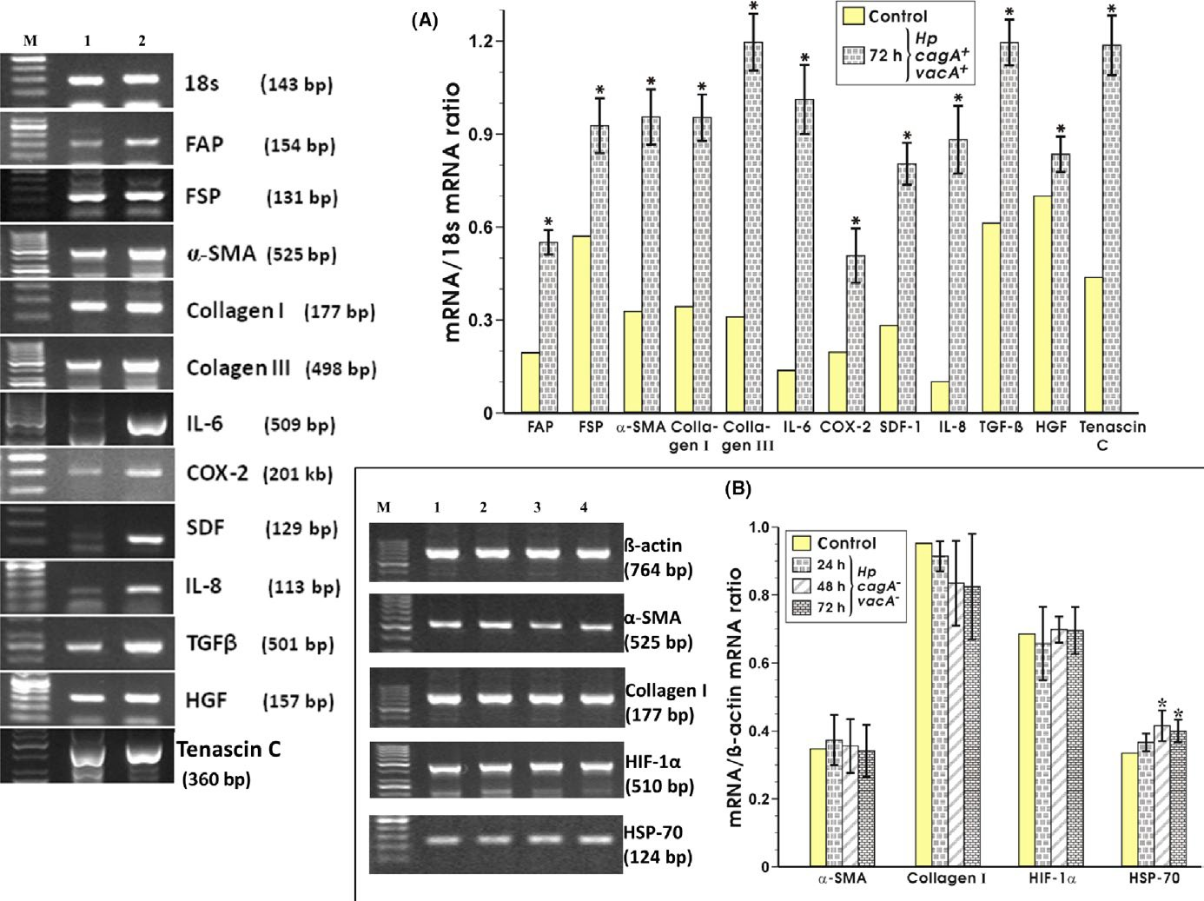
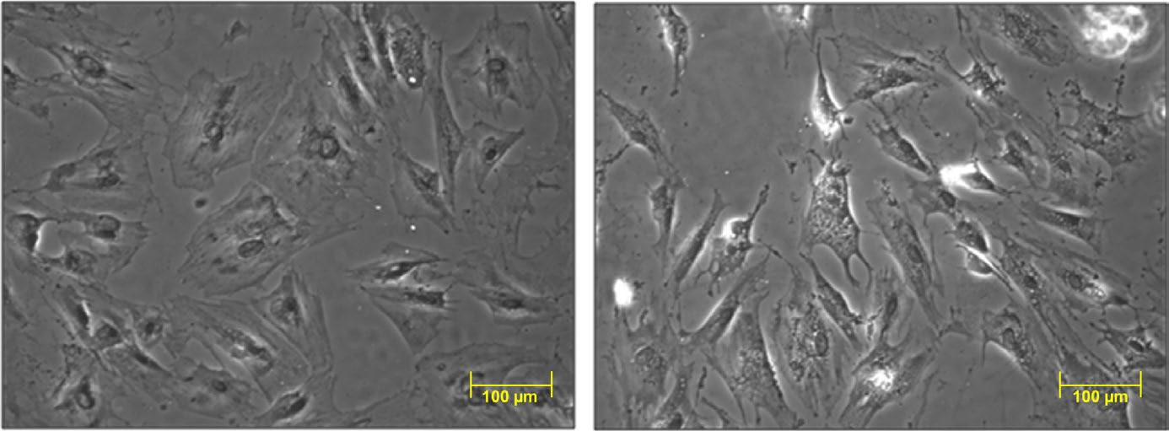
|
KRZYSIEK-MACZKA_{EtAl}.
5of15
FIGURE2RT-PCRanalysis of expression of18sRNA and apanel ofCAFmarkersmRNAexpressionin rat gastricfibroblasts after 72hofcoincubationwithHelicobacterpyloristraincagA+vacA+and thesemiquantitative ratio of selected genesover 18safter 72hofcoincubationwiththisbacteria(panelA).RT-PCRdeterminationofβ-actinandmarkersofthefibroblastsdifferentiationafter24,48,and72hofratgastricfibroblastscoincubatedwithH.pylori(cagA−vacA−)strainandtheratioofselectedgenesoverβ-actinafter24,48,and72hofcoincubationwiththisstrain(panelB).Resultsaremean±SEMofsixdeterminations.Asteriskindicatesasignificantchange(P<0.05)ascomparedtothecontrolvalue
(A)
(B)
FI G U R E 3Morphology of isolated normal gastric fibroblasts (A) and of fibroblasts after 72 h coculture withHelicobacter pylori(cagA+vacA+) (B).Contrast-phase microscopy view showing the difference in morphology of both cultures of fibroblasts as indicated by elongated shape and abundant protrusions (arrows) (B vs A)

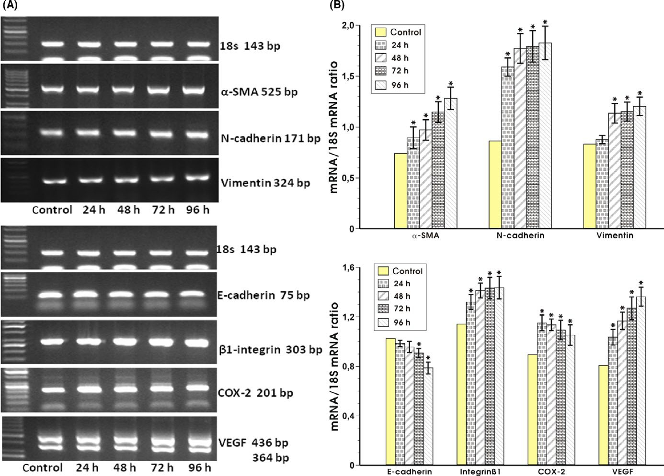
6 of 15|

KRZYSIEK-MACZKA_{EtAl}.
The RT-PCR analysis of mRNA expression for mesenchymal markers (α-SMA, N-cadherin, vimentin) and promigrative and
FI G U R E 4
proangiogenic factors (E-cadherin,β1-integrin, COX-2, VEGF) standardized to 18s RNA in rat epithelial RGM-1 cells after 24, 48, 72, and 96 h of coculture with fibroblasts which were initially infected withHelicobacter pyloristrain (cagA+vacA+) for 72 h (panel A) and the semiquantitative ratio of selected mRNAs over 18s mRNA after coculture of these epithelial cells withH. pylori-infected or noninfected
(control)fibroblasts(panelB).Resultsaremean±SEMofsixdeterminations.Asteriskindicatesasignificant(P<0.05)changeascomparedto the controlvalue
fibroblasts compared with control (Figure 4A,B). The increase in COX-2 mRNA expression was sustained up to 96 hours of incuba- tion (Figure 4A,B).
TheangiogenicpotentialwasevaluatedbydeterminationofVEGF mRNA expression. Consistently, the VEGF mRNA showed a signifi- cantincreaseat24hourswithfurtherincreasewithtimeascompared
with control coculture withoutH. pyloriinfection (Figure 4A,B).
3.5.2|Expression of promigrative andproangiogenic factors
Thestatisticallysignificant transcriptional suppressionof the ad-hesion molecule E-cadherinwas noticedbetween 48and 72hoursof RGM-1 cellscoculturedwithH.pylori-infectedfibroblastscomparedto controlcoculture. This suppression increasedat 96hoursof coculturesuggestingaprogressive downregulationofE-cadherinover the time ofincubation(Figure4A,B).Inordertoestimate possible increaseinmigrative propertiesof RGM-1cells,we havemeasuredtheβ1-integrinexpressionofmRNA.Thecoin-cubationRGM1 cells withH.pylori-infectedfibroblastsresulted in asignificant increaseinβ1-integrinmRNA expressionat 24hourswhich wassustainedover the time ofobservationup to 96hoursascomparedwith control coculture (Figure4A,B).Inaddition,themRNA expressionfor COX-2, thefactorconsideredas an accel-eratorofinvasion,metastasis,andangiogenesis,wassignificantly increasedat 24hours followingcoculture withH.pylori-infected
3.5.3|Expression of EMT triggering signals
The expression of the mRNAs for growth factors receptors for TGFβ, HGF, and FGF known as the EMT triggering signals was determined. The TGFβR and FGFR mRNA expressions were strongly upregulated from 24 hours up to 96 hours of incubation withH. pylori-infected fi- broblasts compared with control coculture (Figure 5A,B). The signifi- cant increase in mRNA expression for HGFR was also observed after 24 hours with further increase within time up to 96 hours of incuba- tion compared with control coculture (Figure 5A,B).

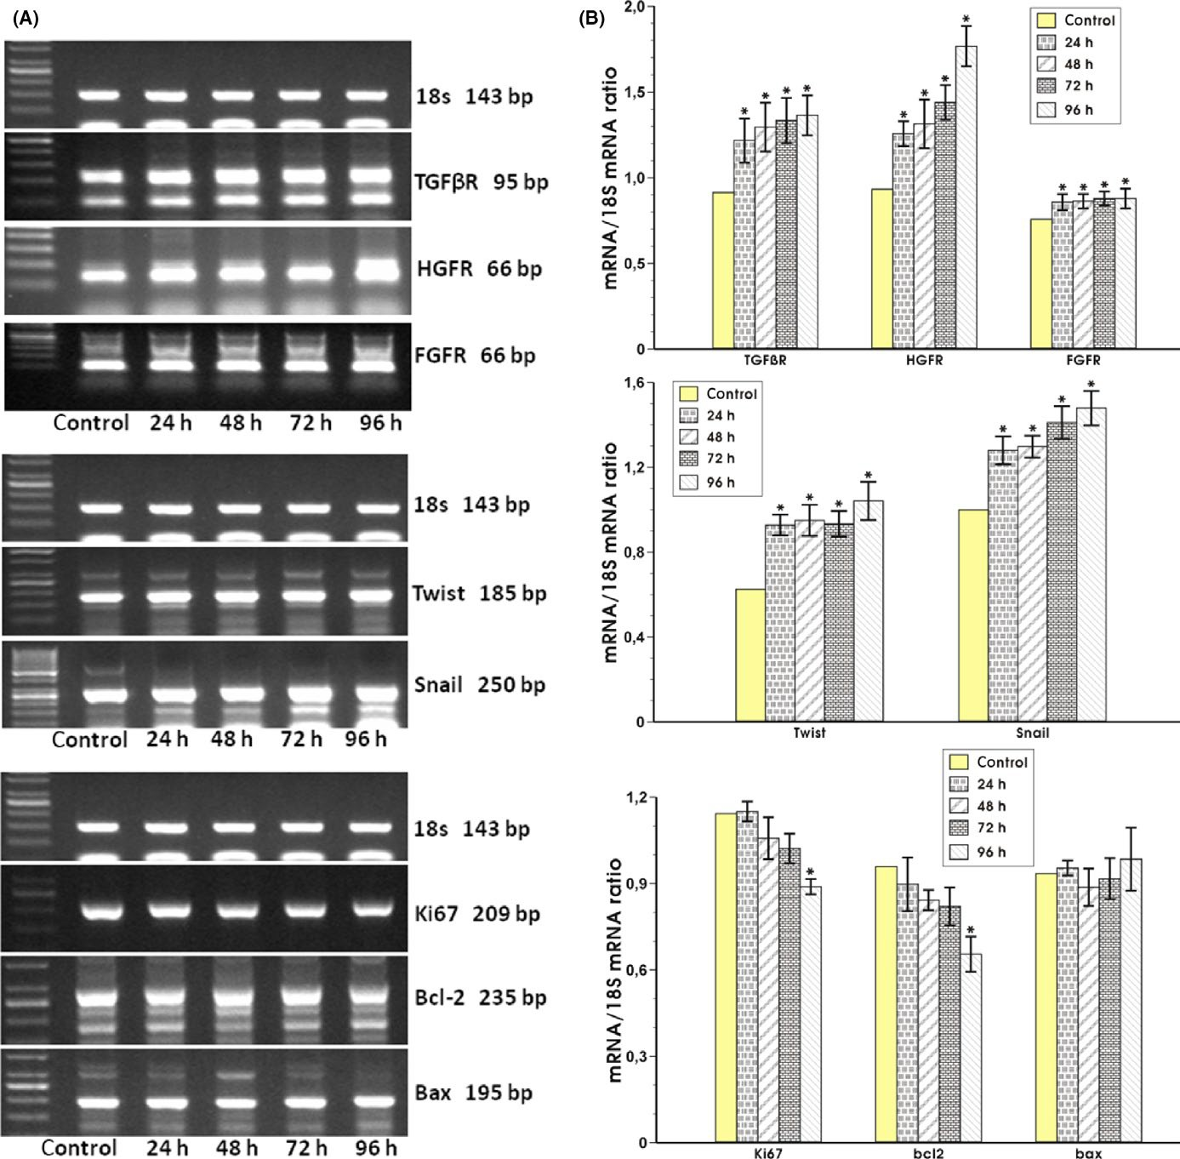
|
KRZYSIEK-MACZKA_{EtAl}.
7of15
FIG U R E 5The RT-PCR analysis of mRNA expression for receptors for EMT triggering factors (TGFβR, HGFR, FGFR), transcription factors (Twist, Snail), and proliferation and apoptosis regulators(Ki67,Bcl-2, Bax) in rat epithelial RGM-1 cells standardized to 18s RNA in rat epithelial RGM-1 cells after 24, 48, 72, and 96 h of coculture with fibroblasts which were initially infected withHelicobacter pyloristrain (cagA+vacA+) for 72 h (panel A) and the semiquantitative ratio of selected mRNAs over 18s mRNA after coculture of these epithelial cells withH. pylori-infected or noninfected (control) fibroblasts (panel B). Results are mean ± SEM of six determinations. Asterisk indicates a significant(P<0.05)changeascomparedtothecontrolvalue
increased over the time of observation up to 96 hours as compared with control coculture (Figure 5A,B). The mRNA expression for pro- liferation indicator Ki67 significantly decreased at 72 and 96 hours of incubation withH. pylori-infected fibroblasts in comparison with control coculture (Figure 5A,B). The mRNA for proapoptotic Bax was not significantly altered at any of the time periods while expression ofmRNAforantiapoptoticBcl-2showedasignificantdecreaseat
96 hours as compared to control coculture (Figure 5A,B).
3.5.4|Expression of transcription factors specific for induction of EMT process, proliferation, and apoptosis
The expression of mRNA for transcription factors Twist and Snail was significantly increased at 24 hours of epithelial cells coculture withH. pylori-infected fibroblasts. Twist mRNA expression remained elevatedupto96hours(Figure5A,B)andtheSnailmRNAexpression

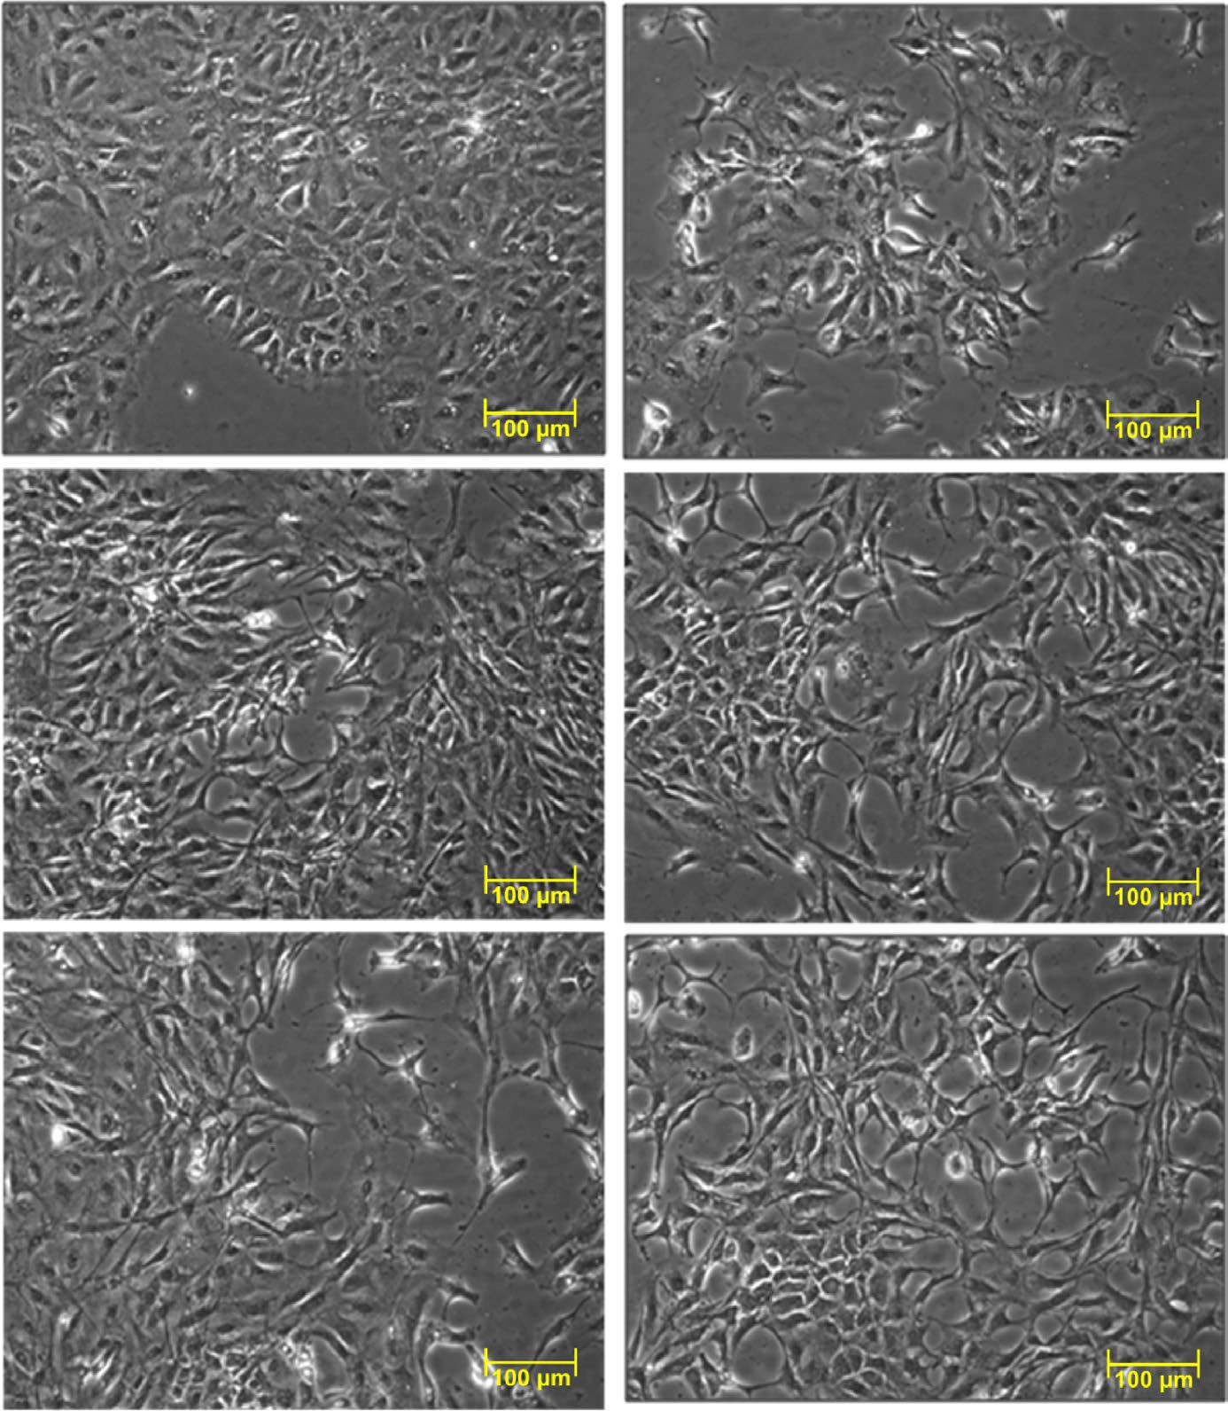
8 of 15|

KRZYSIEK-MACZKA_{EtAl}.
(A)
(B)
(C)
(D)
(E)
(F)
FI G U R E 6Contrast-phase microscopy view showing control epithelial RGM-1 cells cultured in DMEM + 10% FBS + antibiotics (A), control epithelial RGM-1 cells cultured in supernatant from 96 h culture of normal, noninfected fibroblasts (B) and RGM-1 cells cultured for 24, 48, 72, and 96 h respectively, in supernatant from 96 h culture of fibroblasts previously infected withHelicobacter pylorifor 72 h (DMEM + 10% FBS + antibiotics) (C-F). The changes in morphology of epithelial cells and disorders in continuity of monolayers were
observed already after 24 h of the culture in the supernatant from fibroblasts infected withH. pylori(C) and have been particularly apparent
at 96 h of culture in this supernatant (F) comparing to control conditions (A, B)

|
KRZYSIEK-MACZKA_{EtAl}.
9of15
have addressed the question whether isolated fibroblasts can ac- quire the characteristic of CAFs when coincubated with cytotoxic cagA+vacA+ strain ofH. pylori.
The formation of CAFs involves several important features: (a)
the expression of fibroblast markers vimentin, FSP1 and FAP; (b) the expression of activation markerα-SMA; (c) the expression of aggres- sive/invasive markers including TNC; (d) an increase in cytokine and growth factor expression includingIL-8, IL-6, SDF-1, VEGF,TGF-β,HGF,andFGF-2;and (e) the reprogramming of ECM proteins and matrix remodeling proteins.^{4,35,48-53}Interestingly, we have observed that the mRNA expression ofα-SMA, collagen I, orHIF-1αwas not alteredbyH. pylori(cagA−vacA−)incontrasttothemoderateincrease inHSP-70mRNA expression possibly due to the “cytoprotective” properties of bacterial wall product LPS.^{54,55}In the case ofH. pylori(cagA+vacA+),wehaveobservedastrongupregulationofmRNAforα-SMA along with overexpression ofFAPmRNA in fibroblasts. The membrane gelatinaseFAPbelonging to the serine protease family has been implicated in extracellular matrix remodeling^{52,53}as well as in the regulation of fibroblast growth and EMT interactions during development, tissue repair, and epithelial carcinogenesis.^{52,53,56}The FAP-positiveCAFsenhancedthesurvival,proliferation,andmigration of gastric cancer cell (GC) line in vitro, in addition of inducing a drug resistance of the GC cells in the gastric cancer patients.⁵³SinceFAPisupregulatedinstromafibroblastsofover90%ofmalignantepithe- lialtumors,thisfactormayserveasapotentialbiomarkerandthera- peutic target of stromal tumors.⁵⁶Furthermore, the FAP-expressing CAFs increased expression of proinflammatory genes, thus promot- ingtumorimmuneevasioninamousemodelofpancreaticcancer.⁵⁷
Whenfibroblastswere coincubated withH.pylori(cagA+vacA+), theincreased expressionof FSPmRNAhasbeen observedin ourpresentstudy. FSP isconsideredas amarkeroffibroblastsin dif- ferentorgans undergoingtissueremodelingand helps to iden-tify fibroblastsderivedfrom EMT inseveral organs includingthe liver.⁵⁸H.pylorican stimulate TLRs leadingtoactivationof innateimmunity against bacterial inflammation,thus creating an inflam-matory microenvironment,aprerequisitefortumordevelop- mentthrough activationof NF-κB and STAT3 pathways inhuman GC.^{59,60}Herein,we have shown thatpossible downstream targetsofNFκBand STAT3 pathwaysincludingTGFβ, HGF, IL-6, IL-8,TNC,collagens I and III were upregulated infibroblastsinfectedbyH.py-lori(cagA+vacA+). We have alsoobservedasignificant inductionofCOX-2mRNA expression,which iscloselyassociated with theformationanddevelopmentofmajorityofgastriccancers.^{61,62}
The expression ofIL-6andIL-8mRNAs was implicated in the early stage of tumorigenesis.^{35,63}The media collected from GC lines haveinducedIL-6secretioninfibroblastsconsideredastheparacrine stimulant of proliferation of tumor gastric cells through the activa- tion ofSTAT3signaling.⁶³Besides, the upregulation ofIL-6after the coincubation of fibroblasts withH. pylori(cagA+vacA+), we have observed a reciprocal increase in the expression ofSDF-1mRNA. Both,IL-6andSDF-1mRNA signals have been shown to potentiate eachother,thusacceleratingthecytokinenetworkintumortis-
sues.⁶⁴Consistently,wehaveobservedanincreaseinmRNAsforIL-8
3.6|Morphology of RGM-1 cells
Depending on culture conditions, the RGM-1 cells show prominent morphological changes (Figure 6A-F). RGM-1 cells cultured in the presence of the supernatant from 96 hours culture of fibroblasts in- fected for 72 hours withH. pylori(cagA+vacA+) became elongated with prominent protrusions. This evidently suggests their activation and phenotypical changes. These alterations occurred already after 24 hours of incubation with the supernatant fromH. pylori-infected fibroblasts (Figure 6C-F). Differences in RGM-1 cells were particu- larly apparent at 96 hours (Figure 6F) suggesting progression of these changes with time. We have also observed distortion of the monolayer continuity starting at 24 hours of the RGM1 culture with theH. pylori-infected fibroblasts supernatant (Figure 6C) comparing with control conditions (Figure 6A,B), with the most prominent ef- fect being observed at 96 hours of incubation (Figure 6F).
3.7|IdentificationofH.pylori(cagA−vacA−)strain used for comparison withH. pylori(cagA+vacA+)strain
Figure A1 (Appendix I) shows the detection ofH. pyloricagAand vacA (m1, m2, s1, and s2) DNA regions in strains isolated from nine different samples collected fromH. pylori-infected patients. For this purpose, we have utilized strainH. pyloriATCC43504 cagA+vacA+ (m1,s1positive)forcagAands1,m1vacAregionsexpressingahigh- est vacA activity (left red frame).Asshown in Figure A1, the sample number 9 indicatestypes2 and m2 (m2s2) strain which was chosen as beingcagAnegative and bearing the lowest vacA cytotoxin ex- pression (H. pyloricagA−vacA−; right redframe).
4|DISCUSSION
Previous studies have established a key role ofH. pyloriin the patho- genesis of a variety of gastric diseases including gastritis, peptic ulcers, B lymphoma, and gastric cancer.^{1-4,7,8}The impaired balance betweenH. pylori-producing aggressive bacterial endotoxins and host defensive mechanisms is critical in the different clinical out- comes observed in patients infected with this bug. Recently, we have reported that gastric fibroblasts can represent cellular targetof
H. pylori.¹⁰The increased fibroblasts to myofibroblasts differentia- tion with increased collagen production, the alteration in prolifera- tion, and apoptosis were implicated in the mechanism of interaction between fibroblasts andH. pylori(cagA+vacA+).¹⁰This suggests that stroma cells may constitute a novel target ofH. pyloriactivity.¹⁰
It has been demonstrated that further transformation of myo- fibroblasts and fibroblasts into CAFs as well as the interactions be- tween the neoplastic and non-neoplastic cells with the ECM leads to the extensive desmoplastic reaction. CAFs play an important role in tumor progression.^{39,46,47}The coinjection of CAFs with tumor cells enhanced tumor formation which was uncommon after the coinjec-
tion of these tumor cells with normal fibroblasts.^{46,47}Therefore, we

10 of 15|

KRZYSIEK-MACZKA_{EtAl}.
suggesting that both,IL-8andSDF-1could contribute to phenotypic changes observed in myofibroblasts cocultured withH. pylori.SDF-1andIL-8can synergistically increase endothelial cell proliferation and migration,boostingtheangiogenicpathwaywithIL-8,predominantly induced in gastric cancer.^{35,38,64}The secretion ofIL-6,FAP,andIL-8by CAFs plays pivotal role in macrophage differentiation or M2 polar- ization resulting in an immunosuppressivemicroenvironment.³⁶
We have previously reported that mRNA for HIF-1α, the another potent tumor activator,⁶⁵is upregulated in fibroblasts infected by
H. pylori(cagA+vacA+) strain.¹⁰HIF-1αis known to induce transcrip- tion of more than 60 genes and to play an important role in CAFs activation and release of a great number of proangiogenic factors including SDF-1, IL-8, and VEGF^{35,65}also examined in our present study. CAFs produce a variety of ECM proteins such as fibronectin, TNC, and collagens, the structural components that make up con- nective tissue and contribute to the dense fibrous nature of solid tumors.⁶⁶⁻⁷¹The metabolism of collagen is deregulated in cancer by the increased expression, turnover, elevated deposition, and altered organization with enhanced matrix metalloproteinases (MMPs) ac- tivity, all implicated in tumor progression.^{67,68}Furthermore, ECM stiffening was required to corporate with TGFβto induce EMT in human breast tumor cells, further strengthening the notion that me- chanical properties of the tumor microenvironment are key factors regulating EMT and promoting tumor progression.⁶⁹
TNC belongs to an antiadhesive or adhesion-modulating proteins thathavebeenshowntointeractwithfibronectinandtopromotethe migratory activities of various cell types including fibroblasts, epithe- lial,andcancercells.⁷¹TheelevatedexpressionofIL-6,IL-8,andSDF-1mRNAscouldbemediatedbytheincreaseddepositionofTNC.The
H. pyloristrain (cagA+vacA+) enhanced mRNA expression for TNC, collagenIandIIIpossiblyduetoactivationofSTAT3,NFκB,andHIF-1αpathways.Moreover,theincreasedexpressionofHGFandTGFβboth considered as the essential promigrative growth factors secreted by CAFs^{35,40,72}hasbeenobservedinourH.pylori(cagA+vacA+)-infected fibroblasts. These results indicate that theH. pylori-derived cyto- toxic antigens cagA and vacA may be essential for fibroblast differ- entiation and myofibroblast formation and might act as prerequisite for progression of normal fibroblasts into CAFs. The tumor invasion andmetastasisareinitiatedbyEMTprograminvolvingcellsacquiring mesenchymal phenotype characterized with decreased cell-to-cell adhesion, increased motility and invasive properties. Such cellsonce
detached from primary tumor invade surrounding tissues through
epithelial RGM-1 cells cocultured with differentiated fibroblasts revealed the fall in expression of E-cadherin mRNA and the rise in N-cadherin and vimentin mRNA expression. Downregulation of E- cadherin and initiation of EMT can be triggered by key EMT-inducing transcription factors including Snail and Twist. Since Snail directly represses epithelial markers including E-cadherin, it can also upreg- ulate markers of the mesenchymal phenotype and facilitate EMT processes during tumor progression.^{23,74}The Snail expression as- sociated with features of EMT has been observed, for example, in colon and esophageal cancers.⁷⁵
TwisthasbeenshowntoactasanotherpotentE-cadherinre-pressorandN-cadherinactivator.^{23,24,74}Both,SnailandTwistaredownstreaminsignalingpathwaysactivatedbyTGFβ,integrins,IL-6,FGF,andHGF.^{3,23,76}Inagreementwiththesefindings,weprovideevidencethatH.pylori-induceddifferentiationandactivationoffi-broblasts with rise in HGF and TGFβmRNA expressionwereaccom-panied by increase in HGFR,TGFβR, FGFR, Snail, and TwistmRNAexpressioninRGM-1cells.Themechanismofactivationofcellpro-liferationandsurvivalpathwaysthroughintegrininteractionswithdownstreammoleculesisconsideredascrucialforcellmotilefunc-tionandsurvival.^{77,78}Thatiswhywehavedecidedtoanalyzetheex-pression ofβ1-integrinmRNA,which as shown in ourpresentwork,has also increased. During cancer differentiationandmetastasisprocesses,upregulationofintegrinshasbeenlinkedtocancerin-vasiveness.^{79,80}Among others, theβ1-integrin subunitisexpressedinmetastaticcellsandcanbeconsideredasindicatorformetasta-sis.⁸¹Xuetal⁸²observedthatTGF-β1hadobviouslyincreasedtheexpressionofintegrinα5β1.TheyassumedthatTGF-β1-promotedEMTandcelladhesioncontributetotheTGF-β1enhancedcellmi-gration in SMMC-7721 cells.⁸²All these observationssupportournotionthattheepithelialRGM-1cellsunderwenttheEMTprocess.ChangesinmRNA expressionofvarious mediatorsobservedinRGM-1cellsinour presentstudyarestrengthenedbyanevidencefromcontrast-phase microscopyshowing changesincellmorphol-ogy characterizedbycellelongationwithprominentprotrusionsand distorted continuityofmonolayers.Takentogether,ourpres-entstudy underlinestheimportanceofH. pylori(cagA+vacA+)af-fectingfibroblastsdifferentiationinthedirectionofcellsbearingCAFscharacteristics,likelytoinitiateEMTprocessinepithelialRGM-1cellsasreflectedbytheiractivationandphenotypicalchanges.Ournextgoalwillbetoconfirmtheobservedchanges
on EMT induced byH. pyloriat the level of protein expression.
migration.3,20-26,67-71,73
collective or individual cell
Therefore, we
propose that fibroblasts infected withH. pylori(cagA+vacA+) likely acquiredcharacteristicsofCAFswithchangesinmorphologyandele- vatedHGF,TGFβ,andadditionallyIL-6andSDF-1release,whichmay enhanceEMTprograminepithelialgastriccells.
Inconsequence,thealterationsuchasreductionincell-to-cellad- hesion molecule E-cadherin, the upregulation of more “plastic” mes- enchymal proteins such as vimentin, N-cadherin, andα-SMA were facilitated. The E-cadherin to N-cadherin “switch” exerts critical role incancerprogressionbeingessentialforenhancedcellmotilityand
migration.²⁶Our results are in keeping with these observations as
ACKNOWLEDG EMENTS
This article was supported by Jagiellonian University Medical
College grant: K/ZDS/005736.
DISCLOSURES OF INTERESTS
There is no actual or potential conflict of interest including financial, personal, or other relationship with other people or organizations
associated with article.

|
KRZYSIEK-MACZKA_{EtAl}.
11of15
ORCID
22.
Khan MI, Adhami VM, Lall RK, et al. YB-1 expression promotes epithelial-to-mesenchymal transition in prostate cancer that is in- hibitedbyasmallmoleculefisetin.Oncotarget.2014;5(9):2462-2474. MousumiT,KhanMA,Fu J. Epithelial to mesenchymal transition inducing transcription factors and metastatic cancer.Tumor Biol. 2014;35:7335-7342.
KhanMA,ChenHC,ZhangD,FuJ.Twist:amoleculartargetincan- cer therapeutics.Tumor Biol.2013;34:2497-2506.
Martin TA, Goyal A, Watkins G, et al. Expression of the transcrip-
tion factors snail, slug, and twist and their clinical significance in human breast cancer.Ann Surg Oncol. 2005;12:488-496.
De Craene B, Berx G. Regulatory networks defining EMT during
cancer initiation and progression.Nat Rev Cancer.2013;13:97-110.Choi YJ, KimN,ChangH,et al.Helicobacter pylori-induced epithelial-mesenchymal transition, a potential role of gastric cancer initiation and an emergence of stem cells.Carcinogenesis. 2015;36:553-563.
Kalluri R, Neilson EG. Epithelial-mesenchymal transition and its im- plications for fibrosis.J Clin Invest. 2003;112(12):1776-1784.
Karagiannis GS, Poutahidis T, Erdman SE, et al. Cancer-associated
fibroblasts drive the progression of metastasis through both para- crine and mechanical pressure on cancer tissue.Mol Cancer Res. 2012;10(11):1403-1418.
Bhowmick NA, Neilson EG, Moses HL. Stromal fibroblasts in cancer
initiation and progression.Nature. 2004;432(7015):332-337. KalluriR,Zeisberg M. Fibroblasts in cancer.Nat Rev Cancer. 2006;6:392-401.
Yamaguchi H, Sakai R. Direct interaction between carcinoma cells and cancer associated fibroblasts for the regulation of cancer inva- sion.Cancers (Basel). 2015;7(4):2054-2062.
Van de Veerdonk FL, Gresnigt MS, Kullberg BJ, et al. Th17 re-
sponses and host defense against microorganisms: an overview.
BMB Rep. 2009;42(12):776-787.
De Monte L, Reni M, Tassi E, et al. Intratumor T helper type 2 cell infiltrate correlates with cancer-associated fibroblast thymic stro- mal lymphopoietin production and reduced survival in pancreatic cancer.J Exp Med. 2011;208(3):469-478.
De Veirman K, Rao L, De Bruyne E, et al. Cancer associate fibro-
blasts and tumor growth: focus on multiple myeloma.Cancers(Basel). 2014;6(3):1363-1381.
Raz Y, Erez N. An inflammatory vicious cycle: fibroblasts and im- mune cell recruitment in cancer.Exp Cell Res. 2013;319:1596-1603. Servais C, Erez N. From sentinel cells to inflammatory culprits: cancer-associated fibroblasts in tumour-related inflammation.JPathol. 2013;229:198-207.
Lim H, Moon A. Inflammatory fibroblasts in cancer.Arch Pharm Res.
2016;39(8):1021-1031.
Erez N, Glanz S, Raz Y, et al. Cancer associated fibroblasts express pro-inflammatory factors in human breast and ovarian tumors.Biochem Biophys Res Commun. 2013;437(3):397-402.
Tyan SW, Kuo WH, Huang CK, et al. Breast cancer cells induce
cancer-associated fibroblasts to secrete hepatocyte growth factor to enhance breast tumorigenesis.PLoS One.2011;6(1):e15313.
Scotti C, Mignosi P, Filipazzi P, et al. Molecular alterations in fibro-
blasts exposed toHelicobacter pyloribroth culture filtrate: a poten- tial trigger of autoimmunity?Helicobacter. 2010;15(1):76-77.
Atherton JC, Cao P, Peek RM Jr, et al. Mosaicism in vacuolating cytotoxin alleles ofHelicobacter pylori. Association of specific vacA types with cytotoxin production and peptic ulceration.J Biol Chem. 1995;270(30):17771-17777.
Krzysiek-MaczkaG,KorohodaW.Surface anisotropy orients cell di- visionsincontactguidedcells.FoliaBiol(Krakow).2008;56(1-2):13-19.Krzysiek-MaczkaG,Michalik M, Madeja Z, et al. Involvement of cytoskeleton in orientation of cell division in contact guided cells.Folia Biol (Krakow).2010;58(1-2):21-27.
Tomasz Brzozowski
http://orcid.org/0000-0002-5805-0065
23.
REFERENCES
24.
1.
JemalA,BrayF,Center MM, et al. Global cancer statistics.CACancer J Clin.2011;61:69-90.
Xu AM, Huang L, Liu W, et al. Neoadjuvant chemotherapy followed by surgery versus surgery alone for gastric carcinoma: systematic review and meta-analysis of randomized controlled trials.PLoS One. 2014;9:e86941.
Huang L, Wu R-L, Xu A-M. Epithelial-mesenchymal transition in
gastric cancer.Am J Transl Res. 2015;7(11):2141-2158.
Chen JQ, Kong YY, Weng SS, et al. Outcomes of surgery for gas- tric cancer with distant metastases: a retrospective study from the SEER database.Oncotarget.2017;8(3):4342-4351.
Memon MA, Subramanya MS, Khan S, et al. Meta-analysis of D1
versus D2 gastrectomy for gastric adenocarcinoma.Ann Surg.
2011;253:900-911.
Huang L, Xu A, Li T, et al. Detection of perioperative cancer antigen 72-4 in gastric juice pre- and post-distal gastrectomy and its signif- icances.Med Oncol. 2013;30:651.
Suzuki M, Kiga K, Kersulyte D, et al. Attenuated CagA oncoprotein
inHelicobacter pylorifrom Amerindians in Peruvian Amazon.J BiolChem. 2011;286(34):29964-29972.
Uemura N, Okamoto S, Yamamoto S, et al.Helicobacter pyloriin- fection and the development of gastric cancer.N Engl J Med. 2001;345:784-789.
KonturekPC,Konturek SJ, BrzozowskiT.Helicobacter pyloriinfec- tion in gastric cancerogenesis.J Physiol Pharmacol. 2009;60(3):3-21. Krzysiek-MaczkaG,TargoszA,Ptak-BelowskaA,et al. Molecular alterations in fibroblasts exposed toHelicobacter pylori: a missing link in bacterial inflammation progressing into gastric carcinogene- sis?J Physiol Pharmacol.2013;64(1):77-87.
Backert S, Blaser MJ. The role of CagA in the gastric biology of
Helicobacter pylori.Cancer Res. 2016;76(14):4028-4031.
Franco AT, Johnston E, Krishna U, et al. Regulation of gastric car- cinogenesis byHelicobacter pylorivirulence factors.Cancer Res. 2008;68(2):379-387.
NecchiV,Candusso ME,TavaF,et al. Intracellular, intercellular, and stromal invasion of gastric mucosa, preneoplastic lesions, and can- cer byHelicobacter pylori.Gastroenterology. 2007;132(3):1009-1023. HemersE,DuvalC,McCaigC,etal.Insulin-likegrowthfactorbinding protein-5 is a target of matrix metalloproteinase-7: implications for epithelial-mesenchymal signaling.Cancer Res. 2005;65:7363-7369. McCaigC,DuvalC,Hemers E, et al. The role of matrix metallopro- teinase (MMP)-7 in redefining the gastric micro-environment in re-sponsetoHelicobacterpylori.Gastroenterology. 2006;130:1754-1763. Chang L-L, Hsu W-H, Lin C-C, et al. Stromal C-type lectin receptor COLEC12 integratesH. pylori, PGE2-EP2/4 axis and innate immu- nityingastricdiseases.SciRep.2018;8:3821.
Watson SA, Grabowska AM, El-Zaatari M, et al. Gastrin-active participant or bystander in gastric carcinogenesis?Nat Rev Cancer. 2006;6:936-946.
Pritchard DM, Crabtree JE.Helicobacter pyloriand gastric cancer.
Curr Opin Gastroenterol. 2006;22(6):620-625.
Bagnoli F, Buti L, Tompkins L, et al.Helicobacter pyloriCagA induces a transition from polarized to invasive phenotypes in MDCK cells.Proc Natl Acad Sci USA. 2005;102(45):16339-16344.
Wang Y, Zhou BP. Epithelial-mesenchymal transition a hallmark of
breast cancer metastasis.Cancer Hallm. 2013;1(1):38-49.
Yang G, Yuan J, Li K. EMT transcription factors: implication in os- teosarcoma.Med Oncol. 2013;30:697.
25.
2.
26.
3.
27.
4.
28.
5.
29.
6.
30.
7.
31.
8.
32.
33.
9.
10.
34.
11.
35.
12.
36.
13.
37.
14.
38.
15.
39.
40.
16.
17.
41.
42.
18.
19.
43.
20.
44.
21.

12 of 15|

KRZYSIEK-MACZKA_{EtAl}.
45.
Chomczynski P, Sacchi N. Single-step method of RNA isolation by acid guanidinium thiocyanate-phenol-chloroform extraction.AnalBiochem. 1987;162(1):156-159.
Trimis G, Chatzistamou I, Politi K, et al. Expression of p21waf1/Cip1 in stromal fibroblasts of primary breast tumors.Hum Mol Genet. 2008;17:3596-3600.
Hu M, Peluffo G, Chen H, et al. Role of COX-2 in epithelial-stromal cell interactions and progression of ductal carcinoma in situ of the breast.Proc Natl Acad Sci USA. 2009;106:3372-3377.
McAnulty RJ. Fibroblasts and myofibroblasts: Their source, func-
tion and role in disease.Int J Biochem Cell Biol. 2007;39:666-671. Sugimoto H, Mundel TM, Kieran MW, et al. Identification of fibro- blast heterogeneity in the tumor microenvironment.Cancer BiolTher.2006;5:1640-1646.
Wolf BB, QuanC,TranT,et al. On the edge of validation - can- cer protease fibroblast activation protein.Mini Rev Med Chem. 2008;8:719-727.
Nakagawa H, Liyanarachchi S, DavuluriRV,et al. Role of cancer- associated stromal fibroblasts in metastatic colon cancer to the liver and their expression profiles.Oncogene. 2004;23:7366-7377. Koczorowska MM, Tholen S, BucherF,et al. Fibroblast activation protein-α, a stromal cell surface protease, shapes key features of cancer associated fibroblasts through proteome and degradome alterations.Mol Oncol.2016;10(1):40-58.
Wen X, He X, Jiao F, et al. Fibroblast activation protein-α-positive fibroblasts promote gastric cancer progression and resistance to immune checkpoint blockade.Oncol Res. 2017;25(4):629-640. Chen H, Wu Y, Zhang Y, et al. Hsp70 inhibits lipopolysaccharide-
65.
Chiavarina B, Whitaker-Menezes D, Migneco G, et al. HIF1-alpha functions as a tumor promoter in cancer associated fibroblasts, and as a tumor suppressor in breast cancer cells: autophagy drives compartment-specificoncogenesis.CellCycle.2010;9(17):3534-3551.Chen B, Wang Z, Sun J, et al. A tenascin C targeted nanoliposome with navitoclax for specifically eradicating of cancer-associated fi- broblasts.Nanomedicine.2016;12(1):131-141.
Jodele S, Blavier L, Yoon JM, et al. Modifying the soil to affect the seed: role of stromal-derived matrix metalloproteinases in cancer progression.Cancer Metastasis Rev. 2006;25:35-43.
Levental KR, Yu H, Kass L, et al. Matrix crosslinking forces
tumor progression by enhancing integrin signaling.Cell.
2009;139:891-906.
Jung HY, Fattet L, Yang J. Molecular pathways: linking tumor mi- croenvironment to epithelial-mesenchymal transition in metastasis.Clin Cancer Res. 2015;21:962-968.
Orend G, Chiquet-Ehrismann R. Tenascin-C induced signaling in
cancer.Cancer Lett. 2006;244(2):143-163.
NagaharuK,ZhangX,YoshidaT,etal.TenascinCinducesepithelial- mesenchymal transition-like change accompanied by SRC activa- tion and focal adhesion kinase phosphorylation in human breast cancer cells.Am J Pathol.2011;178:754-763.
Ronnov-Jessen L, Petersen OW. Induction ofα-smooth muscle
actin by transforming growth factor-β1 in quiescent human breast gland fibroblasts. Implications for myofibroblast generation in breast neoplasia.Lab Invest.1993;68:696-707.
Katsuno Y, Lamouille S, Derynck R. TGF-beta signaling and
epithelial-mesenchymal transition in cancer progression.Curr OpinOncol. 2013;25:76-84.
Garg M. Epithelial-mesenchymal transition-activating transcrip- tion factors multifunctional regulators in cancer.World J Stem Cells. 2013;5:188-195.
Okada T, Suehiro Y, Ueno K, et al. TWIST1 hypermethylation is observed frequently in colorectal tumors and its overexpression is associated with unfavorable outcomes in patients with colorectal cancer.Gene Chromosomes Cancer. 2010;49:452-462.
Nantajit D, Lin D, Li JJ. The network of epithelial-mesenchymal
transition: potential new targets for tumor resistance.J Cancer ResClin Oncol. 2015;141(10):1697-1713.
Alizadeh AM, Shiri S, Farsinejad S. Metastasis review: from bench to
bedside.Tumour Biol. 2014;35:8483-8523.
White DE, Muller WJ. Multifaceted roles of integrins in breast can- cer metastasis.J Mammary Gland Biol Neoplasia. 2007;12:135-142. Jin H, Varner J. Integrins: roles in cancer development and as treat- ment targets.Br J Cancer. 2004;90:561-565.
Janik ME,LitynskaA, VereeckenP.Cellmigration-theroleofintegrin glycosylation.BiochimBiophys Acta. 2010;1800:545-555.
Guan X. Cancer metastases: challenges and opportunities.ActaPharm Sin B. 2015;5(5):402-418.
Xu Z, Shen MX, Ma DZ, et al. TGF-beta1-promoted epithelial-to- mesenchymal transformation and cell adhesion contribute to TGF-beta1-enhanced cell migration in SMMC-7721 cells.Cell Res. 2003;13(5):343-350.
46.
66.
47.
67.
48.
68.
49.
69.
50.
70.
51.
71.
52.
72.
53.
73.
54.
induced NF-kappaBactivationbyand inhibiting its ubiquitination.29;580(13):3145-3152.
interacting with TRAF6
FEBS Lett. 2006 May
74.
55.
BrzozowskiT,KonturekPC,MoranAP,et al. Enhanced resis- tance of gastric mucosa to damaging agents in the rat stom- ach adapted toHelicobacter pylorilipopolysaccharide.Digestion. 2003;67(4):195-208.
Hamson EJ, Keane FM,TholenS,etal.Understanding fibro-blast activationprotein(FAP):substrates,activities,expres-sionandtargetingforcancertherapy.Proteomics Clin Appl. 2014;8(5-6):454-463.
Yang X, Lin Y, Shi Y, et al. FAP Promotes Immunosuppression by cancer-associated fibroblasts in the tumor micro- environment via STAT3-CCL2 signaling.Cancer Res. 2016;76(14):4124-4135.
Wen SL, Gao JH, Yang WJ, et al. Celecoxib attenuates hepatic cirrhosis through inhibition of epithelial-to-mesenchymal transition of hepatocytes.J Gastroenterol Hepatol. 2014;29(11):1932-1942.
Pimentel-Nunes P, Afonso L, Lopes P, et al. Increased expression of toll-like receptors (TLR) 2, 4 and 5 in gastric dysplasia.Pathol OncolRes. 2011;17(3):677-683.
Huang Y, Yang M, Hu H, et al. Mitochondrial GRIM-19 as a potential therapeutic target for STAT3-dependent carcinogenesis of gastric cancer.Oncotarget. 2016;7(27):41404-41420.
Fengjuan H, Juchao R, Jinjin Z, et al. JMJD2B is required for
Helicobacter pylori-induced gastric carcinogenesis via regulating
COX-2 expression.Oncotarget. 2016;7(25):38626-38637.
Wang Y, Wang M. Prognostic significance of expression of cysteine- rich 61 and cyclooxygenase-2 in gastric cancer.BMC Gastroenterol. 2016;16:74.
Kinoshita H, Hirata Y, Nakagawa H, et al. Interleukin-6 mediates epithelial-stromal interactions and promotes gastric tumorigenesis.PLoS One. 2013;8:e60914.
Echizen K, Hirose O, Maeda Y, Oshima M. Inflammation in gastric
cancer:interplayoftheCOX-2/prostaglandinE2andtoll-likerecep- tor/MyD88pathways.CancerSci.2016;107(4):391-397.
75.
56.
76.
57.
77.
78.
58.
79.
80.
59.
81.
60.
82.
61.
62.
Howtocitethisarticle:Krzysiek-MaczkaG,TargoszA,Szczyrk U, et al. Role ofHelicobacter pyloriinfection in cancer- associated fibroblast-induced epithelial-mesenchymal transitioninvitro.Helicobacter.2018;23:e12538.https://doi.
org/10.1111/hel.12538
63.
64.

|
KRZYSIEK-MACZKA_{EtAl}.
13of15
APPENDIX I
TABLEA1RatoligonucleotideprimersfordetectionofmRNAbyRT-PCR,annealingtemperature,andsizeofPCRproductsemployedin the experimentalprotocol
α-SMA
Forward5′-CATCAGGCAGTTCGTAGCTC-3′
Reverse:5′-CGATAGAACACGGCATCATC-3′
60°C
525 bp
CollagenIII
Forward5′-TGCAGGGCCTGGACTACC-3′
Reverse 5′-CCT GGA CCT CAG GGT ATC-3′
60°C
498 bp
Bcl-2
Forward 5′-CTG CCA ACC CAC CCT GGT CT-3′
Reverse 5′-TGG CAG CTG ACA TGT TTT CT-3′
55°C
235 bp
E-cadherin
Forward5′-AACGAGGGCATTCTGAAAACA-3′
Reverse5′-CACTGTCACGTGCAGAATGTA CT-3′
60°C
75 bp
FGFR
Forward 5′-CTG GGC AGC AAC GTG GA-3′
Reverse5′-CAGCCACTGGATGTGAGGC-3′
60°C
66 bp
Snail
Forward5′-CTGGGCGCTCTGAAGATGCA-3′
Reverse 5′-GGA GCA GCC AGA CTC TTG GTG T-3′
60°C
250 bp
FSP 1
Forward 5′-ACC TCT CTG TTC AGC ACT TCC-3′
Reverse 5′-GAA CTT GTC ACC CTC GTT GC-3′
60°C
131 bp
Integrinβ1
Forward5′-GAGAGAGATTACTTCAGAC-3′
Reverse 5′-AGC AGT CGT GTT ACA TTC-3′
60°C
303 bp
VEGF
Forward5′-TGCACCCACGACAGAAGGGGA-3′
Reverse 5′-TCA CCG CCT TGG CTT GTC AC A-3′
60°C
436 bp
364 bp
SDF-1
Forward5′-AAACCAGTCAGCCTGAGCTAC-3′
Reverse 5′-TTA CTT GTT TAA AGC TTT CTC-3′
60°C
129 bp
(Continues)
TGFβR Forward5′-TGTGGC AGA GCGCTTCAGT-3′ 60°C 95bp
Reverse 5′-TGT TCA GGG AGC CGT CTT CT-3′
FAP Forward5′-AGCCATATGGGGATGGTCCT-3′ 60°C 154bp
Reverse 5′-TGT TGG GAG GCC CAT GAA TC-3′
Vimentin Forward 5′-GCA AGG ATT CCACTTTACGTTCA 62°C 324bp
AGG-3′
Reverse5′-GGTGGATCAGCTCACCAATGACAAG-3′
N-cadherin Forward5′-GACCCAGAAGAT GATGTAAG-3′ 60°C 171bp
Reverse 5′-CTC AGC GTG GAT AGG C-3′
Twist Forward5′-GCCGGA GAC CTA GATGTCATT-3′ 60°C 185bp
Reverse 5′-GGC CTG TCT CGC TTT CTC TT-3′
HGFR Forward5′-TCCAGC TGT TGC AGGGAAG-3′ 60°C 66bp
Reverse 5′-GGC GTG CCA ACA TCG C-3′
18s-RNA Forward5′-GTTGGTTTTGATCTGATAAAT 60°C 143bp
GC-3′
Reverse 5′-CAT TAA ATC AGT TAT GGT TCC TT TG-3′
COX-2 Forward5′-ACAACA TTC CCTTCCTTC-3′ 56°C 201bp
Reverse 5′-CCT TAT TTC CTT TCA CAC C-3′
CollagenI Forward 5′-GGCAACAGT CGATTCACC-3′ 60°C 177bp
Reverse 5′-AGG GCC AAT GTC CAT TCC G-3′
Gene Primersequence Annealingtemperature SizeofPCRproduct

14 of 15|

KRZYSIEK-MACZKA_{EtAl}.
TA B LE A 1
(Continued)
IL-6
Forward 5′-GAC TGA TGT TGT TGA CAG CCA CTG C-3′
Reverse5′-TAGCCA CTCCTTCTG TGA CTC TAA CT-3′
60°C
509 bp
TenC
Forward5′-AGGCCACTGAGTACGAAATT-3′
Reverse 5′-GAC CAT CGA GAG GCT GTG ATT-3′
55°C
360 bp
Bax
Forward 5′-CGT CCA ACC CAC CCT GGT CT-3′
Reverse 5′-TGG CAG CTG ACA TGT TTT CTG AC-3′
55°C
195 bp
TABLEA 2The sequence, annealing temperature,andsizeofPCRproductsof oligonucleotide primers for detection of rat and specificHelicobacter pylorimRNAs by RT-PCR for selection ofH. pylori(cagA−vacA−)anditsexpressionrelevanceinfibroblasts
cagA
Forward5′-ATAATGCTAAATTAGACAACTTGAGCG-3′
Reverse5′-TTAGAATAATCA ACAAACATCACGCCA-3′
60°C
298 bp
vacA m2F
Forward5′GGAGCCCCAGGAAACATTG-3′
Reverse5′-CATAACTAGCGCCTTGCAC-3′
57°C
352 bp
HSP70
Forward5′-CAAGAATGCGCTCGA GTCCTA-3′
Reverse 5′-GGA GAT GAC CTC CTG GCA CTT-3′
60°C
124 bp
HIF-1α
Forward 5′-TCT GGA CTC TCG CCT CTG-3′
Reverse 5′-GCT GCC CTT CTG ACT CTG-3′
61°C
510bp
β-Actin Forward5′-TTGTAACCAACT 54°C 764bp GGG ACGATATGG-3′
Reverse 5′-GAT CTT GAT CTT CAT GGT GCT AGG-3′
vacAs1/s2 Forward5′-ATGGAAATACAA 57°C 259/286bpCAAACACAC-3′
Reverse5′-CTGCTTGAATGC GCCAAAC-3′
vacAm1 Forward 5′-GGTCAAAATGCG 57°C 290bp GTCATGG-3′
Reverse 5′-CCA TTG GTA CCT GTA GAA AC-3′
Size of PCR
Gene Primersequence Annealingtemperature product
IL-8 Forward5′-CCCCCA TGG TTC AGAAGA TTG-3′ 60°C 113bp
Reverse 5′-TTGTCAGAAGCCAGCGTTCAC-3′
Ki-67 Forward 5′-AAC CAG GACTTTGTGCTCTGT 60°C 209bp AA-3′
Reverse 5′-CTC TTT TGG CTT CCA TTT CTTC-3′
TGFβ1 Forward5′-ACTGAAGCGAAAGCCCTG TA-3′ 58°C 501bp
Reverse 5′-CTG TCC AAA CTA AGG CTC GC-3′
Gene Primersequence Annealingtemperature SizeofPCRproduct
HGF Forward5′-TCTTGGTGTCATTGTTCCTG-3′ 60°C 157bp
Reverse 5′-CCA TGG ATG CTT CAA ATA CA-3′

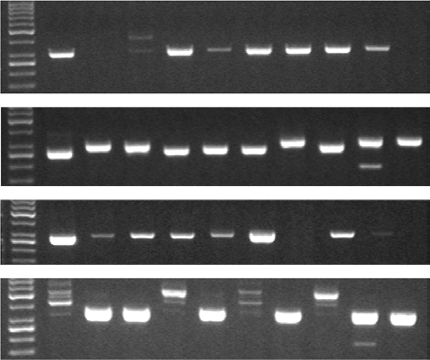
|
KRZYSIEK-MACZKA_{EtAl}.
15of15
43504
(HpcagA+ vacA+) 1
2
3
4
5
6
7
8 9
cagA (298 bp)
s2 (286 bp)
s1 (259 bp)
m1 (290 bp)
m2 (352 bp)
FIG U R E A 1Detection ofHelicobacter pyloricagAand vacA (m1, m2, s1, and s2) DNA regions in strains isolated from nine different samples collected fromH. pylori-infected patients as compared with strainH. pyloriATCC43504 cagA+vacA+ (m1, s1 positive) used as the controlforcagAands1,m1vacAregionsexpressingahighestvacAactivity(leftredframe).Thesamplenr9indicatestypes2andm2(m2s2) strainwhichwaschosenasbeingcagAnegativeandbearingthelowestvacAcytotoxinexpression(H.pyloricagA−vacA−)(rightredframe)

