
This is an open access article published under a Creative Commons Attribution (CC-BY) License, which permits unrestricted use, distribution and reproduction in any medium, provided the author and source are cited.

pubs.acs.org/JPCC

Limitations of Generic Chromophore Concept for Femtosecond Vibrational Coherences
Article
Marcin Andrzejak, Tomasz Skoŕa, and Piotr Petelenz*


Cite This: J. Phys. Chem. C 2020, 124, 3529−3535

ACCESS Metrics & More Article Recommendations
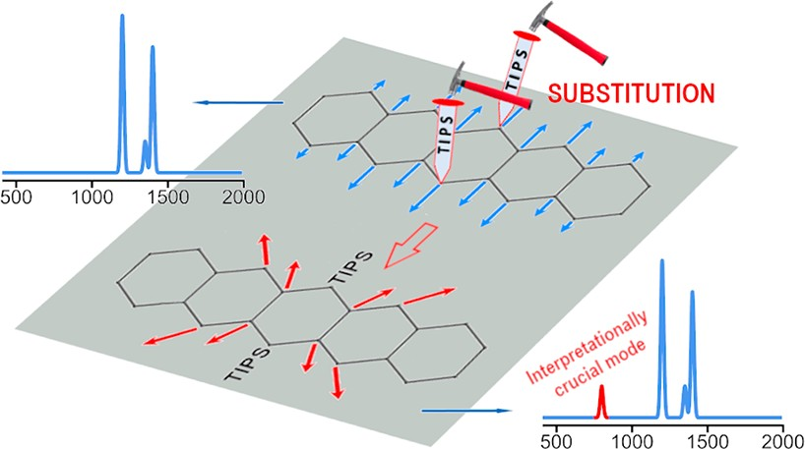
ABSTRACT: The spectrum of vibrational coherences modulating transient triplet−triplet absorption of bis-triisopropylsilylethynylpentacene that prop- agate in the course of the ﬁssion process from the singlet state of this molecule
to the triplet manifold has been lately reproduced by ab initio calculations. This has led to the conclusion that, contrary to a recent hypothesis, spontaneous generation of coherent vibrational wave packets is not a constitutive feature of singlet exciton ﬁssion. Here we demonstrate by calculations that the corresponding spectrum of unsubstituted pentacene is signiﬁcantly diﬀerent, so that the two systems cannot be viewed as diﬀerent models of the same generic chromophore. This shows that femtosecond
pump−probe spectra of vibrational coherences are sensitive to subtle features
of molecular structure, which we identify here, thereby rationalizing the registered spectral diﬀerences. The crucial factor is the
substituent-induced coupling between some pentacene normal modes that in other contexts may be safely ignored. Overall, our study indicates that this kind of spectroscopy requires great caution in using the generic chromophore concept for interpretative purposes and experimental design.

INTRODUCTION
See https://pubs.acs.org/sharingguidelines for options on how to legitimately share published articles.
Singlet exciton ﬁssion is presently extensively investigated because of its prospective application in increasing the eﬃciency of photovoltaic devices by charge carrier multi- plication. In order to attain ultimate understanding of the process and optimize its conditions, considerable eﬀort is invested in synthesizing and examining new compounds
endowed with ﬁssionable singlet state.1−9 Their majority
derive from tetracene and pentacene, which at interpretational level are treated as generic chromophores in the sense that the relevant photophysical mechanisms operative in the acenes are tacitly assumed to be unaﬀected by chemical modiﬁcations. The most common substituents, designed to make the samples solution-processable, are the triisopropyl-silylethynyl (TIPS) groups. On their example, we will now demonstrate that even this seemingly innocuous change may critically inﬂuence interpretation of crucial experimental data. Vibrational coherence spectroscopy, widely used in recent singlet ﬁssion studies,4,8,9 seems to be particularly sensitive to this eﬀect.
The ﬁssion process, consisting in the decay of an
intramolecular singlet state into an entangled pair of triplets located at diﬀerent molecules, is a very fast one. For this reason, major progress in this ﬁeld that has been registered in recent years is largely due to application of femtosecond spectroscopy, enabling one to probe in real time the progress of the radiationless transition in hand, which can be accomplished, for instance, by measuring transient absorption
of the emergent triplet states in the pump−probe regime.
These transients are modulated by coherent vibrational wave packets (CVWP) generated by the pumping pulse in the initially excited singlet state; those, according to recent literature, freely penetrate into the intramolecular triplet manifold, being practically unaﬀected by the boundary between the S1 and TT potential energy surfaces (PES).
In a study performed by Stern et al. on TIPS-tetracene4 (bis-
triisopropylsilyl-ethynyl-tetracene), a similar technique enabled
the authors to detect wave packets (in 760 cm−1 normal mode) created directly in the triplet manifold as a kind of byproduct of the singlet ﬁssion process (without any precursor CVWP in
the singlet manifold). On the other hand, the results of the pump−probe experiment performed by Musser et al. for the related TIPS-pentacene,8 when assisted by theoretical study,10
demonstrated that in this system no such phenomenon occurs, i.e., that all coherent wave packets that reach the triplet manifold are those induced by the initial pump pulse. This refuted the hypothesis that generation of a coherent vibrational wave packet is a general constitutive feature of singlet ﬁssion. The above conclusion was based on comparison of the coherence power spectrum obtained from accurate ab initio
calculations10 with the experimental results of Musser et al.8

Received: December 20, 2019
Revised: January 23, 2020
Published: January 27, 2020


© 2020 American Chemical Society

3529
https://dx.doi.org/10.1021/acs.jpcc.9b11772
J. Phys. Chem. C 2020, 124, 3529−3535
The resultant meticulous inventory revealed quantitative agreement between the vibrational coherences generated by
the pumping pulse and those detected by probing the transient triplet−triplet absorption. Here we will show that to reach this conclusion it was absolutely necessary to do the calculations
with the TIPS substituents explicitly taken into account (as was actually done)10 and that the generic pentacene chromophore alone would indeed fail to render a pivotal feature of the underlying physical mechanism. We will also analyze the physical causes of this sensitivity to the presence of substituents, with potential consequences for future studies of other singlet-ﬁssionable materials in mind.
So far, in such studies the conjectures highlighting crucial involvement of vibrational coherences in singlet ﬁssion have been continually reappearing,4,11−14,15−19 and it is to be
expected that this trend will be further pursued. The femtosecond coherent vibrational wave packet spectroscopy is the technique of choice for this kind of experimental investigations. In this context, the interpretational paradigm of this spectroscopy seems to be a fundamental problem, which we are addressing in this paper.
Our strategy is to compare (in Section 3) the vibrational coherence spectra which we theoretically predict for pentacene with those of TIPS-pentacene10 (the latter, as mentioned above, exhibited very good agreement with experiment).8 To make the comparison valid, in the present treatment we will exactly repeat our previous procedure (brieﬂy summarized in Section 2). The diﬀerences between the calculated spectra of the two compounds will be exposed and rationalized to pinpoint the underlying physical mechanisms

THEORY
  - Theoretical Simulation of Coherence Power Spectra. The gist of the experiment of Musser et al., the results of which are our main reference, consisted in using a
the S1 state of a chromophore molecule.10 The molecule (with the vibrational wave packet on its S1 PES) is viewed as a moiety of a hypothetical dimer, prepared by the pumping pulse in its excited singlet state eg. This state is assumed to radiationlessly relax to the triplet-pair state tt by triplet exciton transfer to the other moiety, while a second triplet exciton (accompanied by the originally generated vibrational wave packet) is left behind. The mechanism of this transition is not explicitly decreed, presumably being mediated by a black box that consists of the originally unexcited moiety (which takes care of energy balance) and the surroundings.
In other words, for further considerations the above dimer model is projected onto the single-molecule subspace of the originally excited moiety, to which the coherent vibrational wave packet is presumably conﬁned. Within the coherence lifetime, the molecule’s PES (that supports the packet) changes from singlet to triplet, the latter serving as the initial state for the probing Tn ← T1 transition.
The above picture, although obviously simpliﬁed, is
conceptually convenient. In reality the pertinent electronic states are delocalized over both moieties, but the requisite matrix elements of the Hamiltonian and dipole moment are readily obtained from those derived in the localized representation. The resultant coherence spectra, deﬁned correct to a constant factor, are not aﬀected by this transformation.
The fundamental equation that describes the temporal modulation of net absorption intensities in transient triplet spectra (eq 3 of ref 10) was derived by time-dependent perturbation theory, deviating from the textbook standard only in assuming the optical transition to have a nonstationary vibrational wave packet as the initial (or ﬁnal) state. The latter and the former apply, respectively, to the pumping (S1 ← S0)
and the probing (Tn ← T1) stages, and the equation we are
referring to above combines both stages. Each band Iint(ω ) in
Tn χ
femtosecond laser pulse of 10 fs duration to generate vibrational wave packets on the S1 potential energy surface.8 Those, according to the presently accepted paradigm, subsequently penetrated onto the PES of the triplet-pair state, to be interrogated after a variable time delay by a (probe) white-light continuous pulse. Transient absorption of the probe pulse was recorded in the energy ranges corresponding to the T2 ← T1 and T3 ← T1 electronic transitions. The absorption intensity was found to oscillate in time, being
periodically modulated by the CVWPs propagating on the T1 PES. Each of the spectrally resolved T2 ← T1 and T3 ← T1 absorption signals was subsequently Fourier-analyzed, and the resultant Fourier amplitudes for individual vibrational modes were integrated over the corresponding (T2 ← T1, T3 ← T1) energy range, yielding the power spectrum to be interpreted.
It should be mentioned for completeness that the scheme presented above is oversimpliﬁed, as it disregards a third (dump) laser pulse, interposed between those already described. It served to eliminate the contributions from the CVWPs generated by the pump on the S0 PES. By ignoring them in our simulations, we implicitly take the dumping pulse into account.
In this work the general premises and basic formulas for predicting the CVWP power spectrum are the same as in our recent paper10 and its Supporting Information, to which the reader is referred for details. Here is their brief summary.
The calculations are rooted in a wave function-based model describing temporal evolution of a wave packet generated in
the calculated coherence power spectrum (vide infra) corresponds (in the experiment of Musser et al.8) to the squared module of the Fast Fourier Transform coeﬃcient (|FFT|2) for an individual normal mode ωχ, integrated over the Tn energy range.
According to experimental conditions in the measurements we are theoretically reproducing,8 the pump pulse is assumed to be instantaneous (as justiﬁed by its actual duration of 10 fs),
and its spectral shape (centered at 2.18 eV and covering the 500−650 nm range) strictly mimics that used in the pertinent experiment (cf. the Supporting Information of ref 10). The calculated Iint(ω ) signals are averaged over the estimated
Tn χ
experimental error in time domain, for which we adopt the same value of 20.7 fs as in our preceding paper.10 The set of technical details of the experiment in hand is completed by adding that the texture-related inhomogeneous broadening of
spectral lines is approximated by Gaussian distribution with dispersion σ ≈ 450 cm−1, derived from the experimentally observed diﬀerences between the spectra of the TIPS- pentacene thin ﬁlm and its constituent individual crystalline domains,20,21 and also consistent with the pentacene single
crystal spectral characteristics.
The needed molecule-speciﬁc input data are the following:
(i) The S1 state energy of 1.75 eV for TIPS-pentacene, and
1.83 eV for pentacene (0−0 lines22). We adopt these experimental values in our present calculations. (ii) The Franck−Condon parameters (FCP) for the pumping
Table 1. Frequencies and Franck-Condon Parameters of Interpretationally Relevant Normal Modes for Low Energy Singlet−
Singlet and Triplet−Triplet Transitions in the Pentacene Molecule
normal mode | S0 | S1 | wavenumber (cm−1)  T1 | T2 | T3 | dimensionless displacement
 |  |  |  |  |  | S0-S1 | S1-T1 | S0-T1 | T1-T2 | T1-T3

ω2 | 264 | 262 | 261 | 261 | 262 |  | −0.678 | −0.105 | −0.785 | −0.257 | −0. 152
ω3 | 617 | 613 | 613 | 614 | 609 |  | 0.197 | −0.029 | 0.212 | −0.014 | −0.037
ω4 | 648 | 628 | 631 | 637 | 627 |  | −0.103 | 0.016 | 0.109 | 0.080 | 0.036
ω5 | 764 | 757 | 755 | 768 | 762 |  | 0.327 | −0.090 | 0.213 | −0.042 | −0.047
ω6 | 797 | 804 | 807 | 804 | 802 |  | −0.111 | −0.121 | −0.258 | 0.233 | 0.218
ω9 | 1019 | 1048 | 1051 | 1049 | 1045 |  | −0.071 | −0.043 | −0.120 | −0.030 | −0.079
ω11 | 1186 | 1183 | 1183 | 1180 | 1182 |  | −0.402 | −0.018 | −0.434 | 0.043 | −0.014
ω12 | 1209 | 1221 | 1216 | 1216 | 1220 |  | −0.527 | −0.200 | −0.701 | −0.567 | −0.330
ω13 | 1333 | 1312 | 1271 | 1264 | 1285 |  | −0.172 | −0.019 | −0.311 | −0.200 | −0.085
ω14 | 1410 | 1382 | 1435 | 1433 | 1429 |  | −0.755 | 0.179 | 0.214 | 0.994 | 0.562
a  ω15 | 1433 | 1426 | 1358 | 1351 | 1382 |  | 0.448 | −0.229 | 0.958 | −0.537 | −0.315
ω16 | 1497 | 1511 | 1496 | 1508 | 1496 | −0.136 |  | 0.182 | 0.578 | 0.577 | 0.301
ω17 | 1558 | 1536 | 1535 | 1556 | 1539 | 0.495 |  | 0.105 | 0.494 | −0.040 | −0.065
ω18 | 1576 | 1578 | 1592 | 1578 | 1569 | −0.181 |  | 0.007 | −0.212 | 0.384 | 0.183
aNote that this frequency considerably decreases upon excitation. As mode numbering is based on the ground state, this may be confusing when confronted with the presented spectra.
(S1 ← S0), probing (T2 ← T1, T3 ← T1), and radiationless (T1 ← S1) electronic transitions in all relevant normal modes, which have been calculated as described below.
  - Evaluation of Franck−Condon Parameters. The Franck−Condon parameters for the S1 ← S0, T2 ← T1, T3 ← T1, and T1 ← S1 electronic transitions are the prime
input data to generate the coherence power spectrum of interest. To calculate them for the pentacene molecule, we have applied the TDDFT approach with the B3LYP energy functional and def2-TZVPP basis, in the TURBOMOLE V6.4 2011 implementation.23 This guarantees perfect consistency with our previous paper,10 which we have now followed also in treating the T1 state as the ground state in the triplet manifold; then, the higher triplet states have been generated in subsequent TDDFT procedure. Next, we have projected the geometry changes on the normal modes of the initial and ﬁnal state of each transition of interest.
On the basis of the arguments presented earlier,10 in the conditions of the Musser et al. experiment8 the FC parameters relevant for the S1 ← S0 pumping step are those obtained by projecting the S0-S1 geometry change on the normal modes of the (ﬁnal) S1 state, as usually practiced in absorption spectroscopy; the same applies to the radiationless T1-S1 step. In contrast, for the transitions in the triplet manifold, the geometry change is projected on the normal modes of the (initial) T1 state on which the CVWPs that drive the probed absorption are moving. These values are listed in Table 1 for all
FC-active normal modes (the modes exhibiting negligible parameter values for all the transitions under consideration are omitted).
To reduce the computational eﬀort, in our recent calculations10 the target 6,17-bis(triisopropylsilylethynyl)- pentacene (TIPS-pentacene) was mimicked by 6,17-bis- silylethynylpentacene (SE-pentacene), which was justiﬁed by the fact that the inﬂuence of the remote propyl groups on the chromophore electronic states is negligible, and the alkyl vibrations are also well separated. Nonetheless, owing to the presence of SE groups, even for the latter molecule the number of normal modes inevitably exceeds that of pentacene. On the basis of frequency and displacement analysis, we have
pinpointed the SE-pentacene modes that have no counterparts
in pentacene to be those previously labeled as ω1, ω7, ω8, and ω10. To facilitate the comparison, we skip these numbers in our present labeling of pentacene modes, which then becomes entirely consistent with that of ref 10. The coherence amplitudes of those modes for TIPS-pentacene were below
the detectability level anyway, except for ω1 ≅ 250 cm−1
(which we ignored then because its frequency was beyond the range covered by the referential experiment8 and consistently ignore here).
Direct confrontation indicates that in most modes the qualitative picture for pentacene is very similar to that earlier obtained for TIPS-pentacene.10 Speciﬁcally, it turns out that for the radiationless T1 ← S1 electronic transition, the FC parameters are negligibly small in all relevant normal modes, so that in actual calculations we follow ref 10 in assuming that the vibrational quantum numbers v do not change when the wave packet crosses the boundary between the two PES.
This prevailing picture notwithstanding, for a few modes the situation in pentacene substantially diﬀers from that in its TIPS derivative. It so happens that these diﬀerences are interpreta- tionally crucial.

RESULTS AND DISCUSSION
  - Diﬀerences between TIPS-Pentacene and Penta- cene Spectra. The mission of a generic chromophore is to serve as an idealized proxy of the actual chromophore, providing a more general view of a problem by ignoring those details of the molecular structure that are deemed insigniﬁcant in the pertinent context. It usually also oﬀers a chance to reduce the needed computational eﬀort.
In the present case, neither of those is our aim. Pentacene is introduced here as a generic chromophore for a slightly diﬀerent purpose: its comparison with TIPS-pentacene is intended to highlight the details that are relevant speciﬁcally
for ﬁssion studies performed by means of femtosecond pump−
probe spectroscopy of vibrational coherences. The clues in this
regard will be provided by revealing the features of the TIPS- pentacene coherence spectrum that cannot be reproduced by the generic pentacene model.
Figure 1a,b shows the calculated power spectra of vibrational coherences modulating the T2 ← T1 and T3 ← T1 transient

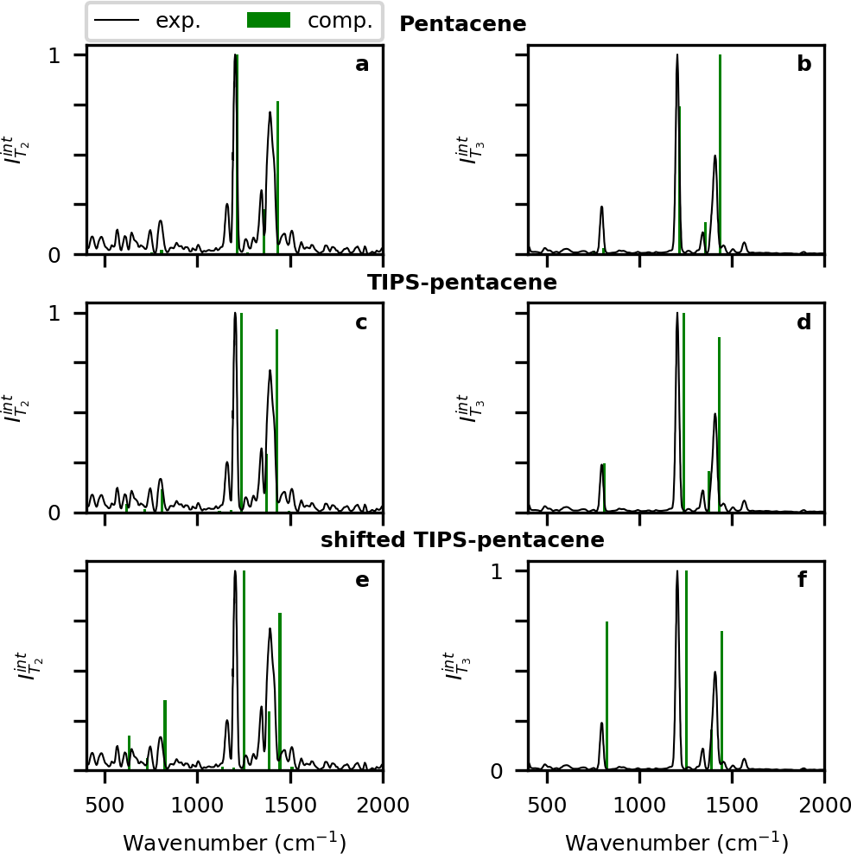
Figure 1. Vibrational coherences (green sticks) modulating the (a) T
1400 cm−1, are well reproduced in both the frequency and intensity domains.
The consistent overestimation of vibrational frequencies by several percent is only to be expected, as it is an inherent feature of most ab initio methods and of the B3LYP functional applied here, as well as of the harmonic approximation. It could have been corrected with one of the scaling procedures often used in such situations, but we preferred to leave the results of our calculations unaltered, having the (quite small) errors under control. Besides, in order to show precisely the location of the calculated bands we used the stick
representation. The stick spectrum seemingly overrates the signals around 1400 cm−1. The discrepancies, however, are
mostly due to the larger experimental widths of these bands with respect to the rest of the spectrum, thus the relative integral intensities of the experimental bands would be much closer to the theoretical predictions. In view of the fact that photoinduced absorption is actually a nonlinear optical phenomenon (which makes the intensities especially sensitive to the quality of applied methodology) and that calculations for excited states (especially the triplet ones) are more prone
to errors than those for the ground state, the agreement with the experiment that has been attained10 may be considered
← T1
and (b) T3
← T1
transient absorption, calculated for
2
pentacene
nearly perfect.
(viewed as generic chromophore), compared with the corresponding experimental spectrum measured for TIPS-pentacene (from ref 8, solid black line). Panels (c) (T2 ← T1) and (d) (T3 ← T1): the same TIPS-pentacene experimental spectrum compared with the spectrum calculated speciﬁcally for TIPS-pentacene (using the same method-
ology). Panels (e) (T2 ← T1) and (f) (T3 ← T1): analogous comparison for TIPS-pentacene but with the S1 ← S0 0−0 line energy
replaced by that of pentacene (0.08 eV blue shift).

absorption of pentacene in a hypothetical pump−probe experiment strictly analogous to that of Musser et al. They are based on the set of input parameters described above, to be compared with the corresponding TIPS-pentacene spectra (Figure 1c,d) generated in ref 10 within exactly the same computational scheme (but with the input parameters calculated speciﬁcally for that molecule). In all ﬁgures the continuous lines represent the reference experimental spectra of TIPS-pentacene,8 and the calculated amplitudes are normalized against the most intense signal of the spectrum in hand.
The TIPS-pentacene amplitudes, calculated in ref 10 and reported here for comparative purposes, need some comments concerning their quality with respect to the experimental references. In the ﬁrst place, the experimental T2 ← T1 spectrum exhibits a high level of background noise, which results from the low intensity of the pertinent electronic transition, combined with inherent errors of the complex data collection and numerical processing procedures. It complicates the analysis of the experimental spectrum, as the real, less intense bands are diﬃcult to distinguish from random wiggles. Speciﬁcally, the apparent coherence signal at around 1150
cm−1 is an artifact generated at the stage of eliminating (with
application of the dump pulse) the contributions from the CVWPs generated by the pump on the S0 PES.8 The situation is much clearer for the T3 ← T1 spectrum, which (owing to higher intensity of this electronic transition) displays a much
lower level of background noise. For both spectra, however, the prominent bands at around 800 cm−1, as well as 1200 and
The imperfect match between the TIPS-pentacene spectra (calculated and experimental alike) and the ones calculated for the native pentacene is readily justiﬁed by the fact that these are diﬀerent molecules, after all. However, in the respect in which pentacene (serving as generic chromophore) should precisely mimic its TIPS derivative, the two diﬀer so blatantly that it disqualiﬁes pentacene in this capacity. The discrepancies in the high frequency region, although for T3 ← T1 large in scale, are of lesser interpretational importance because none of those coherences was ever claimed to be generated in the course of singlet ﬁssion, so they are unlikely to shed light on
that phenomenon. In contrast, the role of the ω6 = 802 cm−1
mode is pivotal in assessing the recently postulated4 proclivity of the ﬁssion process to spontaneously generate coherent vibrational wave packets. The agreement of our earlier results10 with the experiment8 demonstrated that in TIPS-pentacene the pumping step entirely accounts for coherent activity of all modes detected in the probing step, which eliminated the need to invoke coherence generation in the ﬁssion step itself. The fact that no coherence deﬁcit was detected in the ω6 mode is especially important because it contrasts with the situation in TIPS-tetracene4 where the coherences experimentally observed
just in a related 760 cm−1 mode were reported to emerge in the
course of the ﬁssion process.
The essential point is that, had our calculations at that time used pentacene as a model for TIPS-pentacene, the minuscule intensity predicted for ω6 would have led us to a contrary (and erroneous) inference, so that our ultimate (negative) conclusion concerning ﬁssion-induced spontaneous CVWP generation would be reverted. This demonstrates that in this speciﬁc context neither could pentacene serve as a model for TIPS-pentacene, nor vice versa, since their spectra drastically diﬀer just in the region that is interpretationally crucial for ﬁssion considerations;4,10 manifestly, the generic chromophore
approach is blatantly inapplicable here. On the other hand, to most intents and purposes of standard UV−vis vibronic spectroscopy (except high-resolution low-temperature meas-
urements), both molecules can be used practically on equal footing as the same generic chromophore. Our present
objective is to determine what makes the femtosecond pump− probe spectroscopy diﬀerent in this regard.
  - Causes of the Diﬀerences: Numerical Test. In our input, the molecules of pentacene and TIPS-pentacene diﬀer in two respects: singlet excitation energy (point i in the itemized list above) and Franck−Condon parameters (point ii). We have tested the inﬂuence of the former by repeating the
calculations using the FC parameters of TIPS-pentacene and the 0−0 line energy of the native pentacene. The resultant coherence spectra are displayed in Figure 1e,f.
Evidently, the blue shift of 0.08 eV has substantially increased the amplitude of the ω6 coherences. Hence, it has to be noted that even a minor spectral shift of the S1 ← S0 absorption underlying the pumping process may signiﬁcantly aﬀect the relative contributions of diﬀerent vibrational modes to the measured coherence power spectrum.
It is clear, however, that the low amplitude of the ω6 wave packets in the spectra of unsubstituted pentacene is deﬁnitely not caused by the higher energy of its 0−0 line; on the contrary, this location promotes the contribution from ω6 coherences. Despite this favoring factor, the ω6 mode in the pentacene spectrum is less prominent than in its TIPS derivative, so the diﬀerence must have its roots in the FC
parameters (vide infra).
  - Role of TIPS Substituents. As inferred in Section 3.2, the main dissimilarity between the pentacene and TIPS- pentacene vibrational coherence spectra must be due to some
diﬀerence(s) in their Franck−Condon parameters. In this
context one should bear in mind that, in order to considerably modulate triplet−triplet absorption, a normal mode must combine (i) substantial supply of coherent wave packets in the
singlet state, with (ii) substantial wave packet detectability in the triplet manifold.
As mentioned above, the former requirement implies that the pumping pulse, when creating the S1 state, must simultaneously excite in this mode nonnegligible contributions from at least two vibrational eigenstates (diﬀering in the quantum number v), which necessitates an appreciable FC parameter for the S1 ← S0 transition. Likewise, it ensues from the latter of the two stipulations formulated above that, by virtue of the selection rule derived in the past,10 a similar inference applies to FCP modulation of the Tn ← T1 transitions.
When applied to pentacene, the above criteria clearly explain why neither of the two modes (cf. Table 1) with frequencies in
the 700−800 cm−1 range eﬀectively modulates triplet−triplet
absorption. Coherent wave packets in the ω5 mode (at about
760 cm−1), with displacements occurring primarily along the short axis of the molecule and concentrated mostly in its central part (Cf Figure 2a), although abundantly generated by pumping due to a large S1 ← S0 FC parameter (0.327), are
practically unable to modulate Tn ← T1 absorption because for both T2 and T3 the corresponding parameters (−0.042 and
−0.047, respectively, according to Table 1) are negligible. The situation is reversed for ω6 (around 800 cm−1), for which
detectability is promising (with FCPs of about 0.2), but coherence generation by the pump is rather ineﬃcient (FCP = 0.111). The largest displacements in this mode contain a large component parallel to the L molecular axis (cf. Figure 2b) and are distributed more or less evenly over all benzene rings, with slight prevalence of the peripheral ones.
In TIPS-pentacene, however (for complete FCP sets see ref 1), the heavy TIPS side groups constrain the motion of the

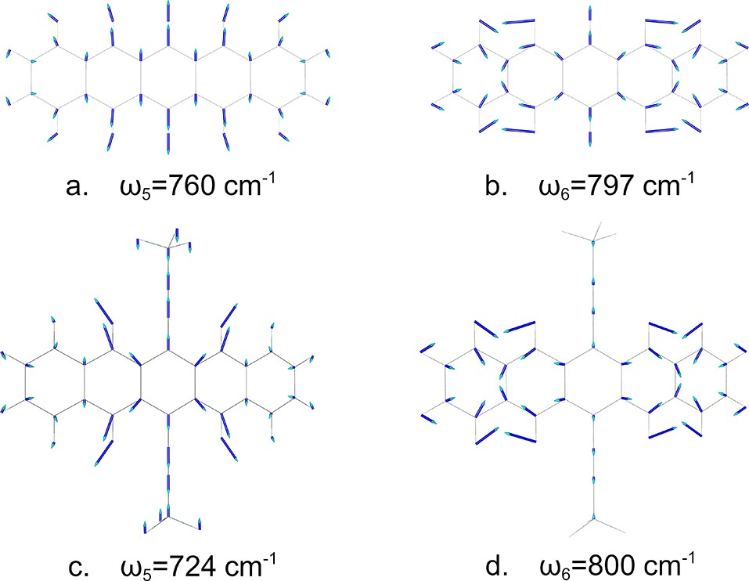
Figure 2. Displacement patterns for the ω5 and ω6 normal modes of the pentacene and TIPS-pentacene molecules.

ring carbon atoms to which they are attached, dramatically distorting the ω5 displacement pattern. When the ring bonds parallel to the short molecular axis (cf. Figure 2a) stretch with the positions of the 6 and 13 carbons ﬁxed, the angles between the bonds in the central ring are inevitably deformed and this ring expands/contracts sideways, i.e., along the L axis of the molecule (as depicted in Figure 2c). This motion is bound to interfere with ω6 vibrations (Figure 2b), and the emergent
coupling aﬀects both modes, as displayed in Figure 2c,d.
As a consequence, in TIPS-pentacene the module of the ω5 FCP for pumping (S1 ← S0) diminishes to 0.195 but that for the T2 ← T1 probing transition grows to 0.119 (which makes this coherence spectrally discernible) with its T3 ← T1 counterpart barely aﬀected (−0.030).
The impact of the coupling is much more pronounced for
ω6. Apart from the probing T2 ← T1 transition, for which the Franck−Condon parameter is practically unchanged (0.216), the FCPs for ω6 increase substantially, namely to 0.309 for T3
← T1 probing and to 0.304 for pumping. Especially the latter is crucial, ascertaining a suﬃcient wave packet supply to make
this mode appear pretty prominently in both probing transitions. It is due to this eﬀect that in the experimental modulation spectra the ω6 mode is the most noticeable low- frequency coherence.
The above eﬀect is reminiscent of intensity borrowing, which is a rather common phenomenon in UV−vis spectros- copy. By mixing the electronic states of a molecule, a
perturbation (be it a vibration or a substituent) transfers a part of the transition moment from an allowed (lending) electronic transition to a spectroscopically mute (borrowing) state, thereby making the latter spectroscopically observable. Analogously, the coupling mediated by a heavy substituent endows the original pentacene ω6 mode with the substantial S1
← S0 FC parameter of 0.304, thereby enabling this vibration to eﬃciently form coherent wave packets in the pumping S1 ← S0 transition, which then conspicuously appear in probing, owing to this mode’s substantial FC parameters in the triplet manifold (of which one is also enhanced by the coupling). The ω5 mode, on the other hand, gains a suﬃcient increment in the T2 ← T1 FCP to become discernible in probing, since its supply in pumping, although reduced by the coupling, is still considerable.

CONCLUSIONS
In contrast to traditional (for instance, absorption) spectros- copies, vibrational coherences observed by femtosecond
pump−probe technique are sensitive to even minor energy
shifts of the absorbing electronic state. Thus, small
dissimilarities in this regard between two compounds may lead to their qualitatively diﬀerent coherence spectra.
Besides, the two-step nature of the pump−probe technique
makes it very selective, as it imposes on any normal mode two independent selection rules concerning the Franck−Condon factors: one in the singlet (pumping) and the other in the
triplet (probing) manifold. In consequence, the mere mass of an inert substituent may suﬃce to modify these selection rules by mode coupling, substantially changing the coherence spectra. As we have shown on the pentacene/TIPS-pentacene example, even if the coupling aﬀects just a couple of modes, but at least one of those happens to be interpretationally crucial for the phenomenon under study, this may dramatically alter not only the quantitative but also the qualitative conclusions concerning the photophysical mechanisms under study. In practical terms, such a situation deﬁes the usefulness of the chromophore in hand in the capacity of a generic chromophore. Yet, its unsuitability may be nontrivial to detect, since the mode couplings introduced by substitution (while inﬂuencing the coherence signals) may barely aﬀect the mode frequencies, so that the latter may seemingly corroborate resemblance to the unsubstituted chromophore.
As a consequence, ill-considered application of the generic chromophore concept may lead to qualitatively erroneous interpretations. As far as we can see, pitfalls of this kind may be detected only by accurate quantum chemistry calculations for all the states involved in pumping and probing. Overall, our results suggest that special caution must be exercised when applying intuitive notions of chemical similitude that underlie the generic chromophore concept (ﬁrmly established in absorption and emission spectroscopy) for planning and
interpreting pump−probe vibrational coherence experiments.
■

AUTHOR INFORMATION
Corresponding Author
Piotr Petelenz − The K. Guminśki Department of Theoretical Chemistry, Faculty of Chemistry, Jagiellonian University, 30- 387 Krakoẃ, Poland; orcid.org/0000-0001-5481-1958; Phone: +48 12 6325456; Email: petelenz@chemia.uj.edu.pl
Authors
Marcin Andrzejak − The K. Guminśki Department of Theoretical Chemistry, Faculty of Chemistry, Jagiellonian University, 30-387 Krakoẃ, Poland
Tomasz Skóra − Department of Complex Systems, Institute of Physical Chemistry, Polish Academy of Sciences, 01-224
Warszawa, Poland; orcid.org/0000-0003-4394-4928
Complete contact information is available at: https://pubs.acs.org/10.1021/acs.jpcc.9b11772

Notes
The authors declare no competing ﬁnancial interest.

ACKNOWLEDGMENTS
The authors express their gratitude to Andrew Musser for
providing the emission spectrum of the pump used in the experiments of ref 8. This research was performed with
equipment purchased because of the ﬁnancial support of the European Regional Development Fund in the framework of the Polish Innovation Economy Operational Program (contract no. POIG.02.01.00-12-023/08).

REFERENCES
- Pensack, R.; Ostroumov, D. E. E.; Tilley, A. J.; Mazza, S.; Grieco,
C.; Thorley, K. J.; Asbury, J. B.; Seferos, D. S.; Anthony, J. E.; Scholes,
G. D. Observation of Two Triplet-Pair Intermediates in Singlet Exciton Fission. J. Phys. Chem. Lett. 2016, 7, 2370−2375.
- Lukman, S.; Chen, K.; Hodgkiss, J. M.; Turban, D. H. P.; Hine,
N. D. M.; Dong, S.; Wu, J.; Greenham, N. C.; Musser, A. J. Tuning the Role of Charge-Transfer States in Intramolecular Singlet Exciton
Fission through Side-Group Engineering. Nat. Commun. 2016, 7,
13622.
- Basel, B. S.; Zirzlmeier, J.; Hetzer, C.; Phelan, B. T.; Krzyaniak,
M. D.; Reddy, S. R.; Coto, P. B.; Horwitz, N. E.; Young, R. M.; White,
F. J.; et al. Unified Model for Singlet Fission within a Non-Conjugated Covalent Pentacene Dimer. Nat. Commun. 2017, 8, 15171.
- Stern, H. L.; Cheminal, A.; Yost, S. R.; Broch, K.; Bayliss, S. L.; Chen, K.; Tabachnyk, M.; Thorley, K.; Greenham, N.; Hodgkiss, J. M.; et al. Vibronically Coherent Ultrafast Triplet-Pair Formation and
Subsequent Thermally Activated Dissociation Control Efficient Endothermic Singlet Fission. Nat. Chem. 2017, 9, 1205−1212.
- Basel, B. S.; Zirzlmeier, J.; Hetzer, C.; Reddy, S. R.; Phelan, B.
T.; Krzyaniak, M. D.; Volland, M. K.; Coto, P. B.; Ryan; Young, M.; et al. Evidence for Charge-Transfer Mediation in the Primary Events of Singlet Fission in a Weakly Coupled Pentacene Dimer. Chem.
2018, 4, 1092−1111.
- Hetzer, C.; Guldi, D. M.; Tykwinski, R. R. Pentacene Dimers as
a Critical Tool for the Investigation of Intramolecular Singlet Fission.
Chem. - Eur. J. 2018, 24, 8245−8257.
- Buchanan, E. A.; Kaleta, J.; Wen, J.; Lapidus, S. H.; Císarǒva,́I.;
Havlas, Z.; Johnson, J. C.; Michl, J. Molecular Packing and Singlet
Fission: The Parent and Three Fluorinated 1,3-Diphenylisobenzofur- ans. J. Phys. Chem. Lett. 2019, 10, 1947−1953.
- Musser, A. J.; Liebel, M.; Schnedermann, C.; Wende, T.; Kehoe,
T. B.; Rao, A.; Kukura, P. Evidence for Conical Intersection Dynamics Mediating Ultrafast Singlet Exciton Fission. Nat. Phys. 2015, 11, 352− 359.
- Schnedermann, C.; Alvertis, A. M.; Wende, T.; Lukman, S.; Feng, J.; Schrőder, A. Y. N.; Turban, D. H. P.; Wu, J.; Hine, N. D. M.; Greenham, N. C.; et al. A Molecular Movie of Ultrafast Singlet
Fission. Nat. Commun. 2019, 10, 4207.
- Andrzejak, M.; Skoŕa, T.; Petelenz, P. Is Vibrational Coherence a Byproduct of Singlet Exciton Fission? J. Phys. Chem. C 2019, 123, 91−101.
- Chan, W. E.; Berkelbach, T. C.; Provorse, M. R.; Monahan, N.
R.; Tritsch, J. R.; Hybertsen, M. S.; Reichman, D. R.; Gao, J.; Zhu, X.-
Y. The Quantum Coherent Mechanism for Singlet Fission: Experi- ment and Theory. Acc. Chem. Res. 2013, 46, 1321−1329.
- Berkelbach, T. C.; Hybertsen, M. S.; Reichman, D. R.
Microscopic Theory of Singlet Exciton Fission. I. General Formulation. J. Chem. Phys. 2013, 138, 114102.
- Berkelbach, T. C.; Hybertsen, M. S.; Reichman, D. R. Microscopic Theory of Singlet Exciton Fission. II. Application to Pentacene Dimers and the Role of Superexchange. J. Chem. Phys.
2013, 138, 114103.
- Berkelbach, T. C.; Hybertsen, M. S.; Reichman, D. R. Microscopic Theory of Singlet Exciton Fission. III. Crystalline
Pentacene. J. Chem. Phys. 2014, 141, 074705.
- Morrison, A. F.; Herbert, J. M. Evidence for Singlet Fission Driven by Vibronic Coherence in Crystalline Tetracene. J. Phys. Chem. Lett. 2017, 8, 1442−1448.
- Tempelaar, R.; Reichman, D. R. Vibronic Exciton Theory of
Singlet Fission. I. Linear Absorption and the Anatomy of the Correlated Triplet Pair State. J. Chem. Phys. 2017, 146, 174703.
- Tempelaar, R.; Reichman, D. R. Vibronic Exciton Theory of
Singlet Fission. II. Two-Dimensional Spectroscopic Detection of the Correlated Triplet Pair State. J. Chem. Phys. 2017, 146, 174704.
- Tempelaar, R.; Reichman, D. R. Vibronic Exciton Theory of Singlet Fission. III. How Vibronic Coupling and Thermodynamics Promote Rapid Triplet Generation in Pentacene Crystals. J. Chem.
Phys. 2018, 148, 244701.
- Monni, R.; Capano, G.; Aubock, G.; Gray, H. B.; Vlcek, A.; Tavernelli, I.; Chergui, M. Vibrational Coherence Transfer in the Ultrafast Intersystem Crossing of a Diplatinum Complex in Solution.
Proc. Natl. Acad. Sci. U. S. A. 2018, 115, E6396−E6403.
- James, D. T.; Frost, J. M.; Wade, J.; Nelson, J.; Kim, J.-S.
Controlling Microstructure of Pentacene Derivatives by Solution Processing: Impact of Structural Anisotropy on Optoelectronic
Properties. ACS Nano 2013, 7, 7983−7991.
- Folie, B. D.; Haber, J. B.; Refaely-Abramson, S.; Neaton, J. B.; Ginsberg, N. S. Long-Lived Correlated Triplet Pairs in a π-Stacked Crystalline Pentacene Derivative. J. Am. Chem. Soc. 2018, 140, 2326− 2335.
- Bakulin, A. A.; Morgan, S. E.; Kehoe, T. B.; Wilson, M. W. B.; Chin, A. W.; Zigmantas, D.; Egorova, D.; Rao, A. Real-Time Observation of Multiexcitonic States in Ultrafast Singlet Fission Using
Coherent 2D Electronic Spectroscopy. Nat. Chem. 2016, 8, 16−23.
- TURBOMOLE V6.4, a Development of University of Karlsruhe and Forschungszentrum Karlsruhe GmbH, 1989−2007, TURBO- MOLE GmbH, 2011, http://www.turbomole.com.

