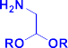
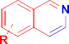
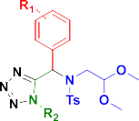


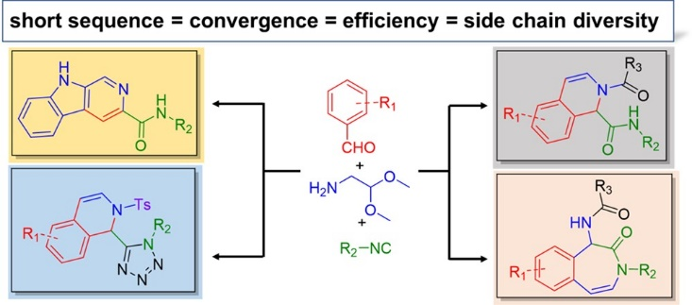
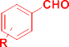
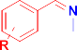
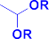

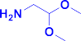
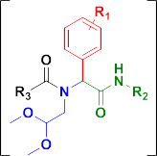
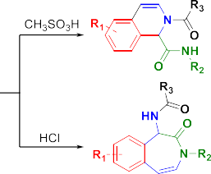


This is an open access article published under a Creative Commons Non-Commercial No Derivative Works (CC-BY-NC-ND) Attribution License, which permits copying and redistribution of the article, and creation of adaptations, all for non-commercial purposes.
pubs.acs.org/OrgLett
Cite This: Org. Lett. 2019, 21, 3533−3537
Diverse Isoquinoline Scaﬀolds by Ugi/Pomeranz−Fritsch and Ugi/ Schlittler−Müller Reactions
Yuanze Wang,† Pravin Patil,† Katarzyna Kurpiewska,‡ Justyna Kalinowska-Tluscik,‡ and Alexander Dömling*,†
†Drug Design, University of Groningen, Deusinglaan 1, 7313 AV Groningen, The Netherlands
‡Faculty of Chemistry, Jagiellonian University, 3 Ingardena Street, 30-060 Krakow, Poland
*S Supporting Information
I
Fritsch reaction have been published.13 Inspired by the fact that the Pictet−Spengler reaction has been successfully used in the Ugi postcondensation strategy in our lab,11j we surmised that the combination of Ugi reaction with Pomeranz−Fritsch reaction and Schlittler−Müller reaction could also be attractive way to form diversiﬁed isoquinolines (Scheme 1).
We ﬁrst explored the Pomeranz−Fritsch reaction as the
post-Ugi strategy. By using 3,4,5-trimethoxybenzaldehyde,
soquinoline represent as an important heterocyclic template
and privileged moiety in medicinal chemistry and exhibit a
wide variety of biological and pharmacological properties.1−7
The known traditional methods to construct the isoquinoline core include the Bischler−Napieralski reaction,8 the Pictet− Spengler reaction,9 and the Pomeranz−Fritsch reaction.10 The Bischler−Napieralski reaction is by far the most frequently explored isoquinoline alkaloids synthesis approach in the past decades. The Pictet−Spengler reaction has not only been explored as a convenient method for the asymmetric synthesis of isoquinoline alkaloids, but also was widely used for the synthesis of alkaloid-like polycyclic compounds by combining with MCR chemistry in recent years.11 The Pomeranz−Fritsch reaction is the synthesis of isoquinolines via an acid-mediated electrophilic cyclization of benzalaminoacetals. Since the ﬁrst and concurrent report by Pomeranz and Fritsch in 1893, this reaction has been extensively modiﬁed.12 To improve the reaction yield, the Fischer modiﬁcation involved the treatment of benzalaminoacetal with fuming sulfuric acid. In 1948, E. Schlittler and J. Müller modiﬁed the reaction by using benzyl amines and glyoxal semiacetal as the starting material. Later on, Bobbitt reported synthesizing the 1,2,3,4-tetrahydroisoquino- lines by hydrogenation of the imine intermediate in situ to the aminoacetal, which allows for the preparation of 1-, 4-, and N- substituted isoquinolines. At the same time, Jackson described the dehydrogenation of 1,2-dihydroisoquinoline via a N-tosyl derivative to a fully aromatic system.
Although a variety of modiﬁcations have been introduced to
improve the Pomeranz−Fritsch strategy, it has not been explored as often as the Bischler−Napieralski reaction and Pictet−Spengler reaction. Only a few isolated reports on the synthesis of isoquinoline derivatives based on Pomeranz−
aminoacetaldehyde diethyl acetal, 4-chlorophenylacetic
acid,
Scheme 1. Ugi/Pomeranz−Fritsch Reaction

Received: Published:
March 4, 2019
April 29, 2019
3533
© 2019 American Chemical Society
DOI: 10.1021/acs.orglett.9b00778
Org. Lett. 2019, 21, 3533−3537
See https://pubs.acs.org/sharingguidelines for options on how to legitimately share published articles.
Letter
ABSTRACT: The Pomeranz−Fritsch reaction and its Schlittler−Müller modiﬁcation were successfully applied in the Ugi postcyclization strategy by using orthogonally protected aminoacetaldehyde diethyl acetal and complemen- tary electron rich building blocks. Several scaﬀolds, including isoquinolines, carboline, alkaloid-like tetrazole-fused tetracy- clic compounds, and benzo[d]azepinone scaﬀolds, were synthesized in generally moderate to good yield. All our syntheses provide a short MCR-based sequence to novel or otherwise diﬃcult to access scaﬀolds. Hence, we foresee multiple applications of these synthesis technologies.







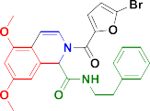
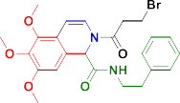
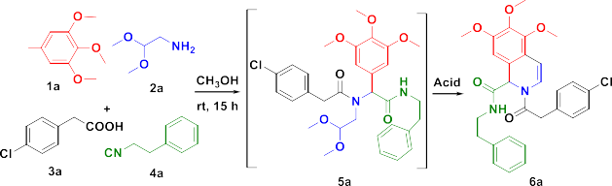

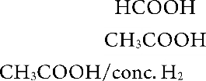
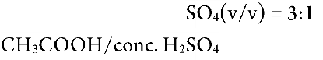
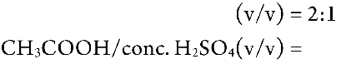
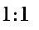
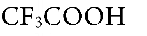
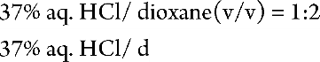
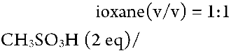
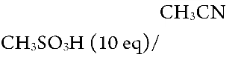
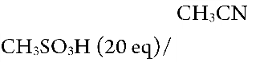
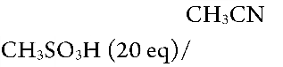
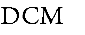
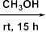
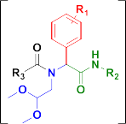
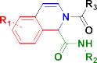
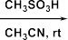
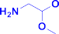
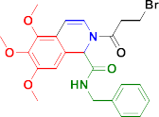
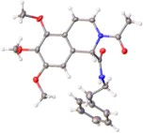

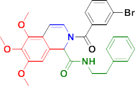
Organic Letters
Letter
and phenylethyl isocyanide as test substrate, the Ugi reaction was conducted in methanol at room temperature for 15 h. As the Ugi reaction works excellently with aliphatic aldehydes and amines, the crude Ugi adduct 5a was directly treated with various acid conditions (Scheme 2). It is worthy to note that
Scheme 3. Examples of N,2-Disubstituted Isoquinolines Derivatives

Scheme 2. Optimization of Reaction Conditions
Albeit in lower yields, most of the aliphatic acids also work except pivalic acid, which failed to give any cyclized product from isolated Ugi adduct. The structure of 6j was conﬁrmed by X-ray crystallography.
To ﬁgure out the unexpected failure of pivalic acid in the Ugi/Pomeranz−Fritsch reaction, we rescreened all the acid conditions in Scheme 2. Surprisingly, we observed the formation of the benzo[d]azepinone scaﬀold in good yield when 37% HCl(aq) solution in dioxane was used as the cyclizing acid. As a class of seven-membered N-heterocycles, benzo[d]- azepinone scaﬀolds are also interesting in medicinal chemistry, where they represent as an important class of so-called “privileged scaﬀolds”.16 To show some scope, we synthesized ﬁve compounds in 39−52% yield by changing the aldehyde and isocyanide moiety as shown in Scheme 4. A single crystal X-ray analysis further conﬁrmed the structure of 8a.
Recently, we reported the isoquinoline synthesis of 10 by Ugi/Schlittler−Müller modiﬁcation using an unprecedented fast nanoscale technology.17 This eﬃcient method was explored to synthesize hundreds of derivatives of 10 with the help of acoustic droplet ejection (ADE). 3,4,5-Trimethoxyl- benzylamine, 3,4-(methylenedioxy)benzylamine, four dime- thoxy substituted benzylamine, and thiophen-3-yl-methylamine were used previously by us as amine component in the Ugi reaction. To further extend the reaction scope, we further explored some other electron rich aromatic amines (Scheme 5). To our delight, 3-methoxylbenzylamine, 4-(aminomethyl)- 2-methoxyphenol, and heterocyclic 1H-indol-2-ylmethylamine were successfully applied by increasing the concentration of the acid and extension of the reaction time in the

DOI: 10.1021/acs.orglett.9b00778
Org. Lett. 2019, 21, 3533−3537
Nadzan and co-workers has reported the formation
of 2-
oxopiperazines by Ugi-N-acyliminium ion cyclization with
good yield using TFA as acid condition.14 Thus, potentially there is a competition between Ugi-N-acyliminium ion cyclization and Ugi-Pomeranz−Fritsch reaction to be expected. To our delight, no 2-oxopiperazines product was observed in all the acid conditions we screened, and 46% of isoquinoline product 6a was formed when TFA was used as the acid. However, HCOOH, CH3COOH, and 37% HCl(aq) solution in dioxane failed to give any isoquinoline product. CH3COOH and coc. H2SO4 were found to be a good combination for this reaction, which aﬀorded 6a in 30−36% yield. Methanesulfonic acid, which has been proved to be a good acid condition for Ugi/Pictet-sprengler reaction, also works well in our Ugi/ Pomeranz−Fritsch sequence.15 Although only trace amount of product was formed when two equivalents of methanesulfonic acid were used, the reaction yield increased to 35% when methanesulfonic acid was increased to 10 equiv. Finally, 20 equiv of methanesulfonic acid in acetonitrile turned out to be the best condition for this reaction, which aﬀorded 6a in 52% yield in two steps. Solventless methanesulfonic acid was inferior.
With optimized reaction conditions in hand, nine isoquino- line products 6 were synthesized by using three aldehyde, three isocyanide, and eight acid building blocks (Scheme 3). Both aromatic and aliphatic isocyanides work well for this reaction. Regardless of the acid moiety, all Ugi adducts obtained from aromatic acid aﬀorded isoquinolines in good to moderate yield.
3534

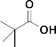
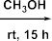
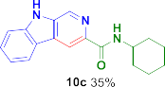
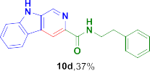
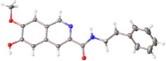
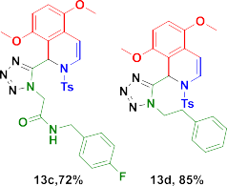
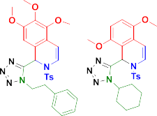
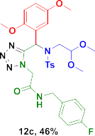
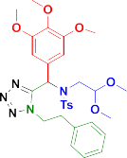
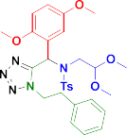
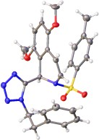
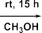
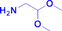
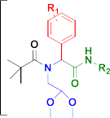
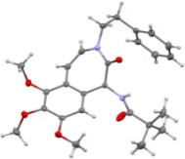
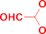
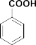
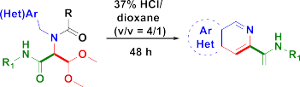

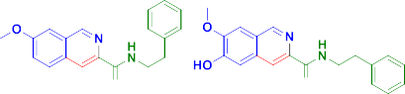
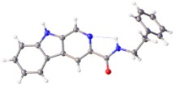
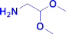
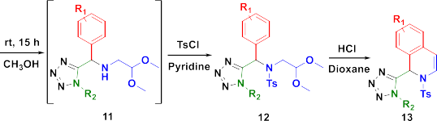
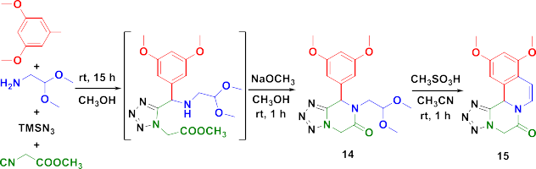

Organic Letters
Scheme 4. Synthesis of Benzo[d]azepinone Scaﬀold
Scheme 6. Synthesis of Isoquinoline-Tetrazoles
Scheme 5. Synthesis of Isoquinoline and Carboline Scaﬀold
Finally, as a further application of our isoquinoline-directed Ugi postcondensation strategy, we synthesized an alkaloid-like tetrazole-fused tetracyclic compound by using isocyanide prepared from amino acid ester as starting material (Scheme 7). Instead of tosyl group protection, the methyl ester from
Scheme 7. Synthesis of Tetracyclic Isoquinolines
postcyclization step. The structures of 10b and 10d were conﬁrmed by X-ray crystallography.
As valuable bioisosteres of carboxylic acid and cis-amide, tetrazole is an important drug-like scaﬀold, which often exhibits improved pharmacokinetics in drug discovery.18 Exploration of the Ugi-Azide MCR and postcyclization by Hulme et al. and others has created several unique scaﬀolds as exempliﬁed by ketopiperazine-tetrazoles,19 quinoxaline-tetra- zoles,20 azepine-tetrazoles,21 benzodiazepine-tetrazoles,22 and lactam-tetrazoles.23 Inspired by these methodologies, we successfully constructed the isoquinoline-tetrazoles by combin- ing the Ugi-azide with the Pomeranz−Fritsch reaction (Scheme 6). Initially, we subjected the Ugi-azide product 11 directly to acidic condition for cyclization. To our surprise, however, the subsequent Pomeranz−Fritsch reaction was very sluggish and only trace amount of product was formed. In addition, variation of the acid condition and solvent did not greatly improve to the reaction performance. We reasoned that the exposed secondary amine could interfere with the reaction and cause side reactions. Thus, we ﬁrst protected the secondary amine by a tosyl group in situ to obtain product 12, which then undergoes clean cyclization to form the isoquinoline-tetrazoles 13. This stepwise reaction proved to be highly superior and the desired product was isolated in good to excellent yields. Eight diverse intermediates and products were characterized, and the X-ray structure of 13d was obtained.
isocyanide moiety will react with the exposed secondary amine in basic condition to form the tetrazolopyrazinone 14, followed by the Pomeranz−Fritsch cyclization to aﬀord tetracyclic product 15. To support the diversity of our isoquinoline-based scaﬀolds, we generated virtual libraries of each 100 randomly generated molecules and for comparison ChEMBL using JChem software.24 The chemical properties MW and log P were calculated and plotted in Figure SI-1 (see Supporting Information p S75). Moreover, an SCI-FINDER sub- and Markush structure query revealed 8 and 9, 0 and 1, 2353 and
848, 847 and 61, 1 and 0, 0 and 0 results for the herein
described scaﬀolds 6, 8, 10-isoquinoline, 10-carboline, 13, and 15, respectively. Also, ChEMBL substructure searches found one hit for scaﬀold 6, zero hits for scaﬀold 8, 422 hits for scaﬀold 10-isoquinoline, 182 hits for scaﬀold 10-carboline, and zero hits for scaﬀold 13 and scaﬀold 15, respectively. In conclusion, we have developed several straightforward methods to assemble isoquinoline derivatives, benzo[d]- azepinone and carboline scaﬀold. The Ugi postcyclization strategy is probably the most powerful tool to create structural diversity and large compound numbers while keeping the number of synthetic steps low. It already has gained lots of
DOI: 10.1021/acs.orglett.9b00778
Org. Lett. 2019, 21, 3533−3537
3535
Letter

Organic Letters
Letter
interest in the ﬁeld of medicinal chemistry.25 Our new strategy of Ugi/Pomeranz−Fritsch reaction is an expedited and convergent access to skeletal diverse compounds. Signiﬁcantly, isoquinoline-tetrazoles and tetrazole-fused tetracyclic com- pound can now be constructed in just two steps with this method. One of the herein described reactions in a variation already has found an application in nanoscale accelerated and automated synthesis; however, we foresee many more
Phillipson, J. D.; Kirby, G. C.; Schiff, P. L.; et al. J. Nat. Prod. 2000, 63, 1638. (d) Kartsev, V. G. Med. Chem. Res. 2004, 13, 325. (e) Chen, P.; Norris, D.; Haslow, K. D.; Dhar, T. M.; Pitts, W. J.; Watterson, S. H.; Hollenbaugh, D. L.; et al. Bioorg. Med. Chem. Lett. 2003, 13, 1345.
(f) Giri, P.; Suresh, K. G. Mini-Rev. Med. Chem. 2010, 10, 568.
(2) (a) Tillhon, M.; Ortiz, L. M. G.; Lombardi, P.; Scovassi, A. I. Biochem. Pharmacol. 2012, 84, 1260. (b) Vennerstrom, J. L.; Klayman, D. L. J. Med. Chem. 1988, 31, 1084. (c) Guo, J.; Wang, S. B.; Yuan, T. Y.; Wu, Y. J.; Yan, Y.; Li, L.; Du, G. H.; et al. Atherosclerosis 2013, 231,
384. (d) Beecher, C. W. W.; Kelleher, W. J. Tetrahedron Lett. 1983, 24, 469. (e) Giri, P.; Hossain, M.; Kumar, G. S. Bioorg. Med. Chem. Lett. 2006, 16, 2364. (f) Maiti, M.; Nandi, R.; Chaudhuri, K. FEBS Lett. 1982, 142, 280.
(3) (a) Rozwadowska, M. D. Pol. J. Chem. 1994, 68, 2271−2278.
(b) Chrzanowska, M.; Rozwadowska, M. D. Chem. Rev. 2004, 104, 3341. (c) Chrzanowska, M.; Grajewska, A.; Rozwadowska, M. D. Chem. Rev. 2016, 116, 12369.
- Xiang, Z.; Luo, T.; Lu, K.; Cui, J.; Shi, X.; Fathi, R.; Yang, Z.; et al. Org. Lett. 2004, 6, 3155.
- Ngouansavanh, T.; Zhu, J. Angew. Chem., Int. Ed. 2007, 46, 5775.
- Che, C.; Yang, B.; Jiang, X.; Shao, T.; Yu, Z.; Tao, C.; Lin, S.; et al. J. Org. Chem. 2014, 79, 436.
- Chen, Y.; Feng, G. Org. Biomol. Chem. 2015, 13, 4260.
- Heravi, M. M.; Khaghaninejad, S.; Nazari, N. Adv. Heterocycl. Chem. 2014, 112, 183.
- Stöckigt, J.; Antonchick, A. P.; Wu, F.; Waldmann, H. Angew. Chem., Int. Ed. 2011, 50, 8538.
- Bobbitt, J. M. Adv. Heterocycl. Chem. 1973, 15, 99.
- (a) El Kaim, L.; Gageat, M.; Gaultier, L.; Grimaud, L. Synlett 2007, 20070500−0502. (b) Liu, H.; Dömling, A. J. Org. Chem. 2009, 74, 6895. (c) Znabet, A.; Zonneveld, J.; Janssen, E.; De Kanter, F. J.; Helliwell, M.; Turner, N. J.; Orru, R. V.; et al. Chem. Commun. 2010, 46, 7706. (d) Wang, W.; Herdtweck, E.; Dömling, A. Chem. Commun. 2010, 46, 770. (e) Wang, W.; Ollio, S.; Herdtweck, E.; Dömling, A. J. Org. Chem. 2011, 76, 637. (f) Cano-Herrera, M. A.; Miranda, L. D. Chem. Commun. 2011, 47, 10770. (g) Liu, H.; William, S.; Herdtweck, E.; Botros, S.; Dömling, A. Chem. Biol. Drug Des. 2012, 79, 470.
(h) Tyagi, V.; Khan, S.; Bajpai, V.; Gauniyal, H. M.; Kumar, B.; Chauhan, P. M. J. Org. Chem. 2012, 77, 1414. (i) Lesma, G.; Cecchi, R.; Crippa, S.; Giovanelli, P.; Meneghetti, F.; Musolino, M.; Silvani, A.; et al. Org. Biomol. Chem. 2012, 10, 9004. (j) Sinha, M. K.; Khoury, K.; Herdtweck, E.; Dömling, A. Chem. - Eur. J. 2013, 19, 8048.
(12) (a) Bobbitt, J. M.; Moore, T. E. J. Org. Chem. 1968, 33, 2958.
(b) Bobbitt, J. M.; Winter, D. P.; Kiely, J. M. J. Org. Chem. 1965, 30, 2459. (c) Bobbitt, J. M.; Kiely, J. M.; Khanna, K. L.; Ebermann, R. J. Org. Chem. 1965, 30, 2247. (d) Bobbitt, J. M.; Roy, D. N.; Marchand, A.; Allen, C. W. J. Org. Chem. 1967, 32, 2225. (e) Bobbitt, J. M.; Sih,
J. C. J. Org. Chem. 1968, 33, 856. (f) Gensler, W. J.; Shamasundar, K. T.; Marburg, S. J. Org. Chem. 1968, 33, 2861. (g) Bobbitt, J. M.; Dutta, C. P. J. Org. Chem. 1969, 34, 2001. (h) Bobbitt, J. M.; Steinfeld, A. S.; Weisgraber, K. H.; Dutta, S. J. Org. Chem. 1969, 34, 2478. (i) Huffman, J. W.; Opliger, C. E. J. Org. Chem. 1971, 36, 111.
(j) Birch, A. J.; Jackson, A. H.; Shannon, P. V. J. Chem. Soc., Perkin Trans. 1 1974, 1, 2185. (k) Birch, A. J.; Jackson, A. H.; Shannon, P. V.
J. Chem. Soc., Perkin Trans. 1 1974, 1, 2190. (l) Gensler, W.; Lawless, S.; Bluhm, A.; Dertouzos, H. J. Org. Chem. 1975, 40, 733.
(m) Hendrickson, J. B.; Rodriguez, C. J. Org. Chem. 1983, 48, 3344. (n) Schlittler, E.; Müller, J. Helv. Chim. Acta 1948, 31, 1119.
(13) (a) Głuszynśka, A.; Rozwadowska, M. D. Tetrahedron:
Asymmetry 2000, 11, 2359. (b) Boudou, M.; Enders, D. J. Org. Chem. 2005, 70, 9486. (c) Kosćiołowicz, A.; Rozwadowska, M. D. Tetrahedron: Asymmetry 2006, 17, 1444. (d) Chrzanowska, M.; Grajewska, A.; Meissner, Z.; Rozwadowska, M.; Wiatrowska, I. Tetrahedron 2012, 68, 3092. (e) Li, B.; Wang, G.; Yang, M.; Xu, Z.;
Zeng, B.; Wang, H.; Zhu, W. E.; et al. Eur. J. Med. Chem. 2013, 70,
677. (f) Naciuk, F. F.; Milan, J. C.; Andreaõ, A.; Miranda, P. C. J. Org.
applications in the discovery of novel biologically
active
compounds.17
■
ASSOCIATED CONTENT
*S Supporting Information
The Supporting Information is available free of charge on the
ACS Publications website at DOI: 10.1021/acs.or- glett.9b00778.
Experiment procedures, compounds data, NMR spectra, HRMS and crystal structure determinations (PDF)
Accession Codes
CCDC 1573261, 1827865, 1827938, 1828772, and 1856636
contain the supplementary crystallographic data for this paper. These data can be obtained free of charge via www.ccdc.ca- m.ac.uk/data_request/cif, or by e-mailing data_request@ccdc. cam.ac.uk, or by contacting The Cambridge Crystallographic Data Centre, 12 Union Road, Cambridge CB2 1EZ, UK; fax:
+44 1223 336033.
■
AUTHOR INFORMATION
Corresponding Author
*E-mail: a.s.s.domling@rug.nl.
ORCID
Pravin Patil: 0000-0002-0903-8174
Justyna Kalinowska-Tluscik: 0000-0001-7714-1651
Alexander Dömling: 0000-0002-9923-8873
Notes
The authors declare no competing ﬁnancial interest.
■
ACKNOWLEDGMENTS
This research was ﬁnancially supported to (AD)
by the
National Institute of Health (NIH) (2R01GM097082-05), the
European Lead Factory (IMI) under grant agreement number 115489, the Qatar National Research Foundation (NPRP6- 065-3-012). Moreover, funding was received through ITN “Accelerated Early stage drug dIScovery” (AEGIS, grant agreement No 675555) and COFUND ALERT (grant agreement No 665250), Hartstichting (ESCAPE-HF, 2018B012) and KWF Kankerbestrijding grant (grant agree- ment No 10504). The research was carried out with the equipment purchased thanks to the ﬁnancial support of the European Regional Development Fund in the framework of the Polish Innovation Economy Operational Program (contract no. POIG.02.01.00-12-023/08). We acknowledge
the China Scholarship Council for supporting Y.W.
■
REFERENCES
(1) (a) Markmee, S.; Ruchirawat, S.; Prachyawarakorn, V.;
Ingkaninan, K.; Khorana, N. Bioorg. Med. Chem. Lett. 2006, 16, 2170. (b) Chao, Q.; Deng, L.; Shih, H.; Leoni, L. M.; Genini, D.; Carson, D. A.; Cottam, H. B. J. Med. Chem. 1999, 42, 3860.
(c) Wright, C. W.; Marshall, S. J.; Russell, P. F.; Anderson, M. M.;
Chem. 2013, 78, 5026. (g) Banerjee, S.; Zare, R. N. Angew. Chem., Int.
Ed. 2015, 54, 14795. (h) Vaźquez-Vera, Ó.; Sańchez-Badillo, J. S.; Islas-Jaćome, A.; Rentería-Goḿez, M. A.; Pharande, S. G.; Cortes-

DOI: 10.1021/acs.orglett.9b00778
Org. Lett. 2019, 21, 3533−3537
3536

Organic Letters
Letter
García, C. J.; Gonzaĺez-Zamora, E.; et al. Org. Biomol. Chem. 2017, 15, 2363.
- Cheng, J. F.; Chen, M.; Arrhenius, T.; Nadzan, A. Tetrahedron Lett. 2002, 43, 6293.
- (a) Patil, P.; Khoury, K.; Herdtweck, E.; Dömling, A. Org. Lett. 2014, 16, 5736. (b) Patil, P.; Khoury, K.; Herdtweck, E.; Dömling, A. Bioorg. Med. Chem. 2015, 23, 2699.
- (a) Smith, S. G.; Sanchez, R.; Zhou, M. M. Chem. Biol. 2014,
21, 573−583. (b) Kaur, N. Int. J. Pharm. Bio. Sci. 2013, 4, 318.
- Wang, Y.; Shaabani, S.; Ahmadianmoghaddam, M.; Gao, Li.; Xu, R.; Kurpiewska, K.; Kalinowska-Tluscik, J.; Olechno, J.; Ellson, R.; Kossenjans, M.; Helan, V.; Groves, M.; Dömling, A. ACS Cent. Sci. 2019, 5, 451.
- (a) Neochoritis, K.; Zhao, T.; Dömling, A. Chem. Rev. 2019,
119, 1970. (b) Herr, R. Bioorg. Med. Chem. 2002, 10, 3379.
- Nixey, T.; Kelly, M.; Hulme, C. Tetrahedron Lett. 2000, 41, 8729.
- Kalinski, C.; Umkehrer, M.; Gonnard, S.; Jager, N.; Ross, G.; Hiller, W. Tetrahedron Lett. 2006, 47, 2041.
- (a) Nixey, T.; Kelly, M.; Semin, D.; Hulme, C. Tetrahedron Lett. 2002, 43, 3681. (b) Nayak, M.; Batra, S. Tetrahedron Lett. 2010, 51, 510.
- Borisov, R. S.; Polyakov, A. I.; Medvedeva, L. A.; Khrustalev, V. N.; Guranova, N. I.; Voskressensky, L. G. Org. Lett. 2010, 12, 3894.
- (a) Gunawan, S.; Petit, J.; Hulme, C. ACS Comb. Sci. 2012, 14,
160. (b) Gunawan, S.; Hulme, C. Org. Biomol. Chem. 2013, 11, 6036.
(c) Boltjes, A.; Liao, G. P.; Zhao, T.; Herdtweck, E.; Dömling, A.
MedChemComm 2014, 5, 949.
(24) (a) Davies, M.; Nowotka, M.; Papadatos, G.; et al. Nucleic Acids Res. 2015, 43 (W1), W612−W620. (b) Gaulton, A.; Hersey, A.; Nowotka, M.; Bento, A. P.; Chambers, J.; Mendez, D.; Mutowo, P.; Atkinson, F.; Bellis, L. J.; Cibriań-Uhalte, E.; Davies, M.; Dedman, N.; Karlsson, A.; Magariños, M. P.; Overington, J. P.; Papadatos, G.; Smit, I.; Leach, A. R. Nucleic Acids Res. 2017, 45 (D1), D945−D954.
(c) Pirok, G.; Mate, N.; Varga, J.; Szegezdi, J.; Vargyas, M.; Dorant, S.; Csizmadia, F. J. Chem. Inf. Model. 2006, 46, 563.
(25) Hulme, C.; Dietrich, J. Mol. Diversity 2009, 13, 195.
3537
DOI: 10.1021/acs.orglett.9b00778
Org. Lett. 2019, 21, 3533−3537

