
DOI: 10.1515/cdem-2015-0002
CHEM DIDACT ECOL METROL. 2015;20(1-2):19-30
KamilJUROWSKI¹,AnnaJUROWSKA²andMałgorzataKRZECZKOWSKA^{3,4*}
PRELIMINARY STUDIES ABOUT KNOWLEDGE AND APPLICATIONS OF SCIENCE MNEMONICS BY POLISH PUPILS
BADANIAPILOTAŻOWEOWIEDZYISTOSOWANIUMNEMONIK Z PRZEDMIOTÓW ŚCISŁYCH PRZEZ POLSKICHUCZNIÓW
Abstract:Mnemonic devices are specific ways, which during coding new information apply known elements for improving subsequent access to that information in the memory. Consequently, not much is known about techniques for optimizing recall performance with mnemonic devices or the suitability of using mnemonic devices in educational applications. Moreover, in literature there are a lot of examples in chemistry, biology, physics and mathematics mnemonics approaches, however in the related literature, there is a lack of current and reliable studies for this subject.Inthis original work we describe mnemonic methods from this point of view in the learning and teachings of science subjects. A large trumps of this article is the demonstration of the old well-known method of the learning/teaching in the new scene. This is the first article in literature that present actual data about this topic according to learning and studying the science subjects by mnemonicstudies.
Keywords:mnemonics, mnemonic methods, mnemonic devices, memorizing methods, science subjects
Introduction
The word mnemonic derives from the Greek goddess of memory - Mnemosyne, and means "memory enhancing". Mnemonic ("nee-moh-nick") techniques, also called a mnemonic strategies, mnemonic devices, or mnemonics, are systematic procedures designed to improve one's memory [1]. Hence, mnemonics strategies ought to be understood as systematic procedures for intensification a memory. The main idea of mnemonic strategies is application in developing betterwaysto encode (take in) information, so that it will be much easier to retrieve (remember) [2]. Therefore,mnemonic
1The Toxicological and Pharmaceutical Analysis Group, Department of Analytical Chemistry, Faculty of Chemistry, Jagiellonian University in Kraków, ul. R. Ingardena 3, 30-060 Kraków, Poland, email:jurowski@chemia.uj.edu.pl
2The Coordination Chemistry Group, Department of Inorganic Chemistry, Faculty of Chemistry, Jagiellonian
University in Kraków, ul. R. Ingardena 3, 30-060 Kraków, Poland, email:jurowska@chemia.uj.edu.pl
3Department of Chemical Education, Faculty of Chemistry, Jagiellonian University in Kraków, ul. R. Ingardena 3, 30-060 Kraków, Poland, fax +48 12 63 40 515, email:krzeczko@chemia.uj.edu.pl
4Secondary School No. 6, ul. Wąska 7, 31-057 Kraków, Poland, email:krzeczko@chemia.uj.edu.pl
*Corresponding author:krzeczko@chemia.uj.edu.pl

20
Kamil Jurowski, Anna Jurowska and Małgorzata Krzeczkowska
devicescanbeattendedaslearningstrategieswhichcanoftenenhancethelearningandlater recall of information [3]. The main task in developing mnemonic strategies is to find a way to connect new information to information students already have locked in long-term memory. If pupils or students make an enough strong connection, the memory will last averylongtime,becausethemnemonicstrategyhadcarefullylinkedittothingsthatwillbe very familiar according to these procedures can be extraordinarily effective [2]. Moreover, the mnemonic strategies can be incorporated for the elements that require recall, what is both advantage and disadvantage of this method. These methods are also useful way of improving memory in studentswhoexhibit difficulty remembering things. Hence, the mnemonic devices do not represent an educational panacea but can be an important component in improving memory and learning or teachingprocess.
Mnemonic methods are unlikely to benefit memory in skilled everyday activities, however, where memory encoding must be task specific and appropriate for the relevant tasks [4]. During skilled everyday activity information needs to be encoded to allow direct access to domain-specific knowledge necessary to complete the task [5]. It is proper to pay attention, that these methods have a wide applications in problems connected with the memory of older personsegremembering of the shopping list, face-name association learning [6, 7].
From education point of view, many sources evidence that pupils and studentwhoare using mnemonics method also perform better on comprehension tests (eg[8-10]). Moreover, using of mnemonic devices often results in very high levels of recall performance. These methods operate by the use of cognitive structures, but on the other hand these methods are characterized by low or lack of relation to the conceptual content of the material being learned and also they are focused only on certain aspects of their operation[3].
Overall, the mnemonic devices are not teaching methods. It was also proved that mnemonic strategies can be used to enhance science learning when the curriculum involves a lecture, textbook format [2, 11], or when the curriculum involves a hands-on, inquiry learning format. However, in spite of many advantages it is possible to obtain a wrong conclusion that mnemonic devices inhibit comprehension [12]. In turn, the mnemonic methods are very good way to understanding science in school but in academic content those strategies may be an important instructional component [2]. It was observed also that, when students generate their own strategies, instruction may proceed at a much slower rate and students' performances may be lower than when teachers supply the strategies [11]. On the other hand, some studies indicated that studentswhohave been taught strategies for creating their own mnemonics outperform comparison students in free-study conditions. This problem can be summarized that, everyone needs individual developed strategy, but it seems that combination of student-generated and teacher created mnemonic strategies is the bestway.
Materials and methods
Are students of Upper Secondary Schools in Poland know and use mnemonic methods in school practice? If they use, are they use these methods consciously? These and many otherquestionswereaninspirationtotheundertakingthisresearchbyauthorsofthisarticle.

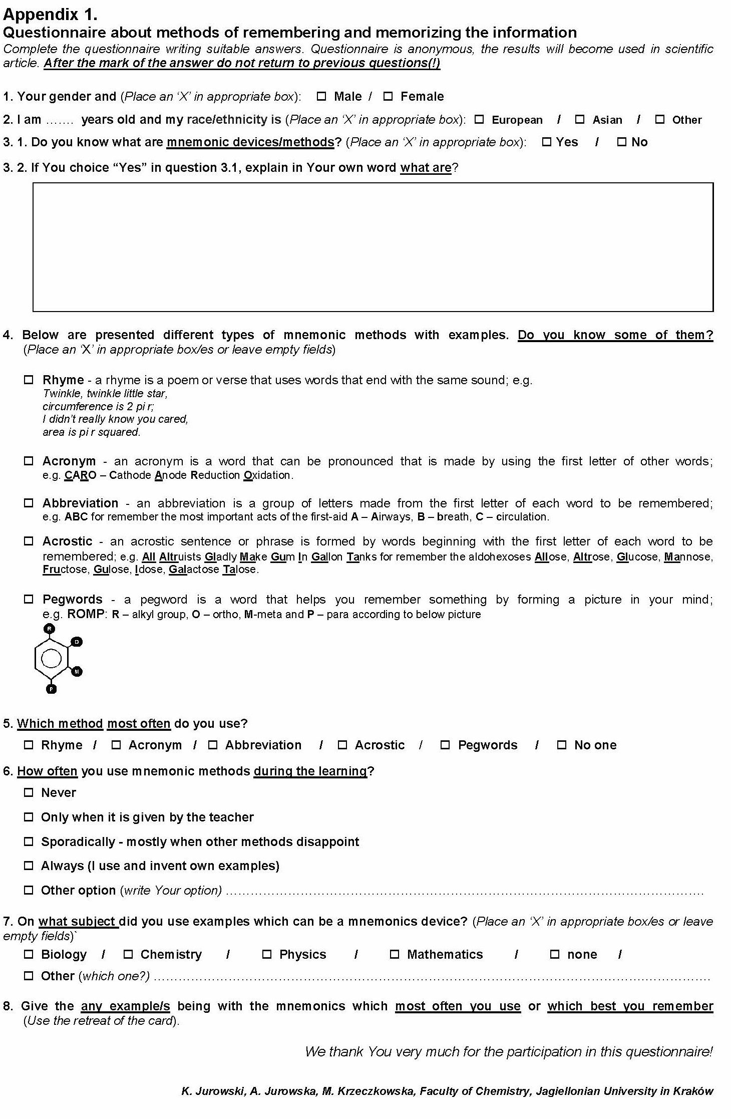
21
Preliminary studies about knowledge and applications of science mnemonics by Polish pupils
Fig. 1. Questionnaire about methods of remembering and memorizing the information
The first experiment was connected with examining general information
about
knowledge, popularity, the consciousness and practical approach of mnemonics devices

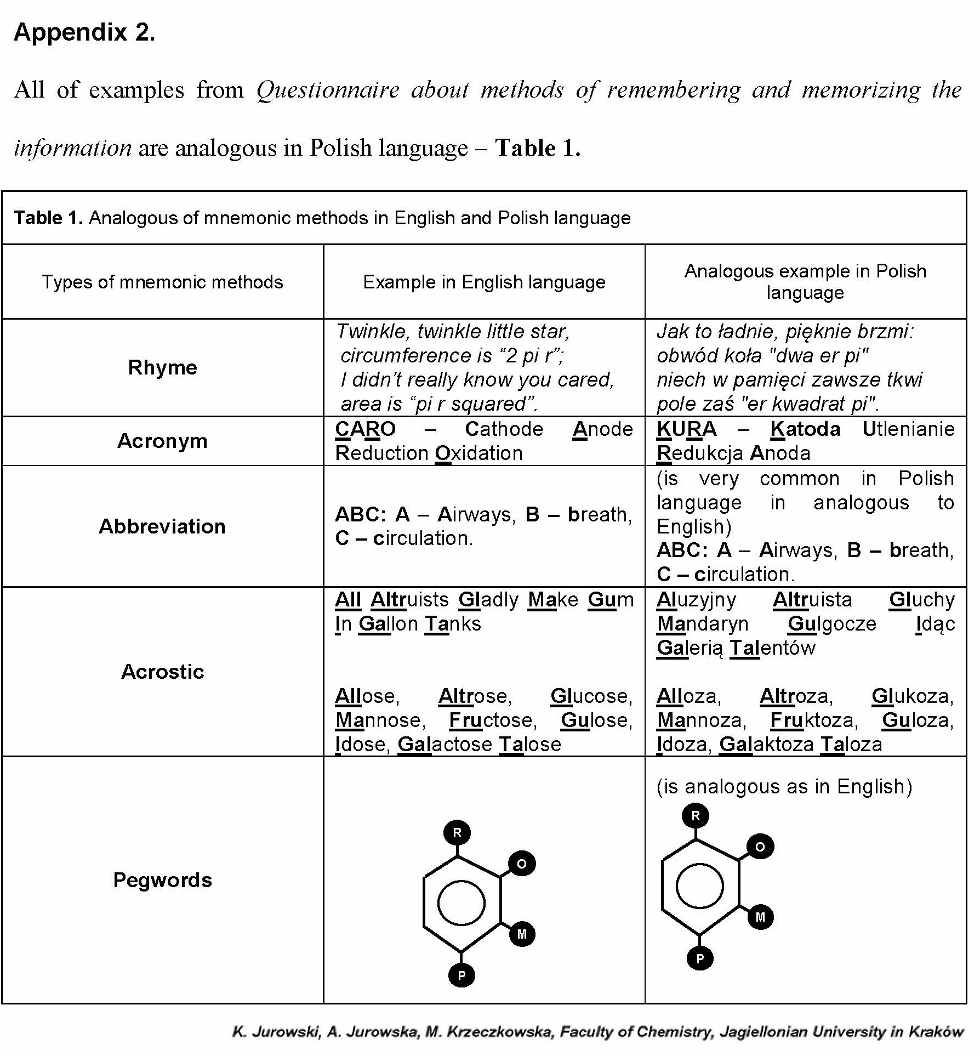
22
Kamil Jurowski, Anna Jurowska and Małgorzata Krzeczkowska
accordingtolearningchemistry,biology,physicsandmathematics.Moreover,wewantedto find out how which pupils (by gender, age, race/ethnicity) of Upper Secondary Schools in Poland, how use (own, given on the lesson, found in literature etc.), how often and in which circumstances (subjects, topics). In research take part a two public Upper Secondary Schools in Warsaw from full-day state-fundedclass-rooms.
Materials
In according to gather information about the mnemonics methods knowledge by students, the appropriate questionnaires about general information were prepared - the Figure 1. Questionnaire covered two categories of information: 1) information about participants (gender, age, race/ethnicity) and 2) their information about the knowledge, application and examples of mnemonic methods.
Fig. 2. All of examples from Questionnaire about methods of remembering and memorizing the information
In questionnaire we focused mostly on:
- knowledgeandtheunderstandingtheterm“mnemonicsmethod/devices”;
- usagesandconsciousnessesoftheusageofmnemonicmethodsinlearning;

Preliminary studies about knowledge and applications of science mnemonics byPolish pupils 23
3)
popularities of given methods according to applications and depending on the given subject;
giving examples being with the mnemonics which most often students use or which best their remember;
connection age, gender and race/ethnicity with mentioned problems (questions 1-4). Importantly, we include the simple description of each mnemonics method and
4)
5)
examples - Figure 2. This was done to ensure that all participants understand all methods ideas and could give the any example/s being with the mnemonics.
Method
Participants.
Participants
included
479
students
aged:
15-19
years
(M_{age}= 17.48 years; SD = 1.8). All investigated students come from the two public Upper Secondary Schools from full-day state-funded class-rooms in Warszawa (capital of Poland).
Table 1
Students characteristics, by conditions
adue to the fact that participant did not mark (empty answer),^{b}egnational minorities (Jews, Romani people)
Upper Secondary School
School 2 (n= 238)
Level of education
1stclasses
n= 81
2ndclasses
n= 79
3rdclasses
n= 78

[%]
n
Missingª
[%]
n
Missingª
[%]
n
Missingª
Gender

81
0

78
1

77
1
Male
51.8

43,6

53.2

Female
48.2

56.4

46.8

Race/ethnicity

78
3

79
0

76
2
European
100

98.8

92.1

Asian
0

0.0

1.3

Other^{b}
0

1.2

6.6

Student’s Age [years]

80
1

76
3

78
0
15
2.5

0

0

16
93.75

5.5

0

17
3.75

94.5

2.5

18
0

0

92.4

19
0

0

5.1

Upper Secondary School
School 1 (n= 241)
Level of education
1stclasses
n= 77
2ndclasses
n= 81
3rdclasses
n= 83

[%]
n
Missingª
[%]
n
Missingª
[%]
n
Missingª
Gender

76
1

81
0

83
0
Male
48.7

51

53

Female
51.3

49

47

Race/ethnicity

75
2

83
1

79
4
European
90.4

98.8

89.3

Asian
5.5

0

4.0

Other^{b}
4.1

1.2

6.7

Student’s Age [years]

74
0

84
0

82
1
15
1.3

0

0

16
93.2

1.2

0

17
5.5

94.0

1.2

18
0

4.8

97.6

19
0

0

1.2

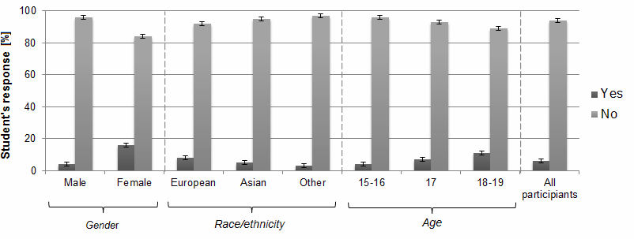
24
Kamil Jurowski, Anna Jurowska and Małgorzata Krzeczkowska
Differences in the level of participation are the same due to the fact that in all classes, the same curriculum (program) is applied. We had an approximately number of males and females in each class. In both schools we investigated groups of 1st-3rdclasses.
Before studies, students were asked to complete a questionnaire that included demographic information, such as birth date, gender and ethnicity. Because all participants were fluent in Polish, hence all of them full understand all questions in questionnaire. All participants provided informed consent. Participants were given office supplies gifts as compensation for their involvement. The Table 1 presents all participants characteristics by conditions.
Procedure
Before the accession to the questionnaire about mnemonics method, all students were informed that their answers were anonymous and results will be published in scientific article. All of the participants filled a questionnaires individually, at school (classrooms) after lessons having the appropriate time on their own answers (approx. the one lesson hour
- 45 minutes or more), however they could not use any sources (egbooks, phones, internet, own notes etc.) and they could not communicate each other. Few students had a problem with given by them examples - they did not know whether their example can be an example of mnemonic methods. In this situation they consulted their dilemmas with a teacher on personally conversation. Participants were not given solution feedback and were asked not to reveal information about the experiment to others. The research was made in period of September - December in 2014.
Results and discussion
Do Polish students know what are mnemonics devices/methods?
The data of question 3.1 (Do you know what aremnemonics devices/methods?) according to gender, race/ethnicity, age and from point of all participants are presented in Figure 3.
Fig. 3. The student’s response of question 3.1 (Doyouknow what mnemonic devices/methods are?) from questionnaire in experiment 1 by gender, race/ethnicity, age and from point of all participants

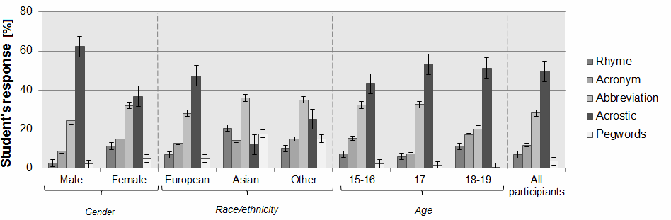
Preliminary studies about knowledge and applications of science mnemonics byPolish pupils 25
As can be expected, the most of participants (94% according to all participants) do not know term “mnemonic devices/methods”. From the point of view of the gender, this term is known more by female than male (16% - female, 4% - male). According to race/ethnicity the results are very similar (8% - European, 5% - Asian, 3% - other). Very interesting resultscanbegavebyresearchduetotheageofparticipants-theknowledgeabouttheterm increases according to the age of students. This can be connected with fewaspects:
1) together with the age students recognize the term of mnemonics methods on different subjects; 2) schoolboys together over time find and explore suitable for themselves method for memorization (egthey find in the literature - handbooks/internet).
All participants from these that know what are mnemonics methods can also correctly define this term (question 3.2). To most frequent answers wereeg"Methods makingpossible quick memorization", "Manners of easy remembering", "Strategies of the learningand remembering facts", "Very useful methods permitting quickly recall the informationfrom memory", "Useful methods for remembering facts and information".
Do Polish people know some of mnemonic methods/devices?
The results suggest that the most of students does not know this term. This can be true conclusion, however it can be possible also that students do not know term, but they can knowthemethods.Inotherwords,studentscanuseinpracticesomeofmnemonicsmethod, but can do this unconsciously - do not know the definition, but can give chosen examples. According to this approach, the question 4 can give appropriate answers for this dilemma. In this question students got also the name, the explanation and the example of the given method. This type of the approach made possible the introduction of students with this problem. The obtained results are presented in Figure4.
Fig. 4. The student’s response of question 4 (Do you know some of mnemonic methods/devices?) from questionnaire in experiment 1 by gender, race/ethnicity, age and from point of all participants
Analysis of results from Figure 2 indicate knowledge about method, according to all participants are the most known methods are - Acrostic (49.55%) and Abbreviation (28.2%). From the point of view of the gender, the most known for female are also Acrostic (36.8%) and Abbreviation (32.1%) methods. This observation is also analogous to male, however the Acrostic method is twice more pointed in male according to female (62.3% - male vs. 36.8% -female).

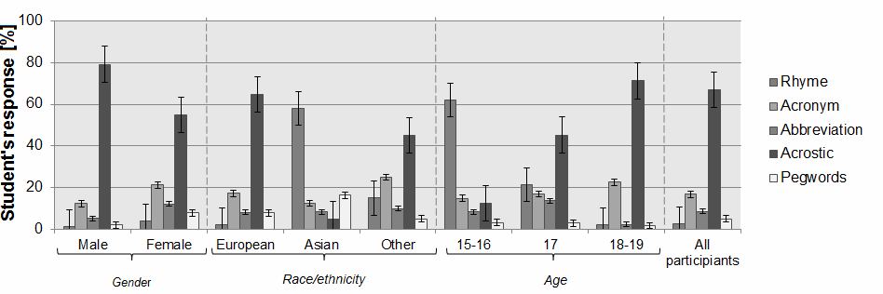
26
Kamil Jurowski, Anna Jurowska and Małgorzata Krzeczkowska
According to race/ethnicity the results are quite different. For European results are very similar to male and female results (Acrostic - 47.3%, Abbreviation - 28.1%, Acronym - 12.9%, Rhyme - 6.8% and Pegwords - 4.9%). For Asian and other nationalities the most known is Abbreviation method (Asian - 14%, other - 15%), however second place is different - Rhyme for Asian (20.5%) and Acrostic for other nationalities (25%). Other methods are on the comparable level of the popularity for both groups (Asian: Pegwords - 17.5%, Acronym - 14%, Acrostic - 12%; other nationalities: Pegwords - 15%, Acronym - 15%, Rhyme - 10%).
The ranking of the knowledge of given methods are the same for all age groups, however, there are changes in their quantitative value.
Which mnemonics method/methods most often do Polish students use?
The information aboutknowledgeabout mnemonics methods is one of the important indicators, however also important ispopularitydue to the uses. According to this issue, authoritative question is “Which method/methods most often do you use?”. The results of given question are presented in Figure 5.
Fig. 5. The student’s response of question 5 (Which method/methods most often do you use) from questionnaire in experiment 1 by gender, race/ethnicity, age and from point of all participants
Presented results shown that the most of participants (67% according to all participants) pointed as the most popular - Acrostic method. This method is also very popular according to gender (male - 79.2%, female - 54.8%). However, this observation is quite different according to the ethnicity. For European this method is most popular (64.8%), but for Asian is on the last position in the ranking of the popularity (4.9%), on the first place isRhymemethod. However, for other nationalities this method is the most popular(45%).Veryinterestingthedependenceisobservedaccordingtoageofparticipants
- the popularity of Acrostic method is increases together with the age. This correlation can beexplainedaccordingtothreefacts:1)infollowingstagesoftheeducationmoreandmore often appears this method; 2) this method is most often used by students; 3) there exist a lot of examples in relatedliterature.
The second place in ranking of popularity according to all participants is Acronym method. This observation has also good correlation according gender (male - 12.3%, female
- 21.3%), however this method is more popular in female than male. Due to the nationality, for European and for other nationalities, this method is still on second place - but forAsian

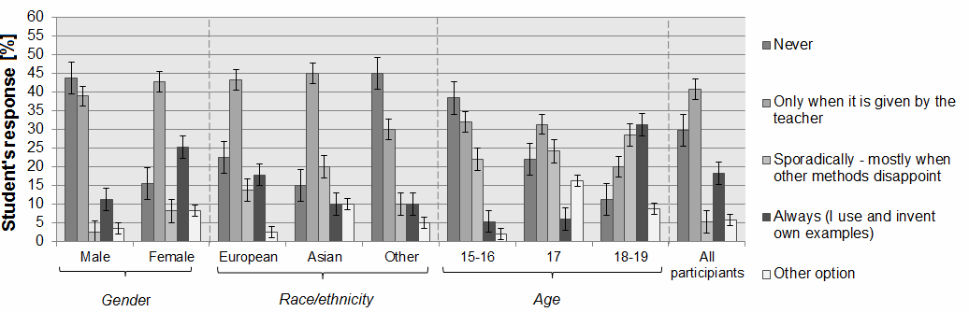
Preliminary studies about knowledge and applications of science mnemonics byPolish pupils 27
on second place is Pegwords method. According to age, on the second place is also Acronymmethod,moreoverthepopularityofthismethodisincreasestogetherwiththeage.
How often Polish students use mnemonic methods during the learning
Thenextimportantquestionduetotheusefulnessofmnemonicsmethodsis-howoftenstudents use mnemonic methods during the learning?The results of this question are presented in Figure6.
Fig. 6. The student’s response of question 6 (How often do you use mnemonic methods during the learning?) from questionnaire in experiment 1 by gender, race/ethnicity, age and from point of all participants
These results indicate that most of male (43.8%) never uses mnemonic methods during learning,moreoversimilaramountofmaleusesmnemonicsdevicesonlywhenitisgivenby the teacher (38.9%). Only 11.3% of male uses always and invite their own mnemonic devises. Small amount of participants sporadically uses these methods when other methods disappoint (2.5%) and similar amount of male pointed other option(3.5%).
The different situation can be observed according to results of female - most of them onlyusemnemonicsmethodswhenitisgivenbytheteacher(42.7%)butone-fourthofmale always uses and invite their own examples (25.3%). On the other hand - 15.6% never use these methods, and 8.2% of female admits that uses these methods sporadically. 8.2% of female pointed other option (3.5%).
Big divergences in results can be observed due to the nationality. In European ethnicity most of participants (43.2%) uses mnemonics methods only when it is given by teacher. Approximately amount of European admit that they never uses mnemonics method (22.6%) or always they uses and invited their own examples (17.9%). 13.8% of participants pointed that they uses sporadically - mostly when other methods disappoint. Very small part of European ethnicity chose other option (2.5%). Very similar response can be observed according to Asian nationality, however big differences are in other nationality/races. Most of other race (45%) pointed that they never use mnemonics methods, and big part of these participants (30%) uses these methods only when is given by teacher. Only 10% uses always these methods and these same amounts of participant’s uses sporadically, mostly when other methods disappoint.
Interesting results can be observed also according to age of participants. Most of 15-16 years old participants never use mnemonic devices (38.4%) and also only when it is used by the teacher (32.1%). In this age of participants, the big part use mnemonics methods

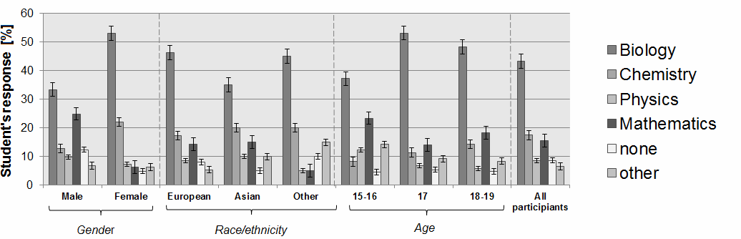
28
Kamil Jurowski, Anna Jurowska and Małgorzata Krzeczkowska
sporadically - mostly when other methods disappoint (22.1%). Only 17.9% of 15-16 years old students always use and invited their own examples. According to participants at 17 years old, the results are different. Most of this group pointed that they only use mnemonics studies when it is given by the teacher (31.4%), on the other hand they also use sporadically
- mostly when other methods disappoint (24.2%). Similar amount of participants indicate that they never use mnemonic devices (22.1%). Very small group of students always use and invite own examples (6.1%). Generally, in according to 18-19 years old students, situation is inverse due to the 15-16 years students.
On which subject did Polish students use examples which can be a mnemonics device?
The results of application of mnemonics devices according to subjects in Polish schools are presented in Figure 7.
Fig. 7. The student’s response of question 6 (On which subject didyouuse examples which can be a mnemonics device?) from questionnaire in experiment 1 by gender, race/ethnicity, age and from point of all participants
The results of question 6. Due to the gender are unexpected enough. For male and also female the most pointed subject is biology, but it is not clearwhyresults are so scattered (male-33.4%,female-53%).Anotherdifferentissecondplace-formaleitismathematics (24.9%), but for female is chemistry (22.1%). The physics is on third place according to female (7.4%), but for male on the third place is chemistry (12.8%). These differences could be explained by differences in memory according to female andmale.
Due to the ethnicity, the most popular is biology (European - 46.3%, Asian - 35% and other nationalities - 45%), the second is chemistry (European - 17.3%, Asian - 20% and other nationalities - 20%) and the third place is mathematics for European (14.4%) and for Asian (15%), however for other nationalities are other subjects (15%).
According to age, the results are very similar for all groups - the first place is biology (15-16: 37.2%; 17: 53.1%; and for 18-19: 48.3%), the second place is mathematics (15-16:
23.4%; 17: 14.1%; and for 18-19: 18.3%).
Most of students indicate as other subjects - history (43.7%), geography (22.3%) and music/art (18.4%), Polish language (10.4%).

Preliminary studies about knowledge and applications of science mnemonics byPolish pupils 29
Conclusions
Why mnemonics devices are effective? From a cognitive perspective, mnemonic strategies are effective because they form an effective acoustic-imaginal link between the stimulus and response. As didactic tool, they are extremely effective in helping pupils to rememberthings,howeverthereisalackofrelationshipbetweentheconceptualcontentand the material being learned. What is interesting is that, the educational research indicate that, the own prepared mnemonics by students outperform the results in comparison to students in free-study conditions, but also students' performances may be lower than when teachers supply the strategies. In most cases among Polish pupils, they known a lot of examples of mnemonics studies in chemistry, biology, physics and mathematics, however they don’t know what kind of this method are. Due to the information point of view, mnemonics techniques often better enables information to be retained in memory, however they are focused only on certain aspects of their operation and they are not dependent as a memory schema. And at last - mnemonics devices are memory strategies but they are not a teaching and learning methods, they can be only considered as didacticstools.
Acknowledgments
This article was made by the support of Anna Jurowska scholarship by theMarian Smoluchowski Kraków Research Consortium “Matter-Energy-Future”granted the statusofaLeadingNationalResearchCentre(KNOW)atFacultyofChemistryJagiellonian University inKraków.
The Authors wish to express their thanks also to the all teachers and all students from the Upper Secondary Schools in Warszawa, which wants to be anonymous.
References
[1]
[2]
Guthrie J, Encyclopedia of Education. New York: Macmillan Reference; 2002; 1669-1672.
Mastropieri M, Scruggs T. Enhancing school success with mnemonic strategies. Intervention School Clinic. 1998;33:201-209. DOI: 10.1177/10534512980 3300402.
Bellezza F. Mnemonic devices classification, characteristics, and criteria. Rev Educational Res. 1981;51:247-275. DOI: 10.3102/00346543051002247.
Ericsson KA, Kintsch W. Long-term working memory. Psychol Rev. 1995;102:211-245. DOI: 10.1037/0033-295X.102.2.211.
Ericsson K. Exceptional memorizers: made, not born. Trends Cognitive Sci. 2003;7(6):233-235. DOI: 10.1016/S1364-6613(03)00103-7.
Robertson-Tchabo E, Hausman C. A classical mnemonic for older learners: a trip that works! Educational Gerontol. 1976;1:215-226. DOI: 10.1080/0360127760010301.
Kessels R, De Haan E. Mnemonic strategies in older people: a comparison of errorless and errorful learning. Age Ageing. 2003;32:529-533. DOI: 10.1093/ ageing/afg068.
Gruneberg M, Monks J, Sykes R. The first letter mnemonic aid. Medical Sci: and Psychiatry: Social Occupational Medicine. 1977;5:304-308.
Scruggs T, Mastropieri M, McLoone B, Levin J, Morrison C. Mnemonic facilitation of learning disabled students' memory for expository prose. J Educational Psychol. 1987;79:27-34. DOI: 10.1037/0022-0663.79.1.27.
Mastropieri MA, Scruggs T, Fulk B. Teaching abstract vocabulary with the keyword method: Effects on recall and comprehension. J Learning Disabilities. 1990;23:92-96. DOI: 10.1177/002221949002300203.
Scruggs T, Mastropieri M. Classroom applications ot mnemonic instruction: Acquisition, maintenance, and generalization. Exceptional Children. 1992;58:219-229. DOI: 10.1177/001440299105800305.
Kilpatrick J. Doing mathematics without understanding it: A commentary on Higbee and Kunihira. Educational Psychol Rev. 1985;20:65-68. DOI: 10.1207/ s15326985ep2002_2.
[3]
[4]
[5]
[6]
[7]
[8]
[9]
[10]
[11]
[12]

30
Kamil Jurowski, Anna Jurowska and Małgorzata Krzeczkowska
BADANIAPILOTAŻOWEOWIEDZYISTOSOWANIUMNEMONIK Z PRZEDMIOTÓW ŚCISŁYCH PRZEZ POLSKICHUCZNIÓW
Wydział Chemii, Uniwersytet Jagielloński w Krakowie
Abstrakt:Strategie mnemoniczne to specyficzne sposoby, które podczas kodowania nowej informacji wykorzystują znane już elementy do polepszenia późniejszego dostępu do tej informacji w pamięci. Strategie te mogą często wspomagać uczenie się oraz późniejsze przywoływanie informacji. Jednak niewiele wiadomo na temat technik optymalizowania przywoływania myśli za pomocą metod mnemotechnicznych lub stosowalności metod mnemotechnicznych w praktyce edukacyjnej. Ponadto, w literaturze jest wiele przykładów metod i podejść mnemotechnicznych w chemii, biologii, fizyce czy matematyce, jednakże w literaturze fachowej brak jest aktualnych i miarodajnych badań na ten temat. Artykuł ten stanowi autorskie podejście do zagadnienia metod mnemotechnicznych z punktu widzenia uczenia i nauczania przedmiotów przyrodniczo-ścisłych. Dużym atutem artykułu jest demonstracja starych i dobrze znanych metod uczenia/nauczania w nowym wymiarze. Zgodnie z naszą wiedzą jest to pierwszy artykuł w literaturze opisujący aktualne dane na temat związany z uczeniem i studiowaniem przedmiotów ścisłych przy użyciu metodmnemotechnicznych.
Słowa kluczowe:mnemonika, metody mnemotechniczne, metody mnemoniczne, metody zapamiętywania, przedmioty przyrodniczo-ścisłe

