J Mol Model (2014) 20:2272DOI 10.1007/s00894-014-2272-y
Ontheoriginofinternalrotationinammoniaborane
Monika Parafiniuk&Mariusz P. Mitoraj
Received:6December2013/Accepted:24April2014/Publishedonline:27May2014
#TheAuthor(s)2014.ThisarticleispublishedwithopenaccessatSpringerlink.com
Abstract The internal rotation in ammonia borane (AB)was studied on the basis of natural orbitals for chemical valence (NOCV) and eigenvectors for Pauli repulsion (NOPR).Wefound that the total hyperconjugation stabilization(ca.
5 kcal mol⁻¹), based on the charge transfer from the occupiedσ(B–H) orbitals into the emptyσ*(N–H),
slightly favorsthestaggered conformationovertheeclipsed one; however, the barrier to internal rotation in ammonia borane can be understood predominantly in a‘classical’way,as originating from the steric (Pauli) repulsion contributions (of the kinetic origin) that actsolely betweenN–H and B–Hbonds. Repulsionbe- tween the lone pair of ammonia and the adjacent B–H bonds was found to be dominant in absoluteterms;however,itdoesnotdeterminetherotationalbarrier.
appliedtothedescriptionofelectronicstructures:molecular orbitals (MOs) [3,4], localized molecular orbitals (LMOs) [5–7], bond orders [8–17], atoms in molecules (AIM) [18], Fermi hole [19], kinetic energy and information theory based quantities [20–22], and various charge and energy decomposition schemes [23–28]. A useful and elegant approach suitable for description of energy pro-filesofchemical reactionswasproposedbyTorro-Labbe and coworkers [29] based on the reaction force concept. Bickelhaupt and Zeist [30] proposed the“acti- vation strain model”, which also appears to be very useful in the analysis of chemicalreactions.
Rotationaroundasinglecarbon–carbonbondisoneofthe mostimportantconformationaltransitionsinorganicchemis- try [31,32]. A typical example is ethane, which exhibits staggered and eclipsed conformations; the formerminimum energy structure is more stable than the transitionstate
eclipsedstructureby∼3.0kcalmol⁻¹[33].Theclassicaland intuitiveexplanationofthebarriersuggestedinorganictext-
books is based on the steric repulsion between C–H bonds, whichisdominantintheeclipsedstructure[34].Analterna-tive explanation is based on hyperconjugation stabilization, which is stronger in the staggered conformation [35–38].However,aspointedoutbyMulliken[35],hyperconjugation effectshouldhaveonlyaminorinfluenceonthebarrier.Bader et al. [39] stated that the barrier to rotation in ethane can be relatedtothepolarizationofchargedensityalongthecarbon–carbon bond. Goodman and coworkers [40] have shown, based on the natural bond orbitals (NBO) method, that eth-ane’sstaggeredconformationistheresultofhyperconjugation. This point of view was also presented by Weinhold [41]. Goodman’s results based on theNBOmethodhave beenchallengedbytheworkofBickelhaupt and Baerends [42] based on the model of a chemical bond originating from fragmented molecular orbitals; according to these results the internal rotationalbarrierinethaneisduetoPaulirepulsionacting
Similar conclusions on the role of CH↔HC appeared to be valid for isoelectronic ethane.
repulsion
KeywordsAmmoniaborane.Stericrepulsion.Hyperconjugation
Introduction
Oneofthemostimportantgoalsoftheoreticalchemistryisto understandtheoriginofconformationalchangesinmolecules [1,2]. In order to achieve this goal many methodscan be
ThispaperbelongstoTopicalCollectionMIB2013(ModelingInteractionsinBiomoleculesVI)
ElectronicsupplementarymaterialTheonlineversionofthisarticle(doi:10.1007/s00894-014-2272-y)containssupplementarymaterial,whichisavailabletoauthorizedusers.
M.Parafiniuk:M.P.Mitoraj(*)
Department ofTheoretical Chemistry,Faculty ofChemistry,JagiellonianUniversity,R.Ingardena3,30-060Krakow,Poland e-mail:mitoraj@chemia.uj.edu.pl
ORIGINAL PAPER

2272, Page 2 of 9
JMolModel(2014)20:2272
between the CH bonds of opposite CH₃units. Subse- quent calculations by Mo and coworkers [44,45] andthenbyPendas et al.[43],confirmed theclassical,steric-based interpretationof thebarrier;inaddition,the former authors have shown that hyperconjugationstabilizesthestaggered conformeronlybyabout
4 kJ mol⁻¹relative to the eclipsed form [45]. A very elegantrecentpaperbyMoandGao[46]provideda
compact overview of the most important studies on this subject; the main conclusion is that the internal rota- tional barrier in ethane is due predominantly to steric effects acting between C–H bonds, with minor partici- pation stemming fromhyperconjugation.
Wehave recently developed the ETS-NOCV scheme[47–50]bycombiningtheextended transition state(ETS) [25,26]energy decomposition approachwiththe natural orbitals for chemical valence (NOCV) meth- od [51–57]. ETS-NOCV has proved suitable for quali- tative and quantitative description of the crucial compo- nents (σ,π,δ, etc.) that constitute various types of chemical bonds [58–61]. In addition, the energy profiles of some chemical reactions can be also characterized [62,63]. More importantly for this study, it was shownthat NOCV representation allowsforqualitativeandquantitative description of hyperconjugation effects [47,48].Furthermore,theETSenergydecompositionscheme provides quantitative information on the Pauli repulsion effects [2,25,26].
Therefore,themaingoalofthisarticlewastoapplyforthe firsttimetheETS-NOCVchargeandenergydecomposition schemetoanalysisoftheinternalrotationinammoniaborane. Hyperconjugation and steric factors will be discussed in a detailedway.It should be noted that ammonia borane is considerednowadaysasoneofthemostpromisinghydrogen storage materials. In addition, it was already proven that ammoniaboraneexhibitsdissimilarfeaturesascomparedto isoelectronic ethane [64]. Furthermore, the present study shedsadditionalqualitativeandquantitativelightonthesteric repulsioninammoniaboranebydecompositionoftotalPauli repulsionintospecificcontributionsstemmingfromdifferent symmetry (σandπ). In order to achieve this goal, wedefinedfor thefirst timetheeigenvectorsforPaulirepulsion; in this representation, one can thus discuss the Pauli repulsion components originating from differ- ent symmetries. For comparison, similar analyses will be performed forethane.
[69,70]wasapplied(BP86).Astandardtriple-zetaSTObasis containing two sets of polarization functions (TZ2P) was adoptedforallatoms.Thecontoursofdeformationdensitieswere plotted based on ADF-GUI interface[71].
Computational methods
OuranalysisisbasedontheETS-NOCVapproach,whichisa combination of the extended transition state (ETS) [25,26] methodwiththenaturalorbitalsforchemicalvalence(NOCV) scheme[51–57].
ThebasicconceptoftheETSschemeinvolvespartitioningof the total bonding energyΔE_{total}between interacting frag- ments into fourcomponents:
ΔEtotal¼ΔEdistþΔEelstatþΔEPauliþΔEorb
ð1Þ
The first component,
ΔEdist,
referred
to
as the distor-
tion term, represents the amount of energy required to promote the separated fragments from their equilibrium geometry to the structure they will take up in the combined molecule; it can also be seen as strain energy.
The second term,
ΔEelstat,
corresponds to the classical
electrostatic interaction between the promoted fragments as they are brought to their positions in the finalcom-
plex. The third term,
ΔEPauli,
accounts for the repulsive
Pauli interaction between occupied orbitals on the two fragments in the combined molecule. It is calculated as the difference between the energies of orthogonalized and non-orthogonalized fragments [2,25]. Finally, the last stabilizing term,ΔE_{orb}, represents the interactions between the occupied molecular orbitals of one frag-ment with theunoccupied molecular orbitalsoftheother fragment as well as the mixing of occupied and virtual orbitals within the same fragment (inner-fragment polarization). This energy term,ΔE_{orb}, may be linked to the electronic bonding effect coming from the formation of a chemical bond (Eq.2).
TheNOCVareeigenvectorsthatdiagonalizedeformation densitymatrixΔP^{orb}=P_{molecule}−P0,whereP0correspondsto thesumofdensitymatricesfororthogonalizedfragments;it
hasbeenshownthatthenaturalorbitalsforchemicalvalence pairs(ψ_{-k},ψ_{k})decomposethedeformationdensityΔρ_{orb}into
NOCV-contributions,Δρ^{k}:
orb
M=2
h
i
M=2
X
X
ΔρorbðrÞ¼ v_{k}−ψð
2
2
rÞ¼ Δρ^{k}
rÞþψð
ð1Þ
−
k
k
orb
k¼1
k¼1
Computational details
whereν_{k}andMare the NOCV eigenvalues and the number of basis functions, respectively. Visualinspec-
tion of deformation density plots (Δρ^{k}) helps to attri-
AllDFTcalculationspresentedherewerebasedontheAm- sterdam Density Functional (ADF 2009.01) program [2,65–68] in which the ETS-NOCV scheme was implemented [47–63].TheBecke-Perdewexchange-correlationfunctional
orb
bute
symmetry and the
direction of the
charge
flow. In
addition, information gained from the analysis of defor- mation density plots can be enriched by providing the

JMolModel(2014)20:2272
Page 3 of 9, 2272
energetic estimations,ΔE^{k},
eachΔρ^{k}
for
within
thatamoredetaileddescriptionofthistermbasedonEqs.3,4, couldbeofwideinterest.Itisveryimportanttopointoutthat the main source of the Pauli repulsion is related to an increaseinthekineticenergycontribution;sowecouldalso refer to the Pauli repulsion term as kinetic repulsion due to the Pauli exclusion principle [2]. Such a concept, which relates the steric repulsion to the‘kinetic energy pressure’hasalreadybeenputforwardbyvariousauthors[73,74].In addition,thePaulirepulsioncontributionappearstoqualita- tively correlate very well with the experimentalTaft’ssteric parameters[75].
orb
orb
ETS-NOCV scheme:
M=2
h
i
X
X
ΔE_{orb}¼ ΔE^{k}¼ v_{k}
−FTS
TS
þF
ð2Þ
−k;−k
orb
k;k
k
k¼1
whereF^{TS}arediagonalKohn-Shammatrixelementsdefined
i,i
overNOCVwithrespecttothetransitionstatedensity(atthe midpoint between density of the molecule and thesum of
fragmentdensities).TheabovecomponentsΔE^{k}providethe
orb
energetic estimation ofΔρ^{k}that may be related to the
orb
importanceofaparticularelectronflowchannelforthebond- ing between the considered molecularfragments.
Inthepresentstudy,inanalogytoNOCVs,wedefinedfor the first time the natural orbitals (eigenvectors) for Pauli repulsion,ϕ_{k},thatdiagonalizethePaulideformationdensity
Results anddiscussion
Wewillstartwithabriefdescriptionofthebondingsituation
ΔPPauli
P0−Pisolated,
matrix,
=
where
Pisolated
is the sum of
in the most stable staggered conformation (S)
of ammonia
densitymatricesfornon-orthogonalizedfragments,whereas P0correspondtothesumofdensitymatricesfororthogonal- izedfragments.SucheigenvectorsdecomposethetotalPauli
borane (Fig.1). It can be seen fromTable1that the bond dissociation energy (−ΔE_{total}) amounts to 31.94 kcal mol⁻¹(BP86/TZ2P).Thisvaluefitswelltotheexperimentalenthal- pyestimatedbyHaaland(31.1±1kcalmol⁻¹[76,77])aswellas to other theoretical estimations [48,78–81]. In linewith
previousstudies[48,78,82–85],wefoundaslightdominance (by∼0.7kcalmol⁻¹)oftheelectrostaticstabilizationoverthe orbitalinteractionterm(Table1).Decompositionofthelatter stabilizingtermintoNOCV-baseddeformationdensitychan-
ΔρPauli=ρ0
deformationdensity,
( orthogonalized-
fragments)−ρ(non-orthogonalized-fragments), into the
NOCV-likecontributions(Δρ^{Pauli})(inanalogytoEq.1):
k
i
N=2
X
h
N=2
X
Pauli
Δρ ðrÞ¼ vk−ϕð
Pauli
Pauli 2
rÞþϕðrÞ¼ ΔρkðrÞ ð3Þ
2
−k
k
k¼1
k¼1
nels leads to the conclusion that donation (Δρ^{σ}) from the
orb
The total charge transferred in this channel can be considered as:
loneelectronpairofammoniatothelowestunoccupiedorbital
of BH₃is by far most dominant (ΔE^{σ}=−66.32 kcal mol⁻¹)
orb
as compared to the two hyperconjugation contributions,
Pauli
Paulik
Δqk ¼ν
ð4Þ
Δρ^{hyp1},Δρ^{hyp2}; the corresponding orbital interaction stabili-
orb orb
zations areΔE^{hyp1}=ΔE^{hyp2}=−2.30 kcal mol⁻¹(Fig.2). The
orb
orb
lattertwodegeneratedcontributionsstemfromchargetransfer fromtheoccupiedσ(B–H)orbitalsintotheemptyσ*(N–H) (Fig.2).Itisnoteworthythat,intheisoelectronicethane,thesumofstabilization arisingfromthe twoorthogonalhyperconjugation components was found to besignificantly
stronger (∼10 kcal mol⁻¹) [46,85].
ItisclearfromFig.1thatrotationfromthestaggeredtothe eclipsedformleadstoachangeinenergy,by1.93kcalmol⁻¹. Thisbarrieragreesquitewellwiththeexperimentalvalueof
2.07kcalmol⁻¹determinedbasedonmicrowavespectra[86], andwithotherhighlevelcomputations[87].Itisveryimpor-tanttopointoutthatwhengoingfromthestaggered(S)tothe
eclipsedisomer(E),oneobservesanotablestretchoftheB–N bond, by∼0.03 Å. Such elongation leads expectedly to a significant decrease in Pauli repulsion, by 7.27 kcal mol⁻¹; at the same time the electrostatic (ΔE_{elstat}) and orbitalinter-
action (ΔE_{orb}) contributions become less stabilizing, by
4.14kcalmol⁻¹and4.69kcalmol⁻¹,respectively(seeTable1andthebluelineinFig.3).Fromtheexamplesofethane[42]
orbiphenyl[88],itisknownthatthistypeofelongationwhen goingfromoneisomertotheotherisduetothesteric(Pauli)
Thepresentstudycharacterizednotonlythetotalvaluesof
Pauli repulsion
(ΔEPauli)
in ammonia borane based on the
originalETSscheme(Eq.1)but,inaddition,providedamore detailedpicturebyanalysesofboththePaulirepulsioncon-
tributionsΔρ^{Pauli}(Eq.3) and the corresponding quantitative
k
charge estimationsΔq^{Pauli}(Eq.4). This approach (Eqs.3,4)
k
was implemented by one of us in the home version of ADF2009.01.Atpresent,theenergeticPaulirepulsioncontri-
butions (ΔE^{k})
ΔρPauli
from
(calculated in an analogous
Pauli
k
waytoEq.2)areunavailable.Hence,wefocusedourattention
on the quantitative measures ofΔρ^{Pauli}based on Eq.4. Red
k
areas of deformation density channels correspond to charge depletion,whereasblueindicateschargeaccumulationupon bondformation.
Due to the fact that the steric interaction, which is anon- observablequantity[72],isveryoftenattributedinthelitera- turetoPaulirepulsionquantumeffect[2,43,46],weuseboth termsinterchangeablythroughoutthetext.Finally,weshould note that Pauli repulsion is one of the bonding components invariousenergydecompositionschemes;hence,webelieve

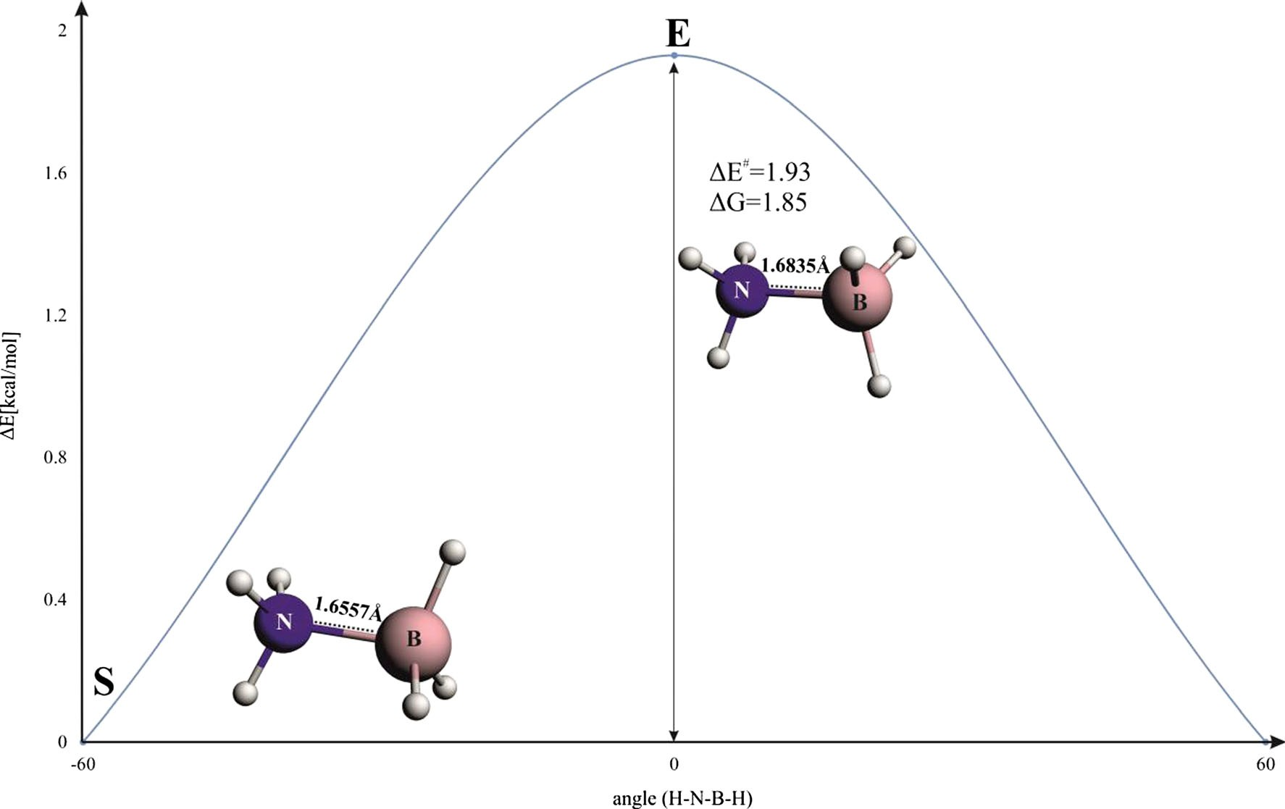
2272, Page 4 of 9
JMolModel(2014)20:2272
Fig.1Energyprofileforinternalrotationinammoniaborane.B–Nbondlengths(inÅ)areindicated
∠(H–B–N–H) = 0.0, is noted when considering the rigid rotation from the geometry of the eclipsed structure to the
geom
staggeredone(S_{e} )(graycurveinFig.3).Thus,thePauli
(steric)repulsioncontributionisresponsibleforstretchingof the B–N bond and,accordingly,for the rotational barrier in ammonia borane; the analogous situation holds true for the ethane molecule, as demonstrated first by Bickelhaupt etal.
[42]andthenbyothers[43–46].Anincreasedkineticrepul-
repulsion.Asindicatedinaseriesofrecentworks[42–46,88,89],inordertoestimateandcharacterizetheforcesleadingto suchelongation,onemustfirstconsiderrigidrotationfromthe staggeredtotheeclipsedconformation;wehavelabeledsuch
geom
eclipsedconformation(inthestaggeredgeometry)asE_{s} .
Wecan clearly see now fromTable1and Fig.3(the orange curve),thatanincreaseinthePaulirepulsioncontribution,by
2.11 kcal mol⁻¹, is noted when going fromStoE^{geom}; it is
s
sion(themainsourceofthePauliterm)intheE^{geom}geometry
importanttonotethattheremainingbondingcomponentsare practically unchanged. A similar trend, i.e., the maximum Pauli repulsion in ammonia borane with thedihedral angle
s
isrelatedthroughthevirialtheoremtotheexistenceofrepul- siveforcesactingpredominantlyonnitrogenandboronnuclei
Table1Extendedtransitionstate(ETS)^{a,b}energydecompositionresultsdescribingtheH₃N–BH₃bondinvariousisomersofammoniaborane.Charge estimates for Pauli repulsion contributions areindicated^{c}
E−S
geom
E_{s}
S
E
−31.94
12.65
−77.32
109.39
−76.66
1.1833
0.7261
0.2286
0.2286
−30.01
13.02
−73.18
102.12
−71.97
1.1693
0.7049
0.2325
0.2319
−29.87
12.65
−77.8
111.5
−76.22
1.2135
0.7267
0.2434
0.2434
ΔEtotalΔEdistΔEelstatΔEPauliΔEorb
1.93
0.37
4.14
−7.27
4.69
−0.014
−0.0212
0.0039
0.0033
ΔQPauli(ΔqPauli+ΔqPauli+ΔqPauli)
global 1
2
3
ΔqPauli
1
ΔqPauli
2
ΔqPauli
3
aΔEtotal=ΔEorb+ΔEPauli+ΔEelstat+ΔEdist[kcal mol−1]
bLabelsassignedinFig.1;E_{s} correspondstotheeclipsedstructureinthestaggeredgeometry
geom

cSee Eqs.3,4inComputational Methodsand Fig.5

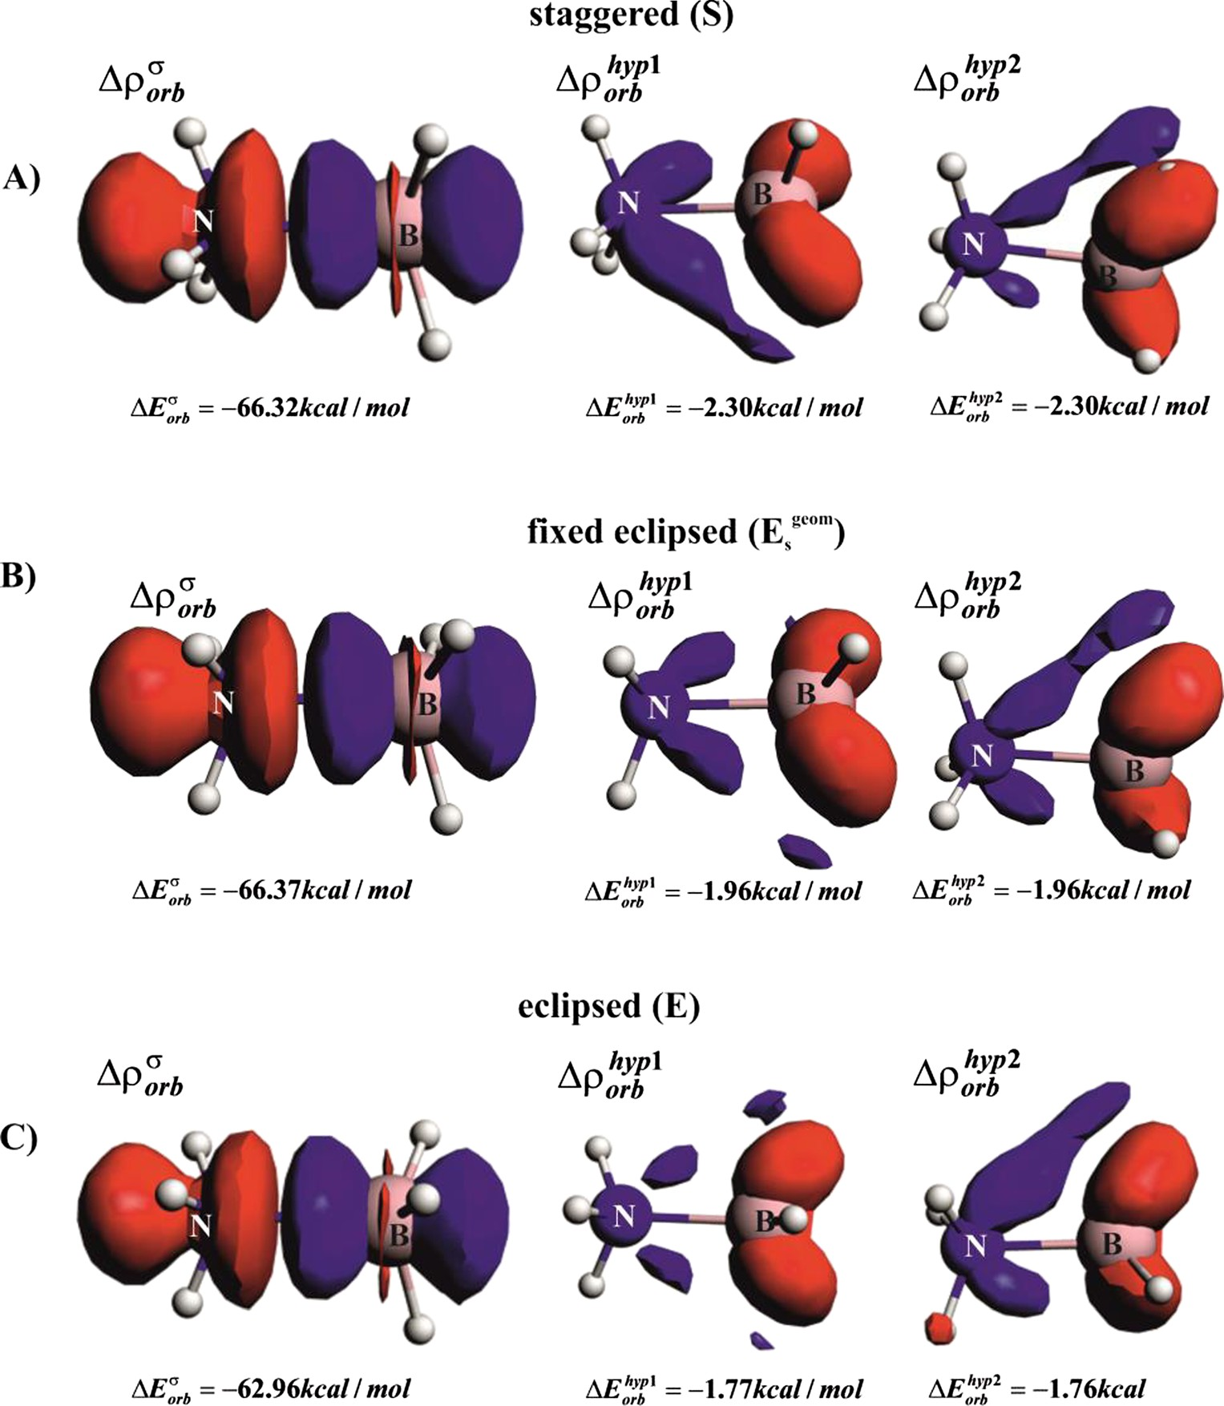
JMolModel(2014)20:2272
Page 5 of 9, 2272
Fig. 2 Dominant natural orbitals for chemical valence (NOCV)- based deformation density
channels,Δρ^{σ}
,Δρhyp1,Δρhyp1,
orb orb orb
withthecorrespondingorbital interaction energies forthe
alternative isomers of ammonia borane.Thecontourvalueis|Δρ|
= 0.005 a.u. forΔρ^{σ}, whereas
orb
for remaining hyperconjugation contributions 0.001 a.u. wasapplied.Blue/redcontours correspond toaccumulation/depletion of electrondensity.SFullyoptimizedstaggeredisomer,
E^{geom}eclipsedstructureinthe
s
staggeredgeometry,Efully optimized eclipsedisomer
[18]. It must be added that hypercongutation stabilizations stemming from the charge transfer from the occupiedσ
‘distributed’between NH₃and BH₃fragments. An analysis offunctionΔρ^{Pauli}leadstotheobservationthatelectronsare removed from the N–B binding region (in fact, it is amani- festationofthePauliexclusionprinciple[2,90]);althoughone canseethattheredlobesextendalsototheareasofNH↔HB interaction.However,suchcontoursdonotallowustoextract information on whether the total changes in Pauli repulsion aredeterminedbytherepulsiveinteractionbetweenthelone electronpairofammoniawiththeoccupiedσ(B–H)orbitals ordirectlyby‘classical’N-H↔H-Brepulsion[aninteraction between the occupiedσ(B–H) orbitals with the occupiedσ(N–H)]. In order to obtain such separated information, we have decomposed total Pauli repulsionΔρ^{Pauli}into thecon-
(Δρhyp1,Δρhyp2),
(B–H) orbitals into the emptyσ*(N–H)
orb orb
favorsthestaggeredconformation(Fig.2),althoughtheeffect is minor (∼0.4 kcal mol⁻¹) compared to changes in there-maining bonding contributions(Table1). Aquantitatively
similareffectisobservedforthechangeintheenergydistor- tion contribution (ΔE_{dist})(Table1).
Letusnowfocusourattentionondetailedchangesinthe Paulirepulsioncontributionsinthethreeammoniaborane
isomers,S,E^{geom}andE. Figure4presents the total Pauli
s
deformationdensitycontours(Δρ^{Pauli})togetherwiththecor-responding energy values(ΔE_{Pauli}).
Asalreadystated,theS→E^{geom}transitionleadstoajump
tributions(Δρ^{Pauli})accordingtoEq.3.ThethreeleadingPauli
s
k
deformation density channels,Δρ^{Pauli},Δρ^{Pauli},Δρ^{Pauli}, to-
inthePaulitermthatitisthen‘relieved’byelongationofthe
1
2
3
Egeom→E.
B–N
bond in step
The important question that
getherwiththecorrespondingquantitativechargeestimations (Eq.4)arepresentedinFig.5.Itshouldbenotedthatthetotal
s
arises at this point is how the total Pauli repulsion is

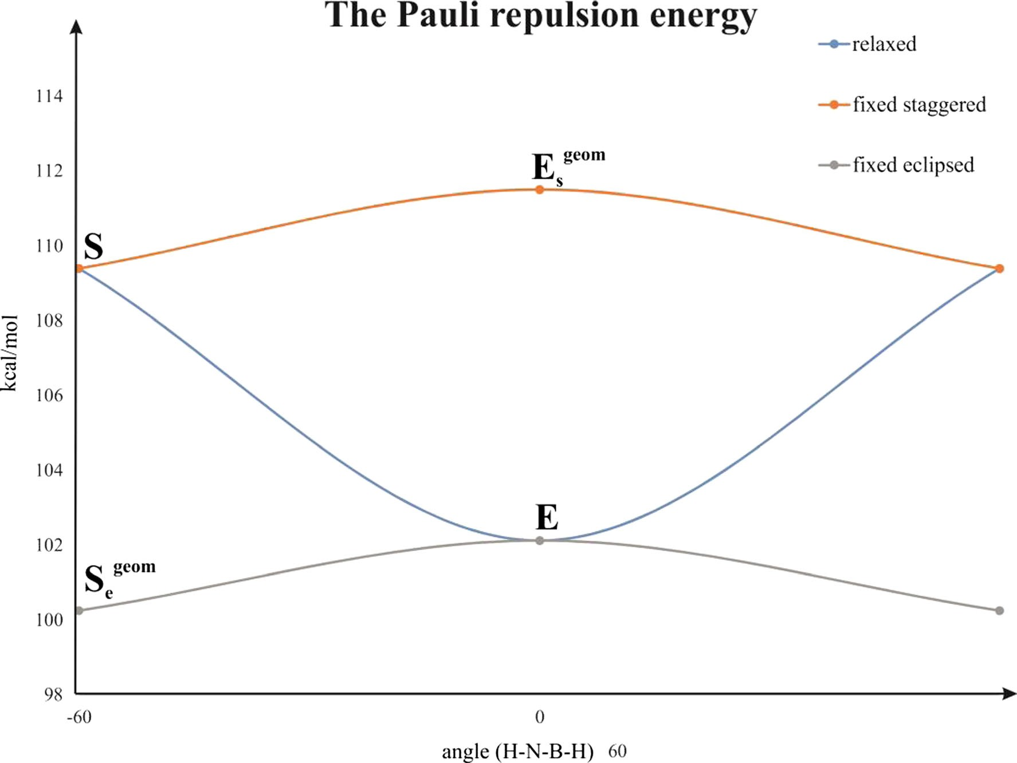
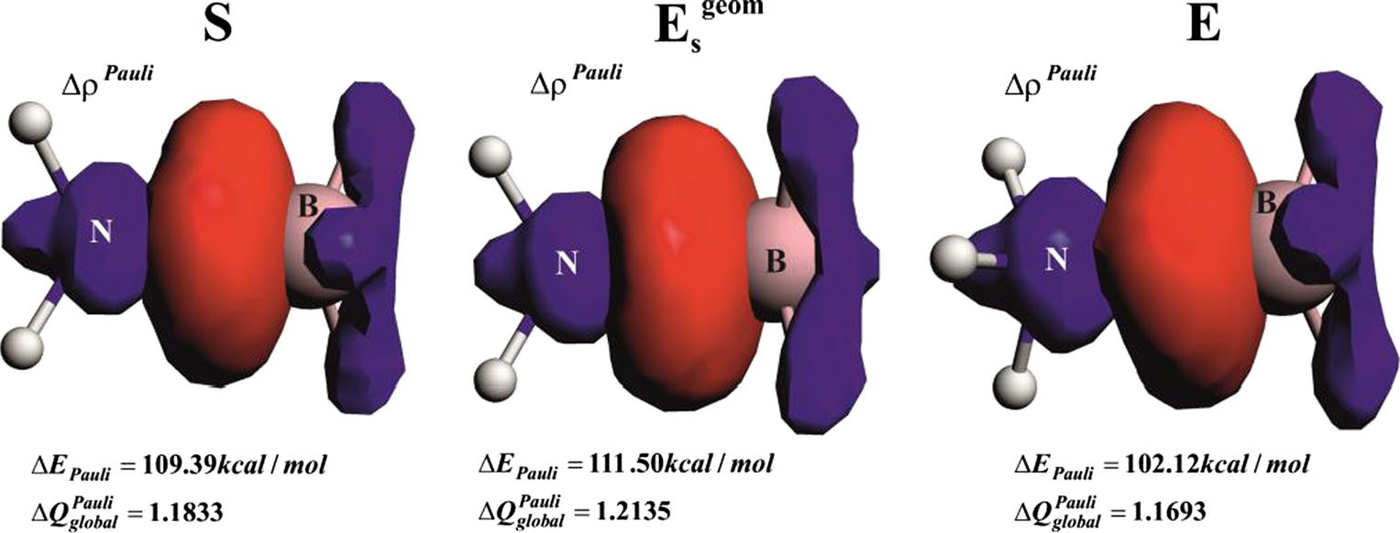
2272, Page 6 of 9
JMolModel(2014)20:2272
geom
structure in the staggeredgeometry,S_{e} staggered structure inthe
eclipsed geometry,Efully optimized eclipsed isomer
Fig. 3 Pauli repulsionenergiesin the alternative isomers of ammonia borane.BlueFullyrelaxedstructures;orangestaggeredgeometry;gray
eclipsedgeometry.SFully optimized staggeredisomer,E^{geom}eclipsed
s
charge,ΔQ^{Pauli}=Δq^{Pauli}+Δq^{Pauli}+Δq^{Pauli}, that is removed
the conclusion that, when going fromS→E^{geom}, the major
global 1
2
3
s
from the H₃N–BH₃binding region correlates well with the trend based on the Pauli repulsion energy (Table1, Fig.4).
changes (by 0.0148 a.u.) are within the second and third
values ofΔq^{Pauli},Δq^{Pauli}. The repulsionΔρ^{Pauli}characterized
2
3
1
ΔρPauli
ΔqPauli
Qualitative inspection of the contours
leads to the
by
remains unchanged. Once going to the relaxed
i
1
important observation that the first channel (Δρ^{Pauli}) corre-
eclipsedstructure,thePaulicontributionisfurther‘relieved’
1
(Δρ^{Pauli}values decrease in linewithΔE ). These results
spondssolelytotheinteractionbetweentheloneelectronpair ofammoniawiththeB–Hbonds,whereasthetwolatter
i
Pauli
show that an increase in the total repulsion in the eclipsed
(ΔρPauli,ΔρPauli)
Egeom)
orthogonal contributions
show NH↔HB
conformation compared to staggered (S→
is deter-
2
3
s
repulsion(Fig.5).Moreimportantly,quantitativeanalysisof thechargedepletion,basedontheeigenvalues(Eq.3),leadsto
minedsolelybytheNH↔HBrepulsion(ofthekineticorigin) due to the Pauli exclusion principle (an interaction between
Fig.4ContoursofthetotalPaulideformation density together withthe correspondingenergies.In addition, charge-based estimations are presented based on Eq.4. Theblue/redcontours correspond toaccumulation/depletionofelectrondensitydue tothePauliexclusionprinciple

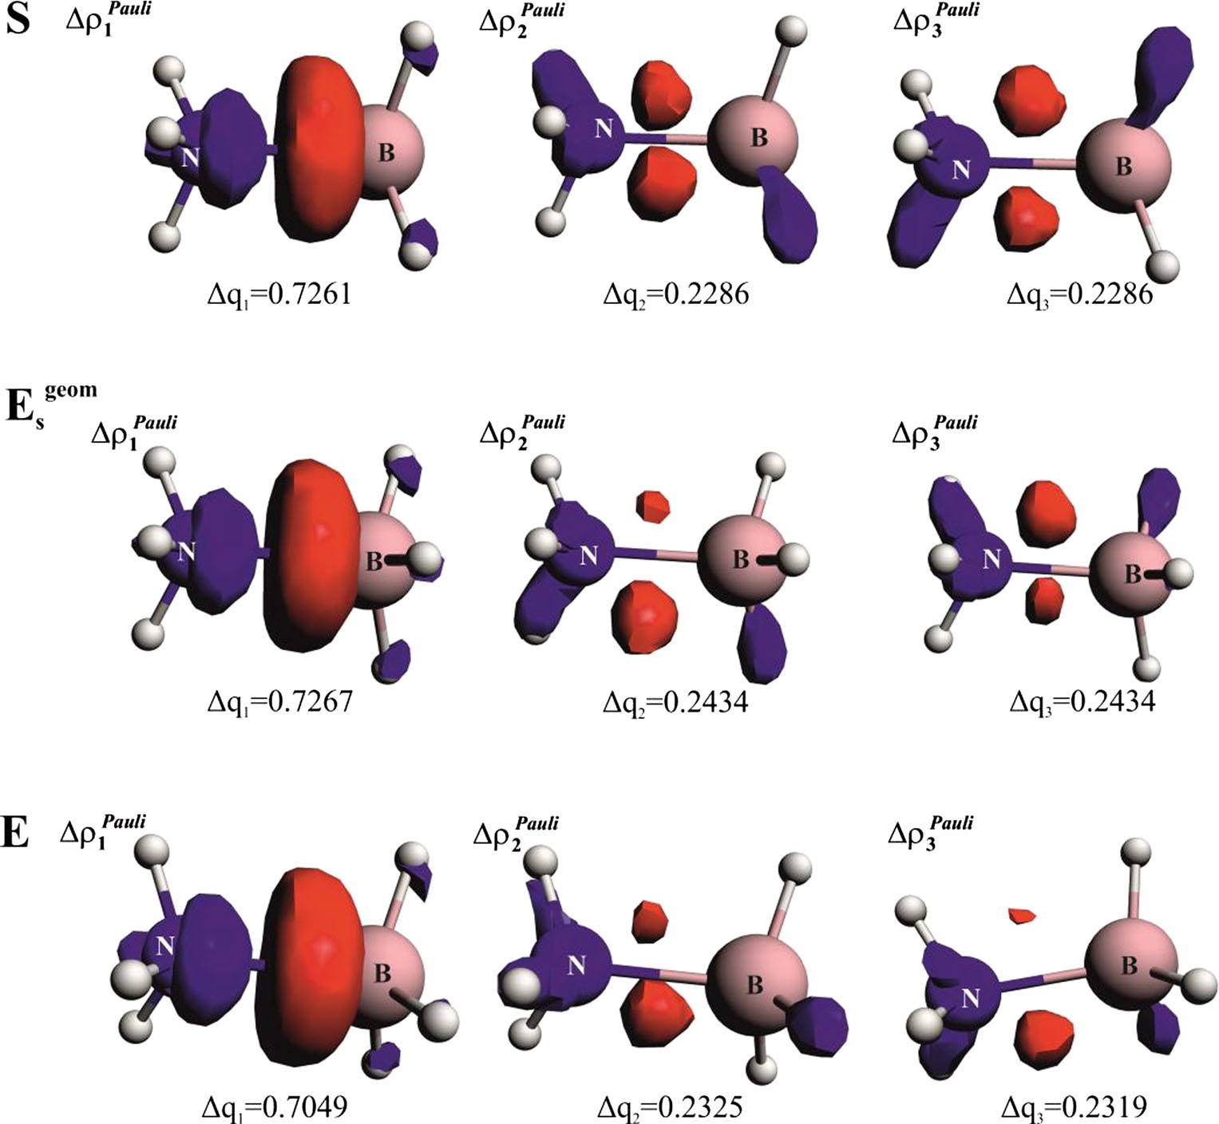
JMolModel(2014)20:2272
Page 7 of 9, 2272
Fig. 5 Dominant Pauli repulsion deformation density channels,
Δρ^{Pauli},Δρ^{Pauli},Δρ^{Pauli},together
1 2 3
withthecorrespondingcharge estimations,
ΔqPauli,ΔqPauli,ΔqPauliin the
1 2 3
selected ammonia borane conformations.Theblue/redcontours correspond toaccumulation/depletionof electrondensity.SFully optimizedstaggeredisomer,
E^{geom}eclipsedstructureinthe
s
staggeredgeometry,Efully optimized eclipsedisomer
theelectronswiththesamespinaswithintheB–HandN–H bonds). The repulsive contribution from the interaction be- tweentheloneelectronpairofammoniawiththeelectronsof
and others for ethane [18]. Such an approach, while very physical and compelling, does notallow,for example,sepa- rate discussion of the role of the hyperconjugation effect, which is well rooted inchemistry.It was shown thatrigid
B–Hbonds(Δρ^{Pauli})isdominatinginabsoluteterms;howev-
1
rotationS→E^{geom}leads to a rise in all of the destabilizing
er,itdoesnotinfluencethebarrier.Theseresultsconfirmthe‘classical’viewthattheinternalrotationalbarrierinammonia boranecanbeunderstoodsolelyintermsofNH↔HBsteric (Pauli) effects, with minor participation stemming from the hyperconjugation (Fig.2) and geometry distortion term. It must be further noted that we performed a detailed studyof
s
terms(ΔT∼+9kcalmol⁻¹,ΔV_{nn}+ΔV_{ee}∼+16kcalmol⁻¹),whereastheelectron-nuclei stabilizationisΔV_{ne}∼
−22 kcal mol⁻¹. (Fig.6.11in [18]). At thisnon-equilibrium
geometry, the rise in kinetic energy is related, through the
virial theorem, to the repulsion force acting on the nuclei.
the changes inΔq^{Pauli}values (based on various sets of mol-
Accordingly, in the next step,E^{geom}→E, the CC bond elon-
i
s
gates,whichleadstoweakeningoftheattraction(ΔV_{ne}∼+ 207kcalmol⁻¹)anddecreaseintherepulsion(ΔV_{nn}+ΔV_{ee}∼
–201kcalmol⁻¹;ΔT∼–3kcalmol⁻¹,thevaluesareprovided
with respect to ethane in staggered geometry). One should
alsonotethatvariousauthorshavecombinedtheabovecon- tributionsindifferentways[31].Finally,LiuandGovind[91], definedinanelegantwayatDFTlevel,thestericcontribution (equal to the kinetic Weizsäcker term) from a difference betweenthetotalelectronicenergyandthesumofelectrostat- ic (ΔV_{ne}+ΔV_{ee}+ΔV_{nn}) and quantum energy termsΔE_{q}(comprisingthesumΔE_{xc}+ΔE_{Pauli});thechangeinthekinetic term due to the Pauli exclusion principle is incorporatedin
ecules)andhavefoundthatdifferencesintheseconddecimal place are quantitativelymeaningful.
Finally,weperformedsimilarETS-NOCVandPaulirepul- sion analyses for ethane and found that CH↔HC Pauli (kinetic) repulsion channels are responsible for the rotation ofmethylgroups(seeSupplementaryelectronicmaterial);this isinlinewiththeconclusionsreachedfirstbyBickelhauptand subsequentlybyotherresearchers[42–46].Itisimportantat thispointtociteanotherimportantworkinthefieldexplaining theoriginofrotationinethane.Itispossibletodecomposethe barrierintochangesinthekinetic(ΔT)andpotentialenergycontributions: nuclei–-nuclei (ΔV_{nn}), nuclei–-electrons(ΔV_{ne}) and electrons-electrons(ΔV_{ee}),as done byBader
ΔE_{Pauli}. It was shown that rigid rotationS→E^{geom}results in
s

2272, Page 8 of 9
JMolModel(2014)20:2272
the appearance of destabilizing forces originating from
Open Access This article isdistributedunder the terms of the CreativeCommonsAttributionLicensewhichpermitsanyuse,distribution,and reproduction in any medium, provided the original author(s) and the source arecredited.
the fermionic quantum contributionΔE_{q};
closer
inspec-
tion of the author’s data shows that this change is due
entirely to a rise in the kinetic energy term [91]. Final-ly,one should cite the separate work of Nagy [92], who discussed the Fisher information based on the kinetic term; the role of kinetic energy and theinformation
References
origin of the chemical Nalewajski [22].
bonding
have
been
studied
by
- FrenkingG,FrohlichN(2000)ChemRev100:717–774(andrefer-encestherein)
- BickelhauptFM,BaerendsEJ(2000) In:LipkowitzKB,Boyd DB (eds) Reviews in computational chemistry: Kohn-sham density functional theory: predicting and understanding chemistry, vol 15. Wiley, Hoboken, pp 1–86. doi:10.1002/9780470125922.ch1
3. Hund F (1926) Z Phys 36:657–674
4. Mulliken RS (1927) Phys Rev 29:637–649 5. Boys SF (1960) Mol Phys 32:296–299
- EdmistonC,RuedenbergK(1963)RevModPhys35:457–464
- ReedAE,CurtissLA,WeinholdF(1998)ChemRev88:899–926
- WibergK (1968)Tetrahedron24:1083–1096
- GopinathanMS,JugK(1983)TheorChimActa63:497–509
- Mayer I (1984) Chem Phys Lett97:270–274
- NalewajskiRF,MrozekJ(1994)IntJQuantumChem51:187–200
- NalewajskiRF,MrozekJ,FormosinhoSJ,VarandasAJC(1994)IntJ Quantum Chem52:1153–1176
- NalewajskiRF,MrozekJ(1996)IntJQuantumChem57:377–389
- NalewajskiRF,Mrozek J, Mazur G (1996) Can J Chem 74: 1121–1130
- NalewajskiRF,MrozekJ,MichalakA(1997)IntJQuantumChem 61:589–601
- NalewajskiRF,Mrozek J, Michalak A(1998)Polish J Chem 72:1779–1791
- Michalak A, De Kock R, Ziegler T (2008) J Phys Chem A112:7256–7263
- Bader RF (1990) Atoms in molecules. A quantumtheory.OxfordUniversity Press, Oxford, and referencestherein
19. Ponec R (1997) J Math Chem 21:323–333
- Jackobsen H (2010) DaltonTrans39:5426–5428
- BeckeAD,EdgecombeKE(1990)JChemPhys92:5397–5403
- NalewajskiRF(2010)Informationoriginsofchemicalbond,chem-istryresearchandapplicationsseries.NovaScience,NewYork
- DapprichS,FrenkingG(1995)JPhysChem99:9352–9362
- KitauraK,MorokumaK(1976)IntJQuantumChem10:325–340
- ZieglerT,Rauk A (1977) Theor Chim Acta46:1–10
- ZieglerT,Rauk A (1979) Inorg Chem18:1755–1759
- Pendás AM, Blanco MA, Francisco E (2006) J Chem Phys 125:184112–184120
- Jeziorski B, Moszynski R, Szalewicz K (1994) Chem Rev 94:1887–1930
- Toro-LabbéA,Gutiérrez-OlivaS,MurrayJS,PolitzerP(2009)JMolModel 15:707–710
- VanZeist WJ, Bickelhaupt FM (2010) Org Biomol Chem 8:3118–3127
- PaynePW,AllenLC(1977)In:SchaeferHF(ed)Moderntheoreticalchemistry.Plenum, NewYork,pp29–108
- Wiberg KB (1998) Encyclopedia of computational chemistry,Schelyer PvR.Wiley,Berlin, pp2518–2525
- Kemp JD, Pitzer KS (1936) J Chem Phys4:749
- SoversOJ,KernCW,PitzerRM,KarplusM(1968)JChemPhys49:2592–2599
- MullikenRS(1939)JChemPhys7:339–352 36. Lowe JP (1973) Science179:527–532
37. England W, Gordon MS (1971) J Am Chem Soc 93:4649–4657
Concluding remarks
Thepresentworkstudiedforthefirsttimetheinternalrotation in ammonia borane based on our recently developed charge andenergydecompositionscheme,ETS-NOCV,aswellasthe eigenvectors for Pauli repulsion. Detailed analyses of the electronicandthestericfactorswereperformedinorder
to understand the ammonia borane.
origin
of
the
barrier
to
rotation
in
Wefoundthatthebarriertorotation,staggered↔eclipsed, is only∼2 kcal mol⁻¹. It was demonstrated using the ETS- NOCV scheme that the hyperconjugation, originating from thechargetransferfromtheoccupiedσ(B–H)orbitalsintothe emptyσ*(N–H),favorsthestaggeredisomer,although,quan- titativelyitleadstoonlyaslightstabilization(∼5kcalmol⁻¹).Forethane, thisstabilizationwasmorepronounced,
∼10 kcal mol⁻¹. We have found, based on our newly proposed scheme, the natural orbitals for Pauli repul-
sion, that rigidrotationfrom thestaggeredtotheeclipsed conformation causes predominantlytheen-hancement of steric (Pauli) repulsion acting solely be- tween N–H and B–H bonds; this is subsequently‘re- lieved’, leading to elongation of the B–N bond in thefully optimized eclipsed structure. Analogoustrendswere foundforethane(TableS1). Accordingly,thebarrier to rotation in ammonia borane can be understood in a classical way; namely, as originating from the steric (Pauli)repulsioncontributionsthatactsolelybetween
N–H
and B–H bonds. Repulsion between the lone pair
of ammonia and the B–H bonds is dominant in absolute terms; however, it does not influence the barrier.
AcknowledgmentsM.P.M.greatlyappreciatesextremelyvaluabledis- cussionswithDr.ChadMcKeeandProf.vonRagueSchleyer(University ofGeorgia)ontheoriginofrotationalbarriersinhydrocarbons.M.P.M.also acknowledges the financial support from the Polish Ministry of ScienceandHigherEducation(“OutstandingYoungResearchers”schol- arships, 2010, 2011–2014 and for young researchers T-subsidy). M.ParafiniukacknowledgesthePolishMinistryofScienceandHigher Education for the support of the project“Diamentowy Grant,”No.DI2011010241.Weare also grateful to Academic Computer Center CYFRONET (PL-GridInfrastructure)for the computertime.

JMolModel(2014)20:2272
Page 9 of 9, 2272
- Epiotis ND, Cherry WR, Shaik S,YatesRL, Bernardi F (1977)Structuraltheoryoforganicchemistry.In:Topicsincurrentchemis-try,vol 70.Springer,Berlin
- BaderRFW,Cheeseman JR, Laidig KE,WibergKB, Breneman C(1990) J Am Chem Soc112:6530–6536
- PophristicV,Goodman L (2001) Nature411:565–568
- WeinholdF (2003) Angew Chem Int Ed42:4188–4194
- Bickelhaupt FM, Baerends EJ (2003) Angew Chem Int Ed 42:4183–4188
- Pendás AM, Blanco MA, Francisco E (2009) J Comput Chem30:98–109
44. Mo Y (2010) J Org Chem 75:2733–2736
- MoY,WuW,SongL,LinM,ZhangQ,GaoJ(2004)AngewChemInt Ed43:1986–1990
- MoY,Gao Y (2007) Acc Chem Res40:113–119
- MitorajM,MichalakA,ZieglerT(2009)JChemTheoryComput5:962–975
48. Mitoraj M (2011) J Phys Chem A 115:14708–14716
- KurczabR,MitorajMP,MichalakA,ZieglerT(2010)JPhysChemA114:8581–8590
- MitorajMP,Michalak A(2011)Inorg Chem50:2168–2174
- Michalak A, Mitoraj M, Ziegler T (2008) J Phys Chem A 112:1933–1939
- MitorajM,MichalakA(2007)JMolModel13:347–355
- MitorajMP,Zhu H, Michalak A, Ziegler T (2009) Int J Quantum Chem109:3379–3386
- MitorajM,MichalakA(2007)Organometallics26:6576–6580
- MitorajM,MichalakA(2008)JMolModel14:681–687
- Srebro M, Mitoraj M (2009)Organometallics28:3650–3655
- Nalewajski RF (1993) KöSter AM, Jug K. Theor Chim Acta85:463–484
- ParafiniukM,MitorajMP(2013)Organometallics32:4103–4113
- Dyduch k, MitorajMP,Michalak A (2013) J Mol Model 19: 2747-2758.
- KozyraP,Brocławik E, MitorajMP,Datka J (2013) J Phys Chem117:7511–7518
KadantsevES, vanKesselG,KloosterR,KootstraF,KrykunovMV,vanLentheE,Louwen JN,McCormackDA,MichalakA,MitorajM,NeugebauerJ,NicuVP,NoodlemanL,OsingaVP,PatchkovskiiS,PhilipsenPHT,PostD,PyeCC,RavenekW,RodriguezJI,RomanielloP,RosP,SchipperPRT,SchreckenbachG,SethM,SnijdersJG, SolàM,SwartM,SwerhoneD,teVeldeG,VernooijsP,VersluisL,VisscherL, Visser O, WangF,WesolowskiTA,van Wezenbeek EM,WiesenekkerG,WolffSK,WooTK,YakovlevAL,ZieglerT(2009)ADF2009.01SCM,Amsterdam,TheNetherlands.
- teVeldeG, Bickelhaupt FM, Baerends EJ, Fonseca Guerra C, van GisbergenSJA,SnijdersJG,ZieglerT(2001)JComputChem22: 931–967, and referencestherein
- BaerendsEJ,EllisDE,RosP(1973)ChemPhys2:41–51
- BoerrigterPM,teVeldeG,BaerendsE(1988)JIntQuantumChem33:87–113
69. Becke A (1988) Phys Rev A 38:3098–3100
70. Perdew JP (1986) Phys Rev B 34:7406–7406
- VisserO, LeyronnasP,van Zeist WJ, Lupki M (2009) ADF-GUI,SCM, Amsterdam, The Netherlands,http://www.scm.com.
- SchwarzWHE,SchmidbaurH(2012)ChemEurJ18:4470–4479,and referencestherein
- Ruedenberg K (1962) Rev Mod Phys34:326–352
- TokiwaH, Ichikawa H (1994) Int JQuantumChem50:109–112
- PinterB,FievezT,BickelhauptFM,GeerlingsP,DeProftF(2012)Phys Chem14:9846–9854
- Haaland A (1989) Angew Chem Int Ed101:1017–1032
- Haaland A (1989) Angew Chem Int Ed28:992–1007
- JonasV,Frenking G, Reetz MT (1994) J Am Chem Soc 116: 8741–8753
- JagielskaA,MoszynskiR,PielaL(1999)JChemPhys110:947–954
- DixonDA,GutowskiM(2005)JPhysChemA109:5129–5135
- BauschlicherCWJr,RiccaA(1995)ChemPhysLett237:14–19
- MoY,Song L, WuW,Zhang Q (2004) J Am Chem Soc 126: 3974–3982
- PlumleyJA,EvanseckJD(2007)JPhysChemA111:13472–13483,and referencestherein
- BessacF,Frenking G (2006) Inorg Chem45:6956–6964
- FernándezI,FrenkingG(2006)ChemEurJ12:3617–3629
- ThorneLR,SuenramRD,LovasFJ(1982)JChemPhys78:167–171
- LeboeufM,RussoN,SalahubDR,ToscanoM(1995)JChemPhys103:7408–7413
- PoaterJ,SolaM,BickelhauptMF(2006)ChemEurJ12:2889–2895
- Goodman L, Hongbing G, Pophristic V (1999) J Chem Phys110:4268–4275
- BaderRFW,Preston HJT (1966) Can J Chem 44:131–145, andreferences therein.
- Liu S, Govind N (2008) J Phys Chem A112:6690–6699
- Nagy Á (2007) Chem Phys Lett449:212–215
61. Mitoraj MP, Michalak 28:3727–3733
A, Ziegler T (2009) Organometallics
62. Mitoraj MP, Parafiniuk M, Srebro M, Handzlik M, Buczek A,
Michalak A (2011) J Mol Model 17:2337–2352
- Piękoś Ł,MitorajMP(2013)JComputChem34:294–304
- Paul A, Musgrave CB (2007) Angew Chem119:8301–8304
- Baerends EJ, Autschbach J, Bashford D, Berger JA, Bérces A,BickelhauptFM, Bo C, de Boeij PL,BoerrigterPM, Cavallo L,ChongDP,DengL,DicksonRM, Ellis DE, vanFaassenM,FanL,Fischer TH, Fonseca Guerra C, Giammona A, Ghysels A, vanGisbergenSJA, GötzAW,GroeneveldJA,GritsenkoOV,GrüningM,HarrisFE,van den HoekP,Jacob CR,JacobsenH,JensenL,

