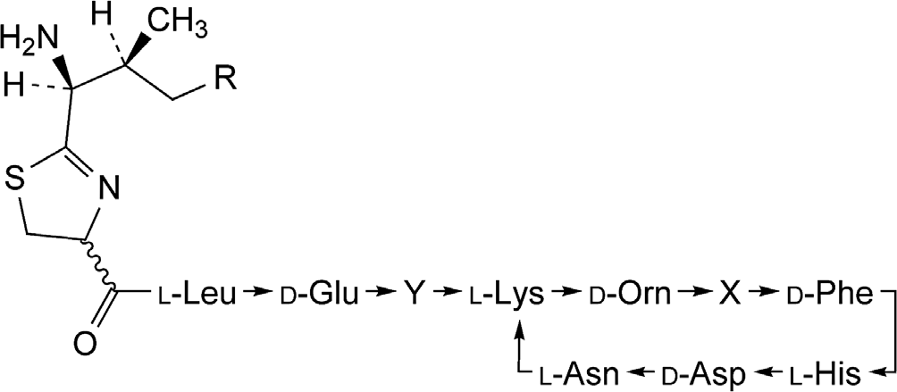
Acta Poloniae Pharmaceutica ñ Drug Research, Vol. 68 No. 6 pp. 853ñ858, 2011
ISSN 0001-6837
Polish Pharmaceutical Society
SPECTROPHOTOMETRIC DETERMINATION OF BACITRACIN IN BULK DRUG AS DABSYL DERIVATIVE IN A RANGE OF VISIBLE LIGHT
JAN KRZEK* and JOANNA PIOTROWSKA
Department of Inorganic and Analytical Chemistry, Jagiellonian University, Medical College, 9 Medyczna St., 30-688 KrakÛw, Poland
Abstract: A fast spectrophotometric method has been developed for bacitracin identification and determination after condensation reaction with dabsyl chloride. In addition, determination of dye stability of sulfonamide derivative and identification of the molar ratio of reagents was done at various time-points. The developed method has a good linearity with very broad spectrum, correlation coefficient of r = 0.9972, good precision (RSD = 1.54 ± 0.11%), and recovery at three different levels of concentration was found between 98.33% and 103.47%. Usefulness of the method was demonstrated by positive results obtained during determination of bac- itracin concentration in bulk drug.
Keywords: bacitracin, dabsyl chloride, VIS spectrophotometry.
Bacitracin from B. licheniformis and B. subtilis strains represents a mixture of nine cyclic polypep- tides and the most important component is baci- tracin A. It has bactericidal properties against Gram (+) bacteria and is used in treatment of skin, eye, and ear infections. Because bacitracin demonstrates local action and is not absorbed through mucous membrane, then it is possible to use it in treatment of patients with pseudomembranous enterocolitis. Bacitracin is mostly administered in the form of
drops and ointments, in complex preparations with neomycin (1, 2). Structure of bacitracin A used in therapy is presented in Figure 1.
Since 1975, dabsyl chloride (DBS) is used for identification of N-terminal amino acid in polypep- tide chain during analysis of compounds containing amine group (3). The first step in the process is con- densation of DBS with polypeptide through N-ter- minal amino acid. The second step is hydrolysis in acidic environment that results in a product ñ sulfon-
Figure 1. Structure and different types of bacitracin according to FP VIII
* Corresponding author: e-mail address: jankrzek@cm-uj.krakow.pl
853
Name
Molecular formula
X
Y
R
Bacitracin A
C66H103N17O16S
L-Ile
L-Ile
CH3
Bacitracin B1
C65H101N17O16S
L-Ile
L-Ile
H
Bacitracin B2
C65H101N17O16S
L-Val
L-Ile
CH3
Bacitracin B3
C65H101N17O16S
L-Ile
L-Val
CH3

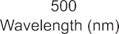
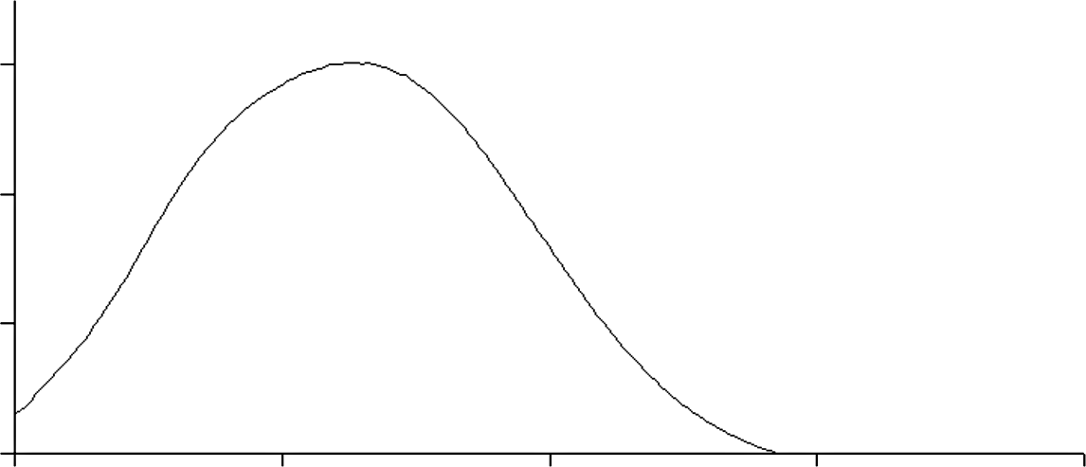

854
JAN KRZEK and JOANNA PIOTROWSKA
amide derivative. The final, third, step is chromato- graphic identification of obtained product. This reaction is highly sensitive (10-9 ñ 10-10 mol/dm3).
Published data demonstrate wide application of chromatographic techniques with varied methods of detection like HPLC-MS, HPLC-UV, MEKC (4ñ10). TLC method with densitometric detection with co-occurrence of neomycin in the study mate- rial was also used in the quantitative determination of bacitracin (11, 12).
In this paper, the quantitative determination of bacitracin after condensation reaction with dabsyl
chloride is presented. Modification in the method of N-terminal amino acid determination with the use of DBS was done by exclusion of hydrolysis and estab- lishing reaction conditions to enable direct spec- trophotometric estimation of the product of DBS reaction with the antibiotic.
ANALYSIS
Reagents
Bacitracin from B. licheniformis (Sigma, St. Louis, USA), dabsyl chloride = 97.5% (AT) (Fluka
Figure 2. The UV spectrum of the product of bacitracin-DBS condensation.
Figure 3. Changes in the absorbance dependent on the molar ratio of DBS : bacitracin

855
Spectrophotometric determination of bacitracin in bulk drug as...
Chemie AG, Buchs, Switzerland), acetone p.a. sodi- um carbonate p.a. and sodium bicarbonate p.a. (POCh Gliwice, Poland).
Bacitracin used for the experiments met the requirements described in a monograph in Polish Pharmacopoeia (FP VIII) in the scope of identity, purity and biological activity.
recorded in a studied range of measurement. Therefore, it may be assumed that the absorbance value at the maximum of absorption originates from a product obtained in a reaction of the studied reagents.
Further studies estimated the product in the context of its use to develop a new method.
Instruments and software
UV/Vis spectrophotometer
Determination of the molar ratio of reagents
In flasks of 5 cm3 volume, a series of 9 solu- tions with the same concentration of bacitracin (2◊10-5 mol/dm3) and increasing concentration of DBS (1◊10-5 ñ 2◊10-4 mol/dm3) was prepared. A ref- erence material containing identical volume of car- bonate buffer (pH = 9.00) and DBS concentration as in the study sample was prepared for each individual sample. The samples and their references were heat- ed up in water bath at 70OC for 15 min, and then cooled down and adjusted with acetone to the final volume of 5 cm3. Absorbance was measured in rela- tion to appropriate reference material. A graph pre- senting dependence of absorbance at 474 nm towards the molar ratio of DBS to bacitracin was created. This graph indicates quantitative run of the reaction with molar ratio 1:6, bacitracin : DBS (Fig. 3).
Cary 100 Conc.
Varian, 10 mm glass cells, STATISTICA 9 soft- ware.
Formation of bacitracin derivative with dabsyl chloride
A product of reaction was formed when 0.06 mL of bacitracin solution (1◊10-3 mol/dm3) in car- bonate buffer (pH = 9.0) was mixed with 0.6 mL of dabsyl chloride solution (1◊10-3 mol/dm3), heated up at 70OC for 15 min, then cooled down to 25OC and adjusted with acetone to the final volume of 5.0 cm3. The product demonstrated characteristic absorption spectrum in a range 400 nm to 800 nm with maxi- mum at λ = 474 nm.
Absorption spectrum of the formed product, recorded in the presence of reference material pre- pared in the same way as a study sample, is present- ed in Figure 2.
In the above-described conditions, no absorp- tion of separate bacitracin and DBS solutions was
Stability of color in solutions
Stability of color in solutions was studied by measurement of samples absorbance at λ = 474 nm
Figure 4. Changes in the solutions absorbance in time

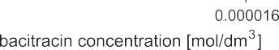
856
JAN KRZEK and JOANNA PIOTROWSKA
from 0 to 240 min after termination of incubation. The recorded changes of absorbance value at a par- ticular time are presented in Figure 4. Results of these studies confirmed stability of color in solu- tions after 30 min from termination of incubation which was kept at a constant level for the next 2 h.
were cooled down to 25OC and completed with ace- tone to 5 cm3. The absorbance of samples was recorded at λ = 474 nm. A graph representing the dependence of absorbance on concentration of baci- tracin in the sample had a good correlation coeffi- cient, r = 0.9972 (Fig. 5).
Linearity
In order to determine a dependence of absorbance of solutions on the content of antibiotics, a series of solutions with increasing concentration of bacitracin (2◊10-6 to 2◊10-5 mol/dm3) and constant concentration of DBS (1.2◊10-4 mol/dm3) were pre- pared based on the earlier determined molar ratio of reagents. A series consisting of 6 samples contain- ing bacitracin with reference material was incubated in water bath at 70OC for 15 min. Then, the samples
Absorption coefficient
In the above-described conditions, values of molar absorption coefficient (ε474nm = 2.4◊104) and
coefficient A = 168 were obtained during studies
1%
1cm
of linearity A = f(c).
Limit of Detection (LOD) and Limit of Quantitation (LOQ)
Based on parameters of the curve, the LOD and LOQ (mol/dm3) values were 1.08◊10-10 and 3.28◊10-10,
Figure 5. Dependence of the solutions absorbance on bacitracin concentration
Table 1. Precision of the method.
S = standard deviation, RSD = relative standard deviation
Concentration level of bacitracin in sample
Measured absorbance values
S
RSD [%]
50%
0.1637; 0.1588; 0.1602; 0.1629; 0.1594; 0.1580
2.30◊10-3
1.43
100%
0.2875; 0.2849; 0.2861; 0.2795; 0.2921; 0.2906
4.48◊10-3
1.56
150%
0.3681; 0.3842; 0.3796; 0.3823; 0.3779; 0.3718
5.81◊10-3
1.65

857
Spectrophotometric determination of bacitracin in bulk drug as...
Table 2. Bacitracin recovery values expressed as a percentage for three various levels of concentration.
A474 nm = absorbance at 474 nm
Table 3. The amount of bacitracin in bulk drug.
xúr = average [mol/dm3], S = standard deviation, RSD = relative standard deviation, µ = confidence interval
respectively. These values corresponded to low con- centrations of bacitracin and at the same time indi- cated satisfactory sensitivity of the method.
replicates at three different concentrations of the antibiotic (80%, 100% and 120%) were prepared. The obtained values of absorbance, which were used for estimation of bacitracin recovery, are presented in Table 2.
Precision
For precision determination, six samples with three different concentrations of bacitracin (50%, 100% and 150%) were prepared. The samples with reference material were heated up in water bath at 70OC for 15 min and then cooled down and adjusted with acetone to the scale mark. The absorbance was recorded at λ = 474 nm. The obtained values of absorbance as well as calculated standard deviation
(S) and relative standard deviation (RDS) values are presented in Table 1.
Determination of bacitracin in bulk drug
A solution of bacitracin (1◊10-3 mol/dm3) in carbonate buffer at pH = 9.00 as well as 6 identical mixtures of DBS with bacitracin solutions (1.2◊10-5 mol/dm3) were prepared. The absorbance of solu- tions was recorded at λmax = 474 nm. Concentration of bacitracin in the samples was calculated based on the slope obtained for calibration curve. The obtained values of absorbance and corresponding with them concentrations of bacitracin as well as the percentage ratio to weighted amounts are presented in Table 3.
In bulk drug, concentration of bacitracin was in a range 100 ± 1.67%.
Recovery
Recovery was determined based on identified concentration in relation to weighted amount under conditions of developed method. For studies, 3
Average absorbance
λ = 474 nm
Bacitracin concentration [mol/dm3]
Amounts [%]
0.2729
1.22◊10-5
101.67
0.2716
1.21◊10-5
100.83
0.2648
1.18◊10-5
98.33
0.2677
1.19◊10-5
99.17
0.2718
1.22◊10-5
101.67
0.2653
1.18◊10-5 9
8.33

xúr= 1.20◊10-5 S= 1.90◊10-7 RSD = 1.58%
µ0.05 = 1.20◊10-5 ± 1.18◊10-7
xúr= 100.00
S= 1.58
RSD= 1.58%
µ0.05 = 100.00 ± 0.99
Concentration level of bacitracin
in sample

A474 nm

Weighted bacitracin concentration [mol/dm3]
Measured bacitracin concentration
[mol/dm3]
Recovery [%]
Average recovery [%]

80%

0.2274
0.2279
0.2215

9.60◊10-6

9.78◊10-6
9.81◊10-6
9.46◊10-6
101.88
102.17
98.52

100.86

100%

0.2677
0.2648
0.2653

1.20◊10-5

1.20◊10-5
1.18◊10-5
1.19◊10-5
100.00
98.33
99.17

99.17

120%

0.3215
0.3090
0.3198

1.44◊10-5

1.49◊10-5
1.42◊10-5
1.48◊10-5
103.47
98.61
102.78

101.62

858
JAN KRZEK and JOANNA PIOTROWSKA
RESULTS AND DISCUSSION
2.
Sheth V.M., Weitzul S.: Dermatitis 19, 181 (2008).
Lin J.-K., Chang J.-Y.: Anal. Chem. 47, 1634 (1975).
Romero R., Bagur M.G., S·nchez-ViÒas M., G·zquez D.: Chromatographia 51, 404 (2000). Romero R., S·nchez-ViÒas M., G·zquez D.,
Reaction of free amine groups
with dabsyl
3.
chloride was used for development of a new method for determination of bacitracin in bulk drug. It was observed that molar ratio of DBS to bacitracin in reaction of condensation was 6:1. The product was stable for 2 h.
The method demonstrated high sensitivity (LOD = 1.08◊10-10 mol/dm3 and LOQ = 3.28◊10-10
mol/dm3), good precision for various levels of con- centration (RSD = 1.43% to 1.65%) and high accu- racy expressed as a percentage of recovery (98.33% to 103.47%). The dependence of absorbance on con- centration was straight in a range 2◊10-6 to 2◊10-5 mol/dm3. The results of determination of bacitracin in bulk drug are characterized by narrow confidence interval, which is a confirmation of practical usabil- ity of the method developed for controlling raw material during production.
4.
5.
Bagur
M.G.,
Cuadros-RodrÌguez
L.:
Chromatographia 53, 481 (2000).
Castillo M.A., Castells R.C.: Chromatographia 54, 711 (2001).
Witek A., Hopkala H., Matysik G.: Chromatographia 50, 41 (1999).
Wan E., Ho C., Sin D., Wong Y.: Anal. Bioanal. Chem. 385, 181 (2006).
Capit·n-Vallvey L.F., Navas N., Titos A., Checa R.: Chromatographia 54, 15 (2001).
Lemus Gallego J.M., PÈrez Arroyo J.: Chromatographia 56, 455 (2002).
Krzek J., Starek M., KwiecieÒ A., Rzeszutko W.: J. Pharm. Biomed. Anal. 24, 629 (2001). Scheidl C.O.R., Menzinger F., Maier E.J., Capek E., Scheidl O., Huck C.W.: Chromatographia, 69, 11 (2009).
6.
7.
8.
9.
10.
11.
REFERENCES
12.
1. Bonomo R.A., Van Zile P.S., Li Q., Shermock K.M., McCormik W.G., Kohut B.: Expert Rev. Anti. Infe. Ther. 5, 773 (2007).
Received: 24. 02. 2011

