
Received: 6 January 2018|Accepted: 22 July2018
DOI: 10.1111/1365-2435.13191
RESEARCHARTICLE
Gradientsofseasonlengthandmortalityriskcauseshiftsinbodysize,reservesandreproductivestrategiesofdeterminategrowers
MaciejJ.Ejsmond^{1,2} |John M.McNamara³
|Janne Søreide²
|Øystein Varpe^{2,4}
1Institute of Environmental Sciences, Jagiellonian University, Kraków, Poland
2Department of Arctic Biology, University Centre in Svalbard, Longyearbyen, Norway
3School of Mathematics, University of Bristol, Bristol, UK
4Akvaplan‐niva, Fram Centre, Tromsø, Norway
Correspondence
Maciej J. Ejsmond, Institute of Environmental Sciences, Jagiellonian University, ul.Gronostajowa 7, 31‐387 Kraków, Poland.
Email:maciek.ejsmond@gmail.com
Funding information
National Science Centre in Poland, Grant/ Award Number: 2014/15/B/NZ8/00236; ResearchCouncilofNorway,Grant/Award Number:216537,227046and227139;
Jagiellonian University, Grant/Award Number: DS/WB/INoS/757/2018
Handling Editor: Jean‐François Lemaître
This is an open access article under the terms of theCreative Commons AttributionLicense, which permits use, distribution and reproduction in any medium, provided the original work is properly cited.
© 2018 The Authors.Functional Ecologypublished by John Wiley & Sons Ltd on behalf of British Ecological Society.
|
Functional Ecology.2018;32:2395–2406.
wileyonlinelibrary.com/journal/fec 2395
Abstract
- The theory of life‐history evolution investigates how growth‐reproduction trade‐ offsdriveevolutionofbodysizeinuni‐andmultivoltine(oneormoregenerations peryear)arthropods.Existingtheorydoesnotpredicthowthelengthofthefeed- ingseason(seasonlengthhereafter)affectsbodysizeinsemivoltine(i.e.,juvenile period longer than 1 year) determinate growers and usually ignores that uni‐ and semivoltine arthropods accumulate large reserves to cover costs of diapause and futurereproduction.
- Here, we present how the trade‐offs between growth, storage and reproduction drive evolution of body mass and reproductive strategy in arthropods with deter- minate growth. Our life‐history model concerns high‐latitude marine copepods livinginastronglyseasonalenvironment.
- Wefind that small changes in season length and mortality rate translate into abruptshiftsinleanbodymass(aproxyforbodysize).Bodysizeshiftsarecaused by a change from multi‐ to uni‐ and semivoltine life cycles with semivoltine life histories selected for in short seasons and only if background mortality is low. Shifts in the number of generations per year do not translate into shifts in the mass of lipid reserves. The model predicts less reserves the shorter the winter. Seasonlengthaloneisnotasufficientpredictorofthedegreeofcapitalbreeding. Storing for reproduction is strongly selected for under short season but lowmor-tality rate. Hence, capital breeding contributes to fitness in uni‐ and semivoltine organisms whereas multivoltines are income breeders.Wealso show that storing reserves for diapause and capital breeding trades off with adult size of determi- nately growingarthropods.
- Our results, in particular regarding optimal body size, reproductive strategy (in- come‐to‐capital breeding) and degree of storage are relevant to a number of de- terminategrowers,includinginsectsandcrustaceans.

K E Y WO R D S
body composition, body size,Calanuscopepods, capital breeding, determinate growth, life‐ history evolution, optimal allocation, season length

|
2396 FunctionalEcology
EJSMOND_{Etal}.
1|INTRODUCTION
in which egg load created in the juvenile stage impede flight perfor- mance (Snaell et al., 2007). Adult size in semi‐ and univoltinedeter-minatelygrowingarthropodsisanoutcomeofallocationofresources to growth and storage with time constraints being the core axis for theevolutionofbodysizeandreproductivestrategiesintheseorgan- isms.Modelsofevolutionofadultsizeindeterminategrowerswithex-plicit consideration of season length either do not consider allocation to storage (Kozłowski,1992;Kozłowski & Wiegert,1987),constrain themodelledorganismwithrespecttomaximaladultsize(Sainmont, Andersen,Varpe,&Visser,2014;Varpe,Jørgensen,Tarling,&Fiksen,2007;Varpeetal.,2009)orforceorganismstoadoptincomeorpure capitalbreeding(Sainmontetal.,2014).Theseassumptionspreclude investigations of the trade‐off between growth, storage and repro- duction.Inthepresentedannualroutinemodel,lifehistory,adultsize, reproductive strategy and the duration of the juvenile phase emerge fromtrade‐offoptimizationthroughmaximizationoffitness.Ourwork shows the landscape of optimal life histories of determinate growers alonggradientsofseasonlengthandmortalityrate.Threetypesoflife historiesemergefromourmodel:multivoltines(maturingearlyinthe yearofbirthwiththeiroffspringreproducinginthesameyear),univol- tines(maturingintheyearofbirthbutwiththeiroffspringreproducing the next year) and semivoltines (maturing after the first year of life). Thefemalecopepodsinourmodelproduceeggscontinuouslyandcan potentiallybreedinmorethan1yearifalive.Hence,ourmodelallows generationstooverlap.Theoverlappinggenerationsandpossibleiter-oparityreflectsobservedlife‐historydiversityinmarinecopepods(see MaterialsandMethods)butalsoothercrustaceanssuchasDecapoda andOstracodathatdonotgrowaftermaturationandmaybreedover severalyears(Hartnoll,1984).Wedonotassumeseasonlengthtocor-relate with mortality rate but instead generate predictions in a broad space of parameters allowing for discussion of cases where mortality rate changes together with season length. The presented results, in particularregardingoptimalsize,reservesandreproductivestrategy,
are relevant to a number of determinately growing arthropods.
Amajorityofthelife‐historytrade‐offsaremediatedbyorganismalsize (Stearns,1992),and the evolution of body size has gained particular attention(Charnov,1993;Kozłowski,1992).Thedurationofthefeed- ingseason(referredtoasseasonlengthbelow)andmortalityriskare thetwokeydriversofthebodysizeevolutioninmulti‐andunivoltine determinate growers as they limit time available for growth. Season length defines the period of resources acquisition and mortality de- termines life expectancy. Elevated background mortality, that is, the unavoidablecorepartofthedeathprocessthatoccursindependently on variation in body size or condition, leads to earlier maturation and smaller adult size (e.g., Abrams,Leimar,Nylin, & Wiklund,1996;Kozłowski,1992).Variationinseasonlengthgeneratesbodysizeclines withpossiblechangesinthenumberofgenerationsperyearinmulti‐ andunivoltines(e.g.,Kivela,Valimaki,&Gotthard,2013;Roff,1980).In determinategrowers,shorteninggenerationsleaveslesstimeforde- velopmentandgrowthofjuvenileswhichinturnnegativelyaffectadult size(Roff,1980).However,theclassificationofdeterminatelygrowing arthropodsintouni‐andmultivoltine(i.e.,thosewithoneormorethan onegenerationperyear)speciesdoesnotgraspthelife‐historydiver-sity of the group where some species spend several years in the ju- venile period, such as the high‐latitude copepodCalanus hyperboreus, wood feeding beetles of Cerambycidae or arctic mothsGynaephorespp. (Hirche,1997;Morewood & Ring,1998;Walczyńska, Dańko, & Kozłowski,2010).Such semivoltine (i.e., with juvenile period longer than 1 year) determinately growing arthropods are represented by thousandsofspeciesofcrustaceansandinsects;manymembersofco- pepods(Copepoda),damselflies(Odonata),mayflies(Ephemeroptera), butterflies (Lepidoptera), beetles (Coleoptera) and stoneflies (ple- coptera) are semivoltine (Corbet, Suhling, & Soendgerath, 2006; Lillehammer,Brittain,Saltveit,&Nielsen,1989;Tammaru&Haukioja,1996;Varpe,2012;Walczyńskaetal.,2010).Furthermore,wemustaim to explain intraspecific variability of age at maturation in semivoltine speciessuchasthebeetleAredolponarubra(Walczyńska,2010),dam- selfliesCoenagrionjohanssoniandC.pulchellum(Śniegula,Johansson,& Nilsson‐Ortman,2012;Śniegula,Nilsson‐Ortman,&Johansson,2012) orcopepodsCalanusglacialisandCalanoidesacutus(Daaseetal.,2013; Tarling,Shreeve, Ward, Atkinson, & Hirst, 2004). In only a couple of theoretical studies considering time constraints as triggers oflife‐his- tory trade‐offs, the juvenile period is allowed to last for longer than 1year(e.g.,McNamara,Welham,Houston,Daan,&Tinbergen,2004; Walczyńska et al.,2010)and only few investigate how differences in adultsizeaffectfitness.Altogether,currenttheorydoesnotshowhow interactionbetweenseasonlengthandmortalityrateaffectsbodysize evolutioninorganismsthatspendmorethan1yearinjuvenilestages.
Many uni‐ and semivoltine arthropods gather excessive lipid re- serves to cover costs of overwintering and to contribute to future reproduction (capital breeding) (Conover, 1988; Kivela, Valimaki, Carrasco, Maenpaa, & Manttari, 2012; Tammaru & Haukioja, 1996; Varpe, Jørgensen, Tarling, & Fiksen, 2009). Reserves may constitute significant parts of the body and even influence adult mobility, as in
flightless female winter moths (tribe Operophterini, Geometridae)
2|MATERIAL S AND METHODS
2.1|Model organisms
Herbivorous zooplankton species are ideal for life‐history investiga- tions focused on time constraints and the trade‐off between growth, storage and reproduction. They are exposed to strong variability in seasonlengthastheirprimaryfoodsource,marinealgae,isavailable for a limited time period. For marine copepods, the duration of the feeding season (season length) declines the higher the latitude (Leu et al., 2015). Mortality risk also differs between populations as fish abundance, and light conditions vary between high and low latitudes (Langbehn & Varpe, 2017). Our life‐history model is inspired by the interspecific differences in adult size, lipid reserves and reproduc- tive mode (income‐capital breeding) within calanoid copepods of the genusCalanusspp. (Varpe, 2012). The copepod speciesCalanusfinmarchicus,C. glacialisandC. hyperboreus, constitute thedominant

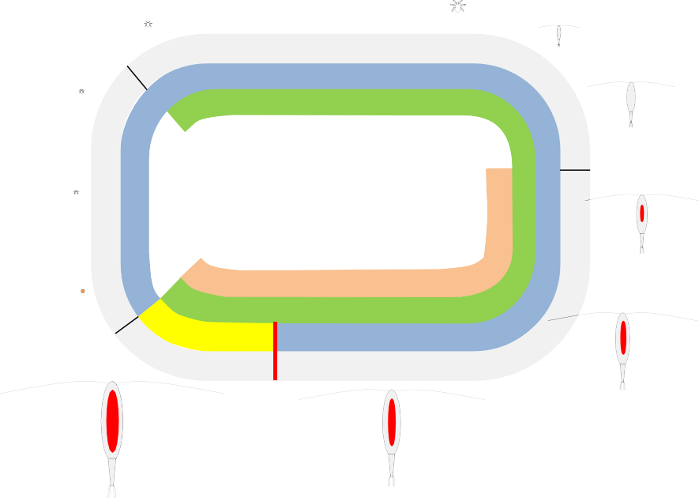
|
FunctionalEcology 2397
EJSMOND_{Etal}.
group of primary grazers in Arctic and sub‐Arctic seas, reaching up to80%ofthebiomassinArcticshelfseas(Blachowiak‐Samolyketal., 2008;Conover,1988).Theydisplaylife‐historyvariabilitywithrespect tobodysizeandageatmaturityalongalatitudinalgradient.Largeand long‐livedC.hyperboreusfrom the high Arctic reaches maturity in its second, third or fourth year of life whereas smallC. finmarchicusfrom the North Atlantic can have up to two overlapping generations per year(Conover,1988;Hirche,1997).C.glacialishasintermediatebody sizeandreachesmaturityinitssecondyearoflife,withsomepopula- tionsbeingunivoltine(Daaseetal.,2013).Femalesoflong‐livedC.hy‐perboreousandC. glacialiscan breed over more than 1 year (Hirche, 2013;Kosobokova,1999).Thelifecycleofcalanoidcopepodsinvolves winter diapause, preceded by accumulation of substantial reserves anddescenttodeepwaterlayers(Conover,1988).Calanoidcopepods canbelipidrichwithlipidreservesofsomespecieslikeC.hyperboreusreaching50%–70%ofdrybodymass.Thevariabilityinfatcontentis linked to the reproductive strategy asCalanusspp. cover the whole income‐capitalbreedingcontinuum;withC.hyperboreusapurecapital breeder,C. finmarchicuspredominantly an income breeder andC. gla‐cialisatypicalmixedcapitalandincomebreeder(Conover,1988;Falk‐Petersen,Mayzaud,Kattner,&Sargent,2009;Hirche,2013).
availability and temperature (season length). The optimal life‐history arises as a consequence of actions undertaken by the model organ- isms.Tomodeloptimalannualroutinesinseasonalenvironments,we apply the theoretical framework that allows the time‐related value of offspring to emerge from the model assumptions (see Supporting InformationAppendixS1).Inourmodel,theorganismoptimizesallo- cationofresourcestogrowth,reproductionandstorageaswellastim- ingofdiapause(Figure1).By“diapause”wemeanrestingphasespent atdepthwithmetabolicprocessessloweddown.Foodavailabilityand temperature are seasonal (Figure 2a) and the timing of actionsmat-ters.Theoptimallifehistoriesinourmodelarestatedependent,that is, actions depend on the lean body mass, reserves and time ofyear.Theleanbodymassinthemodelledorganismscannotshrinkandisa proxyofbodysize(seebelow)inthesenseofstructuraltissuethatis notincludingthereserves.Weusethetermsleanbodymassandbody sizeassynonyms.Ratesofgrowth,developmentandmetabolismwere parameterized to resemble the physiology ofCalanusspp. (see below and Supporting Information AppendixS1).However,conclusions re- garding trends in body size and voltinism were not qualitativelyaf-fected if the assumed rates of physiological processes, forexample,
resource assimilation or maintenance costs, changed.
2.2|The model
The model focuses on optimal annual routines (cf. Houston
2.3|Seasonal fluctuations of food availability,
temperature and offspring value
Years in the modelled environment are divided into 360 days, and seasonality is driven primarily by food availabilityfbut also by
&
McNamara, 1999; McNamara & Houston, 2008), that is, a set of ac-
tions that maximizes fitness for environmental periodicity of food
Juvenile k= 2
Growth Feeding
Moult, migrate When?
Diapause
Reproduction
Adults k= 4
Immature k= 3
Immaturestore vs. growth
Adultstore vs.reproduce
F I G U R E 1Schematic of the life cycle of the modelled female copepod with represented life stages (Egg‐Adult). The size of drawings was scaled with the actual size of developmental stages inCalanus glacialis. Biological stages are represented along with the developmental stages(k)usedinthemodel.Thecopepod'slipidsacisdrawninred.Colourfieldsrepresenttheperiodsthatcanbededicatedforfeeding,
migration, growth and reproduction. Individuals in the immature and adult stages can descend to deep water layers and diapause at any time. Copepods in stages prior to the immature stage are unable to store reserves and suffer high mortality rate during winter. The immatures allocate energy between storage and growth whereas adults may divide the concurrent food intake between storage and reproduction.
Reproduction rate in adults can be boosted by utilization of stored lipids (see the model description)
Egg k= 1

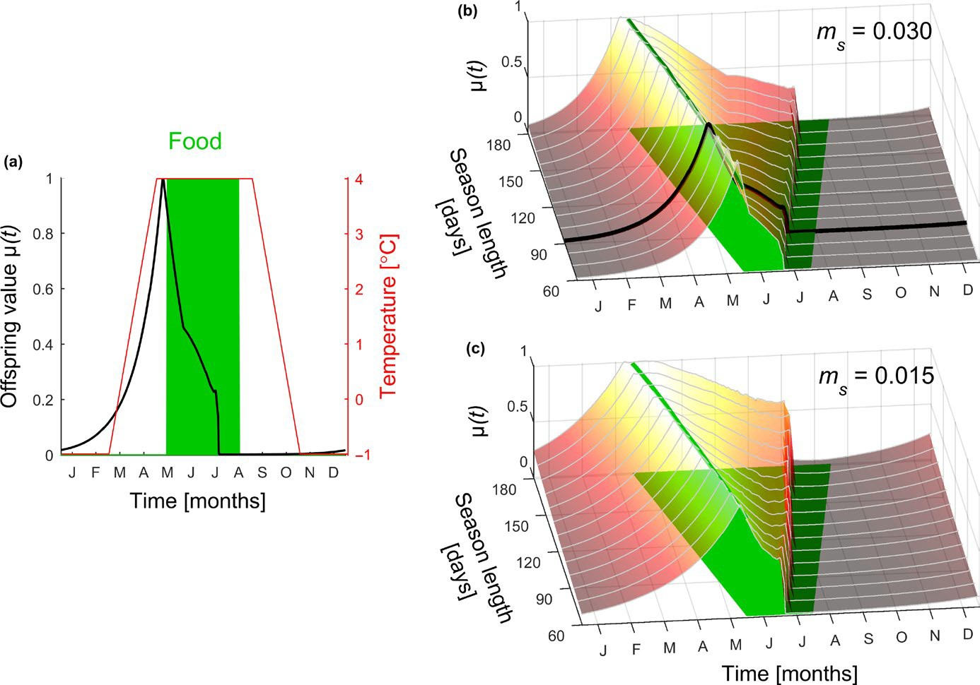
|
FunctionalEcology
2398
EJSMOND_{Etal}.
FIGURE2Thecomponentsofmodelledseasonality.(a)Foodavailabilityisdepictedbythegreenrectangleandtemperaturebythered line. (a, b) Thick black line represents offspring value for an exemplary scenario in which food is available for 3 months and mortality rate atsurfacemsequals0.03.(b,c)Theseasonaldynamicsofoffspringvaluechangeswithseasonlength(rangingfrom2to6months),and
mortalityriskms=0.03(b)and0.015(c).Variouslengthsofthefeedingperiodareoutlinedbythegreenpatch.Thethickgreenlineinband
c indicates food onset mapped on the offspring value functions
changes in water temperatureT(Figure 2a).Tokeep our model easy to follow, we assumed that food availabilityf, represented by the carbon mass of phytoplankton, is constant across the feeding sea- son (see Supporting Information Appendix S1). The third seasonal componentinourmodelisoffspringvalueμ(t)whichrepresentshow offspringbornatagivendaycontributetofitness(seeFigure2),and istheoutcomeoftheoptimizationprocessthatemergesfromthe
model assumption (see Supporting Information Appendix S1).
assumed able to modify the growth rate by optimally diverting re- sources to growth vs. storage (see Table 1 and details given below).
Individuals in all age classes are characterized by their lean body massx[μg carbon] (body size or lean body mass hereafter) and im- mature and adult organisms (k =3 andk =4) can build reservesy[μg carbon]. These most developed stages are able to migrate between the feeding habitat of surface waters (active phase) and a refuge at depth (diapause) (see Figure 1) (e.g., Hirche, 1997). In the two‐first functionalstages(k=1andk=2),thelipidreservesarenotexplicitly modelled.
Todefine net resource gainG[μg carbon∙individual⁻¹day⁻¹], we used literature data on food level‐dependent assimilation rateA(f)and maintenance costsMto parameterize mass‐specific rates [μg carbon∙μg carbon⁻¹day⁻¹] (Supporting Information Appendix S1). Next, we assumed that the balance between assimilation and maintenance costsA(f)‐Mscales with body sizexandtemperature
Taccording to
2.4|Life history: development and physiology
Copepods ofCalanusspp undergo complex development
with
eleven instars preceding the adult stage. We model the life history ofafemalecopepod,fromeggtoadult,forsimplicitydividedinto
four functional stagesk∊{1, 4} (see Figure 1, Table 1). Growth and
development in stagesk =1 andk =2 (hereafter “egg” and “juvenile” stage) are determined by temperature and food availability only(seeSupportingInformationAppendixS1).Forthestagepreceding
maturation,k =3, hereafter “immature stage,” the model organism is
(1)
(T−Tref)∕10xb
G x,f,T=A(f)−M Q
10

|
FunctionalEcology 2399
EJSMOND_{Etal}.
TA B L E 1The outline of state variables and activities that can be undertaken by the model organism in a given functional developmental stagek
Egg stagek =1 (Egg‐N2)
Lean body mass(x)
Food independent growth (no decisions)
Immaturek =3 (C3‐C5)
Leanbodymass(x)Reserves(y)Surfacevs. deep(n)
Growvs.store(α)Migrate(θ)Moultto adults(γ)
Note. The respective biological stages of development (with reference to nauplii and copepodite stages), state variables and optimized decision param- eters are given in parentheses.
withQ10= 2.5 andbset Appendix S1).
to
0.75
(see
Supporting
Information
T) < 0, then mortality rate increases due to starvation bymtand all
stored reserves are utilized for maintenancey(t+1) = 0.
We assume that the migration imposes costs related to descent andascenttaking1dayeach.Themassofcarbonnecessarytocover costs of migrating down Cm[μg carbon] was set proportional to thetotalmass(x+y)ofanorganismaccordingtoCm(x,y)=−a(x+y) and taken from reserves, witha =0.2 (see Supporting Information AppendixS1).Thetimingofmigrationisoptimized,andwhenanani- malmigrates(θ=1),thereservesarereducedaccordingto
2.5|Mortality rate
The probability of surviving 1 day is given byp =exp(‐m) wheremmatches the daily mortality rate. The model copepods suffer mor- tality ratemsif staying in surface waters andmdwhen diapausing at depth. Starving individuals with no reserves suffer the additional mortalitymt= 0.003equivalenttomonthlysurvivalprobabilityof
(3)
y(t+1)=y(t)+(1∕C)[C(x,y)]
r m
0.4. A key assumption in our model is thatm<m, which fits with
d s
An individual unable to cover the energetic cost of the descent (i.e.,y+Cm(x,y)<0)diesduringmigration.Weassumedtheascentto
be a passive process driven by positive buoyancy and lipid utilization
(see Equation 1).
Immature individuals with positive carbon gain divide the surplus resources between allocation to growth and storage according to decisionα(Equation 4).
empiricalestimates(Tarlingetal.,2004).Wepresentresultswhenm
d
is five times lower thanm, that is,m = m/5. However, larger differ-
s
d s
encesinmortalitydonotaffectourconclusions.Weconsiderabroad
rangeofmortalityratesinthesurfacehabitat,m
∈0.006,0.036, to
(
s
reflect conditions of variable environments and latitudes. The inves- tigated daily mortality rates corresponded to a range from ca. 0.6 to
0.05 probability of surviving a 3‐month period at the surface. Our model assumes no differences in stage‐dependent mortality but the predicted trends in body size, reserves and voltinism would remain qualitatively unchanged as long as mortality of juveniles is higher
than mortality of adults.
y(t+1)=y(t)+(1−a)G(x,f,T)
x(t+1)=x(t)+aG(x,f,T)
(4)
An increase inxpositively affects the net carbon gainG(see Equation1).Consequently,growthinourmodelshouldbeconsidered an investment in future reproduction as individuals with larger lean body are able to assimilate resources and reproduce at higher rate (see below). Immature organisms (k =3) in surface watersoptimize
timingoftheirmoulttoadultstage(k=4)(seedecisionγinTable1).
2.6|Diapause, starvation and migration
Copepods with negative net gainG <0 (f =0, see Equation 1) use lipid reserves to cover maintenance costs according to
(2)
y(t+1)=y(t)+(1∕Cr)G(x,f,T,n)
2.7|Lifehistory,allocationandbehaviourofadults
Adultorganismsinthesurfacewatersareabletobuildreservesand/ orproduceeggs.Thosenotreproducingcanstorereserveswitharate determined by carbon gainG(x,f,T)(see Equation 1). Reproducing copepods utilize reserves, currently gained resources or both for off- springproduction.ThemaximalrateofreproductionRpisgivenby
y
wherenindicates whether the organism is diapausing (n =0) or ac- tive in the surface waters (n =1) and determines the costs of main- tenance and mortality rate as staying in surface waters is more
riskythandiapause(seetheaboveparagraph).Weassumedthatre-
servesyare used to cover maintenance with efficiency C=0.8 (see
r
Supporting Information Appendix S1), which means that 1 – C car-
r
bon is lost during the reserves mobilization. If the level of reserves
ywas insufficient to cover maintenance costs, that is,y+ (1/Cr)G(x,
(
R=G(x,f,T)+C min
(5)
p
r
G
max
Adultk =4(adult) Leanbodymass(x)Reserves(y)Surfacevs. Reproducevs.store(β)Migrate(θ) deep(n)
Juvenilek =2(N3‐C2) Lean bodymass(x) Food‐dependent growth (nodecisions)
Developmental stage; functionalk(corresponding Actionstakenandallocation
biologicalstage) State(statevariable) trade‐offs (decisionparameter)

|
2400 FunctionalEcology
EJSMOND_{Etal}.
in response to different mortality rates interacts with season length. The shorter the feeding season, the less time for growth within a year, and time spent growing trades off with time necessary for gathering reserves that are later used to cover costs of migration, diapause and capital breeding. Thus, changes in mortality rate can movetheoptimalbodysize(leanbodymass)tovaluesthatcouldonly beachievedbychangingthenumberofseasonsdedicatedtogrowth (Figure 3). This change could be a shortening or a prolongation of the life cycle. The vast change in body size in response to decreased risk comes about through a prolonged life cycle. Figure 3 illustrates how a relatively small change in mortality rate can cause a dispro- portionally large change in optimal lean body mass due to a switch from a1‐to a 2‐year life cycle (Figure 3a–c) or from a2‐to a 3‐year life cycle (Figure 3d–f). Discontinuous changes in total body mass(x
+y), caused by the switch between an univoltine and a semivoltine
life cycle, arise not only as an effect of the change in mortality but canalsobecausedbyachangeinseasonlengthwithoutachangein mortalityrisk(seeFigure4a,b).
Under high mortality rate, the modelled copepod reaches matu- rity within the first year of life (e.g., Figure 3a) and has enough time for one or more generations per year (i.e., uni‐ or multivoltinism). Timing of offspring production matters, but for long seasons and highmortality,theoffspringcontributiontofitnessμisrelativelyhigh across the season (see Figure 2b) and mothers maximize expected offspring value not only through timing of offspring production but also by shortening their own development time and consequently maturingearlier.Asaresult,mothersshortentheirgrowthphaseand leavemoretimeforoffspringandsubsequentgenerations,butreach
smaller total body mass (lean body + reserves) (Figure 4c).
y

wheremin
sets the amount of reserves that can be used to
Gmax
fuel reproduction in a given time unit. The ceiling is set by the maxi- mal rate at which reserves can be utilizedGmax, which equals CrG(x,
fmax,T). The rate of reproduction is optimized through the decision
parameterβ(see Table 1) which sets the rate of egg production ac- cording to
R=/3Rp
(6)
Allocation in adults is subject to a trade‐off between reproduction and storage. If, for example,β= 0, an organism does not reproduce andcurrentincomeisstored.Ifcurrentgainissufficienttocoveroff- spring productionR≤G, then the organism gain reservesaccording
toy(t+1)=y(t)+[G(t)–R(t)].Otherwise,theorganismutilizesreserves
tocoverreproductionaccordingtoy(t+1)=y(t)+(1/C)[G(t)–R(t)].
r
2.8|Fitness maximization
The fitness of a strategyVis the asymptotic growth rate of female copepods that follow the strategy and is calculated as the expected
number of produced eggs weighted by offspring valueμ(t) (see
B
Supporting Information Appendix S1). The offspring valueμis equiv- alent to the normalized reproductive value at birth and is a func-
tion of the day of birthμ(t). To obtainμ(t) and to find the set of
B
B
optimalallocationdecisionsmaximizingfitness,weapplieddynamic programming (see Houston & McNamara, 1999 and Supporting InformationAppendixS1).Allcalculationswereperformedwithmat-
lab7.9 (MathWorks, Natick, MA).
3|RESULTS
3.3|Storing for diapause and capital breeding
trades‐off with growth
In general, the shorter the season, the more reserves are stored for winter diapause (Figure 5a) and reproduction is only fuelled, to a meaningful degree, with reserves when mortality is low (Figure 5b). That is because at high mortality the fitness benefit from capital breeding is lower because chances of survival to the following sea- son are low and production of offspring by income breeding brings higher fitness benefits. Second, at low mortality copepods attain large body size and because costs of maintenance (metabolism) rise slowerthanlinearlywithleanbodymassx(seeEquation1),smallco- pepods pay higher costs of metabolism per unit of mass than larger ones. In turn, in small copepods proportionally smaller amounts of reserves are left after winter diapause for capital breeding, and particularly so when winters are long (i.e., when the feeding season is short). Storing for diapause and capital breeding leaves less time for growth. The shorter the season the higher the degree of capital breeding and the larger reserves, but less investment in lean body mass(Figure5c–e).However,thistrendcanbedisruptedifachange in lean body mass is associated with a switch to a lower number of generations per year which rapidly increases the time available for growth(Figures5eand4b).
3.1|Highcontributiontofitnessbyearlyoffspring
The dynamics of offspring valueμ(t) that defines offspring contri- bution to fitness (Figure 2a), was primarily dependent on season length. When the season is short, the time window of high offspring value becomes narrow (Figure 2b,c). The best moment to be born falls just before the food onset, giving time for offspring to develop feeding ability on time (Figure 2). Releasing eggs far ahead of the bloom comes with additional costs to parents if also aiming to sur- vive to the onset of the bloom; adults would need to either stay in the surface waters, utilize reserves and be exposed to high mortality risk or pay the costs of another migration.
3.2|Size of adults emerges as a combination of
mortality rate and season length
Before maturity, the modelled copepod grows to increase future fecundity (Equation 1). However, growth requires time and the or- ganism consequently takes a mortality risk during this investment phase. The model predicts postponed maturation under low mortal- ity ratems. However, the degree to which lean body mass changes

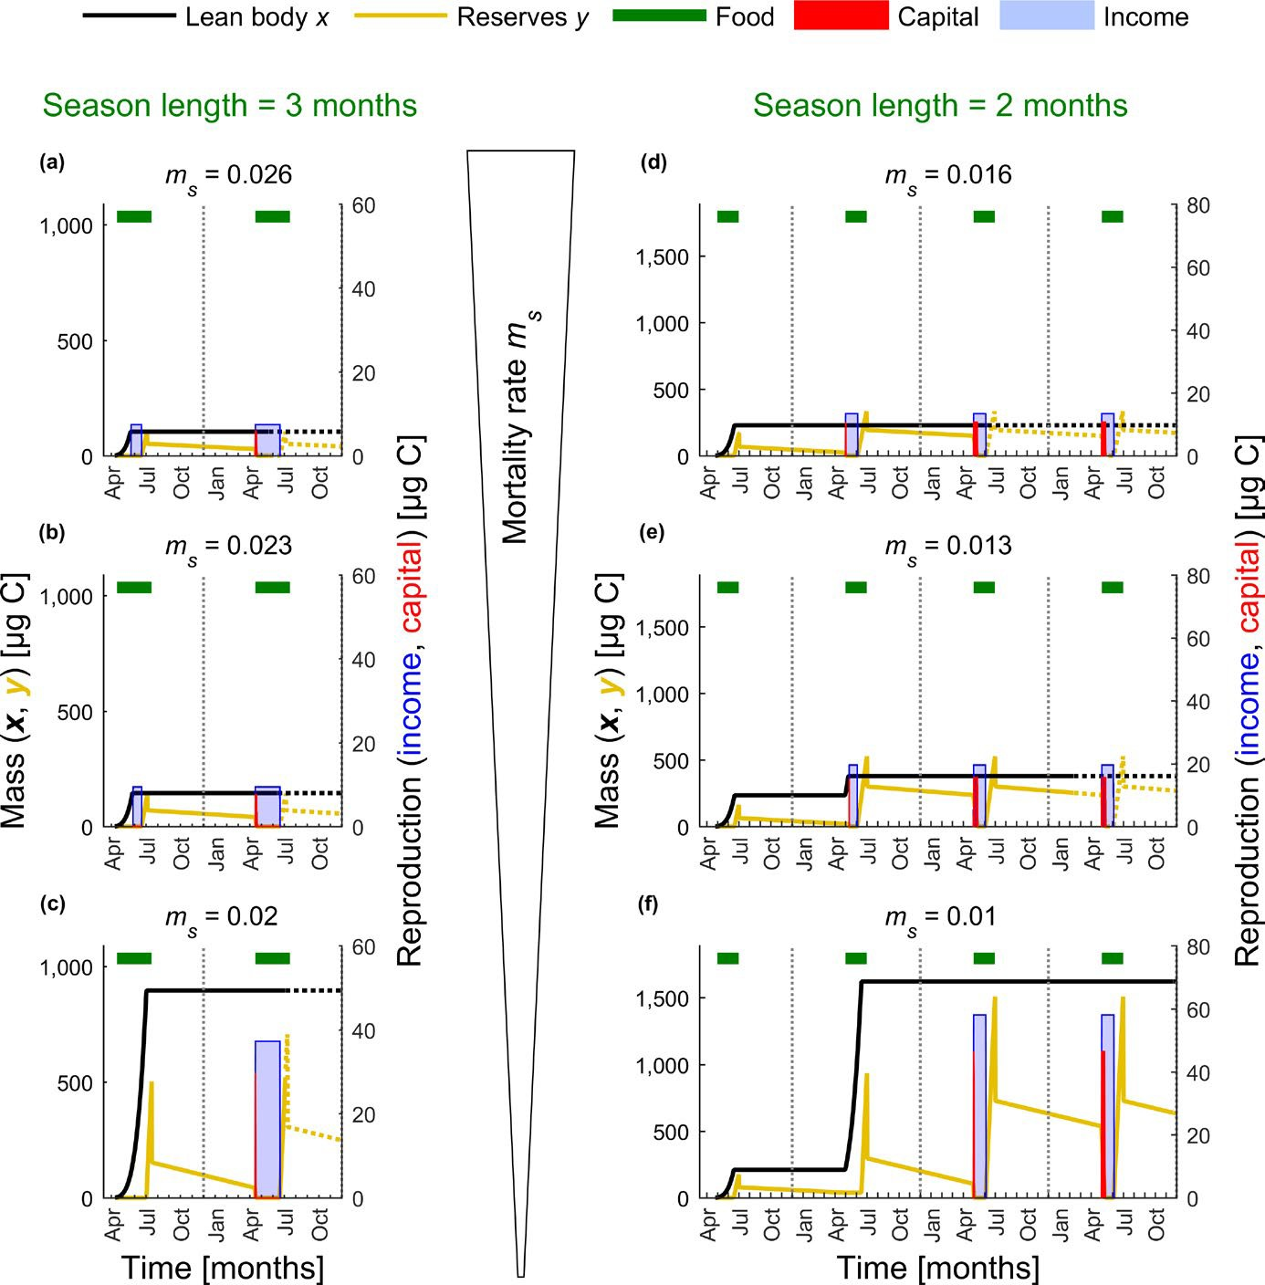
|
FunctionalEcology
EJSMOND_{Etal}.
2401
F I G U R E 3Lean body mass (body size), reserves and allocation strategies under decreasing mortality regime (schematically illustrated by the triangular shape). Decreasing mortality rate leads to a switch in age at maturation associated with a dramatic increase in body size and reserves: (a–c) a switch from 1‐ to 2‐year life cycle for season length set to 3 months, (d–f) a switch from 2‐ to 3‐year life cycle for season length set to 2 months. (a–f) Individual trajectories of lean body mass and reserves turn dotted when survival chance drops below 0.01. The ticks on thex‐axis represent months. See red lines in Figure 4b that illustrate the position of the scenarios illustrated in a–f mapped on the full parameter space
4|DISCUSSION
can be postponed to the following season (see also Kozłowski & Wiegert,1987;Walczyńska et al., 2010). Multivoltines differ from uni‐ and semivoltines with respect to the evolutionary forces under- lying evolution of adult size. In uni‐ and semivoltines, the main se- lectiveforceisthetrade‐offbetweenallocationtogrowth,storage
and reproduction optimized within a limited period of time (season).
4.1|Seasonality and adult body size
Variation in season length drives body size clines in determinate growers; a shorter season means less time available for growth unless the survival prospects are high enough so that maturation

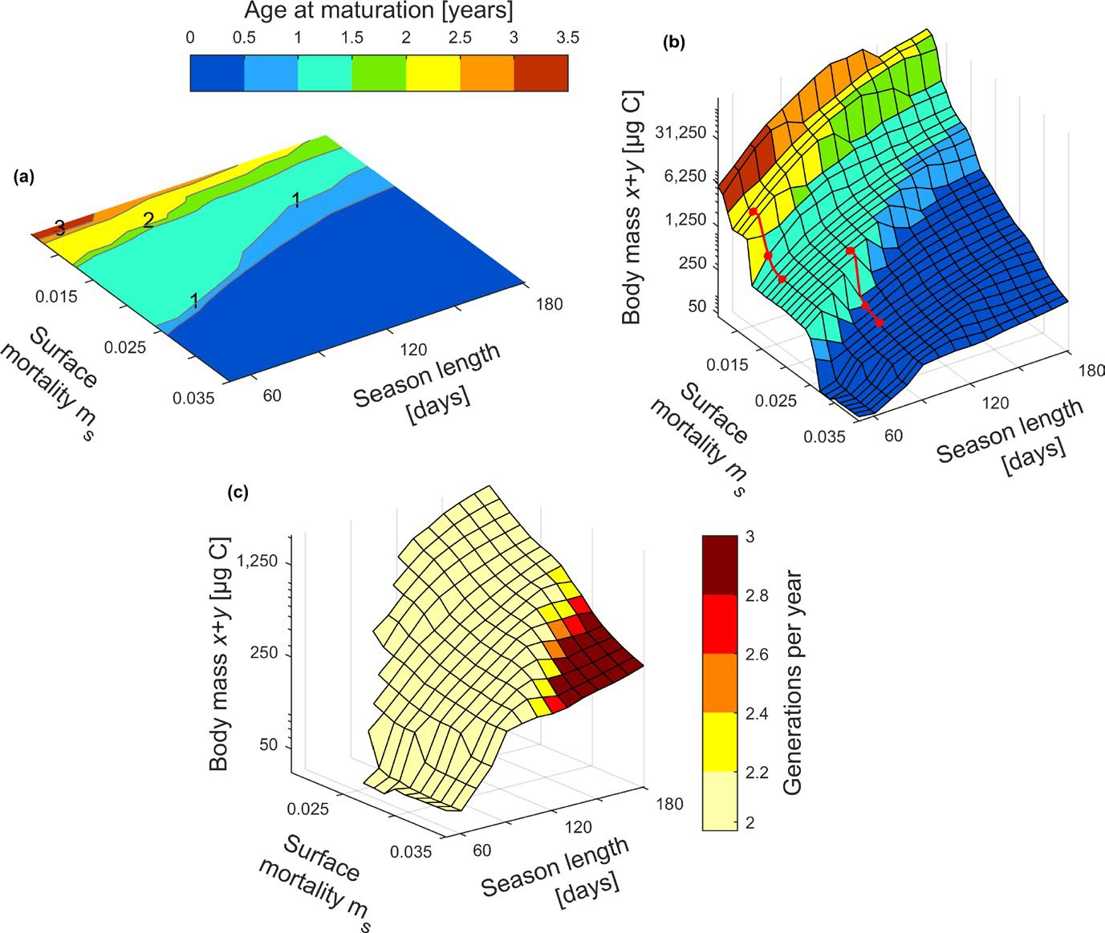
|
FunctionalEcology
2402
EJSMOND_{Etal}.
F I G U R E 4The age at maturity and total body mass (lean body + reserves) represented along gradients of background mortality rate in surface watersmsand the duration of season length. Panels illustrate average characteristics for individuals born when offspring valueμ>0.9,thatisearlyintheseasonandwithahighcontributiontofitness.(a,b)Thesurfacecoloursrepresentageatmaturation.(b)Thick
red lines match the combination of season length and mortality rate used to produce panels in Figure 3. (c) The surface colour indicates the average number of generations for multivoltine females born atμ> 0.9. The number of generations was counted by following trajectories of individual females, their daughters and grand‐daughters (see Supporting Information Figure S1). For clarity of presentation, panel c shows results for bivoltine and multivoltine life histories only
In multivoltines, the trade‐off between growth and storage is a rel- evant selective force when the season is short (Figure 5e). However, the longer the season, the more important is the optimization of the number vs. length of generations (Figure 4c); high number of generations per year means early maturation and small body mass. Roff (1980) predicted body size shifts in multivoltine, semelparous arthropods arising from optimization of generation length, but he did not consider allocation to storage. Semelparity creates a strong selection force synchronizing timing of reproduction with season length. Furthermore, many models with assumed iteroparity and noreservespredictnoshiftsinbodysizeinresponsetovariations
in season length (e.g., Abrams et al., 1996). However, low mortality
rate during diapause could significantly extend the period of growth (e.g.,Kozłowski&Wiegert,1987).Ourresultsextendthepredictions by Roff (1980) and show that for multivoltine life histories, even if generations are overlapping, the trade‐off between generation length and number drives evolution of adult size in arthropods (see Figure4c(thisstudy),Kivelaetal.,2013).
It would be incomplete to discuss the selection gradients in body size driven by season length without referring to the large‐scale pat- terns observed across latitude—which for many environmental vari- ables provide gradients of season length. The saw‐tooth latitudinal clines in body size (shifts in adult size with latitude) documented in
several species, such as cricketsAllonemobious fasciatus(Mousseau

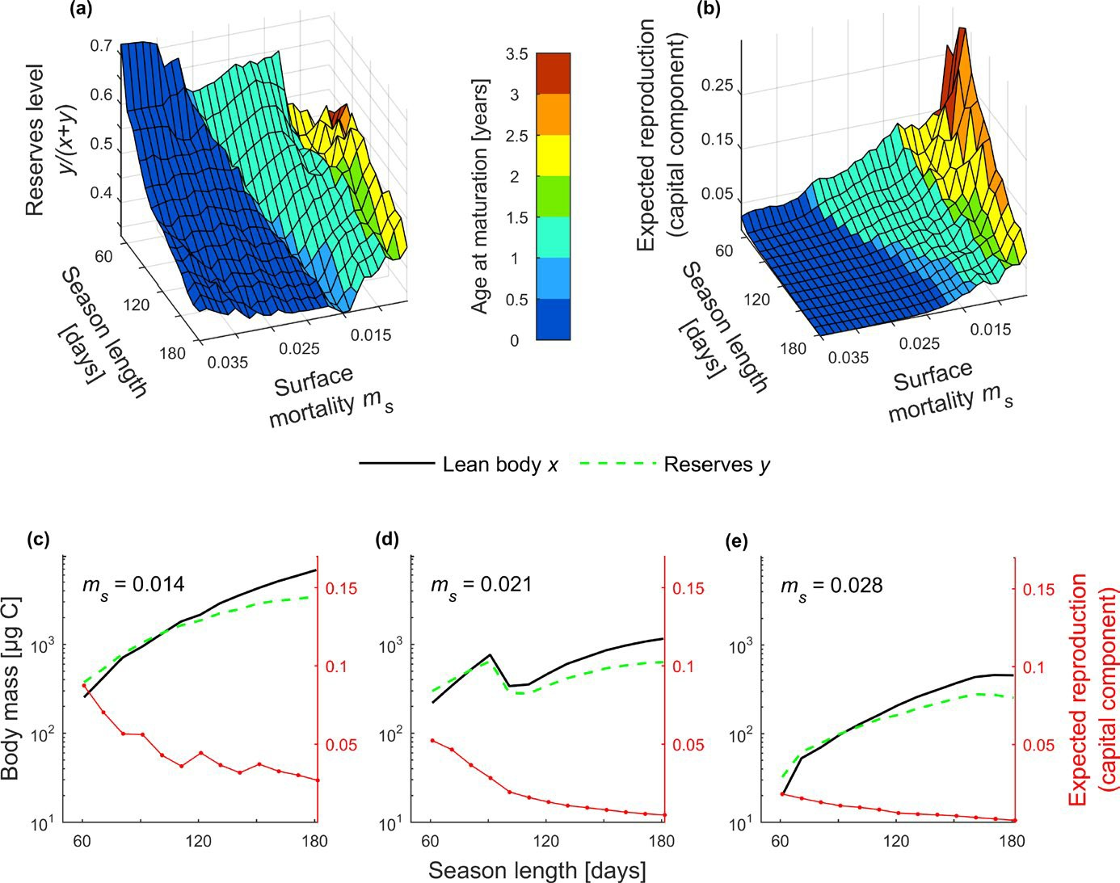
|
FunctionalEcology
EJSMOND_{Etal}.
2403
F I G U R E 5The level of reserves, the degree of capital breeding and body size (lean body mass) presented along gradients of background mortality rate in surface watersmsand the duration of season length. (a, b) The surface colours in panels a and b represent age at maturation. (c–e) Lean body mass, reserves and degree of capital breeding for three exemplary gradients of season length, with season length and mortality risk assumed uncorrelated. (d) Note the shift in body size caused by the change in number of generations per year. Panels illustrate average characteristics for individuals born when offspring valueμ> 0.9, that is early in the season and with a high contribution to fitness
& Roff, 1989) or butterfliesLycaena hippothoe(Fischer & Fiedler, 2002), are not the prevailing pattern in arthropods (Horne, Hirst, & Atkinson,2015;Shelomi,2012).Instead,therearemanyexamplesof continuous change with latitude. For instance in some Geometridae moths size increases with season length (Kivela, Valimaki, Carrasco, Maenpaa,&Oksanen,2011),whereasyellowdungflies(Scathophagastercoraria)attain larger size at shorter seasons (Blanckenhorn & Demont, 2004). In general, the body size of many arthropods fol- low Bergmann’s rule, that is, increases with latitude (Horne et al., 2015)or,as in insects, show an equiprobable Bergmann and con- verse Bergmann cline (Shelomi, 2012). Our model predicts a con- verse Bergmann cline or saw‐tooth cline when background mortality and season length are uncorrelated (see Figure 5c–e). Overall, the predicted trends in body size depend on the assumedcorrela-
tion between season length and mortality rate, which is similar to
predictions by Kozłowski, Czarnołęski, and Dańko (2004) for inde-
terminate growers.
4.2|Evolution of voltinism
When season length does not correlate with mortality rate, the full continuum of life cycles from multi‐ to semivoltines can only be achieved by varying mortality risk (see Figure 4a). However, both shortseasonlengthandinparticularlowbackgroundmortalityselect for semivoltine life histories in our model. The role of mortality rate for the postponed maturation in semivoltine determinate growers is described in several studies (e.g., Charnov, 1993; Kozłowski, 1992), but the effect of season length on the evolution of postponed matu- ration in determinate growers has not been discussed before. Our modelpredictsthatsemivoltinearthropodswithmuchpostponed

|
2404 FunctionalEcology
EJSMOND_{Etal}.
maturation would live only in safe environments and are more likely to be selected for when season length is short. Indeed, marine co- pepods or dragonflies at high latitudes are semivoltine in contrast to conspecifics living in temperate regions (Conover, 1988; Corbet et al., 2006). StonefliesNemurellasp. display intraspecific variability in voltinism with univoltine southern populations and semivoltine at higher latitudes (Lillehammer et al., 1989). Our predictions of the evolution of uni‐ and semivoltine life cycles in arthropods with over- lapping generations extend the view by Kivela et al. (2013) derived for multivoltine species where season length is a major force driving the number of generations per year. Our model predicts that pro- longedjuvenileperiodinarthropodsismorelikelytoevolvewhen
short season length is associated with low mortality risk.
4.4|Season length and capital breeding
Short season and large body size predispose arthropods for high de- greeofcapitalbreedinginourmodel(seeFigure5b),butdonotselect forpurecapitalbreeding(consistentwithresultsbyVarpeetal.,2009). Purecapitalbreedinghas,however,evolvedinmanyarthropods.SomeNeocalanusspp.arepurecapitalbreedersunabletofeedintheiradult stage (Miller, Frost, Batchelder, Clemons, & Conway, 1984).Calanushyperboreuscan also be regarded as a pure capital breeder (Hirche, 2013),butitisiteroparousincontrasttothesemelparousNeocalanusspp. (see also Varpe & Ejsmond, 2018). The prevailing views about evolution of pure capital breeding in arthropods are based on verbal models(Bonnet,Bradshaw,&Shine,1998;Jönsson,1997)orassumed intheoreticalworkonlifehistoryofarthropods(e.g.,Sainmontetal.,2014;Walczyńskaetal.,2010).Overall,shortseasonsseemtoselect for a high degree of capital breeding—a boost in the rate of repro- duction during a narrow time window, but are not sufficient for pure capital breeding to evolve in ectotherms. Separation of breeding and feeding grounds and high mortality related to feeding during repro- duction are the strongest drivers responsible for evolution of pure capitalbreedinginectotherms(Bonnetetal.,1998).
Marine andterrestrial arthropodsarehighly diverse withre-specttodegreeofcapital breedingbutthereis aprevailing rep-resentationofthosewho combine income andcapital breeding(Daaseetal.,2013; Javois,Molleman,& Tammaru, 2011;Kivelaetal.,2012). In ourwork,capital breedingisindeedaccompaniedbyincomebreedingandoccursatthe beginningofthebreedingseason(cf.Varpe,2017).Egg productioninthe laterpartofthebreedingseasoniscovered with incomingresources.Sucha pat-ternhasalsobeen predictedbyearlier life‐historywork(Ejsmond,Varpe,Czarnoleski,&Kozłowski,2015;Varpeetal.,2009)andreportedinseveralarthropods.Adulthawkmoths(Amphionfloridensis) allocatecarbon storedduring thelarval stage(capital)oracquiredfromnectar(income)toproduceeggs,but thecapital breedingcomponentisonlyearlyinthebreedingseason(O’Brien, Schrag,&delRio,2000).Similardynamicsofagradualdecreaseofthedegreetowhichstored carbonisallocatedtoeggproductionhasbeen observedinparasiticwasps(Dinarmusbasalis) (Rivero,Giron,&Casas,2001). FleshfliesoftheSarcophagidae familyaremixedbreedersinthefirstclutch andalmostpure incomebreed- erswhenproducingthesecondclutch(Wessels,Jordan,&Hahn,2010).Marinezooplankton membersthat combinecapitalandin- comebreeding oftenusestoredlipidsearlytoproduceeggs(e.g., Hirche&Kattner,1993).This confirms theresultsbyVarpeetal.(2007)andEjsmondetal.(2015);thecontributionofreservestoreproduction(capitalbreeding)is arelevantfitnesscomponent whenanarrow time windowisavailableforproductionofearly
offspring that is of high reproductive value.
4.3|Seasonlengthandmortalityrisk—implications
for life histories of marine copepods
Large and lipid‐rich copepods are selectively preyed on by fish and determinelipidandenergyflowthroughmarineecosystems(Aksnes, Nejstgaard, Soedberg, & Sornes, 2004). There are so far few clear answers, as to how variation in season length affects the adult body size and body composition in marine copepods (Varpe, 2012).Arctic
C.hyperboreus, maturing in their 3th‐4th year of life, is ca.4–5times heavier than aC. glacialismaturing in its 2nd year of life, and more than10times heavier than bivoltineC.finmarchicus(Falk‐Petersen et al., 2009), although intraspecific variability in body size exists (Choquet et al., 2018). The Bergmann cline observed inCalanusspp. intheNorthernHemisphere(Conover,1988)fitswiththepredictions ofourmodelonlyifmortalitydecreasesalongwithseasonlength.In other words, the further north the lower the mortality risk. Little is known about the latitudinal trends in survival rate of marine copep- ods, but the abundance of visual predators and light conditions may correlatenegativelywithseasonlengthandcontributetoalowerrisk of death at high latitudes (Aksnes et al., 2004; Langbehn & Varpe, 2017).
Our work contributes to the current discussion on climate‐ drivenshiftsin the life history of Calanoid copepods by showing thatlengthof feeding season is not a sufficient factor for pre- dicting body size, reproductive strategy and voltinismshifts.The role of backgroundmortalityrate cannot be underestimated and there is a need for a comprehensive analysis of howmortalityrisk changes along with feeding season duration in marine environ- ments.Becausewe wanted to keep our work simple, we assumed backgroundmortalityindependent of size. There is an ongoing dis- cussion about the levels ofmortalityand the degree to which the risk of death changes with body size in marine copepods (Eiane,Aksnes,Ohman, Wood, & Martinussen, 2002; Ohman, 2012). The size dependence of risk may also depend on thetypeof predator with visual andtactilepredators expected toselectfor opposed sizespectra.Thus, instead of assuming size‐dependentmortalitywe focused on the background component ofmortalityrisk and consideredoptimallifehistorieswithexpectedlifedurationranging
from few weeks to several years.
ACKNOWLEDG EMENTS
WethankJanKozłowskifordiscussions andcommentson ear-
lier versions of the manuscript. The research was financed by

|
FunctionalEcology 2405
EJSMOND_{Etal}.
the National Science Centre in Poland, project nr. 2014/15/B/ NZ8/00236, the Research Council of Norway through projects nr. 216537, 227046 and 227139 and Jagiellonian University (DS/WB/
INoS/757/2018).
marinecopepodCalanusglacialis:Apan‐Arcticperspective.CanadianJournal of Fisheries and Aquatic Sciences,70, 871–884.https://doi.org/10.1139/cjfas‐2012‐0401
Eiane, K., Aksnes, D. L., Ohman, M. D., Wood, S., & Martinussen, M. B. (2002). Stage‐specific mortality ofCalanusspp. under different pre- dation regimes.Limnology and Oceanography,47, 636–645.https://doi.org/10.4319/lo.2002.47.3.0636
Ejsmond, M. J., McNamara, J. M., Søreide, J., & Varpe, Ø. (2018). Gradients of season length and mortality risk cause shifts in body size, reserves and reproductive strategies of determinate growers.Zenodo.https://doi.org/10.5281/zenodo.166313
Ejsmond, M. J., Varpe, Ø., Czarnoleski, M., & Kozłowski, J. (2015).
Seasonality in offspring value and trade‐offs with growth explain capital breeding.The American Naturalist,186, E111–E125.https://doi.org/10.1086/683119
Falk‐Petersen, S., Mayzaud, P., Kattner, G., & Sargent, J. (2009). Lipids and life strategy of ArcticCalanus.Marine Biology Research,5, 18–39.https://doi.org/10.1080/17451000802512267
Fischer, K., & Fiedler,K.(2002). Life‐history plasticity in the but- terflyLycaena hippothoe: Local adaptations and trade‐offs.Biological Journal of the Linnean Society,75, 173–185.https://doi.org/10.1111/j.1095‐8312.2002.tb01421.x
Hartnoll,R.G.(1984).Strategiesofcrustaceangrowth.AustralianMuseumMemoir,18,121–131.https://doi.org/10.3853/j.0067‐1967.18.1984.378Hirche, H. J. (1997). Life cycle of the copepodCalanushyperboreusin the Greenland sea.Marine Biology,128, 607–618.https://doi.
org/10.1007/s002270050127
Hirche, H. J. (2013). Long‐term experiments on lifespan, reproductive activity and timing of reproduction in the Arctic copepodCalanus hy‐perboreus.Marine Biology,160, 2469–2481.https://doi.org/10.1007/s00227‐013‐2242‐4
Hirche,H.J.,&Kattner,G.(1993).EggproductionandlipidcontentofCalanusglacialisinspring:Indicationofafood‐dependentandfood‐ independent reproductive mode.Marine Biology,117,615–622.https://doi.org/10.1007/BF00349773
Horne, C. R., Hirst, A. G., & Atkinson, D. (2015). Temperature‐size re- sponses match latitudinal‐size clines in arthropods, revealing critical differences between aquatic and terrestrial species.Ecology Letters,18, 327–335.https://doi.org/10.1111/ele.12413
Houston, A. I., & McNamara, J. M. (1999).Models of adaptive behaviour.
Cambridge, UK: Cambridge University Press.
Javois, J., Molleman,F.,& Tammaru,T.(2011). Quantifying in- come breeding: Using geometrid moths as an example.Entomologia Experimentalis Et Applicata,139, 187–196.https://doi.org/10.1111/j.1570‐7458.2011.01120.x
Jönsson, K. I. (1997). Capital and income breeding as alternative tac- tics of resource use in reproduction.Oikos,78, 57–66.https://doi.org/10.2307/3545800
Kivela, S. M., Valimaki,P.,Carrasco, D., Maenpaa, M. I., & Manttari, S. (2012). Geographic variation in resource allocation to the abdomen in geometrid moths.Naturwissenschaften,99,607–616.https://doi.org/10.1007/s00114‐012‐0940‐2
Kivela, S. M., Valimaki, P., Carrasco, D., Maenpaa, M. I., & Oksanen,
J. (2011). Latitudinal insect body size clines revisited: A criticalevaluation of the saw‐tooth model.Journal of Animal Ecology,80,1184–1195.https://doi.org/10.1111/j.1365‐2656.2011.01864.xKivela, S. M., Valimaki, P., & Gotthard, K. (2013). Seasonality maintains al-ternative life‐history phenotypes.Evolution,67, 3145–3160.https://
doi.org/10.1111/evo.12181
Kosobokova,K.N.(1999).Thereproductivecycleandlifehistoryofthe Arctic copepodCalanus glacialisin the White Sea.Polar Biology,22, 254–263.https://doi.org/10.1007/s003000050418
Kozłowski,J.(1992).Optimalallocationofresourcestogrowthandrepro- duction ‐ implications for age and size at maturity.Trends in Ecology &Evolution,7,15–19.https://doi.org/10.1016/0169‐5347(92)90192‐E
AUTHORS’ CONTRIBUTIONS
M.J.E., J.S. andØ.V.conceived the study. M.J.E., J.M.M. andØ.V.de- signed the model. M.J.E. performed the analyses. M.J.E. andØ.V.
wrote the article.
DATA ACCESSIBILIT Y
The model outcomes are available at the Zenodo open digital re- pository (accession number 166313;https://doi.org/10.5281/ze-
nodo.166313), Ejsmond, McNamara, Søreide, and Varpe (2018).
ORCID
Maciej J. Ejsmond
http://orcid.org/0000‐0002‐3598‐4578
R EFER EN CE S
Abrams, P. A., Leimar, O., Nylin, S., & Wiklund, C. (1996). The effect of flexible growth rates on optimal sizes and development times in a seasonal environment.American Naturalist,147, 381–395.https://doi.org/10.1086/285857
Aksnes,D.L.,Nejstgaard,J.,Soedberg,E.,&Sornes,T.(2004).Opticalcon- trol of fish and zooplankton populations.LimnologyandOceanography,49,233–238.https://doi.org/10.4319/lo.2004.49.1.0233
Blachowiak‐Samolyk, K., Soreide, J. E., Kwasniewski, S., Sundfjord, A., Hop, H., Falk‐Petersen, S., & Hegseth, E. N. (2008). Hydrodynamic control of mesozooplankton abundance and biomass in northern Svalbard waters (79–81 degrees N).Deep‐Sea Research Part Ii‐TopicalStudies in Oceanography,55, 2210–2224.https://doi.org/10.1016/j.dsr2.2008.05.018
Blanckenhorn, W. U., & Demont, M. (2004). Bergmann and converse Bergmann latitudinal clines in arthropods: Two ends of a contin- uum?Integrative and Comparative Biology,44, 413–424.https://doi.org/10.1093/icb/44.6.413
Bonnet, X., Bradshaw, D., & Shine, R. (1998). Capital versus income breeding: An ectothermic perspective.Oikos,83, 333–342.https://doi.org/10.2307/3546846
Charnov, E. L. (1993).Life history invariants: Some explorations of symmetryin evolutionary ecology. Oxford, UK: Oxford University Press.
Choquet, M., Kosobokova, K., Kwasniewski, S., Hatlebakk, M., Dhanasiri, A. K. S., Melle, W., … Hoarau, G. (2018). Can mor- phology reliably distinguish between the copepodsCalanus fin‐marchicusandC. glacialis, or is DNA the only way?Limnology andOceanography‐Methods,16, 237–252.https://doi.org/10.1002/lom3.10240
Conover,R.J. (1988). Comparative life histories in the generaCalanusandNeocalanusin high latitudes of the northern hemisphere.Hydrobiologia,167,127–142.https://doi.org/10.1007/BF00026299
Corbet,P.S.,Suhling,F.,&Soendgerath,D.(2006).VoltinismofOdonata: A review.International Journal of Odonatology,9,1–44.https://doi.org/10.1080/13887890.2006.9748261
Daase, M., Falk‐Petersen, S., Varpe, Ø., Darnis, G., Soreide, J. E., Wold, A., … Fortier, L. (2013). Timing of reproductive events in the

|
2406 FunctionalEcology
EJSMOND_{Etal}.
Kozłowski, J., Czarnołęski, M., & Dańko, M. (2004). Can optimal re- source allocation models explain why ectotherms grow larger in cold?Integrative and Comparative Biology,44, 480–493.https://doi.org/10.1093/icb/44.6.480
Kozłowski,J.,&Wiegert,R.G.(1987).Optimalageandsizeatmaturity in annuals and perennials with determinate growth.EvolutionaryEcology,1,231–244.https://doi.org/10.1007/BF02067553
Langbehn,T.J.,&Varpe,Ø.(2017).Sea‐icelossboostsvisualsearch:Fish foraging and changing pelagic interactions in polar oceans.GlobalChange Biology,23, 5318–5330.https://doi.org/10.1111/gcb.13797
Leu, E., Mundy, C. J., Assmy, P., Campbell, K., Gabrielsen, T. M., Gosselin, M., … Gradinger, R. (2015). Arctic spring awakening ‐ Steering principles behind the phenology of vernal ice algal blooms.Progress in Oceanography,139, 151–170.https://doi.org/10.1016/j.pocean.2015.07.012
Lillehammer,A.,Brittain, J. E., Saltveit, S. J., & Nielsen,P.S. (1989).Egg development, nymphal growth and life cycle strategies in Plecoptera.Holarctic Ecology,12,173–186.
McNamara, J. M., & Houston, A. I. (2008). Optimal annual routines:
Behaviour in the context of physiology and ecology.PhilosophicalTransactions of the Royal Society B: Biological Sciences,363, 301–319.https://doi.org/10.1098/rstb.2007.2141
McNamara, J. M., Welham, R. K., Houston, A. I., Daan, S., & Tinbergen,
J. M. (2004). The effects of background mortality on optimal repro- duction in a seasonal environment.Theoretical Population Biology,65, 361–372.https://doi.org/10.1016/j.tpb.2003.10.006
Miller, C. B., Frost, B. W., Batchelder, H. P., Clemons, M. J., & Conway,
R.E. (1984). Life histories of large, grazing copepods in a subarc- tic ocean gyre: Neocalanus plumchrus, Neocalanus cristatus, and Eucalanus bungii in the northeast pacific.Progress in Oceanography,13,201–243.
Morewood,W.D., & Ring,R.A.(1998). Revision of the life history of theHighArcticmothGynaephoragroenlandica(Wocke)(Lepidoptera: Lymantriidae).Canadian Journal of Zoology,76, 1371–1381.https://doi.org/10.1139/z98‐085
Mousseau, T. A., & Roff, D. A. (1989). Adaptation to seasonality in a cricket: Patterns of phenotypic and genotypic variation in body size and diapause expression along a cline in season length.Evolution,43, 1483–1496.https://doi.org/10.1111/j.1558‐5646.1989.tb02598.x
O'Brien, D. M., Schrag, D.P.,& del Rio,C.M. (2000). Allocation to repro- duction in a hawkmoth: A quantitative analysis using stable carbon isotopes.Ecology,81,2822–2831. https://doi.org/10.1890/0012‐96 58(2000)081[2822:ATRIAH]2.0.CO;2
Ohman, M. D. (2012). Estimation of mortality for stage‐structured zoo- plankton populations: What is to be done?Journal of Marine Systems,93, 4–10.https://doi.org/10.1016/j.jmarsys.2011.05.008
Rivero,A.,Giron,D., &Casas,J.(2001).Lifetime allocationofjuvenileand adultnutritional resourcestoeggproductionin aholometab-olousinsect.Proceedingsof the RoyalSocietyB‐Biological Sciences,268,1231–1237.https://doi.org/10.1098/rspb.2001.1645
Roff,D.(1980).Optimizingdevelopmenttimeinaseasonalenvironment: The ‘Ups and Downs’ of clinal variation.Oecologia,45,202–208.https://doi.org/10.1007/BF00346461
Sainmont, J., Andersen, K. H., Varpe, Ø., & Visser, A. W. (2014). Capital versus income breeding in a seasonal environment.The AmericanNaturalist,184, 466–476.https://doi.org/10.1086/677926
Journal of the Linnean Society,92, 241–252.https://doi.org/10.1111/(ISSN)1095‐8312
Śniegula, S., Johansson, F., & Nilsson‐Ortman, V. (2012). Differentiation in developmental rate across geographic regions: A photoperiod driven latitude compensating mechanism?Oikos,121, 1073–1082.https://doi.org/10.1111/j.1600‐0706.2011.20015.x
Śniegula, S., Nilsson‐Ortman, V., & Johansson, F. (2012). Growth pat- tern responses to photoperiod across latitudes in a Northern Damselfly.PLoS ONE,7, e46024.https://doi.org/10.1371/journal.pone.0046024
Stearns, S. C. (1992).The evolution of life histories. Oxford, UK: Oxford University Press.
Tammaru, T., & Haukioja, E. (1996). Capital breeders and income breed- ers among Lepidoptera ‐ Consequences to population dynamics.Oikos,77, 561–564.https://doi.org/10.2307/3545946
Tarling,G.A.,Shreeve,R.S.,Ward,P.,Atkinson,A.,&Hirst,A.G.(2004).
Life‐cycle phenotypic composition and mortality ofCalanoidesacutus(Copepoda: Calanoida) in the Scotia Sea: A modelling ap- proach.Marine Ecology Progress Series,272, 165–181.https://doi.org/10.3354/meps272165
Varpe, Ø. (2012). Fitness and phenology: Annual routines and zooplank- ton adaptations to seasonal cycles.Journal of Plankton Research,34, 267–276.https://doi.org/10.1093/plankt/fbr108
Varpe, Ø. (2017). Life history adaptations to seasonality.Integrativeand Comparative Biology,57,943–960.https://doi.org/10.1093/icb/icx123
Varpe, Ø., & Ejsmond, M. J. (2018). Semelparity and iteroparity. In G. Wellborn & M. Thiel (Eds.),Natural history of crustacea, volume 5: Lifehistories(pp. 97–124). Oxford, UK: Oxford University Press.
Varpe, Ø., Jørgensen, C., Tarling, G. A., & Fiksen, Ø. (2007). Early is better: Seasonal egg fitness and timing of reproduction in a zoo- plankton life‐history model.Oikos,116, 1331–1342.https://doi.org/10.1111/j.0030‐1299.2007.15893.x
Varpe,Ø.,Jørgensen,C.,Tarling,G.A.,&Fiksen,Ø.(2009).Theadaptivevalueofenergystorageandcapitalbreedinginseasonalenvironments.Oikos,118,363–370.https://doi.org/10.1111/j.1600‐0706.2008.17036.x
Walczyńska, A. (2010). Is wood safe for its inhabitants?Bulletin ofEntomological Research,100, 461–465.https://doi.org/10.1017/S0007485309990514
Walczyńska,A.,Dańko,M.,&Kozłowski,J.(2010).Theconsiderableadult size variability in wood feeders is optimal.Ecological Entomology,35,16–24.https://doi.org/10.1111/j.1365‐2311.2009.01142.x
Wessels,F.J.,Jordan,D.C.,&Hahn,D.A.(2010).Allocationfromcapitalandincome sourcestoreproduction shiftfromfirsttosecondclutchinthefleshfly,Sarcophaga crassipalpis.JournalofInsectPhysiology,56, 1269–1274.https://doi.org/10.1016/j.jinsphys.2010.03.033
SUPPORTING INFORMATION
Additional supporting information may be found online in the
Supporting Information section at the end of the article.
Shelomi, M. (2012). Where are we now? Bergmann's lato in insects.American Naturalist,180,511–519.org/10.1086/667595
rule sensuhttps://doi.
Howtocitethisarticle:EjsmondMJ,McNamaraJM,Søreide J, Varpe Ø. Gradients of season length and mortality risk cause shifts in body size, reserves and reproductive strategies of determinate growers.Funct Ecol.2018;32:2395–
2406.https://doi.org/10.1111/1365‐2435.13191
Snaell, N., Tammaru,T.,Wahlberg, N., Viidalepp, J., Ruohomaeki, K., Savontaus, M.‐L., & Huoponen,K.(2007). Phylogenetic relation- ships of the tribe Operophterini (Lepidoptera, Geometridae): A casestudyoftheevolutionoffemaleflightlessness.Biological

