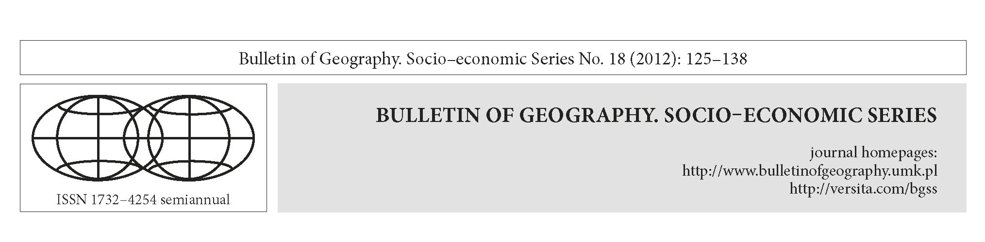

A comparative study of local railway networks in Poland
and the Czech Republic

Jakub Taczanowski
Jagiellonian University, Institute of Geography and Spatial Management, Gronostajowa 7, 30-387 Kraków, Poland; phone:
+48 126 645 296, e-mail: jakub.taczanowski@uj.edu.pl
Taczanowski, J., 2012: A comparative study of local railway networks in Poland and the Czech Republic. In: Szymańska, D. and
Biegańska, J. editors, Bulletin of Geography. Socio-economic Series, No. 18, Toruń: Nicolaus Copernicus University Press, pp. 125-138.
DOI: http://dx.doi.org/1Q.2478/v1QQ89-012-0Q25-1
Abstract. Despite similar economic and legal conditions in Poland and the Czech
Republic, the situation of local railway lines in each of these neighbouring coun-
tries is completely different. In Poland more than 90% of third-category and over
44% of second-category lines were closed down between 1989 and 2011, whereas
the Czech Republic did away with only 14% of its regional lines during the same
period. This means that two decades of transformation processes in Poland have
resulted in a massive decline in the importance of the regional railway network,
which is one of the most important symptoms of a rapid decline in the role of the
railway transport system as a whole. By contrast, the Czech Republic still has one
of the densest railway networks in Europe, thanks to the vital role of its local lines.
The main reasons for this big difference between the two countries - and for the
very minor importance of the regional railway service in Poland - are the lack of
a realistic transport policy at the state level and the badly conducted restructuring
of the national PKP railway company (PKP - Polskie Koleje Państwowe, Polish
State Railways). Other reasons are the poor state of the railway infrastructure and
also factors connected with the structure of settlement, as well as the historical de-
velopment of the railways in certain parts of the country. These factors have merely
reinforced an already vast bureaucracy and aggravated the wastage for which the
PKP was known during the communist period. The main question that arises con-
cerning the future is whether decision-makers in Poland at both national and re-
gional levels - as well as those in the railway companies themselves - will be able
to follow the Czech example, as this would appear to be the best solution for the
greatest crisis the Polish railway system has seen in decades.
© 2012 Nicolaus Copernicus University Press. All rights reserved.
Article details:
Received: 17 October 2011
Revised: 19 March 2012
Accepted: 25 September 2012
Key words:
Poland, Czech Republic, local
railway line, regional railway line,
rail transport, regional transport,
scaling down of railway systems.

Contents:
- Introduction. The concept of local railway lines and their role in the transport system 126
- The aim of the article and methods of research 126
- The delimitation of local railway lines in Poland 127
- Local railway lines in Poland at the end of the communist period and today 127
© 2012 Nicolaus Copernicus University Press. All rights reserved.

126
Jakub Taczanowski / Bulletin of Geography. Socio-economic Series 18 (2012): 125-138
- The delimitation of local railway lines in the Czech Republic 128
- Local railway lines in the Czech Republic at the end of the communist period and today 129
- Local railways in the Polish and Czech networks - a comparison 131
- The reasons for the differences 133
- A short comparison of approaches to the local railway question in other Central European
countries - Slovakia and Austria 135
10. Conclusions 136
References 137
- Introduction. The concept of local
railway lines and their role in the
transport system
Local railway lines are those which do not belong to
any network of national significance and which are
characterised by relatively low technical parameters
(a low minimum curve radius, a high maximum gra-
dient and low quality of the track). In many European
countries the responsibility for organising services on
these lines lies with local governments - which is why
national railway companies here often play a less im-
portant role than regional railway operators, includ-
ing those owned by private capital.
In Central Europe local railway lines were mostly
built between about 1880 and 1914, once the main
networks had been constructed. The main aim of local
railways was to connect towns of local importance, in-
dustrial plants or tourist resorts with the main railway
line. New local lines led to an increase in the density
of the country’s entire transport system. One impor-
tant benefit of these lines was that they boosted the
profitability of the main lines to which they were con-
nected (Kreft-Kettermann, 1989: 34). Local lines were
usually constructed by companies formed by local au-
thorities and industrialists, though with considerable
financial aid from the state. This was made possible
thanks to special local railway acts which were passed
by the parliaments of many countries (e.g. Prussia in
1879 and Austria-Hungary in 1880), which provided
for various tax exemptions - not only for those firms
which were responsible for the construction of local
railways, but also for those which were responsible for
running them (Kupka, 1898). Up to the second half of
the 20th century the local railways - which had a mo-
nopoly on passenger and goods transport - played
a vital role in the economy of the regions and exerted
a strong influence on their spatial organisation (Kreft-
Kettermann, 1989: 69). They stimulated building and
trade, increased the profitability of agriculture and
enabled workers to live outside industrial centres
(Koziarski, 1993a: 84).
The role of local railway lines underwent a com-
plete change in the second half of the 20th century be-
cause of the rapid growth of motorisation. Individual
road transport, which is much more flexible and of-
fers ‘door-to-door’ journeys, has in many cases dis-
placed local railways. Nowadays it is the car and not
the railway that has a fundamental bearing on spatial
organisation, not least because of its independence of
the fixed route (Kreft-Kettermann, 1989: 70).
The political, economic and social transformation
of Central-Eastern Europe has ushered in the rapid
growth of private motorisation, which has been ac-
companied by a fall in the significance of public
transport (Ivan, 2010: 394). This process has been
intensified by residential and industrial suburbani-
sation (Ivan, 2010: 395). As a result, the role of local
railway lines in the economy and in spatial organisa-
tion is nowadays generally less important. According
to Marada et al. (2006: 54) it is often limited to con-
necting mountainous areas (because of the higher
reliability of railways in winter) and to providing
services for tourists (because of the attractiveness of
a particular line). Even if the present significance of
local railways cannot be compared with their role at
the beginning of the 20th centrury, local railways can
nevertheless continue to be an important element
of the transport system at the regional level. Their
importance, however, differs significantly from one
country to another.
- The aim of the article
and methods of research
The aim of this article is to compare the respective
situations of local railway lines in Poland and the
Czech Republic and to attempt to discover the rea-
sons for any differences. In order to be able to discuss
the present importance of these railway lines in both
countries, we must first analyse their respective situa-
tions as they were in 1989.
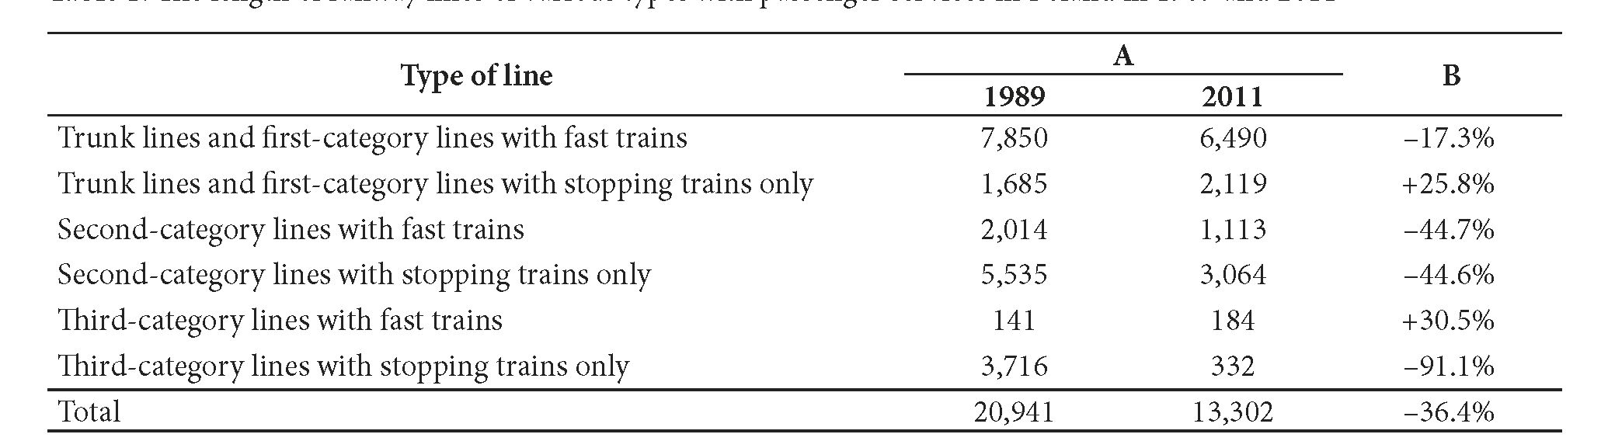
Jakub Taczanowski / Bulletin of Geography. Socio-economic Series 18 (2012): 125-138
127
The methods of research that were used comprise
an analysis of railway timetables, cartographic and
literature sources - including railway company docu-
ments and acts of parliament - and a basic quantita-
tive analysis of the railway networks of Poland and the
Czech Republic.
This article will discuss only normal-gauge railway
lines on which there is (or has been) a regular pas-
senger service on working days throughout the year.
Lines which operate only at weekends or during the
tourist season (e.g. Lębork - Łeba, Bon Les - Lednice
and Chomutov - Vejprty) are therefore excluded from
the present analysis.
- The delimitation of local railway lines
in Poland
In order to delimit local railway lines in the Polish
network, two criteria may be applied. The first is
a technical one and relates to the division of Polish
railway lines into four categories according to their
technical characteristics. This is an official classifica-
tion that can be found in a decree of the Ministry of
Transport issued in 1998. Classic local lines are those
belonging to the third category, whose official head-
ing reads ‘of local importance’ (in Polish: ‘znaczenia
miejscowego’ - Rozporządzenie Ministra Transportu
i Gospodarki Morskiej..., 1998). The author of the
present article, however, is of the opinion that second-
category lines can also be classified as local railway
lines - especially after 1989, which saw the begin-
ning of a vast scaling-down of the railway network in
Poland. The second criterion relates to the services on
the line. According to this criterion, local railway lines
are those on which only stopping trains (in Polish
‘pociąg osobowy’ - nowadays ‘pociąg regio’) operate.
In Poland neither criterion is very coherent (be it
for 1989 or for 2011), as on the one hand quite a few
second-category lines (and even some third-category
lines) were used by fast trains - especially in 1989 -
while on the other hand there are plenty of first-
category or even trunk-line sections where only stop-
ping trains are in service. This is connected with the
fact that many of these important lines are vital only
for freight trains (e.g. the ‘coal trunk line’ between
Herby Nowe and Inowrocław) or with the fact that
they play a strategic role as important interregional
connections (e.g. Piła - Tczew - as part of the former
Prussian Eastern Railway service between Berlin and
Gdańsk/Kaliningrad).
- Local railway lines in Poland at the end
of the communist period and today
Local railway lines as defined by both aforementioned
criteria were an important element of the Polish
railway network until the beginning of the 1990s.
They formed a dense system, particularly in the west-
ern and northern parts of the country, i.e. in those
regions which were in the German partition up to
1918 (Fig. 1).
The situation at the present time is completely dif-
ferent. The development of the Polish national rail-
way system since the beginning of the political, social
and economic transformation of the country begun
in 1989 has been characterised by a massive scaling
down of the network. Between 1989 and 2011 more
than 36% of the lines were taken out of passenger
Table 1. The length of railway lines of various types with passenger services in Poland in 1989 and 2011
Explanation: A - length (in km); B - B - 1989 to 2011 difference
Source: Compiled by the author on the basis of Sieciowy Rozkład Jazdy Pociągów 1988-1989 & 2010-2011 and D29.
Wykaz., 1985

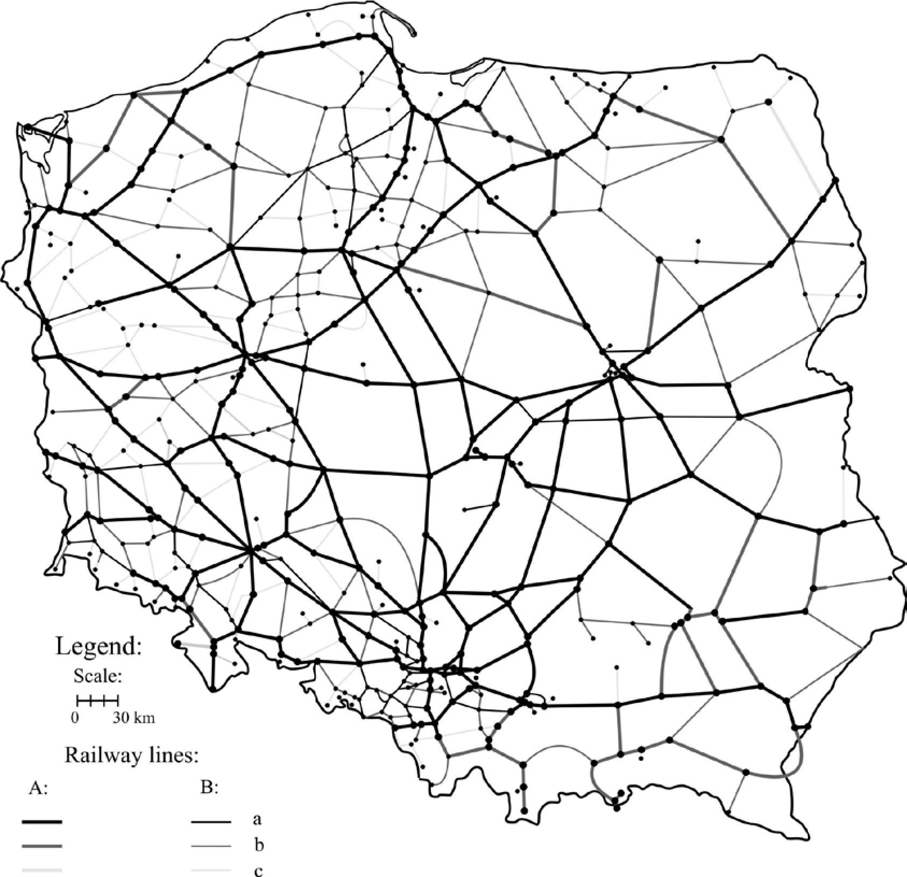
128
Jakub Taczanowski / Bulletin of Geography. Socio-economic Series 18 (2012): 125-138

Fig. 1. The Polish railway network in 1989
Explanation: A - on which there is a fast train service during the whole year; B - on which there is a stopping train service
only; a - trunk lines and first-category lines; b - second-category lines; c - third-category lines (lines of local importance)
Source: Compiled by the author on the basis of Sieciowy Rozkład Jazdy Pociągów 1988-1989; Stankiewicz, Stiasny, 2010;
D29. Wykaz., 1985
service (Table 1). The process of closing down those
railway lines which were seen as ‘uneconomic’ had
actually already begun during the communist pe-
riod, but the larger-scale changes date back to the
first years of the transformation. The intensity of this
scaling down of the Polish railway network was par-
ticularly high in the years 1988-1992 and 1998-2002
(Komusinski, 2010). Local lines - especially those of
the third category - were the first to be closed down
for passenger service. More than 90% of them disap-
peared from the map of the Polish passenger railways
between 1989 and 2011 (Table 1). As a result, not
many local lines are now left. The regional differences
that were so significant in 1989 are today very small.
However, in the western part of Poland the number
and density of local lines is still slightly higher than
in other regions (Fig. 2). The quantitative changes in
Polish railway lines of different types between 1989
and 2011 are shown in Table 1.
- The delimitation of local railway lines
in the Czech Republic
An unequivocal delimitation of local railway lines
in the Czech Republic is much easier because the
regional lines are listed in a Government resolution
of 1995 which excluded them from the network of
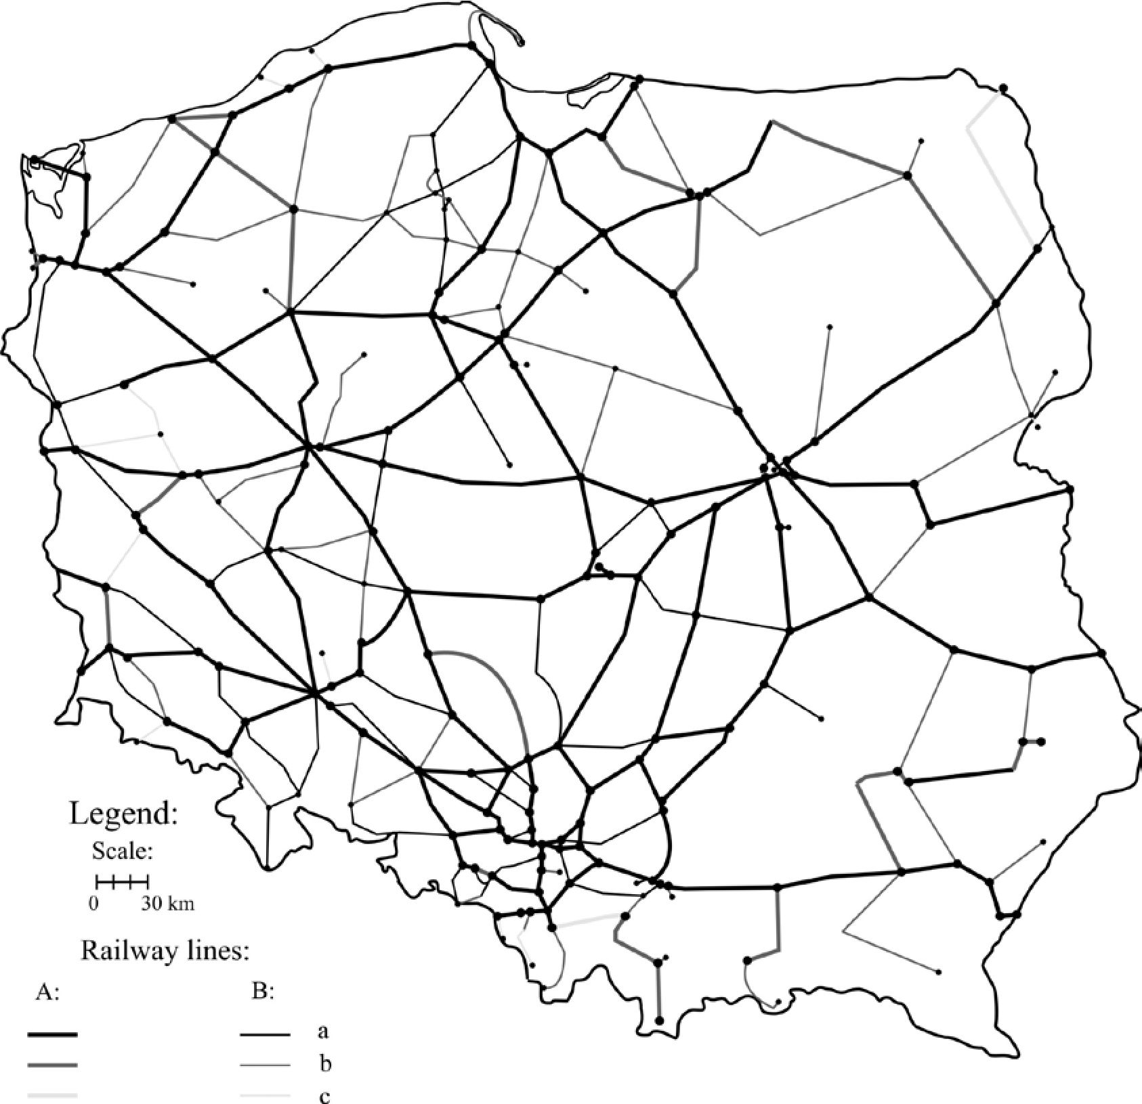
Jakub Taczanowski / Bulletin of Geography. Socio-economic Series 18 (2012): 125-138
129

Fig. 2. The Polish railway network in 2011
Explanation: A - on which there is a fast train service during the whole year; B - on which there is a stopping train service
only; a - trunk lines and first-category lines; b - second-category lines; c - third-category lines (lines of local importance)
Source: Compiled by the author on the basis of Sieciowy Rozkład Jazdy Pociągów 2010-2011; Stankiewicz, Stiasny, 2010;
D29. Wykaz., 1985
nationally important railways (Usneseni vlady Ceske
republiky..., 1995). The list comprises 128 lines,
which are in fact 133 sections (including all three
Czech narrow-gauge lines and two lines which no
longer existed in 1989) - thus 128 sections. However,
the service criterion can also be applied to the Czech
case, and so local lines are also those on which only
stopping trains (in Czech ‘osobni vlak’) as well as fast-
stopping trains (in Czech ‘spesny vlak’) now run.
Both criteria are quite coherent, as all the ‘offi-
cial’ regional lines are used only by stopping trains.
However, there are some sections belonging to the
national network where only stopping trains are in
service.
- Local railway lines in the Czech
Republic at the end of the communist
period and today
Local railway lines have always played a very impor-
tant role in the Czech Republic (before 1993 in the
Czech part of Czechoslovakia). The extremely high
density of the Czech railway network (10.9 km/100
km² in 2011) is largely due to the great number of local
lines which exist in all parts of the country. Although
some sections were closed down after the end of
the communist period, there is not much difference
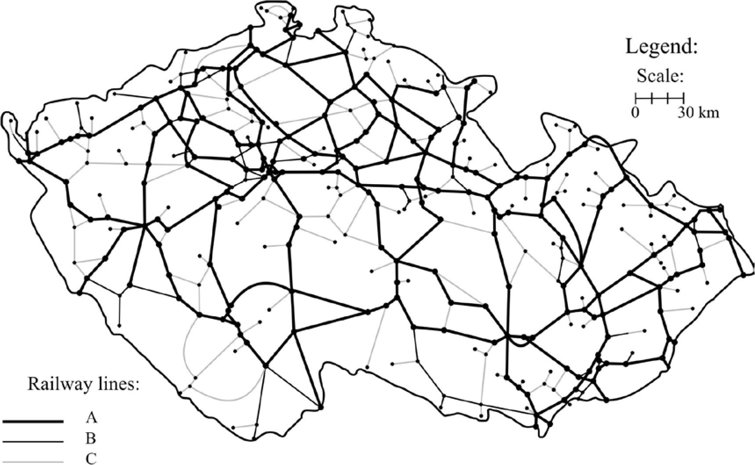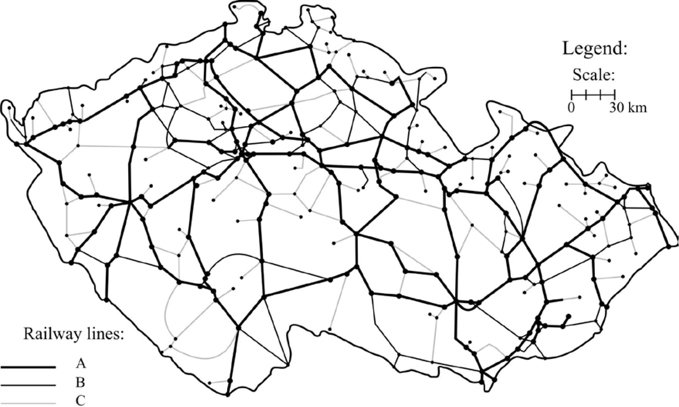
130
Jakub Taczanowski / Bulletin of Geography. Socio-economic Series 18 (2012): 125-138

Fig. 3. The Czech railway network in 1989
Explanation: A - of national importance on which there is a fast train service during the whole year; B - of national
importance on which there is a stopping train service only; C - regional lines (stopping trains only)
Source: Compiled by the author on the basis of Atlas drah Ceske republiky, 2006 and Jizdni fad CSD 1989-1990

Fig. 4. The Czech railway network in 2011
Explanation: A - of national importance on which there is a fast train service during the whole year; B - of national
importance on which there is a stopping train service only; C - regional lines (stopping trains only)
Source: Compiled by the author on the basis of Atlas drah Ceske republiky, 2006 and Jizdni fad 2011
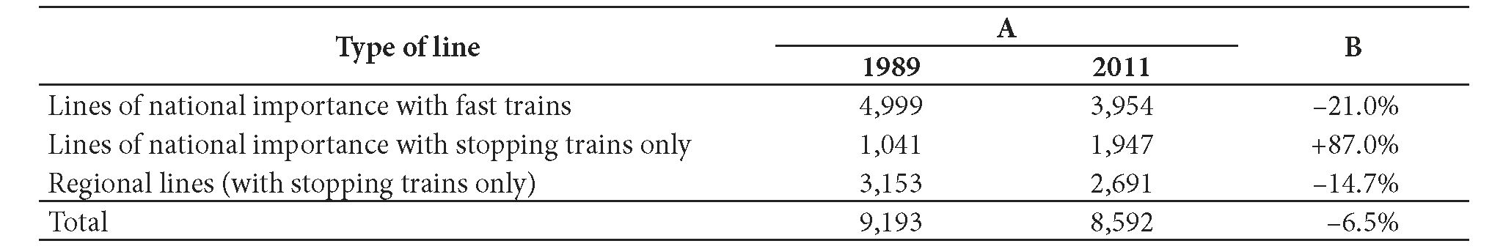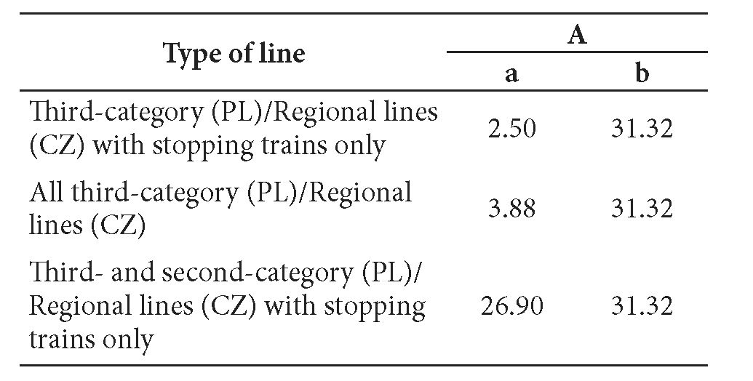
Jakub Taczanowski / Bulletin of Geography. Socio-economic Series 18 (2012): 125-138
131
Table 2. ^e length of railway lines of various types with passenger services in the Czech Republic in 1989 and 2011
Explanation: A - length (in km); B - B - 1989 to 2011 difference
Source: Compiled by the author on the basis of Jizdni fad 1989-1990 & 2010-2011 and Usneseni vlady Ceske republiky...,
1995
between the Czech network of 1989 and that of 2011
(Fig. 3 and 4). Of 128 local lines that were listed in the
resolution of 1995, 104 were still in use for passenger
services in 2011. ^e quantitative changes in Czech
railway lines of different types between 1989 and 2011
are shown in Table 2.
A characteristic feature of Czech local railways
is the high percentage of dead-end lines. These are
often lines which were built to connect a tourist re-
sort or a town of local importance with the main line
(e.g. Martinice v Krkonosich - Rokytnice nad Jizerou
or Suchdol nad Odrou - Novy Jicin mesto). In 1989
of 128 local railway lines, 75 were dead-end lines
(1,123 km out of 3,153 km) and in 2011 the figure
was 58 out of 104 lines (901 km out of 2,651 km).
^e change between 1989 and 2011 is, of course, due
to the closing down of some lines. However, two lines
running to the border which had been shortened after
the Second World War were reopened after 1989 and
so are no longer dead-end lines (Tanvald - Harrachov,
extended to the Polish border, and Sokolov - Kraslice,
extended to the German border).
- Local railways in the Polish and Czech
networks - a comparison
In Poland local railway lines now play hardly any part
in the country’s transport system. More that 90% of
sections of local importance (third-category lines)
were closed down for passenger traffic between 1989
and 2011. ^ose which are still in operation - to-
gether with some second-category lines and degraded
main connections - are in fact a rather unimportant
and neglected element of the Polish railway network.
After 1989 many first-category lines and even trunk
lines (which used to play an important role as inter-
regional connections) were degraded and are now de
facto local lines (e.g. Kędzierzyn Koźle - Nysa and
Leszno - Głogów). Moreover, the number of trains is
usually smaller and journey times are usually longer
than they were in 1989. Komusiński (2010: 42-44)
has examined this problem on the example of eight
railway lines, two of which are second-category lines
and three of which are lines with stopping trains only.
Between 1988 and 2008 on two lines with stopping
trains only the number of trains decreased by 50-57%,
while only one line maintained the frequency it had
had in 1988. ^e average speed of trains decreased on
one line by 18%, while it increased by 12% and 19%
on two other lines. However, Komusiński (2010: 46)
stresses the fact that these speeds of about 50 km/h
at the very most (and on some lines 30 km/h or even
less) cannot be said to come up to passengers’ expec-
tations. ^is is a reflection of the poor state of the rail-
way infrastructure and is also characteristic of many
main lines. The percentage share of local lines in the
total length of the railway networks of Poland and the
Czech Republic are shown in Table 3.
Table 3. ^e percentage share of local lines in the total
length of the railway networks of Poland and the Czech
Republic in 2011
Explanation: A - percentage share in the total length of the
railway network; a - Poland; b - Czech Republic
Source: Compiled by the author on the basis of Sieciowy
Rozkład Jazdy Pociągów 2010-2011, Jizdni fad 2010-2011,
D29. Wykaz., 1985 and Usneseni vlady Ceske republiky...,
1995

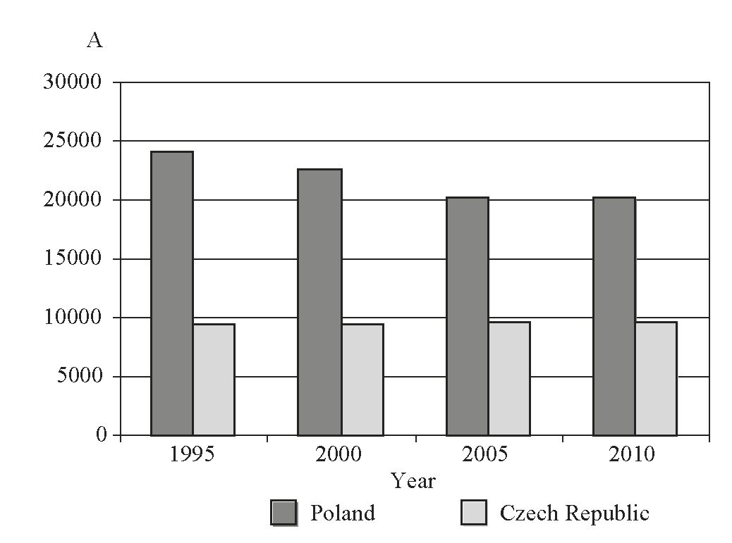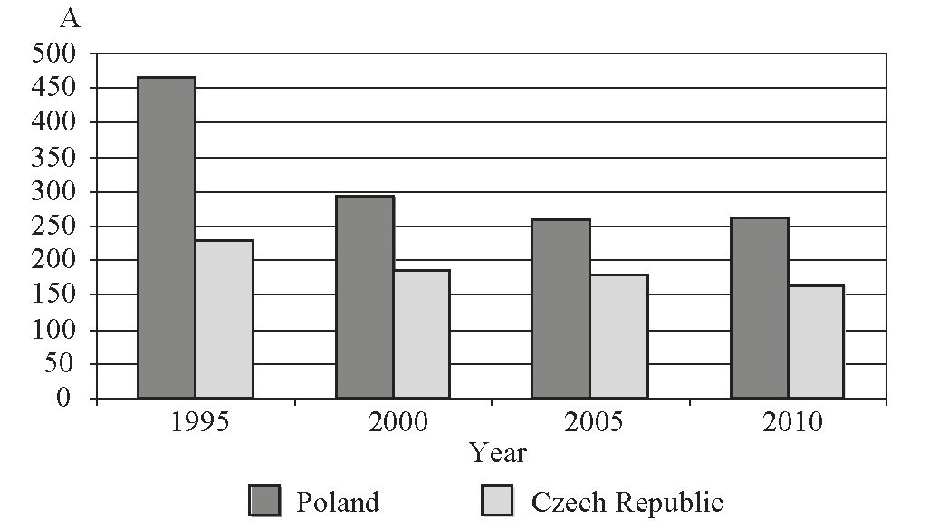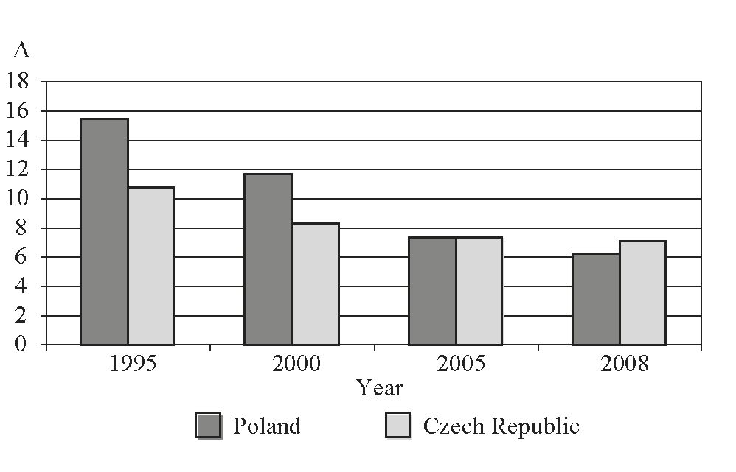
132
Jakub Taczanowski / Bulletin of Geography. Socio-economic Series 18 (2012): 125-138
The table shows that all the Polish third-category
lines, together with the second-category lines where
only stopping trains are in service, make up just
26.9% of the total length of the network that is avail-
able for passenger services; ‘real’ local lines (i.e. those
of the third category) account for only 3.9%, while
third-category lines used only by stopping trains ac-
count for just 2.5%. Although local differences in the
distribution of these lines are not very significant,
the western and northern parts of Poland continue
to have slightly denser networks. These, however,
are now mostly isolated sections. More extensive
systems of local lines - albeit degraded main lines -
are located south of Gdańsk (Chojnice, Wierzchucin,
Grudziądz), in the vicinity of Poznań and in Lower
Silesia.
In the Czech Republic, by contrast, the decrease
in the length of local railway lines between 1989 and
2011 was very small and was limited to certain sec-
tions of very low importance. The regional lines are
still a vital element of the railway system; they make
up 31.3% of the total length of the Czech railway
network, which is not much less than the 34.3% that
it was in 1989. It should be stressed that - unlike in
Poland - the standard of service on these lines is usu-
ally comparable with that of 1989, owing to similar
or even smaller time intervals between the trains.
Moreover, the Czech railway infrastructure is gener-
ally in quite good condition.
Fig. 5. The total length of the railway networks of Poland
and the Czech Republic in 1995, 2000, 2005 and 2010
Explanation: A - the total length of the railway lines [km]
Source: Compiled by the author on the basis of: Rocenka
dopravy Ceské Republiky 1999, 2005 & 2010 on the
webpages www.sydos.cz (2012); www.stat.gov.pl (2012);
http://epp.eurostat.eu (2012); www.kolej.most.org.pl (2012)
There are few regional differences in the distri-
bution of local railway lines in the Czech Republic,
whose network is almost evenly dense. A more sig-
nificant concentration of these lines is characteristic
for Central Bohemia and Northern Moravia, includ-
ing Czech Silesia. Not surprisingly, the former region
includes counties (Czech okresy) where most com-
muting is done by rail. In the latter region - as in the
whole of the eastern part of the Czech Republic - the
level of motorisation is low and this correlates with
the fact that a greater proportion of commuting is
done using public transport (albeit more by bus than
by rail - Marada et al, 2006: 55-56).

Fig. 6. The total number of passengers transported by the
railways in Poland and in the Czech Republic in 1995, 2000,
2005 and 2010
Explanation: A - the total number of passengers [million]
Source: Compiled by the author on the basis of: Rocenka
dopravy Ceské Republiky 1999, 2005 & 2010 on the
webpages www.sydos.cz (2012); www.stat.gov.pl (2012);
www.kolej.most.org.pl (2012)
Fig. 7. The percentage share of rail transport in total
passenger-kilometres in Poland and the Czech Republic in
1995, 2000, 2005 and 2008
Explanation: A - the percentage share of rail transport in
total passenger-km
Source: Compiled by the author on the basis of: http://epp.
eurostat.eu (2012)
Jakub Taczanowski / Bulletin of Geography. Socio-economic Series 18 (2012): 125-138
133
The considerable difference in the importance of
local railway lines in Poland and in the Czech Republic
is just one aspect of the fundamentally different ap-
proach to rail transport in each country. Although the
railways still played an important role in the transport
systems of both countries at the end of the commu-
nist period, the first decade of free market economics
brought about a complete change. Figures 5-7 show
the most important indicators for Poland and the
Czech Republic for the period 1995-2008/2010: the
total length of the railway networks, the number of
passengers transported and the percentage share of
rail transport in total inland passenger-kilometres.
Fig. 5 shows that the total length of the railway
network in Poland decreased between 1995 and 2010
from 23,986 km to 20,228 km (i.e. by 15.7%), whereas
it increased from 9,430 km to 9,568 km in the Czech
Republic (i.e. by 1.5%). The data refers to the total
length of the network, i.e. also to lines with freight
trains only.
What is much more interesting from the point
of view of passenger transport analysis, however, is
a comparison of the numbers of passengers trans-
ported by rail in Poland and in the Czech Republic
(Fig. 6). The decrease in Poland was rather dramatic -
from 465.9 million in 1995 to 261.3 million in 2010
(i.e. 43.9%). A fall in the number of rail passengers
in the 1990s and 2000s was also characteristic for the
Czech Republic, but the scale was considerably small-
er - 27.4%. What is more, a stabilisation of the num-
ber of passengers can be seen after 2005. This would
seem to indicate that over recent years the number
of passengers - especially those using rail transport
frequently (i.e. commuters) - has levelled off and is
not likely to undergo significant changes (Pospisil,
Polansky, 2006: 81).
Probably the best illustration of the different
role played by the railways of both countries in the
transport of passengers is a comparison of their re-
spective percentage shares in passenger-kilometres.
While in 1995 the Polish State Railways transported
15.5% of inland passengers, this share later decreased
to a mere 6.2% in just 13 years. In other words, the
present impact of rail on the Polish transport market
can be described as falling far short of its potential. In
the Czech Republic the fall was less significant - from
10.8% in 1995 to 7.1% in 2008. This shows that the
Czech railways too have suffered somewhat as a result
of the increasing number of private cars, though to
a much lesser extent. Indeed, by contrast with Poland,
the main losers in the competition with individual
road transport have been public bus services and not
the railways (Benes et al., 2008: 39).
- The reasons for the differences
The reasons for the insignificant role of local railway
lines in Poland are to a large extent synonymous with
the causes of the general crisis in the national railway
system, the symptoms of which are listed above. It is
the view of the author of the present article that the
condition of local railways can to a certain extent be
seen as being one of the indicators of the general state of
a country’s entire railway transport system. The main
lines cannot be taken as such an indicator, as they are
invariably given much more attention by the authori-
ties and, as a result, are often the only railways that
are in relatively good condition. A good example of
a country where the role of regional and local railway
services is rather insignificant while at the same time
many new high speed lines are being built is Spain (or,
in part, France). The reasons for the general decline of
the railways in Poland have been listed in many pub-
lications, e.g. by Taylor (2007) and Koziarski (1993b,
1995). Taylor (2007) divides them into two categories:
external, i.e. those inherent in the State, and internal
ones, i.e. those inherent in the Polish State Railways
and its present successors. Among the former the
most important factor is the railway transport policy
of the State, which Taylor describes as being incom-
petent, deficient and inconsistent (Taylor, 2007: 183).
One of the most significant results of this policy is the
very bad financial situation of Polish railways (Taylor,
2007: 183-185). This permanent financial crisis has
a bearing on the condition of rolling stock and, in
particular, on infrastructure, whose condition - in the
present author’s opinion - can only be described as
disastrous. In his book on the railway system of the
industrial urban agglomerations of the southern mac-
roregion of Poland - written at the end of the com-
munist period - Koziarski (1989: 39) sees the poor
state of the infrastructure as being one of the most
important reasons for the closing down of local rail-
way lines in this part of Poland. The areas of neglect
listed by Koziarski - the poor condition of the track,
points, signal systems and also the rolling stock - have
plagued local rail connections in all regions of Poland
since the 1980s or even earlier. Koziarski (1993b: 177)
writes that many local lines remained in service un-
til the condition of the infrastructure finally made it
impossible for it to be used any more. The author of
the present article is of the opinion that the closing
down of passenger services on several ‘uneconomic’
Polish railway lines bears all the hallmarks of a vicious
circle. The low number of passengers results in low
134
Jakub Taczanowski / Bulletin of Geography. Socio-economic Series 18 (2012): 125-138
profitability, which in turn leads to the closure of the
service. The result has been a constant decrease in the
number of passengers. This process - which is pecu-
liar not only to Poland - is described in many publica-
tions (e.g. Marada, Kvetoń 2010: 22). The restructur-
ing process of the PKP national railway company that
was begun in 2000 - and in particular the saddling
of the regional governments (voivodships) with re-
sponsibility for the Przewozy Regionalne company
(regional railway service) in 2009 - have multiplied
the problems mentioned above and have exacerbated
chaos on the Polish railways. Several companies are
active in the local railways sector: apart from the big-
gest railway company - Przewozy Regionalne - which
has 16 owners (i.e.all the voivodships), there are also
firms which operate only in one voivodship (Arriva
RP in the Kujawsko-Pomorskie voivodship) and re-
gional railway companies created by regional authori-
ties in the Mazowieckie, Śląskie, Dolnośląskie, and
Wielkopolskie voivodships. Paradoxically, this rather
high level of liberalisation has often brought with it no
improvement in standards of service - nor even better
management - because the decisions of local govern-
ments to create their own railway companies are fre-
quently purely political and the new companies quite
simply inherit or imitate the bureaucratic structures
of the PKP and the Przewozy Regionalne companies.
From among the internal reasons for the decline
of Polish railways, Taylor (2007) singles out disastrous
management, which manifests itself in wastage and
a lack of ideas for any improvement (Taylor, 2007:
190). The author of the present article thinks that
other consequences of bad management that ought
to be emphasised are the enormous bureaucracy
and unjustifiable proliferation of employees both
in the PKP and in its successor company Przewozy
Regionalne (or regional railway service). It is also his
opinion that one of the most disastrous aspects of this
wastage with respect to local railways was the rolling-
stock policy of the PKP up to the beginning of the
21st century. During the communist period and in
the 1990s the Polish State Railways used heavy die-
sel locomotives (e.g. class SU 45 or ST 43) with one
or two carriages - instead of light railcars - even on
minor lines. The restructuring process of the PKP in
the early years of the 21st century gradually changed
this situation, but it was a step taken at least 30 years
too late, when most of the local lines had already been
closed down.
The author of the present article is of the opinion
that in addition to the reasons given above for the
scaling down of the Polish passenger railway system,
certain general historical and geographical factors
deserve mention. In the 19th century policies relating
to the development of the railways in Poland did not
always take into consideration the needs of the inhab-
itants of the area where a new line was to be built.
This was especially true of the Russian partition, were
the government’s priority was to construct main con-
nections between the biggest cities in a straight line,
e.g. the Warsaw - Białystok - Vilnius - St. Petersburg
trunk line. As a result, many an important town
either had no railway station at all, or the station
was very far away from the town centre (Lijewski,
1986: 56). It was above all in the central and eastern
parts of Poland (in the former Russian partition) that
the location of many towns with regard to the railway
network was rather unfavourable, e.g. Zamość and
Łomża (which were voivodeships or county towns
between 1975 and 1998). Lijewski (1985: 20) stresses
that this factor, combined with the low density of
the railway network, the low frequency of trains and
a lack of coordination between timetables was re-
sponsible for the minor role played by rail transport
in journeys to county towns, e.g. the capitals of the
Suwalskie, Włocławskie and Sieradzkie voivodeships
(according to the former administrative division of
Poland into 49 voivodships between 1975 and 1999).
The author of the present article is also of the opinion
that one factor which has favoured the rapid decline
in the role played by Polish railways in commuting -
especially after 1989 - is the scattered distribution of
settlement and workplaces in the country. The po-
litical, social and economic transformations begun
in the 1990s have increased this scattering, which is
connected with processes such as suburbanisation
and the decline of traditional heavy industry. This has
usually led to a lengthening of the walking distance to
the nearest railway station, which is one of the most
important factors taken into consideration when
deciding which form of public transport to choose
for commuting (Ivan, 2010: 397, 409). As a result, it
has no longer been possible - or even relatively sim-
ple - to maintain the important role of the railways as
a means of transport used by commuters, especially
given the extremely rapid growth of motorisation and
the equally rapid development of private bus compa-
nies in many parts of the country.
The reasons for the totally different situation of
local railways in the Czech Republic are to a certain
extent the exact opposite of the circumstances of the
development of the railways in Poland. The author
of the present article is of the opinion that the most
important factors which enabled the Czechs to main-
tain a very dense local line network were the coun-
try’s transport policy and the management policies of
Jakub Taczanowski / Bulletin of Geography. Socio-economic Series 18 (2012): 125-138
135
Czech State Railways (CD), as well as the fact that the
historical and geographical factors which affected the
development of the railways in the Russian partition
of Poland do not apply (to any significant extent, at
least) in the case of the Czech Republic.
The Czech State transport policy with respect to
the railways (also at a local level) includes concrete
items such as the introduction of lines on which
trains should run at regular intervals and the inte-
gration of rail and road transport in the regions by
means of a common fare system (Dopravni politika
Ceske republiky: 2005). Although - as in Poland -
responsibility for regional transport in the Czech
Republic now lies with the governments of the re-
gions (in Czech kraje) this does not on the whole
lead to disputes relating to competence and financial
problems, as the authorities are aware of the fact that
a stable offer regarding public transport in the regions
must be maintained.
The second important reason for the success of
local railways in the Czech Republic is the manage-
ment policy of the passenger-train operator CD.
Paradoxically, the level of liberalisation of the railway
market in the Czech Republic is much lower than
in Poland, as only five regional railways (of a total
length of 130 km) are run by companies other than
Czech State Railways. However, the management
policies of the national company have been success-
ful, the prime example being a proper rolling-stock
policy that has resulted in investments in rail cars,
which have a lower fuel consumption, greater ac-
celeration and a much less destructive influence on
the track. As early as in 1946 the Czechoslovak State
Railways (CSD) ordered new class M131.1 railcars, of
which 549 were built. Their successors - the class 810
railcars, of which 680 were built between 1973 and
1984 - have rescued literally hundreds of kilometres
of local railway lines (Bittner et al., 2006). The first
decade of the 21st century brought new investments in
rolling stock, including the modernisation of the class
810 and 852/853 railcars (the new classes being 814
and 854). Benes et al. (2008: 39) see these investments
as an ‘improved transport culture’ which, together
with rising fuel prices, enhances the significant role
played by the railways in the Czech transport system.
A good illustration of this effective management in
the Czech Republic can also be a comparison between
the number of passengers [P] and the number of
railway employees [E]. In 2004 the CD transported
180,300 passengers and had 73,800 employees. In
Poland the corresponding numbers for the same year
were: P = 265,700 and E = 134,000 (www.ceskedrahy.
cd: 2011 and www.pkp.pl: 2011). A comparison of
the quotients Q = P/E shows the difference between
both State railways quite clearly: Q_{Czech Republic} = 2.44,
^{whereas Q}Poland = ^{L98}.
A third reason for the success of Czech local rail-
ways is their historical development in the times of
the Austro-Hungarian Empire, whose authorities
were favourable to the idea of connecting towns of
local importance. Lines of this kind were usually built
by companies set up by local authorities and industri-
alists on the basis of the Local Railway Act (German
Lokalbahngesetz) of 25th May 1880, which provided for
State aid and tax exemptions (Kupka, 1898: 484, 488).
A further important reason for the success of
Czech local railways is the fact that the distribution
of settlement and workplaces in the Czech Republic is
generally less scattered than in Poland. Together with
the factors mentioned above, this enables the Czech
railways to play a much more important role in com-
muting than those of Poland. Of course, this does not
mean that the role of Czech railways in journeys to
work and school has not suffered because of competi-
tion from private cars. Marada et al. (2006: 55) show
that in 2001 in all counties of the country (Czech
okresy) the railways came last among means of trans-
port used for commuting. This is the result of a rapid
growth of motorisation and a concomitant fall in the
use of all public transport - a characteristic feature
of the transformation process (Ivan, 2010: 394).
However, it should be stressed that the considerable
number of trains - even on most local lines - is a fac-
tor that encourages a considerable number of passen-
gers to use rail transport for their journeys to work
and school. An analogous correlation cannot be seen
in the case of public bus transport (Marada, Kvetoń,
2010: 23).
The arguments listed above do not mean that no
discussions about the possible closure of passen-
ger services on some local lines ever take place in
the Czech Republic (Zlinsky, 2012). Some authors
(e.g. Marada et al., 2006: 58) think that in coming
years quite a few railway lines will probably disappear
as the network is ,‘rationalised’.
- A short comparison of approaches
to the local railway question in other
Central European countries - Slovakia
and Austria
In Central Europe approaches to the question of lo-
cal railways vary from country to country. The rail-
way network of Slovakia maintained its fairly dense
136
Jakub Taczanowski / Bulletin of Geography. Socio-economic Series 18 (2012): 125-138
system of local lines up to the beginning of the 21st
century. In 2003, however, 15 local lines of a total
length of 396 km (about 11% of the entire Slovak net-
work) were permanently closed for passenger services
(www.vlaky.net, 2012). As a result, some important
towns - including the capitals of counties (Slovak:
okresy) - as well as many tourist regions were de-
prived of their rail connections. This process of clos-
ing down passenger services has since been contin-
ued, though on a much smaller scale. Today the local
railway system in Slovakia consists of isolated lines on
which service is often limited to a few pairs of trains
a day. This decrease in the significance of local lines
correlates with the overall decrease in the number of
passengers on Slovak railways that became evident in
the second half of the 1990s and in the first years of
the 21st century (Hornak, 2006: 22).
In Austria the process of the scaling down of
passenger railway services began much earlier than
in those Central-Eastern European countries which
were under communist rule before 1989. Individual
road transport began to displace rail transport as
early as the 1950s, especially on connections of local
importance (Kreft-Kettermann, 1989: 69). As a result,
the closure of sections that were seen as being ‘uneco-
nomic’ began in the 1970s, though this happened on
a large scale only in the second half of the 1980s. These
lines, whose infrastructure and rolling stock were an-
tiquated and whose timetables no longer met passen-
gers’ expectations, could not compete with individual
transport (Ullram, Ladner, 2006: 72). The year 1988
saw the closure of passenger services on 337 km of
local lines (more than 5% of the entire Austrian net-
work). Most of the sections closed down in 1988 were
located in Lower Austria, which until the 1980s had
had the country’s densest railway network. Local lines
do still play quite an important role in the Western
part of Austria (the Tyrol and Salzburg) and also in
Upper Austria, this being mainly due to their sig-
nificance for tourism. One vital factor here, however,
is railway policy at the regional level, especially in
view of the fact that several Austrian states (German
Länder) often have completely different approaches to
public transport.
- Conclusions
Despite many similarities in the present socio-eco-
nomic situation and also in the history of the two
countries - especially over the last 50 years - the
importance of local railway lines in Poland differs
completely from that in the Czech Republic and
this is a good reflection of the general condition of
rail transport in each country. Owing to many exter-
nal and internal factors, Polish local lines - like the
whole Polish railway system - have not adjusted to
the new circumstances of the free market after 1989.
The bad management practices of the PKP and the
shortcomings of the communist period have not been
eliminated - and so the railways have not been able
to compete on the transport market. The process of
liberalisation has to date not brought any substantial
improvement to the local lines sector. In the Czech
Republic, however, a different attitude to railway
transport on the part of the authorities, together with
much more efficient management (even during the
communist period), has made it possible to maintain
most of the local railway lines as an important element
of the public transport system. Although the role of
the railways in the Czech transport system has also
decreased after 1989, recent years have seen a level-
ling off of the number of passengers and the number
of connections in operation. This should bring hope
that discussions about the future of local lines - which
also take place in the Czech Republic - will not result
in decisions to reduce or close passenger services - at
least not on any significant scale.
The general decline of Polish railways - and not
only at the local or regional level - certainly presents
a challenge regarding any new national transport
policy. It is very difficult to say whether any direct im-
plementation of Czech solutions in Poland could be
feasible. Probably the only chance for Polish railways
is to concentrate on those lines which still have sig-
nificant potential for competing with car, bus and -
in the case of main lines - air transport. Without
a new plan for Polish railways their role in transport
at every level - not only local or regional, but also
national and international - will rapidly decline still
further. The author of the present article is of the
opinion that among the local lines which have been
closed for passenger services - especially after 2000 -
there are many with great potential. A precondition,
however, is that the infrastructure is modernised.
Certainly the first railway lines of local significance
whose role ought to be enhanced are those which
are situated in the largest urban agglomerations and
those which connect tourist resorts (especially those
of the Sudety Mountains) with main railway lines and
major cities. Although lines located in urban agglom-
erations are usually sections of main rail connections
and therefore cannot be seen as classic local lines,
they could play a very important role at the local or
regional level.
Jakub Taczanowski / Bulletin of Geography. Socio-economic Series 18 (2012): 125-138
137
One cannot but wonder whether some good
Czech solutions at least might not serve as an exam-
ple for the Polish authorities and railway companies
to follow in an attempt to stop the general decline of
rail transport in Poland - a decline which is in direct
contradiction to present European trends.

References
Atlas drah Ceske republiky (A Railway atlas of the Czech
Republic - in Czech) 2006-2007: 2006, Praha: Malkus.
Benes, L., Brezina, E., Bulicek, J. and Mojżis, V., 2008:
The development of transport in the Czech Republic.
In: European Transport Nr 39, pp. 33-43.
Bittner, J., Krenek, J., Skala, B., and Sramek, M., 2006:
Maly atlas lokomotiv 2007 (A little locomotive atlas - in
Czech), Praha: Gradis Bohemia.
D 29. Wykaz linii kolejowych i ich klasyfikacja na poszc-
zególne kategorie (The register and classification of rail-
way lines - in Polish), 1985, Warszawa: Ministerstwo
Komunikacji.
Dopravni politika Ceske republiky pro leta 2005-2013
(The transport policy of the Czech Republic for the
years 2005-2013 - in Czech), Usneseni vlady Ceske
republiky ze dne 13. cervence 2005 ć. 882 k Dopravni
politice Ceske republiky pro leta 2005-2013: 2005.
Hornak, M., 2006: Pozicia żeleznićnej dopravy na Slo-
vensku - stagnacia alebo upadok?, (The position of
rail transport in Slovakia - stagnation or decline? -
in Czech). In: Narodohospodafsky obzor, Cislo 4,
pp. 16-24.
Ivan, I., 2010: Dochazka na zastavku a jeji vliv na dojiżdku
do zamestnani (Walking to a transport stop and its in-
fluence on commuting - in Czech). In: Geografie, Cislo
4, pp 393-411.
Jizdni rad CSD (The Czechoslovak railway timetable - in
Czech) 1989-1990: 1989.
Jizdni rad CD (The Czech railway timetable - in Czech)
2011: 2010.
Komusiński, Sz., 2010: Przekształcenia przestrzenne
sieci pasażerskiego transportu kolejowego w latach
1988-2008 (The reshaping of the passenger railway
transport system in Poland in the years 1988-2008 - in
Polish). In: Prace Komisji Geografii Komunikacji PTG,
Warszawa - Rzeszów: Komisja Geografii Komunikacji
PTG, Wydział Ekonomii Uniwersytetu Rzeszowskiego,
Nr XVII, pp. 9-140.
Koziarski, S., 1989: Sieć kolejowa w aglomeracjach miej-
sko-przemysłowych makroregionu południowego
(The railway system in urban-industrial agglomerations
of the southern macroregion - in Polish), Opole: Insty-
tut Śląski, Instytut Naukowo-Badawczy w Opolu.
Koziarski, S., 1993a: Sieć kolejowa Polski w latach
1842-1918 (The railway network in Poland in the years
1842-1918 - in Polish), Opole: Państwowy Instytut
Naukowy, Instytut Śląski w Opolu.
Koziarski, S., 1993b: Sieć kolejowa Polski w latach
1918-1992 (The railway network in Poland in the years
1918-1992 - in Polish), Opole: Państwowy Instytut
Naukowy, Instytut Śląski w Opolu.
Koziarski, S., 1995: Przekształcenia struktury przestrzen-
nej sieci kolejowej w Polsce i na świecie (The spatial
structure transformation of the railway systems in
Poland and in the world - in Polish), Opole: Państwowy
Instytut Naukowy, Instytut Śląski w Opolu.
Kreft-Ketterman, H., 1989: Die Nebenbahnen im Öster-
reichischen Alpenraum. Entstehung, Entwicklung
und Problemanalyse vor dem Hintergrund gewandel-
ter Verkehrs- und Raumstrukturen (Local railways in
the Austrian alpine region. Origins, development and
problem analysis in view of the changed transport
and spatial structures - in German), Forschungen zur
Deutschen Landeskunde, Band 232, Trier: Zentralaus-
schuß für deutsche Landeskunde.
Kupka, P.F., 1898: Das Localbahnwesen in Österreich
(The local railway question in Austria - in German), In:
Strach, H. editor, Geschichte der Eisenbahnen der Öster-
reichisch-Ungarischen Monarchie (The history of the
railways in the Austro-Hungarian Empire - in German),
Band I, Theil II, Wien-Teschen-Leipzig: Karl Prochas-
ka, pp. 476-520.
Lijewski, T., 1985: Układy komunikacyjne województw
(The transportation system of voivodships - in Polish).
In: Dokumentacja Geograficzna, Warszawa: Instytut
Geografii i Przestrzennego Zagospodarowania PAN,
Nr 1, pp. 5-77.
Lijewski, T., 1986: Geografia transportu Polski (The trans-
port geography of Poland - in Polish), Warszawa:
Państwowe Wydawnictwo Ekonomiczne.
Marada, M. and Kveton, V., 2010: Diferenciace nabidky
dopravnich prileżitosti v ceskych obcich a sociogeogra-
fickych mikrogerionech (Differences in the availability
of transport possibilities in Czech municipalities and
socio-geographical micro-regions - in Czech). In: Geo-
grafie, Cislo 1, pp. 21-43.
Marada, M., Kveton, V. and Vondrackova, P., 2006:
Żeleznićni doprava jako faktor regionalniho rozvoje
(Rail transport as a factor of regional development
- in Czech). In: Narodohospodafsky obzor, Cislo 4,
pp. 51-59.
Pospiśil, T. and Polansky, J., 2006: Analyza a odhad bu-
douciho vyvoje żeleznićni dopravy v Ceske Republice
(An analysis and appraisal of the future development
138
Jakub Taczanowski / Bulletin of Geography. Socio-economic Series 18 (2012): 125-138
of rail transport in the Czech Republic - in Czech). In:
Narodohospodafsky obzor, Cislo 4, pp. 75-83.
Rocenka dopravy Ceske Republiky (Transport yearbook
of the Czech Republic - in Czech) 1999, 2005 & 2010,
available at: www.sydos.cz, DoA: 2012.
Rozporządzenie Ministra Transportu i Gospodarki Mor-
skiej w sprawie warunków technicznych, jakim powin-
ny odpowiadać budowle kolejowe i ich usytuowanie
(Dz. U. z 1998 r. Nr 151, poz. 987) (The resolution of
the minister of transport and maritime economy on
technical regulations to which railway constructions
and their location should conform - in Polish).
Sieciowy Rozkład Jazdy Pociągów (The Polish railway time-
table - in Polish) (różne lata, different years).
Stankiewicz, R. and Stiasny, M., 2006: Atlas linii kole-
jowych Polski (A railway atlas of Poland - in Polish),
Rybnik: Eurosprinter.
Taylor, Z., 2007: Rozwój i regres sieci kolejowej w Polsce
(The growth and contraction of the railway network
in Poland - in Polish), Warszawa: Instytut Geografii
i Przestrzennego Zagospodarowania PAN.
Ullram, G. and Ladner, F., 2006: 100 Jahre Landesbahn
Korneuburg-Mistelbach-Hohenau, Mistelbach-Ga-
weinstal-Gänserndorf (100 years of the local railways
Korneuburg-Mistelbach-Hohenau, Mistelbach-Ga-
weinstal-Gänserndorf - in German), Wien: Verein
Neue Landesbahn.
Usneseni vlady Ceské republiky ze dne 20 prosince 1995
c. 766 + P o vycleneni regionalnich drah z drahy celo-
statni (The resolution of the government of the Czech
Republic on the exclusion of local railway lines from the
State railway system - in Czech): 1995.
Zlinskÿ, Z., 2012: Lokalky statem nemilované (The local
railways unliked by the state - in Czech), availbale at:
www.vlaky.net.
http://epp.eurostat.eu, DoA: 15 March 2012.
www.ceskedrahy.cz, DoA: 27 October 2011.
www.kolej.most.org.pl, DoA: 15 March 2012.
www.pkp.pl, DoA: 27 October 2011.
www.stat.gov.pl, DoA: 15 March 2012.
www.sydos.cz, DoA: 15 March 2012.
www.vlaky.net, DoA: 23 March 2012.
© 2012 Nicolaus Copernicus University Press. All rights reserved.

