

EnvironmentalScienceandPollutionResearch(2018)25:36693–36701https://doi.org/10.1007/s11356-018-3479-8
AnnualvariabilityofheavymetalcontentinSvalbardreindeerfaeces as a result of dietarypreferences
MichałHubert Węgrzyn¹&Paulina Wietrzyk¹
- Sara Lehmann-Konera²&Stanisław Chmiel³&
BeataCykowska-Marzencka⁴ &ŻanetaPolkowska²
Received:11April2018/Accepted:16October2018/Publishedonline:30October2018
#The Author(s) 2018
Abstract
Duringbothwinterandsummer,Svalbardreindeerselectivelyfeedondifferenttypesofvegetationthatarenotonlyasourceof nutritionalvalue,butalsoaplaceofheavymetalaccumulation.Inthepresentstudy,thecontentofcadmium,chromium,copper,iron, lead, nickel, manganese, and zinc in reindeer excrement was measured. The main aims wereto determine the seasonal contentofseveralheavymetalsinSvalbardreindeerfaeces,andtocomparetheirvaluesintermsofdietarypreferencesduringtheyear.SummerandwinterreindeerexcrementwasgatheredalongadesignatedlineartransectrunningthroughBolterdalenandthe vegetationdescribedon1m²plots.Alloftheanalysedheavymetalsweredetectedinthereindeerfaecesandthisfactseemstobe connectedwiththeincompletecontentoftheseelementsinananimal’stissueafterforagedigestion.Analysisshoweddifferences betweensummerandwinterexcrementintermsofconcentrationsofcadmium,chromium,iron,andnickel,butnodifferences werefoundfortheotherfourelementsanalysed(manganese,lead,zinc,andcopper).However,concentrationsofheavymetalsin faecesareratherlowincomparisonwithboththelevelsinthevegetationthatmaybegrazedbyreindeerandinreindeertissue.
KeywordsRangifertarandusplatyrhynchus.Contamination.Pollution.Vegetation
Introduction
issueinArcticecosystems.Althoughpolarecosystemsexpe- riencelessdirectimpactfromhumanactivitycomparedwith other areas, all their abiotic and biotic components receive contaminantsduetothelong-distancetransportoftoxicsub- stances from lower latitudes (e.g. Weinbruch et al.2012). Anthropogenicpollutants,includingheavymetals,mayaccu- mulate in ecosystems, both directly via atmosphericdeposi- tion(Nriagu1989,1979)andindirectlythroughtheinfluence ofwindblowndust,marineaerosols,andwaterfrommelting snowandglaciers(Drbaletal.1992;Steinnes1995;Aastrupet al.2000; Samecka-Cymerman et al.2011; Ruman et al.2012;Weinbruchet al.2012).
Oneofthepriority issuesoftheArcticMonitoringAssessment Programmeis tomonitorandassessheavymetals. According to AMAP (2005), most heavy metals are released into the environment from anthropogenic sources, while Mn and Cr mostly originate from natural sources. Regardless of the origin of heavy metals, they may have a crucial impact on the Arctic environment due to their toxic effectsonlivingorganisms.InArcticterrestrialecosystems, themajorityofheavymetalsaccumulateinvegetation:vascu- lar plants (Jóźwik2000), bryophytes (Samecka-Cymerman etal.2011)andlichens(Garty2001;Węgrzynetal.2013,
Disturbancestowildlifecausedbyhumanactivityandindus- trial development pressures are an importantenvironmental

Responsible editor: Philippe Garrigues
ElectronicsupplementarymaterialTheonlineversionofthisarticle(https://doi.org/10.1007/s11356-018-3479-8)containssupplementarymaterial, which is available to authorizedusers.
*PaulinaWietrzykpaulina.wietrzyk@doctoral.uj.edu.pl
1
Prof.Z.CzeppeDepartmentofPolarResearchandDocumentation,Institute ofBotany,Jagiellonian University,Gronostajowa3,
30-387 Cracow, Poland
DepartmentofAnalyticalChemistry,FacultyofChemistry,Gdańsk University ofTechnology,11/12 NarutowiczaSt.,
80-233 Gdańsk, Poland
Department of Hydrology andClimatology,Faculty of Earth Sciences and Spatial Management, Maria Curie-Skłodowska UniversityinLublin,2cdKraśnickaSt.,20-718Lublin,Poland
LaboratoryofBryology,W.Szafer Institute ofBotany,PolishAcademyof Sciences, Lubicz 46, 31-512Cracow,Poland
2
3
4
RESEARCH ARTICLE

36694
EnvironSciPollutRes(2018)25:36693–36701
2016;Wojtuńetal.2013),whicharealsoforagedbySvalbard reindeer (Rangifer tarandus platyrhynchus). The AMAPre- port(2005)classifiedheavymetalsintoelementsthatarebi- ologically essential (e.g. Cr, Cu, Ni, Fe, Mn, Zn) or non- essential (e.g. Cd, Pb) for a living organism. According to Clarkson (1986), the first group of elements is toxic only in excessandorganismshavedevelopedmechanismsforregu- lating their levels. The metals in the second group are more likelytohavetoxiceffectsonanorganismthanbiologically essentialmetals;forexample,thetolerablecontentinair-driedforagefordomestic animalswasestimatedto be500–1000 mgkg¹forZn,0.5mgkg¹forCd,25–80mgkg¹for Cuand30mgkg¹forPb(NationalResearchCouncil1980; Stoltz and Greger2002).
According to Environmental Monitoring of Svalbardand Jan Mayer (http://www.mosj.no), the total population of Svalbard reindeer is extremely difficult to determine, but in 2015,thelocalpopulationwasestimatedtobeashighas1315 in the valley of Adventdalen alone. Furthermore, itwasreported that in 2016, a total of 235 reindeer were shot, representingonlyc.2.5–5%oftheSvalbardpopulation,and therefore did not result in any significant decline. The raw materialsobtainedfromreindeerprimarilyservetheneedsof human consumption; consequently, those who eat reindeer meat can be considered another link in the trophic chain, astheyareexposedto theaccumulationofanthropogeniccontaminants in theirtissue.
Theaccumulationofcontaminantsinvegetation,andlaterin animals(herbivoresandcarnivores),contributestothecircula-tion ofharmful elementsandcompoundsinArctic terrestrialecosystems (Hallanger et al.2011; Węgrzyn et al.2016).Trophicchainsinpolarareasconsistofarelativelysmallnum-berofspeciesthat areassociatedwitharangeofdifferent in- teractions. Thus,thepresenceofpollutantsintheArctic envi- ronmentmayevenleadtoecological imbalanceintheecosys-tem(Koivurova2005). AccordingtoSimõesandZagorodnov (2001),SvalbardisoneoftheareasintheArcticmostaffectedbyanthropogenic pollutionduetoatmosphericcirculation.
TheSvalbardreindeersubspeciesthatinhabitsthearchipel- agoistheonlyruminantthatgrazesthetundravegetationall yearround.Becauseoftheirhighpopulation,whichisduetoa lackofnaturalenemies,reindeeroccupyallareasofSvalbard not covered by glaciers. The local reindeer populations are considerednon-migratory,asaresultofwhichtheyconsume vegetationwithinarelativelysmallarea(Bjørkvolletal.2009; Hansenetal.2010).Duringtheshort,three-monthvegetation period,Svalbardreindeerhavetoeatenoughforagetosurvive andbuildadditionalreservesofenergyforthewinterseason (Bjørkvolletal.2009;Reimers1982;Tyler1986).However,the long winter usually results in the premature depletionof bodyreservesandaconstantsearchforfoodunderthesnow layer(Bjørkvolletal.2009;Tyler1986).Becauseofspecific climate conditions of the archipelago, the diet ofSvalbard
reindeerisdividedintoasummerdiet,dominatedbythegreen parts and flowers of vascular plants and graminoids, and a winter diet, consisting of cryptogams and woody parts of dwarf-shrubs,whicharetheonlysourceoffoodavailableto reindeerafterremovingthesnowcover(Bjørkvolletal.2009; EkernandKildemo1987;Staalandetal.1993;Węgrzynetal.2013).Duetoitsspecificcompositionoflong-livingvegeta-tion,thewinterdietseemstoconsistofvegetationcharacterisedbyanextendedperiodofheavymetalaccumu- lation(Austrheimetal.2005;Sanchoetal.2007),thelichens, bryophytes and woody parts of vegetation being exposed to heavy metal accumulation over many years due to fact that they are not annual vegetation. It is therefore assumed that winter forage significantly contributes to the elementalcon- tent ofreindeer.
The main aim of the present study was to determine the seasonaldifferencesinthecontentsofselectedheavymetals measured in Svalbard reindeer faeces, and to comparethese valuesbetweenthesummerandwinterperiodsinreferenceto reindeerdietarypreferences.Wesetahypothesisthatassumed that contents of heavy metals in summer excrement will be lower than those in winterexcrement.
Materialandmethods
Studyareaanddatasampling
Fieldwork was carried out in the summer season of 2015 in Bolterdalen,aglacialvalleylocatedinNordenskiöldLandin centralSpitsbergen(Fig.1)c.6kminlengthandcoveringc.
7.5 km². The valley is bordered by Bolternosa andBreinosa and enclosed by theScott-Turnerbreenand Rieperbreengla- ciers(Lysåand Lnne2001).
Summerandwinter reindeer excrementwasgatheredalongalineartransectdelimitedalongBolterdalen(Figs.1,S1)sinceapossibledifferenceinshapeandconsistencybetweensummerandwinter excrementwasnoticed.Forsummerfaeces,onlyfresh, moist samples were collected, and thendried.Winterfaeces were characteristic pellet-shaped droppingsandtheiragefor2014/2015seasonswasdeterminedonthebasisoftheircompactstructures,namelynoclearcavitiesasaresultofage-ing,nocoverofcyanobacterialayerontheirsurface,theirblackorblack-grey surfaces being shinywith noclearmattcoatingonfaeces older thanlastwinter.Bothtypesofexcrementwerecollectedatthesame15sites(30samples)locatedbetween150and250ma.s.l.Thesamplesweredried,packedinsealedplastic bagsandtransportedtoPolandforlaboratoryanalyses.Toidentifyvegetationfromthestudyarea,1-m²plotsweredesignatedattenselectedexcrementcollectionsitesalongthetransect.Withintheseplots,thepercentagecoverofvascularplants, bryophytes and lichens was determined accordingto
the scale of Braun-Blanquet (1964).

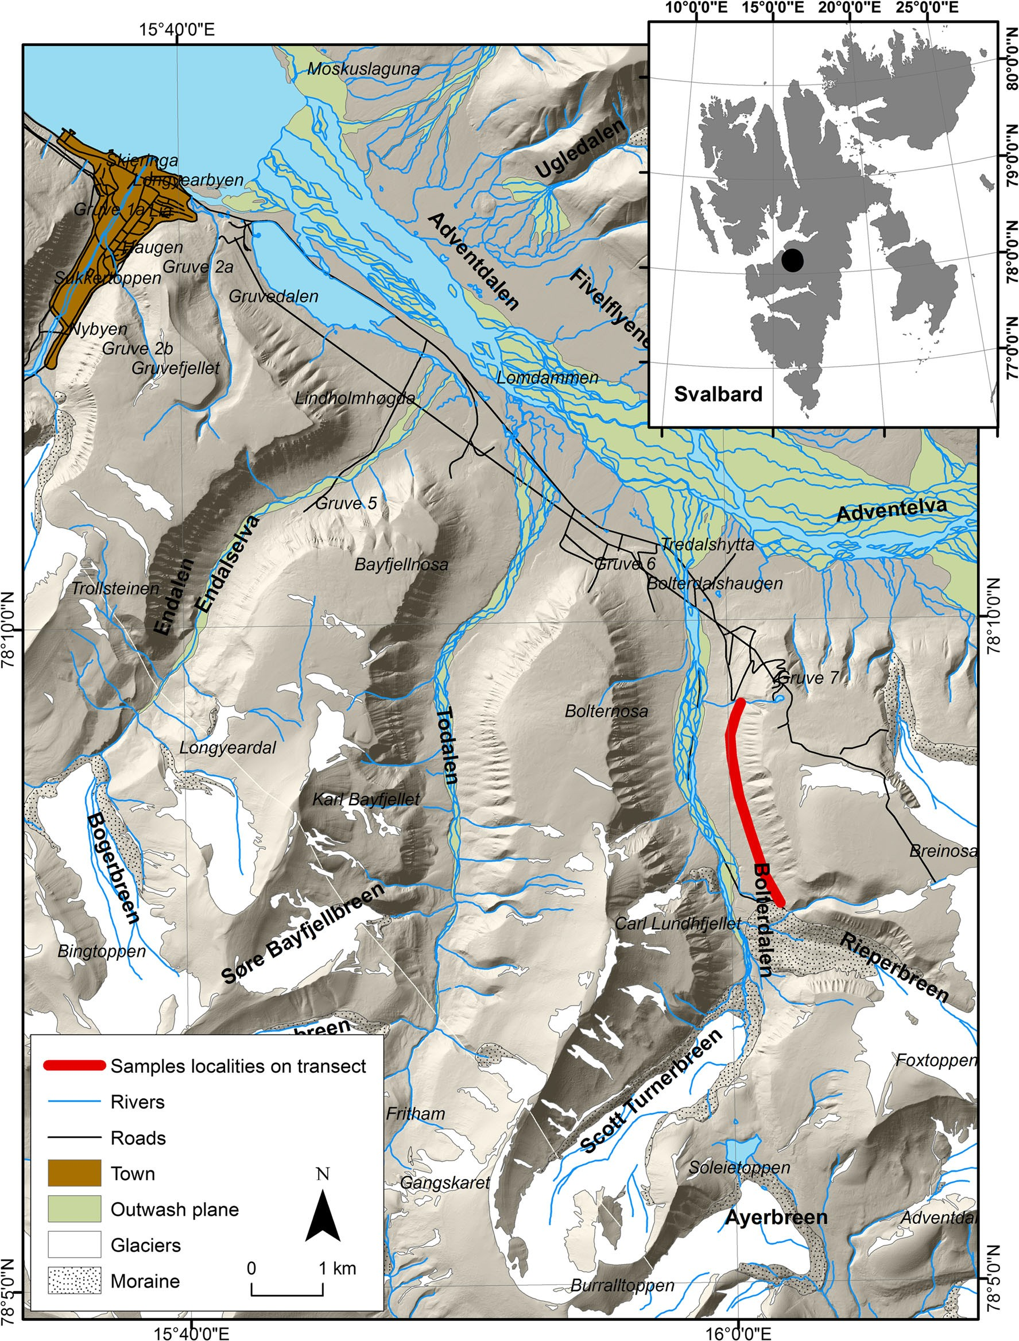
EnvironSciPollutRes(2018)25:36693–36701
36695
Fig.1Locationofthestudyarea(©NorwegianPolarInstitute2016,www.npolar.no)
Laboratory analyses
Microwave Digestion System (MultiwaveGO ofAntonPaar).Themineralisationtemperatureprogrammewasasfollows:a20-minincreaseintemperatureto180°C,a10-minholdintemper-atureat 180°Cand10minofcoolingto60°C.Following the mineralisationprocessthesamplesweretransferredquantitative-ly to25-ml flasksandfilledwithdionisedwater.
Samplesofreindeer excrementwerelyophilisedat−80 °Cand subsequentlyhomogenisedandsievedwitha2-mmplasticsieve.
Thereafter,0.5gofexcrement sampleswasmineralisedandextracted in 8 ml of 65% HNO₃(suprapur) acid using the

36696
EnvironSciPollutRes(2018)25:36693–36701
Table1 Validationparametersandtechnicalspecificationsusedtodeterminemetals
LODª
LOQ^{b}
Parameter
Measurement range
Measurement instrumentation
Heavymetals[μg/L] Cd
Cr,Mn, Ni, Cu, Zn, Pb
Fe
0.01–1000
0.1–1000
1.0–1000
0.01
0.10
1.00
0.03
0.30
3.00
Thermo Scientific XSERIES 2 ICP-MSGermany,collisioncelltechnology,coolgasflowAr:12l/min, cell gas flow He/H: 5,5ml/min
aThe limit of detection (LOD) was calculated on the basis of the standard deviation of the response
(s) and the slope of the calibration curve (b), according to the following formula: LOD = 3.3(s/b)
bThelimitofquantitation(LOQ)wascalculatedonthebasisofthestandarddeviationoftheresponse
(s) and the slope of the calibration curve (b) according to the following formula: LOQ = 10(s/b)
Flavocetrarianivalis,aspeciesfrequentlygrazedbyreindeer(Ziajaet al.2016;Olechet al.2011), butStereocaulonalpinum,CetrarielladeliseiandCladoniamacrocerasprovid- edrelativelyhighcovervaluesinalltheplots(TableS1).
Variousgroups of analyses involved the application ofMili-Q demineralised water (Mili-Q® UltrapureWaterPurification Systems, Millipore® production). Metals (cadmi-um, chromium, copper, iron, lead, nickel, manganese and zinc)weredeterminedbymeansofioncoupledplasmamassspectrometry (Thermo Scientific XSERIES2ICP-MS)(Table1). These were analysed using Standard ReferenceMaterialNIST1643eTraceElementsinWater,andReference MaterialEnviroMATES-L-2CRM,ES-H-2CRMSCPSCIENCE.Calibrationoftheapparatuswasbasedonreference materials suppliedbyInorganicVentures:ANALITYK-CCS-4, CCS-6, CCS-1 andIV-ICPMS-71A.
Heavy metal content in reindeer excrement
Eight of the selected heavy metals were detected in the col- lectedreindeerfaeces(Table2,S2);acomparisonofbetween theirsummerandwinterelementallevelsisprovidedinFig.2, significant differences confirmed by the U Mann–Whitneytestasfollows:Cd (U = 39;p=0.002),Cr (U = 57;p=0.022),Fe(U=56;p=0.02)andNi(U=64;p=0.046);how-
ever,there were no differences in element contentsbetween summerandwinterfaecesforthefollowing:Cu(U=111;p= 0.97), Mn (U = 79;p= 0.17), Pb (U = 83;p= 0.23) and Zn (U=65;p=0.051).
Statisticalanalyses
Levene’stest was performed to assess the equality of vari- ances,whiletheShapiro–Wilktesthelpeddeterminethenor- malityofthedataset.TheUMann–Whitneytestwasusedto assess differences in heavy metal concentrations between summerandwinterreindeerexcrementalongthetransect.
Discussion
Only a few studies have focused on reindeer excrementasasubjectofresearch(Naetal.2015;Wangetal.2015;Zhangetal.2014;Zhuetal.2015),allofwhichexaminedthepres-ence of organic pollutants known for theircarcinogenicandmutagenic properties(e.g.polychlorinatedbiphenyls,polybrominatedbiphenylethers,polycyclicaromatichydro-carbons).Theliteratureincludesmuchlessinformationonthemetalcontentofreindeerkidneys(Borch-Iohnsenetal.1996;LarterandNagy2000),livers(Aastrupetal.2000;Borch-Iohnsen et al.1996) or muscles (Aastrup et al.2000).Inthecase of Svalbard, only Staaland et al. (1983)conductedre-search on the content of iron,copper,manganese,zinc, mo-lybdenumandcobaltinreindeerexcrement,butthesesamplesweregathereddirectlyfromdistalcolons.BecauseSvalbardreindeerareconsideredtobenon-migratory(Bjørkvolletal.2009;Hansenetal.2010;TylerandØritsland1989),dataontheheavymetalcontentoftheirfaecesmaybeusedfornon-invasivecontaminationmonitoringpurposesonalocalscale.
Thepresenceofallstudiedheavymetalsinreindeerfaecesispossiblyconnectedwiththeincompletecontentofthese
Results
A description of the vegetation in the study area
A general characterisation was prepared of the vegetation alongthedesignatedtransectasshowninTableS1whichlists therecordedspeciestogetherwiththedegreeofcoverandthe phytosociologicalconstancyofeachtaxon.Thevegetationis represented by mesic tundra, dominated by vascular plants(59%), mainly dwarf shrubs, suchasDryas octopetala,CassiopetetragonaandSalixpolaris;bryophytesandlichens respectively represented 16% and 20% of thecover.
Inthecaseofbryophytes,Sanionia uncinata,AulacomniumturgidumandDitrichum flexicaulewerepres- entinalltheplotsandprovidedthemostcover.Crustoseand folioselichensspeciesweredominant,withPeltigeravenosa,Collema ceraniscumandOchrolechiafrigidaproviding themaincomponentsofthebiologicalsoilcrusts(BSCs). Fruticoselichenswereinfrequentlyobserved,suchas

EnvironSciPollutRes(2018)25:36693–36701
36697
Table2 The average, standard deviation, minimum and maximum valuesofheavymetalcontent[mgkg⁻¹]insummerandwinterfaeces
Themesic tundraofthestudyareaisdominatedbydwarfshrubs,floweringplantsandgraminoids,whilebryophytesandlichenswere lesscommon(TableS1).AccordingtoElvebakk (2005),thevegetationofBolterdalenisdominatedbyCassiopetetragona, which is similar to the vegetation of ColesdalenwheretheresearchbyBjørkvolletal.(2009)wasundertaken.InthestudyconductedbyBjune(2000)inTodaleninthevalley paralleltoBolterdalen,thecharacteristicvegetationwassimilartothatofBolterdalenandtheareainvestigatedbyStaalandetal.(1993)inBroggerhalvoyawasdominatedbyCassiopetetragonaandLuzula nivalis(Elvebakk2005), whichisalso similartothatofBolterdalen.Thespeciescompositionofmesic tundrahasadirectinfluenceonthereindeer’sdiet,whichinturn dictatestheheavymetalcontentinexcrement(Fig.2;Table2).Floweringplantsandgraminoidsarethemostfrequentlygrazedbyreindeer during summer (Fig.3), butgraminoidsare alsocommonly eaten duringtheearly winter (Staalandetal.1993; Bjune2000; Bjørkvolletal.2009).Incontrast, dwarf shrubs,bryophytesandlichensareimportantcomponentsofthe
Element
N
Summerfaeces
Winterfaeces
Average
SD
Average
SD
CrMnFe Ni Cu Zn Cd
Pb
15
15
15
15
15
15
15
15
0.012
0.698
9.51
0.029
0.074
0.371
0.003
0.006
0.009
0.378
6.15
0.018
0.061
0.225
0.002
0.003
0.02
0.454
14.9
0.018
0.072
0.198
0.001
0.008
0.006
0.125
4.52
0.004
0.064
0.056
0.001
0.004
elements in animal tissue after forage digestion as they are excretedinfaeces.Nevertheless,theconcentrationsofheavy metalsinthefaeceswerelowcomparedwiththoseinvascular plants, bryophytes and lichens grazed by the reindeer, and their content in reindeer tissue (Fig.2;Table3).
Althoughthestatisticalanalysisshowedsignificantdiffer-encesbetweensummerandwinterexcrementintermsofthe concentrations of the selected heavy metals, it is difficult to drawanyunequivocalconclusionsonthisissuesincenoother data on the content of elements in reindeer excrement inthe Arctic region exist. Furthermore, it is worth underlining the factthat,comparedtoNorwegianreindeer,Svalbardreindeer are a different subspecies which subsist in different habitat conditions that influence the microbial structure of reindeer rumen (Sundset et al.2007). The only study on the above- mentioned topic was conducted in 1979 in Adventdalen, wheresixfaecalsampleswerecollectedfromthedistalcolon ofreindeershotinthefield(Staalandetal.1983)thatshowed differencesbetweenconcentrationsofFe,Cu,Mn,andZnin summerandwinterexcrement.Whenwecomparethisstudy withourownresults,wecanobservethattheaverageheavy metal content in faecal samples from 1979 is much higher(Table3). These concentrations are also much higher whencompared with reindeer tissueandexaminedvegetation(Table3),anditisdifficulttocomparethesevalueswiththe obtainedresults.
The results can be analysed in terms of reindeer dietary preferencesduringtheArcticyear,theformofavailablefor- ageprobablyinfluencingtheheavymetalcontentinsummer and winter faeces (Figs2and3;Table3). Differences inthe percentagesofherbaceousplants,shrubs,bryophytesandli-chens eatenbyreindeer during the summerandwinter(Bjørkvoll et al.2009; Ekern and Kildemo1987; Staaland etal.1993),aswellasdifferentcontentsofparticularelement insuchvegetation(Table2;Wojtuńetal.2013),areprobably amajorreasonforvariationsinheavymetalcontent,bothin reindeertissue(Borch-Iohnsenetal.1996)andinexcrement.
reindeer’s winter diet (Staaland et al.1993;
Bjune2000;
Bjørkvollet al.2009). Inthe summertime, reindeerfeedonflowerpetals, while inwinterthey eat theligneouspartsofplants(Staalandetal.1993;Bjune2000;Bjørkvolletal.2009).Theobtainedresultsonlypartlyconfirmedthehypothesisthatassumedthatcontentsofheavymetalsinsummerexcre-mentwillbelowerthaninwinterexcrement.ContentsofCdwere higher in the summer faeces, which maybeconnectedwiththeeasyaccumulationofCdintheleavesandflowersofvascularplants(Kabata-Pendias2011).InSvalbard,Wojtuń
et al. (2013) claimed that vascular plants accumulated Cd within a range of 0.29–1.08 mg kg⁻¹(Table3), but in a pre-vious studybyJóźwik (2000), this figure couldreach8 mg kg⁻¹.However,a lower Cd content has been observed in lichens, bryophytes, and the ligneous parts of vascular
plants(Table3,Wojtuńet al.2013), which may explain the differences observed in winter and summer excrement. In comparison to reindeer tissue, the Cd content in vascular plants is rather low(Table3).However,higher levels of Cd accumulationwereobservedinreindeertissue,mainlyinthe kidneys,whichmaybethereasonforthelowerlevelsofthis element in excrement (Fig.2).
TheCrcontentwashigherinwinterexcrement.AccordingtoKabata-Pendias(2011),theconcentrationofCrishigherin bryophytesthaninvascularplants.Reindeerfrequentlyfeed on bryophytes during the early winter and winter (Fig.3), which may directly result in a higher Cr content in winter faeces.Similarly,the Fe content is also higher in winter ex- crement, and was also observed to be higher in bryophytes than in vascular plants, and indeed in lichens(Table3). The higherproportionofbryophytesandlichensinwinterforage maydirectlyresultinahighFecontentinwinterexcrement. However, data are not available on Fe content in reindeer tissue.

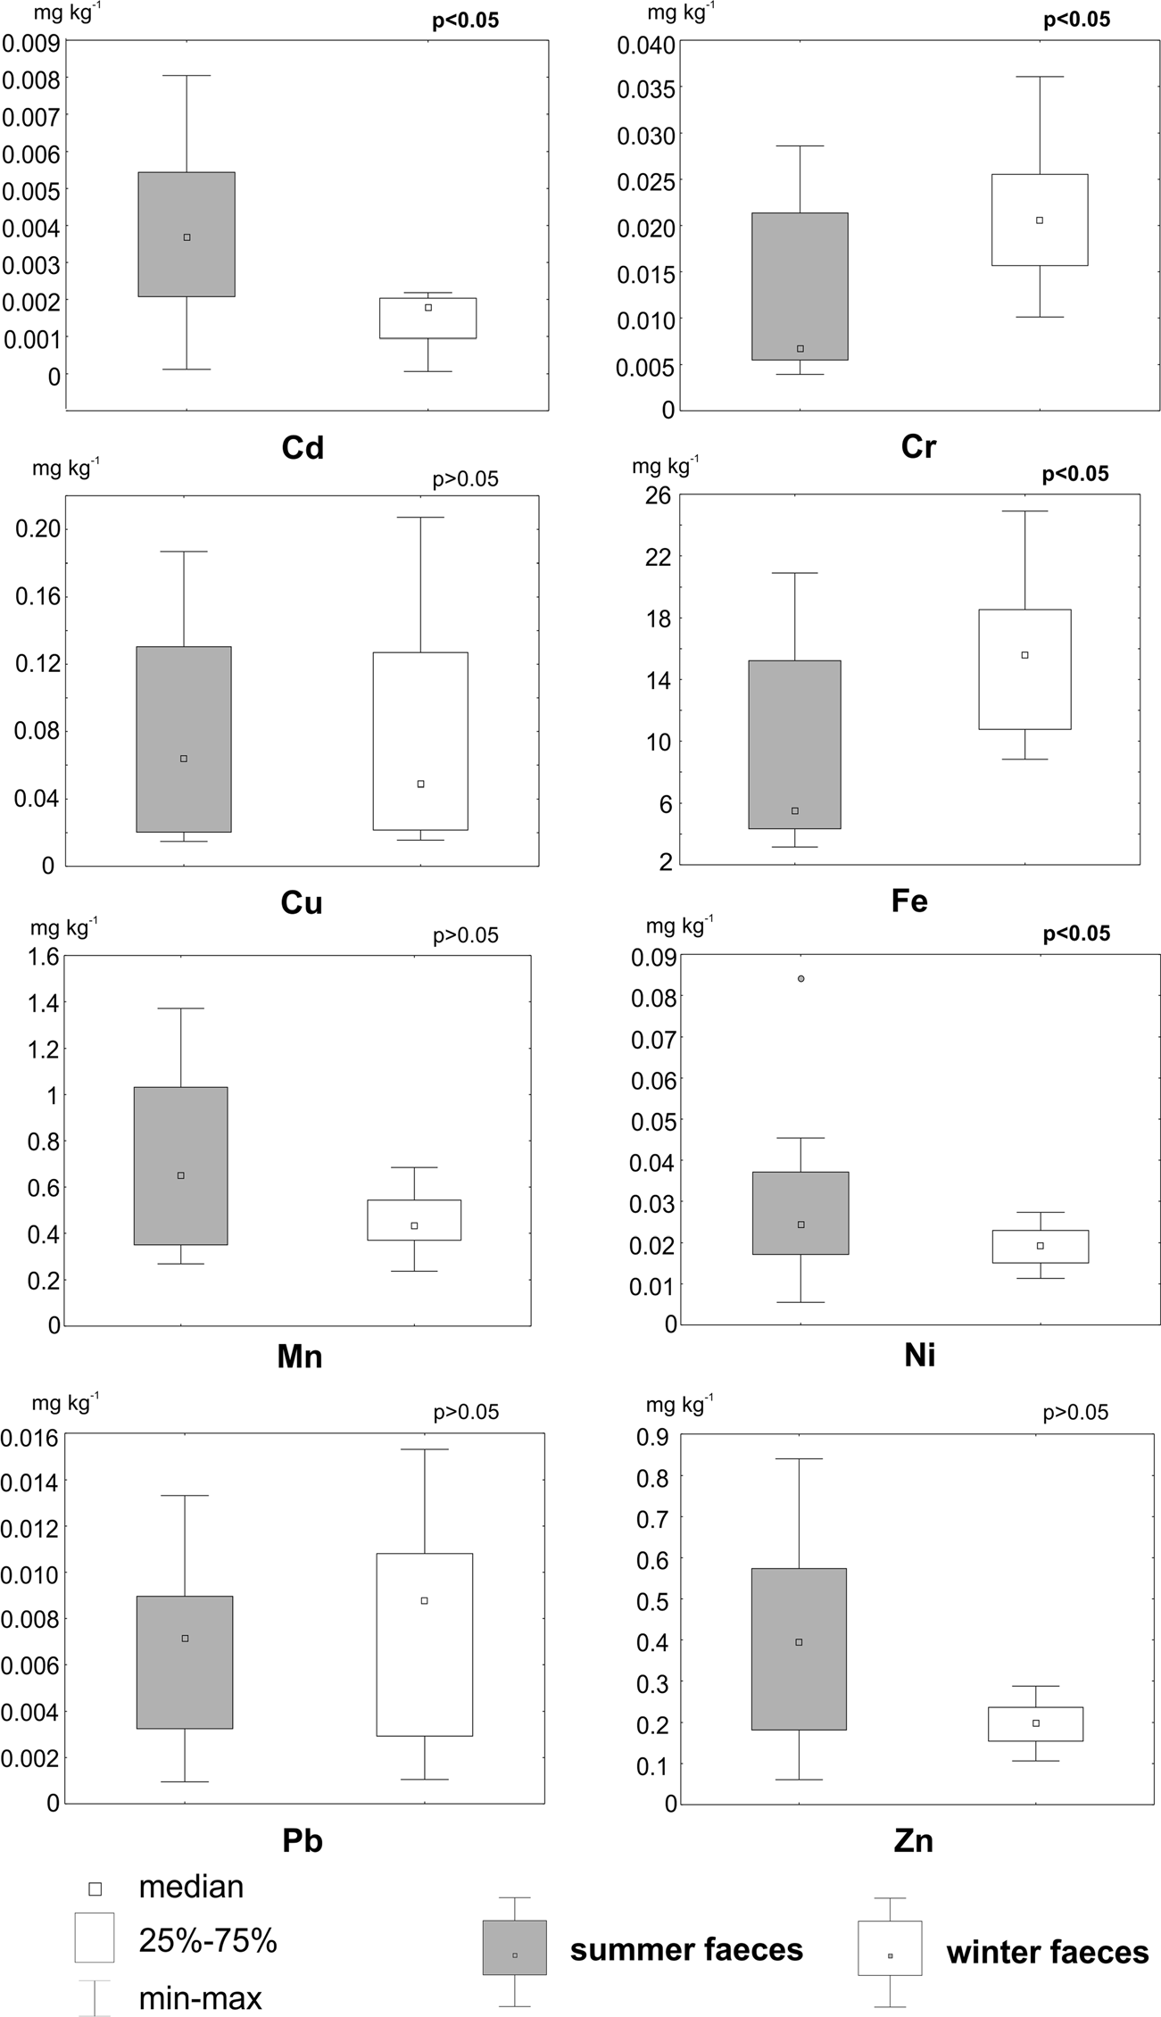
36698
EnvironSciPollutRes(2018)25:36693–36701
Fig. 2The UMann–Whitneytestcomparingheavy metal content between summer and winter excrement. Significant differences(p<0.05)aremarked bypvalueshighlightedinbold
TheMncontentseemstobesimilarinwinterandsummer excrement (Fig.2). Mn in vascular plants, the content of which can be metabolically controlled, mainlyaccumulates
Mn in the liver and kidney, appear to explain its consistent level in excrement across the different seasons. A slightly higher content of Ni was noted in summer excrement (Fig.2), which may be due to its high content in the leaves and seeds of graminoids, flowering plants and shrubs (Kabata- Pendias2011). However, its high content was also noted in bryophytes, which may explain the similar Ni level in the winter excrement.
kg−1
in leaves and may reach 121 mg
(Kabata-Pendias
2011). On the other hand, its concentration in bryophytes canbetwiceashighasinvascularplants(Table3).Thehigh proportionofforageconsistingofvascularplantsinsummer and bryophytes inwinter,together with the accumulationof

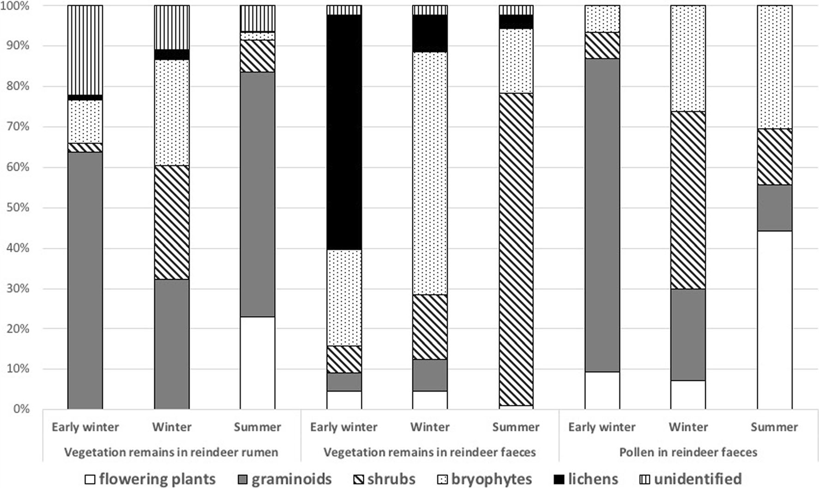
EnvironSciPollutRes(2018)25:36693–36701
36699
Table3Acomparisonoftheminimumandmaximumcontentofheavy metalsinlichens,bryophytes,vascularplants(Wojtuńetal.2013),theliver,kidney of Svalbard reindeer(Borch-Iohnsenet al.1996)together
with the obtained element contents in all reindeer excrement. Alsothe averageelementcontentsinfaecalsamplesfromdistalcolonofSvalbard reindeer are given (Staaland et al.1983)
Minimumandmaximumelementcontent[mgkg⁻¹]
Averageelement content [mgkg⁻¹]
Heavymetal
Lichens
Bryophytes
Vascularplants
Liver
Kidney
Reindeerfaeces
Distalcolon
Cd
MinMaxMinMaxMinMaxMinMaxMinMaxMinMaxMinMaxMin
Max
0.06
0.10
0.27
0.83
0.77
1.33
357
629
12.0
18.3
0.47
0.90
1.77
2.53
11.0
16.3
0.15
0.51
2.28
8.49
4.85
13.50
1,97
7,11
77.38
298
1.74
6.89
1.49
9.95
19.5
33.4
0.29
1.08
0.38
1.12
2.20
6.00
120
353
47.6
121
0.60
2.14
0.48
1.38
34.20
65.60
0.20
2.40
–
–
3.20
260
–
–
1.20
6.50
–
–
0.50
6.10
15.0
140
0.50
23.0
–
–
2.20
7.60
–
–
0.40
2.50
–
–
0.60
15.0
15.0
38.0
0.001
0.008
0.004
0.036
0.015
0.207
3.15
24.9
0.237
1.37
0.005
0.084
0.001
0.015
0.061
0.839
–
–
–
–
26
11.1
4.39
15.69
623
267
–
–
–
–
545
148
Cr
Cu
SummerWinterSummerWinterSummer
Winter
Fe
Mn
Ni
Pb
Zn
Summer
Winter
TherewasnodifferenceinPbcontentbetweenthesummer andwinterexcrement(Fig.2).Thiselementaccumulatessim- ilar levels in both vascular plants and cryptogams(Table3). ThehighcontentofPbinreindeerkidneysandliversmightbe
afactorinfluencingitscontentinfaeces(Table3).Thediffer-enceinZncontentbetweensummerandwinterexcrementhas notbeenconfirmedbystatisticalanalysis(Fig.2).AswithPb, thiselementhasaccumulatedathighlevelsinreindeerlivers
Fig.3Differencesinthepercentagecompositionofreindeerdietintheearlywinter,winterand summer,basedonthespeciesremainsinvestigatedinreindeerrumenfromareindeerpopulationinColesdalen in1999–2002(Bjørkvolletal.2009)andspeciesremainsinvestigatedin
reindeerfaecescollectedinBroggerhalvoyain1989(Staalandetal.1993) and based on the pollen investigated in reindeer faeces collected inTodalenin 1994–1995 (Bjune2000)

36700
EnvironSciPollutRes(2018)25:36693–36701
(Rangifer tarandus). Sci Total Environ 245:149–159.https://doi.org/10.1016/S0048-9697(99)00440-4
AMAP(2005)AMAPassessment2002:heavymetalsintheArctic.In:Arctic monitoring and assessment programme,Oslo
AustrheimG,HasselK,MysterudA(2005)Theroleoflifehistorytraits forbryophytecommunitypatternsintwocontrastingalpineregions.Bryologist 108(2):259–271. https://doi.org/10.1639/0007-2745(2005)108[0259:TROLHT]2.0.CO;2
BjørkvollE,PedersenB,HyttebornH,JónsdóttirIS,LangvatnR(2009) Seasonalandinterannualdietaryvariationduringwinterinfemale Svalbardreindeer(Rangifertarandusplatyrhynchus).ArctAntarctAlp Res 41:88–96.https://doi.org/10.1657/1523-0430-41.1.88
BjuneAE(2000)Pollenanalysisoffaecesasamethodofdemonstrating seasonal variations in the diet of Svalbard reindeer (Rangifertarandus platyrhynchus). Polar Res19:183–192
Borch-IohnsenB,NilssenKJ,NorheimG(1996)Influenceofseasonand diet on liver and kidney content of essential elements and heavy metals in Svalbard reindeer. Biol Trace Elem Res 51:235–247.https://doi.org/10.1007/BF02784078
Braun-Blanquet J (1964) Pflanzensoziologie. Grundzuge derVegetationskunde. Springer-Verlag, Wien
ClarksonTW(1986)Effects:generalprinciplesunderlyingthetoxicac-tionofmetals.In:FribergL,NordbergG,VoukV(eds)Handbookonthetoxicologyofmetals.Elsevier,Amsterdam,pp128–148
DrbalK,ElsterJ,KomarekJ(1992)HeavymetalsinwatericeandbiologicalmaterialfromSpitsbergenSvalbard.PolarRes11:99–101EkernK,KildemoK(1987)Svalbardreinensernæring.Hovedoppgave,
Institutt forNaturforvaltning, NorgesLandbrukshøyskole, As ElvebakkA(2005)AvegetationmapofSvalbardonthescale1:3.5mill.
Phytocoenologia 35(4):951–967.https://doi.org/10.1127/0340-269X/2005/0035-0951
Garty J (2001) Biomonitoring atmospheric heavy metals with lichens: theoryandapplication.CritRevPlantSci20:309–371.https://doi.org/10.1080/20013591099254
HallangerIG,WarnerNA,RuusA,EvensetA,ChristensenG,HerzkeD, GabrielsenGW,Borgå K(2011) Seasonalityin contaminantaccu- mulationinArcticmarinepelagicfoodwebsusingtrophicmagnifi- cation factor as a measure of bioaccumulation. Environ ToxicolChem 30:1026–1035.https://doi.org/10.1002/etc.488
Hansen BB, Aanes R, Sæther B-E(2010)Partial seasonalmigrationin high-arctic Svalbard reindeer (Rangifer tarandusplatyrhynchus).Can J Zool 88:1202–1209.https://doi.org/10.1139/Z10-086
JóźwikZ(2000)HeavymetalsintundraplantsoftheBellsundinWestSpitsbergen,investigatedintheyears1987–1995.PolPolarRes21:
43–54
Kabata-Pendias A (2011) References. In: Trace elements in soils andplants.CRCPress,BocaRaton.https://doi.org/10.1201/b10158-25
Koivurova T (2005) Environmental protection in the Arctic and Antarctic: can the polar regimes learn from each other? Int J LegInf 33(2):204–218
Larter NC, Nagy JA(2000)A comparison of heavy metal levels inthe kidneys of high Arctic and mainland caribou populations in the NorthwestTerritoriesof Canada. SciTotalEnviron246:109–119.https://doi.org/10.1016/S0048-9697(99)00418-0
LysåA,LnneI(2001)Morainedevelopmentatasmallhigh-Arcticvalley glacier:Rieperbreen,Svalbard.JQuatSci16:519–529.https://doi.org/10.1002/jqs.613
NaG,WeiW,ZhouS,GaoH,MaX,QiuL,GeL,BaoC,YaoZ(2015) DistributioncharacteristicsandindicatorsignificanceofDechloranesinmulti-matricesatNy-AlesundintheArctic.JEnvironSci(China)28:8–13.https://doi.org/10.1016/j.jes.2014.07.019
NationalResearchCouncil(1980)Mineraltoleranceofdomesticanimals.
National Academy of Science, Washington, DC
Norwegian Polar Institute (2016) Norwegian Polar Institute MapData andServices.NorwegianPolarInstitute.https://geodata.npolar.no/.Accessed 21 March2018
and kidneys, and this may have an indirect influence on its content in faeces.
Analysingtheheavymetalcontentsinvegetationand inanimalsfeduponit,thelocalsourcesofcontaminationalsoplayanimportant role.Asregards Borteldalen, situatedc.300mabovethevalley,thecoal dust whichisemittedfrom thestill activeGruve7coalminemayaffectthecontentofheavymetalsinvegetationgrazedbyreindeer,andmaybedepositedonthesurface of faeces. Theconducted studies(e.g. Pandey et al.2014)showedthatcoaldustmayinfluencethecontentofheavymetals,butinSvalbardtherehasbeennodetailedinvestigationofitsdepositionandimpactonbothvegetationandanimals. DuetothefactthatfromthesecondhalfofthetwentiethcenturyNorwegiancoal mines have beensuccessively closed, furthercomparative analysesof heavy metalcontentwill allow thescaleoffuturepollutantchangestobeestimated.
Conclusions
Despiteitspreliminarycharacter,theresearchinvestigatedthe heavy metals in reindeer excrement. Differences in thecon- centrationofheavymetalsinwinterandsummerexcrement would appear to be as a consequence of the variability of reindeer forage during the year, as well as possibly being influencedbytheiraccumulationinreindeertissue.Thepre- sented study is a starting point for future research on heavy metal contents and non-invasive monitoring of pollutantsin Arcticecosystems.
AcknowledgementsWewould like to thank Professor Monica A. Sundset (Department of Arctic and Marine Biology, University ofTromsø-TheArcticUniversityofNorway)forherhelpfulcriticismof an earlier draft of this contribution.Wewould like to thank Professor Mark Seaward (Department of Archaeological andEnvironmentalScience,UniversityofBradford)forhislinguisticcorrectionsandvalu- able remarks.Weare also grateful to anonymous reviewers for their suggestions and remarks on ourmanuscript.
Funding informationThe contribution made by Paulina Wietrzyk re- ceived financial support from the statutory fund of the Institute of Botany of the Jagiellonian University (K/DSC/004623). The work of BeataCykowska-Marzenckawassupportedbythestatutoryfundofthe
W. Szafer Institute of Botany of the Polish Academy of Sciences.
Open AccessThis article isdistributedunder the terms of the CreativeCommonsAttribution4.0InternationalLicense (http://creativecommons.org/licenses/by/4.0/),whichpermitsunrestricteduse, distribution, and reproduction in any medium, provided you giveappropriatecredittotheoriginalauthor(s)andthesource,providealink totheCreativeCommonslicense,andindicateifchangesweremade.
References
Aastrup P, Riget F, Dietz R, Asmund G (2000) Lead, zinc, cadmium, mercury, selenium and copper in Greenland caribou and reindeer

EnvironSciPollutRes(2018)25:36693–36701
36701
sub-species ofreindeer.Microb Ecol 54:424–438.https://doi.org/10.1007/s00248-007-9254-x
TylerNJC(1986)TherelationshipbetweenthefatcontentofSvalbardreindeer in autumn and their death from starvation in winter.Rangifer6:311–314
Tyler N, Øritsland N (1989) Why don’t Svalbard reindeer migrate?
Holarct Ecol 12:369–376
WangZ, Na G, Ma X, Ge L, Lin Z,YaoZ(2015) Characterizingthe distribution of selected PBDEs in soil, moss and reindeer dungatNy-AlesundoftheArctic.Chemosphere137:9–13.https://doi.org/10.1016/j.chemosphere.2015.04.030
Węgrzyn M, Lisowska M, Nicia P(2013)The value of theterricolouslichenCetrarielladeliseiinthebiomonitoringofheavy-metallevelsin Svalbard. Pol Polar Res 34:375–382.https://doi.org/10.2478/popore-2013-0022
WęgrzynM,WietrzykP,LisowskaM,KlimekB,NiciaP(2016)What influences heavy metals accumulation in arctic lichenCetrarielladeliseiinSvalbard?PolarSci10:532–540.https://doi.org/10.1016/j.polar.2016.10.002
WeinbruchS,WiesemannD,EbertM,SchützeK,KallenbornR,StrömJ (2012) Chemical composition and sources of aerosol particles atZeppelinMountain(Ny-Ålesund,Svalbard):anelectronmicrosco- py study. Atmos Environ 49:142–150.https://doi.org/10.1016/j.atmosenv.2011.12.008
WojtuńB,Samecka-CymermanA,KolonK,KempersAJ,SkrzypekG (2013)Metalsinsomedominantvascularplants,mosses,lichens, algae, and the biological soil crust in various types of terrestrialtundra,SWSpitsbergen,Norway.PolarBiol36:1799–1809.https://doi.org/10.1007/s00300-013-1399-0
ZhangP,GeL,GaoH,YaoT,FangX,ZhouC,NaG(2014)Distribution andtransferpatternofpolychlorinatedbiphenyls(PCBs)amongthe selectedenvironmentalmediaofNy-Ålesund,theArctic:asacasestudy. Mar Pollut Bull 89:267–275.https://doi.org/10.1016/j.marpolbul.2014.09.050
Zhu C, LiY,WangP,Chen Z, Ren D, SsebugereP,Zhang Q, Jiang G (2015)Polychlorinatedbiphenyls(PCBs)andpolybrominatedbi-phenyl ethers (PBDEs)inenvironmental samplesfromNy-Ålesund and London Island, Svalbard, the Arctic. Chemosphere 126:40–46.https://doi.org/10.1016/j.chemosphere.2015.01.043
Ziaja W, Wegrzyn M, Dudek J, Ostafin K, Lisowska M, Olech M,Osyczka P (2016) Transformation of the natural environment in Western Sørkapp Land (Spitsbergen) since the 1980s. Springer International Publishing, Cham
NriaguJ(1979)Globalinventoryofnaturalandanthropogenicemissions oftracemetalstotheatmosphere.Nature279(5712):409–411
NriaguJ(1989)Aglobalassessmentofnaturalsourcesofatmospheric trace metals. Nature338(6210):47–49
Olech M, Węgrzyn M, Lisowska M, Słaby A, Angiel P (2011)
Contemporary changes in vegetation of polar regions. Papers on Global Change IGBP 18:35–51.https://doi.org/10.2478/v10190-010-0003-8
Pandey B, Agrawal M, Singh S (2014) Assessment of air pollution aroundcoalminingarea:emphasizingonspatialdistributions,sea- sonalvariationsandheavymetals,usingclusterandprincipalcom- ponent analysis. Atmos Pollut Res5(1):79–86
ReimersE(1982)WintermortalityandpopulationtrendsofreindeeronSvalbard,Norway.Arct Alp Res 14:295–300
Ruman M, Kozak K, Lehmann S, Koziol K, Polkowska Z (2012) PollutantspresentindifferentcomponentsoftheSvalbardarchipel- agoenvironment.EcolChemEngS19:571–584.https://doi.org/10.2478/v10216-011-0040-9
Samecka-CymermanA, WojtuńB, Kolon K, Kempers AJ (2011)Sanioniauncinata(Hedw.)loeskeasbioindicatorofmetalpollution in polar regions. Polar Biol 34:381–388.https://doi.org/10.1007/
s00300-010-0893-x
Sancho LG, Green TA, Pintado A (2007) Slowest to fastest: extreme range in lichen growth rates supports their use as an indicator of climate change in Antarctica. Flora 202(8):667–673
Simões JC, Zagorodnov VS (2001) The record ofanthropogenicpollu-tion in snow and ice in Svalbard,Norway.Atmos Environ 35(2):403–413.https://doi.org/10.1016/S1352-2310(00)00122-9
StaalandH,BrattbakkI,EkernK,KildemoK(1983)Chemicalcompo- sitionofreindeerforageplantsinSvalbardandNorway.Ecography 6:109–122.https://doi.org/10.1111/j.1600-0587.1983.tb01072.x
Staaland H, Scheie JO, Grøndahl A, Person E, Leifseth AB, HolandØ (1993)TheintroductionofreindeertoBrøggerhalvøya,Svalbard: grazingpreferenceandeffectonvegetation.Rangifer13:15–19
SteinnesE(1995)Acriticalevaluationoftheuseofnaturallygrowing moss to monitor the deposition of atmospheric metals. SciTotalEnviron 160:243–249.https://doi.org/10.1016/0048-9697(95)04360-D
StoltzE,GregerM(2002)AccumulationpropertiesofAs,Cd,Cu,Pband Znbyfourwetlandplantspeciesgrowingonsubmergedminetail- ings. Environ Exp Bot 47(3):271–280.https://doi.org/10.1016/S0098-8472(02)00002-3
SundsetMA,PræstengKE,CannIKO,MathiesenSD,MacKieRI(2007) Novel rumen bacterial diversity in two geographicallyseparated

