
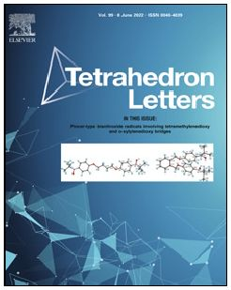


Tetrahedron Letters 99 (2022) 153830
ELSEVIER
Contents lists available at ScienceDirect
Tetrahedron Letters
journal homepage: www.elsevier.com/locate/tetlet

Regioselective synthesis of the 4,5-dialkoxy-2-nitroanilines bearing two
different alkoxy substituents

Jarosław Grolik *, Paweł Ręka, Magdalena Gorczyca, Katarzyna Stadnicka
Faculty of Chemistry, Jagiellonian University, ul. Gronostajowa 2, Kraków 30 - 387, Poland
ARTICLE INFO
ABSTRACT
Article history:
Received 4 March 2022
Revised 22 April 2022
Accepted 25 April 2022
Available online 2 May 2022
Keywords:
Aromatic nucleophilic substitution
2-nitroaniline
Regioselectivity
Chemoselectivity
Transetherification
This article reports the regioselective and chemoselective synthesis of 4,5-dialkoxy-2-nitroanilines sub-
stituted with two alkoxys at C-4 and C-5. Here we show the optimization protocol of the transetherifica-
tion reaction used to synthesize 20 new compounds with good to excellent yields (50-92%). We describe
a simple and efficient one-step procedure that can be applied to obtain a significant number of pharma-
cologically active compounds, including antimalarial drug Primaquine analogs.
© 2022 The Authors. Published by Elsevier Ltd. This is an open access article under the CC BY-NC-ND license
(http://creativecommons.org/licenses/by-nc-nd/4.0/).

Introduction
2-Nitroanilines belong to versatile chemical synthons. They are
used to synthesize numerous compounds such as o-phenylenedi-
amines [1], benzimidazoles [2], quinoxalines [3], quinolones [4],
phenazines [5], and other heterocycles. Some of these derivatives
are investigated for the treatment of cancer, antipyretic, analgesic,
and anti-inflammatory drugs and have many other medical appli-
cations. One of the essential compounds synthesized from 2-
nitroanilines is Primaquine, a drug used to treat and prevent
malaria. The changing climate is causing the proliferation of
malaria-carrying mosquitoes at higher geographic altitudes,
increasing malaria transmission. New drugs are needed in the case
of drug resistance to current drugs. Primaquine analogs based on
5-alkoxy-4-methoxy-2-nitroaniline (Scheme 1) are promising
compounds with high antimalarial activity and lower toxicity [6].
- Dialkoxy-2-nitroanilines substituted with two different alkoxy
chains allow the synthesis of primaquine derivatives and other
heterocyclic compounds that are not substituted symmetrically.
These are difficult to prepare through the o-phenylenediamine route
because of the low differences in the reactivity of both amino
groups. Starting synthesis from 2-nitroanilines substituted with
two different alkoxy groups instead of o-phenylenediamine may
* Corresponding author.
E-mail address: jaroslaw.grolik@uj.edu.pl (J. Grolik).
overcome the tedious resolution of the regioisomers, which usually
occurs in equal proportions.
To our knowledge, only one comprehensive route described in
the literature (Scheme 2) to synthesize 4,5-dialkoxy-2-nitroanili-
nes with two different alkoxy groups using 1,2-dihalo-4-nitroben-
zene [7]. Unfortunately, this method requires a six-step synthetic
procedure.

Results and discussion
This work reports a novel procedure for the regioselective syn-
thesis of 4,5-dialkoxy-2-nitroanilines with two different alkoxy
groups based on nucleophilic aromatic substitution (ArSN).
According to a reported survey [8], ArSN reactions often require
solvents such as DMAc, DMF, DMSO, or NMP, which are not recog-
nized as green solvents. In the synthetic procedure we use, alcohol
acts as both a reagent and a solvent under basic condition.
We have observed that a small amount of by-product appears
during the hydrolysis of 1,2-dialkoxy-4-nitroacetanilides in aque-
ous ethanol with sodium hydroxide. Further purification of this
by-product and analysis showed that during acetamide basic
hydrolysis additionally occurs the substitution of C-5 with the
ethoxy group. Aromatic nucleophilic substitution, described in
the literature for nitroaromatic compounds [9-13], goes through
the postulated Meisenheimer complex intermediate formation.
Alkoxy substitution usually occurs at the ortho- para- position to
https://doi.org/10.1016/j.tetlet.2022.153830
0040-4039/© 2022 The Authors. Published by Elsevier Ltd.
This is an open access article under the CC BY-NC-ND license (http://creativecommons.org/licenses/by-nc-nd/4.0/).
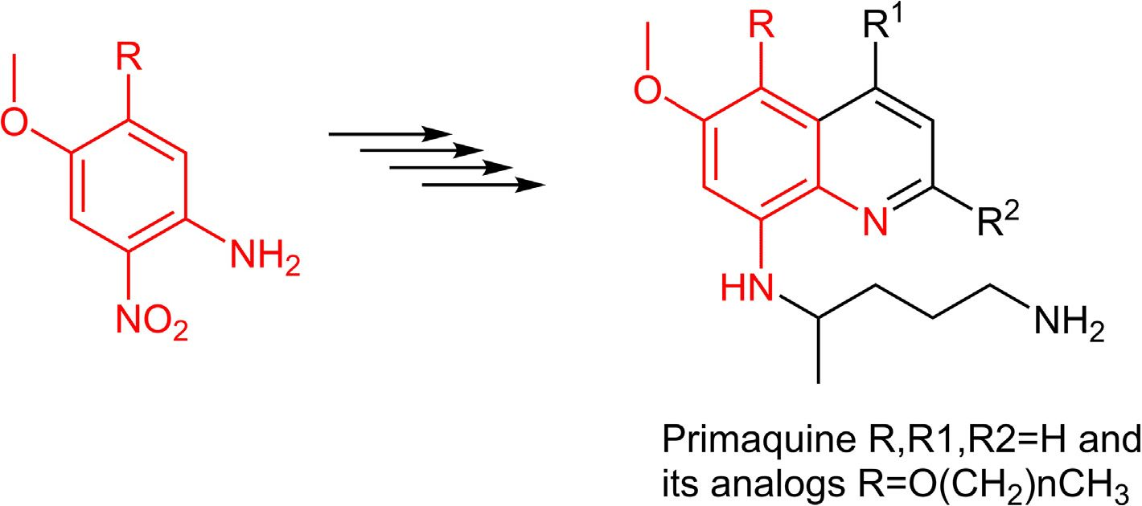
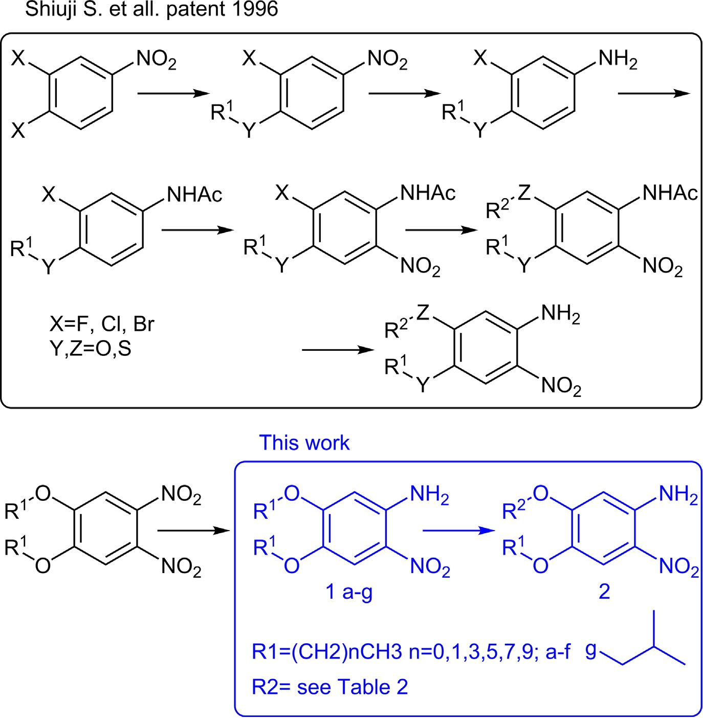
Jarosław Grolik, Paweł Reka, M. Gorczyca et al.
Tetrahedron Letters 99 (2022) 153830
Scheme 1. Synthesis of Primaquine and its Analogues.
Scheme 2. Methods for the synthesis of 4,5-dialkoxy-2-nitroanilines with two different alkoxy groups.
2

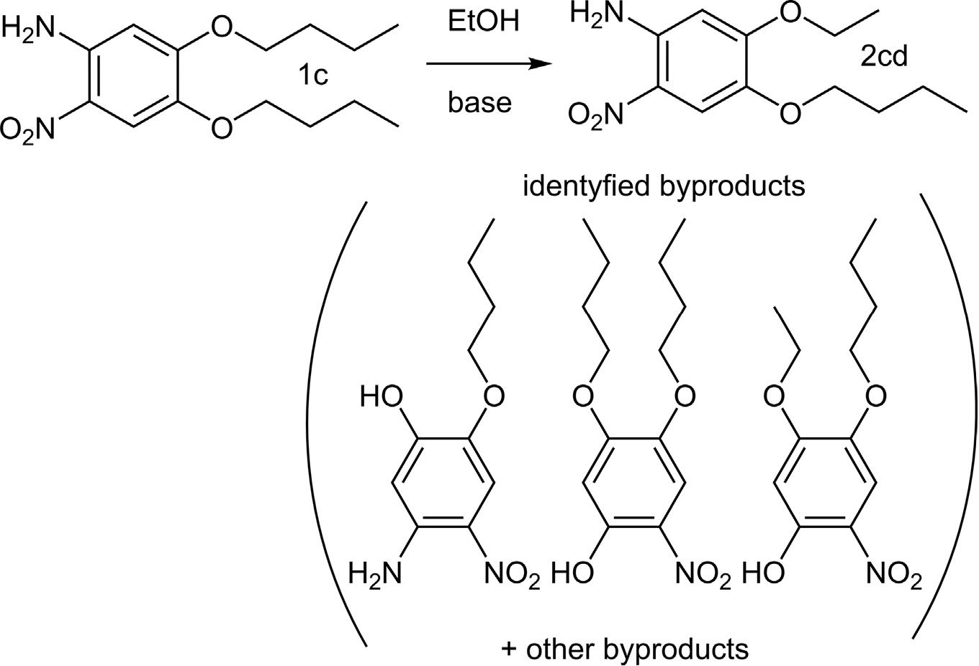
Jarosław Grolik, Paweł Reka, M. Gorczyca et al.
Tetrahedron Letters 99 (2022) 153830
Table 1
Optimization of the reaction conditions.
Entry | Base | Base Eq. | Time [h] | EtOH Eq. | Temp °C | Yield [%]a
1 | NaOH | 0.2 | 1 | 200 | Reflux | 0
2 | NaOH | 1 | 1 | 200 | Reflux | 5
3 | NaOH | 3 | 1 | 200 | Reflux | 7
4 | NaOH | 5 | 1 | 200 | Reflux | 13
5 | NaOH | 10 | 1 | 200 | Reflux | 37
6 | NaOH | 15 | 1 | 200 | Reflux | 51
7 | NaOH | 20 | 1 | 200 | Reflux | 85
8 | NaOH | 30 | 1 | 200 | Reflux | 80
9 | NaOH | 10 | 6 | 50 | Reflux | 30
10 | NaOH | 10 | 6 | 100 | Reflux | 60
11 | NaOH | 10 | 6 | 200 | Reflux | 86
12 | KOH | 10 | 6 | 200 | Reflux | 81
13 | LiOH | 10 | 6 | 200 | Reflux | 2
14 | NaOH | 10 | 1 | 200 | 110 | 91b
1 mmol of 4,5-dibutyloxy-2-nitroaniline, base, ethanol 96%, temperature a) 2 cd yield from 'H NMR [20], b) reaction in the high-pressure tube.
the electron-acceptor group, but the o/p ratio highly depends on
reaction conditions.
Since our observation, we have conducted further investiga-
tions to optimize the procedure to obtain the desired unsymmetri-
cally substituted 4,5-dialkoxy-2-nitroanilines with higher yields.
For the optimization protocol (Table 1, entries 1-8), we had cho-
sen 4,5-dibutoxy-2-nitroaniline, ethyl alcohol, and sodium hydrox-
ide. First, we have started to test reactions with different amounts
of sodium hydroxide in refluxing ethanol solution. The higher base
equivalent applied (from 0.2 eq. to 30 eq.) gave the higher conver-
sion and higher yield of the transetherification product. The higher
than 20 equivalents of sodium hydroxide do not allow higher
yields because some insoluble polymers/tars are formed.
Analysis of reaction by-products with higher equivalents of
sodium hydroxide proved the formation of phenol derivatives as
by-products that can be expected according to the literature
[10,14]. Extending the reaction time to 6 h (Table 1, entry 9) gave
reasonable higher yields of 2 cd.
The next step was to find the optimal alcohol equivalent. The
selected 200 eq of ethanol was optimal for excellent yields and
economic reasons (Table 1, entry 9-11). Additionally, higher alco-
hol equivalents yield higher desired 2-nitroanilines and lower
amounts of different derivatives of phenols and polymers/tars.
To test the scope and limitations of this protocol, a variety of
bases and alcohols were used. Sodium hydroxide (Table 1, entry
9) gave yields similar to potassium hydroxide (Table 1, entry 12).
Lithium hydroxide (Table 1, entry 13) gave almost no reaction. A
little lower yields with potassium hydroxide are presumably due
to the 10% water content in the commercially available reagent.
These results are in good agreement with the data in the literature
on the stability of Meisenheimer complexes with alkali metals,
which depends on their nucleophilicity and metal ion radius [16].
The influence of the reaction temperature was also optimized.
In the case of low-boiling alcohols, the reaction conducted under
reflux must be heated longer to obtain good yields. We used a
high-pressure tube to shorten the reaction time and heat the mix-
ture to 110 °C under an argon atmosphere. In the case of ethyl alco-
hol, the reaction time was reduced from 6 to 1 h (Table 2, entry 11,
12) and from 22 to 1 h when isopropyl alcohol was used. The yield
increased significantly from 23 to 81% (Table 2, entry 13,14).
3

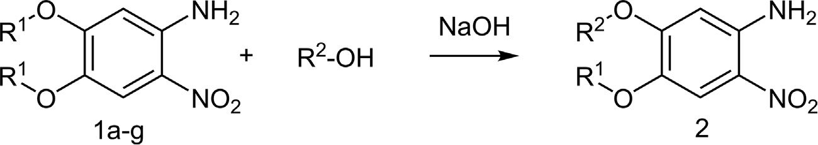
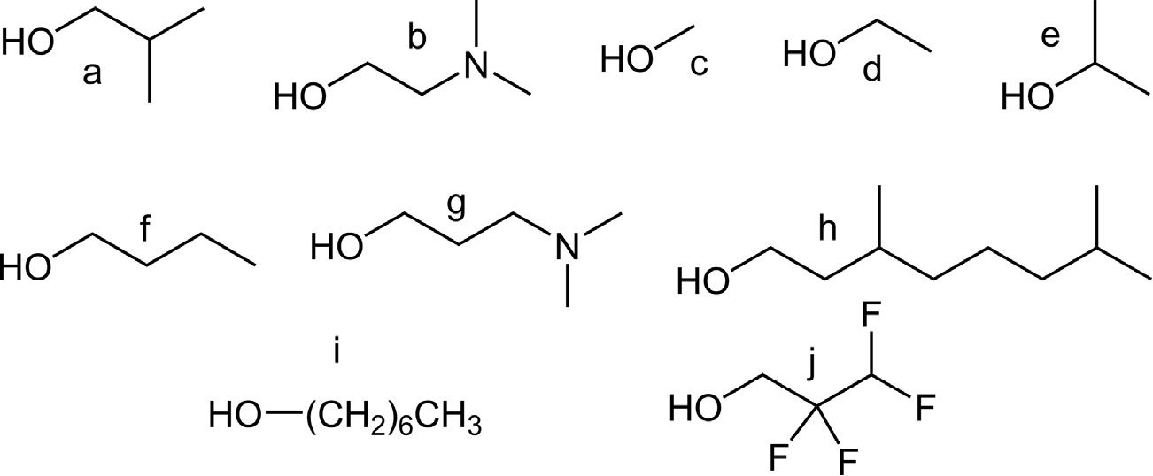
Jarosław Grolik, Paweł Reka, M. Gorczyca et al.
Tetrahedron Letters 99 (2022) 153830
Table 2
Transetherification reactions of 2-nitroanilines.
Entry | R1 | R2 | Prod. 2 | Time [h] | Temp. [°C] | Yield* [%]
1 | CHs (a) | a | 2aa | 1 | 110 | 77**/62*****
2 |  | b | 2ab | 1 | 110 | 88**
3 | C2H5 (b) | a | 2ba | 1 | 110 | 86**/61*****
4 |  | b | 2bb | 1 | 110 | 92**
5 |  | h | 2bh | 22 | 90 | 69
6 |  | i | 2bi | 48 | 80 | 74
7 | n-C4H9 (c) | a | 2ca | 2 | 110 | 69**
8 |  |  |  | 1 | 110 | 62**/61*****
9 |  | b | 2cb | 1 | 110 | 77**
10 |  | c | 2 cc | 1 | 110 | 88**
11 |  | d | 2 cd |  | reflux | 86
12 |  |  |  | 1 | 110 | 91**
13 |  | e | 2ce | 22 | reflux | 23
14 |  |  |  | 1 | 110 | 81**
15 |  | g | 2cg | 1 | 110 | 75**
16 |  | j | 2cj |  | 110 | 0
17 | n-C6H13(d) | a | 2da | 1 | 110 | 78**/68****/67*****
18 |  | b | 2db | 1 | 110 | 69**
19 | n-C8H17 (e) | a | 2ea | 1 | 110 | 72**/70*****
20 |  | b | 2eb | 1 | 110 | 50**
21 | n-C10H21 (f) | a | 2fa | 1 | 110 | 86**/70*****
22 |  |  |  | 1 | 110 | 67***
23 |  |  |  | 1 | 110 | 55****
24 |  | b | 2fb | 1 | 110 | 61**
25 | i-C4H9 (g) | d | 2gd | 1 | reflux | 21
26 |  |  |  | 1 | 110 | 81**
27 |  | f | 2gf | 2 | 110 | 69**/58*****
1 mmol 4,5-dialkoxy-2-nitroaniline (2NA), 10 mmol NaOH, 200 mmol R2OH, Argone *) Isolated yield after purification,
2NA, air, ****) 10 mmol 2NA, air *****), 1 mmol 2NA without protecting atmosphere and not dried R2OH.
) according to the general procedure, ***) 5 mmol
Many other alcohols (R2-OH) were tested to find the scope and
limitations. The primary and secondary aliphatic alcohols gave
good to excellent yields (50-92%) (Table 2, alcohols a-i). In case
of longer aliphatic alcohols are used, it may be helpful to use a
lower temperature (80-90 °C) and a longer reaction time to mini-
mize tar formation. Fluorinated alcohols (Table 2, entry 16, and
- octafluoro-1-pentanol) did not form transetherifi-
cation products in this reaction, presumably due to their much
higher acidity, which implies weaker nucleophilic properties of a
conjugated base.
For the screening of different homologs of nitroanilines, we
choose 2-methylpropan-1-ol due to its interesting properties in
liquid crystals based on unsymmetrically substituted o-phenylene-
diamines [15], where it introduces a nematic phase to discotic
columnar liquid crystals. The next alcohol used in the tests was
2-(dimethylamine)ethan-1-ol due to its higher solubility in water.
In this reaction, the length of the substrate chain does not influence
the product yields (Table 2, entries 1-27) in opposition to the alka-
line displacement of the 1-alkoxy group in 1,2,-dialkoxy-4-
nitrobenzenes [10] probably due to the low solubility of higher
alcohols in the case of aqueous bases, but is good in other alcohols.
The yields of products for the tests carried out without the pro-
tective atmosphere and drying of the alcohols were about 10-30%
lower (Table 2, entries 1, 3, 8,17,19, 21-23, 27).
We conducted three additional experiments to elucidate the
influence of the electron-donating substituents (alkoxy and amine
groups) on the reaction regioselectivity (Scheme 3). All reactions
were carried out according to the general procedure (GP) [19].
4
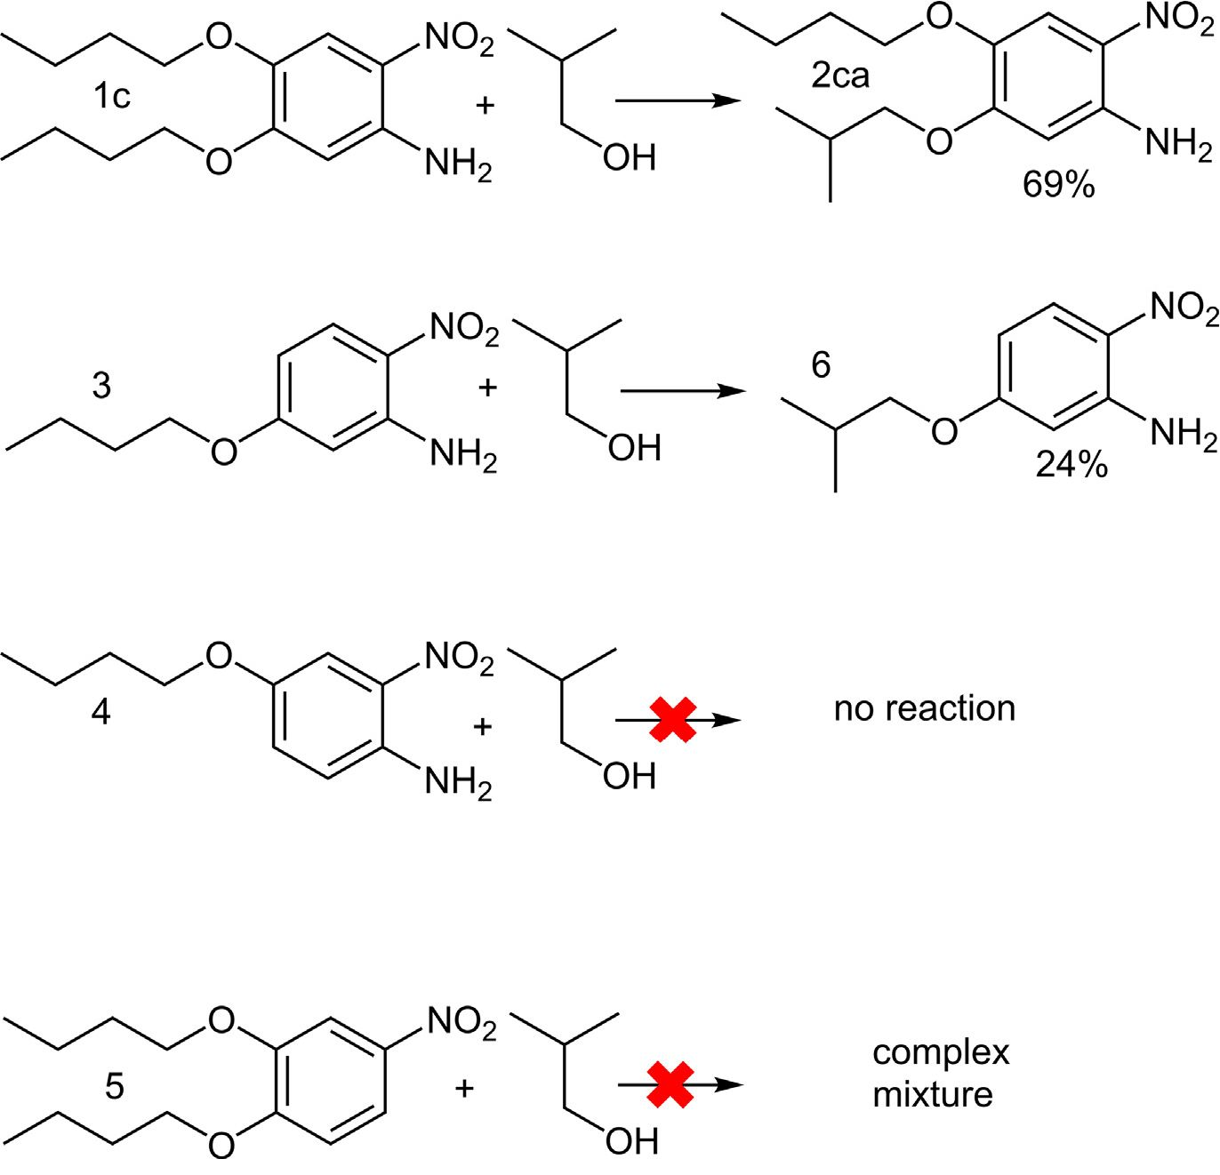
Jarosław Grolik, Paweł Reka, M. Gorczyca et al.
Tetrahedron Letters 99 (2022) 153830
The results of these reactions clearly show that the absence of C-4
alkoxy group lowers the yield of this reaction. Furthermore, the
lack of an amino group did not give an expected product under
the GP[19] conditions. As shown in Scheme 3, 5-butoxy-2-
nitroaniline (3) reacting under this condition gave 6 with a yield
of 24%. The substrate was recovered in 74% (conversion 26%), com-
pound 1c produced 69% of 2ca, 4-butoxy-2-nitroaniline (4) was
reacted according to GP [19], and 96% of the starting material
was recovered without formation of any transetherification
products. The reaction of 1,2-dibutoxy-4-nitrobenzene (5) under
GP [19] conditions results in a complex mixture without a sub-
strate or transetherification product.
Reactions carried out on a 5- or 10-mmol scale gave 3-15%
lower yields (Table 2, entries 17, 22, 23).
The alcohols can be reused after distilling under reduced pres-
sure from the reaction mixture, which does not significantly influ-
ence the yield (Table 2, entry 23).
The positions of ethoxy and isobutoxy substituents in 2ba and
2gd were confirmed by 1H and 2D NMR (NOESY and HMBC) exper-
iments. Based on the influence of the electron-donor (NH2) and
electron-acceptor (NO2) groups on the chemical shift of the neigh-
boring protons in the 1H NMR spectra, signals for the C3-H and C6-
H protons were assigned for 2ba (5C3_H = 7.53 ppm, (5C6_
H = 6.14 ppm) and 2gd (5C3-H = 7.52 ppm, (5C6-H = 6.13 ppm). As
can be clearly seen in the plotted part of the NOESY spectra, there
are two correlations indicating that in 2ba the isobutoxy group
(doublet) is close in space to C6-H proton and, respectively, the
ethoxy group (quartet) is in the vicinity of C3-H proton (Fig. 1a),
and in 2gd this correlations are reversed (Fig. 1b). The 13C NMR
assignment was made by analysis of the HMBC experiments. The
correlation between the C5 carbon signal at 157 ppm with the isob-
utoxy (C51-H) proton and the C41-H proton of ethoxy substituent
with carbon C4 at 141 ppm in case 2ba (Fig. 1c) confirms the struc-
ture. In the case of 2gd (Fig. 1 d) the observed correlations are
reversed, which confirms that transetherification occurs on the
C-5 benzene carbon atom. The NMR assignment of other com-
pounds was performed in an analogy to these two examples.
The undeniable confirmation of the substitution at the C-5 in
- dialkoxy-2-nitroanilines was shown by analysis of the crystal-
lographic structure by single crystal X-ray of 2cg, 2ba, and 2gd
(Fig. 2).
This efficient synthetic procedure for the synthesis of 4,5-dia-
lkoxy-2-nitroaniline containing two different alkoxy chains
encouraged us to apply it in the synthesis of biologically active
2,3-dialkoxyphenazine derivatives and liquid-crystalline
compounds.
We have shown that widely known ArSN could be used to syn-
thesize unsymmetrically substituted 2-nitroanilines and devel-
oped a new, simple, one-step synthesis of 4,5-dialkoxy-2-
nitroanilines substituted with two different alkoxy groups with
good to excellent yields. The reaction was conducted without the
use of additional solvents (the alcohols were substrates and sol-
vents simultaneously). The transetherification reaction at C-5
was also confirmed by X-ray crystallographic structure analysis.
5
Scheme 3. Regioselectivity of nucleophilic substitution.

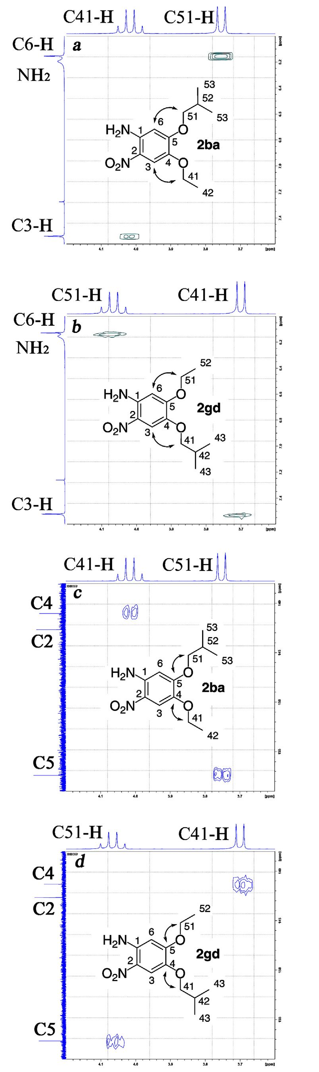
Jarosław Grolik, Paweł Reka, M. Gorczyca et al.
Tetrahedron Letters 99 (2022) 153830
6
Fig. 1. Part of 2D NMR spectra: a) 2ba NOESY, b) 2gd NOESY, c) 2ba HMBC, d) 2gd HMBC.

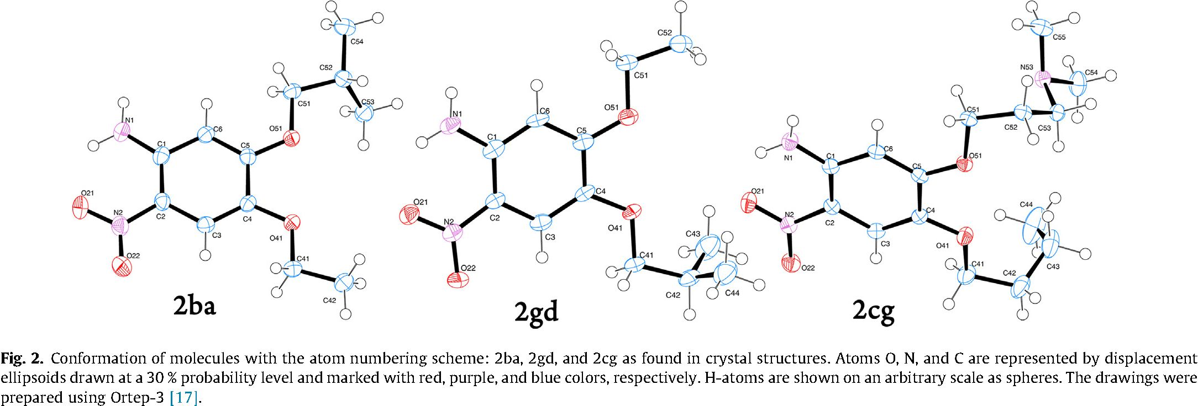
Jarosław Grolik, Paweł Reka, M. Gorczyca et al.
Tetrahedron Letters 99 (2022) 153830
Declaration of Competing Interest
The authors declare that they have no known competing finan-
cial interests or personal relationships that could have appeared
to influence the work reported in this paper.

Acknowledgements
The authors acknowledge Professor Katarzyna Ostrowska for
her great support, help, and faith. This work was supported by
the National Science Center Poland (NCN) under the Research
Grant MINIATURA 2 2018/02/X/ST5/01971. The research was car-
ried out with equipment purchased thanks to the financial support
of the European Regional Development Fund in the framework of
the Polish Innovation Economy Operational Program (contract no.
POIG.02.01.00-12-023/08).

Appendix A. Supplementary data
Crystallographic data for 2ba-2cg and 2gd-2gd’ have been
deposited with the Cambridge Crystallographic Data Centre as sup-
plementary publication numbers CCDC 2120283-2120284 and
CCDC 2120286-2120287, respectively. Copies of the data can be
obtained, free of charge, on application to CCDC, 12 Union Road,
Cambridge CB2 1EZ, UK (fax: +44-(0)1223- 336033 or email:
deposit@ccdc.cam.ac.uk). Supplementary data to this article can
be found online at https://doi.org/10.1016Zj.tetlet.2022.153830.

References
- (a) S.A. Duggan, G. Fallon, S.J. Langford, V-L. Lau, J.F. Satchell, M.N. Paddon-
Row, J. Org. Chem. 66 (2001) 4419;
- K.C. Frisch, M. Silverman, M. Taylor Bogert, J. Am. Chem. Soc. 65 (1943)
2432.
- (a) R. Reddy Putta, S. Chun, S. Hyun Choi, S. Beom Lee, D.C. Oh, S. Hong, J. Org.
Chem. 85 (2020) 15396;
- T. Binh Nguyen, J. Le Bescont, L. Ermolenko, A. Al-Mourabit, Org. Lett. 15
(2013) 6218;
- J. Pina, J.S. Seixas de Melo, R.M.F. Batista, S.P.G. Costa, M. Manuela, M.
Raposo, J. Org. Chem. 78 (2013) 11389.
- (a) S. Shee, D. Panja, S. Kundu,J. Org. Chem. 85 (4) (2020) 2775;
(b) B. Tanwar, P. Purohit, B. Naga Raju, D. Kumar, D.N. Kommia, A.K.
Chakraborti, RSC Advances. 5 (2015) 11873.
- (a) H.L. Yale, J. Bernstein, J. Am. Chem. Soc. 70 (1948) 254;
- S. Vangapandu, S. Sachdeva, M. Jain, S. Singh, P. Pal Singh, C. Lal Kaul, R.
Jain, Bioorganic & Medicinal Chemistry 11 (2003) 4557;
- K.K. Sharma, D.I. Patela, R. Jain, Chemical Communications 51 (2015)
15129.
- (a) M. Tietze, A. Iglesias, E. Merisor, J. Conrad, I. Klaiber, U. Beifuss, Org. Lett 7
(2005) 1549;
(b) A. Go,G. Lee, J. Kim, S. Bae, B.M. Lee, B.H. Kim,Tetrahedron 71 (2015) 1215.
- K. Kaur, S.R. Patel, P. Patil, M. Jain, S.I. Khan, M.R. Jacob, S. Ganesan, B.L.
Tekwani, R. Jain, Bioorganic & Medicinal Chemistry 15 (2007) 915.
- Shiuji, S.: Taro, M.: Mariko, O.: Kensei, Y.: Katsuo. H.: WIPO Patent Application
WO/1996/004235 A1, 1996.
- C.P. Ashcroft, P.J. Dunn, J.D. Hayler, A.S. Wells, Org. Process Res. Dev. 19 (2015)
740.
- Y. Ogata, M. Okano,J. Am. Chem. Soc. 71 (1949) 3211.
- (a) D.F. Page, R.O. Clinton,J. Org. Chem. 27 (1962) 218;
(b) G. Oliverio, Gazz. Chim. Ital. 73 (1943) 181.
- Y. Imakura, K. Okimoto, C. Gorohata, S. Kobayashi, M. Kihara, S. Yamashita,
Heterocycles 31 (1990) 1067.
- J. Song, H.J. Kang, M.A. Wenas, S.H.Jeong, T. Lee, K. Oh, K.H. Min, PLoS ONE 12
(2017) e0183575.
- J. Song, J.W. Lee, S. Jang, D. Jung, T. Lee, K.H. Min, Bulletin of the Korean
Chemical Society 10 (2019) 933.
- E.F. Caldin, G. Long, Journal of the Chemical Society (Resumed) 3737 (1954).
- J. Grolik, L. Dudek, J. Eilmes, Tetrahedron Letters. 38 (2012) 5127.
- S. Ohsawa, H. Nagasue, NIPPON KAGAKU KAISHI 1 (1974) 79.
- L.J. Farrugia, J. Appl. Cryst. 45 (2012) 849.
- D.C. Owsley, J.J. Bloomfield, Synthesis 2 (1977) 118.
- General procedure (GP): To the solution of 1 mmol of 4,5-dialkoxy-2-
nitroaniline (1a-g)|18] in 200 mmol of alcohol, 10 mmol of freshly powdered
NaOH was added. This mixture was deoxygenated with argon and heated at
110 C for 1 h (for lower boiling alcohols, the heating was carried out in a high
pressure glass tube). In the case of reactions conducted on a larger scale, 10 eq
of AcOH was added and the alcohol was distilled off. After being cooled to RT,
50 ml of Et2O (DCM can be used) was added and the organic layer was washed
3 times with 100 ml of water and an additional 1 time with brine. The organic
phase was dried with anhydrous MgSO4 and evaporated to dryness on a rotary
evaporator. Purification was carried out on 40-63im 60Á SiO2 short column
with gradient elution of DCM-Hexane 1:1 to DCM or DCM to DCM: MeOH:
NEt3 90: 10: 1 for products with N,N-dimethylaminoalkoxy substituent.
- Yields were calculated by integrating characteristic 1H NMR signals, taking
into account the mass of the crude mixture extracted from the reaction after
NaOH neutralization with AcOH.
7

