GEOLOGICA CARPATHICA, 54, 3, BRATISLAVA, JUNE 2003
181-187

THE TRACE FOSSIL CHONDRITES
IN UPPERMOST JURASSIC-LOWER CRETACEOUS DEEP CAVITY
FILLS FROM THE WESTERN CARPATHIANS (CZECH REPUBLIC)

ALFRED UCHMAN¹, RADEK MIKULAS² and VACLAV HOUSA²
- Institute of Geological Sciences, Jagiellonian University, Oleandry 2a, 30-063 Kraków, Poland; fred@ing.uj.edu.pl
- Institute of Geology, Academy of Sciences of the Czech Republic, Rozvojova 135, 165 00 Praha 6, Czech Republic;
mikulas@gli.cas.cz; housa@gli.cas.cz
(Manuscript received July 26, 2002; accepted in revised form December 12, 2002)
Abstract: The common marine trace fossil Chondrites occurs in thin layers in laminated micrites which fill deep subma-
rine cavities in peri-reefal biocalcarenites and calcirudites of the Tithonian-Berriasian Stramberg Limestone. The cavity
fills display several generations which originated during long periods of time. Periodic colonization of this very stressful
environment by the Chondrites trace maker was possible probably owing to episodic deposition of more oxygenated and
more nutritious sediment at a certain stage of development of the cavities related to increased tectonic activity during the
Berriasian. In more bioturbated laminae ?Palaeophycus also occurs. The occurrence of Chondrites in fillings of deep
cavities represents new evidence for adaptation of its trace maker to stressful environments.
Key words: Jurassic, Cretaceous, Western Carpathians, Czech Republic, peri-reefal cavities, cryptobionts, trace fossils,
Chondrites, Palaeophycus.

Introduction
Chondrites Sternberg, 1833, is one of the commonest inverte-
brate trace fossils in Phanerozoic marine deposits. It occurs in
a wide spectrum of environments from nearshore to the deep-
sea, including occurrence in different high-stress environ-
ments. It is widely known from organic-rich, oxygen-deficient
environments, where it occurs commonly as the first trace fos-
sil in the transition from anaerobic to dysaerobic deposits
(e.g., Bromley & Ekdale 1984; Savrda & Bottjer 1994). In fly-
sch deposits, Chondrites represents the last, deep colonization
of turbidites under conditions of decreased food and oxygen
content in sediments (Wetzel & Uchman 2001). Chondrites is
also common within a low-diverse trace fossil assemblage in
well-oxygenated, organics-poor, deep-sea variegated shales,
where it is related to strong oligotrophy (Leszczyński & Uch-
man 1993). It also occurs in brackish (Wightman et al. 1987;
Pemberton & Wightman 1992) and hypersaline deposits (Gib-
ert & Ekdale 1999).
Surprisingly, Chondrites occurs in fillings of deep cavities
in the Stramberg Limestone of the Kotouc quarry in Stram-
berk (Moravia, Czech Republic) (Fig. 1). Chondrites appears
here in distinct horizons providing a new insight into the prob-
lem of filling of the cavities. The aim of the present contribu-
tion is to describe and interpret the occurrence of Chondrites
in this environment, which is uncommon in the fossil record,
that is in the fill of submarine cavities within peri-reefal lime-
stones.

Geological setting
Several huge limestone bodies composed mostly of Titho-
nian to Berriasian limestones and locally of accompanying
Lower Cretaceous carbonate and siliciclastic rocks occur at
Stramberk in northern Moravia in the Czech Republic (e.g.,
Housa 1975, 1990) (Fig. 1). There are four main bodies, from
several hundred metres up to 1 km long, and dozens of smaller
bodies (tens of metres across) in their close neighbourhood.
All the bodies are isolated from the strata originally underly-
ing them, but they are partly accompanied by their original
sedimentary cover of flysch deposits of the Silesian Nappe of
the Carpathians.
The Stramberg Limestone is dominated by Tithonian-lower
Berriasian biocalcarenites and calcirudites with local blocks of
true biohermal limestones. They represent peri-reefal accumu-
lations; bioherms preserved in situ have not been recognized.
They were deposited on the so-called Baska Elevation. The
peri-reefal sedimentation persisted till the calpionellid
C. ferasini Subzone (Early Berriasian). The following C. el-
liptica Subzone is not reliably documented. Probably, at the
time interval of this zone, the Baska Elevation was partially
emerged, and reef and peri-reefal sedimentation was terminat-
ed. The emergence corresponds to the global Early Berriasian
eustatic sea level fall (Housa 1990). It was followed by a new
sedimentation cycle represented by argillaceous limestones
(Olivetska hora Member), which contain calpionellids of the
C. simplex Subzone. As the successive C. oblonga Subzone
was not ascertained, it presumably represents the time interval
of the next phase of emergence of the Baska Elevation. Sedi-
mentation took place in the late Valanginian again. Deposits
of the Gloriet Formation, which contains pelites, conglomer-
ates and blocks of the Stramberg and Olivetska hora Lime-
stones, accumulated at that time. Sedimentation continued till
the Hauterivian, represented by the deposits of the Planava
Formation, which is dominated by black pelites with blocks of
the Stramberg and Olivetska hora Limestones. Barremian, Al-
bian, and early Aptian sediments are not documented in the
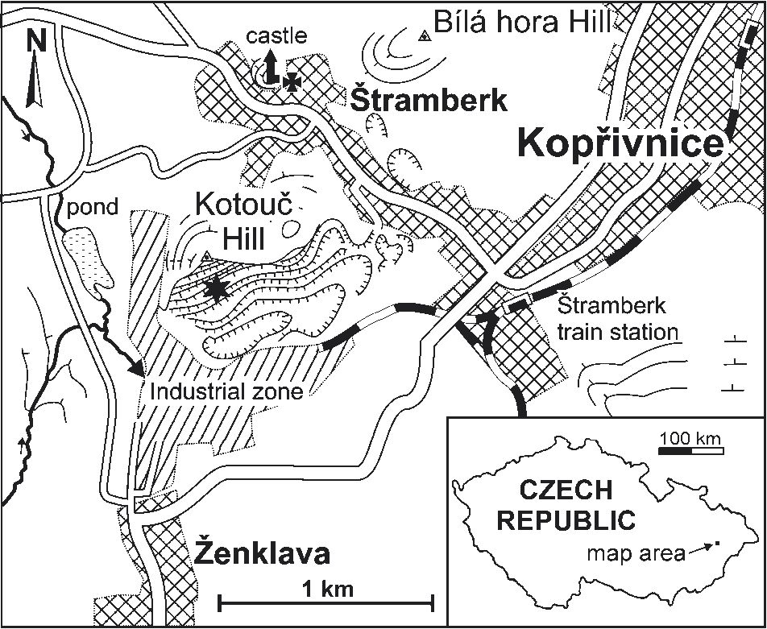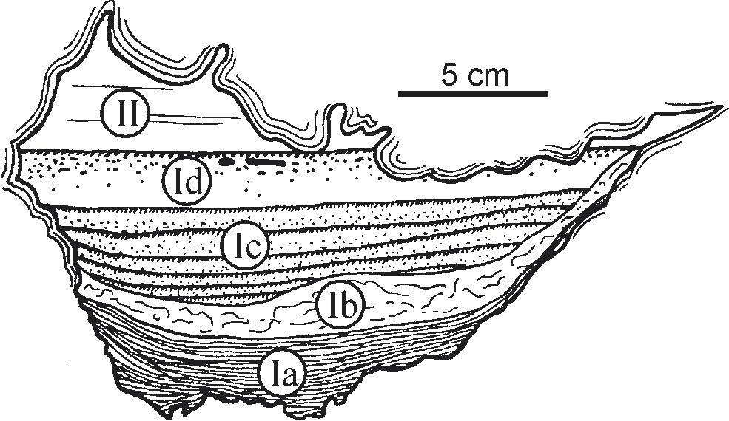
182
UCHMAN, MIKULAS and HOUSA

Fig. 1. Location map. The occurrence of the cavities described in
the Stramberg Limestone is marked by asterisk.
area. During this period, we presume a long-lasting break in
sedimentation of the Stramberg Limestone and its karstifica-
tion. The karst cavities of that age are filled with poorly sorted
conglomerates (Chlebovice Formation), which contain peb-
bles mostly from the Stramberg Limestone, and less common-
ly from all the above-mentioned Early Cretaceous formations
(Housa 1990).
To summarize, Early Cretaceous sedimentation was inter-
rupted by three main emergence episodes corresponding to
eustatic sea-level falls. Probably, it was also influenced by lo-
cal tectonic activity, which was responsible for formation of
deep and narrow fissures in the Stramberg Limestone. The fis-
sures are filled with upper Lower Cretaceous deposits (Housa
1965) and represent places of unique epifaunas on their walls
(Housa 1974) and interesting bioerosion (Mikulas 1992).

Cavities in the Stramberg Limestone
Contemporaneously with sedimentation of the Stramberg
Limestone, various cavities, several decimetres to more than
1 m across, formed in the rising body (Housa 1964). They
were partly formed by falls of huge limestone blocks; some of
them, however, are found in calcarenites and thus they might
have originated at places within bodies that were capable of
decay, leading to a cavity (e.g., wood, algal masses). The roof
and side walls of the cavities are usually covered with stroma-
tolitic crusts. The fill of the cavities is complex. Several gen-
erations of mainly marly micritic limestones can be observed.
The succession corresponds to the order of sedimentation on
the Baska Elevation during the Late Jurassic and Early Creta-
ceous. However, each cavity shows its own peculiar features.
Housa (1964) distinguished the following generations of
the filling of the primary cavities in a stratigraphic order (Fig.
2): (Ia) (the author’s original acronym) finely laminated mi-
critic limestone of the same lithology as the Stramberg Lime-
stone, covering the uneven floor of the cavity. Certain laminae
contain numerous ooids and pseudo-ooids; (Ib) micritic lime-
stone with convolute-structure; (Ic) rhythmically stratified
light to dark yellowish-green argillaceous limestone with “bur-
rows”. Its lithology is very similar to the Olivetska hora Lime-
stone; (Id) thicker layer of yellowish-green argillaceous lime-
stone identical to Ic; and (II) yellowish-green calcareous
claystone to argillaceous limestone identical to a terminal gen-
eration of the fill of the “fissures”, that is greenish-yellow
argillaceous limestones (Housa 1965). Some of the genera-
tions may be missing in some cavities. The filling material of
the cavities, especially the generations Ib to II, contrasts litho-
logically with the surrounding rock, which is composed most-
ly of biocalcarenites, biocalcirudites and biolitites. The “bur-
rows” from generation Ic and Id are referred to as Chondrites
in this paper.
According to Housa (1964), generation Ia is contempora-
neous with the reef sedimentation and therefore it is Tithonian
to earliest Berriasian in age. In the beginning, the cavities were
connected to the sea floor only by pores in the detrital sub-
strate. Later, as the reef body was tectonically elevated, thin
fissures appeared, connecting the cavities with the sea floor.
Contemporaneously, large and deep fissures appeared. They
were called “fissures of the Stramberk generation” by Housa
(1964). Generation Ib probably corresponds to termination of
sedimentation of the Stramberg Limestone and the related
short hiatus. Generations Ic and Id originated presumably con-
temporaneously with the Olivetska hora Limestone (late Berri-
asian). Generation II, richest in clay minerals, originated very
probably contemporaneously with the terminal phase of fill of
the “fissures of the Olivetska hora generation” (Housa 1964).
These argillaceous limestones have no analogue among the ad-
jacent Cretaceous formations, and do not contain any fossils.
They probably belong to the late Valanginian.
We presume that nearly all cavities were only connected
with the sea floor through thin fissures which were always
formed together with widening of large fissures during the
above-mentioned uplift phases of the Baska Elevation. As new

Fig. 2. Schematized section of a cavity in the Stramberg Limestone
and its fill. Drawn according to Housa (1964) and collected sam-
ples of fill of cavities. Ia-Id, II are generations of the fill as de-
scribed in more detail in the text. The ceiling and roof of the cavity
is covered with a stromatolitic growth which occur typically on
cavity roofs, but may also cover walls and bottoms. For details of
Ic-Id generations see photographs on Figs. 3C and 4A.
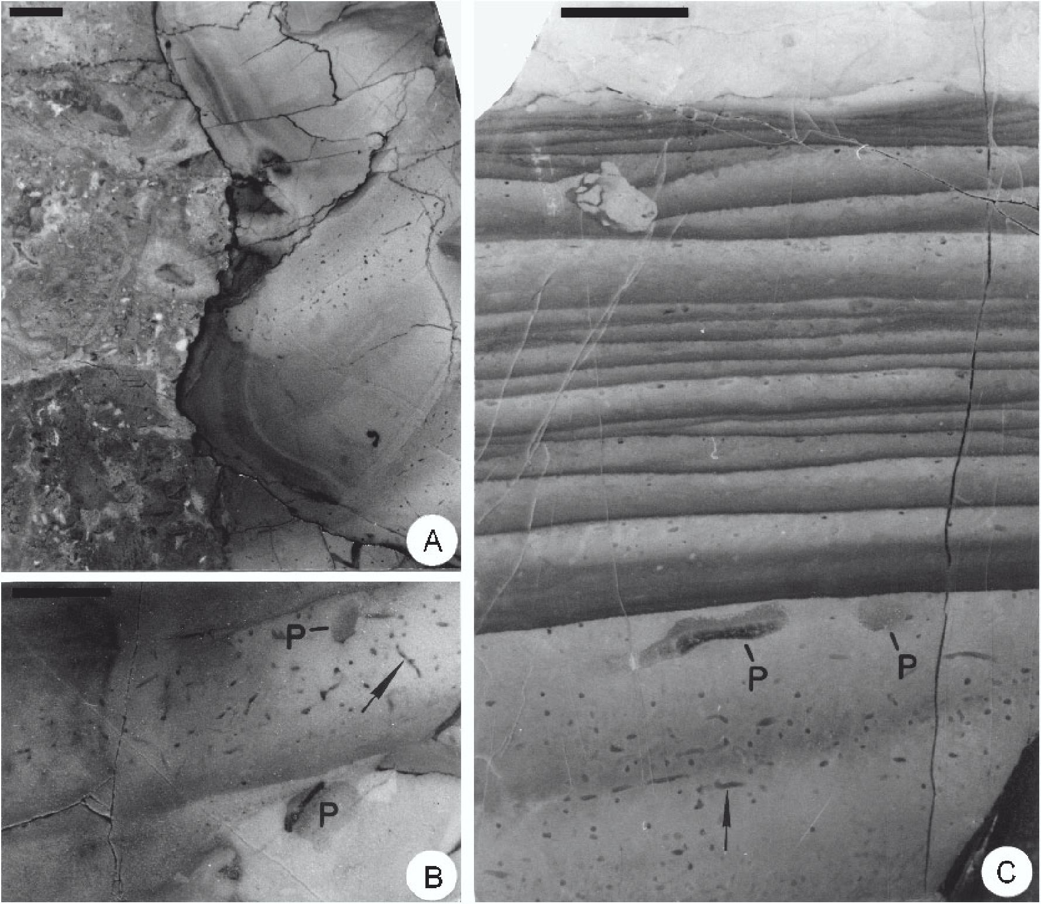
THE TRACE FOSSIL CHONDRITES IN DEEP CAVITY FILLS
183

Fig. 3. Filling of the cavities from the Stramberg Limestone. Scale bars = 1 cm. A — Contact of the filling (to the right) with calcarenites of
the Stramberg Limestone (to the left); B — fragment of the filling with Chondrites (an example indicated by the arrow) and ?Palaeophycus
(P); C — fragment of filling of “cavity 1964”, floor No. 4 of the Kotouc quarry (after Housa 1964: pl. I, fig. 2). Bioturbated laminae of the Ic
(in the middle and lower upper part) and Id generations (in the lower part) with Chondrites (arrow) and ?Palaeophycus (P).
space within large fissures became filled and thin fissures
were stopped up, sedimentation in cavities became extremely
slow or halted.
Up to now, several dozens of cavities have been observed in
walls of the Kotouc quarry. Numerous samples of their fill are
stored in the Institute of Geology, AS CR, Praha, and in the
Jagiellonian University, Kraków. The Institute of Geology
also owns a photographic documentation of the former quarry
walls. In spring of 2000, dozens of filled cavities were observ-
able in the quarry walls of floors Nos. 5 and 6 of the Kotouc
quarry, but only one cavity having generation Ic containing
Chondrites was easily available at floor No. 6 (Fig. 1).

Chondrites and its host deposits
The cavity filling containing Chondrites was classified by
Housa (1964) as generations Ic and Id. Both generations are
composed of laminated micrite. In generation Ic (Figs. 2, 3C,
4, 5) the laminae are parallel, 5-12 mm thick. The limestone
displays different colour zonation from light-grey, grey to yel-
low-grey. Boundaries of the laminae are sharp or slightly dif-
fuse at a distance of about 1 mm. There are also a few centi-
metre-thick bundles of hummocky laminae between the
parallel laminae (Figs. 3C, 4B). They are uneven, with
smooth, irregularly wavy boundaries. Individual laminae dis-
play swellings and narrowings. They are at most 4 mm thick
in the swellings.
In generation Id (Fig. 2), the micrite is light-grey, grey,
dark-grey and yellow-grey in colour. The lamination is indis-
tinct and is marked by the occurrence of Chondrites. The fill-
ing is cross-cut by dark stylolites (Fig. 3A). Locally, stylolites
occur at the boundary of this lithology. In the filling, irregular
patches of very fine, stromatolitic-like lamination are present
(Fig. 4A).
Chondrites has been observed in vertical and horizontal sec-
tions in polished slabs and in thin-sections. It occurs as groups
of small dots and single or branched straight bars (Figs. 3B-C,
4, 5, 6), which are cross-sections of slightly curved tunnels
branched in a dendroid manner, similarly to other occurrences
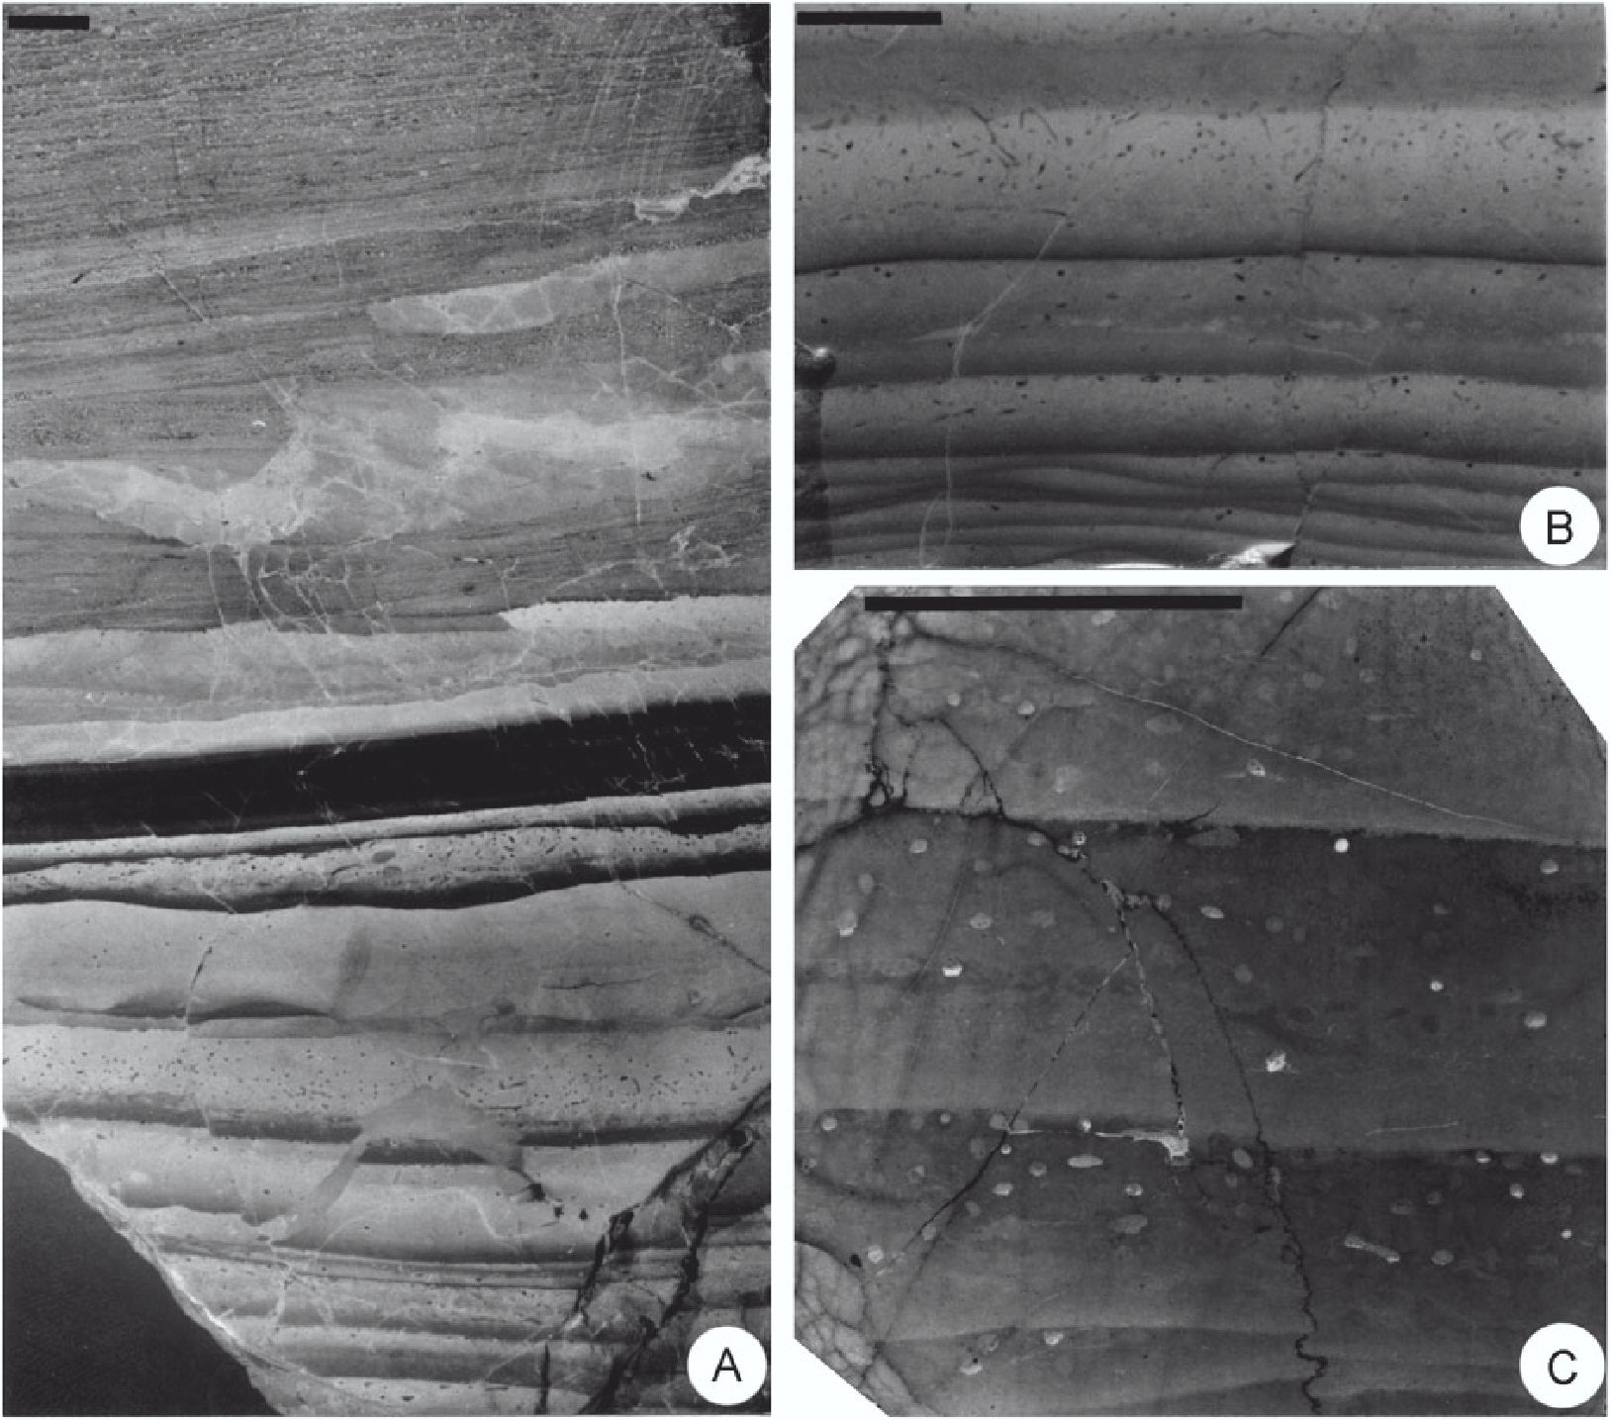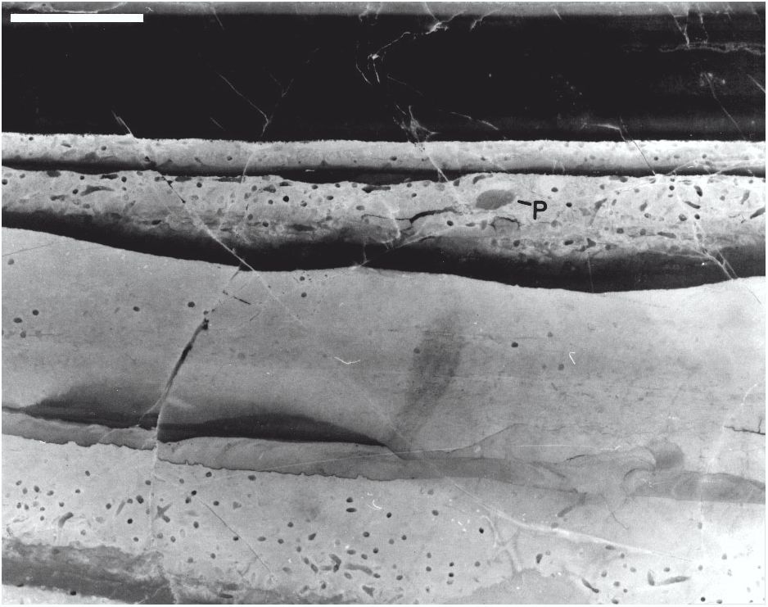
184 UCHMAN, MIKULAS and HOUSA

Fig. 4. Other examples of filling of the cavities from the Stramberg Limestone. Scale bars = 1 cm. A — Fragment of filling of the “cavity
1981”, floor No. 4 of the Kotouc quarry. The bioturbated Ic generation (lower part) with Chondrites (close view in Fig. 5) and the overlying
generation II (middle and upper part); B — the generation Ic with Chondrites. The hummocky lamination in the lower part; C — detail of B
in a thin section. Some Chondrites tunnels exhibit geopetal filling.
(e.g., Werner & Wetzel 1981; Ekdale & Bromley 1991; Wet-
zel & Uchman 1998). The tunnels are 0.3 to 0.5 mm wide and
differently oriented to the bedding. The tunnels are usually
filled with slightly darker and coarser material than the host
rock or with blocky calcite cement. Combinations of these
two types are also present, where the blocky cement occurs as
geopetal structures (Fig. 4C). The tunnels filled with micritic
limestone are often surrounded by a diagenetic “halo” up to
1 mm thick (Fig. 3C).
The small size and simple morphological elements suggest
that the analysed form is a small Chondrites intricatus
(Brongniart, 1823). This ichnospecies was discussed, for in-
stance, by Fu (1991) and Uchman (1999). As the individual
tunnels are rarely branching and we cannot observe a radial
structure of the system, they resemble the ichnogenus Pili-
chnus Uchman (1999), but the latter displays long, exclusive-
ly horizontal tunnels.
In generation Ic, Chondrites occurs in the upper part of the
parallel laminae up to 8 mm from their top. In some laminae,
the zone with Chondrites is only 1-3 mm thick, and in other
laminae it does not occur at all. Some of the laminae devoid of

Fig. 5. Detail of Fig. 4A. Dark non-bioturbated laminae in the upper
part. Chondrites and ?Palaeophycus (P) in other laminae. Scale bar
= 1 cm.
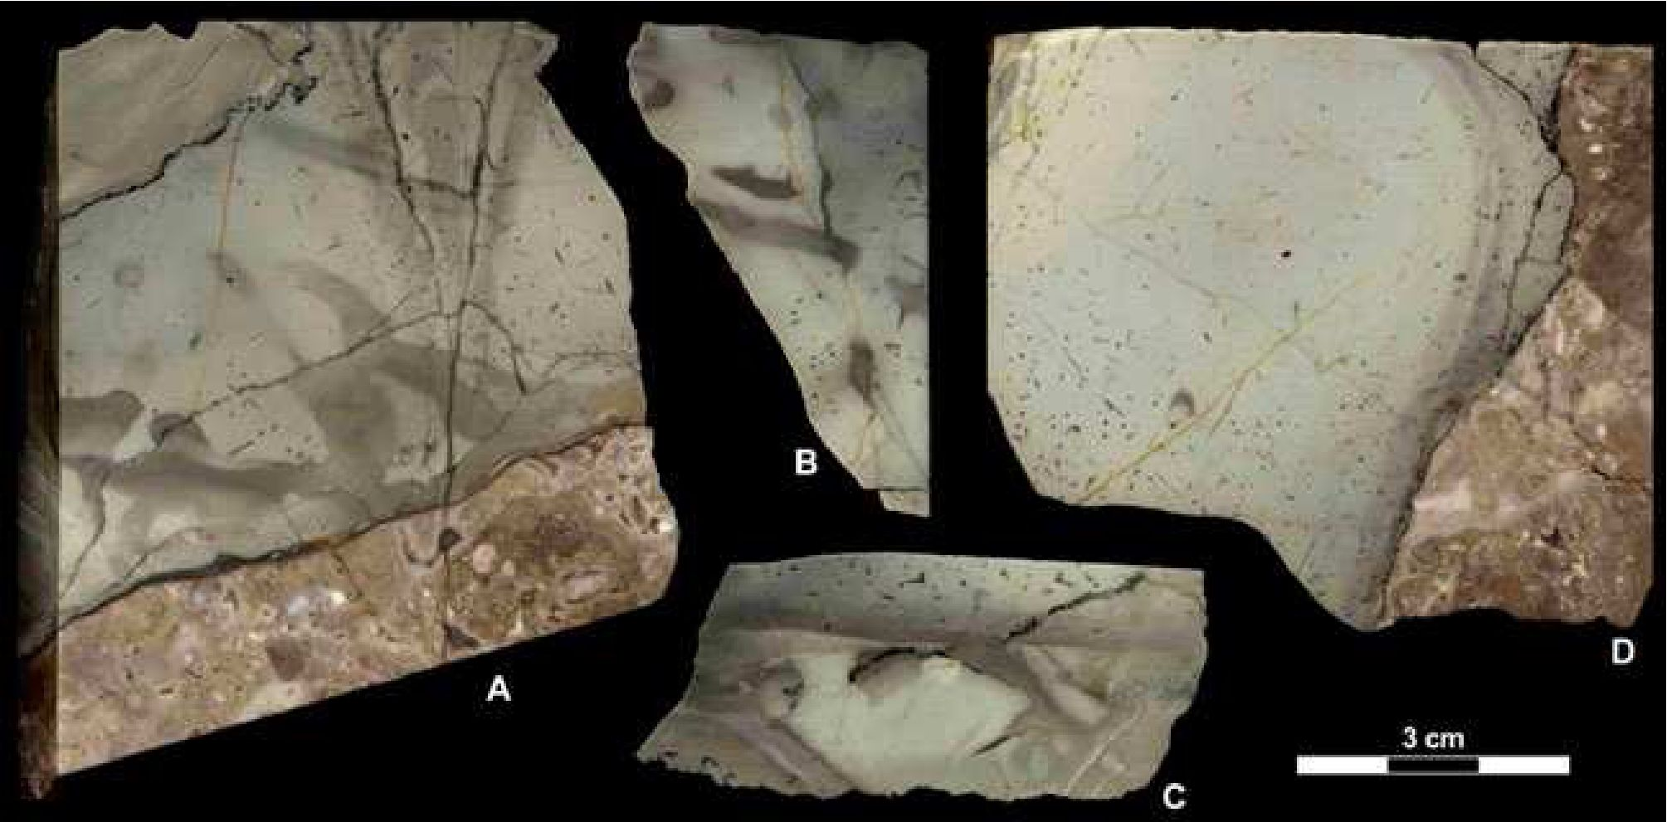
THE TRACE FOSSIL CHONDRITES IN DEEP CAVITY FILLS
185

Fig. 6. Horizontal cross-sections of the described trace fossils. A, D — Chondrites intricatus (Brongniart, 1823). Contact of the filling with
calcarenites of the Stramberg Limestone clearly visible. B, C — Chondrites intricatus (Brongniart, 1823) and ?Palaeophycus isp. Scale
bar = 3 cm.
Chondrites are dark (Figs. 4A, 5). No Chondrites cross-cuts
the laminae boundaries. It is the only trace fossil in most of
the laminae examined. However, two of the laminae of the Ic
generations, from two different cavities, also contain sections
of a tubular, subhorizontal, slightly curved trace fossil, 2.0-
2.5 mm in diameter, lacking discernible or having indistinct
wall lining but apparently uncollapsed (Figs. 3A-B, 5). It may
be classified as Palaeophycus tubularis Hall, 1847 (Pember-
ton & Frey 1982; Keighley & Pickerill 1995) if we presume
that the wall is not a diagenetic effect. Provided the tunnels
were originally unlined, they might be better referred to as Pla-
nolites Nicholson, 1873 (Pemberton & Frey 1982). Regard-
less of these doubts, it is very probably that all the described
2.0-2.5 mm thick tunnels represent the same ichnotaxon. As
we cannot solve the problem under the present material, we
leave the ichnotaxon in the open nomenclature as ?Palaeo-
phycus isp.
In generation Id, Chondrites occurs in 8-25 mm thick zones
(Fig. 3C). The thickest zone also contains sections of a tubular
trace fossil, about 2 mm in diameter, with a thin wall, which is
probably ? Palaeophycus isp.

Discussion
Trace fossils in cavities
Fauna exclusively inhabiting cavities (also called cryptic
fauna, cryptos, cryptobionts, or coelobites) is known mostly
from reef environments (see summary by Kobluk 1988b, who
also reviewed pre-Cenozoic reef organisms; Kobluk 1988a).
Most of animal cryptobionts are represented by sessile or vag-
ile epibenthos. Infaunal soft-substrate cryptobionts are less
known. Among them, trace fossils are the most obvious
record of infaunal activity in cavities, but literature on the top-
ic is very scarce. James & Kobluk (1978); Kobluk & James
(1979) and Pemberton et al. (1979) mentioned trace fossils in
filling of cavities in the Lower Cambrian reefs of Labrador in
Canada, which include Palaeophycus, ?Teichichnus, Torrow-
angea, and three other unidentified forms (Kobluk 1988a).
Most published data on trace fossils in cavities concern bor-
ings in hard substrates (e.g., Palmer & Fürsich 1974; Bromley
& Asgaard 1993; Wilson 1998).
The case of Chondrites
We may presume that the cavities occurred several metres
to several tens of metres below the sea floor when the genera-
tion Ia was formed. The stromatolitic crust on the cavity
walls, produced probably by microbes, indicates that the cavi-
ties have been at least partially empty for long periods. The
cavities were accessible only for very fine clay and micritic
material, which could be strained through pores in the biode-
tritic substrate. Subsequently, as the bottom became more dis-
tant from the cavities, influx of the clay and micrite became
weaker and the sedimentation of generation Ia stopped. It was,
however, several times restarted, presumably when new thin
fissures formed during phases of tectonic uplift of the Baska
Elevation. Besides these processes, weak exchange of water
enabled growth of stromatolitic ?microbial communities.
Further rejuvenation of tectonic activity was probably con-
temporaneous with the sedimentation of the Olivetska hora
Member. Generations Ic and Id of the cavity fill correspond to
this period. Lamination of the fill and concentration of Chon-
drites at the top of individual laminae suggest that the cavities
have been filled incidentally. Deposition of individual lami-
nae was rapid. It was followed by colonization of the Chon-
drites trace maker, and of the ?Palaeophycus producer for
186
UCHMAN, MIKULAS and HOUSA
some laminae. The filling of some Chondrites is composed of
blocky calcite cement, which probably originated in the early
stages of diagenesis. This indicates cessation of sedimentation
between deposition of laminae and that the sediment was un-
disturbed by other burrowers.
Penetration of Chondrites in the sediment is very shallow,
especially in generation Ic. The diameter of the Chondrites
tunnels is very small here in comparison to the diameters of
Chondrites intricatus from the Rhenodanubian Flysch of the
Alps (Uchman 1999, p. 92). Those facts and the fact that
Chondrites occurs alone in most of the laminae, and that there
is no evidence of intensive bioturbation, suggest an extremely
stressful environment. The environment, however, differed in
various cavities and changed according to the degree of com-
munication of the cavities to the sea floor. One sample
(Fig. 3C) shows a relatively intensive bioturbation (up to
40 % of the substrate volume) and occurrence of ?Palaeophy-
cus in one of the first laminae of generation Id. In other cavities,
bioturbation is generally weak. Approximately 90 % of the cav-
ities do not display bioturbational structures in their fill.
The stress factors in deep cavities can be variable and relat-
ed mainly to limited food, and oxygenation, and lack of light.
The last factor is not important in the case of Chondrites,
which occurs in the completely dark deep-sea environments.
Low oxygenation in the limited, mostly stagnant environment
of deep cavities is very probable. Black laminae (Figs. 4A, 5)
are not colonized. The oxygenation may have improved dur-
ing episodes of deposition, when influx of oxygenated waters,
which enabled the colonization, took place. It is difficult to es-
timate the amount and role of food. Certainly, the cavities are
isolated from the fertile plankton rain. Chondrites is a station-
ary structure that is relatively inefficient for deposit-feeding.
According to Seilacher (1990) and Fu (1991), the tracemaker
of Chondrites may have been able to live at the aerobic/anox-
ic interface as a chemosymbiotic organism, which pumps
methane and hydrogen sulphide from the sediments. Deep
submarine cavities or fissures can be conduits for these gases,
which might be exploited by the Chondrites trace maker not
only from sediment, but also directly from the water.
Another interesting problem is the occurrence of ?Palaeo-
phycus in some laminae, which may indicate improvement of
oxygenation. ?Palaeophycus occurs in laminae where the
zone occupied by Chondrites is relatively thick or the intensi-
ty of bioturbation is relatively high. Palaeophycus is interpret-
ed as a trace of a vagile ?carnivorous organism (Pemberton &
Frey 1982) but, in the described case, ? Palaeophycus may
rather represent a dwelling burrow of a stationary detritus-
feeder. There is no evidence of other macroorganisms in the
cavities.
Acknowledgments: Jozef Michalik (Bratislava), Franz Für-
sich (Würzburg), Jordi M. de Gibert (Barcelona) and an anon-
ymous reviewer provided helpful comments and improve-
ments of the manuscript. The paper is a part of the research
programme of the Institute of Geology, Academy of Sciences
of the Czech Republic (No. CZK-Z3 013 912). A.U. was
sponsored by the Jagiellonian University, Kraków, and the
CEEPUS Academic Exchange Programme, which enabled his
visit to the Czech Republic. Because of its relevance to the
study of trace fossils in stressful environments, the paper has
been partly supported by the Grant No. 205/00/0118 of the
Grant Agency of the Czech Republic.

References
Bromley R.G. & Asgaard U. 1993: Endolithic community replace-
ment on a Pliocene rocky coast. Ichnos 2, 93-116.
Bromley R.G. & Ekdale A.A. 1984: Chondrites: a trace fossil indi-
cator of anoxia in sediment. Science 224, 872-874.
Ekdale A.A. & Bromley R.G. 1991: Analysis of composite ichno-
fabrics: an example in uppermost Cretaceous chalk of Den-
mark. Palaios 6, 232-249.
Fu S. 1991: Funktion, Verhalten und Einteilung fucoider und lopho-
ctenoider Lebensspuren. Courier Forschungs Inst. Sencken-
berg 135, 1-79.
Gibert J.M. & Ekdale A.A. 1999: Trace fossil assemblages reflect-
ing stressed environments in the Middle Jurassic Carmel Sea-
way of central Utah. J. Paleont. 73, 4, 711-720.
Housa V. 1964: Determination of the position of the Stramberk lime-
stone on the Kotouc hill near Stramberk according to the stratifi-
cation of the cavity-fills. Vest. Üstr. Üst. Geol. 39, 429-434.
Housa V. 1965: The fillings of fissures in the Stramberk limestone.
Cas. Miner. Geol. 10, 381-389.
Housa V. 1974: Traces of boring of organisms and attached epifau-
na on the surface of the Stramberk and Olivetska hora lime-
stones in Stramberk. Cas. Miner. Geol. 19, 403-414.
Housa V. 1975: Geology and paleontology of the Stramberg Lime-
stone (upper Tithonian) and the associated lower Cretaceous
beds. Mem. Bur. Rech. Géol. Min. (Paris) 76, 342-349.
Housa V. 1990: Stratigraphy and calpionellid zonation of the Stram-
berg limestone and associated lower Cretaceous beds. In: Pallini
G., Cecca F., Cresta S. & Santanorio M. (Eds.): Atti del Secondo
Convegno Internattzuionale “Fossili, Evoluzione, Ambiente”.
Comitato Centenario Raffaele Piccinini, Pergola, 365-370.
James N.P. & Kobluk D.R. 1978: Lower Cambrian patch reefs and
associated sediments: southern Labrador, Canada. Sedimentol-
ogy 25, 1-35.
Keighley D.G. & Pickerill R.K. 1995: The ichnotaxa Palaeophycus
and Planolites: historical perspectives and recommendations.
Ichnos 3, 301-309.
Kobluk D.R. 1988a: Pre-Cenozoic fossil record of cryptobionts and
their presence in early reefs and mounds. Palaios 3, 243-250.
Kobluk D.R. 1988b: Cryptic faunas in reefs: ecology and geologic
importance. Palaios 3, 379-390.
Kobluk D.R. & James N.P. 1979: Cavity-dwelling organisms in
Lower Cambrian patch reefs from southern Labrador. Lethaia
12, 193-218.
Leszczyński S. & Uchman A. 1993: Biogenic structures of organics-
poor siliciclastic sediments: Examples from Paleogene varie-
gated shales, Polish Carpathians. Ichnos 2, 267-275.
Mikulas R. 1992: Early Cretaceous borings from Stramberk. Cas.
Miner. Geol. 37, 297-312.
Palmer T.J. & Fürsich F.T. 1974: The ecology of a Middle Jurassic
hardground and crevice fauna. Palaeontology 173, 507-524.
Pemberton S.G. & Frey R.W. 1982: Trace fossil nomenclature and the
Planolites-Palaeophycus dilemma. J. Paleont. 56, 843-881.
Pemberton S.G., James N.P. & Kobluk D.R. 1979: Ichnology of the
Labrador Group (Lower Cambrian) in southern Labrador. Bull.
Amer. Assoc. Petrol. Geol. 63, 508.
Pemberton S.G. & Wightman D.M. 1992: Ichnological characteris-
tics of brackish water deposits. In: Pemberton S.G. (Ed.): Ap-
plications of ichnology to petroleum exploration: a core
workshop. SEPM (Society for Sedimentary Geology), Core
THE TRACE FOSSIL CHONDRITES IN DEEP CAVITY FILLS
187
Workshop 17, 141-167.
Savrda C.E. & Bottjer D.J. 1994: Ichnofossils and ichnofabrics in
rhythmically bedded pelagic/hemi-pelagic carbonates: recogni-
tion and evaluation of benthic redox and scour cycles. Spec.
Publ. Int. Assoc. Sedimentologists 19, 195-210.
Seilacher A. 1990: Aberration in bivalve evolution related to photo-
and chemosymbiosis. Historical Biology 3, 289-311.
Uchman A. 1999: Ichnology of the Rhenodanubian Flysch (Lower
Cretaceous-Eocene) in Austria and Germany. Beringeria 25,
65-171.
Werner F. & Wetzel W. 1981: Interpretation of biogenic structures
in oceanic sediments. Bull. Inst. Géol. Bassin Aquitaine 31,
275-288.
Wetzel A. & Uchman A.1998: Biogenic sedimentary structures in
mudstones — an overview. In: Schieber J., Zimmerle W. &
Sethi P.S. (Eds.): Shales & Mudstones. I. Basin studies, sedi-
mentology and paleontology. E. Schweitzerbart, Stuttgart,
351-369.
Wetzel A. & Uchman A. 2001: Sequential colonization of muddy
turbidites: examples from Eocene Beloveża Formation, Car-
pathians, Poland. Palaeogeogr. Palaeoclimatol. Palaeoecol.
168, 171-186.
Wightman D.L., Pemberton S.G. & Singh C. 1987: Depositional
modelling of the upper Mannville (Lower Cretaceous), central
Alberta: Implications for recognition of brackish water depos-
its. In: Tillman R.W. & Weber K.J. (Eds.): Reservoir sedimen-
tology. SEPM, Spec. Publ. 40, 189-220.
Wilson M.A. 1998: Succession in a Jurassic marine cavity commu-
nity and the evolution of cryptic marine faunas. Geology 26,
379-381.

