Acta Poloniae Pharmaceutica ñ Drug Research, Vol. 69 No. 5 pp. 821ñ831, 2012
ISSN 0001-6837
Polish Pharmaceutical Society
KINETIC AND THERMODYNAMIC STUDIES OF MOXIFLOXACIN HYDROLYSIS IN THE PRESENCE AND ABSENCE OF METAL IONS IN ACIDIC SOLUTIONS
URSZULA HUBICKA1, BARBARA ØUROMSKA-WITEK1, JAN KRZEK1*, MARIA WALCZAK2 and MAREK ØYLEWSKI3
1Department of Inorganic and Analytical Chemistry,
2Department of Pharmacokinetics and Physical Pharmacy,
3Department of Organic Chemistry, Jagiellonian University, Medical College, Medyczna 9, 30-688 KrakÛw, Poland
Abstract: Chromatographic and densitometric method for determination of moxifloxacin in the presence of products of acidic hydrolysis was developed. The established method had suitable specificity, precision, good accuracy and high sensitivity.In addition, stability of moxifloxacin in acidic solutions at temperature 90∞C and 110∞C in the presence and absence of metal ions, such as Cu(II), Fe(III), Zn(II), and Al(III) was studied. It was proved that decomposition of moxifloxacin proceeds according to kinetics of the first-order reaction and is dependent on temperature, incubation time and the type of the metal ion. Based on the calculated kinetic (k, t0.1 and t0.5) and thermodynamic (Ea) parameters, it was observed that among studied ions the highest effect on decomposition process of moxifloxacin had Cu(II) ions. The liquid chromatography coupled with mass spec- trometry detection (LC-MS) and proton nuclear magnetic resonance (1H NMR) techniques have been used to identify degradation products of moxifloxacin.
Keywords: fluoroquinolones, 1H NMR, LC-MS, metal ions, moxifloxacin, stability
Moxifloxacin (1-cyclopropyl-7-[(1S, 6S)-2,8- diazabicyclo[4.3.0]non-8-yl]-6-fluoro-8-methoxy- 4-oxo-quinoline-3-carboxylic acid, monohydrochlo- ride) is a fourth generation synthetic fluoro- quinolone chemotherapeutic agent (1). It possesses excellent activities against a variety of different types of Gram-negative (Streptococcus pneumoniae and Staphylococcus aureus), Gram-positive (Enterobacteriaceae family, and Pseudomonas aeruginosa) and anaerobic bacteria (Bacteroides and Clostridium). Its activity against atypical bacteria of Chlamydia spp., Mycoplasma spp., and Legionella spp. genera and bacilli of genus Mycobacterium is of high value (2ñ5).
The mechanism of action of moxifloxacin, similar to other fluoroquinolones, lies in inhibiting the activity of two bacterial enzymes ñ DNA gyrase (topoisomerase II) and topoisomerase IV, which regulate spatial arrangement of DNA in bacterial cells. These proteins can cut both strands of the nucleic acid and rejoin them. Inhibiting the activity of those enzymes by formation of irreversible com- plex drug/enzyme/DNA, disables DNA synthesis and leads to the bacterial cell death (3, 4).
According to the available literature, high pres- sure liquid chromatography (HPLC) technique is mainly used for analysis of moxifloxacin in pharma- ceutical preparations and biological material (5ñ14). This technique was used for identification of moxi- floxacin and its decomposition products (1, 15, 16). The ligand-exchange liquid chromatography with the use of a chiral modifier in stationary phase was used for separation of moxifloxacin and its (R, R)- isomer (17).
The LC-MS/MS technique was used for identi- fication and quantification of moxifloxacin in human plasma and cerebrospinal fluid (18, 19).
The TLC method for identification of lome- floxacin, moxifloxacin and sparfloxacin and their decomposition products was recommended by Salem et al. (20) Identification of moxifloxacin was performed on TLC plates covered with silica gel with the mobile phase: 0.3 M ammonium acetate solution ñ conc. ammonia ñ n-propanol (1: 1: 8, v/v/v). The spots on chromatograms were recorded densitomerically at λ = 290 nm (20).
For stress studies with moxifloxacin, Motwani et al. used the silica gel coated HPTLC plates and
* Corresponding author: e-mail: jankrzek@cm-uj.krakow.pl
821

822
URSZULA HUBICKA et al.
Apparatus
Densitometer ñTLC Scanner 3 with WinCats
1.3.4 software (Camag, Muttenz, Switzerland). Sample applicator ñ Linomat V Camag (Muttenz, Switzerland). TLC plates ñ 10 ◊ 12 cm (cut from 20
◊ 20 cm precoated TLC sheets of silica gel 60 F254 on aluminium; Art. 1.05548; Merck Darmstadt, Germany). Chromatographic chamber ñ 17.5 ◊ 16 ◊
8.2 cm in size (Sigma ñ Aldrich, Cat. No. Z20, 415- 3). LC system ñ Agilent 1100 (Agilent Technologies, Waldbronn, Germany) LC system. Column ñ XBridge C18 (30 mm ◊ 2.1 mm, 3.5 mm, Waters, Ireland). Mass spectrometer ñ Applied Biosystem MDS Sciex (Concord, Ontario, Canada) API 2000 triple quadrupole mass spectrometer equipped with an electrospray ionization (ESI) inter- face. NMR spectrophotometer ñ Mercury VX 300 MHz; Varian (USA).
the mobile phase: propanol ñ ethanol ñ 6 M ammo- nia (4 : 1 : 2, v/v/v); the spots were densitometrical- ly recorded at λ = 298 nm (21).
Capillary electrophoresis with florescence detection induced with laser for identification of moxifloxacin in body fluids and capillary elec- trophoresis with spectrophotometric detection in the UV range for studies of enantiomeric purity (22, 23) should be mentioned among other separation meth- ods. Besides separation methods, differential pulse polarography (24), differential pulse voltammetry
(25) and spectrophotometry (20, 26) or spectrofluo- rimetry (27, 28) are applied for identification of moxifloxacin.
There are not so many available papers on studies of acidic hydrolysis of moxifloxacin. Two publications report the acidic hydrolysis carried out using 0.5 M HCl at 50OC for 5 days; no presence of decomposition products was observed (15). Djurdjevic et al., demonstrated around 0.3% decom- position and they detected two decomposition prod- ucts in 0.1 M HCl solution after 3 h heating at 50OC (16).
After 10 h heating in 2 M HCl at 100OC, Salem et al. demonstrated the presence of one decomposi- tion product that was identified by infrared (IR) spectroscopy as a product of moxifloxacin decar- boxylation (20).
During stress studies with moxifloxacin, Motwani et al. observed significant decomposition of the compound after 3 h of heating at 40 to 90OC in 1 M HCl; however, they did not identified decomposition products (21).
Developent of chromatographic-densitometric method for determination of stability of moxi- floxacin in acidic solutions and the influence of cho- sen Cu(II), Fe(III), Zn(II) and Al(III) ions on kinet-
Solutions
Metal salts solutions
To prepare the solutions of metal ions at 0.1 mol/L concentration the following salts were used: (1.2488 g) CuSO4∑5H2O, (1.4337 g) ZnSO4∑7H2O,
(0.9988 g)
Fe2(SO4)3∑H2O,
(1.6753
g)
Al2(SO4)3∑18H2O. Above given weighed portions of salts were transferred to 50 mL flasks and filled with water to required volume. Directly for testing, the obtained solutions were diluted with the same sol- vent to a final concentration of 0.025 mol/L.
Standard solution
The amount of 0.2 g of moxifloxacin, weight- ed with a precision of 0.1 mg, was dissolved in the volume of 50 mL of methanol, and filled up to 100 mL with the same solvent. For method validation, a solution with concentration of 60 µg/mL was pre- pared, and later appropriately diluted.
ic (k,
t0.1, t0.5)
and thermodynamic (Ea) parameters
was the aim of this study. In addition, LC-MS and
1H
NMR was used to determine the structure of
Preparation of samples
The amount of 3.0 mL 0.2% methanol solution of moxifloxacin, 3.0 mL HCl (3 mol/L) solution and
1.0 mL of distilled water or solution with proper salt with 0.025 mol/L concentration of metal ion was added to 8.0 mL vials. Final concentration of HCl in the studied samples was 1.3 mol/L. The vials were tightly closed with plastic cap and placed in incuba- tor at temperatures 90OC and 110OC to prevent them from direct light. The amount of 0.5 mL of solution diluted with methanol to the final volume of 10.0 ml was collected after 24, 48 and 72 h for further analy- sis. In case of sediment occurrence, the solutions were centrifuged at 3000 ◊ g for 10 min and the supernatant was analyzed.
hydrolysis products.
EXPERIMENTAL
Chemicals and reagents
All reagents used for studies had analytical quality and were manufactured by POCH Gliwice, Poland or Merck, Darmstadt, Germany.
Standard substance
Moxifloxacin hydrochloride series Strasbourg Cedex; Code:Y0000703; Id: 002IC0; Council of Europe ñ EDQM CS; Cat No. T30026 F-6081.
823
Kinetic and thermodynamic studies of moxifloxacin hydrolysis in the presence...
TLC analysis
A chromatographic-densitometric method was used for identification of moxifloxacin and its hydrolysis products. The amounts of 10 mL of solu- tions were applied by Linomat V in a form of 8 mm bands on TLC plates of 10 ◊ 12 cm in size. The chromatograms were developed to the height of 11.5 cm using mobile phase: methylene chloride ñ ethanol ñ toluene ñ n-butanol ñ ammonia 25% ñ water (6:6:2:3:1.8:0.3, v/v/v/v/v), and then dried at room temperature for 30 min. The peak areas were scanned and recorded at λ 294 nm. The absorption spectra within the range from 200 nm to 400 nm were recorded for identification purposes. Identification of constituents was based on compar- ison of retardation factor (Rf ) values and the absorp- tion spectra. The percentage share of the constituent (%i) was calculated from the ratio of peak area of evaluated constituent (Ai) to the sum of all peak areas (ΣA) on densitogram according to the formula
%i = (Ai/SA) ◊ 100.
The study results represent average values obtained from two measurements.
The method was validated for specificity, lin- earity, precision, recovery, limit of detection and limit of quantitation according to ICH guideline (28). The specificity of the method is its ability to measure analyte response in the presence of poten- tial impurities. In order to determine the specificity, 20 µL of moxifloxacin solutions without and with ions of studied metals, after hydrolysis were spotted onto TLC plates. For linearity studies aliquots of
0.03 µg per band to 2.5 µg per band of standard solu- tions were applied on a TLC plate. Further analyti- cal procedure was as described above. Determination of linearity was made in three repli- cates. Linearity was assessed as a relationship between mean peak area and concentration from
0.06 to 1.5 µg per band and was reported as the lin- ear calibration equations and the correlation coeffi- cients (r). For precision, repeatability of sample application and determination of peak area were assessed by making 5 replicates of different amounts of standard solution (0.12, 0.6, 1.2 µg per band). Assay of accuracy was determined by estimating recovery percentage for moxifloxacin. Known amounts of standard substance of moxifloxacin (80%, 100%, 120%) were added to model solution of this compound. Recovery in percentage value was calculated on the basis of determined content of moxifloxacin to weighed amount. Each level was analyzed in triplicate and a mean value from 9 analyses was taken as a result. In order to asses limit of detection (LOD) and limit of quantitation (LOQ)
decreasing volumes (5, 4, 3, 2, 1 µg per band) of standard solution of the concentration 6 µg/mL were applied on a TLC sheet. Further analytical proce- dure was as described above. Peak area was meas- ured and signal to noise ratio 3:1 was regarded as LOD, whereas signal to noise ratio 10:1 was regard- ed as LOQ.
LC/MS/MS analysis
High-performance liquid chromatography condi- tions
Liquid chromatography was performed using an Agilent 1100 HPLC system consisting of degasser, a gradient pump, an autosampler and a DAD detector. Chromatographic separation was carried out with a commercially available XBridge C18 column set at 30OC.
The mobile phase consisted of acetonitrile and water with an addition of 0.01% formic acid was set at a flow rate of 0.6 mL/min using a gradient elution. Two solvent mixtures were used. Solvent A: ace- tonitrile ñ formic acid (0.01%) and solvent B: water ñ formic acid (0.01%). The following gradient was used: 0ñ5 min, 0ñ100% A; 5ñ7 min, 100% A; 7ñ8 min, 100ñ0% A; 8ñ15 min, 100% B. A sample vol- ume of 20 μL was injected onto the analytical col- umn for compound analysis.
Mass spectrometry conditions
Mass spectrometric detection was performed on an Applied Biosystems MDS Sciex API 2000 triple quadrupole mass spectrometer equipped with an electrospray ionization (ESI) interface and per- formed in the positive ion mode. The mass scanning was done on quadrupole Q1 in full scan mass spec- trum using the mass range from m/z 50 to 1000 amu.
A standard solution of polypropylene glycol was used for instrument tuning and mass calibra- tion according to the Applied Biosystems manual. The mass spectrometer was operated with a dwell time of 200 ms, and a 5 ms delay between scans for each transition in full scan mass spectrum on quadrupole Q1.
To find the optimal parameters of the ion source and the ion path, the mass spectrometer was tuned by direct infusion of studied drug at a concen- tration of 10 ng/mL using a Hamilton syringe pump set at 5 µL/min.
The ion source parameters were as follows: ion spray voltage (IS): 5500 V; nebulizer gas (gas 1): 40 psi; turbo gas (gas 2): 45 psi; temperature of the heated nebulizer (TEM): 300OC, and curtain gas (CUR): 10 psi. Nitrogen (99.9%) from Peak NM20ZA was used as the curtain and collision gas.
824
URSZULA HUBICKA et al.
Table 1. The kinetic results of moxifloxacin decomposition in the presence and absence of metal ions at temperature 90OC and 110OC.
The ion path parameters for moxifloxacin were as follows: declustering potential (DP): 10 V; focusing potential (FP): 350 V; entrance potential (EP): 10 V, electron multiplier (CEM): 2850 V. Data acquisition and processing were accomplished using the Applied Biosystems Analyst version 1.4.2 software.
RESULTS AND DISCUSSION
TLC analysis
Well-developed peaks and good separation of moxifloxacin from hydrolyzed products were obtained in the developed chromatographic condi- tions. Retardation factors were: Rf 0.32 for moxi- floxacin and 0.15, 0.29 and 0.89 for degradation products. Mobile phase: methylene chloride ñ ethanol ñ toluene ñ n-butanol ñ ammonia 25% ñ water (6 : 6 : 2 : 3 : 1.8 : 0.3, v/v/v/v/v) used in these studies for determination of moxifloxacin differs from those described in the literature (20, 21). The method was validated according to ICH require- ments (29).
Under the established method conditions, no mutual peak interference, or influence of other con- stituents present in the samples, was observed. Therefore, it is considered that the developed method meets the specificity criteria. The method is characterized by a wide linear range, from 0.06 µg per band to 1.5 µg per band, with good correlation (r
= 0.9900). The regression coefficient is P = 9354.5c
+ 2766.4, and the standard estimation error equal Se
= 808.2. This method has high sensitivity with LOD
= 12 ng per band and LOQ = 30 ng per band. Good precision and intermediate precision RSD does not exceed 1.08% and the recovery from 100.34% to 101.50%.
1H NMR analysis
Preparing samples for 1H NMR analysis
To identify the degradation products
by
1H
NMR it was necessary to isolate individual con- stituents from the chromatograms. For this purpose, having developed chromatograms and after location of bands of degradation products, appropriate layers of gel were scraped off. The silica gel was shaken mechanically with 5.0 mL of methanol for 1 h, and then filtered through a C8 column (Bakerbond speTM,
J.T. Baker, Deventer, Holland). The solvent was
removed by distillation obtained.
until
a
dry
mass
was
1H NMR conditions
NMR spectra were measured in a mixture of CDCl3 and CD3OD on a Varian Mercury-VX 300 spectrometer operating at 300.08 MHz (1H) and
282.32 MHz (19F), chemical shifts (δ in ppm) were referenced to solvent lock signal. All spectra were acquired at ambient temperature. Due to low sample concentration, for each 1H NMR spectra 256 scans were accumulated with spectral width of 4.2 kHz and 16 k data points. 19F spectrum was recorded with spectral width of 56 kHz and 64 k data points, 512
Acidic hydrolysis of moxifloxacin
Durability studies of moxifloxacin in acidic environment have been an element of many publica- tions in which authors demonstrated the presence of
scans were accumulated for spectrum acquisi- tion.
19F
Temperature [OC]
Ion
Rate constant k ◊ 10-2 [h-1]
t0.1
[h]
t0.5
[h]
Correlation coefficient

90

Cu(II)
0.74
14.23
93.65
0.9312
Fe(III)
0.19
55.42
364.74
0.9769
Al(III)
0.18
59.76
393.30
0.9478
Zn(II)
0.18
59.93
394.42
0.9645
None
0.16
65.81
433.13
0.9777

110

Cu(II)
3.27
3.22
21.19
0.9998
Fe(III)
2.16
4.88
32.08
0.9994
Al(III)
2.10
5.01
33.00
0.9981
Zn(II)
1.98
5.32
35.00
0.9831
None
1.54
6.84
45.00
0.9998
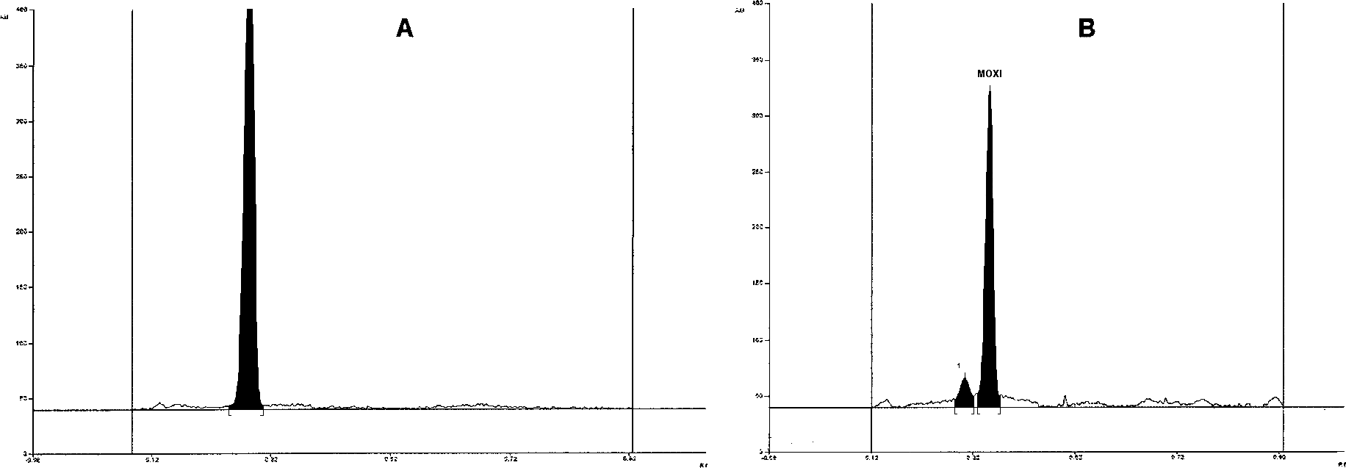
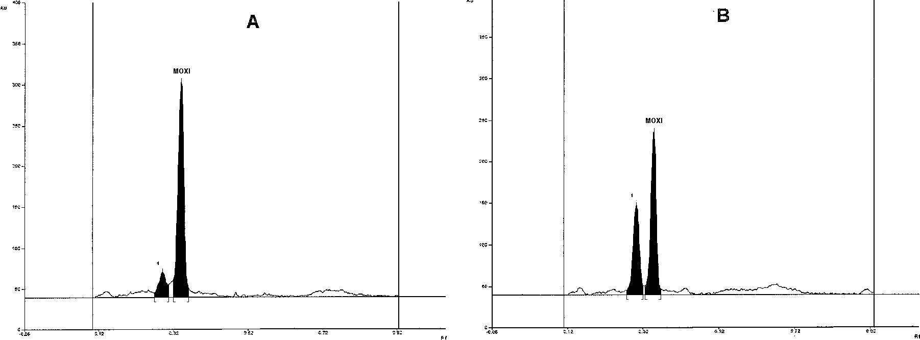
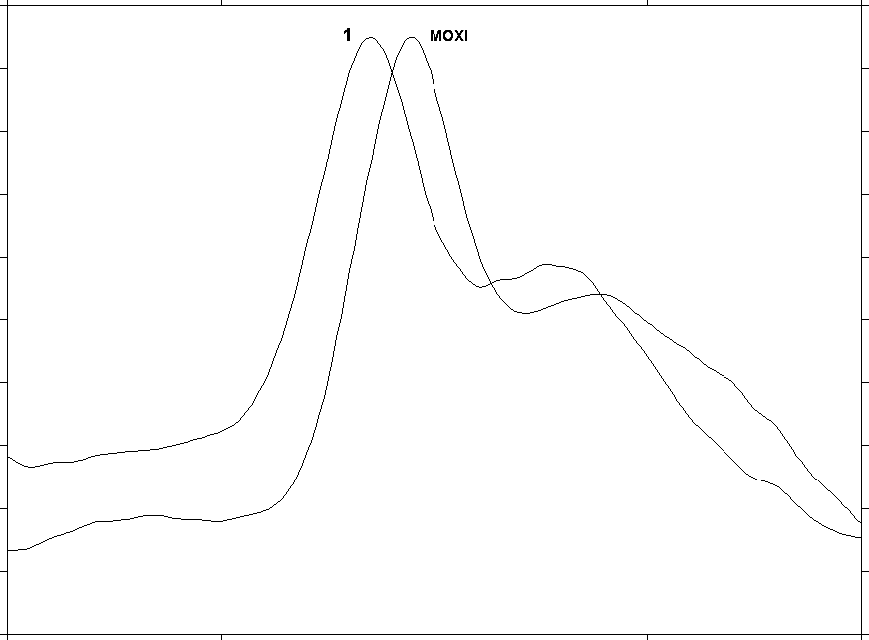
825
Kinetic and thermodynamic studies of moxifloxacin hydrolysis in the presence...
Figure 1. The densitogram of moxifloxacin solution in hydrochloric acid in the absence of metal ions: A ñ before heating, B ñ after heat- ing at 90OC for 72 h. Peak 1 ñ the degradation product
Figure 2. Densitograms of moxifloxacin hydrolysis in the presence of metal ions: Fe(III) (A), Cu(II) (B) after 72 h heating at 90OC. Peak 1 ñ degradation product P-2
of many studies; however, these studies only con- cerned ciprofloxacin and norfloxacin (30). Moxifloxacin differs from the above-mentioned flu- oroquinolones at positions 7 and 8, and this differ- ence has an influence on physicochemical properties and durability of the compound (31ñ33).
During selection of metal ions for studies, we based our decision on the presence of metal ions in many, commonly used diet supplements (Cu(II), Fe(III), Zn(II)) or alimentary tract coating agents (Al(III)), which can be administered during therapy with moxifloxacin.
In preliminary studies, no change was observed in moxifloxacin solutions in the presence and absence of metal ions before incubation at 90OC and 110OC was applied. There was only one peak repre- senting studied compound with Rf 0.32 value on recorded densitograms (Fig. 1A).
Decomposition of moxifloxacin in the pres- ence and absence of ions proceeds in solutions not earlier than after 24 h of heating at 90OC. This decomposition intensifies with the increase of heat- ing time. After 72 h of heating, the decomposition process of moxifloxacin solutions in the absence of metal ions did not exceed 10%. On the other hand, the decomposition process was faster in the presence of metal ions: Cu(II) 41.92%, Fe(III) 13.61%, Zn(II) 12.8% and Al(III) 11.25%.
Figure 3. Absorption spectra of moxifloxacin (MOXI) and its degradation product P-2 (1) after incubation for 72 h at 90OC
one decomposition product obtained in the process of decarboxylation (20) or few decomposition prod- ucts which structure has not been identified yet (16, 21).
In the searched literature, there was lack of data concerning durability of moxifloxacin in the presence of metal ions, which may result in some type of interaction during compound application in medical care. Acidic hydrolysis of fluoroquinolones with the presence of metal ions has been subjected

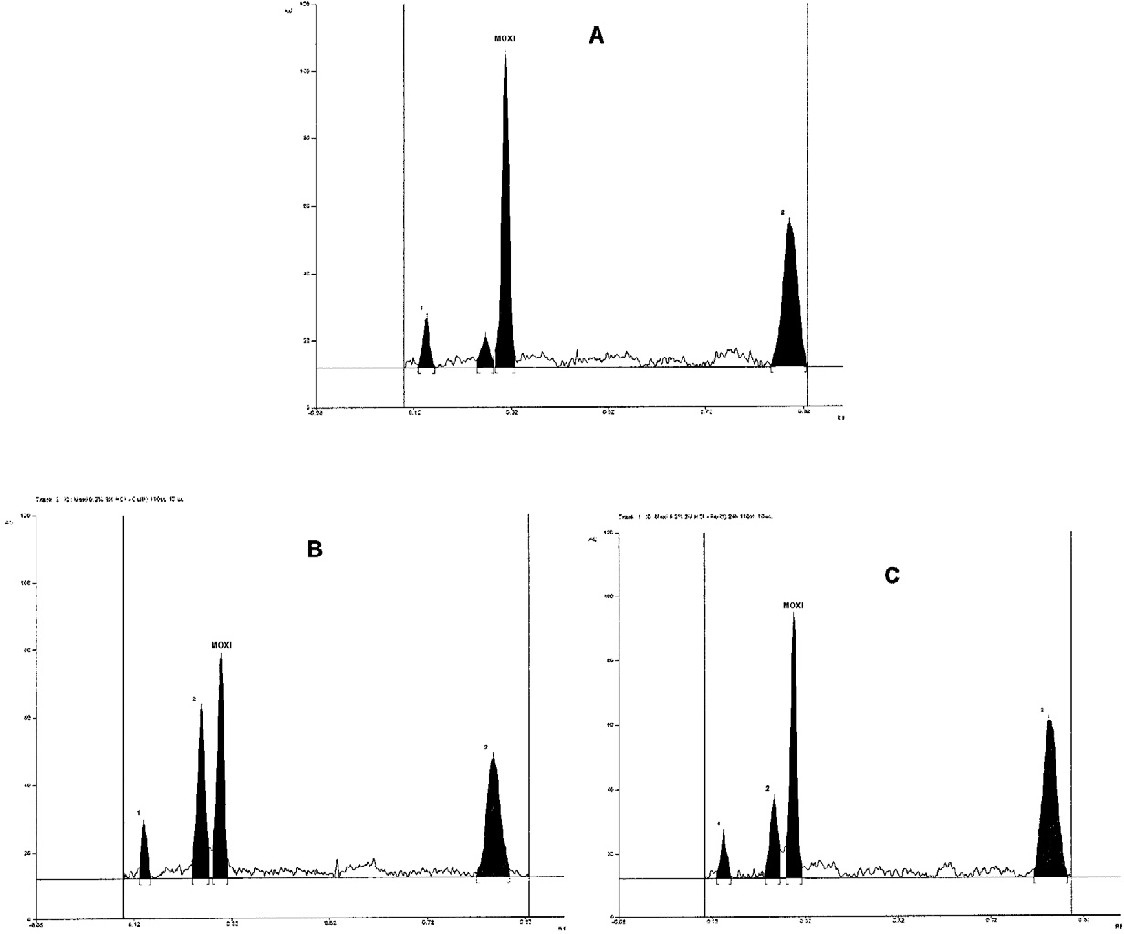
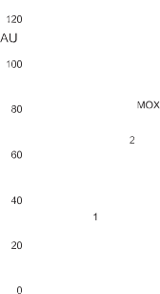
826
URSZULA HUBICKA et al.
Besides moxifloxacin peak with Rf value, only one extra peak (P-2) with Rf
0.32
0.29
study. Similarly to studies at 90OC, a (P-2) peak with Rf 0.29 value and two extra peaks (P-1) and (P-3) with Rf 0.15 and Rf 0.89 values, respectively, were observed next to the studied compound on den- sitograms independently of the composition of the solution (Fig. 4)
The maxima of absorption spectra for decom- position products differ between themselves, P-1 (λ1 275), P-2 (λmax 288 nm), P-3 (λmax1 281), and are slightly shifted towards shorter wavelengths in comparison to parent compound (λ max 295 nm). In case of P-3 product, a well developed maximum of absorption at λ 340 nm is observed. Therefore, the structure of quinolinic ring is probably maintained and observable differences are only related to
recpective substituents.
Kinetic and thermodynamic evaluation
For kinetic evaluation, results of moxifloxacin decomposition at 90 and 110OC were considered. It was established that decomposition of moxifloxacin in solutions in the presence and absence of metal ions proceeds according to kinetics of the first- order reaction based on changes of ln c = f(t) (Figs. 5 and 6).
The constant rate (k) for study solutions con- taining metal ions decreases in the following order: Cu(II) > Fe(III) > Zn(II) > Al(III), reaching the low- est values for moxifloxacin solutions in the absence
value occurred on all the recorded chromatograms. (Figs. 1B and 2)
The absorption spectra directly recorded from chromatograms within the range from 200 to 400 nm for spot coming from decomposition product (Rf 0.29) had similar shape and their maximum was slightly shifted in a direction of shorter wavelengths
(λmax
288 nm) in relation to spectra of moxi-
floxacin (λmax 295 nm ) (Fig. 3).
Based on these observations, it may be
assumed that the same decomposition product with structure similar to moxifloxacin is generated inde- pendently on the composition of study solutions.
Faster decomposition of moxifloxacin was demonstrated during studies performed at 110OC. This decomposition was 52.04% after 48 h and increased in the presence of metal ions: Cu(II) (79.35%), Fe(III) (63.97%), Al(III) (62.42%) and
Zn(II) (58.62%). The observed changes of moxi- floxacin in the presence and absence of metal ions are similar to changes at 90OC. The fastest decom- position was observed in the presence of Cu(II) ions, and slower in case of Fe(III) to Zn(II) ions.
Besides increased decomposition of moxi- floxacin, the observed changes also concern the number of generated decomposition products in the
Figure 4. Densitograms of moxifloxacin hydrolysis in the absence (A) and in the presence of metal ions: Cu(II) (B) and Fe(III) (C) after 24 h heating at 110OC. Peaks: 1, 2, 3 the degradation products: P-1, P-2, P-3, respectively

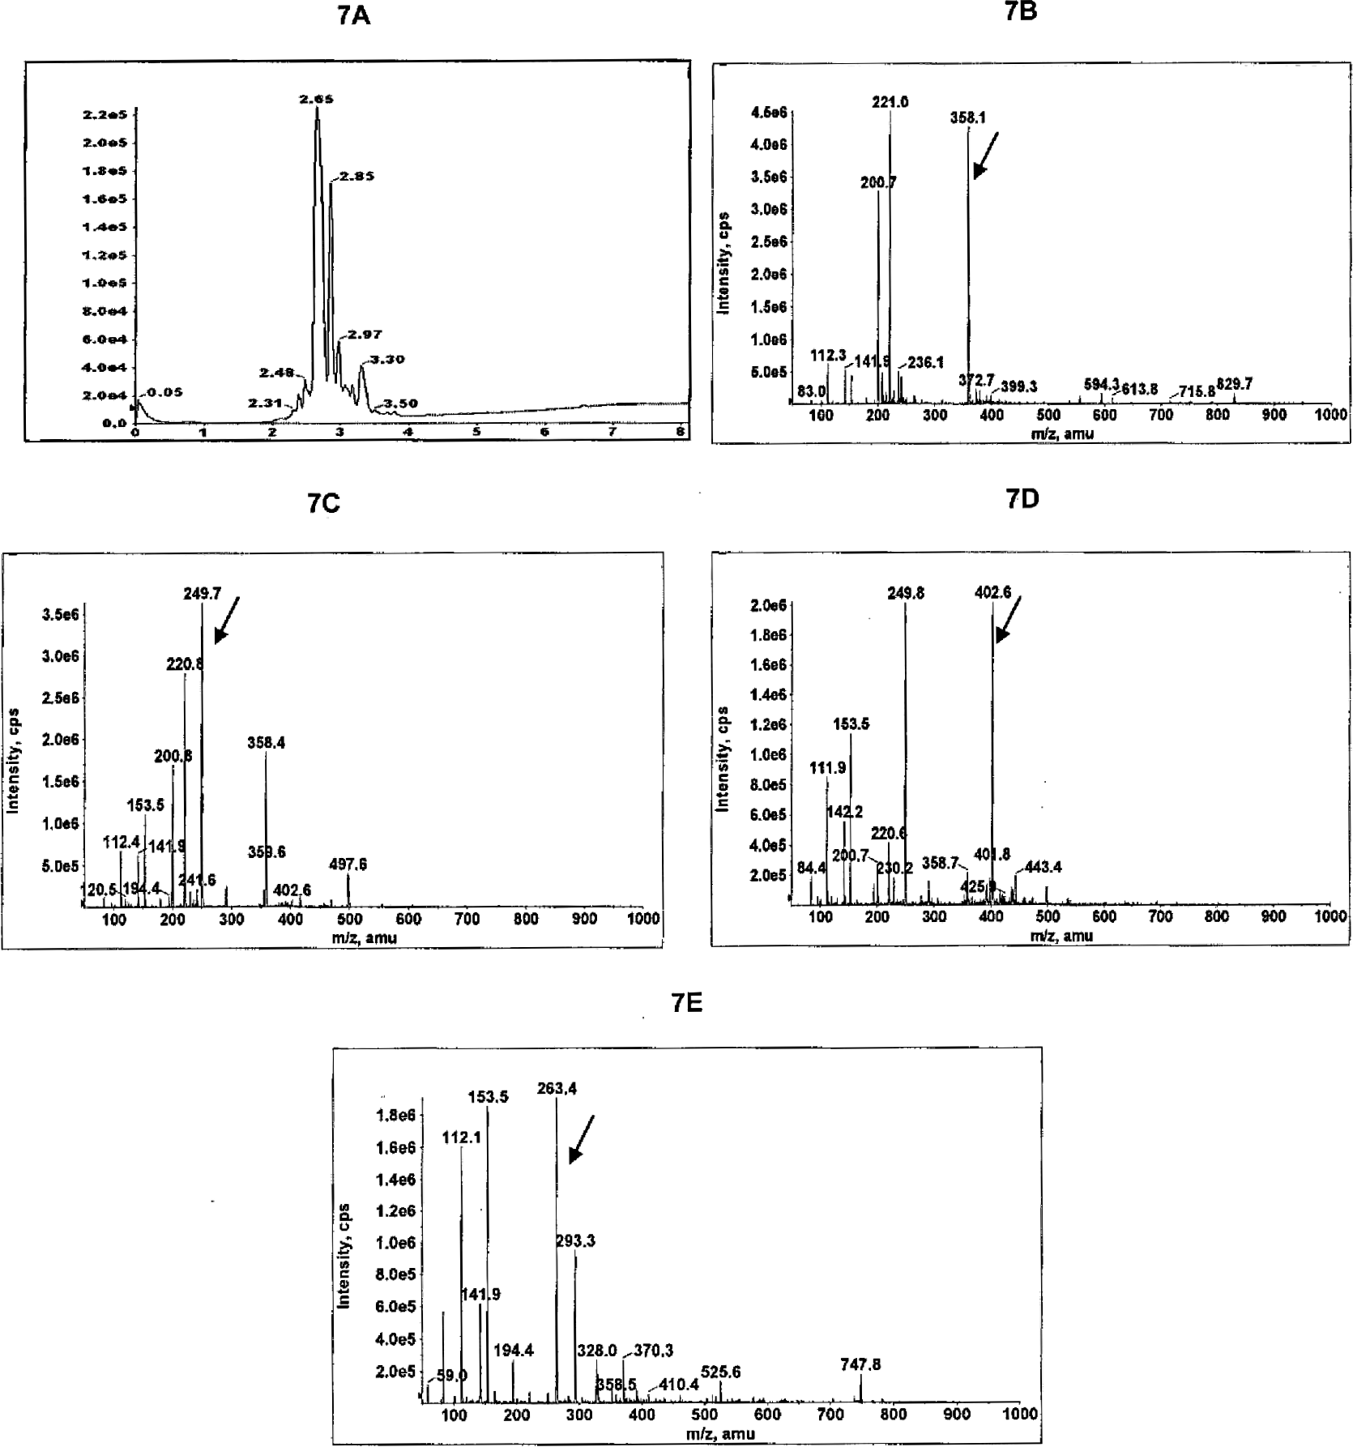
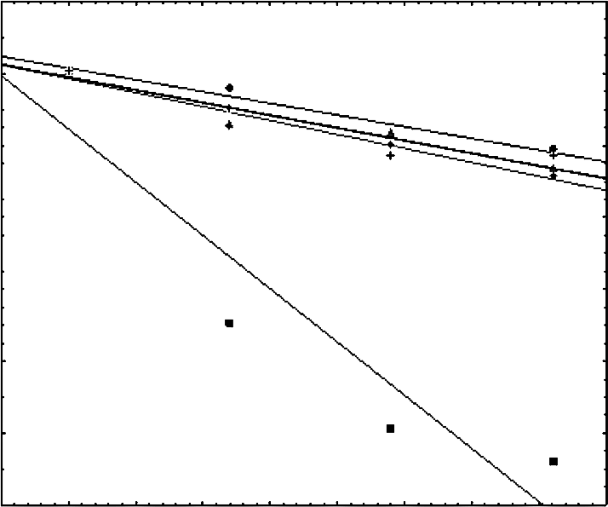

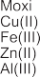
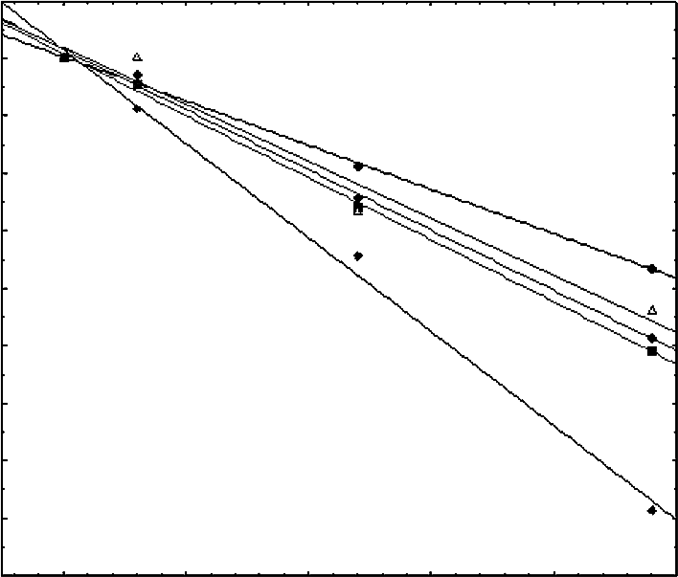

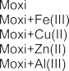
827
Kinetic and thermodynamic studies of moxifloxacin hydrolysis in the presence...
Figure 5. The ln c = f(t) graph of moxifloxacin in 3 mol/L hydrochloric acid at 90OC
Figure 6. The ln c = f(t) graph of moxifloxacin in 3 mol/L hydrochloric acid at 110OC
Figure 7. HPLC chromatogram with diode array detection of studied sample of moxifloxacin in acidic conditions with addition of Cu ions (A), mass spectrum of sample of studied drug at retention time of 2.65 min (B), 2.85 min (C), 2.97 min (D) and 3.4 min (E), respectively
of metal ions. The calculated values of t0.1 and t0.5 confirm better stability of moxifloxacin in solutions in the absence of metal ions, and the stability
decreases in the presence of Zn(II), Al(III), Fe(III) ions and reaching the lowest durability in the pres- ence of Cu(II) ions (Tab. 1).
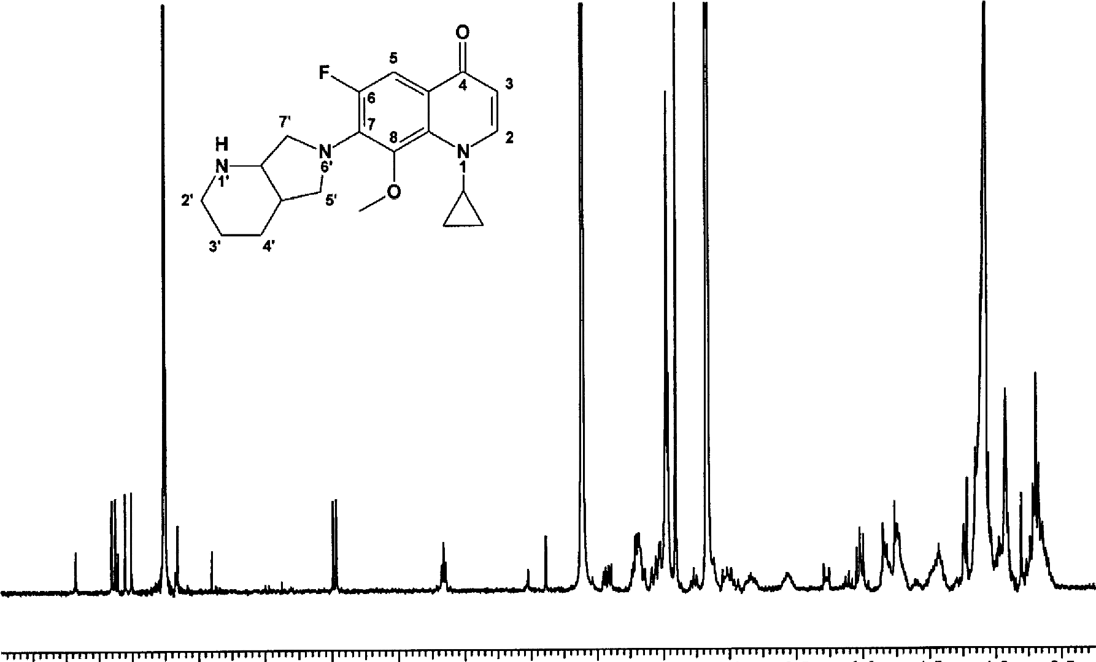
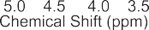
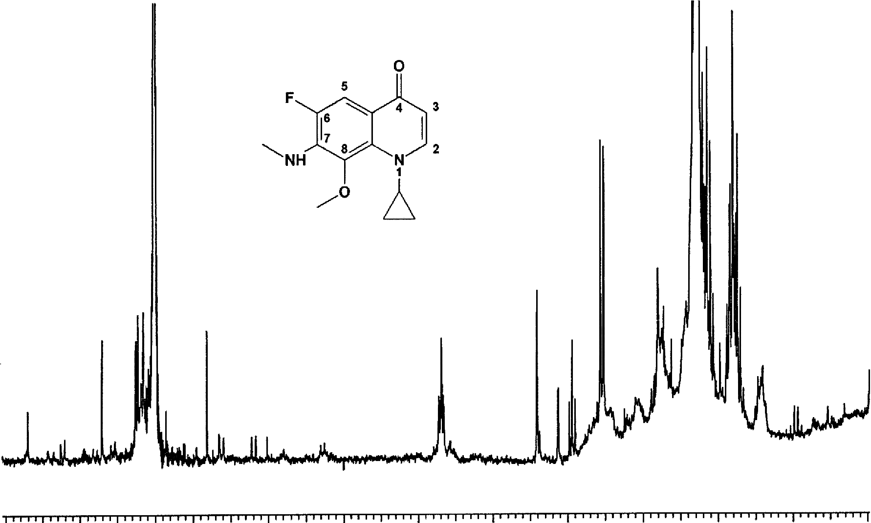
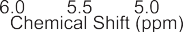
828
URSZULA HUBICKA et al.
Figure 8. 1H NMR spectrum of degradation product P-3
Figure 9. 1H NMR spectrum of degradation product P-2
The calculated energy activation (Ea) value for hydrolysis process of mixofloxacin solutions in the presence of Cu(II) (Ea = 85.83 kJ/mol) is lower than values obtained in the presence of Fe(III) (Ea =
138.42 kJ/mol), Al(III) (Ea = 138.52 kJ/mol) and Zn(II) (Ea = 141.82 kJ/mol), and in the absence of metal ions (Ea Moxi = 141.92 kJ/mol).
Based on the individual results of Ea and t0.1 and
It seems that the effect of ions on decomposi- tion of moxifloxacin and their varied contribution to the hydrolysis process, can be interpreted as a com- plex-generated activity of individual metal ions with quinolones, which results in formation of less or more solid bonds prone to decomposition.
Identification of hydrolysis products
LC-MS
The identification of degradation products of moxifloxacin and their structural analysis was done by LC-ESI/MS method. Three potential degradants were identified using the above mentioned proce- dure.
t0.5
parameters, some type of similarity may be
observed, namely, both kinetic as well as thermody- namic parameters differ significantly in moxi- floxacin solutions in the presence of Cu(II) ions, in which the fastest decomposition occurs, from values obtained for other solutions.
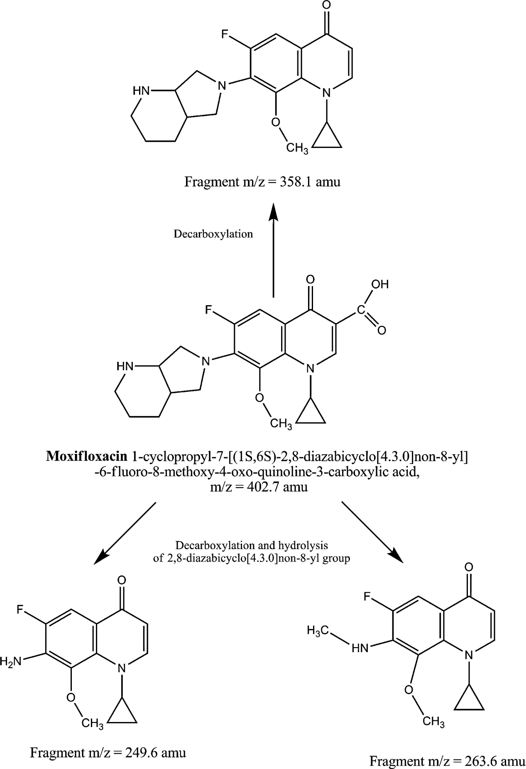
829
Kinetic and thermodynamic studies of moxifloxacin hydrolysis in the presence...
Figure 7A illustrates the HPLC diode array chromatogram of a sample of moxifloxacin under its degradation process in acidic environment with addition of cuprum ions at 110OC. The parent com- pound of moxifloxacin (m/z 402.6 amu) was observed at retention time of 2.97 min (Figure 7D). In the full scan mass spectrum of studied sample of moxifloxacin under the degradative analysis we observed at a retention time of 2.65 min a possible degradation product with m/z 358.1 amu, due to the loss of the functional carboxyl group from studied drug (Fig. 7B).
The next process could involve decarboxylation and hydrolysis of 2,8-diazabicyclo[4.3.0]non-8-yl group reaction of moxifloxacin, which gives the final product with m/z 263.4 amu observed at retention time 3.4 min (Fig. 7E). The similar reaction could be observed for degradation product at retention time of
2.85 min having m/z 249.7 amu (Fig. 7C).
1H NMR
1H NMR spectrum of sample P-3 shows char- acteristic signals corresponding to chemical struc- ture of degradation product (Fig. 8).
Figure 10. The plausible degradation patterns of moxifloxacin under studied conditions
830
URSZULA HUBICKA et al.
CONCLUSION
The most important are signals of quinoline moiety protons, which indicates decarboxylation of starting compound. Two doublets δ 7.65 ppm (d, J =
7.7 Hz, H2) and δ 5.98 ppm (d, J = 7.7 Hz, H3) are clearly visible. The latter corresponds to proton in position of detached carboxylic group. In the aro- matic fragment of spectrum there is one more dou- blet possessing large coupling constant: δ 7.53 ppm (d, J = 14.1 Hz, H5). This large value of coupling constant corresponds to H-C-C-F system. Confirmation can be found in 19F spectrum, which exhibits only one signal: δ ñ123.58 ppm (d, J = 14.7 Hz) indicating fluorine atom coupled with one pro- ton. Despite of complicated pattern of signals observed in the aliphatic region of the spectrum it is possible to conclude that there is no other changes in chemical structure of analyzed compound. Signals in the range 4ñ1 ppm can be assigned to protons of 2,8-diazabicyclo[4.3.0]nonane moiety and signals between 1 and 0.5 ppm can be assigned to protons of cyclopropyl fragment. There is also visible strong singlet at δ 3.41 ppm corresponding to protons of methoxyl group. Analysis of P-3 spectrum clearly indicates that on this stage of degradation process only decarboxylation occurs while the rest of mole- cule remains unchanged.
Due to very low concentration of investigated compound, analysis of its spectrum is possible only through the comparison to spectrum of sample P-3. It is worth to note that in the aromatic range of spec- trum similar pattern of signal is observed (Fig. 9).
Three doublets at δ 7.65, 7.53 and 6.14 ppm indicate the same manner of substitution of quino- line moiety, which confirms decarboxylation process. Quite different set of signals observed in the aliphatic region of spectrum shows that degrada- tion of bicyclic fragment occurs. Singlet at δ 3.38 ppm can be assigned to protons of methyl group yielded from this process. Apart of these changes, it is possible to find singlet assigned to methoxyl group protons at δ 3.41 ppm, indicating that hydrol- ysis process in this fragment of the starting com- pound does not occur. On that basis, it can be assumed that sample P-2 contains the product of subsequent decarboxylation and degradation of diazabicyclic moiety, which can be treated as a next step of moxifloxacin degradation.
The structure for P-1 spot could not be fully confirmed by 1H NMR technique because of the low amount of received product and strong interferential background coming from the gel. However, based on the LC-MS results it may be assumed that the compound with m/z = 249.6 amu (P-1 spot) has a structure presented in Figure 10.
In this paper, a new method for determination of moxifloxacin in the presence of its hydrolysis products was developed. This method allows evalu- ation of hydrolysis process in the acidic environ- ment in the studied concentration ranges. It was proved that stability of moxifloxacin depends on temperature, heating time, and the presence of metal ions in solution.
The highest impact on decomposition of moxi- floxacin have Cu(II) ions. This impact decreases then in the following order Fe(III) > Al(III) > Zn(II).
Decomposition of moxifloxacin in the presence of metal ions proceeds according to the kinetics of the first-order reaction. The presence of metal ions in mox- ifloxacin solutions increases the rate of the reaction (k) and decreases activation energy (Ea), which is well exemplified in the case of Cu(II) ions. In the remaining solutions, independent on their composition, changes in the above parameters are not significant.
Based on the calculated t0.1 and t0.5 values, it can be assumed that decomposition of moxifloxacin is faster in the presence of ions. Under the described conditions, decomposition process of moxifloxacin results in development of three degradation prod- ucts, which structures were determined by LC-MS and 1H NMR techniques (Fig. 10).
REFERENCES
1.
Zhanel G.G., Ennis K., Vercaigne L., Walkty A., Gin A.S., Embil J., Smith H., Hoban D.J.: Drugs 62, 13 (2002).
Balfour J.A., Lamb H.M.: Drugs 59, 115 (2000).
Andriole V.T.: Clin. Infect. Dis. 41, 113 (2005). Champoux J.J.: Annu. Rev. Biochem. 70, 369 (2001).
Tobin C.M., Sunderland J., White L.O., MacGowan A.P., Reeves D.S.: J. Antimicrob. Chemother. 42, 278 (1998).
Liang H., Kays M.B., Sowinski K.M.: J. Chromatogr. B 772, 53 (2002).
Lemoine T., Breilh D., Ducint D., Dubrez J., Jougon J., Velly J.F., Saux M.C., J. Chromatogr. B 742, 247 (2000).
2.
3.
4.
5.
6.
7.
- Laban ñ DjurdjeviÊ A., JelikiÊ-Stankov M., Djur- djeviÊ P.: J. Chromatogr. B 844, 104 (2006).
- Ulu S.T.: J. Pharm. Biomed. Anal. 43, 320 (2007).
- De Smet J., Boussery K., Colpaert K., De Sutter P., De Paepe P., Decruyenaere J., Van Bocxlaer J.: J. Chromatogr. B 877, 961 (2009).
831
Kinetic and thermodynamic studies of moxifloxacin hydrolysis in the presence...
11.
European Pharmacopeia, 6th edn., Council of Europe, European Directorate for the Quality of Medicines, Strasbourg, 2008.
Hemanth Kumar A.K., Ramachandran G.: J. Chromatogr. B 877, 1205 (2009).
Collado-S·nchez M.A., Rambla-Alegre M., Carda-Broch S., Esteve-Romero J.: J. Liq. Chromatogr. Relat. Technol. 33, 513 (2010).
Rambla-Alegre M., Esteve-Romero J., Carda- Broch S.: J. Chromatogr. B 877, 3975 (2009). Devi M.L, Chandrasekhar K.B.: Chromato- graphia 69, 993 (2009).
Djurdjevic P., Ciric A., Djurdjevic A., Stankov M.J.: J. Pharm. Biomed. Anal. 50, 117 (2009).
22.
Cruz L., Hall R.J.: J. Pharm. Biomed. Anal. 38, 8 (2005).
Moller J.G.: J. Chromatogr. B 716, 325 (1998).
Inam R., Mercan H.: Anal. Lett. 40, 529 (2007). Radi A.E., Wahdan T., Anwar Z., Mostafa H.: Drug Testing Anal. 2, 397 (2010).
Motwani S.K., Chopra S., Ahamad F.J., Khar R.K.: Spectrochim. Acta Part A 68, 250 (2007). Ulu S.T.: Spectrochim. Acta Part A 72, 138 (2009).
Xi H.P., Xie H.T., Gong W.Q.: Chinese J. Antibiotics 35, 105 (2010).
ICH-Q2 (R1) Validation and Analytical
23.
24.
25.
12.
13.
26.
14.
27.
15.
28.
16.
29.
Procedures: Text
and Methodology,
17.
Ravikumar
M., Satish
Varma
M.,
International Conference on Harmonization, Geneva, November 2005: http://www.ich.org Hubicka U., Krzek J., Walczak M.: Pharm. Develop. Technol. 15, 532 (2010).
Domagala J.M.: J. Antimicrob. Chemither. 33, 685 (1994).
Satyanarayana Raju T., Suchitra P., Yadagiri Swamy P.: Chromatographia 69, 85 (2009).
Vishwanathan K., Bartlett M. G., Stewart J. T.:
J. Pharm. Biomed Anal. 30, 961 (2002). Pranger A.D., Alffenaar J.W., Wessels A.M., Greijdanus B., Uges D.R., J. Anal. Toxicol. 34, 135 (2010).
Salem M.Y., El-Guindi N.M., Mikael H.K., El- Sayed Abd El-Fattah L., Chem. Pharm. Bull. 54, 1625 (2006).
Motwani S.K., Khar R.K., Ahamad F.J., Chopra S., Kohil K., Talegaonkar S.: Anal. Chim. Acta 582, 75 (2007).
30.
18.
31.
19.
32.
Marutami Nagamuta Hasegawa
K., Matsumoto M., Otabe Y., M., Tanaka K., Miyoshi A.,
T. et al.: Antimicrob. Agents
20.
Chemother. 37, 2217 (1993).
Rosen J.E., Chen D., Parahalad A.K., Spratt T.E., Schluter G., Williams G.W.: Toxicol. Appl. Pharmacol. 145, 381 (1997).
33.
21.
Received: 3. 02. 2012

