Iwona HAJDYLA-BANAŚ1'
Tomasz BANAS2'
Iwona RYDZ-STRYSZOWSKA1
Bogdan BATKO1
Antoni SKURA
Teresa GÓRNISIEWICZ2
Elżbieta PITYŃSKA-KORAB3

Pregnancy course and neonatal outcome after exposure to leflunomide - 2 cases report and review of literature
’Rheumatology Department of J. Dietl Hospital in Krakow
Head: A. Skura, MD, PhD
2Chair of Obstetrics and Gynecology, Jagiellonian University, Krakow Head: Prof. A. Basta, MD, PhD.
3State Academy in Jarosław, Jarosław
Head: Prof. Zbigniew Makieia, PhD
Dodatkowe słowa kluczowe:
ciąża
leflunomid
reumatoidalne zapalenie stawów
Additional key words:
leflunomide
pregnancy
rheumatoid arthritis
* these two authors contributed equally to this paper
Adres do korespondencji:
Tomasz Banas, MD, PhD, MPH
Chair of Obstetrics and Gynecology
Jagiellonian University
Kopernika Str. 23, 30-501 Krakow, Poland tel. +48 12 424 85 60; fax +48 12 424 85 85 e-mail tbanas@mp.pl
Leflunomide (LMF) is an immune- modulatory drug used in the therapy of Rheumatoid Arthritis (RA). After oral administration in the mucosa of digestive tract LMF is quickly converted to an active metabolite A77126 which is a competitive inhibitor of dihydrooro- tate dehydrogenase - enzyme required in pirymidynę synthesis resulting in decreased proliferation of T and B lymphocytes. As animal studies showed A77126 embryo- and fetotoxity and no relevant epidemiological research in humans were available, LMF received category X pregnancy destination. This is a detailed presentation of two pregnancy cases during LMF therapy in Poland. The first patient was a multiparous woman suffering from RA for 17 years and treated with LM during the last 16 months. The second woman was a primigrávida with RA diagnosed 4 years ago and treated with LMF for the last 20 months. LMF wash-out procedures were started immediately as the patients referred with diagnosed early pregnancies with oral administration of 8g of cholestyramine tid for 11 days. After completing the procedure the patients were referred to the Gynecology and Obstetrics Department. The first pregnancy successfully finished with a vaginal delivery of a completely healthy, female newborn of 2540g at the 41 st gestational week and the second patient also delivered vgi- nally a healthy female newborn of 3200g at 39th week of pregnancy.
Introduction
Leflunomide (LMF) is a competitive inhibitor of dihydroorotate dehydrogenase, an enzyme that is required in pirymidynę syn-
Leflunomid (LMF) jest lekiem im- munomodulującym stosowanym przede wszystkim w leczeniu reumatoidalnego zapalenia stawów (RZS). Po podaniu doustnym ulega szybkiemu przekształceniu do aktywnego metabolitu A771226 w błonie śluzowej przewodu pokarmowego, który kompetencyjnie hamuje dehydrogenazę dihydro- ortanową - enzym niezbędny do prawidłowej syntezy zasad pirymidynowych - czego wynikiem jest zahamowanie proliferacji aktywowanych limfocytów T i B. Ponieważ badania na zwierzętach wykazały embriotoksycz- ność i fetotoksyczność metabolitu A771226, przy braku odpowiednich badań epidemiologicznych przeprowadzonych wśród ludzi, LMF został zakwalifikowany do kategorii X - ryzyko zastosowania leku w ciąży zdecydowanie przewyższa potencjalne korzyści i leku nie należy stosować u kobiet ciężarnych. Prezentujemy przypadki ciąży u dwóch pacjentek w trakcie terapii LMF. Pierwsza przedstawiona pacjentka była wieloródką, od 17 lat chorującą na RZS i od 16 miesięcy leczoną LMF. Druga kobieta to pierwiastka, od 4 lat chorująca na RZS i leczenia LMF od 20 miesięcy. W obydwu przypadkach niezwłocznie po rozpoznaniu ciąży zastosowano procedurę wypłukiwania leku i jego metabolitów z organizmu kobiet stosując trzy razy dziennie 8g cholesytraminy doustnie przez 11 dni. Pacjentki konsultowano w Katedrze Ginekologii i Położnictwa Uniwersytetu Jagiellońskiego. Pierwsza kobieta w 41. tygodniu ciąży urodziła droga pochwową zdrową córkę o masie ciała 2540g, w drugim przypadku ciąża również zakończyła się porodem kierowanym drogami natury i w 39. tygodniu urodzono zdrową córkę o macie ciała 3200g.
thesis [6] and is widely used in Rheumatoid Arthritis (RA) treatment [7,10]. As animal studies showed its embryo- and fetotoxity and no relevant epidemiological research in
Przegląd Lekarski 2009 /66/ 12
1069

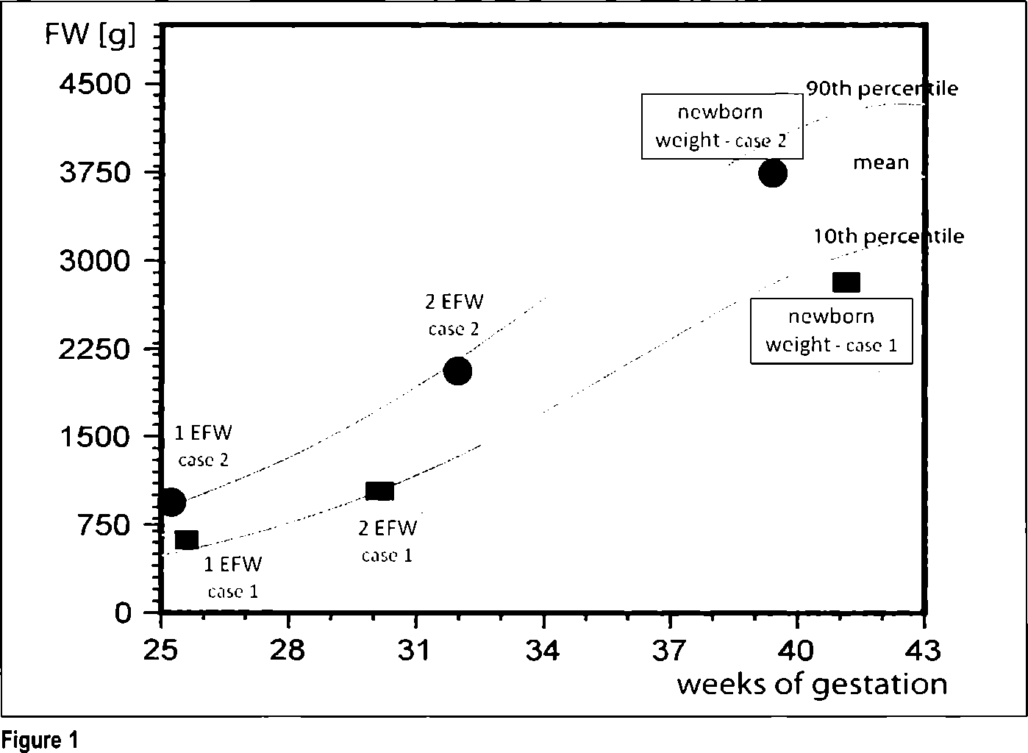
humans were available, LMF received category X pregnancy destination [7]. Therefore pregnancy must be excluded before LMF introduction and during the treatment plus 2 years after the therapy is completed. Women in reproductive age should use a reliable contraception [5]. When unexpected pregnancy occurs or patient wants to conceive earlier a wash-out procedure should be started immediately using oral administration of 8g cholestyramine tid, alternatively 50g of activated charcoal four times a day, both for 11 days, to obtain the leflunomide A771726 metabolite plasma level less than 0,02mg/L that is considered to have minimal risk for fetal development [1]. No detectable A771726 plasma levels of <0,02mg/L should be than confirmed by two separate tests 14 days apart [1] and it is advised to wait at least three menstrual cycles before conceiving [1].
The aim of this report is to present clinical management and outcomes of LMF-ex- posed pregnancies based on very detailed case presentations of such pregnancies reported in Poland for the firs time.

1 Case Report
A thirty-eight-year old woman had been suffering from RA for 17 years. During the first 15 years she was treated with Methotrexat (17,5mg per week) and with low doses of steroids (Methylprednizolon 4mg a day). In March 2005 because of an active RA LMF was introduced after pregnancy exclusion. The patient was informed that LMF could be potentially harmful to embryo and she must have avoided pregnancy during the therapy and two years after it was completed. The patient was introduced with a load-dose of 100mg LMF on the first three days and continued the dose of 20mg per day. During the first year of LMF therapy Disease Activity Socore (DAS) was reduced from 7,36 points to 4,51 that according to European League Against Rheumatism (EULAR) response criteria meant a good therapeutic effect. Health Assessment Questionnaire (HAQ) was used to asses the patient's physical function and improvement was noticed with a significant decrease from 3,75 to 1,5 points. In the 16th month of the LMF therapy the patients informed that she was pregnant and her last menstrual period (LMP) was 6 weeks and 2 days before. The LMF wash-out procedure was started immediately with an oral administration of 8g of cholestyramine tid for 11 days. After completing the procedure the patient refused to have the blood level of the A771726 metabolite checked. She was then referred to the Gynecology and Obstetrics Department of the Jagiellonian University as IV-gravida; IV-para in early pregnancy. During the first obstetrical consultation her past medical history was collected: LMP 12 weeks before; painless, irregular periods every 28 - 38 days lasting for 5 days. Vaginal delivers as follows: 1991 alive female of 3350g of weight, born in the 41st week of gestation; 1993 alive female of 2850g, born in the 39th week of gestation; 1997 alive female of 3150g born premature in the 35th week of gestation. Pelvic examination revealed an enlarged uterus with the full and closed cervix. In ultrasound examination (USG) a single, viable fetus was visualized with heart rate 182 bits per minute (bpm), CRL (crown-rump length) = 30,5mm was relevant for 9 weeks 7 days (9w7d) of gestation. A complete blood cell count (CBC), urinanalysis and blood glucose level were normal also cervical cytology revealed no evidence of malignancy
The second USG was made in the 25th week of gestation based on the LMP. Fetal biometry was assessed for 22w0d of gestation. Fetal movements (FM) were present, fetal heart rate (FHR) was regular, 145 bpm; placenta present on the front wall of the uterus type I in Grannum scale. Amniotic Fluid Index (AFI) was 98mm. Doppler flow velocities in Umbilical Artery (UA)
Reference range for fetal weight during pregnancy. 1. EFW - expected fetal weight based on fetal biometry
assessed during the 3rd ultrasound examination. (USG); 2. EFW - expected fetal weight based on fetal biometry
assessed during the 4th USG.
Wartości referencyjne zakresu masy płodu w trakcie ciąży. 1. EFW - szacowana masa płodu na podstawie biometrii
wykonanej w trakcie 3. badania ultrasonograficznego (USG); 2. EFW - szacowana masa płodu na podstawie biometrii
wykonanej w trakcie 4. badania USG.
Table I
Results of ultrasound fetuses' biometry during gestation.
Wyniki ultrasonograficznej biometrii płodów.
 | Ultrasound examinations
 | 1. |  | 2. |  | 3. |  | 4.
 | Case 1 | Case 2 | Case 1 | Case 2 | Case 1 | Case 2 | Case 1 | Case 2
Time of gestation according to LMP* [weeks-days] | 12-0 | 9-2 | - | 18-5 | 254 | 23-6 | 30-1 | 32+3
Crown-rump length (CRL) [mm] | 30,5 | 24,4 | - | - | - | - | - | -
Biparietal diameter (BPD) [mm] | - | - | - | 40,2 | 52,7 | 58,9 | 72,0 | 82,0
Head circumference (HC) [mm] | - | - | - | 150,3 | 204,0 | 214,6 | 231,0 | 308,7
Abdominal circumference (AC) [mm] | . - | - | - | 146,3 | 170,0 | 177,9 | 205,0 | 288,9
Femur length (FL) [mm] | - | - | - | 27,1 | 39,5 | 41,4 | 50,0 | 65,2
GASA" [weeks-days] | 9-6 | 9-0 | - | 18-2 | 22-0 | 23-0 | 26-6 | 33-2 | Newborn weight
Expected fetal weight (EFW) [g] according to Headlock formula C scale  **• | - | - | - | 263 | 468 | 564 | 996 | 2158 | Case 1 2540g | Case 2 3200g
*LPM - last menstrual period; "GASA - growth adjusted sonographic age
*** Log10(EFW) = 1,3596+0,00061xBPDxAC+0,424xAC+0,174xFL+0,0064xHC-0,00386xACxFL
and Medial Cerebral Artery (MCA) were normal with cerebral-placental ratio (CPR)=1,4.
The oral glucose tolerance test (OGTT) result was within limits and also no abnormal results of routine laboratory tests were presents.
Mild anemia (hemoglobine [HGBj: 10,3g/l; hematocrit [HCT|: 32,4%) was diagnosed in the 28th week of gestation in spite of iron and follicle acid supplementation throughout the pregnancy so the supplementation therapy was enforced.
Third USG was performed in the 30th week of gestation which revealed the fetus in cranial presentation. FM were present, FHR was regular 138 bpm, AFI was 87mm and type I placenta according to Grannum scale was visualized on the anterior uterus wall. Fetal biometry was assessed for 26w6d of pregnancy (Table I).
In the 33rd week of gestation the patient was referred to the hospital due to threaten premature delivery. Standard therapy was introduced including intravenous application of magnesium sulfátate and fenoterol additionally steroids (2 dosage of 12mg of Dexamethasone) were given for stimulating the fetal lungs maturity in case of preterm delivery. The patient was discharged after 5 days recovering completely from premature delivery symptoms.
In the 41 st week of gestation according to LMP the patient was admitted to hospital in the first stage of labor. Physical examination at the delivery room revealed one live fetus in cranial presentation, FHR 135 bpm. The cervix was soft and shortened with a 3cm dilatation. Because of weak uterus contractions a drip with oxitocine was introduced and a 2540g female newborn with 9 Ap
1070
Przegląd Lekarski 2009 /66/ 12
T. Banaś i wsp.

gar points in the first minute (and 10 Apgar points in the 5th minute) was delivered vaginally. After parturition of a complete placenta a first-degree perineal laceration was repaired with absorbable sutures. The length of the delivery was following: I stage - 5h and 15min; II stage -10 min; III stage - 15min; IV stage - 2h as a standard. Pediatric examination of the newborn revealed no abnormalities.
When the nursing period was over the patient continued leflunimide therapy

2 Case Report
A thirty-year old women had been suffering from RA for 4 years. During the first 2 years she was treated with Methotrexal (17,5mg per week for two month), intramuscular gold injections (for one moth only), sulfazalazine (for 13 months 1g bid) and finally with Merhotre- xat again. In September 2005 because of an active RA LMF was started after pregnancy exclusion. The patient was also informed that LMF therapy could be potentially embryo- and fetotoxic. LMF in a load-dose of 100mg on the first three days was introduced and continued in a dose of 20mg per day. During the first year of LMF therapy the patient's general condition improved (decrease in HAQ scale from 3,2 to 1,7 points) and also a reduction in DAS from 7,21 to 4,17 points was noticed. In the 28th month of the LMF therapy the patients informed that she was pregnant and LMP was 8 weeks and 1 day before. A LMF wash-out procedure was started immediately with an oral augmentation of 8g of cholestyramine tid for 11 days and in subsequent two checkup tests the serum blood level of A771726 metabolite was undetectable. She was referred to the Gynecology and Obstetrics Department of the Jagiellonian University. During first obstetrical consultation hert medical history was obtained: Primigravida with LMP 9 weeks before; painful and heavy but regular periods every 26 days; lasting for 4 days. Pelvic examination revealed an enlarged uterus with the full and closed cervix. In ultrasound examination a single, viable fetus was visualized with heart rate 178 bits bpm, CRL=24,4mm was relevant for 9w0d. CBC, urinanalysis and blood glucose level were normal also cervical cytology revealed benign cellular changes and cervical culture was negative for Neiseria gonorrheae, Chlamydia trachomatis, Mycoplasma ho- minis and Group B Streptococci.
The next USG was made in the 18th week of gestation based on the LMP. Fetal biometry corresponded with gestational age (table I). Doppler flow velocity in UA MCA were normal with CPR=1,6. FM were observed and FHR was regular, 145 bpm; placenta present on the back wall of the uterus grade 0 according to Gran- nume scale with no signs of detachment and AFI was 102mm.
The third USG was made in the 23rd week of gestation. The fetal anatomy was accurately checked revealing no abnormalities or malformations. Fetal biometry was assessed for 22 wOd of gestation (Table 1). FM were present, FHR was regular, 145 bpm; placenta present on the back wall of the uterus type I in Grannum scale without any symptoms of drtachement. AFI was 98mm.
The OGTT result was within limits and also no abnormal results of routine laboratory tests were presents
In the 32rd week of gestation USG revealed normal fetal development without any symptoms of growth restriction (Table 1) with CPR=3,2). All the additional la
boratory tests as well as physical examination were normal.
In the 38th week of gestation according to LMP the patient was admitted to the delivery room in the first stage of labor with regular contractions. Physical examination at admission showed a single life fetus in longitudal cranial presentation with regular heart rate of 135 bpm. The cervix was soft and shortened with a 2cm dilatation. Because of weak uterus contractions an inlravenosus application of a solution of 5U of oxitocine in 500ml of 0,9%NaCL was started. After 3 hours and 30 minutes of the first stage and 10 minutes of the second stage a 3200g female newborn with 10 Apgar points in the first minute (and 10 Apgar points in the 5th minute) was delivered vaginally. After parturition of a complete placenta the episiotomy that was performed during the second stage of delivery was managed with absorbable sutures. The third and forth stages of delivery lasted subsequently 10 minutes and 2 hours. Pediatric examination of the newborn revealed no abnormalities.

Comment
Because of scarce clinical data LMF is contradicted for pregnant women and nursing mothers. Chakravarty et al. reported 10 pregnancies during LMF treatment from which two full-term healthy newborns, one preterm newborn with no malformations were delivered and two pregnancies had been being continued at the time of reporting [2]. Additionally one miscarriage and two legal abortion took place in this presented group of patients and two cases were lost at follow-up [2]. In the 2004 Chambers et al. reported 43 LMF-exposed pregnancies compared to 78 pregnant RA controls and 47 non-diseased pregnant controls [3]. The prevalence of newborn malformations was similar between the three groups however LMF-exposed women and RA controls more often delivered preterm compared to nondisease controls, also mean birth weight of full term infants in both RA groups was lower compared to non-disease controls. The largest group of 310 LMF-exposed pregnancies (of these 164 with known outcome: 36 miscarriages; 43 terminations; 85 term pregnancies with malformations in seven cases) reported Ostensen based on the manufacture's data collected up to 2003 year, however no further details were published [8]
Recently De Santis et al. have presented 5 well-documentated cases of maternal LMF exposure in pregnancy from which four underwent voluntary abortion and only one healthy male newborn of 2600g was delivered by Caesarean section at 39th week of gestation [4]. No wash-out procedure was applied in any case [4].
Also one case of a twin pregnancy was reported with a normal neonatal outcome [10].
In the first presented case a three-week difference was noticed in the pregnancy
duration based on LMP compared to fetal USG biometry. However this difference was observed from the point when the first USG was performed and was steady during the whole pregnancy (table I, figure 1) also the newborn weight was at 10th percentile relevant for 38th week of gestation. After exclusion of pregnancy pathology irregularity of periods was considered to be the cause of this difference.
The second presented pregnancy was uneventful and resulted in delivery of the completely healthy newborn.
The wash-out procedure was started in both cases immediately after the patients referred with diagnosed pregnancy, nevertheless the fetuses were exposed to A771726 during early organogenesis, however no congenital malformations occurred.
As collecting data of outcomes of LMF- exposed gestations is essential in adverse events risk estimation [9] we do hope that others Author will find this report useful in their research.
References
- Brnet R.L.: Teratogen update: reproductive risks of leflunomide (Arava); a pyrimidine synthesis inhibitor: counseling women taking leflunomide before or during pregnancy and men taking leflunomide who are contemplating fathering a child. Teratology 2001, 63,106.
- Chakravarty E.F., Sanchez-Yamamoto D., Bush T.M.: The use of disease modifying antirheumatic drugs in women with rheumatoid arthritis of childbearing age: a survey of practice patterns and pregnancy outcomes. J. Rheumatol. 2003, 30, 241.
- Chambers C.D., Johnson D.L., Macaraeg G.R., Jones K.L.: Pregnancy outcome following early gestational expousure to Iflunomide: The OTIS Rhematoid Arthritis in Pregnancy Study. Pharmacoepidemiology Drug Safety 2004,13,126.
- De Santis M., Straface G., Cavaliere A. et al.: Paternal and maternal exposure to leflunomide: pregnancy and neonatal outcome. Ann. Rheum. Dis. 2005, 64,1096.
- Hajdyla I., Skura A., Banas I, Batko B.: Analysis of treatment efficacy and safety with leflunomide according to patients' age and rheumatoid arthritis duration. Reumatologia 2007,1,11.
- Kremer J.M.: Methotrexate and leflunomide: biochemical basis for combination therapy in the treatment of rheumatoid arthritis. Semin. Arthritis. Rheum. 1999,29, 14.
- Lyons-Jones K., Johson D.L., Chambers C.D.: Monitoring leflunomide (Arava) as a new potential teratogen. Teratology. 2002, 65, 200.
- Ostensen M.: Disease specific problems related to drug therapy in pregnancy. Lupus. 2004,13, 746.
- Uhl K., Kennedy D.L, Gilliland W.R.: Disease modifying antirheumatic drugs and pregnancy. J. Rheumatol. 2004, 31, 400.
- Heine K, Poets C F.: A pair of twins born after maternal expousure to leflunomide. J. Prinatol. 2008, 28, 841.
Przeglqd Lekarski 2009 /66/ 12
1071

