




Biol Invasions (2019) 21:947–960https://doi.org/10.1007/s10530-018-1874-1
Linear and non-linear effects of goldenrod invasions
on native pollinator and plantpopulations
DawidMoron´ .PiotrSko´rka.MagdalenaLenda.JoannaKajzer-Bonk.
Łukasz Mielczarek.Elz_bieta Roz_ej-Pabijan.Marta Wantuch
Received: 28 August 2017 / Accepted: 7 November 2018 / Published online: 19 November 2018
©The Author(s) 2018
Abstract The increased introduction of non-native species to habitats is a characteristic of globalisation. The impact of invading species on communities may be either linearly or non-linearly related to the invaders’abundanceinahabitat.However,non-linear relationships with a threshold point at which the communitycannolongertoleratetheinvasivespecies without loss of ecosystem functions remains poorly studied. We selected 31 wet meadow sites that encompassedtheentirecoveragespectrumofinvasive goldenrods, and surveyed the abundance anddiversity ofpollinatinginsects(bees,butterfliesandhoverflies)
andnativeplants.Thespeciesrichnessofnativeplants decreased linearly with goldenrod cover, whereas the abundanceandspeciesrichnessofbeesandbutterflies decreased non-linearly with increasing goldenrod cover. However, no statistically significant changes across goldenrod cover were noted for the abundance andspeciesrichnessofhoverflies.Becauseofthenon- linear response, goldenrod had no visible impact on bees and butterflies until it reached cover in a habitat ofabout50%and30–40%,respectively.Moreover,
changes driven by goldenrod in the plant
and
D.Moron´(&)
Institute of Systematics and Evolution of Animals, PolishAcademyofSciences,Sławkowska17,31-016Krako´w,
Poland
e-mail:dawidmoron@poczta.onet.pl
Ł. Mielczarek
DepartmentofForestsandNature,Krako´wMunicipalGreenspaceAuthority,Reymonta20,30-059Krako´w,
Poland
e-mail:lukasz@insects.pl
E. Roz_ej-Pabijan
Institute of Biology, Pedagogical University,
Podchora˛z_ych2,30-084Krako´w,Polande-mail:elarozej@vp.pl
P.Sko´rka
Institute of Nature Conservation, Polish Academy ofSciences,Mickiewicza33,31-120Krako´w,Polande-mail:skorasp@poczta.onet.pl
M. Wantuch
Institute of Environmental Sciences, JagiellonianUniversity,Gronostajowa7,30-387Krako´w,Polande-mail:swistakmw@o2.pl
M. Lenda
School of Biological Sciences, The University of Queensland, Qld 4072 Brisbane, Australia
e-mail:m.lenda@uq.edu.au
J. Kajzer-Bonk
Institute of Zoology and Biomedical Research,JagiellonianUniversity,Gronostajowa9,30-387Krako´w,
Poland
e-mail:joanna.kajzer.bonk@gmail.com
13
ORIGINAL PAPER

948
D.Moron´etal.
pollinator communities were related to species loss ratherthanspeciesreplacement.Wedemonstratedthat the impact of goldenrod cover on a habitat is not instantaneous.Habitmanagementaimedatpreventing the invasion process and alleviating its impact should take into account that, for the non-linearrelationships, the negative impact can appear rapidly after crossing the thresholdpoint.
species at which negative effects on native commu- nities appear (Fig.1). It is expected that, if the threshold of density is high (Fig.1), the number of species effectively endangered during the course of invasion tends to be underestimated and hence the consequences of invasions on biodiversity might be undervalued.
This study explores the pattern of the density- dependentimpactofinvadersusingpollinatingarthro- pods. Pollinators are key components of ecosystems providing various ecosystem services important for agriculture and the human economy (Mouquet et al.2012). The effect of invasive plants on a pollinatorcommunity is rather equivocal (Bjerknes et al.2007). The invasion of alien plants might affect pollinator populations by decreasing the diversity of native plants, and subsequently the pollinator food-base(Moron´etal.2009).Atthesametime,alienfloweringcrops might boost pollinator population sizes by increasing their resource availability (Tepedino et al.2008).Thus,anon-linearimpactofinvadersonnative pollinators may be caused by the buffering character- istics of the environment (McCary et al.2016). For example, plant-pollinator food webs may exhibit high functional redundancy (Memmott et al.2006). Thus, even though an invasive plant at lower densities may eliminate several native plant species, high functional redundancy of the food web reduces the probability thatthiswillleadtoadeclineinpollinators.Moreover, a novel invader might not substantially reduce forag- ing options for arthropods (McCary et al.2016). Less food-specialised pollinators may be able to find their preferred resource while ignoring the presence of the plantinvader,resultinginzeroorminimalchangestoa pollinatorcommunityinresponsetoplantinvasionsat low densities. Additionally, the non-linear impact of invasive species can be generated by the neutral or partially positive effects of invaders on natives(Hejda andPysˇek2006; Hulme et al.2012), for example ifan invader constitutes a novel, collateral food-source at low abundance and density (Salisbury et al.2015). Regardless of the direction of the invasive species impactonpollinators,afullunderstandingwillrequire knowing whether this impact may be linear or non- linear as the invader becomes moreabundant.
As a model invasive alien plant we used North American goldenrods (Solidago canadensisandS.gigantea), among the most invasive species inEurope andAsia(Weber2001).Flowersofthisspeciesare
Keywords Bees·Biodiversity·Biological conservation·Butterflies·Ecological invasions·Hover flies·Invasive plants
Introduction
Theintroductionofnon-native speciestohabitats increasesconsistentlyasaresultofglobalisation(Amanoet al.2016). Established alienorganisms—invasivespecies—cause environmental changesthatthreaten native biodiversityand thehuman economy (PejcharandMooney2009).Theenvironmentalchangesinducedbyinvasivespeciesconcernsthecompositionofinvadedcommunities(Moron´etal.2009).Theeffectsmaymovethrough foodwebstoinfluence other trophic levelsanddifferent habitats (Simaoetal.2010; Lendaetal.2018).Inparticular,thelossofplantspecies,primaryproducers,mayimpactkeyecological processes suchasecosystem productivity(Pysˇeketal.2012), decomposition(vander Puttenet al.2013),orecosystem resiliencetodistur-bances(Richardsonetal.2007).Asaresult,thediversity declineattheleveloftheprimaryproducersmayimpact associated arthropod species (Haddadetal.2009).However, whether plantsandarthropodcommunitieschangeatallpoints alongtheinvasion pathway (i.e.alinear responsetoinvasion),or ifthereisratherathreshold beyond whichthecommunities changeasthe invasiveplantbecomesdominant(non-linearresponseto invasion),remainsunclear.
It is frequently assumed that the impact of an invadingspeciesisproportional(linearlyrelated)toits density or abundance in a habitat (Yokomizo et al.2009; Elgersma and Ehrenfeld2011; Panetta and Gooden2017).However,onemayhypothesisethatthe density-dependent impact of invader populations may also elicit a non-linear response from native species (Crooks2005; Panetta and Gooden2017). Thus,there might be a threshold of density of invasivealien
13

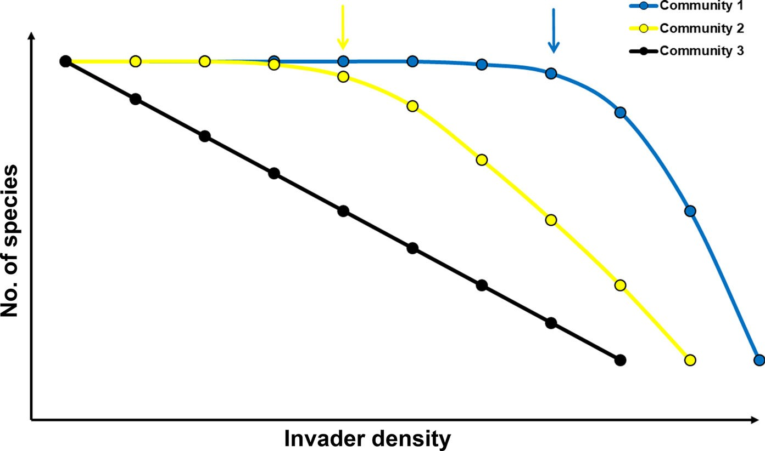
Linear and non-linear effects of goldenrod invasions
949
Fig. 1 Conceptual model of density-dependentimpact of invasive species onnative communities. With the increasing density of an invasive species, the richness of native communitiesdecreases.
Decrease of native communities could be non- linear (community 1 and 2) or linear (community 3) dependent on the invaders’ density. Arrows at the top indicate the threshold points for community 1 and 2
rich in pollen and nectar (Kabuce2006), and are visited by a spectrum of pollinating insects in their native areas (Pavek2012) and in invaded ones (Kabuce2006). Earlier findings showed that, in meadow habitats invaded by non-native goldenrods,there is a significant decline of native plant diversity(Moron´etal.2009;Paletal.2015).Thegoldenrodinvasionsalsocausecommunitiesofnativepollinators(Moron´etal.2009;Fenesietal.2015),ants(Lendaetal.2013;Kajzer-Bonketal.2016),beetles(deGrootetal.2007;Baranova´etal.2014)orbirds(Sko´rkaetal.2010) todisappear.
We selected sites ranging from 0 to 100% of invasivegoldenrodcover,andsurveyedtheabundance and diversity of the most important pollinator com- munities of the temperate zone (bees, butterflies and hover flies). For better mechanistic understanding of the potential linear or non-linear pollinators’response to the invasive goldenrods, we also recorded the number of native plant species, which are the main resources for pollinators (Blaauw and Isaacs2014). Weexpectedthattherewouldbeanon-linearresponse of pollinator communities to increasing goldenrod cover. We identified threshold values at which the negative impact increases for different groups of pollinators. Moreover, we tested whether theresponse ofplantandpollinatorassemblagesreflectsthedegree of goldenrod cover. Specifically, we address the following questions: (1) Is there evidence ofnon- linearityinthenumericalresponseofnativeplantsand pollinators as the cover of goldenrod increases? (2) If so, what is the threshold goldenrod cover at whichthe
nativeplantsandpollinatorsstarttoshowadecreasein abundance and species richness? And, (3) Are plant and pollinator community changes caused by species replacement (i.e., turnover) or elimination (i.e., nest- edness) as goldenrod coverincreases?
Materials andmethods
Study area
The study was carried out in the meadow landscape locatedinthevalleyoftheVistularivernearthecityofKrako´w,southernPoland(Fig.2).Usingpresentandhistorical vegetation data, we mapped the meadows(Kornas´andMedwecka-Kornas´1974; Dubiel1995;Pepkowska2002;Sko´rkaetal.2007;Moron´etal.2009) where soil is periodically saturated with water. The meadows have similar geological history,climate and soil properties(Kornas´andMedwecka-Kornas´1974). All the studied meadows originated from wet meadows dominated byMolinia caerulea,GaliumborealeandSanguisorba officinaliswith a number of other plants suitable for pollinators(Kornas´andMedwecka-Kornas´1974;Moron´etal.2008).Afterthe collapse of communism, the wet meadows were maintained mostly by an irregular management scheme, with intervals of several years betweenmowing,burningorgrazing(Sko´rkaetal.2007).
The rapid change in management allowed the
goldenrod invasion (S. canadensisandS. gigantea) to begin at all sites basically at the same time, 20 years
13

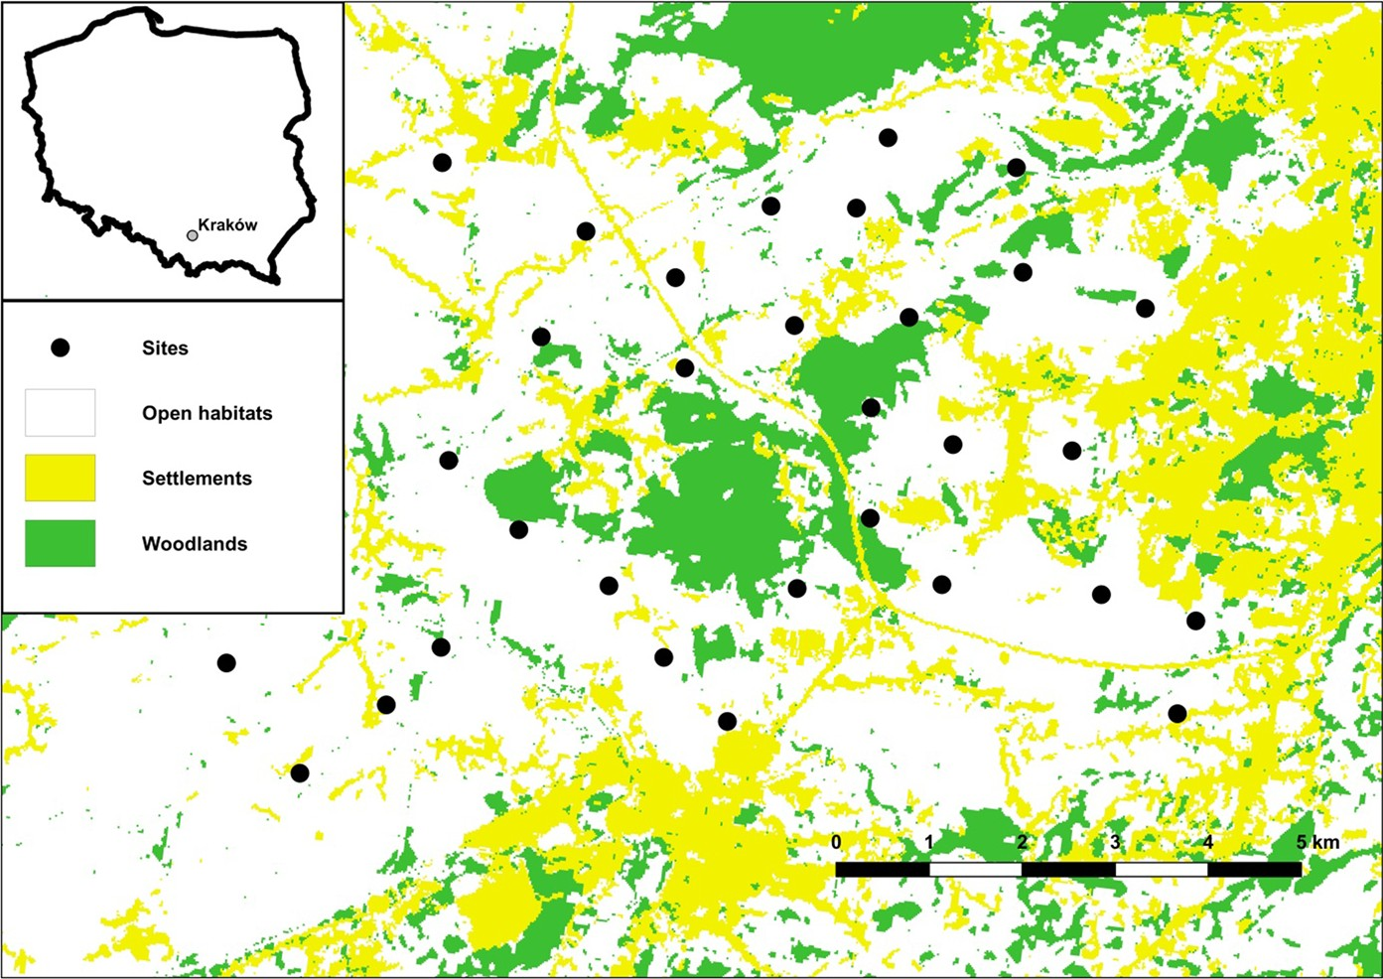
950
D.Moron´etal.
Fig. 2 Location of 31 study sites in the Krakow region, Southern Poland
before this study
began
(which was confirmed by
characteristics did not correlate with goldenrodcover. The sizes of the sites (6.12±6.48 ha) were not correlated with goldenrod cover (r_{S}= 0.136,p= 0.274). The goldenrod cover of selected sites did not correlate with the sites’ distance to the closest arable field (r_{S}= 0.167,p= 0.369; 473±516m),
woodland (r_{S}=-0.277,p=0.132;259±294m),
historical vegetation data). Differences in invasive goldenrod cover appear to be the result of local, random factors occurring at sites, e.g. occasional mowing, grazing or burning (personal observations). Moreover, because goldenrods are herbaceous plants, we can assume that the impact of coverage is not dependent on the temporal component of their lifecy- cle development stages (time taken for developmentfrom seedling to mature plant), unlike, for example, the case for trees (Pawson et al.2010). From all located meadows, we selected 31 patches, ensuring that invasive goldenrod cover ranged from 0% up to 100% (43.06±35.32%; mean±SD). To calculate goldenrod cover, the study sites were carefully inspected and all patches of invasive goldenrods were mapped with the help of GPS. The study sites were at least 1.07±0.18 km apart and were surrounded by arable fields, forests and human settlements.
To control for the confounding effects of potential spatial gradients (sites’ size and distance to arable fields, human settlements, meadows and woodlands) for the investigated impact of goldenrod coveron pollinators, the wet meadows were selected in a relatively homogenous landscape. However, we applied QGIS 2.18.14 (QGIS Development Team2018) software to calculate the spatial gradients ofthe study sites and used Spearman’s test to ensure thatthe
human
settlements
(r_{S}=0.175, p=0.347;
239±168 m) or meadows (r_{S}= 0.082,p= 0.660;
125±69 m).
Surveys
A200mtransectwasestablishedinthemiddleofeach site (Fig.2; Pollard and Yates1993; Westphal et al.2008). Bees and hover flies were sweep-netted along the transect on each site during four surveys, first in June, second in July, third in August and fourth in September (overall 124 transect-walks). During the transect walks on each site, the collectors walked slowly, making 500 sweeps to standardise the sweep- ingeffort.Sweepsencompassedallfloweringplantsat transects.Butterflieswerecountedoneachtransect,on four occasions from June to September of 2010, and were captured only for identification purposes. The duration of a single transect walk for butterfly assessment lasted 20 min. The order in which the transects were sampled was random. Eachtransect
13

Linear and non-linear effects of goldenrod invasions
951
wasvisitedduringdifferentpartsoftheday(9:00a.m. to 6.00 p.m.) throughout the season to cover entire period of pollinator activity during a day. The native plants were surveyed at five permanent plots (each with an area of 3.14 m²), distributed at each transect withadistanceof50mbetweentheplots.Thenumber of native plant species was surveyed twice during the study: first in the pre-blooming period (beginning of May) and second at the beginning of the goldenrodflowering period (in the middle ofJuly).
significant non-linear relationships revealed by GAMMs. To this point we applied the R (R Devel- opment Core Team2016) package ‘‘segmented’’ (Muggeo2015).
Differencesbetweenspeciesassemblagescanbean effect of species replacement between sites (turnover, which leads to different assemblages) and speciesloss fromsitetosite(nestedness,whichleadstothepoorest assemblage being a strict subset of the richest one, Baselga and Orme2012). To understand the mecha- nism of potential effects of goldenrod cover on pollinator and plant assemblages, we used theJaccard dissimilarity index. This index takes into account the speciesthataredifferentbetweenapairofsites,andis definedastheproportionoftheoverallpoolofspecies present at each site. The index ranges from 0for identicalpoolofspeciesatallsitesto1fornocommon species between sites. The dissimilarity indexes were computed for each pair of sites for pollinators and plants, and the total dissimilarity partitioned into two separate components accounting for the dissimilarity derived solely from turnover and that derived from nestedness (Baselga2012). Then, with the help of partial redundancy analysis, we tested the goldenrod cover contribution to the dissimilarity derived from turnover and nestedness of pollinators and plants.The statistical analysis was performed using the packages‘‘betapart’’(Baselga et al.2013) and‘‘vegan’’(Oska- nen et al.2013), implemented in R (R Development Core Team2016).
Statistical analysis
To study the relationship between goldenrod cover and its impact on meadow pollinating insects and the potential role of native plant richness in shaping the effect, we used generalised additive mixed models (GAMM) with Poisson error and a logarithmic link function. Applying additive models, we analysed the expected non-linear relationships between the response and the explanatory variable (Wood2006). We employed separate models to check whether the per site species richness and abundance of bees, butterflies and hover flies, and the richness of plant species, depended on goldenrod cover (seven models overall). Because the effect of the goldenrod cover on pollinatorswasconsistentacrossthepre-floweringand floweringperiods(‘‘Appendix1’’),andastheeffecton native plants was not dependent on whether plants were forbs or graminoids(‘‘Appendix2’’),we pooledthe data for each group (bees, butterflies, hover flies and plants). We fitted the goldenrod cover with the help of splines, to allow for the possible non-linear relationship between the variables and the cover. The possible spatial dependence of the data wasaddressed by including the interaction of longitude and latitude in GAMMs fitted with thin plate regression splines (Wood2006). Using this procedure, part of the variation of a response variable is explained by the spatial location of a given transect, which makes the residuals from GAMMs spatially independent (Wood2006). We based the parameter estimation on the‘‘mgcv’’(Wood2006) computing models imple- mented in R (R Development Core Team2016).
Moreover, to identify a threshold value of golden- rod cover where the slope of function described its impact on pollinators and plant changes we used estimation of regression models with break-points. The break-point values were calculated for all
Results
Overall, 79 native plant and 135 native pollinator species were recorded in the investigated plots (Table1;‘‘Appendix3’’).Among the bees, the most abundant wereBombus lapidarius(17% of the total number of bees),B. terrestris(17%) andSeladoniasubaurata(11%;‘‘Appendix3’’).Three species made up 36% of the total number of butterflies:Aphantopushyperantus(13% of the total number of butterflies),Pieris rapae(13%) andCoenonympha pamphilus(10%;‘‘Appendix3’’).The most abundant species of hoverflywereSphaerophoriascripta(28%ofthetotal number of hover flies),Melanostoma mellinum(19%) andEristalis arbustorum(7%;‘‘Appendix3’’).
Linear and non-linear responses of plant and pollinator communities were found. The number of
13

952
D.Moron´etal.
Ehrenfeld2011; Panetta and Gooden2017). Such a linear relationship is more expected for direct inter- actions between invaders and natives. For example, low abundance of invasive plants can affect a native plant community via competition for space, soil resources and light (Crooks2005). Accordingly, we found a negative, linear relationship between golden- rod cover and native plant species richness.
However, the expectation for indirectrelationships, such as recorded in pollinating insects, is not so obvious (Lenda et al.2010). Indeed, we showed that the negative impact of invasive goldenrod cover on beeandbutterflycommunitiesisnon-linear.Thisnon- linear response creates an threshold point and indi- cates that the invader effects accelerate only after a certaindensitythresholdvalueisreached.Wepropose at least two food-web based mechanisms behind the effectofinvasiveplantsresultingintheobservednon- linear impact. The first possible mechanism arises from the buffering potential of the environment such as food-web redundancy (Gilbert and Levine2013). Thesecondmechanismmightbearesultoftheneutral or positive impact of the invaders on pollinators by increasing food-base (Hejda et al.2009; Stout and Morales2009). Both mechanisms may lead to a delayed abrupt collapse of populations (Kajzer-Bonk etal.2016)or,alternatively,evenreversethenegative impact of invasive plants on native pollinators. For example, patches with moderate cover of goldenrods can still provide sufficient key resources to maintain the lifecycle of native insects (Stout and Morales2009). Pollinating insects, depending on theirspecial- isation, may also switch between different plant species to find food and nesting sites. If flowering, the invasive plant can itself be an important foodbase for many pollinators (Bjerknes et al.2007). Wefound a strong negative linear impact of goldenrod cover on the richness of native plant species, and a non-linear impactonpollinators.Thus,thebufferingeffectofthe food-web might be a result of the food base redun- dancy of pollinators. Moreover, invasive goldenrodscan be used as a food source by only some bee andbutterflyspecies(Sko´rkaetal.2007;Lendaetal.2010).
Butterflies appear to be least resistant to the invasion, there was a negative effect on the number of individuals at sites with 30–40% goldenrod cover. Butterflies are herbivorous insects depending on different plant species during consecutive lifestages.
Table 1 The number of collected species and individuals from each pollinator group
Pollinator group
No. of species
No. of individuals
BeesButterflies
Hover flies
40
53
42
247
2258
468
native plant species decreases linearly withincreasing goldenrod cover (Fig.3a; Table2), whereas the he abundance and species richness of hover flies did not change across goldenrod cover (Fig.3b, c, Table2). However, the abundance of bees and their species richness decreased non-linearly with increasing gold- enrod cover (Fig.3d, e; Table2). As with bees, anon- linear decrease in abundance and species richness of butterflies occurred towards high goldenrod cover (Fig.3f, g, Table2).
Threshold points were identified for non-linear responses of pollinators to goldenrod invasion. There was a negative effect of invasive goldenrods on bee species, and the number of individuals appeared at cover (± SE) of 50±2% and 49±1%, respectively (Fig.3). A comparable detrimental impact of golden- rods on butterfly abundance appeared at cover of 31±14% (Fig.3). For the richness of butterfly species, the relationship, albeit non-linear, was more monotonic, with a threshold point at 43±12%, (Fig.3).
Species assemblages derived from species replace- ment (turnover) did not differ between sites of different goldenrod cover for all pollinator groups and plants. However, species assemblages derived from species loss (nestedness) was significantly different between sites of different goldenrod cover for bees (F_{1,29}= 28.53, R²= 0.50,p= 0.002), butter- flies (F_{1,29}= 41.53, R²= 0.52,p=0.001) and plants
(F_{1,29}= 28.15, R²= 0.49,p= 0.001) but not hoverflies(F_{1,29}=1.21,R²=0.03,p=0.416).
for
Discussion
An underlying assumption of the impact of invasive species on native ones is the proportional negative relationship between invader density and native pop- ulation sizes (Dupont et al.2009; Elgersma and
13

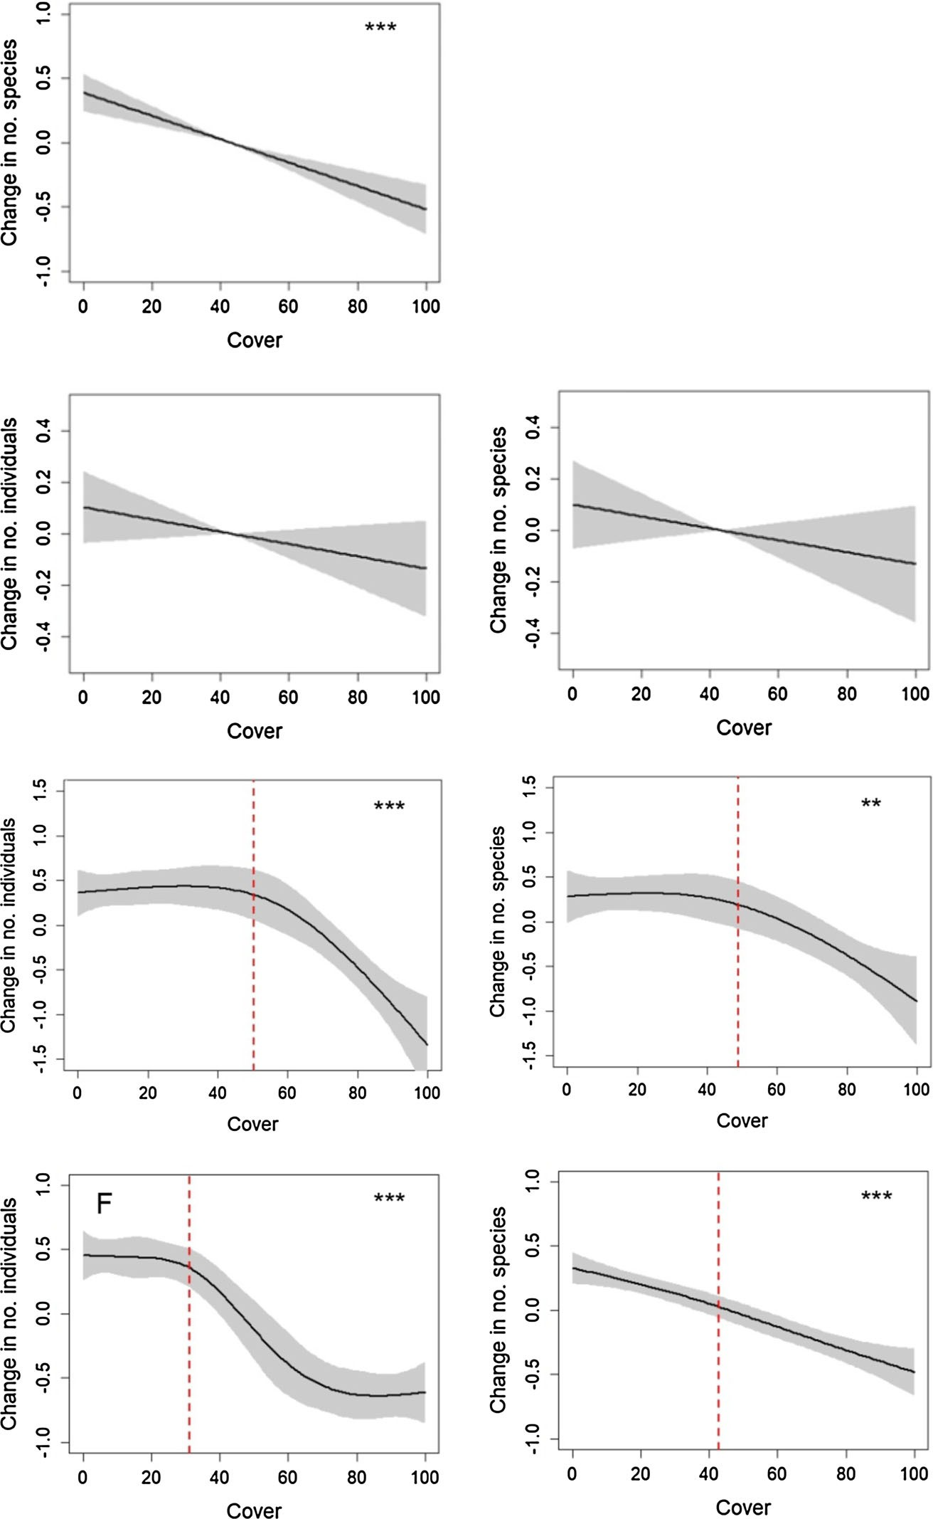
Linear and non-linear effects of goldenrod invasions
953
A
***
B
ns
ns
C
E
D
*
*
G
F
***
***
***p\0.001,95%CIaremarkedwithgreypolygons.Red lines indicate estimated threshold points for non-linear relationships
Fig.3Theeffectsofinvasivegoldenrodcoveronthenative plantrichness(a)aswellasonhoverfly(b,c),bee(d,e)andbutterfly(f,g)abundanceandspeciesrichnessaspredictedbyGAMMmodelspresentedinTable1.nsp[0.05,**p\0.01,
As adults, they feed on nectar of plants that may be different than plant species used by their often monophagous larvae (Brock2015). Many butterfly
species are recognised as food specialists for which food source redundancy is relatively low—70% of collected species were food specialised. Thus,bearing
13
Butterflies
Bees
Hover flies
Plants

*
**

954
D.Moron´etal.
larvae feed on nectar and pollen as well as on other food sources (Brock2015). However, the larvae of some species can be specialised, for example by requiring decaying wood to complete their lifecycle, or in the case of predators feeding on aphids (Brock2015). Unlike bees and butterflies, which often have mutual relationships with a particular group of plants (Brock2015),hoverfliesseemstobecapableofusing flowersofmanyspeciesasfoodsources.Theabilityto use available resources might give an advantage, especially in habitats homogenised by few food sources. This may explain why, for hover flies, we found no direct link between the number of species and individuals, and goldenrodcover.
The pollinator and plant community assemblages seem to be affected as goldenrod cover increases. Changesinthecommunityassemblagesarearesultof species loss rather than of the constitution of new communities by species replacement. Thus, in areas highlyimpactedbyinvasivegoldenrods,onlyapartof the original pool of species can persist. The next step should be to identify traits which make some species less vulnerable to biologicalinvasions.
Global environmental changes, along with the pressure of invasive species, has prompted a need to understand the trajectories of complex ecological systems (Mouquet et al.2015) for better projections of biodiversity loss or changes and ecosystem func- tioning on the global scale (Barnosky et al.2012). Unfortunately, biological invasions seem to be idiosyncratic, including non-linear relationships betweeninvadersandnatives,whichmakesprediction much harder (Richardson et al.2000). However, if non-linear relationships are results of the understood intrinsic processes, the relationships can be incorpo- rated into ecological predictions and plant manage- ment (Crooks2005). The existence of the non-linear relationships also indicate some resistance of native communities to invasion, at least until the invasive species reaches a certain density. This prompts the recommendation that goldenrod cover below 30% for butterflies and about 50% for bees should sustain pollinator populations and their ecosystem services in meadowhabitatsunderpressureofaliengoldenrods.It also indicates that habitats and their pollinator com- munities, even when invaded, can be successfully restored to the point of relatively moderate goldenrod density, lowering costs of invader removal and the reintroductionofnativespecies(Szymuraetal.2016).
Table 2 Generalised additive mixed models indicate the effect of goldenrod cover (smooth term) on the abundance and richnessofpollinatorsandspeciesrichnessofnativeplants
edfª
pValue^{b}
R2
Variable
FValue
adj
Abundance Bees Butterflies Hover flies
Species richness Native plants Bees Butterflies
Hover flies
2.711
3.258
1.000
13.27
25.93
2.160
< 0.001
< 0.001
0.156
0.54
0.93
0.29
1.000
2.090
1.481
1.000
29.07
7.69
29.49
1.358
< 0.001
0.002
< 0.001
0.254
0.69
0.43
0.58
0.05
aEstimated degrees of freedom (edf = 1 is a
linear
relationship);^{b}Statisticallysignificant(p\0.05)effectsare inbold
in mind the negative impact of goldenrods on native plants, and the dependency of butterfly life stages on different plant species, the impact of the invasive goldenrods on butterflies may multiply, leading toco- extinctionofhostandbutterfly(Koh2004).Moreover, whereassomebutterflyspeciesadultscanuseinvasive goldenrodsasanectarsource,itseemsthatgoldenrods are not used as food sources by their larvae (Ebert2005; Buszko and Masłowski2015). As such,the buffering mechanism seems to work only partiallyfor butterflies, causing their relatively fast response tothe invasion.
Among other pollinators, bees have theclosest, very often mutual, relationships with nativeflowering plants, as both larvae and adult bees are dependent on nectarandpollencollectedfromflowers(Brock2015). Comparedtobutterflies,thenumberofbeespeciesand individuals appeared to show a strong non-linear impact to goldenrod invasion. This relativerobustness might indicate the strong food base redundancy of bees, as only 35% of collected bee species were food specialised. The negative impact at the level of 50% goldenrod cover may also indicate that bees utilise goldenrods, but as a supplementary resource rather than one complementary to the non-invadedmeadows(Moron´etal.2019).Moreover,forsomefood-specialised bees, a patch dominated by one floweringspeciesmightbenotpreferred(Moron´etal.2009).
Hoverflies,amongallthestudiedpollinatorgroups, aretheleastflowerspecialisedbecausebothadultsand
13

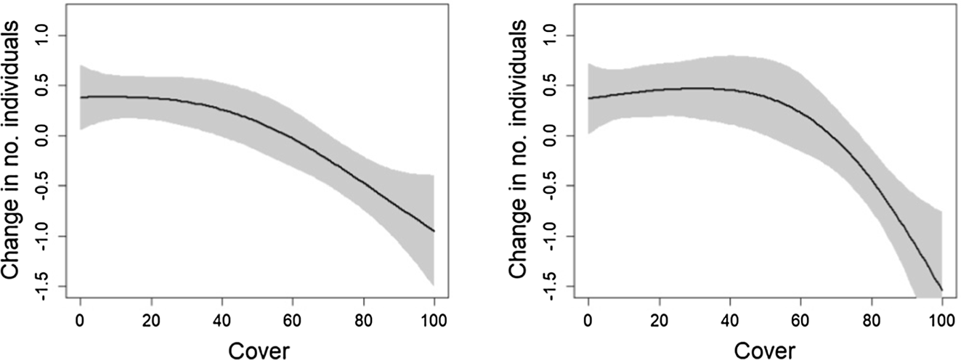
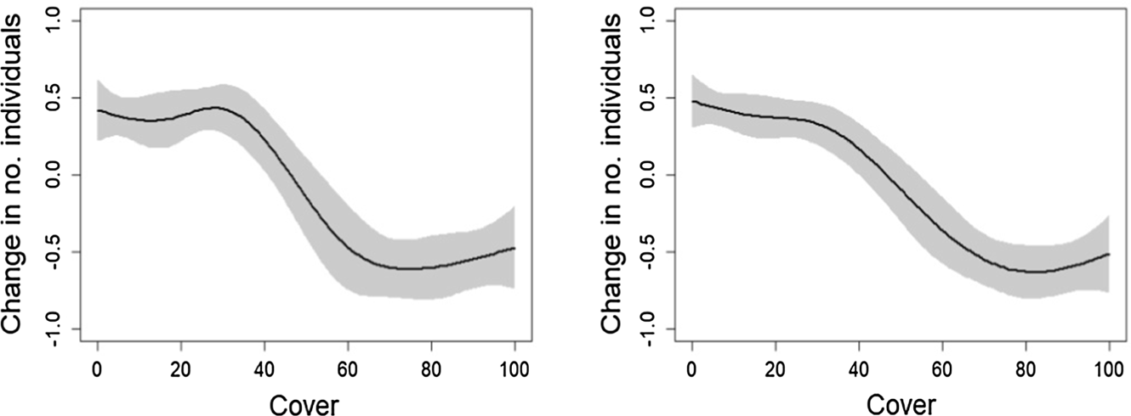
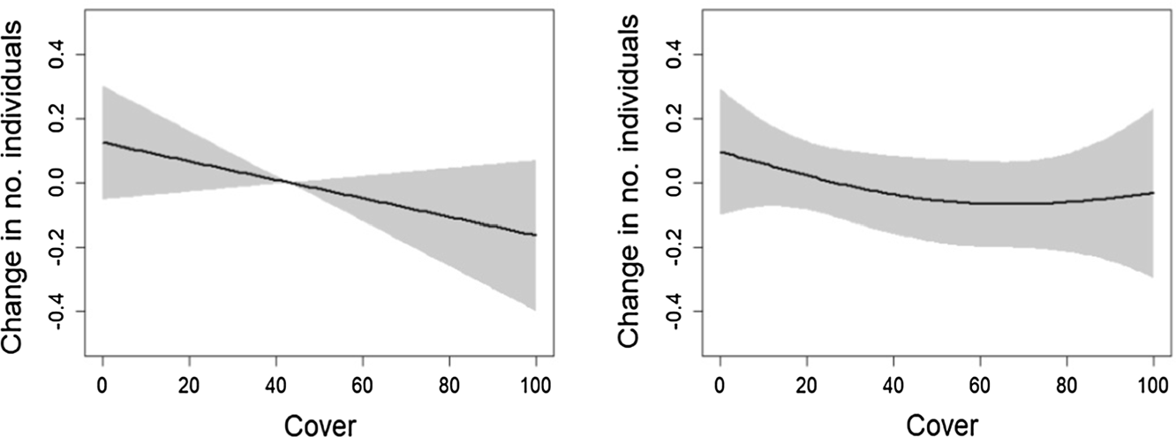
Linear and non-linear effects of goldenrod invasions
955
predicted by GAMM models. ns p[0.05;
*p\0.05,**p\0.01,***p\0.001,95%CIare marked with greypolygons.
Acknowledgements The referees provided very critical comments on themanuscript.
useful
Open Access This article is distributed under the terms of theCreativeCommonsAttribution4.0InternationalLicense(http://creativecommons.org/licenses/by/4.0/), which permits unre- stricted use, distribution, and reproduction in any medium, provided you give appropriate credit to the original author(s) and the source, provide a link to the Creative Com- mons license, and indicate if changes weremade.
Appendix 2
Theeffectsofinvasivegoldenrodcoveronthenative forb and graminoid species richness as predictedbyGAMMmodels.nsp[0.05;*p\0.05,**p\0.01,
***p\0.001, 95% polygons.
CI
are
marked
with
grey
Appendix 1
The effects of invasive goldenrod cover on the bee, butterflyandhoverflyabundanceduringpre-flowering
and
flowering
period
of invasive goldenrods as
**
**
Pre-flowering
Flowering
***
***
Pre-flowering
Flowering
ns
ns
Flowering
Pre-flowering
13
Hoverflies
Butterflies
Bees

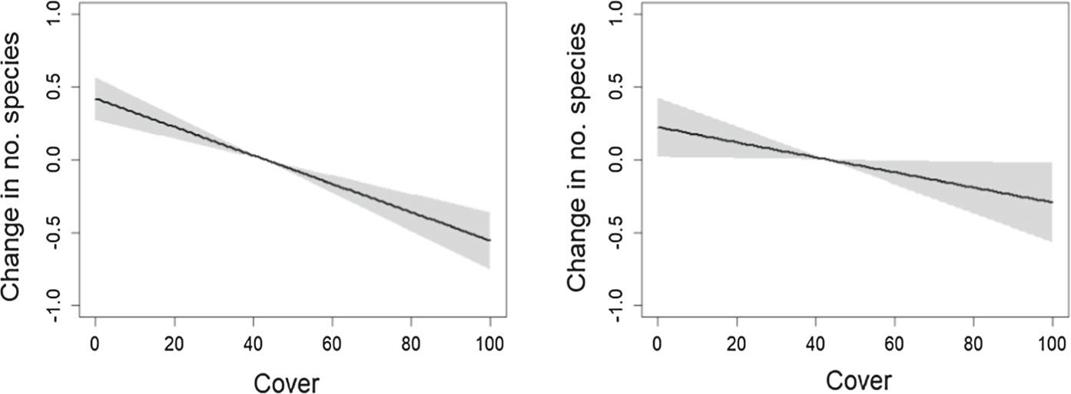
956
D.Moron´etal.
***
*
Forbs
Graminoids
Appendix 3
List of pollinator and flowering plant species found at study sites.
Bees
Butterflies
Hover flies
Plants
Andrena chrysoscelesAndrena denticulata Andrena hattorfiana Andrena labiata Andrena minutula Andrena minutuloides Andrena pontica Andrena proxima Andrena subopaca Bombus lapidarius Bombus pascuorum Bombus pratorum Bombus sylvarum Bombus terrestris Colletes daviesanus Colletes fodiens Colletes similis Dasypoda altercator Epeoloides coecutiens Evylaeus albipes Evylaeus calceatus Evylaeus fulvicornis Evylaeus laticeps Evylaeus leucopus Evylaeus morio Evylaeus pauxillus Evylaeus sabulosus Heriades truncorum
Aglais urticaeApatura ilia Apatura iris
Aphantopus hyperanthusAraschnia levana Argynnis aglaja Argynnispaphia
Aricia agestisBoloria dia Boloria selene Brenthis ino Callophrys rubi
Carcharodus alceaeCelastrina argiolus Coenonympha arcania Coenonympha glycerion Coenonympha pamphilus Colias hyale
Cupido argiadesErynnis tages Gonepteryx rhamni Hesperia comma Inachis io
Issoria lathoniaLeptideasp.
Lycaena dispar
Lycaena hippothoeLycaena phlaeas
Anasymia lineataCheilosia pagana Cheilosia proxima Cheilosia vernalis Chrysotoxum bicinctum Chrysotoxum festivum Episyrphus balteatus Eristalinus aeneus Eristalinus sepulchralis Eristalis arbustorum Eristalis nemorum Eristalis pertinax Eristalis tenax Eupeodes latifasciatus Eupeodes luniger Helophilus hybridus Helophilus pendulus Helophilus trivittatus
Melangyna compositarumMelanostoma mellinum Meligramma triangulifera Merodon equestris Microdon mutabilis Parhelophilus versicolor Pipizella viduata Platycheirus angustatus Platycheirus clypeatus
Platycheirus fulviventris
Achillea millefoliumAegopodium podagraria Alopecurus pratensis Armoracia rusticana Artemisia vulgaris Astragalus glycyphyllos Atriplex nitens
Bromus arvensisCalamagrostis epigeios Carduus crispus Centaurea jacea Centaurea scabiosa
Chamaenerion angustifoliumChamomilla recutia
Cirsium arvenseCirsium oleraceum Convolvulus arvensis Crataegus monogyna Dactylis glomerata Daucus carota Elymus repens Epilobium hirsutum Equisetum arvense Erigeron annuus
Erysimum cheiranthoidesEuphorbia cyparissias Festuca pratensis
Filipendula ulmaria
13

Linear and non-linear effects of goldenrod invasions
957
continued
Bees
Butterflies
Hover flies
Plants
Hoplitis leucomelanaHoplitis spinulosa Hylaeus difformis Hylaeus gredleri Hylaeus sinuatus Macropis europaea Macropis fulvipes Megachile alpicola Melitta nigricans Seladonia subaurata Seladonia tumulorum Sphecodes crassus
Lycaena tityrusLycaena virgaureae Maniola jurtina Minois dryas Ochlodes sylvanus Papilio machaon Phengaris alcon Phengaris nausithous Phengaris teleius Pieris brassicae Pieris napi
Pieris rapaePlebejus argus
Plebejus argyrognomonPolygonia c-albumPolyommatus icarus Polyommatus semiargus Pontia edusa
Pyrgus alveusPyrgus malvae Thecla betulae Thymelicus lineola Thymelicus sylvestris Vanessaatalanta
Vanessa cardui
Platycheirus immarginatusPlatycheirus occultus Platycheirus peltatus Platycheirus scutatus Sphaerophoria scripta Sphaerophoria taeniata Syritta pipiens
Syrphus ribessiSyrphus torvus Triglyphus primus Tropidia scita Xanthandrus comtus
Xanthogramma pedissequum
Xylota segnis
Fragaria vescaGalium verum
Gentiana pneumonantheGeranium pratense Geum urbanum Heracleum sphondylium Holcus lanatus Hypericum perforatum Iris sibirica
Lamium amplexicauleLathyrus pratensis Lathyrus tuberosus Leucanthemum vulgare Lolium perenne Lychnis flos-cuculiLysimachia vulgaris Lythrum salicaria Medicago lupulina Melilotusalba
Mentha arvensisMolinia caerulea Origanum vulgare Phleum pratense Phragmites australis Plantago lanceolata Plantago major
Poa annuaPoa pratensis
Polygonum bistortaPotentilla anserina Potentilla erecta Ranunculus acris Reseda lutea
Rosa caninaRubus caesius Rubus idaeus Rumex acetosa
Sanguisorba officinalisSolidago canadensis Solidago gigantea Stellaria media Symphytum officinale Tanacetum vulgare Taraxacum officinale
Trifolium hybridum
13

958
D.Moron´etal.
continued
Bees
Butterflies
Hover flies
Plants
Trifolium repensTussilago farfara Urtica dioica Verbascum densiflorum Vicia cracca
Vicia sepiumVicia tenuifolia
Vicia tetrasperma
References
Development Core Team R (2016) R: a language and environ-mentforstatisticalcomputing.RFoundationforStatistical Computing,Vienna
Dubiel E (1995) Kierunki antropogenicznych przemian szatyros´linnejdolinyWisływKrakowie.FoliaGeogrSerGeogr 26–27:139–148
DupontYL,Padro´nB,OlesenJM,PetanidouT(2009)Spatio-temporal variation in the structure of pollinationnetworks.Oikos 118:1261–1269.https://doi.org/10.1111/j.1600-0706.2009.17594.x
Ebert G (ed) (2005) Die Schmetterlinge Baden-Wurttembergs.
Band 10, Erganzungsband. Eugen Ulmer, StuttgartElgersma KJ, Ehrenfeld JG (2011) Linear and non-linear
impacts of a non-native plant invasion on soil microbialcommunity structure and function. Biol Invasions 13:757–768.https://doi.org/10.1007/s10530-010-9866-9
FenesiA,Va´ga´siCI,BeldeanMetal(2015)Solidago
canadensisimpacts on native plant and pollinator com-munities in different-aged old fields. Basic Appl Ecol16:335–346.https://doi.org/10.1016/j.baae.2015.03.003
Gilbert B, Levine JM (2013) Plant invasions and extinctiondebts. Proc Natl Acad Sci 110:1744–1749.https://doi.org/10.1073/pnas.1212375110
HaddadNM,CrutsingerGM,GrossKetal(2009)Plantspecies loss decreases arthropod diversity and shifts trophicstructure. Ecol Lett 12:1029–1039.https://doi.org/10.1111/j.1461-0248.2009.01356.x
Hejda M, Pysˇek P (2006) What is the impact of impatiens glandulifera on species diversity of invaded riparian veg-etation? Biol Conserv 132:143–152.https://doi.org/10.1016/j.biocon.2006.03.025
HejdaM,PysˇekP,Jarosˇ´ıkV(2009)Impactofinvasiveplantson
the species richness, diversity and composition of invadedcommunities.JEcol97:393–403.https://doi.org/10.1111/j.1365-2745.2009.01480.x
Hulme PE, Pysˇek P, Jarosˇ´ık V et al (2012) Bias and error in
understanding plant invasion impacts. Trends Ecol Evol28:212–218.https://doi.org/10.1016/j.tree.2012.10.010
Kabuce N (2006) NOBANIS—invasive alien species fact sheetSolidago canadensis. NOBANIS—invasive alien species fact sheet
Kajzer-Bonk J, Szpiłyk D, Woyciechowski M (2016) Invasive goldenrodsaffectabundanceanddiversityofgrasslandant communities(Hymenoptera:Formicidae).JInsect
Amano T, Coverdale R, Peh KSH (2016) The importance of globalisation in driving the introduction andestablishment of alien species in Europe. Ecography (Cop) 39:1118–1128.https://doi.org/10.1111/ecog.01893
Baranova´B,MankoP,Ja´szayT(2014)Differencesinsurface-dwellingbeetlesofgrasslandsinvadedandnon-invadedby goldenrods(Solidagocanadensis,S.gigantea)withspecial reference to Carabidae. J Insect Conserv 18:623–635.https://doi.org/10.1007/s10841-014-9666-0
BarnoskyAD,HadlyEA,BascompteJetal(2012)Approaching astateshiftinEarth’sbiosphere.Nature486:52–58.https://doi.org/10.1038/nature11018
Baselga A (2012) The relationship between species replace- ment, dissimilarity derived from nestedness, and nested- ness. Glob Ecol Biogeogr 21:1223–1232.https://doi.org/10.1111/j.1466-8238.2011.00756.x
Baselga A, Orme CDL (2012) betapart: an R package for the study of beta diversity. Methods Ecol Evol 3:808–812.https://doi.org/10.1111/j.2041-210X.2012.00224.x
Baselga A, Orme D, Villeger S, Bortoli J De (2013) Package ‘‘betapart’’
Bjerknes A-L, Totland O, Hegland SJ, Nielsen A (2007) Do alien plant invasions really affect pollination success in native plant species? Biol Conserv 138:1–12.https://doi.org/10.1016/j.biocon.2007.04.015
Blaauw BR, Isaacs R (2014) Larger patches of diverse floral resources increase insect pollinator density, diversity, and their pollination of native wildflowers. Basic Appl Ecol 15:701–711.https://doi.org/10.1016/j.baae.2014.10.001
Brock PD (2015) A comprehensive guide to insects of Britain and Ireland. Pisces Publications, Newbury
BuszkoJ,MasłowskiJ(2015)MotyledziennePolski.Koliber&JarosławBuszko,JanuszMasłowski,NowySa˛cz
CrooksJA(2005)Lagtimesandexoticspecies:theecologyand management of biological invasions in slow-motion1.E´coscience12:316–329.https://doi.org/10.2980/i1195-
6860-12-3-316.1
deGrootM,KleijnD,JoganN(2007)Speciesgroupsoccupying different trophic levels respond differently to the invasion of semi-natural vegetation bySolidago canadensis. Biol Conserv 136:612–617.https://doi.org/10.1016/j.biocon.
2007.01.005
13

Linear and non-linear effects of goldenrod invasions
959
Conserv 20:99–105.https://doi.org/10.1007/s10841-016-
9843-4
KohLP(2004)Speciescoextinctionsandthebiodiversitycrisis.Science 305:1632–1634.https://doi.org/10.1126/science.
1101101
Kornas´J,Medwecka-Kornas´A (1974) Szataros´linnaKrakowaLendaM,Sko´rkaP,Moron´D(2010)Invasivealienplantspe-cies—A threat or an opportunity for pollinating insects inagricultural landscapes? In: Lee TH (ed) Agriculturaleconomics: new research. Nova Science Publishers, New
York, pp 67–87
LendaM,WitekM,SkorkaP,Moron´D(2013)Invasivealienplants affect grassland ant communities, colony size andforaging behaviour. Biol Invasions 15:2403–2414.https://doi.org/10.1007/s10530-013-0461-8
LendaM,KnopsJH,Sko´rkaPetal(2018)Cascadingeffectsofchanges in land use on the invasion of the walnut Juglansregiainforestecosystems.JEcol106:671–686.https://doi.org/10.1111/1365-2745.12827
McCary MA, Mores R, Farfan MA, Wise DH (2016) Invasive plants have different effects on trophic structure of greenand brown food webs in terrestrial ecosystems: a meta- analysis. Ecol Lett.https://doi.org/10.1111/ele.12562
MemmottJ,AlonsoD,BerlowELetal(2006)Biodiversitylossandecologicalnetworkstructure.In:PascualM,DunneJA(eds)Ecologicalnetworks:linkingstructuretodynamicsinfood webs. Oxford University Press, Oxford,pp325–350Moron´D,Szentgyo¨rgyiH,WantuchMetal(2008)Diversityofwild bees in wet meadows: implication forconservation.
Wetlands 28:975–983
Moron´D,LendaM,Sko´rkaPetal(2009)Wildpollinatorcommunities are negatively affected by invasion of alien goldenrods in grassland landscapes. Biol Conserv142:1322–1332.https://doi.org/10.1016/j.biocon.2008.12.
036
Moron´D,Sko´rkaP,LendaM(2019)Disappearingedge:theflowering period changes the distribution of insect polli-nators in invasive goldenrod patches. Insect ConservDivers.https://doi.org/10.1111/icad.12305
Mouquet N, Gravel D, Massol F, Calcagno V (2012)Extendingthe concept of keystone species to communities and ecosystems. Ecol Lett.https://doi.org/10.1111/ele.12014
Mouquet N, Lagadeuc Y, Devictor V et al (2015) REVIEW:predictive ecology in a changing world. J Appl Ecol 52:1293–1310.https://doi.org/10.1111/1365-2664.12482
Muggeo VMR (2015) Regression models with breakpoints/changepoints estimation. R package version 0.5-1.4
Oskanen J, Blanchet FG, Kindt R et al (2013) Vegan: commu- nity ecology package. R package version 2.0-10
Pal RW, Chen S, Nagy DU, Callaway RM (2015) Impacts ofSolidagogiganteaonotherspeciesathomeandaway.BiolInvasions 17:3317–3325.https://doi.org/10.1007/s10530-
015-0955-7
Panetta F, Gooden B (2017) Managing for biodiversity: impact and action thresholds for invasive plants in naturalecosystems. NeoBiota 34:53–66.https://doi.org/10.3897/neobiota.34.11821
Pavek PLS (2012) Plant fact sheet for Canada goldenrod (Sol-idago canadensis). In: USDA-Natural Resources Conser- vation Service.https://plants.usda.gov/factsheet/pdf/fs_soca6.pdf
Pawson SM, McCarthy JK, Ledgard NJ, Didham RK (2010) Density-dependent impacts of exotic conifer invasion on grassland invertebrate assemblages. J Appl Ecol 47:1053–1062.https://doi.org/10.1111/j.1365-2664.2010.
01855.x
Pejchar L, Mooney HA (2009) Invasive species, ecosystem services and human well-being. Trends Ecol Evol 24:497–504.https://doi.org/10.1016/j.tree.2009.03.016
Pe˛pkowskaA(2002)Inwentaryzacjaiwaloryzacjakrajobra-zowo-przyrodniczatereno´wprzyległychdoKampusu600-leciaOdnowieniaUiwersytetuJagiellon´skiego.JagiellonianUniversity,Krako´w
Pollard E, Yates TJ (1993) Monitoring butterflies for ecology and conservation. Chapman & Hall, London
PysˇekP,Jarosˇ´ıkV, Hulme PE et al (2012) A global assessment of invasive plant impacts on resident species,communities and ecosystems: the interaction of impact measures, invading species’ traits and environment. Glob Change Biol 18:1725–1737.https://doi.org/10.1111/j.1365-2486.2011.02636.x
QGISDevelopmentTeam(2018)QGISgeographicinformation system. Open source geospatial foundation project.https://qgis.org/en/site/. Accessed 5 June2018
Richardson DM, Allsopp N, D’antonio CM et al (2000) Plant invasions—the role of mutualisms. Biol Rev 75:65–93.https://doi.org/10.1111/j.1469-185X.1999.tb00041.x
Richardson DM, Holmes PM, Esler KJ et al (2007) Riparian vegetation: degradation, alien plant invasions, and restorationprospectsRIDA-1495-2008RIDF-5883-2010. Divers Distrib 13:126–139.https://doi.org/10.1111/j.1472-4642.2006.00314.x
Salisbury A, Armitage J, Bostock H et al (2015) EDITOR’S CHOICE:enhancinggardensashabitatsforflower-visiting aerialinsects(pollinators):Shouldweplantnativeorexotic species? J Appl Ecol 52:1156–1164.https://doi.org/10.1111/1365-2664.12499
Simao MCM, Flory SL, Rudgers JA (2010) Experimental plant invasion reduces arthropod abundance and richness across multiple trophic levels. Oikos 119:1553–1562.https://doi.org/10.1111/j.1600-0706.2010.18382.x
Sko´rkaP,SetteleJ,WoyciechowskiM(2007)Effectsofman-agement cessation on grassland butterflies in southern Poland. Agric Ecosyst Environ 121:319–324.https://doi.org/10.1016/j.agee.2006.11.001
Sko´rkaP,LendaM,TryjanowskiP(2010)Invasivealiengoldenrodsnegativelyaffectgrasslandbirdcommunitiesin Eastern Europe. Biol Conserv 143:856–861.https://doi.org/10.1016/j.biocon.2009.12.030
Stout JC, Morales CL (2009) Ecological impacts of invasive alien species on bees. Apidologie 40:388–409.https://doi.org/10.1051/apido/2009023
Szymura M, Szymura TH, Wolski K (2016) Invasive solidago species:Howlargeareadotheyoccupyandwhatwouldbe the cost of their removal? Polish J Ecol 64:25–34.https://doi.org/10.3161/15052249PJE2016.64.1.003
TepedinoVJ,BradleyBA,GriswoldTL(2008)Mightflowersof invasive plants increase native bee carrying capacity? IntimationsfromCapitolReefNationalPark,Utah.Nat
Areas
J
28:44–50.
https://doi.org/10.3375/0885-
8608(2008)28%5b44:MFOIPI%5d2.0.CO;2
13

960
D.Moron´etal.
van der Putten WH, Bardgett RD, Bever JD et al (2013) Plant- soil feedbacks: the past, the present and future challenges.J Ecol 101:265–276.https://doi.org/10.1111/1365-2745.12054
Weber E (2001) Current and potential ranges of three exoticgoldenrods (Solidago) in Europe. Conserv Biol 15:122–128
Westphal C, Bommarco R,Carre´G et al (2008) Measuring bee
biogeographical regions. Ecol Monogr 78:653–671.https://doi.org/10.1890/07-1292.1
Wood SN (2006) Generalized additive models: an introduction with R. Chapman and Hall, Boca Raton
Yokomizo H, Possingham HP, Thomas MB, Buckley YM (2009) Managing the impact of invasive species: the value
of knowing the density—impact curve. Ecol 19:376–386.https://doi.org/10.1890/08-0442.1
Appl
diversity
in
different
European
habitats
and
13

