Original paper
Minimally invasive video-assisted thyroidectomy: seven-year experience with 240 cases
Marcin Barczyński, Aleksander Konturek, Małgorzata Stopa, Aleksandra Papier, Wojciech Nowak
Third Department of General Surgery, Jagiellonian University Medical College, Krakow, Poland
Videosurgery Miniinv 2012; 7 (3): 175-180
DOI: 10.5114/wiitm.2011.28871
Abstract
Introduction: Minimally invasive video-assisted thyroidectomy (MIVAT) has gained acceptance in recent years as an alternative to conventional thyroid surgery.
Aim: Assessment of our 7-year experience with MIVAT.
Material and methods: A retrospective study of 240 consecutive patients who underwent MIVAT at our institution between 01/2004 and 05/2011 was conducted. The inclusion criterion was a single thyroid nodule below 30 mm in diameter within the thyroid of 25 ml or less in volume. The exclusion criteria were previous thyroid or parathyroid sur- gery, T2 or higher thyroid cancer, N1 stage, and thyroiditis. The Miccoli technique was used. The analysis included indi- cations, eligibility rate, operative time, morbidity and cosmetic effects.
Results: Of 6,574 patients referred for thyroid surgery, 240 (3.6%) were eligible for MIVAT. In the final pathology report, there were 206 follicular adenomas, 21 papillary thyroid cancers, 9 cases of Graves’ disease and 4 follicular cancers. Reasons for exclusion were as follows: thyroid volume above 25 ml in 5401 (85.3%), thyroid cancer larger than stage T1 in 392 (6.2%), thyroiditis in 358 (5.6%), and previous neck surgery in 183 patients (2.9%). Minimally invasive video- assisted thyroidectomy operations consisted of 210 lobectomies and 30 total thyroidectomies, including 15 one-stage parathyroidectomies. Mean operative time was 38.6 ±15.1 min. Transient versus permanent recurrent laryngeal nerve injury was found in 8 (3.0%) vs. 2 (0.7%) nerves at risk, respectively. Cosmetic effects were assessed after 1 and 6 months of follow-up as very good or excellent by 89.6% and 95.8% of patients, respectively.
Conclusions: Minimally invasive video-assisted thyroidectomy is suitable for surgeons experienced in thyroid and video-assisted surgery. It is feasible for well-selected patients including cases of T1 thyroid cancer, Graves’ disease and concomitant parathyroid adenoma.
Key words: minimally invasive surgery, video-assisted thyroidectomy, benign thyroid disease, thyroid cancer.
Introduction
Thyroidectomy is one of the most common opera- tions performed in endocrine surgery. The basic princi- ples of safe and efficient thyroid surgery established in the early 20th century have remained unchanged, with only a few minor refinements to the technique [1].
Multiple endoscopic approaches for thyroid exci- sion have been developed, ranging from a gasless,
video-assisted central or lateral approach to a com- plete endoscopic supraclavicular, axillary, anterior chest wall or breast approach and even robotic sur- gery [2]. Among all these new operations, minimally invasive video-assisted thyroidectomy (MIVAT) des- cribed in 1998 by Miccoli has gained increasing popu- larity in Europe over the last 15 years [3]. It is safe and offers improved outcomes of surgery in terms of
175
Videosurgery and Other Miniinvasive Techniques 3, September/2012
Address for correspondence:
Marcin Barczyński MD, PhD, FEBS-ES, Third Department of General Surgery, Jagiellonian University Medical College, 37 Prądnicka, 31-202 Krakow, Poland, phone: +48 602 37 59 39, fax: +48 12 633 31 05, e-mail: marbar@mp.pl
Videosurgery

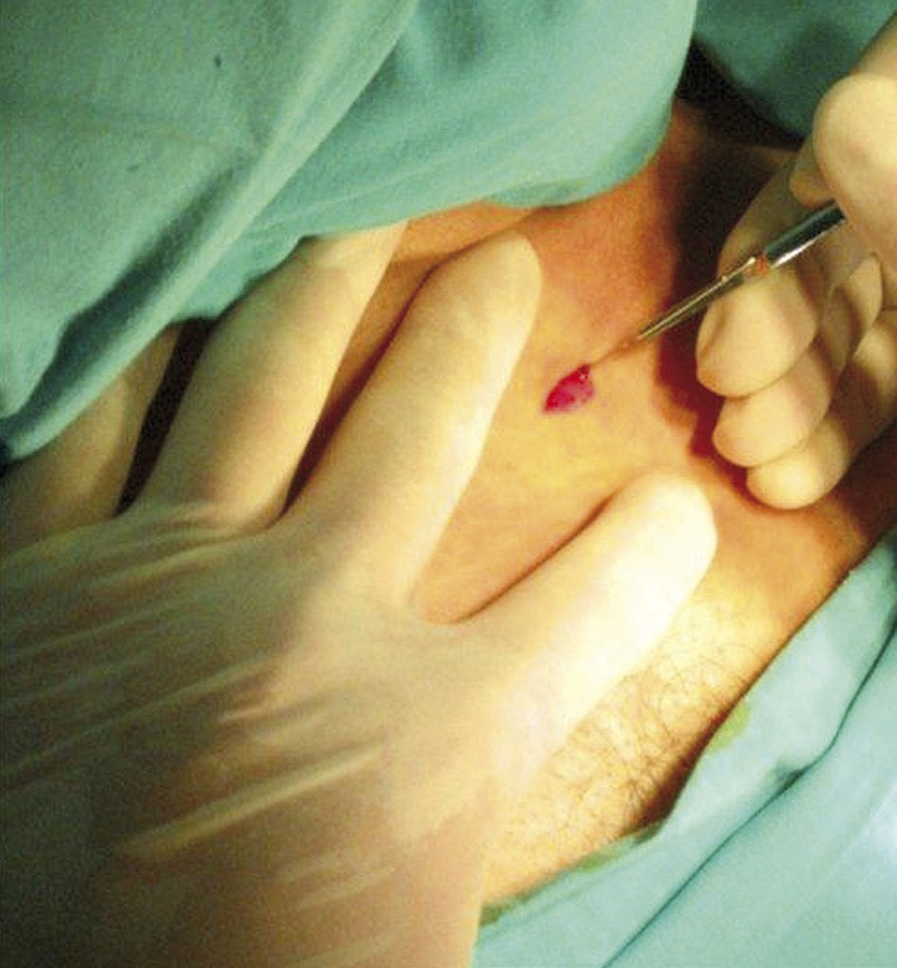
Marcin Barczyński, Aleksander Konturek, Małgorzata Stopa, Aleksandra Papier, Wojciech Nowak
decreased postoperative pain, a shorter scar and greater cosmetic satisfaction when compared to con- ventional thyroidectomy [4]. In experienced hands, it is suitable not only for removal of small and benign unilateral thyroid nodules, but also for more demand- ing operations, such as total thyroidectomy for Gra- ves' disease or low-risk thyroid cancer [5, 6].
Study endpoints and follow-up data
The primary endpoints were indications and eligi- bility rate for MIVAT. The secondary endpoints were operative time, morbidity and cosmetic effects. Eligi- bility rate was calculated as the percentage of patients who underwent MIVAT from a cohort of all patients who underwent thyroid surgery at our insti- tution during the study period. Operative time was calculated from skin incision to skin closure. Morbi- dity assessment involved prevalence of recurrent la- ryngeal nerve (RLN) injury, postoperative hypocal- cemia, infection and bleeding. Indirect laryngoscopy was mandatory on postoperative day 1 and in case of identified early vocal cord dysfunction, during 6-month follow-up. Recurrent laryngeal nerve injury was calculated for nerves at risk and it was consid- ered transient if unilateral vocal fold mobility was restored within 6 months following surgery, whereas it was considered permanent in cases of dysfunction lasting for at least 6 months. Postoperative hypocal- cemia was diagnosed in a patient who developed a serum calcium level below 2 mmol/l. Cosmetic effects were assessed on a visual analogue scale (VAS) at 1 and 6 months following the operation.
Aim
The aim of this study was to evaluate our 7-year experience with MIVAT.
Material and methods
This is a retrospective study of 240 consecutive patients who underwent MIVAT between January 2004 and May 2011 and were prospectively registered at our institutional computer-based register of thy- roid surgery. The study protocol was approved by the Institutional Review Board. The eligibility criteria for MIVAT were: a solitary thyroid nodule below 30 mm in maximum diameter, absence of both echographic and biochemical signs of thyroiditis, thyroid volume below 25 ml, no previous neck surgery or neck irradi- ation, and in case of suspicion of thyroid malignancy, cT1 stage according to the TNM 2010 classification.
Surgical technique
All the operations consisted of MIVAT thyroid lobectomy, either unilateral or bilateral, and were performed by the same experienced surgeons. The MIVAT procedure was performed according to the Miccoli technique [3-7], with a 1.5-2 cm horizontal skin incision two fingers above the sternal notch (Figure 1). Having dissected but not divided the strap muscles in the midline, a working space was created by blunt dissection with a tiny spatula and retraction of the strap muscles laterally to mobilize the thyroid lobe. The gasless video-assisted approach employing a 5 mm 30° rigid endoscope and other instruments designed for parathyroid and thyroid surgery (Karl- Storz, Tutlingen, Germany) were used (Figure 2). The optical magnification allowed for excellent visualiza- tion of the external branch of the superior laryngeal nerve and the recurrent laryngeal nerve, which were dissected together with the upper parathyroid gland (Figure 3). The vessels of the upper thyroid pole were double-clipped and cut or were dissected and divided with the harmonic shears until the lobe was com- pletely freed and could be extracted by gentle pulling it out through the skin incision (Figure 4). The isth-
Figure 1. Skin incision for MIVAT is 2 cm long and is placed two fingers above the sternal notch
176
Videosurgery and Other Miniinvasive Techniques 3, September/2012
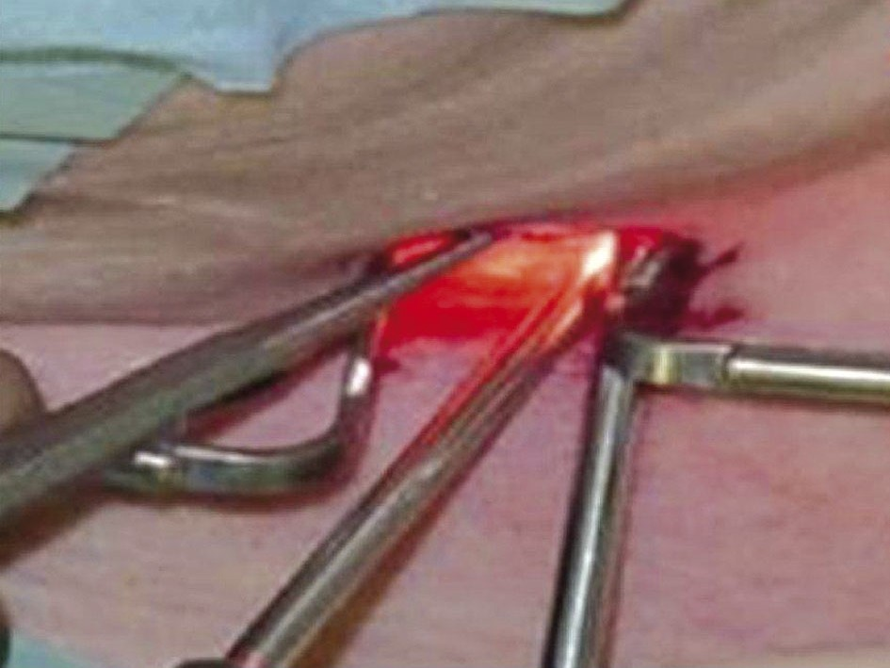
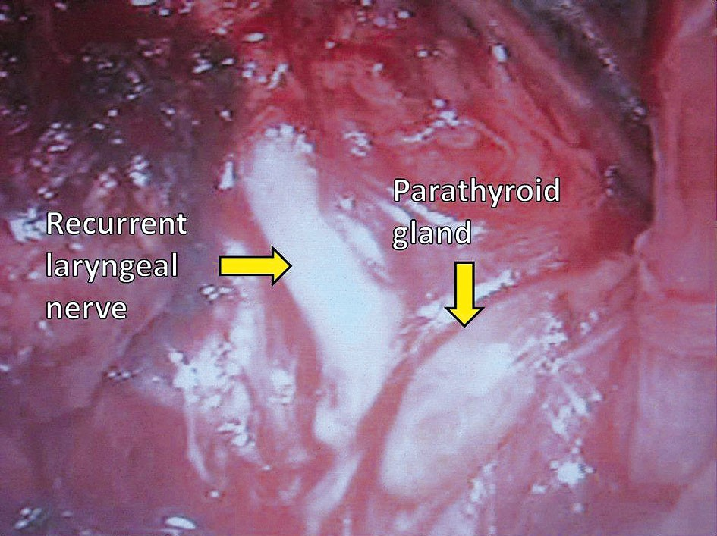
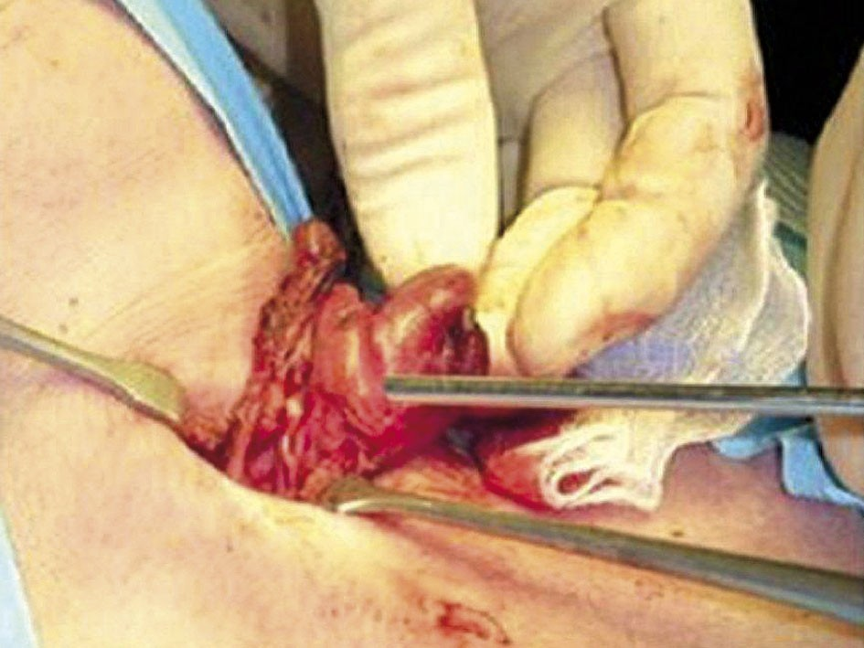
Minimally invasive video-assisted thyroidectomy: seven-year experience with 240 cases
Figure 2. Working space is created by blunt dis- section and retraction with hooks without gas insufflation. A 5 mm 30-degree oblique scope is inserted through a single neck incision together with other working instruments
Figure 3. Recurrent laryngeal nerve and parathy- roid glands should be identified before any thy- roid vessel ligation. This goal is facilitated by magnification of the scope used in this video- assisted approach
mus was then dissected and divided, followed by dis- section and division of the inferior thyroid pole ves- sels using the harmonic scalpel or a 5 mm clip appli- er and bipolar coagulation. After the final check of the recurrent laryngeal nerve, the lobe was removed and sent for histopathology. For total thyroidectomy the same technique was used for contralateral thy- roid lobe dissection. The strap muscles were approxi- mated using one stitch and the skin incision was closed with a continuous non-absorbable monofila- ment suture, removed routinely on the second post- operative day and replaced by Steri-strips adhesive tapes. No drainage was necessary.
Figure 4. Having secured the superior thyroid vessels using the video-assisted approach, the thyroid lobe is gently extracted above the wound level and thyroid lobectomy is complet- ed using open dissection
Statistical analysis
The statistical significance of categorical variables was evaluated by the χ2-test, whereas the unpaired Student t test was used for the evaluation of contin- uous variables (Statistica, StatSoft, Katowice). All the data were entered into a dedicated spreadsheet (Microsoft Excel 2007; Microsoft Corporation, San Jose, CA) by a medical assistant and then analyzed by a statistician. Value of p < 0.05 was considered to indicate significance.
ried out in 210 patients, whereas MIVAT total thy- roidectomy was performed in 30 patients, including
15 operations involving one-stage video-assisted parathyroid adenoma removal. Mean operative time of lobectomy was 33.2 min (range: 25-90 min), whereas for total thyroidectomy it was 45.4 min (range: 35-120 min) (p < 0.001). Conversion to conventional thyroidec- tomy was not necessary in any of the patients in this study. In the final pathology report, there were 206 fol- licular adenomas, 21 papillary thyroid cancers, 9 cases
Results
Of 6,574 patients
referred for thyroid surgery,
240 (3.6%) were eligible for MIVAT (clinical data are summarized in Table I). The MIVAT lobectomy was car-
177
Videosurgery and Other Miniinvasive Techniques 3, September/2012
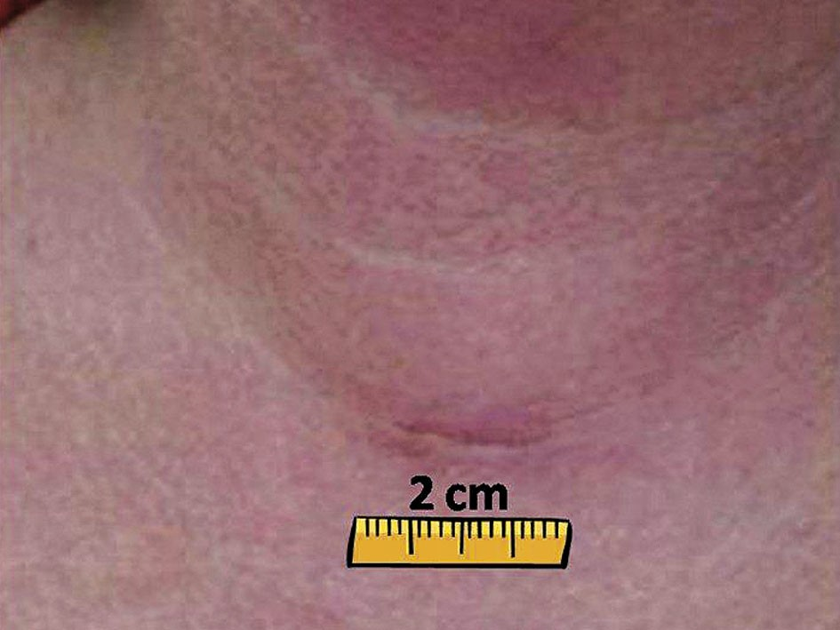
Marcin Barczyński, Aleksander Konturek, Małgorzata Stopa, Aleksandra Papier, Wojciech Nowak
of Graves’ disease and 4 follicular cancers. These four follicular cancers were incidentally diagnosed following thyroid lobectomy and the affected patients under- went MIVAT completion thyroidectomy at 2-3 months
after the initial surgery. The reasons for exclusion from MIVAT were as follows: thyroid volume above 25 ml in 5401 (85.3%), thyroid cancer larger than stage T1 in 392 (6.2%), thyroiditis in 358 (5.6%), and previous neck
surgery in 183 patients (2.9%).
Transient versus permanent recurrent laryngeal nerve injury was found in 8 (3.0%) vs. 2 (0.7%) nerves at risk, respectively. Postoperative hypocalcemia was diagnosed in 2 (1.0%) vs. 11 (36.7%) patients following thyroid lobectomy versus total thyroidecto- my, respectively (p < 0.001). Cosmetic effects were assessed after 1 and 6 months of follow-up as very good or excellent by 215 (89.6%) and 230 (95.8%) patients (Figure 5), respectively (p < 0.001). Postoper- ative bleeding requiring reoperation was not noted in this study. Wound infection occurred in 2 cases (0.4%) after MIVAT (unilateral lobectomy).
Table I. Clinical characteristics of 240 patients who underwent MIVAT in this study
Discussion
Minimally invasive video-assisted thyroidectomy has become the most widely employed technique for minimally invasive thyroidectomy. The rationale be- hind its popularity is a standardized technique, the use of a similar approach to open thyroidectomy via a central anterior skin incision, and reproducibility of the surgical outcomes of this operation in various hands [8, 9].
The most common mistake of the minimally inva- sive surgical access to the thyroid is incorrect selec- tion of patients. Our analysis has shown that using restrictive eligibility criteria, the proportion of pa- tients who could be offered MIVAT was 3.6% of all patients referred for thyroid surgery at our institu- tion, but all of them underwent this intervention suc- cessfully and we experienced no need for conversion to open thyroidectomy in this series. Nevertheless, the eligibility rate for MIVAT has been reported to range from 10% in Italy, which is recognized as an endemic goiter area, to more than 15% in non-en- demic areas. Minimally invasive video-assisted thy- roidectomy is particularly attractive to young female patients who need thyroid surgery and pay special attention to cosmetic effects of surgery [7, 10].
Some technical aspects of the MIVAT procedure
are crucial for achieving safe outcomes. The magnifi- cation of the endoscope allows for easier identifica- tion of some vital structures within the neck, includ- ing the RLN and parathyroid glands. Nevertheless, gentle and complete dissection of the RLN with a spa-
Figure 5. Four weeks after the operation, the scar following MIVAT is hardly visible, as it is hid- den within one of the skin creases
178
Videosurgery and Other Miniinvasive Techniques 3, September/2012
Characteristics MIVAT (n = 240)
Gender, n (%)

Male 228 (95.0)
Female 12 (5.0)
Mean age (range) [years] 40.4 (18-63)
Mean thyroid volume (range) [ml] 18.5 (12-25)
MIVAT, n (%)

Unilateral lobectomy 210 (87.5)
Total thyroidectomy 30 (12.5)
Final pathology, n (%)

Follicular adenoma 206 (85.8)
Papillary cancer 21 (8.8)
Graves’ disease 9 (3.8)
Follicular cancer 4 (1.7)
Mean operative time (range) [min]

Unilateral lobectomy 33.2 (25-90)
Total thyroidectomy 45.4 (35-120)
Minimally invasive video-assisted thyroidectomy: seven-year experience with 240 cases
tula is recommended at the video-assisted stage of the procedure to minimize the risk of stretch injury to the RLN at the second stage of the operation, when the thyroid lobe is extracted above the wound level, which follows the division of the superior thy- roid vessels [11]. The use of any energy-based device (such as harmonic shears) for hemostasis during MIVAT is safe and facilitates dissection, allowing for a significant decrease in the operative time [12, 13]. The operation is safer when it is performed in a dry operative field, in which all the anatomical structures are clearly visible with video-assisted mag- nification. Nevertheless, one should be aware of the possible heat injury to the RLN and parathyroid glands, and the use of an energy-based device should be avoided in close proximity to these structures [13]. In our series of MIVAT, the prevalence of both RLN injury and hypocalcemia was similar to the results reported by others [6, 14-16]. However, it should be stressed that total thyroidectomy involves a signifi- cantly higher risk of postoperative hypocalcemia than unilateral thyroid lobectomy and the use of a video- assisted approach does not seem to reduce the risk of this adverse event.
Radford et al. in a recently published systematic review of the literature and meta-analysis aiming to compare MIVAT to conventional thyroidectomy included five trials comprising a total of 318 patients. This study demonstrated that MIVAT was as safe as the existing gold standard open thyroidectomy, but it had better cosmetic and pain outcomes for patients when compared to conventional surgery [16].
Miccoli et al. performed a systematic evidence- based literature review and analyzed use of MIVAT for benign thyroid disease [6]. This review indicated that MIVAT can be considered an appropriate treat- ment of some thyroid diseases, as it represents a safe procedure with the same prevalence of complications as traditional surgery, and also has advantages in terms of both cosmetic result and postoperative dis- tress [17-19]. On the one hand, in spite of an increas- ing trend toward performing more extensive proce- dures other than thyroidectomy alone during the MIVAT operation, the current literature seems to reaf- firm that the main and safest indication for MIVAT is benign disease [6]. On the other hand, since the first report of MIVAT published in 1999, the indications for this operation have been progressively extended by the Miccoli group from cytologically undetermined thyroid nodules to intermediate-risk differentiated
thyroid cancers. In a recently published analysis of 1946 patients who underwent MIVAT in Pisa between 1998 and 2009, total thyroidectomy was performed in 1435 patients (72.3%) and lobectomy in 511 cases (26.3%) with the final histology classified as benign disease in 979 cases (51.5%) and a malignancy diag- nosed in 915 cases (48.5%). It is of interest that unex- pected thyroiditis (considered as a classic contraindi- cation for MIVAT) was found on final histology in 17.9% of patients with benign disease and 30.9% of patients with malignancy [7, 10]. These data con- firmed the validity of the traditional indications for MIVAT (low-risk differentiated thyroid cancer, cyto- logically undetermined nodules and small-volume benign thyroid disease), but also indicated that the indications may be further and safely extended to patients with associated thyroiditis or with interme- diate-risk differentiated thyroid cancer [7]. Minuto et al. concluded that MIVAT can be now proposed on a much larger scale than it was at its onset and can- not be considered an option for only a limited num- ber of patients [10]. Despite these promising obser- vations made in a tertiary referral center, it should be stressed that reproduction of these excellent out- comes should be preceded by achieving expertise in application of the technique of unilateral MIVAT lobectomy.
Our data confirm that MIVAT is suitable for sur- geons experienced in thyroid and video-assisted sur- gery. In our hands, MIVAT is feasible for well-selected patients, including cases of T1 thyroid cancer, Graves' disease and concomitant parathyroid adenoma [20, 21]. However, it is more likely that in the future, the MIVAT technique of total thyroidectomy will be used with increasing frequency worldwide for the treatment of both benign and malignant thyroid diseases in pa- tients with small goiters.
Presented in part to the International Con- gress of the European Association for Endoscopic Sur- gery (EAES), Geneva, Switzerland, 16-19 June 2010.
18th
References
- Hannan SA. The magnificent seven: a history of modern thyroid surgery. Int J Surg 2006; 4: 187-91.
- Becker AM, Gourin CG. New technologies in thyroid surgery. Surg Oncol Clin North Am 2008; 17: 233-48.
- Miccoli P, Berti P, Conte M, et al. Minimally invasive surgery for thyroid small nodules: preliminary report. J Endocrinol Invest 1999; 22: 849-51.
179
Videosurgery and Other Miniinvasive Techniques 3, September/2012
Marcin Barczyński, Aleksander Konturek, Małgorzata Stopa, Aleksandra Papier, Wojciech Nowak
- Miccoli P, Berti P, Raffaelli M et al. Comparison between mini- mally invasive video-assisted thyroidectomy and conventional thyroidectomy: a prospective randomized study. Surgery 2001; 130: 1039-43.
- Miccoli P, Berti P, Frustaci G, et al. Video-assisted thyroidectomy: indications and results. Langenbecks Arch Surg 2006; 391: 68-71.
- Miccoli P, Minuto MN, Ugolini C, et al. Minimally invasive video- assisted thyroidectomy for benign thyroid disease: an evidence- based review. World J Surg 2008; 32: 1333-40.
- Miccoli P, Pinchera A, Materazzi G, et al. Surgical treatment of low- and intermediate-risk papillary thyroid cancer with mini- mally invasive video-assisted thyroidectomy. J Clin Endocrinol Metab 2009; 94: 1618-22.
- Miccoli P, Bellantone R, Mourad M, et al. Minimally invasive video-assisted thyroidectomy: multiinstitutional experience. World J Surg 2002; 26: 972-5.
- Dzielicki J, Korlacki W, Kołodziej A, et al. Minimally invasive thy- roid surgery. Pol Przegl Chir 2004; 76: 578-86.
- Minuto MN, Berti P, Miccoli M, et al. Minimally invasive video- assisted thyroidectomy: an analysis of results and a revision of indications. Surg Endosc 2012; 26: 818-22.
- Miccoli P, Materazzi G, Berti P. New technologies in surgery: diag- nosis and treatment of complication of MIVAT (minimally Inva- sive Video-assisted Thyroidectomy). Pol Przegl Chir 2008; 80: 435-40.
- Miccoli P, Berti P, Raffaelli M, et al. Impact of harmonic scalpel on operative time during video-assisted thyroidectomy. Surg Endosc 2002; 16: 663-6.
- Barczyński M, Konturek A, Cichoń S. Minimally invasive video- assisted thyreoidectomy (MIVAT) with and without use of har- monic scalpel – a randomized study. Langenbecks Arch Surg 2008; 393: 647-54.
- Barczyński M, Konturek A, Stopa M, et al. Total thyroidectomy for benign thyroid disease: is it really worthwhile? Ann Surg 2011; 254: 724-30.
- Barczyński M, Konturek A, Gołkowski F, et al. Five-year follow- up of a randomized clinical trial of unilateral thyroid lobectomy with or without postoperative levothyroxine treatment. World J Surg 2010; 34: 1232-8.
- Radford PD, Ferguson MS, Magill JC, et al. Meta-analysis of min- imally invasive video-assisted thyroidectomy. Laryngoscope. 2011; 121: 1675-81.
- Miccoli P, Berti P, Raffaelli M, et al. Comparison between mini- mally invasive video-assisted thyroidectomy and conventional thyroidectomy: a prospective randomized study. Surgery 2001; 130: 1039-43.
- Sahm M, Schwarz B, Schmidt S, et al. Long-term cosmetic results after minimally invasive video-assisted thyroidectomy. Surg Endosc 2011; 25: 3202-8.
- Ujiki MB, Sturgeon C, Denham D, et al. Minimally invasive video- assisted thyroidectomy for follicular neoplasm: is there an advantage over conventional thyroidectomy? Ann Surg Oncol 2006; 13: 182-6.
- Alesina PF, Singaporewalla RM, Eckstein A, et al. Is minimally invasive, video-assisted thyroidectomy feasible in Graves' dis- ease? Surgery 2011; 149: 556-60.
21. Barczyński M, Cichoń S, Konturek A, et al. Comparison of two techniques of minimally invasive parathyroidectomy: video- assisted (MIVAP) and open (OMIP). Pol Przegl Chir 2007; 79: 1264-80.
180
Videosurgery and Other Miniinvasive Techniques 3, September/2012

