

Naunyn-Schmiedeberg's Archives of Pharmacology (2018) 391:185–196 https://doi.org/10.1007/s00210-017-1448-2
ORIGINAL ARTICLE

Pharmacokinetic study of tianeptine and its active metabolite MC5
in rats following different routes of administration using a novel liquid chromatography tandem mass spectrometry analytical method
Małgorzata Szafarz1 & Agnieszka Wencel1 & Krzysztof Pociecha1 & Filip A. Fedak1 & Piotr Wlaź 2 & Elżbieta Wyska 1

Received: 1 September 2017 / Accepted: 29 November 2017 / Published online: 12 December 2017
# The Author(s) 2017. This article is an open access publication

Abstract
Tianeptine is an atypical antidepressant with a unique mechanism of action and recently it has been also reported that its major metabolite, compound MC5, possesses pharmacological activity similar to that of the parent drug. The current study aims to investigate the pharmacokinetics (PK) of both tianeptine and MC5 after intravenous or intraperitoneal administration of the parent drug as well as the metabolic ratio of MC5 in rats. To achieve these goals an LC-MS/MS method using the small sample volume for the quantitation of tianeptine and its active metabolite MC5 in rat plasma and liver perfusate has been developed and validated. Following an intravenous administration of tianeptine pharmacokinetic parameters were calculated by non- compartmental analysis. The average tianeptine volume of distribution at steady state was 2.03 L/kg and the systemic clearance equaled 1.84 L/h/kg. The mean elimination half-lives of tianeptine and MC5 metabolite were 1.16 and 7.53 h, respectively. The hepatic clearance of tianeptine determined in the isolated rat liver perfusion studies was similar to the perfusate flow rate despite the low metabolic ratio of MC5. Mass spectrometric analysis of rat bile indicated that tianeptine and MC5 metabolite are eliminated with bile as glucuronide and glutamine conjugates. Bioavailability of tianeptine after its intraperitoneal administration was 69%. The PK model with a metabolite compartment developed in this study for both tianeptine and MC5 metabolite after two routes of administration may facilitate tianeptine dosage selection for the prospective pharmacological experiments.

Keywords Tianeptine . MC5 metabolite . Pharmacokinetics . Rats . Mass spectrometry

Introduction

The challenge of treatment-resistant depression is one of the most significant in contemporary psychiatric therapy. It has been reported that only one-third of major depressive patients achieve remission after 3 months of monotherapy with anti- depressants. The most common approaches for these patients include switching to another antidepressant of the same or different group or combining antidepressants with, e.g.,

* Małgorzata Szafarz malgorzata.szafarz@uj.edu.pl

1 Department of Pharmacokinetics and Physical Pharmacy, Faculty of Pharmacy, Jagiellonian University Medical College, Krakow, Poland
2 Department of Animal Physiology, Institute of Biology and Biochemistry, Faculty of Biology and Biotechnology, Maria Curie-Sklodowska University, Lublin, Poland
atypical antipsychotics (Tobe and Rybakowski 2013). Tianeptine is an antidepressant in clinical use that has drawn much attention because of its unique mechanism of action. In contrast to tricyclic antidepressants (TCAs) and selective se- rotonin reuptake inhibitors (SSRI), tianeptine enhances the synaptic uptake of serotonin with minimal effects on that of norepinephrine and dopamine; nevertheless, its efficacy against depressive episodes is comparable with that of TCAs and fluoxetine (Uzbay 2008; Woo et al. 2013). It shows a faster onset of therapeutic effects against some depressive symptoms (cognitive and anxiety symptoms) as compared to other antidepressants and more importantly is effective in pa- tients resistant to SSRI therapy (Woo et al. 2013). In addition, this drug improves learning and increases long-term memory in rodents, exerts a vigilance-enhancing effect in laboratory animals and improves cognitive functions in depressed pa- tients (Klasik et al. 2011; Jaffard et al. 1991; Zoladz et al. 2008). Tianeptine promotes neuroplasticity by increasing the expression of genes of neuroplasticity factors (Reagan et al.

2007; Wlaź et al. 2011; Kuipers et al. 2013), reverses synaptic plasticity, dendritic atrophy, memory impairment, and neuro- nal loss under conditions of stress (Zhang et al. 2013). Moreover, it has also additional properties, including neuro- protection (Jantas et al. 2014), anticonvulsant activity (Ceyhan et al. 2005; Ceyhan et al. 2007), antinociceptive ef- fect (Uzbay et al. 1999), inhibitory effects on ethanol with- drawal syndrome in rats (Uzbay et al. 2006), and anti- inflammatory effect in lipopolysaccharide-stimulated microg- lia (Slusarczyk et al. 2016). Recently, it has been revealed that tianeptine is a μ-opioid receptor (MOR) agonist and the hy- pothesis has been presented that precisely the MOR activation is the initial molecular event responsible for modulation of the glutamatergic system and for triggering many of known acute and chronic effects of tianeptine, including its antidepressant/ anxiety actions (Gassaway et al. 2014).
Tianeptine is generally well tolerated by patients and causes less side effects compared with SSRI and TCAs (McEwen et al. 2010). In clinical trials, the most common adverse effects caused by this drug were gastrointestinal (nau- sea, constipation, abdominal pain) or CNS (headache, dizzi- ness, change in dreaming) disturbances, which decreased in frequency with continued treatment. Tianeptine appears to have a lower propensity to cause sedative, anticholinergic, and cardiovascular effects than classical TCAs and it has only rarely been associated with hepatoxicity. The low incidences of anticholinergic effects, sedation, and cardiotoxicity make tianeptine particularly attractive for use in the elderly and in patients with previous alcoholism who are known to have increased sensitivity to the adverse effects of psychotropic drugs. Tianeptine has a wide therapeutic margin, and usually, overdosage has been associated with only minor transient ad- verse effects (Wilde and Benfield 1995; Wagstaff et al. 2001). However, a fatal case involving this drug has also been report- ed (Proenca et al. 2007).
Unlike other antidepressants, tianeptine is not primarily metabolized by the cytochrome P450 system. Instead, β- oxidation is the main metabolic pathway. Two major metabo- lites MC5 and MC3 are found in plasma and urine, respec- tively, and the behavioral effects of MC5 are comparable to those of tianeptine (Couet et al. 1990; Royer et al. 1988; Samuels et al. 2017) (Fig. 1).
In preclinical studies, tianeptine exerted beneficial effects in a number of behavioral models related to depression and anx- iety in which rats and mice were used interchangeably. In phar- macological experiments in which rats were used as an animal model, this drug was administered either intravenously (i.v.) at the doses of 2.5, 5, 10, and 20 mg/kg (Bilge et al. 2012) or intraperitoneally (i.p.) at the doses of 2 and 10 mg/kg (Cavalla et al. 2015); 5, 10, and 15 mg/kg (Della et al. 2012); or at multiple (once a day for 21 days) doses of 10 mg/kg (Kuipers et al. 2013; Glombik et al. 2016). Identification of new molec- ular targets for tianeptine as well as the discovery
that metabolite MC5 plays an active role in the behavioral effects of this drug provide a new perspective for interpreting tianeptine clinical and preclinical data. However, interpretation of pharmacological data might be difficult without the exten- sive knowledge about pharmacokinetic (PK) profiles of both tianeptine and MC5 following different routes of administra- tion in laboratory animals commonly used in pharmacological experiments. Up to date, there is only a limited information on this subject in the available literature. Little is also known about the hepatic clearance and hepatic metabolic ratio of this drug in rodents. Tianeptine has been on the market for several decades and despite the fact that for most antidepressants therapeutic drug monitoring (TDM) has been recommended, there are no reports concerning the application of TDM for tianeptine in the clinic or the data dealing with tianeptine concentration-effect relationship in depressed patients. However, taking into ac- count the recent reports regarding its new mechanisms of action and the contribution of metabolite MC5 to the observed phar- macological response after its administration, the availability of a fast and reliable analytical method for simultaneous determi- nation of both compounds seems to be desirable not only from the therapeutic point of view but also due to tianeptine potential for the development of use disorder including abuse and addic- tion (Bence et al. 2016; Gupta et al. 2017).
Therefore, the purpose of this study was to determine PK of tianeptine and its active metabolite MC5 after two different routes of administration of the parent drug to rats, as well as its hepatic clearance, MC5 metabolic ratio, and bioavailability. To achieve these goals a simple, fast, and reliable analytical method for the simultaneous deter- mination of tianeptine and MC5 metabolite in rats plasma and liver perfusate using small sample volumes was de- veloped and validated.

Experimental

Chemicals and materials
Tianeptine sodium salt (purity ≥ 95%) was obtained from Cayman Chemical Company (USA), tianeptine metabolite
MC5 sodium salt (purity ≥ 95%) was obtained from Toronto
Research Chemicals (Canada). HPLC grade acetonitrile, formic acid, and ammonium formate were purchased from Merck (Germany) or Sigma Aldrich (USA). Pentoxifylline used as an internal standard was obtained from Sigma Aldrich (USA). Water was purified and deionized (conductiv- ity below 0.1 μS) by the ultrapure water system HLP Smart 2000 (HydroLab, Poland). Chemicals used for the Krebs Hanseleit buffer preparation, as well as sodium taurocholate and glucose, were purchased from Sigma Aldrich (USA).
Control plasma, containing heparin as an anticoagulant, was obtained from adult male Wistar rats (Animal Facility of

Fig. 1 Metabolic pathways for tianeptine

HO
OH
O O O

HN

Cl
S N
O O

CH3

β-oxidase

Cl

HN

S N
O O CH3

β-oxidase

Cl
OH

HN

S N
O O CH3
tianeptine MC5
MC3

the Jagiellonian University Medical College, Krakow, Poland).

Animals

Male Wistar rats, 13–15 weeks of age and weighing between 200 and 220 g, were used in all the experiments. They were kept under conditions of constant temperature (21–25 °C) and a relative humidity of approximately 40–65% with a standard light/dark cycle. Animals were housed in the stainless steel cages with suspended wire-mesh floors and had free access to water and the commercial rodent chow.

Pharmacokinetic study in rats

Six rats were used in PK experiments, and 3 days prior to the experiment, rat jugular vein was cannulated allowing for the multiple blood sampling from a single animal. The experi- mental groups consisted of three rats each, and tianeptine dis- solved in 0.9% sterile isotonic saline was administered i.v. at a dose of 1 mg/kg or i.p. at the dose of 10 mg/kg. Blood samples (approximately 300 μL) were collected to Eppendorf tubes containing heparin at 5, 15, 30, 60, 120, 240 and 480 min after dosing. Plasma was harvested by centrifuging at 3000 r.p.m.
for 10 min and stored at − 30°C until bioanalysis. Plasma
samples (100 μL) were further processed as described in
BSample preparation^ section.

Liver perfusion study

Rat livers were perfused in situ using PS-1 perfusion system from Harvard Apparatus-Hugo Sachs Electronics (HA-HSE). Rats were anesthetized by an intraperitoneal injection of ketamine/xylazine and after laparotomya ligature was placed around the vena cava inferior above a left renal vein. Heparin (ca. 500 units) was injected into the abdominal vena cava inferior and the portal vein was cannulated. Then, the abdom- inal vena cava inferior was transected and the perfusion buffer was pumped into the portal vein. In the next step, the chest was opened and a second cannulae was inserted through the right atrium into the thoracic vena cava inferior. Finally,
the ligature around the abdominal vena cava inferior was tightened. The perfusions were conducted using freshly pre- pared Krebs Hanseleit buffer (118 mM NaCl, 4.7 mM KCl,
2.5 mM CaCl2, 1.19 mM KH2PO4, 1.18 MgSO4, and 25 mM NaHCO3, oxygenated with 95% O2/5% CO2, pH 7.4) with an addition of 1.2 g/L of glucose pumped through the liver at the constant flow rate equal 20–25 mL/min using a peristaltic pump. The temperature of the perfusion medium was thermo- statically controlled at 37 °C. In each experiment, the common bile duct was cannulated with PE-10 tubing. After an initial stabilization period, within the first 15 min of perfusion, tianeptine was added (300 μg) into the buffer along with the 100 μL (20 mg/mL) of sodium taurocholate. Experiments were carried out in a recirculating manner with the total vol- ume of perfusate equal 200 mL. The flow rate was sufficient to maintain the viability of the liver during the experiments, as determined by the macroscopic appearance, bile flow and in line measurement of oxygen consumption. Samples of bile were collected in pre-weighed Eppendorf vials and measured by gravimetric volume at the end of perfusion period, assum- ing a density of 1. Perfusate was collected from the reservoir at 5 min intervals up to 45 min. To test the stability of tianeptine under perfusion conditions, control experiments were per- formed with application of the same solution to the perfusion model without a liver resulting in no detectable degradation products of tianeptine.

Preparation of stock solutions, calibration, and quality control samples

Two stock solutions of each tianeptine and MC5 metabolite were prepared separately by dissolving the reference com- pounds in methanol to give a final concentration of 1.0 mg/ mL. They were further mixed and serially diluted with meth- anol in order to produce an appropriate calibration and quality control (QC) standards. The stock solution of pentoxifylline (internal standard, IS) was prepared at 1.0 mg/mL in the mix- ture of acetonitrile and water (50/50, v/v). Then IS working solution was prepared by diluting the stock solution with ace- tonitrile to give a concentration of 2.5 μg/mL. All stock and working solutions were stored at + 4 °C.

Calibration and QC samples were prepared by spiking 90 μL of pooled blank plasma or perfusate with a 10 μL of a working solution to produce the calibration curve points equivalent to 2000, 1000, 500, 250, 100, 50, 25, 10, and 1 ng/mL and QC standards at different concentrations along the calibration range (LLOQ at 1 ng/mL, low at 3 ng/mL, medium at 800 ng/mL, and high at 1800 ng/mL).

Sample preparation

Samples were prepared using protein precipitation with ace- tonitrile. A portion (200 μL) of the working IS solution was spiked to 100 μL of plasma or perfusate sample and vortex- mixed for 90 s. Afterward, samples were centrifuged at 15000
r.p.m. for 5 min and the supernatant (100 μL) was transferred to the autosampler vials.

LC-MS/MS quantification of tianeptine and its metabolite MC5 in biological samples

An Agilent 1100 system (Agilent Technologies, Germany) was used for solvent and sample delivery and chromatograph- ic separation was achieved on an Aquasil C18 5 μm 3 × 100 mm analytical column (Thermo Scientific, USA). The mobile phase consisted of acetonitrile with an addition of 0.1% of formic acid (solvent A) and water with an addition of 4 mM of ammonium formate (solvent B). The mobile phase composition was 9:1 (A:B, v/v) and each LC-MS/MS run took 7 min. The flow rate was maintained at 400 μL/min and a sample volume of 5 μL was injected into the LC-MS/MS system.
Mass spectrometric detection was performed on an Applied Biosystems MDS Sciex (Concord, Canada) API 2000 triple quadrupole mass spectrometer with an electrospray ionization (ESI) in the positive ion mode. The tandem mass spectrometer was operated in the selected reaction monitoring (SRM) mode, and Q1 and Q3 quadrupoles were set at unit mass resolution. The ion source temperature was maintained at 450°C and the ionspray voltage was set at 5500 V. The mass transitions of the precursor/product ions were monitored at 437 → 292 m/z and 437 → 228 m/z for tianeptine, at 409 → 292 m/z and 409 → 228 m/z for metabolite MC5, and at 279 → 181 m/z for the IS. The Applied Biosystems Analyst version 1.4.2 software was used to control the LC-ESI/MS/MS system and to collect and treat the data.

Method validation

Since perfusate is a simple matrix with strictly defined and fixed composition, the full method validation according to the EMA guidelines was performed only for the quantification of tianeptine and its MC5 metabolite in rat plasma (EMA 2012).
Precision and accuracy of the assay were assessed by performing replicate (n = 5) analyses of QC samples at differ- ent concentration levels on the same day (within-day) and on three different days (between-days). Accuracy (percent of re- covery) was evaluated, using the following formula: [mean back calculated concentration/theoretical concentration] ×
100. Precision was expressed as a percent relative standard deviation (RSD, CV%). The LLOQ based on QC samples was defined as the lowest analyte concentration that can be
measured with the RSD ≤ 20% and the accuracy of 100 ± 20%
on a day-to-day basis.
As the concentrations in selected samples were over 2000 ng/mL, the QC samples at fivefold of the highest level of calibration standard concentration were diluted by 10-fold and the dilution integrity was investigated by comparing the calculated concentration with nominal value.
An assessment of matrix effect (ME) was done by compar- ing the peak areas of analytes in extracted samples of blank plasma spiked with an analyzed compounds (post-extraction addition) with the corresponding peak areas obtained by in- jection of standard solutions at the appropriate concentration. For evaluation of the relative matrix effect, five different sources of rat plasma were used. Process efficiency (combined absolute matrix effect and recovery) was evaluated at three replicates of each QC samples. It was determined by compar- ing peak area obtained from extracted plasma samples with the standard solutions at the appropriate concentrations (Matuszewski et al. 2003).
The stability of analytes was determined in the battery of
tests according to the appropriate guidelines. Namely, the bench top stability (for 2 h), freezer stability (at − 30°C for
90 days), freeze/thaw stability and post preparative autosampler stability (at 10°C up to 24 h). Samples were con- sidered to be stable when 85–115% of the initial concentra- tions were found.
Additionally, the stability of standard working solutions was assessed after 90 days of storage at + 4°C.

Pharmacokinetic analysis

Pharmacokinetic parameters were calculated by employing a non-compartmental approach, using Phoenix WinNonlin soft- ware v. 6.3 (Pharsight, USA). For i.v. administration, plasma concentration at time zero (C0) was back-extrapolated using log-linear regression, while the maximum concentration after
i.p. administration (Cmax) and the time to Cmax (tmax) were obtained directly from the concentration-time data. The area under the mean plasma concentration versus time curve ex- trapolated to infinity (AUC0-inf) was estimated using the log/ linear trapezoidal rule. AUMC0-inf was estimated by calcula- tion of the total area under the first-moment curve by combin- ing the trapezoid calculation of AUMC0-t and extrapolated area. The mean residence time (MRT) was calculated from

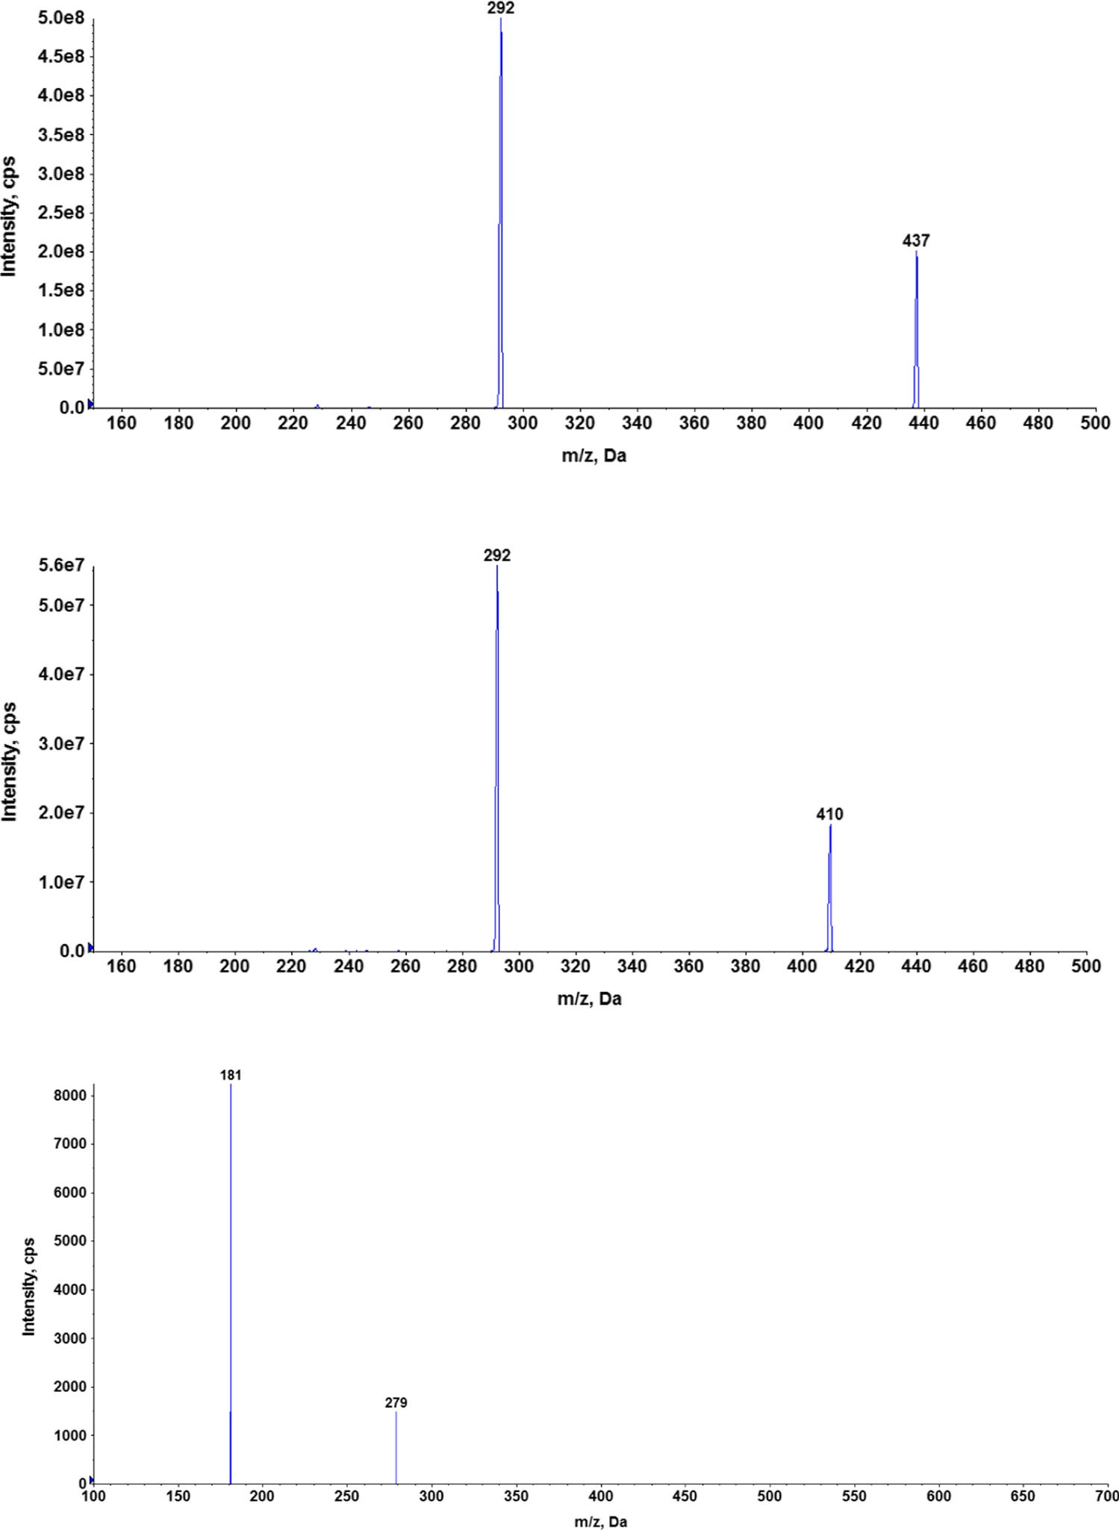
Fig. 2 Product ion mass spectra of [M + H+]+ ions of tianeptine (a), metabolite MC5 (b), and IS
(a)
Cl
O
O
S
N
NH
H3C
OH
O
C14H11ClNO2S 292.0199 Da
C7H14NO2 144.1025 Da
(b)
Cl
O
O
H3C
S
N
NH
OH
O
CC5H10NO2
14H11ClNO2S116.0712 Da
292.0199 Da
(c)
CH3
O
O
N
CH3
N
C6H11O
99.081 Da
ON
CH3
N
C7H7N4O2 179.0569 Da
(c) with the proposed fragmentation paths

AUMC0-inf/AUC0-inf. The terminal rate constant (λz) was cal- culated by log-linear regression of the drug concentration data in the terminal phase and the terminal half-life (t1/2) was cal-

fraction of dose absorbed (F) was fixed to the value calculated using the following equation:
AUC0−t i p ∙Di:v:
¼
culated as 0.693/λz. The systemic clearance (CL) was estimat- ed from the administered dose divided by AUC0-inf. The vol-
F ð : :Þ
AUC0−tði:v:Þ∙Di:p:
ð1Þ
ume of distribution at steady state (Vss) was calculated from
Di.v.⋅AUMC/AUC2, where Di.v is the dose administered i.v. in
mg per kg of body weight. The concentration versus time profiles of the parent drug and metabolite following both routes of administration were also fitted simultaneously to the pharmacokinetic model with a metabolite compartment to obtain one set of parameters. During iteration process, the
where AUC0-t is the area under the concentration versus time curve calculated to the last measured point and D is the dose administered.
Non-compartmental estimates of hepatic pharmacokinetic parameters were determined from the outflow concentration- time profiles. The hepatic extraction ratio (ERH) was

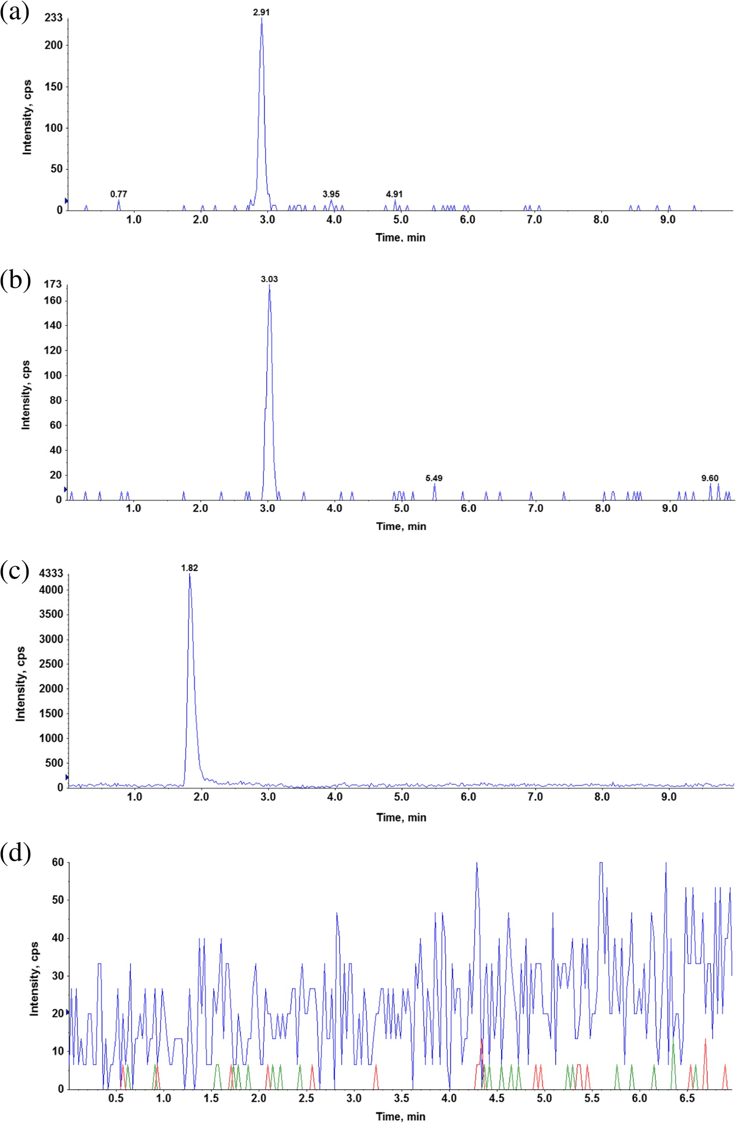
Fig. 3 Representative chromatogram of QC sample at the LLOQ concentration (1 ng/ mL). a Tianeptine. b Metabolite MC5. c Internal standard. d Blank sample

calculated according to the following equation:
ER ¼ CLH ð2Þ
H Q
where CLH is a hepatic clearance (per gram of liver) and Q is a perfusate flow (per gram of liver).
The apparent hepatobiliary clearance (CLb,app) was cal- culated as the cumulative amount of drug excreted in bile divided by the AUC0-t of the drug in the perfusate. The metabolic ratio of MC5 metabolite was calculated by di- viding the AUC0-t of the metabolite by that of tianeptine.

Table 1 Back-calculated plasma concentrations of calibrators for

Nominal concentration
tianeptine and metabolite MC5  (n = 5) | (ng/mL) | Back-calculated concentration (mean | RSD (%) | Accuracy (%) |  | Back-calculated concentration (mean | RSD (%) | Accuracy (%)
 |  | ± SD) |  |  |  | ± SD)
 | 1 | 1.00 ± 0.002 | 0.22 | 99.83 |  | 1.00 ± 0.002 | 0.19 | 99.90
 | 10 | 10.41 ± 1.00 | 9.7 | 104.14 |  | 10.34 ± 0.55 | 5.36 | 103.44
 | 25 | 25.48 ± 2.05 | 8.03 | 101.92 |  | 24.93 ± 0.86 | 3.47 | 99.73
 | 50 | 53.48 ± 2.57 | 4.80 | 106.96 |  | 53.68 ± 2.79 | 5.19 | 107.36
 | 100 | 101.03 ± 8.94 | 8.85 | 101.03 |  | 99.30 ± 13.78 | 13.87 | 99.30
 | 250 | 242.49 ± 12.44 | 5.13 | 96.99 |  | 238.45 ± 22.96 | 9.63 | 95.38
 | 500 | 475.32 ± 31.17 | 6.56 | 95.06 |  | 473.80 ± 60.43 | 12.75 | 94.76
 | 1000 | 1005.03 ± 15.62 | 1.55 | 100.50 |  | 1082.34 ± 51.35 | 4.74 | 108.23
 | 2000 | 1967.83 ± 91.36 | 4.64 | 98.39 |  | 1912.68 ± 124.95 | 6.53 | 95.63

Tianeptine MC5

Statistical analysis

Statistical analysis was performed using Excel 2010 (Microsoft) and Statistica 10 (StatSoft, Tulsa, OK). Results were expressed as geometric means and 90% confidence in- tervals (CI) or arithmetic means ± SD.

Results and discussion

Analytical method and its validation

In order to avoid a time-consuming and tedious liquid–liquid extraction procedure, a simple and rapid one-step protein pre- cipitation method was developed with acetonitrile selected as the optimal precipitation agent. Electrospray ionization oper- ated in the positive ion mode was used for the LC-MS/MS analysis to provide the best sensitivity and selectivity. For the analyzed compounds the dominant ions in the Q1 spectra were used as the precursor ions to obtain Q3 product ion spectra. The resulting SRM transitions (precursor ion m/z → product ion m/z) for each analyte were as follows: 437 → 292 and 437 → 228 for tianeptine, 409 → 292 and 409 → 228 for MC5, and 279 → 181 for the IS. The first pair of ions was
used as a quantifier and the second for the identification pur- pose (qualifier). Product ion mass spectra of [M + H]+ ions of tianeptine, metabolite MC5, and IS with the proposed frag- mentation paths are presented in Fig. 2. An Aquasil C18 (3 × 100 mm, 5 μm) analytical column gave the best retention and baseline separation which in the case of tianeptine and MC5 metabolite was highly desirable to prevent the possibility of peak area contribution from one to the other since for the both analytes the most abundant product ion was at 292 m/z. A mobile phase consisting of acetonitrile with formic acid and water with ammonium formate was used at isocratic condi- tions. The representative extracted ion chromatograms (XIC) of a quality control sample at the concentration of 1 ng/mL (LLOQ) extracted from the supplemented plasma as well as a blank sample are shown in Fig. 3.
The specificity of the method was evaluated by analyzing blank plasma samples from six rats with no interfering peaks observed. The calibration curves were linear over the concen- tration range from 1 up to 2000 ng/mL of both analytes with correlation coefficients above 0.99 and consistent slope values when evaluated by weighted (1/x2) least squares linear regres- sion. The back calculated concentrations of calibrators are presented in Table 1. The lowest concentration on the calibra- tion curve was chosen based on the expected concentrations in

Table 2 Within-day and between-days accuracy (% of nominal concentration) and precision (%RSD) of tianeptine and MC5 in rat plasma (n = 5)

QC nominal concentration (ng/mL)

Tianeptine MC5

Intra-day (%) Inter-day (%) Intra-day (%) Inter-day (%)

 | Accuracy | Precision |  | Accuracy | Precision |  | Accuracy | Precision |  | Accuracy | Precision
1 | 99.78 | 10.8 |  | 100.19 | 8.03 |  | 89.67 | 0.23 |  | 100.96 | 11.49
3 | 107.29 | 3.34 | 105.48 |  | 5.12 | 91.97 |  | 2.84 | 98.11 |  | 8.15
800 | 100.25 | 9.54 | 96.63 |  | 8.96 | 90.48 |  | 3.69 | 93.10 |  | 7.59
1800 | 102.79 | 6.15 | 101.28 |  | 6.61 | 97.71 |  | 11.77 | 100.89 |  | 9.56

Table 3 Serum pharmacokinetic parameters calculated from concentration vs. time data (n = 3) of tianeptine and MC5 metabolite determined by non- compartmental analysis after a single intravenous or intraperitoneal administration of tianeptine to rats at a dose of 1 or 10 mg/kg, respectively. Data are presented as geometric mean (GM), 90% confidence interval (CI), and coefficient of variation (CV)

Parameter | Intravenous 1 mg/kg |  |  |  |  | Intraperitoneal 10 mg/kg
 | Tianeptine | MC5 |  |  |  | Tianeptine | MC5
 | GM | CV% | GM | CV% | GM |  | CV% | GM | CV%
Co/Cmax (mg/L) | (90% CI)  1.27 | 23.64 | (90% CI)  0.117 | 22.16 | (90% CI)  6.65 |  | 1.3 | (90% CI)  2.02 | 22.35
tmax (h) | (0.86–1.9)  n/a |  | (0.064–0.212)  0.4 | 86.6 | (6.44–6.87)  0.083 |  | 0 | (1.1–3.43)  0.5 | 0
λz (h−1) | 0.59 | 41.7 | (0.054–2.89)  0.09 | 3.05 | 0.475 |  | 14.73 | 0.187 | 34.48
t0.5λz (h) | (0.25–1.42)  1.16 | 64.34 | (0.085–0.099)  7.53 | 3.05 | (0.332–0.68)  1.46 |  | 14.03 | (0.07–0.498)  3.69 | 42.29
Vz(Vz/F) (L/kg) | (0.49–2.75)  2.41 | 40.25 | (6.98–8.13)  n/a | 12.42 | (1.018–2.085)  6.51 |  | 18.15 | (1.39–9.83)  n/a | 48.03
AUC0-inf (mg∙h/L) | (0.91–6.4)  1954.02 | 19.44 | 2371.56 | 15.17 | (4.03–10.53)  11,621.28 |  | 7.05 | 14,415.96 | 6.35
 | (1411.02–2705.94) |  | (1617.78–3476.46) |  | (9737.58–13,869.36) |  |  | (12,323.88–16,863.24)
CL/(CL/F) (L/h/kg) | 1.84 | 21.39 | n/a | 15.52 | 3.1 |  | 7.17 | n/a | 5.98
Vss (L/kg) | (1.33–2.55)  2.03 | 55.64 | n/a |  | (2.59–3.69)  n/a |  |  | n/a
 | (0.89–4.62)
MRT (h) | 1.25 | 32.64 | 8.28 | 9.51 | 0.66 |  | 10.36 | 4.1 | 34.52
 | (0.66–2.36) |  | (6.53–10.5) |  | (0.51–0.87) |  |  | (1.83–9.24)

the biological matrices and the lower limit of quantification (LLOQ) was established at 1 ng/mL. LLOQ was accepted with a relative standard deviation of less than 20% and signal to noise ratio at least 20:1 (see Fig. 3). As seen in Table 2 the precision and accuracy values were within the acceptance
Ct Vt
Di.v.
F∙Di.p.
k12k21
fm∙ke
keM
(1-fm)∙ke
Cp Vc
CM
Vm
Fig. 4 Pharmacokinetic model of tianeptine and its metabolite MC5 after two routes of administration of the parent drug. (F is fraction absorbed, Vc, Vm, and Vt are volumes of the central, metabolite, and tissue compartments, respectively, k12 and k21 are first order distribution and redistribution rate constants, ke and keM are the first order rate constants for elimination of the parent drug and metabolite, respectively, and fm is the fraction of the dose metabolized
criteria established by EMA for bioanalytical methods valida- tion (EMA 2012).
The relative ME was expressed as RSD (%) and the results showed a good repeatability from the samples coming from the pooled plasma as well as those coming from different animals and CV values were below 15%. The analysis of absolute ME did not show significant changes in ionization and the absolute recovery (process efficiency) was on average 60% for both analytes across the concentration range.
The stability of tianeptine and metabolite MC5 in rat plas- ma was investigated under a variety of storage and process conditions as described in BMethod validation^ section, and there were no stability related problems during the routine
analysis of samples from pharmacokinetic studies.

Pharmacokinetic study

Pharmacokinetic parameters, calculated based on the concentration-time profiles obtained after a single i.v. or i.p. administration of tianeptine, are presented in Table 3. Regardless of the route of administration, the elimination of MC5 metabolite was much slower than that of the parent drug with the mean terminal half-life for the MC5 metabolite equal
7.53 h as compared to 1.16 h for tianeptine. These results are in accordance with the outcomes of previously performed studies in rats and humans (Couet et al. 1990; Royer et al. 1988). After i.p. administration, tianeptine reached the peak concentration (Cmax) at the first sampling time (5 min), while

(a)
10000

1000
Concentration (ng/mL)
10000

1000
Concentration [ng/mL]

100 100
i.v. dosing
Tianeptine MC5

10

1

0.1

(b)
10000

1000
Concentration (ng/mL)

100

10

1

0.1

0 100 200 300 400 500 600
Time (min)
i.p. dosing
Tianeptine MC5
0 100 200 300 400 500 600
Time (min)
10

1
0 10 20 30 40 50
Time [min]
Fig. 6 The perfusate concentration-time profile of tianeptine in the iso- lated perfused rat liver (mean ± SD; n = 3) after a single dose administra- tion of the drug (300 μg)

In mice, which are the most commonly used animal model in behavioral studies, the conversion of tianeptine to MC5 metab- olite seems to be even more efficient than in rats (Samuels et al. 2017; own unpublished data). Thus, in the light of recent re- ports regarding the pharmacological activity of metabolite MC5 being equal to that of the parent drug, the results of behavioral experiments performed on mice might be mislead- ing (Samuels et al. 2017). Considering that the pharmacokinetic profile of tianeptine and its active metabolite in rats seems to be more in agreement with the results reported in humans as com-
Fig. 5 Measured (symbols) and pharmacokinetic model predicted (lines)
concentration versus time profiles of tianeptine and its metabolite MC5 following intravenous (a) and intraperitoneal (b) administration of the parent drug to rats at the doses of 1 and 10 mg/kg, respectively

metabolite MC5 attained Cmax at 30 min after both routes of administration which is faster than the time reported in humans (2.96 ± 0.95 h) (Carlhant et al. 1990). Moreover, in contrast to the studies performed in humans, where the plasma metabolite concentrations were lower than those of the parent drug, in rats, the concentrations of MC5 after initial 30 min were similar or higher than those of tianeptine and an overall exposure to MC5 was 1.2 times higher as quantified by AUC than that of tianeptine regardless of the route of administration.

Table4 Pharmacokinetic
pared to the profile observed in mice it appears reasonable to argue that in this particular case rats could be better animal model than mice to be used in the further studies of tianeptine.
To facilitate the dosage selection for the prospective pharmacological experiments, the concentration versus time data of the parent drug and metabolite following both routes of administration were fitted simultaneously to the two-compartment pharmacokinetic model with an additional metabolite compartment (Fig. 4). The measured and pharmacokinetic model predicted concentration ver- sus time profiles of tianeptine and its metabolite MC5 following i.v. or i.p. administration of the parent drug at the doses of 1 and 10 mg/kg, respectively, are presented in Fig. 5. It can be seen that the model very well captured the measured concentrations, what may be additionally
confirmed by the low values of coefficients of variation
parameters of tianeptine

estimated using the PK
Parameter Estimate CV (%)

eM
and its metabolite MC5  following intravenous | VC (L/kg) | 0.761 | 24.62 | rate constants, biological half-lives of tian
and intraperitoneal | Vm/fm (L/kg) | 2.971 | 15.6 | metabolite were 0.25 and 1.66 h, respectively.

administration to rats ke (h−1) |  | 2.792 | 16.11
model with a metabolite compartment presented | k (h−1)  k12 (h−1) | 0.416  0.504 | 12.99  39.92
in Fig. 3 | k21 (h−1) | 0.628 | 18.62

F 0.694 fixed
(Table 4). Calculated based on the values of elimination
eptine and MC5

The absolute bioavailability of tianeptine after intraperito- neal administration to rats calculated according to Eq. 1 equaled 69.4%. After i.p. administration, the first-pass effect was supposed to be less pronounced as compared to the oral route therefore these results once again confirm that in rats, metabolism of tianeptine is more efficient than in man where

Tianeptine
M1 M2

Cl Cl Cl
O
O
H3C
S
N
O
O
S
N
NH
H3C
OH
O
O
O
S
N
NH
H3C

NH
O
OH
HO
O C H NO

C5H10NO2
C14H11ClNO2S 292.0199 Da
C7H14NO2 144.1025 Da

C14H11ClNO2S 292.0199 Da
3 6 2
88.0399 Da
C14H11ClNO2S 292.0199 Da
116.0712 Da

m/z 437
m/z 381
m/z 410

M3
Cl
NH
O
S
O N
H3C

O
O
HN
NH2
Cl

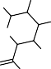
M4 O
O S NH
N
H3C

OH
O
O OH
O OH
C H ClNO S O
C H ClNO S
14 11 2
14 11 2
C12H22N3O4
292.0199 Da OH
292.0199 Da

m/z 566
272.161 Da

m/z 613
O
OH
C13H22NO8 320.1345 Da

Cl
O
O
S
N
NH
3C

M5

H

C H ClNO S

O
HN O

M6 H3C O N
O S
NH

O OH
O OH
O
OH
14 11 2 O
NH2 HO
292.0199 Da

m/z 538
OH
C10H18N3O4 244.1297 Da
Cl
C14H11ClNO2S 292.0199 Da

m/z 585
O
C11H18NO8 292.1032 Da

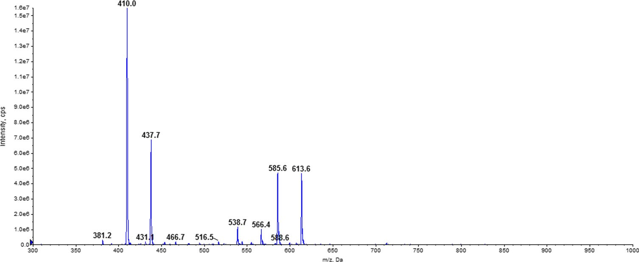

Fig. 7 Mass spectra of rat bile sample scanned in the PI (precursor ion) 292 mode. M/z 437.7 — tianeptine; M1—metabolite MC3; M2— metabolite MC5; M3 and M4—conjugates of tianeptine with glutamine
and glucuronic acid, respectively; M5 and M6—conjugates of metabolite MC5 with glutamine and glucuronic acid, respectively

according to the available data, tianeptine is almost complete- ly absorbed after oral administration (Royer et al. 1988; Wilde and Benfield 1995).
Since liver is considered to be the main metabolic site for tianeptine, an additional experiments were performed using

the system for isolated perfused organs of small animals in order to determine the hepatic clearance and hepatic metabolic ratio of this drug in rats. For the isolated rat liver perfusion (IPRL) studies, the total amount of drug added to the perfusion buffer equaled 300 μg, which considering the volume of the

buffer used in each experiment (200 mL) gave the concentra- tion of 1500 ng/mL. A similar C0 was reached after i.v. ad- ministration of tianeptine at the dose of 1 mg/kg (Table 3). The concentration of tianeptine in the perfusion buffer declined quite fast from the average value of 952 ng/mL at the first sampling time (5 min) to 17 ng/mL after 45 min (Fig. 6). The observed hepatic clearance was high and on average equal to the perfusion buffer flow rate. According to Eq. 2, it gave the high value of ERH (104.55 ± 16.99%) further indi- cating that tianeptine in rats undergoes an extensive hepatic first-pass metabolism. In contrast to these findings, it has been reported that in humans, tianeptine is not subject to first-pass hepatic metabolism and its oral bioavailability equals to al- most 100% (Wilde and Benfield 1995). The main tianeptine metabolites reported in the literature are MC5 (pentanoic acid derivative) and MC3 (propionic acid derivative) both being the products of β-oxidation. However unexpectedly, in the IPRL experiments, despite the high ERH, the metabolic ratio of MC5 was quite low (18.76 ± 8.11%) and the percent of MC5 eliminated into the bile up to 45 min of perfusion was only 3.07 ± 0.66% of the administered dose. At the same time the apparent hepatobiliary clearance was also low (0.2 ±
0.09 mL/min). Additionally, the percent of unchanged drug eliminated into the bile up to 45 min of perfusion was only
0.94 ± 0.33% of the administered dose. Since MC3 metabolite was undetected (based on the theoretical mass/charge ratio) in all analyzed samples, further analysis was performed in search of possible different routes of tianeptine metabolism in rats. Assuming that tianeptine, as well as its metabolites should give the same fragment ion m/z 292, the Q1 scans of rat bile were performed in the precursor ion mode. The major metab- olites found in the analyzed samples are presented in Fig. 7. Beside previously identified MC3 and MC5 metabolites, dif- ferent conjugates, mainly with glutamine and glucuronic acid, were also present what may explain the high ERH value and the low metabolic ratio of MC5 observed in rats in the liver perfusion experiments.

Conclusions

In this manuscript, pharmacokinetics of tianeptine and its ac- tive metabolite MC5 in rats following two routes of adminis- tration was studied. In order to achieve study goals, a sensitive and selective high performance liquid chromatography- tandem mass spectrometry method for the simultaneous deter- mination of both compounds was developed. The validation of the method showed that the method is accurate and precise with the linear response of mass spectrometer in the plasma concentration range from 1 to 2000 ng/mL. This method may also be used in human studies as the transfer of an analytical method to a similar matrix, e.g., from rat to human plasma will require only partial validation. Pharmacokinetic
analysis indicated that in rats, elimination of MC5 metabolite was much slower than that of the parent drug. In contrast to the results of the studies performed in humans, in the elimination phase, concentrations of MC5 were higher than those of tianeptine, although these differences are less pronounced when comparing MC5 concentrations in mice and humans. The results of ex vivo study indicated that in rats both MC5 metabolite and the parent drug are eliminated as glutamine and glucuronide conjugates. The proposed in this study phar- macokinetic model describing the concentration-time profiles of tianeptine and MC5 metabolite after two routes of admin- istration may facilitate the dosage selection for the prospective pharmacological experiments.
In view of recent reports demonstrating the activity of MC5 metabolite being equal to that of tianeptine itself, the differ- ences in the pharmacokinetics of these two compounds ob- served especially in the metabolism process between labora- tory animals and man seem particularly important for the ac- curate interpretation of the results of pharmacological experiments.

Compliance with ethical standards

Conflict of interest The authors declare that they have no conflict of interest.

Ethical approval All applicable international, national, and institutional guidelines for the care and use of animals were followed. All of the animal experiments described in this paper were approved by the Institutional Animal Care and Ethics Committee of the Jagiellonian University (nr 226/2015).

Open Access This article is distributed under the terms of the Creative Commons Attribution 4 .0 International License (http:// creativecommons.org/licenses/by/4.0/), which permits unrestricted use, distribution, and reproduction in any medium, provided you give appro- priate credit to the original author(s) and the source, provide a link to the Creative Commons license, and indicate if changes were made.

References

Bence C, Bonord A, Rebillard C, Vaast P, Alexandre C, Jardri R, Rolland B (2016) Neonatal abstinence syndrome following tianeptine depen- dence during pregnancy. Pediatrics 137(1). https://doi.org/10.1542/ peds.2015-1414
Bilge SS, Bozkurt A, İlkaya F, Çiftcioğlu E, Kesim Y, Uzbay TI (2012) The antinociceptive effects of intravenous tianeptine in colorectal distension-induced visceral pain in rats: the role of 5-HT3 receptors. Eur J Pharmacol 681(1-3):44–49. https://doi.org/10.1016/j.ejphar. 2012.01.043
Carlhant D, Le Garrec J, Guedes Y, Salvadori C, Mottier D, Riche C (1990) Pharmacokinetics and bioavailability of tianeptine in the el- derly. Drug Investig 2(3):167–172. https://doi.org/10.1007/ BF03259191
Cavalla D, Chianelli F, Korsak A, Hosford PS, Gourine AV, Marina N (2015) Tianeptine prevents respiratory depression without affecting analgesic effect of opiates in conscious rats. Eur J Pharmacol 761: 268–272. https://doi.org/10.1016/j.ejphar.2015.05.067

Ceyhan M, Kayir H, Uzbay IT (2005) Investigation of the effects of tianeptine and fluoxetine on pentylenetetrazole-induced seizures in rats. J Psychiatr Res 39(2):191–196. https://doi.org/10.1016/j. jpsychires.2004.06.002
Ceyhan M, Kayir H, Uzbay IT (2007) Effects of tianeptine on onset time of pentylenetetrazole-induced seizures in mice: possible role of adenosine A1 receptors. Neuropsychopharmacology 32:412–416
Couet W, Girault J, Latrille F, Salvadori C, Fourtillan JB (1990) Kinetic profile of tianeptine and its MC5 metabolite in plasma, blood and brain after single and chronic intraperitoneal administration in the rat. Eur J Drug Metab Pharmacokinet 15(1):69–74. https://doi.org/ 10.1007/BF03190130
Della FP, Abelaira HM, Réus GZ, Ribeiro KF, Antunes AR, Scaini G, Jeremias IC, dos Santos LMM, Jeremias GC, Streck EL, Quevedo J (2012) Tianeptine treatment induces antidepressive-like effects and alters BDNF and energy metabolism in the brain of rats. Behav Brain Res 233(2):526–535. https://doi.org/10.1016/j.bbr.2012.05. 039
EMA (2012) Guideline on bioanalytical method validation. EMEA, Comm Med Prod Hum Use 44:1–23
Gassaway M, Rives ML, Kruegel A, Javitch J, Sames D (2014) The atypical antidepressant and neurorestorative agent tianeptine is a μ-opioid receptor agonist. Transl Psychiatry 4(7):e411. https://doi. org/10.1038/tp.2014.30
Glombik K, Stachowicz A, Olszanecki R, Slusarczyk J, Trojan E, Lason W, Kubera M, Budziszewska B, Spedding M, Basta-Kaim A (2016) The effect of chronic tianeptine administration on the brain mito- chondria: direct links with an animal model of depression. Mol Neurobiol 53(10):7351–7362. https://doi.org/10.1007/s12035-016-
9807-4
Gupta S, Wallace R, Sloshower J (2017) Online sales of unscheduled pharmaceutical agents. J Addict Med 11(5):1
Jaffard R, Mocaer E, Poignant JC, Micheau J, Marighetto A, Meunier M, Béracochéa D (1991) Effects of tianeptine on spontaneous alterna- tion, simple and concurrent spatial discrimination learning and on alcohol-induced alternation deficits in mice. Behav Pharmacol 2(1): 37–46
Jantas D, Krawczyk S, Lason W (2014) The predominant protective effect of tianeptine over other antidepressants in models of neuronal apoptosis: the effect blocked by inhibitors of MAPK/ERK1/2 and PI3-K/Akt pathways. Neurotox Res 25(2):208–225. https://doi.org/ 10.1007/s12640-013-9430-3
Klasik A, Krysta K, Krupka-Matuszczyk I (2011) Effect of tianeptine on cognitive functions in patients with depressive disorders during a 3- month observation. Psychiatr Danub 23(Suppl 1):S18–S22
Kuipers SD, Trentani A, Van Der Zee EA, den Boer JA (2013) Chronic stress-induced changes in the rat brain: role of sex differences and effects of long-term tianeptine treatment. Neuropharmacology 75: 426–436. https://doi.org/10.1016/j.neuropharm.2013.08.018
Matuszewski BK, Constanzer ML, Chavez-Eng CM (2003) Strategies for the assessment of matrix effect in quantitative bioanalytical methods based on HPLC-MS/MS. Anal Chem 75(13):3019–3030. https:// doi.org/10.1021/ac020361s
McEwen BS, Chattarji S, Diamond DM, Jay TM, Reagan LP, Svenningsson P, Fuchs E (2010) The neurobiological properties of tianeptine (Stablon): from monoamine hypothesis to glutamatergic modulation. Mol Psychiatry 15(3):237–249. https://doi.org/10. 1038/mp.2009.80
Proenca P, Teixeira H, Pinheiro J, Monsanto PV, Vieira DN (2007) Fatal intoxication with tianeptine (Stablon®). Forensic Sci Int 170(2-3): 200–203. https://doi.org/10.1016/j.forsciint.2007.03.035
Reagan LP, Hendry RM, Reznikov LR, Piroli GG, Wood GE, McEwen BS, Grillo CA (2007) Tianeptine increases brain-derived neuro- trophic factor expression in the rat amygdala. Eur J Pharmacol 565(1-3):68–75. https://doi.org/10.1016/j.ejphar.2007.02.023
Royer RJ, Albin H, Barrucand D, Salvadori-Failler C, Kamoun A (1988) Pharmacokinetic and metabolic parameters of tianeptine in healthy volunteers and in populations with risk factors. Clin Neuropharmacol 11(Suppl 2):S90–S96
Samuels BA, Nautiyal KM, Kruegel AC, Levinstein MR, Magalong VM, Gassaway MM, Grinnell SG, Han J, Ansonoff MA, Pintar JE, Javitch JA, Sames D, Hen R (2017) The behavioral effects of the antidepressant tianeptine require the mu opioid receptor. Neuropsychopharmacology 42(10):2052–2063. https://doi.org/10. 1038/npp.2017.60
Slusarczyk J, Trojan E, Glombik K, Piotrowska A, Budziszewska B, Kubera M, Popiolek-Barczyk K, Lason W, Mika J, Basta-Kaim A (2016) Anti-inflammatory properties of tianeptine on lipopolysaccharide-induced changes in microglial cells involve toll-like receptor-related pathways. J Neurochem 136(5):958–970. https://doi.org/10.1111/jnc.13452
Tobe EH, Rybakowski JK (2013) Possible usefulness of tianeptine in treatment-resistant depression. Int J Psychiatry Clin Pract 17(4): 313–316. https://doi.org/10.3109/13651501.2013.798418
Uzbay IT, Cinar MG, Aytemir M, Tuglular I (1999) Analgesic effect of tianeptine in mice. Life Sci 64(15):1313–1319. https://doi.org/10. 1016/S0024-3205(99)00066-1
Uzbay T, Kayir H, Çelik T, Yüksel N (2006) Acute and chronic tianeptine treatments attenuate ethanol withdrawal syndrome in rats. Prog Neuro-Psychopharmacology Biol Psychiatry 30:478–485
Uzbay TI (2008) Tianeptine: potential influences on neuroplasticity and novel pharmacological effects. Prog Neuro-Psychopharmacol Biol Psychiatry 32:915–924
Wagstaff AJ, Ormrod D, Spencer CM (2001) Tianeptine: a review of its use in depressive disorders. CNS Drugs 15(3):231–259. https://doi. org/10.2165/00023210-200115030-00006
Wilde MI, Benfield P (1995) Tianeptine. A review of its pharmacody- namic and pharmacokinetic properties, and therapeutic efficacy in depression and coexisting anxiety and depression. Drugs 49(3):411– 439. https://doi.org/10.2165/00003495-199549030-00007
Wlaź P, Kasperek R, Wlaź A, Szumiło M, Wróbel A, Nowak G, Poleszak E (2011) NMDA and AMPA receptors are involved in the antidepressant-like activity of tianeptine in the forced swim test in mice. Pharmacol Reports 63:1526–1532
Woo YS, Bahk WM, Jeong JH, Lee SH, Sung HM, Pae CU, Koo BH, Kim W (2013) Tianeptine combination for partial or non-response to selective serotonin re-uptake inhibitor monotherapy. Psychiatry Clin Neurosci 67(4):219–227. https://doi.org/10.1111/pcn.12042
Zhang H, Etherington LA, Hafner AS, Belelli D, Coussen F, Delagrange P, Chaouloff F, Spedding M, Lambert J, Choquet D, Groc L (2013) Regulation of AMPA receptor surface trafficking and synaptic plas- ticity by a cognitive enhancer and antidepressant molecule. Mol Psychiatry 1880:471–484
Zoladz PR, Park CR, Muñoz C, Fleshner M, Diamond DM (2008) Tianeptine: an antidepressant with memory-protective properties. Curr Neuropharmacol 6(4):311–321. https://doi.org/10.2174/ 157015908787386096

