Piotr MUSIAŁEK*
Nitric oxide stimulation of cardiac pacemaking in the sino-atrial node through the activation of a novel signalling pathway: Overview of in vitro and in vivo evidence for a new basic mechanism in the control of heart rate
Tlenek azotu stymuluje tworzenie bodźców w węźle zatokowo-pizedsionkowym przez aktywację nieznanego dotychczas szlaku sygnałowego: przegląd dowodów z badań in vitro i in vivo na istnienie nowego podstawowego mechanizmu kontrolującego rytm serca
Department of Cardiac and Vascular Diseases, Jagiellonian University, Collegium Medicum, John Paul II Hospital, Kraków, Poland Head of Department:
Professor Wiesława Tracz, MD PhD
Joan Mott Cardiovascular Research Fellow, University of Oxford, England

Additional key words:
nitric oxide signalling
heart rate
hyperpolarization-activated 'pacemaker'
current I,
sino-atrial node
Dodatkowe słowa kluczowe: szlaki sygnałowe zależne od tlenku azotu
rytm serca i
prąd rozrusznikowy I,
węzeł zatokowo-przedsionkowy
Recent work has tested the hypothesis that nitric oxide (NO) might play an important role in the control of heart rate (HR) by stimulating cardiac pacemaking in the sino-atrial node (SAN). In isolated guinea-pig SAN cells and atrial preparations, nano-micromolar concentrations of NO donors were shown to elicit a NO-dependent increase of 20-30% in the beating rate. In the pig heart in situ, topical NO donor application to the SAN increased HR by ca. 10%, indicating that the direct positive chronotropic effect of NO is relevant in vivo. Indeed, a similar significant increase in HR (by 12%) was seen in humans with intravenous NO donor infusion while blood pressure was clamped. Inhibition of NO synthase or depletion of its gene have
been associated with a significant reduction in HR by ca. 10% in vitro and in vivo, consistent with a tonic positive chronotropic effect of endogenous NO. The direct stimulatory effect of NO on cardiac pacemaking is mediated by stimulation of the ‘pacemaker’ current I, in SAN cells via a novel cascade involving cGMP, PDE3-PKA signalling and mobilization of intracellular calcium. In conclusion, recent studies have demonstrated for the first time that NO exerts a direct positive chronotropic effect through the activation of a novel signal transduction pathway in SAN cells. Evidence in animals and in humans indicates that direct stimulation of cardiac pacemaking by NO is functionally relevant for the control of HR in vivo.
lotr Musialek was the winner the 1997 British Cardiac oclety Young Investigator’s Award for identifying the lrect positive chronotropic effect of nitric oxide. In 2000 e received the Annual Prize In Cardiology (Great rilain) for elucidating mechanisms responsible for the O-dependent stimulation of cardiac pacemaking in the S|no-atria! node.
rires do korespondencji:
r Piotr Musialek
ePartment of Cardiac and Vascular Diseases, agiellonian University, Collegium Medicum °hn Paul II Hospital, 80 Prądnicka Street,
■202 Kraków, Poland
■mail: pmusialek@szpitaljp2.krakow.pl, P|otr.rnusialek@clinical-medicine. oxford, ac.uk

Introduction
Nitric oxide (NO) is known to be critically important in mediating and maintaining vasodilatation [33]. There is increasing evidence, however, that NO is not a purely vasoactive substance. For instance, it is now known that NO synthase is constitutively expressed in virtually all types of cardiac cells and that low-micromolar concentrations of endogenous NO are ionically released in the heart [31]. Indeed, a number of recent studies indicated that NO contributes to the regulation of cardiac contractility and relaxation [13] and may optimise myocardial oxygen consumption. Nitric oxide, however, has been believed to exert no direct effect on the activity of the sino-atrial node (SAN) [2].
Nitrovasodilators (now known to be donors of NO) have been widely used in cardiovascular medicine since 1860s to treat angina and reduce blood pressure [3]. The increase in heart rate (HR) with systemic administration of these drugs has been considered to result entirely from a neurally
mediated reflex response to the fall in arterial blood pressure [2]. Indeed, based on the assumption that NO donors reduce blood pressure (and thus unload baroreceptors) without a direct effect on cardiac pacemaking in the SAN or baroreflex transmission, nitrovasodilators (e.g. sodium nitroprusside, SNP) have been widely used to evaluate the baroreflex [20]. Suprisingly, however, NO donors have been reported to increase HR also in patients with a recent heart transplant [1,17] (/.e. when the heart is vagally- denervated and before any functional sympathetic re-innervation can occur), suggesting that NO might stimulate the SAN activity directly, i.e. independent of the arterial baroreflex [24,26].
The aim of the work summarised in this overview was to [22] investigate whether NO modulates cardiac pacemaking in the SAN, and [31] establish whether the modulation of pacemaking by NO plays any significant part in the control of basal HR. To gain insight into both basic electrophysiological me
1 rz«łilą<l Lekarski 2002 / 59 / 9
691

chanisms and their functional relevance, an integrative approach was taken. This approach involved (i) experiments in isolated spontaneously beating SAN preparations,
- membrane current recordings in isolated spontaneously beating SAN cells, and
- studies in the heart in situ.

Identification of a 'direct' positive chronotropic effect of NO donors
The investigation of any direct chronotropic effect of NO by administering NO donors systemically in vivo would be confounded by the indirect, baroreflex-mediated increase in HR secondary to a reduction in arterial blood pressure. Therefore, the hypothesis that NO might exert a 'direct' positive chronotropic effect was first evaluated ex vivo, by applying increasing concentrations of NO donors to spontaneously beating atrial preparations isolated from the guinea- pig [24,26]. Several compounds from different classes of NO donors were used to account for a potential confounding effect of NO donor metabolites or decomposition products on the SAN activity. When applied in nano-micromolar concentrations, sodium nitroprusside (SNP), 3-morpholinosydnoni- mine (SIN-1), S-nitroso-N-acetyl-penicillami- ne (SNAP) and diethylamine-NO (DEA-NO) consistently elicited a dose-dependent statistically significant increase in the beating rate by 20-30% [24,26]. In contrast, the carrier molecules (e.g. DEA or N-acetyl-peni- cillamine) used in the same concentration range exerted no chronotropic response [24,26], indicating that the increase in HR with NO donors is dependent on nitric oxide. Consistent with a causal role of NO, the positive chronotropic response to NO donors in vitro was significantly enhanced by superoxide dismutase [24,26] (whose constitutive presence in vivo augments the effects of NO by preventing its breakdown [6]). Furthermore, the HR response to NO donors was not affected by beta-adrenergic inhibition with nadolol [12], suggesting that the increase in HR with NO occurs independent of the beta-adrenergic pathway [26,27]. Similar to the positive chronotropic effect seen with NO donors in atrial preparations, the spontaneous beating rate of isolated SAN cells also increased significantly (by ca. 25%) with NO donor application [24,29].
These findings, subsequently reproduced in other species [see e.g. Ref. 9 and 23], provided the first systematic evidence that exogenous NO exerts a stimulatory effect on the activity of the cardiac pacemaker in the SA node, leading in vitro to a significant increase in spontaneous HR.
Reduction in HR with inhibitors of endogenous NO production Constitutive NO synthase (NOS-3 isoform) is functionally expressed in SAN cells. This, however, is not the only source of endogenous NO production in the SAN, since NOS-3 is also present in cardiac endothelial and endocardial cells and in atrial myocytes, and NO easily and rapidly diffuses through cell membranes. To test whether endogenous NO exerts a positive chronotropic effect similar to NO donors, antagonists of L-arginine (Ze. the NO substrate [22])
binding to the catalytic site of NO synthase were applied to the isolated spontaneously beating atrial preparations. Inhibition of endogenous NO production with L-NMMA or L-NNA reduced HR significantly by 8-13% whereas the 'inactive' D-isomer of NMMA (D-NMMA) was ineffective, consistent with a tonic positive chronotropic effect of endogenous NO [24,28].
In summary, these results indicated that endogenous NO exerts a tonic positive chronotropic effect which can be mimicked with NO donors [24,28].

‘Direct’ positive chronotropic effect of NO donors in vivo
Whether the 'direct' positive chronotropic response to NO occurs in vivo was tested in anaesthetised pigs [24,25]. To avoid the hypotensive response to systemic NO donor administration, the NO donor SNP was delivered locally in the heart in situ [24]. Since an intracoronary administration of a NO donor could lead to an indirect, flow- mediated chronotropic response (as a result of coronary artery dilatation [7]), SNP was applied to the SAN topically, through a small sponge [24,25]. The pigs were vago- tomised bilaterally and beta-blocked with propranolol. Local delivery of the NO donor to SAN caused a washout-reversible increase in HR by ca. 10% in the absence of changes in arterial blood pressure [24,25]. In contrast, control application of normal (0.9%) saline to the SAN exerted no chronotropic response.
In summary, the direct positive chronotropic effect of exogenous NO was demonstrated to occur in vivo, in the absence of a reduction in arterial blood pressure [24,25]. This finding was subsequently confirmed in humans [22], where intravenous infusion of SNP caused a significant sustained increase in HR by 12% while arterial blood pressure was 'clamped' by simultaneous infusion of phenylephrine.

‘Pacemaker’ current I, mediates the NO-dependent increase in HR
Regular spontaneous diastolic depolarisation of SAN cells, which brings the membrane potential from about -65 to ca. -40mV where the upstroke of the action potential starts, is the fundamental basis of pacemaking [11]. Pacemaking is SAN results from a cyclic flow of three main electric currents through the membrane of SAN cells, involving (i) the calcium current (lCa) which significantly contributes to the spontaneous diastolic depolarisation and is primarily responsible for the upstroke of the action potential, (ii) the hyperpolarization-activated 'pacemaker' current (mixed sodium and potassium current named, for its many unusual properties, l( - 'funny') which contributes to the spontaneous diastolic depolarisation and plays an important part in maintaining pacemaker activity, and (iii) potassium currents (lk) whose activation is primarily responsible for repolarisation [11].
It was first hypothesised that the NO-de- pendent increase in HR might occur through stimulation of l^ [24,26]. Inhibition of this current with nifedipine, however, was found to have no effect on the magnitude of the chro
notropic response to NO donors, indicating that lCa does not mediate the increase in HR with NO [24,26]. Indeed, direct recordings of the calcium current in isolated SAN cells showed no change in lCo with NO donor application [24,26]. In contrast to these findings, specific inhibition of the I, current (with ZD7288 or caesium) completely abolished the increase in HR with NO donors in spontaneously beating atrial preparations, indicating that stimulation of the I, current provides the electrophysiological basis for the positive chronotropic effect of NO. Direct evidence for a causal role of I, was obtained in isolated SAN cells where NO donors elicited a significant increase in the lr amplitude and in the cell beating rate, while both effects were reversibly blocked by specific I, inhibition [24,26].
In summary, experiments in isolated atrial preparations and isolated spontaneously beating SAN cells provided evidence that the ‘direct’ positive chronotropic effect of NO occurs through stimulation of the 'pacemaker' current I, [24,26] (Figure 1).

The NO-I, pathway: a novel signalling system in the SAN
In theory, NO could stimulate I, directly; e.g. through S-nitrosylation of f-channels. Most biologically relevant effects of NO, however, are known to be dependent on the activation of guanylyl cyclase (GC) with a subsequent increase in cGMP [1]. Consistent with an essential role of GC in the N0- I, signal transduction (Figure 1), the positive chronotropic response to NO donors in atrial preparations was prevented by specific inhibitors of GC [24,26]. Converse experiments showed that the dose-dependent positive chronotropic effect of NO donors can be mimicked by applying increasing concentrations of a membrane-permeable analogue of cGMP (8-Br-cGMP), indicating that the increase in HR with NO is GC- cGMP-dependent [24,26].
Although it is known that cGMP can directly enhance I, by binding to the intracellular domain of the channel [4,19], its action is several-fold weaker than that of the 'physiological' l( gating nucleotide, cAMP [4,19], suggesting that the direct stimulation of l( by cGMP is unlikely to be exclusively responsible for the increase in HR with NO. Indeed, further experiments provided evidence for a positive feedback between cGMP and cAMP (via cGMP-inhibited phosphodiesterase of cAMP, PDE-3) in mediating the I,- dependent increase in HR with NO donors [24,29] (Figure 1). The increase in cAMP can enhance I, both directly (Ze. by cAMP-bin- ding to the channel and increasing its open probability [4,19]) and indirectly, through the activation of cAMP-dependent protein kinase (PKA) [4]. Specific inhibition of PKA was found to significantly reduce the increase in HR with NO donors, indicating that cAMP- PKA signalling plays a significant part in the NO-I, cascade [26,29]. How to explain the involvement of PKA in mediating the N0-1,- dependent stimulation of SAN activity? Recent evidence shows that modulation of the release of intracellular calcium (from the stores in sarcoplasmic reticulum, SR) significantly affects basal SAN activity [8]. Since
692
Przeglqd Lckurski 2002 /59/9
I*. Musialek

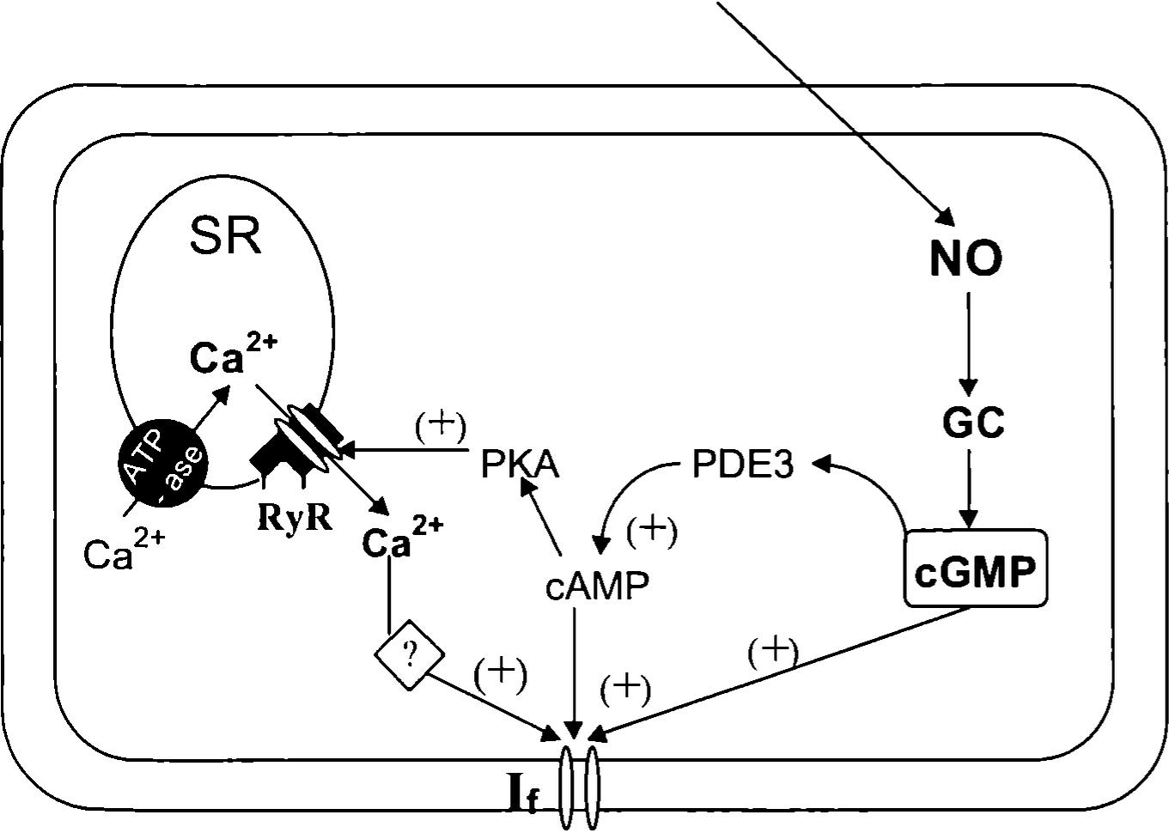
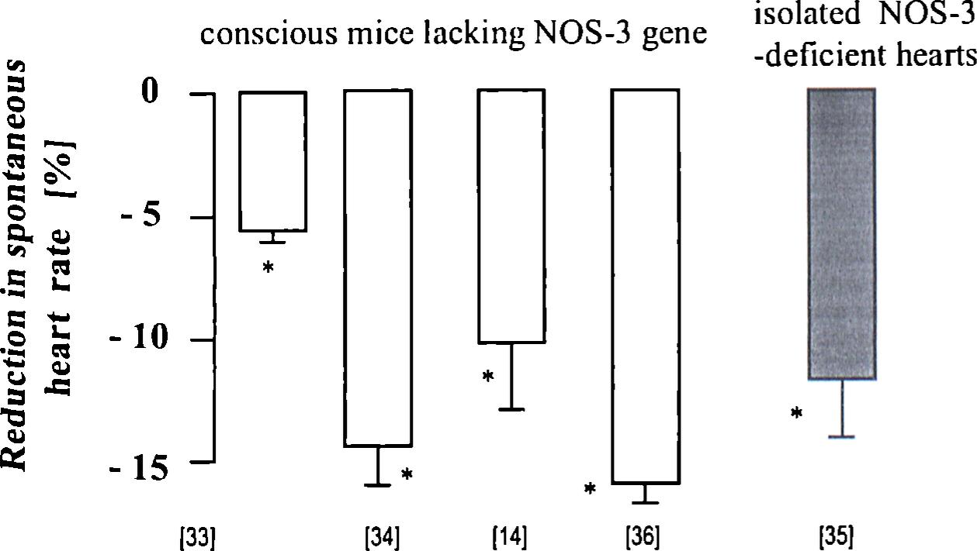
NO
G®
^'gure 1 (modified from ref. 24; see text for abbreviations)
Schematic diagram of the nitric oxide (NO)-I, signalling pathway whose activation In slno-atrlal node (SAN) «Ils mediates the recently Identified 'direct' positive chronotropic effect of NO [26,29].
A NO-dependent increase in the amplitude of the hyperpolarization-activated ‘pacemaker’ current I, provides the final roechanism for an increased frequency of spontaneous firing in the SAN (and thus for the increase in HR) with NO 126]. Guanylyl cyclase (GC) plays an essential role in the pathway, since its inhibition abolishes the positive chronotropic resPonse to NO wheres application of exogenous cGMP mimicks the increase in HR with NO [26]. Cyclic GMP can directly enhance the I, current by binding to the intracellular domain of f-channels, but its action is several-fold weaker Jhan that of the ‘physiological’ I, gating nucleotide, cAMP, indicating that signal transduction downstream of cGMP is 'nvolved. Indeed, recent findings [29] are consistent with a functionally significant role of cAMP/PKA signalling (via CGMP inhibition of PDE-3) and mobilization of sarcoplasmic (SR) calcium in mediating the positive chronotropic effect NO donors. This is not surprisisng since I, activity is known to be enhanced (i) directly by cAMP (whose level is lncreased as a result cGMP-mediated inhibition of PDE-3), and (ii) indirectly by an elevation in cytosolic calcium.
I
* p<0.05 v.s-. control animals
figure 2
of the absence of NO synthase on spontaneous heart rate. Data are from genetically engineered eNOS- uclent mice vs. control animals (the reference number Is shown below each bar).
0 e ,tlat lack of the major source of NO synthesis in the heart leads to a persistent reduction in spontaneous HR in 0 and in vitro, consistent with a tonic positive chronotropic effect of endogenous NO.
(i) in several tissues NO donors can mobilize calcium from intracellular stores and (ii) PKA can stimulate SR calcium release by phosphorylating SR calcium release channels, final investigations tested whether intracellular calcium release plays a role in the NO-dependent increase in HR. Inhibition of SR calcium release with ryanodine or depletion of calcium stores by pre-treat- ment with cyclopiazonic acid were both found to significantly attenuate the chronotropic response to NO donors [24,29], providing functional evidence that SR calcium plays an important part in the NO-I( signal transduction. Direct evidence for the involvement of intracellular calcium in mediating the NO-dependent increase in HR was obtained in isolated SAN cells (incubated with a calcium-fluorescent probe, lndo-1 ) where a low-micromolar concentration of SNP significantly increased both diastolic and peak calcium fluorescence, indicating an increase in cytosolic calcium [26,29]. A link between intracellular calcium and the positive chronotropic effect of NO donors (Figure 1 ) is not unexpected, since an elevation in cytosolic calcium is known to increase I, (through an indirect mechanism), whereas intracellular calcium buffering reduces the amplitude of this current [19].
Thus, recent findings indicate that cAMP/PKA signalling (via cGMP inhibition of PDE-3) and intracellular calcium release play a functionally significant role in mediating the NO-l,-dependent positive chronotropic effect [24,29].

Evidence for a role of endogenous NO in the control of basal HR in vivo
The principal finding from the work [24] summarised above is that NO donors exert a ‘direct’ (i.e. independent of autonomic activation) positive chronotropic effect in the heart in vitro [24] and in vivo [24,25] through the activation of a novel signalling pathway in the SAN [24,25] (Figure 1). The significant reduction in the beating rate of atrial preparations found with inhibition of endogenous NO production suggested that endogenous NO may exert a tonic positive chronotropic effect [24,28]. Indeed, recent findings in genetically-engineered mice which lack the NOS-3 gene are consistent with a functionally significant positive chronotropic effect of endogenous NO. In particular, depletion of the NOS-3 gene (and thus removal of the major source of endogenous NO production in the cardiovascular system) has been consistently found to lead to a significant reduction in HR by 5-15%, both in vitro [35] and in vivo in conscious animals [32-34,36] (Figure 2). Similarly, chronic pharmacologic inhibition of endogenous NO synthesis in mice [12,14,15] and in other species [18,21] leads to a sustained bradycardia, indicating that the ‘direét’ stimulation of SAN activity by NO contributes to the 'setting' of basal heart rate. Consistent with this idea, over-expression of the NOS-3 gene in mice has been associated with a HR elevated in vivo by ca. 10% when compared to wild-type control animals [30]. Hypertension seen with NO synthase inhibition or NOS-3 depletion (and hypotension seen with NOS-3 over-expression) are both
PrzcRlqd Lckarski 2002 /59/9
693

consistent with the critical role of NO in maintaing vasodilation [22]. Since the arterial baroreflex is well-documented to re-set with chronic changes in blood pressure (and thus chronic changes in blood pressure do not lead to changes in HR through a reflex mechanism) [16], the bradycardia in NOS- 3 knock-out mice or during chronic NOS-3 inhibition is in keeping with a tonic 'direct' positive chronotropic effect of endogenous NO (Figure 2).
The evidence that endogenous NO stimulates SAN activity has been recently expanded to the human heart by Exner and colleagues [5]. These authors showed, in humans, that local inhibition of NO production in the SAN causes a significant prolongation of the sinus node recovery time. This indicates that endogenous NO does indeed modulate SAN automaticity in man [5].
In summary, recent evidence indicates that endogenously released NO tonically stimulates SAN activity in vivo.

Conclusions
Recent work [24-26,28,29] has identified and established the 'direct' positive chronotropic effect of NO; a response mediated by the novel signal transduction cascade involving GC, cGMP, cAMP-PKA signalling (via cGMP inhibition of PDE-3), mobilization of intracellular calcium, and stimulation of the l( current as the electrophysiological basis for an increased frequency of spontaneous firing in the SAN (Figure 1 ). Evidence in animals [12,14,15,18,28,30,32-36] and in humans [5] indicates that regulation of cardiac pacemaking by endogenously released NO is functionally relevant for the control of HR in vivo (Figure 2).
References
- Beck W., Barnard C.N., Schrlre V.: Heart rate after cardiac transplantation. Circulation 1969, 40, 437.
- Brunton T.L.: On the use of nitrite of amyl in angina pectoris. Lancet 1867, 2, 97.
- Chen R.Y., Fan F.C., Schuessler G.B., Chien S.: Barorellex control of heart rate in humans during nitroprusside-induced hypotension. Am. J. Physiol. 1982, 243, R18.
- DiFrancesco D., Tortora P.: Direct activation of cardiac pacemaker channels by intracellular cAMP. Nature 1991, 351, 145.
- Exner D.V., Goodhart D.M., Anderson T.J., Duff
H. J.: Prolonged sinus node recovery time in humans after the Intracoronary administration of nitric oxide synthase inhibitor. J. Cardiovasc. Pharmacol. 1999, 34,1.
- Gryglewskl R.J., Palmer R.M.J., Moncada S.: Superoxide anion is involved in the breakdown oi endothelium-derived vascular relaxing factor. Nature 1986, 320, 454.
- Hashimoto K., Tanaka S., Hlrata M., Chiba S.: Responses of the sino-atrial node to changes in pressure in the sinus node artery. Circ. Res. 1967, 21, 297.
- Hata T, Noda T, Nishimura M., Watanabe Y.: The role of Ca2‘ release from sarcoplasmic reticulum in the regulation of sinoatrial node automaticity. Heart Vessels 1996,11,234.
- Hogan N., Casadel B., Paterson D.J.: Nitric oxide donors can increase heart rate independent of autonomic activation. J. Appl. Physiol. 1999, 87, 97.
- Hogan N., Kardos N., Paterson D.J., Casadel B.: Effect of exogenous nitric oxide on baroreflex function in humans. Am. J. Physiol. 1999, 277, H221.
- Irlsawa H., Brown H.F., Giles W.: Cardiac pacemaking in the sinoatrial node. Physiol. Rev. 1993, 73,197.
- Jansses B.J.A., Leenders P.J.A., Smits J.F.M.: Short-term and long-term blood pressure and heart rate variability in the mouse. Am. J. Physiol. 2000, 278, R215.
- Kelly R.A., Balligand J.L., Smith T.W.: Nitric oxide and cardiac function. Circ. Res. 1996, 79, 363.
- Kojda G., Laursen J.B., Ramasamy S. et al.: Protein expression, vascular reactivity and soluble guanylate cyclase activity in mice lacking the endothelial nitre oxide synthase: contributions of NOS isoforms to blood pressure and heart rate control. Cardiovasc. Res. 1999, 42, 206.
- Krege J.H., Hodgin J.B., Hagaman J.R., Smithies O.: A noninvasive computerized tail-cuff system for measuring blood pressure in mice. Hypertension 1995, 25, 1111.
- Krieger E.M.: Mechanisms of complete baroreceptor resetting in hypertension. Drugs 1988, 6, 98.
- Levine T.B., Ollvarl M.T., Cohn J.N.: Effects of orthotopic heart transplantation on sympathetic control mechanisms in congestive heart failure. Am. J. Cardiol. 1986, 58, 1035.
- Liu Y., Tsuchlhashl T, Kaglyama S., Matsumura K., Abe I., Fujlshlma M.: Central and peripheral mechanisms involved in hypertension induced by chronic inhibition of nitric oxide synthesis in rats. J. Hyperetens. 1998,16,1165.
- Ludwig A., Zong X., Jeglltsch M., Hofmann F., Biel M.:Afamily of hyperpolarization-activated mammlian cation channels. Nature 1998, 393, 587.
- Manda G., Ferrari A., Gregorlnl L., Valentlnl R., Ludbrook J., ZanchettI A.: Circulatory reflexes from carotid and extracarotid baroreceptor areas in man. Circ. Res. 1977,41,309.
- Manning R.D.Jr, Hu L, Mlzelle H.J. et al.: Cardiovascular responses to long-term blockade of nitric
oxide synthesis. Hypertension 1993, 22,40.
- Moncada S., Higgs A.: The L-arginine - nitric oxide pathway. N. Engl. J. Med. 1993, 329, 2002.
- Muller-Strahl G., Kottenberg K., Zimmer H.G., Noack E., Kojda G.: Inhibition of nitric oxide synthase augments the positive inotropic effect of nitric oxide donors in the rat heart. J. Physiol. 2000, 522, 311.
- Muslalek P.: Nitric oxide and cardiac pacemaking. DPhil Thesis. University of Oxford, 1999.
- Muslalek P., Casadel B.: Nitrovasodilators and heart rate: more than the arterial baroreflex. Cardiovasc. Res. 2000, 47, 404.
- Muslalek P., Lei M., Brown H.F., Paterson D.J., Casadel B.: Nitric oxide can increase heart rate by stimulating the hyperpolarization-activated inward current, I.. Circ. Res. 1997, 81, 60.
- Muslalek P., Paterson D.J., Casadel B.: The chronotropic response to nitric oxide in the isolated guinea-pig atria is not affected by (l-adrenergic blockade. J. Physiol. 1997, 504P.83.
- Muslalek P., Paterson D.J., Casadel B.: Changes in extracellular pH mediate the chronotropic responses to L-arginine. Cardiovasc. Res. 1999, 43, 712.
- Muslalek P., Rigg L., Terrar D.A., Paterson D.J., Casadel B.: Role of cGMP-inhibited phosphodiesterase and sarcoplasmic calcium in mediating the increase in basal heart rate with nitric oxide. J. Mol. Cell. Cardiol. 2000, 32,1831.
- Ohashl Y., Kawashlma S., Hlrata K., Yamashita T., Ishida T., Inoue N., Sakoda T., Kurlhara H., Yazakl Y., Yokoyama M.: Hypotension and reduced nitric oxide—elicited vasorelaxation in transgenic mice overexpressing endothelial nitric oxide synthase. J. Clin. Investig. 1998,102, 2061.
- Pinsky D.J., Patton S., Mesaros S., Brovkovych V., Kubaszewskl E., Grunfeld S., Mallnskl I: Mechanical transduction of nitric oxide synthesis in the beating heart. Circ. Res. 1997, 81, 372.
- Rakhlt A., Maguire C.T., Waklmoto H. et al.: In vivo electrophysiologic studies in endothelial nitric oxide synthase (eNOS)-deficient mice. J. Cardiovasc. Electrophysiology 2001, 12, 1295.
- Shesley E.G., Maeda N., Kim H.S. et al.: Elevated blood pressure in mice lacking endothelial nitric oxide synthase. Proc. Natl. Acad. Sci. USA 1996, 93, 13176.
- Stauss H.M., Goedecke A., Mrowka R., Schrader J., Persson P.B.: Enhanced blood pressure variability in eNOS knockout mice. Hypertension 1999, 33, 1359.
- Sumeray M.S., Rees D.D., Yellon D.M.: Infarct size and nitric oxide synthase in murine myocardium. J. Mol. Cell. Cardiol. 2000, 32, 35.
- Yang X.P., Liu Y.H., Shesley E.G., Bulagannawar M., Liu F., Carretero O.A.: Endothelial nitric oxide gene knockout mice: cardiac phenotypes and the effect of angiotensin-converting enzyme inhibitor on myocardial ischaemia/reperfusion injury. Hypertension 1999,34,24.
694
Przcglqd Lekarski 2002 /59/9
P. Musialek

