16.02.2021 Under lockdown, Germany's PEGIDA goes to YouTube I openDemocracy

I COUNTERING THE RADICAL RIGHT
Under lockdown, Germany's PEGIDA goes to YouTube

Germany's far-right group PEGIDA is mobilizing weekly 'virtual marches' livestreamed on YouTube.
Sabine Volk

7 May 2020

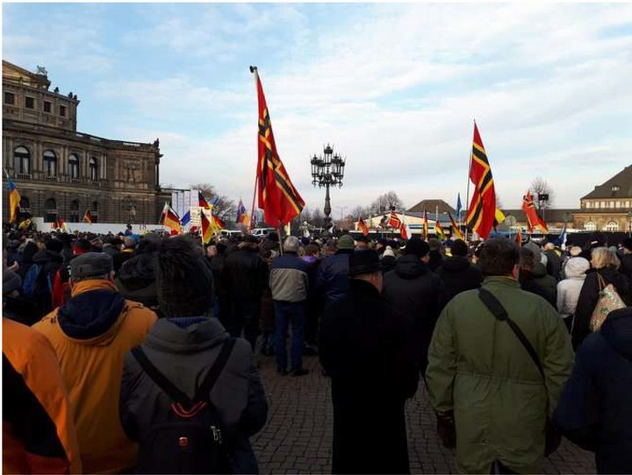
PEGIDA demonstration in Dresden December 16, 2018 I Derbrauni / Wikimedia Commons (CC BY-SA 4.0)
16.02.2021 Under lockdown, Germany's PEGIDA goes to YouTube I openDemocracy
Centre for

CARR

Analysis of the Radical Right

n a Monday evening in early April 2020, around 1,000 users are waiting for a YouTube livestream, hosted by Lutz Bachmann, co-founder of the Dresden
0
based protest movement 'Patriotic Europeans against the lslamization of the
Occident' (PEGIDA). For the second time already, Bachmann's YouTube channel 'LUTZiges' - a pun of his given name and the German word /ustig('funny') - invites to a 'virtual evening march'.

Protest in times of Coronavirus
Since October 2014, PEGIDA had been mobilizing against the 'lslamization' of Europe, the political 'elites', and the established media. On a weekly basis, PEGIDA organizers and supporters demonstrated in Dresden. They marched through the city center and gave speeches with xenophobic and anti-elitist content on some of the most iconic squares. The marches, always scheduled on Mondays, aimed to re perform the 'Monday demonstrations' which toppled the GDR regime in the fall of 1989.

Over the years, participant numbers consolidated at around 1,500 supporters per demonstration. In February 2020, numbers peaked again at 3,000 or so during the 200th march of PEGIDA, marked by the visit of Bjorn Hocke, a high-ranking politician of Germany's far-right party Alternative for Germany (AfD).

Join the COVID-19 DemocracyWatch email list
Sign up for our global round-up ofattacks on democracy during the coronavirus pandemic.
16.02.2021 Under lockdown, Germany's PEGIDA goes to YouTube I openDemocracy

SIGN UP

In the spring of 2020, when countries all around the world have shut down public life as a reaction to the Covid-19 pandemic, it first seemed as if the lockdown would finally disrupt PEGIDA's protest ritual. Indeed, the demonstration planned for Monday, 16 March 2020, was cancelled due to the ban of association in public. Yet, the group quickly adapted and took up 'virtual evening marches' as a new form of protest.

The protest ritual continues
Based on the ethnographic observation of the first two YouTube livestreams, PEGIDA aims to make its online version as similar as possible to its street events by following the offline format and procedures. The livestreams started with PEGIDA's anthem, featured several speeches, and ended with the performance of the German national anthem. Even the march still played a role - in the form of a high speed display of a video of the march during PEGIDA's 200th event. Throughout the YouTube events, the organizers kept their well-studied roles: Wolfgang Taufkirch as serious host, Lutz Bachmann as funny moderator, and Siegfried ('Siggi') Dabritz as bad boy.

A new virtual ritual in PEGIDA's protest politics might be underway

Similarly, the invitees were more than familiar. Some of the best-known figures of the German speaking far-right scene livestreamed or sent video messages from their living rooms to address PEGIDA supporters, including Michael StOrzenberger (activist and blogger from Munich), Christoph Berndt (activist and AfD politician from Brandenburg), Heiko Hessenkemper (AfD politician from Saxony), and Martin Sellner (cover boy of the Austrian ldentitarian Movement). All four are recurrent guests of PEGIDA, in particular at special occasions such as the organization's
16.02.2021 Under lockdown, Germany's PEGIDA goes to YouTube I openDemocracy

anniversaries or Christmas editions.
The speeches featured the usual topics. Importantly, however, PEGIDA's key frames were now adapted to the lockdown. First, PEGIDA criticized the politics of the Covid-19 pandemic in Germany. They denounced the restrictions to public life, rejecting the cutting back on civil rights such as the freedom of association.
Organizers yet again drew parallels between the current state of German democracy and the dictatorships of the German Democratic Republic (GDR) and the Third Reich. Second, the speakers also continued to discriminate against people of immigrant and Muslim background, accusing them of not respecting the restrictions to public life - in contrast to the socially responsible PEGIDA supporters. Third, the speakers praised the movement and its supporters for constituting not only Germany's economic backbone, but also for being the guardian of civil liberties and Europe-wide leader in peaceful protest politics in times of crisis.

The issue with social media

Nevertheless, the online adaption differs in many ways from the well-established protest ritual. The YouTube events ran much less smoothly than real-life PEGIDA marches. The use of the technology seemed unprofessional and confusing, namely because the organizers repeatedly had trouble coordinating the image and sound of up to five simultaneous speakers. "I am approaching the age of 50", said Bachmann in apology.

PEGIDA has mainly endured due to the ritualization of its protest politics

Moreover, nobody knows the audience(s) of the livestreamed performances. Whereas the setting of the street demonstrations was quite straightforward - PEGIDA organizers and supporters on one side, counter-demonstrators on the other, and the police in between and surrounding the two - there was very little certainty about PEGIDA's virtual company. Indeed, it is impossible to find out if the YouTube followers were more or less the same as those who joined the street
nrf'\t�ct Vf'\11T11h�'c rh::at f11nrtif'\n ::ale" nrf'\\/irl�rl f'\nh, lirnit�rl i ncicrht· rn::an\/ rh::at
16.02.2021 Under lockdown, Germany's PEGIDA goes to YouTube I openDemocracy
t,,'I Vl..\,,,.,J\.e I VU I l.,.UJ\..., J \,,.I IUI.. IUI 1'-1..IVI I UIJV t,-'I VVl\.,.4\,...U VI 11,J 111 1 111..'-U 11 IJIQl 1\.e 11 IUI IJ \,,.I IU\.
participants seemed to be regulars, greeting other spectators as well as the
organizers, commenting on the content of the speeches, and sharing their own political views. Most viewers, however, did not use the chat.


Ritualistic performance has its limits


For a long time, both interested observers and PEGIDA's political opponents have been wondering why the movement survived even though many of its demands have found a parliamentary arm in the AfD. There is a good argument to make that PEGIDA has mainly endured due to the ritualization of its protest politics. Indeed, the street events constituted repetitive, highly standardized, and symbolically loaded performances in front of a physical audience which marked a shift from one state of being into another one - in PEGIDA's reading: from ordinary citizens to political activists, revolutionaries, true democrats.


Specifically, the marches through the historically reconstructed center of Dresden, passing some of its most picturesque buildings as well as small groups of noisy counter-demonstrators, were able to create feelings of positive identification and of power - notably the power to induce political change "like in 1989". This ritualized format seemed to be able to keep constant mobilization levels over an extended amount of time.


Do the 'social distancing' measures thus doom PEGIDA to decline? Probably not. Admittedly, the online events can hardly generate the same collective emotions and identity as they lack the communal performative element of taking to the streets. Yet, a new virtual ritual in PEGIDA's protest politics might be underway. Considering the organization's history of ritualized performance, it seems that the group will continue to mobilize in times of lockdown.


*This research is part of a project that has received funding from the European Union's Horizon 2020 research and innovation programme under grant agreement No. 765224.

https://www.opendemocracy.net/en/countering-radical-right/under-lockdown-germanys-pegida-goes-to-youtube/ 5/12

