Annales Societatis Geologorum Poloniae (2010), vol. 80: 285-301.

INJECTION DYKES AS EVIDENCE OF CAMPANIAN
SYNSEDIMENTARY TECTONICS ON THE KRAKÓW SWELL,
SOUTHERN POLAND
Bogusław KOŁODZIEJ, Joachim SZULC, Elżbieta MACHANIEC, Mariusz KĘDZIERSKI
& Maciej DUDA
Institute of Geological Sciences, Jagiellonian University, Oleandry 2a Str., 30-063 Kraków, Poland;
e-mails: boguslaw.kolodziej@uj.edu.pl, joachim.szulc@uj.edu.pl, elzbieta.machaniec@uj.edu.pl,
mariusz.kedzierski@uj.edu.pl, hoploscaphit@gmail.com
Kołodziej, B., Szulc, J., Machaniec, E., Kędzierski, M. & Duda, M., 2010. Inj ection dykes as evidence of
Campanian synsedimentary tectonics on the Kraków Swell, southern Potand. Annales Societatis Geologorum
Poloniae, 80: 285-301.
Abstract: The topmost part of the Oxfordian limestones, building the Zakrzówek Horst in Kraków, is featured by
a network of minute fissures, filled with Upper Cretaceous limestones. The fissures are dominantly subhorizontal,
anastomosing and potygonal in plane. They are filled with white limestones representing mostly foraminiferal-
calcisphere wackestones, with subordinate amount of quartz pebbles and fragments of stromatolite coming from
the latest Turonian-?Early Coniacian conglomerate overlying Oxfordian basement. The fissures are seismically-
induced injection dykes. In contrast to gravitationally-filled neptunian dykes, the recognised injection dykes were
filled by overpressured soft sediments. Foraminifera within some dykes are abundant, and dominated by plankto-
nic forms, which indicate the Early/Late Campanian age (Globotruncana ventricosa and Globotruncanita calcarata
zones) of the filling, and hence date also the synsedimentary tectonics. Abundant and diversified keeled globo-
truncanids in the Campanian of the Kraków region are recognised for the first time. Other important findings at the
studied section include karstic cavities featuring the surface of the Oxfordian bedrock filled with conglomerates of
the latest Tutonian-?Early Coniacian age based on foraminifera and nannoplankton, and lack of Santonian
deposits, which elsewhere are common in the Upper Cretaceous sequences in the Kraków region. The discovered
Campanian dykes provide new evidence for the Late Cretaceous tectonic activity on the Kraków Swell related to
the Subhercynian tectonism, which resulted among others in stratigraphic hiatuses and unconformities characte-
ristic of the Turonian-Santonian interval of this area.
Key words: injection dykes, synsedimentary tectonics, biostratigraphy, Late Cretaceous, Campanian, Kraków
Swell, Poland.
Manuscript received 6 June 2010, accepted 18 November 2010

INTRODUCTION
Late Cretaceous tectonics is commonly accepted as an
important factor controlling sedimentation during the Turo-
nian-Santonian on the Kraków Swell. The Subhercynian
movements are well marked there by multiple stratigraphic
hiatuses and unconformities (Marcinowski, 1974; Walasz-
czyk, 1992; Olszewska-Nejbert, 2004; Olszewska-Nejbert
& Swierczewska-Gładysz, 2009). Direct effects of synsedi-
mentary tectonics like seismically-induced fabrics are, how-
ever, poorly known. The vertical fissures filled with green
marls at the Bonarka Horst in Kraków, interpreted as Santo-
nian neptunian dykes (Wieczorek et al., 1994, 1995a, b;
Wieczorek & Olszewska, 2001), were not commonly ac t
cepted (Dżułyński, 1995; Felisiak, 1995).
New evidence of Cretaceous tectonic mobility in the
Kraków region, discussed herein, come from temporary
outcrops which appeared during construction works carried
out in 2008 at the Zakrzówek Horst in Kraków (Pychowicka
Street).

GEOLOGICAL SETTING
The southern part of the Kraków Upl and is charact er-
ised by horst and graben structures, which originated in the
Miocene as the Outer Carpathian nappes were thrust to the
north. The horsts are composed mainly of the Upper Jura-
ssic limestones and Upper Cretaceous limestones and marls.
The grabens are filled with Miocene molasse deposits with
dominant fine-grained siliciclastics. The studied area be-
longs to the Zakrzówek Horst (Fig. 1A, B; Gradziński,
1993).
Upper Cretaceous rocks are preserved locally as a dis-
continuous cover (up to 25 metres thick) overlying the Ox-
fordian limestones (Alexandrowicz, 1954; Gradziński,
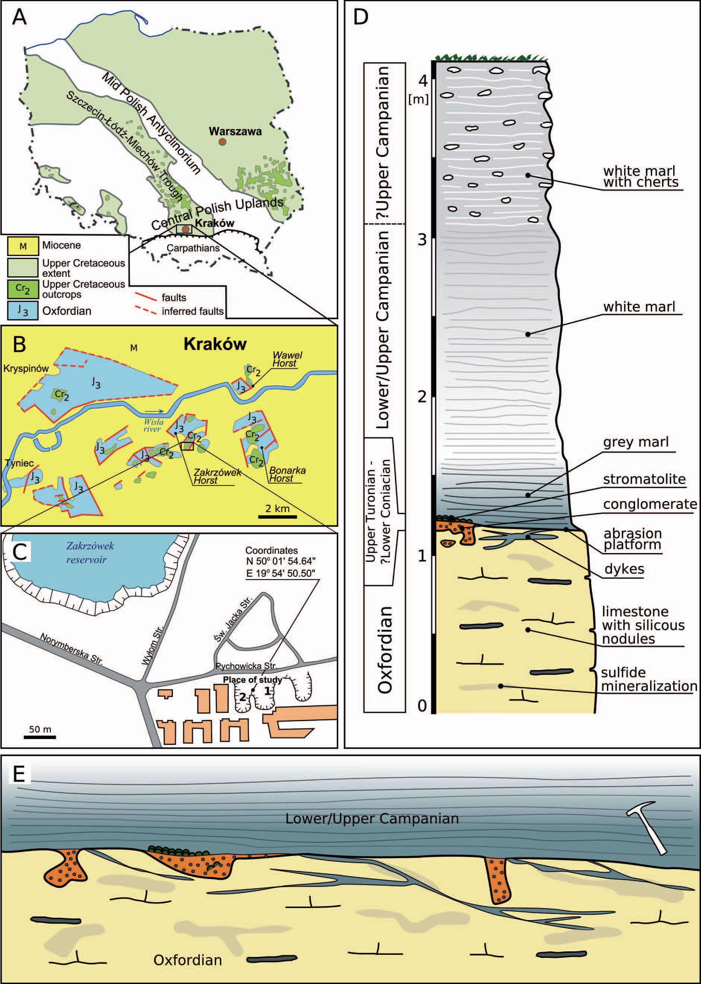
286
B. KOŁODZIEJ ET AL.

Fig. 1. A, B - Location of the study area on the general geological map of Poland (A; based on Sokołowski et al., 1976, fig. 128) and
Kraków region (B; based on Gradziński, 1993), C - Location of the studied pits 1 and 2 (based on Google Earth), D - Generalized section
of the Upper Jurassic and Upper Cretaceous sequence at the Pychowicka street in Kraków, E - Schematic diagram showing spatial rela-
tion of injection dykes, karstic cavities filled with conglomerates, overlying marls and Oxfordian basement truncated by the Late Creta-
ceous abrasion platform; for symbol explanation see Fig. 1D
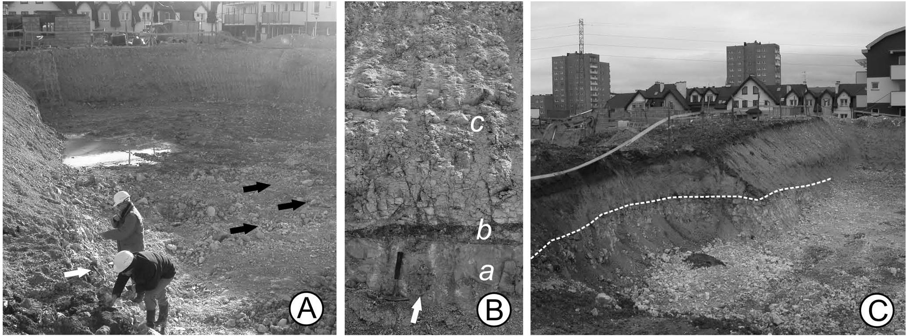
INJECTION DYKES
287

Fig. 2. A - General view of pit 1. On the left (eastern) side of the pit (white arrow) injection dykes occur within outcropped Oxfordian
limestones (see Fig. 5A). At the pit basement, apart from loose blocks of Oxfordian limestones cut by dykes, upward endings of dykes
were observed (black arrows), B - Oxfordian limestones (a) at pit 1 cut by abrasion platform and covered by weathered uppermost
Turonian-?Lower Coniacian conglomerates and ferruginous stromatolites (b), and Campanian marls (c); note oval karstic cavity filled
with conglomerates (arrow; see also Fig. 5D), C - General view of pit 2. Late Cretaceous abrasion platform truncating Oxfordian lime-
stones is marked by dotted line. The pit 1 is partly visible in the left, upper part of the picture
1961; see also overview by Bromtey et al., 2009). To the
north-east of Kraków, in the Miechów Trough, the thick-
ness of the Upper Cre taceous succession increases and at-
tains about 600 m.
The oldest Upper Cretaceous rocks in the Kraków re-
gion are Cenomanian sands and quartzose conglomerates,
which overlie locally an abrasion surface truncating the Ox-
fordian limestones. The overlying Turonian carbonate de-
posits do not exceed 10 m in thickness (Walaszczyk, 1992).
The Coniacian, well recognised northwards from Kraków
(Wataszczyk, 1992; Olszewska-Nejbert & Swierczewska-
Gładysz, 2009), used to be considered absent or not docu-
mented palaeontologically at Kraków, the view that should
be revised (see discussion in the section ‘Btostratigraphic
data’). The Santonian is usually present in the Kraków re-
gion, although stratigraphic gaps still exist. The Upper Cre-
taceous rocks in this region are composed mostly of Cam-
panian marls, marly limestones and siliceous chalky facies.

SEC TION DE SCRIP TION AND METH ODS
The studted sections represented by two pits, each ca.
50 ^{x} 30 m in size, were exposed in the Pychowicka Street,
during construction works, and were accessible from Janu-
ary to April 2008 (Figs 1C, D, 2).
In pit 1 (Figs 1E, 2A, B), the inclined, karstified and
abraded Oxfordian limestones are covered locally by con-
glomerates (uppermost Turonian-?Lower Coniacian) and/
or by weathered ferruginous stromatolites. Conglomerates
usually fill the karstic cavities developed in the Oxfordian
bedrock (see Fig. 5). The palaeokarst surface was partly
truncated during the Late Cretaceous transgression and is
pierced by Entobia cracoviensis Bromley et Uchman, sponge
borings which are abundant on the abrasion platform at the
Bonarka Horst (Bromley et al., 2009). Mostly, however, the
Jurassic bedrock, particularly in pit 2, is covered directly by
the Lower/Upper Campanian grey marls foll owed by the
?Upper Campanian white marls and marls with chert nodu-
les (Figs 1D, 2). The Santonian marls, occurring commonly
in most sections in the Kraków region, were not found in the
studied outcrops.
45 rock samples and 21 thin sections of Oxfordian lime-
stones with dykes or dyke filltng limestones, and 10 sam-
ples from conglomtrates (8 thin sections) were studted.
Most of the samples were collected as loose blocks from the
bottom of pit 1. The stratigraphy is based on foraminifers
and nannoplankton.
Fotaminiters from the dyke fillmgs were anatysed in
thin sections by means of optical microscopy. From the
overtymg marls, the samples were dried and dismtegrated
by repeated heating up and drymg in a sotution of sodium
carbonate. Residues were dried and washed through sieves
with 63 pm mesh diameter.
The slides for calcareous nannoplankton were prepared
usmg the standard smear-slide technique and then investi-
gated at ^{x}1000 magni tication under the light microscope
with bright and cross-polarised light. The average abun-
dance of assemblages is es timated as less than 1 specimen
per 10 fields of views. The studied samples are rich in car-
bonates, thus the main reason of poor preservation seems to
be the secondary calcite overgrowth, then the state of pres-
ervation were established as O-2 or O-3 using Roth’s (1983)
scale of coccolith preservation.
Rock samples, thin sections and other micropalaeonto-
logical samples are deposited at the Institute of Geological
Sciences, Jagiellonian University.
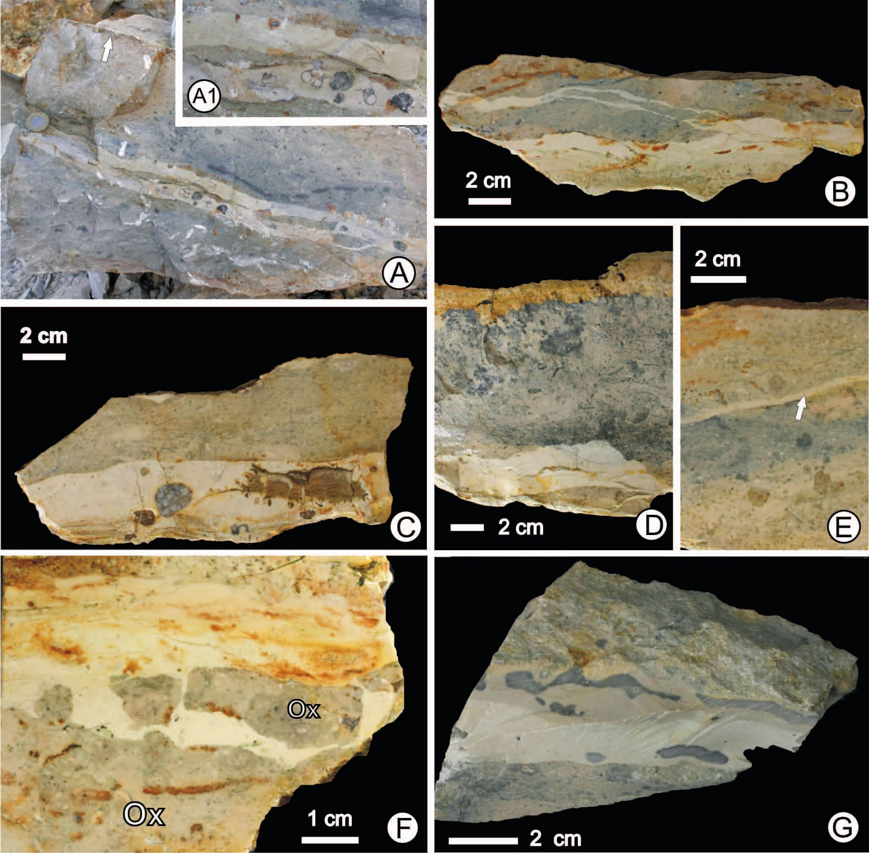
288
B. KOŁODZIEJ ET AL.

DESCRIPTION OF DYKES
The characteristic feature of the studted rocks, in par-
ticular in pit 1, is a fissure network which pierces the top-
most, several centimetres thick Jurassic bedrock (Fig. 5A,
and schematic diagram in Fig. 1E). The cracks are polygo-
nal in plane, commonly anastomosing, with widths ranging
between 1 mm and several centimetres (Figs 3, 4). Some of
the fis tures display upward endmgs. It is intrigumg that
most of the cracks are (sub)horizontal, while the vertical or
oblique ones (those not related with karstification) are short,
thin and quite rare (Fig. 4B). The oppos ite walls of the
cracks display good fitting (Fig. 3A). Slightly displaced
clasts of Oxfordian limestone from dyke wall were also ob-
served (Fig. 3F).
The fissures are filled with hard, pelitic limestones rep-
resenting mostly foraminiferal-calcisphere wackestones
(Figs 4C-F, 9, 10), with rare small gastropods (Fig. 3 A),

Fig. 3. Samples of Oxfordian limestones cut by injection dykes. All sections are approximately perpendicular to the topmost part of
Oxfordian limestones. A - Oxfordian limestones truncated by abrasion surface (arrow) and cut by horizontal injection dykes filled with
foraminiferal-calcisphere limestones with quartz pebbles and gastropod shells. Coin for scale is 2 cm in diameter, A1 - Close-up of the
dyke from the figure A showing gastropod shells and quartz pebbles, B - Polished slab showing fragment of larger dyke and thin out-
growth dykes, C - Dyke (lower part) filled with limestones containing fragment of stromatolite and quartz pebbles, D - Dyke (lower part)
within Oxfordian limestones, dark colour due to sulphide mineralization, E - Thin dyke (arrow) cutting Oxfordian limestones (pit 2), F -
Clasts of Oxfordian (Ox) limestone slightly displaced from the wall of dyke filled with white-reddish limestone, G - Oxfordian limestones
cut by injection dyke filled by Campanian silicified limestones
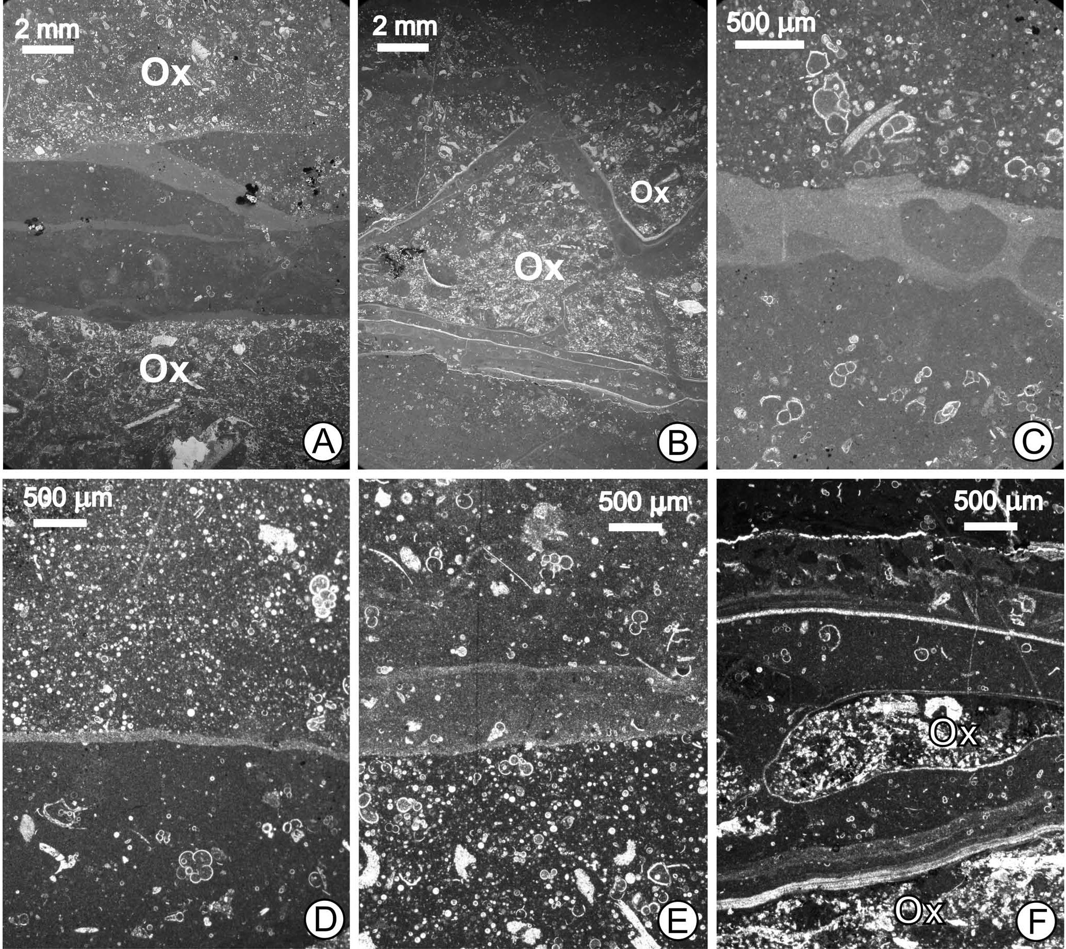
INJECTION DYKES
289
rare quartz pebbles (Fig. 3A, C) and debris of phosphatic
and ferruginous stromatolites (Fig. 3C). The limestones are
white, locally with reddish, green and black spots. Several
gen erations of dykes and fis sure fill ings (mi crostratifi ca-
tion) were recognised (Fig. 4). They differ in abundance of
foraminitera and calcispheres and subtly in sediment colt
our. The dyke fillings usually show lining parallel to the fis-
sure walls.
The fractured Oxfordian limestones from pit 1 are ir-
regularly stained with sulphide minerals (e.g., Fig. 3A, D),
while the non- fractured lime ttones are sparsely mineral
ized. Moreover, microscopic observations revealed that Ox-
fordian limestones are partly dolomitized, but spatial distri-
bution of dolomitization was not studied. The sulphide min-
eralization and silicification were also observed within the
dyke fillings, however less intensively than in the host Ox-
fordian limestones. It is also noteworthy that while in pit 1
the fissures are common (mostly in the eastern part), in pit 2,
located some 100 m apart, the Jurassic bedrock was frac-
tured very sparsely (Fig. 3E).
Additionally, rare vertical karstic cavities filled with
conglomerates were identified (Fig. 5C). They are rounded
in cross sections (Figs 2B, 5D) what indicates that they rep-
resent vertical dips of karstic cavities. They are, however,
developed mostly as superficial depressions exposed on the
abraded Oxfordian limestones (Fig. 5A, B). Vertical cavi-
ties are maximum ca. 50 cm deep, however, their definite
vertical ext ension is not recognised because of poor expo-
sure of the Oxfordian bedrock. Figure 1E shows spatial re-
lation of injection dykes, karstic cavities, overlying marls
and Oxfordian basement truncated by the Late Cre taceous
abrasion platform.

Fig. 4. A-F - Microphotographs of Campanian injection dykes and Oxfordian basement (Ox). Different generations of dykes are re-
flected in differences of filling sediments as result of various content of foraminifera, calcispheres (calcareous dinocysts) and micritic ma-
trix. Note fissure network (B), dyke containing injected fragments of consolidated micritic limestone (C) and subtle lamination (F)
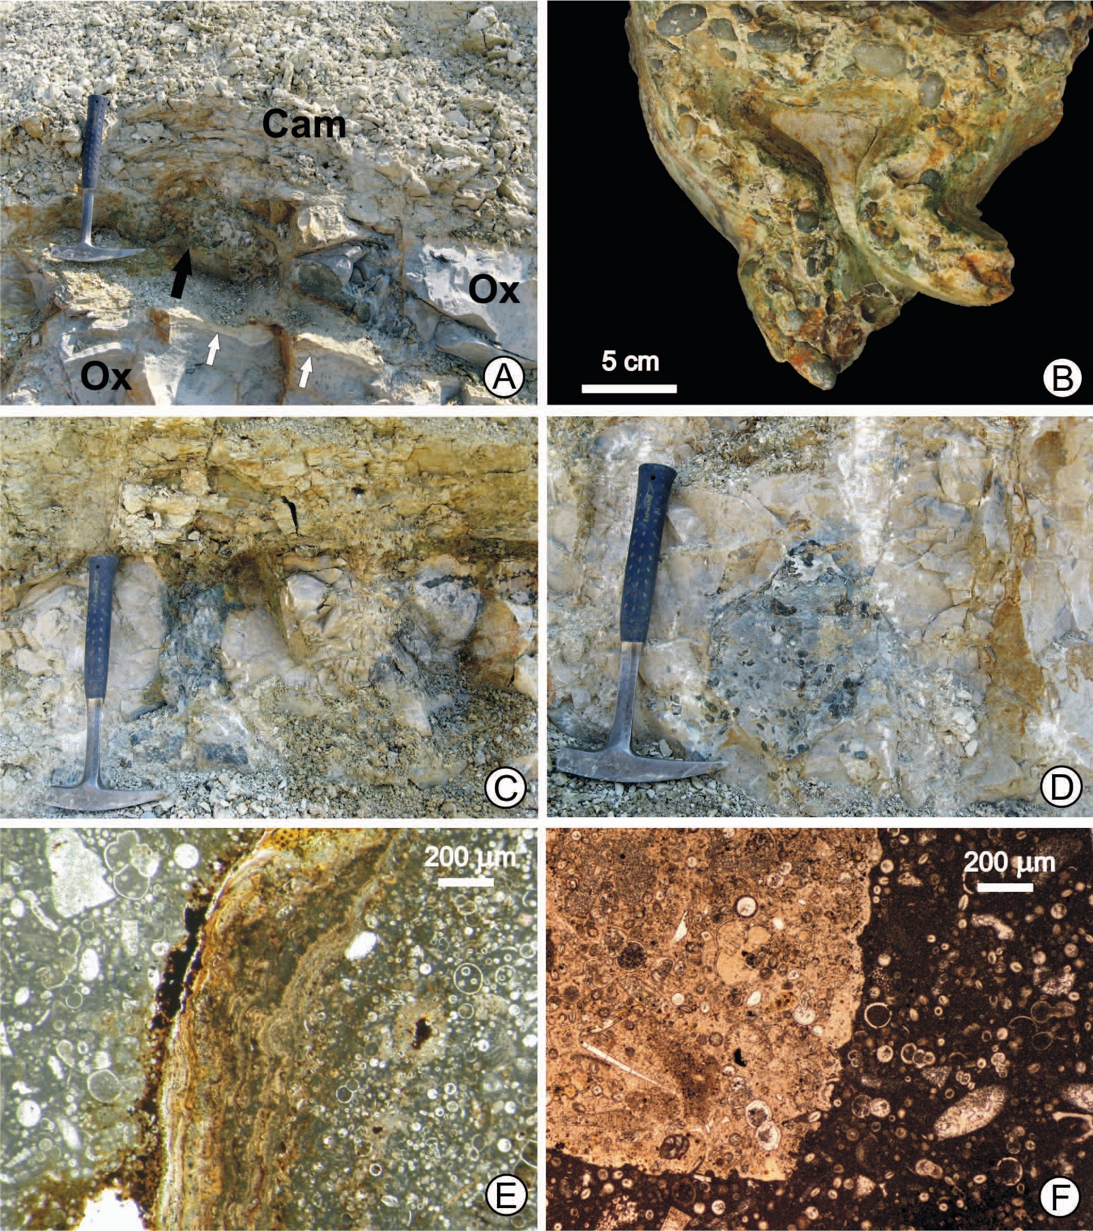
290
B. KOŁODZIEJ ET AL.

Fig. 5. A - Uneven abrasion platform truncatśng Oxfordian limestones (Ox); uppermost Turonian-?Lower Coniacian conglomerate
fills cavity of karstic origin (black arrow) and is covered by Campanian marls (Cam); note subhorizontal injection dykes (white arrows;
see also Fig. 2A), B - Late Cretaceous conglomerate filling karstic cavities (“cast”), C - Vertical karstic cavity filled by conglomerate, D
- Transverse section through channel-like karstic cavity within Oxfordian limestones (compare Fig. 2B), E, F - Microphotographs of the
uppermost Turonian-? Lower Coniacian conglomerate filhng karstic cavhies; note differences in microfacies of carbonate clasts and
encrustation of ferruginous stromatolite
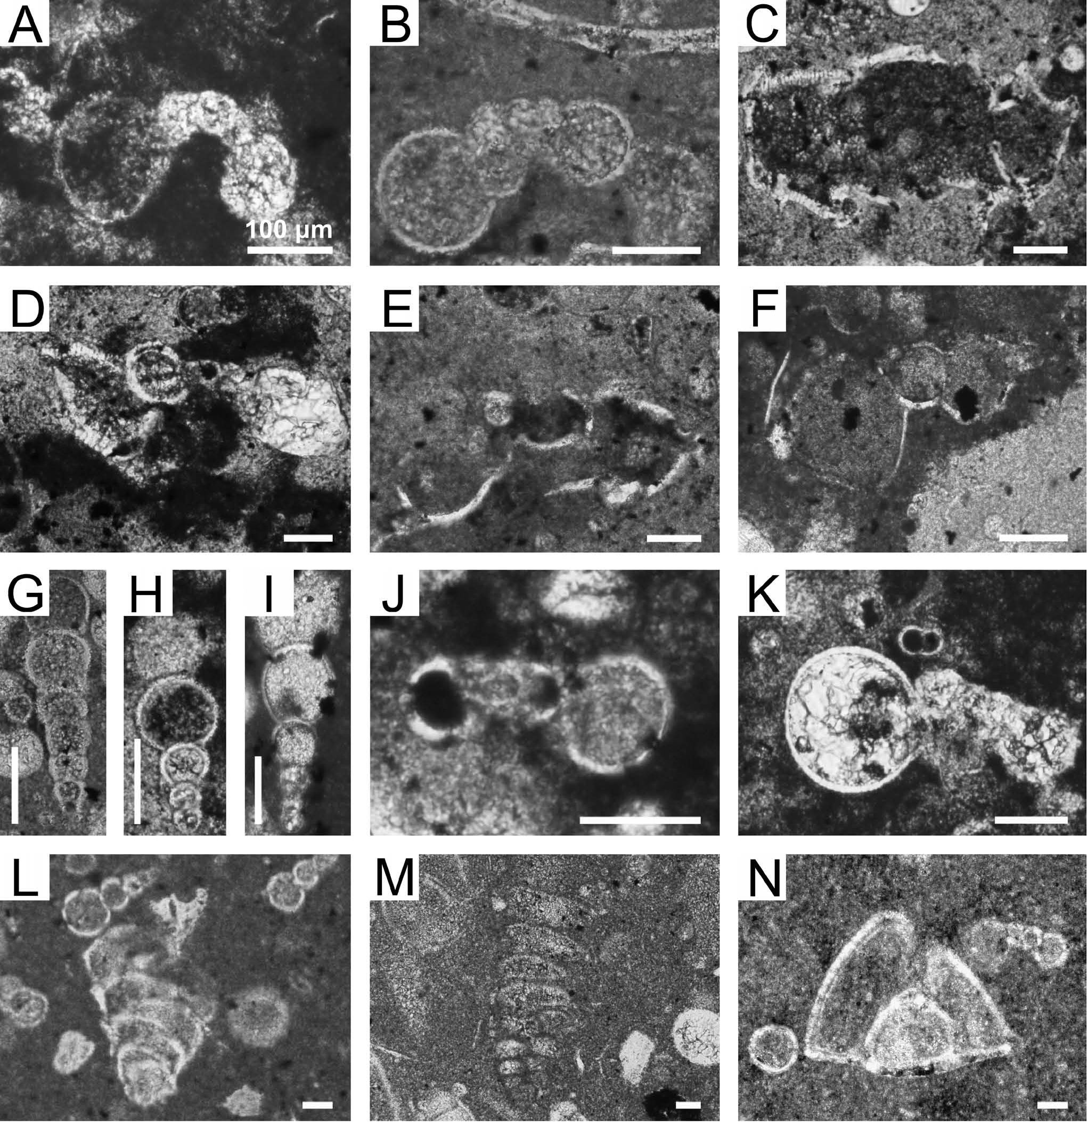
INJECTION DYKES
291

BIOSTRATIGRAPHICAL DATA
The age of conglomerates
Micropalaeontological examination was done both for
the limestone clasts and carbonate matrix of the conglomer-
ates.
Foraminifera distinguished in thin sections include plan-
ktonic index species. The presence of Dicarinella primitiva
(Dalbiez) (Fig. 6E, F), which is the index species of Margi-
notruncana sigali-Dicarinella primitiva Zone (Premoli-
Silva & Sliter, 1999), and the presence of Dicarinella
concavata (Brotzen) (Fig. 6D), which is the index species of
Dicarinella concavata Zone (zonation accordmg to Roba-
szynski et al., 1984; Caron, 1985; Robaszynski & Caron,
1995; Premoli-Silva & Rettori, 2002; Premoli-Silva &
Verga, 2004) indicate an age within the latest Turonian-
Coniacian interval (sample Pych 40; Fig. 7).

Fig. 6. A-K - The planktonic foraminiferids from conglomerate filhng karstic cavkies (Pych 40), axtal sections. A - Archaeo-
globigerina bosquensis (Pessagno), B - Archaeoglobigerina cf. bosquensis (Pessagno), C - Dicarinella sp., D - Dicarinella concavata
(Brotzen), E, F - Dicarinella primitiva (Dalbiez), G - Heterohelix moremani (Cushman), H, I - Heterohelix sp., J - Muricohedbergella
planispira (Tappan), K - Whiteinella baltica Douglas et Rankin, L-N - Benthic foraminiferids from Campanian injection dykes, axial
section. L- Eouvigerina aculeata (Ehrenberg), M - Gaudryina sp., N - Globorotalites cf. michelinianus (d’Orbigny). Scale bar indicates
100 pm
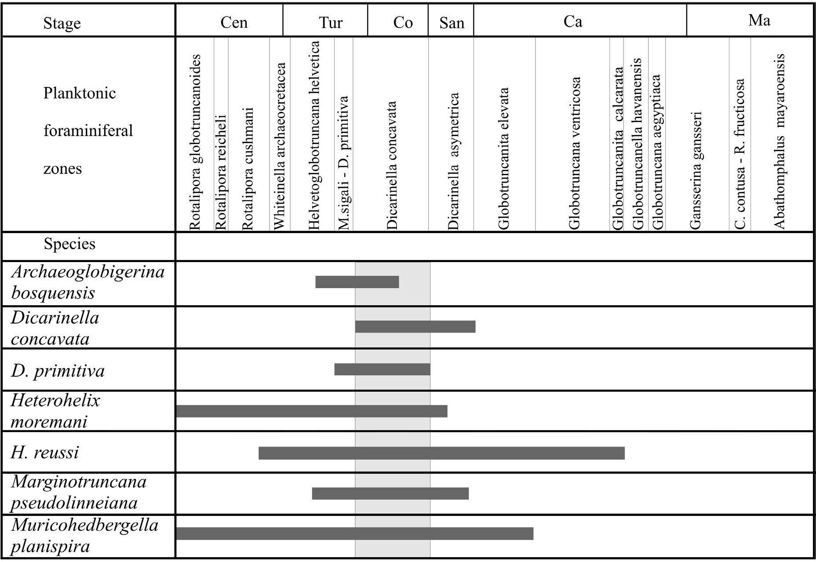
292
B. KOŁODZIEJ ET AL.

Fig. 7. Biostratigraphical ranges of the studted planktonic index foraminiferids from conglomerate. Ranges of species and biozones
combined after Robaszynski et al. (1984), Caron (1985), Robaszynski and Caron (1995), Premoli-Silva and Rettori (2002), and
Premoli-Silva and Verga (2004). The grey area indicates biozones recognised in the studied material
The index taxa are accompanied by other planktonic fo-
rams including Archaeoglobigerina bosquensis (Pessagno)
(Fig. 6A, B), Dicarinella sp. (Fig. 6C), Heterohelix more-
mani (Cushman) (Fig. 6G), Heterohelix reussi (Cushman),
Marginotruncana praelinneiana Pessagno, Marginotrun-
cana sp., Muricohedbergellaplanispira (Tappan) (Fig. 6J),
and Whiteinella baltica Dougtas et Rankin (Fig. 6K). The
Dicarinella concavata Zone contains A. bosquensis, the last
occurrence of which is known from the Middle Coniacian
and characterizes the middle part of this zone (Fig. 7). How-
ever, in the case of the studied conglomerates, the possible
redeposition of the older faunas does not allow us to define
the precise age. Dicarinella concavata Zone remains indica-
tive, thus the age of the conglomerate based on foraminifera
points to the latest Turonian-Coniacian interval.
The nannofossil assemblage, represented by sample
Pych 41, is moderately diversified and abundant. State of
preservation of the nannofossils is the best among the stud-
ied samples, though it is still estimated as O-2. This assem-
blage, dominated by W. barnesiae, contains 24 taxa, includ-
ing among others such taxa as Arkhangelskiella cymbifor-
mis (Fig. 8H), Broinsonia parca expansa (Fig. 8F), Quad-
rum gartneri (Fig. 8Oa) or Micula spp. (Fig. 8M). More-
over, it contains also two index species of Burnett’s (1998)
stratigraphic nannoplankton zonation for the Upper Creta-
ceous (UC zones): Quadrum gartneri (Fig. 8Oa), which de-
fines the base of the middle Turonian UC 7 Zone; and
Broinsoniaparca expansa (Fig. 8F), which defines the base
of the UC9c Subzone, lately correlated with the Upper Tu-
ronian (Lees, 2008). Furthermore, the assemblage also in-
cludes Micula spp. (Fig. 8M). Taxonomy of the found spec-
imens was determined at the genus level due to poor preser-
vation and scarce occurrence, but they may represent either
M. adumbrata or M. staurophora. The first occurrence (FO)
of M. adumbrata (probable ancestor of M. staurophora) is
diachronous through the UC9a to UC9c zones, which em-
braces the interval from the middle Middle Turonian to the
lower Middle Coniacian (Lees, 2008). Lees (2008) noted
the FO of M. adumbrata in Słupia Nadbrzeżna section (Po-
land) within the UC9c Zone (Lower Coniacian), but in the
Czech Repubtic (Brezno section) this species was found
within the UC9b Zone (Upper Turonian). On the other
hand, Kędzierski (2008) studted the Turonian/Coniacian
boundary interval in the Opole Trough (Poland) and did not
find any Micula species up to upper Lower Coniacian. In
contrast, M. staurophora has the certain stratigraphic posi-
tion of the FO, that is the index species of the base of the
UC10 Zone, correlated with the lower Middle Conia- cian.
Therefore, in the case of M. adumbrata occurrence, that is
Micula genus in general, the age of the studied assemblage
is not older than the Late Turonian (UC9c Zone), but its
Late Turonian/Early Coniacian age seems probable.
To conclude: based on foraminifera and nannoplank-
ton, the age of conglomerates is estabtished as the latest
Turonian-?Early Coniacian.
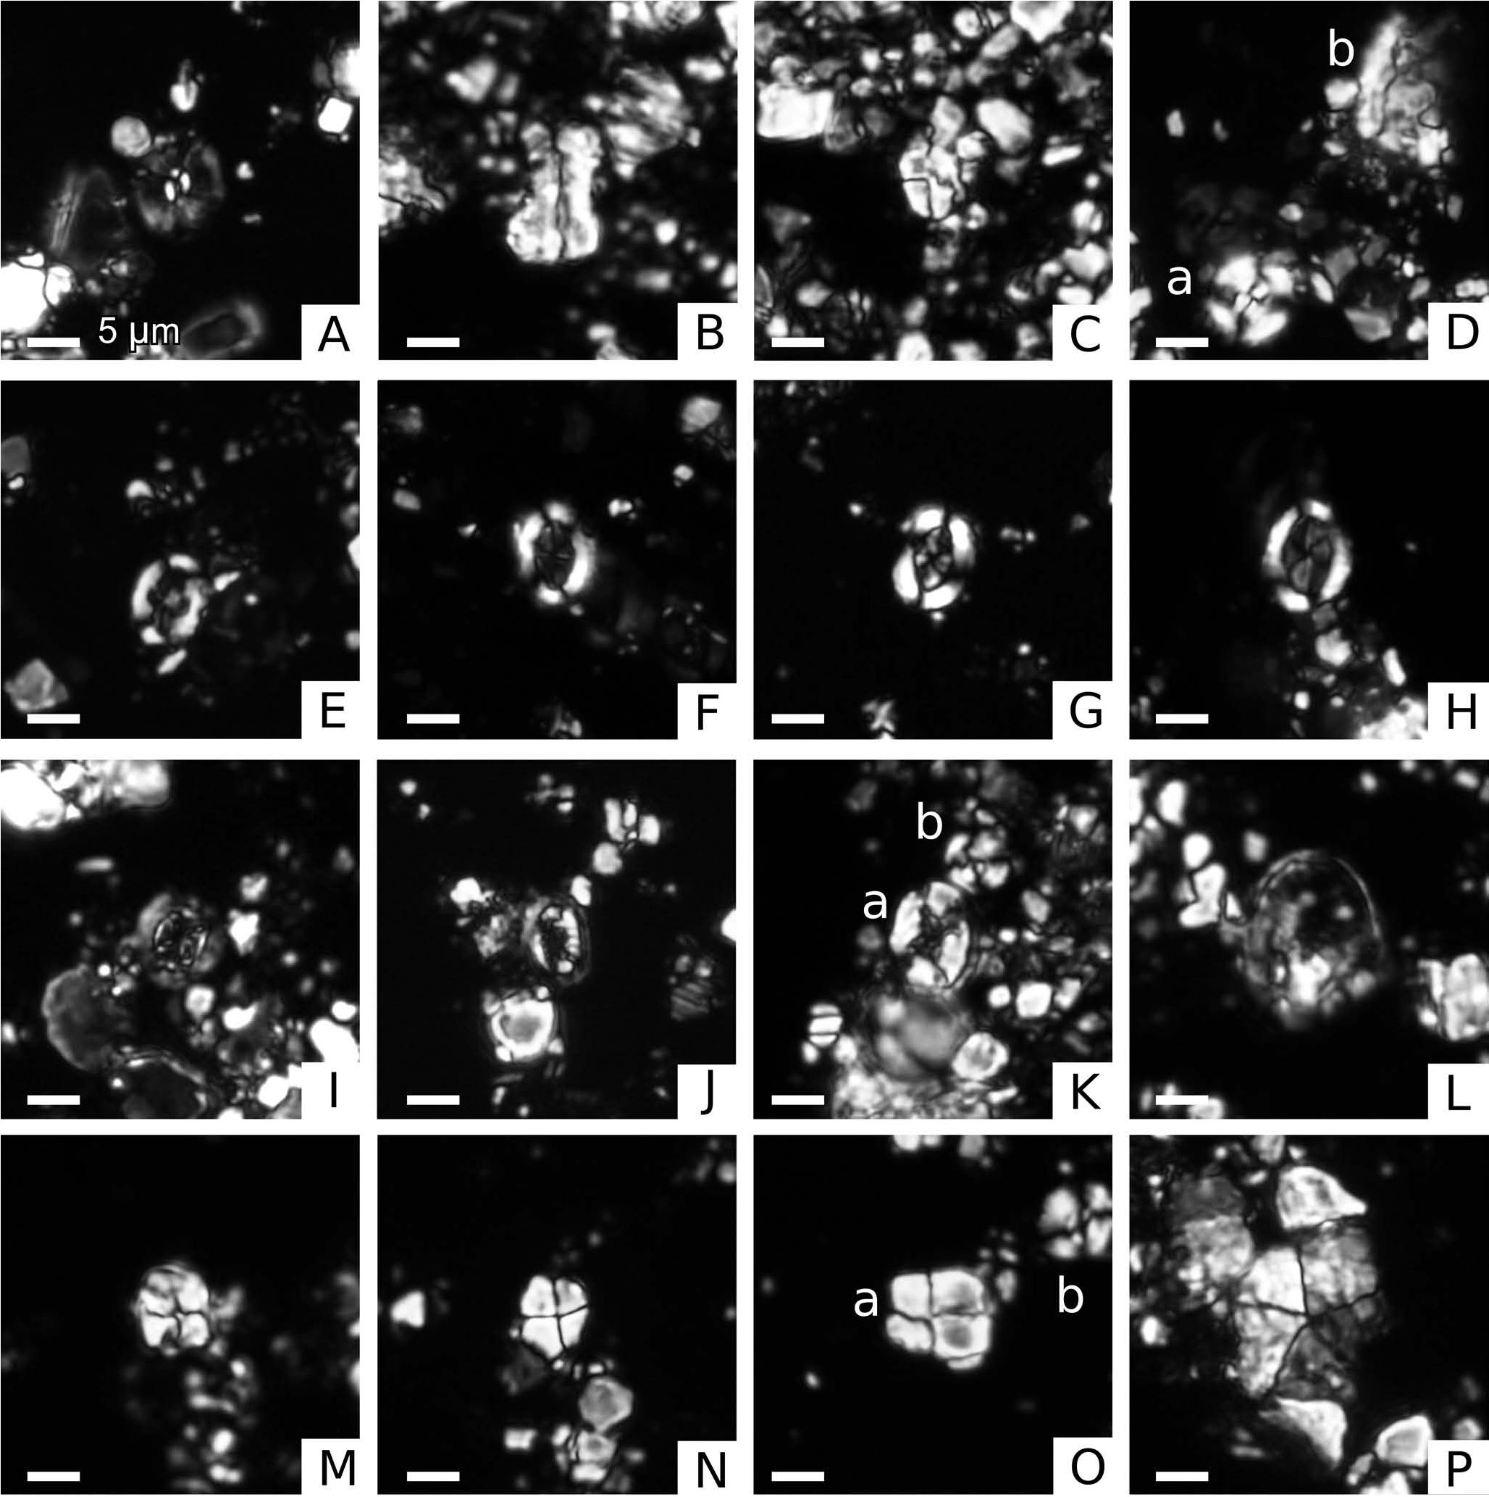
INJECTION DYKES
293

Fig. 8. Calcareous nannoplankton under the light microscope in cross-polarised light. A - Bisctum constans (Pych 41), B - Lucia-
norhabdus cayeuxii (Pych 50), C - Calculites ovalis (Pych 50), D - a. Watznaueria barnesiae, b. Lucianorhabdus cf. L. cayeuxii (Pych
50), E - Broinsonia signata (Pych 41), F - Broinsonia parca expansa (Pych 41), G - Broinsonia matalosa (Pych 41), H - Arkhan-
gelskiella cymbiformis (Pych 41), I - Prediscosphaera cretacea (Pych 41), J - Cribrosphaerella ehrenbergii (Pych 41), K - a. Eiffellithus
eximius, b. Watznaueria barnesiae (Pych 41), L - Kamptnerius magnificus (Pych 41), M - Micula sp. (Pych 41), N - ?Quadrum sp. (Pych
41), O - a. Quadrum gartneri, b. Watznaueria barnesiae (Pych 41), P - Braarudosphaera bigelowii (Pych 41). Scale bar indicates 5 pm
Coniacian depostis are well documented by Walasz-
czyk (1992) and Olszewska-Nejbert and Swierczewska-
Gładysz (2009) ca. 30 km northwards of Kraków, and pos-
sibly they may also be expected in the Kraków region.
There are also some older reports that may point to the pres-
ence of the Coniacian in Kraków vicinity in the light of the
modern stratigraphic scheme. For instance, Zaręczny
(1878), Smoleński (1906), Panow (1934) and Alexandro-
wicz (1954) described fossils which first appear within the
traditional Inoceramus schloenbachi Zone. Lately, I. schlo-
enbachi fell into synonymy with the Cremnoceramus cras-
sus, the index species for C. crassus Zone correl ated with
the Lower Coniacian (Walaszczyk, 1992; Kauffman et al.,
1996; Walaszczyk & Wood, 1998). Hence, the mentioned
findmgs may be ascribed as the Lower Coniacian. Never-
theless, these older findings need current studies to indubi-
tably confirm them.
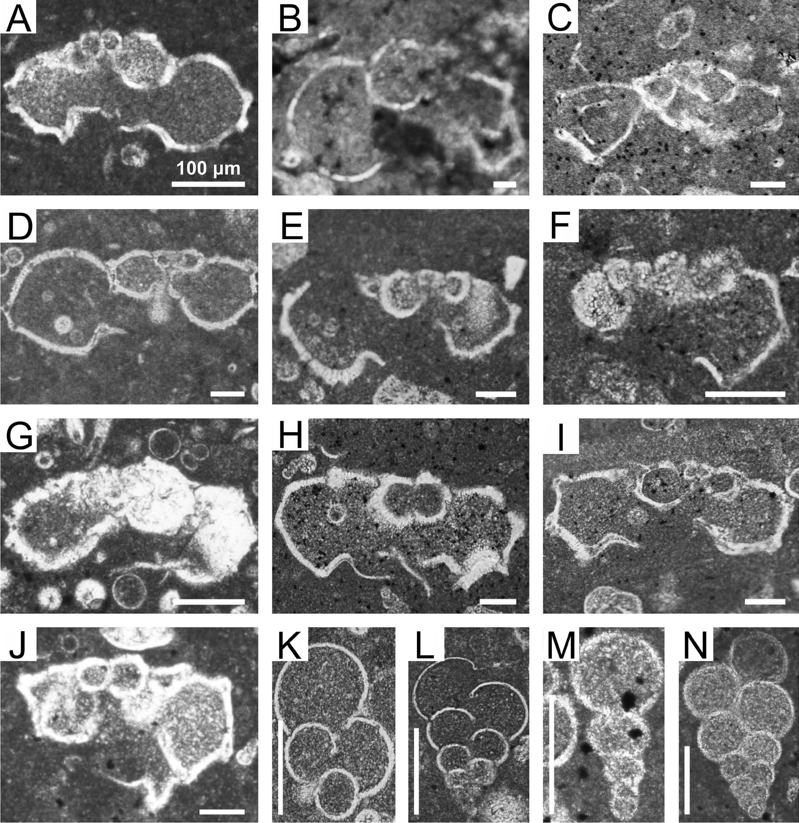
294
B. KOŁODZIEJ ET AL.
The age of the dyke filling limestones
In the foraminiferal assemblages (anatysed in the thin
sections) from dyke filling limestones, abundant planktonic
non-keeled and keeled taxa occur, such as: Archaeoglobige-
rina cretacea (d’Orbigny) (Fig. 9A, 10K), Archaeoglobi-
gerina blowi (Bolli), Contusotruncana cf. plummerae (Gan-
dolfi) (Fig. 9B), Globotruncana arca (Cushman) (Fig. 9C),
Globotruncana bulloides Vogler (Fig. 9D, E), Globotrun-
cana hilli Pessagno (Fig. 9F, G), Globotruncana ex gr.
lapparenti Brotzen (Fig. 9H), Globotruncana linneiana
(d’Orbigny) (Fig. 9I), Globotruncana cf. rosetta (Carsey)
(Fig. 9J), Heterohelix globulosa (Ehrenberg) (Fig. 9K),
Heterohelix cf. reussi (Cushman) (Fig. 9M), Muricohedber-

Fig. 9. Campanian planktonic foraminiferids from injection dykes. A - Archaeoglobigerina cretacea (d’Orbigny), axial section (Pych
5), B - Contusotruncana cf. plummerae (Gandolfi), axtal section (Pych 4), C - Globotruncana arca (Cushman) (Pych 5), D -
Globotruncana bulloides Vogler, axial section (Pych 5), E - Globotruncana bulloides Vogler, axial section (Pych 27), F - Globotruncana
hilli Pessagno, axial section (Pych 5), G - Globotruncana cf. hilli Pessagno, axial section (Pych 4), H - Globotruncana ex. gr. lapparenti
Brotzen, axial section (Pych 5), I - Globotruncana linneiana Brotzen, axial section (Pych 5), J - Globotruncana cf. rosetta (Carsey), axial
section (Pych 5), K - Heterohelix globulosa (Ehrenberg), axtal section (Pych 27), L - Heterohelix sp., perpendicular to axial section
(Pych 4), M - Heterohelix cf. reussi (Cushman), perpendicular to axial section (Pych 27), N - Heterohelix sp., axial section (Pych 27).
Scale bar indicates 100 pm
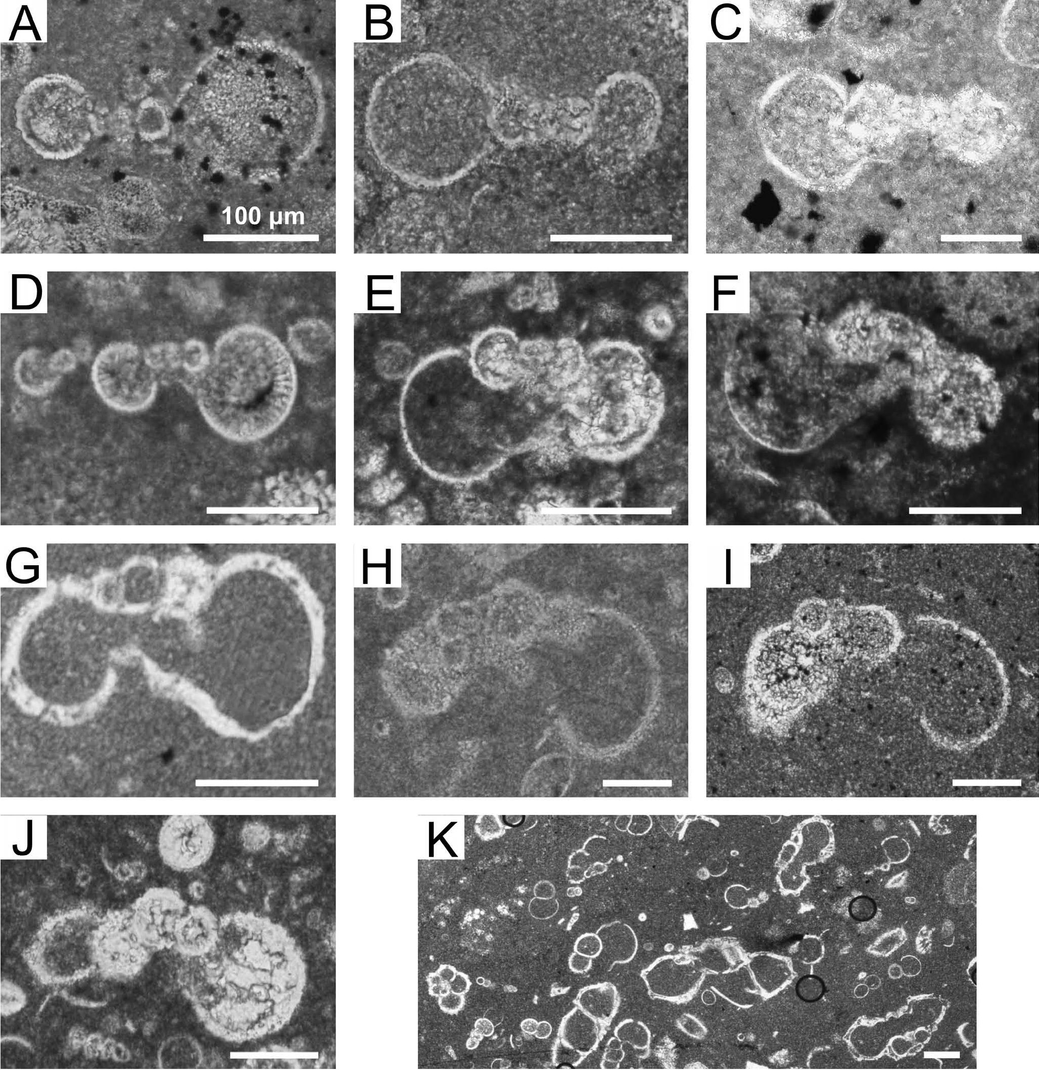
INJECTION DYKES
295
gella holmdelensis (Olsson) (Fig. 10D), Muricohedbergella
monmouthensis (Olsson) (Fig. 10E-G), and Rugoglobige-
rina rugosa (Plummer) (Fig. 10H-J).
Benthic foraminiferids are relatively rare and dominated
by calcareous specimens: Eouvigerina aculeata (Ehrenberg)
(Fig. 6L), Globorotalites cf. michelianus (d’Orbigny) (Fig.
6N), Reussella sp., and Stensioeina sp. Agglutinated ben-
thic forms are represented by Arenobulimina sp. and Gau-
dryina sp. (Fig. 6M).
The planktonic foraminiferal assemblages represent Glo-
botruncana ventricosa and Globotruncanita calcarata zones
sensu Robaszynski et al. (1984), Caron (1985), Robaszynski
and Caron (1995), Premoli-Silva and Rettori (2002), and
Premoli-Silva and Verga (2004) and indicate the Early/Late
Campanian age (Fig. 11), not older than the latest Early
Campanian. All the diagnostic species as well as some taxa
which are typical of the studied foraminiferal assemblages
are illustrated in Figs 9 and 10. Among foraminiferal assem-

Fig. 10. Campanian planktonic foraminiferids from injection dykes; axial sections. A - Macroglobigerinelloides bollii (Pessagno) (Pych
5), B - Macroglobigerinelloides bollii (Pessagno) (Pych 27), C - Macroglobigerinelloides cf. prairiehillensis Possagno (Pych 5), D -
Muricohedbergella holmdelensis (Olsson) (Pych 5), E, F - Muricohedbergella monmouthensis (Olsson) (Pych 5), G - Muricohedbergella
monmouthensis (Olsson) (Pych 5), H-J - Rugoglobigerina rugosa (Plummer) (Pych 5), K - Foraminiferal assemblages domtnated by
Archaeoglobigerina cretacea (d’Orbigny) (Pych 4). Scale bar indicates 100 pm
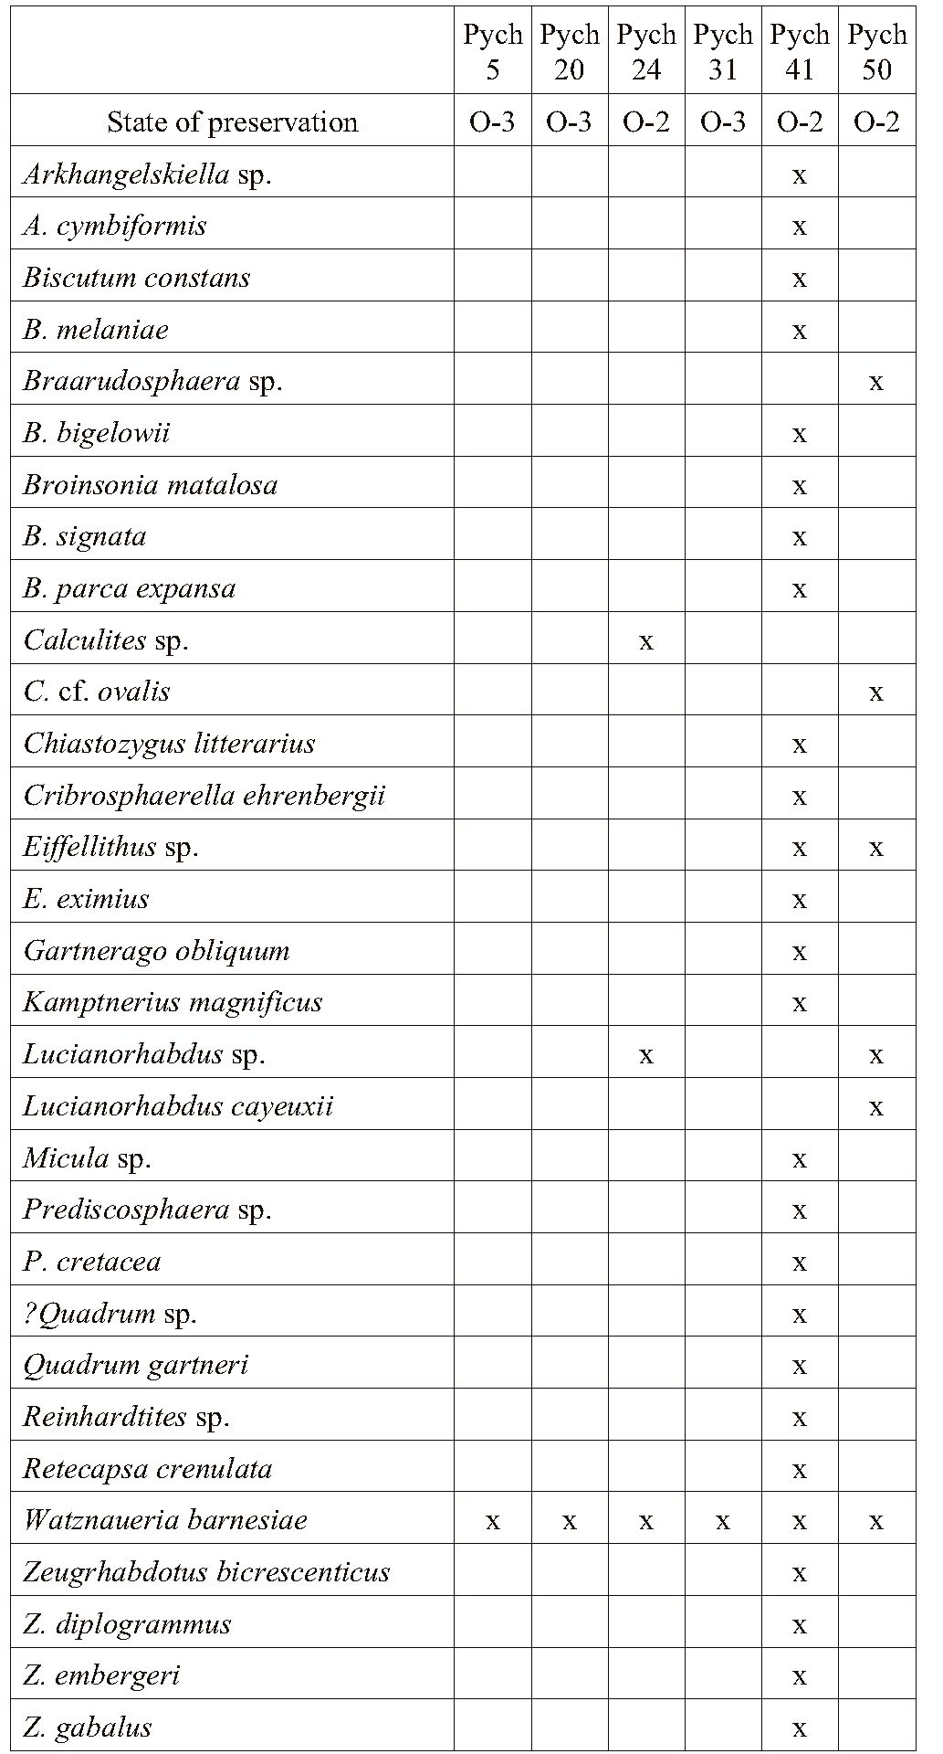
296
B. KOŁODZIEJ ET AL.

Table 1
Distribution of calcareous nannofossils and state of preser-
vation of the studied assemblages
blages only the range of Heterohelix reussi is an exception;
its last occurrence (LO) is characteristic for the middle part
of Globotruncanita elevata Zone (Fig. 11), which represents
the Early Campanian. However, according to Peryt (1980),
the LO of this species in Central Pot and is noted from the
Upper Campanian (Globotruncanita calcarata Zone). In the
current Cretaceous Time Scale (Ogg et al., 2008) Globo-
truncanita calcarata Zone is situated in the lower part of the
Upper Campanian (Fig. 11).
The nannofossil assemblage from dykes (samples Pych
5, 20, 24, 31, 50) contains poorly preserved and scarce cal-
careous nannofossils (Fig. 8B-D). Only five taxa were re-
cognised within this assemblage dominated by Watznaueria
barnesiae (Fig. 8Da), which constitutes about 90% of total
abundance. Furthermore, Calculites ovalis (Fig. 8C), Lucia-
norhabdus cayeuxii (Fig. 8B, Db), Eiffellithus sp., and Bra-
arudosphaera sp. were ascertained as well. Complete list of
the calcareous nannoplankton is given in Table 1.
Although only few index species occur within the dyke
fillings, the presence of L. cayeuxii, whose FO defines the
base of UC11c subzone embracmg the uppermost Conia-
cian and the Lower Santonian, allows one to define the age
of the fillings as not older than the latest Coniacian.
Concluding, the age of limestone filling injection dykes
is Early/Late Campanian (Globotruncana ventricosa and
Globotruncanita calcarata zones), and not older than the lat-
est Early Campanian.

The age of the overlying marls
The grey marls overlying Oxfordian limestones are
lithologically very similar to the Santonian-Lower Campa-
nian marls described from other sites in the Kraków region;
there tore, they were previously betieved to repre tent the
Santonian (Kołodziej et al., 2008), an assumption which is
here revised. The marls contain abundant non-keeled plank-
tonic foraminifera with dominating Archeoglobigerina cre-
tacea (d’Orbigny), Heterohelix navarroensis Loeblich,
Heterohelix striata Ehrenberg, Muricohedbergella mon-
mouthensis (Olsson), and rare Rugoglobigerina rugosa
(Plummer). Planktonic keeled forams are rare and repre t
sented by Globotruncana arca (Cushman) and Globotrun-
cana bulloides Vogler. The first occurrence of M. mon-
mouthensis (zonation according to Robaszynski et al.,
1984; Caron, 1985; Robaszynski & Caron, 1995; Premoli-
Silva & Rettori, 2002; Premoli-Silva & Verga, 2004) indi-
cates the Early/Late Campanian age, not older than the latest
Early Campanian. Numerous benthic species from the
marls, including Cibicides beaumontianus (d’Orbigny),
Gavelinella costulata (Marie), Globorotalites michelinia-
nus (d’Orbigny), Praebulimina div. sp., Stensioeina div. sp.
(Stensioeina exsculpta (Reuss), and Stensioeina gracilis
Brotzen) are characteristic for the Campanian (Zapałowicz-
Bilan, 1982, cf. Gawor-Biedowa, 1992).

DISCUSSION
Re cently, Montenat et al. (2007) reviewed the main
types of seismites and proposed their modüied classiticat
tion. Among principally brittle deformations, neptunian
dykes and inj ection dykes are the best known seismites.
Neptunian dykes are formed by intillmg pre-extstmg fist
sures exposed on the sea bottom, and which may be open
for a long time. Injection dykes are filled by material
through hydrostatically controlled pressure, and are combi-
nation of hydro fracturing of hard substrate and fillmg by
overpressured (fluidized) soft sediments (Flügel, 2004;
Montenat et al., 2007). Fissure networks developed nearby
the fault zone commonly produce a jigsaw-puzzle pattern
(autoclastic breccias; Montenat et al., 2007). Well devel t
oped jigsaw-puzzle pattern of cracks does not occur in the
studi ed case, what can suggests that the region was not
situated close to an active fault.
x - presence; blank - absence

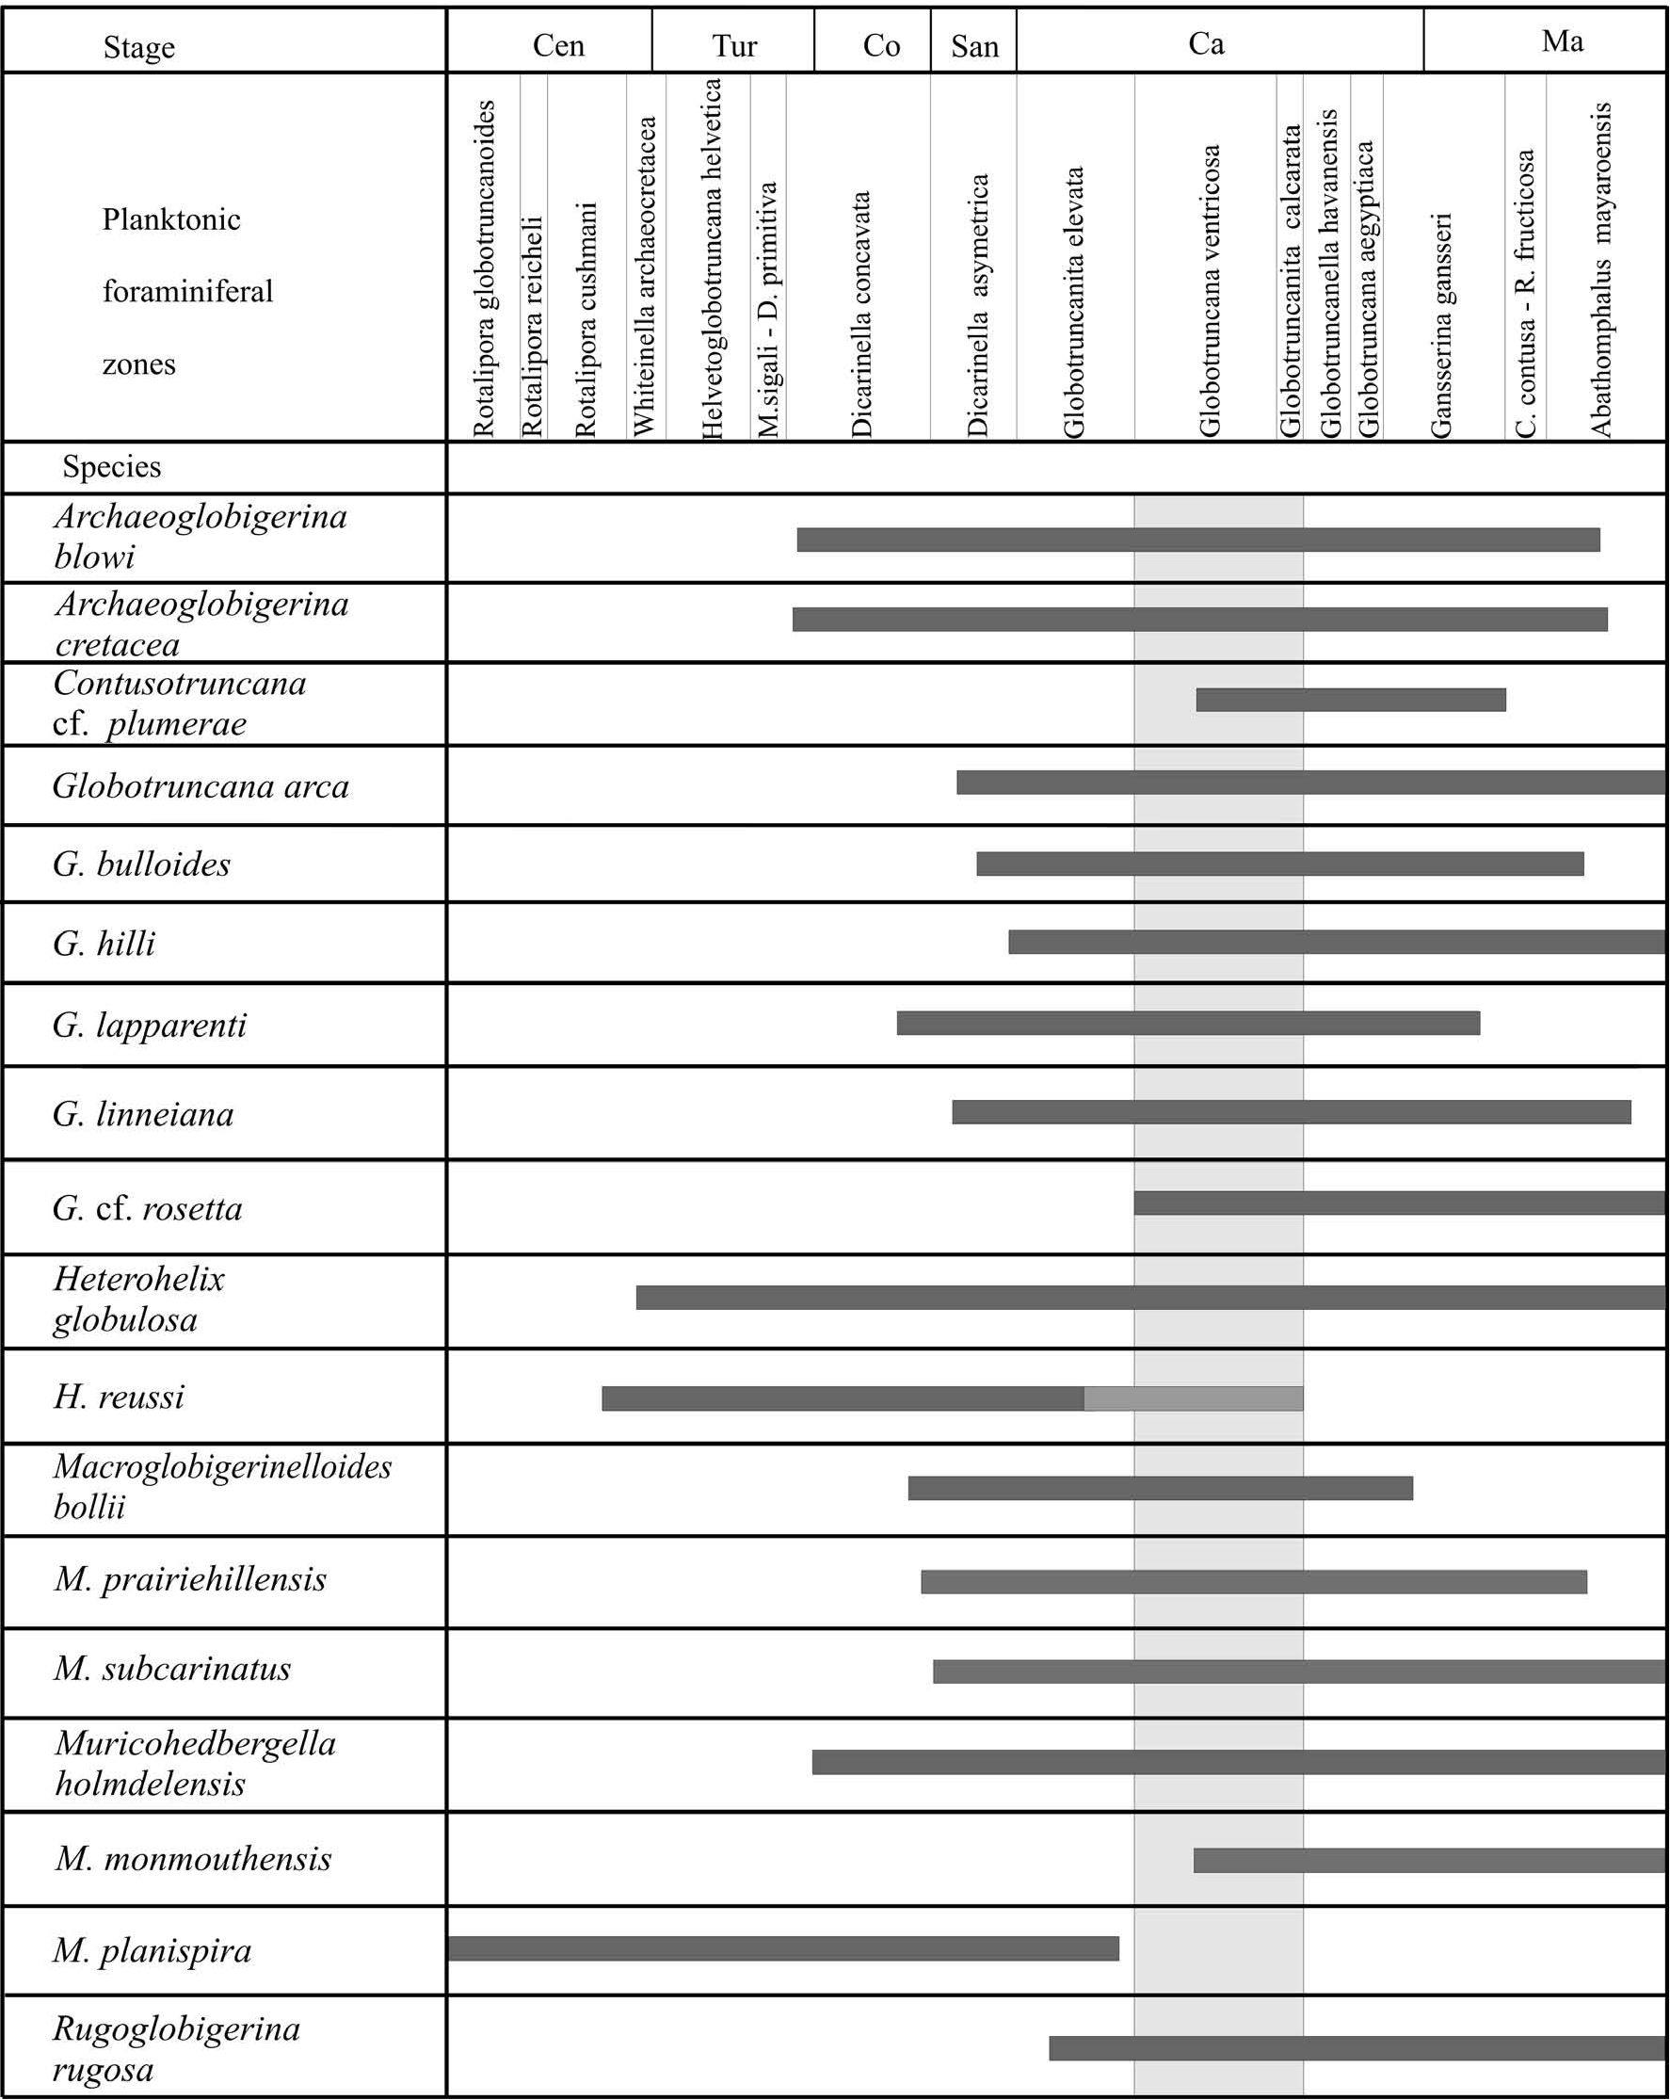
INJECTION DYKES
297

Fig. 11. Biostratigraphical ranges of the planktonic foraminiferids from injection dykes. Ranges of species and biozones combined after
Robaszynski et al. (1984), Caron (1985), Robaszynski and Caron (1995), Premoli-Silva and Rettori (2002), Premoli-Silva and Verga
(2004), and Peryt (1980). The grey area indicates biozones recognised in the studied material
Seduuent fillmgs of the studted dykes display several
characteristics, such as microstratification, instant lithifica-
tion and multiple cross-cutting, which document complex
generation of the cracks. Because the dyke fill shows mostly
lining parallel to the fissure walls, it evidences an active in-
filling typical of injection mechanism, that is forceful mode
of emplacement initiated as a result of high fluid pressures
(Röshoff & Cosgrove, 2002; Montenat et al., 2007). Thus,
as previously suggested by Kołodziej et al. (2008), the fis-
sures are inj ection dykes. Seismic shocks induced fluid
overpressure, hydraulic fracturing of the Jurassic substrate,
and liquefaction of the overlying Lower/Upper Campa-
nian unconsolidated sediments (now recognised only within
dykes). The latter, as well as small quartz pebbles and frag-
ments of stromatolite (from the uppermost Turonian-
?Lower Coniacian conglomerates) are subordinate compo-
nents of some inj ection dykes. They were sucked into the
opened fractures, producing the injection dykes.
298
B. KOŁODZIEJ ET AL.
As mentioned above, the cracks are mostly subvorti
zontal) and aftected only the topmost several centimetre
thick layer of the Jurassic bedrock. This indicates that this
system of cracks origmated by Love or Rayteigh waves
travelling near the ground surface. These surface waves are
most effective in ground displacement and disturbance
(Bolt, 2004).
The morphological features of the discussed injection
dykes differ from the typical, gravitationally-filled neptu-
nian dykes by the dominant role of hydraulic forces. Similar
inj ection dykes are known from other tectonically active
settings, both recent (Montenat et al., 1991, 2007) and an-
cient ones (Füchtbauer & Richter, 1983; Cosgrove, 2001;
Aubrecht & Szulc, 2006), where their origin have been also
ascribed to the quake tremor. Finally, the seismic origin of
such veinlets has been confirmed by quake-simutation ex-
periments (Brothers et al., 1996).
The discussed area was tectonically active in the Late
Cretaceous. During that time the Kraków Swell was located
on the western margin of the Mid-Polish Trough. According
to Krzywiec et al. (2009), inversion movements commen-
ced during the Late Turonian?-Coniacian, and lasted until
Maastrichtian-post-Maastrichtian times. In the opimon of
other authors (Kutek & Głazek, 1972; Swidrowska et al.,
2008 and references therein), inversion of the SE part of the
Mid-Potish Through could be observed not eartier than in
the Maastrichtian. It is noteworthy that the Cretaceous tec-
tonic framework of the studied area was founded as early as
in Late Jurassic times, when a complex system of horsts and
grabens developed under transcurrent motion of the reacti-
vated Variscan, Kraków-Lubliniec mast er fault (Złonkie-
wicz, 2006). Block movements affecting the entire Kraków
region during the Turonian-Santonian influenced sedimen-
tary evolution and resulted in unconformities and stratigra-
phic gaps (Marcinowski, 1974; Walaszczyk, 1992; Olszew-
ska-Nejbert, 2004; Olszewska-Nejbert & Swierczewska-
Gładysz, 2009). The lack of Santonian in the studted area
and in some other parts of the Kraków region (Zapałowicz-
Bilan et al., 2009) might suggest a non-deposition interval.
The Late Cret aceous tectonism in the Kraków region
was possibly linked, simil arly as in northern Germany and
the Anglo-Paris Basin, with compressional stress due to col-
lision of African and European plates (Ziegler, 1990). Tec-
tonic pulses of the Subhercynian tectonism distinguished in
both mentioned areas show only some slight age dif'te^
ences, and in opinion of Mortimore et al. (1998) can be ex-
tended more widely into the northwestern European basins.
Following this opinion, the described injection dykes
(Early/Late Campanian) could be correlated with the Peine
Phase representing the terminal Early Campanian. Campa-
nian tectomcs could be retated to strike-slip movement of
small faults along the NE-SW oriented Kurdwanów- Zawi-
chost Fault Line (Swidrowska et al., 2008).
The injection dykes encompass a foraminiferal assem-
blage which is unknown from the Kraków region. This indi-
cates that the dykes are hosting sediments eroded before de-
position of the overiymg grey marls. The foraminiferal as-
semblage from dykes is characterised by highly diversified
planktonic forms with double-keeled species, particularly
represented by Globotruncana (Fig. 9). Bathypelagic glo-
botruncanids are characteristic of the Tethyan domain. The
presence of Tethyan forms in Boreal areas may indicate
better communication with the Tethys and/or warmmg of
Bot eal waters. The free connection be tween the Tethyan
and Boreal provmces during the Late Cretaceous was alt
ready postulated by Hanzlikova (1972), Pożaryska and
Peryt (1979), Gasiński (1997, 1998), and Marcinowski and
Gasiński (2002). The overiymg Lower/Upper Campanian
grey marls also difter in their foraminiferal compo tition
from the Santonian-Campanian marls from other places of
the Kraków region by dommance of planktonic foramini-
fera, and not by benthic calcareous forms (Machaniec et al.,
2004; Machaniec & Zapałowicz-Bilan, 2005, 2008; Zapa-
łowicz-Bilan et al., 2009).
The recognised karstic cavtties filled with conglome-
rates were interpreted by Krobicki et al. (2008a, b) as neptu-
nian dykes, however, their morphological characteristics
deny such an interpretation. The latest Turonian-?Early Co-
niacian age of conglomerates postdates karstification, how-
ever, dating of karstification is ambiguous. Unequivocal
pre-Cenomanian karst forms are not common in epicratonic
Poland (Głazek, 1989). Bukowy (1956) recognised north of
Kraków (Korzkiew) palaeokarst structures dated as pre-
Turonian.
It is very likely that due to so called seismic pumping,
accompanying the quake tremors (Sibson et al., 1975),
some ascended hydrothermal fluids resulted in sulphide
mineralisation and silicification of the affected rocks.
Gaweł (1949) and Dżułyński and Żabiński (1954) recog t
nised that grey Oxfordian limestones, locally occurring in
the Kraków region, are caused by finely dispersed pyrite
and are associated with Neogene faults. The recent observa-
tions suggest that at least part of the sulphide mineralization
might be related with the Late Cretaceous tectonic activity.
However, its Neogene age due to rejuvenation of Late Cre-
taceous tectonic structures is an alternative explanation,
particularly that this process affected mostly Oxfordian
limestones, and not dyke fillings.

CON CLU SIONS
- The fissures network recognised within the topmost
part of Oxfordian bedded limettones of the Zakrzówek
Horst represents Early/Late Campanian synsedimentary in-
jection dykes.
- Abundant planktonic foraminifera in the dyke fill-
ings indicate the Early/Late Campanian Globotruncana ven-
tricosa and Globotruncanita calcarata zones. The presence
of numerous and diversified keeled globotruncanids in the
Campanian of the Kraków region is recognised for the first
time.
- Injection dykes resulted from seismically induced
hydraulic fracturing of the Jurassic substrate, followed by
filling of overpressured, fluidised carbonate sediments.
Limestones similar to those filling dykes are unknown so far
from the Kraków region, and differ in respect to lithology
and foraminiferal composition from the overlying grey
marls, although they represent the same foraminiferal bio-
zone.
INJECTION DYKES
299
- The Jurassic bedrock was karstified, and the upper-
most Turonian-?Lower Coniacian conglomerates filling of
karst cavities postdates the karstification stage.
- The grey marls overtying the uppermost Turonian-
?Lower Coniacian conglomerates or directly Oxfordian
limestones represent the Early/Late Campanian Globotrun-
cana ventricosa and Globotruncanita calcarata zones, thus
the same as limestones filling injection dykes. These marls
contain abundant non-keeled planktonic foraminifera, while
keeled forms are rare.
- The Santonian depostis, which commonly occur in
the Late Cretaceous sections in the Kraków region, are ab-
sent in the studied section. This indicates differentiated sed-
imentary or tectonic history of particular tectonic blocks be-
longing to the Kraków Swell.
Acknowledgements
Dr. E. Malata and Prof. M. A. Gasiński (Jagiellonian Univer-
sity, Kraków) are thanked for discussion on Late Cretaceous
foraminiferal biostratigraphy. The reviewers, Prof. R. Gradziński
(Poli sh Academy of Sciences, Kraków) and Prof. I. Walaszczyk
(Warsaw University), as well as the editor Dr. M. Gradziński
(Jagiellonian University) are thanked for helpful critical com-
ments and suggestions which improved the paper. Mr. J. Kuchar-
ski (AGH University of Science and Technology, Kraków) is ac-
knowledged for providmg information about buildmg pits in the
Pychowicka Street.

REFERENCES
Alexandrowicz, S., 1954. Turon południowej części Wyżyny Kra-
kowskiej. (In Polish). Acta Geologica Polonica, 4: 361-390.
Aubrecht, R. & Szulc, J., 2006. Deciphering of the complex
depositional and diagenetic history of a scarp limestone brec-
cia (Middle Jurassic Krasin Breccia, Pieniny Klippen Belt,
Western Carpathians). Sedimentary Geology, 186: 265-281.
Bolt, B. A., 2004. Earthquakes. W. H. Freeman and Company,
New York, 378 pp.
Bromley, R. G., Kędzierski, M., Kołodziej, B. & Uchman, A.,
2009. Large chambered sponge borings on a Late Cretaceous
abrasion platform at Cracow, Potand. Cretaceous Research,
30: 149-160.
Brothers, R. J., Kemp, A. E. S. & Maltman, A. J., 1996. Mechani-
cal development of vein structures due to the passage of earth-
quake waves through poorly-consolidated sediments. Tecto-
nophysics, 260: 227-244.
Bukowy, S., 1956. Geology of the area between Cracow and
Korzkwia. (In Pohsh, Engtish summary). Biuletyn Instytutu
Geologicznego, 108: 17-82.
Burnett, J. A., 1998. Upper Cretaceous. In: Bown, P. R. (ed.), Cal-
careous Nannofossil Biostratigraphy. Kluwer Academic Pub-
lishers, Dordrecht: 132-199.
Caron, M., 1985. Cretaceous planktonic foraminifera. In: Bolli, H.
M., Saunders, J. & Perch-Nielsen, K. (eds), Plankton Stratig-
raphy. Cambridge University Press, Cambridge: 17-86.
Cosgrove, J. W., 2001. Hydraulic fracturing during the formation
and deformation of a basin: A factor on the dewatering of
low-permeability sediments. American Association of Petro-
leum Geologists Bulletin, 85: 737-748.
Dżułyński, S., 1995. Neptunian dykes of Bonarka - a testimony of
the Late Cretaceous tectonic movements in the Cracow Up-
land - discussion. (In Pohsh, Engtish summary). Przegląd
Geologiczny, 43: 689-690.
Dżułyński, S. & Żabiński, W., 1954. Ciemne wapienie w jurze
krakowskiej. (In Pohsh). Acta Geologica Polonica, 4: 181-
190.
Felisiak, I., 1995. Neptunian dykes of Bonarka a testimony of the
Late Cretaceous tectonic movements in the Cracow Upland -
discussion. (In Polish, English summary). Przegląd Geolo-
giczny, 43: 869-872.
Flügel, E., 2004. Microfacies of Carbonate Rocks: Analysis, Inter-
pretation and Application. SpringerVerlag, Berlin, 976 pp.
Füchtbauer, H. & Richter, D., 1983. Relations between submarine
fissures, internal breccias and mass flows during Triassic and
earlier rifting periods. GeologischeRundschau, 72: 53-66.
Gasiński M. A., 1997. Tethyan-Boreal connection: influence on
the evolution of mid-Cretaceous planktonic foraminiferids.
Cretaceous Research, 18: 505-514.
Gasiński, M. A., 1998. Campanian-Maastrichtian palaeoecology
and palaeobiogeography of the Andrychów Klippes, Outer
Carpathians, Poland. Uniwersytet Jagielloński, Rozprawy
Habilitacyjne, 333: 1-90.
Gaweł, A., 1949. Dolomitisation des calcaires jurassiques des en-
virons de Cracovie. (In Pohsh, French summary). Rocznik
Polskiego Towarzystwa Geologicznego, 18 [for 1948]: 292-
317.
Gawor-Biedowa, E., 1992. Campanian and Maastrichtian Forami-
nifera from the Lublin Upland, Eastern Poland. Palaeontolo-
gia Polonica, 52: 1-187.
Głazek, J., 1989. Paleokarst of Poland. In: Bosak, P., Ford, D. C.,
Głazek, J. & Horacek, I. (eds), Paleokarst; a systematic and
regional review. Elsevier, Amsterdam & Academia, Prague:
77-105.
Gradziński, R., 1961. The proj ect of the reserve at Bonarka. (In
Polish, English summary). OchronaPrzyrody, 27: 239-251.
Gradziński, R., 1993. Geological map of Cracow region without
Quaternary and terrestrial Tertiary deposits. Muzeum Geo-
logiczne, Instytut Nauk Geologicznych PAN, Kraków.
Hanzlikova, E., 1972. Carpathian Upper Cretaceous Foraminife-
rida of Moravia (Turonian-Maastrichtian). Rozpravy Ustre-
dniho Ustavu Geologickeho, 39: 1-160.
Kauffman, E. G., Kennedy, W. J. & Wood, C. J., 1996. The
Coniacian stage and substage boundaries. Bulletin de l’Insti-
tut Royal des Sciences Naturelles de Belgique, Sciences de la
Terre, 66-supplement: 81-94.
Kędzierski, M., 2008. Calcareous nannofossil and inoceramid
biostratigraphies of a Middle Turonian to Middle Coniacian
section from the Opole Trough of SW Poland. Cretaceous Re-
search, 29: 451-467.
Kołodziej, B., Szulc, J. & Duda, M., 2008. Przejawy późno-
kredowej tektoniki w zrębie Zakrzówka w Krakowie. (In Pol-
ish). In: Haczewski, G. (ed.), 1st Polish Geological Congress,
26-28.06.2008 Kraków, Abstracts. Polskie Towarzystwo
Geologiczne, Kraków: 54-55.
Krobicki, M., Kucharski, J. & Golonka, J., 2008a. Late Jurassic
and Late Cretaceous synsedimentary extensional tectonic ac-
tivtiies in the peri-Tethyan platform of Potand marked by
neptunian dykes. In: 26 IAS Regional Meeting/SEPM-CES
SEDIMENT 2008, Bochum, Abstract Volume, SDGG, 58:
160.
Krobicki, M., Golonka, J. & Kucharski, J. 2008b. Jurajskie i
kredowe dajki neptuniczne w północnej Tetydzie i na obsza-
rze pery-Tetydy - reperkusje geotektoniczne. Geologia
(KwartalnikAGH), 34: 185-188.
Krzywiec, P., Gutowski, J., Walaszczyk, I., Wróbel, G. &
Wybraniec, S., 2009. Tectonostratigraphic model of the Late
300
B. KOŁODZIEJ ET AL.
Cretaceous inversion along the Nowe Miasto-Zawichost
Fault Zone, SE Mid-Pohsh Trough. Geological Quarterly,
53: 27-48.
Kutek, J. & Głazek, J., 1972. The Holy Cross Area, Central Po-
land, in the Alpine Cycle. Acta Geologica Polonica, 22: 603-
653.
Lees, J. A., 2008. The calcareous nannofossil record across the
Late Cretaceous Turonian/Coniacian boundary, including
new data from Germany, Pol and, the Czech Republ ic and
England. Cretaceous Research, 29: 40-64.
Machaniec, E., Kędzior A. & Zapałowicz-Bilan, B., 2004. Bio-
stratygrafia i paleoekologia górnokredowych osadów mar-
glistych okolic Krakowa (Polska) na podstawie otwornic. (In
Polish). In: Zlinska, A. (ed.), 5. Paleontologicka konferencia,
Bratislava, jün 2004, Zbornik Abstraktov. Statny geologicky
ustav Dionyza Stura, Bratislava: 69-71.
Machaniec, E. & Zapałowicz-Bilan, B., 2005. Foraminiferal bio-
stratigraphy and palaeobathymetry of Senonian marls (Upper
Cretaceous) in the vicinity of Kraków (Januszowice-Korz-
kiew area, Bonarka quarry) - preliminary study. Studia
Geologica Polonica, 124: 285-295.
Machaniec, E. & Zapałowicz-Bilan, B., 2008. Biostratygrafia
górnokredowych osadów marglistych rejonu Krakowa na
podstawie otwornic. (In Polish). In: Haczewski, G. (ed.), 1st
Polish Geological Congress, 26-28.06.2008 Kraków, Ab-
stracts. Polskie Towarzystwo Geologiczne, Kraków: 68.
Marcinowski, R., 1974. The transgressive Cretaceous (Upper
Albian through Turonian) deposits of the Polish Jura Chain.
Acta Geologica Polonica, 24: 117-217.
Marcinowski, R. & Gasiński, M. A., 2002. Cretaceous biogeo-
graphy of epicratonic Potand and Carpathians. In: Michalik,
J. (ed.), Tethyan/Boreal Cretaceous Correlation. Mediterra-
nean and Boseal Creiaceous paleobiogeographic areas in
Central and Eastern Europe, VEDA, Bratislava: 95-114.
Montenat, C., Barrier, P. & Ott d’Estevou, P., 1991. Some aspects
of the recent tectomcs in the Strait of Messina, Italy. Tecto-
nophysics, 194: 227-244.
Montenat, C., Barrier, P., Ott d’Estevou, P. & Hibsch, C., 2007.
Seismites: An attempt at critical analysis and classification.
Sedimentary Geology, 196: 5-30.
Mortimore, R., Wood, C., Pomerol, B. & Ernst, G., 1998. Dating
the phases of the Subhercynian tectonic epoch: Late Creta-
ceous tectonics and eustatics in the Cretaceous basins of
northern Germany compared with the Anglo-Paris Basin.
Zentralblatt für Geologie und Paläontologie, Teil I: 11/12:
1349-1401.
Ogg, J. G., Ogg, G. & Gradstein, F. M., 2008. The Concise Geo-
logic Time Scale. Cambridge University Press, Cambridge,
177 pp.
Olszewska-Nejbert, D., 2004. Development of the Turonian/
Coniacian hardground boundary in the Cracow Swell area
(Wielkanoc quarry, Southern Poland). Geological Quarterly,
48: 159-170.
Olszewska-Nejbert, D. & Swierczewska-Gładysz, E., 2009. The
phosphatized sponges from the Santonian (Upper Cretaceous)
of the Wielkanoc Quarry (southern Poland) as a tool in strati-
graphical and environmental studies. Acta Geologica Polo-
nica, 59: 483-504.
Panow, E., 1934. Stratygrafja kredy krakowskiej. (In Polish).
Rocznik Polskiego Towarzystwa Geologicznego. 10: 577-
585.
Peryt, D., 1980. Planktonic foraminifera zonation of the Upper
Cretaceous in the Middle Vistula river valley, Poland. Pala-
eontologia Polonica, 41: 3-101.
Pożaryska, K. & Peryt, D., 1979. The Late Cretaceous and Early
Paleocene Foraminiferal Transitional Province in Poland. In:
Wiedmann, J. (ed.), Aspekte der Kreide Europas. Stuttgart,
International Union of Geological Sciences A, 6: 293-303.
Premoli-Silva, I. & Rettori, R. (eds), 2002. Practical manual of
Cretaceous planktonic Foraminifera. International School on
Planktonic Foraminifera, Perugia 18-22 February, 2002.
Dipartimento di Scienza della Terra, Universita di Perugia,
Perugia, 462 pp.
Premoli-Silva, I. & Sliter, W. V., 1999. Cretaceous paleoceano-
graphy: evidence from planktonic foraminiferal evolution. In:
Barrera, E. & Johnson. C. C., (eds), Evolution of the Creia-
ceous Ocean-Climate System. Geological Society of America
Special Paper, 332: 301-328.
Premoli-Silva, I. & Verga, D., 2004. Practical Manual of Creta-
ceous Planktonic Foraminifera. International School on
Planktonic Foraminifera. 3th Course: Cretaceous. In: Verga,
D. & Rettori, R. (eds), Universities of Perugia and Milano,
Tipografia Pontefelicino, Perugia, 283 pp.
Robaszynski, F. & Caron, M., 1995. Foraminiferes planctoniques
du Cretace: commentaire de la zonation Europe-Medite-
rranee. Bulletin de la Societe Geologique de France, 6: 681-
692.
Robaszynski, F., Caron, M., Gonzates, J. M. & Wonders, A. H.,
(eds), 1984. Atlas of Late Cretaceous globotruncanids. Revue
de Micropaleontologie, 26: 145-305.
Roth, P. H., 1983. Jurassic and Lower Cretaceous calcareous
nannofossils in the western North Atl ant ic (Site 534): bio-
stratigraphy, preservation, and some observations on biogeo-
graphy and palaeoceanography. Initial Reports of the DSDP,
76: 587-621.
Röshoff, K. & Cosgrove, J., 2002. Sedimentary dykes in the
Oskarshamn-Västervik area. A study of the mechanism of for-
mation. SKB Rapport R-02-37. Swedtsh Nuclear Fuel and
Waste Management Company, Stockholm, 98 pp.
Sibson, R. H., Moore, J. Mc. M. & Rankin, A. H., 1975. Seismic
pumping - a hydrothermal fluid transport mechanism. Jour-
nal of the Geological Society, 31: 653-659.
Smoleński, J., 1906. Dolny senon w Bonarce. I. Głowonogi i
Inoceramy. (In Pohsh). Rozprawy Wydziału Matematyczno-
Przyrodniczego Akademii Umiejętności, ser. III, 6 (B): 607-
638.
Sokołowski, S., Cieśliński, S. & Czermiński, J., (eds), 1976. Geol-
ogy of Poland, Volume 1. Stratigraphy, Part 2. Mesozoic,
Wydawnictwa Geologiczne, Warszawa, 859 pp.
Swidrowska, J., Hakenberg, M., Poluhtovic, B., Seghedi, A. &
Visnäkov, I., 2008. Evolution of the Mesozoic basins on the
south western edge of the East European Craton (Potand,
Ukraine, Moldova, Romania). Studia Geologica Polonica,
130: 3-130.
Walaszczyk, I., 1992. Turonian through Santonian deposits of the
Central Polish Uplands; their facies development, inoceramid
paleontology and stratigraphy. Acta Geologica Polonica, 42:
1-122.
Walaszczyk, I. & Wood, C. J., 1998. Inoceramids and biostrati-
graphy at the Turonian/Coniacian boundary; based on the
Salzgitter-Salder Quarry, Lower Saxony, Germany, and the
Słupia Nadbrzeżna section, Central Potand. Acta Geologica
Polonica, 48: 395-434.
Wieczorek, J., Dumont, T., Bouillin, J.-P. & Olszewska, B., 1994.
Neptunian dykes of Bonarka - a testimony of the Late Creta-
ceous tectonic movements in the Cracow Upland. (In Polish,
English summary). Przegląd Geologiczny, 42: 988-995.
Wieczorek, J., Dumont, T., Bouillin, J.-P. & Olszewska, B.,
1995a. Neptunian dykes of Bonarka - a testimony of the Late
Cretaceous tectonic movements in the Cracow Uptand - re-
INJECTION DYKES
301
ply. (In Polish, English summary). Przegląd Geologiczny, 43:
690-692.
Wieczorek, J., Dumont, T., Bouillin, J.-P. & Olszewska, B.,
1995b. Neptunian dykes of Bonarka - a testimony of the Late
Cretaceous tectonic movements in the Cracow Uptand - re-
ply. (In Polish, English summary). Przegląd Geologiczny, 43:
872-875.
Wieczorek, J. & Olszewska, B., 2001. Cretaceous neptunian dykes
of the Cracow Upland. Geologica Saxonica, 46/47: 139-147.
Zapałowicz-Bilan, B., 1982. Foraminiferal zones from the Upper
Cretaceous in the Lublin Coal Basin. Bulletin de l’Academie
Polonaise des Sciences, Serie de les Sciences de la Terre, 29:
261-269.
Zapałowicz-Bilan B., Pilarz, M. & Machaniec, E., 2009. Bio-
stratygrafia mikropaleontologiczna utworów kredy górnej i
miocenu w wierceniu “Bibice” (okolice Krakowa). Geologia
(KwartalnikAGH), 35: 95-103.
Zaręczny, S., 1878. O średnich warstwach kredowych w krakow-
skim okręgu. Sprawozdania Komisji Fizjograficznej Aka-
demii Umiejętności, 12 [for 1877]: 176-246.
Ziegler, P. A., 1990. Geological Atlas of Western and Central Eu-
rope. Shell International Petro, Maatschappij B.V., Geologi-
cal Society Publishing House, Bath, 239 pp.
Złonkiewicz, Z., 2006. Evolution of the Miechów Depression ba-
sin in the Jurassic as a result of regional tectonical changes.
(In Polish, English summary). Przegląd Geologiczny, 54:
534-540.

