
INVESTIGATION

Linkage Map of Lissotriton Newts Provides Insight
into the Genetic Basis of Reproductive Isolation
Marta Niedzicka, Katarzyna Dudek, Anna Fijarczyk, Piotr Zieliński, and Wiesław Babik1
Institute of Environmental Sciences, Jagiellonian University, 30-387 Gronostajowa 7 Kraków, Poland
ABSTRACT Linkage maps are widely used to investigate structure, function, and evolution of genomes. In
speciation research, maps facilitate the study of the genetic architecture of reproductive isolation by
allowing identification of genomic regions underlying reduced fitness of hybrids. Here we present a linkage
map for European newts of the Lissotriton vulgaris species complex, constructed using two families of F2
L. montandoni x L. vulgaris hybrids. The map consists of 1146 protein-coding genes on 12 linkage groups,
equal to the haploid chromosome number, with a total length of 1484 cM (1.29 cM per marker). It is notably
shorter than two other maps available for salamanders, but the differences in map length are consistent with
cytogenetic estimates of the number of chiasmata per chromosomal arm. Thus, large salamander genomes
do not necessarily translate into long linkage maps, as previously suggested. Consequently, salamanders
are an excellent model to study evolutionary consequences of recombination rate variation in taxa with
large genomes and a similar number of chromosomes. A complex pattern of transmission ratio distortion
(TRD) was detected: TRD occurred mostly in one family, in one breeding season, and was clustered in
two genomic segments. This is consistent with environment-dependent mortality of individuals carrying
L. montandoni alleles in these two segments and suggests a role of TRD blocks in reproductive isolation.
The reported linkage map will empower studies on the genomic architecture of divergence and interactions
between the genomes of hybridizing newts.
KEYWORDS
Lissotriton
linkage map
reproductive
isolation
salamander
transmission ratio
distortion
Linkage maps are widely used to explore genome structure, function,
and evolution. Maps allow identification of loci determining specific
phenotypes, such as genomic regions underlying economically impor-
tant traits (Mao et at 2015; Royaert et at 2016), or genetic basis of
adaptive ecological traits, such as migration (Hale et at 2013) or in-
dustrial melanism (van’t Hof et at 2016). In comparative genomics,
linkage maps are indispensable to investigate the conservation of chro-
mosomal segments at various evolutionary time scales (Postlethwait
etal. 2000; Hollenbeck etat 2015). Linkage maps also improve quality
of genome assemblies and inform research on evolutionary consequences
of variation in recombination rate withing the genome (Kawakami et at
2014; Corbett-Detig etat 2015).
Copyright © 2017 Niedzicka et al.
doi: https://doi.org/104 534/g3.117.041178
Manuscript received March 17, 2017; accepted for publication April 30, 2017;
published Early Online May 8, 2017.
This is an open-access article distributed under the terms of the Creative
Commons Attribution 4.0 InternationalLicense (http://creativecommons.org/
licenses/by/4.0/), which permits unrestricted use, distribution, and reproduction
in any medium, provided the originalwork is properly cited.
Supplementalmaterialis available online at www.g3journal.org/lookup/suppl/
doi:10.1534/g3.117.041178/-/DC1.
1Corresponding author: Institute of Environmental Sciences, Jagiellonian University,
Gronostajowa 7, 30-387 Kraków, Poland. E-mail: wieslaw.babik@uj.edu.pl
In speciation research, linkage maps are particularly useful in studies
of the genetic basis of reproductive isolation. Linkage analysis and
mapping provide a framework for examining both the genomic archi-
tecture underlying the reproductive barriers between species or pop-
ulations and interactions between differentiated genes in hybrid
genomes (Rieseberg etal. 2000; Rieseberg and Buerkle 2002). Examples
of the former include identification of chromosomal rearrangements
that may act as barriers to gene flow (Lowry and Willis 2010; Ostberg
etal. 2013; Barb etal. 2014), loci contributing to ecological reproductive
isolation (Bradshaw and Schemske 2003), and phenotypic and expres-
sion quantitative trait loci (QTL) that differentiate hybridizing species
and affect fitness of hybrids (Gagnaire et al. 2013; Lowry et al. 2015;
Fruciano et al. 2016). Genic incompatibilities causing low fitness of
hybrids can also be mapped in natural populations (Schumer et al.
- and in laboratory crosses (Sweigart et al. 2006). Finally, linkage
maps facilitate the discovery and characterization of loci subject to
adaptive introgression between hybridizing species (Fitzpatrick et al.
2010; Whitney etal. 2015).
In interspecific hybrids, genotype frequencies often deviate from those
expected under Mendelian segregation (Jenczewski et al. 1997; Rieseberg
et al. 2000; Fishman et al. 2001). Such segregation or transmission ratio
distortion (TRD) may be caused by various mechanisms acting both prior
to (gametic TRD) and after (zygotic TRD) fertilization [reviewed in
Volume 7 | July 2017 | 2115
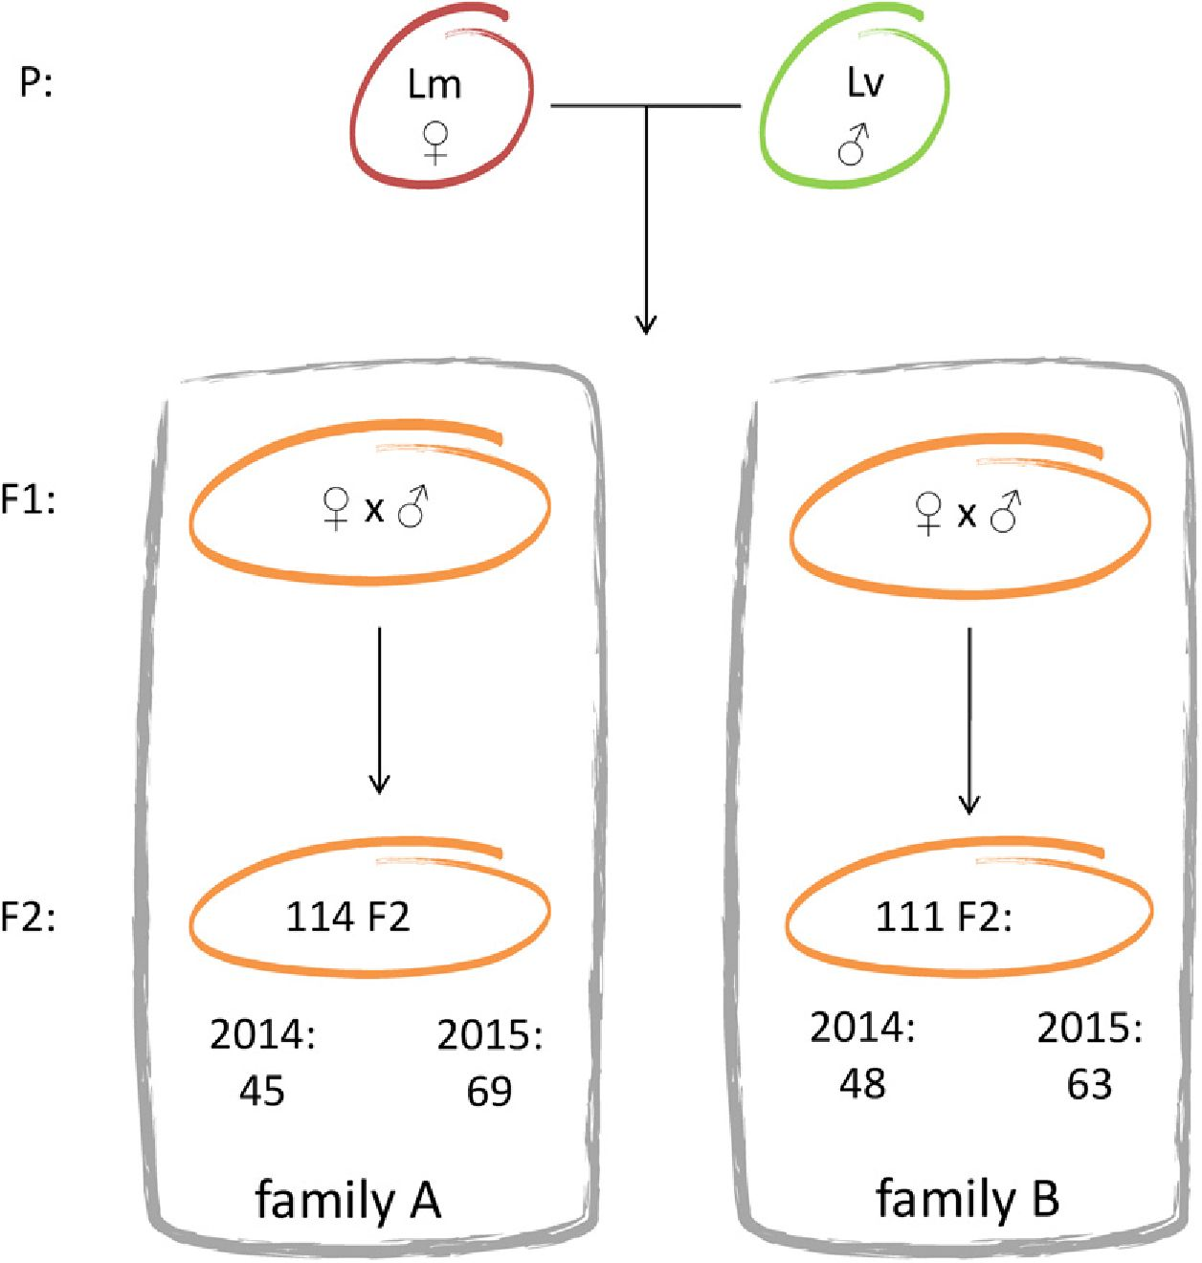

Figure 1 Experimental setup. Interspecific mating (gen-
eration P) resulting in F1 offspring occurred in the
laboratory. Two pairs of F1 were crossed, forming
families A and B, which were used to construct the
linkage maps. Offspring from both families was collected
in two consecutive breeding seasons, 2014 and 2015.
Lm, Lissotriton montandoni; Lv, Lissotriton vulgaris.
Huang et al. (2013)]. The frequency of TRD generally increases with in-
creasing divergence between crossed individuals (Matsubara et al. 2011).
Because the TRDs often reflect genetic incompatibilities between differen-
tiated genomes, detection and mapping of TRD loci provide insights into
mechanisms of postzygotic reproductive isolation between divergent pop-
ulations (Hall and Willis 2005) or species (Fishman etal. 2001; Moyle and
Graham 2006; Brennan et al. 2014; Liu et al. 2016).
The Carpathian (Lissotriton montandoni) and the smooth (Lisso-
triton vulgaris) newts are closely related species that hybridize wherever
their parapatric ranges meet around the Carpathians (Babik et al. 2003;
Zielinski et al. 2014). They form a bimodal hybrid zone, with a large
excess of parental genotypes even in the center of the zone, indicative of
strong assortative mating of parental species (Babik et al. 2003; Babik
and Rafinski 2004). As a consequence, early generation hybrids are rare
in nature (Zielinski et al. 2013, 2014). Further, laboratory experiments
indicate substantial asymmetric premating isolation, with L. montan-
doni females being more choosy (Michalak et al. 1997; Michalak and
Rafinski 1999). So far there has been no information about the strength
and form of postzygotic reproductive isolation between L. montandoni
and L. vulgaris. Despite strong prezygotic isolation, there is evidence for
extensive interspecific flow of the mitochondrial DNA (Babik et al.
2005; Zielinski et al. 2013) as well as for some nuclear gene flow, which
is heterogeneous across the genome (Nadachowska-Brzyska et al. 2012;
Zielinski et al. 2014; Stuglik and Babik 2016; Zielinski et al. 2016). The
linkage map that we report here will facilitate an understanding of the
basis of reproductive isolation between these species. In particular, de-
tection and mapping of loci showing TRD in hybrid families may
provide clues about the genetic architecture of reproductive isolation.
The linkage map of Lissotriton newts can also shed light on the
possible correlation between physical genome size and length of the
linkage map in salamanders. In most taxa, at least a single crossover per
chromosomal arm is required for successful meiosis and consequently
the total number of chromosomal arms is considered the main deter-
minant of the map length (Sybenga 1996). Accordingly, Pardo-Manuel
de Villena and Sapienza (2001) found a strong correlation between the
number of chiasmata, map length, and the haploid number of chro-
mosomal arms in mammals. They also surveyed a variety of other taxa
(mainly plants, arthropods, and fishes) and confirmed that such cor-
relation is generally observed. This evidence combined with high var-
iability of recombination rate and limited range of genome sizes in
mammals indicates the lack of correlation between physical size of
the genome and length of linkage maps. However, the two linkage maps
available for salamander genera Ambystoma (Smith et al. 2005; Voss
et al. 2011) and Notophthalmus (Keinath et al. 2016) are several-fold
longer than the expectations based on the number of chromosomal
arms. Because salamanders exhibit genomic gigantism (Gregory 2015),
a causal relationship between the genome size and map length was
suggested (Smith et al. 2005). However, although salamanders share
large genome size and most families have similar numbers of chromo-
somes (Sessions 2008), the number of chiasmata per chromosomal arm
varies considerably between taxa (Callan 1966; Herrero and Lopez-
Fernandez 1986; Zbozen and Rafinski 1993). Lissotriton newts are at
the lower end of this continuum, with ~1 chiasma per chromosomal
arm. Lissotriton genome sizes are similar to that of Ambystoma mex-
icanum (32 Gb, Keinath et al. 2015): the L. montandoni genome was
estimated at 29.1 Gb, while the range for L. vulgaris, which comprises
several evolutionary lineages, is 27.7-30.8 Gb (Litvinchuk etal. 2007). If
the number of chiasmata predicts the map length in salamanders, we
would expect a ~1200-cM map in Lissotriton. A comparison of the
Ambystoma, Lissotriton, and Notophthalmus maps may thus clarify
2116 I M. Niedzicka et al.
■ Table 1 Summary of the linkage maps
 |  |  | Map A |  |  |  | Map B |  |  | Consensus Map
LG | Length  (cM) | N  Markers | N Unique  Mapped | Marker  Interval (cM) | Length  (cM) | N  Markers | N Unique  Mapped | Marker  Interval (cM) | Length  (cM) | N  Markers | Marker  Interval (cM)
1 | 139.51 | 135 | 53 | 1.04 | 165.55 | 114 | 41 | 1.47 | 181.28 | 148 | 1.23
2 | 140.62 | 131 | 55 | 1.08 | 107.83 | 111 | 48 | 0.98 | 160.22 | 140 | 1.15
3 | 141.06 | 132 | 53 | 1.08 | 145.77 | 119 | 48 | 1.24 | 157.32 | 138 | 1.15
4 | 140.13 | 119 | 56 | 1.19 | 55.76 | 46 | 26 | 1.24 | 142.38 | 120 | 1.20
5 | 134.02 | 85 | 31 | 1.59 | 87.19 | 74 | 29 | 1.19 | 132.07 | 88 | 1.52
6 | 108.62 | 73 | 34 | 1.51 | 108.74 | 61 | 29 | 1.81 | 116.23 | 79 | 1.49
7 | 102.45 | 81 | 35 | 1.28 | 105.35 | 59 | 26 | 1.82 | 112.33 | 81 | 1.40
8 | 97.04 | 52 | 29 | 1.90 | 79.36 | 41 | 23 | 1.98 | 101.90 | 56 | 1.85
9 | 48.35 | 43 | 27 | 1.15 | 82.12 | 56 | 25 | 1.49 | 100.63 | 61 | 1.68
10 | 106.05 | 88 | 36 | 1.22 | 55.02 | 28 | 16 | 2.04 | 100.35 | 89 | 1.14
11 | 102.75 | 54 | 30 | 1.94 | 73.08 | 48 | 18 | 1.55 | 96.23 | 63 | 1.55
12 | 78.73 | 78 | 37 | 1.02 | 71.34 | 65 | 32 | 0.94 | 82.88 | 83 | 1.01
13 | 21.88 | 5 | 5 | 5.47
Total | 1361.21 | 1076 | 481 |  | 1137.11 | 822 | 361 |  | 1483.82 | 1146
Map A: intercross map constructed for the family A (see Results). Map B: outcross map constructed for the family B (see Results). Consensus map was constructed by
merging maps A and B. Linkage groups (LGs) are numbered according to the length on the consensus map.
whether the large size of linkage map is universal among salamanders
or is an attribute of only some species.
In the present study, we report a linkage map obtained using F2
generation L. montandoni X L. vulgaris hybrids from two families.
Resequenced fragments of protein-coding genes were used as genetic
markers. Specifically, we (i) constructed the first linkage map in Lisso-
triton newts containing >1000 protein-coding genes—this map con-
stitutes an essential resource for evolutionary studies in this system; (ii)
compared the relationship between the Lissotriton map length and
physical genome size with the results obtained for other salamander
species; and (iii) identified loci showing TRDs in F2 hybrids and ex-
amined their distribution through the genome, which provides insights
into the genetic basis of reproductive isolation between species.

MATERIALS AND METHODS
Mapping population
A female L. montandoni and male L. vulgaris were collected from
allopatric populations in southern Poland (latitude and longitude of
49.51 N and 20.14 E, and 49.99 N and 19.47 E, respectively) and crossed
in the laboratory (generation P). Hybrids of F1 generation that resulted
from this cross were reared to maturity and two pairs were used to
obtain the F2 hybrids (families A and B). The F2 progeny from these
crosses, collected over two consecutive breeding seasons (2014 and
2015), were used for mapping. The F2 larvae from each family were
maintained in a separate container and fed ad libitum with Artemia
shrimps. The larvae of minimum 1 cm total length were anesthetized in
MS222 and preserved in ethanol. We obtained 114 offspring from
family A and 111 offspring from family B (Figure 1). DNA was extracted
from tail tips of adults (P and F1 generation) and from whole F2
larvae using the Wizard Genomic DNA Purification Kit (Promega).
DNA was dissolved in 100 ml of TE buffer.

Molecular markers
Molecular Inversion Probe (MIP) markers (O’Roak et al. 2012;
Niedzicka et al. 2016) were designed in Lissotriton transcript sequences
(available at http://newtbase.eko.uj.edu.pl). Each MIP amplifies a
112-bp target and all MIPs are assayed simultaneously in a single re-
action. Each marker was located in a single exon to allow amplification
from genomic DNA. The bioinformatics pipeline used to design
markers, laboratory procedures, and sequencing are described in detail
in Niedzicka et al. (2016). The MIP markers used to construct the
linkage map fell into two groups (Supplemental Material, Table S1 in
File S1):
- Markers informative in the F2 cross, i.e., MIPs containing single
nucleotide polymorphisms (SNPs) homozygous for different al-
leles in the individuals of generation P (mm X vv). Such markers
were identified in previously resequenced transcriptomes of two
L. montandoni and two L. vulgaris individuals sampled from the
same geographic regions as the individuals of generation P
(Stuglik and Babik 2016). Although the sample size of four gene
copies per species is small, SNPs diagnostic in such a sample
probably have highly differentiated allele frequencies between spe-
cies. Indeed, generation P individuals were alternative homozy-
gotes in an overwhelming majority of such SNPs. A subset of
205 group 1 markers were reported in Niedzicka et al. (2016).
- Markers designed in genes involved in immune response reported
by Fijarczyk et al. (2016) and other randomly picked transcripts.
Several MIPs were designed for most genes. As these markers were
designed without taking into account interspecific differentiation
of allele frequencies, their utility for mapping varied.
In the initial screen to filter out poorly amplifying markers and
paralogs, all markers were resequenced in parents and 21 F2 offspring
from family A. Deviations from the expected Mendelian segregation
ratio were checked using the exact multinomial test (EMT) in R package
EMT (Menzel 2013). Markers that amplified poorly or contained SNPs
with an excess of heterozygotes at a false discovery rate (FDR) of q <
0.01 were removed from further analyses. The remaining MIPs were
resequenced in both families. Additional 204 F2 informative (group 1)
markers acquired from another project were resequenced only in family
A (Table S1 in File S1).
Mapping and SNP calling were performed as described in Niedzicka
etal. (2016). Briefly, 2 X 75 bp paired-endor 150 bp single-end Illumina
reads were mapped to the reference with Bowtie2. SNP calling was
performed using GenomeAnalysisTK (GATK) UnifiedGenotyper
(DePristo et al. 2011). Genotypes with coverage <16x or genotype
quality <30 phred were considered missing. To estimate genotyping
Volume 7 July 2017 I Linkage Map of Lissotriton Newts I 2117

error 29 individuals were amplified and resequenced twice. Genotyping
error was expressed as the nonreference discrepancy rate (NRD) in
GATK module GenotypeConcordance.

Construction of the linkage map
Mendelian segregation was tested again on the full dataset, and markers
containing SNPs with an excess of heterozygotes in either family at the
FDR q < 0.01 were removed from both families. These could be paral-
ogs missed in the initial screen due to a limited sample size or inclusion
of only a single family. The remaining markers were evaluated in each
family separately. Markers with a genotype missing in either parent or
with >5% missing data were excluded from the analysis.
Separate linkage maps were constructed for each family. In family A,
we used all markers informative in the inbred cross (intercross) with F2
segregation pattern 1:2:1 (P: mm X vv) to extract full information based
on a three-generation pedigree (File S2). Markers showing strong TRD
in a given family (see below) were excluded from mapping to prevent
spurious linkage. Numerous MIPs in family B were excluded for this
reason, which reduced the number of available markers. To maximize
the number of useful markers in family B, we conducted outbred link-
age mapping, for which several marker segregation types are suitable.
The suitable markers were identified based on the genotypic informa-
tion from parents of family B (File S2).
The linkage maps were constructed using the R/onemap package
(Margarido et al. 2007). Linkage groups (LGs) were found using the max-
imum recombination frequency set to 0.55 and a minimum logarithm of
odds (LOD) score of 8. The map distances were obtained by applying the
Haldane mapping function. The order of markers in each LG was defined
using the algorithm RECORD (Mollinari et al. 2009); for eight markers
within each LG all possible orders were calculated and compared to each
other to choose the best one by the multipoint likelihood in order to create
a framework for algorithm operations. The summary statistics (genome
length and map coverage) were calculated for the intercross map. The
genome length was estimated by method 4 of Chakravarti et al. (1991).
Map coverage, expressed as the proportion of the genome within x centi-
morgan of a mapped marker under the assumption of uniform distribution
of markers on the map, was calculated according to Fishman et al. (2001).
To check for uniformity of the distribution of markers along the intercross
map, a chi-square test was performed against Poisson expectations for
markers evenly distributed over 10-cM intervals. A graphical representa-
tion of linkage maps was prepared in MapChart (Voorrips 2002) and the
consensus map was constructed with MergeMap (Wu et al. 2011).

TRDs and epistatic interactions
For each family, deviations from the Mendelian segregation ratio were
tested within each year with the EMT followed by the FDR correction.
For each marker showing TRD at FDR q < 0.01, we followed Leppala
et al. (2013) to check whether data supported the gametic or zygotic
causes of TRD. We calculated the likelihoods of three models: (i) a null
model assuming Mendelian segregation, (ii) a gametic model assuming
that all TRD was caused by departures of gamete frequencies from
those expected under Mendelian segregation, and (iii) a zygotic model
assuming that differential survival of diploid genotypes contributed to
the observed TRD. The models were compared using likelihood ratio
tests, with P < 0.001 considered significant (Leppala et al. 2013).
To test for possible epistatic interactions between pairs of unlinked
markers, contingency tables with the observed two-locus genotype
counts were calculated in Genepop (Rousset 2008). The chi-square test
was then used to compare the observed counts with those expected,
assuming independence between markers. This test was performed for
all pairs of markers located on different LGs.
■ Table 2 Transmission ratio distortions (TRDs) in families and
breeding seasons (2014 and 2015)
Family | P | 2014 | 2015 | 2014 and 2015 Combined
A | Nominal < 0.05 | 89 | 223 | 264
B | Nominal < 0.05 | 86 | 240 | 240
A | FDR < 0.01 | 0 | 0 | 1
B | FDR < 0.01 | 4 | 88 | 95
Deviations from the expected Mendelian segregation ratio were evaluated with
the exact multinomialtest (EMT). Both the nominaland false discovery rate (FDR)
corrected P values are shown. Note that the more numerous significant results at
the nominalP < 0.05 may partially reflect larger sample sizes (Figure 1) and thus
higher statisticalpower in season 2015.

Data availability
File S2 contains genotypes for each individual.

RESULTS
Linkage map
To evaluate the amplification efficiency and Mendelian inheritance of
markers, 1741 MIPs were genotyped in 23 individuals (parents and
21 offspring) from family A. After excluding markers that amplified
poorly or showed signs of paralogy, 1166 MIP markers were resequenced
in both families (Figure 1 and Table S1 in File S1). At this stage, an
additional 31 markers were excluded due to an excess of heterozygotes
in either family, suggesting paralogy. The estimated genotyping error
(NRD) was 0.008. An additional 204 MIPs were resequenced only in
family A (Table S1 in File S1). If more than one MIP per gene was
resequenced, the MIP containing the most informative SNP was used
for mapping.
Separate linkage maps were constructed for each family. The map for
family A was based on the three-generation pedigree (intercross map)
with one type of markers (P: mm X vv). After excluding two markers
with unstable position within a LG, 1076 markers were used and all
were assigned to LGs (Table S2 in File S1). We obtained 13 LGs, one
more than the haploid number of Lissotriton chromosomes (n = 12).
Reduction of the LOD score threshold from eight to six did not cause
any LGs to merge. The predicted genome length is 1404 cM (Table 1)
and 99.9 and 95.3% of the genome was estimated to be within 5 and
2 cM of the mapped markers, respectively. The markers were not
uniformly distributed on the map (x26 = 80.7, P =1.3 X 10_1°).
Numerous highly distorted markers (HDMs) were excluded from
mapping in family B. To maximize the number of useful markers in this
family, we conducted outbred linkage mapping, allowing for several
types of segregation. The map was constructed with 822 markers, 13 LGs
were obtained and one marker remained unlinked. Reduction of the
LOD score threshold from eight to seven linked two LGs together,
reducing their final number to 12, consistent with the haploid Lissotriton
chromosome count (Table S2 in File S1). Groups 9 and 13 from the
family A map were linked together as LG9 in the family B map. The
map length is 1137 cM (Table 1). Because distorted markers clustered
in two blocks on LG4 and LG10, removal of these markers resulted in
shortening these LGs in family B (Figure S1). The overall difference in
the length of corresponding LGs between the two maps was not sig-
nificant (Wilcoxon test V =60, P = 0.11).
To integrate information from all markers, a consensus map was
constructed by merging maps from both families. The consensus linkage
map is 1484 cM and contains a total of 1146 markers on 12 LGs, i.e., on
average one marker per 1.29 cM (Figure 2 and Table 1). Detailed
characteristics of LGs and the order of markers on the consensus
map are provided in Table S3 in File S1.
2118 I M. Niedzicka et al.
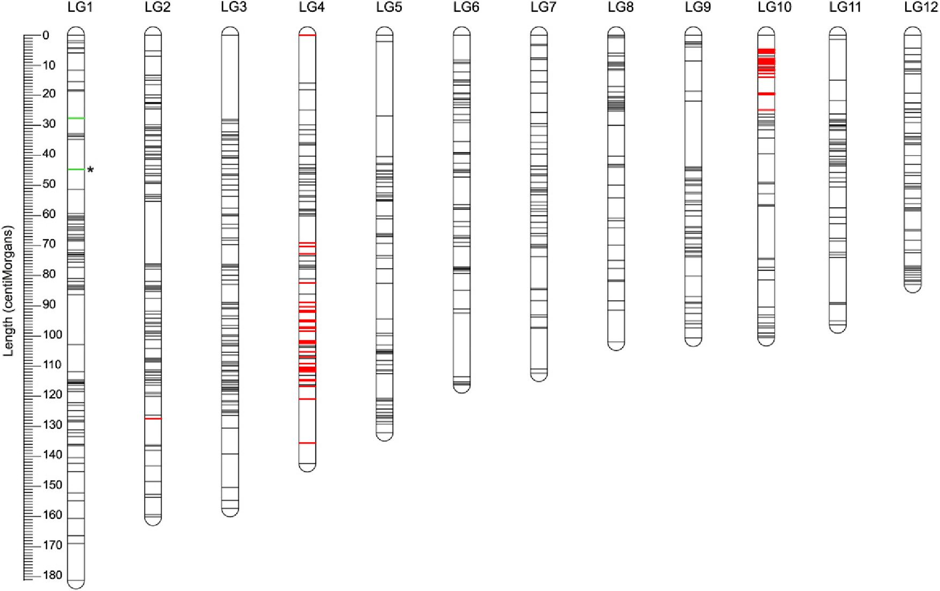

Figure 2 The consensus linkage map. The consensus map contains 1146 markers and has a length of 1484 cM. Red shows highly distorted
markers (HDMs) with a deficit of L. montandoni allele; green shows HDMs with a deficit of L. vulgaris allele. Only a single HDM (asterisk) was
detected in family A, the remaining HDM were detected only in family B.

TRD and epistatic interactions
Deviations from Mendelian segregation at the nominal P < 0.05 were
widespread: 23% (264) and 26% (240) of markers were distorted in
families A and B, respectively. Only 42 deviating markers were com-
mon to both families, which suggests that many significant results may
represent false positives. The families differed drastically in the number
of HDMs (FDR q < 0.01): we found only one HDM in family A and as
many as 95 in family B (HDMs were not shared between families). In all
HDMs, one type of homozygote was underrepresented, and in 95% it
was the mm homozygote. In order to further investigate the causes of
the difference between families, EMT was also calculated within years
(Table 2). The results show that the difference between families in the
number of HDM was mostly due to data from 2015: markers highly
distorted in that year did not show much distortion in 2014 (Figure 3
and Table 2). The distribution of HDMs within the genome was ana-
lyzed using the consensus map. Most HDMs clustered in two separate
blocks on LG4 and LG10 (Figure 3). All markers in these blocks had
deficit of mm homozygotes. The gametic causes of TRD were inferred
for most markers (86), while zygotic or both gametic and zygotic mod-
els were supported for eight and two markers, respectively.
To detect epistatic interactions, we tested the statistical independence
of two-marker genotypes within families for all pairs of markers located
on different LGs. Numerous tests had the nominal P < 10“4 (184 and
11 in families A and B, respectively), but no test remained significant
even at an FDR of 0.1. We note that interpretation of a standard FDR is
unclear here, because of the partial nonindependence of tests due to
linkage between markers. This, together with the very large number of
tests performed (exceeding 0.5 million in family A), makes our tests for
epistasis highly conservative. Therefore we briefly describe interactions
with P < 10“4 as possible cases of epistasis (Table S4 in File S1). Only a
single interaction was common to both families; as both markers were
heterozygous in the L. vulgaris grandparent, this result is difficult to
interpret in the context of reproductive isolation. In family A, almost all
tests with P < 10“4 involved two blocks of markers, on LG6 and LG12,
characterized by a strong deficit or lack of both mm:mm and vv:mm
genotypes, which again is difficult to interpret in the context of repro-
ductive isolation. In family B, nine out of 11 tests with P < 10“4
represent two possible epistatic interactions between a single HDM
(deficit of v alleles) on LG1, and two separate regions on LG6.
Interestingly, these appear as negative epistatic interactions of the
Dobzhansky-Muller (DM) type, with vv:mm genotypes missing and
vv:mv underrepresented.

DISCUSSION
In this study a gene-based linkage map of newts from the L. vulgaris
species complex was constructed using F2 L. montandoni X L. vulgaris
hybrid progeny from two families. The map contains 1146 genes in
12 LGs, equal to the haploid number of Lissotriton chromosomes, and
has excellent genomic coverage but is notably shorter than two other
available salamander linkage maps. Because progeny from each family
was collected over two consecutive breeding seasons, we were able to
detect a complex pattern of segregation distortion in the hybrid ge-
nomes, providing some insight into the nature of reproductive isolation
between the parental species.
The L. montandoni X L. vulgaris linkage map is three to four times
shorter than maps available for two other salamander genera, Ambys-
toma (Ambystomatidae) and Notophthalmus (Salamandridae), even
though these genera have similar number of chromosomes as Lissotri-
ton (Table 3). The difference in map length has two plausible explana-
tions: actual differences in the rate of meiotic recombination between
salamander taxa or reduced recombination in F1 Lissotriton hybrids.
The former explanation is supported by ample cytogenetic evidence.
All Lissotriton species have 12 chromosome pairs and ~1 chiasma per
chromosomal arm in meiosis (Wickbom 1945; Watson and Callan
Volume 7 July 2017 | Linkage Map of Lissotriton Newts | 2119
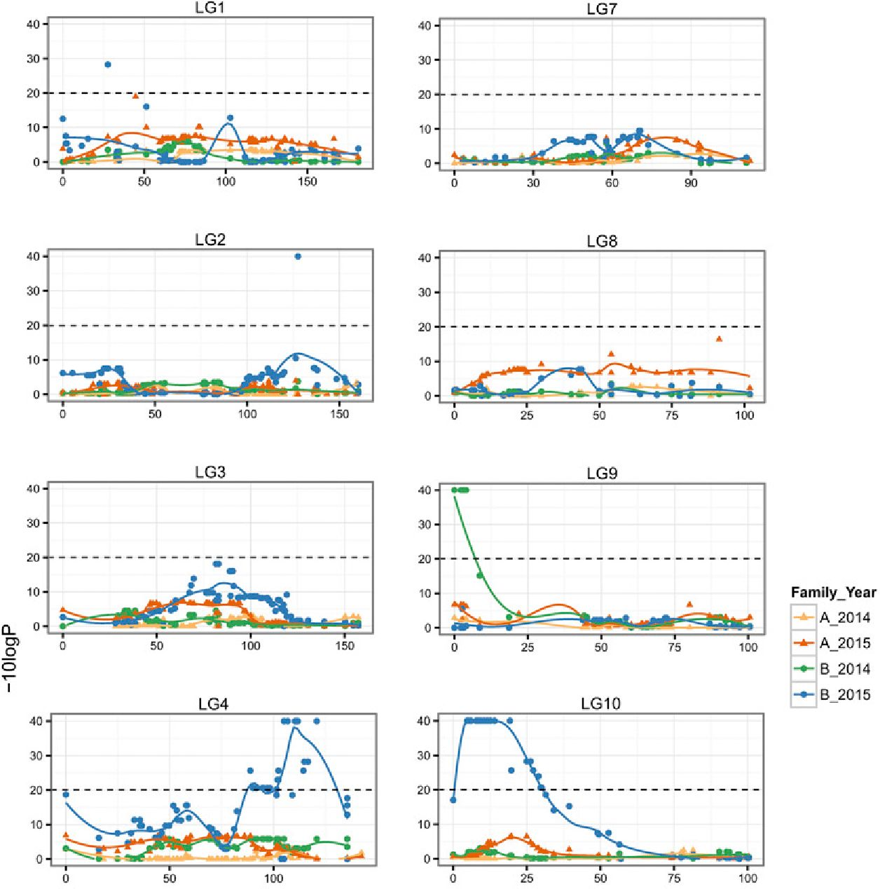
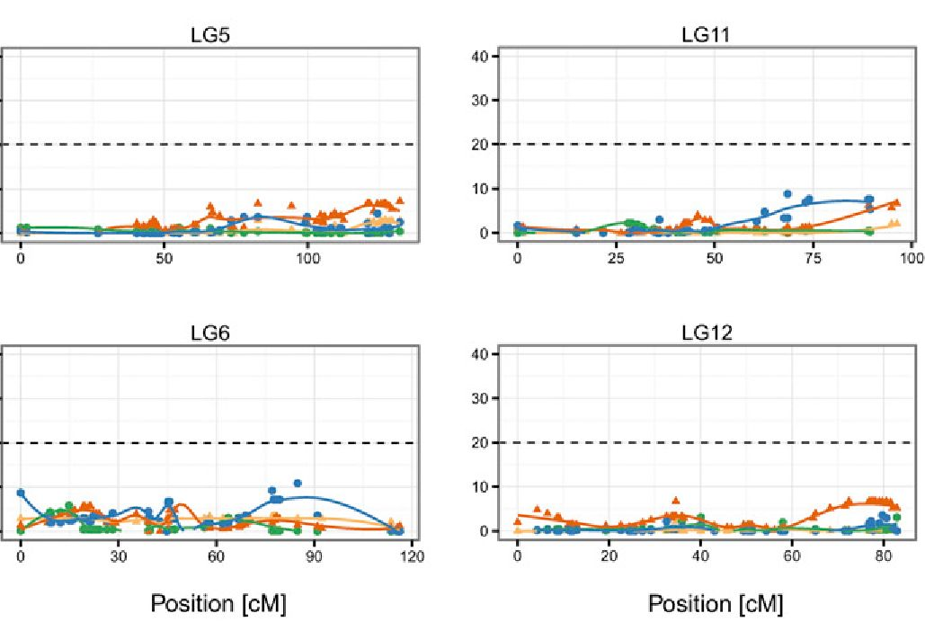

Figure 3 Transmission ratio distortions (TRDs) shown
on the consensus map. Departures of genotype counts
from Mendelian expectations were tested with the
Exact Multinomial Test and the nominal P are given
as — 10logP, the dashed line indicates the nominal P
of 0.01. Polynomial regression trend lines are shown.
1963; Barsacchi et al. 1970; Herrero and Lopez-Fernandez 1986;
Zbozen and Rafinski 1993), which predicts a map length of ~1200
cM, slightly shorter than reported here. However, the number of chi-
asmata in Lissotriton is at the lower end of the scale observed in sala-
manders (Table 3), which typically have more than one chiasma per
chromosome arm (Wickbom 1945; Callan and Spurway 1951), even in
excess of four in A. mexicanum (Callan 1966). Crossover rates are more
variable among salamanders than among mammals, in which a max-
imum of 2.5 chiasmata per chromosome arm were reported (Dumont
2017). A comparison within Ambystoma revealed two times fewer
chiasmata in Ambystoma macrodactylum than in A. mexicanum
(Kezer et al. 1980). The recombination rate in salamanders can thus
evolve relatively quickly despite conservative karyotypes, consistent
with theory and data from other systems (True et al. 1996; Dumont
et al. 2011; Smukowski and Noor 2011).
Another potential explanation for the shorter map in Lissotriton
compared to other salamanders is underestimation of map length
due to reduced recombination in F1 hybrids. This phenomenon has
been reported in many systems, including Triturus newts (Callan and
Spurway 1951). However, in other cases interspecific maps are not
shorter than intraspecific maps (Beukeboom et al. 2010) and can even
be longer (Woram et al. 2004). Strong reduction of recombination in
L. montandoni X L. vulgaris hybrids is unlikely for two reasons. First,
the karyotypes of the parental species are very similar indicating a lack
of major chromosomal rearrangements (Zbozen and Rafinski 1993;
Zbozen 1997). Second, in hybrid males, meiotic recombination assessed
by cytogenetic methods is similar to males of pure parental species
(Zbozen 1997). Because males are heterogametic in Lissotriton, in ac-
cordance with Haldane’s rule they are more likely to experience meiotic
problems. Evidence to the contrary suggests a lack of strong reduction
2120 I M. Niedzicka et al.
■ Table 3 Comparison of the number of chromosomes, number of chiasmata per meiotic cell, and expected and observed map lengths in
ambystomatid and salamandrid salamanders
 |  |  |  | Expected Map Length (cM) Based on
Species | No. | No. of | No. of | No. of | No. of | Observed Map
Species | of Chr | Arms | Chias | Arms | Chias | Length (cM)
Ambystomatidae
Ambystoma macrodactylum | 14 | 28a | 53a | 1400 | 2650 | NA
Ambystoma mexicanumb  Salamandridae | 14 | 28 | 113 | 1400 | 5650 | 4200c
Ichthyosaura alpestris | 12 | 24d | 32.3e | 1200 | 1615 | NA
Lissotriton boscai | 12 | 24d | 21.7e | 1200 | 1085 | NA
Lissotriton helveticus | 12 | 24d | 22.2e | 1200 | 1110 | NA
Lissotriton montandoni | 12 | 24d | 23.3f | 1200 | 1165 | 14849
Lissotriton vulgaris | 12 | 24d | 24.2h | 1200 | 1210 | 14849
Notophthalmus viridescens | 11 | 22d | NA | 1100 | NA | 6162'
Pleurodeles waltl | 12 | 24d | 28.1j | 1200 | 1405 | NA
Salamandra salamandra | 12 | 24d | 36.8k | 1200 | 1840 | NA
Triturus carnifex | 12 | 24d | 31.4' | 1200 | 1570 | NA
Triturus cristatus | 12 | 24d | 37.4' | 1200 | 1870 | NA
Triturus karelinii | 12 | 24d | 40.8' | 1200 | 2040 | NA
Triturus marmoratus | 12 | 24d | 25.7e | 1200 | 1285 | NA
Expected map length based on the number of chromosomalarms assumes a single crossover per arm. No. of chr, haploid number of chromosomes; No. of arms,
number of chromosomalarms; No. of chias, average number of chiasmata per meiotic cell; NA, not available.
bKezer et al. (1980).
bCallan (1966); Smith et al. (2005).
ddVoss et al. (2011).
Allsalamandrids are characterized by biarmed chromosomes (Sessions 2008).
^Herrero and Lopez-Fernandez (1986).
ZboZen and Rafmski (1993); Zbozen (1997).
ggThis study.
. L. vulgaris meridionalis (Barsacchi et al. 1970).
j Keinath et al. (2016).
j, Wickbom (1945).
^ Mancino et al. (1969).
Callan and Spurway (1951).
of meiotic recombination in hybrids of either sex. Reduced recombi-
nation in hybrids is thus unlikely the sole explanation of the observed
map length. It cannot be however dismissed completely as an additional
factor. Therefore, it would be interesting to compare the length of the
map reported here with that of intraspecific and backcross maps. Such
comparisons would also check for the presence of smaller scale re-
arrangements between genomes of parental species, not detectable with
cytogenetic methods.
Our results, together with extensive cytogenetic data accumulated
over decades, show that the large genome size shared by salamander
species does not automatically translate into long linkage maps. Such a
relationship was hypothesized previously based on the Ambystoma map
size (Smith et al. 2005). The several-fold differences in map length
among salamanders make this group well suited to study the evolu-
tionary consequences of recombination rate variation between taxa
characterized by large genomes and similar numbers of chromosomes.
Numerous markers showed TRD in F2 hybrids. Distortions
occurred mostly in one family, in one breeding season, and clustered
in two blocks on LG4 and 10. Almost all HDMs, including all markers
in the two blocks had a deficit of the mm genotype, and also mv
heterozygotes were often underrepresented. Apparent TRD can re-
sult from various methodological artifacts, such as genotyping er-
rors or extensive missing data. Such major artifacts are unlikely in
our study because of the high quality of the MIP markers, highly
repeatable genotyping, and the fact that TRD occurred mostly in a
single family and a single season. Therefore, we are convinced that
the observed TRDs reflect biological reality.
True TRD may arise before (gametic) or after (zygotic) fertilization
and both types can have multiple causes [reviewed in Huang et al.
(2013)]. In principle, one can use the observed genotype counts to
distinguish between gametic and zygotic processes by comparing the
likelihoods of respective models (Leppala et al. 2013). Unfortunately
this approach is sometimes inconclusive. For example, under a realistic
scenario of viability selection against a partially dominant allele, the
zygotic model has only slightly better fit than the gametic model even
though all distortion is due to differential survival after fertilization.
This observation is important because, although the comparison of
models point to mostly prezygotic causes of TRD, their occurrence in
only one breeding season argues against this explanation. The gametic
causes of distortion cannot be dismissed completely, as environment-
or age-dependent examples of meiotic drive are known (Orr and Irving
2005; Lindholm et al. 2016). However, additional observations speak
against such possibility because the parents of the two families were
siblings of the same age, and they shared an environment as juveniles
and then as adults were kept separately only during the breeding sea-
son. Although we used only a single cross direction, we can rule out
cytonuclear interactions as a major cause of TRD because L. montan-
doni alleles were underrepresented in most distorted markers, while all
hybrids carried L. montandoni mitochondrial DNA. Hence, in our
opinion, the most likely explanation of the observed TRDs is environ-
ment-dependent mortality of certain genotypes, and little difference in
fit between gametic and zygotic models suggests partial dominance
of L. montandoni alleles. The environment-dependent mortality
may have been sex-dependent, but we were not able to evaluate this
Volume 7 July 2017 | Linkage Map of Lissotriton Newts | 2121

possibility because the sex of the larvae could not be determined and
sex-linked molecular markers are not available. The F2 larvae from
each family were raised in the same laboratory and at the same time
but in separate aquaria. Although larvae were given the same food
(Artemia hatchlings, ad libitum), we did not tightly control important
environmental conditions, such as larval density, oxygen concentra-
tion, amount of substrate, or decaying organic matter at the bottom
of aquaria. Embryonal and larval mortality during development were
not recorded either, because young newt larvae are small and their
bodies decompose quickly. Larvae from both families were preserved
at the same time and stage, so increased mortality of some develop-
mental stages is not a plausible explanation for the observed differences
in TRDs. Therefore, it is likely that environmental conditions differed
between families and if some genotypes had low survival only under
stressful conditions, differences in the patterns of TRDs between fam-
ilies and/or years would ensue.
Several mechanisms may underlie the environment-dependent
mortality of certain genotypes: (i) inbreeding depression, (ii) low survival
ofhybrids due to genetic incompatibilities between the parental genomes
revealed only in some environmental conditions, and (iii) low survival
under particular conditions of hybrid genotypes carrying L. montandoni
alleles at specific genomic locations. Regarding inbreeding depression,
the parents of families A and B may have differed by chance in the load
of recessive deleterious alleles. These would be exposed in the F2 gen-
eration, leading to differences in TRDs between families. We deem this
explanation unlikely, because in most distorted markers heterozygotes
were also underrepresented, implying partial codominance of deleteri-
ous alleles, which is not compatible with inbreeding depression. The
two remaining mechanisms are plausible and both may contribute to
reproductive isolation. Increased mortality of some hybrid genotypes is
customarily attributed to genetic incompatibilities between parental
populations or species, which are often environment-dependent
(Bordenstein and Drapeau 2001; Willett and Burton 2003; Hou et al.
- . If these incompatibilities take the form of negative epistatic
interactions of the DM type, as commonly observed (Coyne and Orr
2004; Corbett-Detig et al. 2013), statistical associations are expected
between genotypes at unlinked loci. In family B, we detected possible
DM type interactions at the nominal P < 10“4, which may suggest
environment-dependent incompatibilities between the parental ge-
nomes; however, none were significant after the correction for multiple
tests. Blocks of distorted markers on LG4 and LG10 were not involved
in any such interaction, and consequently, there is no support for
environment-dependent DM type incompatibilities as the causes of
TRD in these regions. However, because of the very large number of
tests, samples sizes would need to be much larger to achieve good
statistical power. Further, complex epistasis between TRD blocks and
multiple other genomic regions, which may be even more difficult to
detect, cannot be excluded [reviewed in Fraisse etal. (2014)]. An alter-
native explanation not evoking genetic incompatibilities is poor sur-
vival under some environmental conditions of larvae carrying
L. montandoni alleles in these genomic regions. The species differ
ecologically (Zavadil et al. 2003; Schmidtler and Franzen 2004) and
differences in survival of their larvae in some or even most environ-
mental conditions would not be surprising. The TRD blocks could then
even mark genomic regions involved in prezygotic habitat isolation
between the parental species.
Our experiment was not designed to distinguish between various
isolating barriers. Hence, although we ruled out some explanations of
TRD, unambiguous links between TRD and mechanisms of reproduc-
tive isolation could not be established. Fortunately, tools and experi-
mental designs to detect and quantify components of reproductive
isolation are available (Rundle and Whitlock 2001; Nosil 2012). Com-
mon garden experiments comparing survival of pure L. montandoni,
L. vulgaris, hybrid, and backcross larvae under various conditions in
combination with genotyping of mapped markers would be especially
helpful in this respect. Regardless of the exact mechanisms, there is little
doubt that TRD blocks play a role in reproductive isolation. If so, re-
duced interspecific introgression of these genomic segments is
expected, and this prediction can be tested in L. montandoni X
L. vulgaris hybrid zones by comparing the width and location of allele
frequency clines in TRD segments to the genomic average. The map
reported here is an essential tool to study genomic architecture of di-
vergence between species and interactions between their genomes in
natural hybrid zones. Another important direction of research enabled
by the linkage map is elucidation of the genetic basis of phenotypic and
ecological differences between species by QTL analysis.

ACKNOWLEDGMENTS
We thank A. Kret, A. Osikowski, and G. Pabijan for help in newt
maintenance and breeding; M. Stuglik for assistance in bioinformatics
analyses; and M. Pabijan for valuable comments. This work was
funded by the Polish National Science Centre (2012/04/A/NZ8/00662
to W.B.) and the Jagiellonian University (DS/WBiNoZ/INoS/762/16).

LITERATURE CITED
Babik, W., and J. Rafinski, 2004 Relationship between morphometric and
genetic variation in pure and hybrid populations of the smooth and
Montandon’s newt (Triturus vulgaris and T. montandoni). J. Zool.
(Lond.) 262: 135-143.
Babik, W., J. M. Szymura, and J. Rafinski, 2003 Nuclear markers, mito-
chondrial DNA and male secondary sexual traits variation in a newt
hybrid zone (Triturus vulgaris X T. montandoni). Mol. Ecol. 12: 1913-
1930.
Babik, W., W. Branicki, J. Crnobrnja-Isailovic, D. Cogalniceanu, I. Sas et al.,
2005 Phylogeography of two European newt species - discordance be-
tween mtDNA and morphology. Mol. Ecol. 14: 2475-2491.
Barb, J. G., J. E. Bowers, S. Renaut, J. I. Rey, S. J. Knapp et al., 2014 Chromo-
somal evolution and patterns of introgression in Helianthus. Genetics 197: 969-
979.
Barsacchi, G., L. Bussotti, and G. Mancino, 1970 The maps of the lamp-
brush chromosomes of Triturus (Amphibia urodela). Chromosoma 31:
255-279.
Beukeboom, L., O. Niehuis, B. Pannebakker, T. Koevoets, J. Gibson et al.,
2010 A comparison of recombination frequencies in intraspecific vs.
interspecific mapping populations of Nasonia. Heredity 104: 302-309.
Bordenstein, S., and M. Drapeau, 2001 Genotype-by-environment interac-
tion and the Dobzhansky-Muller model of postzygotic isolation. J. Evol.
Biol. 14: 490-501.
Bradshaw, H., and D. W. Schemske, 2003 Allele substitution at a flower
colour locus produces a pollinator shift in monkeyflowers. Nature 426:
176-178.
Brennan, A. C., S. J. Hiscock, and R. J. Abbott, 2014 Interspecific crossing
and genetic mapping reveal intrinsic genomic incompatibility between
two Senecio species that form a hybrid zone on Mount Etna, Sicily.
Heredity 113: 195-204.
Callan, H. G., 1966 Chromosomes and nucleoli of the axolotl, Ambystoma
mexicanum. J. Cell Sci. 1: 85-108.
Callan, H. G., and H. Spurway, 1951 A study of meiosis in interracial
hybrids of the newt, Triturus cristatus. J. Genet. 50: 235-249.
Chakravarti, A., L. K. Lasher, and J. E. Reefer, 1991 A maximum likelihood
method for estimating genome length using genetic linkage data. Genetics
128: 175-182.
Corbett-Detig, R. B., J. Zhou, A. G. Clark, D. L. Hartl, and J. F. Ayroles,
2013 Genetic incompatibilities are widespread within species. Nature
504: 135-137.
2122 | M. Niedzicka et al.
Corbett-Detig, R. B., D. L. Hartl, and T. B. Sackton, 2015 Natural selection
constrains neutral diversity across a wide range of species. PLoS Biol. 13:
e1002112.
Coyne, J. A., and H. A. Orr, 2004 Speciation, Sinauer, Sunderland, MA.
DePristo, M. A., E. Banks, R. Poplin, K. V. Garimella, J. R. Maguire et at.,
2011 A framework for variation discovery and genotyping using next-
generation DNA sequencing data. Nat. Genet. 43: 491-498.
Dumont, B. L., 2017 Variation and evolution of the meiotic requirement for
crossing over in mammals. Genetics 205: 155-168.
Dumont, B. L., M. A. White, B. Steffy, T. Wiltshire, and B. A. Payseur,
2011 Extensive recombination rate variation in the house mouse
species complex inferred from genetic linkage maps. Genome Res. 21:
114-125.
Fijarczyk, A., K. Dudek, and W. Babik, 2016 Selective landscapes in newt
immune genes inferred from patterns of nucleotide variation. Genome
Biol. Evol. 8: 3417-3432.
Fishman, L., A. J. Kelly, E. Morgan, and J. H. Willis, 2001 A genetic map in
the Mimulus guttatus species complex reveals transmission ratio distor-
tion due to heterospecific interactions. Genetics 159: 1701-1716.
Fitzpatrick, B. M., J. R. Johnson, D. K. Kump, J. J. Smith, S. R. Voss et al.,
2010 Rapid spread of invasive genes into a threatened native species.
Proc. Natl. Acad. Sci. USA 107: 3606-3610.
Fraisse, C., J. Elderfield, and J. Welch, 2014 The genetics of speciation: are
complex incompatibilities easier to evolve? J. Evol. Biol. 27: 688-699.
Fruciano, C., P. Franchini, V. Kovacova, K. R. Elmer, F. Henning et al.,
2016 Genetic linkage of distinct adaptive traits in sympatrically speci-
ating crater lake cichlid fish. Nat. Commun. 7: 12736.
Gagnaire, P. A., E. Normandeau, S. A. Pavey, and L. Bernatchez, 2013 Mapping
phenotypic, expression and transmission ratio distortion QTL using RAD
markers in the Lake Whitefish (Coregonus clupeaformis). Mol. Ecol. 22: 3036-
3048.
Gregory, T. R., 2015 Animal Genome Size Database. Available at: http://
www.genomesize.com. Accessed: December 8, 2016.
Hale, M. C., F. P. Thrower, E. A. Berntson, M. R. Miller, and K. M. Nichols,
- Evaluating adaptive divergence between migratory and nonmi-
gratory ecotypes of a salmonid fish, Oncorhynchus mykiss. G3 3: 1273-
1285.
Hall, M. C., and J. H. Willis, 2005 Transmission ratio distortion in intra-
specific hybrids of Mimulus guttatus. Genetics 170: 375-386.
Herrero, P., and C. Lopez-Fernandez, 1986 The meiotic system of Iberian
species of the genus Triturus (Amphibia: Caudata). Caryologia 39: 385-
395.
Hollenbeck, C. M., D. S. Portnoy, and J. R. Gold, 2015 A genetic linkage
map of red drum (Sciaenops ocellatus) and comparison of chromosomal
syntenies with four other fish species. Aquaculture 435: 265-274.
Hou, J., A. Friedrich, J.-S. Gounot, and J. Schacherer, 2015 Comprehensive
survey of condition-specific reproductive isolation reveals genetic in-
compatibility in yeast. Nat. Commun. 6: 7214.
Huang, L. O., A. Labbe, and C. Infante-Rivard, 2013 Transmission ratio
distortion: review of concept and implications for genetic association
studies. Hum. Genet. 132: 245-263.
Jenczewski, E., M. Gherardi, I. Bonnin, J.-M. Prosperi, I. Olivieri et al.,
1997 Insight on segregation distortions in two intraspecific crosses be-
tween annual species ofMedicago (Leguminosae). Theor. Appl. Genet. 94:
682-691.
Kawakami, T., L. Smeds, N. Backstrom, A. Husby, A. Qvarnstrom et al.,
- A high-density linkage map enables a second-generation collared
flycatcher genome assembly and reveals the patterns of avian recombi-
nation rate variation and chromosomal evolution. Mol. Ecol. 23: 4035-
4058.
Keinath, M. C., V. A. Timoshevskiy, N. Y. Timoshevskaya, P. A. Tsonis, S. R.
Voss et al., 2015 Initial characterization of the large genome of the
salamander Ambystoma mexicanum using shotgun and laser capture
chromosome sequencing. Sci. Rep. 5: 16413.
Keinath, M. C., S. R. Voss, P. A. Tsonis, and J. J. Smith, 2016 A linkage map
for the newt Notophthalmus viridescens: insights in vertebrate genome
and chromosome evolution. Dev. Biol. DOI: 10.1016/j.ydbio.2016.05.027.
Kezer, J., P. E. Leon, and S. K. Sessions, 1980 Structural differentiation of
the meiotic and mitotic chromosomes of the salamander, Ambystoma
macrodactylum. Chromosoma 81: 177-197.
Leppala, J., F. Bokma, and O. Savolainen, 2013 Investigating incipient
speciation in Arabidopsis lyrata from patterns of transmission ratio dis-
tortion. Genetics 194: 697-708.
Lindholm, A. K., K. A. Dyer, R. C. Firman, L. Fishman, W. Forstmeier et al.,
2016 The ecology and evolutionary dynamics of meiotic drive. Trends
Ecol. Evol. 31: 315-326.
Litvinchuk, S. N., J. M. Rosanov, and L. J. Borkin, 2007 Correlations of
geographic distribution and temperature of embryonic development with
the nuclear DNA content in the Salamandridae (Urodela, Amphibia).
Genome 50: 333-342.
Liu, S., Y. Li, Z. Qin, X. Geng, L. Bao et al., 2016 High-density interspe-
cific genetic linkage mapping provides insights into genomic incom-
patibility between channel catfish and blue catfish. Anim. Genet. 47:
81-90.
Lowry, D. B., and J. H. Willis, 2010 A widespread chromosomal inversion
polymorphism contributes to a major life-history transition, local adap-
tation, and reproductive isolation. PLoS Biol. 8: e1000500.
Lowry, D. B., K. Hernandez, S. H. Taylor, E. Meyer, T. L. Logan et al.,
2015 The genetics of divergence and reproductive isolation between
ecotypes of Panicum hallii. New Phytol. 205: 402-414.
Mancino, G., G. Barsacchi, and I. Nardi, 1969 The lampbrush chromo-
somes of Salamandra salamandra (L.) (Amphibia Urodela). Chromosoma
26: 365-387.
Mao, X., N. K. Kadri, J. R. Thomasen, D. De Koning, G. Sahana et al.,
- Fine mapping of a calving QTL on Bos taurus autosome 18 in
Holstein cattle. J. Anim. Breed. Genet. 133: 207-218.
Margarido, G., A. Souza, and A. Garcia, 2007 OneMap: software for genetic
mapping in outcrossing species. Hereditas 144: 78-79.
Matsubara, K., K. Ebana, T. Mizubayashi, S. Itoh, T. Ando et al, 2011 Relation-
ship between transmission ratio distortion and genetic divergence in intra-
specific rice crosses. Mol. Genet. Genomics 286: 307-319.
Menzel, U., 2013 EMT: Exact Multinomial Test: Goodness-of-Fit Test for
Discrete Multivariate Data. Available at: https://cran.r-project.org/web/
packages/EMT/. Accessed: May 15, 2017.
Michalak, P., and J. Rafinski, 1999 Sexual isolation between two newt
species, Triturus vulgaris and T. montandoni (Amphibia, Urodela, Sala-
mandridae). Biol. J. Linn. Soc. Lond. 67: 343-352.
Michalak, P., J. Grzesik, and J. Rafinski, 1997 Tests for sexual incompati-
bility between two newt species, Triturus vulgaris and Triturus montan-
doni: no-choice mating design. Evolution 51: 2045-2050.
Mollinari, M., G. Margarido, R. Vencovsky, and A. Garcia, 2009 Evaluation
of algorithms used to order markers on genetic maps. Heredity 103: 494-
502.
Moyle, L. C., and E. B. Graham, 2006 Genome-wide associations between
hybrid sterility QTL and marker transmission ratio distortion. Mol. Biol.
Evol. 23: 973-980.
Nadachowska-Brzyska, K., P. Zielinski, J. Radwan, and W. Babik, 2012 Interspecific
hybridization increases MHC class II diversity in two sister species of
newts. Mol. Ecol. 21: 887-906.
Niedzicka, M., A. Fijarczyk, K. Dudek, M. Stuglik, and W. Babik,
- Molecular Inversion Probes for targeted resequencing in non-
model organisms. Sci. Rep. 6: 24051.
Nosil, P., 2012 Ecological Speciation. Oxford University Press, Oxford.
O’Roak, B. J., L. Vives, W. Fu, J. D. Egertson, I. B. Stanaway et al.,
- Multiplex targeted sequencing identifies recurrently mutated
genes in autism spectrum disorders. Science 338: 1619-1622.
Orr, H. A., and S. Irving, 2005 Segregation distortion in hybrids between
the Bogota and USA subspecies of Drosophila pseudoobscura. Genetics
169: 671-682.
Ostberg, C. O., L. Hauser, V. L. Pritchard, J. C. Garza, and K. A. Naish,
- Chromosome rearrangements, recombination suppression, and
limited segregation distortion in hybrids between Yellowstone cutthroat
trout (Oncorhynchus clarkii bouvieri) and rainbow trout (O. mykiss).
BMC Genomics 14: 570.
Volume 7 July 2017 I Linkage Map of Lissotriton Newts I 2123

Pardo-Manuel de Villena, F., and C. Sapienza, 2001 Recombination is
proportional to the number of chromosome arms in mammals. Mamm.
Genome 12: 318-322.
Postlethwait, J. H., I. G. Woods, P. Ngo-Hazelett, Y.-L. Yan, P. D. Kelly et al.,
2000 Zebrafish comparative genomics and the origins of vertebrate
chromosomes. Genome Res. 10: 1890-1902.
Rieseberg, L. H., and C. A. Buerkle, 2002 Genetic mapping in hybrid zones.
Am. Nat. 159: S36-S50.
Rieseberg, L. H., S. J. Baird, and K. A. Gardner, 2000 Hybridization, in-
trogression, and linkage evolution. Plant Mol. Biol. 42: 205-224.
Rousset, F., 2008 GENEPOP’007: a complete re-implementation of the
GENEPOP software for Windows and Linux. Mol. Ecol. Resour. 8: 103-106.
Royaert, S., J. Jansen, D. V. da Silva, S. M. de Jesus Branco, D. S. Livingstone
et al., 2016 Identification of candidate genes involved in Witches’
broom disease resistance in a segregating mapping population of Theo-
broma cacao L. in Brazil. BMC Genomics 17: 107.
Rundle, H. D., and M. C. Whitlock, 2001 A genetic interpretation of eco-
logically dependent isolation. Evolution 55: 198-201.
Schmidtler, J., and M. Franzen, 2004 Triturus vulgaris (Linnaeus, 1758)-
Teichmolch, pp. 847-967 in Handbuch der Reptilien und Amphibien
Europas, edited by Bohme, W.. Aula-Verlag, Wiebelsheim.
Schumer, M., R. Cui, D. L. Powell, R. Dresner, G. G. Rosenthal et al.,
2014 High-resolution mapping reveals hundreds of genetic incompati-
bilities in hybridizing fish species. eLife 3: e02535.
Sessions, S. K., 2008 Evolutionary cytogenetics in salamanders. Chromo-
some Res. 16: 183-201.
Smith, J. J., D. K. Kump, J. A. Walker, D. M. Parichy, and S. R. Voss, 2005 A
comprehensive expressed sequence tag linkage map for tiger salamander
and Mexican axolotl: enabling gene mapping and comparative genomics
in Ambystoma. Genetics 171: 1161-1171.
Smukowski, C., and M. Noor, 2011 Recombination rate variation in closely
related species. Heredity 107: 496-508.
Stuglik, M. T., and W. Babik, 2016 Genomic heterogeneity of historical
gene flow between two species of newts inferred from transcriptome data.
Ecol. Evol. 6: 4513-4525.
Sweigart, A. L., L. Fishman, and J. H. Willis, 2006 A simple genetic in-
compatibility causes hybrid male sterility in Mimulus. Genetics 172:
2465-2479.
Sybenga, J., 1996 Recombination and chiasmata: few but intriguing dis-
crepancies. Genome 39: 473-484.
True, J. R., J. M. Mercer, and C. C. Laurie, 1996 Differences in crossover
frequency and distribution among three sibling species of Drosophila.
Genetics 142: 507-523.
van’t Hof, A. E., P. Campagne, D. J. Rigden, C. J. Yung, J. Lingley et al.,
2016 The industrial melanism mutation in British peppered moths is a
transposable element. Nature 534: 102-105.
Voorrips, R., 2002 MapChart: software for the graphical presentation of
linkage maps and QTLs. J. Hered. 93: 77-78.
Voss, S. R., D. K. Kump, S. Putta, N. Pauly, A. Reynolds et al., 2011 Origin
of amphibian and avian chromosomes by fission, fusion, and retention of
ancestral chromosomes. Genome Res. 21: 1306-1312.
Watson, I., and H. Callan, 1963 The form of bivalent chromosomes in newt
oocytes at first metaphase of meiosis. J. Cell Sci. 3: 281-295.
Whitney, K. D., K. W. Broman, N. C. Kane, S. M. Hovick, R. A. Randell et al.,
2015 Quantitative trait locus mapping identifies candidate alleles in-
volved in adaptive introgression and range expansion in a wild sunflower.
Mol. Ecol. 24: 2194-2211.
Wickbom, T., 1945 Cytological studies on dipnoi, urodela, anura, and
emys. Hereditas 31: 241-346.
Willett, C. S., and R. S. Burton, 2003 Environmental influences on epistatic
interactions: viabilities of cytochrome c genotypes in interpopulation
crosses. Evolution 57: 2286-2292.
Woram, R., C. McGowan, J. Stout, K. Gharbi, M. Ferguson et al., 2004 A
genetic linkage map for Arctic char (Salvelinus alpinus): evidence for
higher recombination rates and segregation distortion in hybrid vs. pure
strain mapping parents. Genome 47: 304-315.
Wu, Y., T. J. Close, and S. Lonardi, 2011 Accurate construction of con-
sensus genetic maps via integer linear programming. IEEE/ACM Trans.
Comp. Biol. Bioinf. 8: 381-394.
Zavadil, V., J. Pialek, and R. Dandova, 2003 Triturus montandoni (Bou-
lenger, 1880) - Karpatenmolch, pp. 657-706 in Handbuch der
Reptilen und Amphibien Europas, edited by Bohme, W.. Aula-Verlag,
Wiebelsheim.
Zbozen, J., 1997 Comparative caryological studies of the smooth (Triturus
vulgaris) and Carpathian (T. montandoni) newts (In Polish). Ph.D.
Thesis, Jagiellonian University, Kraków.
Zbozen, J., and J. Rafinski, 1993 A comparative study of mitotic and meiotic
chromosomes of the Montandon’s newt, Triturus montandoni (Urodela:
Salamandridae) from Poland and Rumania. Genetica 88: 69-77.
Zielinski, P., K. Dudek, M. T. Stuglik, M. Liana, and W. Babik, 2014 Single
nucleotide polymorphisms reveal genetic structuring of the Carpathian
newt and provide evidence of interspecific gene flow in the nuclear ge-
nome. PLoS One 9: e97431.
Zieliński, P., K. Nadachowska-Brzyska, K. Dudek, and W. Babik, 2016 Divergence
history of the Carpathian and smooth newts modelled in space and
time. Mol. Ecol. 25: 3912-3928.
Zielinski, P., K. Nadachowska-Brzyska, B. Wielstra, R. Szkotak, S. D.
Covaciu-Marcov et al., 2013 No evidence for nuclear introgression
despite complete mtDNA replacement in the Carpathian newt (Lissotriton
montandoni). Mol. Ecol. 22: 1884-1903.
Communicating editor: F. F. Pardo Manuel de Villena
2124 I M. Niedzicka et al.

