Vol. 137 (2020) ACTA PHYSICA POLONICA A No. 5

Proceedings of the 17th Czech and Slovak Conference on Magnetism, Košice, Slovakia, June 3–7, 2019
Powder Sample Susceptibility for Single Ion Magnets with S = 1, 3/2 with Rhombic Anisotropy
- Czerniaa,∗, R. Pełkaa, M. Zentkováb, P. Koniecznya and D. Pinkowiczc aInstitute of Nuclear Physics, Polish Academy of Sciences, E. Radzikowskiego 152, 31-342 Kraków, Poland b Institute of Experimental Physics, Slovak Academy of Sciences, Watsonova 47, 040-01, Košice, Slovakia
cDepartment of Chemistry, Jagiellonian University, Gronostajowa 2, 30-387 Kraków, Poland
In this paper, the general analysis of powder sample magnetic susceptibility of single ion magnets displaying axial (D) and rhombic (E) local anisotropy, and characterized by the isotropic spectroscopic tensor g, is conducted. The aim is to obtain exact expressions for the temperature dependence of magnetic susceptibility to extract both anisotropy parameters D and E from the powder susceptibility data. Two cases are considered, with integer (S = 1) and half-integer (S = 3/2) spin. In the former, the procedure based on the low-temperature behavior of the susceptibility signal, which effectively reduces the number of fitting parameters, is proposed. By contrast, in the case of the SIM with S = 3/2√, it is explicitly demonstrated that the powder susceptibility depends on the
combined anisotropy parameter ∆ =
constants.
DOI: 10.12693/APhysPolA.137.948
D2 + 3E2, precluding the full resolution of the axial and rhombic anisotropy
PACS/topics: single ion magnets, powder magnetic susceptibility, axial and rhombic anisotropy

Introduction

New materials are recently being sought for further development of data storage density. One of the most promising candidates are single ion magnets (SIM) that theoretically could be used to encode binary information in a single molecule. Concept of magnetic data storage requires bistable remnant magnetization with an effective energy barrier when switching between +z and z states of the magnetic moment [1]. The origin and size of an energy barrier directly lie in magnetic anisotropy, a phe- nomenon in which a molecule is easier to magnetize along a certain crystallographic axis. Basically, the stronger is the magnetic anisotropy, the higher is the energy barrier. SIM’s are mononuclear complexes that possess suffi- cient magnetic anisotropy and spin to retain magnetiza- tion for a specific time in the low-temperature range [2]. They comprise of a single magnetic ion whose proper- ties are modified by the surrounding ligand field causing magnetic anisotropy. In the absence of external mag- netic field, this phenomenon is called zero field splitting (ZFS), which is present only when the spin ground state of a molecule is greater than 1/2 and if the symmetry is lower than cubic [3]. The relevant Hamiltonian Hˆ for an isolated magnetic moment in an anisotropic environment
−
has the following form:
For the integer spin system, ZFS completely removes the degeneracy of the S multiplet if the terms D and E are non-zero. In the case of the half-integer spins, according to the Kramers theorem [4], ZFS splits 2S + 1 energy lev- els into degenerate pairs with the same intrinsic angular momentum MS . Degeneracy can be further removed only by the magnetic field.
The development in the field of coordination com- pounds displaying considerable magnetic anisotropies re- quires appropriate theoretical models. The approach pre- sented in [5] allows deriving the exact formulae for the full magnetic susceptibility tensor with both ZFS param- eters and an arbitrary spectroscopic tensor g for spin models with S = 1, 3/2, 2, and 5/2. In this paper, the special cases of powder sample susceptibility with an isotropic tensor g for the integer S = 1 and the half- integer S = 3/2 spins are discussed in detail. The aim is to allow one to obtain both ZFS parameters from the experimental powder data with simplified formulae and reduced number of fitting parameters.
| |

Results
The temperature dependence of the zero-field powder sample magnetic susceptibility in the system with the rhombic anisotropy is presented in this work. The prob-
, (1)
ˆ ( ˆ2 1
H = D
Sz − 3 S(S + 1)
\ ( ˆ2
ˆ2
lem is divided into two parts, one representing an integer
spin system (S = 1), and the other one, a half-integer
where D and E are the axial and rhombic ZFS param- eters respectively, S is the spin quantum number, and Sˆ = (Sˆ , Sˆ , Sˆ ) denotes the spin operator components.
+ E
Sx − Sy
spin system (S = 3/2). The susceptibility of a powder sample was obtained from the corresponding formulae taken from [5] by appropriately averaging over the con-
x y z
tinuum of single crystal orientations yielding

∗corresponding author
χ¯(T ) =
1
Tr [χˆ(T )] =
3
(χxx(T ) + χyy (T ) + χzz (T )) . (2)
3
1

(948)
Powder Sample Susceptibility for Single Ion Magnets with S = 1, 3/2 with Rhombic Anisotropy 949
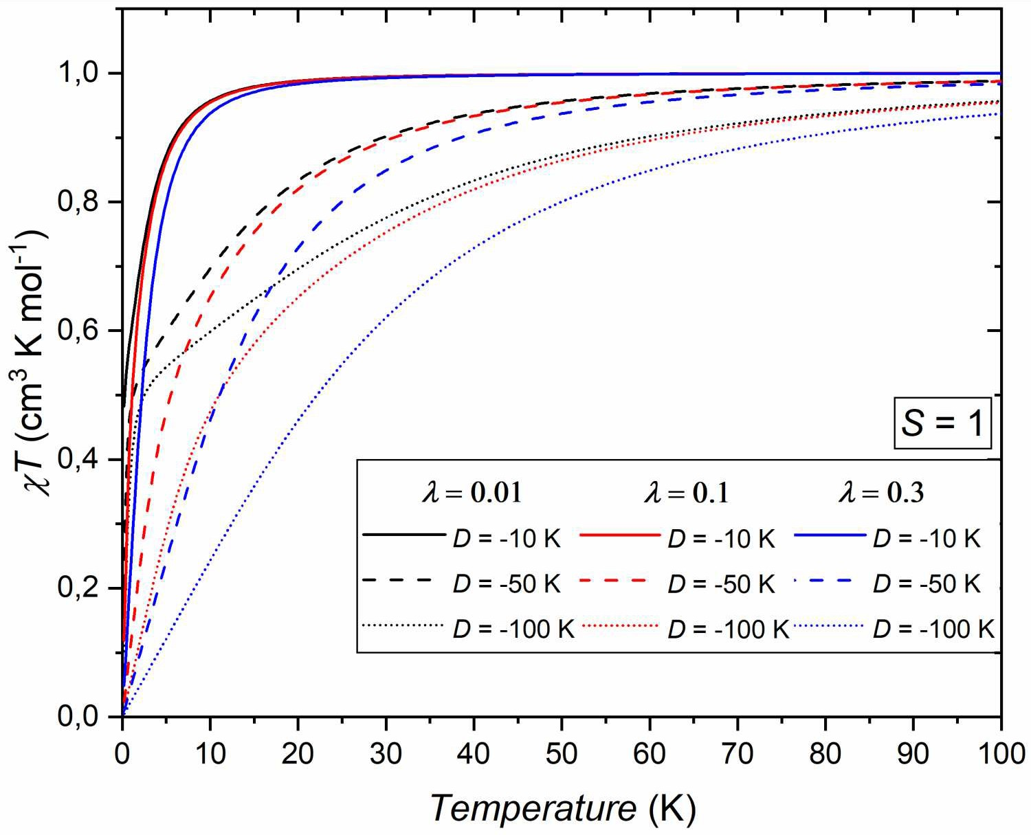
  - The case of S = 1
If molar quantities are considered, the isotropic mag- netic susceptibility χiso(T ) of an isolated magnetic mo- ment reads
2 2
NAµ g S(S + 1)
χiso(T ) = B β, (3)
3
where NA denotes the Avogadro constant, µB is the Bohr magneton, g is the Landé factor, kB is the Boltzmann constant, and β = 1/(kBT ) is the thermodynamic beta. Assuming g = 2.0 and S = 1, χiso(T ) has a constant value of about 1 cm3/(K mol). Let us introduce the parameter λ = E/D which measures the ratio of the ZFS parame- ters and is limited to be λ < 1 to ensure that z-axis is always either the easy or the hard axis [2]. The powder sample susceptibility with isotropic g = diag[g, g, g] then reads
3
| |
χ¯(T ) = χiso(T )F1 (βD, λ) , (4) where
1
F1(u, λ) = eu + 2 cosh(λu)

Fig. 2. As in Fig. 1, but for the various negative axial anisotropy parameters D < 0.

One can extract the leading term proportional to 1/u
2 eu − cosh (λu) 1 − 3λ2 sinh(λu)

as the temperature approaches zero (i.e., u → ±∞). Two
× 1 − λ2
+
u 1 − λ2
λu l . (5)
distinct cases corresponding to the different sign of pa- rameter D must be considered separately. For D < 0 the
The dimensionless quantity u is defined as u = βD. In
the limit of high temperature T or isotropic envi- ronment D 0 (i.e., u 0) function F1(βD, λ) = 1, as expected for an isotropic magnetic susceptibility χiso(T ).
→ →
→ ∞
asymptotic formula reads
F (−β|D|, λ) ∝ 3|λ| + 1 1 , (6) while for D > 0
1 2|λ| (1 + |λ|) β |D|
Figures 1 and 2 show the dependence of the powder sam- 2 1
ple susceptibility for S = 1 and g = 2 for various values of parameters D and λ. When D > 0, it is hard to dis- tinguish between curves with the same D and different λ, which effectively precludes the estimation of E. On the other hand, when D < 0 and is sizable enough, all the curves are well separated, as shown in Fig. 2.
F1(βD, λ) ∝ 1 λ2 βD. (7)
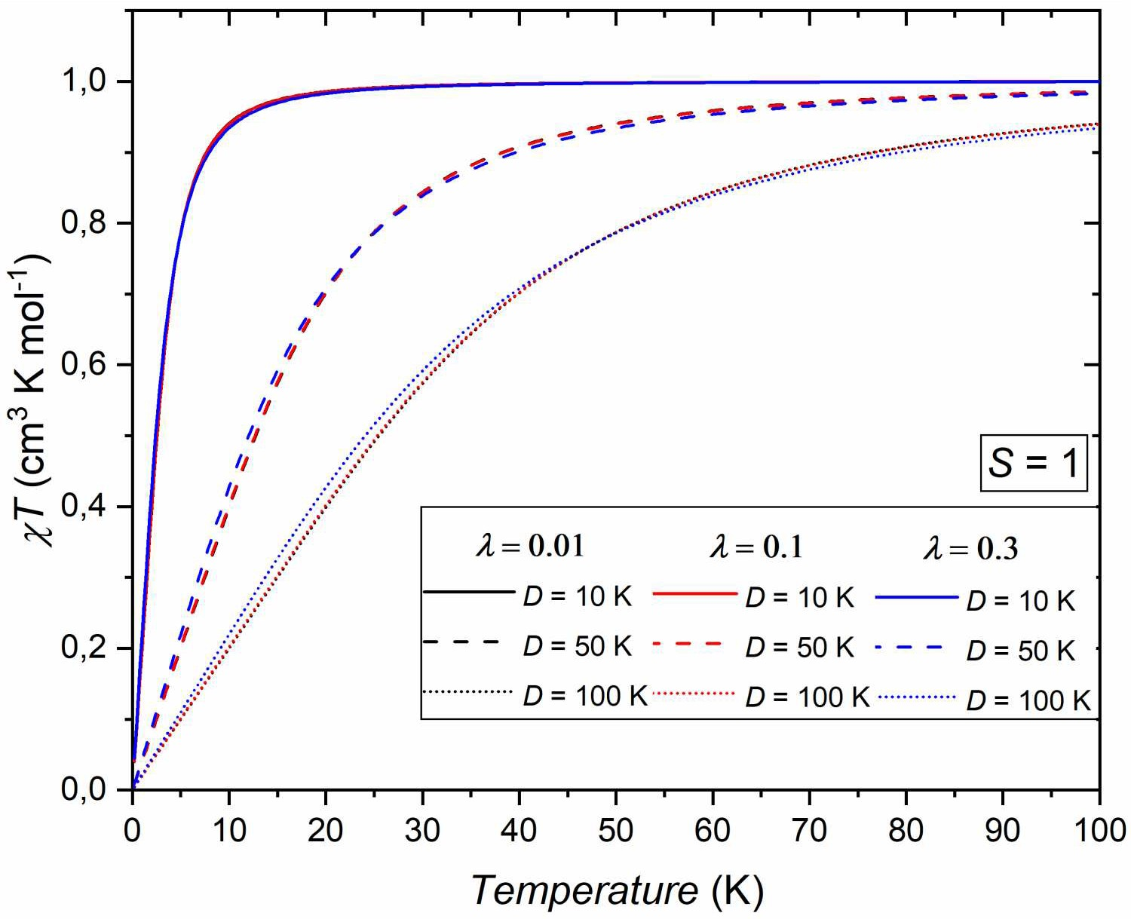
Combining Eq. (3) with either (6) or (7) indicates that the limiting value of χ¯(T 0) is a non-zero constant de- pending on the ZFS parameter ratio λ. Thus, the prod- uct T χ¯(T ) displays a linear temperature dependence in this limit. Let us define a quantity that can be estimated directly from the powder sample susceptibility data
−
→
·
∂ (T · χ¯(T ))
A =
, (8)
∂T T =0
·
which is a slope of the T χ¯(T ) curve in the zero temper- ature limit. With this new variable, the ZFS parameter ratio λ can be expressed in terms of D, A, and g:
1 NAµ2 g2
B
|λ| = 2
|D||A| − 1
/( NAµ2 g2 \2 4 NAµ2 g2 
+ B
|D|A − 1
+ B
3 |D|A
 (9)
for D < 0, and
I
1 − 3

·
|λ| =

4 NAµ2 g2

Fig. 1. Temperature dependence of the powder sample susceptibility χ¯T given in (4), for spin value S = 1 with λ = 0.01 (black), λ = 0.1 (red), and λ = 0.3 (blue), and the various positive axial anisotropy parameters D > 0.
(10)B
DA
for D > 0. Note that in the above expressions A is de- fined in units of cm3/mol. This procedure reduces the number of fitting parameters of function T χ¯(T ) to two, i.e., the axial parameter D and the spectroscopic fac- tor g, provided that one has estimated the slope A. Con- sequently, the rhombic parameter E can be calculated
950 D. Czernia, R. Pełka, M. Zentková, P. Konieczny, D. Pinkowicz

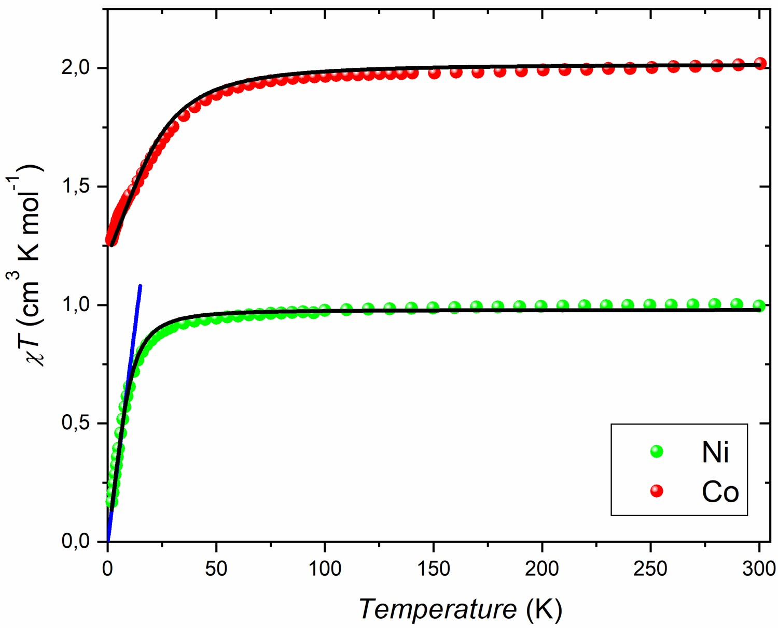
TABLE I
The upper temperature limit of T χ¯ (T ) linear approxi- mation applicability for various D and λ
·
D [K] | λ = 0.01 | λ = 0.1 | λ = 0.3
−10  −50  −100  > 0 | 0.05 K  0.2 K  0.4 K 1 K | 0.5 K 2 K  - K  - K | 1.5 K 6 K 12 K 10 K

instantly as E = λD. Table I shows the upper temper- ature limit at which the above linear approximation is still valid for certain values of parameters λ and D. For D < 0, the larger magnetic anisotropy is (and thus D and E), the higher is the temperature at which one can use (9) to reduce the number of fitting parameters. In the case of D > 0, the upper temperature limit changes only with λ and has no substantial dependence on D.
We have made an attempt to check the above proce- dure out on the real data. We considered two transition- metal complexes [MII(N3N)Li(THF)] (M=Co, Ni) [6]. The transition metal ions CoII and NiII in these com- pounds carry the spin of S = 3/2 and S = 1, respectively. The constraint fitting of the Ni congener according to the above procedure yielded only a slightly lower root mean square deviation of 1.7 10−2 cm3/(K mol) in the D < 0 case than in the D > 0 case. The low-temperature slope of the T χ¯(T ) curve was found to amount to A = 0.072(2) cm3/mol. The linear low-temperature ap- proximation together with the best fit curve are shown in Fig. 3. The best fit parameters amount to g = 1.979(3), D = 18.5(3) cm−1, and E = 7(2) cm−1. While the value of E compares well with the value of 6(1) cm−1 re- ported in [6], that of the D parameter is considerably un- derestimated (in [6] D = 26(1) cm−1 is reported). At the same time the unconstrained fitting with all three pa- rameters g, D, and E relaxed, gives a much better root mean square deviation of 8.7 10−3 cm3/(K mol) and the parameter set, g = 1.987(2), D = 24.2(7) cm−1, E = 5.7(3) cm−1, in a better agreement with the values reported in [6] and obtained by the simultaneous fitting of the susceptibility and magnetization data. This im- plies that the proposed procedure might not be a robust one, depending crucially on the precise determination of the slope A, which can be thwarted by the presence of the intermolecular interactions.
×
·
−
| |
−
×
− | |
  - The case of S = 3/2
As mentioned in the first section, crystal field (elec- trostatic interactions with neighboring valence electrons) cannot fully remove the degeneracy for systems with the half integer spin. The resulting Kramers doublets can be

Fig. 3. The best-fit curves for Ni and Co compounds reported in [6] (black). The blue line shows the low- temperature linear extrapolation of the powder suscep- tibility data for the Ni congener, employed in the pro- posed procedure of the constrained fitting.
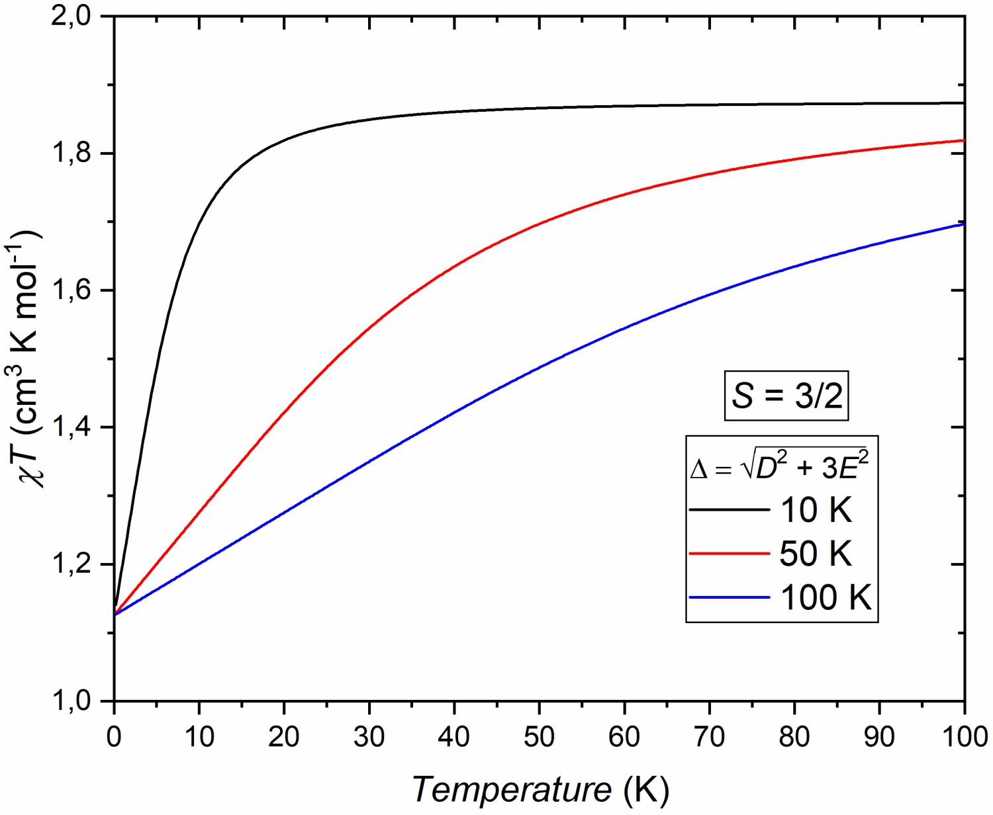
Fig. 4. Temperature dependence of the powder sample susceptibility T χ¯(T ) given in (11), for the spin value S = 3/2 with ∆ = 10 K (black), ∆ = 50 K (red), and
∆ = 100 K (blue).
·

all possible directions of the sampling field one arrives at the common result comprising the arithmetic mean of the susceptibility values taken for the three orthogonal sampling field directions as in (2). The final formula for the powder sample susceptibility of the S = 3/2 system reads
χ¯(T ) = χiso(T )F3/2(β∆) (11)
further split only by applying an external magnetic field.
with ∆ = √D2 + 3E2, χ (T ) is a constant with value
As a consequence, even in the limit of zero magnetic field the susceptibility tensor depends on the direction of the sampling field as demonstrated in [5]. It was not the
of about 1.875 cm3/(K and
iso
mol)
( \ (12)
(g = 2.0) according to (3),
case for S = 1, and it is actually a characteristic fea-
ture for half-integer spins. However, by averaging over
1 tanh(β∆)
F (β∆) = 3 + 2 .
3/2
5
β∆
Powder Sample Susceptibility for Single Ion Magnets with S = 1, 3/2 with Rhombic Anisotropy 951

In the high-temperature limit F3/2(β∆) = 1 and in the low-temperature limit F3/2(β∆) = 3/5, as shown in Fig. 4, above equation may look much simpler compared to the case of S = 1. However, since ∆ combines both ZFS parameters, it is impossible to unambiguously ex- tract both of them from a powder experiment. In fact, only ∆ is attainable which gives information about the size of the magnetic anisotropy but without the distinc- tion between the axial and rhombic ZFS parameters. In Fig. 3 the best-fit curve is shown for the Co congener. The resulting parameter ∆ amounts to 23.9(7) cm−1, which is lower than the value of 28(1) cm−1 implied in [6]. This indicates that fitting of the powder susceptibility alone may not be fully competitive to the simultaneous analysis of the susceptibility and magnetization data.

Conclusions
Exact formulae for the powder sample magnetic sus- ceptibility have been presented and discussed for SIM with integer (S = 1) and half-integer (S = 3/2) spins. In the case of S = 1, it was shown that both ZFS param- eters, D and E, might be distinctly obtained for D < 0 when magnetic anisotropy is large enough. Furthermore, the procedure, albeit not always robust, based on the lin- ear behavior of the T χ¯(T ) in the low temperature limit and reduced number of fitting parameters, was proposed

with the discussion of conditions of applicability of such an approach. A similar approach could not be done for S = 3/2 because T χ¯(T ) depends on the combination of ZFS parameters that does not allow for extracting the exact values of both D and E anisotropy constants simultaneously.

Acknowledgments
·
This work has been partially supported by the EU Project POWR.03.02.00-00-I004/16.

References

- D. Gatteschi, R. Sessoli, J. Villain, Molecular Nano- magnets, Oxford University Press, Oxford 2006.
- B. Sieklucka, D. Pinkowicz, Molecular Magnetic Materials: Concepts and Applications, Wiley-VCH, Weinheim 2017.
- G.A. Craig, M. Murrie, Chem. Soc. Rev. 44, 2135 (2015).
- S. Blundell, Magnetism in Condensed Matter, Oxford University Press, New York 2001.
- R. Pełka, Acta Phys. Pol. A 119, 428 (2011).
- D. Pinkowicz, F.J. Birk, M. Magott, K. Schulte,
K.R. Dunbar, Chemistry A Europ. J. 23, 3548 (2017).

