J Nanopart Res (2014) 16:2678 DOI 10.1007/s11051-014-2678-6
T₁–T₂Dual-modal MRI contrast agents based
on superparamagnetic iron oxide nanoparticles with surface attached gadolinium complexes
Agnieszka Szpak•Sylwia Fiejdasz•Witold Prendota•TomaszStra˛czek•CzesławKapusta•JanuszSzmyd•Maria Nowakowska•Szczepan Zapotoczny
Received: 30 June 2014 / Accepted: 26 September 2014 / Published online: 11 October 2014
©The Author(s) 2014. This article is published with open access at Springerlink.com
Abstract Dual-mode MRI contrast agentsconsisting ofsuperparamagneticironoxidenanoparticle(SPION) cores and gadolinium ions associated with the ionic chitosanprotectinglayerweresynthesizedandstudied. Gadoliniumionswereintroducedintothecoatinglayer via direct complex formation on the nanoparticles surface,covalentattachmentorelectrostaticallydriven depositionofthepreformedGdcomplex.Themodified SPIONs having hydrodynamic diameters ca. 100 nm formstable,well-defineddispersionsinwaterandhave excellent magnetic properties. Physiochemical prop- erties of those new materials were characterizedusing e.g., FTIR spectroscopy, dynamic lightscattering,
X-ray fluorescence, TEM, and vibrating sample mag- netometry. They behave as superparamagnetics and shorten both T₁and T₂proton relaxation times, thus influencing both r₁and r₂relaxivity values that reach
53.7and375.5mM⁻¹s⁻¹,respectively,at15MHz.The obtained materials can be considered as highly effective contrast agents for low-field MRI, particu- larly useful at permanent magnet-based scanners.
Keywords SPION·Superparamagnetic nanoparticles·Gadolinium·Chitosan·Magnetic
resonance imaging·Relaxivity·Composite
nanoparticles
GuestEditors:CarlosLodeiroEspin˜o,Jose´LuisCapeloMartinez
Introduction
Magnetic resonance imaging (MRI) is recognized as powerful and sensitive diagnostic technique widely used in biomedical field (Gupta and Gupta2005; Laurent et al.2008). It is a preferred tool since it does not use ionizing radiation thus allowing to avoid harmfulsideeffects(Stephenetal.2011).Themethod is based on magnetic relaxation processes of water protons that are recorded during the scan (Figuerola et al.2010). It allows for noninvasive body imaging with high spatial resolution which is highly desired in modern clinical diagnostics (De et al.2011). MRI is frequently used for tumor detection as it provides information on cellular level. Despite the wide range ofadvantagesofferedbyMRimaging,therearestill
This article is part of the topical collection on Composite Nanoparticles
A. Szpak·S. Fiejdasz·M. Nowakowska·
S. Zapotoczny (&)
Faculty of Chemistry, Jagiellonian University, Ingardena 3, 30-060 Krakow, Poland
e-mail:zapotocz@chemia.uj.edu.pl
W.Prendota·T.Stra˛czek·C.Kapusta
Department of Solid State Physics, Faculty of Physics and Applied Computer Science, AGH University of Science and Technology, Mickiewicza 30, 30-059 Krakow,Poland
J. Szmyd
Faculty of Energy and Fuels, AGH University of Science and Technology, Mickiewicza 30, 30-059 Krakow,Poland
13
RESEARCH PAPER

2678 Page 2 of 11
J Nanopart Res (2014) 16:2678
many challenges to be faced for more accurate diagnosis like accounting for the presence of various artifacts (air bubbles, calcification) or limited sensi- tivity(Yooetal.2011).Applicationofcontrastagents allowstoeliminatesomeoftheseproblems.Theyplay an important role by enhancing the contrast between healthy and diseased tissue by increasing the image quality therefore increasing sensitivity of the method (Cho et al.2010; Niu et al.2013). Generally, thereare two different classes of MR contrast agents. One type is T₁contrast agents that are reducing proton longi- tudinalrelaxationtimeandprovidingpositivecontrast (bright signal) and the second are T₂agents that can shorten proton transverse relaxation time causing negative contrast (dark signal) (Santra et al.2012). Positive contrast agents are typically of paramagnetic nature usually gadolinium complexes or manganese ions, while superparamagnetic materials, mainlythese based on iron oxide particles, act as the negative contrast agents (Yanga et al.2011).
Nanostructural materials have been showntohavesome advantages over conventionalMRIagents.Nanometerdimensionsofthesematerialshaveconsid-erable impact on certain parameters likeuniquemag-neticpropertiesorabilitytooperateoncellularlevel(Stephenetal.2011).Recently,superparamagneticironoxidenanoparticles(SPIONs),negativecontrastagents,havebeenreceivingagreatinterestamongwiderangeof magnetic nanoparticles studied (Figuerolaetal.2010).Inourpreviousreport,wepresentedsynthesisofSPION coated with ultrathin layerofbiocompatibleionic polymers in aqueous medium andtheirphysico-chemical characterization (Szpak et al.2013).Theobtained results, especially the high value ofther₂relaxivity,equalto369±3mM⁻¹s⁻¹,indicatethattheseagentscanbepotentiallyusefulinMRimaging.Inmodern diagnosis where highlyaccurateinforma-tionisdesired,singlemodecontrastagentsarenotalwayssufficient(Deetal.2011). Thus, thereisagrowinginterestindeveloping multimodal imagingprobes(Zhouetal.2012). Dual-mode T₁–T₂contrastagents,combin-ing theadvantagesofpositiveandnegativecontrasts,mayallowforimproved diagnosisbysharpening
anatomical details in the MR image (De et al.2011).
However, development of dual-mode agents with strong T₁–T₂contrast effects is very challenging. The problem arises when T₁and T₂agents are in close proximity(Deetal.2011).Forinstance,whenT₁andT₂agentsareindirectcontactthereisaninterference
betweenthemthatleadstoperturbationintherelaxation process of the paramagnetic T₁contrast agent. As a result,anundesiredeffectofdecreaseinT₁-dependant signalisobserved(Choetal.2010).Ontheotherhand, easy access of water molecules to both materials that influencetherelaxationofprotonsisalsocrucial.
There are several attempts forcreationcontrastswith T₁–T₂dual modality reported inliterature(Imetal.2013).Amongthem,afewapproachesseemtobe particularly interesting. In thereportconcerningmagnetoliposomes (iron oxide coresinphospholipidbilayer)Gd^{3?}ionswereconjugatedtotheinnerandouterbilayershellsbycreatingappropriatecomplex (De Cuyper et al.2007). Seo et al. (2006)presentedcore–shell type agent with FeCo coreandsinglegraphiteshell.Ther₂valuewas6timeshigherthan that for commercially available usedcontrastagentFerridex. Bimodal agents prepared byconjugatingT₁typeagenttothesurfaceofmagneticT₂structurewerealsoreported(Baeetal.2010).IntheworkofChoiet al., silica layer of different thicknesses wasusedtoseparate T₁(Gd₂O(CO₃)₂) andT₂(MnFe₂O₄)contrastmodes (Cho et al.2010). Depending onthethicknessofSiO₂layer,significantchangesinT₁wereobserved.Inthisreport,weproposethreedifferentapproachesfor preparation of contrast agents withT₁–T₂dualmodality. The presented methods haveseveraladvan-tagesoverthosealreadyreported.TheobtainedSPIONshavethebiocompatiblecoatingsthataresynthesizedinanaqueousmediumandthefabricationprocessiseasyandfast.TheeffectoftheobtainedagentsontheprotonT₁andT₂NMRrelaxationtimeshasbeeninvestigatedand the obtained results are very promisingfor
biomedical applications of the novel contrast agents.
Materials andmethods
Materials
Iron(III) chloride hexahydrate and iron(II) chloride tetrahydrate(Sigma),ammonia(25%solution,puriss. p.a) (Sigma), Diethylenetriaminepentaacetic acid(DTPA,forcomplexometry[99.0%,Fluka),N-Hydroxysuccinimide (NHS, 98 %, Aldrich), Gadolin- ium(III) chloride hexahydrate 99.999 % (Aldrich),N,N,N,N-Tetramethylethylenediamine[99%(TE-MED, BioReagent/SIGMA),N-(3-Dimethylamino- propylethylcarbodiimide hydrochloridecrystalline
13

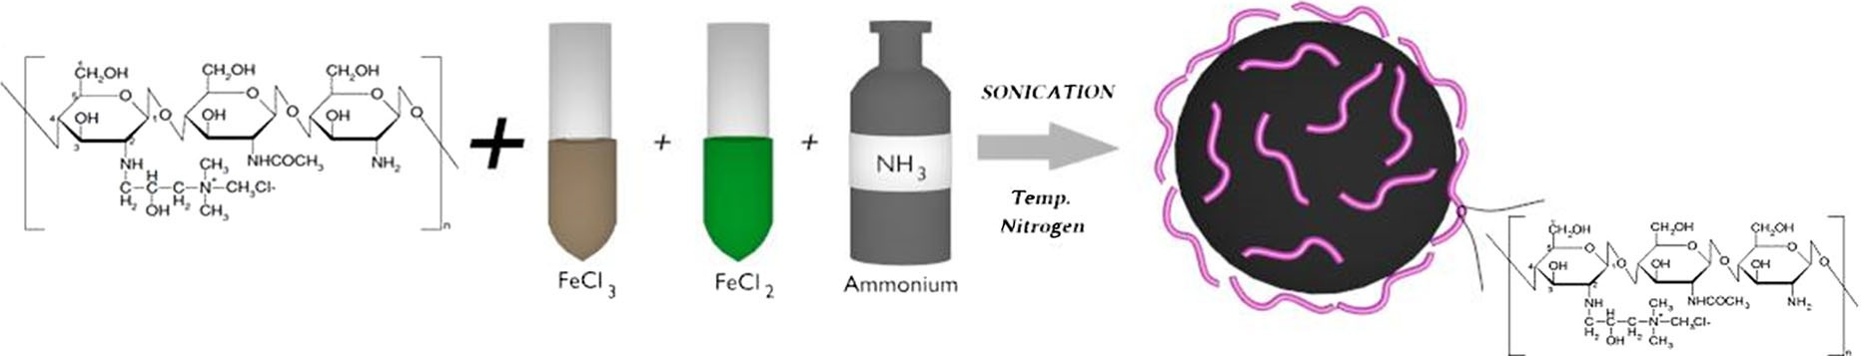
J Nanopart Res (2014) 16:2678
Page 3 of 11 2678
(EDC, Sigma-Aldrich), Diethylenetriaminepentaace- tic acid gadolinium(III) dihydrogen salt hydrate 97 % (GdDTPA, Aldrich), FeREXTM10 mg Fe/mL, OceanNanoTechLCCironoxidenanocrystals(Ocean)5mg/mL,chitosan (low molecular weight, Aldrich). Deionized water was used for preparation of all thesolutions.
firststep,AChpolymerwasmodifiedwithgadolinium complex (see Scheme2) using slightly modified method that was previously described (Huang et al.2008). Briefly, 40 mL of 0.1 % ACh in 0.1 M acetic acid was prepared and 100 mg NHS and 250 mgEDC werethenadded.ThepHofthesolutionwasadjustedto6 by addition of 1 M NaOH solution. Then, 10 mL of 100 mMGdDTPAaqueoussolutionwasaddedandthemixture was stirred for 24 h at room temperature. The resulting mixture was dialyzed against distilled water for 7 days (water was replaced twice a day) and the modifiedpolymer(ACh-GdDTPA)waslyophilized.In thenextstep,SPIONscoatedwithACh-GdDTPAwere prepared. The procedure was as follows: 7.5 mL of ACh-GdDTPAsolution(2g/L)wasmixedwith15 mL
of purified SPION-CCh dispersion (*50 ug/mL) and
sonicated for 10 min. The product was purified by magnetic filtration. As a result, SPION-Gd (ACh- GdDTPA) was obtained.
Method 2 (electrostatic). Firstly, 15 mL of SPION- CCh solution (*50 ug/mL) was mixed with 5 mL of the gadolinium complex (GdDTPA) aqueous solution (21 g/L) and sonicated. After 10 min, 10 mL of ACh solution (2 g/L) was added and again sonicated
(10 min). Subsequently, the magnetic filtration was applied. As a result, SPION-Gd (electrostatic) was obtained.
Preparation of contrast agents based on SPIONs
Synthesis of SPIONs
Cationic (CCh) and anionic (ACh) derivatives of low molecular weight chitosan were obtained accordingto the procedures described previously (Bulwan et al.2009). For CCh, the degree ofsubstitution with
GTMAC (DS
) estimated by NMR was found
GTMAC
tobe57%anddeacetylationdegree(%DD)78%.For ACh, the degree of substitution with sulfonic groups (DS_{TMST}) was found to be 67%.
SPIONs coated with cationic derivative ofchitosan (SPION-CCh) were obtained using the procedure developed by us and described earlier (Szpak et al.2013). Briefly, iron salts in molar ratio Fe(III):- Fe(II)=2:1, (0.1622 g FeCl₃·6H₂O and 0.0596g
FeCl₂·4H₂O) were dissolved in 50 mL of aqueous
solution of CCh (1 g/L). The solution was deoxygen- atedbypurgingwithargonandsonicatedfor10minin a thermostated bath (20°C). Next, 5 mL of 5M
Method 3 (GdCl ). In the first step, DTPA was
3
attached to chitosan macromolecules resulting in formation ChDTPA following the method reported by (Darras et al.2010). Coupling of DTPA with the low molecular weight chitosan was performed withEDC/NHS as coupling agents. Chitosan (0.5 g) was dissolved in water acidified by addition of HCl (pH=4.7). Next DTPA (38 mg) was activated with NHS and EDS in TEMED and added to the chitosan solution. The obtained solution was left for 72 h. The productwassubsequentlydialysed.Theexpected
NH (aq) was added drop-wise, and the solution was
3
further sonicated for 30 min (see Scheme1). Finally, the precipitated nanoparticles, SPION-CCh, were purified by magnetic filtration.
Synthesis of contrasts with dual modality SPION-Gd
Three different pathways were proposed to prepare dual-modecontrastagents.Method1(GdDTPA).Inthe
Scheme 1 Schematic illustration of the synthetic pathway for obtaining SPION-CCh
13

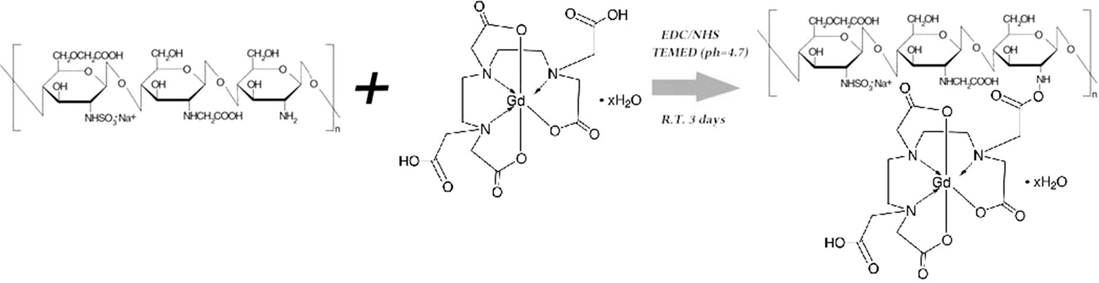
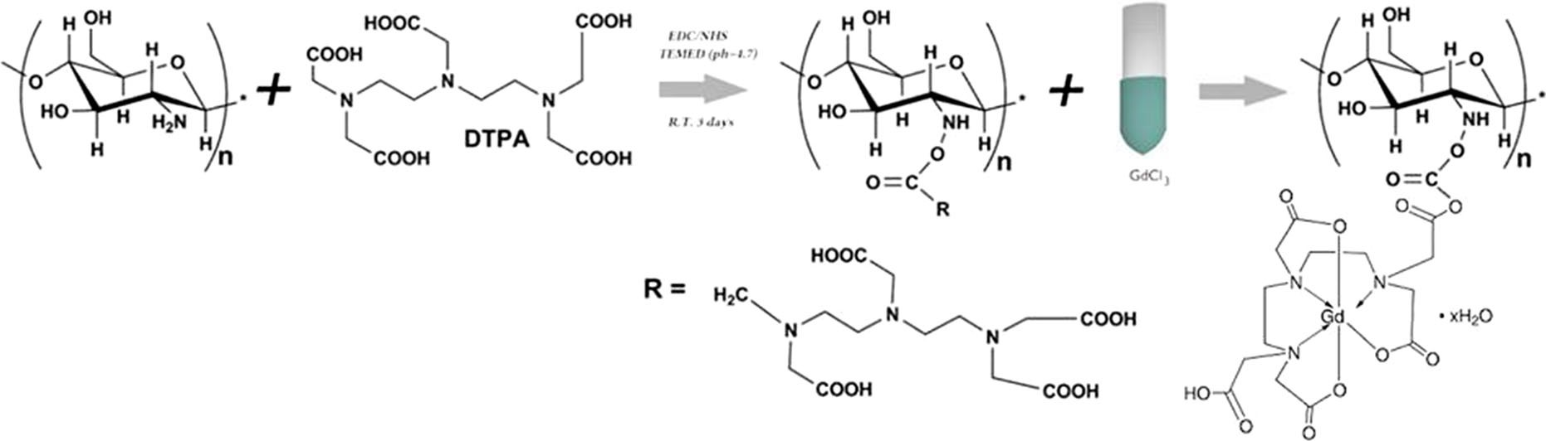
2678 Page 4 of 11
J Nanopart Res (2014) 16:2678
Scheme 2 Schematic illustration of the modification of ACh by the Gd complex (GdDTPA)
Scheme3SchematicillustrationofthemodificationofchitosanbyDTPAandsubsequentformationofcomplexwithGd^{3?}
Dynamic light scattering (DLS)
molar ratio of DTPA grafted to the chitosan for the applied conditions is 10 % (Darras et al.2010). Next, gadolinium chloride was used in order to create complex with DTPA (see Scheme3). For that pur- pose, 10 ml of aqueous solution of chitosan modified with DTPA (ChDTPA) (0.1 g/L) was mixed with 10 mL of 0.2 mM GdCl₃water solution. The formed complex was dialyzed against distilled water with 10 kDa membrane for 7 days. The obtained chitosanmodifiedwithGdcomplex,ChDTPAGd,wasusedfor the synthesis of SPIONs according to the method describedforSPION-CCh(seepoint2.2.1)butinstead of cationic derivative of chitosan (CCh),the ChDT-
Hydrodynamic sizes and zeta potentials of the obtained nanoparticles were measured by dynamic light scattering (DLS) using ZetaSizer Nano ZS (Malvern Instruments Ltd), equipped with He–Ne laser operating at 633 nm. The measurements were performed at 25°C, triple for each sample. The mean weightedsizeaccordingtodistributionbyvolumeand by number, as well as, zeta potential wasdetermined.
Transmission electron microscopy (TEM)
Thesizeandshapeoftheselectedbimodalagentwere characterized by TEM (Tecnai G2 F20 (200 kV) with field emission gun (FEG)). The bright field and highresolution electron microscopy (HREM) images were obtained. SPIONs were sonicated for 2 min beforedeposition on carbon film and air-dried at roomtemperature.
PAGd was used. The product was obtained.
SPION-Gd
(GdCl₃)
as
final
Apparatus
Infrared spectrometry (FTIR)
X-ray fluorescence (XRF)
Fourier transform infrared spectrometry was carried out using Thermo Fisher Scientific Nicolet IR200 spectrometer equipped with ATR accessory.
XRF measurements have been carried out using SEA 1000A analyzer (SII NanoTechnology Inc.) equipped
13

J Nanopart Res (2014) 16:2678
Page 5 of 11 2678
with a rhodium X-ray tube applying bulk analysis mode for dried samples of nanoparticle materials.The calibration of the response (sensitivity) for the indi- vidual elements in this mode of analysis is performed by the authorized service based on the respective calibration samples. Thus, there is no need to repeat calibration for each individual measurement. The applied calibration procedure guarantees goodenough accuracyfordeterminationofFeandGdcontentindrysamples.
FeCl₂) and biocompatible polymer, chitosan (CCh), upon addition of ammonia. According to DLS mea- surements, the obtained nanoparticles form small aggregates with hydrodynamic diameters of about 100 nm. However, the sizes of the magnetic cores were about 12 nm as revealed previously by TEM analysis (Szpak et al.2013).
These nanoparticles were chosen for further mod- ifications owing to their excellent properties e.g., stability of dispersion in aqueous media, biocompat- ibility of the coatings, and superior magnetic param- eters (high values of magnetic saturation and transverse relaxivity). The possibilities for surface modifications were also of considerable importance. Thus,SPIONsunderwentfurthermodificationinorder to create T₁–T₂bimodal agents, which were carried out in three separatepathways.
The first modification method, yieldingfinalmate-rial marked as GdDTPA, involvesconjugationofDTPAcomplexofgadoliniumtoanionicderivativeofchitosan leading to ACh-GdDTPA.Suchmodifiedpolymer was used to coat thepreviouslypreparedSPION-CCh nanoparticlesusing‘‘layer-by-layer’’(LbL) method that involveselectrostaticinteractionsbetween oppositely charged polyelectrolytes.Intheobtained agent, the positive andnegativecontrastmaterialsareseparatedbytwopolymerlayers.TheactualdistancebetweentheironoxidecoreandGdDTPAisdifficulttobepreciselydeterminedbutbased on the thickness of the CCh/ACh bilayeritmay be estimated to be about 2.5 nm (Bulwan etal.2009).Thesecondapproachismainlybasedonelectro-static interactions. Previouslypreparedpositivelycharged SPION-CCh was mixed withthenegativelycharged gadolinium complex, (Tan andZhang2005),forming SPION-Gd nanohybridundersonication.Sonication prevents weak physicaladsorption(drivenbythevanderWaalsinteractions)ofthegadoliniumcomplex,thatotherwisemightbeleakingfromthecoatingoverthetime.Toensurethestabilityoftheobtained agents they were additionallycoatedwithanionicderivativeofchitosan,ACh,usingLbL.Inthatmaterial,thesuperparamagneticcoreisseparatedfromtheparamagneticgadoliniumionsbycationicchitosansurfacelayeronlywiththethicknessofabout1.25nm
(Bulwan et al.2009).
In the third undertaken pathway, the chemical synthesis was carried out. Firstly, DTPA was conju- gated with the native chitosan in order to enable
VSM
Determination of the magnetic properties of suspen- sions of nanoparticles was done with a vibrating sample magnetometer option of a quantum design
physical property measurement system equipped with a superconducting 9 Tesla Hysteresis loops have been measured at
(PPMS)
magnet. selected
temperaturesintherange3–350Kandmagneticfieldrangingfrom-8to?8Tesla.
NMR
Proton nuclear magnetic resonance (NMR) relaxation timesandthelinewidthsweremeasuredwithanNMR spin-echo spectrometer-relaxometer PS-15 operating at the frequency of 15 MHz. For the measurements of T₁relaxation time, a saturation-recovery sequence was applied and for the T₂determination, a Carr- Purcell-Meiboom-Gill sequence was used. For the resonance line measurements, a Fourier transforma- tionoffreeinductiondecayafterasinglep/2pulsewas used. Aqueous dispersions of the nanoparticles at concentration range 1–90 ppm were investigated by applying 5 min sonication prior eachmeasurement.
Results and discussion
Preparation of dual-mode agents
As presented at the schematic diagram (Scheme4), three types of dual-mode contrast agents were prepared based on the method described previously by us for chitosan-coated SPIONs (Szpak et al.2013). The positively charged SPIONs were formed during one-pot synthesis (co-precipitation method) carried out in an aqueous medium using iron salts (FeCl₃and
13

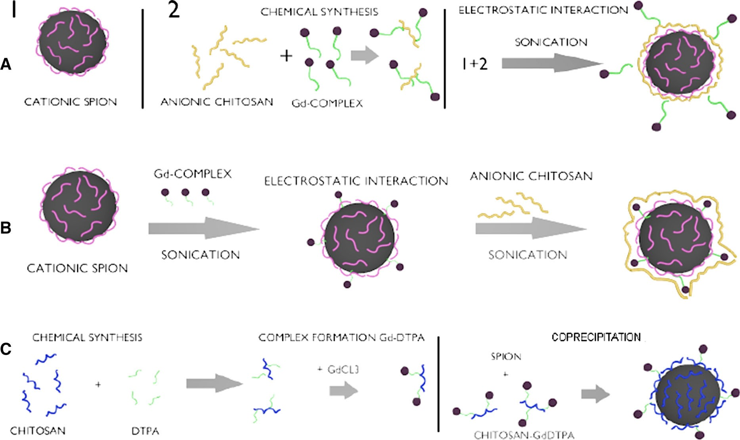
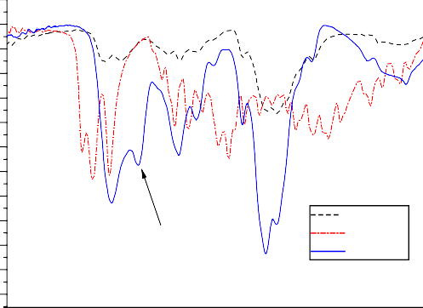
2678
Page 6 of 11
J Nanopart Res (2014) 16:2678
Scheme 4 Schematic illustration of the synthetic pathways (electrostatic), c SPION-Gd (GdCl₃)
of bimodal agents: a SPION-Gd (ACh-GdDTPA), b SPION-Gd
complex formation when the polymer was subse- quently treated with gadolinium chloride. Then, the synthesis of SPION-Gd nanoparticles using chitosan pre-modified with GdDTPA as protecting component was carried out.
105
100
95
90
85
80
75
70
65
Physicochemical characterization of singleand bimodal agents based on SPION
Ch DTPA ChDTPA
60
55
50
45
2000
amide band II
FTIR analysis
In order to check whether DTPA was successfully conjugated with chitosan macromolecules, the infra-red spectroscopy was applied. Figure1presentsFTIR spectra of chitosan, DTPA, and ChDTPA. The IR spectrum of chitosan reveals the broad band between1,100and1,000cm⁻¹thatcanbeattributedtovibration of C–O bond and to –C–O–C– vibration in the monosaccharide unit, reported also by other authors (Justi et al.2005). In case of DTPA,the bandsat1,730,1,696,and1,630cm⁻¹,correspondingtotheC=O bending in –COOH being in the form of monomer,dimer,andcarboxylate,respectively,can
1800 1600 1400 1200 1000
Wavenumber [cm]-1
800
600
Fig. 1 FTIR spectra of : chitosan, DTPA, ChDTPA
be noticed. When analyzing ChDTPA sample, thebandbetween1,100and1,000cm⁻¹,characteristicfor chitosan, can be observed as well as the band at1,620cm⁻¹(C=Ogroup)presentinDTPAspectrum.Thebandat1,530cm⁻¹thatcanbeassigntotheamideIIband,confirmsthatDTPAwasgraftedbythe amide bond to chitosan inChDTPA.
13
Transmittance %

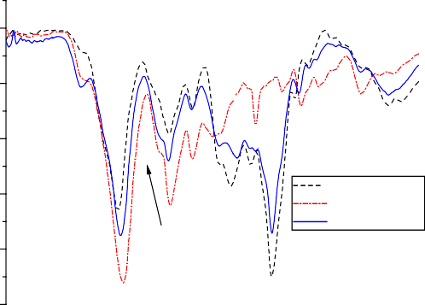
J Nanopart Res (2014) 16:2678
Page 7 of 11 2678
Table 1 The values of the mean hydrodynamic diameter and zeta potential as measured by DLS for the obtained SPIONs suspended in water
100
90
Sample name
Mean diameter (by number) d(nm)
Mean diameter (by volume) d (nm)
Zeta potential n (mV)ª
80
ACh GdDTPA
ACh-GdDTPA
70
SPION-Gd
(electrostatic)
SPION-Gd
(ACh-GdDTPA) SPION-Gd (GdCl₃)
SPION-CCh
86
92
-30±5
amide band II
60
93
94
-34±7
50
2000
1800 1600 1400 1200
1000 800
600
134
121
140
160
-39±7
?32 ± 6
Wavenumber[cm-1]
Fig. 2 FTIR spectra of: anionic derivative of chitosan ACh, GdDTPA, ACh-GdDTPA
a
Average value and its standard deviation
Table 2 The content of gadolinium in the obtained agents, given as weight-percent (wt%) or molar-percent mol% with respect to the sum of Fe and Gd present in the sample
Anionic derivative of chitosan ACh, gadolinium complex GdDTPA, and ACh-GdDTPA were also analyzed by FTIR spectroscopy in order to confirm grafting of GdDTPA to ACh. The spectra of ACh, GdDTPA, and ACh-GdDTPA are presented in Fig.2. As it can be observed, most of the bands that are characteristic for GdDTPA and for ACh are overlap- ping. The significant difference in the spectra of ACh and ACh-GdDTPA that can be noticed is broadening of the band corresponding to C=O bond which is caused by overlapping of the amide band. This
Sample name
Gd wt%
Gd mol%

SPION-Gd (electrostatic) SPION-Gd (ACh-GdDTPA) SPION-Gd (GdCl₃)
SPION-CCh
3.8±1.8
11.5±1.3
0
0
1.3±0.6
4.4±0.5
0
0
Margel2008). What is more, this synthetic method at the applied conditions resulted in unsatisfactorycontent of Gd (see Table2) in the material and was excluded from furtherconsideration.
It is also worth mentioning that all the obtained nanoparticlespossesszetapotentialvaluesintherange required for formation of stable dispersions. What is more,wehavecheckedthestabilityofthesuspensions of the nanoparticles after 3 months of their storage both:inwaterand5%glucoseisotonicsolutionthatis commonly used for injections. For SPION-Gd (ACh- GdDTPA), the measured zeta potential practicallydid not change from the initial value (see Table1) indicating high stability of the suspension in both media. These observations are very important for the possible practical applications of the obtained nano- particles as contrast agents in MRI. Suspension of SPION-Gd (electrostatic) seems to be somehow less stable for long-term storage as the zeta potentialsvaluesincreasedfrominitial-30±5mVto
-11±3intheglucosesolutionand-10±9inwater.Thatcanbeexplainedconsideringthepartial
observation also confirms covalent attachment GdDTPA to ACh.
of
DLS and zeta potential measurements
DLSandzetapotentialmeasurementswerecarriedout to determine the size and zeta potential values of SPION-based agents obtained in different synthesis pathways. The values of the mean hydrodynamic diameters and the zeta potentials are presented in Table1. It may be noticed that the hydrodynamicsize ofthenanoparticlesdoesnotchangesignificantlyafter various treatments and is kept around 100 nm. The zeta potential sign is consistent with the charge of the outer polymericlayer.
Unfortunately, this is not the case for the method SPION-Gd (GdCl₃) that should produce positively charged nanoparticles. It is also likely that the formed SPIONs are not fully coated by ChDTPA as indicated by the negative zeta potential (see Table1) charac- teristic for the naked SPIONs (Boguslavsky and
13
Transmittance %

2678 Page 8 of 11
J Nanopart Res (2014) 16:2678
of the material. Unfortunately, it was not possible to directly observe the presence of gadolinium on the surface of the nanoparticles due to too low sensitivity of the method. The obtained pictures (Fig.4) for SPION-Gd (electrostatic) are consistent with the ones previously obtained by us for SPIONs (Szpak et al.2013).PreliminaryXRDstudiesrevealedthepresence of inverse spinel type structure and Mossbauer mea- surements indicated the presence of Fe^{3?}state of iron only, which corresponds to the fully oxidized magne- tite, i.e., maghemite, c-Fe₂O₃. The detailed discussion of that issue is beyond the scope of the current paperand it is going to be included in the followingreport.
35
Ocean FeRex
SPION-Gd (ACh-GdDTPA)
SPION-Gd (electrostatic) SPION -CCh
30
25
20
15
10
5
0
1
10
100
Size d (nm)
1000
10000
Fig. 3 Distribution of hydrodynamic diameters for SPION- CCh, SPION-Gd (ACh-GdDTPA), SPION-Gd (electrostatic) andforcommercialproducts:IronOxidefromOceanNanoTech and FeREXTMfromBioPAL
X-ray fluorescence (XRF)
The results of XRF analysis of the SPIONs are collected in the Table2. The values of gadolinium content are given as weight-percent or molar-percent, relatively to the sum of Fe and Gd content.
The above presented data show that the highest amount of gadolinium (11.5 wt%) was achieved for SPION-Gd (ACh-GdDTPA), a much smaller content of (3.8 wt%) was obtained for SPION-Gd (electro- static), whereas the content of gadolinium in the SPION-Gd (GdCl₃) was below the detection limit. As expected, there was no gadolinum in SPION-CCh nanoparticles (blank). The sensitivity limit for thesemeasurements was about 0.1 %.
desorption of negatively charged GdDTPA and/or ACh from the coated nanoparticles over the time of storage. These observations additionally confirm the importance of covalent linking of the Gd complex to the polymeric coating of the nanoparticles for their long-term stability in suspension.
Additionally, the effectiveness of the electrostatic coating of SPION-CCh with the gadolinium complex andthenAChwasalsotestedusingDLStechniqueby measuring the zeta potentials. The obtained resultsshow that during the electrostatic coating with GdDTPA the zeta potential of the starting SPION- CCh (n = 132 mV) decreases slightly due to the presence of carboxylic groups from the Gd complex but it is still positive (n = 113 mV). After adsorption of ACh, the surface charge of the nanoparticlesreverses(n=-30mV)asexpectedforAChpolymerlayer covering the adsorbed Gd complexlayer.
The obtained hydrodynamic sizes for the smallest nanoparticles (SPION-Gd (ACh-GdDTPA), SPION- Gd (electrostatic)) were compared with these for the two commercially available products: iron oxidefrom Ocean NanoTech and FeREXTMfrom BioPAL (Fig.3). The hydrodynamic sizes of all nanoparticles are in the same range so the other properties of these objects can be alsocompared.
The shape and size of the nanoparticle core (for SPION-Gd (electrostatic)) were observed by theTEM imaging. The pictures reveal the crystallinestructure
Magnetic properties
Vibrating sample magnetometry (VSM)
The detailed magnetic studies were performed for SPIONs with the highest content of gadolinium. The hysteresis loops measured for the 10 ppm water dispersion of SPION-Gd (ACh-GdDTPA) at selected temperatures are presented in the Fig.5.
These hysteresis loops reveal a substantialdiamag- netic contribution. Data were corrected for this diamagnetic contribution by subtracting straight lines fitted to the linear parts of the plots at highfield ranging from ±30 to ±80 kOe. Such corrected hysteresis loops are shown for the low field range in the Fig.6.
The values of the coercive field Hc amounts to 290 Oe at 3 K and it decreases gradually to 190 Oe at 10K,whichmeansthatthenanoparticlesfrozenin
13
Number (%)

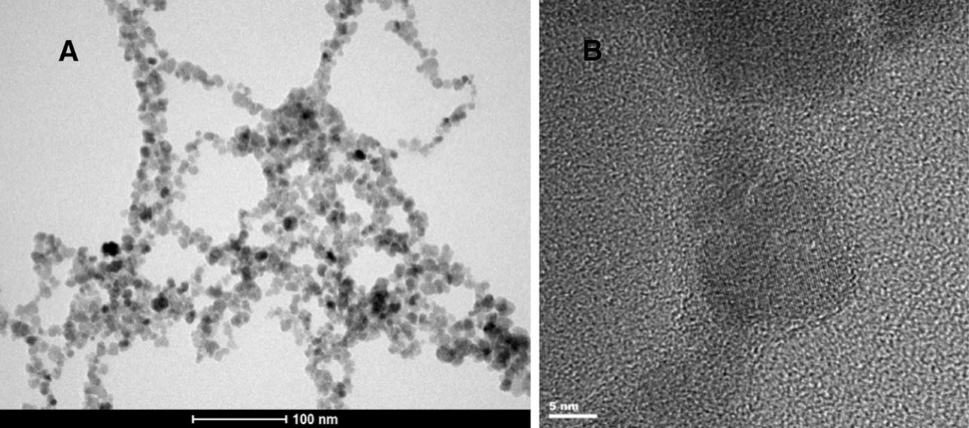
J Nanopart Res (2014) 16:2678
Page 9 of 11
2678
Fig. 4 Bright-field TEM image (a) and HRTEM image (b) of SPION-Gd (electrostatic)
0.03
1x10-3
8x10-4
6x10-4
4x10-4
2x10-4
0
-2x10-4
-4x10-4
-6x10-4
-8x10-4
0.02
0.01
0.00
-0.01
-0.02
-0.03
-1x10-3
-30000
-20000 -10000
0
10000 20000 30000
-2000 -1500
-1000 -500
0
500 1000 1500
2000
Magnetic Field (Oe)
Magnetic Field (Oe)
Fig. 5 Hysteresis loops measured for the 10 ppm (Fe equiva- lent) water dispersion of the SPION-Gd (ACh-GdDTPA) nanoparticles at selected temperatures
Fig. 6 Hysteresis loops for SPION-Gd (ACh-GdDTPA) nano- particles corrected for the diamagnetic contribution
indicating a well ordered structure of the maghemitecores of the nanoparticles.
water exhibit a ferromagnetic or ferrimagnetic effect with a relatively high coercivity at liquid helium temperatures. Already at 50 K and also at higher temperatures, the coercive field is virtually zero,what indicates their superparamagnetic state. The obtained saturation magnetization of 75 emu/g related to the nanoparticlecoresisveryclosetothevalueof70emu/ g reported for maghemite nanoparticles of similar particlesizes(Berkowitzetal.1968).Itisworthnoting that the magnetic saturation is obtained at the applied field ranging from 700 Oe under the temperature ranging from 50 to 250 K, i.e., in the solidified dispersion to 800 Oe at 300 K, in the liquid. A significant linear part of the magnetization curve with onlyasmallnonlinearpart,closetosaturation,reveals aminoreffectfrommagneticinhomogeneities
Relaxivity
In order to investigate potential usefulness of the prepared dual-mode MRI contrast agents relaxivity measurements were carried out. SPION-CCh and commercially used contrast agents: FeREXTMand Ocean were also studied for a comparison. The resulting relaxivity values are presented in Table3and plotted at the Figs.7and8.
The 1/T₁and 1/T₂relaxivities show a linear dependence on the concentration of nanoparticles for the prepared bimodal agents as well as for commer- cially used contrasts. This means that contribution of individual nanoparticles to both relaxivities is
13
Magnetic Moment (emu/g)
Magnetic Moment (emu/g)

3K
10K
50K
100K
150K
250K
300K

3K
10K
50K
100K
150K
250K
300K

2678 Page 10 of 11
J Nanopart Res (2014) 16:2678
As it was indicated in the introduction, the aim of ourstudieswastopreparethecontrastagentswithdual modality containing both: the superparamagnetic material (SPION) acting as negative contrast and paramagnetic gadolinium ion/complex working as a positive contrast. That novel material should shorten T₁and T₂relaxation times thus influencing r₁as well as r₂relaxivities. The calculated r₁and r₂values (see Table3) show that the synthesized bimodal agents gave generally better results than for monomodal agent consisting of SPION-CCh only. In comparison to the commercially available contrasts, the relaxiv- ities of the developed materials are significantly higher. In case of SPION-Gd (electrostatic), r₂value(375.5mM⁻¹s⁻¹)isabout2.5timeshigherthanthatfor FeREXTMand almost four times higher than for Ocean(negativeagents).Thesameappliesforr₁valueforSPION-Gd(electrostatic)(53.7mM⁻¹s⁻¹)thatwas found more than two times higher than forOcean and slightly less forFeREXTM.
The presented results clearly indicate that the developed agents SPION-Gd (Ach-GdDTPA), SPI- ON-Gd (electrostatic) are very promising candidatesfor MRI bimodal contrast enhancements. TheSPION- Gdpreparedbasedontheelectrostaticinteractionscan be of special interest due to the high values for bothr₁and r₂relaxivities.
Table 3 The relaxivity values obtained for prepared bimodal agents and commercially used contrasts
r₁(mM⁻¹s⁻¹)
r₂(mM⁻¹s⁻¹)
Sample name
SPION-Gd (ACh-GdDTPA)
SPION-Gd (electrostatic) SPION-CCh
Ocean
FeREXTM
36.0±0.9
53.7±1.1
46.5±2.8
23.5±0.9
33.1±1.3
361.4±4.3
375.5±9.7
282±21
93.8±1.9
160.1±6.6
60
Ocean FeREX SPION-CCh
SPION-Gd (electrostatic) SPION-Gd (AChGdDTPA)
50
40
30
20
10
0
0,0
0,2 0,4 0,6 0,8 1,0
c (mmol)
1,2
1,4 1,6 1,8
Fig. 7 The dependence of the 1/T1 relaxivity values on the concentration of nanoparticles for prepared bimodal agents and commercial contrasts
Conclusion
600
Ocean FeREX SPION-CCh
SPION-Gd (electrostatic) SPION-Gd (AChGdDTPA)
500
Three methods of preparing novel dual-mode nano- structural MRI contrast enhancement agents based on SPIONs and gadolinium were proposed. Theobtained agents were characterized using severalphysicochem- ical techniques: FTIR, DLS, TEM, XRF, and their magnetic properties were evaluated by VSM and NMR.
SPION-Gd (ACh-GdDTPA) and SPION-Gd (elec-
trostatic) approaches were very successful; the obtained materials have the outstanding relaxivityperformance (high values of r₁and r₂) considerably better than these for the commercially available contrast agents. In addition, the suspension of SPI- ON-Gd(ACh-GdDTPA)exhibitsverygoodlong-term stability.
The methods developed allow for creating bimodal agents with different: gadolinium content, proximity
400
300
200
100

0
0,0 0,2 0,4 0,6 0,8
1,0 1,2 1,4 1,6 1,8
c (mmol)
Fig. 8 The dependence of the 1/T2 relaxivity values on the concentration of nanoparticles for prepared bimodal agents and commercial contrasts
additive, so that a possible agglomeration of the nanoparticles during the NMR measurement can be excluded.
of
superparamagnetic
core–gadolinium
atoms,
13
1/t2
1/t1

J Nanopart Res (2014) 16:2678
Page 11 of 11 2678
improving iron oxide-based magnetic resonance imagingcontrast agents: Anchoring of gadolinium ions to a lipo- philic chelate. Anal Biochem 367:266–273
De M, Chou SS, Joshi HM, Dravid VP (2011) Hybridmagneticnanostructures (MNS) for magnetic resonance imaging applications. Adv Drug Deliver Rev63:1282–1299
Figuerola A, Di Corato R, Manna L, Pellegrino T (2010) From iron oxide nanoparticles towards advanced iron-basedinorganic materials designed for biomedical applications. Pharmacol Res 62:126–143
Gupta AK, Gupta M (2005) Synthesis and surface engineeringof iron oxide nanoparticles for biomedical applications. Biomaterials 26:3996–4021
Huang M, Huang ZL, Bilgen M, Berkland C (2008) Magneticresonance imaging of contrast-enhanced polyelectrolytecomplexes. Nanomed Nanotechnol 4:30–40
Im GH, Kim SM, Lee DG, Lee WJ, Lee JH, Lee IS (2013)
Fe₃O₄/MnO hybrid nanocrystals as a dual contrast agentfor both T₁- and T₂- weighted liver MRI. Biomaterials 34:2069–2076
Justi KC, Favere VT, Laranjeira MCM, Neves A, Casellato A (2005)Synthesisandcharacterizationofmodifiedchitosanthrough immobilization of complexing agents. AdvPolym Mater1:203–207
Laurent S, Forge D, Port M, Roch A, Robic C, Vander ElsLt, Muller R (2008) Magnetic iron oxide nanoparticles: syn- thesis, stabilization, vectorization, physicochemical char-acterizations, and biological applications. Chem Rev 108:2064–2110
Niu D, Luo X, Li Y, Liu X, Wang X, Shi J (2013) Manganese- loadeddual-mesoporoussilicaspheresforefficientT₁-andT₂- weighted dual mode magnetic resonance imaging. Appl Mater Interf5:9942–9948
Santra S, Jativa SD, Kaittanis C, Normand G, Grimm J, PerezJM (2012) Gadolinium-encapsulating iron oxide nanop-robe as activatable NMR/MRI contrast agent. ACS Nano 8:7281–7294
Seo WS, Lee JH, Sun X, Suzuki Y, Mann D, Liu Z, Terashima M, Yang PC, McConnell MV, Nishimura DG, Dai H(2006) FeCo/graphitic-shell nanocrystals as advancedmagnetic-resonance-imaging and near-infrared agents.Nat Mater5:971–976
Stephen ZR, Kievit FM, Zhang M (2011) Magnetite nanopar-ticles for medical MR imaging. Mater Today 7–8:330–338SzpakA,KaniaG,Sko´rkaT,TokarzW,ZapotocznyS,Nowa-kowska M (2013) Stable aquueous dispersion of superpara-magnetic iron oxide nanoparticles protected by charged
chitosan derivatives. J Nanopart Res 15:1372–1383
Tan WB, Zhang Y (2005) Multifunctional quantum dot based magnetic chitosan nanobeads. Adv Mater 17:2375–2380
YangaH,ZhuangaY,SundY,DaiA,ShiX,WueD,LiF,Hua He, Yanga S (2011) Targeted dual-contrast T₁- and T₂- weighted magnetic resonance imaging of tumorsusingmultifunctional gadolinium-labeled superparamagnetic iron oxide nanoparticles. Biomaterials32:4584–4593
YooD,LeeJH,ShinTH,CheonJ(2011)Theranosticmagnetic nanoparticles. Acc Chem Res10:863–874
ZhouZ,HuangD,BaoJ,ChenQ,LiuG,ChenZ,ChenX,GaoJ (2012) A synergistically enhancedT₁–T₂dual-modal con- trast agent. Adv Mater24:6223–6228
allowing penetration of polymer layer by water molecules, and various types of interactions (physical forces or chemical bond) therefore significantly influ- encing magnetic properties.
Additionally, the presented methods allow to change the type of polymer used to coat theiron oxidenanoparticlesandprecisecontrolofthedistance between magnetic core and gadolinium complex.This makes possible to create a very broad spectrum of materials for MRI but also various otherpractical applications.Theobtainedmaterialscanbeconsidered as highly effective contrast agents for low-field MRI, in particular at permanent magnet-basedscanners.
Acknowledgments This work was supported by theEuropean Union from the resources of the European Regional Development Fund under the Innovative Economy Programme (grant coordinated by JCET-UJ, No. POIG.01. 01.02-00-69/09).PartialsupportfromNationalScienceCentre, Poland, Project No. 2012/07/B/ST8/03109 is acknowledged. The authors would like to thank Msc. Gabriela Kania for the help in synthesis of thepolymer.
Open Access This article is distributed under the terms of the Creative Commons Attribution License which permits any use, distribution, and reproduction in any medium, provided the original author(s) and the source are credited.
References
BaeKH,KimYB,LeeY,HwangJY,ParkHW,ParkTG(2010) Bioinspired synthesis and characterization ofGadolinium- labeled magnetite nanoparticles for dual contrast T1- and T2-weighted magnetic resonance imaging. Bioconjugate Chem21:505–512
Berkowitz AE, Schuele WJ, Flanders PJ (1968) Influence of crystallite size on the magnetic properties of acicular c- Fe₂O₃particles. J Appl Phys 39:1261–1263
BoguslavskyY,MargelS(2008)Synthesisandcharacterization of poly(divinylbenzene)-coated magnetic iron oxide nanoparticles as precursor for the formation of air-stable carbon-coated iron crystalline nanoparticles. J Colloid In- terf Sci317:101–114
BulwanM,ZapotocznyS,NowakowskaM(2009)Robust‘‘one- component’’chitosan-basedultrathinfilmsfabricatedusing layer-by-layer technique. Soft Matter5:4726–4732
Cho JS, Lee JH, Shin TH, Song HT, Kim EY, Cheon J (2010) Self-confirming ‘AND’logic nanoparticles for fault-free MRI. J Am Chem Soc 132:11015–11017
DarrasV,NeleaM,WinnikFM,BuschmannMD(2010)Chitosan modified with gadolinium diethylenetriaminepentaacetic acid for magnetic resonance imaging of DNA/chitosan nanoparticles. Carbohydr Polym80:1137–1146
DeCuyperM,SoenenSJH,CoenegrachtsK,TerBeekL(2007) Surface functionalization of magnetoliposomes in viewof
13

