
Signature:©PolJRadiol,2010;75(4):61-63
CASEREPORT
Pleuralmesothelioma–casereport
Received:2010.09.03
Accepted:2010.10.01
AnnaKlawiter,TomaszDamaszke
DepartmentofRadiologyandImagingDiagnostics,F.CeynowaSpecialistHospital,Wejherowo,Poland
Author’saddress:AnnaKlawiter,DepartmentofRadiologyandImagingDiagnostics,F.CeynowaSpecialistHospital,Wejherowo,Poland,e-mail:annaklawiter@gazeta.pl
Summary
Pleuralmesotheliomaisaveryrareneoplasm;especiallythelocalform.Thediagnosticsisdifficultandtheprognosisunfavourable.
Wepresentedacaseofamanwithdyspnoeaandcough.Hischestradiogramshowedhydrothoraxon the leftside. Neithertheexaminationsof thepleural liquid, northeCT-guidedfine needlebiopsyestablishedthediagnosis.CTshowedfeaturessuggestiveofpleuralmesothelioma.Thediagnosiswasconfirmedbythoracoscopy.Althoughnoneoplasticcellswerefoundinthethoracoscopicspecimenfromthesupradiaphragmatictumor,weassumedthattobeacaseofadiffuse,primarilylocalformofmesothelioma.
Diagnosticsofpleuralmesotheliomaisverydifficult.CTandthoracoscopyseemtobeveryvaluablediagnosticmethods.Itisworthrememberingthatpleuralmesotheliomacanhavealocalformwhich maytransformintoadiffuseone.
Background:
CaseReport:
Conclusions:
Keywords:
pleuralmesothelioma•pleuraltumour•hydrothorax
PDFfile:
http://www.polradiol.com/fulltxt.php?ICID=881345
Background
toasbestosinhiswork.AnX-rayshowedashadowintheleftchestcausedbythepresenceoffluidinthepleuralcav-ity(Figure1).Adecompressingpunctureoftheleftpleu-ralcavitywasperformed,andabloodyfluidwasobtained.Fluidculturesfortuberculosisandmicrobiologicalcultureswerenegative.Noneoplasticcellswerefoundincytologi-calexaminationsofthefluid.Bronchoscopywasnormal.ChestCTwasperformed.Itrevealedasignificantamountoffluidintheleftpleuralcavityandapoorlydelineated,inhomogeneousmasslesionbetweenthepleurallayersinthebaseoftheleftlung(Figure2A).Initslargestdimen-sion,thelesionmeasured85mm.Themassshowedaslightenhancementaftercontrastmediumadministration.Abovethetumour,therewasaslightthickeningofthepleuraat3spots(Figure2B).USGofthechestwasperformed.Itshowedeffusioninthepleuralcavityandapoorlyvascu-larised,hyperechogenicmasslesionbetweenthelayersofthethickenedpleura(Figure3).Withinthetumour,therewerehypo-andanechoicareassuggestiveofhaemorrhage.
Mesotheliomaisarareneoplasm,foundinapprox.1case/million/year.Itdevelopsmainlyinindividualsover60,menmostly,althoughitwasalsoreportedinchildren.Itsmainriskfactor isasbestos. Theincidence ofmesotheliomainpeopleexposedtoasbestosis300timeshigherthaninthegeneralpopulation.Otherriskfactorsincludeerion-ite,radiotherapyandothersurgeriescausingpleuralscar-ring.Themostcommonlyreportedsymptomsincludedys-pnoearesultingfrompleuraleffusionandpaininthechest.Diagnosticimaginginvolves:standardX-rays,CT,MRI,andPET.Thebestmethodforafinaldiagnosisseemstobevid-eothoracoscopy.Treatmentofmesotheliomaincludesche-motherapy,radiotherapyandsurgicalresections.Themor-talityisalmost100%.Recoveryhasbeenrarelyreported,andonlyincasesofaveryearlydiagnosis,subjectedtoadjuvanttreatment.
CaseReport
CT-guidedFNABwasperformedtwice.Therewerenoneo-plasticcellsfoundoncytology.ThepatientwastransferredtotheClinicofChestSurgeryoftheMedicalUniversityofGdańsk.Thisiswhereheunderwenttranspleuralthoracos-copythatrevealedasupradiaphragmaticsofttumourwith
Aman,57yearsold,admittedtotheDepartmentofLungDiseasesandTuberculosisforatiring,drycoughanddys-pnoeaoneffort,presentforthelast3weeks.Hehadahis-toryoftuberculosisinthechildhood.Hewasnotexposed
61

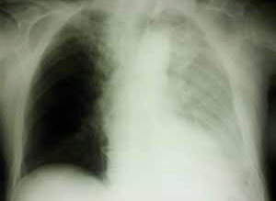
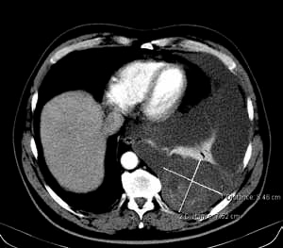
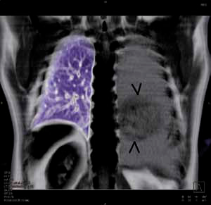
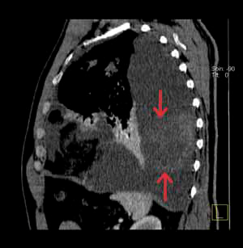
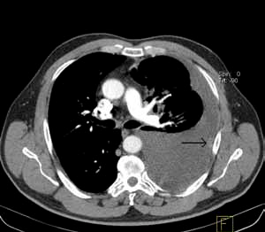
CaseReport
©PolJRadiol,2010;75(4):61-63
Figure1.Chestradiogram.Pleuraleffusionintheleftpleuralcavity.
Figure2.ContrastenhancedCT.(A)Heterogenoustumorbetweenthickenedpleurallaminas.(B)Pleuraltumor.
ableedingsurface,locatedinthepleuralcavity,andminormasslesionsofthepleura.Biopsiesweresampled.Withamicroscopicimageandimmunohistochemistry,wecoulddiagnosethatminornodulouspleuralthickeningasmeso-thelioma(Figure4A,B).Samplematerialfromthesupradia-phragmatictumourshowedahyalinisedtissuewithhaem-orrhage,containingnoneoplasticcells.
Discussion
Computedtomographyplaysanimportantrole,bothinthediagnosticsandintheevaluationoftreatmentresponseinmesothelioma[1].Themostcommonsymptomsofmeso-theliomafoundonCTare:pleuralthickening,includingpleuraininterlobarfissures,effusioninthepleuralcavity,decreasedvolumeoftheaffectedsideofthechest,mediasti-numshiftedtothe healthyside,and pleuralcalcifications [2].
Othersymptomsthatcanbesuggestiveofthediseaseinclude:nodularthickeningofthepleura,pleuralthickeningofover1cm,andinfiltrationofthemediastinalpleura[3].
TheCTimageobtainedfromtheabovepresentedpatientwassuggestiveofadiffusemesotheliomarightfromthebegin-ning.Alargemassbetweenthepleurallayerscouldpresent
aprimarilylocalisedformofmesothelioma,whilethesmallpleuraltumourscouldbeindicativeofneoplasticdissemina-tion.Localisedmesotheliomaisaveryrareformoftumour.
62
B

A

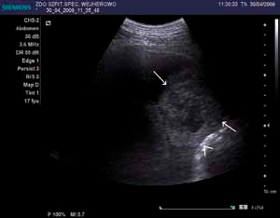
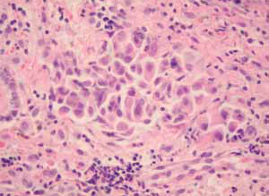
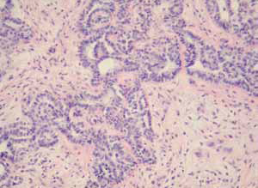
©PolJRadiol,2010;75(4):61-63
KlawiterAetal–Pleuralmesothelioma–casereport
Figure3.Chestultrasonography.Hyperechoictumorbeteweenthickenedpleurallaminas.Hypoechoicandanechoicareasofhaemorrhagewithinthetumor(<diaphragm,®tumour).
Itmanifestsitselfasawell-delineatedtumour,withoutmacro-ormicroscopicfeaturesofdiffusepleuralinfiltra-tion.Sometimes,itisaccompaniedbythepresenceofpleuraleffusion.Localisedmesotheliomaisatumourthatcanreacheven10cmindiameter.Itispedunculatedoradjoinsthevis-ceralortheparietalpleuraonawidebase.Microscopically,itispossibletodistinguishthesametypes,asincaseofdif-fusemesothelioma–epithelioid,sarcomatous,andmixed.Inhistochemicalandimmunohistochemicalexaminations,thelocalisedformspresentasthediffuseones[4].Accordingtosomeauthors,thelocalisedtumouristhefirststageofthedisease, followedby thediffuseform[5]. Despitethefactthatthematerialsampledthoracoscopicallyfromthesupradia-phragmatictumourshowedonlythehyalinisedtissue,with-outneoplasticcells,wemayassumethatthetumourwasprimarilylocalised,andthensubjectedtohyalinisation.
Figure4.Pleuralmesothelioma,epitheliocellulartype.(A)Looselycombinedmultilateralcellsimitatemacrocellularcancerorlymphoma.(B)Mesotheliomacellsimitateglandulartissuewithcell’spolarisationandsecretion.
immunohistochemicalexaminationsrequiredforthefinaldiagnosis[4].Inthepresentedcase,itwasthethoracoscopythat allowed formaking the finaldiagnosis.
Thereportedcaseillustratesquitecommondiagnosticdiffi-cultiesfoundinmesothelioma.Nocytologicalexaminationsofthepleuraleffusionshowedthepresenceofneoplasticcells.Theyarefoundinonlyapprox.50%ofpatientswithpleuraleffusionproducedinthecourseofmesothelioma[4].RepeatedFNABdidnotrevealthediagnosiseither,despiteitscommonuseinmesotheliomadiagnostics.Thisisbecauseitwasthehard,hyalinised,supradiaphragmatictumourthatwaspunctured,whilethediagnosiswasmadeonthebasisofthematerialaspiratedfromsmallpleuralnodules.
Conclusions
Mesotheliomaisatumourcausingmanydiagnosticdif-ficulties.It,andespeciallyitslocalisedform,belongstorareneoplasms.However,weshouldbeawareofthepres-enceofthelocalisedform,duetothepredictedincidenceincreasebytheyear2020–2030[6].
Acknowledgements
Awidelyrecommendeddiagnostictoolincaseofsus-pectedmesotheliomaisthevideothoracoscopy.Itallowsforsamplingasmuchmaterialasnecessarytocarryout
Acknowledgementsto:Prof.KazimierzJaśkiewicz,MDPhD,andMałgorzataKurzępa,MD,fortheirhelpinprepar-ingthecasereport.
References:
- NqCS,MundekRF,LibshitzHI:Malignantpleuralmesothelioma:thespectrumofmanifestationsonCTin70cases.ClinRadiol,1999;54(7):415–21
- KawashimaA,LibshitzHI:Malignantpleuralmesothelioma:CTmanifestationsin50cases.AJRAmJRoentgenol,1990;155(5):965–69
- MooreAJ,ParkerRJ,WigginsJ:Malignantmesothelioma.OrphanetJRareDis,2008;3:34
- TravisWD:WorldHealthClassificationofTumors.PathologyandGenetics.Tumorsofthelung,pleura,thymusandheart.Lyon,2004;128–36
- HiranoH,TakedaS,SawabataYetal:Localizedpleuralmalignantmesothelioma.PatholInt,2003;53(9):616–21
- PorretE,MadelaineJ,Gelateau-SalleFetal:Epidemiology,molecularbiology,diagnosticandtherapeuticstrategyofmalignantpleuralmesotheliomain2007–anupdate.RevMalRespir,2007;24(8Pt2):6S157–64
63

A

B

