



Article

The G-Protein-Coupled Membrane Estrogen Receptor Is
Present in Horse Cryptorchid Testes and Mediates
Downstream Pathways
Maciej Witkowski1,2,+, Laura Pardyak 3,+ , Piotr Pawlicki3 , Anna Gałuszka 1 , Magdalena Profaska-Szymik
Bartosz J. Plachno 4 , Samuel Kantor1, Michal Duliban 5© and Malgorzata Kotula-Balak h*©
Citation: Witkowski, M.; Pardyak, L.;
Pawlicki, P; Galuszka, A.;
Profaska-Szymik, M.; Plachno, B.J.;
Kantor, S.; Duliban, M.; Kotula-Balak,
M. The G-Protein-Coupled
Membrane Estrogen Receptor Is
Present in Horse Cryptorchid Testes
and Mediates Downstream Pathways.
Int. J. Mol. Sci. 2021, 22, 7131.
https://doi.org/10.3390/
ijms22137131
Academic Editor: Claudiu T. Supuran
Received: 13 May 2021
Accepted: 29 June 2021
Published: 1 July 2021
- University Centre of Veterinary Medicine JU-UA, University of Agriculture in Krakow, Mickiewicza 24/28,
30-059 Krakow, Poland; maciej.witkowski@urk.edu.pl (M.W.); anna.galuszka@urk.edu.pl (A.G.);
magdalena.profaska-szymik@urk.edu.pl (M.P.-S.); samuel.kantor@urk.edu.pl (S.K.)
- Equine Hospital on the Racing Truck, Sluzewiec, Pulawska 266, 02-684 Warszawa, Poland
- Center for Experimental and Innovative Medicine, University of Agriculture in Krakow, Redzina 1c,
30-248 Krakow, Poland; laura.pardyak@urk.edu.pl (L.P.); piotr.pawlicki@urk.edu.pl (P.P.)
- Department of Plant Cytology and Embryology, Institute of Botany, Jagiellonian University in Krakow,
Gronostajowa 9, 30-387 Krakow, Poland; bartosz.plachno@uj.edu.pl
- Department of Endocrinology, Institute of Zoology and Biomedical Research, Jagiellonian University in
Krakow, Gronostajowa 9, 30-387 Krakow, Poland; michal.duliban@doctoral.uj.edu.pl
* Correspondence: malgorzata.kotula-balak@urk.edu.pl
+ These authors contributed equally to this paper.
Abstract: Cryptorchidism in horses is a commonly occurring malformation. The molecular basis of
this pathology is not fully known. In addition, the origins of high intratesticular estrogen levels in
horses remain obscure. In order to investigate the role of the G-protein-coupled membrane estrogen
receptor (GPER) and establish histological and biochemical cryptorchid testis status, healthy and
cryptorchid horse testes were subjected to scanning electron microscopy analysis, histochemical
staining for total protein (with naphthol blue black; NBB), acid content (with toluidine blue O; TBO),
and polysaccharide content (with periodic acid-Schiff; PAS). The expression of GPER was analyzed
by immunohistochemistry and Western blot. GPER-mediated intracellular cAMP and calcium (Ca2+)
signaling were measured immunoenzymatically or colorimetrically. Our data revealed changes in
the distribution of polysaccharide content but not the protein and acid content in the cryptorchid
testis. Polysaccharides seemed to be partially translocated from the interstitial compartment to the
seminiferous tubule compartment. Moreover, the markedly decreased expression of GPER and GPER
downstream molecules, cAMP and Ca2+, suggests their potential role in testis pathology. Increased
estrogen levels in cryptorchid conditions may be linked to disturbed GPER signaling. We postulate
that GPER is a prominent key player in testis development and function and may be used as a new
biomarker of horse testis in health and disease.
Publisher's Note: MDPI stays neutral
with regard to jurisdictional claims in
published maps and institutional affil-
iations.
Keywords: cryptorchidism; estrogens; G protein-coupled receptor; horse
- Introduction
Testicular descent is an integral part of the male differentiation process. Testes migrate
from the abdominal cavity to the scrotum. This process is essential for proper testis func-
tioning and it consists of two phases: transabdominal and inguinoscrotal. The migration
involves the regression of the cranial suspensory ligament and the development of the
gubernaculums. The gubernaculum is subject to the superior hormonal regulation of
androgens and insulin-like 3 (INSL3), which are absolutely required for testis descent [1].
In addition, the contribution of other hormones to testicular descent, such as Mullerian
inhibiting substance (MIS) and estrogen, has been reported [2-4]. MIS has little effect on
the gubernaculum but fetal and adult-type Leydig cells express the MIS receptor, which
Int. J. Mol. Sci. 2021, 22, 7131. https://doi.org/10.3390/ijms22137131
https://www.mdpi.com/journal/ijms
Copyright: © 2021 by the authors.
Licensee MDPI, Basel, Switzerland.
This article is an open access article
distributed under the terms and
conditions of the Creative Commons
Attribution (CC BY) license (https://
creativecommons.org/licenses/by/
4.0/).
Int. J. Mol. Sci. 2021, 22, 7131
2 of 14
initiates testicular descent. In contrast, estrogens downregulate INSL3, resulting in maldes-
cent [5]. Both the altered action of endogenous estrogen and the impact of environmental
estrogen change the intratesticular androgen-estrogen ratio, thus disturbing testis de-
scent [3]. It is well known that estrogen exerts its effects through the nuclear estrogen
receptor (ER). In the rat gubernaculum, mRNA and proteins for ERa and ERp have been
detected [6]. In knockout ERa mice, gubernaculum growth retardation, atrophy, and even
cryptorchid symptoms have been reported [7]. Findings by Zhang et al. [8] confirmed the
expression of the G-protein-coupled membrane estrogen receptor (GPER) in the gubernac-
ulum of mice. The authors demonstrated that diethylstilbestrol acted through GPER and
additionally affected its expression. A number of studies showed that this noncanonical es-
trogen receptor is implicated in pleiotropic cellular responses to estrogen via non-genomic
mechanisms (for review, see [9,10]). Unlike in genomic responses, where ERs following
estrogen binding act as transcriptional factors and regulate gene transcription in the es-
trogen target tissues, the non-genomic cellular responses to estrogen start at the plasma
membrane. This leads to rapid activation of a number of second messenger-triggered cyto-
plasmic signal transduction cascades [11]. At present, the expression of GPER and its effect
on spermatogenesis and steroidogenesis, including GPER implication in the pathology of
these processes, has been clearly demonstrated in humans, rodents, and boar [12-17]. In
the horse reproductive system, the presence of GPER was studied in the spermatozoon
neck [18]. Aside from the presence of ERs and their seasonal expression variations in horse
spermatozoa, capacitation and acrosome reactions are postulated to be independent of
ER-mediated action. In addition, estradiol weakly modulates spermatozoa motility and
this effect is strictly associated with GPER and not with ERs. In stallions, and similarly in
boar or bulls, a large amount of testicular estrogen, even higher than in females in estrus, is
produced without an understood purpose [19]. In horses, estrogen synthesis is subject to
seasonal regulation by incomplete spermatogenesis arrest [20]. The main site of estrogen
production is present in Leydig cells, showing strong immunoreactivity for aromatase. The
epididymis and prostate are additional sources of estrogen [21].
Epidemiological studies together with laboratory cryptorchidism models have shown
a strong link between testis descent impairment and xenoestrogen exposure. Such exposure
is also associated with increased estrogen levels and expression of ER in the undescended
testes [22-28].
In horses, cryptorchidism is a common congenital malformation associated with the
failure to descend by one or both testes into the scrotal sac. The major clinical consequences
resulting from elevated temperatures in the undescended testes are impaired fertility
and a significantly increased risk of testicular malignancy [29]. It is a well-known fact
that cryptorchid testis is incapable of producing spermatozoa, or, in some cases when
the retained testis is located in the inguinal canal close to the scrotum, rare production
of spermatozoa has been noted [30,31]. No data on the fertilization abilities of such
spermatozoa are available. The number of Sertoli cells determines the number of produced
spermatozoa. In sexually immature males, the proliferation of Sertoli cells is finished when
the blood-testis barrier is developed, which directly affects the quantity of spermatozoa
produced in the adult. Spermatozoa quantity can be modulated only in experimental
conditions, especially in males with spermatogenesis disturbances. In natural conditions, it
does not occur [32].
In addition, in some cryptorchid horses, the testes are capable of producing testos-
terone, leading to undesirable sexual behaviors [33]. Of note, according to Cox et al. [34] and
Claes et al. [35], in cryptorchid horses, testosterone levels vary greatly between individuals
and fluctuate with age and season, making it unsuitable as a definitive test.
The mode of cryptorchidism inheritance remains unclear and appears to have a
multifactorial etiology, and the phenomenon of high intratesticular estrogen levels is still
an unresolved issue. The present studies were designed to provide additional insight into
estrogen regulation and the role of GPER in healthy and cryptorchid horse testes. These
comparative data can help to elucidate the molecular basis of cryptorchidism in horses.
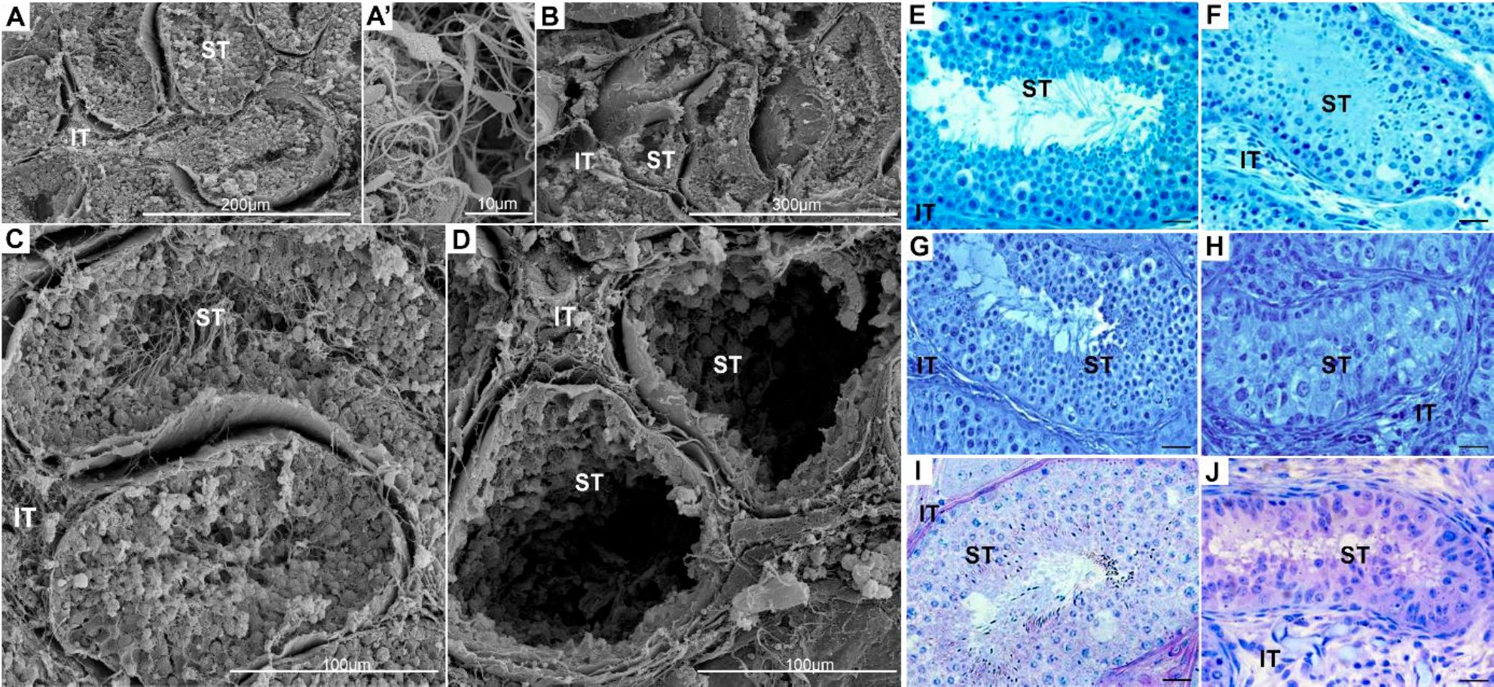
Int. J. Mol. Sci. 2021, 22, 7131
3of 14
- Results

2.1. Topography and Biochemistry of Healthy and Cryptorchid Testes
The typical topography of a healthy testis with full spermatogenesis and spermatozoa
visible in tubule lumen was compared to a cryptorchid testis with severe alterations
(lack of several etagee of seminiferous epithelium) ueing scanning electron microscopy
(Figure 1A,A',B-D).
Figure 1. The general structure of healthy (A,A',C,E,G,I) and cryptorchid (B,D,F,H,J) horse testicular tissues, respectively,
which were used for analyst via scanning; electron microscopy. Bars represent 1 gm. Histochemical staining of healthy aiy
cryptorchid horse testes for the presence and localization of total protein content by naphthol hlue black (NBB) (E,F), acidic
content by toluidine blue O (TBO) (G,H), and polysaccharide content by PAS (I,J). Bar 20 gm. Histochemical staining was
performed on three serial sections from each subject's testis. IT—interstitial tissue, ST—seminiferous tubules.
The general biochemistry of the testes revealed typical histological features of healthy
testis tissue, i.e., normal size of interstitial tissue. In the cryptorchid testis, it was overgrown;
the observed increase was approx. 60°% in comparisop to the healthy testis. In addition,
the cryptorchid seminiferous tubule diameter was decreased compared to healthy testes;
the observed decrease was sp prax .40% (Figure 1B,D). Histochemical staining; for acid and
protein content showed no marked differences beftveen healtiiy and cryptorchid testes
(Figure 1E-H). Both protein ond aaid condeno were distributed uomogenously in the cells
of the seminiferous tubule and the interstitial compartment. Of note, the lack of cello in tile
se miniferous tubules of cryptorchid testes c oincid ed with a visible l ack of protki ns pnd ecid
in this trstis compartment. However, polysaccharide cyntent distribution demonstrated
pronounced diffeoences between healthy and ceyptorcWd tastes (Figure 1I,J) . In the healthy
testes, the acidic content was concentrated in high amounts in the jneritubular-myoid cells
surrounding the seminiferous tubules and in the cells of the mterstitial tissue, but there
were sm all to moderate polysaccharide amornta in the cells o° the semmiferous epi thelium
(Figure 1I). In the cryptorchid testes, polysaccharidepwere located mamly in the remaining
cells of the semmiferous tubulec, and a moderate amount was located in hhe interstitial
tissue (Figuren 1J).

2.2. GPER Protein Expression and Localization in Healthy and Cryptorchid Testes
A markedly decreased expression of GPER (p < 0.001) was revealed in cryptorchid
testes when compared to healthy ones (Figure 2; left panel).
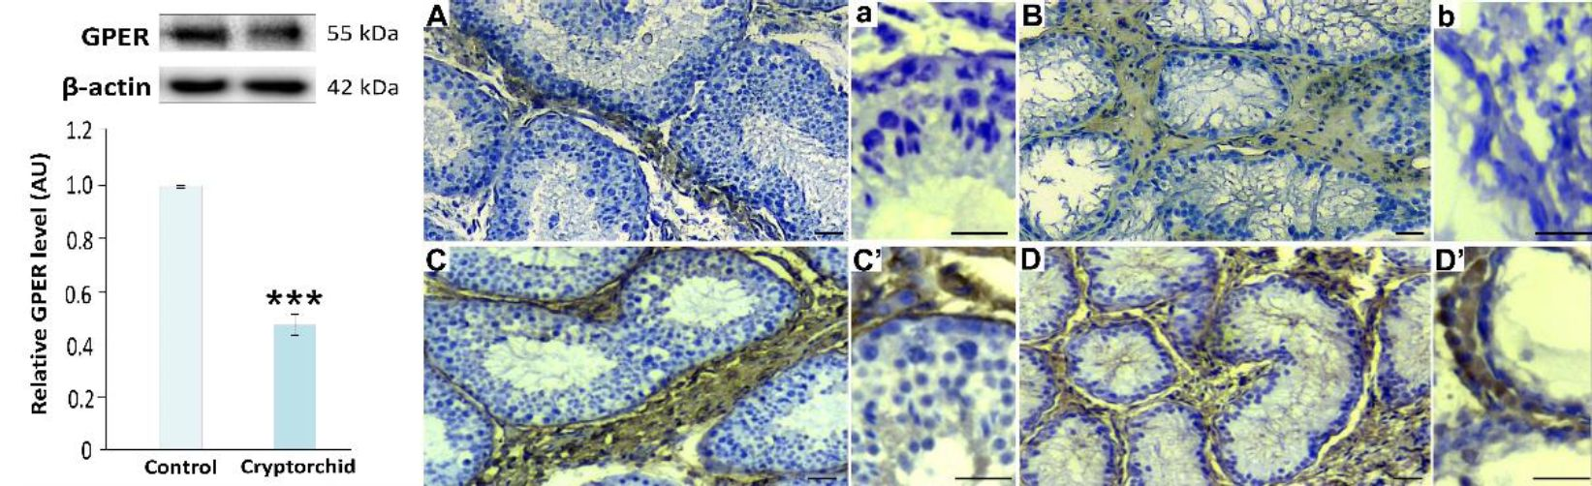
Int. J. Mol. Sci. 2021, 22, 7131
4 of 14
Figure 2. Left panel. Qualitative expression and relative expression (arbitrary units) of GPER in healthy (control) and
cryptorchid horse testes. The relative amount of GPER normalized to (3-actin. The relative intensity of bands from three
sepaeate analyses is expressed as means ± SD. Asterisks show significant differences between healthy and cryptorchid testes.
Significant difference is denoted *** p < 0.001. Right panel. Representative microphotographs of immunohistochemical
localization of GPER (A,B) and INSL3 (C,D and higher magnification C', D' with positively immunostained individual
Leydig cells) in healthy (A,C,C') and cryptorchid (B,D,D') horse testes. a,b—negative contrels representative for GPER or
INSL3 staining;. Staining; with DAB and counterstaining with hematoxylin. Bar 45 pm. Staining was performed at three
serial sections from each animal.
In healthy and cryptorchid testes, the expression of GPER was present exclusively in
the Leydig cells (Figure 2A,B; right panel). However, the immunostaining was decreased
in hyperplasic and hypertrophic Leydig cells in cryptorchid testes. Note that in horse testis,
in contrast to human or rodent ones, the interstitial tissue is composed mainly of Leydig
cells (please additionally see immunostaining for insulin-like protein 3 (INSL3)—marker of
Leydig cells in healthy and cryptorchid horse testes; Figure 2C,C',D,D'; right panel).
  - cAMP and Ca2+ Level in Healthy and Cryptorchid Testes
In cryptorchid testes, decreased levels of cAMP (p < 0.01) and Ca2+ (p < 0.001)
were found when compared ace the control (Figure 3A,B). These results were addition-
ally confirmed by the decreased relative optical density (RODi of the immuneeignal for
cAMP downstresm enzyme protein kinase A (PKA) mea cu red in the semimfer ous tubules
(p < 0.00e) and interstitial tissue ;p < 0.001) and for Ca2+ channel marker (IP3 I) measured
m the eemimferous tubules (p < 0.001) and inteestitial tissue (p < 0.001), respectively, in
ceyptorchid testeswhen compared to healthy ones (Figure 3C,C',D,D',x).
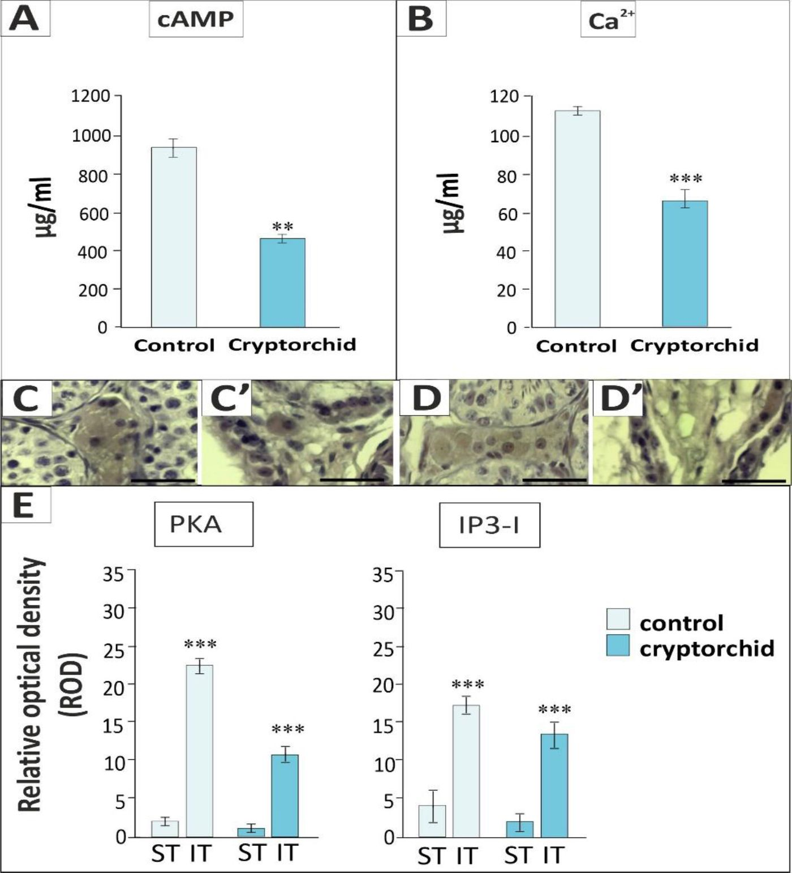
Int. J. Mol. Sci. 2021, 22, 7131
5 of 14
Figure 3. Upper panel: cAMP (A) and Ca2+ (B) levels; lower panel: representative microphotographs
of immunohistochemical localization of PKA (C,C'), IP3 I (D,D'), and quantitative analysis of PKA
or IP3 I immunosignals in the seminiferous tubules (ST) and interstitial tissues (IT) (E) of healthy
(control) and cryptorchid horse testes. Data are expressed as means ± S.D. Significant differences
between healthy and cryptorchid testes are denoted as ** p < 0.01 and *** p < 0.001. Analyses were
performed in triplicate.
- Discussion
It is still unclear how cryptorchidism can be prevented [36]. Moreover, recent studies
by Murase et al. [37] revealed that, sometimes, the (diagnosis can be challenging. The
authors have uncovered undetectable serum MIS in csyptorchid horse testes. In this
study we used scanning electron microfcopy analysis for further confismation of the
testicular tissue morphological status prior to subjecting the tissue to various biochemical
and molecular analyses. Interestingly, in ctyptorchid dogs, the righi testis is more often
affonted than the left [38]1 Our prior studies have demonstrated that senescence markers
can be useful in the diagnosis of cryptorchidism in mixed-breed dogs [39]. In horses, as
in dogs or humans, iesiis/testes located in the abdominal cavity can result in neoplasm
development [40,41]. Here, for the first time, Mochemical staining for protein, acid( and
polysaccharide content in henlthy and cryptorchid horse testes wae performed. Both
physiological and pathological tissue; processes rely on the cell biochemical components
that control cell fenctional specialization. Cellular components can serve; to identify specific
cell altesations or diseases [42-45]. The tich content of the biochemical substances produced
by tetticular somatic ((ells it crucial tor germ and somatic cell function, especially for sperm
physiology [46]. The polysaccharide content and distribution are affected in the cryptorchid
Int. J. Mol. Sci. 2021, 22, 7131
6 of 14
testis. Cell division and an increase in glycosaminoglycans and hyaluronic acid levels cause
caudal enlargement of the gubernaculum during the relative transabdominal movement of
the testis, often referred to as the "swelling reaction" or "gubernacular out-growth" [47].
Glycoproteins are important in the regulation of the blood-testis barrier. Cyclic changes in
glycoprotein composition and distribution occurring in spermatozoa and Sertoli cells are
well described [48]. Our data confirm those reported by Su et al. [49], finding glycoprotein
alterations in the pathological testis. In the cryptorchid testes, the remaining cells were
overloaded with glycoproteins, which probably translocated from interstitial compartments
and/or were overproduced in situ. Protein translocation and mislocalization is frequently
reported in pathological tissues and cells [50]. In addition, any changes in the hormonal
milieu can lead to morphological and biochemical tissue disturbances. Our earlier studies
have revealed hormonal imbalances in horse cryptorchid testes, i.e., reduced testosterone
synthesis and increased androgen aromatization [51]. Additionally, specific changes in
testicular cell hormonal controls due to endogenous (or exogenous) factors also affect
cell-to-cell and molecule-to-molecule interactions [52-55] that in turn affect the morpho-
functional testis status.
Estrogens are necessary for maintaining the structural and functional integrity of the
male reproductive tract [56]. Of note, the importance of estrogen in the male reproductive
system's development was confirmed by the report that diethylstilbestrol treatment during
pregnancy induced, e.g., cryptorchidism, in mice and humans [57]. Furthermore, the
concentration of estrogen in peripheral blood is typically low in the male, but ranges
from 2 to 180 pg/mL in different species [58]. Exceptionally, in the horse, estrone sulfate
is found as high as 2447 pg/mL and the estrone-sulfate concentration is 900 ng/mL
in the testicular lymph, suggesting that intra-testicular estrogen levels can be high [57].
Estrogen concentrations are higher in the testicular vein and lymph than in the general
circulation. Furthermore, in the reproductive tract, estrogen can reach relatively high
concentrations. In addition, estrogens are abundant in semen, with concentrations ranging
from 14 to 900 pg/mL in different species [59]. In the horse, estrone-sulfate is as high as
4000 pg/mL [58].
However, their role in testis descent and associated pathologies requires further in-
depth investigation. Here, for the first time, we have confirmed that GPER is expressed in
both healthy and cryptorchid horse testes. Of note, GPER positive expression was exclu-
sively found in Leydig cells, which are the main source of testicular estrogens in horses. The
responses of Leydig cells to elevated scrotal temperatures have been extensively studied
in various models, including acute hyperthermia, experimental and spontaneous cryp-
torchidism, and heat acclimation [60]. In Leydig cells, following exposure to elevated
testicular temperatures, changes in cell size and number, elevated levels of serum lutropin,
low to normal serum testosterone levels, in vitro androgen hyper-responsiveness, loss of
lutropin receptors, perturbed steroid biosynthesis, excessive accumulation of intracyto-
plasmic lipid droplets, deep nuclear invaginations, irregular outlines, and dilated smooth
endoplasmic reticulum and mitochondria were reported [61]. Therefore, as revealed here,
the biochemical and molecular alterations in the interstitial tissue of cryptorchid testes
can result from the above-listed morphological and functional Leydig cell changes. Our
present results add to a body of reports in a wide range of heat models establishing that
the Leydig cell response occurs subsequently to damage of seminiferous tubules.
In addition to ERs, GPER is involved in maintaining estrogen levels in horse testes [62].
In fact, increased estrogen levels in a cryptorchid testis negatively affect GPER expression
and signaling. Our findings show that GPER appears to be a key player in the regulation of
estrogen-dependent lipid homeostasis and testosterone biosynthesis in Leydig cells [14,15].
Furthermore, our prior results have also shown the important role of GPER in regulating
the number and physiology of the regulatory cells of the interstitial compartment telocytes,
which contribute to maintaining lipid balance and steroidogenic function [62,63]. Based on
the results of others, a lack of expression of GPER in the seminiferous tubule epithelium
suggests a rather indirect modulation of the molecular mechanism involved in the main-
Int. J. Mol. Sci. 2021, 22, 7131
7 of 14
tenance of Sertoli cell numbers, normal testis development, and homeostasis [64,65]. In
humans, GPER is expressed in peritubular-myoid cells, suggesting that estrogenic signaling
via GPER is involved in the regulation of peritubular-myoid cells [66]. This is not the case in
either healthy or cryptorchid horse testes. Similarly, some studies of the expression of GPER
in germ cells suggest a role in modulating both the proliferation of spermatogonia and the
physiological apoptosis regulating the number of spermatocytes and spermatids [17]. It
seems possible that in healthy and cryptorchid horse testes, both of these processes are
indirectly controlled by GPER.
Estradiol binds to GPER with a high affinity, while estrone and estriol have very low
binding affinities [67]. Based on the previous studies in mouse and Atlantic croaker testes,
the order of binding affinity of estrogens for the two canonical estrogen receptors a and p
is similar to that of GPER (estradiol >> estrone = estriol) [68]. Furthermore, several environ-
mental estrogens bind to GPER and activate the downstream signaling pathways, such as
BPA, genistein, and nonylphenol [69]. In light of these facts, environmental hormonal fac-
tors are still an important consideration in cryptorchidism etiology. Decreased expression
of GPER in the cryptorchid horse testis can be indicative of the alteration of GPER protein
structure and/or amounts either by temperature factors and/or by bound xenoestrogens
that further affect pathological testis structure and function. Currently, testicular GPER
localization has been confirmed in a few mammalian species in normal and pathological
conditions as well as in testicular primary cells in vitro and cell lines [17]. Our previous
research shows expression of GPER in bank vole, mouse, boar, and human testes with
leydigioma and GPER interactions with various proteins and lipids [14,15,62,63,70]. Inter-
estingly, GPER has been found in several subcellular compartments, including the internal
membrane of the endoplasmic reticulum, nucleus, and even in a chromatin-binding protein
under certain circumstances [71], as confirmed in this study. Positive immunostaining in
Leydig cell cytoplasm establishes the location of GPER in organelle structures. Of note,
studies in GPER knockout mice have confirmed the role of GPER action on glucose and
lipids in energy metabolism [72]. Specific studies using pharmacological GPER agonists
and antagonists show that, in addition to acting on multiple intracellular pathways with
specific actions on epidermal growth factor, extracellular signal-regulated kinases 1/2,
phospholipase C, phospho-3-inositol, adenylyl cyclase, and Ca2+ immobilization, GPER
is also able to mediate genomic responses [17]. Our data confirmed the action of cAMP
and Ca2+ in GPER signal transmission. In the cryptorchid testis, decreased expression of
GPER affected both Ca2+ and cAMP levels. These two universal second messengers impact
various aspects of cell function, including hormone secretion, gene expression, stimulation
of other messengers, muscle contraction, and metabolism. Due to both biochemical and
molecular changes mainly in the interstitial tissue (which is the first physiological barrier
protecting seminiferous tubules; [73]) in cryptorchid testes, an altered Ca2+ level and cAMP
level is produced by this compartment. In fact, the largest somatic cells of the seminiferous
epithelium, Sertoli cells, seem to be less sensitive to the temperature increase, still actively
producing various molecules [74]. Changes in Ca2+ levels are obvious in the cryptorchid
testis as the contractility of the gubernaculum during testis descent requires an influx of
Ca2+ via dihydropyridine receptors [75]. Calcium ions are also required for steroidogenesis
or spermatozoon acrosome reaction. However, both processes are altered in the cells of the
cryptorchid testis as a consequence of decreased levels of Ca2+.
Additionally, the genomic effect of GPER via cAMP is included. Neural salient
serine/arginine rich protein 1 (NSSR1) is a splicing factor expressed in germ cells and
Sertoli cells. In mice, NSSR1 expression increases significantly during testes development,
descent, and spermatogenic function [76]. In cryptorchid testes, dephosphorylated NSSR1
is significantly increased in association with cAMP response element binding protein
(CREB) transcripts. CREB mainly acts as an inhibitor of cAMP-induced transcription
through the acute regulation of trophic hormone-stimulated steroidogenesis and the acute
steroidogenesis regulatory protein at the mRNA level in Leydig cells [77]. It is known that
GPER can act as an autonomous receptor and can also interact with nuclear ERs based on
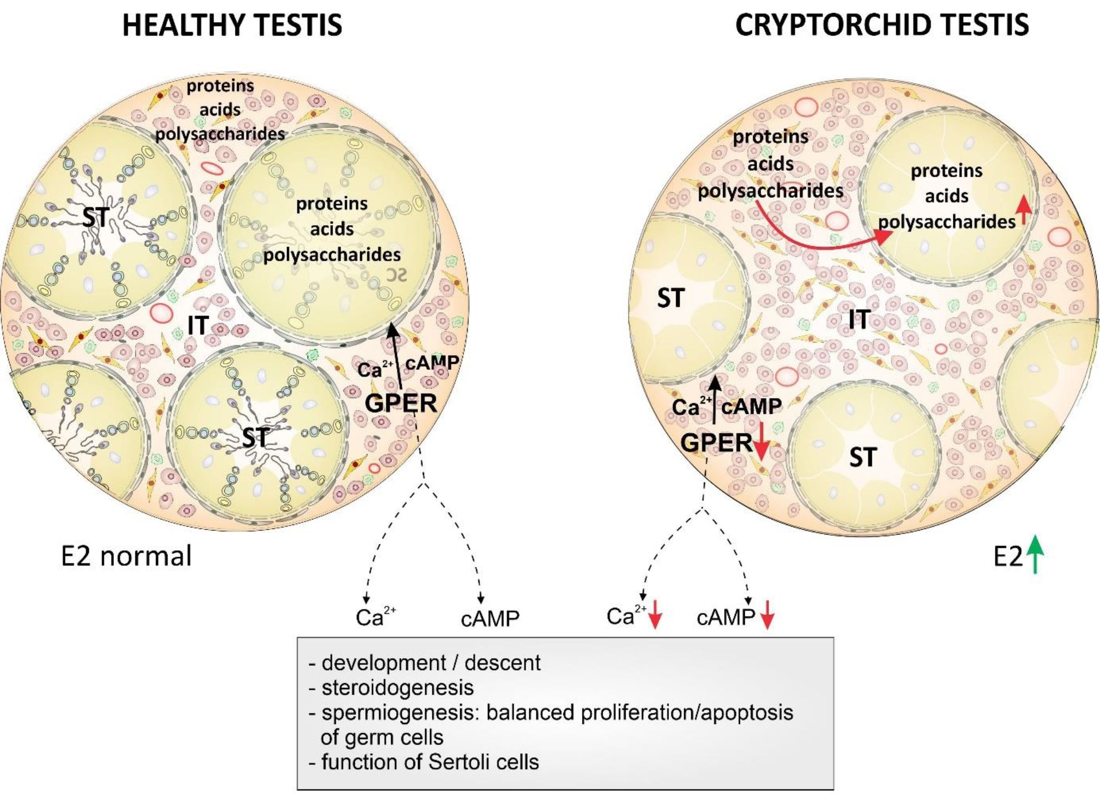
Int. J. Mol. Sci. 2021, 22, 7131
8 of 14
studies performed on knockout mice and cultured cell s [78] . However, the degree to which
GPER acts autonomously depends on the cell type, differentiation status, and pathology,
e.g., cell quiescence, prolśferation, or cancer status. The time of cryptorchid testis retinues
in the abdominal cavity may have an additiotsat effecit en the; biochemical and molecular
changes studied here [79].
In conclusion, a coexistence of (i) global biochemical changes in the testis compart-
ments (referred to as polysaccharide distribution and amounts) and (ii) local molecular
changes (decreased GPER expression in Leydig cells and decreased GPER downstream
pathways via cAMP and Ca2+) in the cryptorchid horse testis is reported here (Figure 4).
Figure 4. Schematic representation of the biochemical and molecular status of healthy and cr}if)torchid horse testes
demonstrating the possible effects of GcER downstream pathways via cAMP and Cs2+ on the testes fromdevelopment to
maturity under both normal in healthy testes and the increased estrogen levels in cryptorchid testes.
Our results, considered with those by Zhang et al. [8], suggest tliat GPER in con-
junction with estrogen exerts its effect on the gubernaculum, apd GPER is an important
molecule in cell-cell mterectisns in mature testis function (metabolic homeosSasis and
nutrilion (based on polysaccharide s and lipids) and sterofd produption. Perturbation of
GPER action either by endogenous oe exogenous factocs effecting the estrogen microen-
vironment cart contribute to pathological testis conditions including cryptorchidism in
horses. Further studies are warranted to define the function of GPER in Leydig cells from
fetus to adulthood in horse testes as well as ts determme wliather GPER can serve as a
biomarker for the cvaluatian of normel tr disturbed testis mtrphology and function.
Int. J. Mol. Sci. 2021, 22, 7131
9 of 14
- Materials and Methods

4.2. Animals
Testes were obtained from 2-3-year-old unilaterally cryptorchid (n = 3; left testis in
inguinal canal (n = 1) and right testis n = 2) Arab horses during open surgical castration (pri-
vate studs in Warsaw and Krakow). Before castration, their libido was normal, indicating
the presence of sufficient testosterone levels secreted by healthy testes.
Healthy testes (n = 2; archival material) were obtained from Arab horses that had been
euthanized due to serious injury, e.g., fracture of the limb or spine during their moving
around the stud, or fighting between horses.
Removed testes were either cut into small fragments for microscopic analyses or
frozen in liquid nitrogen and stored at -80 °C for molecular analyses.
The use of animal tissues was approved by the Local Ethics Committee in Krakow
(permission number: 105a/2015/08084).

4.2. Testis Topography—Scanning Electron Microscope (SEM)
Pieces of testicular tissue were fixed in a mixture of 2.5% formaldehyde with 2.5%
glutaraldehyde in a 0.05 M cacodylate buffer (Sigma-Aldrich; Saint Louis, MO, USA;
pH 7.2) for several days, washed three times in a 0.1 M sodium cacodylate buffer, and later
dehydrated and subjected to critical-point drying. Specimens were then sputter-coated
with gold and examined at an accelerating voltage of 20 kV or 10kV using a Hitachi S-4700
scanning electron microscope (Hitachi, Tokyo, Japan).

4.3. Testicular Tissue Processing and Histological Staining
Pieces of testicular tissue were embedded in Technovit 7100 (Kulzer, Germany). The tis-
sue was fixed in Bouin's solution (Sigma-Aldrich, Saint Louis, MO, USA) at 4 °C overnight
and dehydrated in a graded ethanol series. Then, the tissue was preserved overnight in
absolute ethanol and subsequently infiltrated with mixtures of absolute ethanol and Tech-
novit. The samples were stored in pure Technovit, followed by polymerization of the resin
with the addition of a hardener. Serial 5-gm-thick sections were prepared with the use of a
rotary microtome (Microm, Adamas Instrumenten, Rhenen, The Netherlands). For general
histology and for total protein, sections were stained with naphthol blue black (NBB) in
acetic acid. Then, the slides were immersed briefly in acetic acid, air-dried, and mounted
in Entellan synthetic resin (Merck, Darmstadt, Germany). For acid content, sections were
stained with 0.1% toluidine blue O (TBO) and mounted in Entellan synthetic resin (Merck,
Darmstadt, Germany). In order to detect insoluble polysaccharides, a periodic acid-Schiff
(PAS) reaction was performed. Slides were oxidized in periodic acid and stained in Schiff's
reagent, then rinsed in potassium metabisulfite and mounted in Entellan synthetic resin
(Merck, Darmstadt, Germany).

4.4. Immunohistochemistry
Testicular tissues were cut into 4-gm-thin sections. For antigen retrieval, endogenous
peroxidase neutralization and blocking of non-specific binding sites were performed as
described previously [80]. Thereafter, the sections were incubated overnight at 4 ° C with a
primary antibody: anti-GPER (Abcam; Cambridge UK; ref. no.39742), anti-INSL3 (Santa
Cruz Biotechnology; Dallas, TX, USA ref. no sc-134587), anti-PKA II Antibody (Santa Cruz
Biotechnology; Dallas, TX, USA; ref.no. sc-908), or anti-IP3 I (Sigma-Aldrich Saint Louis,
MO, USA; ref.no. BT AP04603). Next, biotinylated goat anti-rabbit IgG (Vector Labora-
tories, Burlingame, CA, USA) and avidin-biotinylated horseradish peroxidase complex
(ABC/HRP; Dako, Glostrup, Denmark) were applied in succession. The staining was
developed using 3,3/-diaminobenzidine (DAB). Positive controls and negative controls in
the absence of primary antibodies were performed for each immunostaining. Thereafter,
sections were slightly counterstained with Mayer's hematoxylin and mounted using DPX
mounting media (Sigma-Aldrich; Saint Louis, MO, USA). Serial sections were examined
Int. J. Mol. Sci. 2021, 22, 7131
10 of 14
with a Leica DMR microscope (Leica Microsystems, Wetzlar, Germany). The experiments
were repeated three times on sections obtained from different animals.

4.5. Quantitative Analysis of Immunohistochemical Signal
The amount of PKA or IP31 produced in the individual interstitial cells or seminiferous
tubule cells was measured at x 100 magnification using ImageJ software https://imagej.nih.
gov/ij/docs/intro.html (accessed on 5 January 2021). Measurements of freehand outlines
drawn along the circumference of interstitial cell areas or seminiferous tubule areas were
performed. On average, 60 areas of interstitial tissue or tubules were measured per slide.
Relative optical density (ROD) of immunostaining insensitivities was determined for each
animal testicular tissue and finally expressed as means ± SD.

4.6. Western Blot
Separation of protein preparations were performed by SDS-PAGE under reducing con-
ditions and the transfer of proteins to polyvinylidene difluoride membranes. Nonspecific
binding sites were blocked with non-fat dry milk containing Tween® 20. Next, the mem-
branes were incubated with anti-GPER antibody the same as for immunohistochemistry
at 4 ° C overnight, followed by a horseradish peroxidase-conjugated secondary antibody
(Vector Laboratories, Burlingame, CA, USA) at room temperature. Proteins were detected
by chemiluminescence and documented with a ChemiDocTM XRS+ System (Bio-Rad
Laboratories, Hercules, CA, USA). The specificity of antibodies was assessed with the
use of blocking peptides and/or positive controls (not shown). All immunoblots were
stripped and re-probed with an anti-p-actin antibody (Sigma-Aldrich, Saint Louis, MO,
USA; ref. no. A2228) as the loading control. The molecular weights of target proteins
were estimated by reference to standard proteins (Sigma-Aldrich, Saint Louis, MO, USA).
To obtain quantitative results, immunoblots were analyzed densitometrically (arbitrary
units; AU) using the ImageLab software (Bio-Rad Laboratories, Hercules, CA, USA) by an
independent observer.

4.7. cAMP Concentration Measurement
The amount of cAMP produced by healthy and cryptorchid horse testes was deter-
mined by Direct cAMP Elisa kit assay (Enzo, Life Sciences, AG, Lausen, Switzerland),
according to the manufacturer's instructions for the acetylated assay. The sensitivity of the
assay was 0.037 pmol/mL. The cAMP concentrations were calculated as pmol/mL.
Three independent experiments were performed, each in triplicate.

4.8. Ca2+ Concentration Measurement
The amount of Ca2+ produced by healthy and cryptorchid horse testes was deter-
mined by ab102505 Calcium Assay Kit (Colorimetric) (Abcam; Cambridge, UK) according
to the manufacturer's instructions. The Ca2+ concentrations were calculated as ng/mL
(OD = 575 nm). Three independent experiments were performed, each in triplicate.

4.9. Statistics
Each variable was tested using the Shapiro-Wilk W-test for normality. The homo-
geneity of variance was assessed with Levene's test. The distribution of the variables
was normal and the values were homogeneous in variance. All statistical analyses were
performed using a one-way analysis of variance (ANOVA) followed by Tukey's post hoc
comparison test to determine which values differed significantly from controls. The analy-
sis was performed using Statistica software (StatSoft, Tulsa, OK, USA). Data were presented
as a mean ± SD. Data were considered statistically significant at p < 0.05. All experimental
measurements were performed in triplicate from material derived from different animals.
Int. J. Mol. Sci. 2021, 22, 7131
11 of14
Author Contributions: M.W., L.P., A.G., P.P., Investigation, Resources, Validation; B.J.P., Investi-
gation; S.K., M.P.-S., M.D., Methodology, Software, Visualization, Formal Analysis, Methodology;
M.K.-B., Conceptualization, Data Curation, Formal Analysis, Funding Acquisition, Methodology,
Project Administration, Supervision, Validation, Writing—Original Draft, Writing—Review and
Editing. All authors have read and agreed to the published version of the manuscript.
Funding: This work was supported by a grant as part of the statutory activities from the Ministry
of Science and Higher Education to the University Centre of Veterinary Medicine, University of
Agriculture in Krakow (a grant SUB/2020-080100-D016).
Institutional Review Board Statement: The use of animal tissues was approved by the Local Ethics
Committee in Krakow (permission number: 105a/2015/08084).
Informed Consent Statement: Not applicable.
Data Availability Statement: Data will be presented on request.
Acknowledgments: The Hitachi S-4700 scanning electron microscope (Hitachi, Tokyo, Japan) was
available in the Institute of Geological Sciences, Jagiellonian University in Krakow.
Conflicts of Interest: The authors declare that they have no conflict of interest.
References
- Barthold, J.S.; Robbins, A.; Wang, Y.; Pugarelli, J.; Mateson, A.; Anand-Ivell, R.; Ivell, R.; McCahan, S.M.; Akins, R.E., Jr.
Cryptorchidism in the orl rat is associated with muscle patterning defects in the fetal gubernaculum and altered hormonal
signaling. Biol. Reprod. 2014, 92,41. [CrossRef]
- Nation, T.R.; Balic, A.; Southwell, B.R.; Newgreen, D.F.; Hutson, J.M. The hormonal control of testicular descent. Pediatr.
Endocrinol. Rev. 2009, 7, 22-31. [PubMed]
- Toppari, J.; Virtanen, H.E.; Main, K.M.; Skakkebaek, N.E. Cryptorchidism and hypospadias as a sign of testicular dysgenesis
syndrome (TDS): Environmental connection. Birth Defects Res. A Clin. Mol. Teratol. 2010, 88, 910-919. [CrossRef] [PubMed]
- Grinspon, R.P.; Gottlieb, S.; Bedecarrás, P.; Rey, R.A. Anti-Mullerian Hormone and Testicular Function in Prepubertal Boys with
Cryptorchidism. Front. Endocrinol. (Lausanne) 2018,25,182. [CrossRef]
- Lague, E.; Tremblay, J.J. Estradiol represses insulin-like 3 expression and promoter activity in MA-10 Leydig cells. Toxicology 2009,
258,101-115. [CrossRef]
- Staub, C.; Rauch, M.; Ferriere, F.; Trépos, M.; Dorval-Coiffec, I.; Saunders, P.T.; Cobellis, G.; Flouriot, G.; Saligaut, C.; Jégou, B.
Expression of estrogen receptor ESR1 and its 46-kDa variant in the gubernaculum testis. Biol. Reprod. 2005, 73, 703-712. [CrossRef]
- Bartlett, J.E.; Washburn, T.; Eddy, E.M.; Korach, K.S.; Temelcos, C.; Hutson, J.M. Early development of the gubernaculum and
cremaster sac in estrogen receptor knockout mice. Urol. Res. 2001, 29,163-167. [CrossRef] [PubMed]
- Zhang, X.; Ke, S.; Chen, K.H.; Li, J.H.; Ma, L.; Jiang, X.W. Diethylstilbestrol affects the expression of GPER in the gubernaculum
testis. Int. J. Clin. Exp. Pathol. 2015, 8, 7217-7222.
- Han, G.; Li, F.; Yu, X.; White, R.E. GPER: A novel target for non-genomic estrogen action in the cardiovascular system. Pharmacol.
Res. 2013, 71, 53-60. [CrossRef]
- Luo, J.; Liu, D. Does GPER Really Function as a G Protein-Coupled Estrogen Receptor in vivo? Front. Endocrinol. (Lausanne) 2020,
31,148. [CrossRef]
- Pupo, M.; Maggiolini, M.; Musti, A.M. GPER Mediates Non-Genomic Effects of Estrogen. Methods Mol. Biol. 2016,1366, 471-488.
- Sandner, F.; Welter, H.; Schwarzer, J.U.; Kóhn, F.M.; Urbanski, H.F.; Mayerhofer, A. Expression of the oestrogen receptor GPER by
testicular peritubular cells is linked to sexual maturation and male fertility. Andrology 2014, 5, 695-701. [CrossRef] [PubMed]
- Zarzycka, M.; Gorowska-Wojtowicz, E.; Tworzydlo, W.; Klak, A.; Kozub, K.; Hejmej, A.; Bilinska, B.; Kotula-Balak, M. Are aryl
hydrocarbon receptor and G-protein-coupled receptor 30 involved in the regulation of seasonal testis activity in photosensitive
rodent-the bank vole (Myodes glareolus)? Theriogenology 2016, 86, 674-686. [CrossRef] [PubMed]
- Kotula-Balak, M.; Pawlicki, P.; Milon, A.; Tworzydlo, W.; Sekula, M.; Pacwa, A.; Gorowska-Wojtowicz, E.; Bilinska, B.; Pawlicka,
B.; Wiater, J.; et al. The role of G-protein-coupled membrane estrogen receptor in mouse Leydig cell function-in vivo and in vitro
evaluation. Cell Tissue Res. 2018, 374, 389-412. [CrossRef] [PubMed]
- Kotula-Balak, M.; Gorowska-Wojtowicz, E.; Milon, A.; Pawlicki, P.; Tworzydlo, W.; Plachno, B.J.; Krakowska, I.; Hejmej, A.; Wolski,
J.K.; Bilinska, B. Towards understanding leydigioma: Do G protein-coupled estrogen receptor and peroxisome proliferator-
activated receptor regulate lipid metabolism and steroidogenesis in Leydig cell tumors? Protoplasma 2020, 257, 1149-1163.
[CrossRef]
- Krejcírová, R.; Maüasová, M.; Sommerová, V.; Langhamerová, E.; Rajmon, R.; Maüásková-Postlerová, P.G. Protein-coupled
estrogen receptor (GPER) in adult boar testes, epididymis and spermatozoa during epididymal maturation. Int. J. Biol. Macromol.
2018,116,113-119. [CrossRef]
- Chimento, A.; De Luca, A.; Nocito, M.C.; Avena, P.; La Padula, D.; Zavaglia, L.; Pezzi, V. Role of GPER-Mediated Signaling in
Testicular Functions and Tumorigenesis. Cells 2020,17, 2115. [CrossRef]
Int. J. Mol. Sci. 2021, 22, 7131
12 of 14
- Gautier, C.; Barrier-Battut, I.; Guénon, I.; Goux, D.; Delalande, C.; Bouraima-Lelong, H. Implication of the estrogen receptors
GPER, ESR1, ESR2 in post-testicular maturations of equine spermatozoa. Gen. Comp. Endocrinol. 2016,1,100-108. [CrossRef]
[PubMed]
- Raeside, J.I. The isolation of estrone sulfate and estradiol-17 beta sulfate from stallion testes. Can. J. Biochem. 1969, 47, 811-815.
[CrossRef]
- Lemazurier, E.; Moslemi, S.; Sourdaine, P.; Desjardins, I.; Plainfosse, B.; Seralini, G.E. Free and conjugated estrogens and androgens
in stallion semen. Gen. Comp. Endocrinol. 2002,125, 272-282. [CrossRef]
- Hejmej, A.; Gorazd, M.; Kosiniak-Kamysz, K.; Wiszniewska, B.; Sadowska, J.; Bilinska, B. Expression of aromatase and oestrogen
receptors in reproductive tissues of the stallion and a single cryptorchid visualised by means of immunohistochemistry. Domest.
Anim. Endocrinol. 2005,29, 534-547. [CrossRef]
- Nef, S.; Shipman, T.; Parada, L.F. A molecular basis for estrogen-induced cryptorchidism. Dev. Biol. 2000, 224, 354-361. [CrossRef]
[PubMed]
- Bilinska, B.; Kotula-Balak, M.; Gancarczyk, M.; Sadowska, J.; Tabarowski, Z.; Wojtusiak, A. Androgen aromatization in cryptorchid
mouse testis. Acta Histochem. 2003,105, 57-65. [CrossRef] [PubMed]
- Agoulnik, A.I. Cryptorchidism—An estrogen spoil? J. Clin. Endocrinol. Metab. 2005, 90, 4975-4977. [CrossRef]
- Yoshida, R.; Fukami, M.; Sasagawa, I.; Hasegawa, T.; Kamatani, N.; Ogata, T. Association of cryptorchidism with a specific
haplotype of the estrogen receptor a gene: Implication for the susceptibility to estrogenic environmental endocrine disruptors. J.
Clin. Endocrinol. Metab. 2005, 90, 4716-4721. [CrossRef] [PubMed]
- Mizuno, K.; Kojima, Y.; Kurokawa, S.; Kamisawa, H.; Kohri, K.; Hayashi, Y. Altered expression and localization of estrogen
receptors alpha and beta in the testes of a cryptorchid rat model. Urology 2011, 77, e1-e6. [CrossRef] [PubMed]
- Jung, H.Y.; Yoo, D.Y.; Jo, Y.K.; Kim, G.A.; Chung, J.Y.; Choi, J.H.; Jang, G.; Hwang, I.K. Differential expression of estrogen receptor
a and progesterone receptor in the normal and cryptorchid testis of a dog. Lab. Anim. Res. 2016, 32,128-132. [CrossRef]
- Fénichel, P.; Chevalier, N.; Lahlou, N.; Coquillard, P.; Wagner-Mahler, K.; Pugeat, M.; Panaia-Ferrari, P.; Brucker-Davis, F.
Endocrine Disrupting Chemicals Interfere with Leydig Cell Hormone Pathways During Testicular Descent in Idiopathic Cryp-
torchidism. Front. Endocrinol. (Lausanne) 2019, 9, 786. [CrossRef]
- Han, H.; Dong, H.; Chen, Q.; Gao, Y.; Li, J.; Li, W.; Dang, R.; Lei, C. Transcriptomic Analysis of Testicular Gene Expression in
Normal and Cryptorchid Horses. Animals 2020,10,102. [CrossRef]
- Eik-Nes, K.B. Secretion of testosterone by the eutopio and the cryptorchid testes in the same dog. Can. J. Physiol. Pharmacol. 1966,
144, 629-633. [CrossRef]
- Jose, M.; Vilar, J.M.; Batista, M.; Carrillo, J.M.; Rubio, M.; Sopena, J.; Álamo, D. Histological, cytogenetic and endocrine evaluation
in twenty-five unilateral cryptorchid horses. J. App. Anim. Res. 2018, 46, 441-444.
- Schulz, R.W.; Menting, S.; Bogerd, J.; Franęa, L.R.; Vilela, D.A.; Godinho, H.P. Sertoli cell proliferation in the adult testis-evidence
from two fish species belonging to different orders. Biol. Reprod. 2005, 73, 891-898. [CrossRef] [PubMed]
- Cox, J.E. Testosterone concentrations in normal and cryptorchid horses. Response to human chorionic gonadotrophin. Anim.
Reprod. Sci. 1989,18, 43-50. [CrossRef]
- Claes, A.; Ball, B.A.; Almeida, J.; Corbin, C.J.; Conley, A.J. Serum anti-Mullerian hormone concentrations in stallions: Develop-
mental changes, seasonal variation, and differences between intact stallions, cryptorchid stallions, and geldings. Theriogenology
2013, 79, 1229-1235. [CrossRef]
- Ras, A.; Rapacz, A.; Ras-Norynska, M.; Janowski, T.E. Clinical, hormonal and ultrasonograph approaches to diagnosing
cryptorchidism in horses. Pol. J. Vet. Sci. 2010,13, 473-477.
- Raudsepp, T. Genetics of Equine Reproductive Diseases. Vet. Clin. N. Am. Equine Pract. 2020, 36, 395-409. [CrossRef]
- Murase, H.; Ochi, A.; Tozaki, T.; Kakoi, H.; Munkhtuul, T.; Kurimoto, S.; Sato, F.; Hada, T.J. A case of equine cryptorchidism with
undetectable serum anti-Müllerian hormone. Vet. Med. Sci. 2020,18,209-211. [CrossRef]
- Tannouz, V.G.S.; Mamprim, M.J.; Lopes, M.D.; Santos-Sousa, C.A.; Souza Junior, P.; Babinski, M.A.; Abidu-Figueiredo, M. Is the
right testis more affected by cryptorchidism than the left testis? An ultrasonographic approach in dogs of different sizes and
breeds. Folia Morphol. (Warszawa) 2019, 78, 847-852. [CrossRef]
- Ramisz, G.; Turek, W.; Chmurska-Gasowska, M.; Rak, A.; Pietsch-Fulbiszewska, A.; Galuszka, A.; Kotula-Balak, M.; Tarasiuk, K.
Senescence and adiponectin signaling—Studies in canine testis. Ann. Anat. 2020, 20,151606.
- Seetharam, V.; Hameed, Z.B.; Talengala, S.B.; Thomas, J. Bilateral cryptorchidism with bilateral synchronous abdominal testicular
germ cell tumour. BMJ. Case Rep. 2014,12, bcr2013203085. [CrossRef]
- Ugolini, L.W.; Cunha dos Santos, F.C.; Vicensi da Costa, G.; Ramos Oliveira, H.; Folchini, N.; Machado, T.P.; Zannela, R.; Porto
Alves, L. Testicular Teratoma in a Unilateral Right-Sided Abdominal Cryptorchid Horse. Acta Sci. Vet. 2019, 47, 409. [CrossRef]
- Kaneko, S.; Takamatsu, K. Reactive Blue 2 highlights outline and inner vacuoles of human sperm and spermatid that have
undergone protamination, but not somatic cells associated with histones. Int. J. Mol. Sci. 2021. submitted.
- Lustofin, K.; Niedbala, P.; Pawlicki, P.; Tuz, R.; Płachno, B.J.; Profaska-Szymik, M.; Galuszka, A.; Stolarczyk, P.; Gorowska-
Wojtowicz, E.; Kotula-Balak, M. Senescent cells in rabbit, nutria and chinchilla testes. Animal Reprod. Sci. 2021, 226, 106701.
[CrossRef]
- Pawlowska, E.; Szczepanska, J.; Szatkowska, M.; Blasiak, J. An Interplay between Senescence, Apoptosis and Autophagy in
Glioblastoma Multiforme—Role in Pathogenesis and Therapeutic Perspective. Int. J. Mol. Sci. 2018,19, 889. [CrossRef] [PubMed]
Int. J. Mol. Sci. 2021, 22, 7131
13 of 14
- Carroll, B.; Korolchuk, V.I. Nutrient sensing, growth and senescence. FEBS J. 2018,285,1948-1958. [CrossRef] [PubMed]
- Setchell, B.P.; Hink, N.T.; Voglmayr, J.K.; Scott, T.W. Amino acids in ram testicular fluid and semen and their metabolism by
spermatozoa. Bioch. J. 1967,105,1061-1065. [CrossRef]
- Hutson, J.M.; Hasthorpe, S.; Heyns, C.F. Anatomical and functional aspects of testicular descent and cryptorchidism. Endocr. Rev.
1997,18, 259-280. [PubMed]
- Arya, M.; Vanha-Perttula, T. Comparison of lectin-staining pattern in testis and epididymis of gerbil, guinea pig, mouse, and
nutria. Am. J. Anat. 1986,1754, 449-469. [CrossRef]
- Su, L.; Mruk, D.D.; Lui, W.Y.; Lee, W.M.; Cheng, C.Y. P-glycoprotein regulates blood-testis barrier dynamics via its effects on the
occludin/zonula occludens 1 (ZO-1) protein complex mediated by focal adhesion kinase (FAK). Proc. Natl. Acad. Sci. USA 2011,
108, 19623-19628. [CrossRef]
- Wang, X.; Li, S. Protein mislocalization: Mechanisms, functions and clinical applications in cancer. Biochim. Biophys Acta 2014,
1846,13-25. [CrossRef]
- Hejmej, A.; Bilinska, B. The effects of cryptorchidism on the regulation of steroidogenesis and gap junctional communication in
equine testes. Endokrynol. Pol. 2008, 59,112-128.
- Gizejewski, Z. Effect of season on characteristics of red deer /Cervus elaphus L./semen collected using modified artificial vagina.
Reprod. Biol. 2004, 4, 51-66. [PubMed]
- Kotula-Balak, M.; Lenartowicz, M.; Kowal, M.; Styrna, J.; Bilińska, B. Testicular morphology and expression of aromatase in testes
of mice with the mosaic mutation (Atp7a mo-ms). Theriogenology 2007, 67, 423-434. [CrossRef] [PubMed]
- Sharpe, R.M. Environmental/lifestyle effects on spermatogenesis. Phil. Trans. Royal. Soc. Lond. Biol. Sci. 2010, 365,1697-1712.
[CrossRef]
- Hejmej, A.; Kotula-Balak, M.; Chojnacka, K.; Kuras, P.; Lydka-Zarzycka, M.; Bilinska, B. Photoperiod-Dependent Effects of
4-tert-Octylphenol on Adherens and Gap Junction Proteins in Bank Vole Seminiferous Tubules. Int. J. Endocrinol. 2013, 2013,
134589. [CrossRef] [PubMed]
- Carreau, S.; Hess, R.A. Oestrogens and spermatogenesis. Philos. Trans. R. Soc. Lond. B Biol. Sci. 2010, 365,1517-1535. [CrossRef]
- Gill, W.B.; Schumacher, G.F.; Bibbo, M.; Straus, F.H., 2nd; Schoenberg, H.W. Association of diethylstilbestrol exposure in utero
with cryptorchidism, testicular hypoplasia and semen abnormalities. J. Urol. 1979,122, 36-39. [CrossRef]
- Hess, R.A. Estrogen in the adult male reproductive tract: A review. Reprod. Biol. Endocrinol. 2003, 9, 52. [CrossRef]
- Claus, R.; Dimmick, M.A.; Gimenez, T.; Hudson, L.W. Estrogens and prostaglandin F2a in the semen and blood plasma of
stallions. Theriogenology 1992, 38, 687-693. [CrossRef]
- Aldahhan, R.A.; Stanton, P.G. Heat stress response of somatic cells in the testis. Mol. Cell Endocrinol. 2021,1,111216. [CrossRef]
- Muldoon, T.G. Regulation of Steroid Hormone Receptor Activity. Endocr. Rev. Fall. 1980,1, 339-364. [CrossRef] [PubMed]
- Milon, A.; Pawlicki, P.; Rak, A.; Mlyczynska, E.; Płachno, B.J.; Tworzydlo, W.; Gorowska-Wojtowicz, E.; Bilinska, B.; Kotula-Balak,
M. Telocytes are localized to testis of the bank vole (Myodes glareolus) and are affected by lighting conditions and G-coupled
membrane estrogen receptor (GPER) signaling. Gen. Comp. Endocrinol. 2019,15, 39-48. [CrossRef] [PubMed]
- Pawlicki, P.; Hejmej, A.; Milon, A.; Lustofin, K.; Płachno, B.J.; Tworzydlo, W.; Gorowska-Wojtowicz, E.; Pawlicka, B.; Kotula-Balak,
M.; Bilinska, B. Telocytes in the mouse testicular interstitium: Implications of G-protein-coupled estrogen receptor (GPER) and
estrogen-related receptor (ERR) in the regulation of mouse testicular interstitial cells. Protoplasma 2019,256, 393-408. [CrossRef]
- Lucas, T.F.; Siu, E.R.; Esteves, C.A.; Monteiro, H.P.; Oliveira, C.A.; Porto, C.S.; Lazari, M.F. 17beta-estradiolinduces the transloca-
tion of the estrogen receptors ESR1 and ESR2 to the cell membrane, MAPK3/1phosphorylation and proliferation of cultured
immature rat Sertoli cells. Biol. Reprod. 2008, 78,101-114. [CrossRef] [PubMed]
- Ge, L.C.; Chen, Z.J.; Liu, H.Y.; Zhang, K.S.; Liu, H.; Huang, H.B.; Zhang, G.; Wong, C.K.; Giesy, J.P.; Du, J.; et al. Involvement
of activating ERK1/2 through G protein coupled receptor 30 and estrogen receptor alpha/beta in low doses of bisphenol A
promoting growth of Sertoli TM4 cells. Toxicol. Lett. 2014, 226, 81-89. [CrossRef]
- Vaucher, L.; Funaro, M.G.; Mehta, A.; Mielnik, A.; Bolyakov, A.; Prossnitz, E.R.; Schlegel, P.N.; Paduch, D.A. Activation of GPER-1
estradiol receptor downregulates production of testosterone in isolated rat Leydig cells and adult human testis. PLoS ONE 2014,
15, e92425. [CrossRef] [PubMed]
- Prossnitz, E.R.; Barton, M. The G protein-coupled estrogen receptor GPER in health and disease. Nat. Rev. Endocrinol. 2011,16,
715-726. [CrossRef]
- Hawkins, M.B.; Skipper, J.K.; Crews, D.; Thomas, P. Cloning of three estrogen receptor mRNAs from Atlantic croaker. In
Proceedings of the Xth International Congress on Hormonal Steroids, Quebec City, QC, Canada, 17-21 June 1998. Abstract 6.
- Prossnitz, E.R.; Arterburn, J.B. International Union of Basic and Clinical Pharmacology. XCVII. G Protein-Coupled Estrogen
Receptor and Its Pharmacologic Modulators. Pharmacol. Rev. 2015, 67, 505-540. [CrossRef]
- Duliban, M.; Gorowska-Wojtowicz, E.; Tworzydlo, W.; Rak, A.; Brzoskwinia, M.; Krakowska, I.; Wolski, J.K.; Kotula-Balak, M.;
Płachno, B.J.; Bilinska, B. Interstitial Leydig Cell Tumorigenesis-Leptin and Adiponectin Signaling in Relation to Aromatase. Int.
J. Mol. Sci. 2020, 21, 3649. [CrossRef]
- Gaudet, H.M.; Cheng, S.B.; Christensen, E.M.; Filardo, E.J. The G-protein coupled estrogen receptor, GPER: The inside and
inside-out story. Mol. Cell Endocrinol. 2015,15, 207-219. [CrossRef]
- Sharma, G.; Mauvais-Jarvis, F.; Prossnitz, E.R. Roles of G protein-coupled estrogen receptor GPER in metabolic regulation. J.
Steroid Biochem. Mol. Biol. 2018,176, 31-37. [CrossRef]
Int. J. Mol. Sci. 2021, 22, 7131
14 of 14
- Mital, P.; Hinton, B.T.; Dufour, J.M. The blood-testis and blood-epididymis barriers are more than just their tight junctions. Biol.
Reprod. 2011, 84, 851-858. [CrossRef]
- Rune, G.M.; Mayr, J.; Neugebauer, H.; Anders, C.; Sauer, H. Pattern of Sertoli cell degeneration in cryptorchid prepubertal testes.
Int. J. Androl. 1992,15,19-31. [CrossRef] [PubMed]
- Hutson, J.M. The role of the gubernaculum in the descent and undescent of the testis. Ther. Adv. Urol. 2009,1,115-121. [CrossRef]
- Xiao, P.-J.; Hu, L.; Li, J.; Lin, W.; Chen, X.; Xu, P. NSSR1 is regulated in testes development and cryptorchidism and promotes the
exon 5-included splicing of CREB transcripts. Mol. Endocrinol. 2002,16,184-199. [CrossRef]
- Manna, P.R.; Dyson, M.T.; Eubank, D.W.; Clark, B.J.; Lalli, E.; Sassone-Corsi, P.; Zeleznik, A.J.; Stocco, D.M. Regulation of
steroidogenesis and the steroidogenic acute regulatory protein by a member of the cAMP response-element binding protein
family. Mol. Endocrinol. 2002,16,184-199. [CrossRef] [PubMed]
- Romano, S.N.; Gorelick, D.A. Crosstalk between nuclear and G protein-coupled estrogen receptors. Gen. Comp. Endocrinol. 2018,
261,190-197. [CrossRef] [PubMed]
- Tischner M. Zaburzenia płodnosci (Reproduction Disturbances). Weterynaryjne i Hodowlane Aspekty Rozrodu koni. Ogier. (Veterinary and
Breeding Aspects of Horse Reproduction. Equine); Wydanie 1; Wydawnictwo Uniwersytetu Rolniczego w Krakowie: Krakow, Poland,
2010; Volume 1, pp. 180-205. ISBN 978-83-930023-0-6
- Kotula-Balak, M.; Duliban, M.; Pawlicki, P.; Tuz, R.; Bilinska, B.; Płachno, B.J.; Arent, Z.J.; Krakowska, I.; Tarasiuk, K. The meaning
of non-classical estrogen receptors and peroxisome proliferator-activated receptor for boar Leydig cell of immature testis. Acta
Histochem. 2020,122,151526. [CrossRef]

