Vol. 55 2020
RISTICA
FOLIA TU

DOI: 10.5604/01.3001.0014.2423

TOURIST PROFILE IN POLAR REGIONS
ON THE EXAMPLE OF VISITORS TO THE HENRYK ARCTOWSKI POLISH ANTARCTIC STATION

Anna Wilkońska*, Wojciech Maciejowski**, Marta Damaszke***, Bartłomiej Jerzak****, Radosław Łabno*****, Bartosz Matuszczak******, Ewa Palikot*******, Karolina Pińkowska********

Abstract
Purpose. Presentation of the current situation to the extent of touristic arrivals to Antarctica, in view of measuring the scale and structure of incoming tourism recorded at the Henryk Arc- towski Polish Antarctic Station (King George Island, South Shetland Islands).
Method. The number of persons arriving to the Arctowski Station was measured and subjects interviewed according to a standardised questionnaire.
Findings. Research has indicated that there is constant interest in visiting Antarctica. These travellers are mainly people from Europe and North America, in particular seniors, with high- er education, professionally active or retired, affluent and usually travelling individually.
Research and conclusions limitations. Carrying out measurements regarding the scale and structure of incoming tourism is connected with various limitations, including the way in which such measurements are conducted, the access and quality of source materials or the hu- man factor, i.e. interviewers.

* https://orcid.org/0000-0001-8351-6907; Ph.D.; University of Physical Education in Kraków, Faculty of Tourism and Leisure; e-mail: anna.wilkonska@awf.krakow.pl.
** https://orcid.org/0000-0001-7994-8985; Ph.D.; Jagiellonian University, Faculty of In- ternational and Political Studies, Institute of the Middle and Far East; e-mail: wojciech.macie- jowski@uj.edu.pl.
*** M.Sc.; Polish Academy of Sciences, Institute of Biochemistry and Biophysics, Warsaw; e-mail: marta.damaszke@gmail.com.
**** M.Sc.; Polish Academy of Sciences, Institute of Biochemistry and Biophysics, War- saw; e-mail: b.jerzak@ug.edu.pl.
***** M.Sc.; Polish Academy of Sciences, Institute of Biochemistry and Biophysics, War- saw; e-mail: radoslaw.labno@gmail.com.
****** Polish Academy of Sciences, Institute of Biochemistry and Biophysics, Warsaw; e- mail: bartosszmatuszczak@o2.pl.
******* https://orcid.org/0000-0003-4889-7809; M.Sc.; Nicolaus Copernicus University in Toruń, Faculty of Physics, Astronomy and Informatics, Institute of Physics; e-mail: epal- ikot@gmail.com.
******** M.Sc.; Polish Academy of Sciences, Institute of Biochemistry and Biophysics, Warsaw; e-mail: kalina.twardy@gmail.com.
This is an open access article licensed under the Creative Commons Attribution – NonCommercial – NoDerivs License (http://creativecommons.org/licenses/by-nc-nd/4.0/).

Practical implications. This article refers to the latest data concerning the number of per- sons arriving to the Arctowski Station and the structure of the tourist traffic, which constitute basic information for, among others, the tour operators.
Originality. The problem involving the scale and structure of tourism, especially in polar re- gions, is still current and extremely significant due to the importance of the global ecosystem. Research on the structure of incoming tourism to Antarctica, according to the measurements at the Station, has been recently conducted and presented for the first time.
Type of paper. In the article, the results of the authors research, similar to those relevant from literature, are presented.
Keywords: polar tourism, tourism, Antarctic, polar tourists, Henryk Arctowski Polish Ant- arctic Station.

Introduction

The rapid development of tourism and the increasing number of tourists, which has been taking place around the world since the turn of the 19th and 20th centuries, has not evaded polar regions [Warszyńska, Jackowski 1979; Polar tourism 2005, Stewart et al. 2005; Maciejowski 2007; Roura 2010, 2012; Lamers et al. 2012b]. The interest in them, as a potential space for tourism development, was already noticeable at the end of the 19th century and was connected with the growing popularity of polar expeditions, which at that time, were intended to reach the North and South Poles by man [Groch 1996; Lück et al. 2010]. Already then, the first hotels were set up on the Arctic islands, such as Spitsbergen [Baird 1965].
Nowadays, the constantly growing global tourism [Tourism Highlights 2018 Edition1] forces some tourists to look for new, unusual destinations, which are not clearly associated with tourism. These include the Arctic and Antarctic polar regions, perceived as difficult to reach. On the one hand, the long distance, poorly developed tourist infrastructure, the possibility of sightseeing mainly in the short summer season, as well as generally un- favourable environmental conditions (such as low temperatures, frequent storms at sea) cause the vast majority of tourists to not consider trips to these corners of the world at all. On the other hand, the polar regions have unspoilt nature and are largely protected, which for some tourists, is the greatest value of all [Szeligiewicz 2006, Kruczek 2011].
A steady increase in the number of tourists to the Arctic and Antarc- tica has been observed approximately since the late 1950s and in the last 30-35 years, this has been the time of its true prosperity [Bertram 2007; Maciejowski 2007; Hall, Saarinen 2010]. The development of tourism is fostered by the significant potential of tourist assets. These are primarily natural values - virgin or slightly transformed natural environment (includ- ing mountain and continental glaciers), or the possibility of encountering
1 It should be noted that Antarctica is not included in the statistics of the World Tourism Organisation (UNWTO).

unique flora and fauna, but also non-natural values such as archaeological sites, historical objects and research stations [Hansom, Gordon 1998; Ma- ciejowski 2007; Roura 2010].
The increase of interest in polar areas is also influenced by the chang- es taking place in the natural environment of circumpolar areas. It should be borne in mind that according to the World Tourism Organisation (UNWTO), tourism has increasing impact on the natural environment [Kowalczyk 2000]. The climate change, which generates a decrease of the ice cover, is causing polar regions to be seen as the last chance for tourism [Lemelin et al. 2010; Lück et al. 2010; Lamers et al. 2012a; Turner, Marshall 2011]. In addition, the decreasing ice cover makes many areas more accessible and the landscape changes, such as the emergence of new fjords and islands, in- crease great interest in them [Ziaja, Ostafin 2018]. Hence, polar areas are subjected to environmental monitoring, a part of which are tourist traffic streams [Lamers et al. 2012b].
Tourism, due to its dynamics, diversity of forms and variability in time and space, as well as its difficult manner of registration, is a phenomena difficult to capture [Zajadacz 2008]. At the same time, its consequences are long-term and may lead to irreversible changes in natural or cultural envi- ronments. It is a key issue to understand who is a tourist travelling to Ant- arctica, from the point of view of making this area accessible to travellers, tourist flow and its impact on the natural environment. The location of the
H. Arctowski Polish Antarctic Station allows for multidimensional monitor- ing of tourist phenomena.
The aim of this article is to present the current situation regarding tourist arrivals to Antarctica. Two basic aspects of tourism are pointed out: the scale and structure of people arriving to this isolated corner of the world. This refers to the latest data showing the volume of tourism record- ed at the H. Arctowski Polish Antarctic Station2, expanding this knowledge by research in the form of interviews with the use of a standardised ques- tionnaire on a representative research sample, conducted at the Station from the 2013/2014 to the 2017/2018 summer seasons, with a break for the 2016/2017 season. It should be highlighted that these measurements were carried out during the guests’ stay in Antarctica (in situ study) in one meas- urement point, but strategic for the distribution of tourist traffic in this area. Therefore, this article, along with the obtained results of the research, fills an important gap in the context of the knowledge about tourists com- ing to this area.

2 According to the classification of tourist traffic, in the case of the Arctowski Polish Antarctic Station, we are dealing with one-day visitors (without accommodation), however, in the article, the concept of a tourist related to the whole Antarctic and the specificity of travelling to this area are considered.

Method

Taking into account data concerning the scale of tourist traffic measured at the Arctowski Station, results from the last 10 years were totalled, which made it possible to trace the changes that took place during this period.
In the next part of the article, the results of research are presented for direct interviews conducted with the use of a standardised questionnaire during the Antarctica tourist seasons in the years 2013-2016 and at the turn of 2017/2018. A total of 415 correctly completed questionnaires were collect- ed, which was a statistical error margin of 5% for a confidence level of 95%. The respondents were people arriving by ship and having a planned stop at the Arctowski Station. Common tourist groups dominated there. It was assumed that in the case of families, only one person was interviewed and in the case of small groups, at most, two persons from the group were enquired. Taking some larger groups of tourists into consideration, the
maximum number of examined persons was from 5 to 10.
The questionnaire had been earlier prepared in 5 language versions, i.e. Chinese, Polish, Spanish, English and German. All of them were selected in accordance with the previous indications of the Station’s employees, related to the nationality and languages spoken by tourists coming there. Original- ly, 4 language versions were prepared, however, during one of the seasons of the study, an increased number of tourists from China was observed, and as a result, another questionnaire in Chinese was added. These research activities were carried out in the area managed by the Arctowski Station. The questionnaires were filled in on the paper version. A short period of re- search (measurements from 4 tourist seasons), as well as many countries from which tourists came, does not allow to draw far-reaching conclusions, but still gives the opportunity to conduct analyses and observe certain reg- ularities that indicate possible directions for further research.

Study area

The Arctowski Polish Antarctic Station, where the research was carried out and then presented in this article, is located on King George Island, in Admiralty Bay (the South Shetland Islands). It was launched in February 1977, primarily for the purpose of scientific research. The Arctowski Sta- tion and its surroundings are one of the most important reception areas for tourism in Antarctica [Stewart et al. 2005]. It is conveniently located in re- lation to the tourist traffic streams to the Antarctica continent and Antarc- tic entry roads (Antarctic gateways) from South America and Ushuaia city [Vereda 2008, Schillat et al. 2016] (Fig. 1). Therefore, it is often treated by tour operators as a stop on the way to or from Antarctica. P. Ciaputa and K.

Salwicka [1997] estimate that an average 20% of tourists arriving to Antarc- tica visit the Arctowski Station, whereas the data presented in the follow- ing part of the article concerning the scale of tourist traffic according to the measurements carried out at the Arctowski Station and by IAATO, seems to indicate a lower level. Regardless of that, the Station is certainly one of the most important places to conduct research on the volume and structure of tourist traffic.
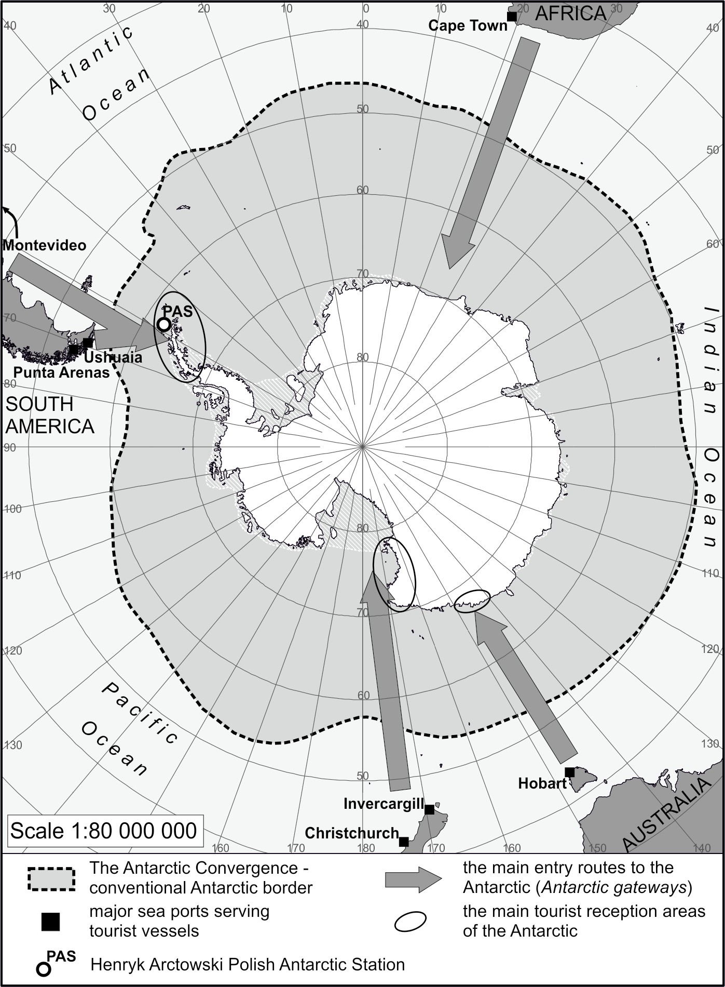
Fig. 1. Antarctic gateways – the main entrance roads to the Antarctic
Source: Own study based on: [Stewart et al. 2005; Lamers et al. 2012a; Schillat et al. 2016].

The measurement of the tourist traffic scale, due to its dynamics, is very problematic. However, in the case of the Arctowski Station and because of so-called bottlenecks3 with which it has to deal with, it is very likely that the traffic volume may can be estimated. Over the past years, the volume of tourism at the Station has been referred to in several scientific publica- tions. P. Ciaputa and K. Salwicka [1997] were among the first authors who pointed out the possibilities of better tourims management at the Station, in conducting an appropriate policy. B. Stonehouse [1999] presented the na- ture and functioning of tourism in the Arctowski Station, while S. P. Dona- chie [1994] pointed to the Station as a good example of combining scientific and tourist functions.

Results

The scale of incoming tourism

In the Antarctic area, tourism has been studied since the middle of the 20th century. The International Association of Antarctica Tour Operators (IAATO) is currently the most important institution collecting data concerning its scale. It has been working since 1991, connecting the largest tour operators organising expeditions to the Antarctic, who are obliged to provide informa- tion about all their activities every year [Stewart et al. 2005]. In addition, IAATO also collects information related to the actions of other tour oper- ators that are not members of IAATO and publishes aggregate data about the number of visitors to Antarctica on its website [https://iaato.org]. They are the major source documenting Antarctic tourism and are often quoted as a reference point in many publications showing the impact of tourism on the functioning of the Antarctic geographical environment [e.g. Stone- house, Crosbie 1995; Chwedorzewska, Korczak 2010; Hall, Saarinen 2010; Lück et al. 2010; Stonehouse, Snyder 2010; Summerson, Bishop 2012; Barre de la et al. 2016].
The first measurements of tourist traffic to the Antarctic Peninsu- la were connected with Argentinean and Chilean expeditions in the early 1950s [Brewster 1982; Hall, Saarinen 2010]. This area has the best condi- tions for the development of tourism from the point of view of its climat- ic and logistic characteristics, as it is the nearest to the inhabited areas of the South American continent [Kruczek 2011]. It was here that the largest number of scientific and research stations were established. From the 1950s

3 Tourist traffic is basically channelled to only one landing site (the second landing site is used very rarely, usually during unfavourable conditions for landing at the main site), which makes its evaluation as accurate as possible.

until the end of the 1980s, tourism throughout Antarctica was relatively low, rarely exceeding 3.5 thousand tourists during the tourist season [Bertram 2007]. A significant increase has been observed only since the beginning of the 1990s [Stewart et al. 2005; Lamers et al. 2012a; Lamers et al. 2012b]. Throughout the 1990s, the number of tourists increased almost three times, attaining a number of 10 thousand people, while in the last 5 years, this number exceeded 20 thousand visitors in the tourist season [IAATO data]. Since the beginning of the 21st century, there has still been a high in- terest in travelling to Antarctica, combined with the diversification of of- fers, transport modes and the initiatives of tour operators [Lamers et al. 2012b]. In recent years, tourist traffic in Antarctica reached its highest val- ues in the 2007/2008 season (Fig. 2), when the number of tourists exceed- ed slightly over 46 thousand people [IAATO data; Chwedorzewska, Korczak 2010; Lamers et al. 2012b], and a decade later, during the 2016/2017 and 2017/2018 seasons, the area was visited by 45.1 thousand and 58.1 thousand tourists, respectively [IAATO data]. Between those two peak seasons, there was a short period of regression (with a minimum of 26.5 thousand visitors in the 2011/2012 season), which was affected by the global economic reces- sion [Lamers et al. 2012b].
For many years, tourist traffic has been monitored at various polar re- search stations (e.g. Brown, Decepción, Esperanza, McMurdo) visited by tourists [Palazzi 1993; Reggio, Haene 2003; Schillat et al. 2016]. This also refers to the Arctowski Polish Antarctic Station, which tourists have been
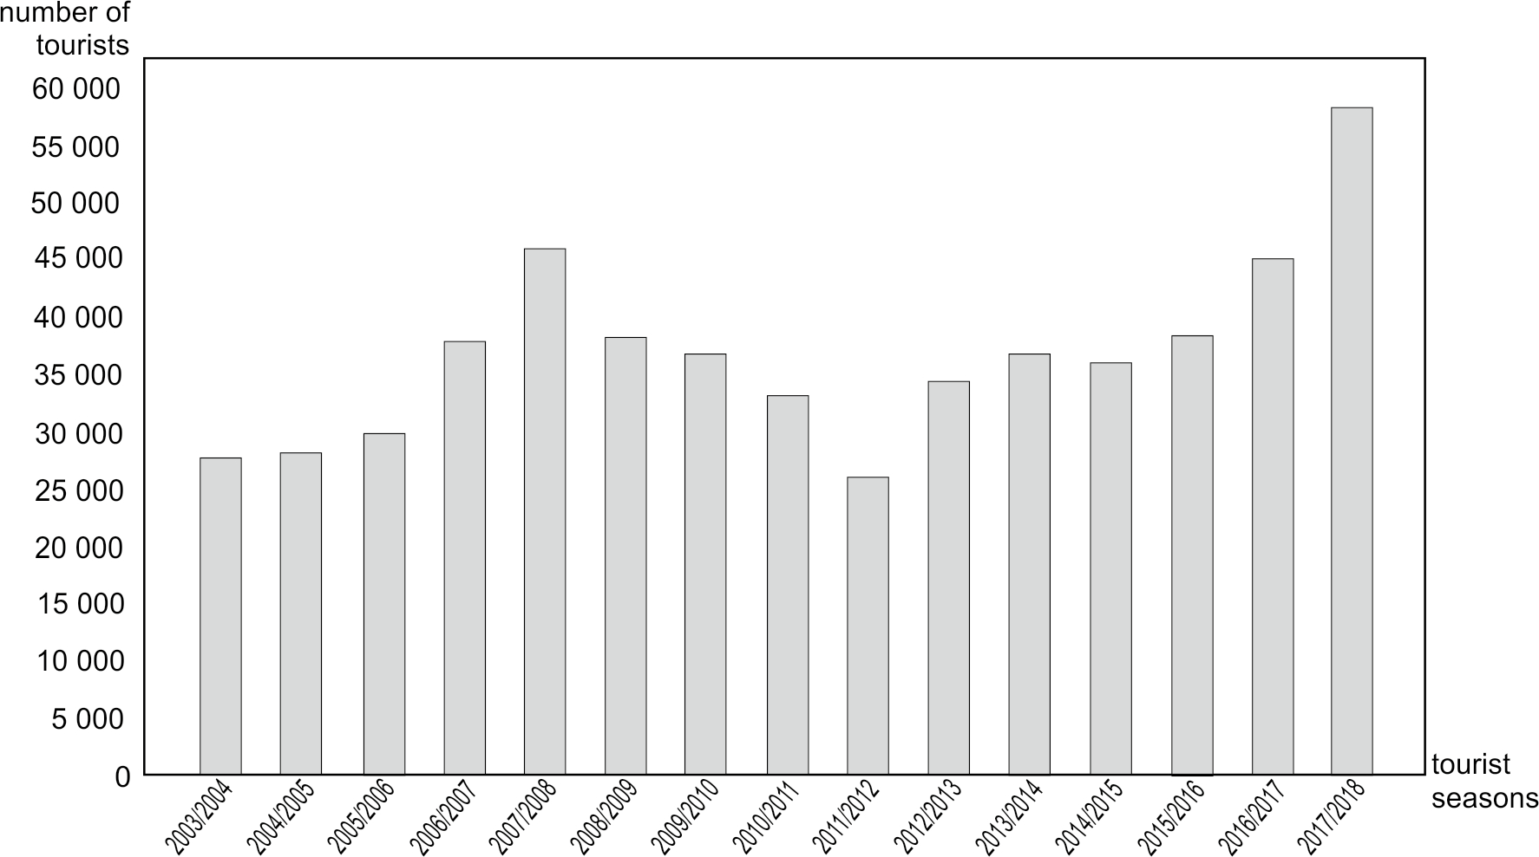
Fig. 2. Tourism in the Antarctic during the last 15 tourist seasons
Source: Own study based on IAATO data [https://iaato.org].

visiting since the 1980s. However, regular monitoring of incoming tourists has been carried out since 1991 [Ciaputa, Salwicka 1997; Kruczek 2011]. Tourists are treated as all the people who arrived here and came ashore for purposes not connected with work in the Antarctic Station areas. Tourist traffic is measured via special staff designated by the Arctowski Station. Monitoring is carried out throughout the summer season (usually from the end of October up to the middle of March), when tourist groups arrive. If it is not possible to calculate large groups of tourists (counted in hundreds), the measurements may be burdened with some errors, nonetheless, they do not disturb the reality of the tourism. At the beginning, the highest number of tourists at the Arctowski Antarctic Station was recorded in the 1992/1993 and the 1993/1994 seasons, when the tourist traffic reached almost 3 thou- sand people [Ciaputa, Salwicka 1997; Chwedorzewska, Korczak 2010]. It increased again to the level of over 3 thousand tourists at the beginning of the 21st century, and in the 2006/2007 season, the Antarctic Station and its surroundings were visited by up to 5.7 thousand tourists [Chwedorzewska, Korczak 2010; Kruczek 2011].
During the last 10 tourist seasons (Fig. 3), the tourist traffic at the Arc- towski Antarctic Station, after exceeding 4 thousand people in the 2008/2009 season, has significantly decreased and at present, does not exceed 2 thou- sand people during the tourist season. A distinct minimum was recorded in the 2010/2011 season, when only 493 tourists reached the Polish Station. Similarly as in the case of the tourism analysed by Z. Kruczek for the whole
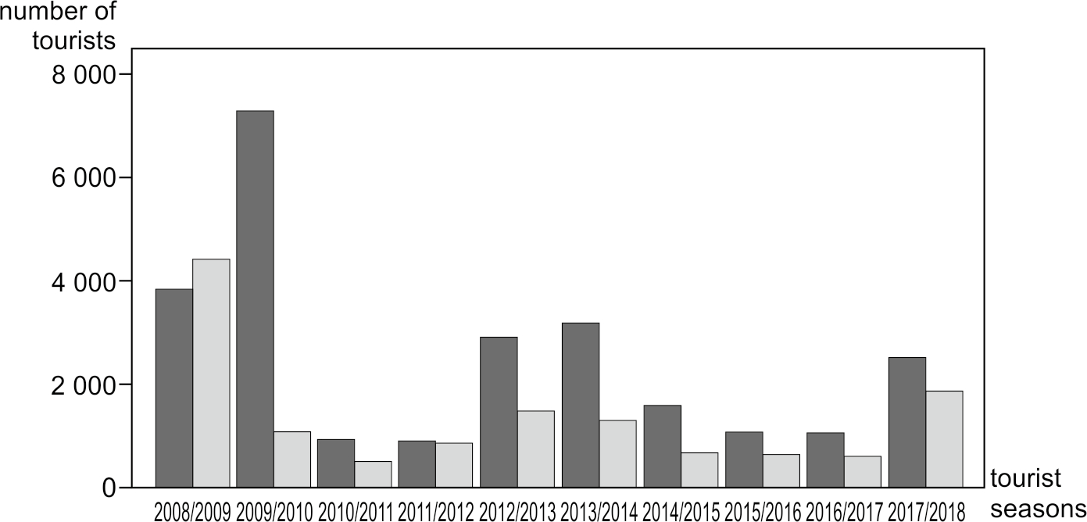
Fig. 3. Tourist traffic at the Henryk Arctowski Polish Antarctic Station during the last 10 tourist seasons; (data marked in black according to IAATO, data marked in grey
from measurements carried out at the Arctowski Station)
Source: Own study and IAATO data (https://iaato.org).

Antarctica area, at the Arctowski Polish Antarctic Station, one can also ob- serve its cyclicality, according to the model proposed by R.W. Butler [Butler 1980; Kruczek, Kruczek, Szromek 2018].
At this point, it is important to note the differences in the data present- ed by the IAATO and the measurements carried out by the employees of the Arctowski Station, which are mentioned by P. Ciaputa and K. Salwicka [1997]. They are certainly connected with the fact that not all ships declar- ing arrivals at the Station are able to get tourists across to the mainland, or with some other difficulties related to the estimation of the incoming tour- ist scale, including the method of measurements or source materials, etc.

Characteristics of tourist traffic

Considering the basic characteristics of tourists coming to Antarctica, i.e. geographical, demographic and economic areas, it should be noted that visitors to the Arctowski Station represented a total of 30 countries and 6 parts of the world. More than a half of them were European citizens (Ta- ble 1), which matches the global data related to tourism, stating that this area generates the largest incoming tourist traffic [Tourism Highlights 2018 Edition]. The distance from Antarctica to Europe does not have any affect on tourism.

Tab. 1. Parts of the world from which the respondents came

PARTS OF THE WORLD | PERCENTAGE OF RESPONSES [%]
Africa | 0.0
South America | 2.7
North America | 18.4
Australia and Oceania | 7.3
Asia | 7.0
Europe | 64.6
TOTAL | 100.0
Source: Own study.

According to the research conducted in Ushuaia (Argentina) by M. Schillat et al. [2016] during the 2012/2013 and 2013/2014 tourist seasons, travelling to Antarctica was dominated by North Americans (45.5%), while Europeans ac- counted for 28.9% of respondents.
Distribution concerning the countries of origin of the respondents com- ing to Antarctica is quite interesting (Table 2).

Tab. 2. Respondents’ place of residence

COUNTRY | PERCENTAGE OF RESPONSES [%]
Germany | 23.3
USA | 15.8
Switzerland | 10.2
Great Britain | 9.0
Australia | 6.3
Poland | 6.1
China | 5.6
OTHERS | 23.7
TOTAL | 100.0
Source: Own study.

The high presence of tourists from Poland has been also observed, which is certainly related to their willingness to visit the native base in this area. It should be remembered that the survey is significantly influenced due to the languages spoken by the interviewers; in the case of the Arctowski Station’s employees, English language skills are required. In previous years, there has been an increase in the number of tourists coming from China. Many years ago, the enormous potential of this market in global tourism had al- ready been pointed out [Kowalczyk 2000]. The last category includes visi- tors from such countries as Belgium, Norway and Canada.
Considering the demographic characteristics of respondents, we may observe a relatively high average age of visitors to Antarctica, i.e. 51.5

Tab. 3. Professional status of visitors to the Arctowski Polish Antarctic Station

TYPE | PERCENTAGE OF RESPONSES [%]
school student | 0.5
unemployed | 1.3
professionally active | 55.5
university student | 2.7
retired person (annuitant) | 37.1
housekeeper | 2.9
TOTAL | 100.0
Source: Own study.

years, with the small domination of women (54%) in comparison to men (46%). In general, the largest number of visitors was at working age, how- ever, with a high share of older people (42.2% of all respondents at the age of 60 and above).
Taking the education of visitors to Antarctica into account, it should be emphasised that well-educated persons dominated, i.e. 77.6% declared high- er education, 12.7% secondary education and only 9.7% some others. Anoth- er specified feature of the visitors to the Arctowski Station was the profes- sional status of respondents (Tab. 3).
The respondents were dominated by professionally active persons (1/2 of persons), with a high share of retired people and annuitants (over 1/3 of persons). In the studies quoted by M. Schillat et al. [2016], there were 33.4% of retirees and 61.3% of professionally active people.
The visitors to the Arctowski Station were also asked to indicate their material status, at their own discretion, considering the scale proposed for assessment: from very poor to very good situation. In general, 1/3 of peo- ple (33.2%) stated that they had very good financial status, and adding the indication for the “good” status - this gave a total of 84.7% of people who declared better financial affluence. Nobody described their material situ- ation as very poor or poor. Such results are certainly connected with the higher costs of coming to Antarctica. Taking the company of the respond- ents who travelled to Antarctica into account, almost half of them arrived alone (45.9%), while those remaining were accompanied by friends and/or colleagues (54.1%). More than a half of the travellers to this area took part in a package travel organised by a specific travel agency (64.7%). The oth- er persons purchased some seats on ships (29.4%) or the trip was connected with their work (5.9%).
It should be noted that all of the interviewed tourists at the Arctowski Station indicated that during their stay in the Antarctic areas, it was always planned to disembark the mainland .
Respondents were asked whether they had already been to Antarctica before. For a significant number of visitors to the Arctowski Station, it was their first stay in the area. A positive response was received from 14.5% of the respondents, but most of them were people sailing on ships or research- ers. The majority of subjects were from: Germany, China, Poland and Great Britain. In a study presented by M. Schillat et al. [2016] - 4.8% of people in- dicated that they had previously been to Antarctica.
Completely different was the distribution of answers to the question connected with staying in other areas, similar in nature to the Antarctic. A relatively high number of people, i.e. 42.4%, indicated that they had been to some other places with similar climate and environmental conditions be- fore. The most frequent mentioned regions were Arctic ones, mainly coun- tries with part of their territories located near the Arctic Circle (Tab. 4).

Tab. 4. Most frequently mentioned areas outside Antarctica visited by respondents (multiple indications)

DIRECTION | PERCENTAGE OF RESPONSES [%]
Svalbard | 31.3
Greenland | 29.0
Spitsbergen | 14.8
North Scandinavia | 9.7
Iceland | 8.0
Alaska | 7.4
Canada | 5.7
Russia | 5.1
Source: Own study.

The northern borderlands of the world, including Europe, were the most frequently visited. This group of respondents, who had previously been to the polar regions, was dominated by people from Germany, the USA and Poland (more than a half of all people), as well as those British, Swiss, Norwegian and Chinese.
Respondents who had previously been to other areas with similar cli- mate and environmental conditions as Antarctica, were at an average age of 54 years, including both men (49.7%) and women (50.3%). The vast ma- jority of them (77.2%) had higher education. They were mostly profession- ally active persons (60.6%) or retirees (26.3%). Their declared material sta- tus is similar to that of all respondents - mainly very good (33.4%) and good (53.8%), which in total, is a slightly higher indicator of better material sta- tus than for the whole research sample.

Conclusions

The development of global tourism as well as global changes in the natural environment make it necessary to monitor what is happening in the Ant- arctic region. The question that arises here is: to what extent do the grow- ing trends in tourism around the world have impact on this area? Within the framework of environmental monitoring, especially in Antarctica, there is a need for constant control of the activity and behaviour of tourists in the local geographical area.
In this publication, aspects related to the scale of tourism and the pro- file of tourists visiting the Arctowski Polish Antarctic Station are the only noted. Information concerning the scale of this phenomenon is currently

very important in polar regions, especially from the point of view of efficient planning tourism development, including the control of tourist traffic. For it is here in the Arctic and Antarctica that monitoring and protection of the natural environment are some of the most important challenges faced by to- day`s modern world.
Taking into account the results of research and analysis presented in this article, it is necessary to pay attention to several aspects:
- there is continued tourist interest in the Antarctic tourism. In recent years, it has started to increase, reaching 60 thousand visitors during the tourist season;
- the Arctowski Polish Antarctic Station is an important point on the map of tourist traffic streams and in the study of tourist phenomena;
- in the recent period, the Arctowski Station has recorded about 2 thou- sand tourists during the summer season;
- a tourist in Antarctica, according to the measurements conducted at the Arctowski Station, is a person who arrives there for the first time, but more than once, it is another area which is similar in its climate and environment. Most visitors come from Europe and North America. It is a person above the age of 50, with higher education, professionally ac- tive or retired. This tourist quite often travels alone, using the services of travel agencies. Therefore, it is a conscious tourist, who is interested in polar directions, is well-educated, elder and financially afluent.
The Polish Academy of Sciences, as the institution directly managing the Arctowski Station, within the context of its plans and intentions points out, among others, the importance of social research in relation to the po- lar areas and polar policy of Poland [Węsławski, Ziaja eds. 2017]. It is neces- sary to pay attention to the importance of tourism research, from the point of view of appropriate development planning, awareness of threats connect- ed with tourism and to quickly respond to them. It should be borne in mind that today’s development, related to a regional level, is not considered to be the equivalent in its growth. This is a sustainable process, indicating pos- itive changes, also in the preservation of natural environment [Wilkońska 2017]. Nowadays, all over the world, it is said that there is a problem of too expansive tourism, especially in cities, so called overtourism may also begin to have impact on polar regions in the next few years. Therefore, the dam- age that mass tourism can cause may be irreversible, especially in Antarcti- ca. For that reason, monitoring tourist phenomena provides strong contri- butions to research in these areas.

Acknowledgements

The data used in the study come from the research conducted at the Hen- ryk Arctowski Polish Antarctic Station. The project was carried out in coop-

eration between the Institute of Biology and Biophysics of the Polish Acad- emy of Sciences and the University of Physical Education in Kraków. The authors would also like to thank Professor Katarzyna Chwedorzewska and Dr. Joanna Plenzler for their help and support.

References

Barre de la S., Maher P., Dawson J., Hillmer-Pegram K., Huijbens E., Lam- ers M., Liggett D., Müller D., Pashkevich A., Stewart E. (2016), Tourism and Arctic Observation Systems: exploring the relationships, „Polar Re- search”, Vol. 35, 24980, doi: 10.3402/polar.v35.24980.
Baird P.D. (1965), The Polar World, Wiley, New York.
Bastmeijer K., Roura R.M. (2004), Regulating Antarctic tourism and the precautionary principle, „The American Journal of International Law”, Vol. 98, pp. 763–781.
Bertram E. (2007), Antarctic shipborne tourism: An expanding industry, [in:] Snyder J., Stonehouse B., eds., Prospects for Polar Tourism, CABI, Wallingford, pp. 285–309.
Brewster B. (1982), Antarctica – Wilderness at Risk, Friends of the Earth, Wellington.
Chwedorzewska K., Korczak M. (2010), Human impact upon the environ- ment in the vicinity of Arctowski Station, King George Island, Antarctica,
„Polish Polar Research”, Vol. 31, pp. 45–60, doi: 10.4202/ppres.2010.04. Ciaputa P., Salwicka K. (1997), Tourism at Antarctic Arctowski Station 1991- 1997: policies for better management, „Polish Polar Research”, Vol. 18,
pp. 227–239.
Donachie S.P. (1994), Henryk Arctowski Station: mixing science and tour- ism, „Annals of Tourism Research”, Vol. 21, pp. 333–343.
Groch J. (1996), Norwegia [Norway], [in:] Warszyńska J., ed., Geografia tu- rystyczna świata. Część 1 [Tourist Geography of the World, vol. 1] PWN, Warszawa, pp. 250–256.
Hall C.M., Saarinen J. (2010), Tourism and Change in Polar Regions. Intro- duction – definitions, locations, places and dimensions, [in:] Hall C.M., Saarinen J., eds., Tourism and Change in Polar Regions. Climate, Envi- ronment and Experience, Routledge, London–New York, pp. 1–41.
Hansom J.D., Gordon J.E. (1998), Antarctic Environments and Resources, Longman, New York.
Kowalczyk A. (2000), Geografia turyzmu [Tourism Geography], PWN, Warszawa.
Kruczek Z. (2011), Tourism in the Antarctic region. The dilemma of devel- opment and environment protection, „Current Issues of Tourism Re- search”, Vol. 1, pp. 19–25.

Lamers M., Eijgelaar E., Amelung B. (2012), Last chance tourism in Antarc- tica: cruising for change?, [in:] Lemelin R.H., Dawson J., Stewart E.J., eds., Last chance tourism: Adapting tourism opportunities in a chang- ing world, Routledge, Oxon, pp. 25–41.
Lamers M., Liggett D., Amelung B. (2012), Strategic challenges of tourism development and governance in Antarctica: taking stock and moving for- ward, „Polar Research”, Vol. 31, 17219, doi: 10.3402/polar.v31i0.17219. Lemelin R.H., Dawson J., Stewart E.J., Maher P.T., Lück M. (2010), Last chance tourism: boom, doom, and gloom, „Current Issues in Tourism”,
Vol. 13, pp. 477–493.
Lück M., Maher P.T., Stewart E.J. (2010), Polar Cruise Tourism in the 21 st Century, [in:] Lück M., Maher P.T., Stewart E.J., eds., Cruise Tourism in Polar Regions. Promoting Environmental and Social Sustainability?, Earthscan, London–Washington, pp. 1–10.
Machowski J. (2000), The status of stations under the Antarctic legal regime,
„Polish Polar Research”, Vol. 21, pp. 99–136.
Maciejowski W. (2007), Walory turystyczne i formy turystyki w archipelagu Svalbard (Norwegia) [The tourist attractions and the forms of tourism on the Svalbard Archipelago, Norway], [in:] Kurek W., Faracik R., eds., Studia nad turystyką. Prace geograficzne i regionalne. Geograficzne, ekonomiczne i społeczne aspekty turystyki [Tourism studies. Geograph- ical and regional studies. Geographical, economic and social aspects of tourism], Instytut Geografii i Gospodarki Przestrzennej Uniwersytet Jagielloński, Kraków, pp. 123–134.
Palazzi R. (1993), Antártida y Archipiélagos Subantárticos. Factores para su análisis, Escuela Superior de Guerra Aérea, Buenos Aires.
Polar tourism: Tourism in the Arctic and Antarctic regions (1995), Hall C.M., Johnston M.E., eds., John Wiley and Sons Ltd., Chichester.
Reggio P., Haene E. (2003), Visitors’ reception Plan at the Antarctic Base Esperanza. A proposal for discussion, Aves Argentinas–Antarctic Com- mand of the Army, Base Esperanza.
Roura R.M. (2010), Cultural Heritage Tourism in Antarctica and Svalbard, [in:] Hall C.M., Saarinen J., eds., Tourism and Change in Polar Regions. Climate, Environment and Experience, Routledge, London–New York, pp. 180–203.
Roura R.M. (2012), Being there: examining the behaviour of Antarctic tour- ists through their blogs, „Polar Research” Vol. 31, 10905, doi: 10.3402/ polar.v31i0.10905.
Schillat M., Jensen M., Vereda M., Sánchez R. A., Roura R. (2016), Tourism in Antarctica. A Multidisciplinary View of New Activities Carried Out on the White Continent, Springer.
Stewart E.J., Draper D., Johnston M.E. (2005), A Review of Tourism Re- search in the Polar Regions, „Arctic”, Vol. 58, pp. 383–394.

Stonehouse B. (1999), Antarctic shipborne tourism: facilitation and research at Arctowski Station, King George Island, „Polish Polar Research”, Vol. 20, pp. 65–75.
Stonehouse B., Crossbie K. (1995), Tourist impacts and management in the Antarctic Peninsula area, [in:] Hall C.M., Johnston M.E., eds., Polar Tourism: Tourism in the Arctic and Antarctic Regions, John Wiley and Sons Ltd. Chichester, pp. 217 –233.
Stonehouse B., Snyder J. (2010), Polar Tourism. An Environmental Perspec- tive, Channel View Publications, Bristol–Buffalo–Toronto.
Summerson R., Bishop I. D. (2012), The impact of human activities on wil- derness and aesthetic values in Antarctica, „Polar Research”, Vol. 31, 10858, doi: 10.3402/polar.v31i0.10858.
Szeligiewicz W. (2006), Ekosystem Antarktydy – cel egzotycznych wypraw tu- rystycznych [Antarctica ecosystem – the goal of exotic touristic expedi- tions], „Turystyka i Rekreacja”, Vol. 2, pp. 5–11.
Tourism Highlights 2018 Edition, UNWTO, www2.unwto.org. (30.08.2019). Turner J., Marshall G.J. (2011), Climate change in the polar regions, Cam-
bridge University Press, Cambridge.
Vereda M. (2008), A study on the expectations of Antarctic visitors towards their trip: Images created about Antarctica and the relationship with Ushuaia (Argentina) as a gateway city, [in:] Saarinen J., Tervo K., eds., Tourism and Global Change in Polar Regions: International Confer- ence, University of Oulu Press, Oulu, pp. 77–83.
Warszyńska J., Jackowski A. (1979), Podstawy geografii turyzmu [The basics of the Geography of Tourism], PWN, Warszawa.
Węsławski J.M., Ziaja W., eds. [2017], Strategia polskich badań polarnych – koncepcja na lata 2017-2027 [Strategy for Polish Polar Research – a con- cept for the year 2017-2027], Polskie Konsorcjum Polarne.
Wilkońska A. (2017), Strategic planning in the area of tourism development in the light of analysis of strategic documents of polish cities, „Folia Tu- ristica”, Vol. 44, pp. 105-125.
Zajadacz A. (2008), Ruch turystyczny jako przedmiot badań geograficznych [Tourist movement as a subject of geographic surveys], [in:] Młynarczyk Z., Zajadacz A., eds., Uwarunkowania i plany rozwoju turystyki. Tom 2 [Tourist development: determinats and plans, vol. 2], Wyd. Naukowe Uniwersytetu im. A. Mickiewicza w Poznaniu, Poznań, pp. 187–209.
Ziaja W., Ostafin K. (2018), Origin and location of new Arctic islands and straits due to glacial recession, “Ambio”, Vol. 48, pp. 25–34, doi: 10.1007/ s13280-018-1041-z.

