

Interaction of iron ions with melanin*

Andrzej ŻądłoH, Tadeusz Sarna
Department of Biophysics, Faculty of Biochemistry, Biophysics and Biotechnology, Jagiellonian University, Krakow, Poland
One of the antioxidant roles of melanin is binding redox-
active transition metal ions. The aim of this study was to
examine the redox reactions accompanying iron bind-
ing by melanin. Two kinds of synthetic eumelanin were
mixed with iron (II) and iron (III) in the presence and
absence of citrate and ADP in the aerobic and anaero-
bic system. The iron binding was examined by electron
paramagnetic resonance (EPR) spectroscopy and thio-
cyanate assay. Obtained results indicate that although
melanin reduces iron (III) that is unbound to this poly-
mer, binding of iron (II) is accompanied by its oxidation
by melanin.
Key words: melanin, iron, oxidation, saturation curves
Received: 18 October, 2019; revised: 19 November, 2019; accepted:
01 December, 2019; available on-line: 11 December, 2019
Ee-mail: andrzej.zadlo@uj.edu.pl
*Some of results shown in this paper were presented at XXII Inter-
national Pigment Cell Conference, Singapore 4-7 September 2014,
XLII Szkoła Zimowa, Zakopane, Poland, 10-14 February 2015 and
XXVI International EPR Seminar 2015, Graz, Austria, 8-10 Jun 2015.
Acknowledgements of Financial Support: This work was support-
ed by National Science Center grant (grant 2012/07/D/ST4/02211).
Abbreviations: ADP, adenosine 5'-diphosphate; DMa, synthetic
eumelanin prepared by autooxidation of DOPA; DMt, synthetic
eumelanin prepared by DOPA oxidation catalyzed by tyrosinase;
DOPA,3,4-dihydroxyphenylalanine; EPR, electron paramagnetic
resonance; P1/2, half-power (microwave power at which the first de-
rivative amplitude is reduced to half of its unsaturated value); PBS,
phosphate buffered saline.
INTRODUCTION
Although melanin is well known as photoprotec-
tor (Meredith & Sarna, 2006; Brenner & Hearing, 2008;
d’Ischia et al., 2015), its antioxidant action is also note-
worthy. One of the antioxidant roles of melanin is bind-
ing redox-active transition metal ions (Pilas et aL, 1988),
(Kaczara et al., 2012). On the other hand, melanin was
shown to be prooxidant in the presence of strong chela-
tors such as EDTA or an excessive amount of iron (Ko-
rytowski et al., 1987; Pilas et al., 1988). Such prooxidant
action was based on the reduction of iron (III) that was
not bound to melanin. Iron is one of the most ubiq-
uitous metals in the body. Therefore, the elucidation of
the mechanism of interaction of melanin with iron may
be the key to better understand such pathologies as age-
related macular degeneration (ARMD), skin melanoma
or Parkinson’s disease (PD), which were proposed to
be based on oxidative stress of pigmented cells (Sarna,
1992; Beatty et at., 2000; Sarna et al., 2003; Zecca et al.,
2003; Wood et al., 2006; Zecca et al., 2008; Noonan et
al, 2012). The aim of this research was to examine the
changes of the oxidation state of iron accompanying
its binding to melanin. A water-soluble synthetic model
of eumelanin prepared by DOPA autooxidation (DMa)
and insoluble synthetic model of eumelanin prepared by
enzymatic oxidation of DOPA (DMt) were mixed with
salts of iron (II) and iron (III) or their complexes with
citrate and ADP in the aerobic and anaerobic system.
MATERIAL AND METHODS
Reagents. All chemicals were reagent grade or better
and used as supplied. Water was deionized by a millipore
system (Millipore S A. 67120 Molsheim, France), citric
acid solution and PBS prepared using this water were
additionally treated with Chelex-100 to remove the traces
of metal ions.
Preparation of synthetic eumelanins. Water-soluble
model of eumelanin (DMa) was prepared by autooxi-
dation of DOPA (Felix et al., 1978) and purified by a
modified method described previously (Szewczyk et al.,
2016). In brief, 25 g of D,L-^-dihydroxyphenylalanine
(D,L-DOPA) was dissolved in 5 l of water and alkalized
to pH 8 by 25% ammonia. The solution was stirred and
air-bubbled for three days. Every several hours the pH
was corrected to 8.0 by the addition of small amounts
of ammonia. Then the solution was stirred without air-
bubbling for the next three days. After that, the solution
was acidified to pH 2.5 with hydrochloric acid and cen-
trifuged at 4040 xg for 10 minutes. The obtained pre-
cipitate was washed 8 times with water acidified to pH
2.5 and once with non-acidified water. The precipitate
was suspended in about 0.5 l of water, placed in a di-
alysis bag (~ 12 000 u) and dialyzed for 12 days against
5 l of water with four changes of the water. DMa was
quantified by determination of its dry mass. This mela-
nin precipitated only in the acidic pH. At neutral pH it
was soluble in water, the size of particles of DMa was
determined to be about 20 nm (Zadlo et al., 2017) and
melanin did not show any tendency to aggregate.
Insoluble model of eumelanin, prepared by enzymatic
oxidation of DOPA (DMt), was prepared as follows:
2 g of L-^-dihydroxyphenylalanine (L-DOPA) was dis-
solved in 995 ml of 0.1 M Na/K phosphate buffer (pH
6.8). The solution was vigorously stirred for at least 10
minutes. 223 000 units of tyrosinase were dissolved in
5 ml of phosphate buffer and added to the solution of
L-DOPA. The mixture was bubbled with air at 37°C
for 24 h. Then the mixture was centrifuged for 0.5 h at
13 000 xg at 4°C. The precipitate was suspended in 300
ml of water and centrifuged under the same conditions.
Such a washing procedure was carried out seven times.
Finally, the precipitate was suspended in 38 ml of wa-
ter. DMt was quantified in the same way as DMa. This
melanin was insoluble in water even at neutral pH and it
sedimented even without centrifugation.
Preparation of iron and copper complexes with
melanin. Iron complexes with melanin were prepared
either using complexes with citrate and ADP or using

Vol. 66, No 4/2019
459-462
https://doi.org/10.18388/abp.2019_2889
Regular paper
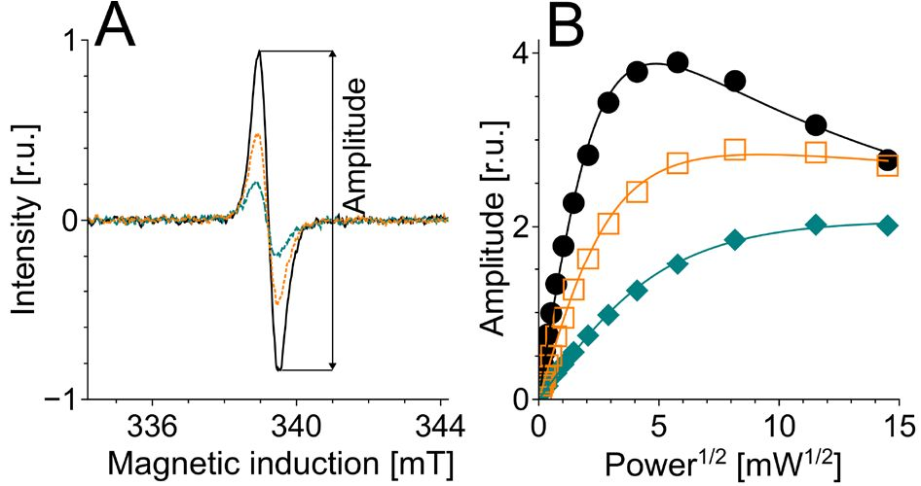
460
A. Żądło and T. Sarna
2019
free salts. Some comparative experiments were carried
out using copper (II) complexes with citrate. Iron (II)
and copper (II) complexes with citrate were prepared by
addition of 0.1 M citric acid to 0.025 M ferrous sulphate
or cupric sulphate in 10-4 M H2SO4. Under such con-
ditions, citrate:metal molar ratio was 2:1. Then the pH
was adjusted to 7 by drop-wise addition of 1 M NaOH.
Finally, water was added, adjusting the metal ion concen-
tration to 10 mM. Iron (III) complexes were prepared
in a similar manner except that 0.025 M ferric chloride
was in 0.02 M hydrochloric acid. Iron complex with
ADP was prepared similarly but ADP was acidified to
pH 2 before the addition of iron salt and the molar ra-
tio ADP:Fe was 4:1. The final concentration of the iron
complexes with ADP was 2 mM. The prepared citrate or
ADP complexes were added to 4 mg/ml melanin solu-
tion adjusted to pH 7.4. The mixture was diluted with
water to melanin concentration 2 mg/ml and metal ion
concentration 0.358 mM i.e. 1% (w/w) in the case of
iron and 1.14% (w/w) in the case of copper. After 0.5 h
of incubation, the pH was readjusted to 7.4 and the mix-
ture was further incubated at room temperature in the
dark. Iron complex with ADP was added only to DMt.
In the case of the iron complex with ADP, melanin sam-
ples were washed three times after 0.5 hours of incuba-
tion. As a result, the data for supernatant from melanin
with iron complex with ADP are limited to time 0.5 h
(Fig. 3B). A control sample without iron was prepared in
a similar manner except for the addition of citrate with-
out iron. Preparation of iron complex with melanin us-
ing iron (II) salt without citrate and ADP was done as
described in (Zadlo et al., 2017). In brief, such amount
of water and 0.025 M ferrous sulphate in 10-4 M H2SO4
was added to 4 mg/ml melanin adjusted to pH 5 that
the final melanin concentration was 2 mg/ml and iron
concentration was 0.358 mM i.e. 1% (w/w). After 0.5 h
of incubation, the pH was adjusted to 7.4 and treated
similarly as during addition of iron complex with citrate
or ADP. The control melanin was prepared similarly ex-
cept for the addition of ferrous sulphate. Complexes of
iron (III) with melanin were prepared in the following
manner: 0.025 M solution of ferric chloride in 0.02 M
hydrochloric acid was added to the diluted solution of
melanin acidified to pH 2. The pH of such samples was
increased in three steps i.e. after adjustment to pH 4 and
pH 6 the sample was incubated for at least two hours
before the further increase of pH. Finally, the pH was
increased to 7.4. There was additional control melanin
for iron (III) treated analogously as melanin with iron
(III) except for the addition of ferric chloride.
For the preparation of iron (II) solutions, 10-4 M
H2SO4 or 0.1 M citrate were saturated with argon by
bubbling for at least 0.5 hours. The results presented in
Fig. 2B and Fig. 4 were obtained using argon-saturated
melanin.
Photoreduction of iron (III) and copper (II). Pho-
toreduction of metal ions bound to melanin was carried
out using the rose bengal/^-NADH system (Korytowski
& Sarna, 1990) where, upon photoexcitation of the dye,
two strongly reducing radicals (Rose Bengal- and NAD)
are formed (Lambert et aL, 1990). A mixture containing
0.5 mM rose bengal, 2.5 mM ^-NADH and 1 mg/ml
DMa with and without 1% (w/w) iron (III) or Cu (II)
in PBS was irradiated with 516-586 nm (50 mW/cm2)
light originating from XBO 450 short-arc xenon lamp
equipped with CuSO4 filter and Green additive dichroic
filter 585FD62-25 (Andover Corporation, Salem, USA).
Irradiation was carried out in a closed spectrofluorime-
tric cuvette. Before irradiation, the sample was saturated
with argon for at least 0.5 h. The initial volume of the
sample was 1 ml. During irradiation, the sample was
gently stirred. Before irradiation and after 20 minutes
of irradiation, 0.2 ml of the mixture was withdrawn for
EPR spectroscopy examination.
Electron paramagnetic resonance (EPR) spectros-
copy. EPR spectroscopy was done using Bruker EMX-
AA EPR spectrometer (Bruker BioSpin, Rheinstetten,
Germany). The efficiency of melanin-iron interaction
was determined by measurements of the influence of
iron on microwave power saturation of the EPR sig-
nal of melanin. Such measurements were carried out at
room temperature using EPR flat cell (0.3 mm thickness
and 8 mm width). Just before EPR measurements, the
sample pH was adjusted to 7.4. Typical instrumental set-
tings were: modulation amplitude 0.305 mT; center field
339.2 mT; scan range 5 mT; scan time 42 s and time
constant 327.7 ps. Microwave power was selected in the
range of 0.00839 to 211 mW. If signal:noise ratio was
greater than 20, the amplitude of melanin EPR signal
was determined digitally, otherwise, it was determined
manually. The amplitude (Fig. 1A) was plotted against
the square root of microwave power and half- power
(P1/2) was determined from the fit of the equation:
f(x)=A'x'[1+(21/B-1)'x2/P1/2]-B
(Altenbach et al., 1994) (Fig. 1B), where x is the square
root of microwave power, f(x) is EPR signal ampli-
tude, A is the initial slope, b is the homogeneity coeffi-
cient and P1/2 is the half-power i.e. microwave power, at
which the first derivative amplitude (Fig. 1A) is reduced
to the half of its unsaturated value.
The EPR signals of iron (III) and copper (II) bound
to melanin were measured at 77 K. Iron measurements
were carried out at modulation amplitude 0.805 mT;
center field 158.49 mT; scan range 50—100 mT; scan
time 42-84 s; time constant 327.7 ps and microwave
power 5.29 mW. The final EPR spectra of iron were
taken from averaging 5-10 scans. Copper was meas-
ured at modulation amplitude 0.805 mT; center field 300
mT; scan range 100 mT; scan time 42 s; time constant
327.7 ps and microwave power 5.29 mW. The final EPR
spectra of copper were averages from 10 scans.
Figure 1. The effect of iron on EPR signal of 2 mg/ml DMt after
24 h of incubation with iron complex with citrate.
(A) EPR spectra of melanin registered at microwave power
1.06 mW for control melanin only with citrate (continuous line)
or melanin with citrate complex of iron (II) (broken line) or iron
(III) (dotted line). (B) melanin signal amplitude plotted against the
square root of microwave power and fitted with the following
function: f(x)=A-x-[1+(21/e-1)-x2/P1/2U (Altenbach et al., 1994) as de-
scribed in the "Material and methods” section. Filled circles - con-
trol melanin without iron, filled diamonds - melanin with iron (II),
open squares - melanin with iron (III).
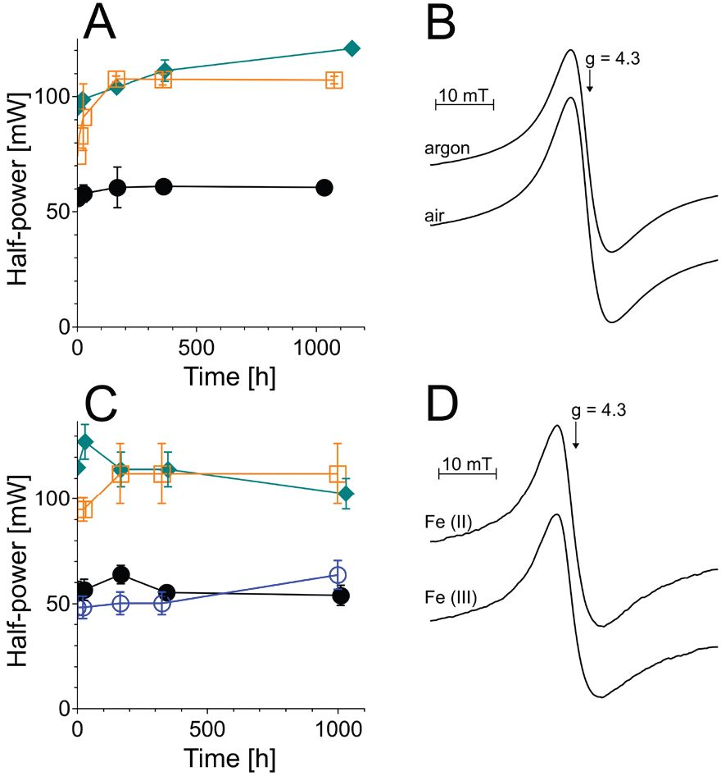
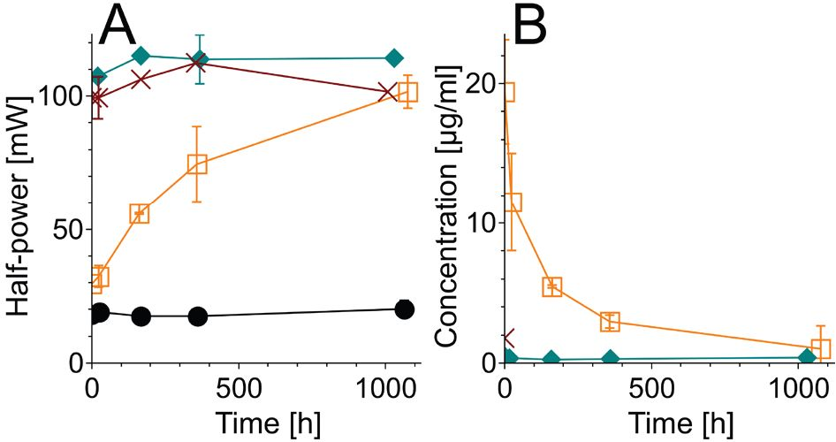
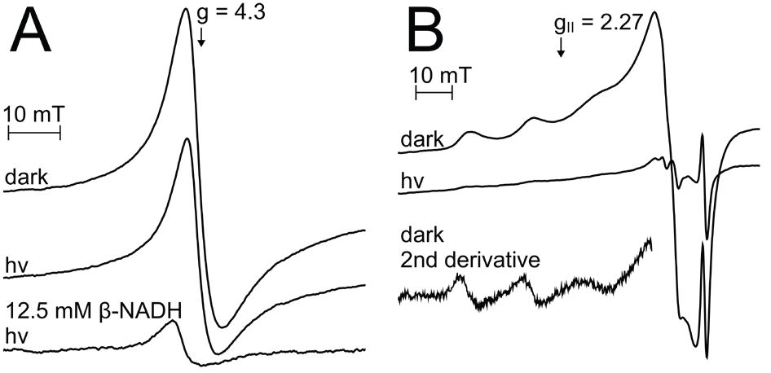
Vol. 66
Melanin-iron interaction
461

Determination of the unbound iron. 0.2 ml of
the sample was centrifuged at 20,871 for 5 minutes.
0.18 ml of the supernatant was acidified by addition
of 0.01 ml of 2 M HCl. After the addition of 0.01 ml
of 0.1 M H2O2, the sample was heated at 100°C for
15 minutes to oxidize iron. Iron (III) was determined by
thiocyanate assay as previously described (Żądło, 2019).
Determination of the unbound iron was limited only to
DMt which is insoluble and can be centrifuged at pH
7.4.
RESULTS AND DISCUSSION
Iron strongly increased the value of P1/2 for both
types of melanin (Figs. 2A, C and 3A). Such an effect of
iron was fast in the case of free salt of iron (III) or iron
(III) complex with ADP and in all melanin samples with
iron (II). On the other hand, iron (III) complex with
citrate caused a very slow increase of half-power (P1/2),
especially in the case of DMt (Fig. 3A). The correspond-
ing kinetics very well correlated with the decrease of iron
content in the supernatant from DMt (Fig. 3B). The re-
sults indicate that P1/2 is a good indicator of iron bind-
ing by melanin. Interestingly, the addition of iron (II) to
DMa resulted in a strong, slightly asymmetric EPR sig-
nal at g=4.3 typical for iron (III) complex with melanin
(Sarna et al., 1981). The signal was similar to that ob-
served when iron (III) was added to melanin (Fig 2D).
This signal was almost independent of the presence of
oxygen (Fig. 2B) The data suggest that the binding of
iron (II) is accompanied by its rapid oxidation and that
this process is independent of oxygen. Therefore, we
checked the susceptibility of iron (III) bound to melanin
to photosensitized reduction in rose bengal/^-NADH
oxygen-free system, where two strongly reducing radi-
cals (Rose Bengal- and NAD) are formed (Lambert et
Figure 2. The interaction of iron with DMa.
Time-dependent changes of half-power (A, C) in samples con-
taining 2 mg/ml DMa. Iron was added in complex with citrate (A)
or as a free salt (C). Filled circles - control melanin without iron,
open circles - control melanin without iron treated analogously
as melanin with iron (III), filled diamonds - melanin with iron (II),
open squares - melanin with iron (III). B, D - EPR signals of high-
spin iron (III) in samples with added iron (II) in anaerobic and aer-
obic conditions (B) or with added iron (II) and iron (III) in aerobic
conditions (D).
Figure 3. The kinetics of iron binding by DMt.
Time-dependent changes of half-power (A) or iron concentration
in the supernatant (B) in samples containing 2 mg/ml DMt. Iron
was added in complex with citrate except for the sample marked
by crosses. Filled circles - control melanin without iron, filled dia-
monds - melanin with iron (II), open squares - melanin with iron
(III), crosses - melanin with iron (III) added in complex with ADP.
al, 1990). For comparison, we used melanin-copper (II)
complex in which copper (II) was previously shown to
be reduced in such system (Korytowski & Sarna, 1990).
In the dark, DMa with 1% (w/w) iron showed EPR
signal typical for Fe(III)-melanin complex (Fig. 4A),
while DMa with 1.14% (w/w) copper exhibited EPR
signal typical for Cu(II)-melanin complex (Fig. 4B) with
g|,=2.27 (Froncisz et al, 1980). Although the irradiation
of 1 mg/ml DMa with 1.14% (w/w) Cu in the presence
of 0.5 mM rose bengal and 2.5 mM ^-NADH caused al-
most complete disappearance of copper (II) EPR signal
(Fig. 4B), the reducing radicals formed by the interaction
of the excited triplet state of rose bengal with NADH
had only a little effect on iron (III) EPR signal when
iron was bound to melanin. In such samples, five times
higher concentration of ^-NADH was necessary for the
photoreduction of iron (III) (Fig. 4A). It seems that
photoreduction of iron (III) is possible only after the
depletion of the redox capacity of melanin. It indicates
that melanin is able to oxidize the bound iron (II). Al-
though in the previous studies it was demonstrated that
melanin reduces iron (III) to iron (II) (Korytowski et
aL, 1987; Pilas et al., 1988), it is important to stress that
the ability of melanin to reduce iron (III) was shown
either in the presence of EDTA which prevented iron
binding by melanin or at low concentration of melanin
with part of the iron remaining unbound. However, in
this study citrate and ADP were used. Iron (II) could
Figure 4. Photoreduction of iron (III) and copper (II) complexed
with melanin.
EPR spectra of iron (III) (A) and copper (II) (B) bound to DMa in
the dark and after 20 minutes of irradiation with 50 mW/cm2
(516-586 nm) light. Samples were buffered in PBS and contained
1 mg/ml DMa with 1% (w/w) iron (III) (A) or Cu (II) (B), 5 mM rose
bengal and, except for the sample marked as "12.5 mM p-NADH”,
2.5 mM p-NADH. The value of g^ for Cu (II) was determined from
the second derivative of EPR signal acquired in the dark.
462
A. Żądło and T. Sarna
2019
be easily bound by melanin in the presence of citrate as
shown in Figs. 2A and 3A. Importantly, reduced mela-
nin subunits (catechols) are more hydrophilic and thus
more exposed to the external environment than oxidized
forms (ortho-quinones), which are expected to be rather
inside the polymer. Therefore, it can be postulated that
melanin is able to reduce unbound iron (III) but iron
- complexed with melanin is rapidly oxidized by this
polymer. This conclusion is in accordance with the ob-
servable slow kinetics of iron (III) binding by melanin
in the presence of citrate (Fig. 3A, B). Iron (III) forms
a stronger complex with citrate than iron (II) and can-
not be bound by melanin but melanin reduces iron (III)
complexed with citrate. Then, iron (II) is bound by me-
lanin and finally, melanin oxidizes iron (II). The reduc-
tion of iron (III) seems to be the slowest process that
controls the rate of iron (III) binding by melanin in the
presence of citrate.
In conclusion, although melanin acts as an electron
donor for iron (III) that is not bound to this polymer,
the dominant form of iron complexed with melanin is
iron (III). This phenomenon can be explained by the
fact that the reduced melanin subunits (catechols) are
more hydrophilic and thus more exposed to the exter-
nal environment than the oxidized forms of the mela-
nin subunits (ortho-quinones), which are expected to
be rather hidden inside the polymer. Binding of iron
- by melanin can be essential for antioxidant ac-
tion of melanin because such iron cannot participate in
Fenton reaction. On the other hand, oxidative modifi-
cation of melanin, induced by light or hydrogen perox-
ide may increase the one-electron reduction potential
of the iron (III) bound to melanin and expose the iron
ions to physiological reductants, such as ascorbate and
glutathione. We postulate that under such conditions,
iron (III) bound to oxidatively modified melanin could
be relatively easily reduced and participate in the further
degradation of melanin.

REFERENCES
Altenbach C, Greenhalgh DA, Khorana HG, Hubbell WL (1994) A
collision gradient method to determine the immersion depth of ni-
troxides in lipid bilayers: application to spin-labeled mutants of bac-
teriorhodopsin. Proc Natl Acad Scie U S A 91: 1667—1671. https://
doi.org/10.1073/pnas.91.5.1667
Beatty S, Koh H, Phil M, Henson D, Boulton M (2000) The role of
oxidative stress in the pathogenesis of age-related macular degen-
eration. Survey Ophthaly 45: 115—134. https://doi.org/10.1016/s0039-
6257(00)00140-5
Brenner M, Hearing VJ (2008) The protective role of melanin against
UV damage in human skin. Photochemi Photobiol 84: 539—549. htt-
ps://doi.org/10.1111/j.1751-1097.2007.00226.x
Felix CC, Hyde JS, Sarna T, Sealy RC (1978) Interactions of melanin
with metal ions. Electron spin resonance evidence for chelate com-
plexes of metal ions with free radicals. J Am Chem Soc 100: 3922—
3926. https://doi.org/10.1021/ja00480a044
Froncisz W, Sarna T, Hyde JS (1980) Cu2+probe of metal-ion bind-
ing sites in melanin using electron paramagnetic resonance spec-
troscopy. I. Synthetic melanins. Arch Biochem Biophys 202: 289-303.
https://doi.org/10.1016/0003-9861(80)90430-0
d’Ischia M, Wakamatsu K, Cicoira F, Di Mauro E, Garcia-Borron JC,
Commo S, Galvan I, Ghanem G, Kenzo K, Meredith P, Pezzella A,
Santato C, Sarna T, Simon JD, Zecca L, Zucca FA, Napolitano A,
Ito S (2015) Melanins and melanogenesis: from pigment cells to hu-
man health and technological applications. Pigment Cell Melanoma Res
28: 520-544. https://doi.org/10.1111/pcmr.12393
Kaczara P, Zaręba M, Herrnreiter A, Skumatz CMB, Ządło A, Sarna
T, Burke JM (2012) Melanosome-iron interactions within retinal
pigment epithelium-derived cells. Pigment Cell Melanoma Res 25: 804-
814. https://doi.org/10.1111/pcmr.12008
Korytowski W, Pilas B, Sarna T, Kalyanaraman B (1987) Pho-
toinduced generation of hydrogen peroxide and hydroxyl radi-
cals in melanins. Photochem Photobiol 45: 185-190. https://doi.
org/10.1111/j.1751-1097.1987.tb05362.x
Korytowski W, Sarna T (1990) Bleaching of melanin pigments. Role of
copper ions and hydrogen peroxide in autooxidation and photooxi-
dation of synthetic dopa-melanin. J Biol Chem 265: 12410-12416.
Lambert C, Sarna T, Truscott TG (1990) Rose bengal radicals and
their reactivity. J Chem Soc Faraday Trans 86: 3879-3882. https://doi.
org/10.1039/FT9908603879
Meredith P, Sarna T (2006) The physical and chemical properties of
eumelanin. Pigment Cell Res 19: 572-594. https://doi.org/10.1111/
j.1600-0749.2006.00345.x
Noonan FP et al (2012) Melanoma induction by ultraviolet A but not
ultraviolet B radiation requires melanin pigment. Nat Communi 3:
1-10. https://doi.org/10.1038/ncomms1893
Pilas B, Sarna T, Kalyanaraman B, Swartz HM (1988) The effect of
melanin on iron associated decomposition of hydrogen peroxide.
Free Radic Biol Med 4: 285-293. https://doi.org/10.1016/0891-
5849(88)90049-4
Sarna T (1992) Properties and function of the ocular melanin - a pho-
tobiophysical view. J Photochem Photobiol B, Biol 12: 215-258. https://
doi.org/10.1016/1011-1344(92)85027-r
Sarna T, Burke JM, Korytowski W, Rózanowska M, Skumatz CMB,
Zareba A, Zareba M (2003) Loss of melanin from human RPE
with aging: possible role of melanin photooxidation. Exp Eye Res
76: 89-98. https://doi.org/10.1016/s0014-4835(02)00247-6
Sarna T, Korytowski W, Pasenkiewicz-Gierula M, Gudowska E (1981)
I on-exchange studies in melanins. In Proceedings of the 11th Interna-
tional Pigment Cell Conference, Sendai, Seiji M ed. pp 23-29. University
of Tokyo Press: Tokyo
Szewczyk G, Zadlo A, Sarna M, Ito S, Wakamatsu K, Sarna T (2016)
Aerobic photoreactivity of synthetic eumelanins and pheomelanins:
generation of singlet oxygen and superoxide anion. Pigment Cell Mel-
anoma Res 29: 669-678. 23-29 https://doi.org/10.1111/pcmr.12514
Wood SR, Berwick M, Ley RD, Walter RB, Setlow RB, Timmins GS
(2006) UV causation of melanoma in Xiphophorus is dominated
by melanin photosensitized oxidant production. Proc Natl Acad Sci
US A 103: 4111-4115. https://doi.org/10.1073/pnas.0511248103
Zecca L, Casella L, Albertini A, Bellei C, Zucca FA, Engelen M, Zad-
lo A, Szewczyk G, Zareba M, Sarna T (2008) Neuromelanin can
protect against iron-mediated oxidative damage in system modeling
iron overload of brain aging and Parkinson’s disease. J N euro chem
106: 1866-1875. https://doi.org/10.1111/j.1471-4159.2008.05541.x
Zecca L, Zucca FA, Wilms H, Sulzer D (2003) Neuromelanin of
the substantia nigra: a neuronal black hole with protective and
toxic characteristics. Trends Neurosci 26: 578-580. https://doi.
org/10.1016/j.tins.2003.08.009
Zadlo A, Pilat A, Sarna M, Pawlak A, Sarna T (2017) Redox active
transition metal ions make melanin susceptible to chemical degrada-
tion induced by organic peroxide. Cell Biochemi Biophys 75: 319-333.
https://doi.org/10.1007/s12013-017-0793-6
Żądło AC (2019) Application of transition metal ions in a study of
photoinduced modifications of melanin. Acta Biochim Pol 66: 237-
241. https://doi.org/10.18388/abp.2018_2802

