

© Pol J Radiol 2022; 87: e181-e185
DOI: https://doi.org/10.5114/pjr.2022.114866
Received: 01.01.2021
Accepted: 17.02.2021
Published: 20.03.2022
http://www.polradiol.com
Review paper
Magnetic resonance defecography findings of dyssynergic defecation
Nuray HalilogluB,D,E,F, Ayse ErdenB,D
Ankara University Faculty of Medicine, Ankara, Turkey
Abstract
Dyssynergic defecation (DD) is defined as paradoxical contraction or inadequate relaxation of the pelvic floor mus- cles during defecation, which causes functional constipation. Along with the anal manometry and balloon expulsion tests, magnetic resonance (MR) defecography is widely used to diagnose or rule out pelvic dyssynergia. Besides the functional abnormality, structural pathologies like rectocele, rectal intussusception, or rectal prolapse accompany- ing DD can also be well demonstrated by MR defecography. This examination can be an uncomfortable experience for the patient, so the imaging method and the importance of patient cooperation must be explained in detail. The defecatory phase of the examination is indispensable for evaluation, and inadequate effort should be ruled out before diagnosing DD. MR defecography provides important data for the diagnosis of DD, but optimal imaging cri- teria should be applied. Further tests can be suggested if patient co-operation is not sufficient or MR defecography findings are irrelevant.
Key words: pelvic floor, MR defecography, dyssynergic defecation, anismus.
before they are referred to the radiology department for
MR defecography. Patients with DD complain about re- peated and prolonged attempts of evacuation, excessive straining during defecation, a sense of incomplete evacu- ation, bloating, hard and lumpy stool, and the need for digital manoeuvre to facilitate defecation [4].
When a patient presents with these complaints, the first step is to enquire a detailed patient history including sys- temic disorders (Parkinson’s disease, diabetes, etc.), medi- cations, dietary habits, previous surgery, pregnancy, and childbirth history. Digital rectal examination should not be underestimated. Colonoscopy is not a diagnostic tool for DD unless there is a suspicion of colorectal cancer [2].
Anal manometry and rectal balloon expulsion tests may be performed simultaneously. Measuring the time required to expel a rectal balloon filled with water or air is known as a rectal balloon expulsion test. It is a useful screening method but may not always exclude DD [5]. Manometry measures anorectal pressures during rest, squeezing, and straining and also assesses first/urge/ maximum tolerated rectal sense while an inserted rectal
Introduction
Dyssynergic defecation (DD), or anismus, is defined as
paradoxical contraction or inadequate relaxation of the pelvic floor muscles during defecation, which causes func- tional constipation [1]. It is accepted as an acquired behav- ioural problem and reduces quality of life [2]. Along with the anal manometry and balloon expulsion tests, magnetic resonance (MR) defecography is widely used to diagnose or rule out pelvic dyssynergia. Besides the functional ab- normality, structural pathologies like rectocele, rectal intus- susception, or rectal prolapse accompanying DD can also be well demonstrated by MR defecography [3].
The aim of this manuscript is to demonstrate the MR defecography findings of DD and to emphasize the key points of the imaging method.
Before magnetic resonance defecography
Constipation is a chronic problem, and patients usually
indicate that they have been seeking help for a long time
Correspondence address:
Nuray Haliloglu, Ankara University Faculty of Medicine, Ankara, Turkey, e-mail: nurayunsal2@hotmail.com
Authors’ contribution:
A Study design ∙ B Data collection ∙ C Statistical analysis ∙ D Data interpretation ∙ E Manuscript preparation ∙ F Literature search ∙ G Funds collection
This is an Open Access journal, all articles are distributed under the terms of the Creative Commons Attribution-Noncommercial-No Derivatives 4.0 International (CC BY-NC-ND 4.0). License (https://creativecommons.org/licenses/by-nc-nd/4.0/).
e181

Nuray Haliloglu, Ayse Erden
balloon is increasingly inflated. Patients with DD demon-
strate that anal canal pressures either fail to decrease or paradoxically increase during defecation. These patients also fail to evacuate the inflated balloon within 5 minutes while sitting on the toilet [4]. It should be kept in mind that even asymptomatic patients can have findings of dys- synergic defecation by anal manometry [5].
Ultrasound (US) using transperineal or transrectal ap- proaches is suggested as a first-step technique to visualise the pelvic floor anatomy and to assess non-complicated patients with pelvic floor dysfunction [6]. Dynamic US may also be a diagnostic tool for patients with DD but should be performed by experienced hands [7,8].
Conventional defecography can provide us all the in- formation we need to diagnose DD. It would be less time consuming, easier, and cheaper to perform a convention- al defecography instead of MR defecography if our only concern was DD. Conventional defecography can dem- onstrate inadequate opening of the anal canal, impaired evacuation of the rectum, inappropriate narrowing in the anorectal angle, and even accompanying rectocele or intussusception [9]. Conventional defecography also has the advantage of imaging in the physiological defecation position. Ionising radiation is one of the main disadvan- tages of this method, but it is not the only reason why MR defecography is preferred over conventional defecography in many institutions. MR units are widely available now, and radiologists are familiar with the cross-sectional anat- omy of the pelvic floor on MR images. Visualization of the bladder, vagina-uterus, and small intestine without con- trast administration eases the examination and provides comfort for the patient. Evaluating both the anatomy and function of the entire pelvic floor with a single examina- tion that has high soft tissue contrast, that is non-invasive, and that does not utilise ionising radiation is a widely ac- cepted method but preference may be based on the local availability and level of expertise [9,10].
very useful for the radiologist in order not to overlook
multicompartment involvement. No premedication, no preparation for bowel cleansing, and no intravenous or oral contrast administration is required in standard pro- cedure. 120–250 cc of ultrasound gel is commonly used to fill the rectum. The patients are usually instructed not to urinate in the hour immediately prior to the examina- tion [11,12].
Magnetic resonance defecography technique
As open magnet MR systems are not widely available,
MR defecography is generally performed using at least a 1.5-T closed magnet MR unit with phased array coils with patients in supine position and the knees slightly elevated on a pillow [12]. The MR imaging table should be covered with disposable sheets and adult diapers, or inflatable plastic enema rings may be used to protect the MR unit.
After T2-weighted fast spin-echo images in sagittal, axial, and coronal planes are acquired at rest for ana- tomic evaluation, ultrasound gel is instilled using a cath- eter with the patient in the lateral decubitus position. In some institutions ultrasound gel is mixed with 1-2 ml of gadolinium-based contrast medium [13]. Then functional imaging is performed using cine-type true fast imaging with steady-state precession (TrueFISP) or single-shot fast spin-echo (SSFSE) sequences in the midsagittal plane during squeeze, strain, and defecation [14]. When patient co-operation is not optimal or instructions for squeeze and strain phases lead to confusion, these phases may be omitted, but 3 or more attempts of the defecatory phase are indispensable for evaluation. Inadequate effort should be ruled out before diagnosing DD [3].
Table 1 shows the MR defecography parameters used in our department.
Magnetic resonance imaging findings
of dyssynergic defecation
Patient preparation
A radiologist or a trained MR technician should interview
the patient before MR defecography. This examination is an uncomfortable experience for the patient, so the imag- ing method and the importance of patient cooperation should be explained in detail. Also, obtaining clinical information directly from the patient before imaging is
Normal evacuation should not last longer than 30 s, and
more than 80% of the contrast media should be expelled. The most specific finding of DD is prolonged and incom- plete evacuation during MR defecography [11]. Retention of more than 50% of rectal contrast at the end of defecation can be reported as clinically significant [4] (Figure 1A, B).
Table 1. Magnetic resonance defecography imaging parameters
TR – time to repeat, TE – time to echo, FA – flip angle, FOV – field of view
e182
© Pol J Radiol 2022; 87: e181-e185
Sequences TR (msec) TE (msec) FA FOV (cm)
T2W axial
5100
102
160˚
24 x 24
T2W sagittal
3500
96
160˚
26 x 26
T2W coronal
4000
104
160˚
26 x 26
2D FIESTA CINE sagittal
4
1.8
60˚
29 x 29

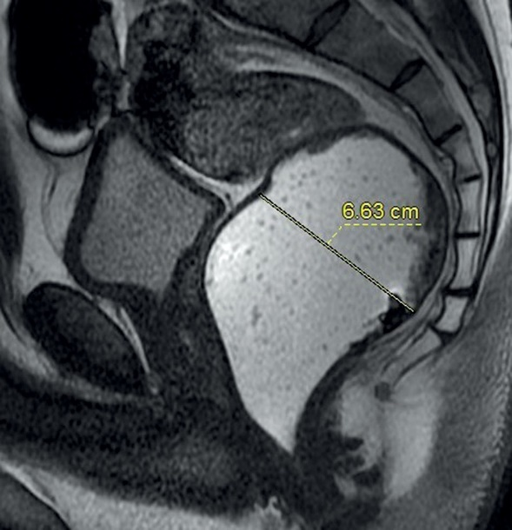
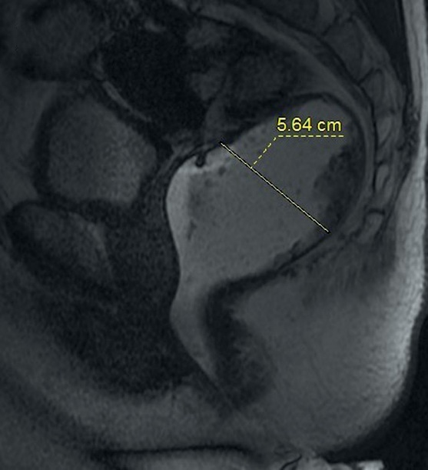
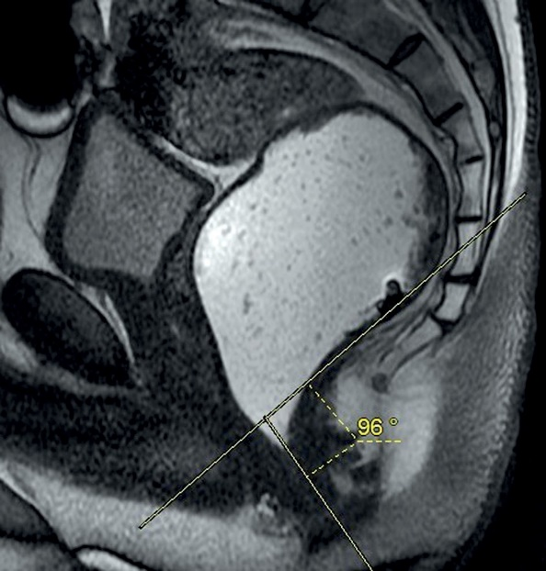
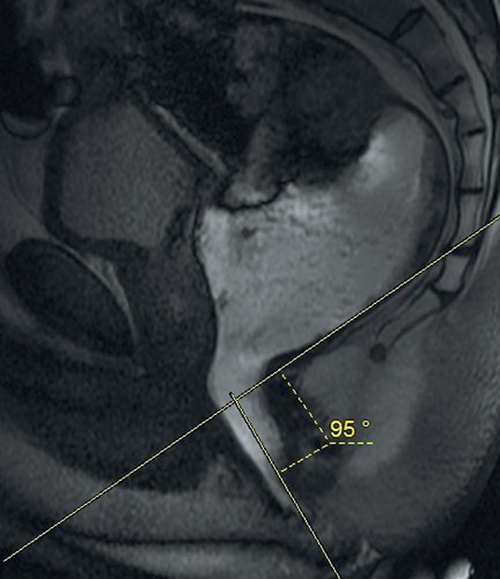
Magnetic resonance defecography findings of dyssynergic defecation
Figure 1. Rectal emptying can be assessed by measuring the maximum diameter of the contrast-filled rectum before (A) and after (B) defecatory attempts. Here we can see that most of the ultrasound gel is retained within rectum at the end of the examination
Figure 2. There is no change in anorectal angle on sagittal cine images at rest (A) and during defecation (B). This is a significant finding in the diagnosis of dyssynergic defecation
In healthy individuals the anorectal angle (the angle
between the midline of the anal canal and the line par- allel to the posterior rectal wall) increases by more than 20° during evacuation because of the relaxation of the puborectalis muscle. In DD, the puborectalis muscle is not relaxed during defecation, so a smaller increase or even a decrease in the anorectal angle can be seen on MR defecography (Figure 2A, B). Moreover, paradoxical con- traction of the muscle may cause a prominent puborectal impression on dynamic images [15]. Due to the impres- sion of the puborectalis muscle on the anorectal junction, a persistent narrowing, so-called “sandglass-like”, appear- ance has been described in the literature [16] (Figure 3).
Although there is no consensus about the usefulness of measuring the anal canal diameter, a diameter of less than 15 mm during defecation may indicate incomplete relaxation of the anal sphincter [17] (Figure 4). It has been reported that defecography can detect anismus more spe-
cifically when the straining sphincteral pressure exceeds
50% of the resting pressure [1].
Besides the findings of DD, due to excessive straining dur- ing defecation, pelvic floor descent can also be seen on MR defecography (Figure 5). According to the “rule of 3”, the cau- dal descent of bladder base, fornix of vagina, and anorectal junction with respect to the pubococcygeal line is classified as mild (< 3 cm), moderate (3-6 cm), and severe (> 6 cm) [4]. Another accompanying finding may be anterior recto- cele, which is defined as abnormal bulging of the anterior rectal wall (Figure 4). Small rectoceles (< 2 cm) are not clin- ically significant, but moderate (2-4 cm) or severe (> 4 cm) rectoceles with contrast material retention after evacua-
tion may cause a sense of incomplete evacuation [12].
Rectal intussusception may co-exist with DD, but it may not be demonstrated in patients with impaired evac- uation because intussusception occurs when the rectum collapses [11].
© Pol J Radiol 2022; 87: e181-e185
e183

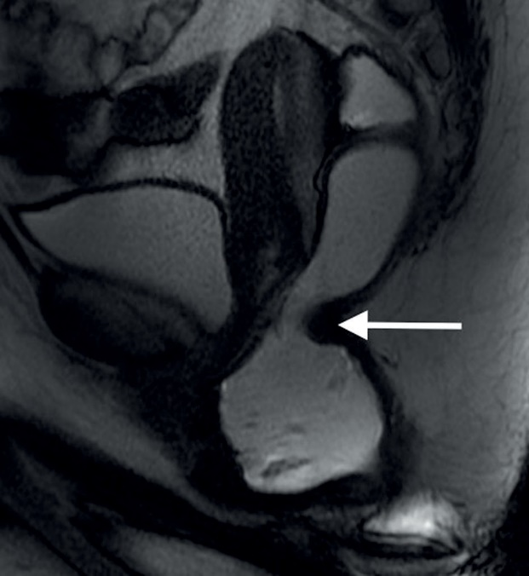
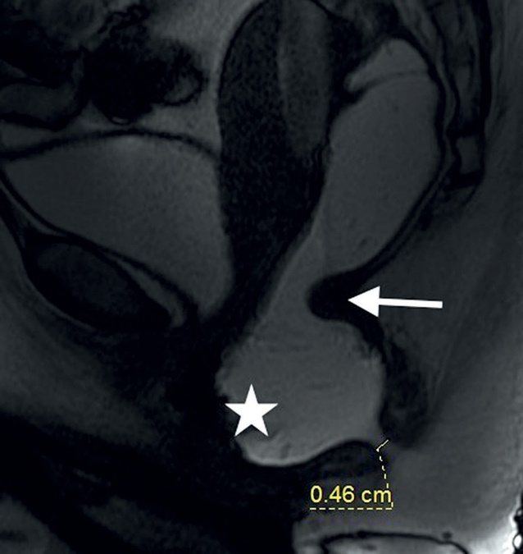
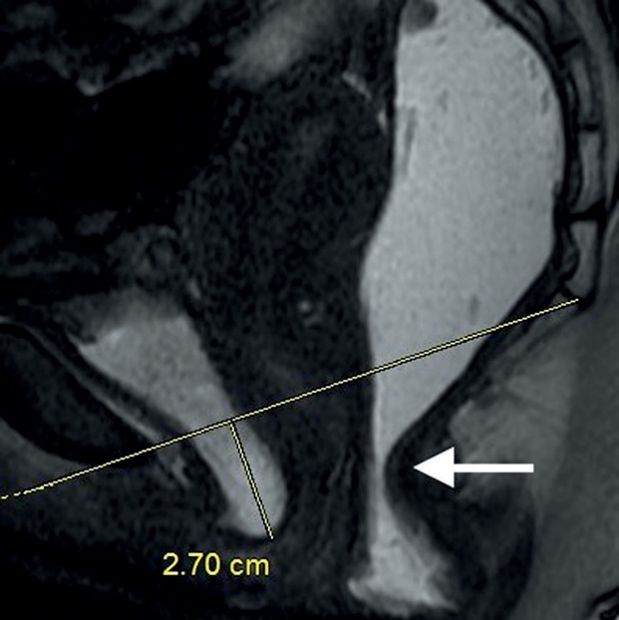
Nuray Haliloglu, Ayse Erden
Figure 3. The impression of the puborectalis muscle on the anorectal junc- tion during defecation causes a persistent narrowing (arrow). “Sandglass- like”appearance
Figure 4. On a sagittal cine image the impression of the puborectalis muscle on the anorectal junction (arrow), rectocele (asterisk), and minimal opening of the anal canal can be seen
Figure 5. Mild cystocele (< 3 cm) and“sandglass-like” appearance (arrow) are demonstrated during defecation
patient co-operation is insufficient or if MR defecography
findings are irrelevant.
Conclusions
MR defecography provides useful information about
the morphological and functional integrity of the defeca- tion process. There are key points for the diagnosis of DD, but optimal imaging criteria should be applied in order to make the diagnosis. Anal manometry can be suggested if
Conflicts of interest
The authors report no conflict of interest.
References
1. Pisano U, Irvine L, Szczachor J, et al. Anismus, physiology, radiology:
is it time for some pragmatism? A comparative study of radiologi- cal and anorectal physiology findings in patients with anismus. Ann Coloproctol 2016; 32: 170-174.
2. Black CJ, Ford AC. Chronic idiopathic constipation in adults: epide-
miology, pathophysiology, diagnosis and clinical management. Med J Aust 2018; 209: 86-91.
e184
© Pol J Radiol 2022; 87: e181-e185

Magnetic resonance defecography findings of dyssynergic defecation
- Kanmaniraja D, Arif-Tiwari H, Palmer SL, et al. MR defecography
review. Abdom Radiol (NY) 2021; 46: 1334-1350.
- Lalwani N, El Sayed RF, Kamath A, Lewis S, Arif H, Chernyak V. Imaging and clinical assessment of functional defecatory disorders with emphasis on defecography. Abdom Radiol (NY) 2021; 46: 1323-1333.
- Bharucha AE, Wald A, Enck P, Rao S. Functional anorectal disorders. Gastroenterology 2006; 130: 1510-1518.
- Chamié LP, Ribeiro DMFR, Caiado AHM, Warmbrand G, Serafini PC. Translabial US and dynamic MR imaging of the pelvic floor: normal anatomy and dysfunction. Radiographics 2018; 38: 287-308.
- Murad-Regadas SM, Regadas FSP, Rodrigues LV, et al. A novel proce- dure to assess anismus using three-dimensional dynamic anal ultra- sonography. Colorectal Dis 2007; 9: 159-165.
- Murad-Regadas SM, Regadas FSP, Barreto RGL, Rodrigues LV, Fernandes GOS, Lima DMR. Is dynamic two-dimensional anal ultra- sonography useful in the assessment of anismus? A comparison with manometry. Arq Gastroenterol 2010; 47: 368-372.
- Poncelet E, Rock A, Quintonc JF, et al. Dynamic MR defecography of the posterior compartment: comparison with conventional X-ray
defecography. Diagn Interv Imaging 2017; 98: 327-332.
- Maglinte DDT, Bartram CI, Hale DA, et al. Functional imaging of
the pelvic floor. Radiology 2011; 258: 23-39.
- Ganeshan A, Anderson EM, Upponi S, et al. Imaging of obstructed defecation. Clin Radiol 2008; 63: 18-26.
- Salvador JC, Coutinho MP, Venâncio JM, Viamonte B. Dynamic magnetic resonance imaging of the female pelvic floor – a pictorial review. Insights Imaging 2019; 10: 4.
- Piloni V, Tosi P, Vernelli M. MR-defecography in obstructed defe- cation syndrome (ODS): technique, diagnostic criteria and grading. Tech Coloproctol 2013; 17: 501-510.
- Khatri G, Leon AD, Lockhart ME. MR imaging of the pelvic floor. Magn Reson Imaging Clin N Am 2017; 25: 457-480.
- Brandão AC, Ianez P. MR imaging of the pelvic floor defecography. Magn Reson Imaging Clin N Am 2013; 21: 427-445.
- Piloni V, Bergamasco M, Melara G, Garavello P. The clinical value of magnetic resonance defecography in males with obstructed defeca- tion syndrome. Tech Coloproctol 2018; 22: 179-190.
- Lee TH, Lee JS, Hong SJ, et al. Rectal hyposensitivity and functional anorectal outlet obstruction are common entities in patients with functional constipation but are not significantly associated. Korean
J Intern Med 2013; 28: 54-61.
© Pol J Radiol 2022; 87: e181-e185
e185

