Andrzej Szczerski
Jagiellonian University, Kraków

Stanisław Witkiewicz and the Zakopane Style

In February 1886 Stanisław Witkiewicz, a painter, draughtsman and art critic from Warsaw, came to Zakopane for the first time, a village in the region called “Podhale” at the foot of the Tatra Mountains, in southern Poland. The immediate pretext for Witkiewiczs visit was to improve his bad health, as he had been suffering from tuberculosis for several years. The choice of the destination was not accidental. In the 1860s Zakopane became a well known spa and a meeting place of Polish elites from the non-existing country, divided between three partitioning powers: Russia, Prussia and Austria. But above all, his several-week-long stay allowed Witkiewicz to acquaint himself with the architecture and folk art of the Podhale region. This new knowledge was soon to be used in an original theory of a new, Polish national style he developed.
Stanisław Witkiewicz was born in 1851 to a Polish gentry family, who lived in Lithuania, then a part of the Russian Empire. 1 In 1864, as a result of their active support for the January Insurrection (1863), fomented by Poles against Russia, Witkiewiczs estate was confiscated and the family was forced to leave their homeland and move to Siberia. In 1868, after the declaration of amnesty, Witkiewicz decided to take up studies at the Academy of Fine Arts in Sankt Petersburg, probably as an unenrolled student, and stayed in the city for a year. He continued his artistic training in Munich (1871 — 1873), to where many young Polish artists came to study, especially in the second half of the nineteenth century. In 1873 Witkiewicz returned to Warsaw and joined a group of artists, such as Józef Chełmoński and Antoni Piotrowski, who supported emerging Naturalism in painting. The artists shared not only their artistic credo but also interest in national and social questions. Apart from his artistic career, Witkiewicz became also an influential art critic, who promoted Naturalism and Impressionism, calling for the closer engagement between art and life. In 1884 the artist married Maria Pietrzkiewicz and their relationship turned out to be the foundation of Witkiewiczs future activities, also because it was his wife who earned the living for the whole family in Zakopane. The artist used to say: “Prophets aren’t paid, and I am the prophet of the Zakopane Style. ” All his efforts aimed at propagating the Zakopane Style were entirely unpaid.
The period of his most intense engagement with the Zakopane Style started in 1890. In that year because of Witkiewiczs rapidly deteriorating health, a decision was taken that the artist and his family should move to Zakopane. Witkiewicz not only highly valued the importance of the folk art of the Podhale region but also underscored the
' For biographical information on Witkiewicz, see: Olszaniecka (1996: 27-41); see also Moździerz (1997).

80 ♦ Andrzej Szczerski
possibility of applying the forms of Highlander architecture in the development of national, Polish architecture. He said, among other things, that: “the Highlander hut is a more elevated type of timber architecture; it is independent and original in style, [... ] and some of its internal parts represent a highly developed and finished form which may satisfy even the most sophisticated artistic tastes. ”2
The emphasis on the national character of regional culture was the principal idea underlying the foundation of the Zakopane Style. Witkiewiczs crucial objective was to create a Polish national style which would be able to resist foreign influences and bring about the renewal of art in Poland. This Polish style was to be based on original models which, according to Witkiewicz, had survived in the art of Highlanders of Podhale. This very region, thanks to the natural boundaries which prevented an easy access to it, was an enclave cut off from the world and hence free from foreign influences. Witkiewiczs admiration for Highlanders’ culture made him think that over centuries it had preserved the primeval forms of architecture and ornamentation which in the past was widespread in all of Poland. For this reason the types of construction used in Highlander architecture, if appropriately adapted to modern needs, could become a model for architecture around the country. In this way, the distinct character of the Polish nation would be emphasised and the deplorable practice of repeating foreign patterns could be abandoned. Equally important was the social aspect of the theory. Witkiewicz believed that the idea of the rebirth of national Polish art, based on folk art, would eventually lead to national solidarity and remove social inequalities. He wrote that: “Over the heads of wealthy people as well as of poor folk there rises a roof of the same style; a church, a drawing room and the room of a poor Highlander’s hut shine with the brilliance of the same beauty. The ‘lower classes’ have thus provided the civilised elements embracing all social classes. ” Thirdly and lastly, Witkiewicz supported the idea of removing the division between “inferior” and “superior” arts, design and fine arts respectively. Indeed, the Zakopane Style manifested itself mostly in architecture, interior design and artistic handicrafts. Additionally, the reference to authentic folk art of Highlanders was of purely artistic importance and was aimed at renewing art dominated then by historicism.
Although Witkiewicz emphasised the originality of his creation, numerous other theories comparable to the Zakopane Style existed at that time both in Poland and elsewhere in Europe. Firstly, the Zakopane Style was a part of a pan-European current of the search for national styles, which culminated around 1900. 3 The idea of national expression was of particular importance for nations deprived of their independent statehood and incorporated into multinational empires, such as Austria-Hungary and Russia. Artistic expression was the means of creating national community and of manifesting its distinct identity. The characteristic feature of the movement, as in the case of the Podhale region, was also the “discovery” of the intact areas where the pristine folk art flourished. The common source of inspiration for the search of the national style based on primitive folk art were the writings of British theorists and artists associated
2 Quoted after: Witkiewicz (1970: 43).
’ See: Gryglewicz (1992: passim).

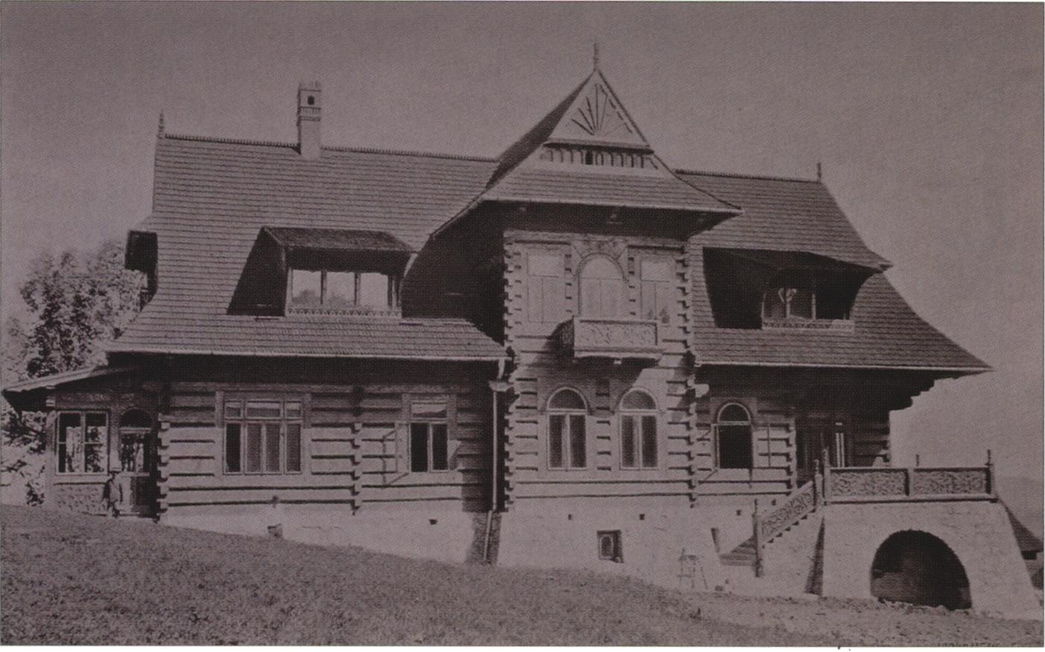
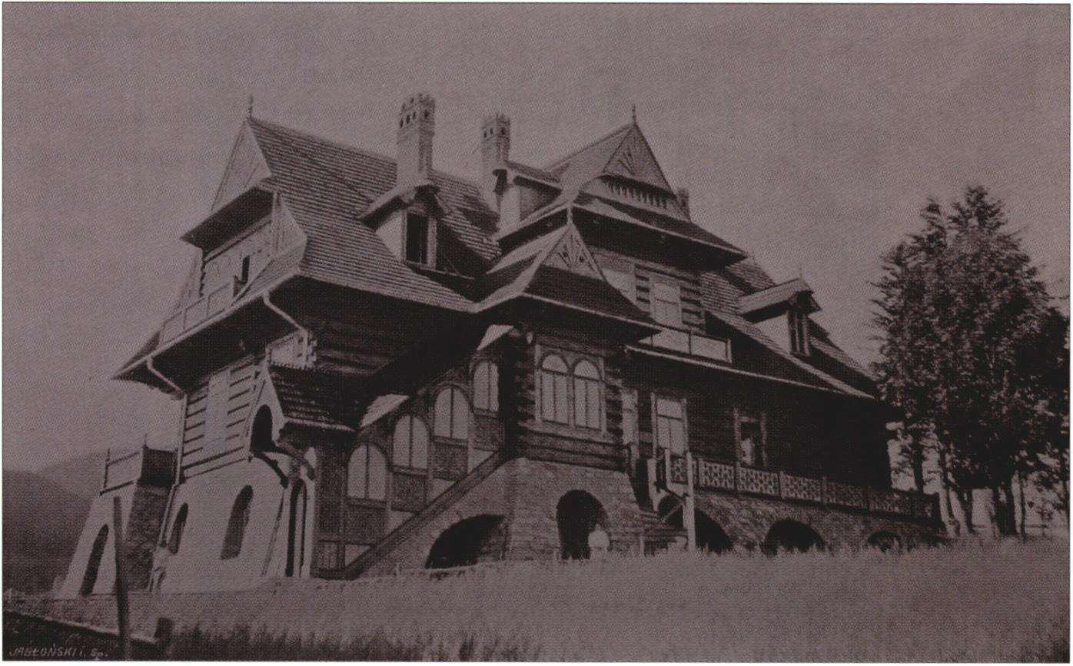
1. Stanisław Witkiewicz, House under the Firs, Zakopane, 1897

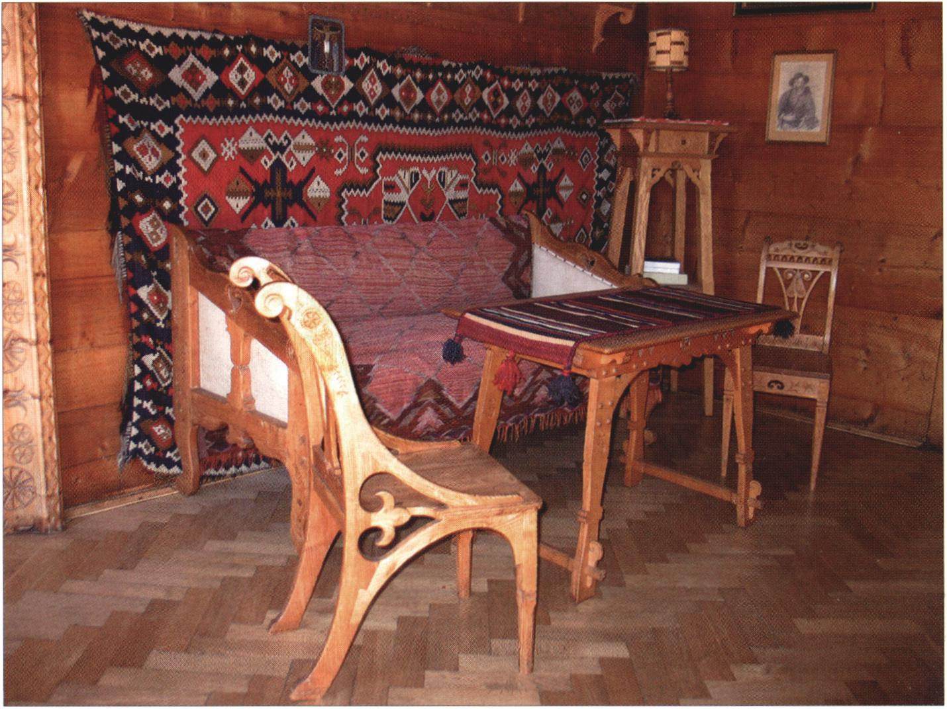
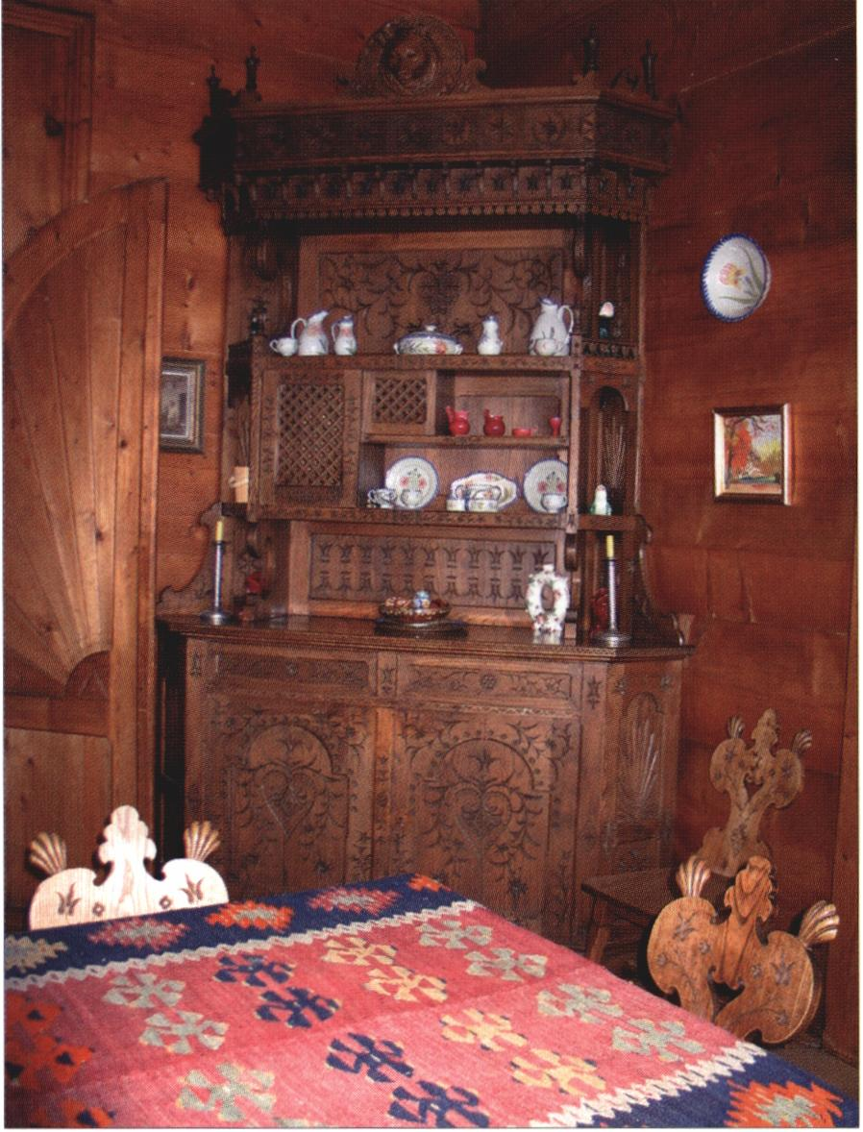
2. Stanisław Witkiewicz, House under the Firs, Zakopane, 1897, interior of the drawing room
3. Stanisław Witkiewicz, House under the Firs, Zakopane, 1897, interior of the kitchen

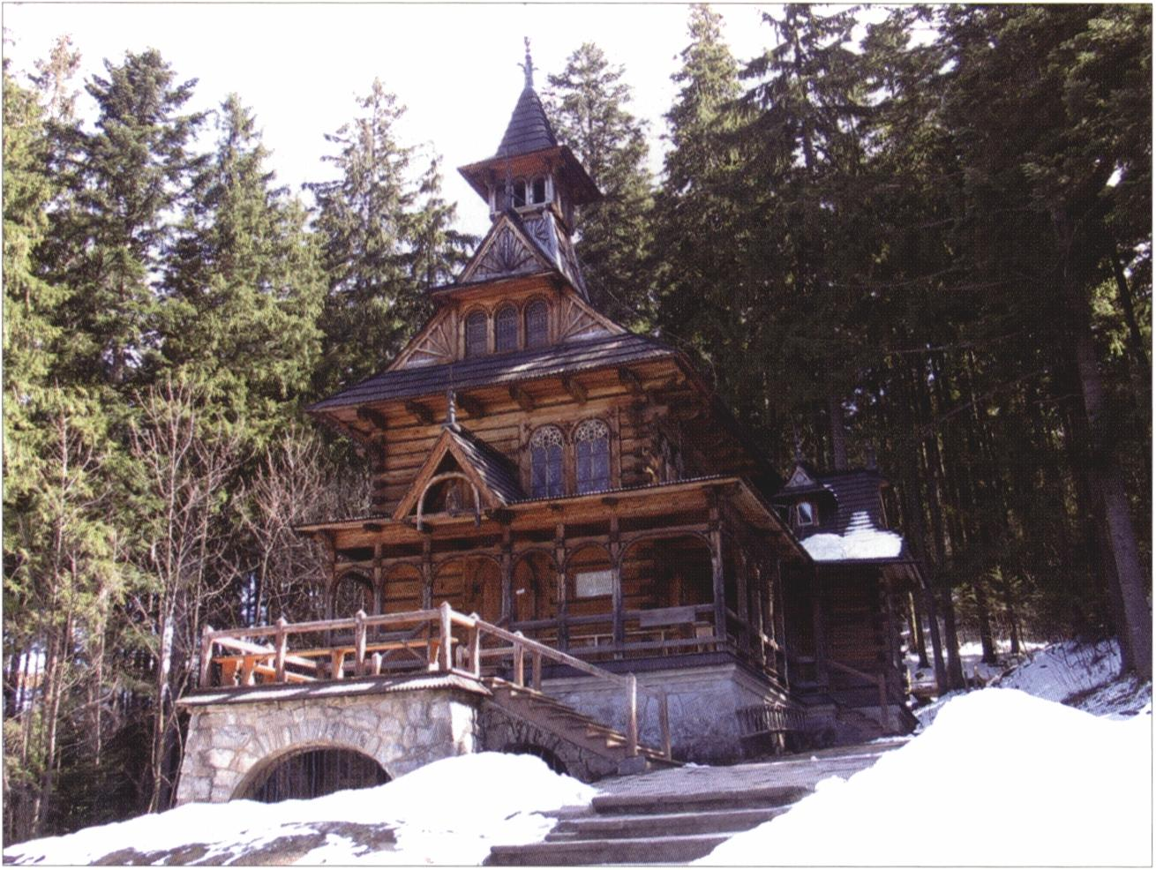
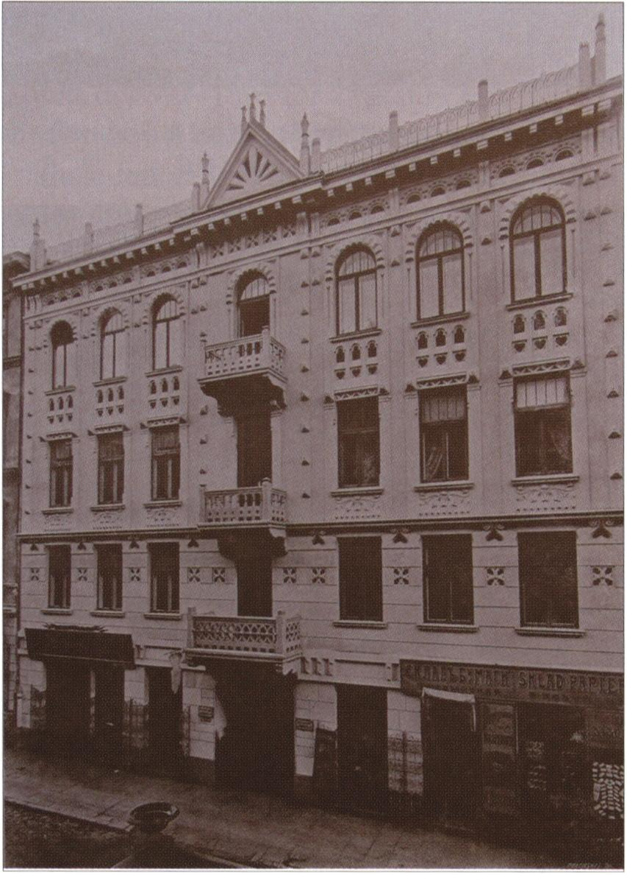
- Stanisław Witkiewicz, Chapel of the Most Sacred Heart of Jesus,
Zakopane-Jaszczurówka 1904-1906
- Jarosław Wojciechowski, tenement house in Zakopane Style, Warsaw, Chmielna street,
1905-1906

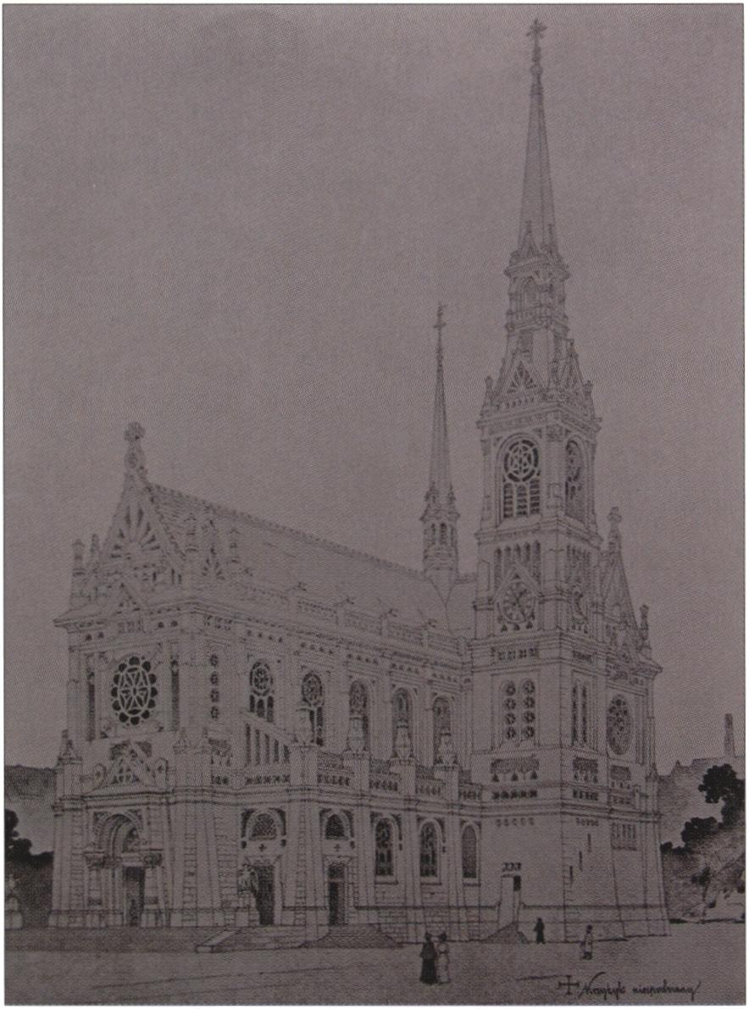
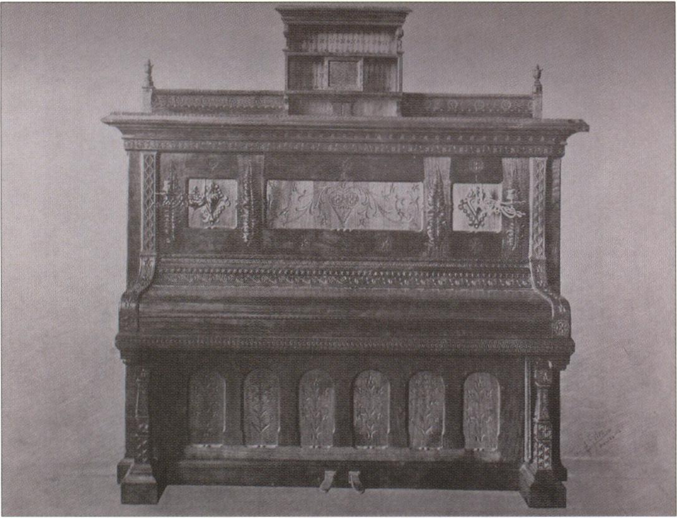
- Jarosław Wojciechowski, competition design for St Elisabeth church in Lwow
in Zakopane Style, 1903
- J. Kerntopf and Son, Warsaw, piano in Zakopane Style, 1907
All photos from the authors archive

Stanislaw Witkiewicz and the Zakopane Style # 81
with The Arts and Crafts Movement. In Poland the ideas of renewal of art through folk artistic crafts were not Witkiewicz’s exclusive domain, either. The idea recurred in Warsaw social and literary circles in the 1880s, and still earlier, in 1851, it appeared in Promethidion, a verse dialogue on aesthetics by Polish poet Cyprian Kamil Norwid. In his work, very popular at the end of the century, Norwid presented his ideas on developing national art and broadening of the concept of art by including applied arts into it. He also pointed to the folk crafts as a life-giving source of art. Around 1900 the interest in folk art was very common among the exponents of Polish Modernism and in Zakopane, before the arrival of Witkiewicz, the regional Tatra Museum actively researched folk art of Podhale.
Witkiewicz made extensive use of all those experiences and inspirations, yet, his theory of the Zakopane Style was undoubtedly not based on any immediate models; he was the only one who had put forward an idea of a national style that originated in folk art. The idea was exceptional also when compared with other conceptions of a Polish national style, which were usually based on the revival of historic styles.'1 The idea of the Zakopane Style quickly turned to be attractive enough for the Witkiewicz’s vision to be put into practice, not only in Zakopane but also in other areas of the partitioned country. Witkiewicz, using private financial means of the Polish elites residing in Zakopane, managed to construct a few buildings which epitomized his dream of Polish national style.
The Koliba Villa, built in 1892-1893 for Zygmunt Gnatowski, a Polish landowner from Ukraine, was the first house built in the Zakopane Style.4 5 Gnatowski himself was a great admirer of Podhale folk culture and founding member of the Tatra Museum Association, so not surprisingly he decided to support Witkiewicz endeavours. Koliba was to demonstrate that the adaptation of the forms and construction system of Highlander timber architecture to the function of high-standard residential architecture was possible. It was intended to resolve “any doubts concerning the possibility of reconciling folk architecture with the requirements of more complex and more refined needs for comfort and beauty.”6 In order to achieve those goals Witkiewicz combined into one whole two distinct parts: a fragment of a Highlander peasant hut with a one-storey villa reminiscent of typical health resort architecture. The Zakopane-Style character of the whole was achieved mostly through the use of stylized ornamentation, modelled on typical Highlander patterns. Witkiewicz’s inventiveness while transforming the indigenous Highlander motifs and changing their original functions was imposing: e.g. the skylights illuminating the room in the attic were inspired by a hinged trap-door in the roof of peasants’ barns which was lifted to put hay inside. In the interior of the villa many elements repeated or alluded to their Highlander models, e.g. spoon-holders turned curtain rods or sleigh serving as model for chairs.
But the most accomplished of Witkiewicz’s architectural creations in the Zakopane Style was a villa called “Under the Firs,” built in 1896-1897 for Jan Gwalbert Paw-
4 Omilanowska (1993: 99-116).
5 Jabłońska, Moździerz (1994).
6 Witkiewicz (1970: 399).

82 # Andrzej Szczerski
likowski, also a member of the local patriotic elite. The villa was planned as a monumental piece of architecture, a momentous testimony to the potential of the Zakopane Style. Its architecture, though it tries to faithfully repeat a Highlander hut, is in fact a picturesque mass, a work more of a painter than of an architect. The constituent features of this impressive creation include a massive stone plinth, in places four metres high, an extremely skilful construction of roofs over veranda, as well as cascades of gables filled with ornaments. Witkiewicz thus described the villa: “It is the building which is so far the most developed, the richest in form and the fullest in its application of the elements of the Zakopane Style.”7
Witkiewicz did not restrict his projects to residential buildings only. The chapel at Jaszczurówka near Zakopane, built in 1904-1906 for the Uznański family, is an example of the Zakopane Style applied to church architecture. Here Witkiewicz once again used the forms and proportions of Highlanders timber-built hut, but changed it into a single-aisled chapel with slightly narrower chancel and a sacristy. The church furnishings included an altarpiece composed almost exclusively of ornaments patterned after those used by Highlanders, as well as two stained-glass windows depicting two images of Our Lady from Częstochowa and Vilna, most venerated in Polish Catholicism. In this way the artist wanted to underscore the patriotic elements contained in the ideology of the Zakopane Style. Interior decoration of the parish church of the Holy Family in Zakopane is another important example of the Zakopane Style application to furnishing and decoration of a sacred space. Apart from the altar of Our Lady of the Rosary (1896) Witkiewicz furnished in full the chapel of St John the Baptist (mural paintings and furnishings; 1900). Since in the altar painting Witkiewicz portrayed himself as the chapel’s patron saint, set against a background featuring the Tatra Mountains, it looks that the artists self-identification with his work was total.
Soon appeared attempts at recreating the Zakopane Style in masonry - a condition sine qua non of the style’s dissemination throughout the land and its adaptation to manifold utilitarian purposes. The best known examples of such attempts are: a tenement house in Chmielna Street in Warsaw, designed by Jarosław Wojciechowski in 1905 - a typical example of nineteenth-century tenement house which was adorned with “Tatra Mountains” decorative applications, e.g. the sun ornament and pegging. Another example is the Tatra Museum building in Zakopane, designed by Witkiewicz, but completed after his death. The building was designed in cooperation with Franciszek Mączyński and fairly faithfully repeated the external appearance of Witkiewicz wooden villas. Yet, the architects did not intend to imitate in masonry the wooden walls of villas, which gave the museum building a more functional look. Other worth mentioning masonry buildings in the Zakopane Style, designed by Witkiewicz outside of the Podhale region, are: a manor house in Przyborów near Dębica (1892) and a manor house in Łańcuchów, built for Jan Stecki (designed in 1901, constructed in 1903-1904).
Around 1900 the Zakopane Style was at the height of popularity and in 1900 the first scholarly monograph by Stanisław EIjasz Radzikowski Styl zakopiański (The Za-
' Ibid.: 418-421.

Stanislaw Witkiewicz and the Zakopane Style
83
kopane Style) was published. Nevertheless, already at that time certain contradictions present in Witkiewicz’s concept were noticeable: above all, it was impossible to use the Podhale-style architecture in the Polish lowlands, where the climate was different, and second, the recreation of timber construction in other materials posed considerable difficulties. Yet, the Zakopane Style had many enthusiasts. Witkiewicz himself set example: apart from building the above-mentioned houses, one of his famed undertakings was to send a group of Highlander builders and carpenters to Lithuania, to build a narrow-gauge railway station in the Zakopane Style in family estate of his sister at Sylgudyszki (1899). Franciszek Mączyński, one of the most talented architects of the young generation, developed even a project of a whole city in the Zakopane Style (1899-1901).8
But above all, it was in the areas of interior design and artistic handicrafts that the Zakopane Style was most successful and long lasting. Podhale-region patterns were very quickly adopted by many craftsmens workshops. Telling examples of the above statement may be the interior design of the villas built by Witkiewicz, including the manor house of Polish Nobel Prize winner in literature Henryk Sienkiewicz in Oblęgorek (1901). Some Zakopane-Style decorative elements appeared also sporadically in buildings constructed around 1900 in major Polish cities such as Krakow and Lwow. The Zakopane Style was developed also by many other architects active in Zakopane well into 1920s and 1930s, e.g. by Zygmunt Dobrowolski, Eugeniusz Wesołowski or Witkiewicz’s nephew, Jan Koszczyc Witkiewicz. Worth mentioning is the fact that Witkiewicz managed to train a few Highlander builders, such as Wojciech Roj and Wojciech Brzega, who were able to build houses in the Zakopane Style on their own.
There is no doubt that Witkiewicz was as much fascinated by the craftsmanship of the Highlanders as by the people themselves. It was among people that he found the very virtues that were to help him to rejuvenate art, and it is not a coincidence that he hired Highlanders to build his villas. Thus he wrote about the builders of his Koliba Villa: “There were also workers at hand, eager to carry out this work: the Highlanders. They may not have been the creators of these forms, yet it was them who have preserved and perfected them over centuries, and thanks to this peoples exceptional abilities they were able to follow the new requirements and respond quickly and effectively to them.”9
Although the Zakopane Style claimed to have broken with the nineteenth-century tradition of historicism and eclecticism, it was still strongly connected to it. The designs of Witkiewicz, though they were inspired by the local construction system, are in fact another attempt at stylization, based on eclectic arrangement of regional, indigenous, and cosmopolitan elements. Therefore the works executed in this “Polish national style” are often reminiscent of vernacular architecture from other regions of Europe. On the other hand, the unfaltering efforts of Witkiewicz who had been propagating the Zakopane Style until his death in 1915 brought tangible effects in the local colour of the architecture of Zakopane and the importance of the vernacular inspira-
“ Szczerski (2004: 208-212).
9 Witkiewicz (1970: 399).

84 < Andrzej Szczerski
tions in Polish architecture between the wars.10 In his book O sztuce stosowanej (On Applied Art) of 1904 Jerzy Warchałowski, designer and supporter of the national style idea wrote about Witkiewicz: “There he wants to create the best possible conditions for the development of Polish art applied to industry and construction, for autonomous art, free from imitation, from fleeting sways of worlds fashions; an own art, compliant with the nations soul, living and circulating at home and outside, everyday and on holiday. That is not only an artistic, but also an economic and national ideal.”11

BIBLIOGRAPHY
Aneks 1996 = “Aneks. O twórczości Stanisława Witkiewicza,” in: Stanisław Witkiewicz (1851- 1915), exhibition catalogue, Muzeum Tatrzańskie im. dra Tytusa Chałubińskiego, Zakopane, 1996
Gryglewicz 1992 = Gryglewicz, T: Malarstwo Europy Środkowej 1900-1914, Kraków, 1992 Jabłońska, Moździerz 1994 = Jabłońska, T. & Moździerz, Z.: “Koliba", pierwszy dom w stylu zakopiańskim, Zakopane, 1994
Między Giewontem 1997 = Między Giewontem a Parnasem, exhibition catalogue, National Museum, Kraków, 1997
Moździerz 1997 = Moździerz, Z. (ed.): Stanisław Witkiewicz - człowiek, artysta myśliciel, Zakopane, 1997
Olszaniecka 1996 = Olszaniecka, M.: “Kalendarium życia i twórczości,” in: Stanisław Witkiewicz (1851-1915), exhibition catalogue, Muzeum Tatrzańskie im. dra Tytusa Chałubińskiego, Zakopane, 1996
Omilanowska 1993 = Omilanowska, M.: “Searching for a National Style in Polish Architecture at the End of the 19th and Beginning of the 2O'h Century,” in: Gordon Bowe, N. (ed.): Art and the National Dream. The Search for Vernacular Expression in Turn-of-the-Century Design, Dublin, 1993
Szczerski 2004 = Szczerski, A.: “The Arts and Crafts in Poland: in Search of a National Utopia,” Centropa, vol. 4, nr 3 (September 2004), pp. 203-217
Witkiewicz 1970 = Witkiewicz, S.: Pisma zebrane, vol. 3: W kręgu Tatr, Hennel, R. (ed.), Kraków, 1970
10 On subsequent inspirations by the art of the Podhale region, see: Między Giewontem (1997: passim).
" Quoted after: Aneks (1996).

