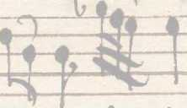
CRATO BUTNER
Laudate pueri
Psalm 112
Ed. by Justyna Szombara
The edition was prepared in the frame of the research project: Z badań nad recepcją włoskiej «musica moderna» w Europie Północnej: koncert kościelny w twórczości kompozytorów gdańskich [On the reception of Italian musica moderna in Northern Europe: the sacred concertos of Gdańsk composers] financed by the Polish National Science Center (Decision no. DEC-2012/05/N/HS2/02836) and realized in the years 2013-2016 in the Institute of Musicology of the Jagiellonian University.
Project leader: Justyna Szombara (justyna.szombara@gmail.com)
1
Hardly anything is known about the early youth and musical education of Crato Bütner (1616— 1679), organist, composer, and cantor of St Catherine’s Church in Gdańsk. Even information on his place of birth is contradictory. The inscription on his grave in St. Catherine’s does not really clarify matters. It informs readers that the composer hailed from Sonneberg in Thuringia (Sonnenberga Thuringus).1 Conversely, in Geistliche Concerte, a print from 1651, Bütner states that he was born in Gotha (Crato Bütnern von Gotha aus Thür: Musico und Organist zu S. Salvator in Dantzig).2 The aforementioned print is also the earliest document confirming that the musician was active in Gdańsk. It proves that in 1651, Bütner was employed as the organist at the Church of the Holy Saviour on the outskirts of the city.3 He held the post until 1656, that is, until the church was demolished.4 In 1660, after the end of the Second Northern War, Bütner was entrusted with the post of cantor and musical director (directore chori musici and directore musico) at St Catherine’s, which he held until his death.5 At the time, the ensemble of St Catherine’s performed at a very high level and could easily compete with the city’s foremost ensemble, St Mary’s ensemble.6 The cantor’s duties included teaching music at the parish school, managing the ensemble, and providing the repertoire. Bütner’s achievement in the last area was particularly notable. His composing and copying activity helped to popularise and reinforce the style of the Italian musica moderna in the local repertoire. Bütner copied the works of Polish and Italian artists connected to the Royal Court in Warsaw (Marcin Mielczewski, Bartłomiej Pękiel, Marco Scacchi, Tarquinio Merula), other Italian artists (Giovanni Rovetta, Gasparo Casati), and German composers of the musica moderna style (Heinrich Schütz, Philip Friedrich Buchner). This choice of repertoire clearly reveals Bütner’s stylistic preferences on the one hand, while on the other it attests to his contacts with members of the Warsaw Royal Ensemble. Unfortunately, the sources — including the autographs of more than 50 compositions by Bütner himself that used to belong to the library of St Catherine’s Church kept at the City Library of Gdańsk (Danziger Stadtbibliothek) before the Second World War — are currently considered lost.7
1 We know the text of the inscription from Johann Gottfried Walther, Musicalisches Lexicon, Wolfgang Deer, Leipzig 1732, p. 121, and from Danuta Szlagowska, “Twórczość Crato Bütnera, kompozytora działającego w Gdańsku w drugiej połowie XVII wieku” [The Output of Crato Bütner, a Composer Active in Gdańsk in the Later Part of the 17th Century], [in:] Muzyka w Gdańsku wczoraj
- dziś [Music in Gdańsk Yesterday and Today] I, “Kultura Muzyczna Północnych Ziem Polski” 3, Akademia Muzyczna im. Stanisława Moniuszki, Gdańsk 1988, p. 162, as well as from other sources.
2 Bütner dedicated Geistliche Concerte to Georg Neumark, “his reputable patron, dear friend and countryman, when after 10 years he bethought himself of his homeland, Mühlhausen in Thuringia, and left Gdańsk, as an expression of particular respect and as a token of honest and eternal friendship” (“seinem geehrten Gönner, liebwerthem Freunde und Landesmanne als derselbe nach verfliessung zehn Jahr endlich einmal wieder in sein Vaterland nach Mühlhausen in Thüringen gedachte, und von Dantzig abreisete zu sonderlichen Ehren, und Andencken einer aufrichtigen und beständigen Freundschaft”), see Crato Bütner, Geistliche Concerte mit zwei Tenoren, zwey Violinen, einer Violdegamm oder Dulcian und einem Generalbaß, Michael Pfeiffer, Hamburg 1651. Georg Neumark (1621—1681), German composer, poet, and author of religious songs, was born in Langensalza, c. 20 km north of Gotha. In 1636 he entered the college in Gotha, in 1640 he began to study law at Königsberg. Having graduated, he left for Gdańsk, and in 1649—1650 lived in Toruń, returning to Thuringia in 1651, where he assumed the post of a chancellery registrar (Kanzleiregistrator) and librarian in the court of William Prince of Saxony-Weimar. It is therefore possible that the two met before arriving in Gdańsk.
3 This information returns in successive publications of Bütner’s music: Musicalische Concerto (Philip Christian Rhete, Dantzig 1652), Musicalische Herzens-Frewde (Philip Christian Rhete, Dantzig 1653), Geistreiche Concerto (Philip Christian Rhete, Dantzig 1654), and Aria Sunamithica (Philip Christian Rhete, Dantzig 1654). It also appears on the title page of the autograph of O quanta in coelis laetitia from 1654.
4 The people of Gdańsk demolished the church in preparation for the defences against the Swedish attack; see Sławomir Kościelak, “Kościół Zbawiciela (I)” [The Church of the Holy Saviour], [in:] Gedanopedia, ed. by Błażej Śliwiński,
http: //www.gedanopedia.pl/gdansk/?tirie=KO%C5%9ACI%C3%93%C5%81 ZBAWICIELA (1) [accessed on 18 May 2016].
5 Danuta Szlagowska, Repertuar muzyc^y z siedemnastowiecznych rękopisów gdańskich [Musical Repertoire in the 17th Century Manuscripts from Gdańsk], “Kultura Muzyczna Północnych Ziem Polski” 10, Akademia Muzyczna im. Stanisława Moniuszki, Gdańsk 2005, p. 197.
6 Danuta Szlagowska, “Musik in der Katharinenkirche in Danzig”, [in:] Musica Baltica. Interregionale musikkulturelle Beziehungen im Ostseeraum, “Greifswalder Beiträge zur Musikwissenschaft” 4, ed. by Ekkehard Ochs, Nico Schüler, Lutz Winkler, Lang, Frankfurt/Main 1997, p. 182; Dominika. Biegaj, “Stile concertato we wczesnym baroku” [Stile Concertato in the Early Baroque], “Glosa. Rocznik Polskiego Stowarzyszenia Przyjaciół Muzyki Dawnej”, vol. 1/2005, p. 21.
7 The titles and the scoring of these compositions were recorded in Otto Günther’s catalogue: Katalog der Handschriften der Danziger Stadtbibliothek, Bd. IV, Die musikalischen Handschriften der Stadtbibliothek und der in ihrer Verwaltung befindlichen Kirchenbibliotheken von St. Katharinen und St. Johann in Danzig, Kommissions-Verlag der L. Saunierschen Buch- und Kunsthandlung, Danzig, 1911, pp. 48, 53, 55-61, 64.
2
The inscription on the Bütner’s abovementioned gravestone is a testimony to the extraordinary artistic activity of the Gdańsk cantor and his devotion to the matters of music.
Crato Buthnerus, of Sonneberg, a Thuringian. An excellent worshipper of the Muses, who formerly held the positions of organist, music director of the church, and cantor here, in the suburb at the Church of the Holiest Saviour. Later in the city proper, at this Church of St Catherine, he was appointed the director of the choir and cantor. He fulfilled his duties devotedly both in the church and in the school. He lived his life a bachelor, and contenting himself with the love and dowry of the Muses, he passed away. He left to this church the fame of his consummate musical expertise and illimitable diligence in music, which have remained on the lips of lovers of the Muses even after his death, as well as a number of harmonious works beyond count, for the holy ornament of the public, which he composed thanks to his mastery. Finally buried, his body rests lying here, but nonetheless in spirit he is among the choirs of Paradise, thanks to the ringing lyre of Jesse,8 as his eternal and greatest desire was to “sing of the mercies of the Lord forever”. Psalm 89. Born in 1616. Deceased in 1679.9
Less than 30 works of Bütner’s oeuvre, which encompassed at least 90 compositions, have survived to our day and age. These are primarily vocal and instrumental church concertos, also including pieces for special occasions, Missa German: O Vater Allmächtiger Gott (written for CATB, CATB (ripieno), vl, 3 vle, b.c.) and a handful of Protestant songs for solo voice and basso continuo, published in the contemporary popular anthologies of Georg Neumark10 and Johann Franck.11 Nine pieces have been preserved in independent prints published during the composer’s lifetime12. Another one is Bütner’s autograph,13 and the remaining ones are manuscript copies made for various centres of music. Most of these sources are undated, yet the majority were probably created in the last decades of the 17th century. Only two pieces have survived in copies made in 1833 by Carl Ferdinand Becker (1804-1877), a Leipzig organist, writer on music, and composer.14
Bütner’s compositions are currently held in a number of European libraries: Universitetbiblioteket Carolina Rediviva in Uppsala, in the collection of Gustav Düben, kapellmeister of the Stockholm Royal Court Orchestra15 (13 pieces); Leipziger Stadtbibliothek, in the collection of Carl Ferdinand Becker (4 pieces); the Gdańsk Library of the Polish Academy of Sciences (4 pieces); Staatsbibliothek Preußischer Kulturbesitz in Berlin (2 pieces); Sächsische Landesbibliothek — Staats- und Universitätsbibliothek
8 A reference to the psalms attributed to David, son of Jesse.
9 D.O.M.S. | Crato Buthnerus | Sonnenberga Thuringus. | Musarum Cultor eximius, Olim in suburbano hic ad sanctissimam | Salvatoris AEdem | Organo Templi musico & Cantoris | Muneri pr«fuit. | Dein intra Urbem | Ad hanc S. Catharinae AEdem Director | Chori Musici | Et Cantor constitutus, | In Templo pariter & in Schola munere suo fideliter perfunctus est. | Vitam egit crelebs Musarum amore & dote contentus moriens. | Famam Scienti« Music« pr«clar« studiique musici inexhausti | Etiam post Fata superstitem in ore Musas amantium, | Insuperque opera harmoniaca quam plurima | et numeros innumeros | In sacrum publicorum ornamentum sua solertia | compositos | Ecclesi« huic reliquit. | Denique hic conditus et compositus corpore | quidem requiescit, | Anima vero inter choros crelestes | Jess«a pr«cinente Lyra | Quod perpetuum ita supremum ejus etiam | Votum fuit: | Misericordias Domini cantabo in «ternum. | Psalm. LXXXIX. | Natus Anno M.D.C. XVI. Denatus Anno M.DC.LXXIX”
10 Poetisch- und Musikalisches Lustwäldchen, J. Naumann (Michael Pfeiffer), Hamburg 1652 and Musikalisch-Poetischer Lustwald, Georg Sengenwald, Jena 1657.
11 Johann Franckens Geistliches Sion Das ist: Neue Geistl. Lieder und Psalmen, Gruber, Guben 1674.
12 Additionally, in a single case (Hochzeitliche Parnassus Wünsche, Georg Rheten Witwe, Dantzig [1654]) only the lyrics have survived.
13 This is the autograph of O quanta in coelis laetitia for 8 voices and 5 instruments, presented to the Senate of the City of Wrocław in 1654. Until the Second World War, the manuscript was stored in the so-called Collection of Emil Bohn (a collector of early music and organiser of historical concerts; author of the catalogue in question) in the Stadtbibliothek in Wrocław, and is currently kept at the Staatsbibliothek Preußischer Kulturbesitz in Berlin (cat. No. Bohn Mus.ms. 131).
14 Becker gathered an impressive collection of old music prints and manuscripts and of theoretical treatises from the 15th to 19th centuries. Four prints besides copies of Bütner’s compositions (Wo der Herr nicht beg uns wäre and Anima Christi (cat. No. Becker III.2.194)) have been preserved in the collection of the Leipzig organist: Anima Christi, David-Fridericus Rhetius [i.e. Rhete], Dantisci 1661, Lobet den Herren, David-Fridericus Rhetius, Dantisci 1661, Wo der Herr nicht bey uns were, David-Friedrich Rhete, Dantzig 1661, and Te Deum, Typis Davidis Friderici Rhetii, Dantisci 1662.
15 Precious information on Düben’s collection can be found in a work by Maria Schildt, Gustav Düben at Work: Musical Repertory and Practice of Swedish Court Musicians, 1663—1690 (doctoral dissertation, Uppsala Universitet), Uppsala 2014.
3
Dresden (1 piece); Stadtkirche St. Nikolai, Kantoreibibliothek in Luckau (1 piece); Herzog August Bibliothek in Wolfenbüttel (1 piece), and the British Library (1 piece). Georg Neumark’s prints that contain Bütner’s Protestant songs are held by the Fondation Martin Bodmer Bibliotheca Bodmeriana in Cologny (Switzerland), the Schleswig-Holsteinische Landesbibliothek in Kiel, and the Leipziger Stadtbibliothek, Musikbibliothek16 among others, and Johann Franck’s anthology is available at the Bayerische Staatsbibliothek München and the Staatsbibliothek Preußischer Kulturbesitz in Berlin, among others.17 We know the titles and — in most cases — also the scoring of the lost compositions listed in Günther’s catalogue,18 copies of inventories,19 and Rauschning’s publication.20
The surviving musical and indirect sources support the assertion that vocal and instrumental religious works on biblical texts, mostly in German, and Protestant chorale arrangements held chief position among Bütner’s compositions.21 No sources or even mentions of instrumental music by the Gdańsk organist and cantor have survived. The scoring is fairly varied in the works available to us. They are strophic songs for solo voice with basso continuo, an aria for solo voice, and church concertos for 1-4 voices, string instruments and basso continuo, as well as compositions scored for larger ensembles, including a mass and concertos for two and three choirs (in a number of cases with ripieno choir), accompanied by instruments and basso continuo.22 The extant works and entries in Günter’s catalogue are clear proof of the composer’s predilection for the use of an extended ensembles, encompassing five or even more solo voices and a string ensemble often reinforced with wind parts and — obviously — basso continuo. For this, the cantor of St Catherine’s must have had a good ensemble of singers and instrumentalists at his disposal. It should be noted here that students of the parish school were obliged to participate in the music for church services.

COMMENTS ON THE REVISIONS
The manuscript of the Laudate pueri Dominum is kept at the Universitetbiblioteket Carolina Rediviva in Uppsala under catalogue No. Vok. mus. i hs. 5:13. It consists of 7 sheets of 210 x 170 mm. The order of the successive sheets is specified with Arabic numerals, written by hand in the top right-hand corner of the recto sheets. The title page (of Basso continuo Part) reads: “Laudate Pueri Dominum | A 3 | Canto Solo | e | doi Violini | Con Basso Continuo | di | S. Cratone Butnero | 169. The contemporary catalogue number (in red ink) is in the top left-hand corner. The pages 1-2, and 3-4 contain a watermark (deer in laurel wreath).
16 For the full list of libraries, see RISM database. Collection Fortgepflantzter Musikalisch-Poetischer Lustwald, Jena 1657, also accessible online:
https:/ /books.google.pl /books?id=pnpFAAAAcAAJ&lpg=PT302&ots=vFslDzIm33&dq=%22Georg%20Neumark%22%20Fo rtgepfla.nzt%20Musikalisch-Poetischer%20Lustwald&hl=pl&pg=PP1#v=onepage&q&f=false [accessed on 19 May 2016].
17 The collection of J. Franck is also available online: http://stimmbuecher.digitale-sammlungen.de/view?id=bsb00091840 [accessed on 19 May 2016].
18 Otto Günther, op. cit., pp. 53, 61—64.
19 See Max Seifert, “Die Chorbibliothek der St. Michaelisschule in Lüneburg”, Sammelbände der Internationalen Musikgesellschaft IX 1907/1908, p. 603; Tadeusz Maciejewski, “Inwentarz muzykaliów kapeli karmelickiej w Krakowie na Piasku z lat 1665—1684” [The inventory of musical materials of the Carmelite monastery at Kraków from the years 1665-1685], Muzyka 1976 No. 2, pp. 81, 83.
20 H. Rauschning, op. cit., p. 242. For a list of Bütner’s preserved vocal and instrumental concertos and the titles of the lost ones, see Justyna Szombara, “On the reception of Italian ‘musica moderna’ in Northern Europe: the sacred concertos in seventeenth- century Gdańsk”, [in:] Musica Baltica: music-making in Baltic Cities various kinds, places, repertoire, performers, instruments, ed. by Danuta Popinigis, Danuta Szlagowska, Jolanta Woźniak, Akademia Muzyczna im. Stanisława Moniuszki, Gdańsk 2015, pp. 272—273, 278— 285.
21 It provided a particular counterbalance to the repertoire Bütner copied, which encompassed Latin pieces by composers connected to the Warsaw royal ensemble.
22 It must, however, be noted that in the case of pieces that used to be property of the library of the Church of St John in Gdańsk (Deus in adjutorium na SSATB, SSATB (ripieno), 2vl, fag, 3trb bombarde, 2 cornettini, b.c., and vla basso, bombarde, fag — ad placitum, and Siehe es hat überwunden for SSATTB, SATB (ripieno), trb bombarde, 2 cornettini, 2 trombetti, b.c. (2 cornettini, vla, vla basso, bombarde grosso ad placitum)), the vocal ripieni parts and instrumental ad plaätum ones were added by the local cantor, Gottfried Nauwerck (d. 1692); see O. Günther, op. cit., pp. 134—135. Nauwerck also provided additional parts for the manuscripts with works by Marcin Mielczewski, Jacek Różycki, Bartłomiej Pękiel, and Tarquinio Merula.
4
* * *
The compositions were drawn in a notation similar to the contemporary one. The accidentals that are not present in the source and yet were recognised to be necessary were placed in square brackets in this edition. Sharps introduced in the source in the function of naturals are replaced here by naturals without additional comments (with the exception of the basso continuo, where the original notation was retained). Incomplete basso continuo parts were not complemented. The ties irregularly present in the vocal part (introduced to denote melisma) were omitted, yet each instance thereof in the source was recorded in the list of corrections. The comments Tutti, Viol:, and C, Can:, Cant: placed — according to the contemporary convention — in the vocal and instrumental parts to ease the performers’ task were removed from this edition, yet they are accounted for in the list of corrections. The words denoted in the print by the ij character are entered in italics in this edition. This edition has the score preceded by the music incipit portraying the clefs present in the mauscript.

LIST OF CORRECTIONS
In the detailed remarks, the first numeral indicates the number of the bar; the part is indicated after a dot; a digit after a semicolon indicates the note in the bar; the notes or other remarks following a colon are marked as such in the original source.
Abbreviations:
Bc — Basso continuo C — Canto Vl — Violini Vla - Viola
- Vl I; over 13: #
- Vl I; over 8, 10, 14: #
- Vl I; over 10: #
3. Vl II; over 12: #
5. Vl I; over 2: #
5. Vl II; before 7: # ; over 9: #
- Bc; over 1-2: Cant:
- C; over 6, 11: # ; before 9, 14: #
- C; over 1-2, 4-5, 6-7, 8-9: ~ ; over 4: #
- C; before 9; #
- C; over 1-2, 3-4, 8-9, 10-11: # ; before 7: #
13. Vl I; over 8: #
- Bc; over 1-2: Viol:
- Vl I; over 5: #
- Vl II; over 3: #
- Vl I; over 4: #
- Vl II; over 4: #
16. Bc; under 3: C.
- C; under 9: # ; before 12: #
- C; over 7, 10: # ; before 13: #
- Bc; under 3: Viol:
- Vl I; over 4: #
5
24. Vl I; over 7: #
- Vl II; over 2, 3, 5: #
- Bc; under 2: C.
- C; before 6: # ; under 11: #
- C; before 9, 13: #
- C; before 5, 9, 11: #
- Vl I; over 10: #
32. Bc; under 1: Viol:
- Vl I; over 3, 5: #
- Bc; under 1: C.
38. C; before 7: #
41. C; under 6: #
44. Bc: under 1-2: Viol:
47. C; before 5: #
47. Bc; under 1: C.
- Bc; under 2: Viol:
- Vla; under 5: #
- Bc; under 1: C.
- C; over 10-11: ~
57. C; over 12: #
61. C; over 1-2: ~
61. Bc; under 1-2: Viol:
- Vl I; before 4: #
- Bc; under 1: C.
68. C; over 4-5: ~
70. C; over 2-3: ~ ; before 4: #
- C; under 2-3: ~
- Bc; under 2-3: Viol:
79. Bc; under 1-2: Cant:
88. Bc; under 2-4: Viol:
- Bc; under 1-2: Can:
- C; over 7: #
- C; over 8-9: ~
109. Bc; under 1: Viol:
115. Bc; under 1: Cant:
119. C; over 2-3: ~
- C; over 6-7: ~
- C; over 1-2, 3-4: ~
124. Bc; 2: black note
- Vl II; before 6: [>
- Bc; 1-2: black notes 137. Bc; under 2-3: Viol:
139. Vl I, II; under 2-3: Tutti 139. Bc; under 1-2: Tutti 142. C; under 1-2: ~
145. Vl II; before 3: #
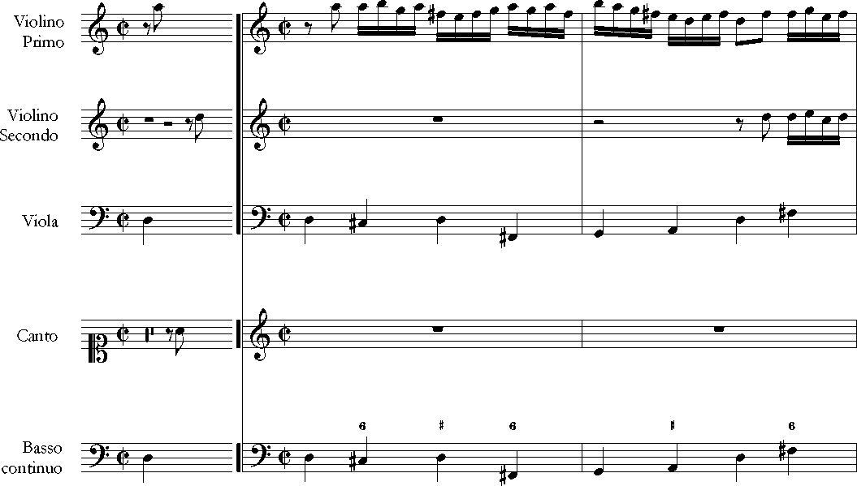
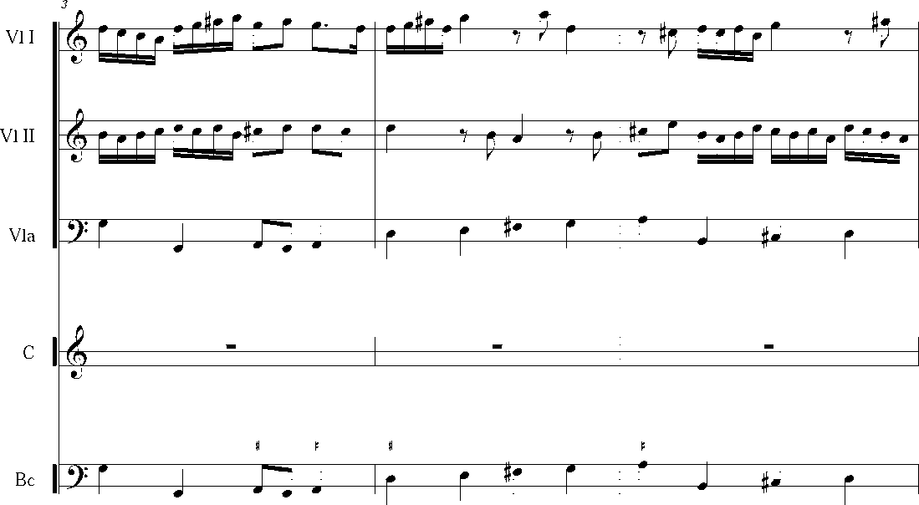
LAUDATE PUERI
Crato Bütner (1616-1679)
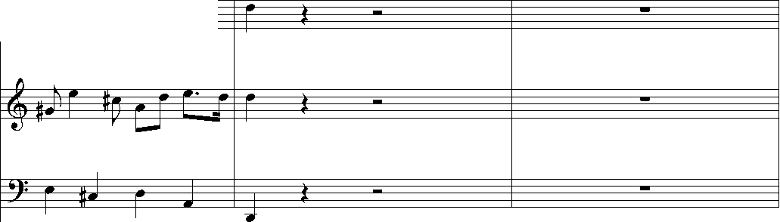
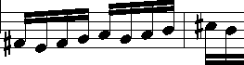
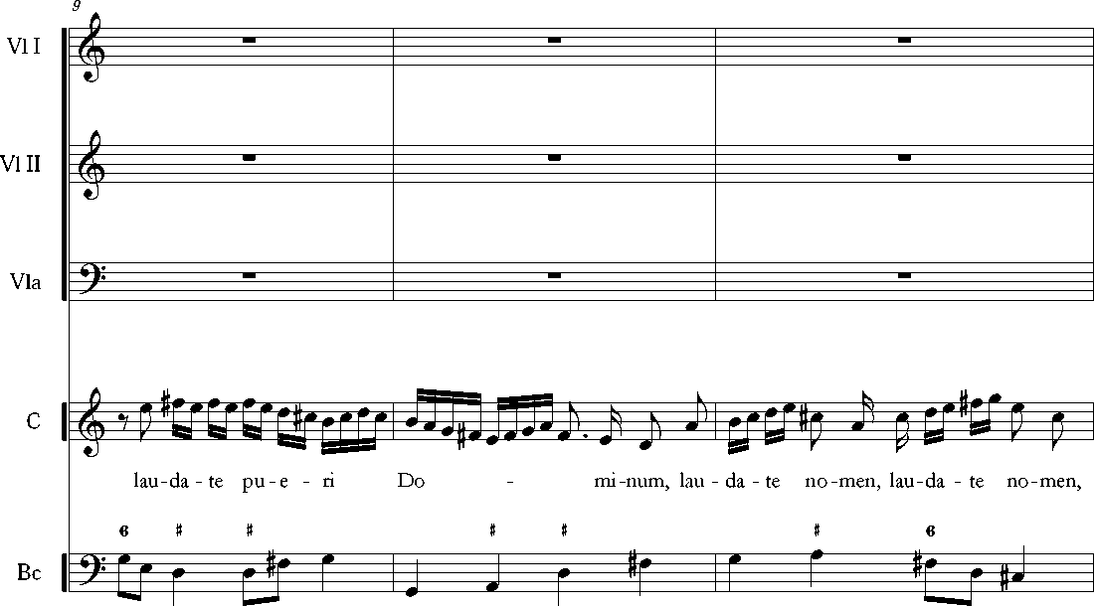
Vl I
Vl II
Vla
r ttLr eir
C

hm
Lau - da
4 #3
e #
te
tr r |  | r t r r. j |  |  |  |  | r
-H P r |  | r *r r =*= | r | r | r
Bc
6
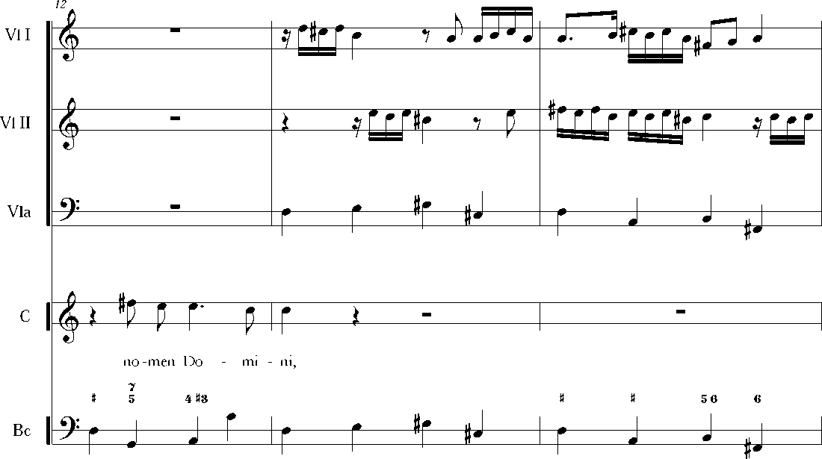
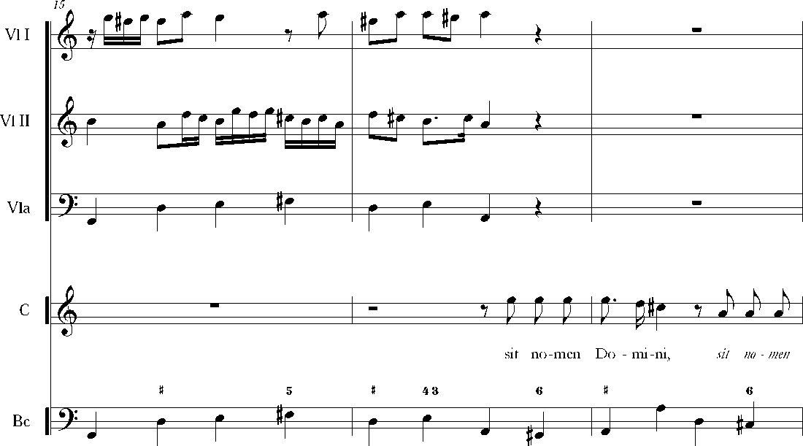
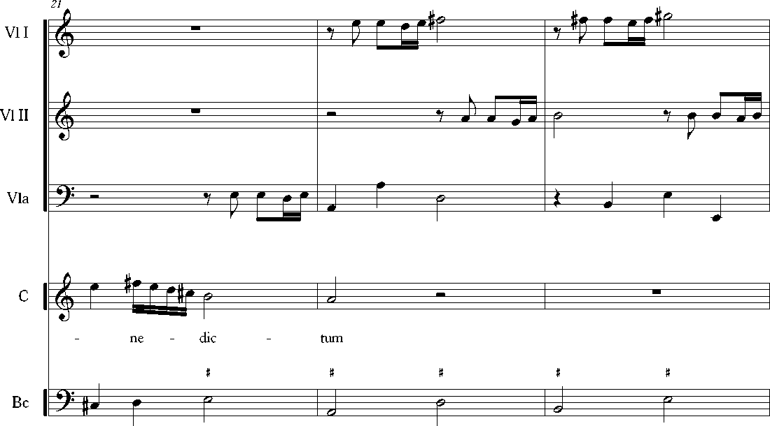
1S
Vl I
Vl II
Vla
C
a -  a — == | —  — | —  —
& = ? — | — | —
y  ~a—^h—»—»• » |  | » Ï»
& » •^  Do - mi - ni sit no - men Do - mi  t » 65  “?“» ^ » f | ni be - - -  JTIi .nJ"! | JJ ff  t  1»" ÎT » F“»
V r | —¿J-J ^ » | LJrL./L.J^
Bc
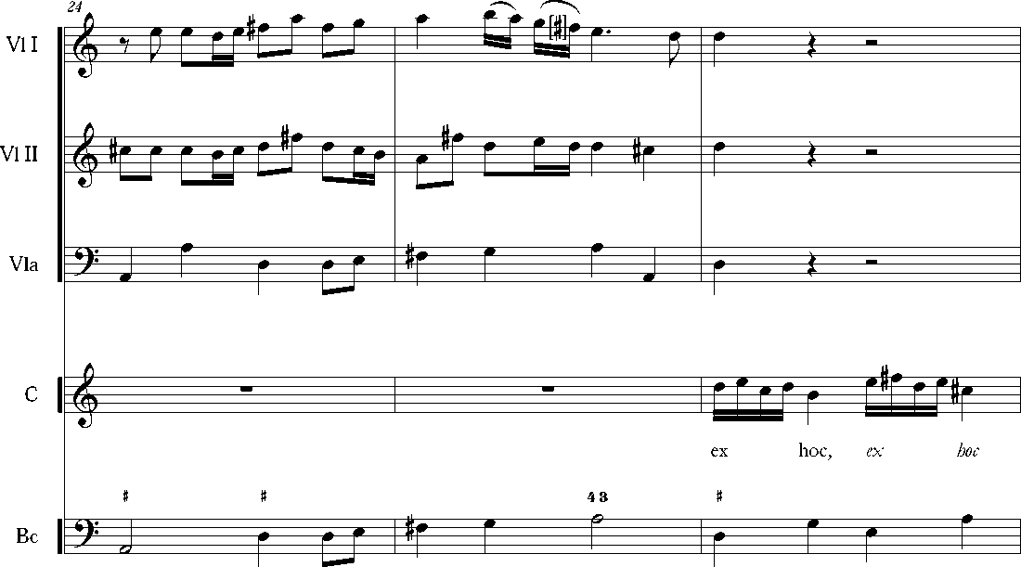
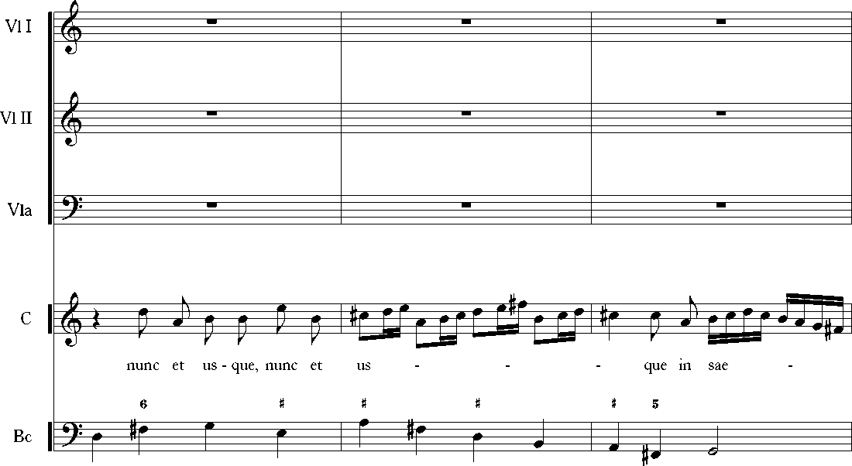
ZT
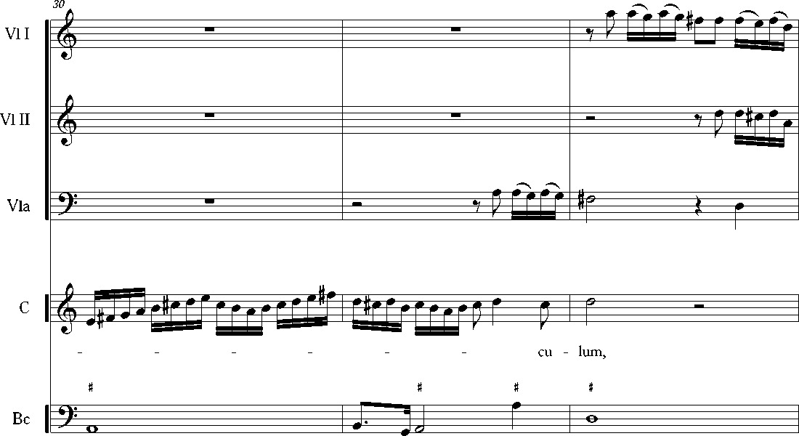
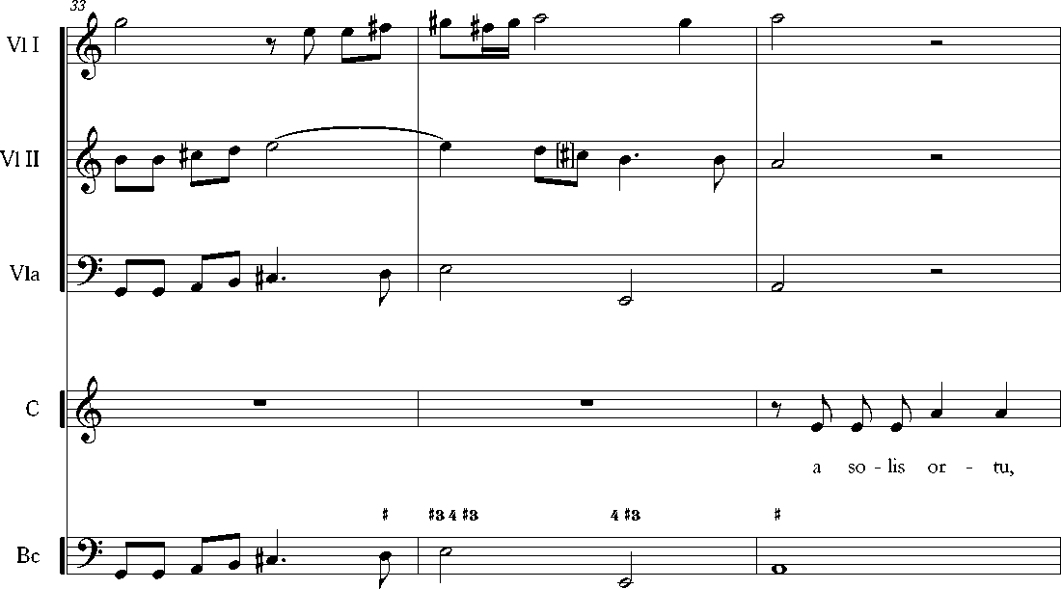
36
Vl I
Vl II
Vla
a ~  a — | —  — | —  —
a  ? — | — | —
j  a 7 k tJ J | J j J J ~ | —FF*— K r }' j r }'
a7 J J JT N  a so - Us or - tu  *  -? | J J * JJJ J  us - que ad oc - ca - - e * | ttJJJ^JJJJJ^ J J J1J  - - sum, lau - da - bi - le * e  j t J
 | hJ J | P H
C
Bc
3o
Vl I
Vl II
Vla
a ~  a — | —  — | —  —
a = ? — | — | —
y  i ~a k~ j—jj—^ j_ | » i* * J~3 T~~* r P | —““S  — fz —F-
a tj j M pp  no - men, lau - da - bi -le  *e  ? J J | [_ü J J JBJ J X ^  no - - -  -f J | tJ JJJ JJJ J'JJJJ  *  J J J—J
l> j ° |  | J ^—J
C
Bc

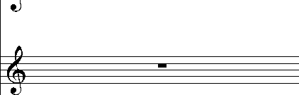
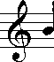
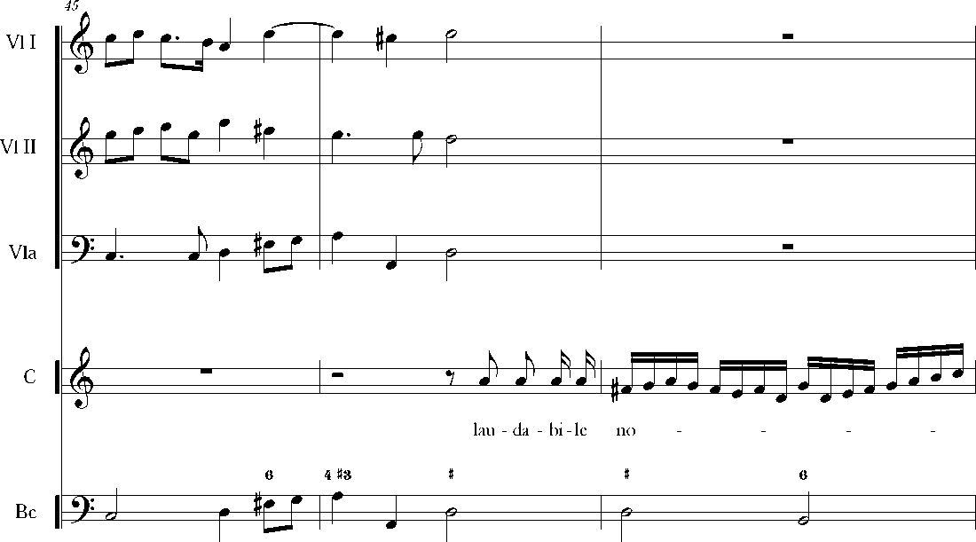
Vl I
Vl II
Vla
42
ê
JLJ/lTLT
Jm

a
3
r¥jJ—LJ »/"J J. J
C
-0
men Do - e * es *
mi - ni
? |  |  | -H
/  • | J J |  | =tjLH? | 4 |  | —\ J
Bc
?
7

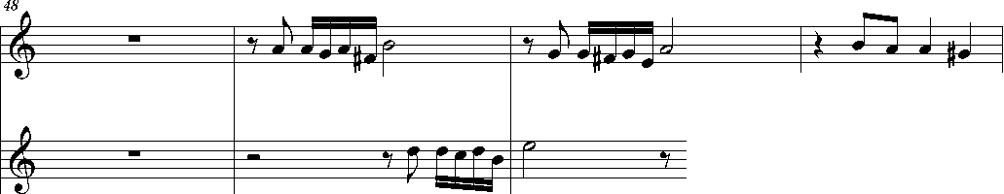
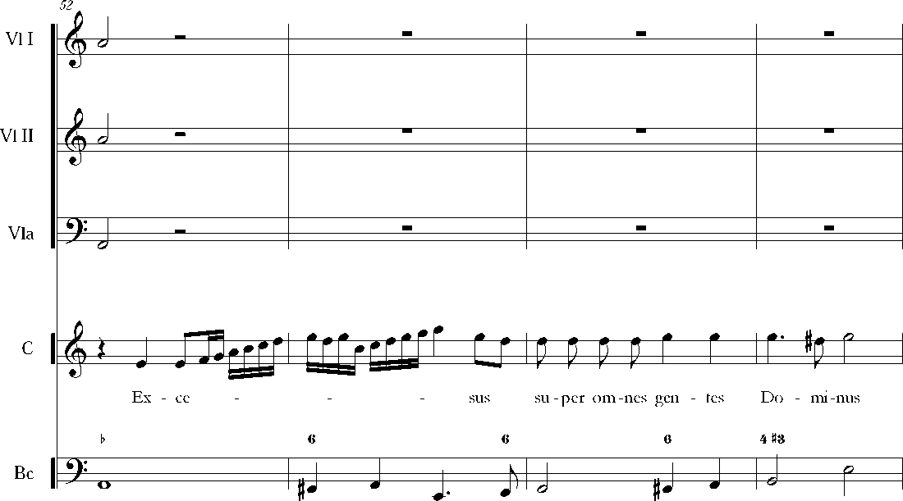
Vl I
Vl II
Vla
•D:
Jm r Jr J
jlJJjjlJ 7 łJlJU7~]|j jjJjj
hfi= | 1 | J= | ]• | J-- | J s | — | —
 | ^ |  |  | '—
C
men Do - mi - ni.
s * *
 |  |  |  |  |  |  | J J —
J —  1 # | —# | # | 4 |  | l£ j |  | 1¿¿ | J r
Bc
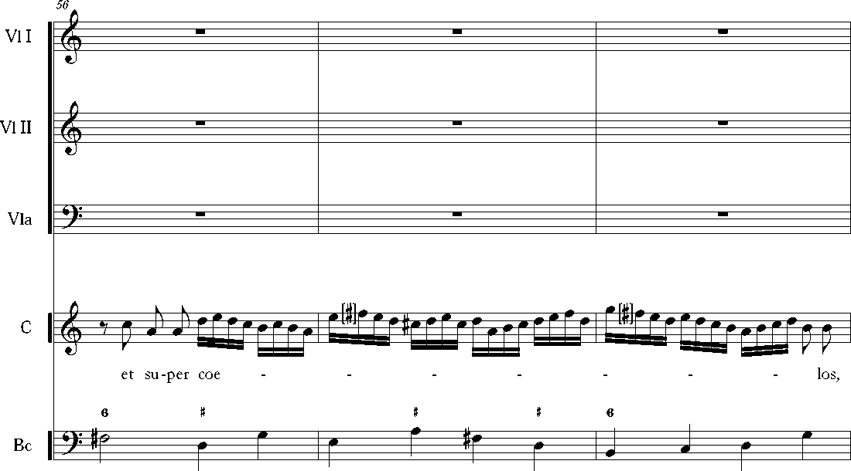
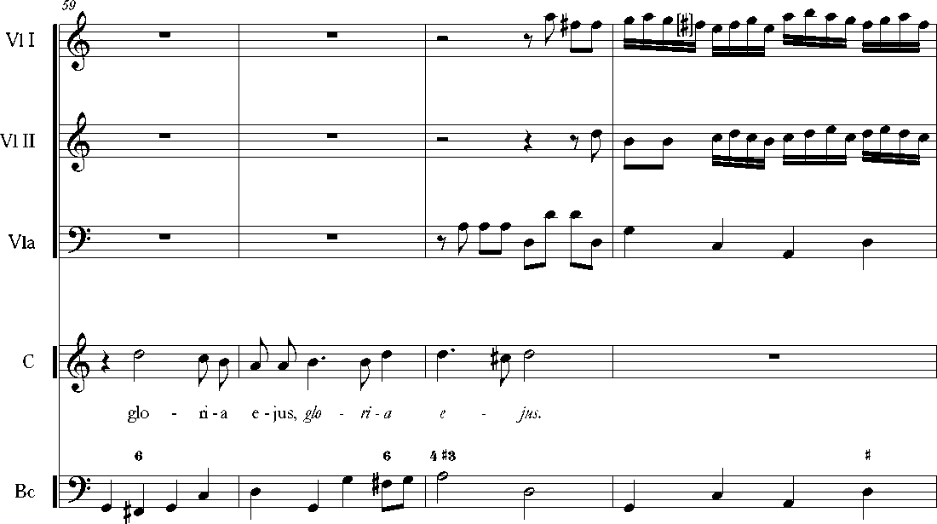

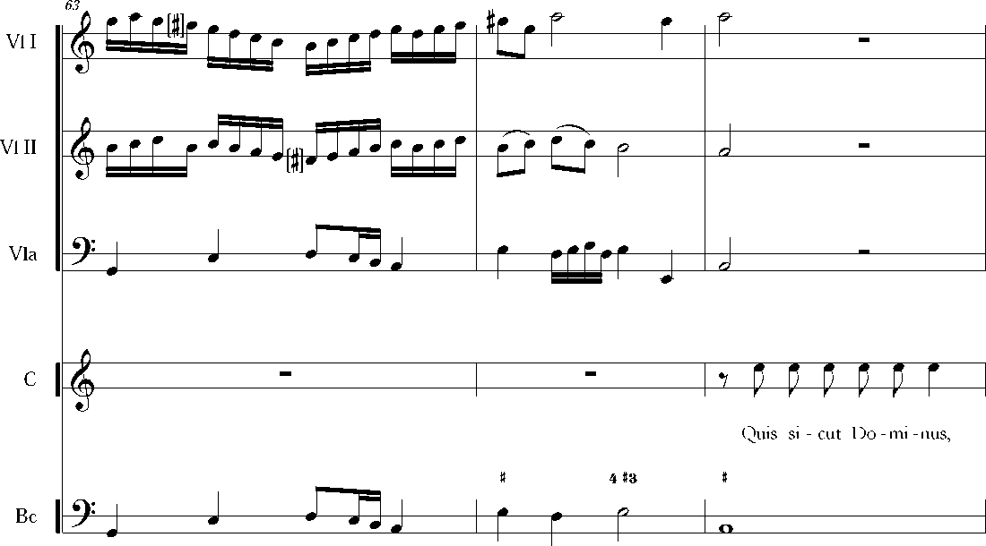
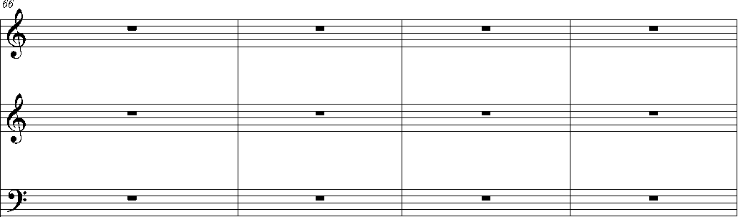
Vl I
Vl II
Vla
J1 Jt J1J1Jt j li ». j li J J
C
quis si - cut Do - mi - nus De -us no - ster,
**
qui in al - tis ha - bi-tat, qui in

ee

Bc
m
?
72

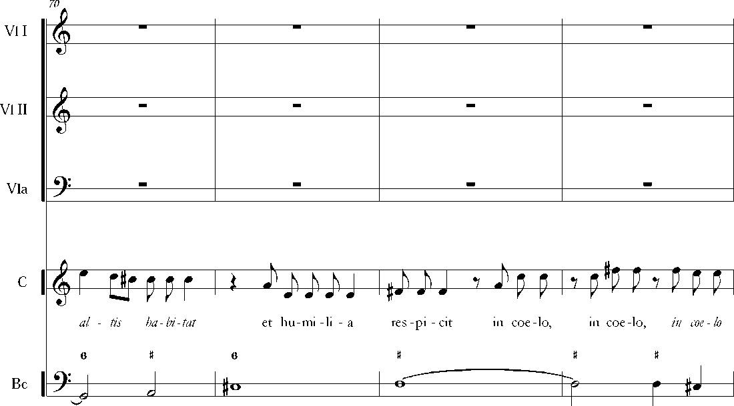
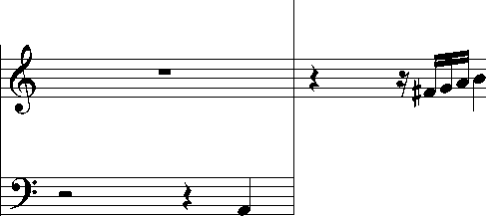
Vl I
Vl II
Vla
l& - = |  | rf ! | yf | j J J jT j tjj ] | 0
& - = | w | jT ^Bss¿ |  | - 1 1 1 •f-Tf-
mj j j
j r j «
j
=v=t | 0 1
=&= |  |  |  | I |  | I
if * |  | ^ •
C
Bc
7  tt 5 | 4 t | s | t |  | • | e  J. — J+ I
^=- | I |  | j r • |  |  | r j »a
m

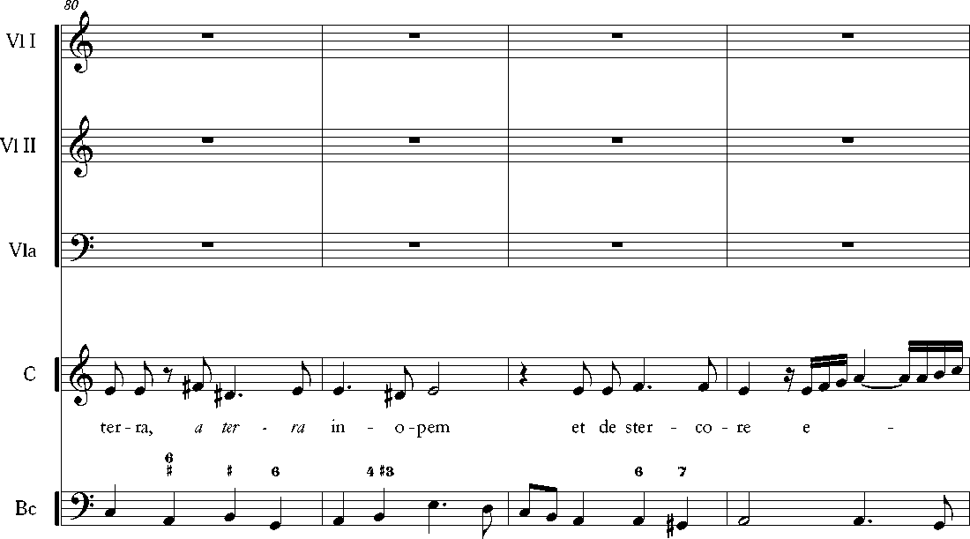
Vl I
Vl II
Vla
|& JjjfTJJJ*J
0-
& ». jji^r j££r | 4 | J — —. h
 |  | -ir r J
? j. mj ^ |  | J » n a
-J- P- J-J-^-j | J | »j w r== | a

C
J—• # *
sus - ci - tans a ter - ra, a
# e
4 #3
? j. n | J |  |  | — » rr a
^ J 11 |  |  |  | »J w r== | a | j j
Bc
m
m
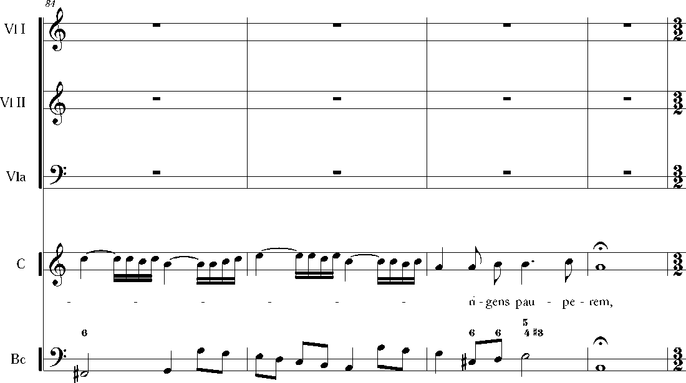
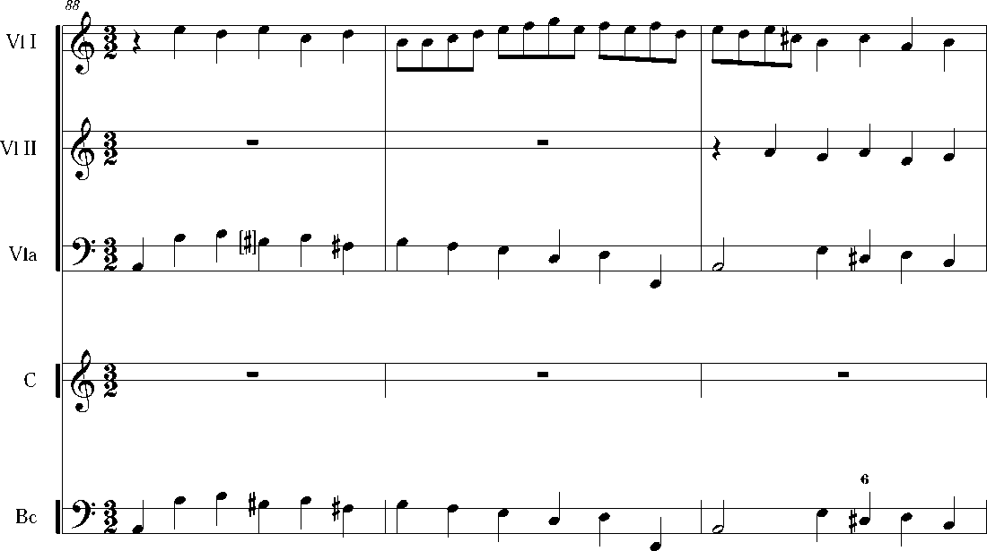
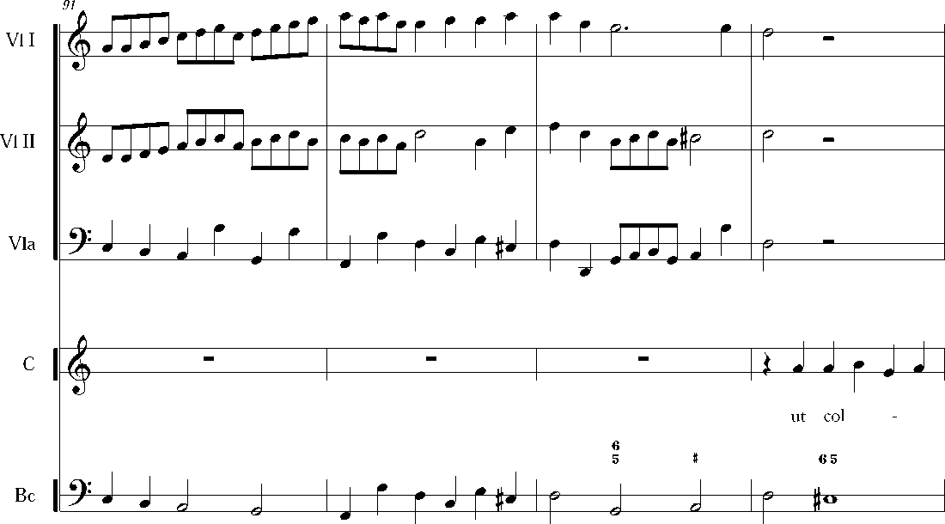
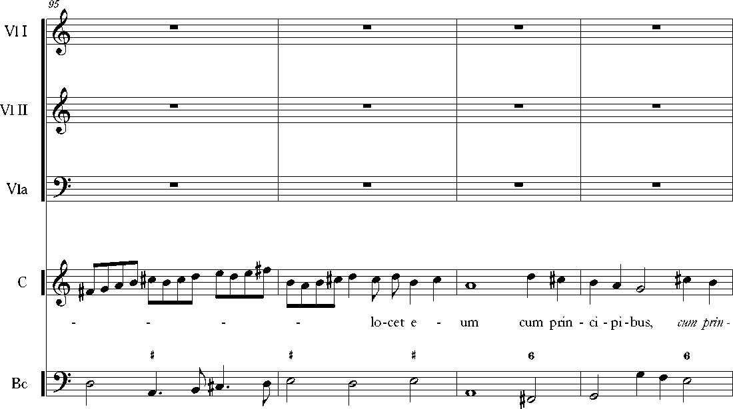
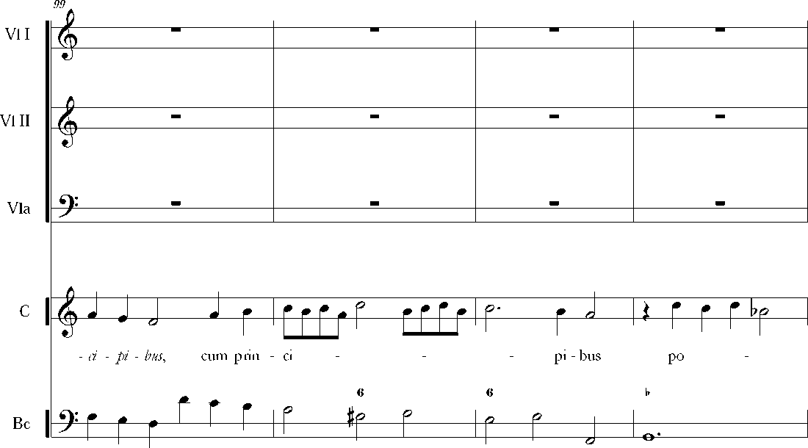
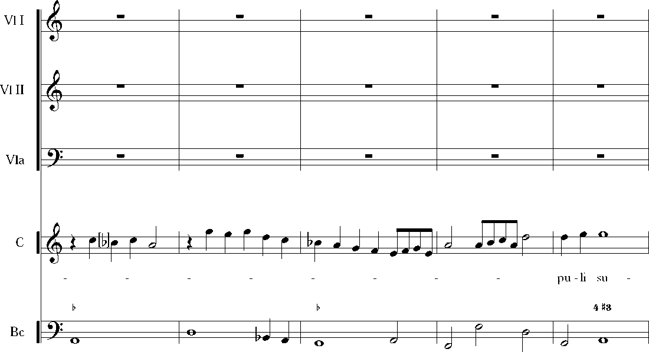
103
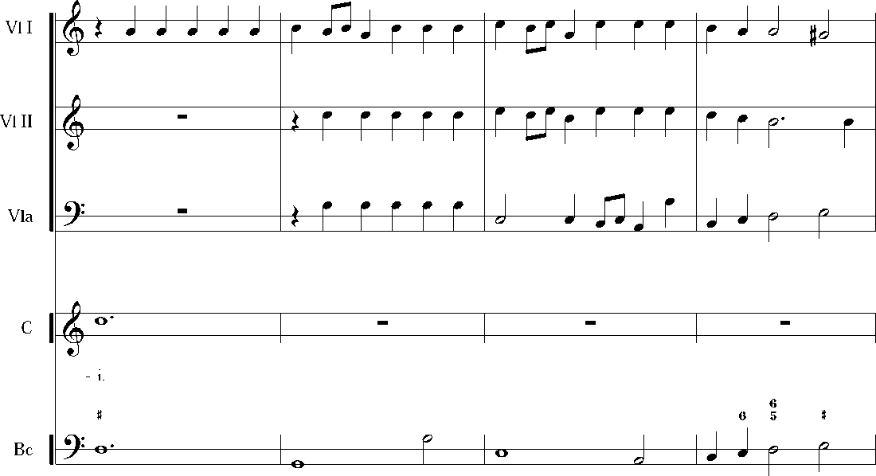
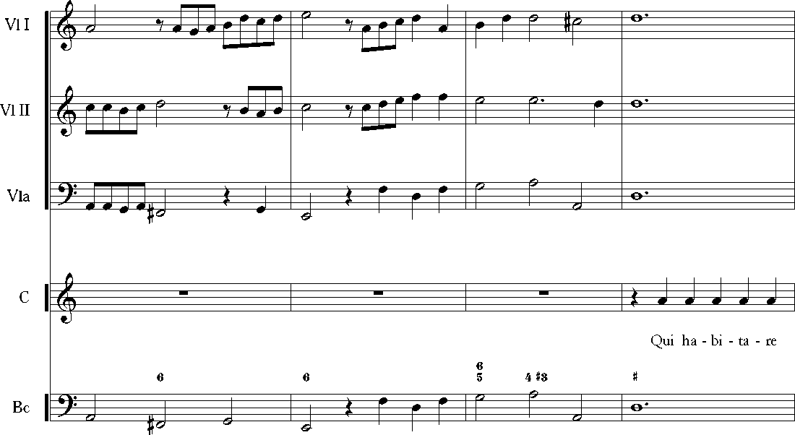
10S
112
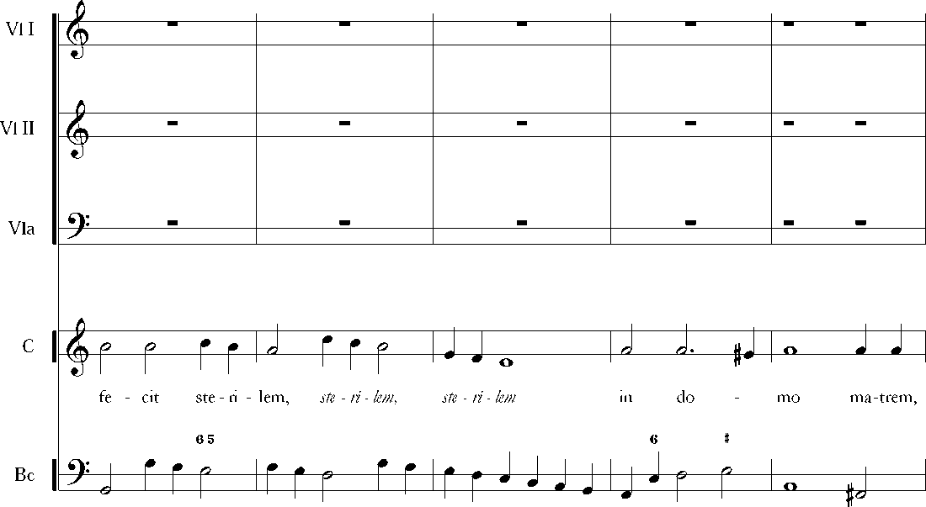
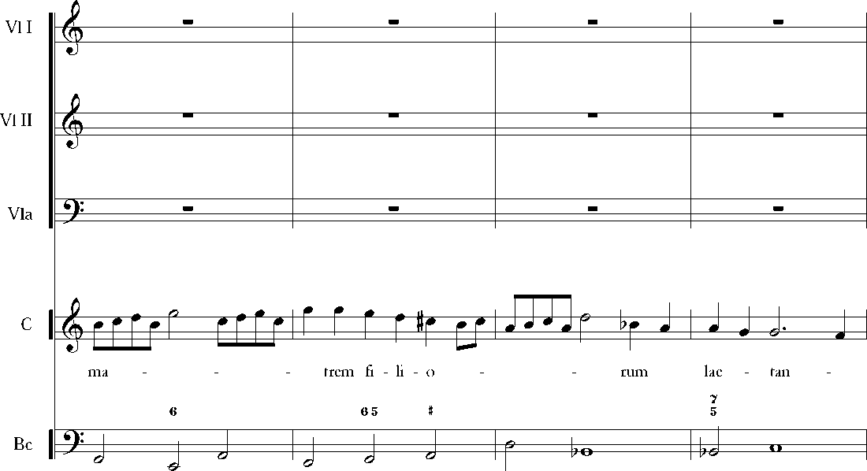
11o
121

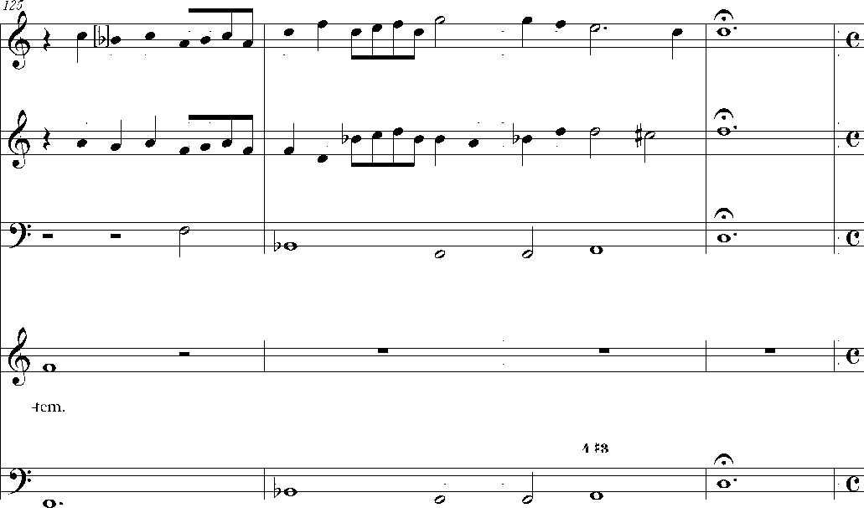
Vl I
Vl II
Vla

C

Bc
Vl I
Vl II
Vla
12O

É
w
í
w
=3=e=

JJ- Pir JJ
C
Glo - ri - a Pa - tri et Fi - li
et Spi-ri
=3=e=
tu-i Sanc - cto
Bc
P
tJ J r T
9&
~Zl
~zl
o
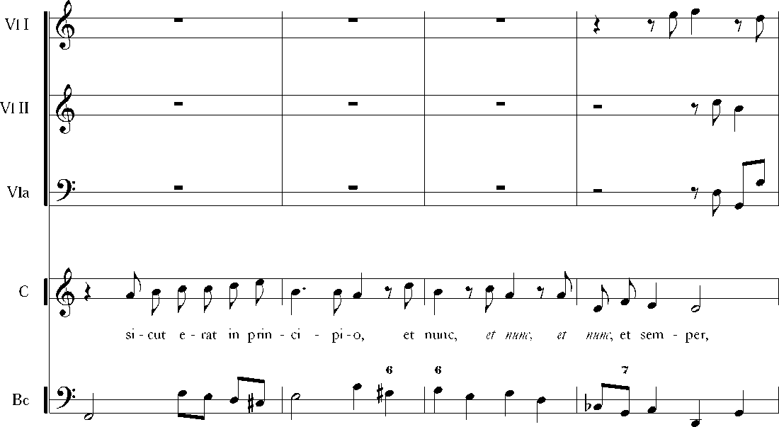
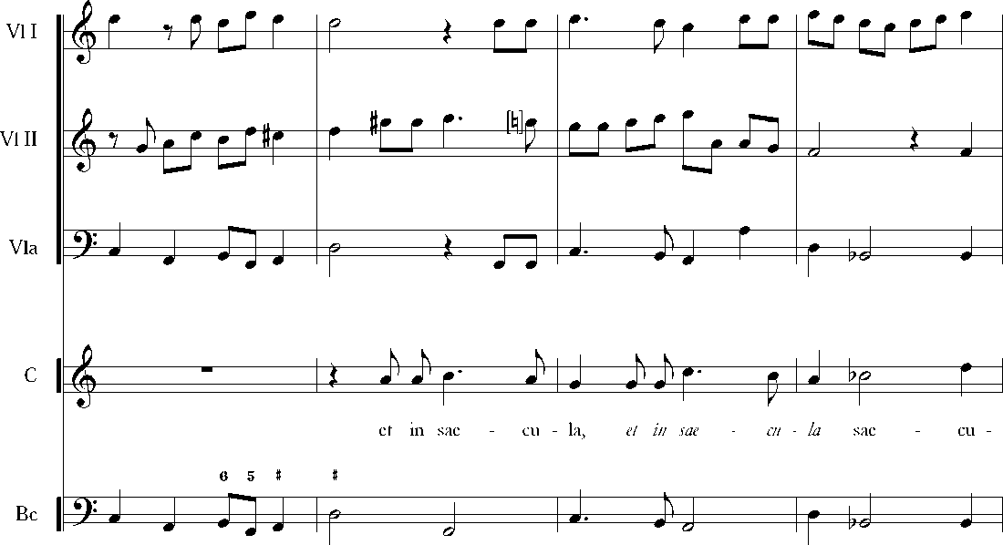
134
13S

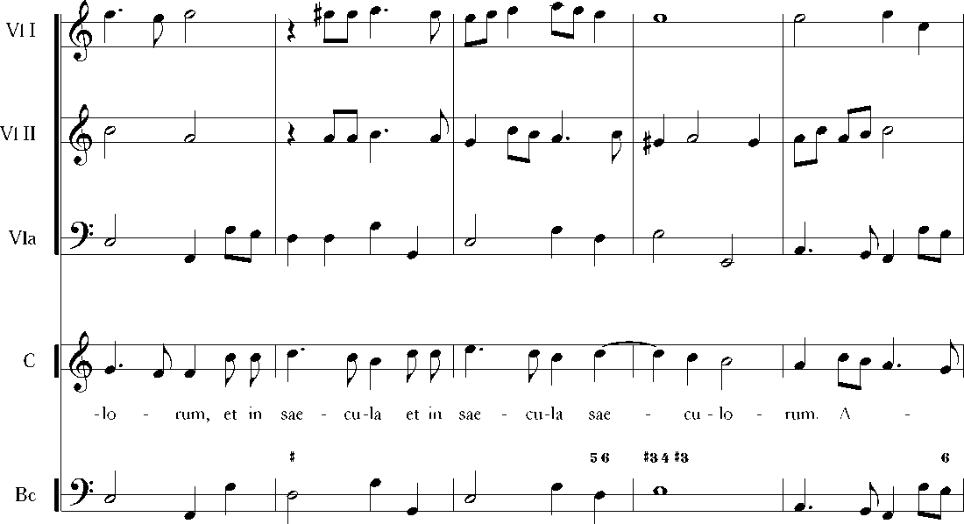
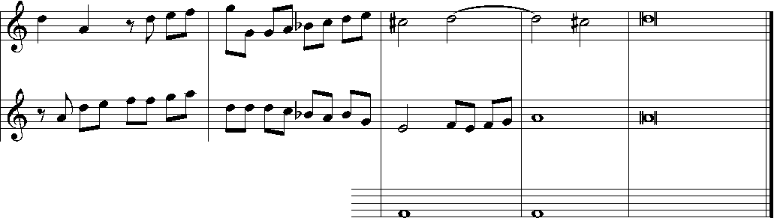
147
Vl I
Vl II
Vla
 |  | V
kr |  |  | J | J
C
J- ÏJ W lbJ
-&
L-o-
men, a
76 5
-?— Bi |  | j
J r J | kr | jP- | J | J
1M-
Bc
w
o
M
BIBLIOGRAPHY
Old prints and manuscripts
Crato Bütner, Laudatepueri Dominum (Universitetbiblioteket Carolina Rediviva in Uppsala, catalogue No. Vok. mus. i hs. 5:13).
Walther Johann Gotfried, Musicalisches Lexicon, Wolffgang Deer, Leipzig 1732.
Books and articles
Biegaj Dominika, Stile concertato we wczesnym baroku [Stile Concertato in the Early Baroque], „Glosa. Rocynik Polskiego Stowaryysyenia PryyjaciółMuyyki Dawnej”, vol. 1/2005.
Günther Otto, Katalog der Handschriften der Danyiger Stadtbibliothek, Bd. IV, Die musikalischen Handschriften der Stadtbibliothek und der in ihrer Verwaltung befindlichen Kirchenbibliotheken von St. Katharinen und St. Johann in Danyig, Kommissions-Verlag der L. Saunierschen Buch- und Kunsthandlung, Danzig 1911.
Kościelak Sławomir, Kościół Zbawiciela (I) [The Church of the Holy Saviour (I)], [w:] Gedanopedia, red. Błażej Śliwiński,
http:/ /www.gedanopedia.pl/gdansk/?title=KO%C5%9ACI%C3%93%C5%81 ZBAWICIELA (P [dostęp: 18.05.2016].
Kurkowa Alicja, Gdański ilustrowany utwór okolicynościowy y 1668 r. poświęcony abdykacji Jana Kayimierya [Gdańsk Illustrated Occasional Piece from 1668, on the Occasion of the Abdication of Jan Kayimiery], „Rocznik Gdański” 1981, t. 41, z. 1.
Maciejewski Tadeusz, Inwentary muyykaliów kapeli karmelickiej w Krakowie na Piasku y lat 1665-1684 [The inventory of musical mateńals of the Carmelite monastey at Kraków from the years 1665-1685], „Muzyka” 1976 nr 2.
Schildt Maria, Gustav Düben at Work: Musical Repertory and Practice of Swedish Court Musicians, 16631690, (dysertacja doktorska, Uppsala Universitet), Uppsala 2014.
Seifert Max, Die Chorbibliothek der St. Michaelisschule in Lüneburg, „Sammelbände der Internationalen Musikgesellschaft” IX 1907/1908.
Szlagowska Danuta, Repertuar muyycyny y siedemnastowiecynych rękopisów gdańskich ['Musical Repertoire in the 17th Century Manuscripts from Gdańsk], «Kultura Muzyczna Północnych Ziem Polski» 10, Akademia Muzyczna im. Stanisława Moniuszki, Gdańsk 2005.
Szlagowska Danuta, Musik in der Kathańnenkirche in Danyig, [w:] Musica Baltica. Interregionale musikkulturelle Beyiehungen im Ostseeraum, «Greifswalder Beiträge zur Musikwissenschaft» 4, red. Ekkehard Ochs, Nico Schüler, Lutz Winkler, Lang, Frankfurt/Main 1997.
Szlagowska Danuta, Music in Gdańsk under the Vasa Dynasty, [w:] Polish-Swedish Cultural Relations During the Vasa Dynasty: Stokholm, February 10th-12th 1995. Conference Papers, red. Tadeusz Maciejewski, Akademia Muzyczna im. Fryderyka Chopina, Warszawa 1996.
Szlagowska Danuta, Twórczość Crato Bütnera, kompozytora działającego w Gdańsku w drugiej połowie XVII wieku [The Output of Crato Bütner, a Composer Active in Gdańsk in the Later Part of the 17th Century], [w:] Muzyka w Gdańsku wczoraj i dziś, I, «Kultura Muzyczna Północnych Ziem Polski» 3, Akademia Muzyczna im. Stanisława Moniuszki, Gdańsk 1988.
Szombara Justyna, On the reception of Italian ’musica moderna' in Northern Europe: the sacred concertos in seventeenth-century Gdańsk, w: Musica Baltica: music-making in Baltic Cities various kinds, places, repertoire, peformers, instruments, red. Danuta Popinigis, Danuta Szlagowska, Jolanta Woźniak, Akademia Muzyczna im. Stanisława Moniuszki, Gdańsk 2015.

