

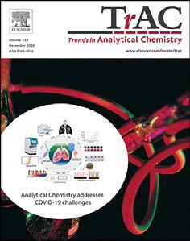
Trends in Analytical Chemistry 133 (2020) 116065
Overview of the three multicriteria approaches applied to a global assessment of analytical methods
Paweł Mateusz Nowak ^{a,} *, Paweł Ko'scielniak ª, Marek Tobiszewski ^{b,} **,
Ana Ballester-Caudet ^{c}, Pilar Campíns-Falco' c, ***
a Department of Analytical Chemistry, Faculty of Chemistry, Jagiellonian University in Krako'w, Ul. Gronostajowa 2, 30-387, Krako'w, Poland
b Department of Analytical Chemistry, Faculty of Chemistry, Gdan'sk University of Technology (GUT), Ul. Narutowicza 11/12 G, 80-233, Gdan'sk, Poland
c MINTOTA Research Group, Departament de Química Analítica, Facultat de Química, Universitat de Val'encia, Dr. Moliner 50, 46100, Burjassot, Valencia, Spain
a r t i c l e i n f o
a b s t r a c t
Article history:
Available online 14 October 2020
Critical and global evaluation of analytical methods should be one of the primary goals in analytical chemistry. A holistic approach, however, requires a look at the varied features: commonly discussed validation criteria, often underrated practical and economic aspects, and typically overlooked compliance with the principles of green analytical chemistry. Carrying out such an assessment in a critical and transparent way is extremely difﬁcult without special tools. The purpose of this work is to discuss and compare the three different approaches that seem to be potential candidates: multi-criteria decision analysis methods (MCDA), HEXAGON, and RGB model. The basic principles of each methodology, indi- vidual possibilities offered, and the results of the assessment of selected model methods will be pre- sented. Ultimately, the potential compatibility of assessing the same group of methods using different tools will be examined. This contribution can help to select optimal tool and conduct more thorough and insightful assessments.
© 2020 The Author(s). Published by Elsevier B.V. This is an open access article under the CC BY license
(http://creativecommons.org/licenses/by/4.0/).
Keywords:
Analytical methods Metric tool Validation
Green chemistry
Multi-criteria decision analysis Hexagon
RGB model Sunset yellow FCF
1. Introduction
An important trend observed in recent years is paying more attention to the assessment of the so-called “greenness” of an analytical method, i.e. its friendliness in terms of safety for user health and the environment. This entails the constant development of new algorithms for assessing the greenness [1,2], including
qualitative and quantitative approaches, e.g. Eco-Scale developed by the Group of Professor Jacek Namie'snik [3]. However, a holistic and comprehensive assessment of methods in terms of both
analytical efﬁciency (validation criteria) and greenness is impos- sible using these metrics. Finally, the global assessment of a method also requires a look at its other features, often underestimated or considered in a highly simpliﬁed and only intuitive sense. However, they are often as important in everyday life as analytical perfor- mance expressed in validation parameters. These features relate to the “productivity” of the method and its effectiveness, understood in purely practical/economic terms. Due to the above, conducting a comprehensive assessment of an analytical method covering all of the mentioned attributes is extremely difﬁcult without special tools dedicated for this purpose.
Currently, there are three proven tools that can be used in the
overall assessment of analytical methods taking into account the
Critical assessment of the potential of new analytical methods is crucial in analytical chemistry regardless of the speciﬁcity of the method. Currently, commonly formalized validation criteria are used for this purpose, including parameters such as precision, ac- curacy (trueness), sensitivity, recovery, etc., and the assessment of the potential of a method consists in separate consideration and comparison of individual parameters with commonly accepted standards, as well as between different alternative methods. This approach, despite many advantages, has the disadvantage that it is difﬁcult to express the analytical potential of a method using one uniﬁed measure (performance indicator), which would cover all validation criteria and allow easy overall assessment.
* Corresponding author.
** Corresponding author.
*** Corresponding author.
E-mail addresses: pm.nowak@uj.edu.pl (P.M. Nowak), marektobiszewski@wp.pl, marek.tobiszewski@pg.edu.pl (M. Tobiszewski), pilar.campins@uv.es (P. Campíns- Falco').
https://doi.org/10.1016/j.trac.2020.116065
0165-9936/© 2020 The Author(s). Published by Elsevier B.V. This is an open access article under the CC BY license (http://creativecommons.org/licenses/by/4.0/).
Contents lists available at ScienceDirect

Trends in Analytical Chemistry

journal homepage: www.elsevier.com/locate/trac

P.M. Nowak, P. Ko'scielniak, M. Tobiszewski et al.
Trends in Analytical Chemistry 133 (2020) 116065
various attributes mentioned above. These are: (i) multi-criteria decision analysis (MCDA) algorithms that result in an indication of the best procedure to solve a given speciﬁc analytical problem [4e7];
(ii) an algorithm that is the extension of the aforementioned Eco- scale to other features of a method, named HEXAGON due to its pictorial form [8]; and (iii) an RGB model [9], named so because of the analogy to the model commonly used in representation and coding of colors in electronic devices, enabling the expression of a method's potential by means of its resultant color, depending on the participation of the three primary attributes (Red, Green, Blue). These algorithms are, as one can assume, still largely unknown to analytical chemists community. Furthermore, their comparison with each other has never beenpresented before. The purpose of this work is to present for the ﬁrst time the principles of operation and possibilities offered by each of the three mentioned approaches, as well as their mutual comparison. It is intended to facilitate a more thorough and comprehensive evaluation of analytical procedures, both being in use and newly developed, as well as to simplify the selection of an optimal tool for a given reader.
and acquisition of antibodies from animals. More details on the in- dividual methods are available in the relevant references [11e14].
3. MCDA (TOPSIS) algorithm
3.1. Working principle
MCDA is a group of tools that are used for scoring and ranking of alternatives according to the given assessment criteria. MCDA techniques are widely used in solving of various analytical prob- lems [15]. The most widely applied ones are Analytical Hierarchical Process (AHP) [16], ELimination and Choice Expressing REality (ELECTRE) [17], Preference Ranking Organization Method for Enrichment Evaluations (PROMETHEE) [18], Technique for Order Preference by Similarity to Ideal Solution (TOPSIS) [19], Multi Attribute Utility Theory (MAUT) [20], Multi Attribute Value Theory (MAVT) and Simple Additive Weighting [21,22]. They were described in detail in several books [23e25]. The mathematical algorithm in each of the techniques is different but the general principles can be summarized by few simple steps:
2. Model methods
- Deﬁnition of the goal of analysis. The goal of the analysis is usu- ally ﬁnding the best solution to the given problem. It might be ﬁnding the optimal process, material, situation, location or state. The goal might also be ranking of all or part of available solutions. In the context of this study the aim of the analysis is ﬁnding the best analytical procedure and ranking of all available ones.
- Deﬁnition of alternatives. The alternatives are the possible ways to achieve the main goal of the analysis. They may be possible processes, materials situations, locations or states that fulﬁl the requirements of the main analysis goal. Alternatives must be fully characterized by the criteria, with no gaps in the dataset. Here, the alternatives are analytical procedures that are applied for the given analytical task.
- Deﬁnition of criteria. Criteria are the characteristic features that describe the set of alternatives. They have to be relevant to the main goal of analysis, have to be measurable in reliable way and comprehensively. As an input to MCDA analysis, they have to be in form of numerical values, or they need to be transformable into numerical values. One of the main advantages and the reasons to apply MCDA is the possibility to deal with criteria that are contradictory to each other. The criteria applied in this study are metrological, economic and greenness criteria.
- Application of weights. The assessment criteria should be rele- vant to the goal of analysis, but their relevance can be different.
Six model methods of quantitative analysis of the popular colorant added to food products and beverage, Sunset Yellow FCF (E110, SY) [10], were selected for presenting the operation and comparing the considered algorithms. These methods include high performance liquid chromatography with diode array detection (HPLC-DAD) [11], high performance liquid chromatography with tandem mass spectrometry detection (HPLC-MS/MS) [11], capillary electrophoresis with UV detection (CE) [12], polyclonal antibody- based indirect enzyme-linked immunosorbent assay (ELISA) [13], photoacoustic spectroscopy (PAS) [14], and ﬁrst derivative spectro- photometry (FDS) [14]. All methods were dedicated to the same analyte e SY, although some of them enabled multi-component analysis of other popular food dyes. The studies were performed on various food samples, including beverages and solid products, hence the sample preparation procedure depended on the type of sample material. In addition, CE and ELISA methods also involved the preparation of speciﬁc reagents needed for proper analysis. In the case of CE, they were diamino moiety-functionalized silica nanoparticles (NPs) [12], used in the extraction process and as an additive to the separation buffer, while in the case of ELISA they were synthetic polyclonal antibodies [13]. The antibody preparation procedure was multi-stage and involved: chemical modiﬁcation of SY to obtain immunogen, immunization of rabbits, and production
2
Abbreviations ICP-MS Inductively Coupled Plasma Mass Spectrometry ICP-OES Inductively Coupled Plasma Optical Emission
AHP Analytical Hierarchical Process Spectrometry
AAS Atomic Absorption Spectroscopy MAVT Multi Attribute Value Theory CE Capillary Electrophoresis with UV detection MB Method Brilliance
CS Color Score MCDA Multi-Criteria Decision Analysis NPs diamino oiety-functionalized silica Nanoparticles PPs Penalty Points
dSPME dispersive Solid-Phase Microextraction PAS Photoacoustic Spectroscopy
ELECTRE ELimination and Choice Expressing REality ELISA Polyclonal antibody-based indirect Enzyme-Linked FM ﬁgures of merit Immunosorbent Assay
ESM Electronic Supplementary Material PROMETHEE Preference Ranking Organization Method for FDS First Derivative Spectrophotometry Enrichment Evaluations
HPLC-DAD High Performance Liquid Chromatography with RGB model Red-Green-Blue model Diode Array Detection SY Sunset Yellow FCF
HPLC-MS/MS High Performance Liquid Chromatography with TOPSIS Technique for Order Preference by Similarity to Ideal tandem Mass Spectrometry detection Solution
P.M. Nowak, P. Ko'scielniak, M. Tobiszewski et al.
Trends in Analytical Chemistry 133 (2020) 116065
To differentiate between the criteria importance weights are usually assigned, or not in case of equal importance.
5. Running the algorithm. One of algorithms is applied to rank the alternatives according to the criteria with appropriate weights. Because of its simplicity, TOPSIS algorithm is applied in this study and is presented below:
a) The ﬁrst step is construction of normalised decision matrix
3.2. Illustrative analysis
3.2.1. Algorithm speciﬁcation
MCDA algorithm (TOPSIS) is applied to rank the procedures applied for Sunset Yellow FCF determination. The criteria of assessment are LOD and precision as representatives of analytical performance criteria. Linearity is not included as all procedures show determination coefﬁcient close to 1 and as a result this cri- terion would not carry any variability. The linearity range is not always stated. The recovery is also not included. Consequently, the requirement of data completeness is not fulﬁlled for recovery. The second group of criteria is related to greenness e the volume of organic solvents used in procedure, hazards-corrected amount of solvents and mass of generated solid waste. Hazards-corrected amount of solvents is included to differentiate solvents of various hazards and it is calculated according to scoring of solvents, frequently applied in analytical laboratories [28]. The volume of each solvent applied is multiplied by the factor that is calculated on the basis of hazards related to toxicity, ecotoxicity and environ- mental persistence. The third group of criteria is related to pro- ductivity or economic aspects. Here the total analysis time is included and the number of other analytes that can be determined together with Sunset Yellow FCF.
qﬃﬃﬃﬃﬃﬃﬃﬃﬃﬃﬃﬃﬃ
X
2
r ¼ x ÷ x ;
i ¼ 1; 2; …; m and j ¼ 1; 2; …; n
(1)
ij ij
ij
where x_{ij} and r_{ij} are original and normalised scores in decision matrix.
b) The second step is construction of the weighted normalised decision matrix, it is done according to relative importance (reﬂected by the weights, subjectively assigned by decision maker) that is set in point 4 of MCDA analysis.
vij ¼ r_{ij} x w_{j};
i ¼ 1; 2; …; m and j ¼ 1; 2; ::; n
(2)
P
n
where w is the weight of the criterion j and. w_{j} ¼ 1
j
j¼1
c) The next step is determination of both positive ideal (A*) and negative ideal (A⁻) solutions
3.2.2. Evaluation results
The results of the assessment carried out using the selected groups of model methods and TOPSIS algorithm as the assessment tool are presented in Table 1.
The important information is the rank of the procedure and the value of similarity to ideal solution. This value carries the infor- mation on the performance of procedure according to assumed criteria and their weights. It is clearly readable that the CE and PAS are characterized by good performance with these values 0.95 and 0.92, respectively. Both procedures are the winners in only two out of eight criteria (CE in amount of organic solvent and time of analysis, while PAS in amount of solid waste and time of analysis) but their performance in all criteria is generally good. CE and PAS procedures are characterized by good performance in four criteria referring to greenness, keeping in mind all weights equal, this is crucial factor in their overall performance. FDS, HPLC-MS/MS and ELISA are characterized by moderate performance, with values of similarity to ideal solution between 0.48 and 0.69. FDS is charac- terized by the highest LOD from all procedures but good perfor- mance in terms of generation of solid waste and consumption of toxic solvents. HPLC-MS/MS is characterized by the poorest preci- sion of Sunset Yellow FCF determination and high consumption of toxic organic solvents, but it can be utilized for determination of other analytes and requires only 2 g of sample. ELISA is very interesting procedure, as its performance in respective criteria is deﬁnitely the best or the worst. It is very good in LOD and RSD criteria but the worst in terms of analysis time and the possibility to determine other analytes, as only Sunset Yellow FCF can be deter- mined. The procedure with clearly the worst performance is HPLC-
{(
) (
)} {
}
A ¼ max v
*

j2C ; min v j2C ¼ v j¼1;

*

2
; …; m
(3)
i ij b
i ij
c
i
n
o
A- ¼ {(minivij j 2 C ; max v j 2 C ¼ v j ¼ 1
) (
)}

*
; 2
; …;
m
c
b
i ij
j
(4)
d) Then calculation of the separation measures for each alternative is performed
vﬃﬃﬃﬃﬃﬃﬃﬃﬃﬃﬃﬃﬃﬃﬃﬃﬃﬃﬃﬃﬃﬃﬃﬃﬃﬃﬃﬃﬃﬃ
m

X
u
2
S ¼
*
t
vij - vj j ¼ 1; 2; …; m
*
(5)
i
j¼1
vﬃﬃﬃﬃﬃﬃﬃﬃﬃﬃﬃﬃﬃﬃﬃﬃﬃﬃﬃﬃﬃﬃﬃﬃﬃﬃﬃﬃﬃﬃﬃ
m

X
u
2
Si ¼
-
t
vij - v-j j ¼ 1; 2; …; m
(6)
j¼1
e) Calculation of the relative closeness to the ideal solution is done
S-
i
; i ¼ 1; 2; …; m and 0 < C* < 1
C ¼
*
(7)
i
i
* S-
S þ
i i
f) In the last step the scenarios are ranked according to similarity to ideal solution e from closest to furthest. The full ranking is created. For each alternative the value of similarity to ideal so- lution is calculated that is crucial in interpreting the ﬁnal ranking as the differences between two consecutive alternatives may be varied.
6. Final decision making. The last step is the interpretation of the result, either the most appropriate alternative or investigation of created ranking. In this study, it is important to ﬁnd the optimal alternative and rank the remaining ones.
Table 1
The ranking of procedures for Sunset Yellow FCF determination (all weights equal).
Procedure
Similarity to ideal solution
CE PAS FDS
HPLC-MS/MS ELISA
HPLC-DAD
0.95
0.92
0.69
0.50
0.48
0.34
Some MCDA applications include the opinions of multiple ex- perts integration [26], and often sensitivity analysis is performed to understand the impact of changes to criteria weights and explore the robustness of the indicated preferred solution [27].
3

P.M. Nowak, P. Ko'scielniak, M. Tobiszewski et al.
Trends in Analytical Chemistry 133 (2020) 116065
DAD with the value of similarity to ideal solution equal to 0.34. It is characterized by relatively poor analytical performance, high con- sumption of organic solvents and the time of analysis is rather long. However, its performance is good in terms of other analytes that can be determined, and the amount of sample needed for analysis. Thus, TOPSIS is a very simple and effective tool as it works on raw data, therefore no transformations and no reference thresholds are required to carry our assessment. By the selection of criteria and the application of adequate weights it can be applied as a ﬁt-for- purpose tool. The ranking is easy to be interpreted, however, it does not carry any information about weak or strong points of the
4.2. Exemplary analysis
4.2.1. Algorithm speciﬁcation
The assessment of the SY analysis in animal feed and meat by means of the high performance liquid chromatography with diode array detection (HPLC-DAD) versus tandem mass spectrometry detection (HPLC-MS/MS) techniques [11] have been taken as a model to show the evaluation procedure established by the hexa- gon tool. Initially, the adequacy of the analytical parameters relative to sample/method and quality control is assessed. The aspects/pa- rameters considered and the PPs assigned for ﬁgures of merit 1 (FM-1) are listed in Tables 2e4 as shown in Ref. [8]. With the aim of only comparing the intrinsic characteristics of each procedure, the number of samples per week in both cases is ﬁxed to 50, that is, the greenest alternative. The HPLC-DAD analytical method implies the need of 5 times preconcentration during the sample treatment (extraction process) in comparison to HPLC-MS/MS. As shown in Fig. 1a, the sum of PPs is 11 for the HPLC-DAD whereas only 9 PPs are assigned to the HPLC-MS/MS. This can be understood by the fact that triple quadrupole tandem mass spectrometer offers better sensitivity (2.18 ng/mL) than detection via diode-array detector (74.81 ng/mL). In addition to this, HPLC-DAD presents worse adaptation to the ﬁgures of merit regarding the calibration pro- cedure than the HPLC-MS/MS due to the limit of detection and working range of concentrations [11]. On the other hand, both techniques present similar penalization concerning quality control and accuracy criteria (FM-2), as it can be seen in Fig. 1a. Overall penalization of ﬁgures of merit FM-1 and FM-2 is indicated in Fig. 1b.
The global penalization assigned to health and safety variables is
presented in Fig. 1b. The high penalization score of both methods is due to the use of hazardous chemical reagents such as methanol, ethanol, formic acid and acetonitrile organic solvent. Toxicity PPs correspond to the sum of the penalties attributed to the pictograms of the SGA system each reagent has. Concerning safety, the HPLC- DAD based analytical procedure implies the evaporation to dry- ness in water bath under nitrogen beam during the sample extrac- tion process. This makes the HPLC-MS/MS based method more suitable related to safety considerations. In order to evaluate sus- tainability, Table 9 in Ref. [8] is employed. Taking into account the amount of waste generated and the principles of green chemistry [33,34], it is concluded that both methods lead to similar contribu- tion in terms of sustainability, that is, 13 PPs as shown in Fig. 1b.
Although similar environmental friendliness is found for the
evaluated methods regarding residues generation, the electricity consumed by the instrumental equipment provides a remarkable difference in the environmental impact. Mainly, the difference between the two methods relies on the fact that a 16-min HPLC- DAD run is needed whereas HPLC-MS/MS requires the equipment to be switched on the whole working day (8 h). This leads to a much higher carbon footprint when using HPLC-MS/MS, as depicted in Fig. 1c. The carbon footprint estimation [27] is computed consid- ering the time analysis and the instrument power set to 0.44 KW
assessed procedures, thus, characteristics is difﬁcult.
a
thorough
analysis
of
a
method's
4. HEXAGON algorithm
4.1. Working principle
The hexagon quantitative tool comprises the rating of ﬁve var- iables of a method through the assignment of penalty points (PPs). The variables are divided into ﬁve groups: analytical features or ﬁgures of merit, associated chemical and health risks, environ- mental friendliness, sustainability and economic cost [8]. Specif- ically, the ﬁgures of merit include the analytical performance of the method under evaluation and they are organized into different blocks as follows: ﬁgures of merit 1 (FM-1) involve the sample treatment, characteristics of the method and calibration procedure while ﬁgures of merit 2 (FM-2) account for the quality control and accuracy. Chemical toxicity, hazard and safety considerations are evaluated by the globally harmonized system (SGA) [29,30]. The residues derived from the analytical method and the possibility to recycle them are taken into account to assess the sustainability offered by the analytical procedure. Additionally, the environ- mental impact is quantiﬁed by the carbon footprint metrics [31], which considers the energy consumption of the equipment employed and the time to perform the analysis. The related annual cost of the analytical determination is estimated according to the cost of the equipment needed in addition to its electricity con- sumption cost, the cost of the reagents and materials used, and the salary assigned to skilled personnel. Carbon footprint and annual cost are quantiﬁed in absolute terms whereas penalty points are ascribed to the other variables. Finally, the sum of the PPs and estimated carbon footprint and cost values are ranked in an overall quantiﬁcation for each variable using a 0e4 scale and organized in a hexagon as resulting pictogram [8]. The higher the score (that is, getting closer to 4), the following statements are accomplished: the worst the adaptation of the ﬁgures of merit for providing a reliable analytical result, the worst the contribution to health and safety, the worst the environmental impact, sustainability and cost-beneﬁt relation. At the ﬁnal stage, the arithmetic mean of the 0e4 score (S_{av}) is calculated for ranking the analytical procedures and even- tually compare the evaluation results when applying the other proposed algorithms in the present article. The scale is related with excellent, good, suitable, weak and fail performance of the tested analytical method for the scores: 0, 1, 2, 3 and 4, respectively. The hexagon algorithm has been applied to a wide variety of methods that employ different analytical techniques. Among them, atomic absorption spectroscopy (AAS), inductively coupled plasma mass spectrometry (ICP-MS) and inductively coupled plasma optical emission spectrometry (ICP-OES), liquid and gas chromatography
as well as radioactivity have already been evaluated when
analyzing water industry [8]. UVeVis spectrophotometry, ﬂuores- cence, quimioluminescence and ISE potentiometry methods for ammonium analysis in water samples have also been recently compared [32].
Table 2
The ranking of procedures for SY determination obtained with the hexagon tool (see Section 4.1 for explanations).
Procedure
Arithmetic mean (S_{av})
HPLC-MS/MS HPLC-DAD ELISA
CE PAS FDS
2.57
2.14
2.29
2.29
1.43
1.43
4

P.M. Nowak, P. Ko'scielniak, M. Tobiszewski et al.
Trends in Analytical Chemistry 133 (2020) 116065
and 3.69 KW for HPLC-DAD and HPLC-MS/MS, respectively. The reference constant value emission factor equals to 0.247 kg CO₂/ kWh [35]. In conclusion, the HPLC-DAD method involves a greener procedure from the environmental point of view.
Last variable analysed is the annual economic cost (in V). To
as both adsorbents in preconcentration of SY colorant by the dispersive solid-phase microextraction (dSPME) process, and pseudostationary phases (PSPs) in capillary electrophoresis (CE) separation. On the other hand, ELISA method showed high sensi- tivity, simplicity and rapidity for the detection of SY, although it is the most expensive method because of the wide variety of chem- icals and equipment needed in the analysis.
With the aim of ranking the analytical procedures from the most sustainable (0 score) to the least (4 score), the arithmetic mean (S_{av}) of each method is indicated in Table 2. The results obtained are comparable to those already explained by using the hexagon pictogram for each method.
compute this value, the sum of the criteria listed in Ref. [8]
Is
assumed. Both HPLC-DAD and HPLC-MS/MS methods are supposed
to analyse 50 samples weekly, giving rise to the same annual average of samples. The salary assigned to skilled personnel taking into ac- count an 8-h working day and the reagents and consumable material costs are similar for both methods. However, noticeable differences are found when deﬁning electricity costs (0.15 V/kWh) according to the time of analysis for the annual average number of samples, and more remarkably, the equipment cost. It is well known that HPLC-
MS/MS equipment with a triple quadrupole mass spectrometer is much more expensive than HPLC-DAD. Therefore, the global esti- mation of the economic cost indicates that HLPC-MS/MS method is more cost-effective than the HPLC-DAD, as represented in Fig. 1d.
5. RGB algorithm
5.1. Working principle
The RGB model develops and extends the concept of “green- ness” of an analytical method by the other primary colors assigned to other basic attributes of a method, as a result of which the resultant color of a method is determined by the contribution of the Red, Green and Blue components [9]. Red (R) color is assigned to analytical performance expressed by validation criteria, which are a measure of the quality of analytical result, green (G) to safety and environmental friendliness, and blue (B) to practical efﬁciency and productivity.
The intensity of a given primary color is expressed by the CS parameter (Color Score) on the scale of 0e100%, distinguishing three ranges: <33.3% - the range of a general lack of acceptance for
4.2.2. Evaluation results
The results obtained when evaluating HPLC-DAD and HPLC-MS/ MS methodologies can be summarized in the hexagon pictogram [8], as shown in Fig. 2. By using a 0e4 penalization scale, the var- iables of the methods are organized in six equilateral triangles and quantiﬁed with a ﬁnal qualiﬁcation mark according to penalty points ranges [8]. The conclusions obtained when comparing the penalization scores from Fig. 2 are the following: the Sunset Yellow analysis by means of HPLC-MS/MS based method is the worst environmentally friendly analysis (2 versus 0) due to the intrinsic characteristics of the technique. However, HPLC-DAD method offers advantages in terms of environmental impact and better cost- effectiveness relation. Therefore, it can be concluded that HPLC- DAD method provides satisfactory analytical performance for the determination of Sunset Yellow in animal feed and chicken sam- ples, as already stated in Ref. [11].
In addition to HPLC-DAD and HPLC-MS/MS analytical tech-
niques, the evaluation of the SY analysis has also been carried out when considering capillary electrophoresis with UV detection (CE) [12], polyclonal antibody-based indirect enzyme-linked immuno- sorbent assay (ELISA) [13], photoacoustic spectroscopy [14], and ﬁrst derivative spectrophotometry (FDS) [14]. The ﬁnal penalization score for each method is indicated in the corresponding hexagon pictogram, in Fig. 3. The ﬁgures presenting more data concerning evaluation of the selected methods are shown in the Electronic Supplementary Material (ESM), in Fig. S1.
When comparing the results between the methods, it should be mentioned that photoacoustic spectroscopy (PAS) presents better adaptation of the ﬁgures of merit than the other methods (compare penalization score FM-1 equal to 2 and FM-2 equal to 1 with 3/2 or 3/1 for CE and ELISA methods, respectively). PAS showed high sensitivity and satisfactory precision, together with its non- destructive character. Also, it allowed the simultaneous determi- nation of food dyes, among them SY, with a very good agreement between the values determined by using ﬁrst derivative spectro- photometry (FDS). Therefore, these results indicated the potential of photoacoustic spectroscopy as an analytical method in the analysis of food dyes, where no preliminary separation step is required.
As regards toxicity and safety variables, CE and ELISA analytical
methods show the worst penalization score (4/3 in comparison to 1/2 from PAS/FDS). This can be understood by the fact that both methodologies imply a sample pretreatment that requires the use of several chemical reagents and materials. For instance, diamino moiety functionalized silica nanoparticles (dASNPs) are employed
the attribute under consideration, ::: 33.3% and <66.6% - the range of
acceptance but not satisfaction, and ::: 66.6% - satisfaction for a
given attribute. The above ranges allow to signiﬁcantly simplify the use of the RGB model for the assessment of analytical methods and distinguish the limited number of resultant/ﬁnal colors of a method, presented in Fig. 4.
A method's color is the qualitative parameter that is easy to estimate and interpret. Another parameter called the “method brilliance” (MB) is dedicated to a more thorough quantitative assessment. MB is calculated as the weighted geometric mean of three CS values corresponding to the respective primary colors, with “W" weights, selected by the user. As a result, MB has no direct correlation with color, as it allows for assigning different weights to the given primary attributes, e.g. greater for red (analytical per- formance) than greenness, etc. In addition, recognizing MB as the geometric mean makes it more sensitive to extremely low values of CS, which may constitute bottlenecks of the whole method and affect its general utility.
To determine the CS value for a given primary color, at least three criteria adequate for the given attribute should be selected, for example: precision, accuracy and sensitivity for R, reagent toxicity, amount of waste and other hazards for G, and cost of analysis, sample throughput and sample consumption for B. Then, appropriate weights should be assigned to the selected criteria (w), independent of the weights assigned to the primary colors (W).
The next step is to assess the given criterion by an appropriate score on a scale of 0e100, e.g. precision expressed by the RSD value, using the two proposed reference points, Lowest Acceptable Value (LAV) and Lowest Satisfactory Value (LSV). LAV is a value from which the result can be considered “only” acceptable (e.g.
RSD ¼ 5%), while LSV is a value from which the result is satisfactory
(e.g. RSD ¼ 2%). The value obtained for a given criterion equal to
LAV should be awarded the score 33.3, while to LSV values - 66.6. Extreme values, i.e. 0 and 100, are given when the criterion is completely unacceptable (e.g. RSD> 25%) or the best of the available
5
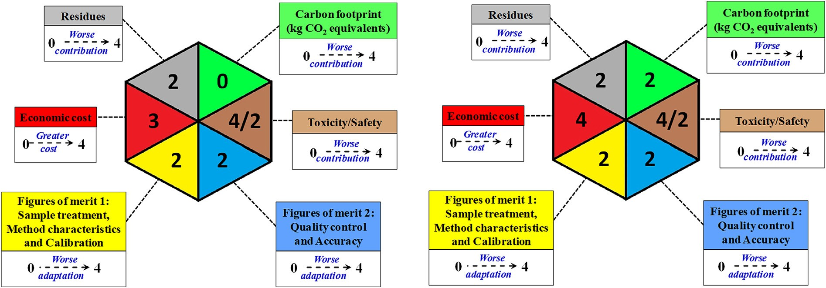
P.M. Nowak, P. Ko'scielniak, M. Tobiszewski et al.
Trends in Analytical Chemistry 133 (2020) 116065
a)
b)
Figures of merit
Variables of the method
Sample
treatment
Method
characteristics
Quality
Control
FM-1
FM-2
Toxicity
Safety
Residues
Calibration
Accuracy
-7
-9
-3
-10-11
-4
-13-13
-6 -6
-22
-7
-7 -7
HPLC-DAD
HPLC-MS/MS
FM-2
-26
-9
-9
HPLC-DAD
HPLC-MS/MS
-32-32
FM-1
-11
Annual cost (€)
Carbon footprint (kg CO2 per sample)
7.282
d)
c)
6.43E+04
HPLC-DAD
HPLC-MS/MS
HPLC-DAD HPLC-MS/MS
Fig. 1. Representation of the penalty points for ﬁgures of merit FM-1 and FM-2, toxicity, safety and residues, and the estimated value of the carbon footprint and annual cost for the SY analysis using HPLC-DAD (red) and HPLC-MS/MS (blue).
Fig. 2. Hexagon pictograms for the SY analysis using HPLC-DAD (left) and HPLC-MS/MS (right).
methods in a given area (e.g. RSD <0.25%). The relationship be- tween the value received for a given criterion (here RSD) and the score to be placed does not always have to be linear over its entire range, and should be adapted to the speciﬁcs of a given criterion.
To facilitate the assessment process, the awarded scores can be rounded off and graded every 5 points, taking into account the additionally mentioned values 33.3 and 66.6 when the result of the method equals LAV and LSV, respectively. Finally, the CS values for a given primary color are calculated as the weighted geometric mean of the scores awarded, with the weights assumed (w), similar to the MB value calculated as the geometric mean of the CS values taken with weights (W).
A special algorithm was designed to evaluate methods using the RGB model, based on a standard Excel spreadsheet. The spread- sheet is available on-line as the original publication's supplement [9]. It should be noted that the proposed model is ﬂexible and al- lows the user to adjust the assessment speciﬁcation to his subjec- tive preferences: weights assigned to given primary colors e W, selection of appropriate criteria for a given primary attribute, weights of given criteria - w, and LAV and LSV values which play the role of reference points. This ﬂexibility is good because it allows a method to be assessed in terms of the planned application and the resulting expectations, it allows the reverse option, i.e. predicting the best method application according to the assessments received
6

0.029

3.89E+04

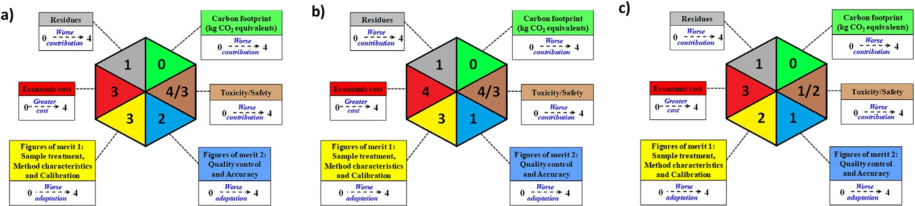
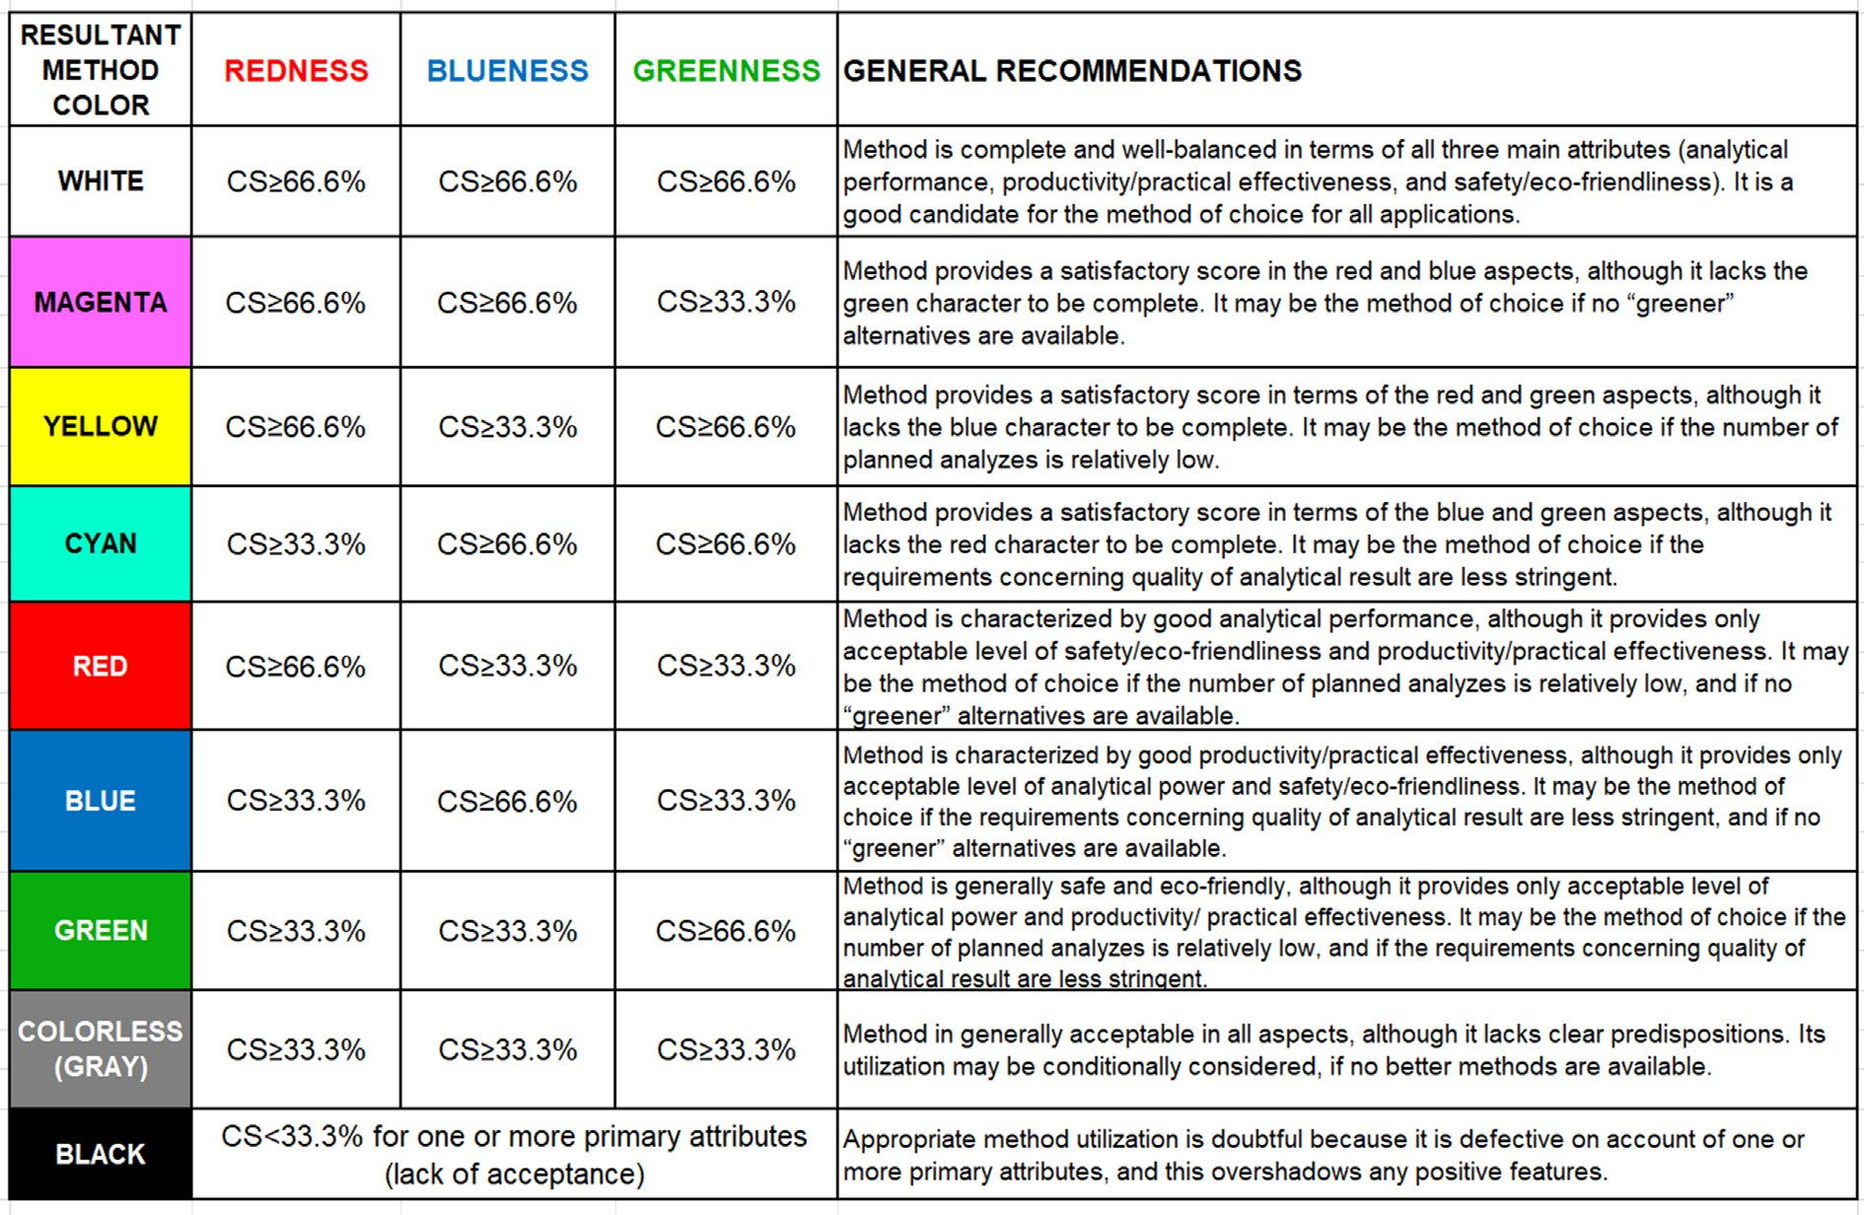
P.M. Nowak, P. Ko'scielniak, M. Tobiszewski et al.
Trends in Analytical Chemistry 133 (2020) 116065
Fig. 3. Hexagon pictograms for the analytical methods: a) CE, b) ELISA, c) PAS and FDS.
with different sets of guidelines, and allows for assessment ac- cording to deﬁned internal standards adopted e.g. in a given labo- ratory due to its speciﬁcity. In addition, the ﬂexibility of the model allows one to re-evaluate the method according to other guidelines. In another scenario, the assessment can be made in an objective manner, according to strictly regulated guidelines adopted by a wider group of analysts. It can be assumed that proposing such standards increasing objectivity of assessments is a matter of the near future.
parameters and their signiﬁcance (weights) was subjective, but was supported by an informal discussion among the widest possible group of employees of the Department of Analytical Chemistry at the Faculty of Chemistry, Jagiellonian University in Krakow, and people from friendly analytical laboratories.
The red attribute (analytical performance) was treated with the
highest relative weight W ¼ 5, which reﬂects the analysts' general
expectations that an effective method should primarily ensure a good quality of the analytical result. The blue attribute (produc- tivity and practical efﬁciency) was treated as the second most
5.2. Exemplary analysis
important, with the relative weight W ¼ 4, because as we assume,
the next general expectation of analysts relates to the practical aspects of the analytical procedure, which can often be another limiting factor. The green attribute (compliance with the principles of green analytical chemistry, i.e. environmental friendliness and
5.2.1. Algorithm speciﬁcation
The assessment using the RGB algorithm was focused on the critical analysis of an overall analytical potential of individual methods. The word “method” was deﬁned as an entire procedure including the preparation of sample material and instrumental analysis, assuming the initial availability of all necessary reagents ready for use in the laboratory. The choice of given assessment
safety) was treated with the weight W ¼ 3. This choice still reﬂects
the strong emphasis on “greenness”, but does not give it priority or equal signiﬁcance to the red or blue attributes, indicated in
informal
discussions
as generally
more
important.
A
detailed
Fig. 4. Nine resultant colors of a method predicted by the RGB model.
7
P.M. Nowak, P. Ko'scielniak, M. Tobiszewski et al.
Trends in Analytical Chemistry 133 (2020) 116065
discussion of the individual criteria selected for evaluation in the red, green and blue areas is given in the ESM.
potential, but rather a simple indication of predispositions and potential areas for improvement, easy to encode graphically, remember and interpret.
5.2.2. Evaluation results
The completed Excel worksheets presenting the assessment results of the six considered methods are shown in Figs. 5e10. To shorten the length of the main text, the detailed discussion of the scores assigned to the individual criteria and resulting CS values is shown in ESM. Below is presented only the discussion of the methods’ resulting colors and MB values (main evaluation outcomes).
5.2.2.2. Brilliance value. An appropriate measure of the global method potential is MB, which is calculated as a weighted geo- metric mean from the corresponding CS values. In addition to the quantitative nature, enabling a more accurate assessment than using color, it depends on the weights (W) assigned to the given
primary attributes (here W ¼ 5 for red, 3 for green and 4 for blue).
Therefore, it allows adjusting the speciﬁcation of assessment (al- gorithm) to the subjective preferences of evaluator, or the more objective rules accepted by a wider group of users.
Considering the individual MB values, HPLC-DAD proved to be
5.2.2.1. Resultant color. The RGB model offers two ways to express an overall assessment of the method, qualitative e using the resultant color, and quantitative e using the method's brilliance value (MB) in the range 0e100%. The best qualitative assessment is white color, which requires having all three CS values over the satisfaction level (Fig. 4). This color is however lacking among the evaluated methods, thus none of them is fully complete. The best method in this sense is HPLC-DAD [11], with the magenta color, and FDS [14] e characterized as cyan. The former one has two primary colors, red and blue, and it lacks green. Thus, in overall, it both ensures good quality of analytical results and is practically/ economically-effective. Therefore, it seems to be worth recom- mending when other more ecological methods are not available. Interestingly, the FDS method has gained another equipotent sec- ondary color of the RGB model (cyan), also indicating the posses- sion of two primary colors, but in this case, they are green and blue. This shows that the strengths and weaknesses of these methods are different. The FDS method lacks analytical performance compared to HPLC-DAD, but is more environmentally-friendly and safe for users in general. It can therefore be a good alternative if frequent routine tests are performed, without stringent requirements regarding the quality of the quantitative results.
The methods that have gained only one primary color are
the best method from the whole group, with MB ¼ 68.1%. This
result, in combination with the obtained magenta color, indicate the undoubted high potential of this method in various respects, with one small drawback in the form of fairly average greenness (see Fig. 7 and ESM). The second method, which may come as a surprise when analyzing the obtained colors, is CE, with the value
of MB ¼ 60.6%. Although this method was previously considered as
gray, i.e. without clearly strong points, the high MB value shows its good inner balance, i.e. maintaining all three attributes at a fairly high level, but slightly below the threshold that guarantees obtaining color (66.6%). This indicates its fairly wide applicability, conﬁrmed by its high position in the ranking. The spectroscopic
methods, FDS (MB ¼ 59.4%) and PAS (MB ¼ 58.6%), as well as HPLC-
MS/MS (MB ¼ 58.3%), were rated slightly lower than CE. The dif-
ferences between these three methods are small. Nevertheless, as shown by the respective colors, the advantages and weaknesses of these methods are different, especially when it comes to the red and green aspects. In this regard, the HPLC-MS/MS (red) is com- plementary to spectroscopic methods (green).
The ELISA method was rated the lowest, with MB ¼ 52.7%. This
result is actually not very low, it still remained above 50%, i.e. above the general “average”, but indicates clear deviations from the other methods. Despite the highest CSred value among all methods and
HPLC-MS/MS [11], ELISA [13]
and PAS
[14]. The HPLC-MS/MS
method has been classiﬁed as red, i.e. its missing attributes are
green and blue. It is worth remembering, however, that despite the high CSred value, above the 66.6% threshold, the two criteria were rated quite poorly e precision and, above all, accuracy (RE above 30%), see Fig. 5 and ESM for more details. Although this method undoubtedly makes up for these deﬁciencies by other features, such as low LOD and “other red aspects”, the low reliability of the assays can be a bottleneck and exclude suc- cessful application of the method in some situations. The ELISA method, in turn, gained red color due to its great precision, ac- curacy, linearity and by far the lowest LOD value. Its big draw- back may be the lack of multi-component analysis, which is simple in the case of separation methods. Therefore, in this respect, HPLC-MS/MS and ELISA complement each other well. The lack of other primary colors, however, informs about their other limitations, which may be crucial in some situations, e.g. costs or complexity of the entire procedure. Another example is the PAS method, considered green, which lacks red and blue colors to be complete. Its use may be justiﬁed in the situation when few analyzes are carried out with relatively low re- quirements regarding the quality of results, e.g. at universities, for educational and didactic purposes related to the problem of adding food colors.
The only method which has not obtained any primary color is CE
[12], marked as gray (colorless). This demonstrates its lack of clearly strong points, hence in the qualitative sense, it can be considered the weakest of the whole group. However, as described in the next paragraph, this does not preclude its competitiveness in relation to other methods, because color is not a good measure of overall
the highest weight assigned to red (W ¼ 5), the low-rated green
and blue attributes, associated mainly with the complexity of an entire experimental procedure, inﬂuenced the lowest position in the general ranking.
6. Comparison of algorithms
The purpose of this section is to compare the evaluation out- comes obtained using the three tools described above. This test was carried out in two variants. In the ﬁrst, the selection of the evalu- ation criteria and the weights assigned to them was done by the authors of the particular approach. It was not previously agreed between the co-authors, so it differed signiﬁcantly between the algorithms (M.T. was responsible for TOPSIS, for HEXAGON A.BeC. and P$CeF., while for RGB P$N and P$K). In the second variant, the speciﬁcity of the algorithms has been uniﬁed, taking the same criteria for assessment as possible, while maintaining the mathe- matical and visual distinctiveness of each tool.
In addition, a new measure of the overall method efﬁciency, Averaged Method Efﬁciency Index (AMEI) expressed in percentages was proposed, which results from assessments obtained using each of the three algorithms:
rﬃﬃﬃﬃﬃﬃﬃﬃﬃﬃﬃﬃﬃﬃﬃﬃﬃﬃﬃﬃﬃﬃﬃﬃﬃﬃﬃﬃﬃﬃﬃﬃﬃﬃﬃﬃﬃﬃﬃﬃﬃﬃﬃﬃﬃﬃﬃﬃﬃ
4 - S
av
3
AMEIð%Þ¼ 100C*$100
$MB
(8)
i
4
8

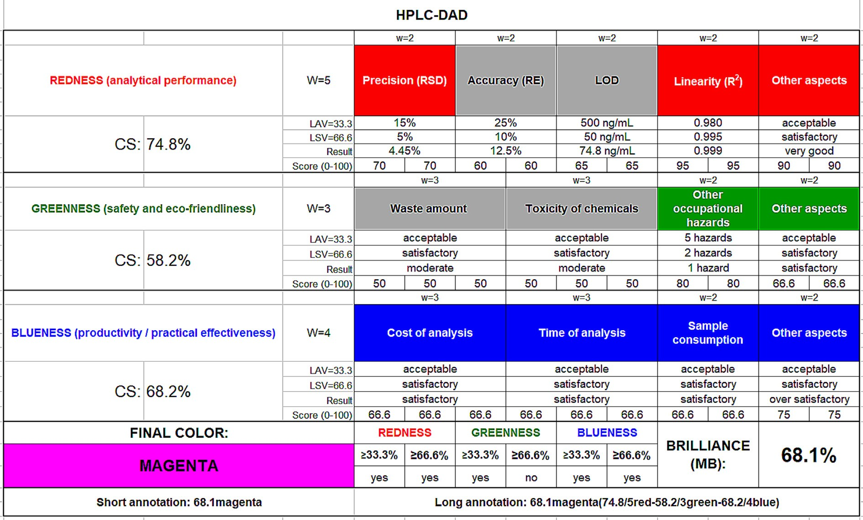
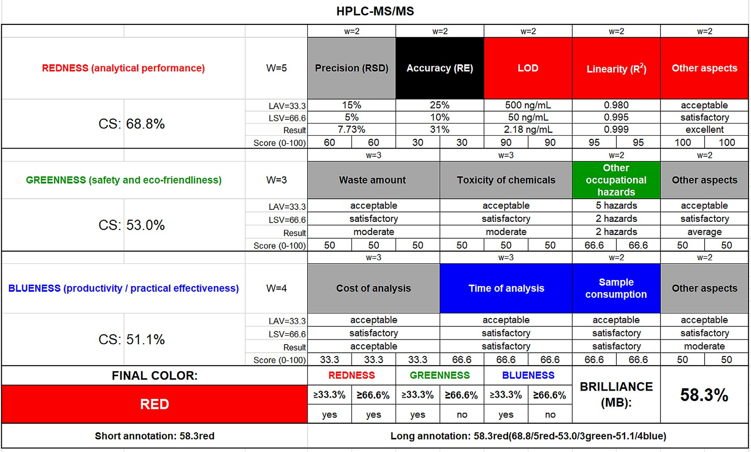
P.M. Nowak, P. Ko'scielniak, M. Tobiszewski et al.
Trends in Analytical Chemistry 133 (2020) 116065
Fig. 5. Outcomes of the HPLC-DAD method evaluation using the RGB algorithm.
Fig. 6. Outcomes of the HPLC-MS/MS method evaluation using the RGB algorithm.
9
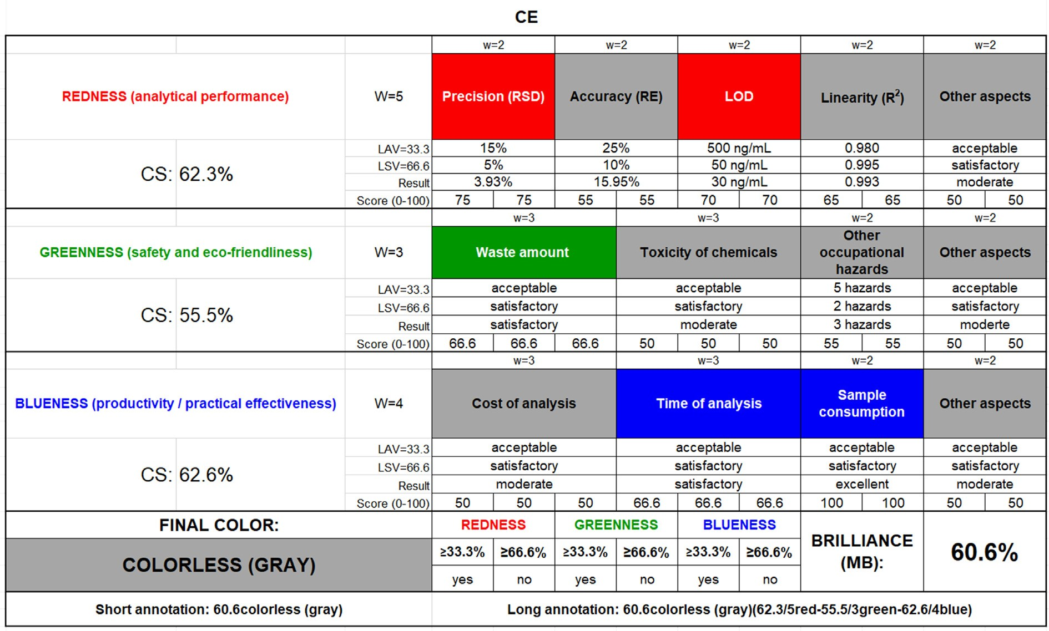
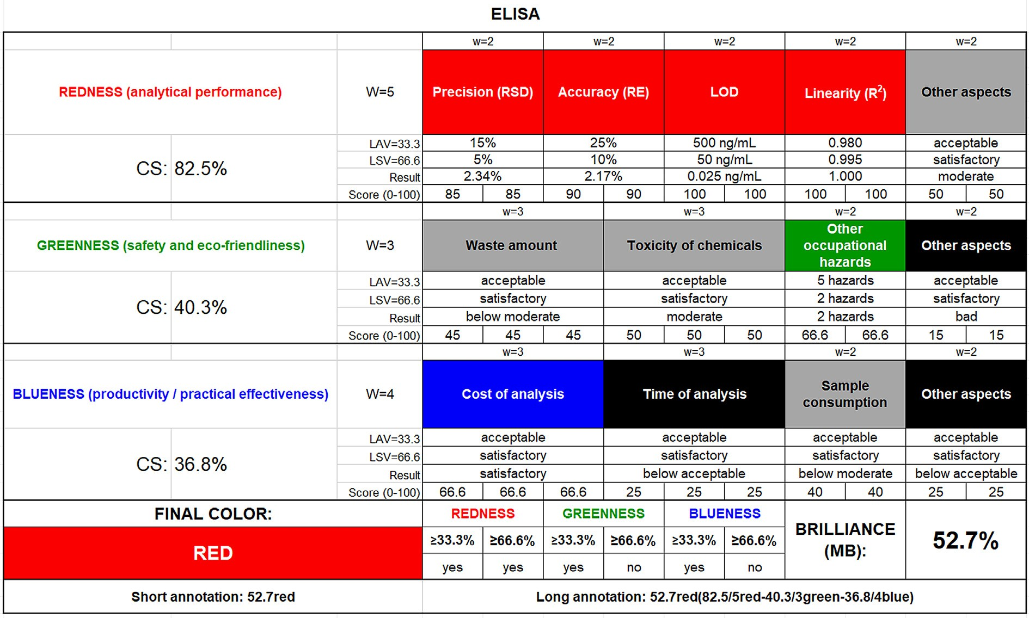
P.M. Nowak, P. Ko'scielniak, M. Tobiszewski et al.
Trends in Analytical Chemistry 133 (2020) 116065
Fig. 7. Outcomes of the CE method evaluation using the RGB algorithm.
Fig. 8. Outcomes of the ELISA method evaluation using the RGB algorithm.
10
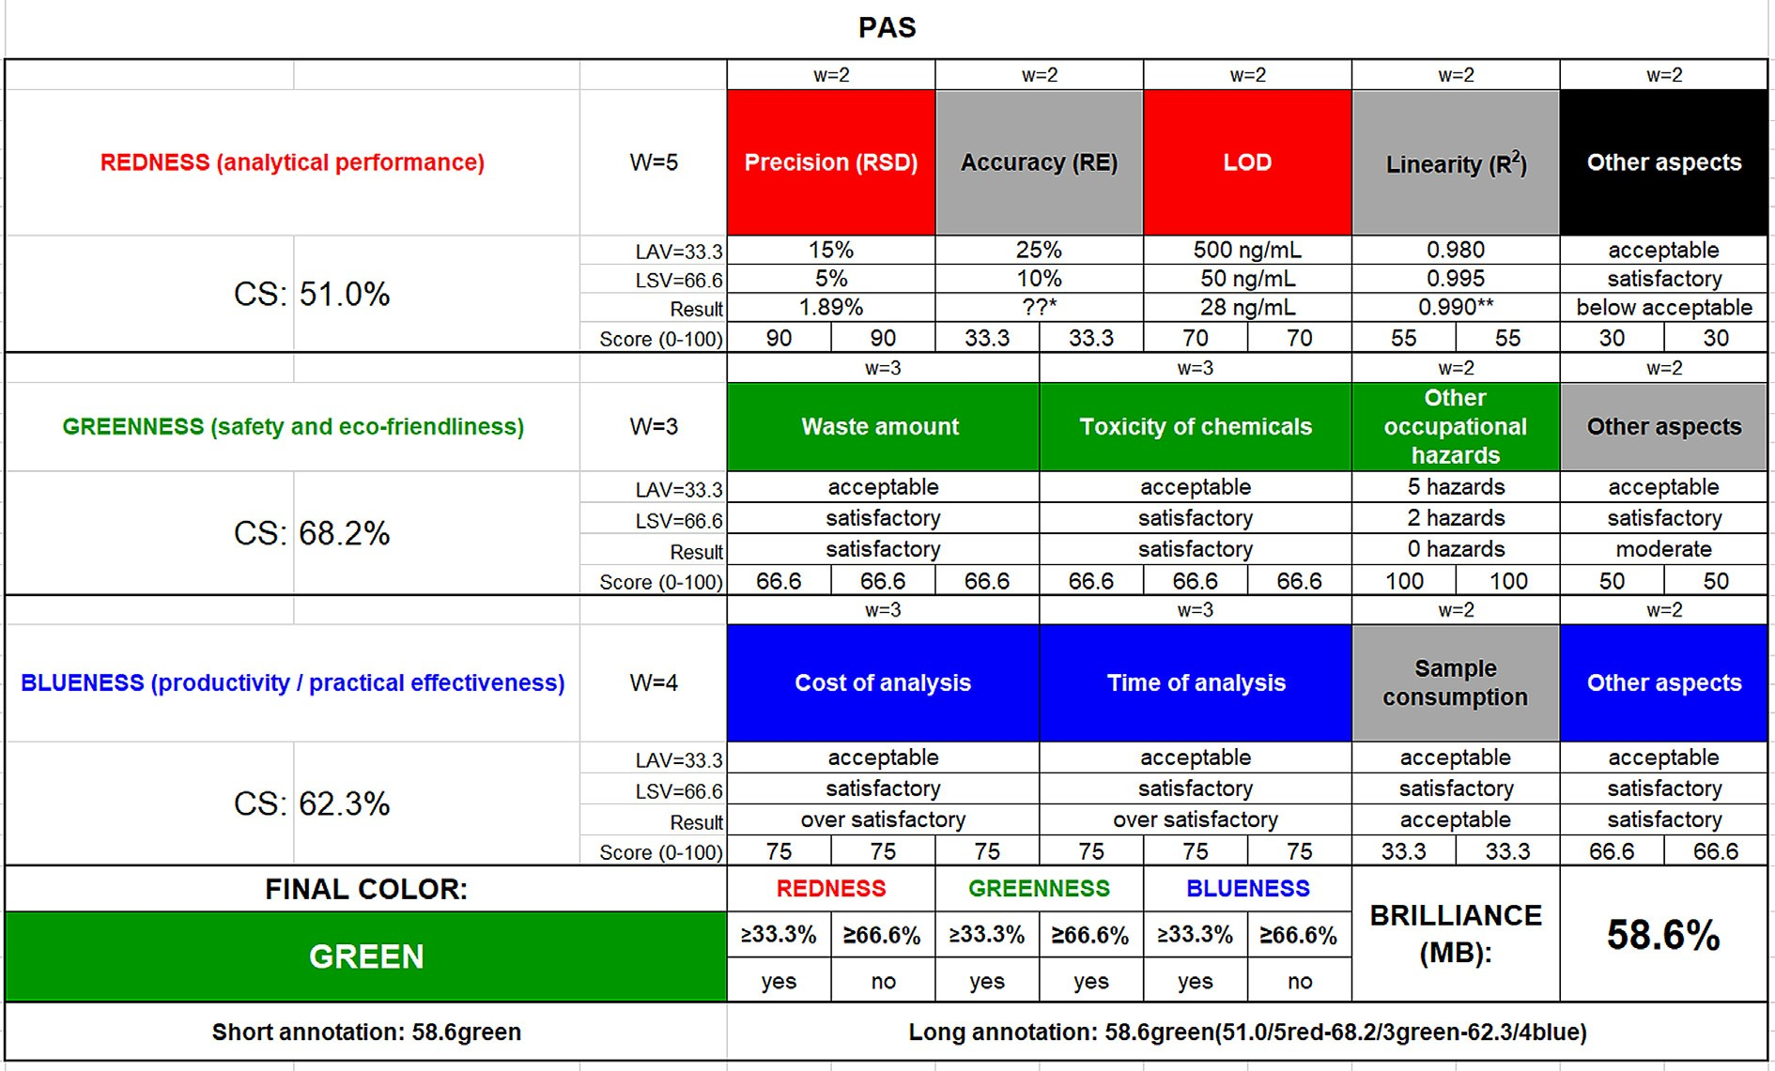
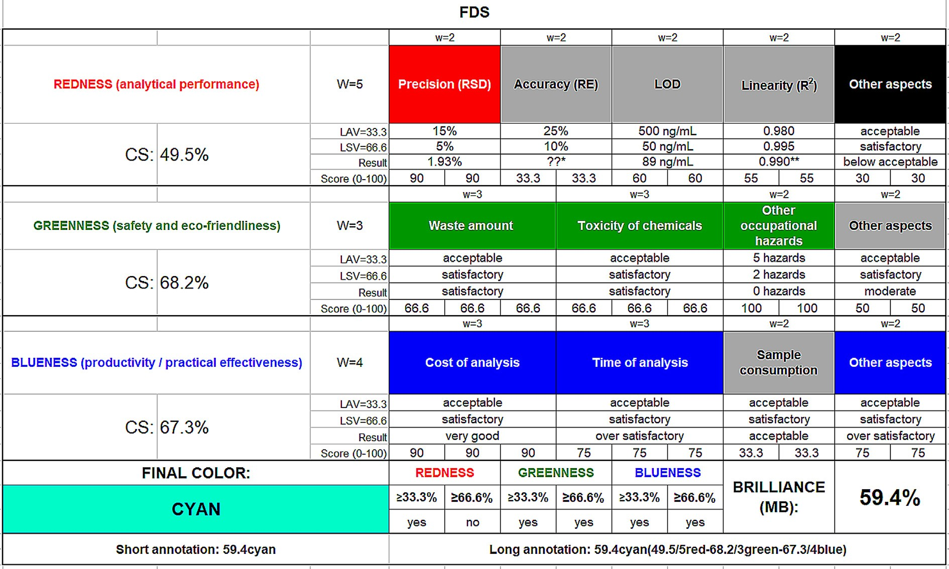
P.M. Nowak, P. Ko'scielniak, M. Tobiszewski et al.
Trends in Analytical Chemistry 133 (2020) 116065
Fig. 9. Outcomes of the PAS method evaluation using the RGB algorithm.
Fig. 10. Outcomes of the FDS method evaluation using the RGB algorithm.
11
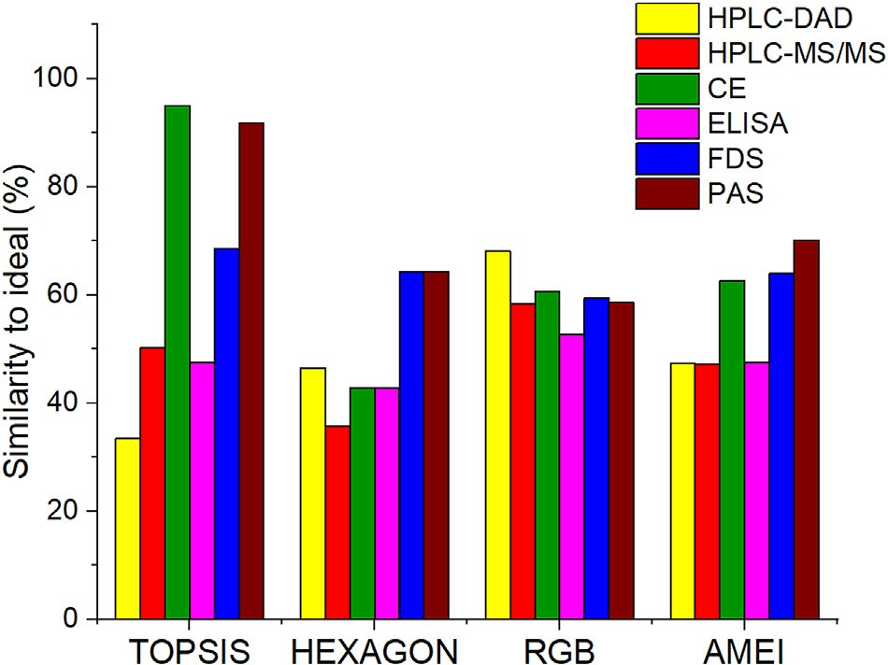
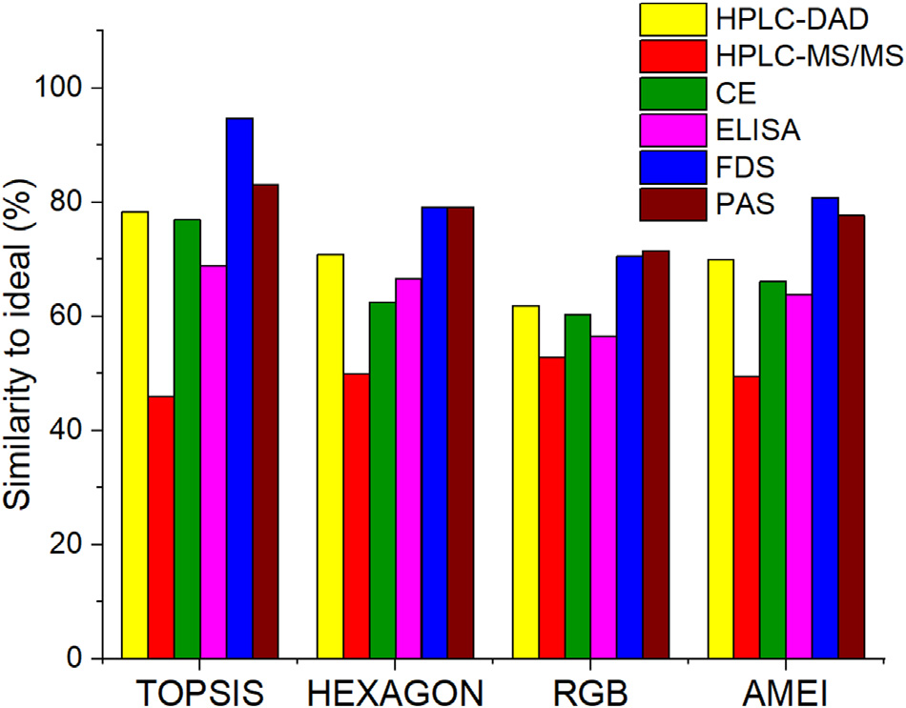
P.M. Nowak, P. Ko'scielniak, M. Tobiszewski et al.
Trends in Analytical Chemistry 133 (2020) 116065
where C* is the closeness to the ideal solution obtained by TOPSIS,
i
S_{av} is the average score (from 0 to 4) obtained by HEXAGON and MB is the brilliance value obtained by RGB model.
AMEI was deﬁned as a weighted geometric mean, to make it more sensitive to possible extreme outcomes that may indicate serious limitations overlooked by the other algorithms. It allows one to rank the compared methods globally from the best to the worst, treating each algorithm used with the same importance. This parameter is therefore useful in expressing the potential of the method in the most general way, eliminating to some extent the subjectivity and speciﬁcs of each approach.
Comparison of the compatibility between the individual assessment outcomes, including: TOPSIS, HEXAGON, RGB and AMEI approaches, is shown in Figs. 11 and 12. They show the values of respective quantitative parameters indicating the overall potential of given methods as a percentage agreement with the ideal situa-
tion, i.e. the best possible value of a given parameter (C*, S_{av} and
i
MB). Fig. 11 refers to the variant in which the selection of assess- ment criteria was different, while Fig. 12 refers to the second variant in which the selection of criteria was agreed as much as possible. To facilitate the analysis of differences between these two variants, the individual criteria used in each algorithm and their relative weights are given in Tables 3 and 4.
As can be seen in Fig. 11, the adoption of different criteria for applying the given algorithms results in the quite different out- comes of assessment. The largest differences are observed in the position of HPLC-DAD and CE methods, while signiﬁcantly smaller and indicating better compatibility, for HPLC-MS/MS and ELISA methods that were poorly assessed by each model, as well as for FDS and PAS that were well rated in any case. This results directly from the guidelines followed by the evaluators of the methods, which are manifested in the selection of the parameters to be evaluated and their relative signiﬁcance. For example, the low po- sition of HPLC-DAD and the high CE according to the TOPSIS model results from a great emphasis on aspects of environmental friendliness and solvent consumption, while the different results obtained by the RGB model for these methods result from the lower relative weight of these criteria and the consideration of other as- pects omitted in TOPSIS, e.g. accuracy, linearity or cost of analysis. On that account, it can be assumed that this situation, combined with a different mathematical structure and other details, is not surprising. On the other hand, the obtained AMEI values indicate an averaged potential of the given methods taking into account all
Fig. 11. Comparison of the evaluation results obtained using all discussed approaches, according to the different speciﬁcs of each algorithm (TOPSIS, HEXAGON and RGB), AMEI presents the averaged outcomes.
Fig. 12. Comparison of the evaluation results obtained using all discussed approaches, according to the uniﬁed speciﬁcs of each algorithm (TOPSIS, HEXAGON and RGB), AMEI presents the averaged outcomes.
Table 3
The list of criteria and their relative weights used in the particular algorithms e variant with the different guideline.
TOPSIS
HEXAGON
RGB
a
Wtot
Criterion
Wtot
Criterion
Wtot
Criterion
LOD
1/8
Figures of merit 1 (sample treatment, method characteristics and calibration)
Figures of merit 2 (quality control and accuracy) Toxicity/Safety
Carbon footprint
1/6
RSD (precision)
10/120
RSD (precision)
Amount of organic solvent Amount of organic solventª
toxicity (hazard) Amount of sample Solid waste
Other analytes (multicomponent analysis)
Time of analysis
1/8
1/8
1/8
1/6
1/6
1/6
Accuracy LOD
Linearity (R²)
10/120
10/120
10/120
1/8
1/8
1/8
Residues
Cost of analysis
1/6
1/6
Other “red” aspects Waste amount Toxicity of chemicals
10/120
9/120
9/120
1/8
Other occupational hazards Other “green” aspects
Cost of analysis Time of analysis
Sample consumption Other “blue” aspects
6/120
6/120
12/120
12/120
8/120
8/120
W_{tot} is the relative weight of a given criterion in respect to all other criteria listed.
a In the case of RGB algorithm W_{tot} includes both “W” and “w” (see Section 4.1).
12

P.M. Nowak, P. Ko'scielniak, M. Tobiszewski et al.
Trends in Analytical Chemistry 133 (2020) 116065
Table 4
The list of criteria and their relative weights used in the particular algorithms e variant with the uniﬁed guideline.
TOPSIS
HEXAGON
RGB
a
Wtot
Criterion
Wtot
Criterion
Wtot
Criterion
RSD (precision) Accuracy
LOD
Linearity (R²) Waste amount
Toxicity of chemicals Cost of analysis
Time of analysis
1/12
1/12
1/12
1/12
2/12
2/12
2/12
2/12
Figures of merit 1 (LOD and linearity) Figures of merit 2 (precision and accuracy) Toxicity of chemicals
Waste amount Cost of analysis Time of analysis
1/6
1/6
1/6
1/6
1/6
1/6
RSD (precision) Accuracy
LOD
Linearity (R²) Waste amount
Toxicity of chemicals Cost of analysis
Time of analysis
1/12
1/12
1/12
1/12
2/12
2/12
2/12
2/12
W_{tot} is the relative weight of a given criterion in respect to all other criteria listed.
a In the case of RGB algorithm W_{tot} includes both “W” and “w” (see Section 4.1). Note, that the choice of criteria and their weights is actually the same for all algorithms. Different are mathematics and visualization.
Table 5
Summary of the strongest and weakest points of each algorithm.
TOPSIS
HEXAGON
RGB
Strong points
Simplicity of operation
Visually attractive pictogram
Colors as an additional platform for coding and communication
Flexibility of selecting criteria and other model's variables
Transparency of assessment by providing all information in an Excel spreadsheet
A more detailed analysis of a method's characteristics is available
Simplicity of visualization/interpretation
Simple assessment rule (awarding penalty points)
e compatible with the Eco-Scale [3] Simplicity of interpretation
No reference thresholds needed
Wide applicability in other ﬁelds than method ranking
Weak points
Lack of a detailed information on a method's characteristics
Applies only to the group of at least several methods (evaluation of a single method is impossible without additional reference data)
A more detailed analysis of a method's characteristics is available
Requires guidelines and expertise for awarding penalty points objectively
Hexagon needs re-scaling (a scale of ﬁve levels with an overall qualiﬁcation ranging from 0 to 4 is established)
Flexibility of assessment variables may potentially diminish its objectivity
Quantitative assessment of some criteria is problematic, sometimes it requires simpliﬁcations and assumptions
algorithms with the same signiﬁcance. They indicate CE, FDS and PAS as globally better than HPLC-DAD, HPLC-MS/MS and ELISA.
The comparison of Figs. 11 and 12 gives a clear conﬁrmation of the role played by the selection of criteria for the ﬁnal evaluation results. In the second variant, much better agreement between individual algorithms was achieved, despite the differences in the assessment method e similarity to the best alternative in TOPSIS, awarding penalty points in HEXAGON and awarding score values based on LAV and LSV reference points in RGB. In addition, other mathematical rules and visualization of outcomes remained different as well. For instance, as far as HEXAGON and RGB present outcomes in a quite pictorial way, TOPSIS is limited to only one table presenting similarity to ideal solution. At the same time, the obtained compliance conﬁrms the usability of each algorithm, and the minor differences observed for some methods should be attributed to maintaining the aforementioned separateness in certain aspects. It is also worth noting that the scores obtained for the methods have different range for the given algorithms. The biggest differences between the methods are observed for TOPSIS, while the smallest for RGB, which results directly from the math- ematical structure.
Our intention was not to indicate the most appropriate approach
to method evaluation, but to make it easier for the reader to choose the optimal tool in a given case. For example, if the graphic design is an important element facilitating the analysis, the HEXAGON and RGB methods are recommended. Conversely, if a user values simplicity, MCDA would be optimal. Moreover, if the assessment of the criteria according to the awarded penalty points seems convenient, as in the case of Eco-scale [3], HEXAGON will be the best choice. If a user values an overall ﬂexibility of the assessment
process, he should choose RGB, if minimum effort, TOPSIS method. To provide readers with additional support, the main advantages and drawbacks of each algorithm are gathered in Table 5. Moreover, the Excel spreadsheets used for evaluating the presented methods, which can be used by readers as a template for other assessments, are provided for each tool in ESM.
7. Conclusions
It can be concluded from this work that the global assessment of the analytical method is not simple, although desirable for many reasons. In this work we illustrated and compared the three different approaches that can be used for this purpose, each with a different speciﬁcation, each worth considering as a valuable auxiliary tool. Despite some differences in the mode of operation, mathematical structure and form of presentation of results, it can be assumed that the results of the assessment of selected methods using these tools will be similar, provided that agreement on the choice of parameters to be assessed and their signiﬁcance is ensured. What is unavoidable, however, some differences should always be expected. In this regard, it is also worth considering the approach of applying all three algorithms, followed by the calcu- lation of AMEI, a new measure of method's general efﬁciency. It quantiﬁes and expresses the averaged overall potential of a given method, and offers yet another perspective of comparing alterna- tive solutions. It may also be interesting to apply another MCDA method, different than TOPSIS, which might occur more effective in a given situation. The aim of this work was not to indicate abso- lutely better or worse approaches to the assessment of methods, because, as the authors agree, each of them offers its own
13

P.M. Nowak, P. Ko'scielniak, M. Tobiszewski et al.
Trends in Analytical Chemistry 133 (2020) 116065
advantages, but also some limitations. We hope, however, that choosing the optimal option in a given situation will be easier, and the interest in carrying out a comprehensive assessment of analytical methods, going beyond the usual validation criteria, will be greater than before and will translate into new opportunities. In the future, we plan to use the described algorithms to evaluate other analytical methods, to further explore their capabilities, develop and improve. For example, a new version of the RGB al- gorithm will be presented soon, it will be simpliﬁed in terms of the selection of variables, allowing for faster evaluation and easier interpretation of results. In case of ambiguities and questions regarding the presented tools, we encourage readers to contact their authors directly.
- A. Gałuszka, Z.M. Migaszewski, P. Konieczka, J. Namie'snik, Analytical Eco-Scale for assessing the greenness of analytical procedures, TrAC Trends Anal. Chem. (Reference Ed.) 37 (2012) 61e72.
- M. Bystrzanowska, M. Tobiszewski, How can analysts use multicriteria deci- sion analysis? TrAC Trends Anal. Chem. (Reference Ed.) 105 (2018) 98e105.
- R. Je˛ drkiewicz, A. Orłowski, J. Namie'snik, M. Tobiszewski, Green analytical
chemistry introduction to chloropropanols determination at no economic and analytical performance costs? Talanta 147 (2016) 282e288.
- R. Je˛ drkiewicz, S. Tsakovski, A. Lavenu, J. Namie'snik, M. Tobiszewski, Simul-
taneous grouping and ranking with combination of SOM and TOPSIS for se- lection of preferable analytical procedure for furan determination in food, Talanta 178 (2018) 928e933.
- M. Kadzin'ski, M. Cinelli, K. Ciomek, S.R. Coles, M.N. Nadagouda, R.S. Varma,
K. Kirwan, Co-constructive development of a green chemistry-based model for the assessment of nanoparticles synthesis, Eur. J. Oper. Res. 264 (2018) 472e490.
- A. Ballester-Caudet, P. Campíns-Falco', B. Pe'rez, R. Sancho, M. Lorente,
G. Sastre, C. Gonz'alez, A new tool for evaluating and/or selecting analytical methods: summarizing the information in a hexagon, Trends Anal. Chem. 118 (2019) 538e547.
- P.M. Nowak, P. Ko'scielniak, What color is your method? Adaptation of the RGB
additive color model to analytical method evaluation, Anal. Chem. 91 (2019) 10343e10352.
- K. Rovina, P. Perumal Prabakaran, S. Siddiquee, S. Md Shaarani, Methods for the analysis of Sunset Yellow FCF (E110) in food and beverage products- a review, Trends Anal. Chem. 85 (2016) 47e56.
- T. Zou, P. He, A. Yasen, Z. Li, Determination of seven synthetic dyes in animal feeds and meat by high performance liquid chromatography with diode array and tandem mass detectors, Food Chem. 138 (2013) 1742e1748.
- F.-J. Liu, C.-T. Liu, W. Li, A.-N. Tang, Dispersive solid-phase microextraction and capillary electrophoresis separation of food colorants in beverages using diamino moiety functionalized silica nanoparticles as both extractant and pseudostationary phase, Talanta 132 (2015) 366e372.
- Y. Xing, M. Meng, H. Xue, T. Zhang, Y. Yin, R. Xi, Development of a polyclonal antibody-based enzyme-linked immunosorbent assay (ELISA) for detection of Sunset Yellow FCF in food samples, Talanta 99 (2012) 125e131.
- T.M. Coelho, E.C. Vidotti, M.C. Rollemberg, A.N. Medina, M.L. Baesso, N. Cella,
A.C. Bento, Photoacoustic spectroscopy as a tool for determination of food dyes: comparison with ﬁrst derivative spectrophotometry, Talanta 81 (2010) 202e207.
- K. Steele, Y. Carmel, J. Cross, C. Wilcox, Uses and misuses of multicriteria decision analysis (MCDA) in environmental decision making. Risk Analysis, Int. J. 29 (2009) 26e33.
- K.F. Pun, I.K. Hui, An analytical hierarchy process assessment of the ISO 14001 environmental management system, Integrated Manuf. Syst. 12 (2001) 333e345.
- K. Govindan, M.B. Jepsen, ELECTRE: a comprehensive literature review on methodologies and applications, Eur. J. Oper. Res. 250 (2016) 1e29.
- M. Behzadian, R.B. Kazemzadeh, A. Albadvi, M. Aghdasi, PROMETHEE: a comprehensive literature review on methodologies and applications, Eur. J. Oper. Res. 200 (2010) 198e215.
- M. Behzadian, S.K. Otaghsara, M. Yazdani, J. Ignatius, A state-of the-art survey of TOPSIS applications, Expert Syst. Appl. 39 (2012) 13051e13069.
- S.J. Dee, B. Cox, R. Ogle, M. Walters, Evaluating inherently safer design with multiattribute utility theory, Process Saf. Prog. 38 (2019), e12022.
- B. Apperl, M. Pulido-Velazquez, J. Andreu A'lvarez, T.K. Karjalainen, Contri-
bution of the multi-attribute value theory to conﬂict resolution in ground- water management application to the Mancha Oriental groundwater system, Spain, Hydrol. Earth Syst. Sci. 19 (2015) 1325e1337.
- M. Maimoun, K. Madani, D. Reinhart, Multi-level multi-criteria analysis of alternative fuels for waste collection vehicles in the United States, Sci. Total Environ. 550 (2016) 349e361.
- C. Zopounidis, P.M. Pardalos (Editors), Handbook of Multicriteria Analysis, vol. 103, Springer Science & Business Media, 2010.
- A. Ishizaka, P. Nemery, Multi-criteria Decision Analysis: Methods and Soft- ware, John Wiley & Sons, 2013.
- V. Belton, T. Stewart, Multiple Criteria Decision Analysis: an Integrated Approach, Springer Science & Business Media, 2002.
- D. Muravev, N. Mijic, A novel integrated provider selection multicriteria model: the BWM-MABAC model, Decision Making: Applications in Manage- ment and Engineering 3 (2020) 60e78.
- M. Noureddine, M. Ristic, Route planning for hazardous materials trans- portation: multicriteria decision making approach, Decision Making: Appli- cations in Management and Engineering 2 (2019) 66e85.
- M. Tobiszewski, J. Namie'snik, Scoring of solvents used in analytical labora-
tories by their toxicological and exposure hazards, Ecotoxicol. Environ. Saf. 120 (2015) 169e173.
- S. Tarín, A. Huici, M.X. Guardino, NTP 726: Clasiﬁcacio'n y etiquetado de
productos químicos: sistema mundialmente armonizado (GHS), Instituto nacional de higiene y seguridad en el trabajo, Spain, 2004. www.insht.es/ InshtWeb/Contenidos/Documentacion/.
- T.V.T. Phan, C. Gallardo, J. Mane, Green MOTION: a new and easy to use green chemistry metric from laboratories to industry, Green Chem. 17 (2015) 2846e2852.
CRediT authorship contribution statement
Paweł Mateusz Nowak: Conceptualization, Data curation, Formal analysis, Investigation, Methodology, Software, Supervision, Visualization, Writing - original draft, Writing - review & editing. Paweł Ko'scielniak: Conceptualization, Supervision. Marek Tobis-
zewski: Conceptualization, Data curation, Formal analysis, Investi- gation, Writing - original draft, Writing - review & editing. Ana Ballester-Caudet: Conceptualization, Data curation, Formal anal-
ysis, Investigation, Methodology, Software, Visualization, Writing - original draft, Writing - review & editing. Pilar Campíns-Falco': Conceptualization, Data curation, Formal analysis, Investigation, Methodology, Software, Supervision, Visualization, Writing - orig-
inal draft, Writing - review & editing.
Declaration of competing interest
The authors declare that they have no known competing ﬁnancial interests or personal relationships that could have appeared to inﬂuence the work reported in this paper.
Acknowledgements
P.M. Nowak acknowledges the ﬁnancial support from the Na- tional Science Centre, Poland (OPUS, 2020e2024, grant no. 2019/ 35/B/ST4/01022). P. Campíns-Falco' and A. Ballester-Caudet are
grateful to EU FEDER and the Gobierno de Espan~a MCIU-AEI
(CTQ2017-90082-P) and the Generalitat Valenciana (PROMETEO 2016/109 and 2020/078) for the ﬁnancial support received. A. B.-C. expresses her grateful to the CTQ2017-90082-P project for her postdoctoral funding.
Appendix A. Supplementary data
Supplementary data to this article can be found online at https://doi.org/10.1016/j.trac.2020.116065.
Electronic Supplementary Material (ESM)
Additional description of algorithms and assessment details, additional outcomes of assessment, Excel worksheets used for evaluations with the integrated algorithms (as a template for modiﬁcation and further use by readers).
References
- M. Tobiszewski, Metrics for green analytical chemistry, Anal. Methods 8 (2016) 2993e2999.
- M. Tobiszewski, M. Mar'c, A. Gałuszka, J. Namie'snik, M. Tobiszewski, M. Mar'c,
A. Gałuszka, J. Namie'snik, Green chemistry metrics with special reference to green analytical chemistry, Molecules 20 (2015) 10928e10946.
14
P.M. Nowak, P. Ko'scielniak, M. Tobiszewski et al.
Trends in Analytical Chemistry 133 (2020) 116065
- J. Płotka-Wasylka, A new tool for the evaluation of the analytical procedure: green analytical procedure Index, Talanta 181 (2018) 204e209.
- M.C. Prieto-Blanco, A. Ballester-Caudet, F.G. Souto-Varela, P. Lopez-Mahía,
P. Campíns-Falco, Rapid evaluation of ammonium in different rain events minimizing needed volume by a cost-effective and sustainable PDMS sup- ported solid sensor, Environ. Pollut. 265 (2020) 114911.
- A. Gałuszka, Z. Migaszewski, J. Namie'snik, The 12 principles of green analytical
chemistry and the SIGNIFICANCE mnemonic of green analytical practices, Trac. Trends Anal. Chem. 50 (2013) 78e84.
- J. Pla-Tolo's, P. Serra-Mora, L. Hakobyan, C. Molins-Legua, Y. Moliner-Martinez,
P. Campins-Falco', A sustainable on-line CapLC method for quantifying anti- fouling agents like irgarol-1051 and diuron in water samples: estimation of the carbon footprint”, Sci. Total Environ. 569e570 (2016) 611e618.
- J. Jime'nez, L. De la Cruz, J. Carballo, A. Dome'nech, Enfoques metodolo'gicos
para el ca'lculo de la Huella de Carbono, OSE Estudios Gr'aﬁcos Europeos S.A., Spain, 2011.
15

