
Sygnatura:PolJRadiol,2007;72(1):15-19
originalarTiClE
Injuriesofdiaphragminchildren–diagnosticproblems
Otrzymano:
2005.01.03
Zaakceptowano:2006.03.20
AgnieszkaBiejat1,TomaszZieliński1,MichałBrzewski1,AnnaJakubowska1,ZofiaMajkowska1,KrystynaIwaszkiewicz2,DariuszPiotrowski2
1DepartmentofPediatricRadiology,MedicalUniversity,Warsaw,Poland
2DepartmentPediatricSurgery,MedicalUniversity,Warsaw,Poland

Author’saddress:AgnieszkaBiejat,DepartmentofPediatricRadiology,MedicalUniversity,Marszałkowska24,00-576Warsaw,e-mail:abiejat@wp.pl
Summary
Nine children with blunt trauma were hospitalized inour hospital from September 2000 to July2005.Thegroupconsistedof7boysand2girlsfrom2to15yearsold.
Theobjectofourarticleistopresentproblemsindiagnosisofdiaphragmaticinjuriesandcomparethepossibilitiesofdiagnosisamongdifferentmethods.Weobserved3childrenwithtraumaofdiaphragm:intwoofthemtheinjurywasonleftsideofdiaphragm,andinone-ontherightside.
Resultsofourexaminationsallowedusonlytosuspectatraumaoftherightsideofdiaphragm,andinonepatientcorrectdiagnosiswasestablishedbasedonautopsy.TheleftsidediaphragmaticinjurywasdiagnosedbymeansoftheCTabdominalscanaftertheextubations.
Althoughvariousdiagnosticmethodswereapplied,diaphragmaticinjuriesconstituteaseriousprobleminthediagnosis.ChestX-rayisstillanimportantpartofdiagnosisinpatientswithdiaphragmatictrauma.
Background:
Material/Methods:
Results:
Conclusions:
Keywords:
traumaticdiaphragmaticrupture•bluntabdominaltrauma•pediatrics
PDFfile:
http://www.polradiol.com/fulltxt.php?ICID=468210
Background
Therecognitionofconsequencesofmultiorganinjurieswasbasedonultrasonographyexamination,computedtomogra-phyandplainfilmexaminationofthethorax,aswellasontheimagesofosseoussystem.
Injuriesof thediaphragm arerarely observed inchildren
–onlyin1–7%ofpatientswithmultiorganinjuries[1–4].Theyareoftenundiagnosedasinthisgroupofinjuriesthemostcommonarethoseaffectingspleen,kidneys,liver,lungsandbones[4].
Ultrasonographywasperformedasaforegroundexamina-tionin6children,whilecomputedtomography–in3chil-dren.Allpatientshadthethoracicplainfilmexaminationsperformedduringtheirhospitalization.Imagesofbones(upperandlowerlimbs,clavicle,ribs,pelvis,spine)weremadefor8patients.
Materialsandmethods
Theaimofhisstudywastocomparediagnosticpossibilitiesofvariousimagingtechniquesinrecognitionoftheconse-quencesofmultiorganinjuries,inordertoevaluatetheirusefulness,particularlyincaseofadiaphragminjury.
Results
Thediaphragminjurieswerestatedin3childrenoutof9intheexaminedgroup.Intwocasestheinjuryconcernedtherightdiaphragmaticdome,andinonecase–theleftdome.Thediaphragminjuriesresultedfromtrafficaccidentsinallcasesandwereaccompaniedbymanyotherinjuriessuchaslungcontusioninallthreepatients,limbs,clavicle,
Withinthelast 5years– fromSeptember2000 untilJuly2005–9childrenwereadmittedtoourhospitalformul-tiorgan injuriessustainedintrafficaccidents(6children)orfallfromaheight(3children).Thegroupconsistedof7boysand2girlsaged2–15years.
15

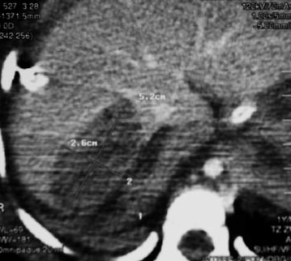
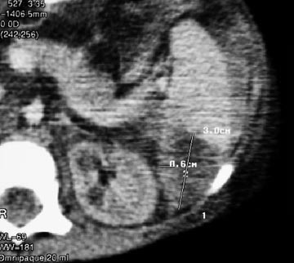
OriginalArticle
PolJRadiol,2007;72(1):15-19
Table1.Consequencesofblunttraumain9children.
No./patient’sage
Locationofchanges
lungs
liver
spleen
diaphragm
bones
intestines
1.*2yr
X
X
X
X
X
2.8yr
X
X
X
X
X
3.7yr
X
X
X
X
4.3yr
X
X
5.8yr
X
X
6.8yr
X
X
7.15yr
X
X
X
8.6yr
X
X
9.6yr
X
X
*–death
pelvisbonefracturesinaneight-year-oldboy,spinalbodyfractureina2-year-oldboyandheadinjurywithlefttemporalbonefractureina7-year-oldboy.Twoofthesepatientswerealsodiagnosedwithliverinjuries,fractureswithhaematomaandspleen injuries(boysaged 2and8).A2-year old patient fromthe described groupdied on the12thdayofhospitalizationinconsequenceofmultiorganinjury(table1).
withindentationofboneelementintothespinalcanalwasalsostated.ThethoracoabdominalCTexaminationrevealedfocusofcontusionintheuppersplenicpole,freeliquidinthevisceralcavityandbothpleuralcavities.CTexamoftheabdomenrevealedlivercontusionfocusinitsrightlobe(fig.1),disorderedareawithinthespleen,con-tusionofitsparenchyma(fig.2)andpresenceofhigherdensityliquid(haemorrhagicexudate)aroundtheliver,rightkidneyandbetweentheintestinalloops.CTexami-nationoftheheadshowedbrainedemawithnotracesofhemorrhage.Veryseriousconditionofthepatientremainedunchangedallthroughthehospitalizationandinconsequenceofseveremultiorganinjuryfollowedbyspinalcordinjurythechilddiedonthe12thdayofhos-pitalization.Autopsyrevealedinterruptionoftherightdiaphragmaticdome,whichwasnotdiagnosedbasedonimagingexaminations.
Allthreepatientshadthoracicplainfilmsdoneinthefirstplace,followedbyabdominalultrasonographyandthora-coabdominalCTscan.
Asforthefirstpatient(table–patentno.1),a2-year-oldboy–themultiorganinjurywasaresultoftrafficacci-dent.Atthetimeofadmission,theplainfilmshowedemphysemawithliquidinbothpleuralcavities.Thetho-racicCTwasperformedafterintubationonthenextdayofhospitalizationattheintensivecareunit.Vesicularlesionswereseenatthebaseofbothlungsandwereinterpretedasposttraumaticchanges.Th6bodyfraction
Thesecondpatient(table–patientno.2),an8-year-oldboy,wasadmittedtohospitalinconsequenceofgettingunderafarmingmachine.ThethoracicCTexaminationperformed
Figure1.AbdominalCT:contusionoftherighthepaticlobe.
Figure2.AbdominalCT:contusionofthespleen.
16

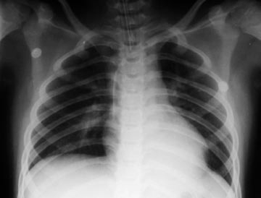
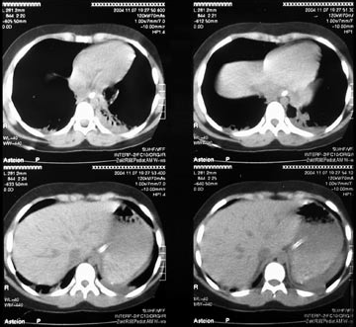
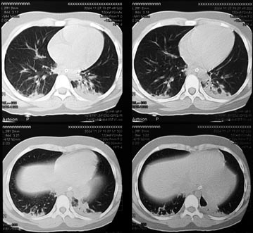
Discussion

Therecognitionofchangeswithinthediaphragm,whichoccurasaresultofmultiorganinjuries,isdifficult.Itisknownthatintheso-calledpenetratingtrauma(e.g.dia-phragminjurycausedbyribfragments),thediaphragmgetsinjuredin25%ofcases,whileinbluntinjuries(trafficaccidents)in75%ofcases[3].

Asforthefrequencyofleftorrightdiaphragmaticdomeinjury,theopinionsdiffer.Someauthorsclaimthattherightdomeisaffectedmoreoften(60%)thantheleftdome(40%)[3].Othersmostlybelievethatthisproportionisreversed,withtherightdomeinjuriesin37,5%–50%ofcases,andtheleft–in50%–78%,whilein12.5%ofcasestheinjuriesinvolvethecentralpartofthediaphragm[1,2,5,6].Asforthethreeofourpatients–theinjuryoftherightdomewasstatedtwiceandtheinjuryoftheleftdome–once.
PolJRadiol,2007;72(1):15-19
Injuriesofdiaphragminchildren...
Figure3.ChestCT:A)contusionofthelowerpartsofbothlungs,B)freefluidbetweenspleenanddiaphragm.
aftertheintubationshowedtherightlungsurroundedbyalargequantityoffreeliquidinthepleuralcavity.Ultrasonographyexaminationoftheabdomenrevealedliverrupturewithpresenceofhaematoma,highlocationofthediaphragmandliquidintherightpleura.TheCTexamperformedafterpleuraldrainageonthe3rddayofhospi-talizationprovedthattherightdiaphragmaticdomewassituatedveryhighandliverwaslocatedwithinthethorax.Although itseemed thatsuch highlocationwas relatedtoamassivehaematomaoftherupturedliver,thefractureofdiaphragmwasalsotakenintoconsideration.Thedefinitediagnosisoftherightdiaphragmaticdomefracturewasmadeduringtheoperation.
Thediagnostic examinationswhich seem tovisualize theinjuriesbestincludethecomputedtomographyandmagneticresonance. Thelatter ismore sensitiveand specificbut israrelyusedfordiagnosticsinemergencycases.Spiraltomog-raphywithsecondaryreconstructionsinthefrontal,sagit-talandaxialplaneshassensitivityandspecificityupto80%[3,4].Onthecontrary–theultrasonographyexaminationsaredifficultandnotunequivocal[4].Inmostcasestheultra-sonographyvisualizesonlytheconsequencesofdiaphragmat-icinjury,e.g.itshighposition,freeliquidintheabdomenorthorax.Sometimeswecanalsoseethereductionofmobilityofthediaphragm,butthissyndromedoesnotnecessarilyprovethetraumaticfracture.Inallpatientsweobservedfreeliquidinthepleuralcavityandabdomenandhighpositionofthediaphragminoneofthethreechildren(patientno.2).
The third patient(table –patient no.3), a 7-year-oldboy,washitbyacarandwasadmittedtohospitalinseriouscondition,withmultiorganinjury.ThoracoabdominalCTscanwasperformedurgentlyaftertheintubation.CTrevealedasmallcontusionareainbothlunglobesandtracesofliquidaroundthespleen(fig.3a,3b).X-rayofthethoraxwasalsomadeandshowedconsolidationinthelowerlobeoftheleftlung(fig.4).Theultrasonogra-phyexaminationoftheabdomenrevealedtracequanti-tyofliquidneartheupperpoleofthespleen.Inviewofpatient’sgoodconditionhewasreferredtothesurgerydepartmentonthe5thdayofhospitalization,aftertheextubation.Withinthenextfewhoursspentatthesur-gerydepartment,abdominalpain,nauseaandvomitingappeared.AbdominalCTexaminationwasprescribed.Itrevealeddisplacementofthestomach andintestineloopsintothethorax.Owingtothatthetraumaticfractureoftheleftdiaphragmaticdomewasdiagnosed.Thesameimagealsoshowedahighpositionofthegastrictube(inthethorax),whatwasanunequivocalsymptomofthefracture(fig.6).Thechildunderwentansurgicalproce-dure.Duringtheoperationa2cmlongfractureoftheleftdiaphragmaticdomewasconfirmed–thestomachandpartofsmallintestinewasplacedbackintheabdomi-nalcavity,andthediaphragmwassutured.Onthe6thdayaftertheoperationthechildwasdischargedfromhospitalinaverygoodgeneralcondition,withnormalimageofthoracicorgans(fig.7).
Thesensitivityofthoracicplainfilmexaminations,whichareperformedtoalmosteverypatient,isonlyabout50%[2].Displacementofthegastrictubeseenontheimageofthethoraxcanleadustothecorrectdiagnosis[2,3],whathappenedincaseofoneofourpatients.Thepassageoftheuppersegmentofdigestivetract[3,7]canalsobeadiag-nosticexamination.Neitherofourpatientsrequiredtheuseofthismethod.
Figure4.ChestX-ray:consolidationoftheleftlowerlobe.
17
B
A

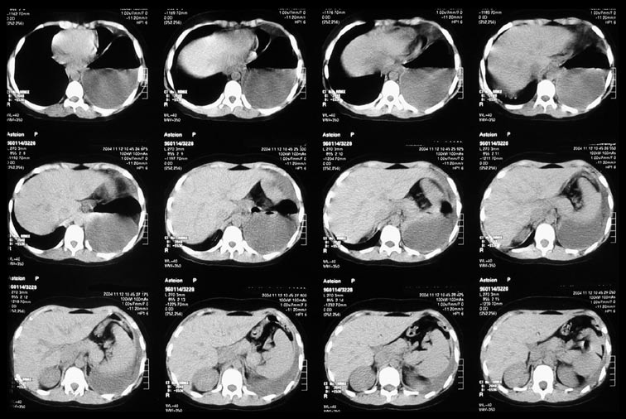
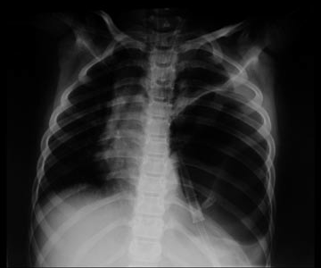
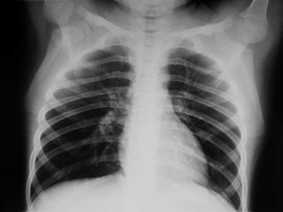
OriginalArticle
PolJRadiol,2007;72(1):15-19
Figure5.AbdominalCT:dislocationofthestomachandbowelstothelefthemithorax.
Themostcommonproblemindiagnosticsofdiaphragmaticinjuriesisthedelayedrecognitionofitsdamage.Latediag-nosis oftraumaticherniaofthe diaphragmcanbecausedbynumerousfactors.Inpatientswhosufferedfromdia-phragmaticmuscleruptureasaresultofbluntinjuryofabdomenandthorax,positivepressureintheabdomenleadstodisplacementoforgansintothethorax.Statesoftympanitesorparalyticileusincreasethepressureinsideoftheabdomenandcancauseorgandisplacementintothethoraxorevenincarcerationoftheseorgansintraumatic
diaphragmaticopening.Itwasobservedinan8-year-oldpatient(patientnr2)withfractureoftherightdiaphrag-maticdomeandextensiveliverhaematomawhichmovedthisorganupwards.Itwassuchanimportantdiagnosticdifficultythatthedefinitediagnosisofpost-traumaticdia-phragmaticherniawasnotmadeuntiltheoperation.
Intheintubatedpatientssupportedwithartificialventila-tion,maintenanceofhighpressureintherespiratorysys-tem preventsfromthepossiblewanderingoforganstothethorax[8].InthesepatientstheimageofthoracicorgansonplainfilmsorCTexaminationsperformedafterintubationcanbenormal.Therefore,thediaphragmfractioncanbe
Figure6.ChestX-ray–largespaceofairinlefthemithorax.Abnormalpositionofthegastrictube.Whitearrow–theproximalendoftubeinthestomach,blackarrow–thedistalendofthetube.
Figure7.ChestX-rayonthedayofdischargefromhospital–normalimageofthethoracicorgans.
18

PolJRadiol,2007;72(1):15-19
Injuriesofdiaphragminchildren...
Conclusions
overlookedin30–50%ofpatients[7,8].Suchsituationtookplaceinoneofourcases(table–patientno.3),whoseplainfilmandCTscandidnotshowanyseriousanomalieswithinthethorax.However,withinafewhoursaftertheextuba-tionthestomachandintestinesweredisplacedintothetho-rax.Dislocationoftheorganscancauseotherseriousclini-calsymptoms(pain,dyspnea,cyanosis,hypoxia,vomiting)whichoccurredinourpatient(table–patientno.3).
1.Injuriesofthediaphragmarerarelyrecognizedandcon-stituteaseriousdiagnosticprobleminspiteoftheuseofvariousdiagnosticimagingtechniques.
2.Computedtomographyisimportantfordiagnosticsandrecognitionofconsequencesofmultitrauma.
However,itshouldalsobeemphasizedthatposttraumaticdiaphragmalhernia,unrecognizedsoonafterthetrauma,canbediagnosedmuchlater,e.g.duringanendoscopicexaminationperformedifthepainsymptomsinpatientsafterbluntinjuriesofthoraxorabdomenremain[3,8].
3.Plainfilmexaminationsofthethoraxstillplayanimpor-tantroleinthediagnosticalgorithmofdiaphragmaticinjuries.Inpreviouslyintubatedpatientsthecheck-upexaminationofthethoraxoughttobeperformedrightaftertheextubation.
References:
- SoundappanSVS,HollandAJA,CassDT,etal:Blunttraumaticdiaphragmaticinjuriesinchildren.JCareInjured2005;36:51–54.
- KilleenKL,MirvisSE,ShanmuganathanK.:HelicalCTofdiaphragmaticrupturecausedbyblunttrauma.AJR1999;173:1611–1616.
- SaccoR,QuitadamoS,RotoloN,etal:Traumaticdiaphragmaticrupturepersonalexperience.ActaBioMedica2003;74;Suppl.2:71–73.
- BlaivasM,BrannamL,HawkinsM,etal:Bedsideemergencyultrasonographicdiagnosisofdiaphragmaticruptureinbluntabdominaltrauma.AmJEmergMed.2004;22(7):601–604.
- MurrayJG,CaoiliE,GrudenJF,etal:Acuteruptureofthediaphragmduetoblunttrauma:diagnosticsensitivityandspecificityofCT.AJR1996; 166(5): 1035–1039.
- BarsnessKA,BensardDD,CieslaDetal:Bluntdiaphragmaticruptureinchildren.JTrauma2004;56:80–82.
- RamosCT,KoplewitzBZ,BabynPSetal:Whathavewelearnedabouttraumaticdiaphragmaticherniasinchildren?JPediatrSurg2000;35(4):601–604.
- CarterYM,Karmy-JonesRC,SternEJ.Delayedrecognitionofdiaphragmaticruptureinapatientreceivingmechanicalventilation.AJR2001;178(2):428.
19

