A C T AA R C H A E o L o G I C AC A R P A T H I C A VoL. XLIX, 2014PL ISSN 0001-5229

A R T I C L E S
5
Nowa Biała aNd Sromowce NiżNe—Late PaLaeoLithic...

PawełValde-Nowak, aNNakraszewska

NowaBiała andSromowceNiżne—
LatePaLaeoLithicceNtraLcarPathiaN SiteS witharched-backedPoiNtS

ABSTRACT

P. Valde-Nowak, A. Kraszewska 2014.Nowa Biała and Sromowce Niżne — Late Palaeolithic CentralCarpathian sites with Arched-backed Points, AAC 49: 5–35.
This article may be viewed as an attempt of summarizing research results of two Late Palaeoli- thic sites from the Central Western Carpathians located in the following places: Sromowce Niżne on the Dunajec river in the Pieniny Mts. and Nowa Biała on the Białka in the Podhale region.The discovery of these sites in the late 70s and 80s of the last century changed the common viewthat mountains areas located north of the Tatras were settled relatively late and that the settle- ment began in the Late Medieval. Both sites were excavated shortly after having been discovered. Although rich inventories of stone remains obtained during excavations are typical for technocom-plex with arched-backed points but, they differ with respect to stone processing technology, typol-ogy and raw materials structure. A thesis about the existence of very classical relations between them and the so-called Witów-complexes as well as typical connections with the Federmesser enviroment is proposed in thisarticle.
K e y w o r d s: Late Palaeolithic; West Carpathians; arched-backed points (ABP) technocomplex;
Federmesser; radiolarite
Received: 09.01.2015; Revised: 21.01.2015; Revised: 29.01.2015; Accepted: 09.03.2015

INTRoduCTIoN

This article is an attempt of summing up results of the excavations of two Late Palaeolithic sites coming from the Western Carpathian Mountains and located in Sromowce Niżne on the Dunajec river in Pieniny Mts. and Nowa Biała on the Białka river in Podhale (Fig. 1). The discovery of these sites changed the widelyheldviewconcerningthelatesettlementofmountainsareaslocatednorth oftheTatras.Accordingtothatview,thesettlementbeganintheLateMiddle

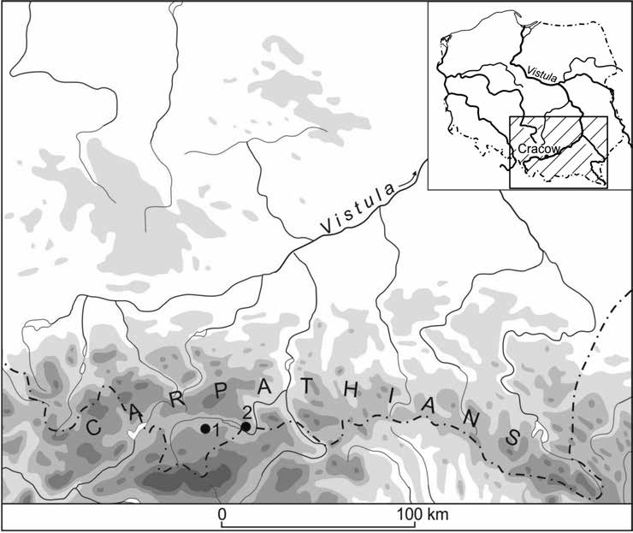
Fig. 1. Polish West Carpathians with two Arched Backed sites; drawn by the authors.
1 — Nowa Biała, powiat Nowy Targ, województwo małopolskie, Poland, site No. 1;
2 — Sromowce Niżne, powiat Nowy Targ, województwo małopolskie, Poland, site No. 1.

Ages. The first of the above-mentioned sites was discovered in the autumn of 1976 during gathering of radiolarites needed for carrying out mineralogical and geochemical research (Fig. 2)1. A dozen of radiolarites items were found then in an area of about 50 square meters. Their location on a high Pleistocene terrace of erosion of Dunajec river between the mouth of Sobczański gorge and the estu- ary of Macelowy Potok in the gorge of the river (Fig. 3) suggested a relationship with the Late Paleolithic hunting and fishing settlement. The second site was discovered in May 1985 during a local inspection of caves in the Obłazowa Rock (670 m asl.;cf. Fig. 4). More than 20 flint and radiolarite artefacts were found in Andrzej Bednarczyk’s farmland during these activities. Both sites were excavated shortly after they having beendiscovered.

1Radiolarities were gathered by students of archaeology of the Jagiellonian university,J.Ry- dlewski andP.Valde-Nowak which resulted in assembling of over a dozen radiolarites from sur- faces of the farm fields belonging to S. Bożęcki, M. Regiec, M. Waradzyn. An endscraper on theflakeandathickbackedpiecewerefoundthen.

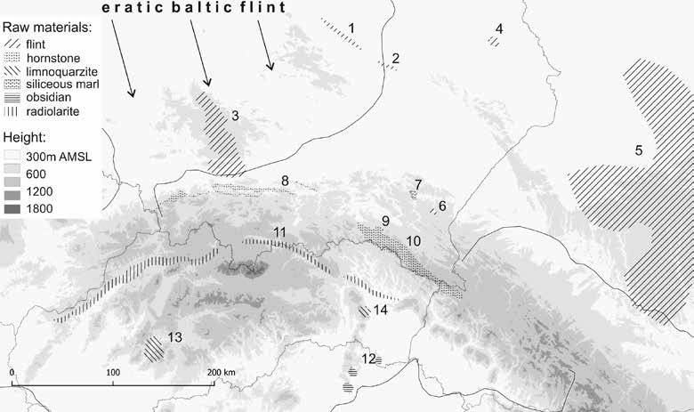
Fig. 2. Main stone sources represented in the Late Palaeolithic inventories
from Western Carpathians (acc. to different authors); drawn by the authors.
1 — Chocolate flint; 2 — Ożarów-, Świeciechów-, Gościeradów-flint; 3 — Jurassic flint; 4 — Rejowiec flint; 5 — Wolhynian flint; 6 — Bircza flint; 7 — Dynów siliceous marl; 8 — Mikuszowice hornstone; 9 — Cergowa hornstone; 10 — Black menilite hornstone; 11 — Pieniny radiolarite; 12 — Tokai obsidian; 13 — Kremnica limnoquarzite; 14 — Banské limnoquarzite.

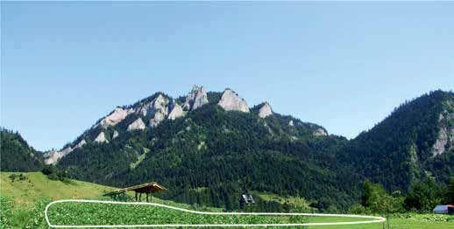
Fig. 3. Sromowce Niżne, powiat Nowy Targ, województwo małopolskie, Poland, site No. 1.
The range of the site (white line) on the agricultural fields ofJ.Regiec, S. Bożęcki
and M. Waradzyn. Trzy Korony Mt. (982 m asl.) in the background; Photo by P. Valde-Nowak.

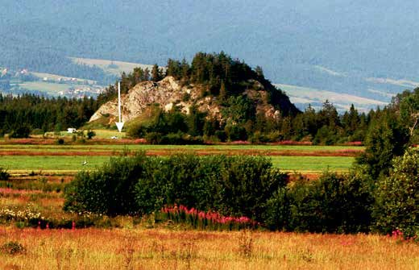
Fig. 4. Nowa Biała, powiat Nowy Targ, województwo małopolskie, site No. 1. Topography
of the site (arrow). The Obłazowa Rock (670 m asl.) in the background; Photo by P. Valde-Nowak.

THE EXCAVATIoNS

The inventory of Sromowce Niżne was discovered in 1976. In summer of 1977 excavations of the site were initiated. They were continued in 1978 and 19802covering an area of 367 square meters. After few years of excavations theinven- tory comprised of 2459 artefacts, from among of which approx. 10% were tools (Rydlewski,Valde-Nowak1978;1979;1981a).Thesiteisofstoneprocess- ing character, utilizing the local beds of radiolarite. The raw material spectrum oftheSromowceinwentoryindicatesapredominanceoftheredradiolaritewich makes up for 90% of there. Among the others there are: Cracow-Jurassic flint and obsidian from the territory of contemporary Slovakia or northernHungary.

2The research excavations during the years 1977–78 were carried out by students of ar-chaeology of the Jagiellonian university,J.Rydlewski andP.Valde-Nowak. They were conducted under the scientific supervision of Prof. Dr.J.K. Kozłowski and with the financial support ofthe Archaeological Comission of Polish Academy of Sciences in Cracow, and Regional office forthe Protection of Monuments in Nowy Sącz (R y d l e w s k i, V a l d e - N o w a k 1978; 1979; 1981a). Materials from the first two seasons have been elaborated in the master thesis in Jagiellonianuniversity (V a l d e - N o w a k1979). The finds from these excavations are in private hands of
J.Rydlewski, M.A. They have been not deposed by the institution indicated by the conservator by this day and therefore they remain inaccesible.

The artefacts lay in a structureless position in the layer II of dusty character and yellow-brown color. Single artifacts were found both in an arable soil and deeper, in traces of the root system. The analysis of the cuts of excavations and geomorphological characteristics indicate dislocation of the artefacts and not keeping their original arrangement which was caused by a colluvium process. The analysis presented below concerns inventories from the first two excavation seasons (V a l d e - N o w a k 1979). The items found in 1980 remain inaccessible (cf. Footnote No.2).
TheinventoryofNowaBiała,siteNo.1,discoveredin1985andexcavatedintheyears1985–1986and2012,2014consistsofover1700artefacts.IncontrasttotheinventoryofSromowce,nowonly77,5%ofartefactswasmadeoflocalradiolarite.
Research excavations at the Nowa Biała, site No. 1 may be divided into two parts. The first one took place in 1985–86 while the second one in2012–14. The area of 54 square meters was explored during the first part. Stratigraphy of the site was identified which resulted in distinguishing the following layers: I — plough soil earth, II — soli of dusty character, III — clay base and rock scree appearing in the northeastern part of the excavation (Fig.5).
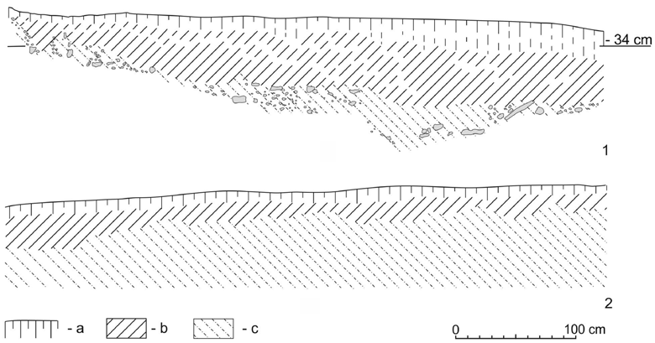
Fig. 5. Nowa Biała, powiat Nowy Targ, województwo małopolskie, Poland, site No. 1.
Southern (1) and northern (2) cross section of the trench I/1986; drawn by the authors.
a — arable layer; b — dusty layer; c — clay base with stones scree.

The inventory gathered at that time, together with artefacts scattered on the surface, comprised of 765items.
The research excavations were resumed in 2012. Excavation trenchI/2012, located west of the already excavated area, covered an area of 125 square meters. The inventory derived there was composed of 952 stone artefacts; 734 amongthemlayinsituwithindustylayerII,150inanarablelayer,whereas

77 artefacts were recovered from the surface of the whole site. Stratigraphy of the excavations partially agreed with observations made during the initial sea- sons of the research, however layer II in the western part of the excavation was completely destroyed by plowing, and an oval structure interpreted as relics of possible dwelling structure was observed in the northeastpart.
In2014anareaof15squaremeterswasexploredtograbthenorthernrange of the excavation site. 74 stone artefacts were found then, 30 of them camefrom the surface of farm fields, 13 lay in an arable layer and 21 in the layer II. The layer II had been leveled out by intensiveplowing.

DWeLLING STRuCTuRe AT NOWA BIAłA, SITe NO. 1

In the northeast corner of the excavation the remains of an oval object of diameter of 3 meters were found. The western part of the object had been destroyed. The outline of the object was regular and its maximum depth was 40–45 cm below of field surface. In the eastern part a hole-root was visible. In the central part traces of the hearth as well as an unidentified structure, most likely being a trace of unidentified organic substance were observed. Few stone artefacts occurred in the fill (Fig. 6).A concentration of stone artefacts was found at the sectors adjacent to the possible dwelling structure to the south. A large number of anvils, hammerstones and debitage forms allow us to interpret this place as a domestic workshop. Accumulation of charcoals has been interpreted as the second, outdoor fireplace. Around the dwelling structure, precisely from its northeastern part, a zone of yellowish clay and, most probably, the activity area was caught. The AMS dating 11270 ± 60 BP (Poz-53553) of charcoals from the fireplace was per- formed. A series of oSL dating was carried out for the above-mentioned hole-root, object and for the geological profiles. Moreover, the archeobotanical samples were taken for those profiles, as well3. A ferruginous concretion of the characteristics ofamagnetitewasfoundinthelayerIIatthedistanceof2meterstoSW4.

3The AMS and oSL measurements as well as archeobotanical analysis were carried out by dr. M. Komar within the project No. 691/N-ukraina:Paleolityczna ekumena strefy pery- i metakar-packiej — studium zmian środowiska zachodniej Ukrainy i południowo-wschodniej Polski w plejsto- cenie i ich wpływu na pierwotne osadnictwo oraz szlaki migracji (na podstawie stanowisk lessowych i jaskiniowych; see http://ekumena.umcs.lublin.pl). Through this grant the analyses of AMS, oSLaswellaspalynologicmeasurementswerecarriedout.WeareindebtedtoProf.Dr.M.łanczont,the head of the project, for co-operation and support for the analytical program of the samples from the excavations of Nowa Biała, site No. 1. The analytical results are being progressed about the final report of theproject.
4A possibility for it to have been a meteorite iron was initially taken into account which, however, was not confirmed by a series of microscope analyses. Edges of the conrection have some traces of crushing. This created a possibility of regarding the item as an element of a tinder-box kit. We express our gratitude to Ass. Prof. dr. M. Biborski, M. Biborski M.A, Ass. and dr. M.Paszkowski for helpful consultations and carrying out primary analysis. We are also gratefulto
J.Śniadek M.A. for geological microscope analysis.

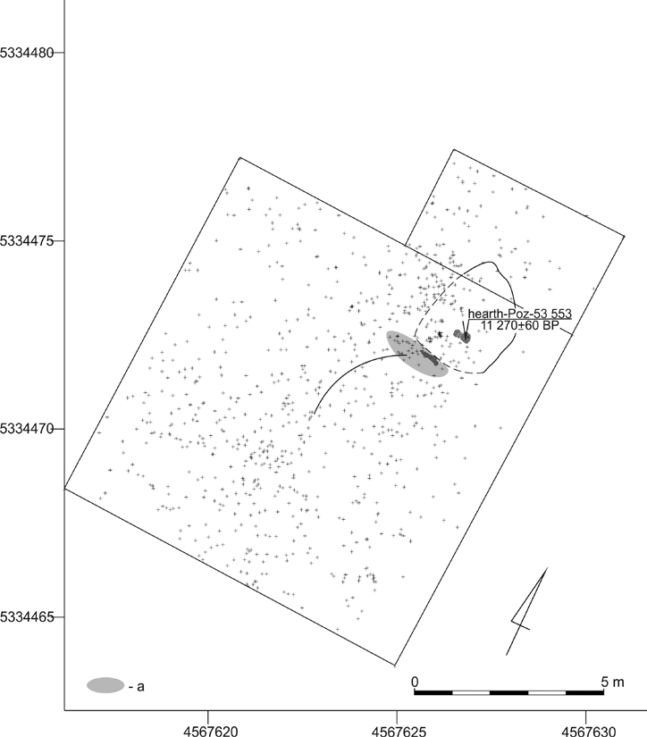
Fig. 6. Nowa Biała, powiat Nowy Targ, województwo małopolskie, Poland, site No. 1.
The planigraphy of stone artefacts in the trench I/2012 and the range of possible dwelling structure; drawn by the authors.
a — domestic flint workshop with sandstone plates and hamerstones.

The INVeNTORy FROM SROMOWCe NIżNe, SITe NO. 1

The inventory consisting of 2437 artefacts was derived from the site. 1016 items were found in the years 1977–1978 (V a l d e - N o w a k 1979) and the next 1421 in 1980 (R y d l e w s k i, V a l d e - N o w a k 1981a; see Table1).

Table1
Sromowce Niżne, powiat Nowy Targ, województwo małopolskie, Poland, site No. 1. Structure
of the inventory.

Sromowce Niżne — inventory | 1977–1978 | 1980 | Total
Cores | 33 | 37 | 70
Flakes | 638 | 917 | 1555
Blades | 127 | 134 | 261
Tools | 92 | 124 | 216
Negative pieces | 97 | 132 | 229
Hammerstones | 24 | 75 | 99
Burin spalls | 5 | 2 | 7
Total | 1016 | 1421 | 2437

Rawmaterialsstructurecanbepresentedasfollows.ThePieninyradiolaritepredominates(96%).onlyfewartefactsaremadeofotherkindsofstonemateri-als:Cracow-jurassicflint—36pieces,obsidian—2pieces,undetermined—6.Thegroupofpre-coresandcoresisrepresentedby70items(2,9%);33ofwhichwerecomprehensivelyanalyzed.Pre-coresarerepresentedbyoneitemofahorseshoeshape(Fig.7:3).Theoriginalintentionofaknapperisrepresentedbysingle-platformflakecores.Among29completeitemsfoundinthefirsttworesearchseasons,asmuchas15aresingle-platformcores(Fig.7:1,4,6,8;8:1;9),onehavetracesoforientationchange(Fig.8:3),3areindouble-platformstage(Fig. 8:5–6). The most common are either small or microlithic,irregularitemsornotwellusedones.Thevariabilityofashapeandproportionisclear.Thesefeaturesaresomehowcausedbythespecificationofrawmaterialandtechniquewas used. Concretions showing strong cracking and bearing traces ofhardhammerused in many cases reveal some unintended effects. As many as 9pieceshaveno core preparation. uneconomical treatment of raw materials puts thestudied
inventory closer to the assemblages occurring in areas rich in raw materials.
Flakespredominatesignificantlyintheinventory(638pieces—thefirsttwo seasons, 917 — the year 1980). Among them there are no cortex flakes coming from the first phase of the knapping. It seems that only already pre-prepared items occurred in the site. In the inventory from two first excavation seasons 127 pieces have been classified as blades. A large number of them bear some traces of intentional fragmentation. Many seem to berandom.
Tools represent 8,9% of the whole inventory. 92 of them, of which 20 formed on blades and 30 on flakes, were found in the years 1977—1978. Other 124 tools were found in 1980.
The structure of the group of tools is as follows (Table 2): endscrapers 64
(30%), arched-backed points 24 (11%), burins 29 (13%), truncations 19 (9%),
perforators 8 (4%), macro-tools 4 (2%), retouched blades and flakes 46 (21%),
combined tools 5 (5%), others 2 (1%).

Table2
Sromowce Niżne, powiat Nowy Targ, województwo małopolskie, Poland, site No. 1.
Structure of tools group.

Sromowce Niżne — tools | 1977–1978 | 1980 | Total
Backed pieces | 11 | 13 | 24
Endscrapers | 23 | 41 | 64
Burins | 14 | 15 | 29
Truncated | 7 | 12 | 19
Perforators | 3 | 5 | 8
Macro-tools | 4 |  | 4
Retouched blades and flakes | 15 | 31 | 46
Combined tools | 4 | 1 | 5
others | 2 |  | 2
Pieces of undetermined tools | 11 | 4 | 15
Total | 92 | 124 | 216

The tools found in the years 1977–1978 were thoroughly analyzed. The most numerous group was composed of endscrapers. Thumbnail endscrapers predomi- nated (8 pcs.). Two of them were made on irregular blades (Fig. 10:9; 11:2), an- other two were the so-called oblique endscrapers on flakes (Fig. 11:1) One item was identified as a circular form (Fig. 11:5), another four as double endscrapers (Fig. 11:3–4, 6). Among further types there are mouth-endscrapers made on a flake (Fig. 11:8). Two forms were recognized as scraper-like tools made on large flakes (Fig. 10:10), five as atypicalforms.
Among the eleven backed pieces there are small and microlitic forms with arched or fully arched backs. Most of the items are complete (9 pcs.). Forms withrefractedbackandobliquereducebase—theonesofdoublerefractedback (Fig. 13:3, 5) and straight back and oblique reduced by base (Fig. 13:10), were also recorded. A similar backed piece with a contour similar to a triangle and a very thick back (Fig. 12:6) appeared in Całowanie, Level III cut XII (S c h i l d et al. 2014, 118). An interesting form is the item considered as a blade with a tiny retouch on its right side (Fig.12:9).
Burinsarerepresentedby14pieces.Thefollowingtypologicalvariantshave beendistinguished:angleburinsagainstatruncation,dihedralsymmetricburins, multiple burins and single blow burins (Fig. 13; 15). Seven items with less or more oblique truncation were classified as truncatedpieces.
Among the perforators, items such as a massive blade with asymmetric sting were recognized (Fig. 12:11). Two tools were classified into the group „Others”. Interesting is an asymmetric trapeze-like tool formed on flakes (Fig. 13:12).

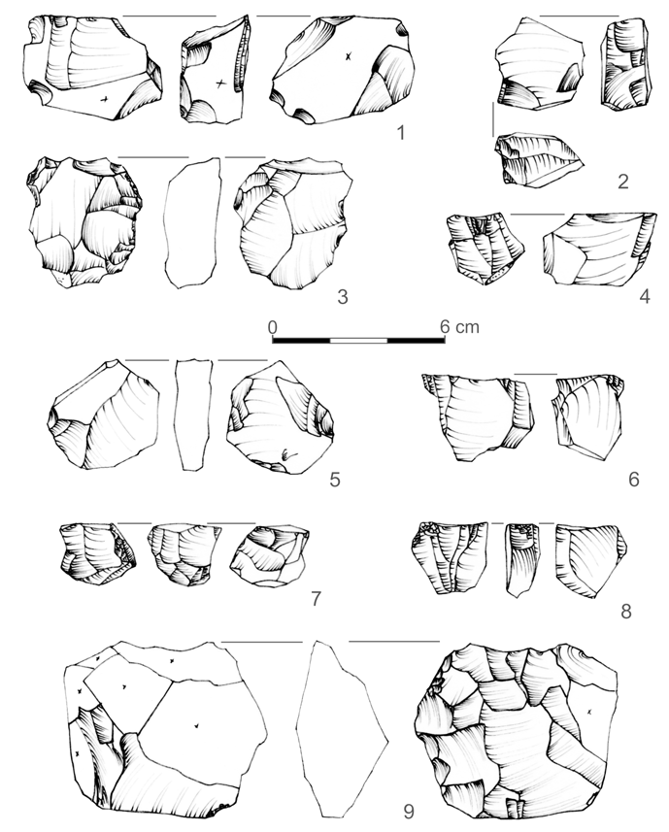

Fig. 7. Sromowce Niżne, powiat Nowy Targ, województwo małopolskie, Poland, site No. 1. Cores;
drawn by authors.
1–9 — radiolarite.

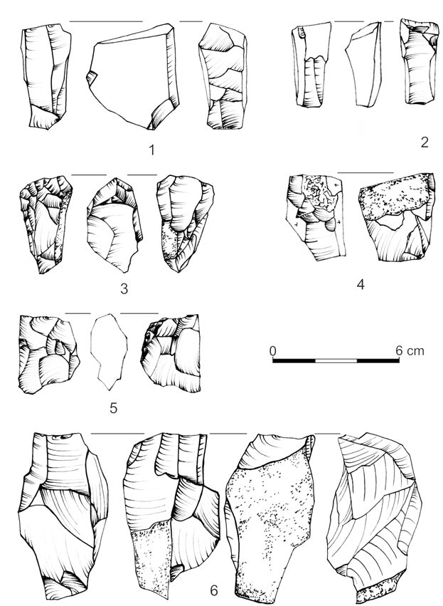

Fig. 8. Sromowce Niżne, powiat Nowy Targ, województwo małopolskie, Poland, site No. 1. Cores;
drawn by the authors.
1–6 — radiolarite.

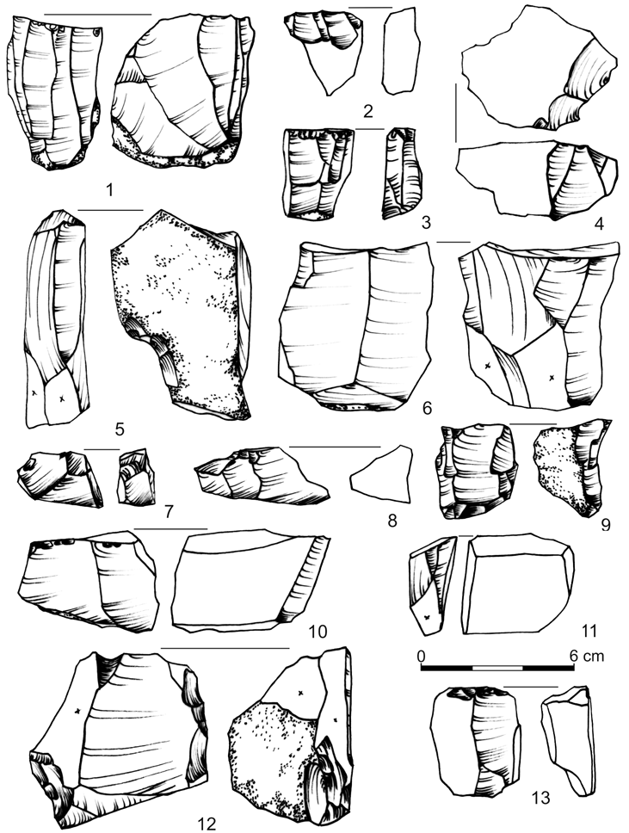

Fig. 9. Sromowce Niżne, powiat Nowy Targ, site No. 1. Cores; drawn by the authors.
1–13 — radiolarite.

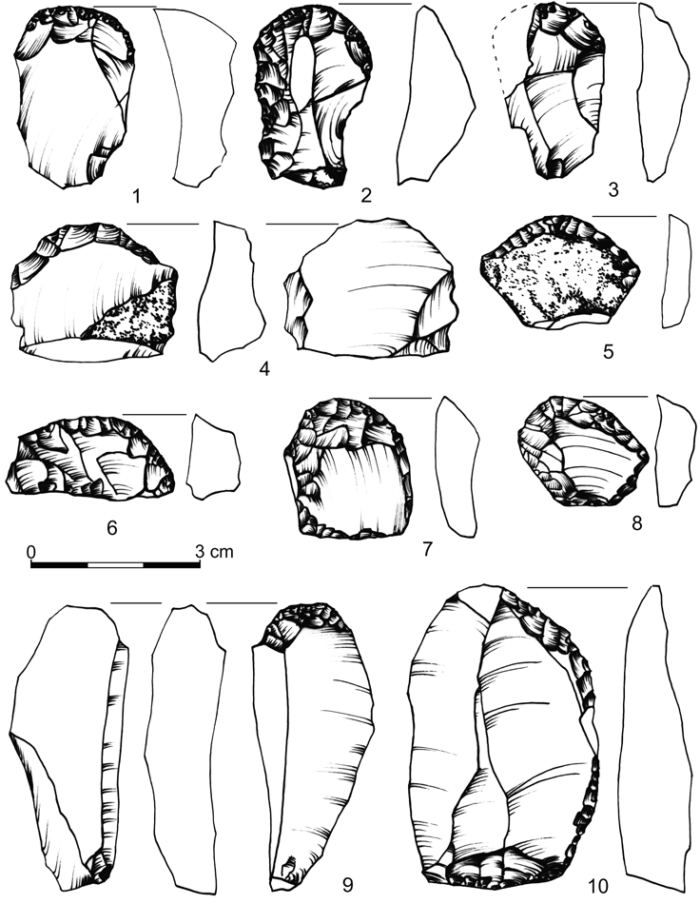

Fig. 10. Sromowce Niżne, powiat Nowy Targ, województwo małopolskie, Poland, site No. 1.
Selected finds; drawn by the authors.
1–9 — endscrapers; 10 — scraper; 1–4, 6–10 — radiolarite, 5 — Cracow Jurassic flint

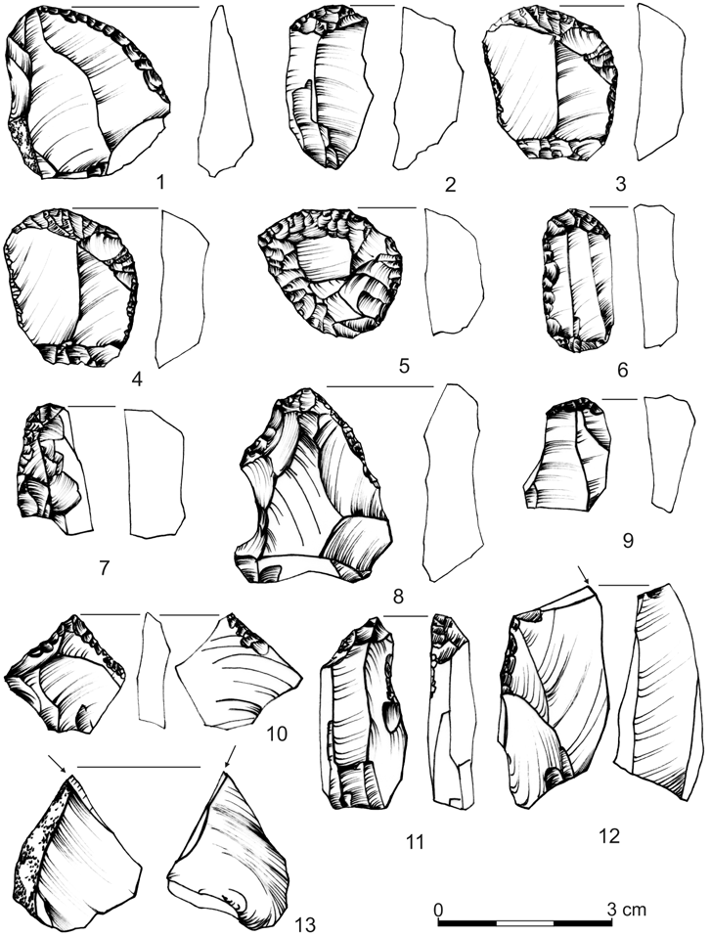

Fig. 11. Sromowce Niżne, powiat Nowy Targ, województwo małopolskie Poland, site No. 1.
Selected finds; drawn by the authors.
1–9 — endscrapers, 10–11 — perforators; 12–13 — burins; 1–13 radiolarite.

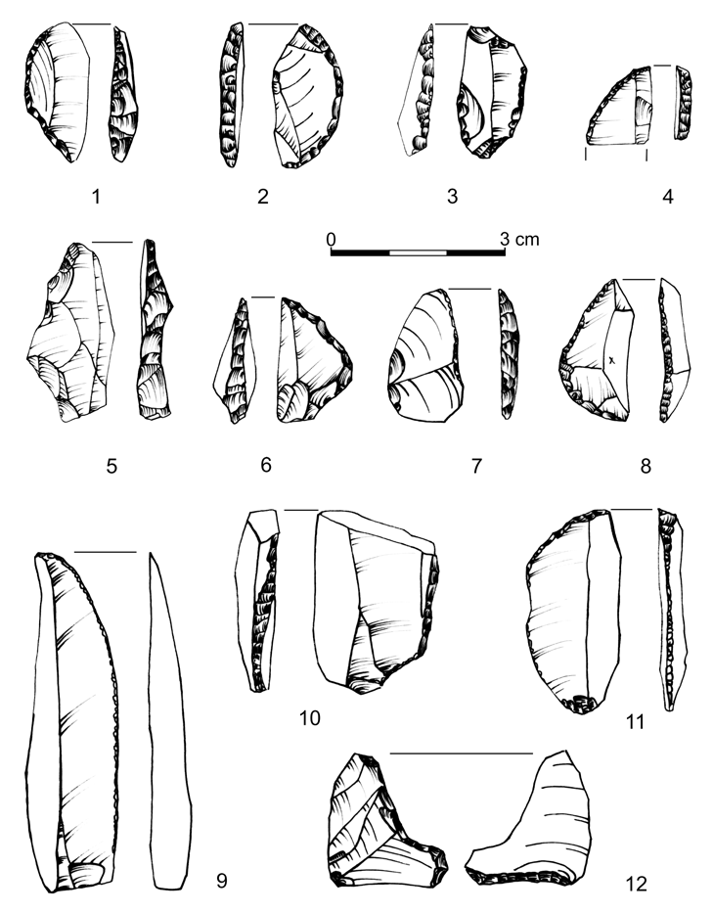

Fig. 12. Sromowce Niżne, powiat Nowy Targ, województwo małopolskie, Poland, site No. 1.
Selected finds; drawn by the authors.
1–11 – backed forms; 12 — atypical form; 1–3, 5–10 — radiolarite; 4, 11 — Cracow Jurassic flint.

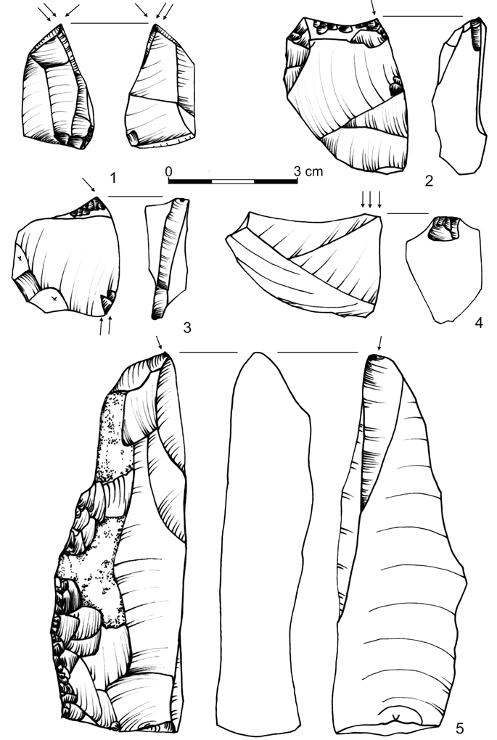

Fig. 13. Sromowce Niżne, powiat Nowy Targ, województwo małopolskie, Poland, site No. 1;
Burins; drawn by the authors.
1–5 — radiolarite.

The INVeNTORy FROM NOWA BIAłA, SITe NO. 1

A collection of 1702 stone artifacts has been derived from the site and 1321 of them layin situin the layer II. An overall structure of the inventory is presented below. A multifaceted analysis was carried out for the material derived fromthe socalledlayerII,whereitlayinsitu(Table3).
Table3
Nowa Biała, powiat Nowy Targ, województwo małopolskie, Poland, site No. 1.
Structure of the inventory.

Nowa Biała — inventory | 2012 | 1985–1986 | Total
Cores | 4 | 8 | 12
Flakes | 303 | 445 | 748
Blades | 143 | 102 | 245
Blade/flakes fragments | 128 |  | 128
Tools | 90 | 54 | 144
Negative pices | 25 | 6 | 31
Burin spall | 13 |  | 13
Total | 706 | 615 | 1321

Therawmaterialsstructuremaybesketchedasfollows.ThePieninyradio-laritepredominates(77,44%).Someshareofartifactsismadeofotherkindsofstonematerials:Cracow-jurassicflint(12,79%),chocolateflint(6,28%),obsidian(0,68%),Świeciechówflint(0,08%),undeterminedflint(0,68%;cf.ChartNo.1).Thenumberofcoresinthewholeinventorywas19(9itemsfrom2012,11from the previous excavations). 12 cores were derived from the layer II(4atstage II, 8 at I). Red radiolarite finds predominate (9 pcs.), other are madeof
Cracow Jurassic flint.
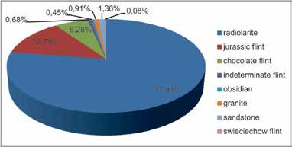
Chart No. 1. Nowa Biała, powiat Nowy Targ, województwo małopolskie, Poland, site No. 1.
Raw material structure of the inventory; drawn by the authors.

Single-platformcores,whosecoretrimmingboileddowntopreparingofstrik- ing surfaces, predominate. one of them is an item of tablet shape with no traces of core preparation on the platform, another one is a conical core (Fig.16:5).
other cores, planned generally for blade exploitation, are characterized by one striking platform. They represent cores with changed orientation. Never did the cores transit into the flake stage. Two such cores were made of Cracow ju- rassic flint. The first of them is cuboid-shaped and does not have prepared sides (Fig. 16:2). Blades are of a small size and have been obtained from the slightly convex striking platform. Despite the significant overexploitation, blades’ exploi- tationfromtheoppositeplatformswascarriedoutconstantly.
Yet another one is made of Cracow Jurassic flint. The striking surface con- firm exploration of blades (Fig. 16:6). yet another one, made of red radiolarite, has a conical shape, prepared platform, traces of edges and back preparation. It is a kind of a core exploited by blades exploitation. Some traces of renovationon one of its faces may be noted. on the apex of core platform negative of removal flakes are visible (Fig. 16:1). An interesting case is a massive blade core made of red radiolarite. It is boat-shaped, with changed orientation (Fig. 16:7). Another example is the red radiolarite core made of a large flake, partially covered by a cortex (Fig.15:3).
This group contains an exemplar of core flakes made of pebble stone of red radiolatite. There are no traces of preparation expect platforms.
Flakes prevail in the inventory (29,54%), however the participation of blades is also significant (12,07%), especially when compared to the inventory out of the Sromowce Niżne, site No.1.
Among the artefacts 144 items have been classified as tools (Chart No. 2; Table 4). Endscrapers prevail through the inventory (48 pcs.). These items are of Tarnowa-type, small and short, made out of the flakes or blade-fragments. Forms with rounded, oblique or straight working edge occur numerously (Fig. 17). 9 tools were classified as burins.

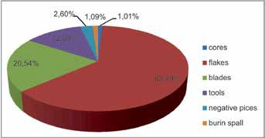

Chart No. 2. Nowa Biała, powiat Nowy Targ, województwo małopolskie, Poland, site No. 1.
General structure of the inventory; drawn by the authors.

Table4
Nowa Biała, powiat Nowy Targ, województwo małopolskie, Poland, site No. 1.
Structure of tools group.

Nowa Biała — tools | 2012 | 1985–1986 | Total
Backed pieces | 9 | 5 | 14
Endscraepers | 16 | 32 | 48
Burins | 4 | 5 | 9
Notched tools | 8 |  | 8
Retouched blades and flakes | 25 |  | 25
Pieces of undetermined tools | 4 |  | 4
Hammerstones | 24 | 6 | 30
others |  | 4 | 4
Combined tools |  | 1 | 1
Perforators |  | 1 | 1
Truncated |  |  | 0
Total | 90 | 54 | 144

Backed pieces are represented by 14 items, mostly preserved fragmentarily.
4 finds were derived during the first stage of the excavations (Valde-Nowak 1987). One of them was made of limnoquarzite (Fig. 18:4), the second was made of obsidian (Fig. 18:2), the third, reminiscent of a shouldered point, was made of chocolate flint (Fig. 18:3) another one of Cracow Jurassic flint (Fig. 18:5). The otherswerefoundinthesecondstageofexcavations.
during the excavations carried out in the year 2012 a complete arched backed piece made of Cracow Jurassic flint, with refracted back and oblique re- duced base was found (Fig. 19:7). A fragment of a massive backed piece made of Volhynian flint (Fig. 19:3) as well as a proximal fragment of backed piece with notched retouch on base, made of red radiolarite (Fig. 19:8) were recognized as slender forms. All these items correspond well to classical forms of Federmesser found in different variants of “Penknife civilization” (S c h w a b e d i s s e n 1973, 253). Among them there is a distinctive item of irregular shape and straight back formed on flake (Fig.19:9).
Nothickset,ogivalformsknownfromWitówandKatarzynów(Chmielew- s k a 1978) and characteristic for the Sromowiec Niżne, site No. 1 have been reported in theinventory.
Numerous hammerstones of quartz and sandstone come from the workshop situated in front of the dwelling structure. one of them forms a few-element puzzle. Flat, broken retoucher, composed of three pieces, comes from the previ- ous excavationresearch.
In 2012 in the ploughing layer (I) three younger elements were discovered in secondary position. They are: top part of the blade — probably the tanged point, made of green radiolarite, Mesolithic trapez made of chocolate flint and flat regular blade core with opposite platforms made of Cracow Jurassic flint.

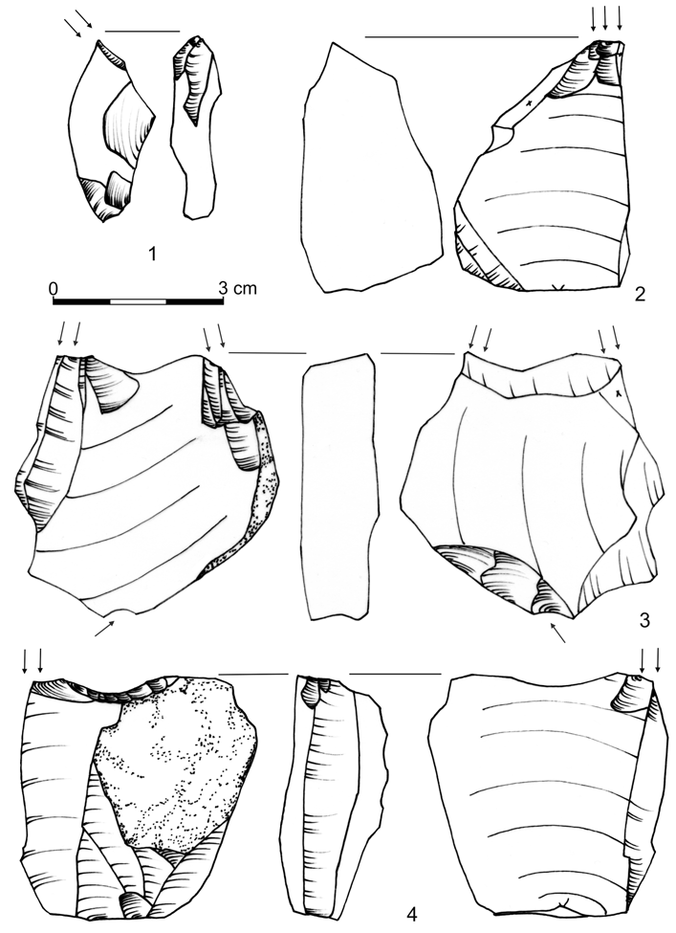

Fig. 14. Sromowce Niżne, powiat Nowy Targ, województwo małopolskie, Poland, site No. 1.
Burins; drawn by the authors.
1–4 — radiolarite.

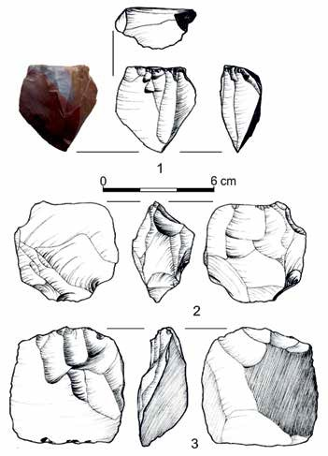

Fig. 15. Nowa Biała, powiat Nowy Targ, województwo małopolskie, Poland, site No. 1. Cores;
drawn by M. Biernat and the authors.
1–3 — radiolarite.

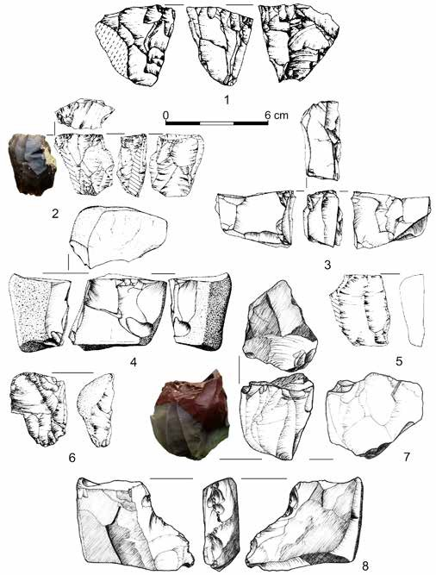

Fig. 16. Nowa Biała, powiat Nowy Targ, województwo małopolskie, Poland, site No. 1. Cores;
drawn by M. Biernat and the authors.
1, 6 — Cracow jurassic flint, 2–5, 7–8 — radiolarite.

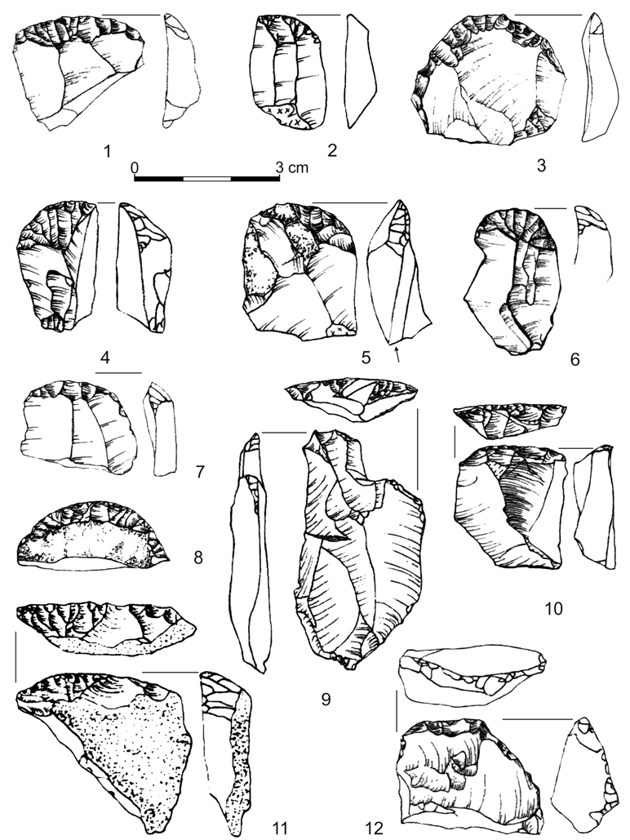

Fig. 17. Nowa Biała, powiat Nowy Targ, województwo małopolskie, Poland, site No. 1.
Endscrapers; drawn by the authors.
1–5, 7, 9–10, 12 — radiolarite, 6 — obsidian, 8, 11 — Cracow jurassic flint.

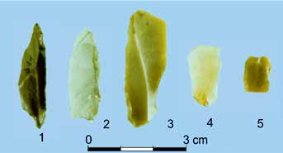
Fig. 18. Nowa Biała, powiat Nowy Targ, województwo małopolskie, Poland, site No. 1.
Backed forms; Photo by the authors.
1 — radiolarite, 2 — obsidian, 3 — chocolate flint, 4 — limnoquarzite, 5 — Cracow Jurassic flint.

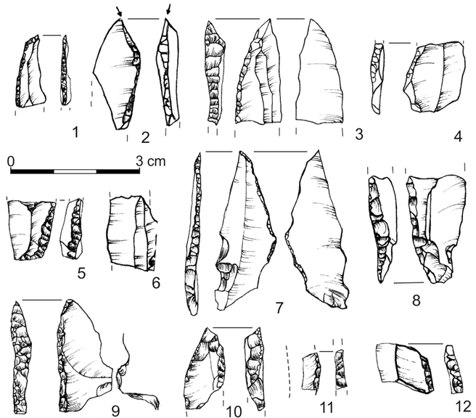

Fig. 19. Nowa Biała, powiat Nowy Targ, województwo małopolskie, Poland, site No. 1.
Backed forms; drawn by the authors.
1, 3, 7, 12 — Cracow jurassic flint, 2, 4–6, 8, 9–11 — radiolarite.

dISCuSSIoN

Raising a discussion on this topic can be enhanced by determinations, on which we intend to focus in this paper. They come out of the view on two Late Pal- aeolithic backed points inventories, known from the mountainous area in the Central West-Carpathians.
Intensification of the archeological research in the northern Carpathian Mountains led to the discovery of two relatively big sites of such technocomplexes: Sromowce Niżne, site No. 1 and Nowa Biała, site No. 1. Our aim is to focus on them as each one represents a different technological and typological variant of thesetechnocomplexes.
Both sites are situated within small areas of the occurrence of radiolarites and both prove this raw material to have been exploited. We will present some elements of differentiating the backed points as well as different ways of stone processing.InscopeoftheproposalofclassificationoftheABPcomplexes,itmay be concluded that one of those sites — Sromowce Niżne — may represent the Witowgroup(Chmielewska1961)whiletheother—NowaBiała—suggests alinkwiththeFedermesserculture(Schwabedissen1954;Taute1963). The stratigraphy of both open air sites is coherent. The artefacts are gathered inloess-likesedimentsrightbelowtheploughinglayer.Thesitesareconvergent in terms of the topographic position. Both are in a valley of a big mountainous river, close to the edge of terraces. It points out for a big role of fishing in the everyday life and diet of the inhabitants of thecampsites.
Clear differences are visible in the case of the cores. Most of them found inSromowce have no traces of preparation, except for the platforms. They representa concept of flake-blade, or just flake core. In case of the inventory of Nowa Biała,contrary to the Sromowce inventories, the blade- and blade-flake cores predomi-nate, usually in the double platform stage. Soft hammer procedure is documented.In the Sromowce inventory the majority of backed pieces have lenghts notexceeding 3 cm. They are thick and segment-like. Thick-back and triangle-in-shape forms draw the attention. Among the tools the end-scrapers constitute30%. Critical for the reconstruction of the technological face of the end-scrapergroup is that the majority of them were made of flakes and not of severed
blades.
In the case of the Nowa Biała inventory the tool index reaches 16%. In the toolgroupthemostcharacteristicarebackedpoints.Theirgroupishoweverdif- ferentiated.Big(over4cm),lancet-likespecimenandbackedpieceswithreduced base are present. End-scrapers with extremely short flakes are typical, however there are also numerous scrapers made of detached blades. It corresponds well with the outcomes of the analysis of thecores.
A value of the site No. 1 in Nowa Biała comes out of yet different factors. A concentration of interesting relics explored in the circular structures that we are ready to assume as a dwelling trace has been found there. From that place hammerstones of sandstone and plates of that material were found there.Also

an iron concretion, probably a magnetite, was determined. It bears traces of percussion working. A function of the “lighter” cannot be excluded. From this area an AMS date 11270 ± 60 BP is known (Poz-53553). It is the dating like of GI-1c, or in another words generally just after the mid-Lateglacial Interstadial period (W e b e r et al. 2011, 278–279).
This is even more interesting since both sites are 20 km away from each other and placed in the same river basin. Moreover, it is difficult to indicate inventories in the Carpathian range providing a context for either of the vari- ants. only few finds of arched points were made within a radius of several tens of kilometers; furthermore, their connection with the techno-complex that we are interested in, is certain by different extent. The first we want to point out is the cave Sucha Díera in Slovakia. After the rescue excavations, a fireplace was found there and few silica artefacts, and among them one thick backed point (S o j á k,ha r n i č á r 1999; S o j á k, S u c h ý 2001; S o j á k,hu n k a 2003). From a bone of Capricorn two C-14 date were obtained. They are as follows: 11620 ± 390 BP (Gd-30012), 11230 ± 280 BP(Gd-18146).
In the picture one can see a range of the chronometric determination asa result of the events fluctuation. It has been done because of the reason thatthe dates were made of bones and their strict relation with the settlement wasnot certain. Anyway the range of both fit well the developed stage of the Allerød.The second West-Carpathian site, which we want to point is Zagórze, site
No. 2, discovered during rescue excavations, connected with the construction of water dam on the Skawa river in Western Beskidy Mts. Amid numerous flint artefacts a fragment of a big and slender backed point was reached. It is featured by massive back. This specimen refers to the obsidian backed point from the Nowa Biała site, which has been showed before (Fig. 18:2). The site in Zagórze, nopublishedyet,correspondsprobablywiththeFedermessertechnocomplex.
MovingbacktothesitesinSromowceNiżneandNowaBiała,itneedstobementioned that both sites have features of base camps, mostprobablywitha dwelling construction, situated on a big river in the CentralWesternCarpathians,wherenotracesofsuchsettlementshadbeenreportedbefore.Inbothcasestheassemblageinventoriesmayberegardedashouseholdstone-processingworkshops.
Ifweaccountthenaturalconditionsforsettlementduringtwolastphases of the Pleistocene in that region, two elements should be underlined, which wouldcontrastwithasituationknownfromtheLowland.Thefirstiscomposi- tion of the vegetation. Both in Allerød as well as in dryas III in the NorthernCarpathians developed Pine-Spruce forests initially with an advantage of HazelsandElms.duringdryasIIIonlytheupperboundaryoftheforestallowedtothe altitude of 600–700 m asl. In Allerød it reached the altitude of about 1150 mabs.(Koperowa1961;Rydlewski,Valde-Nowak1981b;obidowicz1990;Hrynowicka-Czmielewska2009).
The second element comprises of easily accessible and differentiated beds of the silica rocks. They allowed to define of the Carpathian raw material province several years ago (V a l d e - N o w a k 1995; 2013).

Thevalueofthesefindingscanbealsoemphasizedbytheirgeographicloca- tion. Firstly, they prove that the arched point groups embraced a mountainous landscape, in this case the Tatra and Pieniny Mts., with their characteristic cli- mate and fauna. Secondly, intensive studies of the discovered inventories would allowustobetterdefineaSouth-Easternboundaryoftheareapenetratedbythe populationoftheFedermesserculture.Thirdly,thefindsprovidenewinformation for the discussion about the scale of presumed southern (Epigravettian) influ- ences on the ABP communities active in the european Lowland in the Allerød period.

FINAL ReMARKS

It is difficult to indicate inventories in the Carpathian range as well as in the neighborhoods providing a context for the above variants. only few finds of the arched points were made within the radius of several tens of kilometers; further- more, their connection with the techno-complex that we focus on is certain by different extent. In addition to these Carpathians sites, as Sucha Díera in Slovakia and Zagórze in Skawa river basin, as well as the site No. 1 in Skwirtne, distr. Gorlice, in Lower Beskidy Mts. (V a l d e - N o w a k 1991; 1996), the flint work- shop at Pawłów (L i b e r a et al. 2008) and discovered recently in upper Silesia in Sowin, site No. 9 and Kozłówki, site No. 36(Bobak,P o ł t o w i c z - B o b a k 2010; W i ś n i e w s k i, P o ł t o w i c z - B o b a k 2013, 27) as well as Lubrza, site No. 42 and others sites in Odra river basin (K a b a c i ń s k i, S o b k o w i a k - T a b a k a 2010) should bementioned.
Two described ABP assemblages differ from each other. It isrelativelyeasyto find analogies to the Nowa Biała, site No. 1 assemblage among thePolishsitessuch as the Rydno-Sahara cat II and Całowanie III sites (S c h i l d, T o b o l skiet al. 1999; S c h i l d, K r ó l i k et al. 2011; S c h i l d, M a ń k a etal.2014).Similarities between them apply to the raw-materials (radiolarite isreportedinRydno,whereaschocolateflintinNowaBiałainventory),technologyandtoolkits.DwellingstructureswerediscoveredatbothsitesinRydnoandNowaBiała.Sizes,shapes,profilesandsouthernexposureofthehutsaresimilar.Inbothcases,thefireplacewassituatedinsideofthehutandtheworkshopwasoutside.Radiocarbon age obtained from Nowa Biała, site No. 1: 11270 ±60BP(Poz-53553)isclosetothedatesknownfromtheCałownieLevelIII:11380±95BP(GrN-5967),11280±60BP(Poz-5093),11170±60BP(Poz-49027),or11020±50BP
(Poz-4670) (S c h i l d et al. 2014, 99–100) as well as to other datesobtainedfromother Polish sites (K a b a c i ń s k i, S o b k o w i a k - T a b a k a 2010, 153,Fig.17).ThesituationlooksdifferentaboutthesecondassemblagecomingfromtheSromowce-Niżnesite.ItcorrespondswiththematerialsfromWitówandKatar-zynów (C h m i e l e w s k a 1978). The technology of flakes, forms ofABP,andhardhammerprocessingaresimilar.Possiblerelationsbetweenthisassemblage
and the southern zone require further research.

There is a possibility for the observed technological differentiations to be of chronological significance. A succession of the regular blade technology, to be replacedbyflakecoreprocedurethroughthetimeofAllerød,iswelldocumented eitherfromtheAzilianrange(Bodu,Valentin1997),FedermesserfromRhine basin (B a a l e s, S t r e e t 1997, 376–377; G r i m m 2014, 16) or, according to the last publication by R. Schild (S c h i l d, K r ó l i k et al. 2011, 129–130), from the Kamienna river basin in Poland. It may have be significant because of no absolute chronometric determination for the Sromowce Niżne inventory which can be younger as the occupation at NowaBiała.
IntheMiddleEurope,inoder-andVistulaBasinstheissueofArched-backed pieces technocomplexes is not fully understood. Federmesser complexes in the westernpartofcontemporaryPolandweredistintguishedalongtimeago(Wołcz- kowo,Tarnowa,RydnoIV,Siedlnica,siteNo.17).TheyusedtobecalledTarnowa industry by the Tarnowa position in the Lowland (K r u k o w s k i 1939–1948;Taute1963;Burdukiewicz1977;Schild1975;Sobkowiak-Tabaka2011; 2014) or according to the last publication by R. Schild (S c h i l d, K r ó l i k et al. 2011, 129–193, 376–377), classic Tarnovian/Witowian. In the same work theKamiennavariant,asanolderphaseofABPdevelopment(Schild,Królik et al. 2011, 187–193) was separated. The discoveries from over half a century in Witów, Katarzynów and Całowanie let the explorers realize the existence of some distinctive ABP complexes from Allerød period in that region. Many factorsdifferedthemfromthetypicalFedermesserwhatwasemphasizedby
J.K. K o z ł o w s k i and S. K. K o z ł o w s k i (1975; K o z ł o w s k i 1978),
- Chmielewska(1978),andespeciallybyS.K.Kozłowski(1987).The complexes highlighted previously by M. C h m i e l e w s k a (1961) and called the Witów type (Witowian) were associated with the terminal Tardigravettian (K o z ł o w s k i 1978). The taxonomic set outlined in that manner is commonly acceptedtothisday(cf.Kabaciński,Sobkowiak-Tabaka2010,146–149; Sobkowiak-Tabaka2011,82–83;2014).

ReFeReNCeS

BaalesM.,StreetM.
1997 Les groupesàFedermesser de l’Allerød en Rhénanie centrale (Allemagne), Bulletin dela
Société préhistorique française 94:3, p. 373–386.
Bobak D., Połtowicz-Bobak M.
2010A new Federmesser culture site in the Głubczyce Plateau on the background of the settle-mentofthearchedbackedbladecomplexinSouthernPoland,MoraviaandBohemia,[in:]
  - Fridrichová-Sýkorová(ed.),EcceHomoinMemoriamJanFridrich,Praha,p.21–28.
Bodu P., Valentin P.
1997GroupesàFedermesser ou Aziliens dans le Sud et l’Ouest du basin parisien. Propositionspour un nouveau modéle d’évolution, Bulletin de la Société préhistorique française94:3,p.341–348.
Burdukiewicz J. M.
1977Wyniki badań stanowiska schyłkowopaleolitycznego Siedlnica 17, gmina Wschowa, Śląs- kie Sprawozdania Archeologiczne 20, p. 5–12.

Chm ielewska M.
1961 ObozowiskozeschyłkuAlleröduwWitowiewpow.łęczyckim,PMMAe6,p.9–71.
1978 Późny paleolit pradoliny warszawsko-berlińskiej,Wrocław.
Grimm S.
2014Phase transition in behaviour? From Magdalenian to Federmesser-Gruppen in westerncentral Europe.Report on the workshop held in Rösrath, 21st–24thJune 2012, Archäolo- gische Informationen 36, p. 15–16.
Hrynowiecka-Czmielewska A.
2009Zarys badań paleobotanicznych czwartorzędu na terenie Tatr, Pienin i Podhala,Przegląd Geologiczny 57:8, p. 714–718.
Kabaciński J., Sobkowiak-Tabaka I.
2010Between East and West — a new site of the Federmessergruppen in Poland, Quartär 57,p.139–154.
Koperowa W.
1961 Późnoglacjalna i holoceńska historia roślinności Kotliny Nowotarskiej,ActaPalaeobota-
nica 3/4, p. 3–66.
Kozłowski J. K.
1978 PóźnyischyłkowypaleolitKotlinyKarpackiejorazWschodnichipołudniowychKarpat,
AAC 16, p. 39–68.
KozłowskiJ.K., Kozłowski S. K.
1975 Pradzieje Europy od XL do IV tysiąclecia p.n.e.,Warszawa.
Kozłowski S. K.
1987Remarks on the Origins of the Polish Curved Backed Point Assemblages, [in:]J.M. Bur- dukiewicz, M. Kobusiewicz (eds.),Late Glacial in Central Europe. Culture and Environ-ment, Prace Komisji Archeologicznej Oddziału PAN we Wrocławiu 5, Wrocław, p. 241–254.
Krukowski S.
1939–1948Paleolit,[in:]S.Krukowski,J.Kostrzewski,R.Jakimowicz(eds.),Prehistoriaziempol-skich.EncyklopediaPolska4:1,Kraków,p.1–117.
Libera J., Wąs M., Zakościelna A.
2008AllerödzkieobozowiskotechnokompleksuztylczakamiłukowymiwPawłowiekołoZawi-chostu w świetle analizy technologicznej, [in:]J.Borkowski,J.Libera, B.Sałacińska,
S.Sałaciński(eds.),Krzemieńczekoladowywpradziejach.MateriałyzkonferencjiwOroń-sku, 08–10.10.2003, Studia nad gospodarką surowcami krzemiennymi w pradziejach 7, Warszawa–Lublin, p.357–377.
o bidowicz A.
1990Eine Pollenanalytische und Moorkundliche Studie zur Vegetationsgeschichte des Podhale-Gebietes (West Karpaten),Acta Palaeobotanica 30, p. 147–219.
Rydlewski J., Valde-Nowak P.
1978Sromowce Niżne, gm. Czorsztyn, woj. nowosądeckie,Informator Archeologiczny. Badania 1977, p.17.
1979 Sromowce Niżne, gm. Czorsztyn, woj. nowosądeckie,Informator Archeologiczny.Badania
1978, p. 18–19.
1981 Sromowce Niżne, gm. Czorsztyn, woj. nowosądeckie,Informator Archeologiczny.Badania
1980, p. 20–21
1981Próba porównania późnoglacjalnej szaty roślinnej i elementów klimatu Karpat Zachod-nich i Niżu Polskiego z punktu widzenia warunków dla osadnictwa schyłkowopaleolity- cznego, AAC 21, p. 159–169.
Schild R.
1975 Późny paleolit, [in:] W. Hensel (ed.),Prahistoria ziem polskich,vol. I,W.Chmielewski(ed.),Paleolit i mezolit, Wrocław, p.159–338.
Schild R., Królikh.,Tomaszewski A. J., Ciepielewskae.
2011 Rydno. A Stone Red Ochre Quarry and Socioeconomic Center. A Century ofResearch,
Warszawa.

Schild R., M ańka D., Królik h., Marczak M.
2014 Archaeological materials, [in:] R. Schild (ed.),Całowanie. A Final PalaeolithicandEarlyMesolithicSiteonanIslandintheAncientVistulaChannel,Warszawa,p.59–253.
Schild R., Tobolski K., Kubiak-Martens L., Pazdur M. F., Pazdur A., VogelJ.C.,
Stafford T. W., jr
1999Stratigraphy, palaeocology and radiochronology of the site of Całowanie, [in:] M. Kobu- siewicz,J.K. Kozłowski (eds.),Post-Pleniglacial Re-Colonisation of the Great EuropeanLowland, Folia Quaternaria 70, p. 239–268.
Schwabedissen H.
1954 Die Federmessergruppen des nordwestdeutschen Flachlandes,Neumünster.
1973 Palaeolithic and Mesolithic Periods, eiszeitalter und Gegenwart 23/24, p.40–359.
Sobkowiak-Tabaka I.
2011 Społeczności późnego paleolitu w dorzeczu Odry,Poznań.
2014 The recolonisation of the Polish Lowland — new ideas anddiscoveries, [in:] F. Riede,
M. Tallaavaara (eds.),Lateglacial and Postglacial Pioneers in Northern Europe, BAR
International Series 2599, Oxford, p. 53–66.
Soják M., h arničár A.
1999 Paleontologické a sídliskové nálezy z jaskyne Suchádiera, AVANS 1997, p. 51–52.
SojákM., hunkaJ.
2003 PaleolitickésídliskoaneskorostredovekápeňazokazeckádielňavjaskyniSuchádierav Spišskej Teplici,Slov. Arch. 51, p.341–365.
Soják M., Suchý A.
2001 Ukončenie výskumu v jaskyni SucháDiera, AVANS 2000, p. 189–190, 306.
Taute W.
1963 Funde der spätpaläolithischen´Federmesser-Gruppen’aus dem RaumzwischenmittlererElbe und Weichsel, Berliner Jahrbuch für Vor- und Frühgeschichte 3, p.62–111.
Valde-Nowak P.
1979Paleolit schyłkowy w Karpatach Zachodnich ze szczególnym uwzględnieniem Podhalai Beskidu Sądeckiego, typescript of master thesis in Institute of ArchaeologyJagiellonian university,Kraków.
1987 EntdeckungderpaläolithischenFundstellenimTaldesBiałkaTatrzańskaFlusses,AAC
26, p. 5–35.
1991 StudiesinPleistoceneSettlementinthePolishCarpathians,Antiquity65:248,p.593–606.
1995 North-CarpathiansProvinceoflithicrawMaterialsinStoneandBronzeAge,Archeolo-
gia Polona 33, p. 111–118.
1996 PaleolityczneiwczesnobrązoweśladyosadnictwwzachodniejczęściBeskiduNiskiego,
AAC 33, p. 25–49.
2013The North-Carpathians province of silica rocks during Stone Age,[in:] Z. Mester (ed.),The lithic raw material sources and interregional human contacts in the Northern Car-pathian regions, Kraków-Budapest, p.87–97.
Weber M.J.,Grimm S. B., Baales M.
2011 Betweenwarmandcold:ImpactoftheYoungerDryasonhumanbehaviorinCentralEurope, Quaternary International 242, p.277–301.
WiśniewskiA.,Połtowicz-BobakM.
2013 Paleolit, [in:] E. Tomczak (ed.),Archeologia Górny Śląsk, Paleolit,Katowice, p.7–31.

Addresses of the AuthorsPaweł Valde-Nowak Instytut Archeologii Uniwersytet Jagielloński
Gołębia 11, 31-007 Kraków, Polskae-mail:p.valde-nowak@uj.edu.pl
Instytut Archeologii i Etnologii PANOśrodek Archeologii Gór i Wyżyn Sławkowska 17, 31-016 Kraków, Polska
Anna KraszewskaInstytut Archeologii Uniwersytet Jagielloński
Gołębia 11, 31-007 Kraków, Polskae-mail:anna.kraszewska@uj.edu.pl

