

Article
Dielectric, Thermal and Mechanical Properties of
L,D-Poly(Lactic Acid) Modified by
4'-Pentyl-4-Biphenylcarbonitrile and Single Walled
Carbon Nanotube
Patryk Fryn *, Krzysztof Artur Bogdanowicz 2 , Piotr Krysiak 2, Monika Marzec h*©,
Agnieszka Iwan 3,ł and Adam Januszko 3
- Institute of Physics, Jagiellonian University, Lojasiewicza 11, 30-348 Krakow, Poland;
patryk.fryn@doctoral.uj.edu.pl
- Military Institute of Engineer Technology, Obornicka 136 Str., 50-961 Wroclaw, Poland;
bogdanowicz@witi.wroc.pl (K.A.B.); krysiak@witi.wroc.pl (P.K.)
- Faculty of Security and Safety Research, General Tadeusz Kosciuszko Military University of Land Forces,
Czajkowskiego 109 Str., 51-147 Wroclaw, Poland; adam.januszko@awl.edu.pl
* Correspondence: monika.marzec@uj.edu.pl (M.M.); agnieszka.iwan@awl.edu.pl (A.I.)
©check for
updates
Abstract: We report here the preparation and thermal, electrical and mechanical characterization of
binary and ternary films based on L,D-poly(lactic acid) (l,d-PLA) and 4'-pentyl-4-biphenylcarbonitrile
(5CB) and Single Walled Carbon Nanotubes (SWCN) with various weight ratio. The transitions for
all investigated hybrid compositions detected by differential scanning calorimetry method were
shifted to lower temperatures with increasing the concentration of 5CB in the mixture with polymer.
Frequency domain dielectric spectroscopy method and thermal imaging together with polarized
optical microscope were used to study electric and structural properties of created hybrid compositions.
The best electrical conductivity was observed for hybrid composite l,d-PLA:5CB:SWCN with ratio
10:1:0.5 w/w/w - resistance of 41.0 Q and thermal response up to 160 °C without causing any damages.
Films in crystal form are much more inflexible than in amorphous and can be explain by the cold
crystallization occurs at heating while the materials changed their physical state. The value of e'
increases with increasing the 5CB admixture. Moreover, the addition of 5CB to l,d-PLA resulted in
increased flexibility of polymeric base films. The best material flexibility and short-term strength
were obtained for l,d-PLA sample with 9% 5CB content.
Keywords: L,D-poly(lactic acid), 5CB; SWCN; hybrid materials; electric properties; mechanical
properties; thermographic camera
1. Introduction
Hybrid films based on polymer and liquid crystalline materials are at the present time wide
experimentally and theoretically investigated towards use in various of flexible devices [1-12]. Films
and fibres are made with an attempt to build light emitting diodes, transistors or solar cells [13-21].
However, main disadvantages of the binary and ternary films are the fact that additives have negative
impact on the physical characteristics of flexible polymers and reducing their flexibility and transparency.
Various technological concepts are proposed towards created films with good mechanical properties.
For example, Buyuktanir et al. [22] prepared and investigated hybrid fibres based on l,d-PLA and
4'-pentyl-4-biphenylcarbonitrile (5CB) obtained by electrospinning. Well known and a widely used
liquid crystal 5CB, exhibiting a transition from crystalline to liquid crystalline nematic phase at 24 °C
and from nematic to isotropic one at 35 °C [23].
Polymers 2019,11,1867; doi:10.3390/polym11111867
www.mdpi.com/journal/polymers
Polymers 2019,11,1867
2 of 19
Serrano et al. [24] investigated phase behaviour of a binary liquid mixture composed of methanol
and 5CB. Hori et al. [25] analysed phase behaviour and dynamics in blends of 5CB and polystyrene
by using dielectric spectroscopy. On the other hand, Javadian et al. [26] investigated non-covalent
intermolecular interactions of 5CB doped with graphene oxide.
In our previous study we created binary hybrid thin films based on Single-Walled Carbon
Nanotubes (SWCN) and l,d-PLA [27]. Our study showed that a 0.01% SWCN concentration gave
translucent supports; however, it did not exhibit sufficient conductivity. An increase in the amount of
SWCN to 5% was accompanied by an increase in conductivity to about 1.01 X 103 S/m; however, the films
were not fully translucent.
Here, in this article, we are particularly interested in analysing the impact of
4'-pentyl-4-biphenylcarbonitrile (5CB) on the thermal, dielectric and mechanical properties of
L,D-poly(lactic acid) via increase the amount of 5CB in the polymer matrix from 0 to 50%. Moreover,
we fabricated and analysed flexible, semiconducting ternary film based on l,d-PLA:5CB:SWCN
composition with weight ratio of SWCN from 0.01 to 0.5 for possible application as flexible electrode
in organic devices.
Investigated in this work biodegradable l,d-PLA is still very attractive for the science and
industry bearing in mind facts such as: (i) it is an environmentally friendly polymer (compostable
and it derives from renewable resources) and (ii) it shows a high elastic modulus and a high
transparency [28,29]. However, among disadvantages of l,d-PLA the most important ones are low
glass transition temperature, low thermal stability, high brittleness and low crystallization rate. Binary
and ternary mixtures or blends were created to improved selected properties of L,D-PLA and examples
of some components are listed:
- a low molecular weight plasticizer, for example, acetyl tributyl citrate [30,31];
- polymers such as: poly(butylene adipate-co-terephthalate) [32,33] poly(butylene succinate) [34,35],
poly(hydroxy butyrate) [36,37], polyaniline with multiwalled carbon nanotubes as flexible
free-standing electrode for supercapacitors [38];
- carbon nanotubes [39-45];
- graphene and graphene oxide [46-48];
- liquid crystalline poly [4,4'-bis(6-hydroxyhexyloxy) biphenyl phenylsuccinate] as functional
chain to copolymerize with PLA, towards improve the flexibility of PLA and caused interactions
with multiwalled carbon nanotubes via n-n interaction [49];
- magnesium as filament based 3D printing [50];
- TiO2 for antibacterial packaging [51];
- ZnO as potential antimicrobial food packaging materials [52];
- high-density polyethylene/carbon black composites as electrically conductive composites with a
low percolation threshold [53].
The aim of this work was to increase the flexibility and electrical conductivity of l,d-PLA by
addition of SWCN and 5CB. Moreover, we wanted to modulate better properties of l,d-PLA by
including morphological characteristic of the low molecular weight liquid crystalline 5CB compound.
SWCN have extremely good mechanical and electrical properties due to their strong sp2 carbon-carbon
bondings and their geometric arrangement, therefore they are ideal reinforcement fillers for l,d-PLA
based composites. In this work we proposed to improve selected limitation of an environmentally
friendly polymer, such as l,d-PLA, by adding 5CB and SWCN towards reduce high brittleness and
improve electrical properties.
The observed changes in the thermal (differential scanning calorimetry, polarizing optical
microscopy), electrical (thermographic camera, dielectric experiments) and mechanical properties of
the investigated binary and ternary hybrids based on L,D-PLA, 5CB and SWCN suggested that they
depend on the additives weight ratio ordering the polymer matrix.
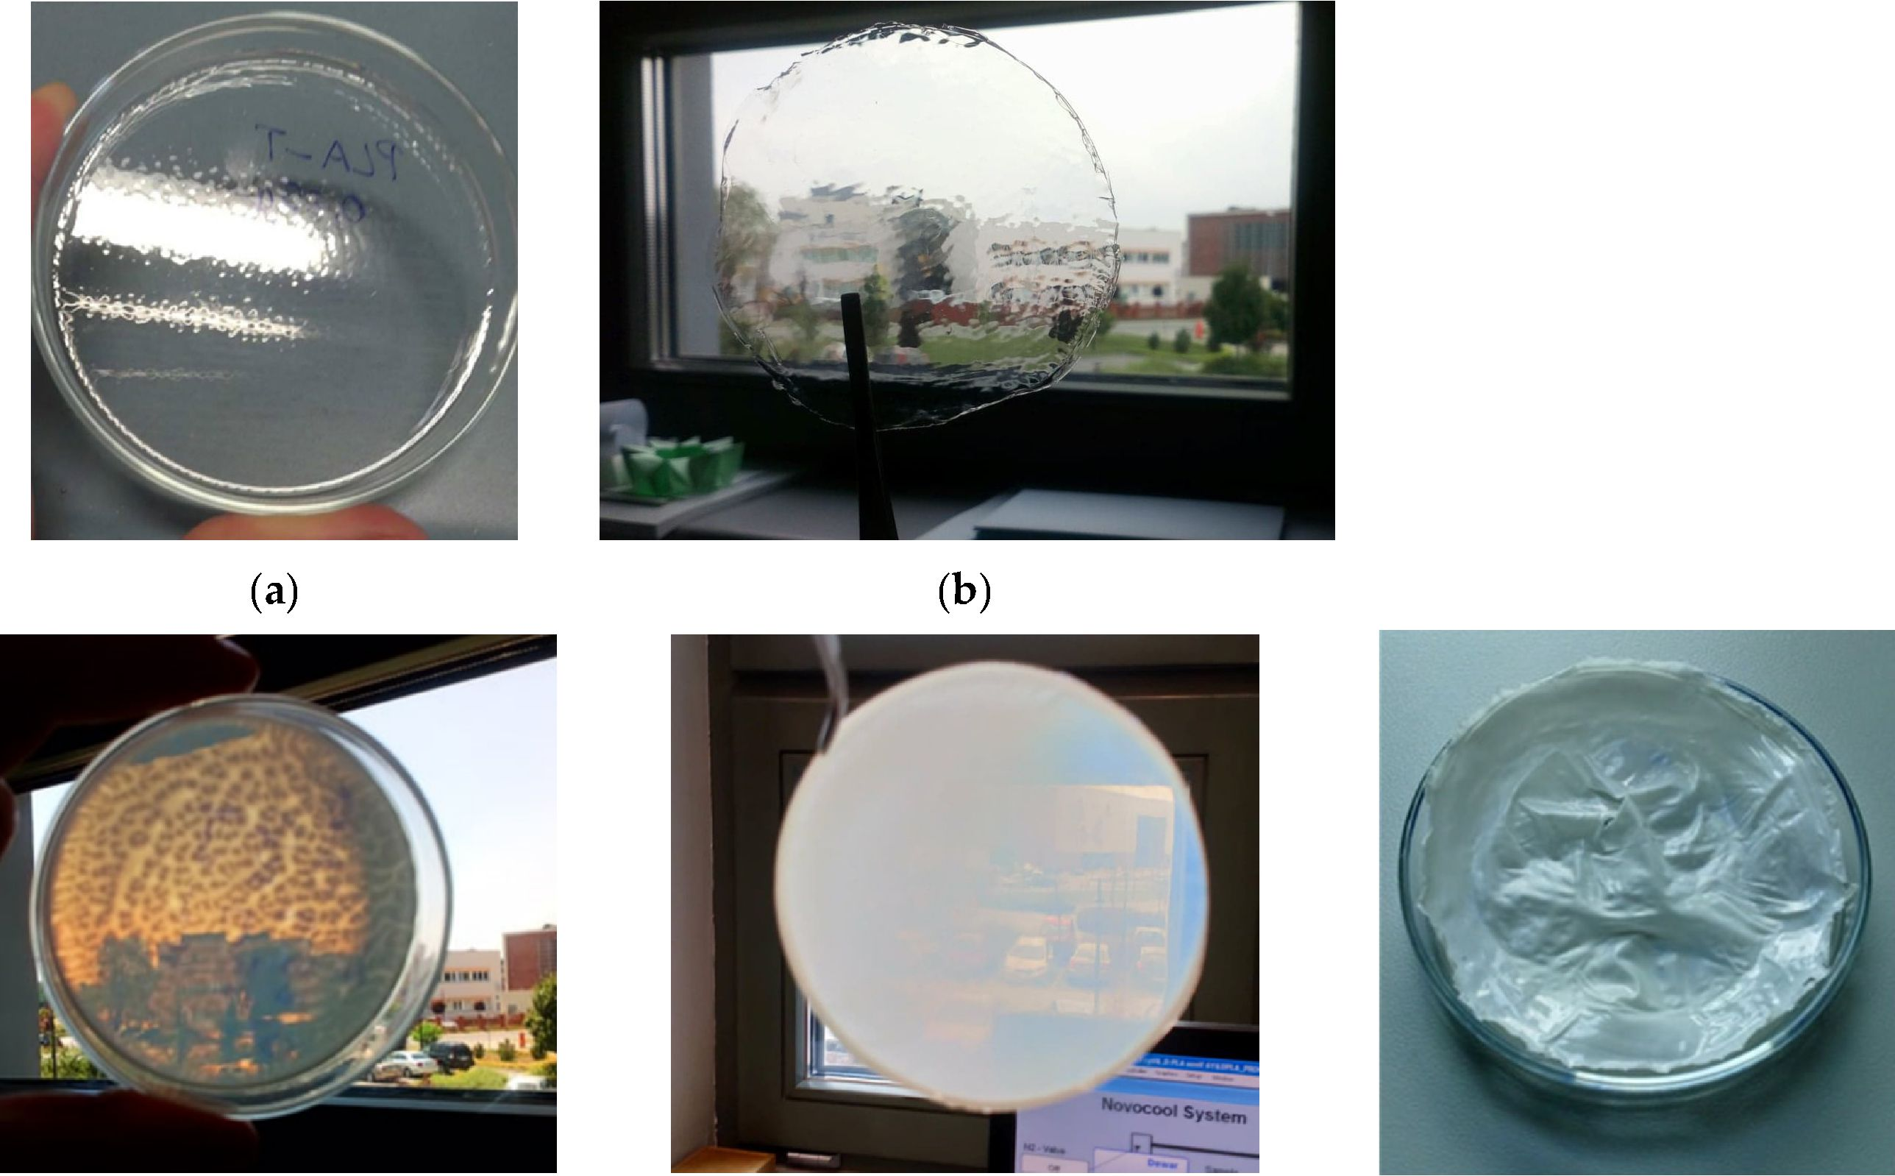
Polymers 2019,11,1867
3 of 19

2. Experimental
  - Materials
The 4'-pentyl-4-biphenylcarbonitrile (5CB) and Single Walled Carbon Nanotubes (SWCN) were
used as received from Sigma-Aldrich (Saint Louis, MO, USA). SWCN used have average diameter
0.84 nm, median lengthlpm, > 95% carbon basis (> 99% as carbon nanotubes). l,d-PLA was used as
received from GALACTIC (Brussels, Belgium).
12.1.1,. Preparation of l,d-PLA:5CB Hybrid Materials
AH fabricated hybrid layers with different concentration of l,d-PLA:5CB were prep ared in tine same
way. l,d-PLA was mixed with appropriate amount of 5CB and poured 4 mL chloroform. The solution
was mixed on the magnetic stirrer for at least 2 h and next it was sonicated for 40 min. Sub sequent
mixture was drop-casted on the glass substrate cf 8 cm diameter to create flexible films after chloroform
evaporation (see Figure a). The thickness of the hybrid films was determined by profślometer and
were foundin nhe rangeof 48 in 4 to 89 ± 4 pm.
(c) (d) (e)
Figure 1. Photos of films pure l,d-PLA (a) and composites l,d-PLA:5CB for different concentrations:
10: 1 w/w (b), 10:3 w/w (c), 10:5 id/id (d) and 10:1 0 w/w (e); the diameter of all created films is 8 cm.
    - Preparation of l,d-PLA:5CB:SWCN Hybrid Materials
Alr created hybrid layers with different concentration of l,d-PLA:5CB:SWCN were prepared in
the same way. l,d-PLA and 5CB with werght ratio 10:1 was mixed with proper amount of SWCN dnd
poured ehloroform. The further procedure was as in the case of preparatoon oa l,d-PLA:5CB hybrid
layers. The createm layees are presented in Figure 2. The thiakness of the hybnid films ’was determined
by profilhmeter (Bruker Co., Billerica, MA, USA) and were found in the range of 43 ± 2 to 55 ± 2 pm.
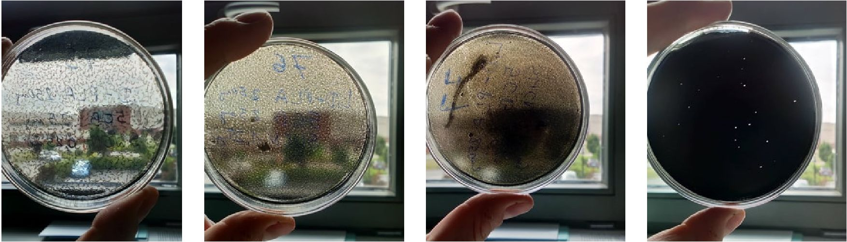
Polymers 2019,11,1867
4 of 19
(a) (b) (c) (d)
Figure 2. Photos of films of composites l,d-PLA:5CB:SWCN for different ratio: 10:1:0.01 w/w/w (a),
10:1:0.05 w/w/w (b), 10:1:0.1 w/w/w (c), 10:1:0.5 w/w/w (d) the diameter of all created films is 8 cm.
  - Characterization of Methods
Differential scanning calorimetry (DSC) measurements were done by using Pyris 1 Perkin Elmer
calorimeter (PerkinElmer, Waltham, MA, USA) to find transition temperatures of the new created
hybrid materials. The samples of ca. 10 mg were placed into 30 pL aluminium crucibles and tightly
closed with a press. The measurements were performed with 5 °C/min rate both on heating and
cooling. At least three cycles of heating and cooling were done for each sample to ensure repeatability
of the results.
Texture observations were performed using Nikon Eclipse LV100POL polarizing microscope
(NIKON Inc., Tokyo, Japan) equipped with the Fine Instruments WTMS-14C heating stage. The images
were registered by the computer-controlled camera C/anon EOS 600D. A smal l p iece of each created
layer (c .a. 1 cm2) was placed between the glass substrate and the cover glas s and put inside the
heating stage.
Frequency domain dielectric spectroscopy ( FDDS) methoO was used to study electric properties of
new created hybrid layers. For thic p urpose, the Alpha analystr (Novocontrol Technologies GmBbH &
Co. KG, MontaOaur, Germany) Novocontrol "Technologies equipped with an automatically controlled
cryostat Novocosl was used. Measurements were performed in the plate capacitor geometry, in the
frequency range from 0.5 Hz to 2.5 MHz versus temperature with temperature step equal to 1 °C. Thin
round pastilles (diameter 20 mm, thickness of c.a. 50-100 pm) were cut off from the created layers and
placed between two electrodes. Measuremene of pure 5CB was done in the celt with golden electrodes
of 25 mm2 area and thickness c.a. 5 pm (AW/AT Company', Warsaw, Poland).
TOe thicknes s of created hybrid layers was determined using DektakXT (Bruker Co., Billerica,
MA, USA) Stylus pcofilometer working in N-Lite modo which ensures a -very low stylus load (radius
2 pm, load 0.3 mg) on sample sucface assuring non-destructive way of analysis. Layers weae placed
at glass aubstrate and profiles of c/toss section were measured. Profiles were edited by esSablish the
ground level which was set Sor gless substrate. Thiskness was determinate by the difference between
the average profile height and the substrate level.
Analysis of the optical textures was done by Fiji program (The Laboratory for Optical and
Computational Instrumentation, Madison, WI, USA) which is distribution of ImageJ .54i. Each texture
image was csnverted on 8-bit type. Brightness contrast was adjusted lay auto iunction. Tle background
was removed with rolling; ball rad iuu 150 pixels. The threshold was settlad by Shanbhag algorithm [55].
Next images were process by dilate aperations. Analysed particles were settled from 2 pm2 up to
infinity to cut off the single pixel's contributions.
Tensile mechanical properties were measured usiag a testing machine Instron 33R4469 (Instron,
Norwood, MA, USA) with a load cell of 5 kN with software Bluehill 3.0 (Instrsn, Norwood, MA, USA).
Samples were in a form of thin strips and uniform width of 12 mm. Sam piles wsre tested at room
temperature al a crosshead speed oh 10 mm/min.
Polymers 2019,11,1867
5 of 19
Thermal behaviour was performed as described in our previous work [56]. Thermal images were
collected using a thermographic camera (VIGOcam v50, VIGO System S.A, Ożarów Mazowiecki, Poland)
while bias voltage between 0 and 10 V was applied using a multichannel potentiostat-galvanostat
(PGStat Autolab M101, Metrohm, Barendrecht, Nederland), connected to computer.

3. Results and Discussion
The l,d-PLA in this work was mixed with well-known organic compound exhibiting nematic phase
in the room temperature—4'-pentyl-4-biphenylcarbonitrile (5CB), in different ratio and drop-casted on
glass substrate to create flexible film after chloroform evaporation. In Figure 1a-e photos of created
films along with increase the amount of 5CB are presented. The transparency of created film decreased
with increasing the 5CB admixture. In details, films without and with very small content of 5CB (10:1
w/w) were transparent (Figure 1a,b), while films with a higher 5CB admixture (10:3 w/w and 10:5 w/w)
were partially transparent (Figure 1c,d). Moreover, thin films with the ratio of l,d-PLA to 5CB equal to
10:10 w/w were not transparent (Figure 1e) and the film attached very strongly to the glass, than it was
hard to peel off from the substrate without causing damage. It seems that the stronger adhesion is for
the surface of the thin film with the ratio l,d-PLA to 5CB 10:10 w/w as compare with other created films
due to the high viscosity of 5CB.Therefore, compositions with a higher than 10:10 w/w 5CB admixture
were not prepared.
  - DSC Measurements and Texture Observations Before and After Mechanical Deformation
l,d-PLA and its mixtures with 5CB as well as l,d-PLA and its mixtures with 5CB and SWCN for
different concentrations were studied using DSC method to determine the influence of content of 5CB
and SWCN on the thermal behaviour. As it is seen in Figure 3 and Table 1, all the transitions are shifted
to lower temperatures with increasing the concentration of 5CB in the mixture, which is connected
with low transition temperatures of pure 5CB: the liquid crystalline nematic phase exists between 24.4
and 35.9 °C (see Figure 3c). On the other hand, addition of SWCN does not influence much on the
transition temperatures (Figure 3b, Table 1).
Table 1. Transition temperature of created l,d-PLA:5CB films in various ratio of 5CB and for
l,d-PLA:5CB:SWCN in various ratio of SWCN based on DSC method.
Compositions [w/w/w] | Glass Transition [°C] | Transition to Liquid [°C]
l,d-PLA | 61 | 161
l,d-PLA:5CB, 10:1 | 45 | 152
l,d-PLA:5CB, 10:3 | 37 | 148
l,d-PLA:5CB, 10:5 | 31 | 147
l,d-PLA:5CB, 10:10 | 30 | 141
l,d-PLA:5CB:SWCN (10:1:0.01) | 52 | 155
l,d-PLA:5CB:SWCN (10:1:0.05) | 48 | 154
l,d-PLA:5CB:SWCN (10:1:0.1) | 50 | 155
l,d-PLA:5CB:SWCN (10:1:0.5) | 53 | 155
Only for composition 10:10 w/w there were visible additional peaks which not appear on DSC
curve for pure l,d-PLA. According to the literature [57] the peak registered on heating at ca. 150 °C is
related to melting of l,d-PLA, while around 55 °C to glass-transition [58].
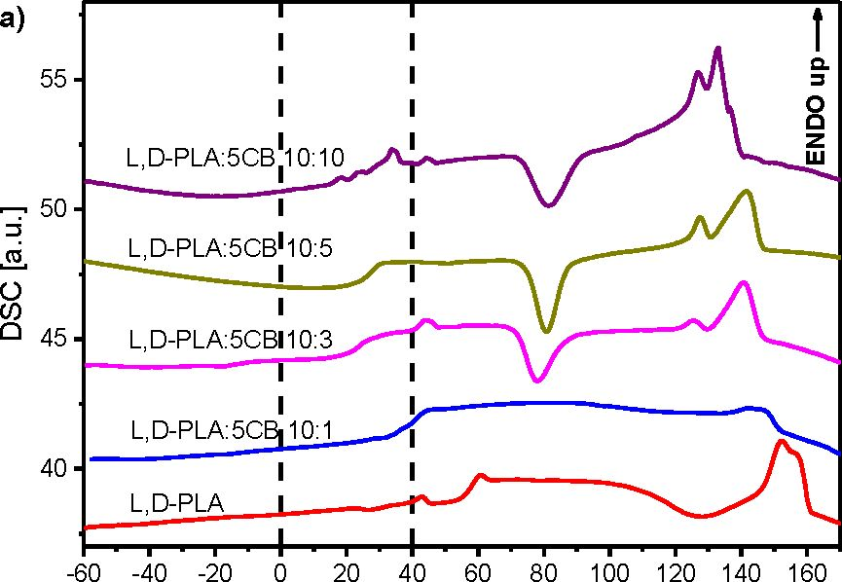
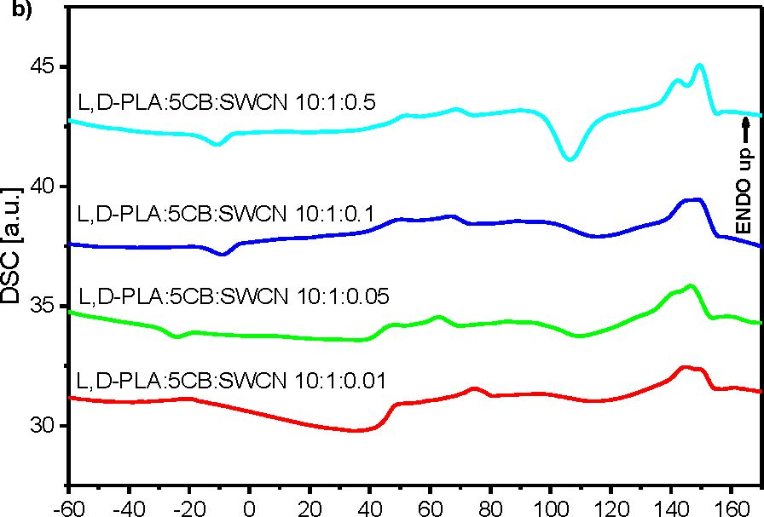
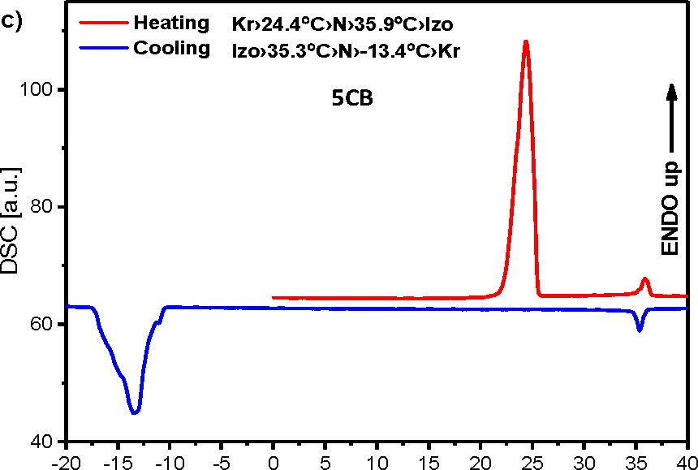
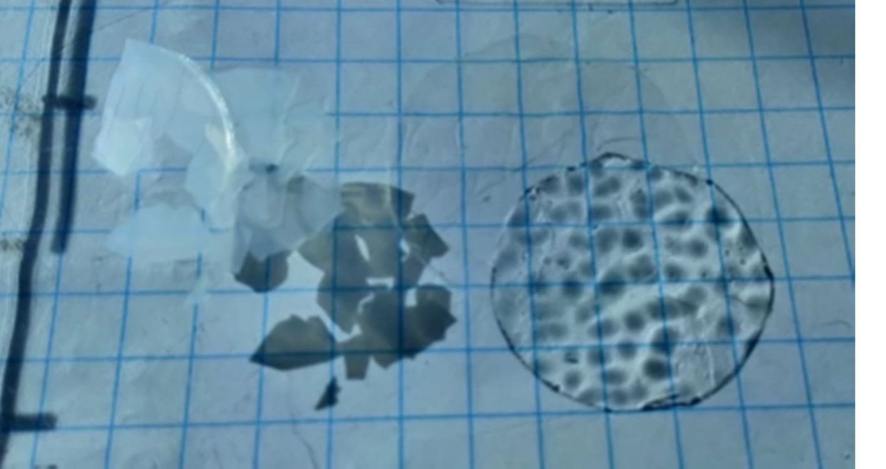
Polymers 2019,11,1867
6 of 19
T [°C]
T [°C]
T [°C]
Figure 3. DSC curves for binary (a) and ternary (b) mixtures registered during Ideating and for pure
5CB during heating and cooling (c).
A_bove (he glass transition fiie cold crystallization occurred and properties of1 (ompositions
changed—flrey become fragile and break eaaily, as it is presented in Figure 4.
Figure 4. Shadow of broken parts of pure l,d-PLA film in crystalline (on the left) and amorphous
(on the right) phass.
Textures registered fit room temperature for created film of pure l,d-PLA and four compositions
before heating and after annealing at 120 °C for a few minutes are presented in Figure 5. Films ot pure
L,DrPLA and composite 10:1 were optically isotropic at room temperature (amorphout phase) and
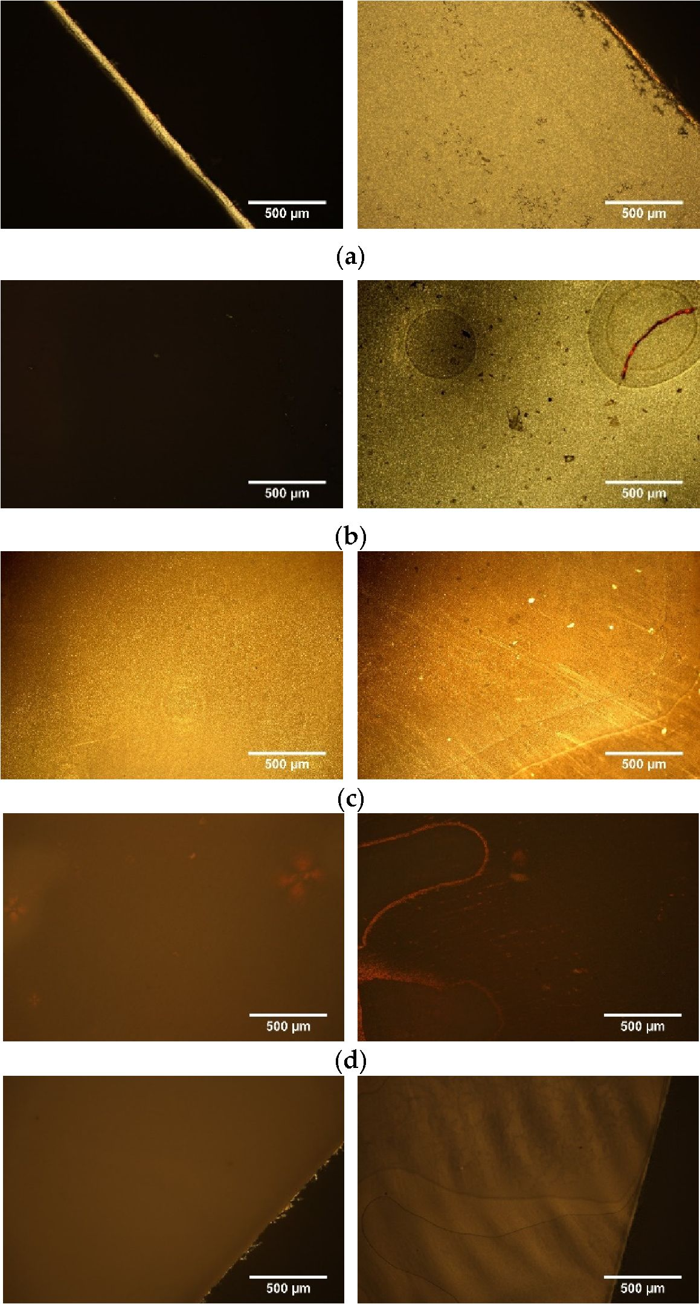
Polymers 2019, 11, 1867
7 of 19
show black image under the polarizing microscope with crossed polarizers. Therefore, only the; edge of
tiie created films, as an example for pure l,d-PLA, is presented in Figure 5. As it is seen, sSter annealing
these filme transSormed to crystal phase which made them visible with crossed polarizers. Films with
more 5CB admixtures were visible beOore and after annealing and they were changing with increasing
the concentration of 5CB (Figure 5).
(e)
Figure 5. Optical textures of the created films, before (left side) and after annealing git g20 °C 0right side)
for l,d-PLA (a) and l,d-PLA:5CB in the ratio 10:1 w/w ((b), 10:3 w/w (c), 10:5 w/w (d) and 10:10 w/w (e).
It was noticed, that during annealing at 120 °C a part of 5CB was pushing out of the polymer
matrix:. Figure 6 presents textures registered for the l,d-PLA:5CB composite 00:5 w/w between two
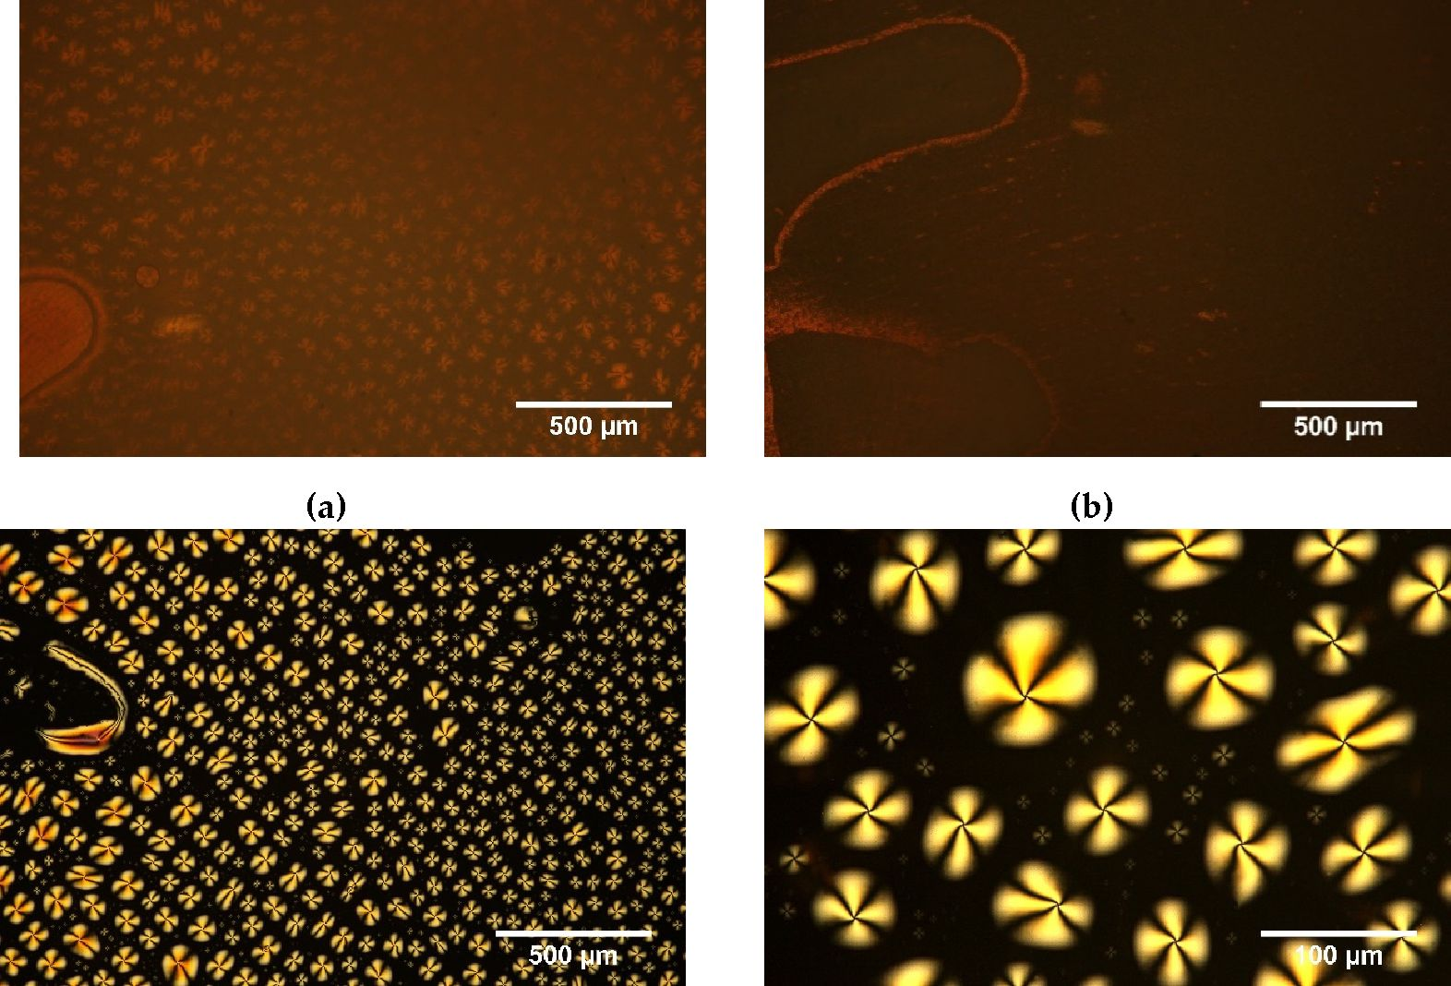
Polymers 2019,11,1867
8 of 19
glass slides and without cover glass after annealing. All the observed anisotropy centres were placed
on the cover glass becouse without the cover glass these centres are absenO (Figure 6b). In turn, they
were well visible on the cover glaso (see Figure 6c,d). It suggests that 5CB was forced out of the l,d-PLA
polymer matrix during; cold crystallization. IV seems that this is due to the very low vitcosity of 5CB
at 120 °C and iCs outflow ftom the rigid, structure oh the l,d-PLA polymer matrix, which means that
heating to such a high temperature destroys the composite.
(c)
(d)
Figure 6. Optical textures a(ter annealing and cooling down to eoom temperature with (o) and
without (Is) cover glass foo composite 10:5 w/w and for 5CB on cover glass (c,d); crossed polarizers,
room temperature.
Process of pushing out the 5CB from the l,d-PLA polymer matrix is presented in Figure 7. As it
can be observvd, ehehigher content of 5CB is pushed out with time: the droplets are formed on cover
glass and they are getting bigger. The results of analysis of the images by Fiji program are presented in
Table 2.
Table 2. Parameters of shape for analysed images.
Time  [min] | Amount of  Droplets | Total Area of Droplets  [pm2] | Average Size  [ pm2] | Area Occupied by  Dro plets [%] | Circularity
0 | 9372 | 1,784,464 | 190 | 55 | 0.74
1 | 7588 | 1,837,159 | 242 | 57 | 0.76
2 | 6653 | 1,997,143 | 300 | si 62 | 0.76
4 | 5600 | 2,175,919 | 389 | 67 | 0.76
6 | 4980 | 2,243,426 | 450 | 69 | 0.76
One can noticsd that (he numbea of droplets decreases with timv from 9372 to 4980), the average
size of one drop increases at the same time (from 190 to 450 pm2) and the total area occupied by 5CB
increases (from 1.8 to 2.2 mm2). The circularity parameter is close to 1 what means that most of the
droplet have a circular shape as it is well visible in Figures 6 and 7.
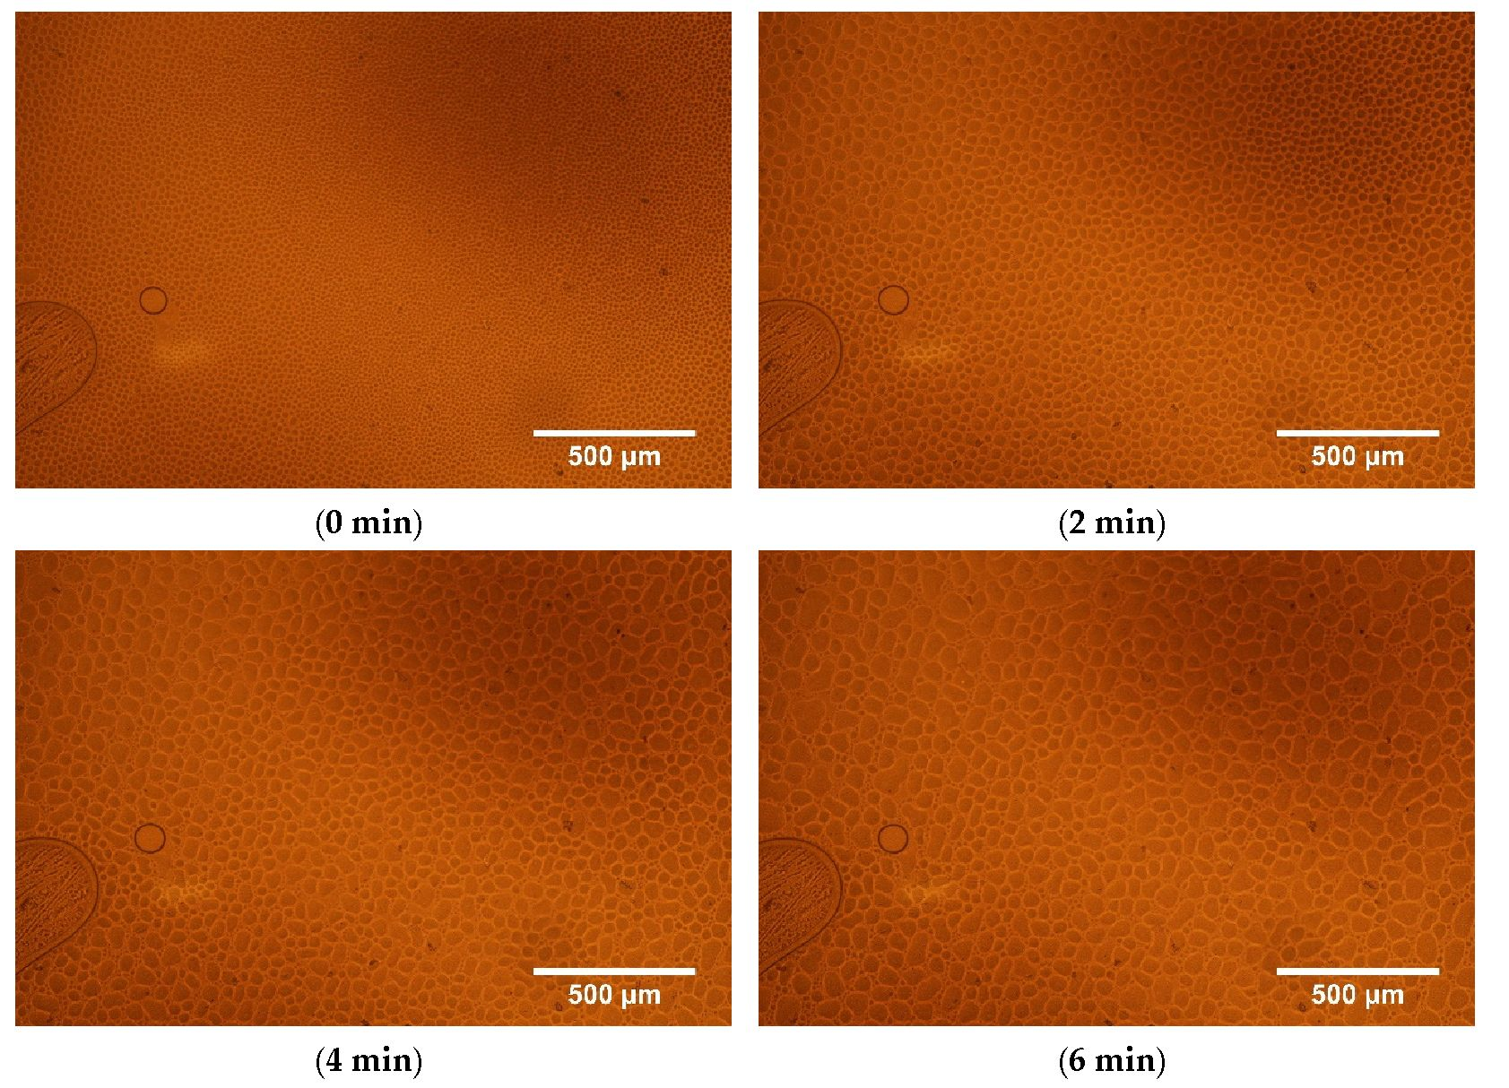
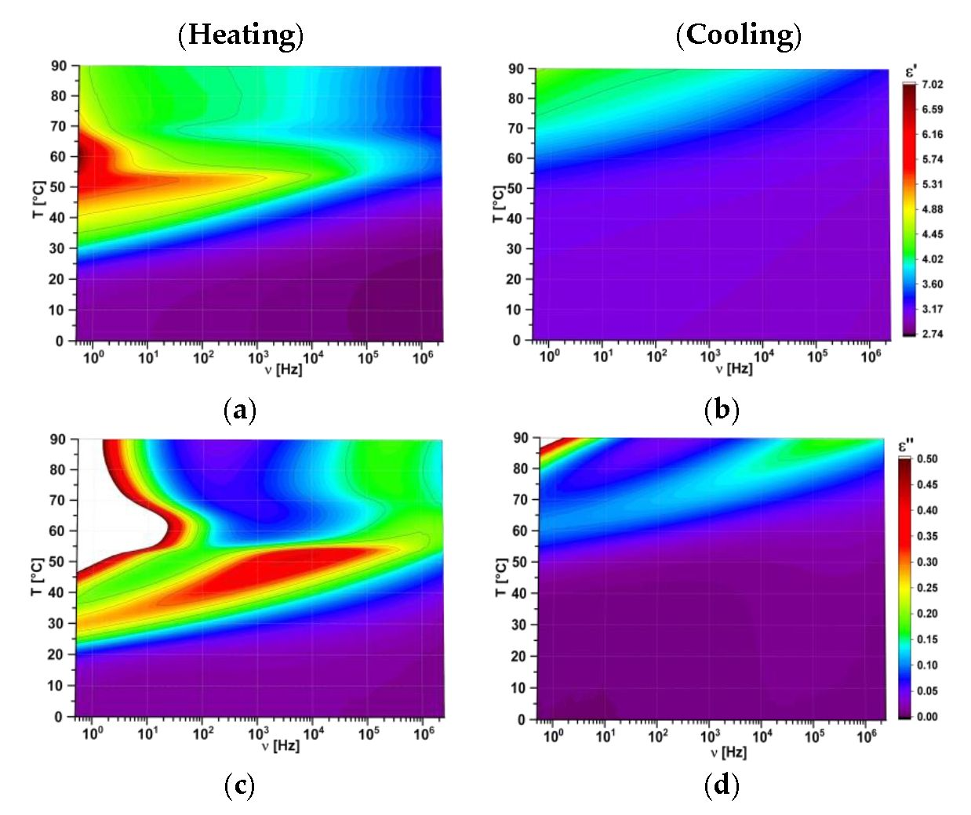
Polymers 2019,11,1867
9 of 19
Figure 7. Op tical textures (without analyser) of l,d-PLA:5CB composite with ratio 10:5 w/w registered
at 120 °C versus time: process of pushing out the droplet of 5CB.
FDDS method was used io study electric properties of created hybrid compositions. All the data
are presented as 3D maps where colour indicates the value of studied parameter. As an example,
the dielectric absorption and dispersion as 3D maps for pure l,d-PLA polymer film are presented in
Figure 8.
Figure 8. Three dimensional maps of real (a, b) and imaginary (c, d) part of dielectric permittivity for
pure l,d-PLA: heating (ion the left) and cooling; (onthe right).
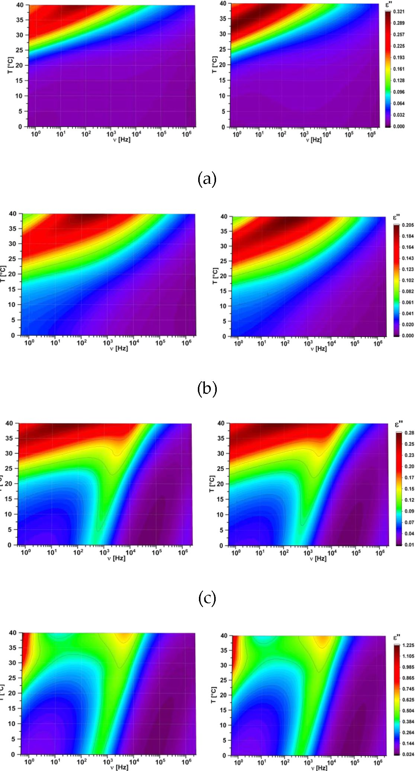
Polymers 2019, 11, 1867
10 of 19
For all the created hybrid films the maps for heating and cooling are different because the cold
crystallization occurred at heating and the materials changed their physical state (as it was shown in
Figure 4). Films in crystal form were much more inflexible than in amorphous form and for this reason
the next research were performed in the temperature range from 0 °C to 40 °C. In this temperature
range pure 5CB can exist in crystalline, nematic or isotropic phases (Figure 3b). It turned out that in this
temperature range the maps for new created films obtained during heating and cooling are identical,
as it is presented in Figure 9. It strongly suggests that created films are stable. In turn, the value of e'
increases with increasing the 5CB admixture (see Figure 9).
(Heating) (Cooling)
(d)
Figure 9. Cont.
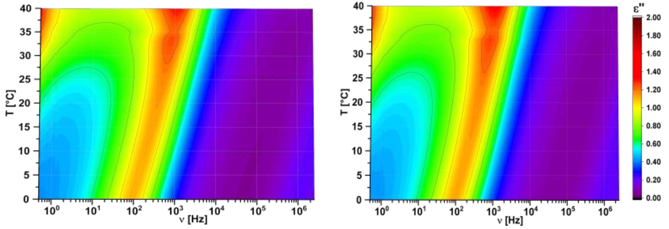
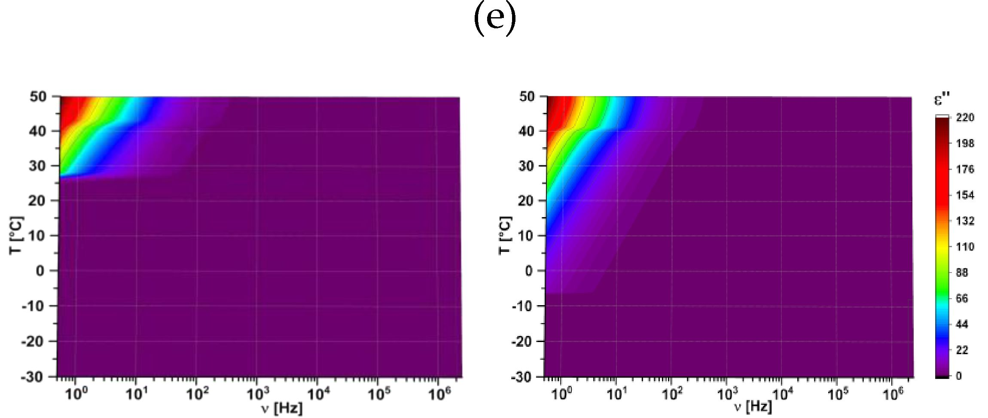
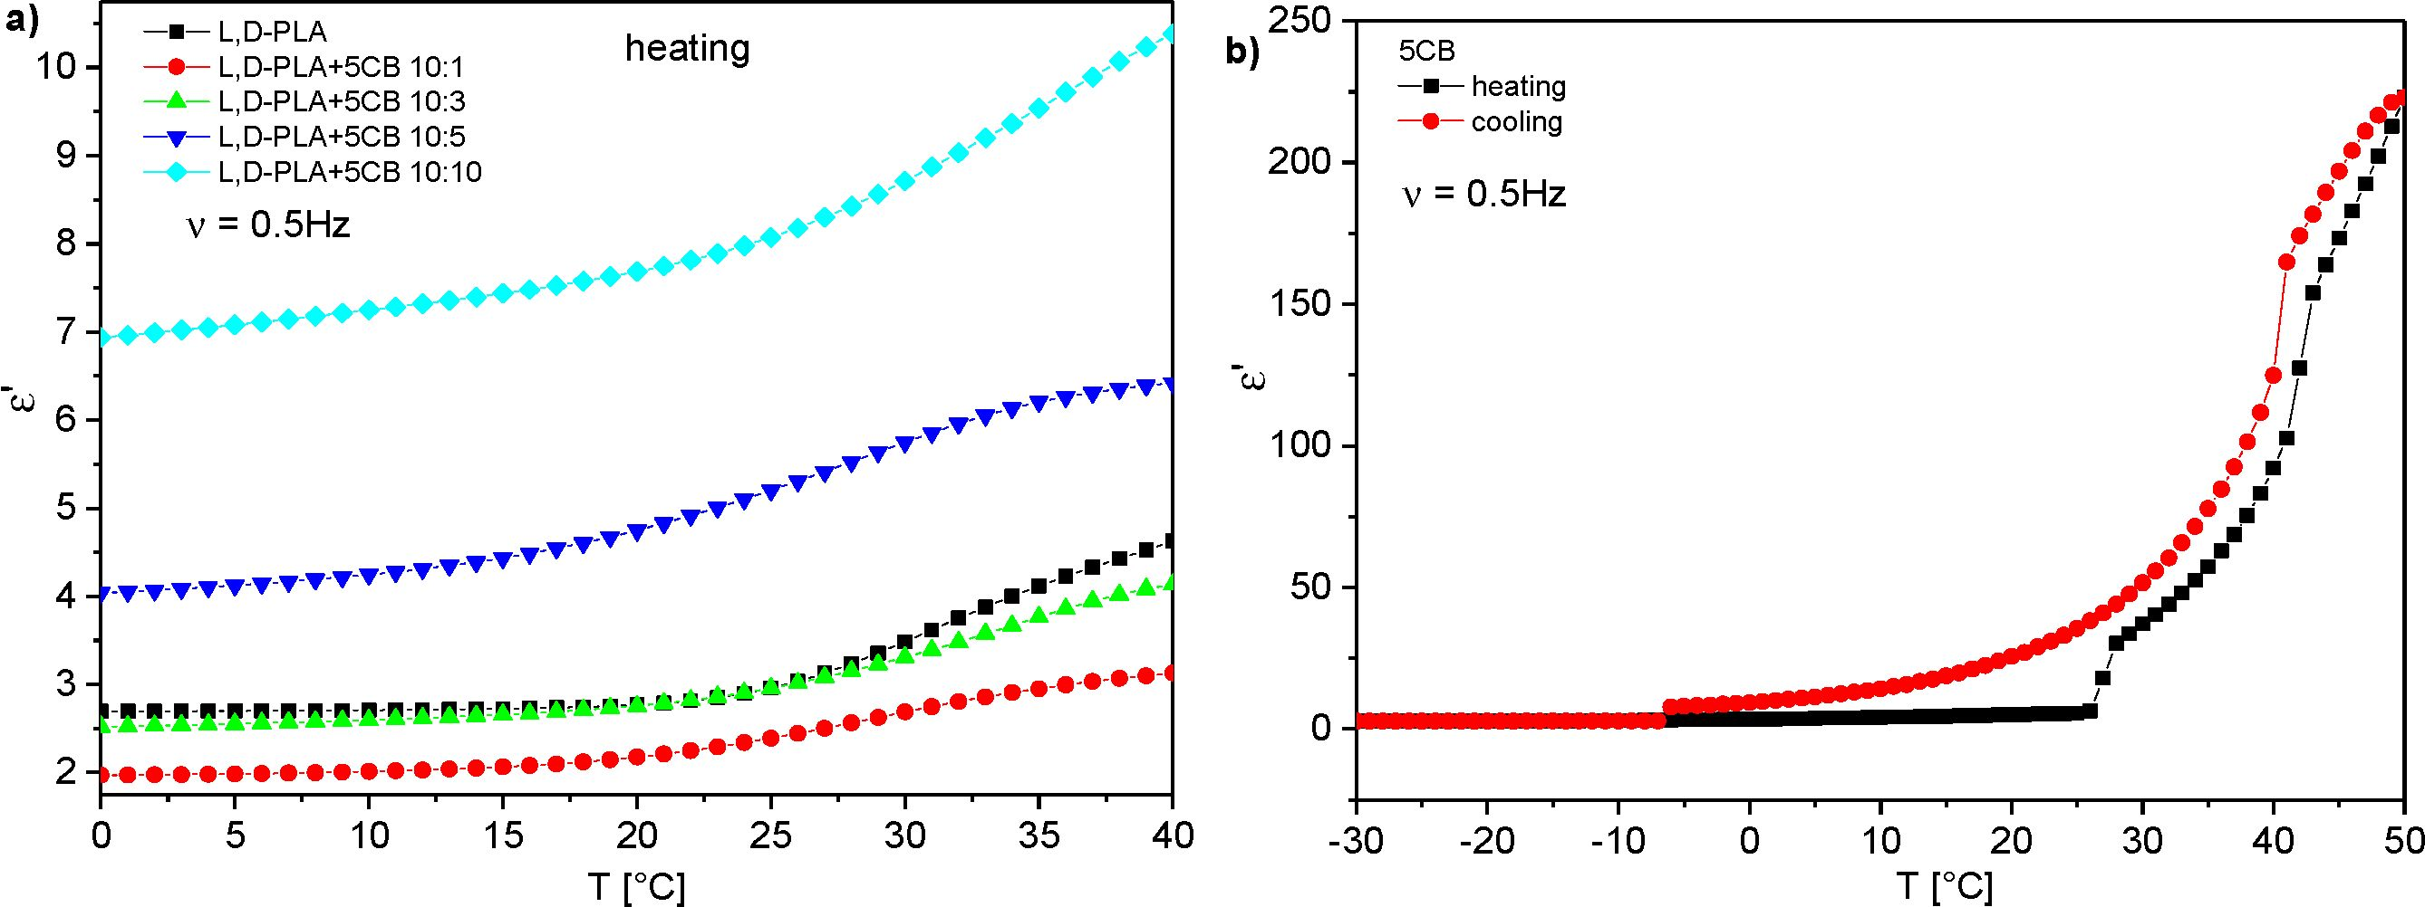
Polymers 2019,11,1867
11 of 19
(f)
Figure 9. Three dimensional maps of imaginary part of dielectric permittivity for created films at
heating (on the left) and cooling (on the right), in the temperature range 0 to 40 °C for l,d-PLA (a) and
l,d-PLA:5CB in the ratio 10:1 w/w (b), 10:3 w/w (c), 10:5 w/w (d), 10:10 w/w (e) and 5CB (f).
Figure 10 presents temperature dependence of the dielectric constant (dielectric dispersion at
0.5 Hz) of created layers. The results for hybrid layers obtained at heating and cooling were identical
therefore only results for cooling are presented in Figure 10a. Results for pure 5CB obtained during
heating and cooling are different and both are presented in Figure 10b. The visible jumps both on
heating and cooling occurred at temperatures associated with the phase transitions as one can compare
with the DSC results presented in Figure 3b. On the other hand, in the case of hybrid layers the jumps
were absent (Figure 10a) what is in good agreement with DSC result (Figure 3a) for this range of
temperatures. Dielectric constant at room temperature is equal to 2.95 for pure l,d-PLA and composite
10:1 w/w and 2.39 for composite 10:3 w/w (see Figure 10a). For higher concentration of 5CB admixture
it grows fast and is equal to 5.20 and 8.07 for composite 10:5 and 10:10, respectively. Taking into
account that dielectric constant was calculated based on the thickness of the created layers one can
conclude that as the 5CB admixture increases in l,d-PLA the dielectric constant is almost constant
up to a concentration of 3:10 w/w, after which it fast increases. It is associated with a very high
dielectric constant of 5CB (at cooling: 35.52 at 25 °C, Figure 10b), whose amount of dopant increases in
composites, which increase s the dielectric constant of the composites produced.
Figure 10. Dispersion at (3.5 Hz versus temperature for new created hybrid films during heating (a)
and pure 5CB during heating and cooling (b).
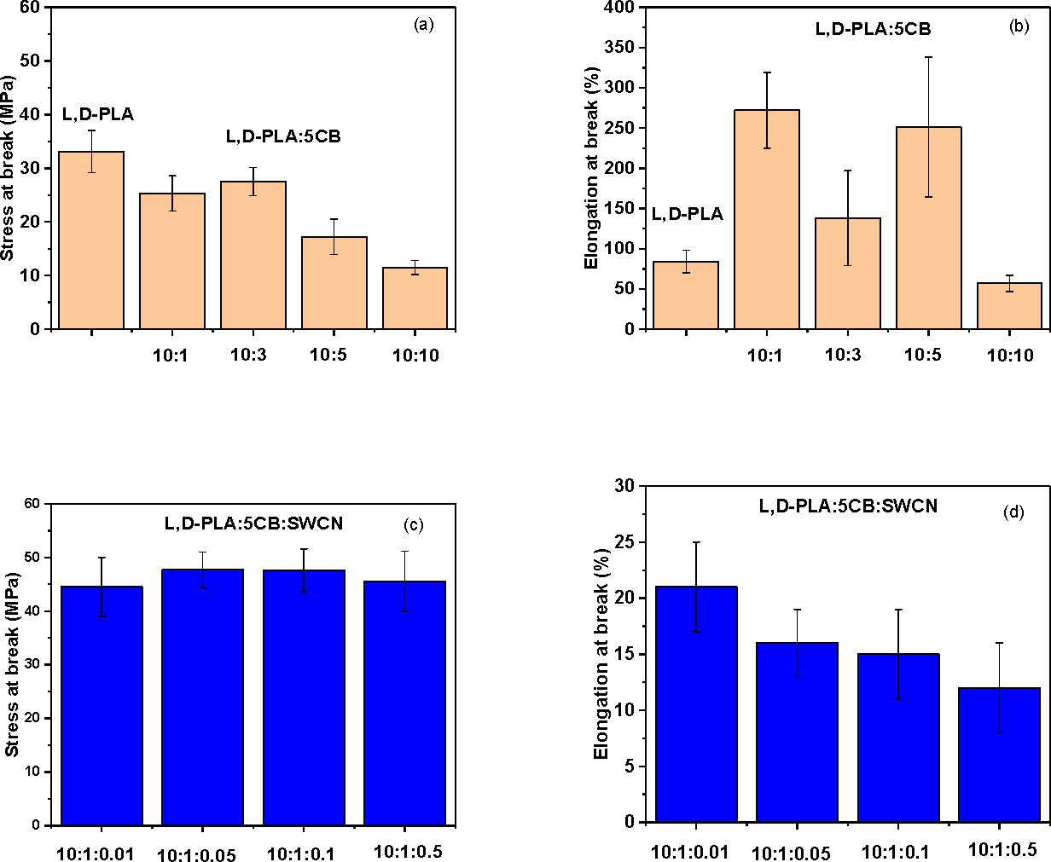
Polymers 2019, 11, 1867
12 of 19
  - Mechanical Properties of l,d-PLA with 5CB and l,d-PLA:5CB:SWCN
Mechanical properties were investigated for created hybrid layers in order to assess:
- the influence of 5CB component and its amount on the properties of thin film;
- select the ratio of l,d-PLA:5CB forming the thin film with the best mechanical properties;
- the influence of SWCN on selected l,d-PLA:5CB composite with required mechanical properties
on the properties of thin film.
All results are listed in Table 3. In the case of two-component samples there is a correlation between
stress at break and the presence of 5CB compound for different samples (Figure 11a). Already 9% of
the addition 5CB to the polymer matrix reduced the stress value at break up to one-third compared
to pure polymer. At the same time the elasticity of thin film increased compared to starting material.
A tendency was also found—increasing the amount of 5CB from 9% to 50% causes stiffening of the film,
reducing the stress at break to 11.5 MPa and elongation at break to 57% of starting length (Figure 11b).
Table 3. Tensile test performance for two- and three-component hybrid layers.
Composition | Thickness | Cross-Section | Length | Stress at Break | Elongation at
(w/w) | (mm) | Area (mm2) | (mm) | (MPa) | Break (%)
l,d-PLA | 0.080 ± 0.005 | 0.89 | 8.2 | 33.1 ± 3.9 | 84 ± 14
l,d-PLA:5CB (10:1) | 0.089 ± 0.004 | 1.10 | 9.4 | 25.3 ± 3.3 | 272 ± 47
l,d-PLA:5CB (10:3) | 0.048 ± 0.004 | 0.60 | 10.0 | 27.5 ± 2.6 | 138 ± 59
l,d-PLA:5CB (10:5) | 0.057 ± 0.010 | 0.69 | 9.2 | 17.2 ± 3.3 | 251 ± 87
l,d-PLA:5CB  (10:10) | 0.072 ± 0.004 | 0.86 | 10.6 | 11.5 ± 1.3 | 57 ± 10
l,d-PLA:5CB:SWCN  (10:1:0.01) | 0.043 ± 0.002 | 0.50 | 9.7 | 44.5 ± 5.5 | 21 ± 4
l,d-PLA:5CB:SWCN  (10:1:0.05) | 0.047 ± 0.001 | 0.60 | 8.5 | 47.7 ± 3.3 | 16 ± 3
l,d-PLA:5CB:SWCN  (10:1:0.1) | 0.055 ± 0.002 | 0.70 | 9.7 | 47.6 ± 4.0 | 15 ± 4
l,d-PLA:5CB:SWCN  /1 n.1 .n | 0.050 ± 0.002 | 0.60 | 9.7 | 45.6 ± 5.6 | 12 ± 4
Figure 11. Stress at break and elongation at break of l,d-PLA:5CB (a and b, respectively) and
l,d-PLA:5CB:SWCN (c and d, respectively).
Polymers 2019, 11, 1867
13 of 19
In general, the highest repeatability was observed for pure l,d-PLA and a mixture l,d,-PLA:5CB in
which the polymer content was the highest (10:10 w/w). In other two cases, for mixture with 10:5 w/w
and 10:1 w/w ratio of L,D-PLA:5CB, a clear strength limit was observed, that is, at high deformations of
the sample normal stress increases, in some cases exceeding the yield point itself. The strength of the
sample with ratio 10:10 w/w and 10:3 w/w after reaching the yield point, decreased.
The film composed of l,d-PLA:5CB (10:1 w/w) showed the highest elasticity, hence it has been
selected as the base composition to add single-walled carbon nanotubes. Our previous study revealed
that adding even a small amount of SWCN reduces the stress value due to loss of the elasticity [27].
Therefore, high elasticity is a desired property for the starting polymeric matrix.
In order to evaluate the effect of adding SWCN into polymeric matrix composed of l,d-PLA:5CB
(10:1 w/w) four samples containing addition of 0.01,0.05,0.1 and 0.5 part by weight of carbon nanotubes
were tested. The results are summarized in Table 3. Generally, the highest mean breaking stress was
noted for samples l,d-PLA:5CB:SWCN (10:1:0.1 w/w/w) and l,d-PLA:5CB:SWCN (10:1:0.05 w/w/w) with
values 47.6 MPa and 47.7 MPa, respectively. On the other hand, the lowest value was obtained for
sample l,d-PLA:5CB:SWCN (10:1:0.01 w/w/w), giving value 44.5 MPa. However, taking into account
the experimental error the values are oscillating within very similar range (Figure 11c). Evaluating the
elongation at break, a gradual decrease of values on increasing carbon nanotubes content, starting
from 21% for l,d-PLA:5CB:SWCN (10:1:0.01 w/w/w) and ending with 12% for l,d-PLA:5CB:SWCN
(10:1:0.5 w/w/w) was observed (Figure 11d). In comparison to our previous report [27] where we
studied films made only of l,d-PLA and SWCN, in this work we discovered that the addition of
5CB to l,d-PLA:SWCN matrix demonstrated the reverse of some mechanical properties. Namely,
the stress at break values decreases and elongation at break remain at similar level with addition of
carbon nanomaterial to pure polymer. In current study, the opposite trends can be explained by the
influence of 5CB on formation of film internal structure, as it was observed in studies for polycarbonate,
where 5CB was used as plasticizer [59].
  - Thermal Images of l,d-PLA with 5CB and SWCN
Thermal imaging technique coupled with current registration was used to observe for overall
behaviour of composite materials while an external potential was applied. As it was described in
mechanical studies the film composition l,d-PLA to 5CB in 10:1 w/w ratio possessed the best mechanical
properties, however due to its insulating properties it was doped with carbon nanotubes in order
to give conductive properties. In general, samples based only on l,d-PLA and 5CB in different
rations are good insulators with resistance in the range of mega ohms in both configurations in- and
through-plane. Therefore, four different contents of SWCN in polymeric composite film were tested.
The electrical conductivity measurements at in-plane configuration revealed that even a small amount
of carbon nanotubes enables current flow, giving the average resistance values equal to 25,061.4 Q,
3186.8 Q, 1051.5 Q and 41.0 Q, for 0.01,0.05,0.1 and 0.5 weight portion of SWCN, respectively. In the
experimental setup the distance between external connections was 1.3 cm. As it can be seen in Figure 12
the correlation of resistance versus SWCN content changes exponentially, decreasing the resistance for
higher carbon nanotube content, as expected. All samples were stable in all measured potential range.
The analysis of the current-voltage curve demonstrated a linear increase of current only in the
case of samples with high resistance of kQ (Figure 13a). For the highest content of SWCN the current
values incremented linearly at two different slopes connected by a deflection between 5 and 7 V.
After 7 V the curve became steeper. It might be related to some phase transition in the sample.
The carbon nanotubes in polymer matrix could rearrange according to external stimulus, like electric
field improving conductivity [34].
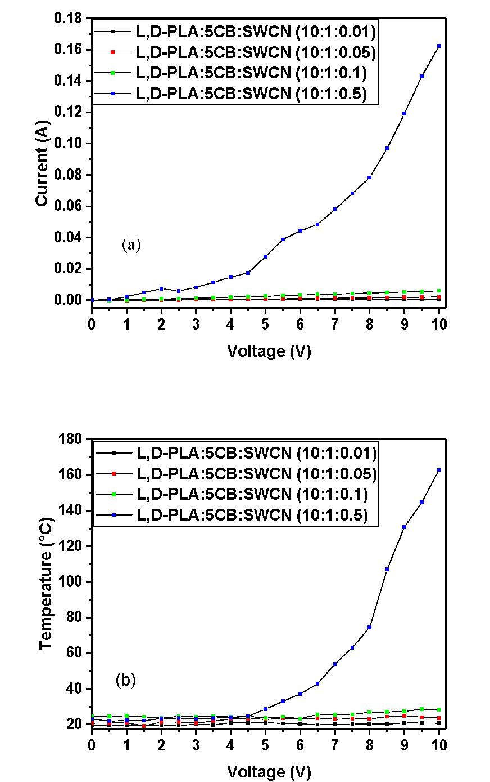
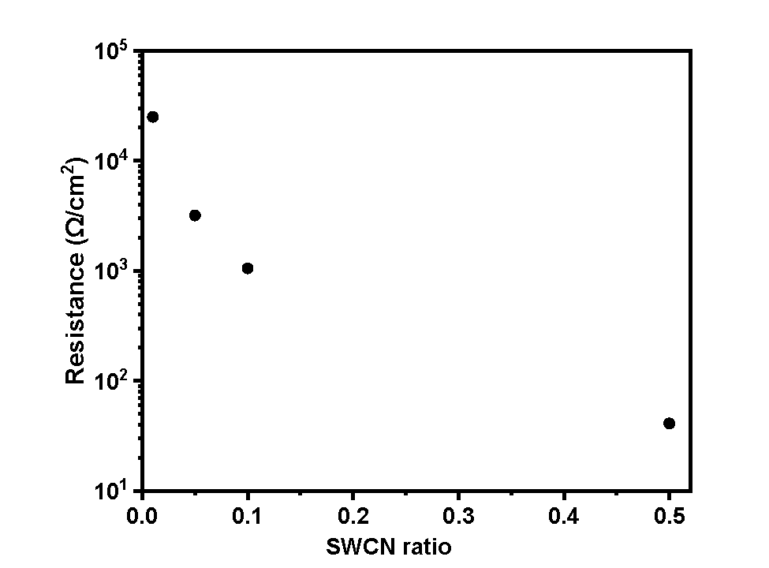
Polymers 2019,11,1867
14 of 19
Figure 13. The correlation of (a) current versus applied potential and (b) temperature versus applied
potential for composite materials containing l,d-PLA, 5CB and SWCN.
The analysis of thermal response to external potential showed that for low conductive samples
containing 0.01,0.05 and 0.1 of SWCN weight portion, the highest observed temperature did not exceed
30 °C (Figure 13b). Whereas, the composite with composition l,d-PLA:5CB:SWCN (10:1:0.5 w/w/w)
demonstrated an logarithmically increasing; temperature, reaching0 slightly above 160 °C for potential
of 10 V. The deflection of the curve was observed in the temperature range corresponding to glass
transition for pure polymeric matrix; as observed in DSC study. It was noticed that the higher the
resistance, the lower temperature was observed, suggesting the pure conductive nature of samples.
Figure 12. The correlation of resistance versus SWCN ratio for composite materials containing l,d-PLA,
5CB and SWCN.
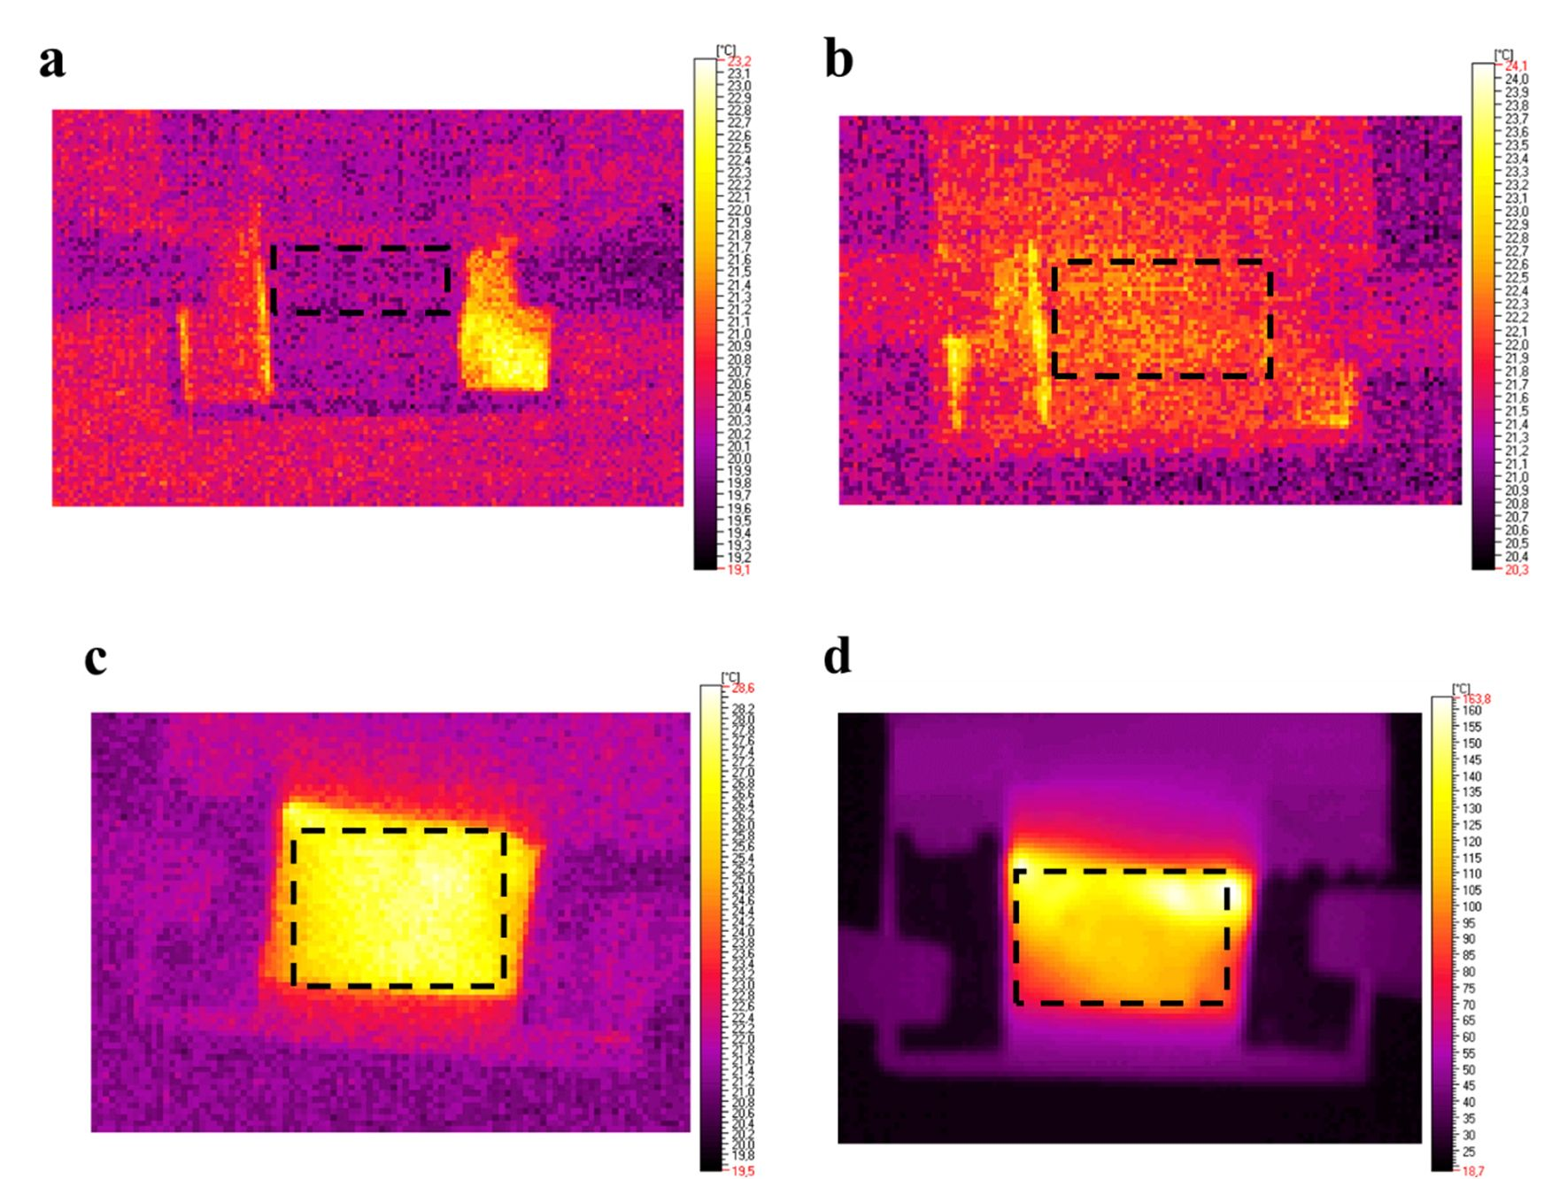
Polymers 2019,11,1867
15 of 19
The analysis of thermographs revealed that the films heat up rather homogenously without any
detectible defects, as it can be seen in Figure 14 for all samples studied.
Figure 14. Thermographic images of films with different content of l,d-PLA:5CB:SWCN with respective
ratios of 10:1:0.01 w/w/w (a), 10:1:0.015 w/w/w (b), 10:1:0.1 w/w/w (c) and 10:1:0.5 w/w/w (d) for applied
potential equal to 10 V. In la lack dashed frame an area used for th ermal study has been marked.

4. Conclusions
In this work, polymer compositions based on biodegradable l,d-PLA, liquid crystal 5CB and
SWCN were fabric ated and investigated lay thermal, electrical end mechanical studies . Following main
conclusions can be drawn:
The addiiion of 5CB to l,d-PLA increased the flexibility of polymeric base films and a strength limit,
as evidenced by the nature of the rupture oS the l,d-PLA samples compared to two-component films;
The best material flexibility and short-term strength were obtained for l,d-PLA sample with 9%
5CB content (10:1 w/w ratio), which means that a small addition of 5CB has a beneficial effect on the
mechani cal properties of the thin film. Increasing the proportion of this c omponent above 30%o reduces
the strength and elasticity of the film;
The addttion of SWCN to the base polymeric n-dtrix with -iquid costal 5CB (10:1 w/w) caused
an almost twofold increase in the strength of the tested materials and an almost tenfold decrease in
their elosticity;
Addition of SWCN into; polymeric mdtrix containing 5CB gave conductive nature to the thin films.
The best electrical conductivity was observed for l,d-PLA:5CB:SWCN with ratio 10:1:0.5 w/w/w, showing
an averege res istance of 41.0 Q and thermal response up to 1C0 ° C without causing any d amages;
Thermal effect accompanying the p assing rurren/ c <tuld have positive influence on the registesed
current flow, possibly causing additional rearrangement of SWCN in the thin film after reaching the
gless transition temperature of l,d-PLA:5CB (10:1 w/w);
Polymers 2019,11,1867
16 of 19
Only binary hybrid layers are dielectric and the dielectric dispersion e' increases with increasing
the 5CB admixture except the hybrid layer with the lowest concentration of 5CB (10:1) where dispersion
is even smaller than for the layer made of pure l,d-PLA;
Films of pure l,d-PLA and composites with low admixture of 5CB are optically isotropic at room
temperature (amorphous phase) while with more 5CB admixture become anisotropic. After annealing
all created binary layers are optically anisotropic and they are changing with increasing the concentration
of 5CB.
Author Contributions: P.F. prepared the thin films, performed and analysed the resistivity, optical, calorimetric
and dielectric studies. K.A.B. performed the thermal imaging experiments and analysed the data. P.K. and K.A.B.
performed and analysed the mechanical study. A.I. and M.M. wrote the paper. A.I., M.M. and A.J. contributed to
the analysis and discussion.
Funding: The European Regional Development Fund in the framework of the Polish Innovation Economy
Operational Program contract no. POIG.02.01.00-12-023/08 (Novocontrol). Financial support of Ministry of Science
and Higher Education (grant no. 2019-N17/MNS/000020) is acknowledged. The research (DektakXT (Bruker Co.,
Billerica, MA, USA) Stylus profilometer) was partially performed using equipment purchased with the financial
support of National Science Centre, project agreement number UMO-2017/25/B/ST5/00575.
Conflicts of Interest: The authors declare no conflict of interest.

References
- Buyuktanir, E.A.; Gheorghiu, N.; West, J.L.; Mitrokhin, M.; Holter, B.; Glushchenko, A. Field-induced polymer
wall formation in a bistable smectic-a liquid crystal display. Appl. Phys. Lett. 2006, 89, 031101. [CrossRef]
- Stephenson, S.W.; Johnson, D.M.; Kilburn, J.I.; Mi, X.-D.; Rankin, C.M.; Capurso, R.G. 16.3: Development of
a flexible electronic display using photographic technology. SID Symp. Dig. Tech. Papers 2004, 35, 774-777.
[CrossRef]
- West, J.L.; Zhang, K.; Zhang, M.; Buyuktanir, E.; Glushchenko, A. Stressed liquid crystals and their application.
In Proceedings of the SPIE 5936, Liquid Crystals IX, 59360L, San Diego, CA, USA, 20 August 2005; SPIE:
Washington, WA, USA, 2005.
- Koncar, V. Optical fiber fabric displays. Opt. Photon. News 2005,16, 40-44. [CrossRef]
- Yase, K.; Suzuki, K.; Hiroshima, M.; Mimura, A.; Shuu, Y.M.; Toda, S.; Koaizawa, H. 64.5l: Late-news paper:
Large area flexible display of fiber oled. SID Symp. Dig. Tech. Papers 2006, 37,1870-1873. [CrossRef]
- Humphries, R.L.; Luckhurst, G.R.; Carrington, A. A statistical theory of liquid crystalline mixtures: Phase
separation. Math. Phys. Sci. 1976, 352, 41-56. [CrossRef]
- Flory, P.J. Molecular Theory of Liquid Crystals. In Advances in Polymer Science; Springer: Berlin, Germany,
2005; pp. 1-36.
- Mucha, M. Polymer as an important component of blends and composites with liquid crystals. Prog. Polym.
Sci. 2003, 28, 837-873. [CrossRef]
- Soule, E.R.; Rey, A.D. Modelling complex liquid crystal mixtures: From polymer dispersed mesophase to
nematic nanocolloids. Mol. Simul. 2012, 38, 735-750. [CrossRef]
- Gorkunov, M.V.; Shandryuk, G.A.; Shatalova, A.M.; Kutergina, I.Y.; Merekalov, A.S.; Kudryavtsev, Y.V.;
Talroze, R.V.; Osipov, M.A. Phase separation effects and the nematic-isotropic transition in polymer and low
molecular weight liquid crystals doped with nanoparticles. Soft Matter 2013, 9, 3578-3588. [CrossRef]
- Milette, J.; Toader, V.; Soule, E.R.; Lennox, R.B.; Rey, A.D.; Reven, L. A molecular and thermodynamic view
of the assembly of gold nanoparticles in nematic liquid crystal. Langmuir 2013, 29,1258-1263. [CrossRef]
[PubMed]
- Kasch, N.; Dierking, I. Phase transitions and separations in a distorted liquid crystalline mixture. J. Chem.
Phys. 2015,143, 064907. [CrossRef] [PubMed]
- Buyuktanir, E.A.; West, J.L.; Frey, M.W. Liquid crystal microfibers lead to responsive optoelectronic textiles.
In Proceedings of the SPIE 7955, Emerging Liquid Crystal Technologies VI, 79550P, San Diego, CA, USA,
2 February 2011; SPIE: Washington, WA, USA, 2011.
- Wu, Y.; An, Q.; Yin, J.; Hua, T.; Xie, H.; Li, G.; Tang, H. Liquid crystal fibers produced by using electrospinning
technique. Colloid. Polym. Sci. 2008, 286, 897-905. [CrossRef]
Polymers 2019,11,1867
17 of 19
- Lagerwall, J.P.F.; McCann, J.T.; Formo, E.; Scalia, G.; Xia, Y. Coaxial electrospinning of microfibres with liquid
crystal in the core. Chem. Commun. 2008, 42, 5420-5422. [CrossRef] [PubMed]
- Lin, Q.; Huang, H.; Jing, Y.; Fu, H.; Chang, P.; Li, D.; Yao, Y.; Fan, Z. Flexible photovoltaic technologies.
J. Mater. Chem. C 2014, 2,1233-1247. [CrossRef]
- Zheng, Q.; Fang, G.; Bai, W.; Sun, N.; Qin, P.; Fan, X.; Cheng, F.; Yuan, L.; Zhao, X. Efficiency improvement
in organic solar cells by inserting a discotic liquid crystal. Sol. Energy Mater. Sol. Cells 2011, 95, 2200-2205.
[CrossRef]
- Iwan, A.; Boharewicz, B.; Tazbir, I.; Hamplova, V.; Bubnov, A. Effect of chiral photosensitive liquid crystalline
dopants on the performance of organic solar cells. Solid-State Electron. 2015,104, 53-60. [CrossRef]
- Krebs, F.C.; Biancardo, M.; Winther-Jensen, B.; Spanggard, H.; Alstrup, J. Strategies for incorporation of
polymer photovoltaics into garments and textiles. Sol. Energy Mater. Sol. Cells 2006,90,1058-1067. [CrossRef]
- Lee, Y.-H.; Kim, J.-S.; Noh, J.; Lee, I.; Kim, H.J.; Choi, S.; Seo, J.; Jeon, S.; Kim, T.S.; Lee, J.Y.; et al. Wearable
textile battery rechargeable by solar energy. Nano Lett. 2013,13, 5753-5761. [CrossRef] [PubMed]
- Buyuktanir, E.A.; Frey, M.W.; West, J.L. Self-assembled, optically responsive nematic liquid crystal/polymer
core-shell fibers: Formation and characterization. Polymer 2010, 51, 4823-4830. [CrossRef]
- Gray, G.W.; Harrison, K.J.; Nash, J.A. New family of nematic liquid crystals for displays. Electron. Lett. 1973,
9,130-131. [CrossRef]
- Serrano, L.A.; Fornerod, M.J.; Yang, Y.; Gaisford, S.; Stellacci, F.; Guldin, S. Phase behaviour and applications
of a binary liquid mixture of methanol and a thermotropic liquid crystal. Soft Matter 2018,14, 4615-4620.
[CrossRef] [PubMed]
- Hori, H.; Urakawa, O.; Adachi, K. Dielectric relaxation in phase-segregated mixtures of polystyrene and
liquid crystal 5cb. Macromolecules 2004, 37,1583-1590. [CrossRef]
- Javadian, S.; Dalir, N.; Kakemam, J. Non-covalent intermolecular interactions of colloidal nematic liquid
crystals doped with graphene oxide. Liq. Cryst. 2017, 44,1341-1355. [CrossRef]
- Fryn, P.; Bogdanowicz, K.A.; Górska, N.; Rysz, J.; Krysiak, P.; Marzec, M.; Marzec, M.; Iwan, A.; Januszko, A.
Hybrid materials based on L,D-poly(lactic acid) and single-walled carbon nanotubes as flexible substrate for
organic devices. Polymers 2018,10,1271. [CrossRef] [PubMed]
- Schindelin, J.; Arganda-Carreras, I.; Frise, E.; Kaynig, V.; Longair, M.; Pietzsch, T.; Preibisch, S.; Rueden, C.;
Saalfeld, S.; Schmid, B.; et al. Fiji: An open-source platform for biological-image analysis. Nat. Methods 2012,
9, 676-682. [CrossRef] [PubMed]
- Mallegni, N.; Phuong, T.V.; Coltelli, M.-B.; Cinelli, P.; Lazzeri, A. Poly(lactic acid) (PLA) Based Tear Resistant
and Biodegradable Flexible Films by Blown Film Extrusion. Materials 2018,11,148. [CrossRef] [PubMed]
- Nagarajan, V.; Mohanty, A.K.; Misra, M. Perspective on Polylactic Acid (PLA) based Sustainable Materials for
Durable Applications: Focus on Toughness and Heat Resistance. ACS Sustain. Chem. Eng. 2016, 4, 2899-2916.
[CrossRef]
- Coltelli, M.B.; Della Maggiore, I.; Bertoldo, M.; Bronco, S.; Signori, F.; Ciardelli, F. Poly(lactic acid) properties
as a consequence of poly(butylene adipate-co-terephthalate) blending and acetyl tributyl citrate plasticization.
J. Appl. Polym. Sci. 2008,110,1250-1262. [CrossRef]
- Scatto, M.; Salmini, E.; Castiello, S.; Coltelli, M.B.; Conzatti, L.; Stagnaro, P.; Andreotti, L.; Bronco, S. Plasticized
and nanofilled poly(lactic acid)-based cast films: Effect of plasticizer and organoclay on processability and
final properties. J. Appl. Polym. Sci. 2013,127, 4947-4956. [CrossRef]
- Farsetti, S.; Cioni, B.; Lazzeri, A. Physico-Mechanical Properties of Biodegradable Rubber Toughened
Polymers. Macromol. Symp. 2011, 301, 82-89. [CrossRef]
- Signori, F.; Coltelli, M.B.; Bronco, S.; Ciardelli, F. Thermal degradation of poly(lactic acid) (PLA) and
poly(butylene adipate-co-terephthalate) (PBAT) and their blends upon melt processing. Polym. Degrad. Stab.
2009, 94, 74-82. [CrossRef]
- Supthanyakula, R.; Kaabbuathongb, N.; Chirachanchai, S. Random poly(butylene succinate-co-lactic acid) as
a multi-functional additive for miscibility, toughness, and clarity of PLA/PBS blends. Polymer 2016,105,1-9.
[CrossRef]
- Su, S.; Kopitzky, R.; Tolga, S.; Kabasci, S. Polylactide (PLA) and Its Blends with Poly(butylene succinate)
(PBS): A Brief Review. Polymers 2019,11,1193. [CrossRef] [PubMed]
- D'Anna, A.; Arrigo, R.; Frache, A. PLA/PHB Blends: Biocompatibilizer Effects. Polymers 2019, 11, 1416.
[CrossRef] [PubMed]
Polymers 2019,11,1867
18 of 19
- Wang, S.; Daelemans, L.; Fiorio, R.; Gou, M.; D'hooge, D.R.; De Clerck, K.; Cardon, L. Improving Mechanical
Properties for Extrusion-Based Additive Manufacturing of Poly(Lactic Acid) by Annealing and Blending
with Poly(3-Hydroxybutyrate). Polymers 2019,11,1529. [CrossRef] [PubMed]
- Wang, Q.; Wang, H.; Du, P.; Liu, J.; Liu, D.; Liu, P. Porous polylactic acid/carbon nanotubes/polyaniline
composite film as flexible free-standing electrode for supercapacitors. Electrochim. Acta 2019,294, 312-324.
[CrossRef]
- Ma, P.; Lv, P.; Xu, P.; Du, M.; Zhu, H.; Dong, W.; Chen, M. Design of bio-based conductive and fast
crystallizing nanocomposites with controllable distribution of multiwalled carbon nanotubes via interfacial
stereocomplexation. Chem. Eng. J. 2018, 336, 223-232. [CrossRef]
- Shi, S.; Chen, Y.; Jing, J.; Yang, L. Preparation and 3D-printing of highly conductive polylactic acid/carbon
nanotube nanocomposites via local enrichment strategy. RSC Adv. 2019, 9, 29980-29986. [CrossRef]
- Zare, Y.; Rhee, R.Y. Following the morphological and thermal properties of PLA/PEO blends containing
carbon nanotubes (CNTs) during hydrolytic degradation. Compos. Part B 2019,175,107132. [CrossRef]
- Liu, Y.; Zhang, W.; Zhang, F.; Leng, J.; Pei, S.; Wang, L.; Jia, X.; Chase, C.; Suna, B.Z.; Chou, T.W. Microstructural
design for enhanced shape memory behavior of 4D printed composites based on carbon nanotube/polylactic
acid filament. Compos. Sci. Technol. 2019,181,107692. [CrossRef]
- Zhou, Y.; Lei, L.; Yang, B.; Li, J.; Ren, J. Preparation and characterization of polylactic acid (PLA) carbon
nanotube nanocomposites. Polym. Test. 2018, 68, 34-38. [CrossRef]
- Yang, L.; Li, S.; Zhou, X.; Liu, J.; Li, Y.; Yang, M.; Yuan, Q.; Zhang, W. Effects of carbon nanotube on the
thermal, mechanical, and electrical properties of PLA/CNT printed parts in the FDM process. Synth. Met.
2019, 253,122-130. [CrossRef]
- Liu, S.; Wu, G.; Chen, X.; Zhang, X.; Yu, J.; Liu, M.; Zhang, Y.; Wang, P. Degradation Behavior In Vitro of
Carbon Nanotubes (CNTs)/Poly(lactic acid) (PLA) Composite Suture. Polymers 2019,11,1015. [CrossRef]
[PubMed]
- Hasheminejad, K.; Montazeri, A. Enhanced interfacial characteristics in PLA/graphene composites through
numerically-designed interface treatment. Appl. Surf. Sci. 2020, 502,144150. [CrossRef]
- Ahmad, A.F.; Ab Aziz, S.; Abbas, Z.; Obaiys, S.J.; Matori, K.A.; Mohd Zaid, M.H.; Raad, H.K.; Sa'ad Aliyu, U.
Chemically Reduced Graphene Oxide-Reinforced Poly(Lactic Acid)/Poly(Ethylene Glycol) Nanocomposites:
Preparation, Characterization, and Applications in Electromagnetic Interference Shielding. Polymers 2019,
11,661. [CrossRef] [PubMed]
- Guo, R.; Ren, Z.; Jia, X.; Bi, H.; Yang, H.; Ji, T.; Xu, M.; Cai, M. Preparation and Characterization of 3D Printed
PLA-Based Conductive Composites Using Carbonaceous Fillers by Masterbatch Melting Method. Polymers
2019,11,1589. [CrossRef] [PubMed]
- Lia, M.-Q.; Wua, J.-M.; Songa, F.; Lic, D.-D.; Wanga, X.-L.; Chena, L.; Wang, Y.-Z. Flexible and electro-induced
shape memory Poly(Lactic Acid)-based material constructed by inserting a main-chain liquid crystalline and
selective localization of carbon nanotubes. Compos. Sci. Technol. 2019,173,1-6. [CrossRef]
- Antoniac, I.; Popescu, D.; Zapciu, A.; Antoniac, A.; Miculescu, F.; Moldovan, H. Magnesium Filled Polylactic
Acid (PLA) Material for Filament Based 3D Printing. Materials 2019,12, 719. [CrossRef] [PubMed]
- Segura Gonzalez, E.A.; Olmos, D.; Lorente, M.A.; Velaz, I.; Gonzalez-Benito, J. Preparation and
Characterization of Polymer Composite Materials Based on PLA/TiO2 for Antibacterial Packaging. Polymers
2018,10,1365. [CrossRef] [PubMed]
- Kim, I.; Viswanathan, K.; Kasi, G.; Sadeghi, K.; Thanakkasaranee, S.; Seo, J. Poly(Lactic Acid)/ZnO
Bionanocomposite Films with Positively Charged ZnO as Potential Antimicrobial Food Packaging Materials.
Polymers 2019,11,1427. [CrossRef] [PubMed]
- Lu, X.; Kang, B.; Shi, S. Selective Localization of Carbon Black in Bio-Based Poly (Lactic Acid)/Recycled
High-Density Polyethylene Co-Continuous Blends to Design Electrical Conductive Composites with a Low
Percolation Threshold. Polymers 2019,11,1583. [CrossRef] [PubMed]
- Shanbhag, A.G. Utilization of information measure as a means of image thresholding. CVGIP Graph. Models
Image Process. 1994, 56, 414-419. [CrossRef]
- Rózycka, A.; Bogdanowicz, K.A.; Górska, N.; Rysz, J.; Marzec, M.; Iwan, A.; Pich, R.; Januszko, A.
Influence of TiO2 nanoparticles on liquid crystalline, structural and electrochemical properties of
(8z)-n-(4-((z)-(4-pentylphenylimino)methyl)benzylidene)-4-pentylbenzenamine. Materials 2019,12,1097.
[CrossRef] [PubMed]

Polymers 2019,11,1867
19 of 19
- Luckachan, G.E.; Pillai, C.K.S. Biodegradable polymers - a review on recent trends and emerging perspectives.
J. Polym. Environ. 2011,19, 637-676. [CrossRef]
- Dichtl, C.; Sippel, P.; Krohns, S. Dielectric properties of 3d printed polylactic acid. Adv. Mater. Sci. Eng. 2017,
2017,10. [CrossRef]
- Liang, Y.; Zhou, X.; Wu, J.; Liao, Y.; Zhu, J.; Xie, X.; Zhou, H. Peanut-like crystals in polycarbonate/plasticizer
blends. Macromol. Chem. Phys. 2017, 218,1600471. [CrossRef]
- Beigmoradi, R.; Samimi, A.; Mohebbi-Kalhori, D. Engineering of oriented carbon nanotubes in composite
materials. Beilstein J. Nanotechnol. 2018, 9,415-435. [CrossRef] [PubMed]
© 2019 by the authors. Licensee MDPI, Basel, Switzerland. This article is an open access
article distributed under the terms and conditions of the Creative Commons Attribution
(CC BY) license (http://creativecommons.org/licenses/by/4.0/).

