


Neotrop Entomol (2019) 48:302-313
https://doi.org/10.1007/s13744-018-0641-4
SYSTEMATICS, MORPHOLOGY AND PHYSIOLOGY

Considerations on the Taxonomy of the Genus Arhuaco Adams
and Bernard 1977, and its Relationships with the Genus Pronophila
Doubleday [1849] (Nymphalidae, Satyrinae)
1 1 9 O A r 4 *9
TW Pyrcz ' , J Lorenc-Brudecka , A Zubek , C Prieto , P Boyer , K Florczyk , B Waceawik ,
D Lachowska-Cierlik2
1Nature Education Centre, Jagiellonian Univ, Kraków, Poland
2Entomology Dept, Institute of Zoology and Biomedical Research, Jagiellonian Univ, Kraków, Poland
3Depto de Biología, Universidad del Atlántico, Barranquilla, Colombia
4SNSB-Bavarian State Collection of Zoology, Munich, Germany
57 Lotissement l'Horizon, Le Puy Sainte Réparade, France
Keywords
Arhuaco, cloud forests, Costa Rica, Sierra
Nevada de Santa Marta, Pronophila,
Pronophilina, COI, RpS5
Correspondence
J Lorenc-Brudecka, Nature Education
Centre, Jagiellonian Univ, Gronostajowa 5,
30-387 Kraków, Poland; j.lorenc-
brudecka@uj.edu.pl
Edited by Andre VL Freitas - UNICAMP
Received 18 October 2017 and accepted 27
September 2018
Published online: 10 November 2018
© The Author(s) 2018
Abstract
Arhuaco Adams & Bernard (1977) is one of the least known genera of
Neotropical Satyrinae. It comprises two species and presents an un-
usual disjunct distribution, with A. ica Adams & Bernard (1977), en-
demic to the isolated Colombian Sierra Nevada de Santa Marta, and
A. dryadina (Schaus 1913) found in the mountains of Costa Rica and
Panama. Here, the female of A. dryadina is described, and a new
generic diagnosis is presented. Affinities with other genera of the sub-
tribe Pronophilina, in particular the potential closest relatives, such as
Pronophila Doubleday (1849), are investigated based on morphologi-
cal, molecular, ecological, and behavioral data. Results from molecular
and morphological sources are incongruent. Molecular data indicate
that Arhuaco is paraphyletic, with A. dryadina segregating within the
Pronophila clade. Morphological data, by contrast, indicate a closer
affinity between the two species currently placed in Arhuaco, favoring
the monophyly of the genus, and show no consistent synapomorphies
for Arhuaco + Pronophila. A vicariance biogeographical scenario is
evaluated.

Introduction
Research on Neotropical satyrines (Nymphalidae, Satyrinae)
has intensified during the last decade, and a number of valu-
able contributions have been published on their relationships
and taxonomy, using molecular, morphological, early-stage,
and ecological data, vastly expanding our knowledge on the
evolution of this group of butterflies, and in particular of the
montane genera (e.g., Peña et al 2011, Pyrcz et al 2009,
Casner & Pyrcz 2010, Marín et al 2017, Pyrcz et al 2017).
However, the two subtribes Pronophilina and Euptychiina,
which constitute the bulk of Neotropical Satyrinae, are
extremely diverse with well over 1000 species and at least
100 genera (Lamas 2004, Pyrcz 2010), and several genera
have still not been thoroughly investigated.
One of these is Arhuaco Adams & Bernard 1977, arguably
one of the least studied and most intriguing genera within
the subtribe Pronophilina. It contains, as currently recog-
nized, two species: A. ica Adams & Bernard 1977, endemic
to the isolated northern Colombian Sierra Nevada de Santa
Marta, and A. dryadina (Schaus 1913) confined to the
Mesoamerican ranges of Talamanca and Meseta Central in
Costa Rica and western Panama. The latter species was de-
scribed originally in the catch-all genus Catargynnis Rober,

Taxonomy of Arhuaco
303
1892, later synonymized as a junior synonym of
Pseudomaniola Röber, [1889] (Adams 1986).
The available information on Arhuaco is scanty. Adams and
Bernard (1977) described the genus for the new species
Arhuaco ica Adams & Bernard, based on male adult morphol-
ogy, with reference to head parts, wing shape, androconia,
color pattern, and male genitalia. Pyrcz (1999) examined the
collection of Edwin Krüger and noticed that this German col-
lector found both sexes of A. ica some 50 years before Adams
and Bernard, but for some reason did not mention it in any of
his papers dedicated to Colombian Satyrinae (Krüger 1924,
1925). Pyrcz (op. cit.) also described the female of A. ica.
Catargynnis dryadina was described by Schaus (1913), and
was later listed by Gaede (1931) and illustrated by D'Abrera
(1988). The only comment on the behavior and ecology of this
species was by De Vries (1987). Pyrcz (2004) transferred
- dryadina to the genus Arhuaco based on similarities in the
male adult morphology in comparison with A. ica.
Both A. ica and A. dryadina are considered very rare in
the field (Adams & Bernard 1977, De Vries 1987), which is
reflected in the scarcity of available material in scientific
collections. Arhuaco ica is known only from a couple of
specimens collected by Edwin Krüger in 1919 and 1925, by
Michael Adams and George Bernard in 1972 and 1975, and
by C. Gibson in 1974 (Adams & Bernard 1977), and recently
from two males collected by Carlos Prieto in 2011 and 2013.
The only known female is that collected by Krüger. The
meagerness of data on A. ica is perhaps not surprising since
the Sierra Nevada de Santa Marta, although easily reach-
able from the coast, has been for many years nearly inac-
cessible due to political unrest. The scarcity of A. dryadina
in scientific collections is, however, less understandable.
This species occurs in central Costa Rica in the vicinity of
large towns, and in areas reachable by asphalt roads.
Moreover, the butterfly fauna of Costa Rica is considered
as arguably the best investigated among all Central and
South American countries (De Vries 1987,1997, Chacón &
Montero 2007).
To date, only the external morphology of the male of
A. dryadina, male and female A. ica, and male genitalia of
the latter species has been examined. The female of
A. dryadina was unknown prior to this study. No molecular
data have been published for either species. Thus, opportu-
nities for more rigorous systematic studies have been ex-
tremely limited, and the validity of Arhuaco is based exclu-
sively on a comparison of wing shape and color pattern, in
particular the configuration of ventral groundplan elements
sensu Nijhout (1991). In order to more reliably evaluate the
monophyly of Arhuaco, therefore, both male and female
genitalia were examined and compared with other genera
of Pronophilina, and genetic distances were estimated in
order to better establish the systematic position of the two
species within the subtribe.
Arhuaco is also particularly intriguing because of its dis-
junct distribution, which is unique among the cloud forest
members of the Neotropical subtribes Pronophilina and
Euptychiina. There is no other genus which shows such an
atypical pattern, with species found in vastly separated geo-
graphical areas. Other satyrine genera occurring in the cloud
forests of Central America are either endemic to that region
(Drucina Butler 1872, Cyllopsis R. Felder 1869) or widespread
throughout the Andes (Oxeoschistus Butler 1867, Pedaliodes
Butler 1867, Eretris Thieme 1905, and Lymanopoda
Westwood 1851). Conversely, the genera found in the Sierra
Nevada de Santa Marta are either endemic (Paramo Adams
& Bernard 1977, Sierrasteroma Adams & Bernard 1977, the
latter, however, synonymized with Steroma Westwood
[1850] (Pyrcz 2010)) or widespread (Eretris Thieme 1905,
Pedaliodes Butler 1867, Lymanopoda Westwood 1851, and
Corades Hewitson 1849). Comparative studies carried out
here are therefore expected to shed some light on the pos-
sible origins of Arhuaco.

Materials and Methods
Morphology
Male and female abdomens of A. ica, A. dryadina, and
several other species of Pronophilina, as listed in the
"Material examined" section, were removed and soaked
in 10% KOH solution for 5-10 min. Subsequently, the
abdomens were preliminarily cleaned of soft tissue in
water in order to expose genital parts. Female abdomens
were stained in chlorazole black to better visualize weak-
ly sclerotized structures. Dissected genitalia were subse-
quently cleaned in ethanol 90% and 95% solutions. A
Nikon digital camera DS-Fi1 and an Olympus SZX9 stereo-
microscope were used to take pictures of dissections,
and images were then processed in Combine ZP and
Corel PHOTO-PAINT X3 programs to enhance focus and
improve quality. Genital dissections were kept in glycerol
vials pinned under corresponding specimens. Genital ter-
minology follows largely Klots (1956). Wing venation pat-
tern and other external macrostructures were examined
under a stereomicroscope Delta Optical SZ-630. The fol-
lowing collection acronyms are used: CEP-MZUJ: Nature
Education Centre (formerly Zoological Museum) of the
Jagiellonian University, Kraków, Poland; MIZPAN:
Museum and Institute of Zoology, Polish Academy of
Sciences, Warsaw, Poland; NHML: Natural History
Museum, London, UK; RCCP: Research Collection of
Carlos Prieto, Cali, Colombia; NMNH: National Museum
of Natural History, Smithsonian Institution, Washington
DC, USA.

304
Pyrcz et al
Molecular analysis
For the DNA analysis, single legs of A. ica; A. dryadina;
Lasiophila regia Staudinger, 1897; Pronophila thelebe
Doubleday [1849]; Pronophila unifasciata Lathy, 1906;
Pronophila timanthes Salvin, 1871; and Pseudomaniola
gerlinda (Thieme, 1907) were removed. Additionally, sequen-
ces for six species were imported from GenBank: Lasiophila
cirta C. Felder & R. Felder, 1859; Oxeoschistus leucospilos
Studinger, 1876; Oxeoschistus pronax (Hewitson, 1850);
Mygona irmina (Doubleday 1849); Junea dorinda (C. Felder
- R. Felder, 1862); and Lymanopoda obsoleta (Westwood
1851) as an outgroup. DNA was isolated using a Sherlock AX
(A&A Biotechnology) extraction kit. Amplification of part of
the mitochondrial gene COI and the nuclear gene RpSs was
done using the following pairs of primers, respectively:
LCO1490 and HCO2198 (Folmer et al 1994), HybrpS5degF
and HybrpS5degR (Wahlberg and Wheat 2008), with stan-
dard PCR protocol. The PCR fragments of 569 bp (COI) and
526 bp (RpS5) were sequenced using a BigDye Terminator
v.3.1. Cycle Sequencing Kit (Applied Biosystems, Foster City,
CA, USA) and ran on an ABI 3100 Automated Capillary DNA
Sequencer. All newly obtained sequences were deposited in
GenBank (accession numbers are provided in Table 1).
Sequences for each marker were aligned in MAFFT version
- (Katoh & Toh 2008) using the default settings, and manu-
ally checked against non-conservative alignments in BioEdit
5.0.0. (Hall 1999). Uncorrected pairwise distances were cal-
culated in MEGA version 7 (Kumar et al 2016). A maximum
likelihood (ML) topology for COI, RpSs, and concatenated
sequences was constructed using RAxML v8.0.19
(Stamatakis 2014). The strength of support for internal nodes
of the ML tree was measured using 1000 rapid bootstrap
replicates. All trees were visualized in FigTree v. 1.4.3
(http://tree.bio.ed.ac.uk/software/figtree).
Material examined
Arhuaco dryadina: Holotype (S): Turrialba, 8200 ft., Aug.,
Type no. 16781, U.S.N.M, NMNH; 6 S and 4 $: Costa Rica,
Cordillera de Talamanca, Cerro de la Muerte, 2950-3000 m,
01-03.VII.2015, 9°32'30"N, 83°43'14"W, T. Pyrcz leg. (DNA
extraction numbers AZ-105, AZ-106; 1 S: prep. genit. 149/
30.09.2015 J. Lorenc-Brudecka, CEP-MZUJ; 1 $: prep. genit.
41/15.07.2015 J. Lorenc-Brudecka); Arhuaco ica: Holotype
(S): Colombia, Sierra Nevada de Santa Marta, East of San
Pedro, 2700 m, 06.VIII.1972, M. Adams leg., NHML; 1 S'-
Sierra Nevada de Santa Marta, San Pedro, 2400 m,
14.I.2013, 10°53'N, 73°58W, i813, C. Prieto leg., RCCP, DNA
extract number AZ-212; 1 S: Sierra Nevada de Santa Marta,
San Pedro, 2400 m, 11.I.2011, 10°53'N, 73°58'W, i748, C.
Prieto leg., RCCP; 1 S: Sierra Nevada de Santa Marta (no
exact locality), 2400 m, 27.IX.1919, E. Krüger leg., prep. genit.
150/30.09.2015 J. Lorenc-Brudecka, MIZPAN; 1 $: Sierra
Nevada de Santa Marta (no exact locality), 2400 m,
24.VII.1925, E. Krüger leg., prep. genit. 148/29.09.2015 J.
Lorenc-Brudecka), MIZPAN; Pronophila timanthes: 1
Costa Rica, Cerro de la Muerte, División - Santa Eduviges,
1900-2050 m, 19.III.2016, 9°29'41"N, 83°44'04"W, T. Pyrcz
leg., prep. genit. 489/22.11.2016 J. Lorenc-Brudecka, CEP-
MZUJ; 1 S: Costa Rica, Cerro de la Muerte, División - Santa
Eduviges, 1700-1850 m, 04.III.2016, T. Pyrcz leg., MZUJ, prep.
genit. 518/15.03.2017 J. Lorenc-Brudecka; 1 S: Costa Rica,
Cerro de la Muerte, División - Santa Eduviges, 1700-
1850 m, 09.III.2016, T. Pyrcz leg., DNA extraction number
AZ-249, CEP-MZUJ; 1 S: Costa Rica, Cerro de la Muerte,
División - Santa Eduviges, 1900-2050 m, 14.III.2016, T.
Pyrcz leg., CEP-MZUJ, DNA extraction number AZ-248;
Pronophila rosenbergi puyango Pyrcz, 2000: 1 $: Peru,
Amazonas, Cocabamba, 2000 m, II.2002, B. Calderón leg.,
prep. genit. 03/14.04.2016 K. Florczyk, CEP-MZUJ;
Table 1 Genetic pairwise distances between analyzed COI sequences.
Mygona irmina_KU359854
Junea dorinda_KU359876 | 0.111
Lasiophila cirta_DQ338851 | 0.097 | 0.104
Oxeoschistus leucospilos_DQ338854 | 0.104 | 0.114 | 0.091
Oxeoschistus pronax_GQ357235 | 0.121 | 0.125 | 0.109 | 0.074
Lymanopoda obsoleta_KU359892 | 0.135 | 0.114 | 0.114 | 0.130 | 0.141
Pronophila thelebe | 0.086 | 0.093 | 0.088 | 0.112 | 0.123 | 0.105
Pronophila unifasciata | 0.091 | 0.093 | 0.091 | 0.112 | 0.120 | 0.104 | 0.053
Pronophila timanthes | 0.109 | 0.097 | 0.098 | 0.121 | 0.134 | 0.105 | 0.067 | 0.039
Arhuaco dryadina | 0.112 | 0.104 | 0.111 | 0.132 | 0.132 | 0.118 | 0.065 | 0.067 | 0.076
Pseudomaniola gerlinda | 0.120 | 0.139 | 0.100 | 0.120 | 0.123 | 0.125 | 0.116 | 0.102 | 0.112 | 0.114
Lasiophila regia | 0.091 | 0.100 | 0.056 | 0.091 | 0.105 | 0.102 | 0.086 | 0.083 | 0.093 | 0.107 0.095
Arhuaco ica | 0.086 | 0.084 | 0.077 | 0.105 | 0.120 | 0.105 | 0.065 | 0.033 | 0.054 | 0.076 0.107 0.069
Taxonomy of Arhuaco
305
Pronophila obscura Butler, 1868:1 $: Venezuela, Carabobo,
Cerro San Isidro, 1500-1600 m, 10.VIII.2003, T. Pyrcz leg.,
prep. genit. 04/14.04.2016 K. Florczyk, CEP-MZUJ;
Pseudomaniola phaselis argyritis (Thieme, 1907): 1 S:
Bolivia, Cochabamba, Villa Tunari - Locotal, 1480-1500 m,
16.II.2009, T. Pyrcz & Y. Gareca leg., CEP-MZUJ, prep. genit.
97/14.10.2016 A. Zubek; Junea doraete (Hewitson, [1858]): 1
$: Ecuador, Cord. Lagunillas, Jimbura - Laguna Negra,
15.V.1998, A. Jasiński leg., prep. genit. 490/22.11.2016 J.
Lorenc-Brudecka, CEP-MZUJ; Lasiophila cirta atropulla
Pyrcz 2004: 1 $: Peru, Amazonas, Abra Pardo Miguel,
2200-2400, II.2003, prep. genit. 01/30.03.2016 K. Florczyk,
CEP-MZUJ; Mygona irmina (E. Doubleday [1849]: 1 $:
Venezuela, Aragua, Colonia Tovar, Los Colonos, 2100 m,
25.II.2007, T. Pyrcz leg., prep. genit. 492/22.11.2016 J.
Lorenc-Brudecka, CEP-MZUJ; Apexacuta astoreth (Thieme,
1907): 1 $: Peru, Apurimac, Distrito Abancay, Ampay,
3200 m, III.2005, J. Bottger leg., prep. genit. 491/22.11.2016
J. Lorenc-Brudecka, CEP-MZUJ; Cheimas opalinus
(Staudinger, 1897): 1 $: Venezuela, Trujillo, Guaramacal,
Qda. El Caote, 2700-2750 m, 16.II.2006, T. Pyrcz leg., prep.
genit. 488/22.11.2016 J. Lorenc-Brudecka, CEP-MZUJ;
Oxeoschistus cothon Salvin, 1871:1 $: Costa Rica, Prov. San
Jose, Cerro de la Muerte, Division-Sta Eduviges, 1900-
2050 m, 13.03. 2016, 9°29'41"N, 83°44'04"W, T. Pyrcz leg.,
DNA extraction number AZ-153, prep. genit. 365/11.04.2013
J. Lorenc-Brudecka, CEP-MZUJ.

Results
Molecular data
The genetic pairwise distance between analyzed COI sequen-
ces ranged from 3.3 to 13.9%, and from 1.2 to 15.3% between
RpSs gene sequences. The genetic distance between
Arhuaco and Pronophila was below 7% (Tables 1, 2).
Analysis of COI resulted in two sister clades, with one group-
ing three species of Pronophila, A. ica, A. dryadina, and Junea
dorinda (Felder & Felder, 1862), and the second clade con-
sisting of other four genera of Pronophilina (Fig 1). The phy-
logenetic tree based on RpSs indicated an internal position of
P. gerlinda and A. dryadina within the Pronophila clade, and
a sister species position of A. ica relative to J. dorinda (Fig 2).
The concatenated tree showed the clade comprising
Pronophila + Arhuaco, with A. dryadina as sister species to
P. thelebe (Fig 3).
Comparative morphology
The genus Pronophila is morphologically exceptionally ho-
mogenous (Fig 4). In addition, its head morphology (hairy
eyes, slender antennae approximately two-fifths length of
costa gradually widening into a weakly marked club, propor-
tions of the segments of labial palps), venation pattern (long
forewing discal veinlet, a well-developed hindwing humeral
vein, and cross cu1-cu2 vein bent into discal cell), androconia
(very large forewing dorsal androconial patch, covering two
thirds of wing surface in median area), male genitalia (stout
uncus, long and thin subunci, valva narrowing gradually to-
wards apex with smooth dorsal surface without any dorsal
processes and short, straight, tubular aedeagus), and female
genitalia (oval bursa with prominent signa, large membrane-
ous pocket enclosing antrum, a single slat-like sclerotized
postvaginal process) do not present any consistent differen-
ces compared with other genera of the so-called large
Pronophilina clade, including Junea Hemming 1964, Eteona
Doubleday 1848, Foetterleia Viloria 2004, Daedalma
Hewitson 1858, Oxeoschistus Butler 1867, Proboscis Thieme
1907, Lasiophila C. Felder & R. Felder 1859, Thiemeia
Table 2 Genetic pairwise distances between analyzed RpSs sequences.
Mygona irmina_GQ357610
Junea dorindaJGQ357605 | 0.049
Lasiophila cirta_GQ3576o6 | 0.136 | 0.128
Oxeoschistus leucospilos_GQ357611 | 0.047 | 0.052 | 0.128
Oxeoschistus pronax_GQ357612 | 0.041 | 0.052 | 0.122 | 0.031
Lymanopoda obsoleta_GQ862058 | 0.105 | 0.115 | 0.124 | 0.124 | 0.111
Pronophila thelebe | 0.043 | 0.019 | 0.126 | 0.049 | 0.045 | 0.111
Pronophila unifasciata | 0.047 | 0.027 | 0.128 | 0.058 | 0.052 | 0.113 | 0.012
Pronophila timanthes | 0.047 | 0.027 | 0.128 | 0.054 | 0.045 | 0.115 | 0.012 | 0.014
Arhuaco dryadina | 0.082 | 0.058 | 0.151 | 0.085 | 0.085 | 0.134 | 0.047 | 0.052 | 0.045
Pseudomaniola gerlinda | 0.072 | 0.052 | 0.153 | 0.078 | 0.070 | 0.140 | 0.037 | 0.039 | 0.025 | 0.070
Lasiophila regia | 0.045 | 0.052 | 0.136 | 0.052 | 0.054 | 0.122 | 0.047 | 0.056 | 0.047 | 0.076 0.072
Arhuaco ica | 0.058 | 0.027 | 0.134 | 0.068 | 0.064 | 0.120 | 0.029 | 0.029 | 0.033 | 0.064 0.058 0.066
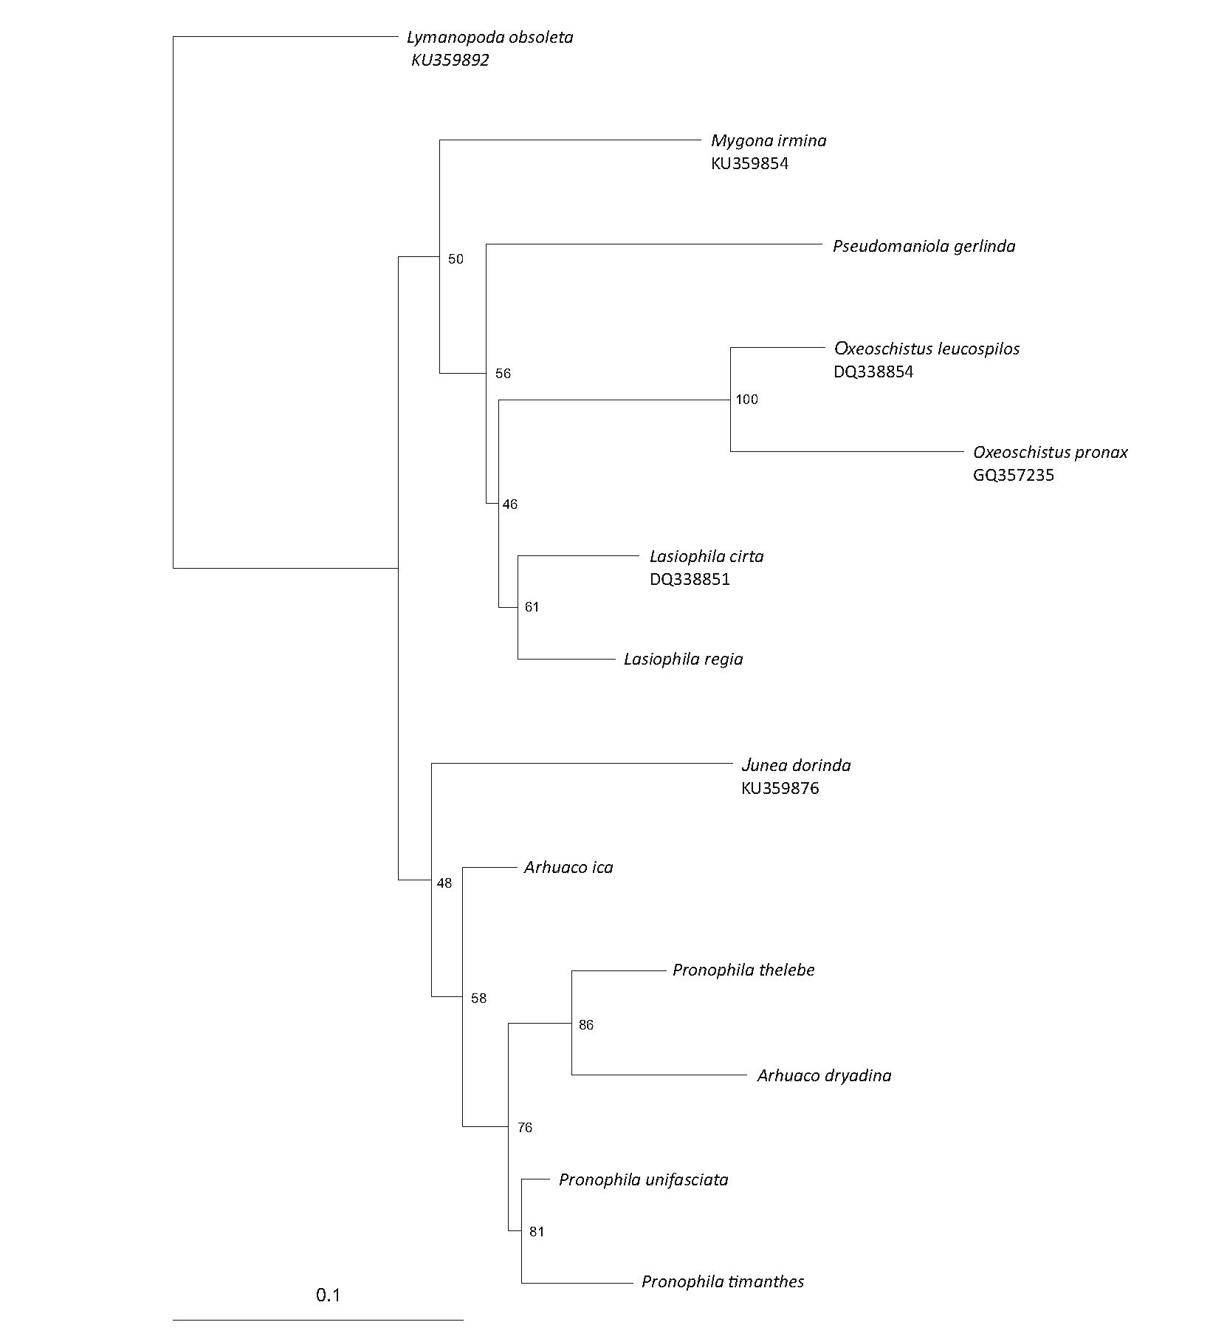
306
Weymer 1911, Apexacuta Pyrcz 2004, Corades Doubleday
[1849] and Pseudomaniola Rober 1889 (excluding some spe-
cies of the latter two genera whose monophyly is not yet
resolved) (Peña et al 2006, Pyrcz 2010), and also Arhuaco.
At the same time, the species of Pronophila are immedi-
ately recognized from other genera of this group, including
Arhuaco, by a series of characters of wing shape, namely,
forewing with a blunt apex and gently concave outer mar-
gins; rounded hindwing wider than forewing with wavy outer
margins; between three and five large, black forewing ventral
submarginal ocelli (in species with white subapical patches
the subapical ocelli are subdued) invariably with violet or
blue pupils, aligned in a row either parallel to the outer mar-
gin or slightly arched basally; and hindwing venter median
band darker than the rest of wing's surface, continuous, with
a nearly straight basal edge and a distal edge sharply pro-
duced distally along discal cell edge.
In Arhuaco (Fig 5), in contrast to Pronophila, the forewing
has an acute apex and straight outer margin, the hindwing is
subtriangular with a scalloped outer margin with sharp tips at
vein ends (in this respect, the wing shape of Arhuaco strongly
resembles that of Pseudomaniola, as a result of which
A. dryadina has been previously associated with this genus).
Importantly, on the hindwing venter, the median band is
discontinuous in the discal cell along cross vein CuAi-CuA2,
with its basal edge connected to the postbasal line (Fig 6).
Additionally, on the forewing underside, there is a row of
black submarginal ocelli roughly parallel to the outer margin
(in A. ica, the ocelli do have small violet pupils as in
Pronophila, whereas in A. dryadina the pupils are white and
very large; in A. ica, there are five well-developed ocelli and
two in the apex transformed into whitish patches; in
A. dryadina, there are as many as eight developed ocelli,
including in the apical area in cells R3-R4 and R4-R5, which
Pyrcz et al
Fig 1 RAxML phylogenetic tree
based on the COI gene. Bootstrap
values are indicated at the nodes.
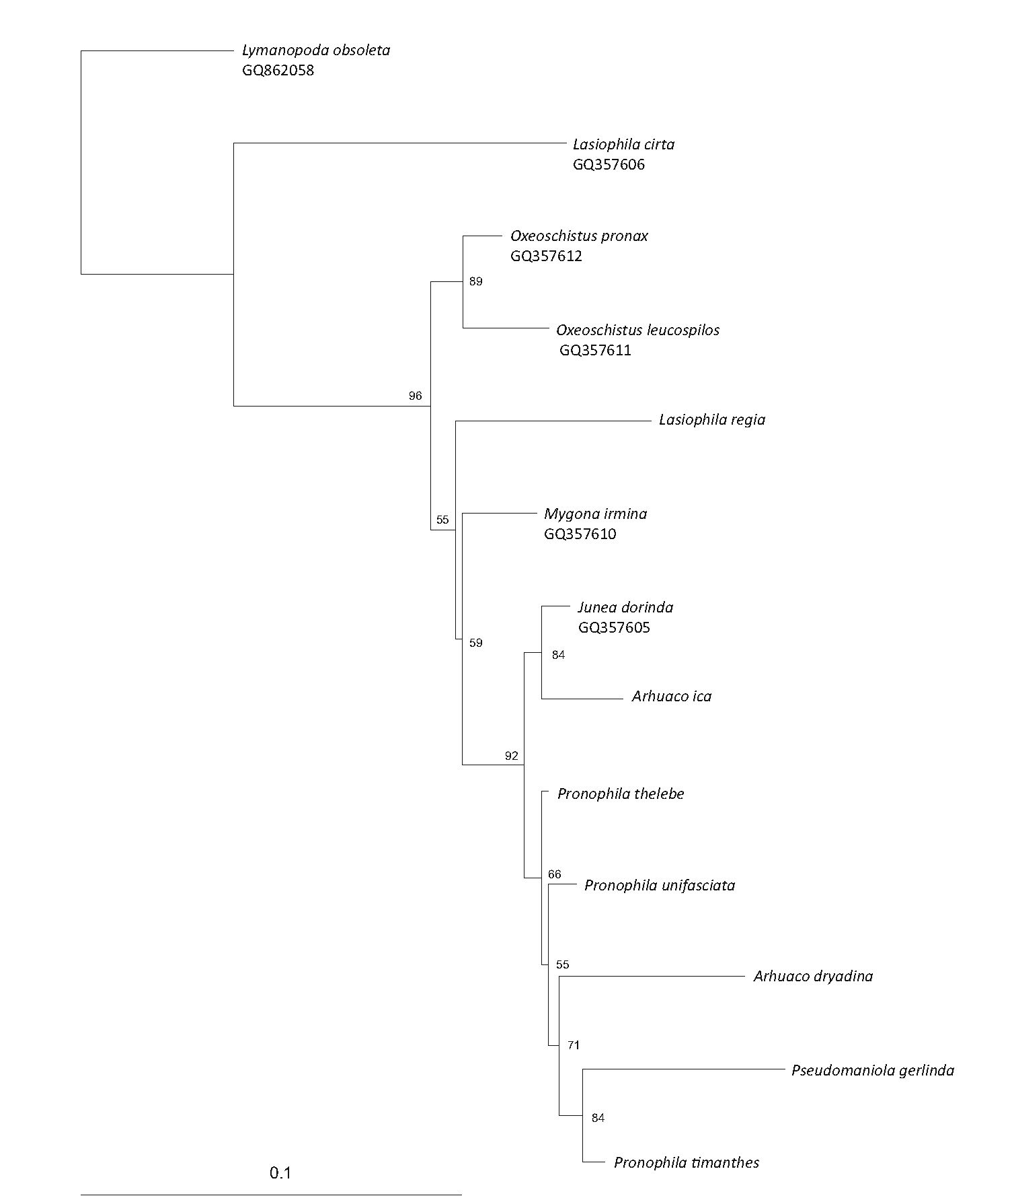
Taxonomy of Arhuaco
307
Fig 2 RAxML phylogenetic tree
based on the RpSs gene.
Bootstrap values are indicated at
the nodes.
is more than in any other genus of Pronophilina). Finally,
there is a row of hindwing black ocelli ringed with red on
wing dorsal surface, most prominently in the females.
The male genitalia of Arhuaco are very simple and do not
present any distinctive character compared to Pronophila or
Junea. All these three genera present a stout uncus (always
shorter than in Oxeoschistus) aligned with the tegumen
shoulder, long and thin subunci, the valva narrowing gradu-
ally towards the apex with a smooth dorsal surface (contrary
to the serrate dorsal surface in Oxeoschistus) without any
dorsal processes, and a short, and straight, tubular and
smooth aedeagus (Fig 7).
the upperside, its brown ground color is a shade lighter, and
the white submarginal ocellar elements on the fore and
hindwing are larger, bordered with a light brown halo, and
on the hindwing additionally ringed with red. The underside
ground color is lighter, predominantly sandy yellow, except
for the basal half on the forewing which is brown with a light
yellowish suffusion. The female genitalia (Fig 8) are charac-
terized by an oval bursa with prominent signa, a large mem-
branous pocket enclosing the antrum, and a single slat-like
sclerotized postvaginal process.
Diagnosis of Arhuaco
Female of Arhuaco dryadina
Sexual dimorphism of A. dryadina is slight (Fig 5). The female
is marginally larger (~2 mm in wingspan) than the male. On
The original generic diagnosis of Arhuaco (Adams & Bernard
1977) does not stand in the light of the above comparative
study. Consequently, a new diagnosis of the genus Arhuaco is
presented as follows:
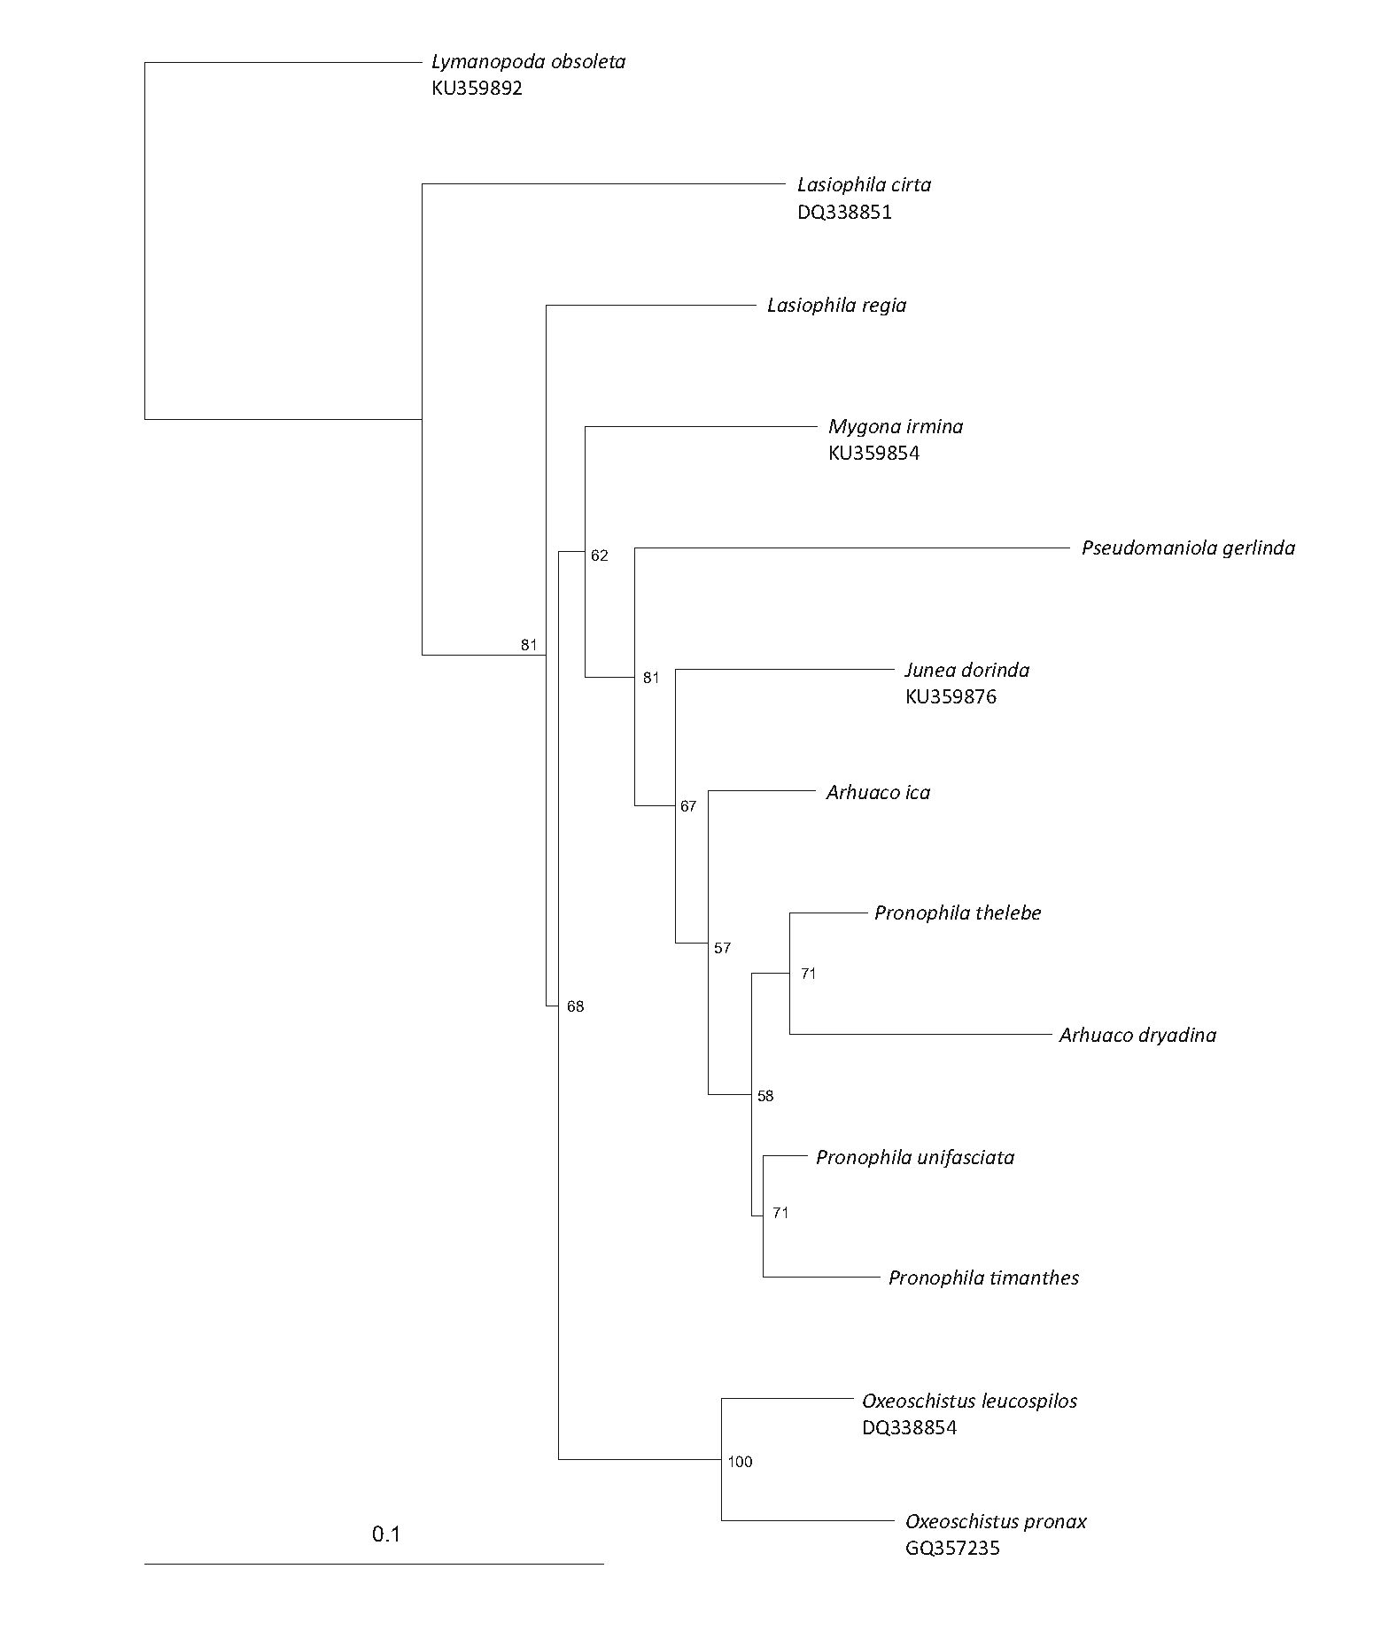
Pyrcz et al
Fig 3 RAxML phylogenetic tree
based on the joined COI and RpS5
genes. Bootstrap values are
indicated at the nodes.
Adults: Forewing with an acute apex (blunt in Pronophila
and Mygona) and straight outer margin (produced below
apex in Pseudomaniola and Junea); hindwing subtriangular
with a scalloped outer margin with sharp tips at vein ends
(similar to Junea); hindwing venter postdiscal band discon-
tinuous in discal cell along cross vein CuAi-CuA2, with basal
edge connected to postbasal line (unlike any other genus of
Pronophilina); forewing underside with a row of five to eight
black submarginal ocelli roughly parallel to the outer margin
(similar to Pronophila), including two, apical in R3-R4 and
R4-R5 (unlike any other genus of Pronophilina), transformed
into whitish patches in A. dryadina; black hindwing ocelli
ringed with red visible on wing dorsal surface (unlike any
other genus of Pronophilina). Sexual dimorphism slight,
females larger, with lighter hindwing ventral patterns and
hindwing ocelli more prominently marked on dorsal surface.
Bionomics
During this research, A. dryadina was found in a rather flat-
tened part of the uppermost area of a mountain ridge, with
high and predominantly uniform forest cover dominated by
oaks (Quercus costarricensis) at 3000-3100 m a.s.l.
Individuals are very actively patrolling. Both males and
females fly rather rapidly, but not as fast as some other
Andean satyrines, such as Corades. On the wing, they resem-
ble somewhat some species of Pronophila or Pseudomaniola,
with the difference that they move invariably high above the
ground, usually in the canopy, compared to other Andean or
Mesoamerican satyrines which can be observed in the sub-
canopy but frequently descend to ground level. Perching
coupled with territorial behavior among the Pronophilina
satyrines is typical of very fast flying species in Corades and
30S
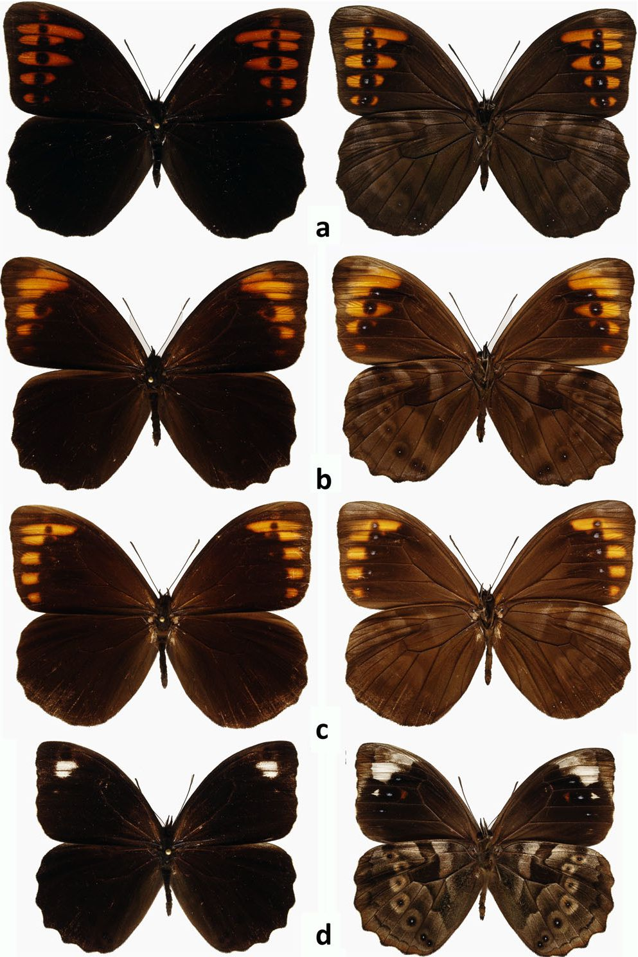
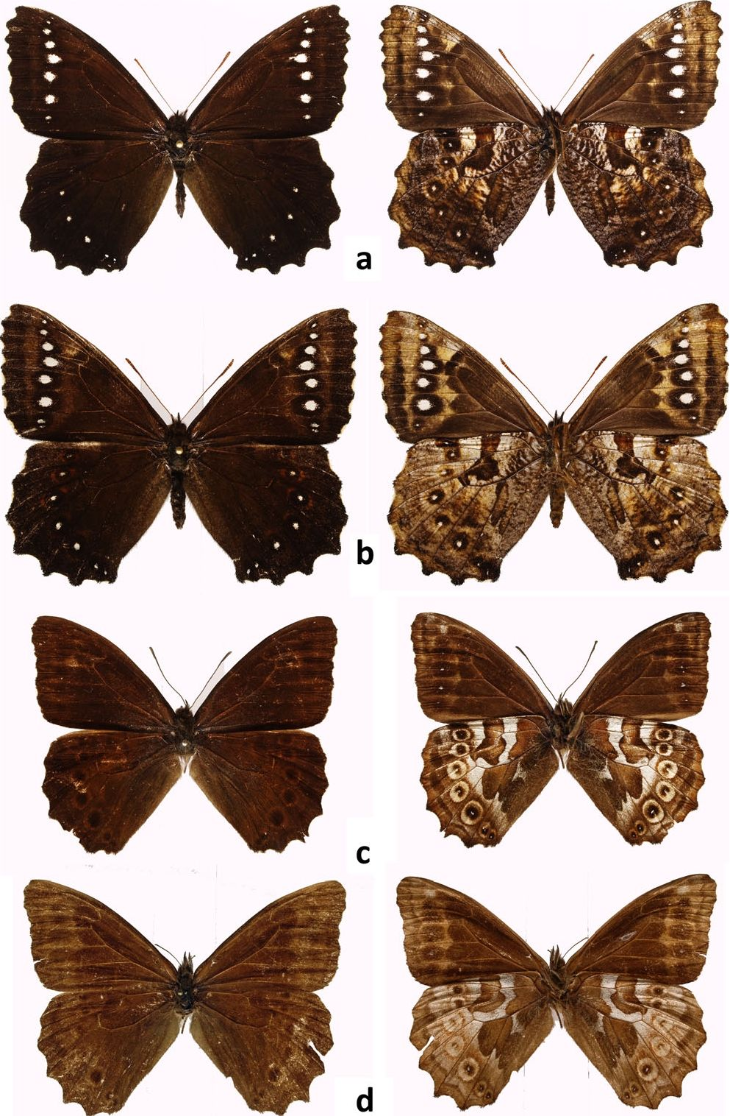
Taxonomy of Arhuaco
В09
Fig 4 Pronophila adults, males (recto, verso): a Pronophila timanthes, b
Pronophila unifasciata unifasciata, c Pronophila thelebina thelebina, d
Pronophila thelebe.
Junea, but is also present in some Steremnia Thieme,
Daedalma, and Thiemeia. Other genera are either patrolling,
or they present intermittent patrolling and perching behavior
with no strong territoriality. Individuals, mostly males, ob-
served in Cerro de la Muerte were very active, starting from
8 A.M. when the day was bright from the early morning.
When days were mostly cloudy, they started being active
during short sunny intervals almost immediately. For most
of the time, they were the only active butterflies in the for-
est, as other species were apparently awaiting an increase in
temperature, requiring at least 10 min of direct sunshine
before taking flight. Males displayed patrolling behavior.
They flew vigorously, high above the trees, occasionally flut-
tering and approaching some leaves or flowers, although
never settling. They showed an obvious preference for
Quercus trees, and, rather surprisingly, they rarely
approached the abundant and frequently tall bamboo
clumps, contrary to what can be observed with most of
Fig 5 Arhuaco adults (recto, verso): a Arhuaco dryadina male, b
Arhuaco dryadina female, c Arhuaco ica male, d Arhuaco ica female.
Andean satyrines, which are most frequently associated
with their host plants. They were not attracted to traps
placed at 1-2 m baited with dog excrement, which other-
wise proved effective with other local satyrines. They were
never observed on hilltops or other prominent topograph-
ical features, such as outstanding trees, contrary to terri-
torial Corades and Junea, or non-territorial Steremnia,
Pedaliodes or several other genera in the Andes. Male indi-
viduals were seen engaging in short interactions consisting
of following one another for a short while, probably iden-
tifying whether the followed individual was a female, but
no contest behavior was observed. No courtship or mating
was observed. Individuals of A. dryadina spent most of the
time in the canopy and were extremely reluctant to ap-
proach ground level, which was observed only above a
boggy clearing covered partially with Vaccinium and
Hypericum bushes. Even then, individuals overflew the
plants but never approached within 2 m of the ground.
DeVries (1987) reports A. dryadina as a rare butterfly.
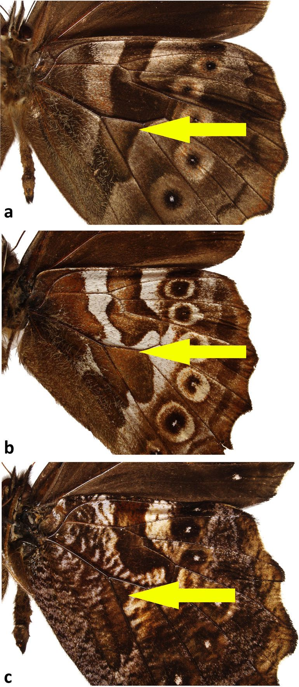
310
Pyrcz et al
Fig 6 Hindwing ventral color patterns (arrows indicating the distortion
of the Nymphalid ground-plan in Arhuaco consisting in the breaking and
basal displacement of the postdiscal line—the so-called Pierellization): a
Pronophila colocasia, b Arhuaco ica, c Arhuaco dryadina.
This is certainly not the case in the Cerro de la Muerte,
where by the end of June and beginning of July
A. dryadina was arguably common, and also the most ob-
vious butterfly considering it was very active, patrolling,
and a large butterfly that could unlikely be confused with
any other species. In February-March (dry season), only
one individual of A. dryadina was observed in the same
area where they were common in June-July (rainy season),
which indicates that the species is possibly strongly sea-
sonal. Such important seasonal fluctuation in abundance is
uncommon among tropical Pronophilina and has been
reported so far only for species occurring in páramo grass-
land, for example, Steromapedaliodes (Pyrcz et al 2017).
The early stages and host plants are not known.
The only information on the ecological preferences of
A. ica was published by Adams & Bernard (1977). They stated
that the species is local and mostly rare, and that it has a
preference for forest canopy, and rarely descends to the
ground. One of the co-authors, however, observed and col-
lected males mud-puddling on the shores of a mountain
stream, which shows that occasionally they descend to
ground level. Arhuaco ica has been collected so far at
2400-3100 m a.s.l., therefore in upper elevation cloud for-
ests. The early stages of A. ica are not known, but its host
plants are almost certainly among Chusquea bamboos, as for
other species of high elevation Pronophilina in the Sierra
Nevada de Santa Marta.

Discussion
The currently available morphological and genetic data
resulted in incongruent inferences about the relationships
among the studied species. In addition, the two sequenced
genes COI and RpS5 also yielded different results, segregat-
ing either the two species of Arhuaco within the Pronophila
clade, placing Arhuaco ica as sister to Pronophila + Arhuaco
dryadina or indicating A. ica as sister to J. dorinda, and even
placing Pseudomaniola gerlinda within the Pronophila clade.
Although only two genetic markers were studied here, the
phylogenies within this section of Pronophilina seem unre-
solved, and the monophyly of Arhuaco should be considered
as uncertain. Interestingly, however, the molecular results
strongly indicate a clade composed of Pronophila, Arhuaco,
Junea, and Pseudomaniola, and, if adopting a broader taxo-
nomic approach, all these could be lumped within a larger
genus Pronophila. These results, incidentally, agree with
morphological evidence which indicates close relationships
among these genera, possibly forming a monophyletic group.
Putative synapomorphies, especially in the wing shape
and color pattern involving the so-called elements of the
nymphalid groundplan sensu Schwanwitsch (Nijhout1991),
suggest a closer relationship of A. ica with A. dryadina than
with any other genus or species of the subtribe
Pronophilina and indicate that Arhuaco is indeed mono-
phyletic. The broken median band with the basal edge
connected to the postbasal line is a rare distortion of the
nymphalid groundplan termed "Pierellization" by
Schwantwitsch, described for the Haeterini genus Pierella
(Nijhout op. cit.). Such a Pierellization in the two species of
Arhuaco is a unique state in any genus or species of
Pronophilina and was considered to be a strong generic
synapomorphy (Pyrcz 2004). On the other hand, the two
species do not present any apparent putative synapomor-
phic characters enabling to associate them with the genus
Pronophila, presenting rather some features of other
genera, in particular of Junea and Pseudomaniola.
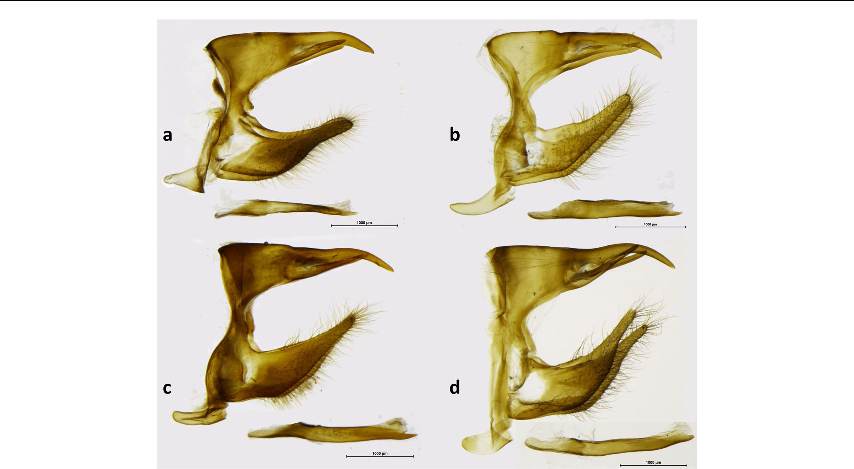
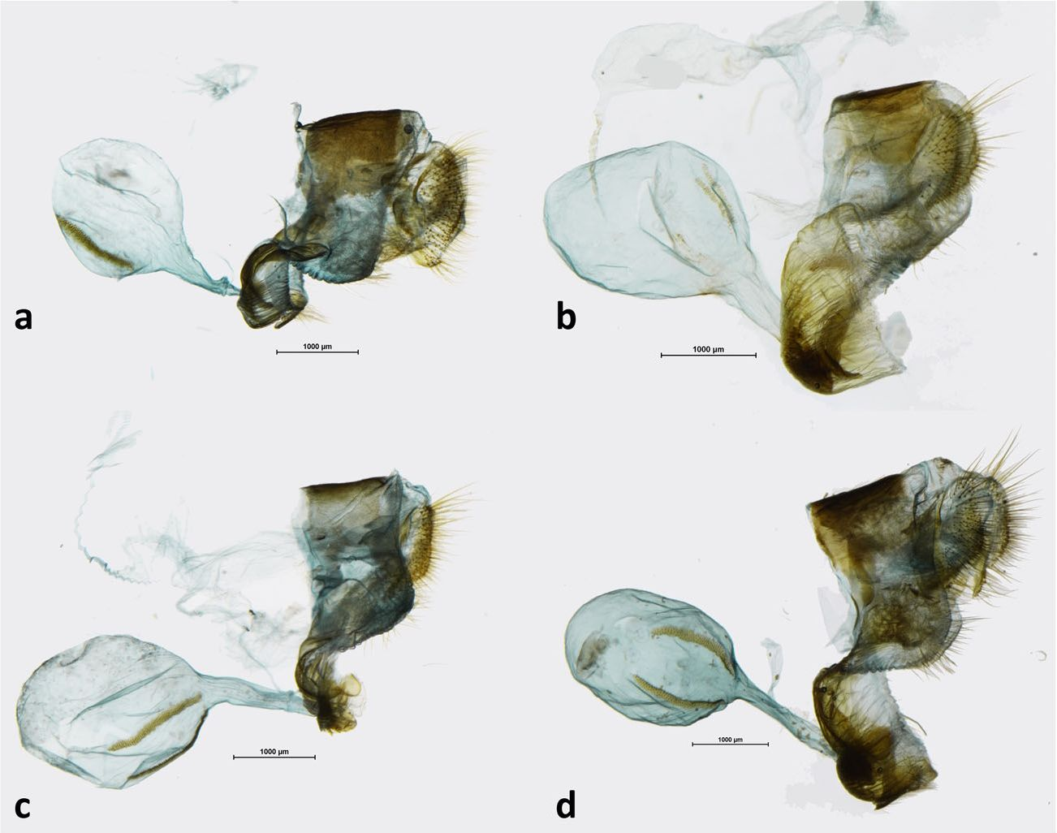
Taxonomy of Arhuaco
311
Fig 7 Male genitalia (lateral view, aedeagus extracted): a Arhuaco dryadina, b Arhuaco ica, c Pronophila orcus, d Pronophila timanthes.
Ecological and behavioral data also indicate closer affini-
ties between A. ica and A. dryadina than with any species of
Pronophila. They both occur in the same kind of habitat, high
elevation forests, at higher elevations than Pronophila, usu-
ally close to the upper forest limit. They also both have an
unusual predilection among the Pronophilina for flying in the
high canopy and not necessarily in association with bamboo
thickets, in contrast to Pronophila which are invariably found
in the vicinity of bamboo and generally in the forest
understory.
At this stage, there is not enough evidence to ascertain
the monophyly of Arhuaco, since it is not supported by mo-
lecular data. It would be, however, premature to synonymize
Arhuaco with Pronophila given sharp-cut morphological
Fig S Female genitalia (lateral view): a Arhuaco dryadina, b Arhuaco ica, c Pronophila rosenbergi, d Pronophila timanthes.
312
Pyrcz et al
differences between the two. More data are needed, in par-
ticular the use of more genetic markers, and the inclusion of
even more species of Pronophila as well as other species of
Junea and Pseudomaniola in the analysis. It is possible that
early-stage data would shed some light on the affinities of
Arhuaco and Pronophila, as they have on the status of the
genus Daedalma, which has very particular larvae compared
to other related genera (Pyrcz et al 2011), but given the scar-
city of Arhuaco ica in the field, and the difficulties in finding
pronophiline larvae, and rearing them, requiring in situ work,
it will be a very difficult task.
The disjunct distribution of Arhuaco in Costa Rica-Panama
and northern Colombia, if the genus is confirmed as mono-
phyletic, would be challenging to explain from a biogeo-
graphical and evolutionary perspective. Recent, long-
distance dispersal of such highly sedentary and habitat-
specific montane satyrines between these areas that are cur-
rently separated by the vast Colombian plains seems ex-
tremely unlikely (Adams 1986, Pyrcz & Garlacz 2012).
Therefore, a vicariance scenario has to be considered. In this
case, Arhuaco would originally have had a wider distribution,
but disappeared from intervening areas in the northern
Andes of Colombia. Such a vicariance scenario would imply
that Arhuaco is an old genus within the subtribe which per-
haps emerged prior to the radiation of the genus Pronophila.
This hypothesis, in turn, could explain, to some extent, the
closer genetic relationships with the latter genus and the
position of Arhuaco within the larger Pronophila clade.
However, we have to consider that the origins of Arhuaco
and, in fact, of other montane species of butterflies belong-
ing to predominantly Andean clades in Central America are
presumably linked with the formation of the Isthmus of
Panama, and the process of the Great Interamerican Biotic
Interchange (GABI). It is generally considered that the land
bridge connection between South and Central America oc-
curred only some 3 MYA, and before that higher mountain-
ous areas in Central America were isolated volcanic islands,
although some data indicate that such a connection could
have existed some 10-15 MYA (Montes et al 2015). The for-
mation of a land connection between these two areas was a
precondition of colonization, but, additionally, ecological
conditions must have evolved to allow montane species from
South America to establish themselves in Central American
highlands. This, in turn, could have happened with the cool-
ing of global climate during the Pleistocene and the evolution
of ecological corridors of suitable vegetation, hence permit-
ting dispersal from the Andes to the Cordillera de Talamanca.
In any case, the timing of such a scenario does not predate
the Pleistocene, which is some 1.85 MYA. It is congruent with
the distribution of most Central American species of
Pronophilina, an overwhelming majority of which are closely
related to north Andean taxa, including Lymanopoda euopis
Godman & Salvin, Pedaliodes ereiba Godman & Salvin,
Pedaliodes lithochalcis Butler & Druce, Eretris suzannae
DeVries, or Pronophila timanthes Salvin (Casner & Pyrcz
2010, Pyrcz & Viloria 2012). These are mostly mid- to low-
altitude species whose ancestors presumably dispersed rela-
tively recently from the Andes. However, the presence of the
high elevation specialist A. dryadina, and indeed of the en-
demic Mesoamerican genus Drucina represented by one
Costa Rican species D. leonata Butler 1872, and by
- championi (Godman & Salvin, [1881]) from Guatemala
and southern Mexico, is difficult to explain by geological
and paleoclimatic data on the one hand, and species phylo-
genetic affinities and the inferred timing of divergence on the
other.
Acknowledgments Research permits of TP in Costa Rica were issued
by the resolution ACOPAC-IV-001-16 (Evaluación de las estructuras gen-
itales de las mariposas hembras en la resolución de problemas
filogenéticos y alfa-taxonómicos de las subtribus Euptychiina y
Pronophilina en la Reserva Forestal Los Santos, Pacífico Central de
Costa Rica). We would like to thank Marianne Espeland (Forschungs
Museum Koenig, Munich) for attempting to obtain additional DNA
sequences of Arhuaco ica.
Author Contribution Statement TP designed experimental work and
conducted data analysis; JL-B and KF carried out morphological analysis,
edited the text and prepared the figures; AZ, BW, and DL-C executed
molecular analysis and interpreter its results; and TP, CP, and PB carried
out field work. TP, PB, CP, and DL-C wrote the manuscript.
Funding Information Research was partially financed from funding
from the National Science Center, granted on the basis of decision num-
ber DEC-2013/09NNZS/03219 and by the Jagiellonian University
(K/ZDS/007357).
Open Access This article is distributed under the terms of the Creative
Commons Attribution 4.0 International License (http://creativecom-
mons.org/licenses/by/4.0/), which permits unrestricted use, distribu-
tion, and reproduction in any medium, provided you give appropriate
credit to the original author(s) and the source, provide a link to the
Creative Commons license, and indicate if changes were made.

References
Adams MJ (1986) Pronophiline butterflies (Satyridae) of the three
Andean Cordilleras of Colombia. Zool J Linnaean Soc 87:235-320
Adams MJ, Bernard GI (1977) Pronophiline butterflies (Satyridae) of the
Sierra Nevada de Santa Marta, Colombia. Syst Entomol 2(4)763-281
Butler AG (1867) Revision of the group of lepidopterous insects hitherto
included in the genus Pronophila of Westwood. Ann Mag Nat Hist (3)
20(ii8):266-268
Butler AG (1872) Descriptions of new butterflies from Costa Rica. Cistula
Entomologica 1(4)72-90
Casner KL, Pyrcz TW (2010) Patterns and timing of diversification in a
tropical montane butterfly genus Lymanopoda (Nymphalidae,
Satyrinae). Ecography 33:251-259
Chacón I, Montero J (2007) Mariposas de Costa Rica. INBIO, San José, p
366
Taxonomy of Arhuaco
313
D'Abrera B (1988) Butterflies of the Neotropical region. Part V.
Nymphalidae (Conc.) & Satyridae. Victoria, Black Rock, Hill House,
pp 680-887
DeVries PJ (1987) The butterflies of Costa Rica and their natural history,
vol 1, Papilionidae, Pieridae, Nymphalidae New Jersey, Princeton
University Press, pp. 456
DeVries PJ (1997) The butterflies of Costa Rica and their natural history,
vol 2, Riodinidae Princeton, Princeton University Press, pp. 288
Doubleday E (1849) The genera of diurnal Lepidoptera: comprising their
generic characters, a notice of their habits and transformations, and a
catalogue of the species of each genus. London, Longman, Brown,
Green & Longmans 1:185-192
Folmer O, Black M, Hoeh W, Lutz RA, Vrijenhoek RC (1994) DNA primers
for amplification of mitochondrial cytochrome c oxidase subunit I
from diverse metazoan invertebrates. Mol Mar Biol Biotechnol 3:
294-299
Gaede M (1931) Familia Satyridae. Lepid Cat 43:1-320 46:321-544, 48:
545-759
Godman FDC, Salvin, OS (1881) Biologia Centrali-Americana. Insecta.
Lepidoptera-Rhopalocera. London, Dulau & Co., Bernard Quartich,
89-208
Hall TA (1999) BioEdit: a user-friendly biological sequence alignment
editor and analysis program. Nucleic Acids Symp Ser 41:95-98
Hewitson WC (1849) Description of a new genus and species of
Satyridae. Proc R Soc Lond 16:115-117
Katoh K, Toh H (2008) Recent developments in the MAFFT multiple
sequence alignment program. Brief Bioinform 9:286-298
Klots AB (1956) Lepidoptera. In: Tuxen SL (ed) Taxonomists' glossary of
genitalia in insect. Munksgaard, Copenhagen, pp 97-110
Krüger E (1924) Beiträge zur Kenntnis der columbischen Satyriden.
Entomologische Rundschau 41(2)7) (3):9-10, 16, 19-20, 23-24, 27-
28, 31-32, 35, 38-39
Krüger E (1925) Beiträge zur Kenntnis der columbischen Satyriden.
Entomologische Rundschau 42(3/10-12 14,17-18, 23-26
Kumar S, Stecher G, Tamura K (2016) MEGA7: Molecular Evolutionary
Genetics Analysis version 7.0 for bigger datasets. Mol Biol Evol 33:
1870-1874
Lamas G (2004) Checklist: Part 4A. Hesperioidea - Papilionoidea. In:
Heppner JB (ed) Atlas of Neotropical Lepidoptera. Volume 5A.
Gainesville, Association, pp 205-224
Marín MA, Cadavid IC, Valdés L, Álvarez CF, Uribe SI, Vila R, Pyrcz TW
(2017) DNA barcoding of an assembly of montane Andean butterflies
(Satyrinae): geographical scale and identification performance.
Neotrop Entomol 46(5/514-523
Montes C, Cardona A, Jaramillo C, Pardo A, Silva JC, Valencia V, Ayala C,
Pérez-Angel LC, Rodriguez-Parra LA, Ramirez V, Niño H (2015) Middle
Miocene closure of the Central American Seaway 348(6231/226-229
Nijhout HF (1991) The development and evolution of butterfly wing
patterns. Smithsonian Institution Press, Washington, D.C., p 291
Peña C, Wahlberg N, Weingartner E, Kodandaramaiah U, Nylin S, Freitas
AVL, Brower AVZ (2006) Higher level phylogeny of Satyrinae butter-
flies (Lepidoptera: Nymphalidae) based on DNA sequence data. Mol
Phylogenet Evol 40:29-49
Peña CA, Nylin S, Wahlberg N (2011) The radiation of the Satyrini butter-
flies (Nymphalidae: Satyrinae): a challenge for phylogenetic methods.
Zool J Linnaean Soc 161:64-87
Pyrcz TW (1999) The E. Krüger collection of pronophiline butterflies, part
1: introduction, genera Altopedaliodes to Lymanopoda. Lambillionea
99(2/221—240
Pyrcz TW (2004) Pronophiline butterflies of the highlands of
Chachapoyas in northern Peru: faunal survey, diversity and distribu-
tion patterns (Lepidoptera, Nymphalidae, Satyrinae). Genus 15(4):
455-622
Pyrcz TW (2010) Wybrane zagadnienia z taksonomii, zoogeografii i ewo-
lucji faun górskich na przykładzie grupy modelowej motyli z plemienia
Pronophilini (Nymphalidae). Mantis, Olsztyn. pp. 245
Pyrcz TW, Garlacz R (2012) The presence-absence situation and its im-
pact on the assemblage structure and interspecific relations of
Pronophilina butterflies in the Venezuelan Andes (Lepidoptera:
Nymphalidae). Neotrop Entomol 41(3/186-195. https://doi.org/10.
1007/s13744-012-0031-2
Pyrcz TW, Viloria AL(2012) Revalidation of Pedaliodes lithochalcis Butler
& Druce, description of a new species from Peru and Bolivia and of a
new subspecies of P. napaea Bates from Honduras (Lepidoptera:
Nymphalidae: Satyrinae). Genus 23(1/133-152
PyrczT, Wojtusiak J, Garlacz R (2009) Diversity and distribution patterns
of Pronophilina butterflies (Lepidoptera: Nymphalidae: Satyrinae)
along an altitudinal transect in North-Western Ecuador. Neotrop
Entomol 38(6):716-726
Pyrcz TW, Greeney H, Willmott K, Wojtusiak J (2011) A taxonomic revi-
sion of the genus DaedalmaHewitson with the descriptions of twenty
new taxa and the immature stages of two species (Lepidoptera:
Nymphalidae: Satyrinae). Zootaxa 2898:1-68
Pyrcz TW, Lorenc-Brudecka J, Zubek A, Boyer P, Gabaldón CM, MavarezJ
(2017) Taxonomy, phylogeny and distribution of the genus
Steromapedaliodes sensu novo in the Cordillera de Merida,
Venezuela (Lepidoptera, Nymphalidae: Satyrinae: Satyrini).
Arthropod System Phylogeny 75:195-243
Röber JKM (1889-1892) II. Theil. Die Familien und Gattungen der
Tagfalter systematisch und analitisch bearbeitet. In: Staudinger O,
Schatz (eds): Exotische Schmetterlinge. Fürth G. Löwensohn, 2(5):
181-224, (6): [5]+ii+225-284
Schaus W (1913) New species of Rhopalocera from Costa Rica. Proc R Soc
Lond 1913(3/339-367
Stamatakis A (2014) RAxML version 8: a tool for phylogenetic analysis
and post-analysis of large phylogenies. Bioinformatics 30:1312-1313
Thieme O (1905) Monographie der Gattung Pedaliodes Butl.
(Lepidoptera. Rhopalocera. Satyridae). Berliner Entomologische
Zeitschrift 50:43-141
Wahlberg N, Wheat CW (2008) Genomic outposts serve the phyloge-
nomic pioneers: designing novel nuclear markers for genomic DNA
extractions of Lepidoptera. Syst Biol 57:231-242
Westwood JO (1850) In: Doubleday E (ed) The genera of diurnal
Lepidoptera: comprising their generic characters, a notice of their
habits and transformations, and a catalogue of the species of each
genus. London, Longman, Brown, Green & Longmans, 2:315-326
Westwood JO (1851) In: Doubleday E (ed) The genera of diurnal
Lepidoptera: comprising their generic characters, a notice of their
habits and transformations, and a catalogue of the species of each
genus. London, Longman, Brown, Green & Longmans, 2:1-2

