
27th International Nuclear Physics Conference (INPC2019) IOP Publishing
Journal of Physics: Conference Series 1643 (2020) 012111 doi:10.1088/1742-6596/1643/1/012111

An application of chiral forces with the semi-local regularization in momentum space to the deuteron photodisintegration process

V. Urbanevych, J. Golak, R. Skibiński and H. Witała
M. Smoluchowski Institute of Physics, Jagiellonian University, PL-30348 Kraków, Poland E-mail: vitalii.urbanevych@doctoral.uj.edu.pl
Abstract. A recent paper by P. Reinert et al. [Eur. Phys. J. A54, 86 (2018)] showed a possibility of improving chiral nucleon-nucleon potential models by employing a semi-local regularization in momentum space. The authors derived nucleon-nucleon potentials with this kind of regularization completely up to the fifth order of the chiral expansion and considered additionally some contact interactions which appear at the sixth order. Such a chiral interaction has never been applied to study electromagnetic processes in two- or three- nucleon systems. Here we continue our research of photodisintegration processes, now using the improved chiral force. In particular, we discuss our predictions for the deuteron photodisintegration reaction in the photon energy range up to 100 MeV. The results of our calculations reveal that the new potential yields predictions characterized by a weaker dependence on the regularization parameter and faster convergence with respect to the chiral expansion order compared to the older chiral potentials.

1. Introduction
Chiral effective field theory (%EFT) is currently the most important theoretical approach to study low-energy nuclear physics. This theory has been intensively developed for nearly 30 years, resulting in sophisticated two-nucleon and many-nucleon interactions [1].
Recently, the Bochum group has derived a completely new version of the chiral potential, with semi-local regularization in momentum space (the so-called ”SMS” potential) [2]. In this model the nucleon-nucleon (NN) interaction is derived up to the fifth order of chiral expansion (N4LO). Even some contributions from sixth order could be tested within the so-called N4LO+ model of the chiral NN force. Beside the new regularization method, there are also other important improvements in the SMS model. For instance, a new way of fixing parameters for pion-nucleon vertices or the fact that revised NN database [3] was used to fix free low energy constants [2].
It is well known, that the non-local regularization of the chiral forces leads to a strong dependence of the predictions on regularization parameters already at N2LO (see [4, 5, 6] for the corresponding results in the electromagnetic sector). In order to evaluate the reliability of the new model, one needs to apply the SMS force to many processes and obtain observables which could be compared with data. The chiral nucleon-nucleon (NN) interaction with semilocal regularization in the momentum space has never been applied to study the electromagnetic processes in two- or three- nucleon systems and we present here such first applications, especially
Content from this work may be used under the terms of the Creative Commons Attribution 3.0 licence. Any further distribution of this work must maintain attribution to the author(s) and the title of the work, journal citation and DOI.
Published under licence by IOP Publishing Ltd
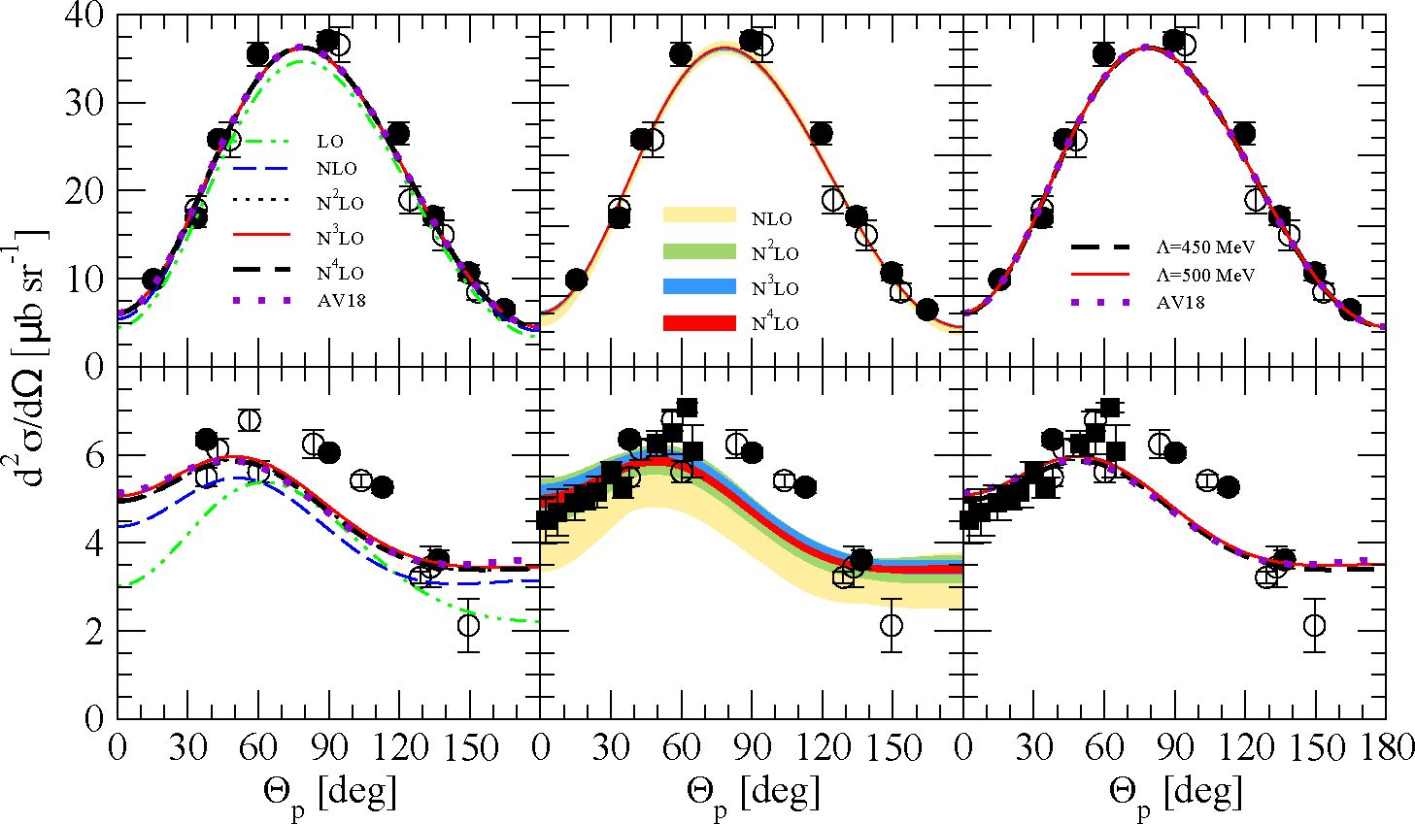
27th International Nuclear Physics Conference (INPC2019) IOP Publishing
Journal of Physics: Conference Series 1643 (2020) 012111 doi:10.1088/1742-6596/1643/1/012111
focusing on the dependence of predictions on the regularization parameters and on the chiral order.
In the present work we follow the line of our previous research [7] and test the new chiral potential in the deuteron photodisintegration reaction for the photon energies up to 100 MeV.

2. Theoretical approach
The theoretical formalism, which is used in the present work has been already described several times (e.g. in [7, 6]). Thus we mention here only the main steps of our calculations.
Figure 1. The differential cross-section d^f for the deuteron photodisintegration as a function of the proton scattering angle dp in the center of mass frame. The upper (lower) row shows results at photon energy EY = 30 MeV (100 MeV). In the left column predictions from various orders of chiral expansion with cut-off parameter A = 450 MeV and from Argonne V18 (AV18) model [8] are shown. The middle column represents truncation errors with respect to the order of chiral expansion. The right column shows the convergence of predictions for two cut-off parameters at the fifth chiral order (N4LO). All data points are taken from [9].
The crucial quantities in the description of electromagnetic process from which one can obtain observables are nuclear matrix elements. For the deuteron photodisintegration process, nuclear matrix element N^eu can be defined as:
NL = , (1)
where the proton-neutron scattering (final) and the deuteron bound (initial) states are represented as and l^oUnd), and j%N is a four-component electromagnetic current
operator. The deuteron wave function is obtained from the Schrodinger equation using the Hamiltonian which corresponds to a given model of the NN interaction V. The same potential is included in the Lippmann-Schwinger equation for the t-operator,
t = V + tGoV, (2)
where G0 is the free NN propagator. Using the solution of Eq. (2), it is possible to construct the scattering state |^2Catt) and to express N^eu as
2
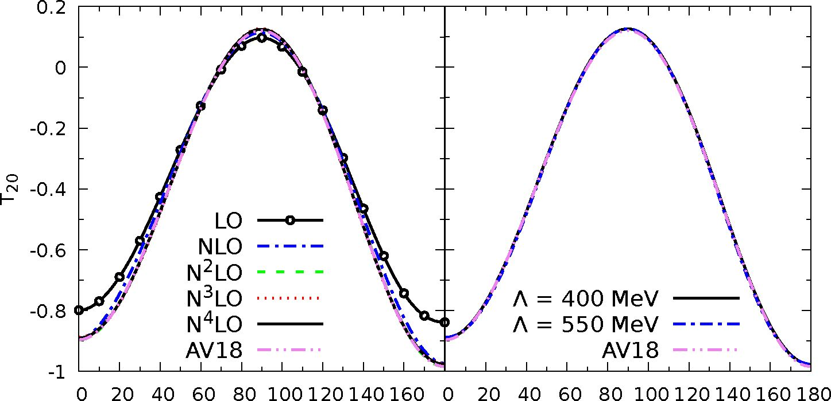
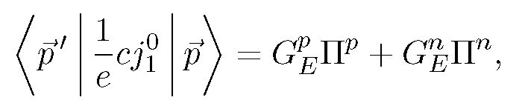
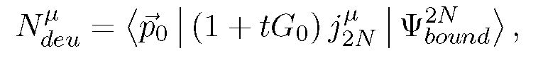
27th International Nuclear Physics Conference (INPC2019) IOP Publishing
Journal of Physics: Conference Series 1643 (2020) 012111 doi:10.1088/1742-6596/1643/1/012111
where |p0) denotes an eigenstate of the relative proton-neutron momentum.
The 2N current operator jbN is a sum of one- and two- nucleon operators, and up to now the two-nucleon current, consistent with the SMS potential, is unavailable. So in this work we use only the single-nucleon current with separate proton and neutron parts.
The zeroth component (charge density) of the single-nucleon current has the form:

(4)
while the vector part is a sum of the so-called convection and spin currents
In Eqs. (4) and (5) p and p' are single-nucleon momenta, GEn and GPM are electromagnetic formfactors, P is the vector of Pauli spin matrices and np,n are projection operators necessary to distinguish the different electromagnetic properties of the proton and neutron in the isospin formalism, finally np = b (1 + (t)3) and nn = l (1 — (t)3) with isospin matrix t.
0p [deg] 0p [deg]
Figure 2. The deuteron tensor analyzing power Tb0 for a photon energy EY = 30 MeV as a function of the proton emission angle dp. The left column shows dependence of predictions on the order of chiral expansion when A = 450 MeV. The right one shows a dependence on the cut-off parameter (at N4LO). For the sake of comparison, the AV18 model [8] predictions are also shown.
Despite the fact that we are not able to use the explicit two-nucleon currents, there is a possibility to include some their contributions. In the presented here results we use the Siegert theorem as an alternative way to include many-body contributions to the nuclear current. More detailed information about our formalism and the Siegert approach can be found in Refs. [10, 11, 12].
As xEFT is a perturbative theory, there are uncertainties of predictions which are connected with neglecting of higher orders of chiral expansion in practical calculations. Using methods from
3
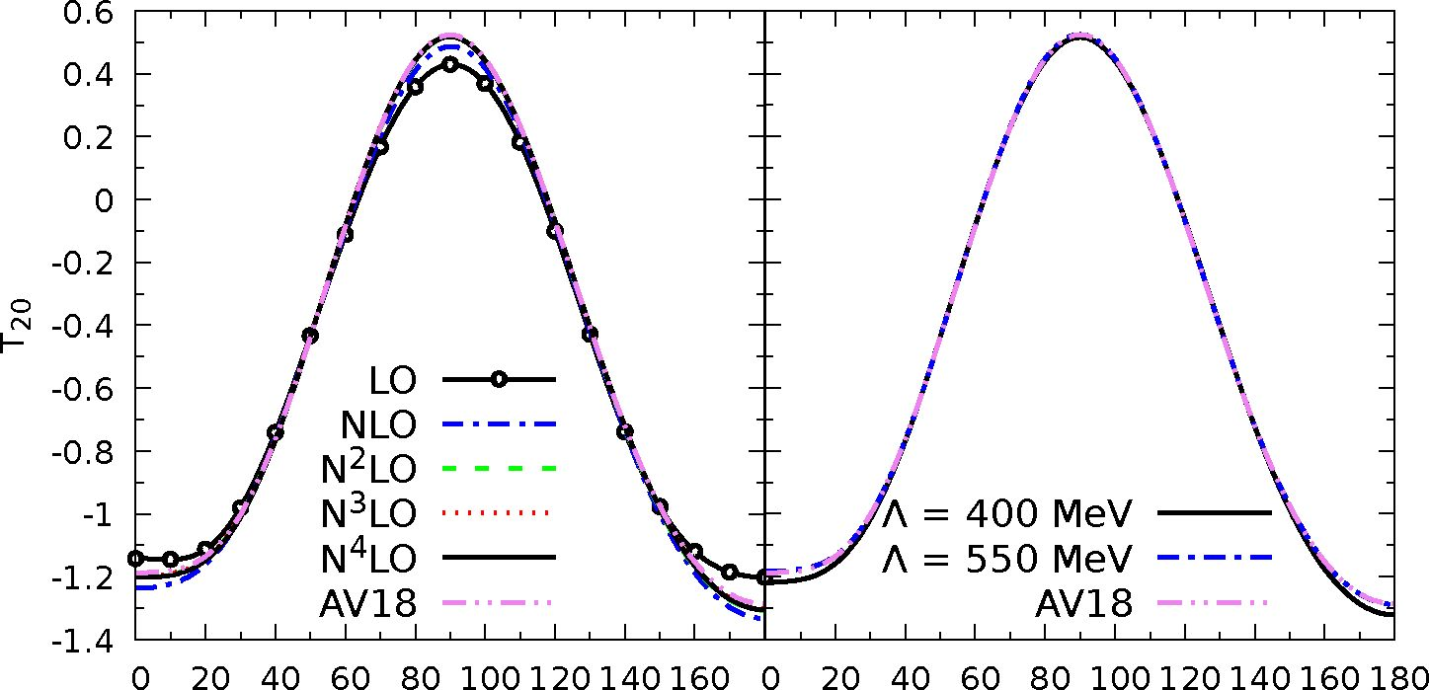
27th International Nuclear Physics Conference (INPC2019) IOP Publishing
Journal of Physics: Conference Series 1643 (2020) 012111 doi:10.1088/1742-6596/1643/1/012111
Ref. [13], we are able to estimate the truncation errors 5(X)(i). Here X denotes an observable at i-th order of chiral expansion, where i = 0, 2, 3, ... . For the chiral expansion parameter Q, truncation errors are:
S(X)(0) > max(Qb X(0) , X(i^0) - X(j^0) ),
5(X)(b) = max(Q3 X(0) ,Q AX(b) , X(^b) - X(j^b) ),
£(X)(i^3) = max(Qi+1 X(0) ,Qi-1 AX(b) ,Qi-b AX(3) ).
(6)
In Eq. (6) X(i) is a predicted value for observable X at i-th order of expansion, AX(2) = X(2) — X(0), and AX(i) = X(i) — X(i-1) (for i > 3). Of course, such errors do not provide us with full information about uncertainties of our calculations. In addition, there are limitations connected with the Siegert theorem instead of the explicit two-nucleon current and others. But it can give us information, which order of chiral expansion is important for the calculation of a particular observable, and whether we need to go to higher orders or not.
- Results of calculations
In order to test the new potential [2], we performed calculations of two observables for the deuteron photodisintegration process at two photon energies in the laboratory system: Ey = 30 MeV and Ey = 100 MeV.
In Fig. 1 the differential cross-section is presented. One can see that the data description for lower energy is much better than for the higher one, what is likely related to the neglection of two-body currents. One the other hand, we see that convergence with respect to chiral orders for both energies is fast enough. The cut-off dependence is weak. Truncation errors at N4LO are quite small, which is represented by the fact that the red band (the darkest one in the black and white version) in the middle column of Fig. 1 is thin. Thus one should not expect large contributions from higher orders of chiral expansion.
0p [deg] 0p [deg]
Figure 3. The same as in Fig. 2 but for the photon energy of 100 MeV.
Figures 2 and 3 show deuteron tensor analyzing power T20 for the photon energies Ey = 30 MeV and Ey = 100 MeV, respectively. Both figures show fast convergence with respect to chiral order and weak dependence on the cut-off parameter. Again we observe that
4
27th International Nuclear Physics Conference (INPC2019) IOP Publishing
Journal of Physics: Conference Series 1643 (2020) 012111 doi:10.1088/1742-6596/1643/1/012111
the current order of chiral expansion is sufficient to describe the analyzing power up to 100 MeV and large contributions from higher orders should not be expected.

4. Conclusions
In the present work, we have applied the chiral SMS potential [2] to a calculation of selected observables for the deuteron photodisintegration reaction. Our calculations for the cross section revealed that the present chiral interaction shows better, compared to the older chiral models [7], convergence with respect to the chiral order (fast for EY = 30 MeV, and only a little bit slower for Ey = 100 MeV) and good behavior with respect to the cut-off parameter. In addition, our results show small truncation error at N4LO, what means that one should not expect significant contributions from higher orders.
The data description is not perfect (especially for the higher energy: Fig. 1 (bottom row)). It can be connected with a simplified current operator used in these calculations. Nevertheless, our results reveal very welcome properties of the SMS potential to study electromagnetic processes.

Acknowledgments
We would like to thank E. Epelbaum, P. Reinert, H. Krebs and other LENPIC members for providing us with the potential subroutine and discussions. This work was supported by the National Science Center, Poland under grant No. 2016/22/M/ST2/00173. The numerical calculations were partly performed on the supercomputer cluster of the JSC, Julich, Germany.

References
- Epelbaum E, Hammer H W and Meifiner U G 2009 Rev. Mod. Phys. 81 1773-1825 (Preprint 0811.1338)
- Reinert P, Krebs H and Epelbaum E 2018 Eur. Phys. J. A54 86 (Preprint 1711.08821)
- Arndt R A, Strakovsky I I and Workman R L 1994 Phys. Rev. C50 2731-2741; SAID partial wave analysis
online service, http://gwdac.phys.gwu.edu/. (Preprint nucl-th/9407035)
- Skibinski R, Golak J, Witała H, Glockle W, Nogga A and Epelbaum E 2006 Acta Phys. Polon. B37 2905-2918
(Preprint nucl-th/0606021)
- Skibinski R, Golak J, Rozpedzik D, Topolnicki K and Witala H 2015 Acta Phys. Polon. B46 159-168
(Preprint 1411.4829)
- Rozpedzik D, Golak J, Kolling S, Epelbaum E, Skibinski R, Witała H and Krebs H 2011 Phys. Rev. C83
064004 (Preprint 1103.4062)
- Skibinski R, Golak J, Topolnicki K, Witala H, Epelbaum E, Kamada H, Krebs H, Meifiner Ulf-G and Nogga
A 2016 Phys. Rev. C93 064002 (Preprint 1604.03395)
- Wiringa R B, Stoks V G J and Schiavilla R 1995 Phys. Rev. C51 38-51 (Preprint nucl-th/9408016)
- Ying S Q, Henley E M and Miller G A 1988 Phys. Rev. C38 1584-1600
- Rozpedzik D, Golak J, Kolling S, Epelbaum E, Skibinski R, Witała H and Krebs H 2011 Phys. Rev. C83
064004 (Preprint 1103.4062)
- Golak J, Kamada H, Witała H, Glockle W, Kuros J, Skibiński R, Kotlyar V V, Sagara K and Akiyoshi H
2000 Phys. Rev. C62 054005 (Preprint nucl-th/0006048)
- Golak J, Skibiński R, Witala H, Glockle W, Nogga A and Kamada H 2005 Phys. Rept. 415 89-205 (Preprint
nucl-th/0505072)
- Binder S et al. (LENPIC) 2016 Phys. Rev. C93 044002 (Preprint 1505.07218)
5

