
Celestial Mechanics and Dynamical Astronomy (2020) 132:56 https://doi.org/10.1007/s10569-020-09993-1
ORIGINAL ARTICLE
Central configurations in the spatial n-body problem for
n = 5, 6 with equal masses

Małgorzata Moczurad1 · Piotr Zgliczyn´ ski1
Received: 3 June 2020 / Revised: 30 October 2020 / Accepted: 3 November 2020 /
Published online: 8 December 2020
© The Author(s) 2020

Abstract
We present a computer assisted proof of the full listing of central configurations for spatial n-body problem for n 5 and 6, with equal masses. For each central configuration, we give a full list of its Euclidean symmetries. For all masses sufficiently close to the equal masses case, we give an exact count of configurations in the planar case for n = 4, 5, 6, 7 and in the
=
spatial case for n = 4, 5, 6.
Keywords Central configurations Symmetries Interval arithmetic Computer assisted proof
· · ·

Contents
- Introduction 2
  - State of the art 2
  - Main result 3
  - Structure of the paper 3
- Equations for central configurations 3
- The reduced system of equations for CC 5
  - Non-degenerate solutions of full and reduced systems of equations 5
  - The reduced system 5
RS
  - Collinearity and coplanarity tests 8
    - Coplanarity test 8
    - Collinearity test 8
- Symmetries 9
  - Finding candidates for (R,σ) 9
    - Initialization of σ 9
    - Finding candidates for symmetric images of qn−2 and q0 10

M. Moczurad and P. Zgliczyn´ski: Partially supported by the NCN Grants 2015/19/B/ST1/01454 and 2019/35/B/ST1/00655.

B Piotr Zgliczyn´ski piotr.zgliczynski@ii.uj.edu.pl
Małgorzata Moczurad malgorzata.moczurad@ii.uj.edu.pl
1 Faculty of Mathematics and Computer Science, Jagiellonian University, ul. prof. Stanisława Łojasiewicza 6, 30-348 Kraków, Poland

    - Constructing R and R : the candidates for the symmetries 10
+ −
    - Construction of σ 10
  - Geometric description of (R,σ) 10
    - Rotations 10
    - Improper rotations 11
- On the computer-assisted proof 12
  - Equal mass case, the reduction in the configuration space for CCs 12
  - Outline of the approach 13
  - The algorithm 13
  - Technical data 14
  - Source and references files 14
- Spatial central configurations 14
  - Five bodies 15
  - Six bodies 15
- The number of non-equivalent CCs for mass parameters close to equal mass case 18
  - Definitions and Pólya’s theorem 22
  - Identifications of CCs made for the main result: summary 24
  - Number of CCs for different masses close to equal mass case 25
- The question of stability for planar CCs 25
References 26
- Introduction
A central configuration, denoted as CC, is an initial configuration (q1,. , qn) in the New-
tonian n-body problem, such that if the particles were all released with zero velocity, they would collapse toward the center of mass c at the same time. In the planar case, CCs are initial positions for periodic solutions which preserve the shape of the configuration. CCs also play an important role in the study of the topology of integral manifolds in the n-body problem (see Moeckel (2014) and the references given there).

  - State of the art

The investigation of central configurations for equal masses is a subcase of more general problem of central configurations with arbitrary positive masses. The general conjecture of finiteness of central configurations (relative equilibria) in the n-body problem is stated in Wintner (1941) and appears as the sixth problem of Smale’s eighteen problems for the twenty first century Smale (1998). We refer the reader to our paper Moczurad and Zgliczyn´ski (2019) for the description of the state of the art of the planar problem.
For the spatial 5-body problem Moeckel in Moeckel (2001) established the generic finite- ness of Dziobek’s CCs (CCs which are non-planar). A computer-assisted work by Hampton and Jensen (2011) strengthens this result by giving an explicit list of conditions for exceptional values of masses.
The spatial 5-body problem with equal masses was studied by Kotsireas and his coworkers (Kotsireas 2000; Faugére and Kotsireas 1999; Kotsireas and Lazard 2002 and references given there). They have shown that possible CCs with some reflectional symmetry can be divided into five classes. For four of them, they proved (computer assisted proof) the existence of a CC and stated a hypothesis that no CC exists in the remaining one. This hypothesis was later proven in Alvarez et al. (2008) through another computer assisted proof. In our paper, we confirm that there are exactly four non-equivalent non-planar CCs having a reflection
symmetry for n = 5 bodies with equal masses; moreover, we prove that there are no non- symmetric non-planar CCs for n = 5.

Next relevant work on spatial CC for n 5 is Lee and Santoprete (2009), where a complete classification of the isolated CCs of the 5-body problem was given. The approach has a numerical component, and hence, it cannot be claimed fully rigorous. (On the other hand, the existence of identified isolated CC has been proven using the Krawczyk’s operator, i.e., a tool from interval arithmetic we also use.) The proof also does not exclude the possibility that a higher dimensional set of solutions exists.
=
The above-mentioned works study the polynomial equations derived from the equations for CC using the (real or complex) algebraic geometry tools. In contrast, we take a different approach: We use standard interval arithmetic tools, and hence, in principle we can treat also other potentials which cannot be reduced to polynomial equations.

  - Main result

In the paper, we show that there exists only a finite number of different CCs (up to euclidean symmetries, scaling and permutations of bodies), for n 5, 6 in the spatial n-body New- tonian problem with equal masses. There are four non-planar CCs for n 5 and nine for n 6; they are listed in Sect. 6. Moreover, for each of these CCs, we give a list of all euclidean symmetries. In particular, we show that each of these central configurations has some reflectional symmetry.
=
=
=
Hence, any CC can be obtained from one of the above CCs by a suitable composition of translation, scaling, rotation, reflection, and permutation of bodies.
Theorem 1 In the spatial n-body Newtonian problem with equal masses, there exists exactly four for n 5 and nine for n 6 types of non-planar CCs. Each of them has a reflectional symmetry.
= =
The method used in the present paper is a straightforward extension of our work Moczurad and Zgliczyn´ski (2019) on the planar case to the spatial one. This is basically a brute force approach using standard interval arithmetic tools.

  - Structure of the paper

The paper is organized as follows. In Sects. 2 and 3, we recall notations, definitions and fundamental equations for central configurations. In Sect. 4 we explain the method of finding and recognizing symmetries of CCs—the idea is the same as in Moczurad and Zgliczyn´ski (2019), however algebraic details are different. We present a subject more formally, since symmetries in 3D are more complicated than in the planar case. In Sect. 5, we give some details of the computer assisted proof focusing on the reduction of the configuration space to be searched. In Sect. 6, we give a full listing of central configurations for n 5 and 6. In Sect. 7, we count the number of non-equivalent CCs for the case of masses close to the equal mass case, where, informally speaking, we call two CCs equivalent if they have the same geometrical shape. In Sect. 8, we report on our non-rigorous computations concerning the instability of all planar CCs in the equal mass case.
=

- Equations for central configurations

This section is almost identical to some parts of Sect. 2 in Moczurad and Zgliczyn´ski (2019). It is included here just to make the paper reasonably self-contained.
By |z| we denote the Euclidean norm of z, i.e., |z| = d
i =1

(x |y), we denote the standard scalar product, i.e., (x |y) = d
=
often use z2 := (z|z). Let qi
∈ Rd , i = 1,..., n and d ≥
i 1
1 (the physically interesting cases
2 1/2 d
i
)z , where z ∈ R . By
xi yi , where x, y ∈ Rd . We

are d = 1, 2, 3), where qi is a position of i th body with mass mi ∈ R+. Let us set
n

M = mi . (1)
i =1
Central configurations are solutions of the following system of equations (see Moeckel (2014)):
n
- mi
j =1 ij j I=i
r
where λ ∈ R is a constant, c =
)
λ(qi − c) = m j (qi − q j ) =: 1 fi (q1,..., qn), i = 1,..., n (2)
n
is the Euclidean distance between i i =1
-th and
mi qi /M is center of mass, rij = r ji = |qi − q j |
j th bodies and (− f ) is the force which acts on
i
i th body resulting from the gravitational pull of other bodies. The system of Eq. (2) has the same symmetries as the n-body problem. It is invariant with respect to group of isometries of Rd and the scaling of variables.
The system (2) has dn equations and dn + 1 unknowns: qi ∈ Rd for i = 1,..., n and λ ∈ R+. The system has a O(d) and scaling symmetry (with respect to qi ’s and mi ’s), where O(d) is an orthogonal group in dimension d. If we demand that c 0 (which is obtained by
=
a suitable translation) and λ 1 (which can be obtained by scaling qi ’s or mi ’s), we obtain the equations (compare Moeckel (2014), Moeckel 2014; Albouy and Kaloshin 2012)
=
qi =
m j 1
(qi − q j ) =: fi (q1,..., qn), i = 1,..., n. (3)
mi
r
3
ij
j , j I=i
It is easy to see that i f (3)) is satisfied, then c = 0 and (2) also holds for λ = 1. A point
i =1
i =1
q = (q1,..., qn) ∈
Rd n is called a configuration. If q satisfies (3), then it is called a
normalized central configuration (abbreviated as CC). For the future use, we introduce the
function F : Tin Rd → Tin Rd given by
Fi (q1,..., qn) = qi −
j , j I=i
m j
r 3 (qi − q j ), i = 1,..., n. (4)
ij
Then the system (3) becomes

F(q1,..., qn) = 0. (5)
It is well know that for any (q1, q2, q3,..., qn) ∈ (Rd )n holds
n

fi = 0, (6)
i =1
n

fi ∧ qi = 0, (7)
i =1
where v ∧ w is the exterior product of vectors, the result being an element of exterior algebra. If d = 2, 3 it can be interpreted as the vector product of v and w in dimension 3. The identities

(6) and (7) are easy consequences of the third Newton’s law (the action equals reaction) and the requirement that the mutual forces between bodies are in direction of the other body.
Consider system (3). After multiplication of i th equation by mi and addition of all equa- tions using (6), we obtain (or rather recover) the center of mass equation
n

mi
i =1
c = mi qi = 0. (8)
i

We can take the equations for nth body and replace it with (8) to obtain an equivalent system.
qi =
m j 1
(qi − q j ) =: fi (q1,..., qn), i = 1,..., n − 1, (9)
r
mi
j , j I=i
3
ij
n−1
qn =− 1 mi qi . (10)

mn i =1
In Sect. 3, we use (7) to define a reduced system of equations for CCs which does not have the degeneracies present in system (3).

- The reduced system of equations for CC

The goal of this section is to derive a set of equations (the reduced system of equations), which gives all CCs, but the system will no longer have SO(3)-symmetry. This section is an
extension to d = 3 of the results of Section 5 in Moczurad and Zgliczyn´ski (2019), where the planar case d = 2 has been treated.
  - Non-degenerate solutions of full and reduced systems of equations

Following Moeckel (2014) we state the following definition.
Definition 1 We say that a normalized central configuration q (q1,..., qn) is non- degenerate if the rank of DF(q) is equal to dn dim (d). Otherwise the configuration is called degenerate.
− SO
=
The idea of the above notion of degeneracy is to allow only for the degeneracy related to the rotational symmetry of the problem, because by setting λ 1 in (2) and keeping the masses fixed we removed the scaling symmetry.
=
We write the system (9–10) obtained from (5) after removing the nth body using the center of mass equation (condition (8)) as
Fred(q1,..., qn−1) = 0, (11)
where Fred : Tin−1Rd → Tin−1Rd . Then it is easy to see that q = (q1,..., qn−1, qn) is a non-
i =1 i =1
degenerate central configuration iff the rank of D Fred(q1,..., qn−1) is d(n−1)−dim SO(d).
  - The reduced system RS
Let d 3. The fact that the system of Eq. (3) is degenerate make this system not amenable for the use of standard interval arithmetic methods (see, for example, the Krawczyk operator)
=

to rigorously count all possible solutions. We need to remove the (3)-symmetry and then hope that all solutions will be non-degenerate. In this section, we present such reduction.
SO
Let us fix k1, k2 ∈ {1,..., n − 1}, k1 I= k2 and consider the following set of equations
1
=i
q mi fi (q1,..., qn(q1,..., qn−1)), i ∈ {1,..., n − 1}, i I= k1, k2 (12)

where
xk1 xk2 yk2
1
= mk
1
1
= mk
2
1
= mk
2
fk1 , fk2 , fk2 ,
x (q1,..., qn(q1,..., qn−1)), (13)
x (q1,..., qn(q1,..., qn−1)), (14)
y(q1,..., qn(q1,..., qn−1)), (15)

n−1
qn(q1,..., qn−1) =− 1 mi qi , (16)

mn i =1
where fi = ( fi,x , fi,y , fi,z). In the sequel, we use the abbreviation RS to denote the reduced system (12–15). Observe that RS coincides with the system (9–10) with the equations for yk1 , zk1 , zk2 dropped.
Observe also that no longer has O(3) as a symmetry group. But still, it is symmetric
RS
with respect to the reflections against the coordinate planes.
The next theorem addresses the question: whether from RS we obtain the solution of (3)?

Theorem 2
Case 1 If q = (q1,..., qn) is a solution of RS and the following conditions are satisfied
(A1) xk1 I= xn,
− − − −
(A2) the vectors (xk1 xn, yk1 yn) and (xk2 xn, yk2 yn) are linearly independent, then it is a normalized central configuration, i.e., it satisfies (3).
Case 2 If q is a solution of such that zi 0 for i 1,..., n and condition (A1) is satisfied, then q is a normalized central configuration, i.e., it satisfies (3).
RS = =
Proof First we show Case 1. For any configuration q„ we set
Ri (q1,..., qn) = mi qi − fi (q1,..., qn), i = 1,..., n (17) and for any (q1,..., qn−1) ∈ (R3)n−1, we define
R˜i (q1,..., qn−1) = Ri (q1,..., qn−1, qn(q1,..., qn−1)), i = 1,..., n. (18)
We use the notation R˜i (R˜i ,x , R˜i ,y, R˜i ,z). Observe that for any (q1,..., qn 1) (R3)n−1
= ∈−
holds
n−1

R˜n (q1,..., qn−1) = − R˜n (q1,..., qn−1). (19)
i =1
Indeed, from (6) and (16)–(18), we have
R˜n (q1,..., qn−1) = Rn(q1,..., qn−1, qn(q1,..., qn−1))
= mnqn(q1,..., qn−1) − fn(q1,..., qn−1, qn(q1,..., qn−1))
n−1 n−1
= − mi qi + fi (q1,..., qn−1, qn(q1,..., qn−1))
i =1
n−1

i =1
= − R˜n (q1,..., qn−1).
i =1
Observe that from (7) it follows that for any configuration (q1,..., qn) holds
n

qi ∧ Ri (q1,..., qn) = 0. (20)
i =1
In particular, for qn = qn(q1,..., qn−1), we obtain from (19)
n−1

0 = qi ∧ R˜i (q1,..., qn−1) + qn(q1,..., qn−1) ∧ R˜n (q1,..., qn−1)
i =1
n−1

= (qi − qn) ∧ R˜i (q1,..., qn−1). (21)
i =1
From now on, we assume that q = (q1,..., qn−1) is a solution of RS and qn = qn(q1,..., qn−1). Without any loss of the generality, we can assume that k1 = n − 1 and k2 = n − 2. We need to show that R˜n−1,y (q) = R˜n−1,z (q) = R˜n−2,z (q) = 0. From (21), we
have
n−1

0 = (qi − qn) ∧ R˜i (q)
i =1
= (qn−2 − qn) ∧ R˜n−2(q) + (qn−1 − qn) ∧ R˜n−1(q)
= (qn−2 − qn) ∧ (0, 0, R˜n−2,z (q)) + (qn−1 − qn) ∧ (0, R˜n−1,y (q), R˜n−1,z (q))
⎡(yn−2 − yn)R˜n−2,z (q) + (yn−1 − yn)R˜n−1,z (q) − (zn−1 − zn)R˜n−1,y (q)⎤

= −(xn−2 − xn)R˜n−2,z (q) − (xn−1 − xn)R˜n−1,z (q) (xn−1 − xn)R˜n−1,y (q)
⎣
⎦
⎡ (yn−2 − yn) −(zn−1 − zn) (yn−1 − yn) ⎤ ⎡ R˜n−2,z (q)⎤
= ⎣−(xn−2 − xn) 0 −(xn−1 − xn)⎦ · ⎣R˜n−1,y (q)⎦ .
0 (xn−1 − xn) 0
R˜n−1,z (q)

This is a homogenous linear system. If the determinant of its matrix is nonzero, then it has only the zero solution. It is easy to see that this implied by the following two conditions
xn−1 − xn I= 0

det (yn−2 − yn), (yn−1 − yn)
−(xn−2 − xn), −(xn−1 − xn)
I= 0
The second condition means that vectors (xn 2 xn, yn 2 yn) and (xn 1 xn, yn 1 yn)
− − − −− − − −
are linearly independent.
˜ Now we treat Case 2, where zi = 0, for i = 1,..., n. Then we obtain R˜n−1,z (q) =
Rn−2,z(q) = 0, and we just need to show that R˜n−1,y (q) = 0. After substitution of this

information in the above formulas, we obtain
⎡
n−1

˜ 0 ⎤
0 = (qi − qn) ∧ Ri (q) = ⎣ 0 ˜ ⎦
(xn−1 − xn)Rn−1,y (q),
i =1
and our assertion follows immediately. nu
Observe that condition (A2) is never satisfied for collinear solutions and also might not be satisfied for some planar solutions containing three collinear bodies—such solutions exist for n 5 and more, see (Moczurad and Zgliczyn´ski 2019, Sec. A.2). This is why we included the second assertion in Theorem 2.
=
Other issue is how to know that a particular solution of the reduced system (12–15) is contained in the plane z 0 , while our information about the solution is that it is a unique solution in some interval set (box), which is not contained in this plane. This issue is addressed below.
{ = }

  - Collinearity and coplanarity tests

To define the reduced system we select k1 = n − 1 and k2 = 1, which implies that qn−1 = (xn−1, 0, 0) and q1 = (x1, y1, 0). Let us denote by Ry (x, y, z) = (x, −y, z) and Rz (x, y, z) = (x, y, −z) the reflections with respect to OX Z and OXY planes, respectively. Let q be a configuration. For any map R : Rd → Rd , we set
R(q) = (Rq1,..., Rqn).
The proposed tests are based on the effective procedure to check the local uniqueness for the reduced system which, in our case, is the application of the Krawczyk operator Krawczyk (1969) (see also (Moczurad and Zgliczyn´ski 2019, Sec. 6.3)).

    - Coplanarity test

Observe that if q is a coplanar solution of the reduced system and q1, 0 and qn−1 are not collinear, then q must be contained in the plane {z = 0}.
Theorem 3 Assume that C is a box containing a unique solution q of RS and that the set C ∪ RzC contains a unique solution of that system. Then q = Rzq, i.e., q is contained in the plane {z = 0}.
Proof Observe that RS is symmetric with respect to Rz , and hence if q is a unique solution of RS in C , then Rzq is a unique solution of RS in RzC . From the uniqueness in C ∪ RzC , it follows that q = Rzq. nu
    - Collinearity test

Observe that if q is a collinear solution of RS , then it is contained in the OX-axis. Indeed,
qn−1 and c = 0 (the center of mass) belongs to the line containing CC.
Theorem 4 Assume that C is a box containing a unique solution of RS and that each of the sets C Ry C and C Rz C contains a unique solution of , then the unique solution in C is collinear.
∪ ∪ RS
Proof From the coplanarity tests, it follows that yi = zi = 0, for all i = 1,..., n. Hence the solution is contained in the OX -axis. nu
- Symmetries

The goal of this section is to describe a method which allows to find all orthogonal symmetries of spatial configurations. Conceptually, this is the same as in Moczurad and Zgliczyn´ski (2019). However, the task of finding symmetries in 3D is a bit more involved, and thus we
are more formal this time and we devote a full section to it. In this section, we index bodies from 0 to n − 1 to be in the agreement with the program. Let us stress that in Sect. 3.3 we describe an effective test, which tells us whether a solution of RS is coplanar (which means that it is contained in the plane {z = 0}). As in Sect. 3.3 (modulo indexing bodies starting from 0), we assume that RS is defined by k1 = n − 2 and k2 = 0.
Definition 2 Let σ 0, 1,..., n 1 0, 1,..., n 1 be a permutation (i.e., σ Sn ) and R (3). Then (R,σ) is an (orthogonal) symmetry of a configuration (q0,..., qn 1) iff
∈ O −
: { − } → { − } ∈
qσ(i) = Rqi , i = 0, 1,..., n − 1. (22)
Definition 3 For σ ∈ Sn and R ∈ O(3), we define a map
(R,σ) : (R3)n → (R3)n,
by
((R,σ )q)σ(i) = Rqi , i = 0, 1,..., n − 1. (23)
Obviously, q has symmetry (R,σ) iff (R,σ)q = q.
In RS the special role is given to the OX -axis (which contains qn−2) and the plane z 0 (containing q0 and qn 2). This should be taken into account when looking for orthogonal
−
{ = }
matrix R which is a symmetry of a given CC. It should act so that from one solution of we should obtain another solution of .
RS
RS
Let us stress that in the paper a normalized central configuration q is the unique solution of in an interval set Z and is represented by this interval set. The basic idea is first to find a good candidate for R and then look for possible σ . Once we have such candidate
RS
(R,σ), we take Z t intervalHull(Z ,(R,σ)(Z )) and show, using the Krawczyk method,
=
the uniqueness of CC in Z t. From this, it follows that q and its symmetric image (R,σ)q, both being the solutions of the reduced system in Z t, coincide.
Below we describe a procedure, which allows to find all symmetries of a given CC. We need to find both R ∈ O(3) and σ ∈ Sn .
  - Finding candidates for (R, o)
CC is given as interval sets qi ⊂ R3, i = 0, 1,..., n − 1. We assume that
xn−2 > 0, y0 > 0. (24)
Moreover, we assume that y0 yi , for i 0, 1,..., n 1. Observe that this condition implies that CC is not collinear. In (4.1.1)–(4.1.4), we describe each step of construction of (R,σ).
≥ | | = −

    - Initialization of o

At the beginning, σ (i ) is undefined for all i .
    - Finding candidates for symmetric images of qn−2 and q0
Since we need to check all possibilities, we repeat the below procedure for each i ∈
{0,..., n − 1}:
      - if |qi |∩ |qn−2| I= ∅, then set σ (n − 2) = i ;
      - if 0 ∈ |qi |, then we would exit with failure; however, this never happens in our program;
      - let us define ex = qi /|qi | and t j = |q j − (q j |ex )ex |. We look for j I= i such that t j ∩ y0 I= ∅. If there is no such j , we abandon the construction and continue for the next i . Otherwise, we set σ (0) = j .
In this way, we identify all possible images of (n − 2)-th and 0-th bodies by orthogonal
symmetries. Observe that if σ (n − 2) = n −3 2 and σ (0) = 0, then R is an identity on the
plane z = 0. i.e., R is either an identity in R or the reflection with respect to z = 0 plane.

    - Constructing R+ and R−: the candidates for the symmetries
At this moment, we have a candidate for the image of the plane z 0 . This is a plane containing 0, qσ(n 2) and qσ(0). If 0 ey , we abandon the construction and return failure (this never happens in the program, because we know that the solution is not collinear and bounds on qi are tight). Let us define e˜y = qσ(0) − (qσ(0)|ex )ex and ey = e˜y /|e˜y |. We define
= ×
∈ | ˜ |−
{ = }
ez ex ey . Now we have two possibilities for R, denoted by R±. We define them on the
standard basis e1, e2, e3 as follows
R±(e1) = ex , R±(e2) = ey , R±(e3) = ±ez .
Observe that det R+ = 1 and det R− = −1.
    - Construction of o
Let us fix R = R+ or R = R−. We extend the definition of σ by demanding that for each i
there exists unique j = σ (i ), such that
q j ∩ Rqi I= ∅.
  - Geometric description of (R, o)

Once we know a symmetry (R,σ) of CC q, we want to recognize its geometric features, for example, the angle of rotation etc.
We have two possibilities for R: It is either a rotation around some axis or is an improper rotation, which is composition of rotation (we allow also for identity) with reflections and are characterized by orthogonal matrices with determinant 1. We should stress that even though R is given as an interval matrix, we can give exact value of the rotation angle, since we have discrete set of points qi which are permuted by σ .
−

    - Rotations
The eigenvalues of R are 1, e±iϕ . The eigenvector corresponding to 1 is the axis of rotation and in the perpendicular plane we have a rotation by the angle ϕ.
{ }

In order to determine ϕ, we decompose σ into cycles. The cycles of length 1 consist of points on the rotation axis. All other cycles should be of the same length k and the rotation angle is ϕ 2π/k. Observe that there must be k > 0 because we assumed that configuration is non collinear.
=

    - Improper rotations
The eigenvalues of R are {−1, e±iϕ }. We have three possibilities:
- the eigenvalue 1 has multiplicity three. In such situation, R Id and the decom- position of σ into cycles have the following properties: there exists at most one cycle of length 1 (this must be qi 0) and all other cycles are of length two,
=
− = −
- the eigenvalue 1 has multiplicity one and 1 has the multiplicity two. This is a reflection with respect to some plane. Thus the decomposition of σ into cycles has the following properties:
−
there might be several cycles of length 1, these are points on the reflection plane, all other cycles are of length 2, if the configuration is non-coplanar then at least one such cycle should appear,
•
•
- all eigenvalues have multiplicity one. The eigenvector corresponding to 1 is the axis of rotation and in the perpendicular plane we have a rotation by the angle ϕ. In this situation, the decomposition of σ into cycles has the following properties:
−
  - there can be at most one cycle of length 1, this must a point at the origin.
  - there can be cycles of length 2, located on the ”rotation” axis,
  - all other cycles should be of the length k or 2k, where ϕ = 2π/k; observe that k must be greater than 2 (k = 2 is taken care of in the case of −1 having multiplicity three).
From the above consideration, it is clear that looking on σ alone we might not be able to distinguish the cases 1 and 2, but this can be done easily by additionally estimating the eigenvalues of R. In the third case we may need to compute eigenvalues to decide on the value of k.
To determine the angle ϕ we use the fact that if A is a linear operator represented by a square matrix and λ1,..., λn are the eigenvalues of A, then
n n
tr ( A) = λi = aii .
i =1
i =1
Since in the orientation reversing case the eigenvalues of R are {−1, e±iϕ }, we obtain
tr (R) = −1 + eiϕ + e−iϕ
= −1 + 2 cos ϕ,
hence

cos ϕ tr (R) + 1 . (25)
=
2
Moreover, if R = −Id , then tr (R) = −3, and if R is a reflection with respect to some plane, then tr (R) = 1. Based on the above observations, we recognize R as follows:
      - if all cycles in σ are of length at most 2, then
– if tr (R)< 1, then R = −Id

- if tr (R) > 3, then R is a refection with respect to the plane perpendicular to the vector qi qσ(i), where i is such that σ (i ) i , i.e., we take any cycle of length two
− I=
−
- if neither of the above holds, then we cannot decide between R Id and R being the reflection (this never happens in our computations)
= −
      - if σ contains a cycle of length k > 2, then we have either ϕ = 2π or ϕ = 2π = 4π . The
k
correct value is obtained by testing the formula (25), i.e.,
        - if only one of the following conditions holds
k/2 k
cos 2π ∈ tr (R) + 1 or cos 4π ∈ tr (R) + 1 ,

k 2 k 2
then we know the value of ϕ,
        - otherwise, we cannot decide between these two possibilities (this never happens in our computations).

- On the computer-assisted proof

We normalized masses so that M = i mi = 1. As in the previous section we index bodies from 0 to n − 1 to be in the agreement with the program. In the sequel, we study the following RS with k1 = n − 2 and k2 = 0 (this is the same choice as in the previous section)

q 1
=i
mi
xn−2 = 1
fi (q0,..., qn−2, qn−1(q0,..., qn−2)), i ∈ {1,..., n − 3}, (26)
fn−2 x (q0,..., qn−2, qn−1(q0,..., qn−2)), (27)
,
mn−2

where
1
x m0 f0,x (q0,..., qn−2, qn−1(q0,..., qn−2)), (28)
=0
1
=0
y m0 f0,y (q0,..., qn−2, qn−1(q0,..., qn−2)), (29)
yn−2 = 0, (30)
zn−2 = 0, (31)
z0 = 0, (32)
n−2
qn−1(q0,..., qn−2) =− 1 mi qi , (33)

mn−1 i =0
  - Equal mass case, the reduction in the configuration space for CCs

After a suitable permutation of bodies and an orthogonal transformation, it is easy to see that each CC has its equivalent in the set of the configurations satisfying the following conditions
- qn−2 = (xn−2, 0, 0) is the furthermost body from the origin, xn−2 > 0,
- q0 = (x0, y0, 0) is the point furthest from the line OX (which is determined by qn−2),
y0 ≥ 0,
- q1 = (x1, y1, z1) is the point furthest from the plane OXY (which is determined by qn−2
and q0), z1 ≥ 0,

- all other bodies have their x coordinates in the order of increasing/decreasing indices. This, combined with Theorem 9 and Lemma 10 in Moczurad and Zgliczyn´ski (2019), shows that it is enough to consider the following set in which we look for the central configurations
0.5 ≤ xn−2 ≤ (n − 1), (34)
xn−2 ≥ |qi |, i = 0,..., n − 1, (35)
xn−2 ≥ |xi |, i = 0,..., n − 1, (36)
yn−2 = zn−2 = 0 (37)
y0 ≥ |yi |, i = 0,..., n − 1 (38)
z0 = 0 (39)
z1 ≥ |zi |, i = 0,..., n − 1 (40)
x2 ≥ x3 ≥ ··· ≥ xn−3 ≥ xn−1. (41) We call this order decreasing due to the requirement (41).

  - Outline of the approach

In the algorithm, we look for all zeros of the reduced system (26–29), which under assump- tions (A1) and (A2) of Theorem 2 is equivalent to (3) for the non coplanar solutions, while (A1) is sufficient for the coplanar ones. These assumptions translate to the following condi- tions
xn−2 I= xn−1, (42)
I= .
det (x0 − xn−1) (xn−2 − xn−1) 0 (43)
(y0 − yn−1) (yn−2 − yn−1)
Observe that condition (35) implies (42).
In the program, we verify condition (43) computing the determinant for the non-planar solutions of the reduced system.
During the program, proving the existence of a locally unique solution in a box is just as important as proving that there is no solution there. Just as in Moczurad and Zgliczyn´ski (2019) for proving the existence, we use the Krawczyk operator applied to the system (26– 29). To rule out the existence of a solution, we use the exclusion tests discussed in Section 4 in Moczurad and Zgliczyn´ski (2019) and also the Krawczyk operator.
As in Moczurad and Zgliczyn´ski (2019) the collinearity, coplanarity and the symmetries of CCs are established by proving the uniqueness in a suitable symmetric box. (See Sects. 3.3 and 4 for details.)

  - The algorithm
The algorithm runs in the reduced configuration space which is a subset of R3(n−1)−3, i.e., a configuration is represented by a point (x0, y0, x1, y1, z1,..., xn−3, yn−3, zn−3, xn−2). Physically, we interpret such a configuration as the positions of n − 1 bodies with q0 = (x0, y0, 0), qi (xi , yi , zi ) for i 1,..., n 3 and qn−2 (xn−2, 0, 0). From (33), we obtain qn 1—the position of the last body.
−
= = − =
The algorithm is the same as for d 2, which was discussed in Moczurad and Zgliczyn´ski (2019). The data types are essentially the same, with obvious modifications taking into account the dimension of the space.
=

Table 1 Comparison of execution times for different number of bodies. Third column contains total of CPU times used by all threads during the run of the program; fourth—real or clock times

No bodies | No CCs | Total no. of CPU-seconds | Elapsed time
 |  |  | h:m:s.d
4 | 5 | 13.68 | 0:00:02.89
5 | 9 | 12502.35 | 0:10:56.00
6 | 18 | 103619048.67 | 534:28:05.76

  - Technical data

The main computations were carried out in parallel using the template function std::async (from the standard C++ library) which runs the function asynchronously (potentially in a separate thread which may be part of a thread pool) on Dell R930 4x Intel Xeon E7-8867 v3 (2,5GHz, 45MB), 1024 GB RAM. The compiler is gcc version 4.9.2 (Debian 4.9.2- 10+deb8u2). Times obtained for different number of bodies are presented in Table 1.

  - Source and references files

Locations of all files related to the numerical part of the proof are specified in Table 2; these include source code of the program with installation instructions, two kinds of output files (text and binary) and Mathematica notebooks with CCs presentations.
Note that we use interval arithmetic, and therefore positions of bodies, in both: text and binary output files, are given as truncated intervals containing the true value. Positions of bodies used in Mathematica notebooks cannot be treated as reference; these notebooks are attached only for visualization.
In the text report files, all non-planar CCs are given together with the symmetries description; planar ones—are indicated by numbering collinear solution no... or planar solution no ....
In binary files, we store just the positions of bodies. These are numbers written with the accuracy obtained by the program; in our case, it is IEEE 754 double. The data can be read independently—see the function readBodiesFromBinaryFile in the source code.

- Spatial central configurations

The program finds all spatial configurations and writes them into output files. However, planar configurations have been already treated in Moczurad and Zgliczyn´ski (2019), and thus here
we present only√non-coplanar CCs for n = 5 and n = 6. We identify CCs presenting them
with U , J = U I and the position of the before last body (recall that qn−2 = (xn−2, 0, 0))
The geometric meaning of xn 2 is: This is the distance of the body in CC which is furthers from the center of mass, and hence this is another reasonable measure of the size of CC. We present CCs also in figures so that their shape is more visible.
−

Table 2 All links above refer to the directory: http://www.ii.uj. edu.pl/~zgliczyn/papers/cc-3d/

Program and instructions
Source code nbodies.zip
Installation instructions Readme.html
Output binary files
Five bodies zeros-3D-5-1.dat undecided-3D-5-1.dat
Six bodies zeros-3D-6-1.dat undecided-3D-5-1.dat
Text report files
Five bodies cc-5b-3d.txt
Six bodies cc-6b-3d.txt
Mathematica notebooks
Five bodies cc-5b-3d.nb
Six bodies cc-6b-3d.nb

  - Five bodies

We prove that there exist four classes of non-coplanar central configurations. This confirms the results from Lee and Santoprete (2009), Kotsireas (2000). For each non-coplanar central configuration, we find its all orthogonal symmetries. These configuration are
diamond with triangular base Fig. 1. Two symmetric pyramids with an equilateral triangle q0q1q2 as the base, the summits of the pyramids q3 and q4 are on the axis perpendicular to the base plane passing through the center of mass. This solution in discussed in (Kotsireas 2000, Sec. 5.2.3) as degree 12 solution and appears Fig. 3a in Lee and Santoprete (2009) a pyramid with square base Fig. 2 , the square q0q3q2q4 with q1 in the summit on the symmetry line; all triangular faces are equilateral; c indicates the center of mass and this lie over the plane of the square; diagonals of the square are marked as dashed blue lines. This is called a square pyramid in (Kotsireas 2000, Sec. 5.2.1) and appears as Fig. 3b in Lee and Santoprete (2009)
•
•
the regular tetrahedron (Fig. 3) q0q1q3q4 with body q2 at the origin, this is regular tetrahedron from (Kotsireas 2000, Sec. 5.2.2) and appears as Fig. 4a in Lee and Santoprete (2009)
•
triangle pyramid (“perturbed tetrahedron”) (Fig. 4) with an equilateral triangle q0q1q4 as the base and q3 at the summit; q2 is inside; c is at the origin. We identify it with the one discussed in (Kotsireas 2000, Sec. 5.2.4) as degree 43 solution , although no geometric description of the obtained central configuration has been given there. It appears as Fig. 4b in Lee and Santoprete (2009).
•

  - Six bodies

There are nine classes of non-coplanar central configurations:
- diamond with a square base (Fig. 5), two symmetrical pyramids with a common square base q0q4q2q5; q1 is the summit of the upper pyramid, q3—the lower one. Points q1, q3 and (0, 0, 0) (the center of mass) are collinear,

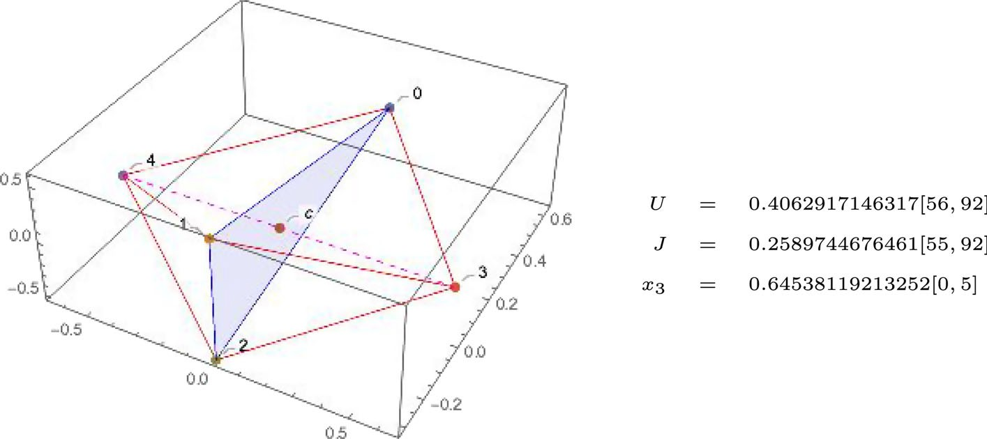
Fig. 1 Diamond with triangular base, n = 5
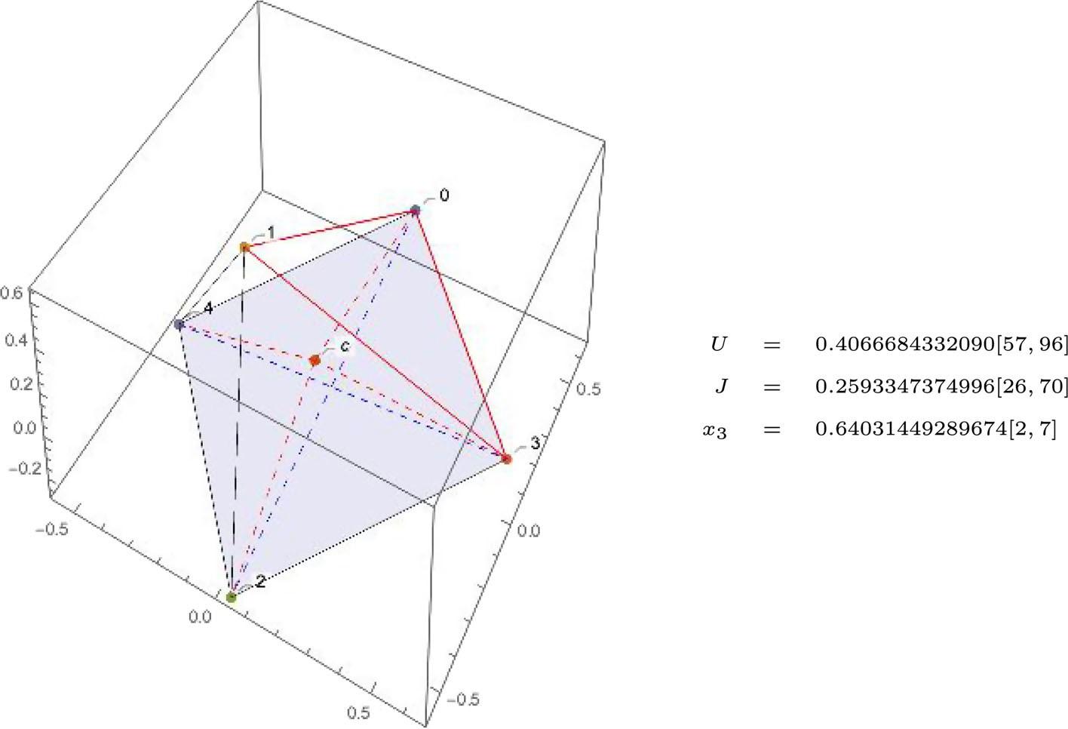
Fig. 2 Pyramid with square base, n = 5

- diamond with regular triangular base (Fig. 6), two tetrahedrons with a common equilateral triangle base q0q1q3; q2 (0, 0, 0) lies at the triangle plane (i.e., bodies q0, q1, q2 and q3 are coplanar); q4 is the summit of right pyramid, q5—the left one. Points q2, q4 and q5 are collinear,
=
- two pyramids (one inside the other) (Fig. 7) with a common square base q0q1q3q5; q2 is the summit of inner pyramid, q4—the outer one. Points q2, q4 and (0, 0, 0) (the center of mass) are collinear,
- two orthogonal isosceles triangles (Fig. 8); altitudes of both triangles, points q2, q4 and the center of mass (point (0, 0, 0)) lie on the line marked red on the picture, which is an intersection line of the planes containing the triangles,

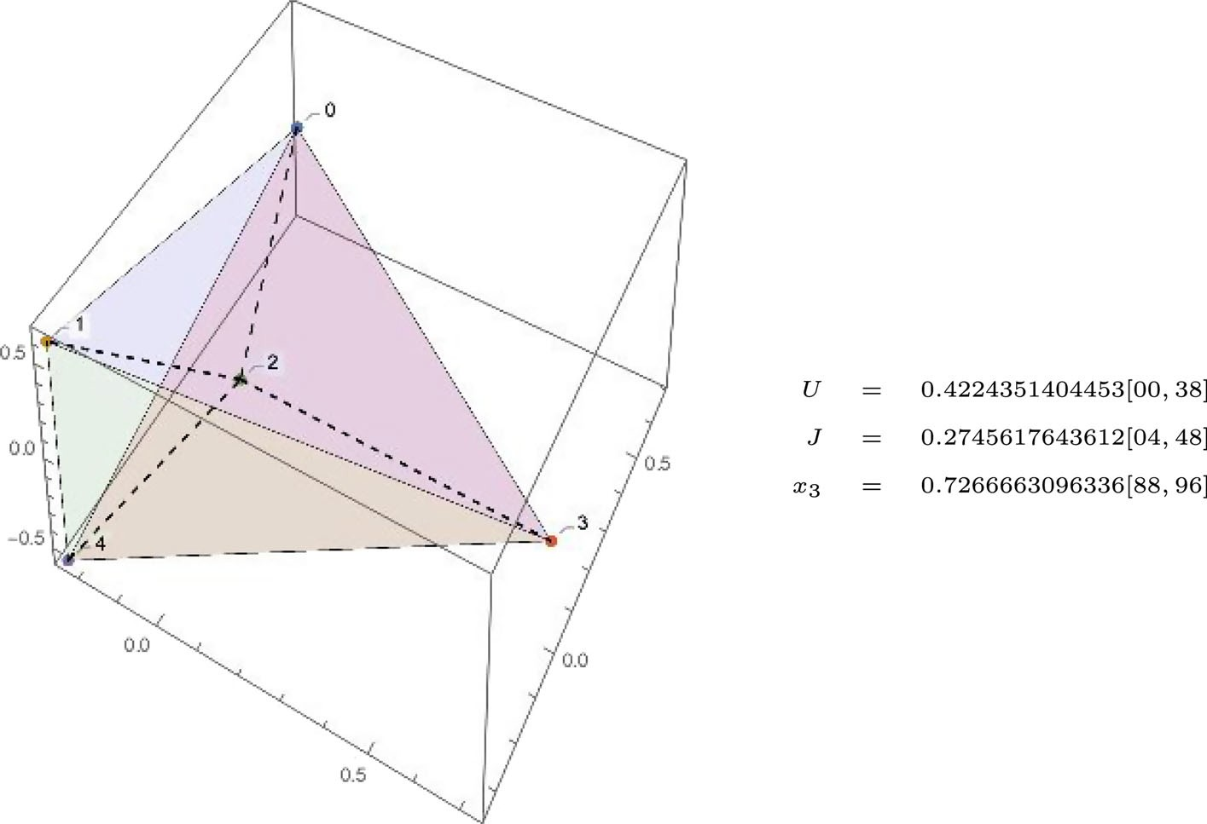
Fig. 3 The regular tetrahedron, n = 5
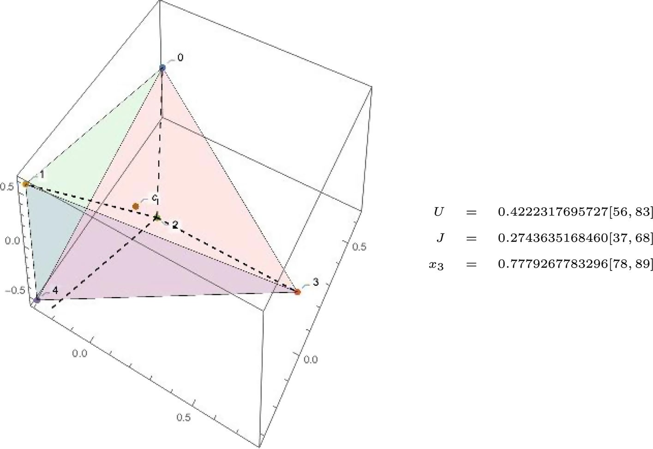
Fig. 4 Perturbed tetrahedron, n = 5

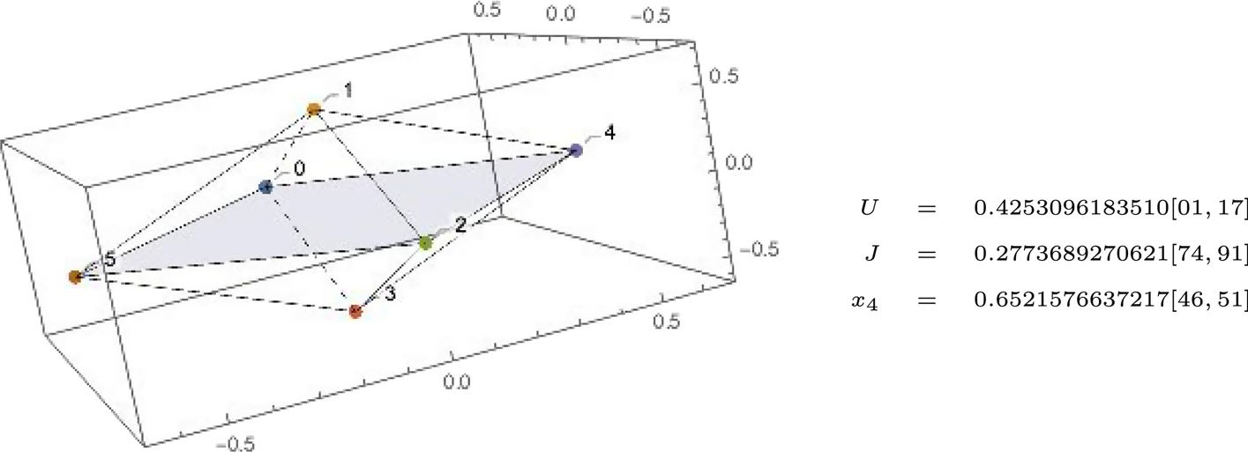
Fig. 5 Diamond with a square base (item 1), n = 6

- two pyramids (one inside the other) (Fig. 9) with a common square base q0q1q3q5; q2 is the summit of inner pyramid, q4—the outer one. Points q2, q4 and (0, 0, 0) (the center of mass) are collinear,
- pentagonal pyramid, (Fig. 10) a polyhedron with a regular pentagon q0q4q2q5q3 as a base; q1 is the summit and is collinear with (0, 0, 0) (the center of mass),
- a prism (Fig. 11), a polyhedron with three rectangular and two triangular faces; q0q1q4 and q2q3q5 are symmetrical equilateral triangles, thus rectangles q0q1q3q5, q0q4q2q5 and q1q3q2q4 are also of the same size—lines with the same length have the same color (red or blue),
- triangular polyhedron (Fig. 12) with faces being isosceles triangles; q0q1q4 and q0q1q5 are symmetrical, q0q4q5 has one side longer (the segment (q4, q5) is longer than (q0, q1)); triangle q0q2q3 is also an isosceles triangle; lines with the same length have the same color (red or blue),
- diamond with triangular base, (Fig. 13) two symmetrical polyhedrons with triangular base q1q4q5 and with summits at q0 and q3; the center of mass ((0, 0, 0)) and the point q2 lies on the plane of triangle q1q4q5 and points q0, q3 are symmetrical with respect to that plane (i.e., triangle q0q2q3 is isosceles); in the figure point c is the center of mass (0, 0, 0); lines with the same length have the same color (red, blue, magenta, green and orange).

- The number of non-equivalent CCs for mass parameters close to equal mass case

In this section, we count the number of CCs (different equivalency classes of CCs) for mass parameters close to the equal mass case. This is possible because for the equal mass case all CCs turned out to be non-degenerate solutions of . Then a simple continuation argument allows us to infer that the number of CCs does not change. A single CC for the equal mass case give rise (can be continued) to multiple CCs when the masses differ.
RS
Example 1 Consider a square—one of the planar CCs for n 4. We distinguish bodies by (possibly different) masses, and we show how many CCs for different masses we obtain. We use vertex labeling (coloring) for this purpose. To suggest different arrangement of masses, we use m1,..., m4 colors. We identify those colorings which result from the application of planar isometry to a CC. In Fig. 14, we present all three different arrangements of bodies
=

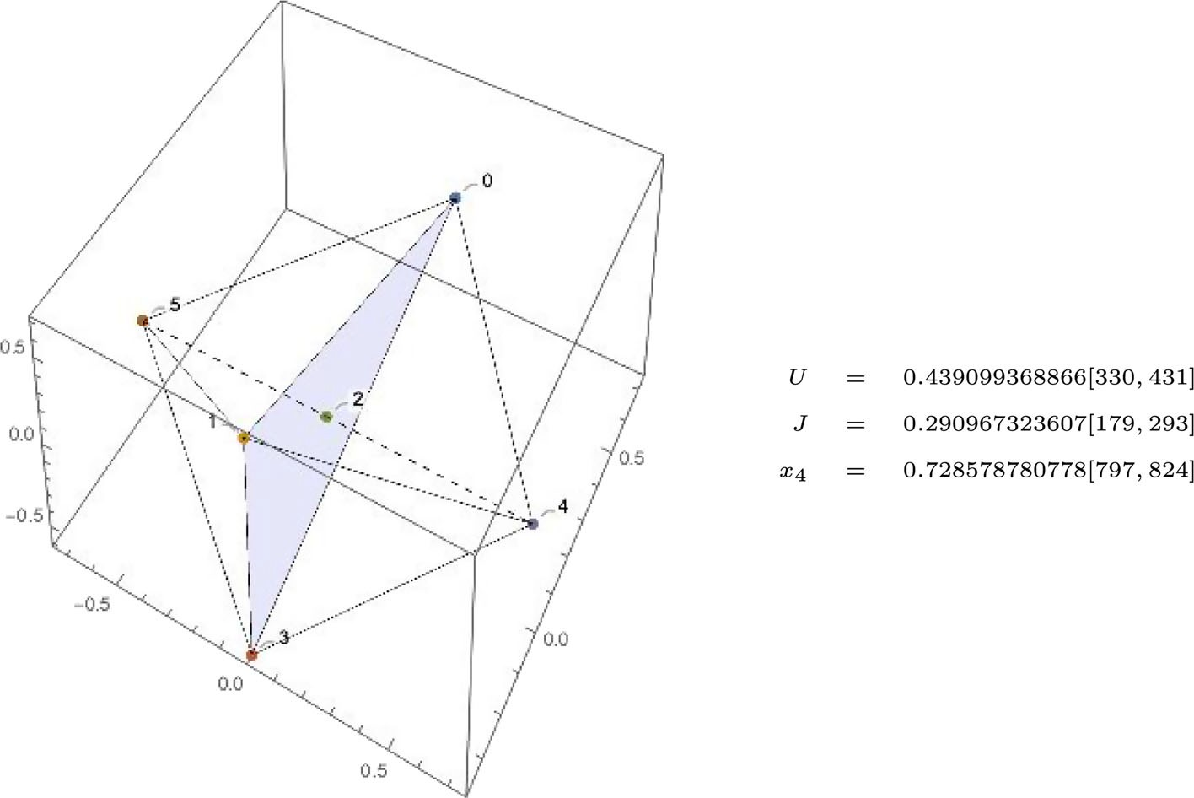
Fig. 6 Diamond with regular triangular base (item 2), n = 6
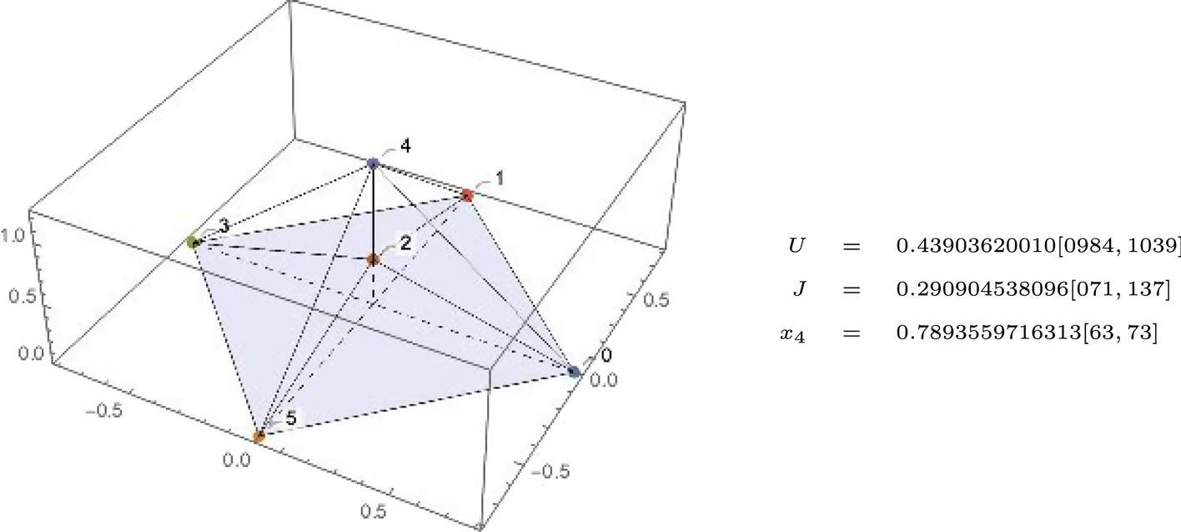
Fig. 7 Two pyramids (item 3), n = 6

for CC being a square under symmetry group O(2). Notice that there are 4! = 24 different colorings of a square by four colors m1,..., m4. However, some of them can be obtained from another by rotation or reflection. For example, arrangement m4m1m2m3 can be obtained from m1m2m3m4 by rotating latter by π/2 angle.
If we use (2) as the symmetry group (we allow rotations and reject reflections), we obtain six colorings, i.e., six non-congruous CCs (see Fig. 15).
SO
Summarizing: if we use just rotations, then there are six non-equivalent CCs obtained from the square in the different masses case; if we additionally allow reflections, then we obtain only three non-equivalent CCs.

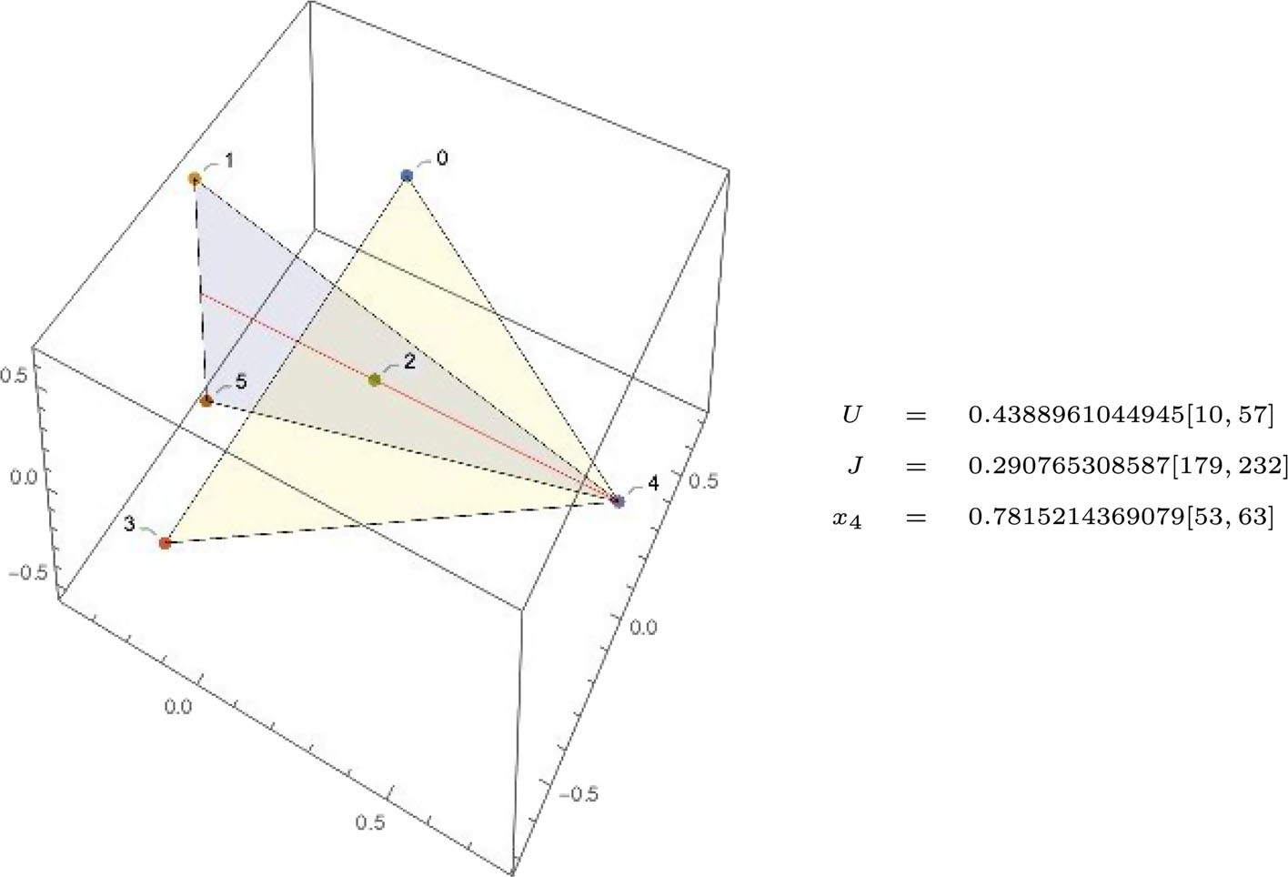
Fig. 8 Two orthogonal isosceles triangles (item 4) n = 6
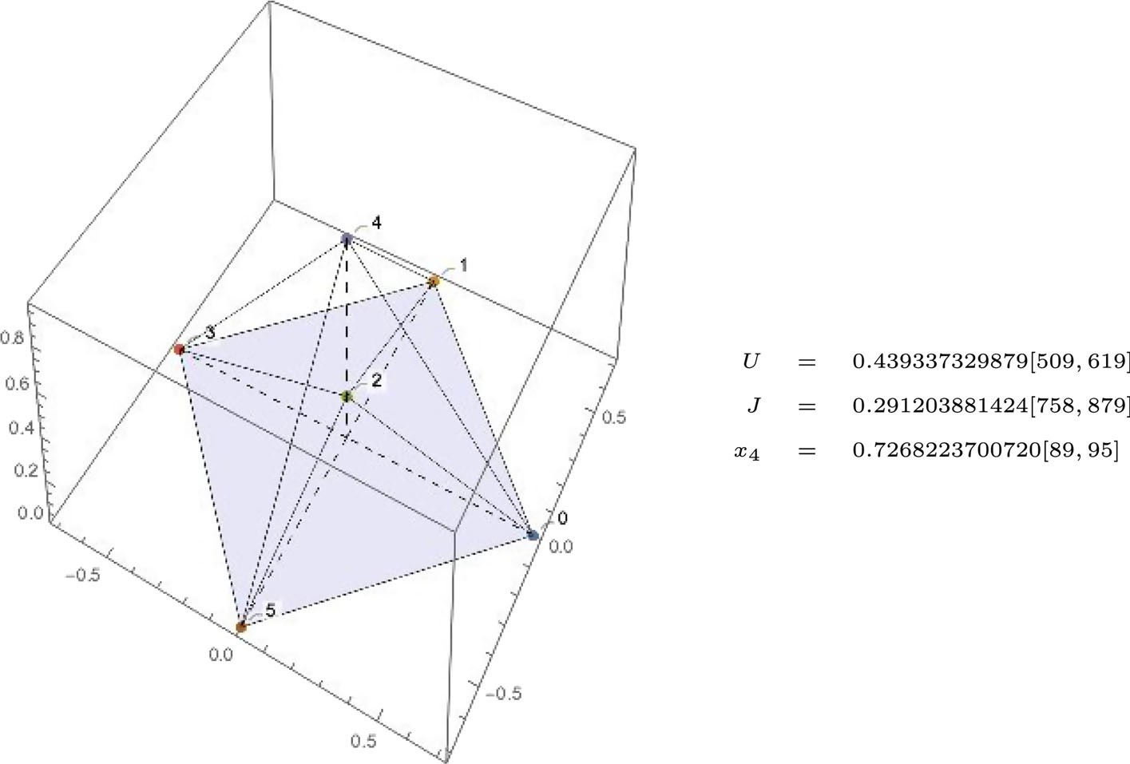
Fig. 9 Two pyramids (item 5), n = 6

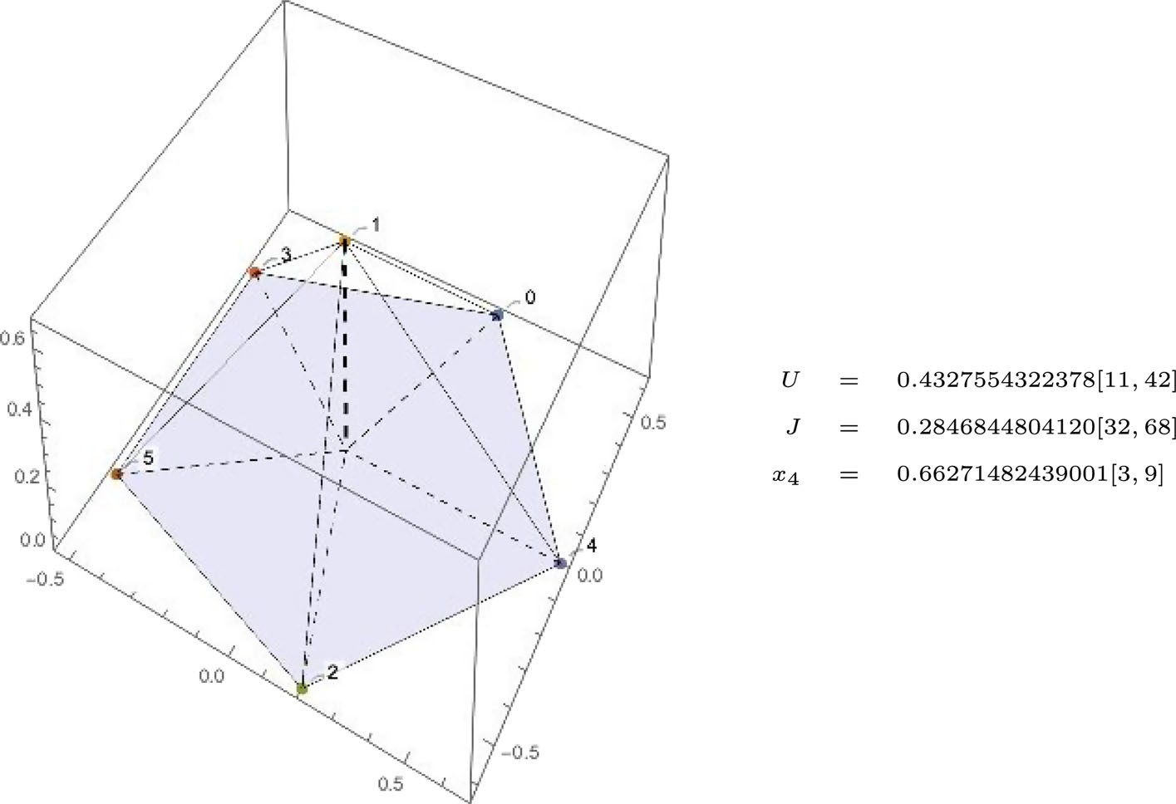
Fig. 10 Pentagonal pyramid (item 6), n = 6
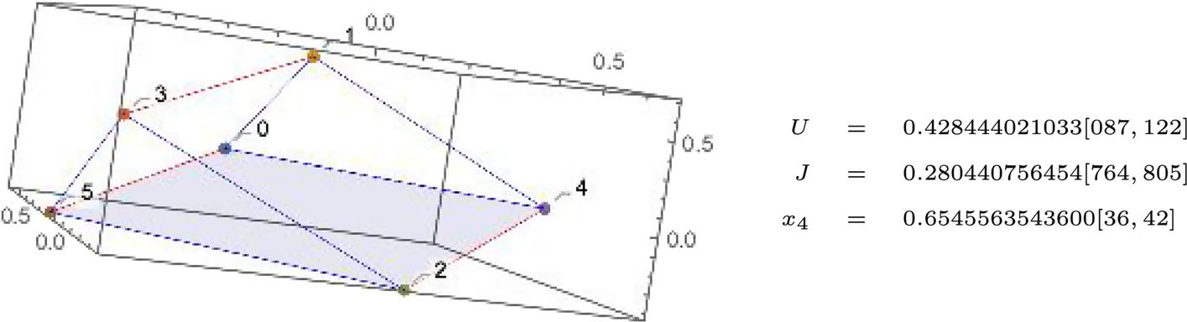
Fig. 11 Prism (item 7), n = 6
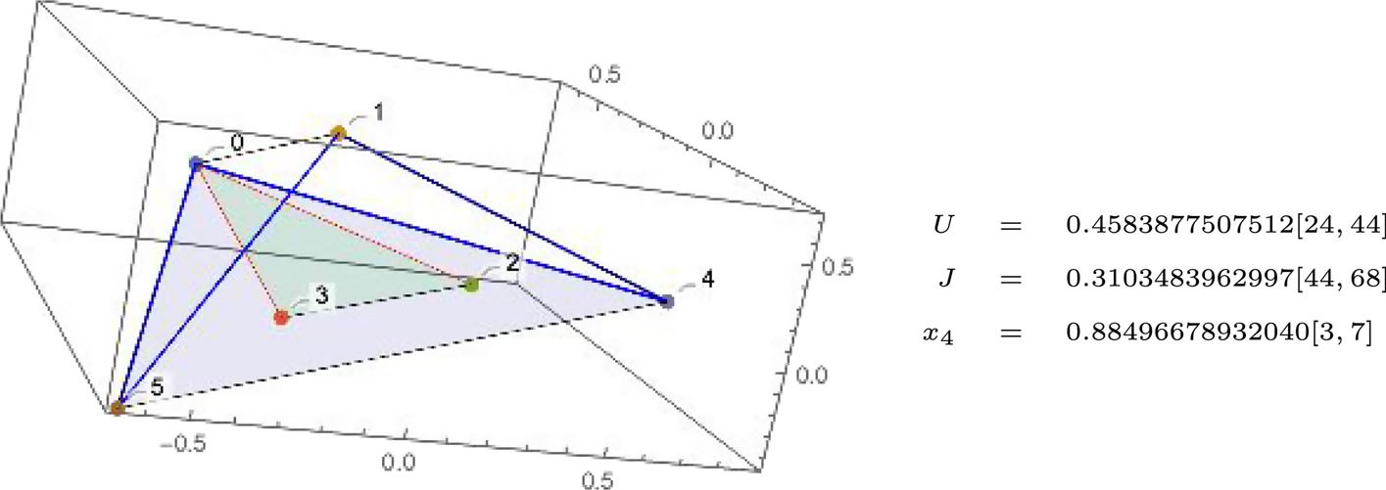
Fig. 12 Triangular polyhedron (item 8), n = 6

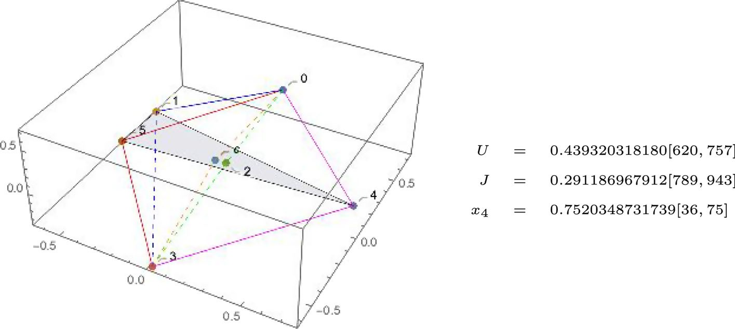
Fig. 13 Diamond with isosceles triangular base (item 9) n = 6

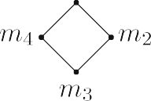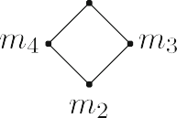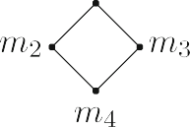
Fig. 14 All non-isomorphic (non-O(2) equivalent) colorings of a square with colors m1,..., m4

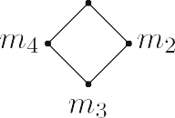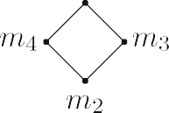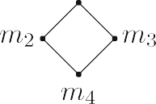

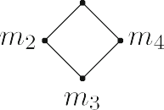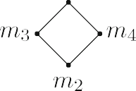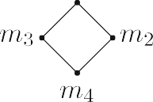
Fig. 15 All non-congruous (not SO(2)-equivalent) colorings of a square with colors m1,..., m4

  - Definitions and Pólya’s theorem

We can count non-isomorphic colorings with the aid of Pólya’s enumeration theorem, see Biggs (1989) or Pólya et al. (1983)) for the detailed treatment and proof. In this section, we just recall the relevant definitions and state main theorems.
Let X be a finite set with |X |= n and (G, ◦) be a subgroup of the group of permutations of X with ◦ denoting the composition of permutations.

Coloring of X is a function ω : X → C, where C is a finite set of colors. We assume that the cardinality of C is k, and it is the only important feature of C. Notice that any non-negative k has a combinatorial sense, but in our counting problem, we have to take k = n.
Definition 4 We say that two colorings ω1, ω2 are isomorphic with respect to group G, if there is a g ∈ G such that
ω1(g(x )) = ω2(x ), ∀x ∈ X.
Definition 5 An index of a permutation g : X → X is a function of n variables
ζg (x1,..., xn) = xα1 · xα2 · ... · xαn ,
1
2
n
where αi is a number of cycles of permutation g containing exactly i elements for i
=
1, 2,..., n.

Definition 6 An index of a group G is defined as
ζG (x1,..., xn) = 1 ζg(x1,..., xn).
|G| g∈G
Theorem 5 The number of non-isomorphic colorings of X with respect to group G with k colors is
ζG (k, k,..., k) .

Example 2 Let X 1, 2, 3, 4 be a square as in Fig. 14. Let (GRR, ) be a group of all rotations and reflections (on a plane) of that square. Permutations in GRR, their decomposition in two cycles and their indices are:
= { } ◦

g0 | (1)(2)(3)(4) ζg0 (x1, x2, x3, x4) = x 4 identity  1
g1 | (1234) ζg1 (x1, x2, x3, x4) = x4 rotation by π/2 (one 4-elements  cycle)
g2 | (13)(24) ζg2 (x1, x2, x3, x4) = x 2 rotation by π (two 2-elements  2  cycles)
g3 | (1432) ζg3 (x1, x2, x3, x4) = x4 rotation by 3π/2 (one 4-elements  cycle)
g4 | (1)(3)(24) ζg4 (x1, x2, x3, x4) = x 2 x2 reflection with respect to line (13)  1  (two 1-element cycles, one
 | 2-element cycle)
g5 | (13)(2)(4) ζg5 (x1, x2, x3, x4) = x 2 x2 reflection with respect to line (24)  1
g6 | (12)(34) ζg6 (x1, x2, x3, x4) = x 2 reflection with respect to line  2  perpendicular to the segment (12)
 | (two 2-elements cycles)
g7 | (14)(23) ζg7 (x1, x2, x3, x4) = x 2 reflection with respect to line  2
perpendicular to the segment (14).

Thus GRR = {g0,..., g7}, |GRR|= 8 and its index is
1
ζGRR (x1, x2, x3, x4) = x 4 + 3x 2 + 2x4 + 2x 2x2) .
8
1
2
1

Hence the number of different coloring with 4 colors is
1
ζGRR (4, 4, 4, 4) = 44 + 42 + 2 · 4) = 2360.
8
In this number, there are all colorings with one, two, three, and four colors, and this is not what we are interested in. We want to know a number of different colorings with exactly four colors. For this we need full version of Pólya’s enumeration Theorem.
Theorem 6 (Pólya’s enumeration Theorem) Let D be a set of all non-isomorphic colorings of a set X with respect to G with k colors. Then the generating function UD
UD (x1, x2,..., xk ) = ζG (σ1, σ2,..., σn) ,
where

σi = xi + xi + ... + xi ,
1
2
k
has its coefficient at xi1 ... xik equal to the number of non-isomorphic colorings using each
1 k
of the colors m1,..., mk exactly i1,..., ik times, respectively.
Example 3 Consider the case from Example 2. The generating function is
2 2 2 2
U(x1, x2, x3, x4) = ζGRR (x1 + x2 + x3 + x4, x1 + x2 + x3 + x4 ,
x 3 + x 3 + x 3 + x 3, x 4 + x 4 + x 4 + x 4)
1
2
3
4
1
2
3
4
= 1 (x1 + x2 + x3 + x4)4
8
+3(x 2 + x 2 + x 2 + x 2)2
1
2
3
4
+2(x 4 + x 4 + x 4 + 2x 4)
1
2
3
4
+2(x1 + x2 + x3 + x4)2(x 2 + x 2 + x 2 + x 2)

1 2 3 4
= x 4 + ... + 3x1x2x3x4 + ... x 4
1
4

(44)
From the expansion above (44), we see that the number of non-isomorphic colorings with four colors, each used once, in the case of square is 3.

  - Identifications of CCs made for the main result: summary

Let us remind the essence of counting of CCs mentioned in Sect. 1.2: any CC can be obtained from one of the normalized CCs, found by the program, by a suitable composition of trans- lation, scaling, rotation, reflection and permutation of bodies. The reasons for such situation are as follows.
- First, in Sect. 2, we normalized central configurations to obtain isolated solutions. This means that we remove possibility of translation (establishing a center of mass c 0) and possibility of scaling symmetry (setting λ 1). However, the obtained system (3) can have (3) and (3) symmetry, which excludes the use of Krawczyk’s method. This method requires non-degenerate solutions .
O SO
=
=
- In Sect. 3.2, we introduce and after these treatments solutions found by our program have no longer neither (3) nor (3) symmetry. But reflections by the planes and some permutations of bodies are still possible. In the case of equal masses, two CCs that differ only by labeling of bodies are equivalent.
SO O
RS

Table 3 The number of different CCs in 2D
n | no-CC(n) | iso(n) | cong(n) | iso(n)/n! | cong(n)/n!
4 | 4 | 31 | 50 | 1.29167 | 2.0833
5 | 5 | 207 | 354 | 1.72500 | 2.9500
6 | 9 | 1992 | 3624 | 2.76667 | 5.0333
7 | 14 | 28080 | 53640 | 5.57143 | 10.6429
n | no-CC(n) | iso(n) | cong(n) | iso(n)/n! | cong(n)/n!
4 | 5 | 32 | 52 | 1.33333 | 2.1667
5 | 9 | 257 | 454 | 2.14167 | 3.7833
6 | 18 | 3099 | 5838 | 4.30417 | 8.1083

Table 4 The number of different CCs in 3D

- Thus we remove remaining symmetries and possible permutations of bodies by a proce- dure of unifications of solutions.
Thus, in the equal mass case we count configurations treating them as indistinct if they have the same geometrical form. In the context of the Póyla’s theorem, this corresponds to taking the permutation group G to be the whole of Sn or, equivalently, using just one color.
  - Number of CCs for different masses close to equal mass case

In the different masses case in the context of the Póyla’s theorem, we use exactly n colors. We consider two CCs equivalent, isomorphic or congruous, if one can be transformed into another by an element of (d) or (d), respectively. Hence depending on whether we allow for reflections (i.e., (d)) or not ( (d)) we get different counts.
O SO
O SO
In the sequel by no-CC(n) we denote the number of CCs obtained for the equal masses case, by iso(n) is number of different non-isomorphic CCs and the number of non-congruous CCs is denoted by cong(n). These numbers are obtained using Pólya’s enumeration Theorem for different groups. Tables 3 and 4 contain the number of different CCs inferred from our rigorous count of CCs. Data in Tables 3 and 4 suggest that the number of different CCs in
the different mass case grow faster than (n!).
Example 4 For n 4 in the planar case there are four different CCs (i.e., no-CC(4) =
=
4) and there are 12 non-isomorphic configurations for collinear solution, 3 for square, 4 for equilateral triangle and 12 for isosceles triangle (for detailed description of CCs see Moczurad and Zgliczyn´ski 2019), thus iso(4) 12 3 12 4 31. The count of non-congruous classes is as follows: 12 non-congruous configurations for collinear solution, 6 for square, 8
= + + + =
for equilateral triangle and 24 for isosceles triangle, thus cong(4) = 12 + 6 + 8 + 24 = 50.

- The question of stability for planar CCs

Now, consider a planar CC. It gives rise to a periodic orbit, where all bodies move on circles with the angular velocity 1. This orbit becomes a fixed point in the rotating coordinate frame. The stability/instability of this fixed point and the circular periodic orbit is the same.

Let
−( θ) = θ
J = 0 −1 . (45)

Then exp J cos θ sin θ is a rotation by the angle in the plane OXY . sin θ cos θ
1 0
The link between coordinates in the inertial frame x R2 and the coordinates q with respect to the rotating frame with the angular velocity equal to 1 is
∈
x = exp(Jt )q. (46)
The equations of motion in the rotating coordinate frame are Simò (1978)
q˙i = vi , (47)
v˙i = −2 Jvi + qi − m j (qi − qj ) . (48)
r 3
j I=i ij
As was mentioned earlier each planar CC with vi 0, i 0,..., n 1 is a fixed point of the system (47,48). We investigated numerically the linear stability of all CCs for n 4, 5, 6, 7 and for some particular non-symmetric CCs for n 8, 9, 10 whose existence has been established in Moczurad and Zgliczyn´ski (2019). It turns out that all these CCs are linearly unstable. The computation of eigenvalues for the linearization of (47,48) has been done non-rigorously, but we are confident that this computation can be with some effort made rigorous.
= =
= = −

Open Access This article is licensed under a Creative Commons Attribution 4.0 International License, which permits use, sharing, adaptation, distribution and reproduction in any medium or format, as long as you give appropriate credit to the original author(s) and the source, provide a link to the Creative Commons licence, and indicate if changes were made. The images or other third party material in this article are included in the article’s Creative Commons licence, unless indicated otherwise in a credit line to the material. If material is not included in the article’s Creative Commons licence and your intended use is not permitted by statutory regulation or exceeds the permitted use, you will need to obtain permission directly from the copyright holder. To view a copy of this licence, visit http://creativecommons.org/licenses/by/4.0/.

References

Albouy, A., Kaloshin, V.: Finiteness of central configurations of five bodies in the plane. Ann. Math. 176, 535–588 (2012)
Alvarez, M., Delgado, J., LLibre, J.: On the spatial central configurations of the 5-body problem and their bifurcations. DCDS S 1, 505–518 (2008)
Biggs, N.L.: Discrete Mathematics. Oxford University Press, Oxford (1989)
Faugére, J. Ch., Kotsireas, I.: Symmetry theorems for the Newtonian 4- and 5-body problems with equal masses. In: Computer Algebra in Scientific Computing—CASC-99, pp. 81–92. Springer, Berlin (1999) Hampton, M., Jensen, A.N.: Finiteness of spatial central configurations in the five-body problem. Celest.
Mech. Dyn. Astron. 109(4), 321–332 (2011)
Krawczyk, R.: Newton-Algorithmen zur Besstimmung von Nullstellen mit Fehlerschranken. Computing 4, 187–201 (1969)
Kotsireas, I.: Central configurations in the Newtonian N-body problem in celestial mechanics. Contemp. Math.
198, 137–154 (2000)
Kotsireas, I., Lazard, D.: Central configurations of the 5-body problem with equal masses in three-dimensional space. J. Math. Sci. 108, 1119–1138 (2002)
Lee, T.-L., Santoprete, M.: Central configurations of the five-body problem with equal masses. Celest. Mech.
Dyn. Astron. 104, 369–381 (2009)

Moczurad, M., Zgliczyn´ski, P.: Central configurations in planar n-body problem for n 5, 6, 7 with equal masses. Celest. Mech. Dyn. Astron. 131, 46 (2019)
=
Moeckel, R.: Generic finiteness for Dziobek configurations. Trans. Am. Math. Soc. 353, 4673–4686 (2001) Moeckel, R.: Central configurations. Scholarpedia 9(4), 10667 (2014)
Moeckel, R.: Lectures on central configurations (2014). http://www-users.math.umn.edu/~rmoeckel/notes/ CentralConfigurations.pdf
Pólya, G., Tarjan, R.E., Woods, D.R.: Notes on Introductory Combinatorics. Birkhauser, Boston (1983) Simò, C.: Relative equilibrium solutions in 4 body problem. Celest. Mech. Dyn. Astron. 18, 165–184 (1978) Smale, S.: Mathematical problems for the next century. Math. Intell. 20, 7–15 (1998)
Wintner, A.: The Analytical Foundations of Celestial Mechanics. Princeton University Press, Princeton, NJ (1941)

Publisher’s Note Springer Nature remains neutral with regard to jurisdictional claims in published maps and institutional affiliations.

