
Signature:©PolJRadiol,2010;75(2):98-100
CASEREPORT
Computedtomographyangiographyrevealsthecrime
Received:2010.03.26
Accepted:2010.04.06
instrument–casereport
AnnaBanaszek1,MaciejGuziński2,MarekSąsiadek2
1StudentScientificGroupattheDepartmentofGeneralRadiology,InterventionalRadiologyandNeuroradiology,Wrocław
MedicalUniversity,Wrocław,Poland
2DepertmentofGeneralRadiology,InterventionalRadiologyandNeuroradiology,WrocławMedicalUniversity,Wrocław,
Poland
Author’saddress:MarekSąsiadek,DepertmentofGeneralRadiology,InterventionalRadiologyandNeuroradiology,WrocławMedicalUniversity,Wrocław,Borowska213Str.,50-556Wrocław,Polska,e-mail:mareks@rad.am.wroc.pl
Summary
ThedevelopmentofmultisliceCTtechnologyenabledimagingofpost-traumaticbrainlesionswithisotropicresolution,whichledtounexpectedresultsinthepresentedcase
Anunconscious,49-year-oldmalewithasuspectedtraumaunderwentaroutineCTexaminationofthehead,whichrevealedanunusualintracerebralbleedingandthereforewasfollowedbyCTangiography(CTA).ThethoroughanalysisofCTAsourcescansledtothedetectionofthebleedingcause.
ThepresentedcaseshowedthatacarefulanalysisofaCTscanallowsnotonlytodefinetheextentofpathologicallesionsintheintracranialspacebutitalsohelpstodetectthecrimeinstrument,whichisofmedico-legalsignificance.
Background:
CaseReport:
Conclusions:
Keywords:
brain•stabwound•computedtomographyangiography
PDFfile:
http://www.polradiol.com/fulltxt.php?ICID=878524
Background
hospitalinWrocław.Apreliminaryphysicalexamina-tionperformedbyaphysicianondutyrevealedsomeposttraumatichaemorrhagiclesionsofthescalp.Duetothepatient’sconditionandsuspicionofaninjuryorastroke,animmediateCToftheheadwascarriedout.Theresultswereunexpected.Themostnoticeablelesionwasanextensive,right-sidedbonedefectintheskull,mostprobablyduetoafrontoparietotemporalcraniectomy(Figure1).Moreover,CT revealedasubarachnoid haem-orrhageinthebasalcisterns,cerebropontineangleandSylvianfissure.Ontheright,therewasadistinct,streaky,hyperdensefocusofhaemorrhage,stretchingfromtheparietalcortextotheIIIventricle(Figure2).Theintegu-mentscoveringthatsitewereslightlyelevated.Duetothatnon-standardimageofthehaemorrhagicfocus,aCTangiographywasperformedtolocalisethesourceofbleeding.Theexaminationdidnotrevealvascularmal-formationsbuttheMIPimages(MaximumIntensity)projections,especiallyinthefrontalplane,showedthatthehaemorrhagicfocusintherighthemisphereassumedastreakyshape,whichledustothesuspicionthatthesourceofinjurycouldbeastabwoundinflictedwitha
Computedtomography(CT),asawidelyavailableandalowinvasivemethod,constitutesaroutinelyapplieddiagnostictoolinthediagnosticimagingofcraniocerebraltraumasandbrainstrokes.Itallowsforthedetectionoftheposttraumaticchangesinthestructureoftheskull(owingtotheapplicationofabonewindow),aswellasforevaluationoftheextentofbraininjuries.OwingtotheintroductionofthemultisliceCTtechnology,itisnowpossibletovisualisehyperdensehaem-orrhagicfociwithasubmillimeterresolution,inanyoftheplanes,andtoperformhigh-qualityangio-CTscanswhentryingtoexcludebleedingfromamalformation.
Incaseofthepresentedpatient,applicationoftheabovementionedimagingmethodinthecourseofroutineemer-gencyproceduresledtounexpectedresults
CaseReport
A49-year-oldman,foundlyingonthefloorofhisflat,wastransportedtotheadmissionroomofaclinical
98

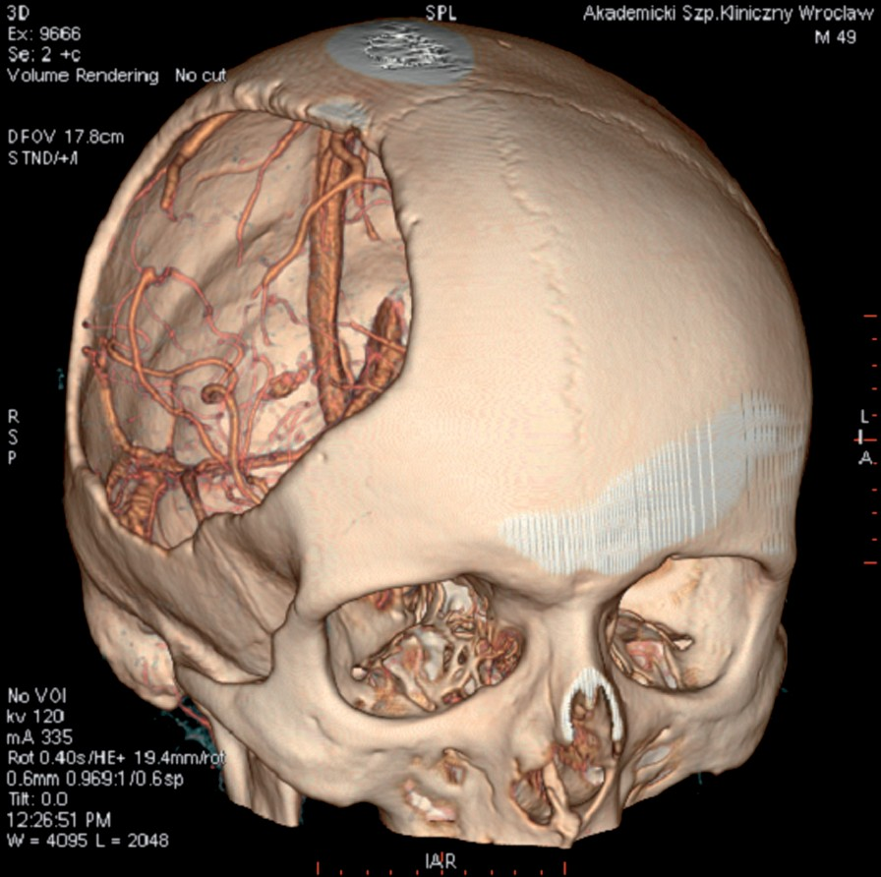
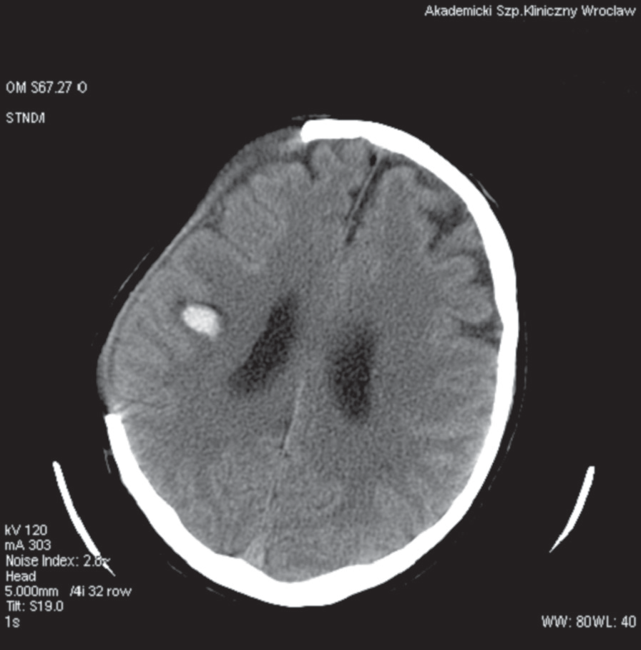
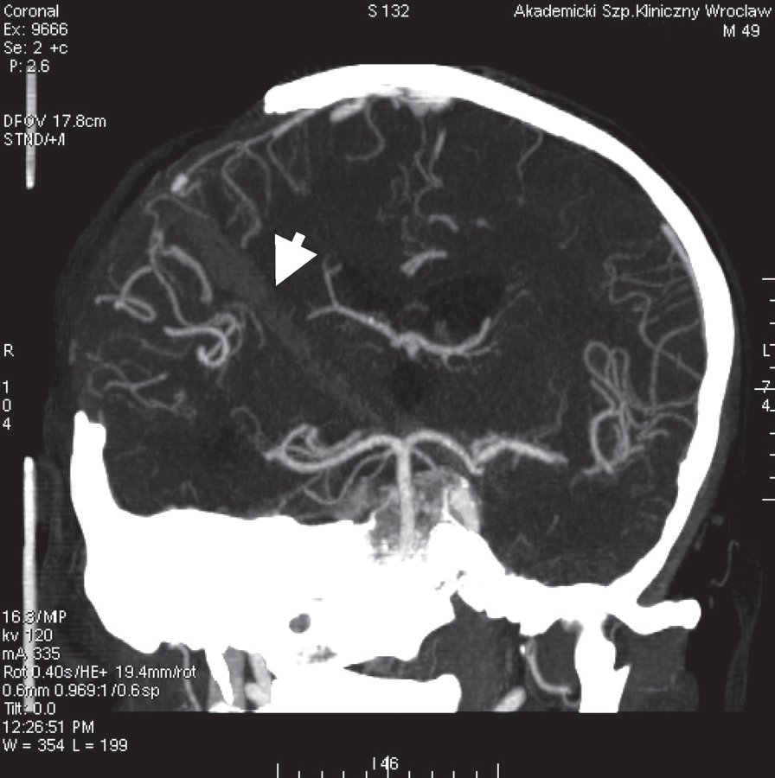
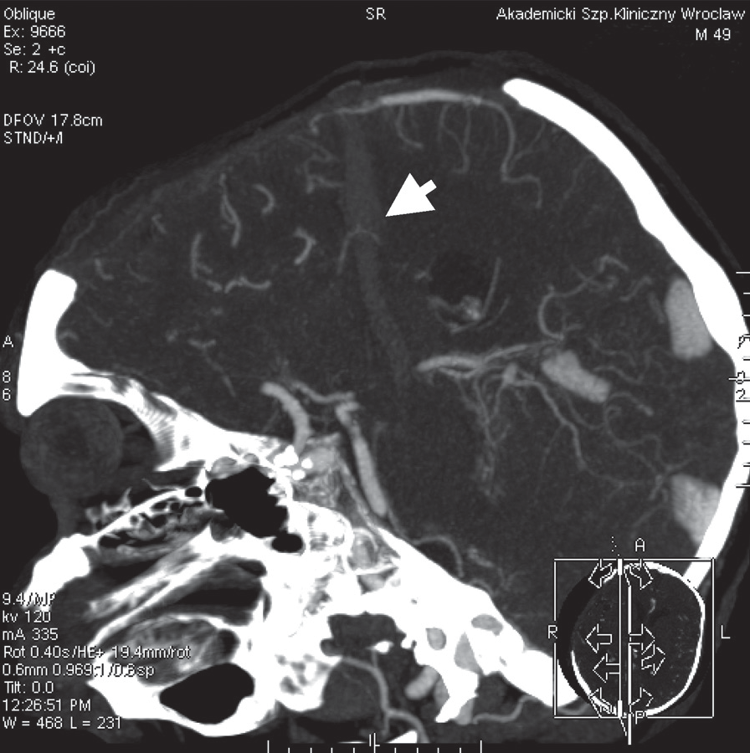
©PolJRadiol,2010;75(2):98-100
BanaszekAetal–Computedtomographyangiographyreveals…
Figure1.Statuspostanextensiveright-sidedcraniectomy,VRreconstruction.
Figure3.CTA:ahyperdensestreakofblood,stretchingfromthesubcutaneouslayerstotheIIIventricle(arrows).Frontalplane(A)andsagittalplane(B),MIPreconstruction.
Discussion
Figure2.CTexaminationwithoutcontrastadministration:haemorrhagicfocusontherightside.
sharpinstrument(Figure3A,B).Inordertoverifythisassumption,acloseforensicexaminationofthescalpwasconductedintheadmissionroom.Theexaminationrevealedalinearincisionofapprox.15mm.Itsdistancefromthemarginofthecraniectomyholeoverlappedwithlocationoftheperipheralpartoftheaforementionedhyperdensestructurerelativetothehole.Thisconfirmedtheconnectionbetweentheskinincisionandthesiteofintracerebralbleeding.Duetothesefacts,therearoseastrongsuspicionthatthebraininjurywasnotacciden-tal.Asaresult,aknifefoundatthesiteoftheincident,nexttothepatient,whichhadnotbeenconnectedwiththepatient’sstatesofar,wassecuredasapotentialcrimeinstrument.Thesizeofitsbladecorrespondedstrictlytothestreakofhyperdenseblood.Theabovepresentedradiologicalandclinicaldatawerereportedtothepolice.
Revealingthecrimeinstrument,andthusestablishingthecauseofthepatient’sseverecondition,waspossiblethankstotheapplicationofa64-slicecomputedtomographyasadiagnostictechnique.Withthisexamination,itispossibletocollectdatafromthewholestudiedstructure(e.g.head)withacloseresolution(oflessthan1mm),inallthreedimensions,within10–20seconds.Dependingonwhatisneeded,theimageofanexaminedanatomicalstructuremaybesubjectedtoanalysiswithdifferentgraphicappli-cations,whichmayleadtoacquisitionofhigh-qualitysec-ondaryreconstructionsinaanyoftheplanes.Thiswasthesensitivity,isotropicresolutionandreconstructiveoptionsofthe64-sliceCTscannerthathelpedustoobtainthoseextraordinarydata.
99

A
B

CaseReport
©PolJRadiol,2010;75(2):98-100
Althoughinthepresentedcase,theexaminationwasper-formedbeforethecauseofthepatient’sstatewasrevealed,generally,CTexaminationsconstituteabasicimagingmethodappliedinthediagnosticsofpenetratingcranioce-rebralinjuries[1,2].CTallowsforevaluationoftheexten-sionofbraininjuries,detectionofpotentialforeignbodiesremaininginthewound,ordiagnosisoffurthercomplica-tions,aswellaslesionsrequiringanimmediateneurosur-gicalintervention.Veryoften,penetratingtraumasoftheheadcauseinjuriesofbloodvesselsandleadtoformationofposttraumaticvascularlesions.ThisiswhyCTexamina-tionsrequireextensionwithCTangiography[2].Theadvan-tageoftheCTAisitsminimalinvasivenessandpossibilityofitsconductionimmediatelyafterastandardCTexamina-tion,withoutanyspecialpreparationofthepatient.Thisisimportantwhenthepatientsufferedapenetratingheadinjury,i.e.isinasevereclinicalcondition,mostofthetime.
connectionbetweenthewoundedareafoundonCTandthesizeofablade[5],asinthecasepresentedabove.
Mostofthepenetratingcraniocerebraltraumascausedwiththeuseofalowkineticenergyareknifewounds,althoughthelistofobjectsthatcouldpossiblyleadtosuchinjuriesislong:nails,screwdrivers,needles,scissors,keys,fanblade,etc.[6].Thetemporalsquamaandtheroofoftheorbitconstitutetworegionswherepenetrationiseasier,astheosseoustissueisthinnerwithinthesestructures.Nevertheless,penetratinginjuriesoccurinotherpartsoftheskullwiththesamefrequency[5].Thereportedcaseseemsextraordinarywhencomparedtoothercases,pre-sentedbyauthors[6–10]. Thisisbecause thebraintissuesufferedadirectinjury,whichwasonlypossibleduetoaconcomitantextensivedefect of theskull,followingcrani-ectomy.Vaguecircumstancesoftheinjury,aswellasnoexternalbleeding,andthepresenceofanunusualCTimagemakethiscaseaninterestingdiversityineverydayworkofaradiologist.
InPoland,penetratingcraniocerebraltraumasarerela-tivelyrare,mainlybecauseofalowpopularityoffirearms.Atthesametime,the rateofpenetratinginjuriesinflictedwithalowkineticenergy(e.g.stabwoundsfromaknife)ishigherthanintheliteratureofWesternEuropeorigin[3].Itisquitecommonthatpenetratinginjuriesresultfromcrim-inalorsuicidalactsandradiologicalfindingsareusefulinforensicinvestigationsandcriminalproceedings.Forensicmedicineisafieldinwhichdifferentimagingexaminationsarefrequentlyused[4].Thisconcernsalsotheprocessofidentificationofthecrimeinstrumentonthebasisofthe
Conclusions
WithaconstantdevelopmentofthemultisliceCTtechnique,thenumberofitsapplicationsincreases.IdentificationofcrimeinstrumentswithaCTisadomainofforensicmedicine.However,astheabovepresentedcaseshowed,thismayalsohappenduringaroutinehospitaldutyofaradiologist.
References:
- OffiahC,TwiggS:Imagingassessmentofpenetratingcraniocerebralandspinaltrauma.ClinRadiol,2009;64(12):1146–57
- PruittBAJr:Managementandprognosisofpenetratingbraininjury:NeuroimagingintheManagementofPenetratingBrainInjury.JTrauma,2001;51:S7–11
- CzyżewskiP,BlokT,BłaszczykMetal:Urazypenetrujące–rzadkieprzypadkiobrażeńgłowyimózgu.Neuroskop,2006;8:53–60
- UrbanikA,ChrzanR,WoźniakKetal:Post-mortemCTexamination
–ownexperiences.PolJRadiol,2009;74(4):55–63
- BauerM,PatzeltD:Intracranialstabinjuries:casereportandacasestudy.ForensicScienceInternational,2002;129:122–27
- IwakuraM,KawaguchiT,HosodaKetal:KnifeBladePenetratingStabWoundtotheBrain.CaseReport.NeurolMedChir,2005;45:172–75
- KennedyUM,GearyUM,SheehyN:Intracranialstabwound:acasereport.EurJEmergMed,2007;14:72–74
- ChuiM,deTillyLN,MoultonRetal:Suicidalstabwoundwithabutterknife.CMAJ,2002;167:899
- SatyartheeGD,BorkarSA,TripathiAKetal:Transorbitalpenetratingcerebralinjurywithaceramicstone:Reportofinterestingcase.NeurolIndia,2009;57:331–33
- DeJonghK,DohmenD,SalgadoRetal:“WilliamTell”Injury:MDCTofanArrowThroughtheHead.AJR,2004;182:1551–53
100

