SEARCH FOR ETA-MESIC HELIUM WITH WASA-at-COSY∗
Magdalena Skurzok
for the WASA-at-COSY Collaboration
INFN, Laboratori Nazionali di Frascati, 00044 Frascati, Italy and
- Smoluchowski Institute of Physics, Jagiellonian University, Kraków, Poland

(Received October 1, 2019)

We report on the search for 4He–η and 3He–η mesic nuclei with WASA- at-COSY detection system. The description of the experimental method as well as recent status of the data analysis are presented.

DOI:10.5506/APhysPolB.51.33

Introduction
The mesic nuclei, an exotic nuclear matter consisting of a nucleus bound via the strong interaction with a neutral meson (η, η/, K or ω), are currently one of the hottest topics in nuclear and hadronic physics, both from the experimental [1–7] and theoretical side [8–31].
η meson is one of the most promising candidates for the creation of the mesic nucleus since its interaction with nucleons is stronger than other mesons [32, 33]. Current investigations of the η-meson production result in a wide range of ηN -scattering length values (aηN ) indicating the η-nucleon interaction to be strong enough to create light η-mesic bound states [10– 13, 34–36]. However, none of the performed experiments have brought clear evidence of their existence [37–44]. Recent reviews concerning η-mesic nuclei searches can be found in Refs. [6, 7, 18, 20, 32, 45–50].
Promising experiments related to η-mesic helium nuclei have been per- formed recently with the WASA-at-COSY facility. The search for 4He–η and 3He–η mesic bound systems has been carried out in dd and pd collisions, re- spectively, using unique ramped beam technique. This paper reports on

∗ Presented at the 3rd Jagiellonian Symposium on Fundamental and Applied Subatomic Physics, Kraków, Poland, June 23–28, 2019.

(33)

the results obtained for the search for η-mesic 4He in dd → 3He nπ0 and dd → 3He pπ− processes [1–4, 51]. Preliminary results for 3He–η mesic nu- clei searches in pd → 3He 2γ(6γ) reactions are also presented [52, 53].

Search for the η-mesic 4He
WASA-at-COSY Collaboration performed two measurements dedicated to search for η-mesic 4He nuclei (in 2008 and 2010) using the unique ramped beam technique which allows for the slow and continuous beam momentum changes around the η-production threshold in each of the beam acceleration cycle [1, 3, 48, 50, 51]. The uniqueness of this technique lies in the reduc- tion of systematic uncertainties with respect to separate runs at fixed beam energies [3, 40].
In order to search for 4He–η bound states, the excitation functions for dd 3He pπ− [1–4] and dd 3He nπ0 [1, 2, 4] reactions have been studied around the 4Heη production threshold (Q ( 70, 30) MeV). A detailed de- scription of the data analysis is presented in Refs. [1, 3]. Since the obtained excitation functions do not reveal any direct signature of the bound state below the η-production threshold, the upper limit of the total cross section for the η-mesic 4He formation and its decay into proper channel was deter- mined at the 90% confidence level. Therefore, the excitation curves were fitted simultaneously using the function being a sum of the Breit–Wigner function with a fixed binding energy and width, and a second order poly- nomial for signal and background, respectively. During the fit, the isospin relation between nπ0 and pπ− pairs has been taken into account.
∈ −
→ →
The upper limit of the total cross section for dd (4He–η)bound 3He nπ0 and dd (4He–η)bound 3He pπ− processes varies in the range from 2.5 to 3.5 nb and 5 to 7 nb, respectively. In the case of the first process, the upper limit was determined experimentally for the first time, while the sensitivity of the cross section achieved for the second reaction was about four times better in comparison with the result obtained in the previous experiment [3]. The obtained upper limits as a function of the bound state width are presented for both studied processes in Fig. 1.
→ →
→ →
The data analysis presented above was carried out under assumption that the signal from the bound state is described by a Breit–Wigner shape with fixed binding energy and width [1, 3]. However, a theoretical description of the cross sections in the excess energy range relevant to the η-mesic nuclear search was proposed in Ref. [9]. A phenomenological approach with an optical potential for the η–4He interaction was applied and the total cross sections were determined for a broad range of real (V0) and imaginary (W0) parameters.
upp
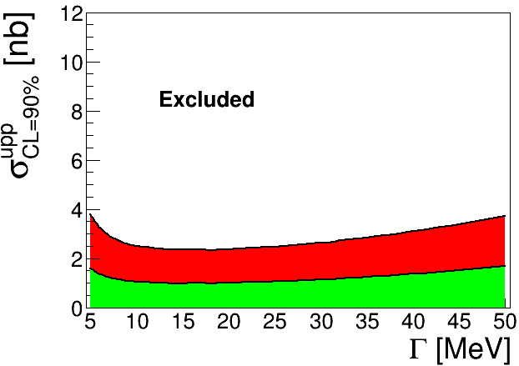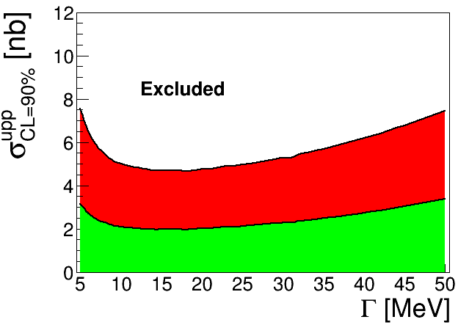
Fig. 1. (Colour on-line) Upper limit of the total cross section for dd → (4He– η)bound → 3He nπ0 (left panel) and dd → (4He–η)bound → 3He pπ− (right panel) reaction as a function of the width of the bound state. The binding energy was fixed to 30 MeV. The upper limit was determined via the simultaneous fit for both channels. The light grey/green area denotes the systematic uncertainties. The figures are adopted from [1].

The upper limit of the total cross section (C.L. = 90%) for creation of η-mesic nuclei via the dd 3He Nπ was determined by fitting the theoretical spectra convoluted with the experimental resolution of the excess energy to experimental data collected by WASA-at-COSY [1]. It was found to vary from about 5.2 nb to about 7.5 nb [2].
→
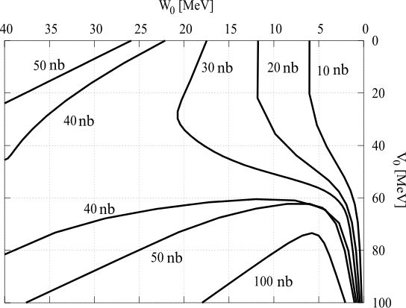
Fig. 2. (Colour on-line) Contour plot of the theoretically determined conversion cross section in the V0–W0 plane [9]. The light shaded area shows the region excluded by our analysis, while the dark shaded area denotes the systematic un- certainty of the σCL=90%. The dashed (red) line extends the allowed region based on a new estimate of errors (see the text for details). Dots refer to the optical potential parameters corresponding to the predicted η-mesic 4He states. Figure is adopted from Ref. [2].
Comparing the determined upper limits with the cross sections obtained in Ref. [9], we were able to put a constraint on the η–4He optical potential parameters. As it is presented in Fig. 2, most optical model predictions [9] are excluded except for extremely narrow and loosely bound states. Details of performed studies are presented in Ref. [2].

Search for the η-mesic 3He
A promising experiment dedicated to the search for η-mesic 3He was performed with the WASA-at-COSY facility using ramped proton beam (Q ( 70, 30) MeV) and deuteron target. Three different mechanisms of the η-mesic bound state decay were considered: (i) the η-meson absorption by one of the nucleons leading to excitation of N ∗(1535) resonance which subsequently decays into nucleon–pion pair (assumed as well in data anal- ysis and interpretations of previous experiments [1–3]), (ii) η-meson decay while it is still “orbiting” around a nucleus, and (iii) two-nucleon η-meson absorption process.
∈ −
The theoretical model (ii) was developped recently [54] and has been ap- plied in analysis of pd (3He–η)bound 3He 2γ and pd (3He-η)bound 3He 6γ decay channels [52]. Excitation functions determined for both chan- nels do not show the bound state signature, therefore, the upper limit of the total cross section at the C.L. = 90% was determined for the η-mesic 3He nucleus creation followed by the η-meson decay. For this purpose, excitation functions for both reactions were simultenously fitted with a Breit–Wigner function (signal) combined with polynomial (background). During the anal- ysis, the branching ratio relation between η 2γ and η 3π0 in vacuum was taken into account. The preliminary estimated upper limit varies be- tween 2 nb to 15 nb depending on the bound state parameters (binding energy, width) [52].
→ →
→ → → →

Summary and perspectives
Search for η-mesic helium was performed with the WASA-at-COSY facil- ity in deuteron–deuteron and proton–deuteron collisions. Resonance struc- ture related to the η-mesic 4He bound state was not observed in dd 3He nπ0 and dd 3He pπ− reactions. However, the upper limits of the total cross sections for η-mesic nuclei formation and decay in each channel were determined to be of the order of a few nb [1, 3]. In addition, the experimen- tal data have been compared with the phenomenological model proposed in Ref. [9] allowing, for the first time, to constrain the range of the η–4He optical potential parameters [2].
→
→
In 2014, an experiment dedicated to the search for η-mesic 3He in three different mechanisms has been performed. The measurement with a high average luminosity ( 3 1030 cm−2s−1) allowed the collection of the largest, available up to now in the world, data sample for 3He–η [53, 55, 56]. The preliminary upper limit value for pd 3He 2γ and pd 3He 6γ channels is on the level of a few nanobarns. The analysis assuming a mechanism of bound state decay via N ∗ excitation and its decay into the nucleon–pion pair is in progress [57].
∼ ×
→ →
REFERENCES

- P. Adlarson et al., Nucl. Phys. A 959, 102 (2017).
- M. Skurzok et al., Phys. Lett. B 782, 6 (2018).
- P. Adlarson et al., Phys. Rev. C 87, 035204 (2013).
- M. Skurzok, P. Moskal, W. Krzemień, Prog. Part. Nucl. Phys. 67, 445 (2012).
[5] Y.K. Tanaka et al., Phys. Rev. Lett. 117, 202501 (2016). [6] H. Machner, J. Phys. G 42, 043001 (2015).
[7] V. Metag, M. Nanova, E.Ya. Paryev, Prog. Part. Nucl. Phys. 97, 199 (2017).
[8] J.-J. Xie et al., Eur. Phys. J. A 55, 6 (2019).
[9] N. Ikeno et al., Eur. Phys. J. A 53, 194 (2017). [10] J.-J. Xie et al., Phys. Rev. C 95, 015202 (2017).
[11] A. Fix et al., Phys. Lett. B 772, 663 (2017).
- N. Barnea, B. Bazak, E. Friedman, A. Gal, Phys. Lett. B 771, 297 (2017).
- N. Barnea, E. Friedman, A. Gal, Nucl. Phys. A 968, 35 (2017).
- T. Sekihara, H. Fujioka, T. Ishikawa, Phys. Rev. C 97, 045202 (2017).
- N. Barnea, E. Friedman, A. Gal, Phys. Lett. B 747, 345 (2015).
- E. Friedman, A. Gal, J. Mares, Phys. Lett. B 725, 334 (2013).
[17] N.G. Kelkar, Eur. Phys. J. A 52, 309 (2016).
- N.G. Kelkar et al., Rep. Progr. Phys. 76, 066301 (2013).
- N.G. Kelkar, Acta Phys. Pol. B 46, 113 (2015).
- C. Wilkin, Acta Phys. Pol. B 47, 249 (2016).
[21] C. Wilkin, Phys. Lett. B 654, 92 (2007).
- S.D. Bass, A.W. Thomas, Phys. Lett. B 634, 368 (2006).
- S.D. Bass, A.W. Thomas, Acta Phys. Pol. B 41, 2239 (2010).
- S. Hirenzaki, H. Nagahiro, Acta Phys. Pol. B 45, 619 (2014).
- H. Nagahiro, D. Jido, S. Hirenzaki, Phys. Rev. C 80, 025205 (2009).
- H. Nagahiro et al., Phys. Rev. C 87, 045201 (2013).
- S. Hirenzaki et al., Acta Phys. Pol. B 41, 2211 (2010).

- S. Wycech, W. Krzemień, Acta Phys. Pol. B 45, 745 (2014). [29] J. Niskanen, Phys. Rev. C 92, 055205 (2015).
- Q. Haider, L.C. Liu, Phys. Lett. B 172, 257 (1986).
- R.S. Bhalerao, L.C. Liu, Phys. Rev. Lett. 54, 865 (1985).
- P. Moskal, Few-Body Syst. 55, 667 (2014).
- P. Moskal et al., Phys. Lett. B 482, 356 (2000).
- A.M. Green, J.A. Niskanen, S. Wycech, Phys. Rev. C 54, 1970 (1996).
[35] C. Wilkin, Phys. Rev. C 47, 938 (1993).
- S. Wycech, A.M. Green, J.A. Niskanen, Phys. Rev. C 52, 544 (1995).
- J. Berger et al., Phys. Rev. Lett. 61, 919 (1988).
[38] B. Mayer et al., Phys. Rev. C 53, 2068 (1996).
- G.A. Sokol, L.N. Pavlyuchenko, arXiv:nucl-ex/0111020.
- J. Smyrski et al., Phys. Lett. B 649, 258 (2007).
- T. Mersmann et al., Phys. Rev. Lett. 98, 242301 (2007).
- A. Budzanowski et al., Phys. Rev. C 79, 012201(R) (2009).
- M. Papenbrock et al., Phys. Lett. B 734, 333 (2014).
- P. Moskal, J. Smyrski, Acta Phys. Pol. B 41, 2281 (2010).
[45] S.D. Bass, P. Moskal, Rev. Mod. Phys. 91, 015003 (2019). [46] Q. Haider, L.-c. Liu, J. Phys. G 37, 125104 (2010).
- B. Krusche, C. Wilkin, Prog. Part. Nucl. Phys. 80, 43 (2014).
- M. Skurzok et al., Acta Phys. Pol. B 47, 503 (2016).
- P. Moskal, Acta Phys. Pol. B 47, 97 (2016).
- P. Moskal, M. Skurzok, W. Krzemień, AIP Conf. Proc. 1753, 030012 (2016).
- M. Skurzok et al., EPJ Web Conf. 199, 01018 (2019).
- O. Rundel, Ph.D. Thesis, Jagiellonian University, 2019; O. Rundel,
M. Skurzok, A. Khreptak, EPJ Web Conf. 199, 02029 (2019) [arXiv:1905.04544 [hep-ex]].
- M. Skurzok et al., EPJ Web Conf. 181, 01014 (2018).
- M. Skurzok et al., arXiv:1908.03429 [nucl-ex].
- O. Rundel et al., Acta Phys. Pol. B 48, 1807 (2017).
- O. Rundel et al., EPJ Web Conf. 130, 02008 (2016).
- A. Khreptak, O. Rundel, M. Skurzok, EPJ Web Conf. 199, 05026 (2019).

