
Signature:©PolJRadiol,2009;74(4):77-82
REVIEWARTICLE
StandardisationoftheMRIimageevaluationinthe
Received:2009.07.20
Accepted:2009.10.14
diagnosticsofrheumatoidarthritiswithinthewristandmetacarpophalangealjoints
KatarzynaKapuścińska,AndrzejUrbanik,WadimWojciechowski
DepartmentofRadiology,CollegiumMedicum,JagiellonianUniversity,Cracow,Poland
Author’saddress:AndrzejUrbanik,DepartmentofRadiology,CollegiumMedicum,JagiellonianUniversity,Kopernika19Str.,Cracow,Poland,e-mail:aurbanik@mp.pl
Summary
Rheumatoidarthritis(RA)isachronicsystemicautoimmunediseaseoftheconnectivetissue,whichresultsindisabilityandearlierdeath.Thusitisveryimportanttorecognisethispathologicconditionasearlyaspossible,tolessenanddelayitsconsequences.Currently,magneticresonanceimagingisthebestimagingmodality,depictingeverystageofthisdiseaseandallowingformonitoringofthetreatmentresponse.TheprocessofstandardisationisneededinassessingMRpictures.TheaimofthisarticlewastopresenttheMRprotocolsofhandandwristMRexaminationsforrheumatologicdemandandstandardsofresults,accordingtoworldwideOMERACTRAMRIS2002andsupplementedbytenosynovitissystem.
Keywords:
rheumatoidarthritis•RAMRISOMERACT•MRI•standardisation•synovitis•tenosynovitis•bonemarrowoedema•erosions
PDFfile:
http://www.polradiol.com/fulltxt.php?ICID=900388
Rheumatoidarthritisisachronicsystemicdiseaseoftheconnectivetissue,ofimmunologicalbackground,leadingtodisability,invalidityandprematuredeath[1].Itisthere-foreextremelyimportanttodetectthisailmentasearlyaspossible,andtointroduceapropercourseoftreatment,inordertodelayandlimititssequelae.Thesuccessivestag-esofthispathologicalprocess,leadingtobonedestruc-tion,are as follows: inflammation and hypertrophyof thesynovialmembraneandofthetendonsheaths,bonemar-rowoedema,erosions.Furtherinjuriesinvolvetheliga-mentousapparatus,whichresultsultimatelyindisloca-tionsanddeformationsofthejoints[1–4].Untilrecently,thebasicmethodinimagingdiagnosticsoftherheumatoidconditionswastheconventional radiography[4–6]in whichthefirstsymptomisperiarticularosteoporosismainly.Subsequentradiologicalsymptomsinclude:narrowingofthearticularspace,subchondralcystsanderosions.Atpresent,theavailablediagnosticmodalities,suchasUS,CTorMRImayvisualisesucherosionsthatareinvisibleintheconventionalmethod[2,4,7–9],andthisisawellknownfactthatvisualisationoftheerosionisanimportantfac-torconfirmingthediagnosisandenablingintroductionofan‘aggressive’treatment,withtheuseofnewmedicines.Moreover,USGwithDopplerimagingmodeandMRIwithintravenouscontrastadministrationvisualisealsothe
initialstagesofthedisease,i.e.inflammationandhyper-trophyofthesynovialmembrane.High-frequencyprobesenable visualisationof small erosions, but,unfortunately,onlyintheregionsaccessibletoultrasounds.Onlythemag-neticresonanceimagingallowsforacomprehensiveevalu-ationofeverystageofthedisease[2,10]–i.e.inflamma-tionandhypertrophyofthesynovialmembraneandofthetendonsheaths(visiblemainlyafterintravenousadminis-trationofthecontrastmedium),bonemarrowoedema(animportantprognosticfactorprecedingbonedestruction)[11–14]anderosions(animportantfactorconfirmingthediagnosis)inalllocations.
TheMRIevaluationinrheumatoidconditionsisdifficultandhighlysubjective,sinceitisnecessarytoknowtheanatomyoftheevaluatedjointsandthecourseofthepath-ologicalprocessesinvolvedinthiscondition,theirvariabil-ity,aswellasdiagnostictrapsconnectedwithexaminationtechniquesandpropertiesofthetissues[15].
AstheMRIexaminationsbecomemoreandmorecom-moninthediagnosticsofrheumatoidconditions,therehasappearedaneedforstandardisationoftheMRIimageevaluationofjointsinvolvedinthispathologicalprocess[16].Thatwastheaimoftheinternationalassociation,
77

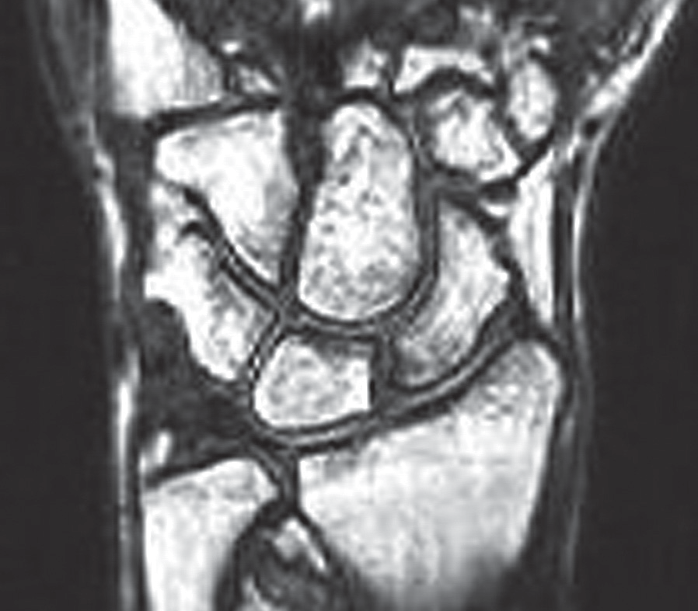
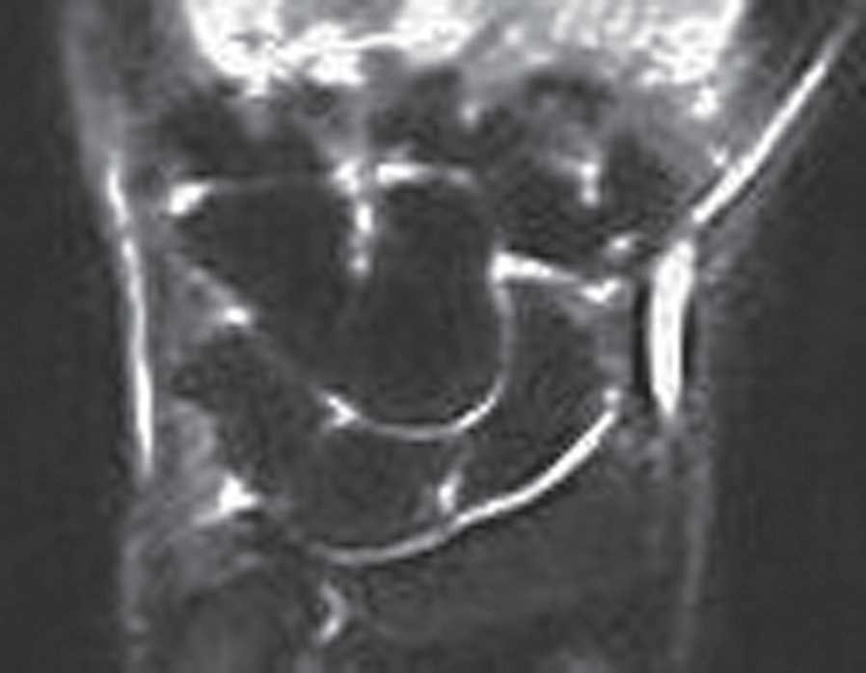
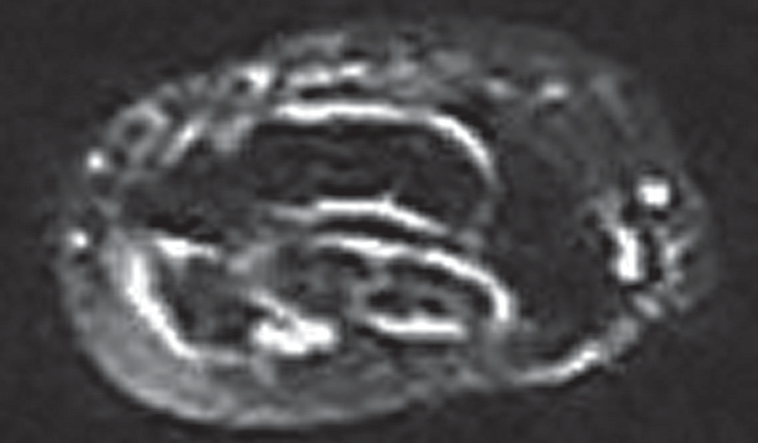
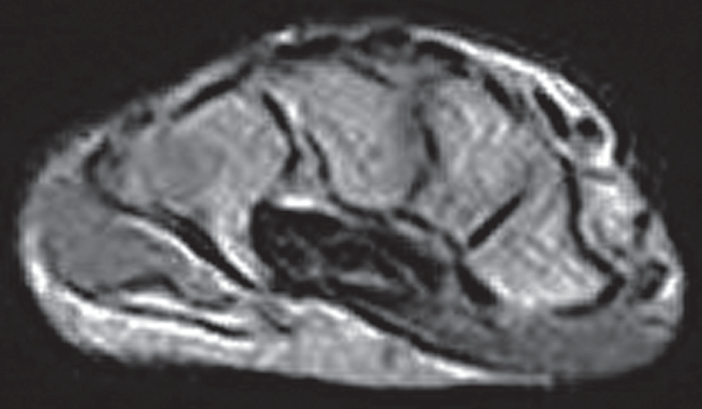
ReviewArticle
©PolJRadiol,2009;74(4):77-82
Figure3A.CoronalSTIRmagneticresonanceimagedemonstratesnormalwrist.
Figure1.CoronalT1Turbo3Dmagneticresonanceimagedemonstratesnormalwrist.
Figure3B.AxialSTIRmagneticresonanceimagedemonstratesnormalwrist.
Figure2.AxialT1SEmagneticresonanceimagedemonstratesnormalwrist.
- T1-weightedsequencesbeforeandafteri.v.contrastadministration,carriedoutintwoplanes:coronalandtransverse.Itshouldbealsopointedoutthatintrave-nousadministrationofcontrastmaybeunnecessaryifthemainaimoftheexaminationistodeterminethepresenceoferosions;(Figures1,2),
- T2-weightedsequenceswithfatsaturationor,whenimpossibletocarryout,theSTIR(ShortTauInversionRecovery)sequences;(Figure3).
OMERACT(OutcomeMeasuresinRheumatoidClinicalTrials),establishedin1992[17].OMERACTfunctionsundertheaegisoftheInternationalLeagueofAssociationsforRheumatology(ILAR),being inpossession ofa groupforRA,underthepatronageoftheWorldHealthOrganization(WHO)[18,19].OMERACTinvolvesagroupofexpertsfromdifferentcountrieswho,actingjointlyandbasingontheclinicaltrials,developandrevisetheguidelinesonrheu-matoiddiseases,includingRA.Andthus,onthebasisofthestudiescarriedoutbytheEULARworkgroupsonRAandOMERACT,therewasdevelopedasystemofRAlesioneval-uation inthe MRIexaminations(OMERACTRAMRIS2002;RAMRIS–RheumatoidArthritisMRIScoringSystem)[20].ThissystemdeterminescorrectMRIsequencesanddefini-tionsofthebasicsymptomsinparticularstagesofthedis-ease,and classifiestheir severity[21–23].
Andsothespecificexaminationprotocolallowsforaprop-erevaluationoftheobtainedMRIimages.
Moreover,thebasicdefinitionsoftheMRIsymptomsweredetermined.i.e.synovitis,bonemarrowoedema,anderosions.
Andthus
- Synovitis(Figure4)isthepresenceofathickenedsynovi-almembrane,revealingintenseenhancementafterintra-venouscontrastadministration,
- Bonemarrowoedema(Figure5)–Isanirregular,poor-lydelineatedregionwithinthebonemarrow,revealinganincreasedsignalintensityconnectedwithahigheramountofwater(highersignalintensityintheSTIRandT2-weightedsequencewithfatsuppression,lowersignalintensityinT1-weightedsequences),
- Boneerosion(Figures6,7)–sharplydelineated,marginalbone defect, with a characteristicperiarticular location
However,themostimportantfactwasthedevelopmentofstandardprotocolsoftheMRIexaminationsofwrists,metacarpophalangealjoints,andinterphalangealjoints,i.e.themostcommonregionstobeinvolvedwithRA.
Accordingtotheguidelines,thebasicsequencesintheMRIexaminationinpatientswithrheumatoidarthritis,enablingthe evaluation of the inflammatory and destruc-tivelesionsofjoints,shouldinclude:
78

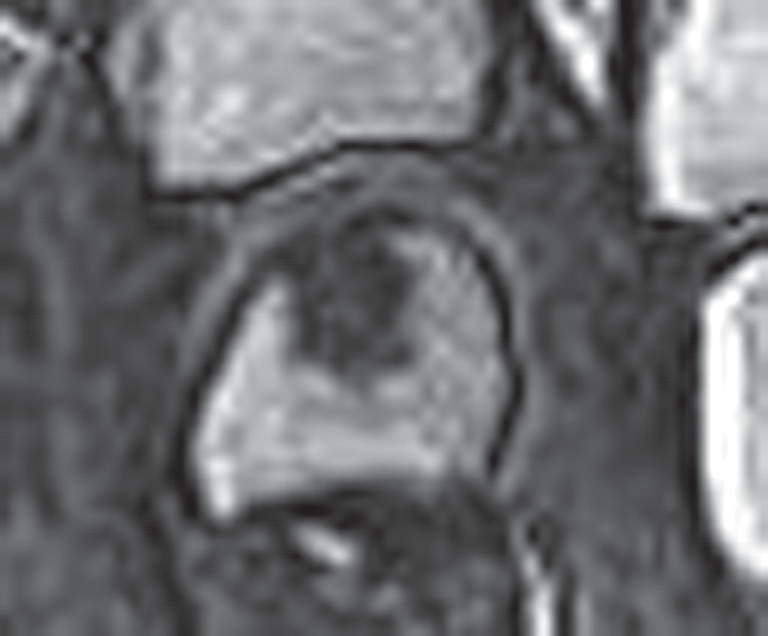
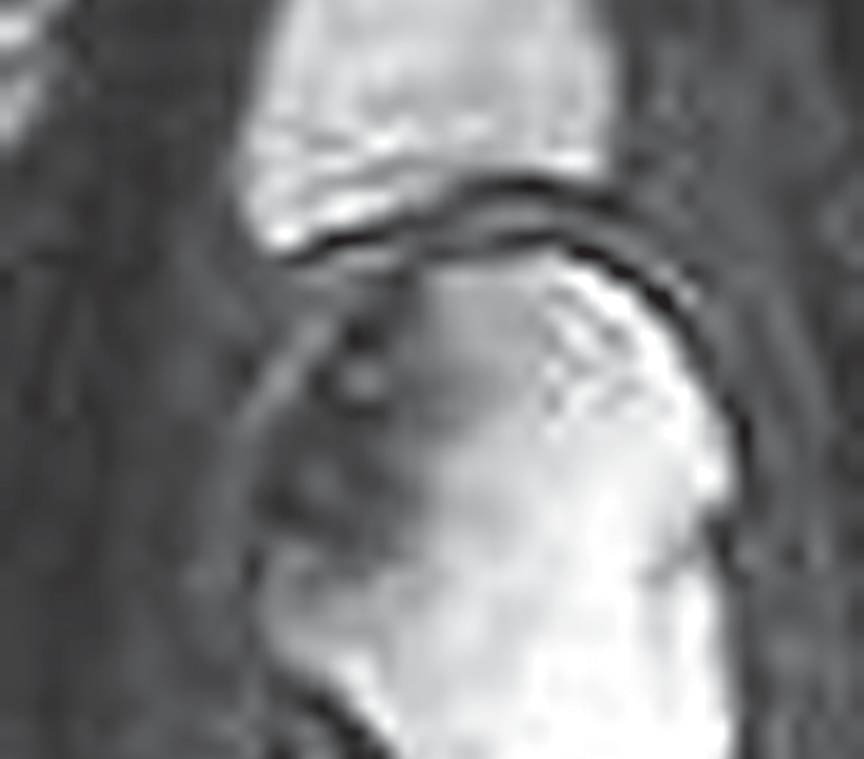
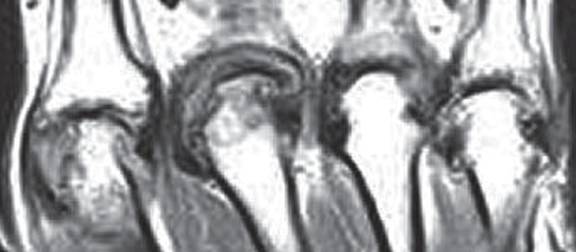
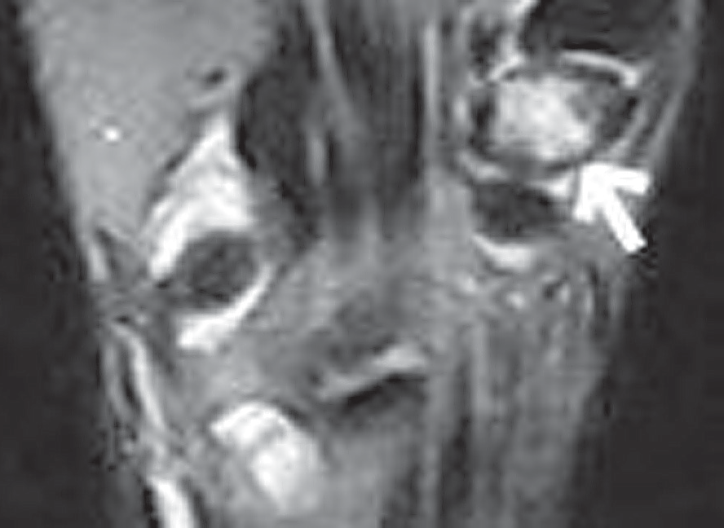
©PolJRadiol,2009;74(4):77-82
KapuścińskaKetal–StandardisationoftheMRIimageevaluation…
Figure4.CoronalT1SEmagneticresonanceimagedemonstratesMCPJsynovitis.
Figure6.CoronalT1Turbo3Dmagneticresonanceimagedemonstrateserosionof3rdmetacarpalhead.
Figure5.CoronalSTIRmagneticresonanceimagedemonstratesbonemarrowoedemaoftrapezium.
andatypicalsignal,foundintwoplanes,withavisibleinterruptionofcortexcontinuityinatleastoneofthem.Asignaltypicalforerosionistheabsenceofthenormal,lowsignalintensitywithinthecortex,andthelossofthenormalhighsignalwithinthebonemarrowintheT1-weightedsequence.Rapidenhancementfoundinero-sionsafterintravenouscontrastadministrationsuggeststhepresenceofanactive,hypervascularisedsynovialmembrane(pannus).
Figure7.SagittalT1Turbo3Dmagneticresonanceimagedemonstrateserosionof3rdmetacarpalhead.
Next,theseverityofparticularsymptomswasdefinedasmentionedbelow.TheOMERACT2002RAMRISclassifica-tionisthecurrentlyapplyingone.
metacarpalbonesandthebaseoftheproximalphalanx).Thedivisionoftheseverityofbonemarrowoedemaintothreedegrees,from0to3,basesontheproportionofboneinvolvement(%)andisasfollows:0degree–nobonemar-rowoedema,1degree–involvementof1–33%ofthevol-umeoftheexaminedbone;2degree–34–66%oftheboneinvolved,3degree–67–100%oftheboneinvolved.
Theseverityofsynovitisshouldbeevaluatedinthreeregionsof the wrist (radio-ulnar distal joint; radio-carpaljoint,aswellas:mediocarpalandcarpometacarpal),andineveryintercarpaljoint,apartfromthefirstcarpometa-carpalandthefirstmetacarpophalangealjoint(i.e.jointsofthethumb).
Theseverityoferosions,similarlytothedegreeofbonemarrowoedema,shouldbeevaluatedseparatelyforeveryboneoftheexaminedjoints(wristbones:scaphoid,lunate,triquetrum,pisiform,trapezium,trapezoid,capitate,hamate,distalpartoftheradialbone,distalpartoftheulna,basesofthemetacarpalbonesandbonesofthemeta-carpophalangealjoints:headofthemetacarpalbonesandthebaseoftheproximalphalanx).
Thedegreeofsynovitisrangesfrom0to3.The0degreeindi-catesanormalstate,whilethedegreesfrom1to3(mild,
moderate,severe)involvesubsequent¹⁄³oftheprobablemaxi-malvolumeofthesynovialmembraneinagivenjoint,reveal-
ingenhancementafterintravenouscontrastadministration.
Thedegreeofbonemarrowoedemashouldbeevaluatedforeveryboneoftheexaminedjointseparately(wristbones:scaphoid,lunate,triquetrum,pisiform,trapezi-um,trapezoid,capitate,hamate,distalpartoftheradialbone,distalpartoftheulna,basesofthemetacarpalbonesandbonesofthemetacarpophalangealjoints:headofthe
Thedivisionintothedegreesfrom0to10isconnect-ed withtheproportion ofbonedestruction (%),andso: 0degree–anormalbone,1degree–1–10%ofbonedefect,2degree–11–20%,3degree–21–30%,4degree–31–40%,5
79

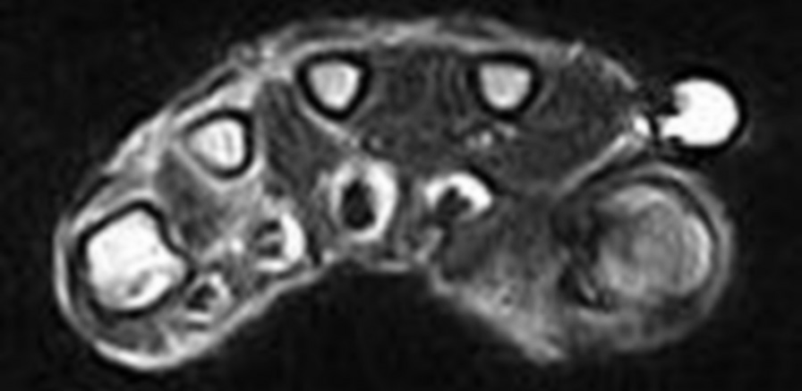
ReviewArticle
©PolJRadiol,2009;74(4):77-82
Figure9.OMERACTRAMISevaluationsheet–metacarpophalangealjoints.
Figure8.AxialT2SEmagneticresonanceimagedemonstratestenosynovitisofdigits’flexors.
degree–41–50%,6degree–51–60%,7degree–61–70%,8
degree–79–80%,9degree–81–90%,10degree–91–100%.
Figure10.SequenceT2SE,transverseplane,tenosynovitisofthedigitalflexors.
Whendeterminingthedegreeofbonemarrowoedemaandoferosionswithinthelongbones(i.e.distalpartoftheradialbone,distalpartoftheulnarbone,basesofthemetacarpalbonesandbasesofthephalanges),oneshouldtakeintoconsiderationthelesionsinagivenregion1cmdeepfromthearticularsurfaceoftheexaminedbone.
compartment–tendonsheathsoftheextensorpollicisbre-visandoftheabductorpollicislongus;II–tendonsheathsoftheextensorcarpiradialislongusandbrevis;III–tendonsheath oftheextensorpollicislongus;IV–tendon sheathsoftheextensordigitorumandtheextensorindicis;V–tendonsheathoftheextensoroflittlefinger;VI–tendonsheathoftheulnarextensorofwrist)and4sheathsoftheflexorsontheventralside(tendonsoftheflexorcarpiradi-alis,oftheflexorhallucislongus,commonforthetendonsoftheflexordigitorumsuperficialisandprofundus,tendonsoftheflexorcarpiulnaris).Thelesionsaremostvisibleintransversecross-sections,inT1-weightedsequences,beforeandafterintravenouscontrastadministration,whereteno-synovitismayappearasafluidinsidethesheathorathick-ening(synovialhypertrophy)ofthesheath,undergoingenhancementafterintravenouscontrastadministration.
Figures8and9presentingsuggestionsofthedescriptivesheetsusedforwristandhandevaluation,respectively.
Thedegreesdefinedbytheaforementionedcriteriaaregivenanequivalentnumberofpoints–i.e.thefirstdegree
– 1point,2degree –2points,3 degree–3points, andsoon.Thefinalscoreresultsfromsummingupthepointsobtainedintheevaluationofparticularsymptomsofalljoints.Forsynovitis,themaximalscoreforthe2–5meta-carpophalangealjoints,carpaljointsandalljoints(ofonehand)amountsto0–12,0–9,and0–21points,respectively.
Likewise,forbonemarrowoedema:0–24;0–45,and0–69
points;forerosions–0–80;0–150,and0–230.
Becauseasmallamountoffluidwithinthesheathmaybealsovisibleinhealthyindividuals,itisimportanttorevealthissymptomatleasttwoadjacentslices.
Thepresentedsystemdoesnotincludetheevaluationofseverityoftenosynovitis(Figure10)–asymptomfrequent-lypresentinRA.Onthebasisofthesequencesandgrad-ingusedinOMERACTRAMRIS2002,therewasdevelopedananaloguesystemforthispathologicalsymptomaswell[24].Theevaluationinvolvedallsixdorsalcompartments(I
Tenosynovitisisdescribedsimilarlytosynovitis.Theclassificationinvolvesdegreesfrom0to3.Thefollow-ingfeaturesarescored:widthofthefluidlayerorsheath
80

OMERACTRAMRISevaluationsheet
OnthebasisofreferenceatlasesofEULAR-OMERACTRAMRI

Metacarpophalangeal joints

Patient’snameandsurname:………………… ……….…… Evaluation date: ……………Synovitis - evaluation

Erosions and bonemarrowoedema– evaluation

Bone erosion – degrees from0 to 10;according to the proportion of the destructed bone surface (10-percentranges);
0:0%, 1:1- 10%, 2:11-20%, 3:21-30%, …, 10:99 – 100%
Bonemarrowoedema– degrees from0 to 3; percentage of the involved bone surface (33-percent ranges);0:0%, 1:1-33%, 2:34-66%, 3:57-100%

The bone is evaluated fromthe articular surface, to the depth of 1cm.

……………………………………… Evaluating physician

On the basis of: “An introduction to the EULAR–OMERACTrheumatoidarthritis MRI referenceimageatlas”MØstergaard,JEdmonds,FMcQueen,CPeterfy,MLassere, BEjbjerg, PBird,PEmery,H Genantand PConaghan;AnnRheum Dis2005;64 (SupplI):i3-i7.

Metacarpopha
langeal joints

2
3
4
5
Erosions(0-10)
Proximal

Distal

Bonemarrowoedema(0-3)
Proximal

Distal

Metacarpopha
langeal joints

2
3
4
5
synovitis(0-3)

OMERACTRAMRISevaluationsheet
OnthebasisofreferenceatlasesofEULAR-OMERACTRAMRI

Wrist joints

Patient’snameandsurname:………………… ……….…… Evaluation date: ……………Synovitis - evaluation

Erosions and bonemarrowoedema– evaluation

Bone erosion – degrees from0 to 10;according to the proportion of the destructed bone surface (10-percentranges);
0:0%, 1:1- 10%, 2:11-20%, 3:21-30%, …, 10:99 – 100%
Bonemarrowoedema– degrees from0 to 3; percentage of the involved bone surface (33-percent ranges);0:0%, 1:1-33%, 2:34-66%, 3:57-100%

In case of the carpal bones, the surface of the whole bone is evaluated; in long bones, the area fromthe bonesurface to the depth of 1 cmis evaluated.

……………………………………… Evaluating physician

On the basis of: “An introduction to the EULAR–OMERACTrheumatoidarthritis MRI referenceimageatlas”MØstergaard,JEdmonds,FMcQueen,CPeterfy,MLassere, BEjbjerg, PBird,PEmery,H Genantand PConaghan;AnnRheum Dis2005;64 (SupplI):i3-i7.

Bone
Scaphoid
Lunate
Triquetrum
Pisiform
Erosions(0-10)

Bonemarrowoedema(0-3)

Bone
Trapezium
Trapezoid
Capitate
Hamate
Erosions(0-10)

Bonemarrowoedema(0-3)

Bases
of themetacarpal
bones

1
2
3
4
5
Erosions(0-10)

Bonemarrowoedema(0-3)

Joint
Distal radioulnarjoint(DRUJ)
Radiocarpaljoint(RCJ)
Intercarpal/mediocarpaljoint andcarpometacarpaljoints(IC-CMCJ)
Synovitis (0-3)

©PolJRadiol,2009;74(4):77-82
KapuścińskaKetal–StandardisationoftheMRIimageevaluation…
aforementioneddegreesarescoredwithanadequatenumberofscores–i.e.1degree–1point,2degree–2points,3degree
–3points.Incaseofalackingtendon(anatomicalvariant),theevaluatedstructurereceives0points.Themaximalnumberofpointsthatcanbeobtainedbyonepatientduringtynosynovitisevaluationamountsto30.Thisevaluativesys-temsupplementstheOMERACTRAMRIS2002system.
Thepreviously mentionedsubjectivity of theMRI evalua-tionscarriedoutbyradiologists,dependingontheirexperi-enceandknowledge,inducedOMERACTtodeveloptheref-erenceatlasesincludingMRIimagesofthewristandmeta-carpaljoints,withdivisionsofsymptomsandtheirseverity[21,22].Suchatlasesinclude:
- Acompleteseriesofimagesofalldegreesofsynovitisinmetacarpophalangealjointsandineveryregionofthewrist(distalradioulnarjoints,radiocarpaljoint,medio-carpaljointandcarpometacarpaljoints)and
- Imagesofdifferentkindsoferosionsandofbonemar-rowoedemaofselectedbones:twobonesofthemetacar-pophalangealjoint(headofthemetacarpalboneandthebaseoftheproximalphalanx)and5carpalbones(distalradialbone,scaphoidbone,lunatebone,capitatebone,andthebasesofthemetacarpalbones).
Figure11.Tenosynovitis–adescriptivesheet.
thickeningfoundonexamination,withenhancement.
- 0degree–nofluidorthickeningwithenhancement,
post-contrast
post-contrast
Asfarastheseverityofsynovitisisconcerned,theatlasincludes the instancesfrom theupper andthe lower limitofagivenrange,whichfacilitatesacorrectclassificationofthecomparedimage.
- 1degree–thewidthofthefluidlayerandthethickeningofthesheath(synovialhypertrophy)withpost-contrastenhancement:lessthan2mm,
- 2degree–thewidthofthefluidlayerandthethickeningofthesheath(synovialhypertrophy)withpost-contrastenhancement:equaltoorhigherthan2mmandlowerthan5mm,
- 3degree–thewidthofthefluidlayerandthethickeningofthesheath(synovialhypertrophy)withpost-contrastenhancement:atleast5mm.
Applicationofthepresentedreferenceatlasesisextremelyimportant,especiallyatthebeginningofthelearningprocessinvolvingtheevaluationoftheMRIimagesoftherheuma-toidconditions,aswellasincaseofclinicaluncertainties.Moreover,theuseoftheOMERACTRAMRIS2002systeminthedailypractice,supplementedwiththescaleoftenosy-novitisevaluation,allowsforanobjectiveassessmentofthelesions.Thisalsoenablesacomparisonofresultsobtainedindifferentexaminations,carriedoutatdifferenttimepoints,indifferentcentres,aswellasabettercommunicationbetweenthediagnosticimagingspecialistsandtheclinicians.
Thewidthoftheevaluatedlayerismeasuredatthepointofmaximalthickness,perpendicularlytothesurfaceofthetendon.Figure11showsasuggestionforadescriptivesheetfortenosynovitis.Next,asinOMERACTRAMRIS2002,the
References:
- SzczeklikA:Chorobywewnętrzne,tomII;rozdziałD1–Reumatoidalnezapaleniestawów;1645–57
- LeeDM,WeinblattME:Rheumatoidarthritis.Lancet,2001;358:903–11
- SommerOJ,KladosekA,WeilerVetal:RheumatoidArthritis:APracticalGuidetoState-of-the-ArtImaging,ImageInterpretation,andClinicalImplications.RadioGraphics,2005;25:381–98
- ØstergaardM,EjbjergB,SzkudlarekM:Imaginginearlyrheumatoidarthritis:rolesofmagneticresonanceimaging,ultrasonography,conventionalradiographyandcomputedtomography.BestPractResClinRheumatol,2008;22(6):1019–44
- vanderHeijdeDMFM:PlainX-raysinrheumatoidarthritis:overviewofscoringmethods,theirreliabilityandapplicability.BailleresClinRheumatol,1996;10:435–53
- LarsenA,DaleK,EekM:Radiographicevaluationofrheumatoidarthritisandrelatedconditionsbystandardreferencefilms.ActaRadiolDiagn,1977;18:481–91
- TehJ,WhiteleyG:MRIofsofttissuemassesofthehandandwrist.BrJRadiol,2007;80:47–63
- McAlindenPS,TehJ:Imagingofthewrist.Imaging,2003;15:180–92
- PeterfyCG:MRIofthewristinearlyrheumatoidarthritis.AnnRheumDis,2004;63:473–77
- Foley-NolanD,StackJP,RyanM:MagneticResonanceImagingintheassessmentofrheumatoidarthritis–acomparisonwithplainfilmradiographs.BrJRheumatol,1991;30:101–6
- HaavardsholmEA,BøyesenP,ØstergaardMetal:MRI-detectedbonemarrowedemaisapredictorofsubsequentradiographicprogressioninearlyrheumatoidarthritis.AnnRheumDis,2007;66(Suppl.II),94
- McQueenFM,BentonN,PerryDetal:Boneedemascoredonmagneticresonanceimagingscansofthedominantcarpusatpresentationpredictsradiographicjointdamageofthehandsandfeetsixyearslaterinpatientswithrheumatoidarthritis.ArthritisRheum2003; 48: 1814–27
- PalosaariK,VuotilaJ,TakaloRetal:BoneoedemapredictserosiveprogressiononwristMRIinearlyRA–a2-yrobservationalMRIandNCscintigraphystudy.Rheumatology,2006;45:1542–48
- McQueenFM,Ostendorf,B:WhatisMRIboneoedemainrheumatoidarthritisandwhydoesitmatter?ArthritisResTher,2006;8:222–25
- McQueenF,ŘstergaardM,PeterfyCetal:PitfallsinMRIscoringofrheumatoidarthritiswristandmetacarpophalangealjoints.AnnRheumDis,2005;65(Suppl.1):i48–55
81

Tenosynovitis–descriptivesheet

Patient’snameandsurname:……………… …………… Evaluation date: ……………
The lesionsmustbe present in at least two consecutive transverse sections.Degreesoftenosynovitis:
0 degree(normal state):Noeffusionorhypertrophyofthesynovial membraneaftercontrast enhancement;1 degree:effusioninthesheathoflessthan2mmorhypertrophyofthesynovial membraneaftercontrastenhancement;
- degree:effusioninthesheath> or = 2 and < 5 orhypertrophyofthesynovial membraneaftercontrastenhancement;
- degree:effusioninthesheath> or = 5 orhypertrophyofthesynovial membraneaftercontrast enhancement;

Dorsal side:

Ventral side:

……………………………………… Evaluating physician

On the basis of: “Introduction of a novelmagneticresonanceimagingtenosynovitis score forrheumatoidarthritis:reliabilityinamultireaderlongitudinal study” EAHaavardsholm,M Østergaard, B Ejbjerg, N Kvan, TKvien;AnnRheum Dis2007;66:1216-1220.

Tendonsheath
Ulnarflexormuscleof wrist
Commonsheathofthe digitalflexors
Longflexormuscleofthumb
Radial flexormuscleof wrist
Tenosynovitis (0-3)

Range
I
II
III
IV
V
VI
Tenosynovitis (0-3)

ReviewArticle
©PolJRadiol,2009;74(4):77-82
- BirdP,ConaghanP,EjbjergBetal:ThedevelopmentoftheEULAR–OMERACTrheumatoidarthritisMRIreferenceimageatlas.AnnRheumDis,2005;65(Suppl.1):i8–10
- BoersM,BrooksP,SimonLSetal:OMERACT:Aninternationalinitiativetoimproveoutcomemeasurementinrheumatology.Trials,2007,8:38
- OMERACT:OutcomeMeasuresinRheumatology,(http://www.omeract.org)
- HaavardsholmEA,KvanNP,ŘstergaardMetal:ReliabilityoftheOMERACTRheumatoidArthritisMRIScore(RAMRIS)inaMulti-ReaderLongitudinalSetting.ArthritisRheum,2004;50(Suppl.9):S457–58
- ØstergaardM,EdmondsJ,McQueenFetal:AnintroductiontotheEULAR–OMERACTrheumatoidarthritisMRIreferenceimageatlas.Ann RheumDis,2005;65(Suppl.1):i3–7
- EjbjergB,McQueenF,LassereMetal:TheEULAR-OMERACTrheumatoidarthritisMRIreferenceimageatlas:thewristjoint.AnnRheumDis,2005;65(Suppl.I):i23–47
- ConaghanP,BirdP,EjbjergBetal:TheEULAR–OMERACTrheumatoidarthritisMRIreferenceimageatlas:themetacarpophalangealjoints.AnnRheumDis,2005;65(Suppl.I):i11–21
- HaavardsholmEA,ØstergaardM,EjbjergBetal:Introductionofanovelmagneticresonanceimagingtenosynovitisscorefor
rheumatoidarthritis:reliabilityinamultireaderlongitudinalstudy.AnnRheumDis,2007;66:1216–20
82

