Acta Geologica Polonica, Vol. 65 (2015), No. 2, pp. 205-228
DOI: 10.1515/agp-2015-0008
DE
G
DE GRUYTER
OPEN

Eocene flora and trace fossils from the Hruby Regiel
section in the Tatra Mountains (Poland): Taxonomic
revision of the Wiktor Kuźniar fossil plant collection
GRZEGORZ WOROBIEC¹, RENATA JACH², ELŻBIETA MACHANIEC², ALFRED UCHMAN²
AND ELŻBIETA WOROBIEC¹
'-Department of Palaeobotany, W. Szafer Institute of Botany PAS, Lubicz 46, PL-31-512 Kraków, Poland.
E-mails: g.worobiec@botany.pl, e.worobiec@botany.pl
²Institute of Geological Sciences, Jagiellonian University, Oleandry 2a, PL-30-063 Kraków, Poland.
E-mails: renata.jach@uj.edu.pl, elzbieta.machaniec@uj.edu.pl, alfred.uchman@uj.edu.pl
ABSTRACT:
Worobiec, G., Jach, R., Machaniec, E., Uchman, A. and Worobiec, E. 2015. Eocene flora and trace fossils from
the Hruby Regiel section in the Tatra Mountains (Poland): Taxonomic revision of the Wiktor Kuźniar fossil plant
collection. Acta Geologica Polonica, 65 (1), 205-228. Warszawa.
Latest Eocene plant macrofossils and trace fossils collected a century ago by Wiktor Kuźniar are revised and their
stratigraphical and palaeoecological meaning is re-considered. They derive from marine limestones and marls
cropping out on the northern slope of the Hruby Regiel mountain in the Western Tatra Mountains. Leaves be-
longing to the families Fagaceae and Lauraceae and fruits of the palm Nypa are recognized. The co-occurrence
of the planktonic foraminifer taxa Chiloguembelina cf. gracillima and Globigerinatheca cf. index and fruits of
Nypa suggests a latest Eocene age of the fossil flora. The plant assemblage is typical of paratropical or subtropical
evergreen forests in a warm and humid subtropical climate, recent counterparts of which occur in southeast Asia.
The presence of Nypa is characteristic of mangroves. The good state of preservation of the leaves suggests coast-
line proximity during sedimentation of the plant-bearing deposits.
Key words: Fossil leaves; Fossil fruits; Trace fossils; Foraminifera; Biostratigraphy;
Palaeoecology; Palaeoclimate; Late Eocene; Western Carpathians.
INTRODUCTION
The Eocene, an important epoch in the evolution of
the biosphere, is characterised by significant changes
in the Earth climate. The warm and humid greenhouse
climate of the Early and Middle Eocene changed to an
icehouse climate through the Late Eocene (Zachos et
al. 2001). The climatic deterioration led to dramatic
changes in the Eocene flora and fauna and to a signif-
icant extinction within some groups of animals and
plants (Boulter et al. 1988; Prothero 1994; Sepkoski
1996). During the greenhouse period, land areas ofEu-
rope were covered by paratropical rainforest vegetation
(Mai 1995; Collinson and Hooker 2003).
Fossil remains of Eocene plants are known from
many localities in Europe. One ofthem is Geiseltal near
Halle, Germany, with excellently preserved plants and
animals (Mai 1976; Wilde 1995; Mai and Walther
2000). In Poland, Eocene floras are rather scarce, rep-
resented mainly by assemblages of plant microfossils
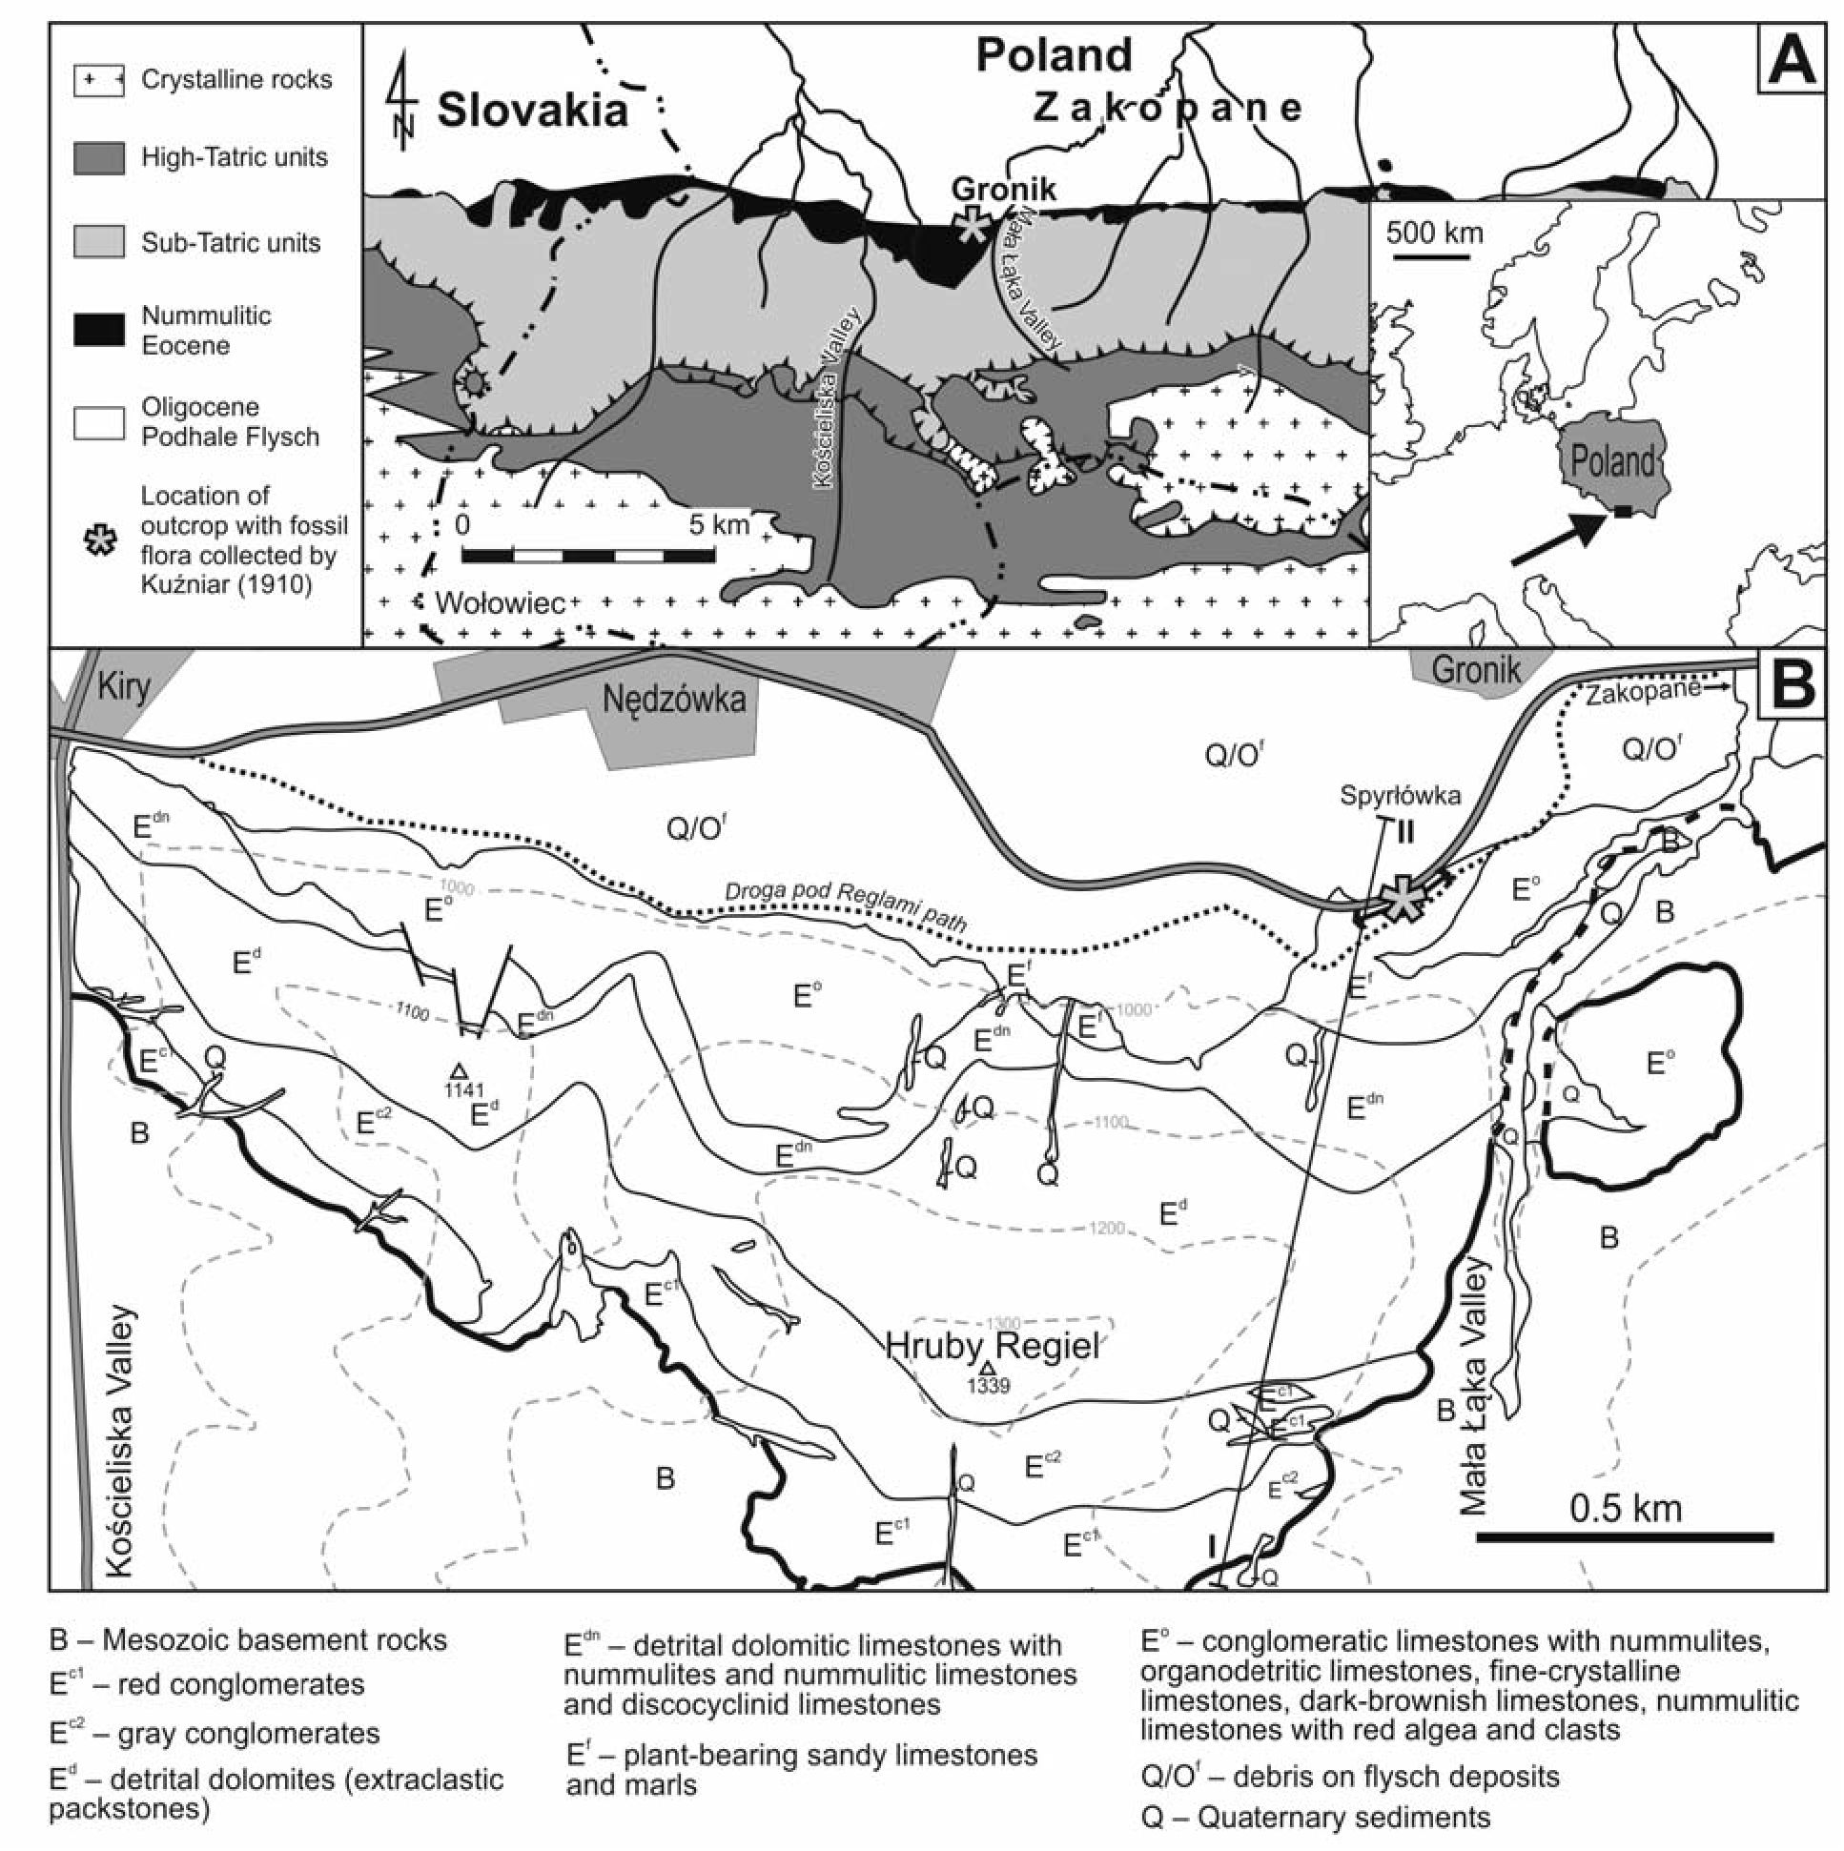
206
GRZEGORZ WOROBIEC ET AL.
yielded by borehole cores (Grabowska 1996a). Eocene
plant macroremains in Poland are typically found in
Baltic amber (Grabowska 1996b; Kosmowska-Cera-
nowicz 1996). However, amber in Poland is usually re-
deposited into Quaternary rocks from areas located to
the north. Eocene plant macroremains in southern
Poland were found in the Carpathians and almost ex-
clusively in the Tatra Mountains. They are represented
mostly by plant detritus, in some localities accompanied
by remains of fossil leaves and exceptionally also by
carpological remains (Głazek and Zastawniak 1999).
The first report on plant macroremains from the
Eocene of the northern slopes of the Tatra Mountains
was published by Raciborski (1892). In the “Turek val-
ley” (territory of Slovakia), he found numerous horse-
tail remains, referred to as Equisetum uhligi Raci-
borski, accompanied by an oak leaf, some coniferous
remains and other poorly preserved leaves (probably
Myricaceae and Salicaceae). Kuźniar (1910) described
abundant Eocene plant remains from the road-cutting
on the northern slope of the Hruby Regiel mountain.
This flora comprises almost exclusively impressions of
leaves, with rare carpological remains. Szafer (1958)
presented a new Eocene plant macroremains assem-

Text-fig. 1. Location maps. A - Geological sketch-map of the Polish part of the Tatra Mountains (after Bac-Moszaszwili et al. 1979, simplified). B - Detailed geological
map of the Hruby Regiel Mountain with location of the study area (after Sokoiowski 1959, modified)
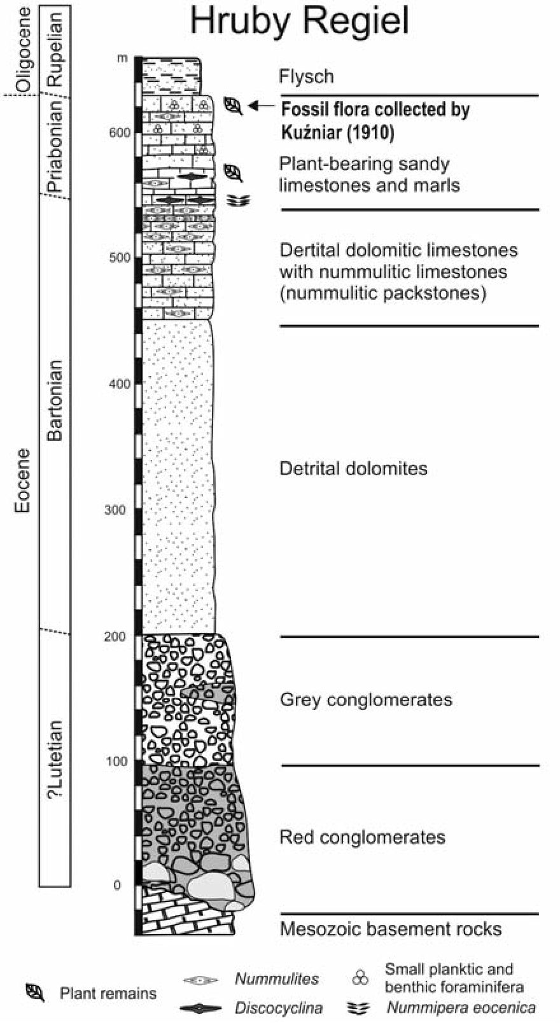
207
EOCENE FLORA FROM THE TATRA MOUNTAINS, POLAND
blage from the quarry at Chłabówka. It is represented
by leaves of Lauraceae (Cinnamomum sp.), Palmae,
Myrtaceae, Cornaceae, and probably also Moraceae
(Ficus), Myricaceae and Sterculiaceae. Zastawniak
(in Passendorfer 1983) briefly revised Szafer’s (1958)
collection and ascribed these remains to Sabalites,
Daphnogene, and presumably to Apocynaceae and
Salicaceae. Subsequently, the material was revised by
Głazek and Zastawniak (1999), who reported leaf re-
mains of the fern Acrostichum, leaves of Lauraceae
(Daphnogene), Araceae, palms (Sabalites) and an ex-
tinct member of Fagaceae, Eotrigonobalanus furcin-
ervis Walther et Z. Kvacek. Starczewska-Koziołowa
(1961) found some Eocene plant remains in the area of
the Krokiew ski jump which were not subsequently in-
vestigated. The history of investigations of the Palaeo-
gene plant macrofossils from the Tatra Mountains was
summarised by Głazek and Zastawniak (1999).
The current investigation was aimed at a taxo-
nomic revision of the plant macroremains of Kuźniar
(1910) from the Eocene of the Hruby Regiel section,
some of which appeared to be trace fossils. Most of the
original plant determinations were revised and the en-
tire material illustrated for the first time; Kuźniar
(1910) did not illustrate his material. The study also re-
vealed the presence of specimens never previously
described. The revision enables reinterpretation of the
taxonomic composition and palaeoecology of plant
assemblages during the Eocene (Priabonian) in the
Western Carpathians in relation to the palaeoclimate at
that time.
GEOLOGICAL SETTING
The so-called Tatric or Nummulitic Eocene of the
Tatra Mountains forms the lowermost part of the sed-
imentary succession of the Central Carpathian Palaeo-
gene (Text-fig. 1; Bac-Moszaszwili et al. 1979). These
deposits discordantly overlie the Variscan crystalline
basement and its autochtonous and allochtonous
Permo-Mesozoic sedimentary cover. They represent a
transgressive sequence which starts with Lutetian and
locally lowermost Bartonian terrigenous and littoral
conglomerates composed of bedrock clasts (Text-fig. 2).
These deposits are overlain by Lutetian-Bartonian lit-
toral extraclastic carbonates represented by detrital
dolomites and detrital dolomitic limestones with num-
mulites. Locally, in their uppermost part, nummulitic
banks with large benthic foraminifera dominated by
Nummulites sp. occur (Bieda 1963; Roniewicz 1969;
Kulka 1985; Olszewska and Wieczorek 1998;
Bartholdy et al. 1999; Jach and Machaniec 2014).

Text-fig. 2. Lithostratigraphical log of Eocene deposits in the Hruby Regiel
section, Tatra Mountains (after Sokołowski 1959, modified)
The uppermost Bartonian through Priabonian car-
bonates are characterized by a distinct facies compo-
sition (Bieda 1963; Bartholdy et al. 1995; Machaniec
et al. 2011; Jach et al. 2012). They are usually devel-
oped as limestones with abundant large benthic
foraminifera and red algae, which are locally overlaid
with carbonate conglomerates. Laterally, they are re-
placed with plant-bearing sandy limestones and marls.
The latter, well-developed in the Hruby Regiel area,
are about 70 m thick. These deposits were previously
referred to as the “sandy limestones with fucoids”
(Kuźniar 1910), “floral beds” (Sokołowski 1959) or
“sandy limestones and shales with flora” (Guzik et al.
1958). In this area, the facies distribution was con-
trolled by synsedimentary tectonics (Jach et al. 2009,
2012; Dąbrowska and Jurewicz 2013). The carbonates
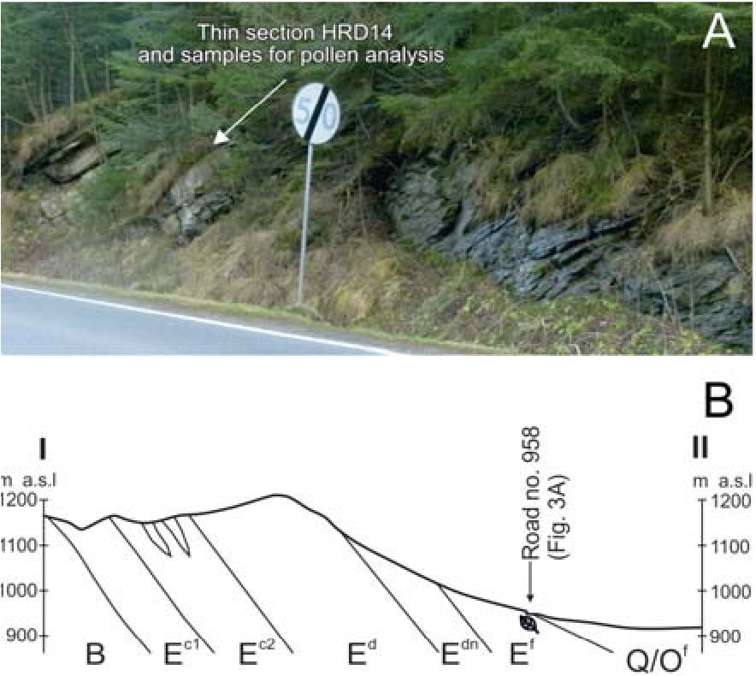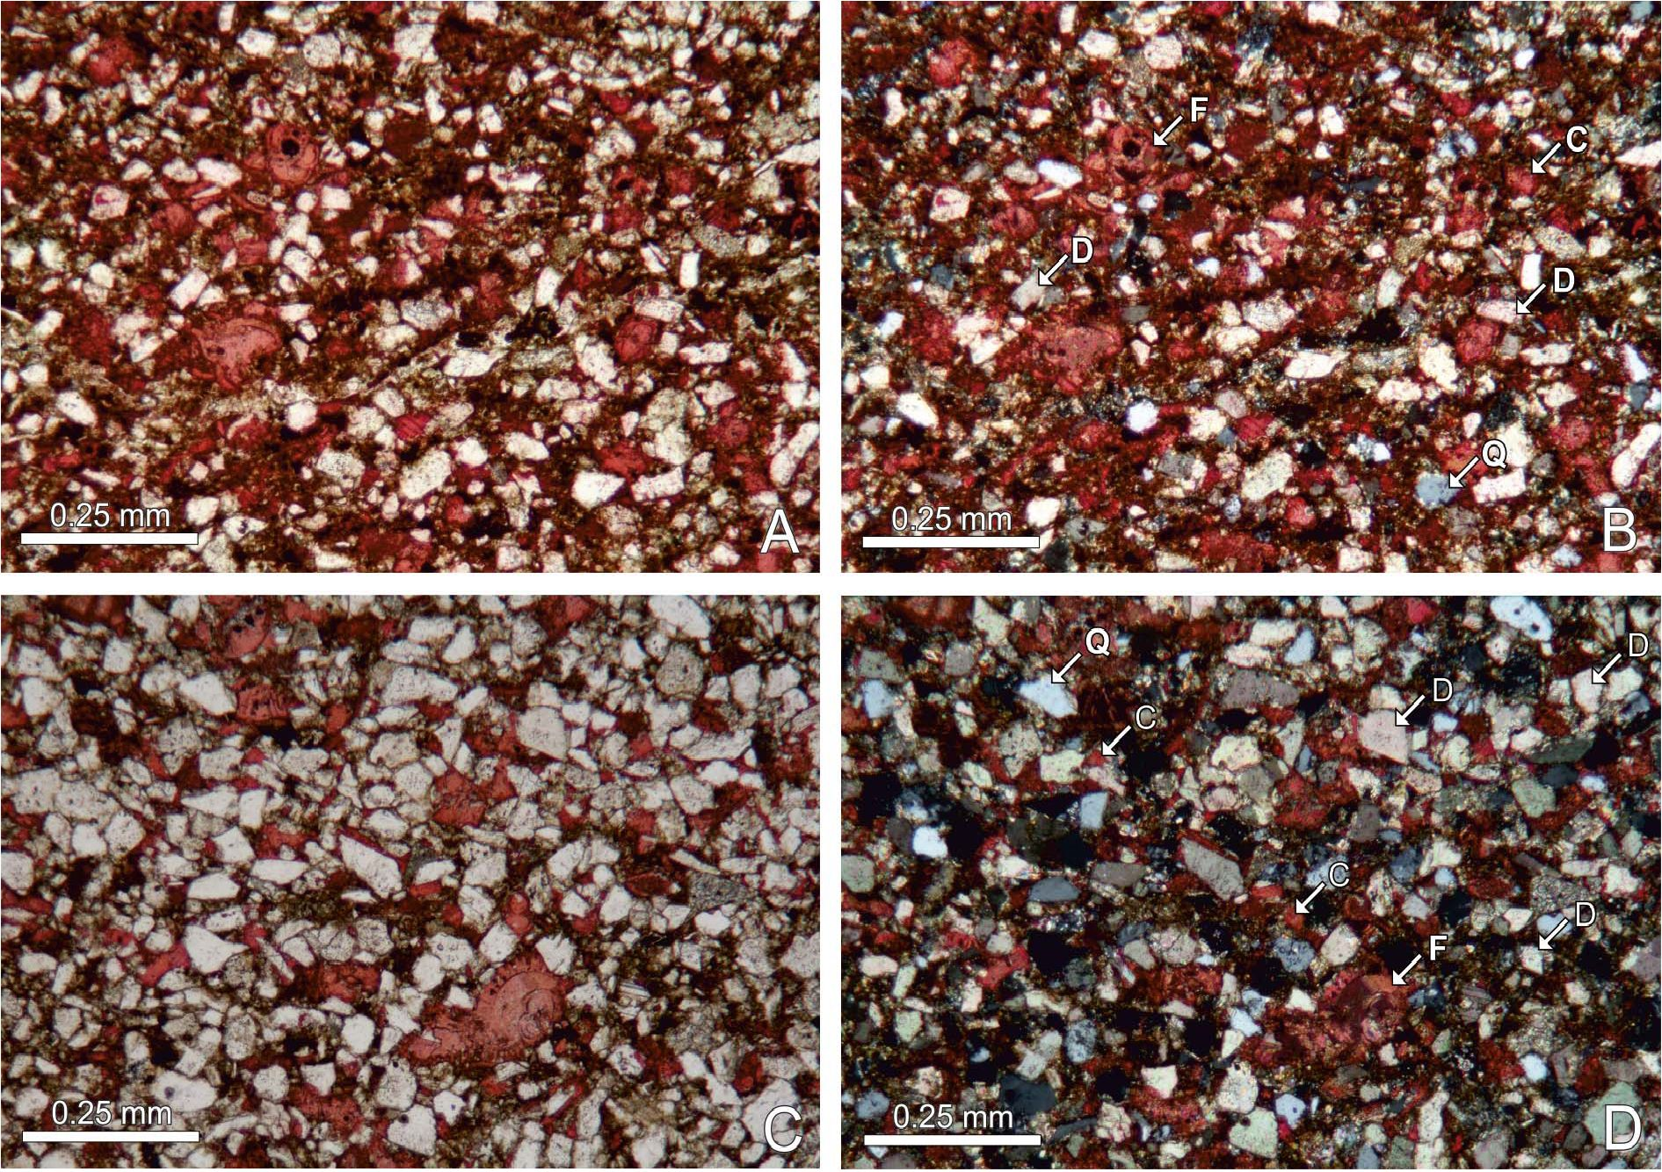
208
GRZEGORZ WOROBIEC ET AL.

Text-fig. 3. Hruby Regiel section. A - View of the rock cliff with plant-bear-
ing sandy limestones and marls, outcrop along the Zakopane-Witow road;
B - Cross section I—II of the Hruby Regiel eastern slope as shown in Text-fig. 1
(after Sokofowski 1959, modified)
are succeeded by Oligocene turbiditic deposits, c. 2.5
km thick (e.g. Radomski 1959; Ludwiniak 2010).
The fossil flora described by Kuźniar (1910) was
collected ex situ from the rock debris available during
roadworks at the beginning of the 20th century. Based
on Kuźniar’s precise description, the locality is iden-
tified as a road-cutting along the Zakopane-Witów
road (at present road no. 958), about 500 m towards the
west from the Mała Łąka valley mouth, between the
gullies running on the northern slope of Hruby Regiel
(Text-figs 1, 3A, B). At present, there is a 3-m high
cliff along the road (from N49°16.509'; E19°53.907' to
N49°16.465'; E19°53.807'), built of the uppermost
part of Priabonian carbonates; their contact with the
overlying flysch deposits is not exposed.
Cropping out in the cliff are sandy limestones and
marls (extraclastic packstones) composed mainly of
sharp-edged dolomite grains, quartz grains, limestone
grains and bioclasts (Text-fig. 4A, B). These deposits re-
veal striking textural and mineralogical similarities to the
samples collected by Kuźniar (1910) (Text-fig. 4C, D).

Text-fig. 4. Microfacies ofplant-bearing sandy limestones and marls ofHruby Regiel section. Thin sections are stained with alizarin red S and ferricyanide potassium
solution. Symbols: Q - quartz, D - dolomite, C - calcite, F -foraminifera. A - extraclastic packstone composed of sharp-edged dolomite grains, angular or moder-
ately rounded quartz and calcitic bioclasts; sample HRD14, plane polarised light; B - sample HRD14, cross polarised light; C - extraclastic packstone composed of
sharp-edged dolomite grains, angular or moderately rounded quartz and calcitic bioclasts mainly of foraminifera tests; sample 24/2013, plane polarised light;
D - sample 24/2013, cross polarised light
209
EOCENE FLORA FROM THE TATRA MOUNTAINS, POLAND
MATERIALS AND METHODS
The collection of Wiktor Kuźniar is stored in the
Museum of the Institute of Geological Sciences, Pol-
ish Academy of Sciences, Kraków. Unfortunately,
Kuźniar (1910) did not put numbers directly on his
specimens. In consequence, the loose labels accom-
panying the specimens are mixed and partially lost.
Some of the specimens were added later by an un-
known collector, as indicated by the label of one the
specimens, with the note “1928”. Barbara Kietlińska-
Michalik (the Museum of the Institute of Geological
Sciences, Polish Academy ofSciences, Kraków) found
some previously uncatalogued and lost specimens
from the collection. Most of the specimens were cat-
alogued later and the catalogue prefix A-III-61 with the
specimen number was added for each specimen. In to-
tal, the collection is composed of 50 specimens. All of
them are re-catalogued here (No. 2013/1-50).
The plant macroremains (mainly leaves) are pre-
served mostly as impressions, one cast, and some coal-
ified plant detritus, all in fine-grained limestones and
marls. The state of preservation of the remains is usu-
ally good. However, the impressions of the network of
the leaf venation are generally poorly preserved and
only impressions of primary and some secondary veins
are visible. The plant fossils were identified solely on
the basis of macromorphology. Leaf descriptions fol-
low mostly Ellis et al. (2009). The drawings were
made under a Carl Zeiss stereomicroscope with a cam-
era lucida attachment. Macrophotographs were taken
using an Olympus E-PL1 digital camera.
Two samples for pollen analysis were taken from
the outcrop (Text-fig. 3A). The material was processed
in the laboratory of the W. Szafer Institute of Botany,
Polish Academy of Sciences, Kraków. Each sample
was divided into two parts. One part of the material
was processed according to the modified Erdtman’s
acetolysis method (Moore et al. 1991), using hydro-
fluoric acid to remove mineral matter; and the second
part was processed using heavy liquid (ZnCl2 + HCl;
density 2.2 g/cm³). Additionally, half of the material
from each sample was sieved at 5 ^m on a nylon
mesh. The microscope slides were made using glyc-
erine as a mounting medium. The rock samples and
palynological residues are stored in the W. Szafer In-
stitute of Botany, Polish Academy of Sciences,
Kraków. Both samples contained no sporomorphs.
However, they were full of organic particles (sedi-
mentary organic matter) allowing analysis of the pa-
lynological matter. Description of the sedimentary
organic matter follows Tyson (1993, 1995) and Bat-
ten (1996). Microphotographs of palynofacies were
taken using a NIKON Eclipse microscope fitted with
a Canon digital camera.
Microfacies as well as the foraminifera were stud-
ied in thin sections [two thin sections from a sample
collected by Kuźniar (1910; sample 24/2013) and 10
thin sections from the outcrop] under Carl Zeiss Ax-
ioskop and Nikon Eclipse E600 POL optical micro-
scopes and a Nikon SMZ 1500 stereo microscope.
Thin sections are stored at the Institute of Geological
Sciences, Jagiellonian University in Kraków.
SYSTEMATIC PALAEOBOTANY
The classification of higher taxonomic categories
follows Reveal (1996) and Takhtajan (2009) and au-
thor names of families follow APG III (2009).
Division: Magnoliophyta (Angiosperms) Cronquist,
Takhtajan et Zimmermann ex Reveal 1996
Class: Magnoliopsida (Dicotyledons) Brongniart 1843
Family Lauraceae Jussieu 1789
Genus Daphnogene Unger 1845
cf. Daphnogene sp.
(Text-fig. 5A)
1910. Daphnogene melastomacea ? Unger; Kuźniar, p. 46.
MATERIAL: 8/2013 (A-III-61/5).
DESCRIPTION: One leaf, about 5 cm long and 4 cm
wide, entire-margined, slightly asymmetric. Venation
pinnate, secondary venation acrodromous.
REMARKS: The characteristic venation of the leaf re-
mains allowed their identification as the fossil-taxon
Daphnogene (synonym of Cinnamomophyllum and
Cinnamomum). The generic name Daphnogene Unger
is an artificial name given to fossil leaves from the
family Lauraceae with acrodromous venation (triplin-
erved), similar to the recent genus Cinnamomum Scha-
effer (Kvacek and Knobloch 1967; Mai and Walther
1978). In the opinion of Kvacek (1971), it is impossi-
ble to assign fossil leaf taxa of the family Lauraceae to
an extant genus on the basis of either the morphology
or the anatomy.
MODERN EQUIVALENTS: In respect of morphol-
ogy, fossil leaves of Daphnogene could be compared
to leaves of several extant genera of the Lauraceae, in-
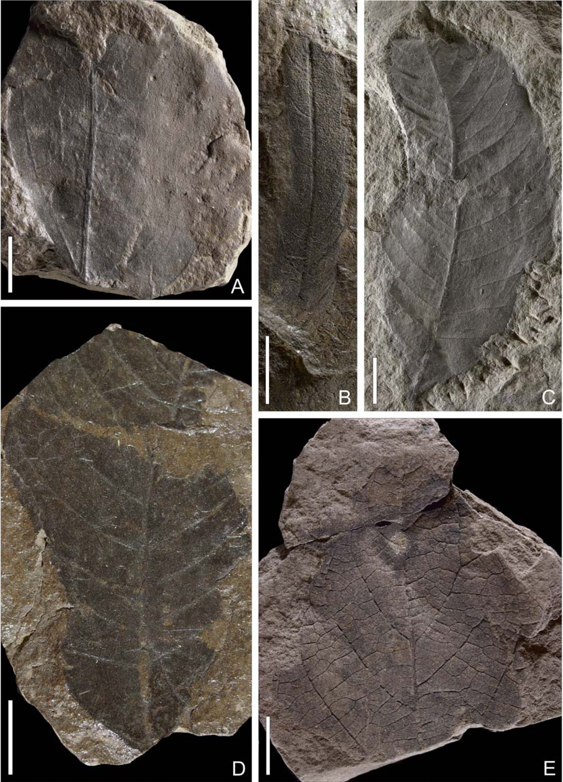
210
GRZEGORZ WOROBIEC ETAL.

Text-fig. 5. Fossil plants from the Wiktor Kuźniar collection. A - cf. Daphnogene sp. (8/2013); B-D -Eotrigonobalanusfurcinervis (Rossmässler) Walther et Z. Kvacek
ssp. furcinervis 1989 (B: 19/2013, C: 42/2013, D: 7/2013); E - Dicotylophyllum cf. juglandoides (Rossmässler) Knobloch et Z. Kvacek 1996 (48/2013). Scale bar - 1 cm
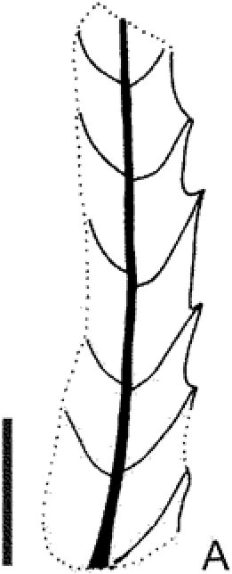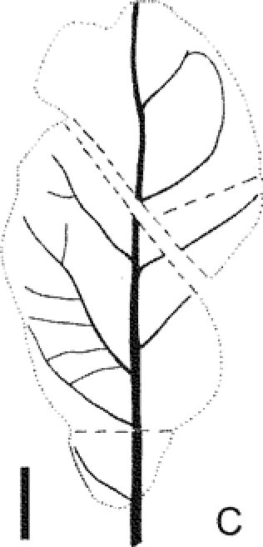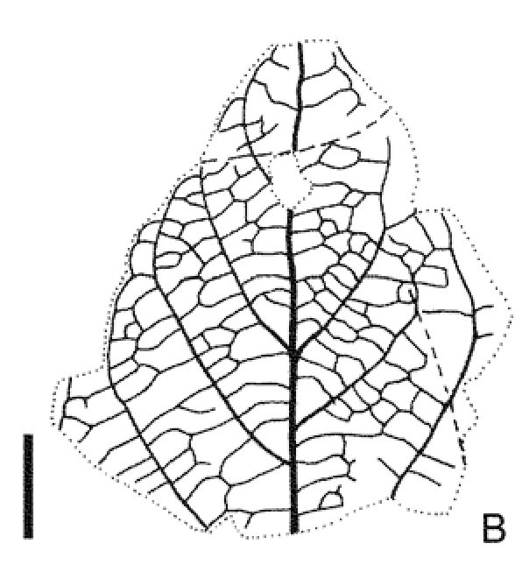
211
EOCENE FLORA FROM THE TATRA MOUNTAINS. POLAND
cluding Cryptocarya, Litsea, Lindera, and Neolitsea
(Kolakovskii 1958; Kvacek 1971). Acrodromous ve-
nation occurs in at least 11 genera of the family Lau-
raceae (Bannister et al. 2012).
ECOLOGY: Daphnogene represents a palaeotropical
element and was a component of mesophytic and
swamp vegetation.
OCCURRENCE: Leaves of Daphnogene are com-
mon in the fossil leaf assemblages of warm periods of
the Palaeogene and Neogene ofEurope (Mai 1995). In
the territory of Poland, they are reported from Eocene
and Miocene floras (Worobiec 2007).
Family Fagaceae Dumortier 1829
Genus Eotrigonobalanus Walther et Z. Kvacek 1989
Eotrigonobalanus furcinervis (Rossmassler) Walther
et Z. Kvacek ssp. furcinervis 1989
[cf. Eotrigonobalanus furcinervis (Rossmassler)
Walther et Z. Kvacek 1989]
(Text-figs 5B-D, 6A)
1840. Phyllites furcinervis Rossmassler, p. 33-34, pl. 6, fig.
25, pl. 7, figs 32-36.
1910. Carpinus grandis Unger; Kuźniar, p. 43
1989. Eotrigonobalanus furcinervis (Rossmassler); Walther
et Z. Kvacek ssp. furcinervis, p. 583, figs 3-5, pl. 33,
figs 1-6, pl. 38, fig. 3, pl. 39, fig. 1, pl. 40, figs 1-5,
pl. 41, figs 1-4, pl. 42, figs 1-4, pl. 43, figs 1-6.
MATERIAL: 7/2013 (A-III-61/17), 19/2013 (A-III-
61/6), 42/2013 (A-III-61/29), 2/2013 (cf. Eotrigono-
balanus furcinervis).

DESCRIPTION: Leaf fragments, up to 7.6 cm long and
2-4 cm wide, one specimen with obtuse leaf base.
Leaves both serrate and entire-margined, especially in
basal part. Secondary veins and their branches termi-
nate at tooth apex. Venation pinnate, primary vein
straight or bent, usually rather thick. Secondary vena-
tion mixed: craspedodromous in serrate part of leaves
and brochidodromous in entire-margined part. Up to 13
pairs of secondary veins are preserved. Secondaries
curved upward, at intervals of 0.4-0.6 cm. Secondary
veins form an angle of 50-70° with the primary vein.
REMARKS: Extinct member of the family Fagaceae.
Serrate leaves are typical of this subspecies. A leaf of
?Eotrigonobalanus furcinervis was earlier reported
from the Upper Eocene deposits of Chłabówka (Głazek
and Zastawniak 1999). Kuźniar (1910) also probably
reported it mistakenly as Dryandroides angustifolia ?
Unger and Quercus urophylla Unger. It was not possi-
ble to find Kuźniar’s (1910) taxonomic determinations
of specimens 2/2013, 7/2013, and 19/2013.
MODERN EQUIVALENTS: Fossil-taxon related to
recent members of the fagaceous genera Castanopsis.
Litocarpus and Trigonobalanus (Denk et al. 2012).
ECOLOGY: Eotrigonobalanus furcinervis represents
a palaeotropical element. This taxon was an important
component of the European Palaeogene mesophytic to
swamp forest vegetation (Mai 1995; Uhl et al. 2002;
Denk et al. 2012; Hennig and Kunzmann 2013).
OCCURRENCE: Eotrigonobalanus furcinervis is re-
ported from the Middle Eocene to Lower Miocene
deposits of Europe (Mai 1995; Uhl et al. 2002; Denk
et al. 2012; Hennig and Kunzmann 2013).

Text-fig. 6. Fossil plants from the Wiktor Kuźniar collection. A - Eotrigonobalanus furcinervis (Rossmassler) Walther et Z. Kvacek ssp. furcinervis 1989 (19/2013);
B - Dicotylophyllum cf. juglandoides (Rossmassler) Knobloch et Z. Kvacek 1996 (48/2013); C - sp. 5 (47/2013). Scale bar - 1 cm

212
GRZEGORZ WOROBIEC ET AL.
Dicotyledones incertae sedis
Genus Dicotylophyllum Saporta 1894
Dicotylophyllum cf. juglandoides (Rossmassler)
Knobloch et Z. Kvacek 1996
(Text-figs 5E, 6B)
? 1840. Phyllites juglandoides Rossmassler, p. 29-30, pl. 4,
fig. 16.
? 1996. Dicotylophyllum juglandoides (Rossmassler)
Knobloch et Z. Kvacek; Knobloch et al., p. 108-111,
figs 53a-e, 54a-c, 55a-c, pl. 14, figs 2-3, pl. 20, figs
1-4, pl. 21, figs 1-3.
MATERIAL: 48/2013 (A-III-61/18).
DESCRIPTION: Leaf fragment, about 5 cm long and
5 cm wide, entire-margined. Venation pinnate, pri-
mary vein straight, of moderate thickness. Secondary
venation brochidodromous. Secondaries curved up-
ward and interconnected in loops, distributed at inter-
vals of 0.7-1.2 cm. Secondary veins form an angle of
40-50° with the primary vein. Tertiary venation dis-
tinctly percurrent. About 5 tertiary veins occur per 1
cm of secondary vein length. Higher-order venation
reticulate.
REMARKS: The leaf shape and architecture of the leaf
venation are similar to those in the fossil-species Di-
cotylophyllum juglandoides (Rossmassler) Knobloch
et Z. Kvacek, a new combination erected on the basis
of the Eocene leaf material from the locality Stare
Sedlo in Czech Republic (Knobloch et al. 1996). It was
not possible to find Kuźniar’s (1910) taxonomic de-
termination of this specimen.
MODERN EQUIVALENTS: Rossmassler (1840)
compared discussed fossil with leaves of the Recent
genera Magnolia, Tetranthera, Persea and Visnea.
Dicotylophyllum sp. 1
(Text-fig. 7A)
1910. Eucaliptus oceanica Unger; Kuźniar, p. 48-49.
MATERIAL: 6/2013 (A-III-61/32), 11/2013 (A-III-
61/24).
DESCRIPTION: Leaffragments, (specimen 11/2013:
6.6 cm long and 1.2 cm wide), entire-margined. Ve-
nation pinnate, primary vein straight, thick. Secondary
veins curved upward.
REMARKS: The systematic position of these leaf fos-
sil fragments remains unknown due to the absence of
distinctive features and the poor state of preservation.
The second specimen of Dicotylophyllum sp. 1, found
in the collection of plant remains from Hruby Regiel
and labelled “Edocarpus eocenica Unger”, was not
mentioned in the paper of Kuźniar (1910).
Dicotylophyllum sp. 2
(Text-fig. 7B)
MATERIAL: 18/2013 (A-III-61/21).
DESCRIPTION: Fragment of large leaf, about 13 cm
long and 8 cm wide, entire-margined. Venation pin-
nate, primary vein straight, rather thick. Secondary
veins distributed at intervals of about 2.5 cm, forming
an angle of 40-50° with the primary vein.
REMARKS: The systematic position of this leaf fos-
sil fragment remains unknown due to the absence of
distinctive features and the poor state of preservation.
It was not possible to find Kuźniar’s (1910) taxo-
nomic determination of this specimen.
Dicotylophyllum sp. 3
(Text-fig. 7C)
MATERIAL: 27/2013 (A-III-61/25).
DESCRIPTION: Fragment of probably coriaceous
leaf, 5.2 cm long and 1.7 cm wide, entire-margined.
Venation pinnate, primary vein straight, moderate
thickness. Secondary venation brochidodromous. Sec-
ondary veins distributed at intervals of 0.7-1.1 cm.
forming an angle of about 40º with the primary vein.
REMARKS: The systematic position of this leaf fossil
fragment remains unknown due to the absence of dis-
tinctive features and the poor state of preservation. The
specimen, found in the collection of plant remains from
Hruby Regiel with the label “Quercus daena Heer”, was
not mentioned in the paper of Kuźniar (1910).
Dicotylophyllum sp. 4
(Text-fig. 7D)
1910. Populus mutabilis repando-crenata Heer; Kuźniar,
p. 44-45.
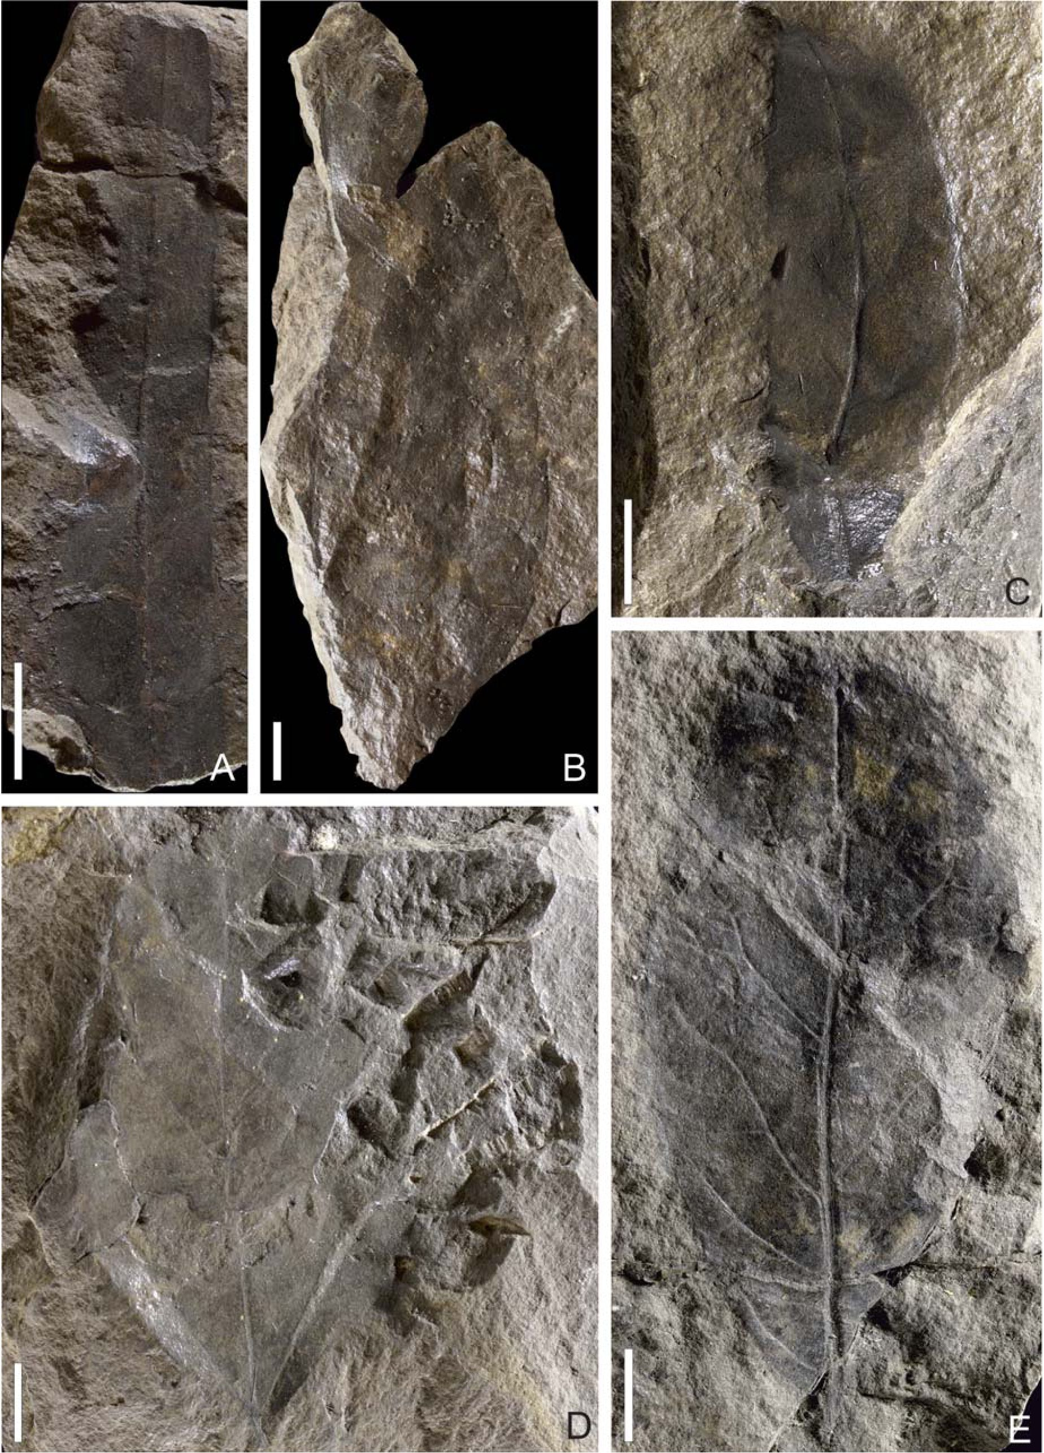
213
EOCENE FLORA FROM THE TATRA MOUNTAINS, POLAND

Text-fig. 7. Fossil plants from the Wiktor Kuźniar collection. A - Dicotylophyllum sp. 1 (11/2013); B - Dicotylophyllum sp. 2 (18/2013); C - Dicotylophyllum sp. 3
(27/2013); D - Dicotylophyllum sp. 4 (33/2013); E - Dicotylophyllum sp. 5 (47/2013). Scale bar - 1 cm
214
GRZEGORZ WOROBIEC ET AL.
MATERIAL: 33/2013 (A-III-61/30), 34/2013 (A-III-
61/14), 45/2013.
DESCRIPTION: Fragments of entire-margined leaves.
Preserved leaf base more or less obtuse. Venation im-
perfectly acrodromous. Secondary veins form an angle
of 50-60° with the midvein.
REMARKS: The systematic position of these leaf fos-
sil fragments remains unknown due to the absence of
distinctive features and the poor state of preservation.
It was not possible to find Kuzniar’s (1910) taxo-
nomic determination of specimens 34/2013 and
45/2013.
Dicotylophyllum sp. 5
(Text-figs 6C, 7E)
1910. Pyrus troglodytarum Unger; Kuźniar, p. 49.
MATERIAL: 47/2013 (A-III-61/31).
DESCRIPTION: Fragment of entire-margined leaf,
with obtuse leaf base. Venation pinnate, primary vein
thick. Secondary venation camptodromous. Second-
aries curved slightly upward and branched, distrib-
uted at intervals of0.9-1.6 cm. Secondary veins form
an angle of 40-55° with the primary vein.
REMARKS: The systematic position of this leaf
fossil fragment remains unknown due to the absence
of distinctive features and the poor state of preser-
vation.
Dicotylophyllum sp. 6
(Text-fig. 8A)
1910. Apocynophyllum lanceolatum Unger; Kuźniar, p. 47.
MATERIAL: 36/2013 (A-III-61/33).
DESCRIPTION: Large coriaceous leaf, 17 cm long
and 5 cm wide, entire-margined, margin revolute. Ve-
nation pinnate, secondary venation camptodromous.
Secondaries curved slightly upward, distributed at in-
tervals of about 1-2 cm. Secondary veins form an an-
gle of about 50º with the primary vein.
REMARKS: The systematic position of this leaf fos-
sil remains unknown due to the absence of distinctive
features and the poor state of preservation
Dicotyledones incertae sedis = Dicotyledones indet.
(Text-fig. 8B, C)
1910. Daphnogene melastomacea Unger; Kuźniar, pro parte,
p. 46 [only 30/2013],
1910. Ficus morloti Unger; Kuźniar, p. 44.
1910. Laurus lalages Unger; Kuźniar, pro parte, p. 45 [only
26/2013 and 28/2013],
MATERIAL: 5/2013, 17/2013 (A-III-61/26), 20/2013
(A-III-61/8), 21/2013, 22/2013, 24/2013, 25/2013 (A-
III-61/19), 26/2013 (A-III-61/28), 28/2013, 30/2013
(A-III-61/10), 31/2013 (A-III-61/9), 32/2013 (A-III-
61/13), 35/2013 (A-III-61/1), 40/2013 (A-III-61/7),
41/2013 (A-III-61/12), 43/2013 (A-III-61/11), 44/2013
(A-III-61/2).
REMARKS: The systematic position of these plant re-
mains is unknown. Specimen found in collection from
Hruby Regiel with the label “Quercus chlorophylla
Unger”, was not mentioned in Kuźniar (1910). It was
not possible to find Kuźniar’s (1910) taxonomic de-
termination ofspecimens 20/2013, 21/2013, 22/2013,
24/2013, 25/2013, 31/2013, and 32/2013.
Class: Liliopsida (Monocotyledons)
Family: Arecaceae Bercht. et Presl. 1820
Genus Nypa Steck 1757
Nypa burtini (Brongniart) Ettingshausen 1879
(Text-fig. 8E, F)
1828. Cocos burtini', Brongniart, p. 121.
1849. Nipadites burtini', Brongniart, p. 88.
1879. Nipa burtini Brongniart; Ettingshausen, p. 393.
1910. Nipadites burtini Brongniart; Kuźniar, p. 40-41.
MATERIAL: 15/2013 (A-III-61/34), 38/2013 (A-III-61/3).
DESCRIPTION: Two remains: impression and
strongly compressed cast of fruit. Cast: 12.5 cm long,
8 cm wide, obovoid, with traces of longitudinal ridges
and deformed umbo (about 2.3 cm in size). Impression:
about 10 cm long and 11 cm wide, suborbicular, sur-
face of impression with numerous impressions oflon-
gitudinal ridges.
REMARKS: The morphology of the remains, espe-
cially the obovoid shape and longitudinal ridges sug-
gest an affinity with the genus Nypa. Fossil carpolog-
ical remains comparable to Nypa, have been described
under the genera Burtinia, Castellinia, Fracastoria,
Nipa, Nipadites, and Nypa (Tralau 1964).
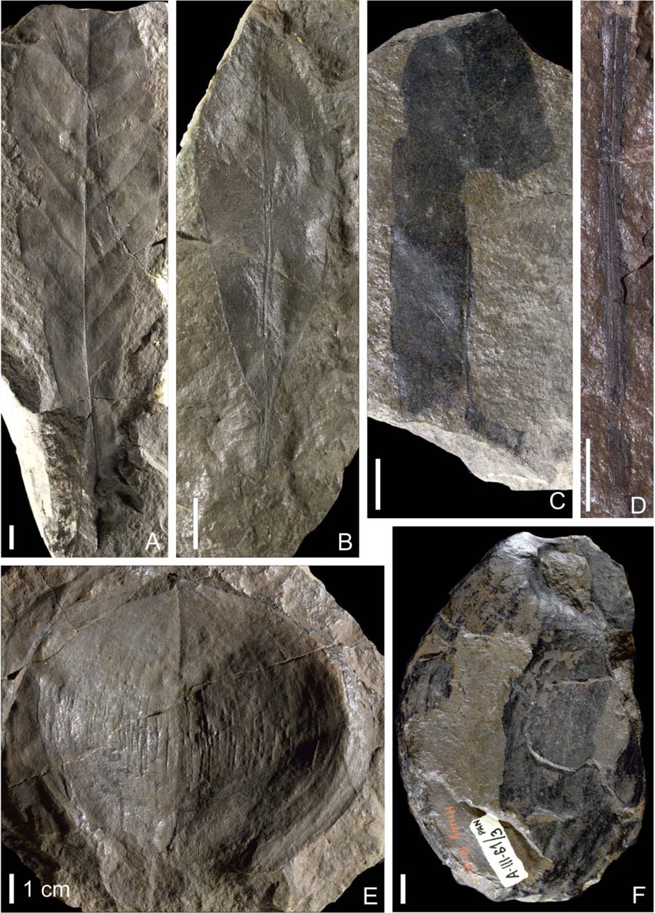
215
EOCENE FLORA FROM THE TATRA MOUNTAINS, POLAND

Text-fig. 8. Fossil plants from the Wiktor Kuźniar collection. A - Dicotylophyllum sp. 6 (36/2013); B, C - Dicotyledones incertae sedis = Dicotyledones indet. (B: 28/2013.
C: 30/2013); D - Incertae sedis (11/2013); E, F -Nypa burtini (Brongniart) Ettingshausen 1879 (E: fruit impression, 15/2013, F: fruit cast, 38/2013). Scale bar - 1 cm
216
GRZEGORZ WOROBIEC ET AL.
MODERN EQUIVALENTS: Today, Nypa is a mono-
typic genus, with the species N. fruticans Wurmb.,
which is restricted to the tropical coast of southeast
Asia and growing mostly in mangrove communities in
a tropical, frost-free climate (Krutzsch 1989). Nypa
burtini differs from the extant N. fruticans in seed
morphology and anatomy, which is discussed broadly
by El-Soughier et al. (2011).
ECOLOGY: Nypa represents a palaeotropical element.
This taxon was a component of mangrove vegetation
(Tsuji et al. 2011).
OCCURRENCE: Nypa is known from the beginning
of the Cretaceous. In Europe it was common in Eocene
floras (Belgium, France, Hungary, Poland, Spain,
Ukraine, United Kingdom) and disappeared in the lat-
est Eocene. Outside Europe, it was reported from the
Late Cretaceous to Palaeocene of South America
(Brazil, Colombia, Venezuela), the Eocene of North
America, the Late Cretaceous to Middle Eocene of
Africa (Cameroon, Egypt, Nigeria) and from the Late
Cretaceous to Recent in many localities in southeast
Asia and Australia (Krutzsch 1989; Gee 1990; Gray
1993; Gee 2001; Plaziat et al. 2001).
Incertae sedis
(Text-fig. 8D)
1910. Quercus sp.; Kuźniar, p. 43.
1910. Poacites sp.; Kuźniar, p. 40.
MATERIAL: 1/2013, 3/2013, 4/2013 (A-III-61/27 and
A-III-61/24), 4/2013, 9/2013, 12/2013 (A-III-61/20),
16/2013, 23/2013, 29/2013, 37/2013, 39/2013,
46/2013, 49/2013 (A-III-61/15), 50/2013 (A-III-
61/22).
REMARKS: Remains of uncertain origin. It was not
possible to find Kuźniar’s (1910) taxonomic determi-
nations of specimens 1/2013, 4/2013, 10/2013,
12/2013, 13/2013, 16/2013, 23/2013, 29/2013,
37/2013, 39/2013, 46/2013, 49/2013, 50/2013, and
14/2013.
TRACE FOSSILS
Three specimens from the studied collection ap-
peared to be trace fossils. Their original labels are
missing. Moreover, small cylindrical burrows co-occur
with leaves in a few specimens. The interpretation of
trace fossils as plants was common throughout the
19th century and continued by some researchers at the
beginning of 20th century (Baucon et al. 2012).
Ichnogenus Gyrolithes Saporta, 1884
IGyrolithes isp.
(Text-fig. 9A, B)
MATERIAL: 10/2013.
DESCRIPTION: Fragments of horizontal to subhori-
zontal, arcuate, endichnial cylinders, 10-12 mm wide,
elliptical in cross section, displaying a thin, knobby
wall. The knobs, seen from the interior, are small, cir-
cular depressions, 0.5-1 mm wide, located 1-2 mm
apart. Filling of the cylinders is the same as in the sur-
rounding rock. The cylinders occur on the lower and
upper surfaces and inside the specimen, which is a
small, 32 mm thick slab. Their arrangement suggests
a vertical, helical spiral pattern. The estimated whorl
radius of the spiral can range from 15 to 40 mm for in-
dividual arcs.
REMARKS: The helical, vertical spiral is typical of
Gyrolithes Saporta, 1884, however the fragmentary
preservation of the described specimen does not allow
its unequivocal determination. The knobby wall is
known from Gyrolithes marylandicus (Mansfield,
1927) and Gyrolithes nodosus Mayoral and Muniz,
1998, but the morphometric parameters (burrow
width, whorl radius) does not fit these ichnospecies
(see Uchman and Hanken 2013), being rather similar
to those of the smooth-walled G. saxonicus
(Hantzschel, 1934) or G. cycloides (Mikulas and Pek,
1994). Larger Gyrolithes are burrows produced by
crustaceans since the Permian (Uchman and Hanken
2013). Their monodominant ichnoassemblages are
typical of brackish, shallow-marine deposits (e.g.
Netto et al. 2007).
Ichnogenus Ophiomorpha Lundgren, 1891
Ophiomorpha isp.
(Text-fig. 9C)
MATERIAL: 13/2013.
DESCRIPTION: This trace fossil is preserved as a
fragment ofa horizontal to subhorizontal (toponomy of
the specimen is unclear), endichnial cylinder, 11-13
mm in diameter, 145 mm long, circular in cross section,
curved in a gentle arc. It displays a thin, knobby wall.

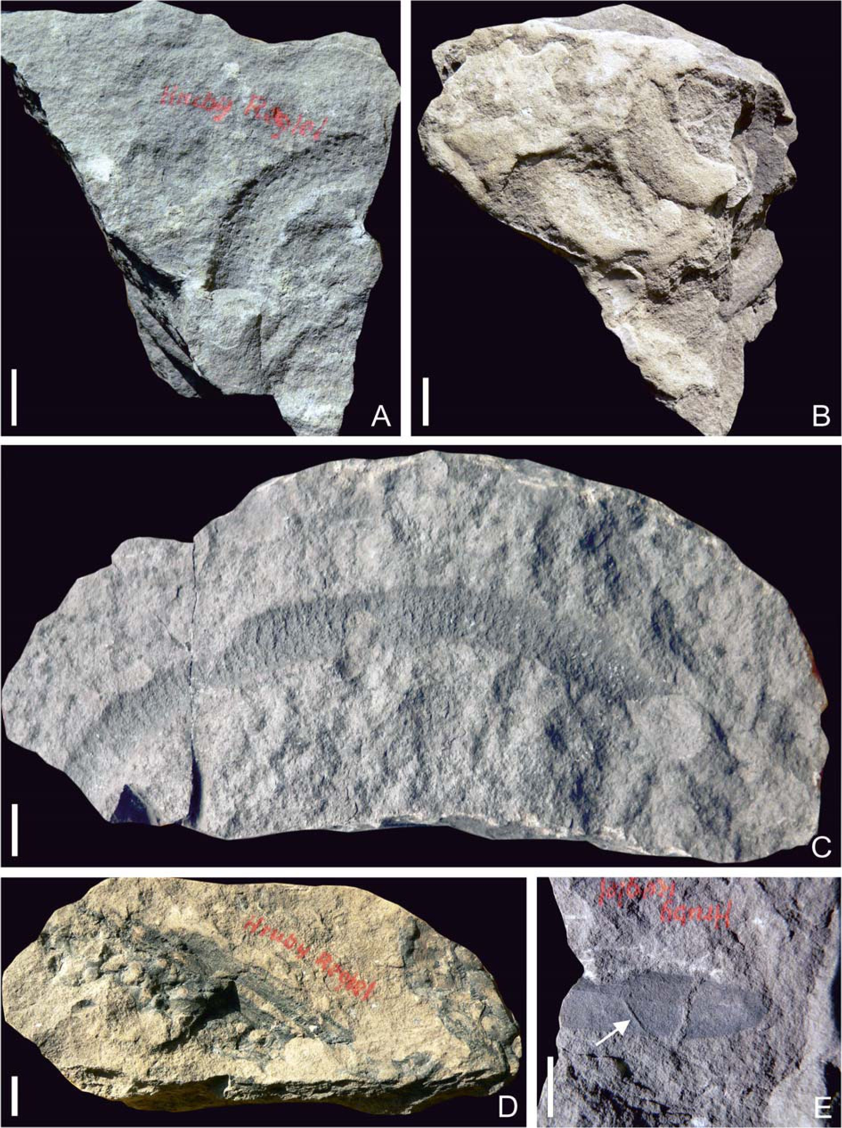
217
EOCENE FLORA FROM THE TATRA MOUNTAINS, POLAND

Text-fig. 9. Trace fossils. A, B - ?Gyrolithes isp. (10/2013), view from opposite surfaces; C - Ophiomorpha isp. (13/2013); D - Teredolites clavatus (14/2013); E - small
cylindrical burrows (arrow) (32/2013)
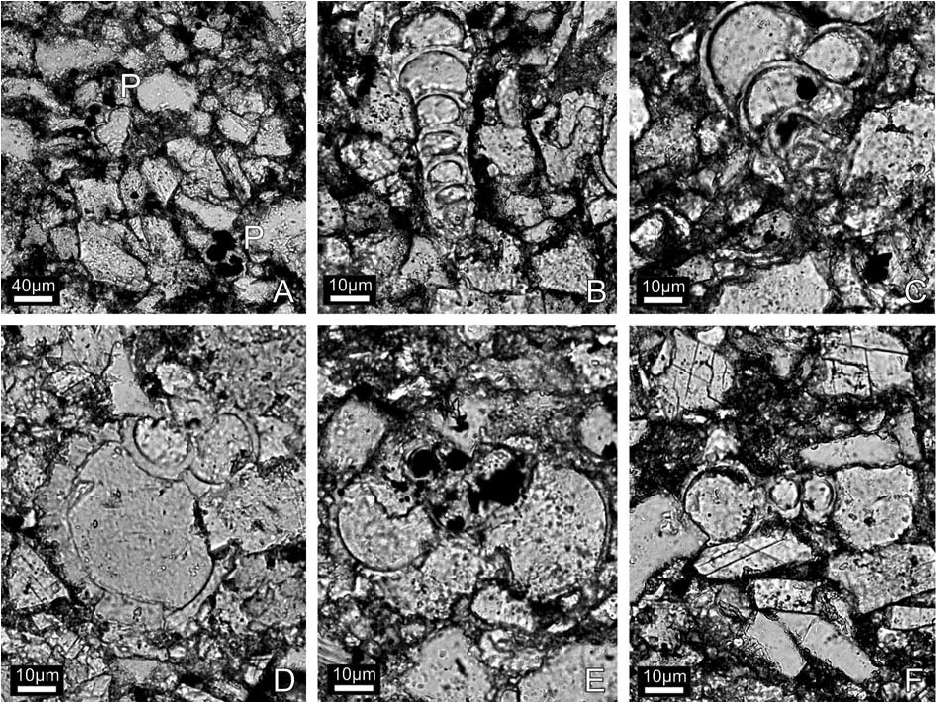
218
GRZEGORZ WOROBIEC ET AL.
The knobs, seen from the interior, are small, shallow, el-
liptical depressions, 2.5-3 mm long, 1-1.5 mm wide,
the longer axes being perpendicular to the course of the
cylinder. The knobs are arranged in rings. Filling of the
cylinder is the same as in the surrounding rock.
REMARKS: The knobs in the wall, interpreted as ag-
glutinated pellets, are typical of Ophiomorpha Lund-
gren, 1891. The perpendicular arrangement of the pel-
lets and the diameter of the burrow are similar to
Ophiomorpha annulata Ksi^zkiewicz, 1977 sensu
Howard and Frey (1984) and Frey and Howard (1985),
described from the Upper Cretaceous of the United
States. However, the type material of Ophiomorpha
annulata Ksi^zkiewicz, 1977 is different, showing
mostly straight, commonly smooth, branched cylinders
(Uchman 1995, 1998). Ophiomorpha is a crustacean,
mostly decapod burrow, of which the type ich-
nospecies O. nodosa Lundgren, 1891 occurs mostly in
shallow-marine sediments (Frey et al. 1978), while
Ophiomorpha annulata Ksi^zkiewicz, 1977 is typical
of fysch deposits (Uchman 1995, 1998).
Ichnogenus Teredolites Leymerie, 1842
Teredolites clavatus Leymerie, 1842
(Text-fig. 9D)
MATERIAL: 14/2013.
DESCRIPTION: Teredolites clavatus is visible as gre-
garious, tightly spaced clavate mounds in carbonized
woody substrate, 2-6 mm in diameter, circular to irreg-
ularly oval in outline, showing sharp boundaries. Their
length is difficult to estimate, because they are observed
in cross section and many mounds are truncated by the
specimen surface. They are perpendicular to oblique to
the grain ofthe woody substrate. Some individual mounds
are in contact with a mutual deformational adjustment.
REMARKS: Teredolites is a boring produced in woody
(xylic) substrates (e.g. Kelly and Bromley 1984) by bi-
valves (Roder 1977) worldwide in shallow- to deep-
marine environments (Kelly 1988). Recently, similar
borings are produced by Martesia and in the fossil
record by Martesia and Opertochasma. T. clavatus

Text-fig. 10. Characteristic planktonic foraminifera from the sample of the Wiktor Kuźniar collection (24/2013). A - abundant Chiloguembelina cf. gracillima (Andreae) (P);
B, C - Chiloguembelina cf. gracillima (Andreae); D - Globigerinatheka cf. index (Finlay); E, F - planktonic foraminifera
Original name in Ku£niar (1910) | Current name
Amygdalus pereger Unger | specimen or original label missing
Apocynophyllum lanceolatum Unger | Dicotylophyllum sp. 6
Carpinus grandis Unger | Eotrigonobalanus furcinervis (Rossmässler) Walther et Z. Kvacek ssp.  furcinervis
Daphnogene melastomacea Unger | cf. Daphnogene sp.
Daphnogene melastomacea Unger | Dicotyledones incertae sedis
Daphnogene paradisiaca Unger | specimen or original label missing
Dryandroides angustifolia Unger | specimen or original label missing
Eucaliptus oceanica Unger | Dicotylophyllum sp. 1
Ficus morloti Unger | Dicotyledones incertae sedis
Laurus lalages Unger | Dicotyledones incertae sedis
Nipadites burtini Brongniart | Nypa burtini (Brongniart) Ettingshausen
Poacites sp. | Incertae sedis
Podocarpus eocenica Unger | specimen or original label missing
Populus mutabilis repando-crenata Heer | Dicotylophyllum sp. 4
Pyrus troglodytarum Unger | Dicotylophyllum sp. 5
Quercus sp. | Incertae sedis
Quercus urophylla Unger | specimen or original label missing
Sapotacites sideroxyloides Ettingshausen | specimen or original label missing
Original name  Table 1. Taxonomic determinations of plant remains from the Hruby Regiel section in Kuźniar (1910) and present determinations | Current name
Edocarpus eocenica Unger | Dicotylophyllum sp. 1
Quercus chlorophylla Unger | Dicotyledones incertae sedis
Quercus daena Heer | Dicotylophyllum sp. 3
Table 2. Labelled specimens found in collection of plant remains from the Hruby Regiel section, not mentioned in Kuźniar (1910) and their current taxonomical
determinations
Current  number | Number used by Museum of the  Institute of Geological Sciences, PAS,  Kraków | Original name in Ku£niar (1910) | Current name
1/2013 |  |  | Incertae sedis
2/2013 |  |  | cf. Eotrigonobalanus furcinervis  (Rossmässler) Walther et Z. Kvacek
3/2013 |  | Quercus sp. | Incertae sedis
4/2013 | A-III-61/27 | Poacites sp. | Incertae sedis
4/2013 | A-III-61/24 |  | Incertae sedis
5/2013 |  |  | Dicotyledones incertae sedis
6/2013 | A-III-61/32 |  | Dicotylophyllum sp. 1
7/2013 | A-III-61/17 |  | Eotrigonobalanus furcinervis (Rossmässler)  Walther et Z. Kvaöek ssp. furcinervis
8/2013 | A-III-61/5 | Daphnogene melastomacea Unger | cf. Daphnogene sp.
9/2013 |  |  | Incertae sedis
10/2013 |  |  | ?Gyrolithes isp.
11/2013 | A-III-61/24 | Eucaliptus oceanica Unger | Dicotylophyllum sp. 1
12/2013 | A-III-61/20 |  | Incertae sedis
13/2013 |  |  | Ophiomorpha isp.
14/2013 |  |  | Teredolites clavatus
15/2013 | A-III-61/34 | Nipadites burtini Brongniart | Nypa burtini (Brongniart) Ettingshausen
16/2013 |  |  | Incertae sedis
17/2013 | A-III-61/26 |  | Dicotyledones incertae sedis
18/2013 | A-III-61/21 |  | Dicotylophyllum sp. 2
19/2013 | A-III-61/6 |  | Eotrigonobalanus furcinervis (Rossmässler)  Walther et Z. Kvaöek ssp. furcinervis
20/2013 | A-III-61/8 |  | Dicotyledones incertae sedis
21/2013 |  |  | Dicotyledones incertae sedis
22/2013 |  |  | Dicotyledones incertae sedis
23/2013 |  |  | Incertae sedis
24/2013 |  |  | Dicotyledones incertae sedis
25/2013 | A-III-61/19 |  | Dicotyledones incertae sedis
26/2013 | A-III-61/28 | Laurus lalages Unger | Dicotyledones incertae sedis
27/2013 | A-III-61/25 |  | Dicotylophyllum sp. 3
28/2013 |  | Laurus lalages Unger | Dicotyledones incertae sedis
29/2013 |  |  | Incertae sedis
30/2013 | A-III-61/10 | Daphnogene melastomacea Unger | Dicotyledones incertae sedis
31/2013 | A-III-61/9 |  | Dicotyledones incertae sedis
32/2013 | A-III-61/13 |  | Dicotyledones incertae sedis + trace fossil
33/2013 | A-III-61/30 | Populus mutabilis repando-crenata Heer | Dicotylophyllum sp. 4
34/2013 | A-III-61/14 |  | Dicotylophyllum sp. 4
35/2013 | A-III-61/1 | Ficus morloti Unger | Dicotyledones incertae sedis
36/2013 | A-III-61/33 | Apocynophyllum lanceolatum Unger | Dicotylophyllum sp. 6
37/2013 |  |  | Incertae sedis
38/2013 | A-III-61/3 | Nipadites burtini Brongniart | Nypa burtini (Brongniart) Ettingshausen
39/2013 |  |  | Incertae sedis
40/2013 | A-III-61/7 |  | Dicotyledones incertae sedis
41/2013 | A-III-61/12 |  | Dicotyledones incertae sedis
42/2013 | A-III-61/29 | Carpinus grandis Unger | Eotrigonobalanus furcinervis (Rossmässler)  Walther et Z. Kvacek ssp. furcinervis
43/2013 | A-III-61/11 |  | Dicotyledones incertae sedis
44/2013 | A-III-61/2 |  | Dicotyledones incertae sedis
45/2013 |  |  | Dicotylophyllum sp. 4
46/2013 |  |  | Incertae sedis
47/2013 | A-III-61/31 | Pyrus troglodytarum Unger | Dicotylophyllum sp. 5
48/2013 | A-III-61/18 |  | Dicotylophyllum cf. juglandoides  (Rossmässler) Knobloch et Z. Kvaäek
49/2013 | A-III-61/15 |  | Incertae sedis
50/2013 | A-III-61/22 |  | Incertae sedis

221
EOCENE FLORA FROM THE TATRA MOUNTAINS, POLAND
BIOSTRATIGRAPHIC POSITION OF PLANT-
BEARING DEPOSITS
The biostratigraphical determinations of the source of
the plant-bearing deposits are based on the flora and
foraminifera. Eotrigonobalanus furcinervis and Nypa
burtini are typical plants ofthe European Palaeogene; N.
burtini is restricted to the Eocene, disappearing by the end
ofthis epoch (Gee 1990, 2001), whereas E. furcinervis is
usually found in the Palaeogene, surviving in some lo-
calities until the Early Miocene (Denk et al. 2012).
The abundant planktonic foraminifera are domi-
nated by Chiloguembelina cf. gracillima (Andreae)
(Text-fig. 10A-C). This species indicates the standard
planktonic foraminifer zones P16/17-P18, dated as
latest Priabonian (Late Eocene) through to Rupelian
(Early Oligocene) (see Berggren et al. 1995). Simi-
larly, Samuel and Salaj (1968) noted Ch. gracillima in
the uppermost part of the Eocene in the Slovak
Carpathians. In addition, Olszewska (2009) reported
this species from the Priabonian nummulitic deposits
of the Tatra Mountains (localities Dolina Lejowa, Żleb
Jaroniec, Dolina za Bramką, Suchy Żleb).
The foraminiferal assemblage also contains abun-
dant, exclusively Late Eocene planktonic foraminifera,
such as Globigerinatheca cf. index (Finlay) (Text-fig.
10D), and small benthic taxa, such as Eponides cf.
poligonus of a Bartonian age and the Priabonian
Maslinella champani Glaessner et Wade (Loeblich and
Tappan 1988). The assemblage also includes rare,
poorly preserved larger benthic foraminifera but they do
not allow a precise dating of these deposits. However,
the youngest Nummulitidae from the Tatric Eocene
are dated as Priabonian (Bieda 1963; Machaniec et al.
2009; Jach and Machaniec 2014), more precisely to the
SBZ 19-20 zones (see Serra-Kiel 1997). The co-oc-
currence of some planktonic (Text-fig. 10 E, F) and
benthic forms of different ages suggests that the plant-
bearing deposits may contain some recycled material.
The co-occurrence of Chiloguembelina cf. gracil-
lima and other planktonic and benthic foraminifera
(with ranges exclusively up to the Late Eocene) to-
gether with well preserved Eocene leaves and fruits
limits the age of the plant-bearing deposits to the lat-
est Priabonian.
CHARACTERISTICS OF THE SEDIMENTARY
ORGANIC MATTER
The organic particles in two samples from the
plant-bearing deposits from the Hruby Regiel section
include no structured organic matter (SOM), i.e. paly-
nomorphs (plant sporomorphs, phytoplankton and
zoomorphs) or structured phytoclasts (cuticles, wood
tissues; Text-fig. 11 A, B). Instead, highly homoge-
neous opaque and translucent phytoclasts with an ad-
mixture of amorphous organic matter (AOM) particles
dominate. The AOM consists of both structureless
grey fragments (derived from phytoplankton or degra-
dation products of bacteria) and highly degraded plant
tissues. The opaque phytoclasts are usually more or
less equidimensional (O-Eq), angular, rarely roundish.
Some of them are slightly translucent. They represent
coalified or highly gelified structureless plant tissues
corresponding to the vitrinite or inertinite maceral
group. The sample dominated by coalified phytoclasts
also contains roundish particles, most probably repre-
senting pyrite framboids. The presence of pyrite fram-
boids was confirmed by means of the heavy liquid pa-
lynological procedure. After heavy liquid separation of
the palynological matter from the residue, the roundish
particles sank completely, confirming that they were
heavier than the palynological matter, which is typical
of pyrite. Pyrite framboids show a broad range of sizes
(from ~ 2 qm to 30 qm) with mean diameters exceed-
ing 5 qm. These framboid characters are typical of up-
per dysoxic depositional conditions (Wilkin et al.
1996; Bond et al. 2004; Zatoń et al. 2008) and indicate
a possible dysoxic sedimentary environment during the
deposition of the sediments of the Hruby Regiel sec-
tion but not necessarily on the sea floor, as suggested
by the absence of primary lamination and the occur-
rence of trace fossils. The absence of structured organic
matter (palynomorphs and structured phytoclasts)
could be due to a high rate of alteration of organic par-
ticles before and/or after burial in sediment. As a result,
the palynomorphs and structured phytoclasts were
highly degraded, homogenised and also coalified. This
is confirmed by the dominance of highly gelified or
coalified particles of plant origin.
PALAEOCLIMATIC CONSIDERATIONS BASED
ON THE PLANT REMAINS AND FORAMINIFERA
Generally, there are two approaches to palaeocli-
matic reconstructions using fossil leaf floras. The first
one is the Nearest Living Relative method (NLR),
based on an assumption that climatic tolerances of
living relatives are similar to those of the fossil taxa
(Mosbrugger and Utescher 1997). The quantitative
method using NLR is the coexistence approach (CoA)
as proposed by Mosbrugger and Utescher (1997). It
Table 3. The catalogue of plant taxa remains and trace fossils from the Hruby Regiel section
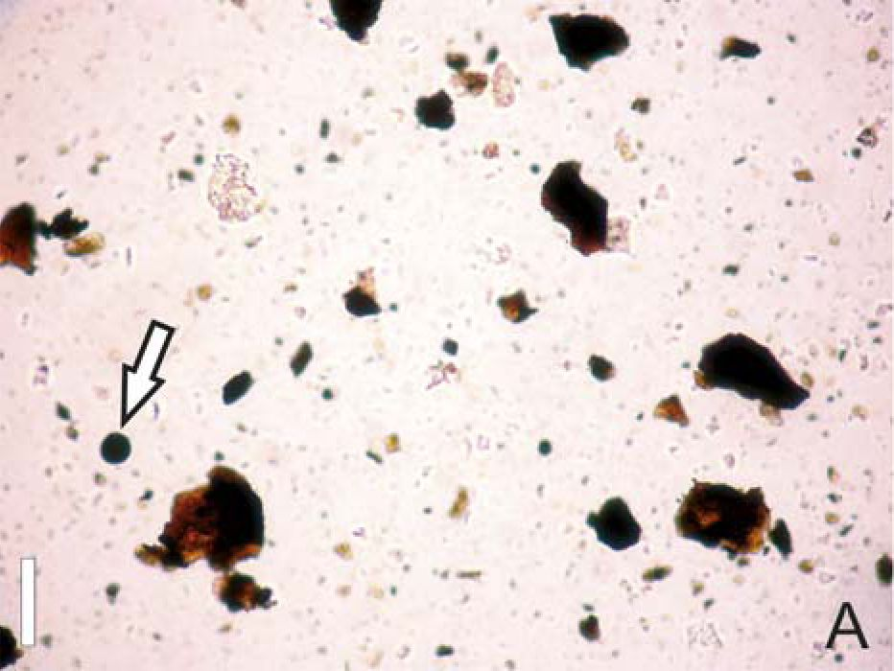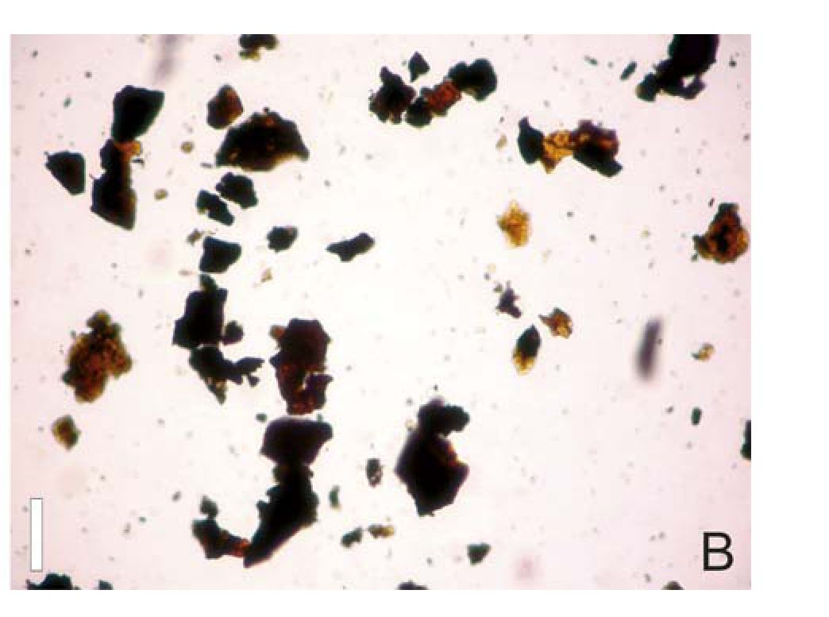
222
GRZEGORZ WOROBIEC ET AL.

Text-fig. 11. Sedimentary organic matter from Hruby Regiel. Palynofacies dominated by highly homogeneous opaque and translucent phytoclasts. A - sample pre-
pared without heavy liquid separation. Arrow indicates roundish pyrite fTamboid; B - sample prepared with heavy liquid separation. Visible concentrated SOM. Pyrite
framboids completely absent. Scale bar - 50 pm
can be reliably used only for very young fossil plant as-
semblages, not older than Palaeogene. The second ap-
proach is based on correlation between climate and leaf
physiognomy, i.e. the assumption that plant architec-
ture (morphology of leaves) is modified by environ-
mental conditions. Morphological characters used in
this method include leaf margin architecture, size and
shape of leaf, leaf thickness and the presence of spe-
cial features, e.g. the drip tips (Spicer 1990). There are
two methods for obtaining palaeoclimate proxies from
leafarchitecture: Leaf Margin Analysis (LMA) and the
Climate Leaf Analysis Multivariate Program
(CLAMP) using Canonical Correspondence Analysis
(Bailey and Sinnott 1915, 1916; Wolfe 1971, 1978,
1993; Wing and Greenwood 1993). Compared with the
NLR method, a palaeoclimatic approach based on leaf
architecture has no time constraint and can be ex-
tended down to the Cretaceous extinct genera. Unfor-
tunately, in the case of the leaf assemblage from the
Hruby Regiel section, due to the rather small number
of specimens (well below 100), a quantitative appli-
cation of both NRL and leaf physiognomy methods
(LMA + CLAMP) is not credible. Nonetheless, some
considerations based on both approaches can be drawn.
Although the systematic position of most of the
Eocene plant fossils from the Hruby Regiel section re-
mains unclear, the leaves of Eotrigonobalanus furcin-
ervis andDaphnogene sp. (Lauraceae) and the fruits of
Nypa burtini could be related to extant nearest rela-
tives. Eotrigonobalanus furcinervis is related to Recent
members of the family Fagaceae belonging to the gen-
era Castanopsis, Lithocarpus and Trigonobalanus
(Denk et al. 2012). All of these three genera are re-
stricted to areas of tropical to subtropical climate.
Daphnogene sp. shares morphological characters with
at least eleven genera of the Lauraceae with acrodro-
mous venation (Bannister et al. 2012). Like all mem-
bers of the Lauraceae, these genera prefer warm cli-
matic conditions. Nypa fruticans, a Recent relative of
Nypa burtini, grows mostly in a tropical frost-free cli-
mate in mangrove communities of southeast Asia
(Krutzsch 1989). It grows in areas with a warm and hu-
mid climate with a minimum temperature 20°C and
more than 1,000 mm annual rainfall evenly distributed
throughout the year (Lim 2012). N. fruticans is limited
to tropical sea coasts with water temperatures above
20°C (Fechner 1988; Akgun 2013).
Among foraminifers occurring in the plant-bearing
deposits the small, planktonic biserial forms of Chi-
loguembelina sp. predominate. Symbiont-bearing large
benthic foraminifera, represented mainly by Num-
mulitidae, also occur. Most of their tests show evidence
of damage. Large benthic foraminifera are limited to
shallow, clear, oligotrophic, warm waters, with tem-
peratures above 20°C in the photic zone (e.g. Ho-
henegger 2004). Planktonic chiloguembelinids re-
quired eutrophic water and are restricted to
near-coastal environments (D’haenens et al. 2012). In
the eutrophic waters of the depositional area, living
conditions for large benthic foraminifera were un-
favourable. In view of this and the damaged tests of the
Nummulitidae, it is possible that the large foraminifera
were redeposited from the shallower areas.
The occurrence of the fruits of Nypa in the deposits
suggests proximity to the shoreline. Extant N. fruticans
thrives only in brackish waters, rarely growing directly
on the seashore, and is usually found in estuarine tidal
floodplains (CABI 2014). It prefers fne-grained sub-

223
EOCENE FLORA FROM THE TATRA MOUNTAINS, POLAND
strates and avoids shores exposed to wave action and
hypersaline conditions (Badve and Sakurkar 2003; El-
lison et al. 2010; Lim 2012). The occurrence of Nypa.
which is limited to coastlines with water temperatures
above 20°C, suggests that the absence oflarge benthic
foraminifers is not conditioned by temperature. It is
probable that the increased supply of organic matter,
clay minerals (marls) and detrital grains by river(s)
were the main limiting factors. Consequently, it can be
concluded that during the latest Eocene in the area of
the Hruby Regiel section, a warm, subtropical to trop-
ical climate prevailed on the adjacent lands.
Irrespective of the rather limited number (50) of
specimens, some deductions in relation to the phys-
iognomy of the studied Eocene leaves can be drawn.
Almost all of the taxa, except for E. furcinervis, have
leaves with an entire, rarely revolute margin, often with
a coriaceous leaf blade. Some leaves are relatively
large. These physiognomic characters are typical of ex-
tant plants in a subtropical to tropical humid climate
(Bailey and Sinnott 1915; Wing and Greenwood 1993;
Wiemann et al. 1998; Royer et al. 2005).
In conclusion, the nearest living relatives and the
morphological characters of the studied fossil leaf taxa
point to a warm and humid climate in the Western
Carpathians during the latest Eocene.
PLANT PALAEOCOMMUNITIES
The Late Eocene in Europe is characterised by
transitional changes in vegetation associated with cli-
mate cooling. Late Palaeocene to Middle Eocene para-
tropical evergreen forest vegetation changed stepwise
to a broad-leaved, mixed, deciduous and evergreen for-
est in the Late Eocene, and then to a mixed mesophytic
forest in the Oligocene (Collinson and Hooker 2003).
The plant assemblage from the Hruby Regiel section
represents vegetation similar to the paratropical or
subtropical evergreen forests rather than to the broad-
leaved mixed deciduous forests. Eotrigonobalanus
furcinervis, Lauraceae, and numerous leaf remains of
entire-margined, coriaceous taxa are typical of parat-
ropical or subtropical evergreen forests. In the Late
Eocene of Central Europe, similar vegetation existed
in the Atlantic-Boreal, Western and Central Europe
Bioprovince (Mai 1995) and is represented by floras of
the Hordle-Zeitz Florenkomplex (floral assemblages
sensu Mai and Walther 1978). The plant assemblages
studied herein are most similar to those from the Stare
Sedlo Formation in the Czech Republic (Knobloch et
al. 1996; Kvacek and Walther 2003) and in the Weis-
selster Basin in Germany (Kunzmann and Walther
2002), which represent subtropical evergreen lauro-
phyllous rainforest of a Eotrigonobalanus-Quercus-
Lauraceae association dominated by members of the
Fagaceae, Lauraceae, Magnoliaceae, Altingiaceae,
Theaceae, Moraceae, Mastixiaceae, Myrsinaceae,
Myrtaceae, Olacaceae, Sapindaceae, Saururaceae,
Sterculiaceae and Symplocaceae (Mai 1995). De-
pending on the methods used, the mean annual tem-
perature estimated for Stare Sedlo ranges between 16
and 24°C (Uhl et al. 2007). Kvacek (2010) classified
this type of Eocene intrazonal vegetation as a broad-
leaved evergreen riparian gallery forest with palms.
The evergreen broad-leaved forests of southeast Asia
(Box et al. 1991) may be regarded as its Recent coun-
terpart. The Late Palaeocene and Eocene vegetation of
Europe is also characterised by mangroves, which in
the material studied are represented by fossil fruits of
Nypa burtini. In the European Eocene, thermophilic
and humid mangroves were associated with coastlines
(Collinson and Hooker 2003). Therefore, the deposits
studied accumulated in the proximity of the coast.
TAPHONOMY OF THE PLANT REMAINS
The plant macroremains are dispersed in fine-
grained deposits. The flora is allochthonous, as indi-
cated by the mixture of taxa characteristic of man-
grove and mesophytic vegetation. The usually good
state of preservation of leaves suggests a proximity to
the source vegetation. However, most of the leaves
are coriaceous. Therefore, they could survive some
transportation in a marine environment. The fruits of
Nypa could have been transported from more distant
coasts.
CONCLUSIONS
The Kuźniar collection of macroflora from the
Hruby Regiel section comprises 50 specimens of plant
remains (mainly leaves, but also fruits of Nypa and
some undetermined remains of plant bodies) and a
few trace fossils. Both the flora and the foraminiferal
assemblages are dated as latest Eocene. The plant as-
semblage represents paratropical or subtropical ever-
green forests in a warm and humid subtropical climate.
The occurrence of plants typical of mangroves is in-
dicative of proximity to a shoreline.
Sedimentary organic particles from the Hruby
Regiel section do not include any structured organic
matter (SOM) such as palynomorphs and structured
phytoclasts. A single sample dominated by coalified
224
GRZEGORZ WOROBIEC ET AL.
phytoclasts also contains pyrite framboids showing
characters indicating a possible dysoxic sedimentary
environment during deposition of the sediments of
the Hruby Regiel section but not necessarily on the sea
floor, as suggested by the absence of primary lamina-
tion and the occurrence of trace fossils.

Acknowledgements
We are grateful to Barbara Kietlińska-Michalik (Mu-
seum ofthe Institute of Geological Sciences, Polish Academy
of Sciences, Kraków), who found several specimens from the
collection that were dispersed in the storage room. She also
organized new cataloguing of the specimens. The research
was supported by the Ministry of Sciences and Higher Edu-
cation 0529/B/P01/2007/33. Additional support was pro-
vided by the Jagiellonian University (DS funds). Investiga-
tions on plant remains were financed by the W. Szafer
Institute of Botany, Polish Academy of Sciences in Kraków
through its statutory funds. The authorities of the Polish Tatra
National Park (TPN, Zakopane) provided permission for the
fieldwork, for which the authors are very grateful. Vlasta
Ćosović (University of Zagreb, Croatia) and Ewa Malata
(Jagiellonian University, Kraków) are thanked for construc-
tive comments. The manuscript was greatly improved with
the help of comments made by Professor Ewa Zastawniak-
Birkenmajer and an anonymous reviewer.
REFERENCES
Akgun, F., Akkiraz, M.S., Uębaę, S.D. Bozcu, M., Kapan
Yeęilyurt, S. and Bozcu, A. 2013. Oligocene vegetation
and climate characteristics in north-west Turkey: data
from the south western part of the Thrace Basin. Turk-
ish Journal of Earth Sciences, 22, 277-303.
APG III [Bremer, B., Bremer, K., Chase, M.W., Fay, M.F..
Reveal, J.L., Soltis, D.E., Soltis, P.S. and Stevens, P.F.
(comp.)]. 2009. An update of the Angiosperm Phylogeny
Group classification for the orders and families of flow-
ering plants: APG III. Botanical Journal ofthe Linnean
Society of London, 161, 105-121.
Bac-Moszaszwili, M., Burchart, J., Głazek, J., Iwanow, A..
Jaroszewski, W., Kotański, Z., Lefeld, J., Mastella, L..
Ozimkowski, W., Roniewicz, P., Skupiński, A. and West-
walewicz-Mogilska, E. 1979. Geological Map of the
Polish Tatra Mountains 1:30 000. Wydawnictwa Geo-
logiczne; Warszawa.
Badve, R.M. and Sakurkar, C.V. 2003. On the disappearance
of palm genus Nypa from the west coast with its present
status in the Indian subcontinent. Current Science, 85.
1407-1409.
Bailey, I.W. and Sinnott, E.W. 1915. A botanical index of
Cretaceous and Tertiary climates. Science, 41, 831-834.
Bailey, I.W. and Sinnott, E.W. 1916. The climatic distribu-
tion of certain types of angiosperm leaves. American
Journal of Botany, 3, 24-39.
Bannister, J.M., Conran, J.G. and Lee, D.E. 2012. Lauraceae
from rainforest surrounding an early Miocene maar lake.
Otago, southern New Zealand. Review of Palaeobotany
and Palynology, 178, 13-34.
Bartholdy, J., Bellas, S.M., Cosovic, V., Premec Fucek, V.
and Keupp, H. 1999. Process controlling Eocene mid-lat-
itude larger foraminifera accumulations: modelling of the
stratigraphic architecture of a fore-arc basin (Podhale
Basin, Poland). Geologica Carpathica, 50, 435-448.
Bartholdy, J., Bellas, S.M., Mertmann, D., Machaniec, E. and
Manutsoglu, E. 1995. Fazies-Entwicklung und Bios-
tratigraphie einer Sequenz eozäner Sedimente im Stein-
bruch Pod Capkami, Tatra Gebirge, Polen. Berliner Ge-
owissenschaften Abhandlungen, 16, 409-425.
Batten, D.J. 1996. Palynofacies and palaeoenvironmental in-
terpretation. In: J. Jansonius and D.C. McGregor (Eds).
Palynology: principles and applications. American As-
sociation of Stratigraphic Palynologists Foundation,
Dallas, 3, 1011-1064.
Baucon, A., Bordy, E., Brustur, T., Buatois, L.A., Cunning-
ham, T., De, C., Duffin, C., Falletti, F., Gaillard, C., Hy.
- , Hu, L., Jensen, S., Knaust, D., Lockley, M., Lowe, P..
Mayor, A., Mayoral, E., Mikuläs, R., Muttoni, G., Neto
de Carvalho, C., Pemberton, G.S., Pollard, J., Rindsberg,
A.K., Santos, A., Seike, K., Song, H., Turner, S., Uch-
man, A., Wang, Y., Gong, Y., Zhang, L. and Zhang, W.
2012. A history of ideas in ichnology. In: R.G. Bromley
and D. Knaust (Eds), Trace Fossils as Indicators of Sed-
imentary Environments. Developments in Sedimentol-
ogy, 64, 3-43.
Bqkowski, Z. 1967. Phoenix Szaferi sp. nov. from the Pod-
hale Region and an outline of the history of the genus
Phoenix L. Prace Muzeum Ziemi, 10, 169-213.
Berggren, W.A., Kent, D.V., Swisher C.C.III and Aubry.
M.-P. 1995. A revised Cenozoic geochronology and
chronostratigraphy. In: W.A. Berggren, D.V. Kent, M.-
P. Aubry, and J. Hardenbol (Eds), Geochronology, Time
Scales and Global Stratigraphic Correlation. Society of
Economic Paleontologists and Mineralogist Special
Publications, 54, 129-212.
Bieda, F. 1963. Larger foraminifers of the Tatra Eocene.
Prace Instytutu Geologicznego, 37, 3-215. [In Polish
with English summary]
Bond, D., Wignall, P.B. and Racki, G. 2004. Extent and du-
ration of marine anoxia during the Frasnian-Famennian
(Late Devonian) mass extinction in Poland, Germany,
Austria and France. Geological Magazine, 141, 173-
193.
225
EOCENE FLORA FROM THE TATRA MOUNTAINS, POLAND
Boulter, M.C., Spicer, R.A. and Thomas, B.A. 1988. Patterns
of plant extinction from some palaeobotanical evidence.
In: G.P. Larwood (Ed.), Extinction and survival in the
fossil record. Systematics Association Special Volume.
34, 1-36.
Box, E.O., Song, Y C., Miyawaki, A. and Fujiwara, K. 1991.
An evergreen broad-leaved forest in transitional eastern
China. Bulletin of the Institute of Environmental Science
and Technology, Yokohama National University, 17, 63-84.
Brongniart, A.T. 1828. Prodrome d’une histoire des végétaux
fossils, pp. 1-121. F.G. Levrault; Paris.
Brongniart, A.T. 1849. Tableau des genres de végétaux fos-
siles considérés sous le point de vue de leur classifica-
tion botanique et de leur distribution géologique, pp. 127.
L. Martinet; Paris.
CABI, 2014. Nypa fruticans (nipa palm). In: Invasive
Species Compendium. Wallingford, UK: CAB Interna-
tional. <www.cabi.org/isc>. Downloaded on 4 June
2014.
Collinson, M.E. and Hooker, J.J. 2003. Paleogene vegetation
of Eurasia: framework for mammalian faunas. Deinsea,
10, 41-83.
Dąbrowska, M. and Jurewicz, E. 2013. Character and struc-
tural evolution of the Mała Łąka Fault in the Tatra Mts..
Carpathians, Poland. Acta Geologica Polonica, 63, 137-
151.
Denk, T., Grimsson, F. and Zetter, R. 2012. Fagaceae from
the early Oligocene of Central Europe: persisting new
world and emerging old world biogeographic links. Re-
view of Palaeobotany and Palynology, 169, 7-20.
D’haenens, S., Bornemann, A., Roose, K., Claeys, P., and
Speijer, R.P. 2012. Stable isotope paleoecology (S¹³C and
S¹⁸O) of early Eocene Zeauvigerina aegyptiaca from
the North Atlantic (DSDP Site 401). Journal of Austrian
Earth Sciences, 105, 179-188.
Ellis, B., Daly, D.C., Hickey, L.J., Johnson, K.R., Mitchell.
J.D., Wilf, P. and Wing, S.L. 2009. Manual of Leaf Ar-
chitecture, pp. 1-190. Cornell University Press, The
New York Botanical Garden Press.
Ellison, J., Koedam, N.E., Wang, Y., Primavera, J., Jin Eong.
O., Wan-Hong Yong, J. and Ngoc Nam, V. 2010. Nypa
fruticans. In: IUCN 2014. IUCN Red List of Threatened
Species. Version 2014.1. <www.iucnredlist.org>. Down-
loaded on 16 June 2014.
El-Soughier, M.I., Mehrotra, R.C., Zhou, Z.Y. and Shi, G.L.
2011. Nypa fruits and seeds from the Maastrichtian-
Danian sediments of Bir Abu Minqar, South Western
Desert, Egypt. Palaeoworld, 20, 75-83.
Ettingshausen, C. 1879. Report on phyto-palaeontological in-
vestigations of the fossil flora of Sheppey. Proceedings
of the Royal Society of London, 29, 388-396.
Fechner, G.G. 1988. Selected palynomorphs from the Lower
to Middle Eocene of the South Atlas border zone (Mo-
rocco) and their environmental significance. Palaeo-
geography, Palaeoclimatology, Palaeoecology, 65, 73-79.
Frey, R.W. and Howard, J.D. 1985. Trace fossils from the
Panther Member, Star Point Formation (Upper Creta-
ceous), Coal Creek Canyon, Utah. Journal of Paleon-
tology, 59, 370-404.
Frey, R.W., Howard, J.D. and Pryor, W.A. 1978. Ophiomor-
pha: its morphologic, taxonomic, and environmental
significance. Palaeogeography, Palaeoclimatology,
Palaeoecology, 23, 199-223.
Gee, C.T. 1990. On the fossil occurrence of the mangrove
palm Nypa. In: E. Knobloch and Z. Kvacek (Eds), Pro-
ceedings of the Symposium on Paleofloristic and Pale-
oclimatic Changes in the Cretaceous and Tertiary.
Prague, August 28th - September 1st, 1989, pp. 315-
319. Geological Survey; Prague.
Gee, C. 2001. The mangrove palm Nypa in the geologic past
of the New World. Wetlands Ecology and Management,
9, 181-203.
Głazek, J. and Zastawniak, E. 1999. Terrestrial plant fossils
in the transgressive Paleogene littoral/flysch sequence of
the Tatra Mountains (Central Carpathians). In: L. Stuch-
lik (Ed.), Proceedings of the 5th EPPC. Acta Palaeob-
otanica, Supplement, 2, 293-301.
Grabowska, I. 1996a. Flora sporowo-pyłkowa. In: L. Mali-
nowska and M. Piwocki (Eds), Budowa geologiczna
Polski 3. Atlas skamieniałości przewodnich i charak-
terystycznych 3a. Kenozoik, trzeciorzęd, paleogen, pp.
395-431. Polska Agencja Ekologiczna; Warszawa.
Grabowska, I. 1996b. Flora liściowa i owocowa. In: L. Ma-
linowska and M. Piwocki (Eds), Budowa geologiczna
Polski 3. Atlas skamieniałości przewodnich i charak-
terystycznych 3a. Kenozoik, trzeciorzęd, paleogen, pp.
432. Polska Agencja Ekologiczna; Warszawa.
Gray, V.R. 1993. Origen y rutas de dispersión de los mangles:
una revisión con enfasis en las especies de America. Acta
Botanica Mexicana, 25, 1-13.
Guzik, K., Guzik, S. and Sokołowski, S. 1958. Mapa geo-
logiczna Tatr Polskich 1:10 000, arkusz Hruby Regiel
A2. Wydawnictwa Geologiczne; Warszawa.
Häntzschel, W. 1934. Schraubenförmige und spiralige
Grabgänge in turonen Sandsteinen des Zittauer Gebirges.
Senckenbergiana, 16, 313-324.
Hennig, D. and Kunzmann, L. 2013. Taphonomy and vege-
tational analysis of a late Eocene flora from Schleenhain
(Saxony, Germany). Geologia Saxonica, 59, 75-87.
Hohenegger, J. 2004. Depth coenoclines and environmental
considerations of Western Pacific larger foraminifera.
Journal of Foraminiferal Research, 34, 9-33.
Howard, J.D. and Frey, R.W. 1984. Characteristic trace fos-
sils in nearshore to offshore sequences, Upper Creta-
ceous of east-central Utah. Canadian Journal of Earth
Sciences, 21, 200-219.
226
GRZEGORZ WOROBIEC ETAL.
Jach, R., Machaniec, E. and Gradziński, M. 2009. Eocene
transgressive deposits in the Polish Tatra Mountains:
preliminary results. In: V. Pascucci and S. Andreucci
(Eds), 27th IAS Meeting, 20-23 September 2009 Al-
ghero, Italy, p. 218. Editrice Democratica Sarda; Al-
ghero.
Jach, R., Machaniec, E. and Uchman, A. 2012 (for 2011).
The trace fossil Nummipera eocenica from the Eocene
nummulitic limestones, Tatra Mts., Poland: morphol-
ogy and palaeoenvironmental implications. Lethaia, 4S,
342-355.
Jach, R. and Machaniec, E., 2014. Skały eocenu. In: R.
Jach, T. Rychliński, and A. Uchman (Eds), Sedimentary
Rocks of the Tatra Mountains, pp. 232-244. Tatrzański
Park Narodowy - Wydawnictwa; Zakopane.
Kelly, S.R.A. 1988. Cretaceous wood-boring bivalves from
western Antarctica with a review of the Mesozoic Pho-
ladidae. Palaeontology, 31, 341-372.
Kelly, S.R.A. and Bromley, R.G. 1984. Ichnological nomen-
clature of clavate borings. Palaeontology, 27, 739-807.
Knobloch, E., Konzalovâ, M. and Kvacek, Z. 1996. Die
obereozäne Flora der Staré Sedlo-Schichtenfolge in Böh-
men (Mitteleuropa). Rozpravy Ceskeho Geologickeho
Üstavu, 49, 1-260.
Kolakovskii, A.A. 1958. The first addition to the Pliocene
flora of Duab. Trudy Sukhumskogo Botanicheskogo
Sada, 11, 311-397. [In Russian with English summary]
Kosmowska-Ceranowicz, B. 1996. Flora bursztynu. In: L.
Malinowska and M. Piwocki (Eds), Budowa geolog-
iczna Polski 3. Atlas skamieniałości przewodnich i
charakterystycznych 3a. Kenozoik, trzeciorzęd, pale-
ogen, pp. 433-435.
Krutzsch, W. 1989. Paleogeography and historical phyto-
geography (paleochorology) in the Neophyticum. Plant
systematics and evolution, 162, 5-61.
Kulka, A. 1985. Arni sedimentological model in the Tatra
Eocene. Kwartalnik Geologiczny, 29, 31-64.
Kunzmann, L. and Walther, H. 2002. Eine obereozäne Blät-
terflora aus dem mitteldeutschen Weißelster-Becken.
Paläontologische Zeitschrift, 76, 261-282.
Kuźniar, W. 1910. Eocen Tatr i Podhala. I. Sprawozdania
Komisyi Fizyograficznej, Akademia Umiejętności, 44,
26-76.
Kvacek, Z. 1971. Fossil Lauraceae in the stratigraphy of the
North-Bohemian Tertiary. Sbornik geologickych véd,
Paleontologie, 13, 47-86.
Kvacek, Z. 2010. Forest flora and vegetation of the European
early Palaeogene - a review. Bulletin of Geosciences, SS,
3-16.
Kvacek, Z. and Knobloch, E. 1967. Zur Nomenklatur der
Gattung Daphnogene Ung. und die neue Art Daphno-
genepannonica sp. n. Véstnik Üstfedniho Üstavu Geo-
logického 41, 291-294.
Kvacek, Z. and Walther, H. 1989. Revision der mitteleu-
ropäischen tertiären Fagaceen nach blattepidermalen
Charakteristiken III. Teil: Dryophyllum Debey ex
Saporta und Eotrigonobalanus Walther & Kvacek gen.
nov. Feddes Repertorium, 100, 575-601.
Kvacek, Z. and Walther, H. 2003. Reconstruction of vege-
tation and landscape development during the volcanic ac-
tivity in the Ceske stredohori Mountains. Geolines, Hi-
bsch Special Volume, 15, 60-64.
Lim, T.K. 2012. Nypa fruticans. In: Edible Medicinal and
Non-Medicinal Plants. Vol. 1. Fruits, pp. 402-406.
Springer; Netherlands.
Loeblich, A.R. and Tappan, H. 1988. Foraminiferal Genera
and their Classification, pp. 1-970. Van Nostrand Rein-
hold Company; New York.
Ludwiniak, M. 2010. Multi-stage development of the joint
network in the flysch rocks of western Podhale (Inner
Western Carpathians, Poland). Acta Geologica Polonica,
60, 283-316.
Machaniec, E., Jach, R., Gradziński, M., Roniewicz, P. and
Uchman, A. 2009. Eocen tatrzański. In: A. Uchman and
J. Chowaniec (Eds), LXXIX Zjazd Naukowy Polskiego
Towarzystwa Geologicznego, Bukowina Tatrzańska, 27-
30 września 2009 r., pp. 159-168. Materiały konferen-
cyjne. Państwowy Instytut Geologiczny; Warszawa. [In
Polish]
Machaniec, E., Jach, R. and Gradziński, M. 2011. Morpho-
type variation of orthophragminids as a paleoecological
indicator: A case study ofLate Bartonian limestone, Pod
Capkami Quarry, Tatra Mts, Poland. Annales Societatis
Geologorum Poloniae, 81, 199-205.
Mai, D.H., 1976. Fossile Früchte und Samen aus dem Mit-
teleozän des Geiseltales. Abhandlungen des Zentralen
Geologischen Instituts, 26, 93-149.
Mai, D.H. 1995. Tertiäre Vegetationsgeschichte Europas,
pp. 1-691. Gustav Fischer Verlag; Jena, Stuttgart, New
York.
Mai, D.H. and Walther, H. 1978. Die Floren der Hasel-
bacher Serie im Weißelster-Becken (Bezirk Leipzig)
DDR. Abhandlungen des Staatlichen Museums für Min-
eralogie und Geologie zu Dresden 28, 1-200.
Mai, D.H. and Walther, H. 2000. Die Fundstellen eozaner
Floren des Weisselster-Beckens und seiner Randgebiete.
Altenburger Naturwissenschaftliche Forschungen, 13, 1-
59.
Mansfield, C. 1927. Some peculiar fossils from Maryland.
Proceedings of the United States National Museum, 71,
1-9.
Mayoral, E. and Muniz, F. 1998. Nuevos datos icnotaxo-
nomicos sobre Gyrolithes del Plioceno inferior de la
Cuenca del Guadalquivir (Lepe, Huelva, Espana). Re-
vista Espanola de Paleontologia, 13, 61-69.
Mikulas, R. and Pek, I. 1994. Spirocircus cycloides, a new ich-
227
EOCENE FLORA FROM THE TATRA MOUNTAINS, POLAND
nofossil from the Upper Cretaceous in northern Moravia.
Vestnik Ceskeho Geologickeo Ustavu, 69, 75-77.
Moore, P.D., Webb, J.A. and Collinson, M.E. 1991. Pollen
Analysis, 216 pp. Blackwell; Oxford.
Mosbrugger, V. and Utescher, T. 1997. The coexistence ap-
proach - a method for quantitative reconstructions of Ter-
tiary terrestrial palaeoclimate data using plant fossils.
Palaeogeography, Palaeoclimatology, Palaeoecology,
134, 61-86.
Netto, R.G., Buatois, L.A., Mangano, M.G. and Balisteri, P.
2007. Gyrolithes as a multipurpose burrow: an ethologi-
cal approach. Revista Brasileira de Paleontologia, 10,
157-168.
Olszewska, B. 2009. Small foraminifera of “Nummulitic
Eocene” of the Tatra Mts. - stratigraphical aspect and pa-
leoenvironment. Przegląd Geologiczny, 57, 703-713. [In
Polish with English summary]
Olszewska, B.W. and Wieczorek, J. 1998. The Paleogene of
the Podhale Basin (Polish Inner Carpathians) - micropa-
leontological perspective. Przegląd Geologiczny, 46, 721-
728.
Passendorfer, E. 1983. Jak powstały Tatry, pp. 1-286.
Wydawnictwo Geologiczne; Warszawa.
Plaziat, J. C., Cavagnetto, C., Koeniguer, J. C. and Baltzer, F.
2001. History and biogeography ofthe mangrove ecosys-
tem, based on a critical reassessment of the paleontolog-
ical record. Wetlands Ecology and Management, 9, 161-
180.
Prothero, D.R. 1994. The late Eocene-Oligocene extinctions.
Annual Review of Earth and Planetary Sciences, 22, 145-
165.
Raciborski, M. 1892. Zapiski paleobotaniczne. Paleoceńska
flora w Tatrach. Kosmos, 17, 526-533.
Radomski, A. 1959. Podhale flysch sedimentation. Biuletyn In-
stytutu Geologicznego, 149, 251-257. [In Polish with
English summary]
Radwański, A. 2009. ‘Phoenix szaferi’ (palm fruitbodies)
reinterpreted as traces of wood-boring teredinid bivalves
from the Lower Oligocene (Rupelian) of the Tatra Moun-
tains, Poland. Acta Palaeobotanica, 49, 279-286.
Reveal, J.L. 1996. Newly required suprageneric names in
vascular plants. Phytologia, 79, 68-76.
Röder, H. 1977. Zur Beziehung zwischen Konstruktion und
Substrat bei mechanisch bohrenden Bohrmuscheln (Pho-
ladidae, Terenidae). Senckenbergiana Maritima, 9, 105-
213.
Roniewicz, P. 1969. Sedimentation of the Nummulite Eocene
in the Tatra. Acta Geologica Polonica, 19, 503-608.
Rossmässler, E.A. 1840. Die Versteinerungen des
Braunkohlensandsteins aus der Gegend von Altsattel in
Böhmen (Elnbogener Kreises), pp. 42. Dresden &
Leipzig.
Royer, D.L., Wilf, P., Janesko, D.A., Kowalski, E.A. and
Dilcher, D.L. 2005. Correlations of climate and plant
ecology to leaf size and shape: potential proxies for the
fossil record. American Journal of Botany, 92, 1141-
1151.
Samuel, O. and Salaj, J. 1968. Micro stratigraphy and
Foraminifera of the Slovak Carpathian Paleogene, pp. 1-
332. Geologicky ustav Dionyza Stura; Bratislava.
Sepkoski Jr, J.J. 1996. Patterns of Phanerozoic extinction: a
perspective from global data bases. In: O.H. Walliser
(Ed.), Global Events and Event Stratigraphy in the
Phanerozoic, pp. 35-51. Springer-Verlag; Berlin-Heidel-
berg.
Serra-Kiel, J., Hottinger, L., Caus, E., Drobne, K., Ferrandez.
- , Kumar Jauhri, A., Less, G., Pavlovec, R., Pignatti, J..
Samso, J. M., Schaub, H., Sire, E., Strougo, A., Tam-
bareau, Y., Tosquella, Y. and Zakrevskaya, E. 1998. Larger
foraminiferal biostratigraphy ofthe Tethyan Paleocene and
Eocene. Bulletin de la Société Géologique de France,
169, 281-299.
Sokołowski, S. 1959. Geological map of the Nummulitic
Eocene Region - Northern Margin of the Polish Tatra. Biu-
letyn Geologiczny, 149, 197-213. [In Polish with English
summary]
Spicer, R.A. 1990. Fossils as environmental indicators: climate
from plants. In: D.E.G. Briggs and P.R. Crowther (Eds).
Paleobiology: A Synthesis. Blackwell Science, Oxford.
401-403.
Starczewska-Koziołowa, A. 1961. Contact of the sub-Tatric se-
ries with the Eocene on Krokwia Hill near Zakopane.
Kwartalnik Geologiczny, 5, 207-216. [In Polish with
English summary]
Szafer, W. 1958. New Eocene flora in the Tatra Mountains:
Preliminary information. Kwartalnik Geologiczny, 2, 173-
176. [In Polish with English summary]
Takhtajan, A. 2009. Flowering Plants, pp. I-XLV, 871.
Springer Verlag; Berlin.
Tralau, H. 1964. The genus Nypa van Wurmb. Kungliga Sven-
ska Vetenskapsakademiens. Handlingar. Fjarde serien, 10.
5-29.
Tsuji, K., Ghazalli, M.N.F. and ArifBn, Z. 2011. Biological and
ethnobotanical characteristics of Nipa palm (Nypa fructi-
cans Wurmb.): A review. Sains Malaysiana, 40, 1407-
1412.
Tyson, R.V. 1993. Palynofacies analysis. In: D.G. Jenkins
(Ed.), Applied Micropaleontology, pp. 153-191. Kluwer
Academic Publishers; Dordrecht.
Tyson, R.V. 1995. Sedimentary Organic Matter. Organic Fa-
cies and Palynofacies, pp. 615. Chapman and Hall; Lon-
don.
Uchman, A. 1995. Taxonomy and palaeoecology of flysch
trace fossils: The Marnoso-arenacea Formation and asso-
ciated facies (Miocene, Northern Apennines, Italy).
Beringeria, 15, 1-115.
228
GRZEGORZ WOROBIEC ET AL.
Uchman, A. 1998. Taxonomy and ethology of flysch trace fos-
sils: A revision of the Marian Ksiqzkiewicz collection
and studies of complementary material. Annales Soci-
etatis Geologorum Poloniae, 68, 105-218.
Uchman, A. and Hanken, N.-M. 2013. The new trace fossil
Gyrolithes lorcaensis isp. n. from the Miocene of SE
Spain and a critical review ofthe Gyrolithes ichnospecies.
Stratigraphy and Geological Correlation, 21, 72-84.
Uchman, A., Pika Biolzi, M. and Hochuli, P.A. 2004. Oligocene
trace fossils from temporary fluvial plain ponds: an ex-
ample from the Freshwater Molasse of Switzerland. Eclo-
gae Geologicae Helvetiae, 80, 133-148.
Uhl, D., Klotz, S., Traiser, C., Thiel, C., Utescher, T., Kowal-
ski, E. and Dilcher, D.L. 2007. Cenozoic paleotempera-
tures and leaf physiognomy - a European perspective.
Palaeogeography, Palaeoclimatology, Palaeoecology,
248, 24-31.
Uhl, D., Walther, H. and Krings, M. 2002. The Palaeogene
flora ofHochstetten-Dhaun (Nahe-area, Rhineland-Palati-
nate, SW-Germany). Feddes Repertorium, 113,477-491.
Wiemann, M.C., Manchester, S.R., Dilcher, D.L., Hinojosa,
L.F. and Wheeler, E.A. 1998. Estimation of temperature
and precipitation from morphological characters of di-
cotyledonous leaves. American Journal of Botany, 85,
1796-1802.
Wilde, V. 1995. Die Makroflora aus dem Mitteleozän des
Geiseltalgebietes, kurze Übersicht und Vergleiche.
Hallesches Jahrbuch für Geowissenschaften, 17, 121-
138.
Wilkin, R.T., Barnes, H.L. and Brantley, S.L. 1996. The size
distribution of framboidal pyrite in modern sediments: An
indicator of redox conditions. Geochimica et Cos-
mochimica Acta, 60, 3897-3912.
Wing, S.L. and Greenwood, D.R. 1993. Fossils and fossil cli-
mate: the case for equable continental interiors in the
Eocene. Philosophical Transactions ofthe Royal Society
of London. Series B: Biological Sciences, 341 (1297),
243-252.
Wolfe, J.A. 1971. Tertiary climatic fluctuations and methods
of analysis of Tertiary floras. Palaeogeography, Palaeo-
climatology, Palaeoecology, 9, 27-57.
Wolfe, J.A. 1978. A paleobotanical interpretation of Tertiary
climates in the Northern Hemisphere. American Scientist,
66, 694-703.
Wolfe, J.A. 1993. A method of obtaining climatic parameters
from leaf assemblages. U.S. Geological Survey Bulletin,
2040, 1-71.
Worobiec, G. 2007. Laurus abchasica (Kolakovsky &
Shakryl) Ferguson from the Neogene of the Bełchatów
Lignite Mine (Central Poland). Acta Paleobotanica, 47,
203-215.
Zachos, J., Pagani, M., Sloan, L., Thomas, E. and Billups, K.
2001. Trends, rhythms, and aberrations in global climate
65 Ma to present. Science, 292, 686-693.
Zatoń, M., Rakociński, M. and Marynowski, L. 2008. Pyrite
framboids as paleoenvironmental indicators. Przegląd
Geologiczny 56, 158-164. [In Polish with English sum-
mary]
Manuscript submitted: 3rd July 2014
Revised version accepted: 20th March 2015

