



Article

Arginase Activity in Eisenia andrei Coelomocytes: Function in
the Earthworm Innate Response

Joanna Homa *, Alina Klosowska and Magdalena Chadzinska
Department of Evolutionary Immunology, Institute of Zoology and Biomedical Research, Faculty of Biology,
Jagiellonian University, Gronostajowa 9, 30-387 Krakow, Poland; alina.klosowska@gmail.com (A.K.);
magdalena.chadzinska@uj.edu.pl (M.C.)
* Correspondence: joanna.homa@uj.edu.pl
Citation: Homa, J.; Klosowska, A.;
Chadzinska, M. Arginase Activity in
Eisenia andrei Coelomocytes: Function
in the Earthworm Innate Response.
Int. J. Mol. Soi. 2021, 22, 3687.
https://doi.org/10.3390/ijms22073687
Academic Editor: Annalisa Grimaldi
Received: 24 February 2021
Accepted: 27 March 2021
Published: 1 April 2021
Publisher's Note: MDPI stays neutral
with regard to jurisdictional claims in
published maps and institutional affil-
iations.
Copyright: © 2021 by the authors.
Licensee MDPI, Basel, Switzerland.
This article is an open access article
distributed under the terms and
conditions of the Creative Commons
Attribution (CC BY) license (https://
creativecommons.org/licenses/by/
4.0/).
Abstract: Arginase is the manganese metalloenzyme catalyzing the conversion of L-arginine to L-
ornithine and urea. In vertebrates, arginase is involved in the immune response, tissue regeneration,
and wound healing and is an important marker of alternative anti-inflammatory polarization of
macrophages. In invertebrates, data concerning the role of arginase in these processes are very limited.
Therefore, in the present study, we focused on the changes in arginase activity in the coelomocytes
of Eisenia andrei. We studied the effects of lipopolysaccharide (LPS), hydrogen peroxide (H2O2),
heavy metals ions (e.g., Mn2+), parasite infection, wound healing, and short-term fasting (5 days) on
arginase activity. For the first time in earthworms, we described arginase activity in the coelomocytes
and found that it can be up-regulated upon in vitro stimulation with LPS and H2O2 and in the
presence of Mn2+ ions. Moreover, arginase activity was also up-regulated in animals in vivo infected
with nematodes or experiencing segment amputation, but not in fasting earthworms. Furthermore,
we confirmed that the activity of coelomocyte arginase can be suppressed by L-norvaline. Our studies
strongly suggest that similarly to the vertebrates, also in the earthworms, coelomocyte arginase is an
important element of the immune response and wound healing processes.
Keywords: coelomocytes; innate immune response; arginase; earthworm

1. Introduction
Arginase (Arg) is the manganese metalloenzyme catalyzing the conversion of L-
arginine to L-ornithine and urea. It has been found in vertebrates and invertebrates, yeast,
bacteria, and plants [1]. In the majority of animals, it occurs in two isoforms, from which
cytosolic arginase I plays a role in ureagenesis, while mitochondrial arginase II is involved
in the biosynthesis of polyamines and in the regulation of inflammatory response [2].
Moreover, as Arg-mediated L-arginine metabolism produces L-ornithine, an important
component of collagen synthesis, arginase is involved in tissue regeneration and wound
healing [1,3]. Furthermore, animals that metabolize excess nitrogen as urea express a
second cytosolic form of arginase named A1 [4].
Interestingly, both in mammals and lower vertebrates, arginase is also involved in
macrophage polarization. It was shown that pro-inflammatory cytokines such as tumor
necrosis factor (TNF-a) and interferon-gamma (IFN-y) as well as bacterial lipopolysac-
charide (LPS) stimulate classical M1 macrophage polarization. M1 cells have enhanced
microbicidal capacity and secrete high levels of pro-inflammatory cytokines (IL-1|3, TNF-a,
IL-12, and IL-23), chemokines (e.g., CXCL8-11) as well as nitric oxide (NO) and reactive
oxygen species (ROS). As a consequence, classically polarized macrophages lead to the
effective eradication of the pathogens. In contrast, anti-inflammatory cytokines (IL-4, IL-13,
and IL-10) polarize macrophages to the alternative anti-inflammatory M2 phenotype. M2
cells down-regulate the inflammatory response to avoid host tissue damage. This comprises
enhancement of phagocytosis, promotion of tissue repair, and elimination of parasites [5,6].
Int. J. Mol. Sci. 2021, 22,3687. https://doi.org/10.3390/ijms22073687
https://www.mdpi.com/journal/ijms
Int. J. Mol. Sci. 2021, 22,3687
2 of 15
A typical difference between M1 and M2 macrophages is their L-arginine metabolism, in-
volving either inducible nitric oxide synthase (iNOS) in classically-activated macrophages
or arginase in alternatively-activated macrophages [5]. An upregulation of arginase ex-
pression and activity in M2 macrophages induced the formation of and polyamines (e.g.,
putrescine, spermidine, and spermine), which support cell growth, motility, and survival,
as well as maintenance of chromatin conformation and free-radical scavenging. Moreover,
polyamines are essential for collagen synthesis [7,8].
In invertebrates, three enzymes representing different arginine metabolic pathways
(nitric oxide synthase (NOS), arginase, and agmatinase) were identified and well character-
ized. For example, in sea cucumber (Apostichopus japonicus), all three enzymes were found
in intestine, tentacle, respiratory tress, and coelomocytes [9]. Moreover, bacterial challenge
or LPS-treatment significantly up-regulated gene expression of AjNOS, but down-regulated
Ajarginase, induced NO production and suppressed arginase activity.
In earthworms, which are ureotelic organisms, arginase was, for the first time, de-
scribed by Cohen and Lewis [10]. In earthworms, arginase is mainly present in the intestinal
tissue, which is related to the enzymatic synthesis of citrulline from L-ornithine, ammonia
bicarbonate, and adenosine triphosphate, which takes place in the soluble fraction of gut
tissue [10-12]. According to our understanding, there are no data describing the expres-
sion and function of arginase in the earthworm immune system. Here, it is important to
mention that earthworms have very efficiently functioning cellular and humoral immune
mechanisms that allow them to survive in their natural, rich in pathogens and environment.
Their main immunocompetent cells are coelomocytes, which have been divided into three
different subpopulations: chloragocytes (eleocytes), hyaline amebocytes, and granular
amebocytes [13]. Both hyaline and granular amebocytes are phagocytic cells and simi-
larly, to mammalian macrophages, migrate to the site of infection, engulf or encapsulate
pathogens and ROS and NO [14-18]. In contrast, eleocytes are mainly involved in nutri-
tion, excretion (e.g., fetidins and lysenin), and the synthesis of cytotoxic and antibacterial
molecules [19-21].
The aim of the present study was to determine the role of coelomocyte arginase in the
immune response against bacteria, parasites, in the process of wound healing as well as
during fasting, in earthworm Eienia andrei.
2. Results

2.1. Effects of In Vitro Coelomocyte Stimulation on Arginase Activity
To assess whether LPS was able to stimulate arginase activity in coelomocytes, cells
were treated with different concentrations of this immunostimulant. Increased arginase
activity was observed in coelomocytes stimulated 24 h with LPS (0.1-1 gg/mL), whereas
LPS in concentrations of 5 and 10 gg/mL decreased arginase activity Figure 1a,b. Similar
changes were not observed at 1 and 48 h of incubation/stimulation. In both time points,
arginase activity was on a low control level Figure 1b. Arginase inhibitor-L-norvaline
did not affect arginase activity in controlling unstimulated cells while inhibiting LPS-
induced up-regulation of its activity. In cells stimulated with 0.1 and 0.5 gg/mL of LPS, the
inhibitory effect of L-norvaline was observed for all used concentrations of the inhibitor
while in cells treated with a high concentration of LPS (1 gg/mL), inhibition was observed
for two concentrations of L-norvaline (50 and 100 mM) Figure 1c.
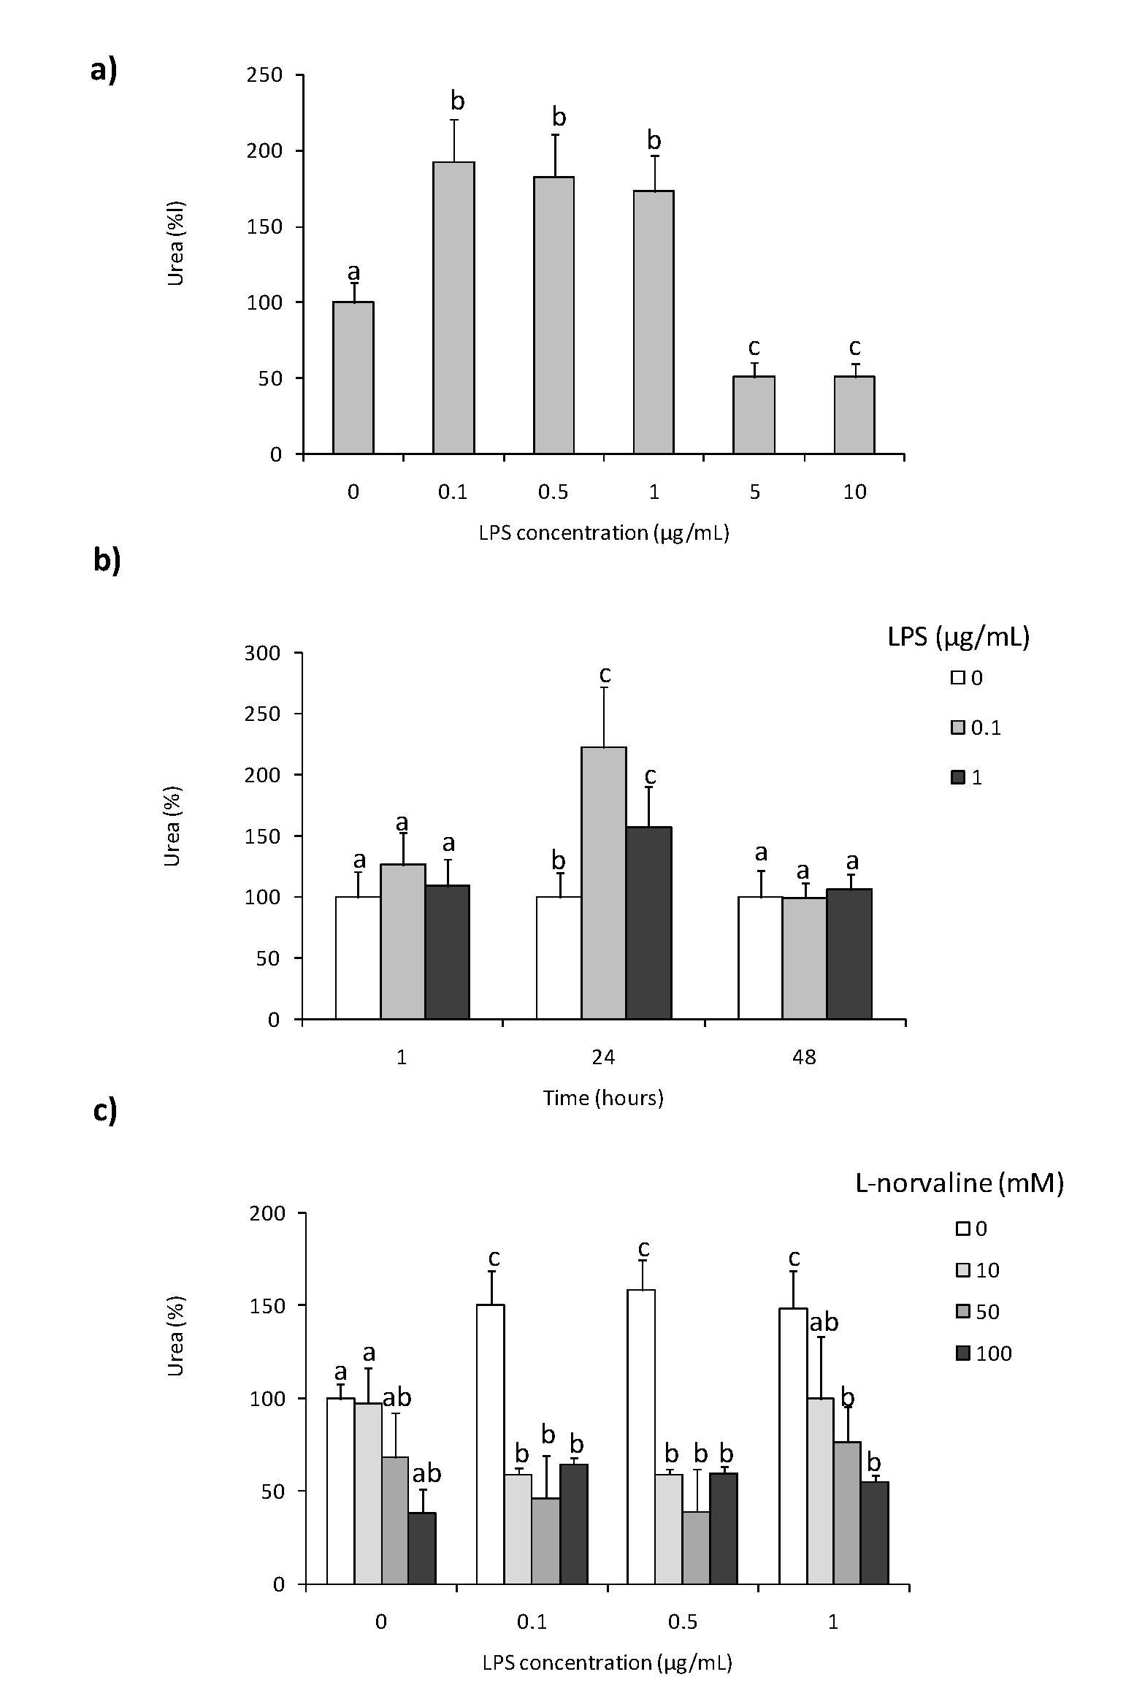
Int. J. Mol. Sci. 2021, 22, 3687
3of 15
Figure 1. Effects of in vitro stimulation with lipopolysaccharide on arginase activity in Eisenia andrei
coelomocytes. (Hells were in vitro treated with lipopolysaccharide (LPS) (0-10 pg/mL) for 24 la (a)
or with LPS (0-1 pg/mL) for 1, 24, car 48 h (b). Some cells 1 h before stimulation were treated with
arginase a ctivity inhibitor (L-norva line, 10-100 mM) (c) . Arginase activity was determined as urea
content and showed as % of control (arginase activity in unstimulated cells = 100%). Mean + standard
errors (SE), n = 8-16. Mean values that are significantlydifferent are not assigned a common letter
(e.g., a "as. la or b vs. c) according to one-way analysis of variance (ANOVA) (aa p < 0. 05).
Moreover, statistically significant up-regulation of arginase activity was found in coelo-
mocytes treated for 24 h with H2O2 but not in cells stimulated with phorbol 12-myristate
13-acetate (PMA) (Figure 2).
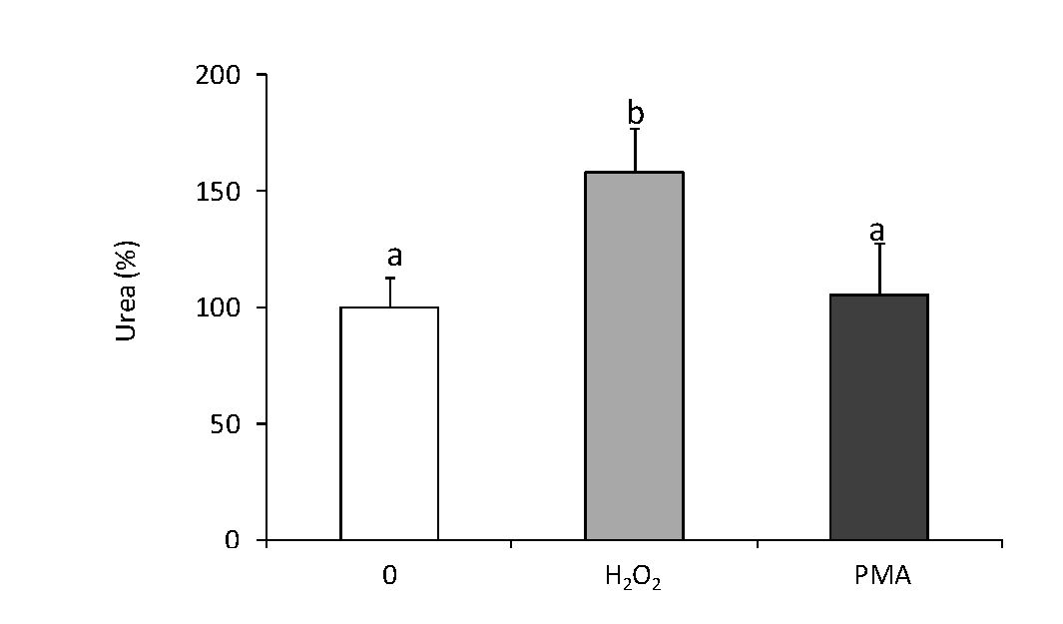
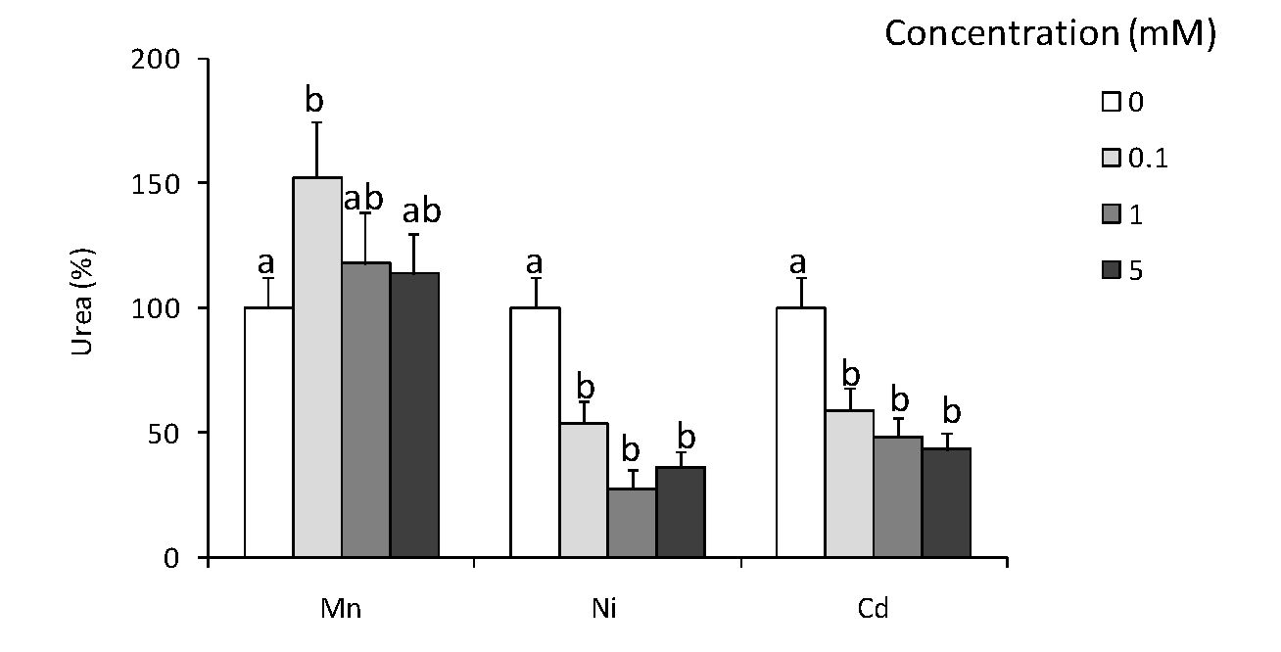
Int. J. Mol. Sci 2021, 22,3687
4 of 15
Figure 2. Effects of in vitro stimulation with hydrogen peroxide or phorbol ester on arginase activity
in Eisenia andrei coelomocytes. Cells were in vitro treated for 24 hwith 12120;) (150 vM), phorbol
12-myristate 13-acetate, PMA (0.1 pg), or with cultuee medium (0). Arginase activity was deter-
mined as urea content and showed as % of control (arginase activity in unstimulatedcells = 100%).
Mean + SE, n = 6-9. Mean values that are eignificantly different are not assigned acommon letter
(e.g., a vs. b or b vs. c) according to one-way analysis of variance (ANOVA) (at p < 0.05).
- Effects of In Vitro Heavy Metal Treatment of Coelomocytes on Arginase Activity
Mn2+ ions in concentration 0.1 mM incceased the arginase activity by 40-50%, while
Nif+ and Cd;r in all tested concenirations down-regulatecl arginase activity (Figure 3).
Figure 3. Effects of in vitro treatment with heavy metals on arginase activity in Eisenia andrei coelomo-
cyte s. Cells were in vitro treated for 24 h with different concentrations of Ni, Cd, and Mn chloride (0.1,
1, or 5 mM). Arginase activity was determined as urea content ¡anti showed as %of control (arginase
activity in unstimulated cells = 100%). Mean + SE, n = 4—10. Mean values that are significantly
different «nit; not assigned a common letter (e.g., a vs. la or la vs. c) according tea one-way analysis of
variance (ANOVA) Sat e < 0.05).

2.3. In Vivo Effects ofLPS
At 24 and 72 h post-LPS-injection, a significant reduction in the number of coelo-
mocytes wf s observed Figure 4a; however, such treatment did not change coelomocyte
composition Figure 4b. At both time points, LPS-treaimfnt enhanced arginase activity
Figure 4d while LPS-induced up-regulation of NO production was observed at 24 h post-
injection only Figure 4c.
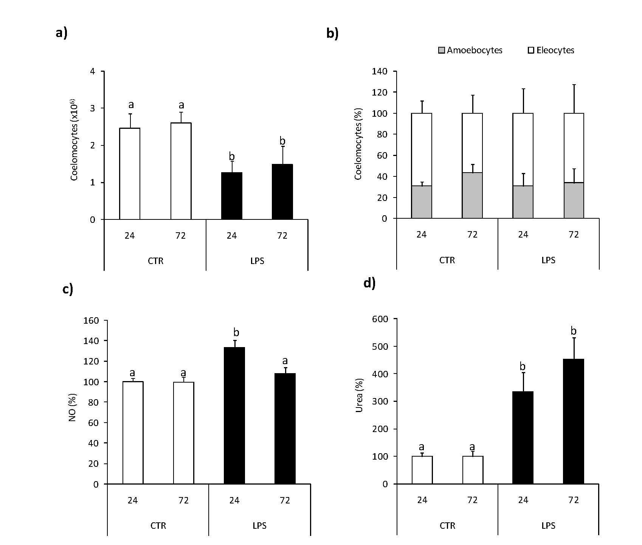
Int. J. Mol. Sci. 2021, 22,3687
5 of 15
Figure 4. Effects of in vivo stimulation with lipopolysaccharide on arginase activity and nitric oxide
production in Eisenia andrei coelomocytes. Coelomocytes were collected 24 or 72 h post earthworms
injection with 0.9% sodium chloride (CTR) or with LPS (1 mg/mL). Number (a) and composition (b)
of coelomocytes was counted. Nitric oxide (NO) production (c) and arginase activity (d) are showed
as % of control (NO production and arginase activity in coelomocytes of CTR animals = 100°%). Mean
-i- SE, n = 8. Mean values that are significantly different are not assigned a common letter (e.g., a vs. b
or b vs. c) according to one-way analysis of variance (ANOVA) (at p < 0.05).

2.4. In Vivo Effects of Nematode Infection
At 24 h post nematode infection reduced number of coelomocytes retrieved from
the coelomic earthworm cavity was observed compared to control animals Figure 5a,
while infection did not affect coelomocyte composition Figure 5b. Neither the number nor
composition of coelomocytes was changed upon L-norvaline pre-treatment Figure 5a,b.
At the same time point, post-injection coelomocytes from nematode-infected earth-
worms showed significantly higher arginase activity than animals injected with saline.
Nematode-induced up-regulation of arginase activity was nest observed in animals pre-
treated with L-norvaline Figure 5c.
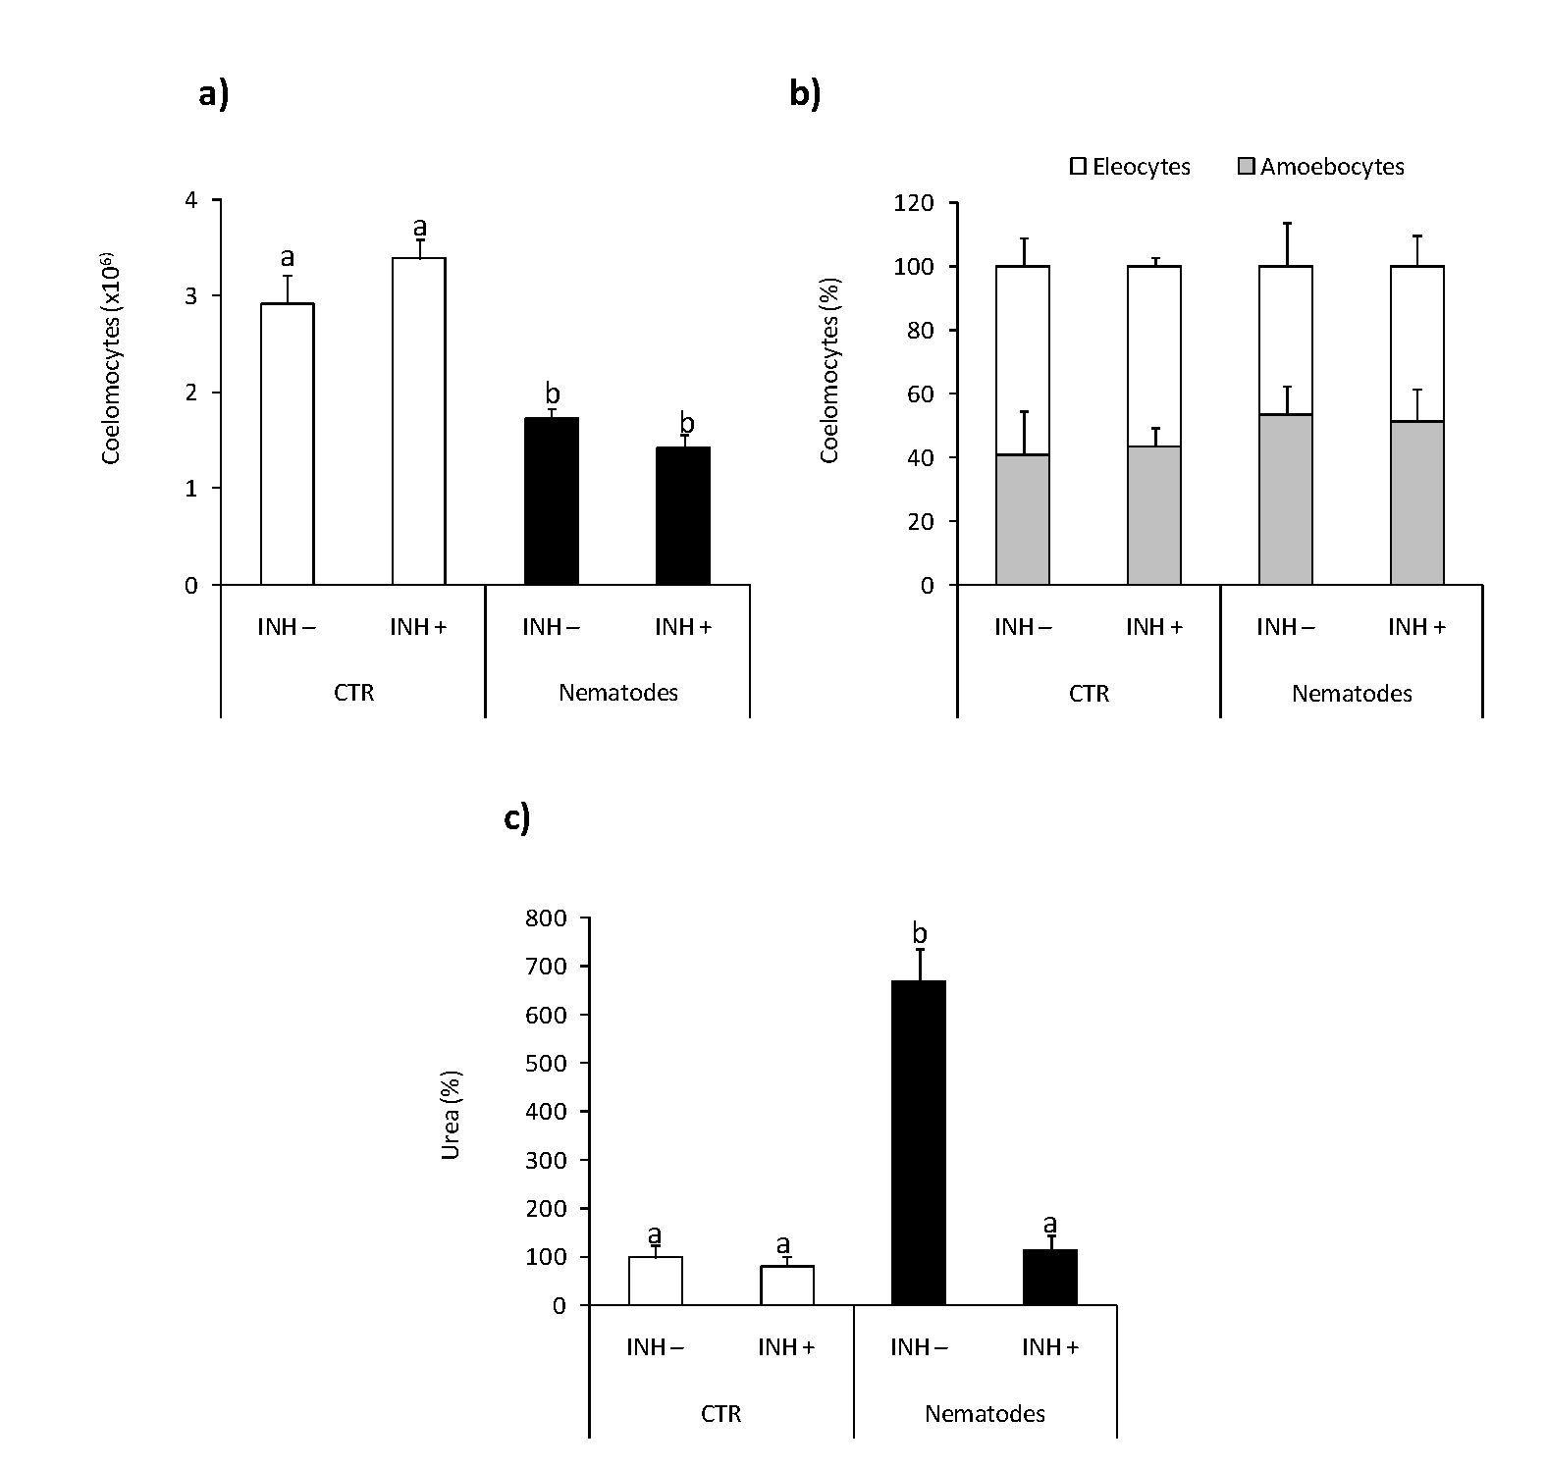
Int. J. Mol. Sei. 2021, 22,36-87
6 of l5
Figure 5. Effects of in vivo nematode infection on arginase activity in Eisenia andrei coelomocytes.
Coelomocytes were collected 24 h post earthworms injection with 0.9% sodium chloride (CTR) or
with nematodes (S.feltiae, 1000-1500 nematodes/mL). Prior to stimulation, some earthworms were
injected for 1 Id with arginase inhibitor L-norvaline (100 mM, INH+) or sodium chloride (INH-). The
number (a) and composition (b) of coelomocytes were counted. Arginase activity was determined as
urea content and showed as % of control iarginase activity in coelomocytes of CTR animals = 100%)
(c). Mean values that are significantly different are not assigned a common letter (e.g., a vs. b or b vs.
c) according to one-way analysis of variance (ANOVA) (at p < 0.05).

2.5. Effects of Tissue Injury
The numbers of coelomocytes reOrieved from earthworms with amputated (Amp .)
posterior segments were lower in compnrison with conirols animals Figure 6a, while tis-
sue injury did not change coelomocyte composition Figure 6b. Neither thr number nor
composition of coelomocytes was changed upon L-norvaline injection Figure 6a,b. Coelo-
mocytes retrieved from animals with amputated segments show slightly but significantly
up-regulated NO production compared to cells from control animals Figure 6c. Coelo-
mocytes from Amp. earthworms also had higher arginase activity Figure 6d than control
worms. L-norvaline slightly but not significantly (p = 0.0579) reduced arginase activity in
coelomocytes of animals with amputated segments while it significantly increased the level
of NO released from coelomocytes retrieved from injure)! animals Figure 6c,d.
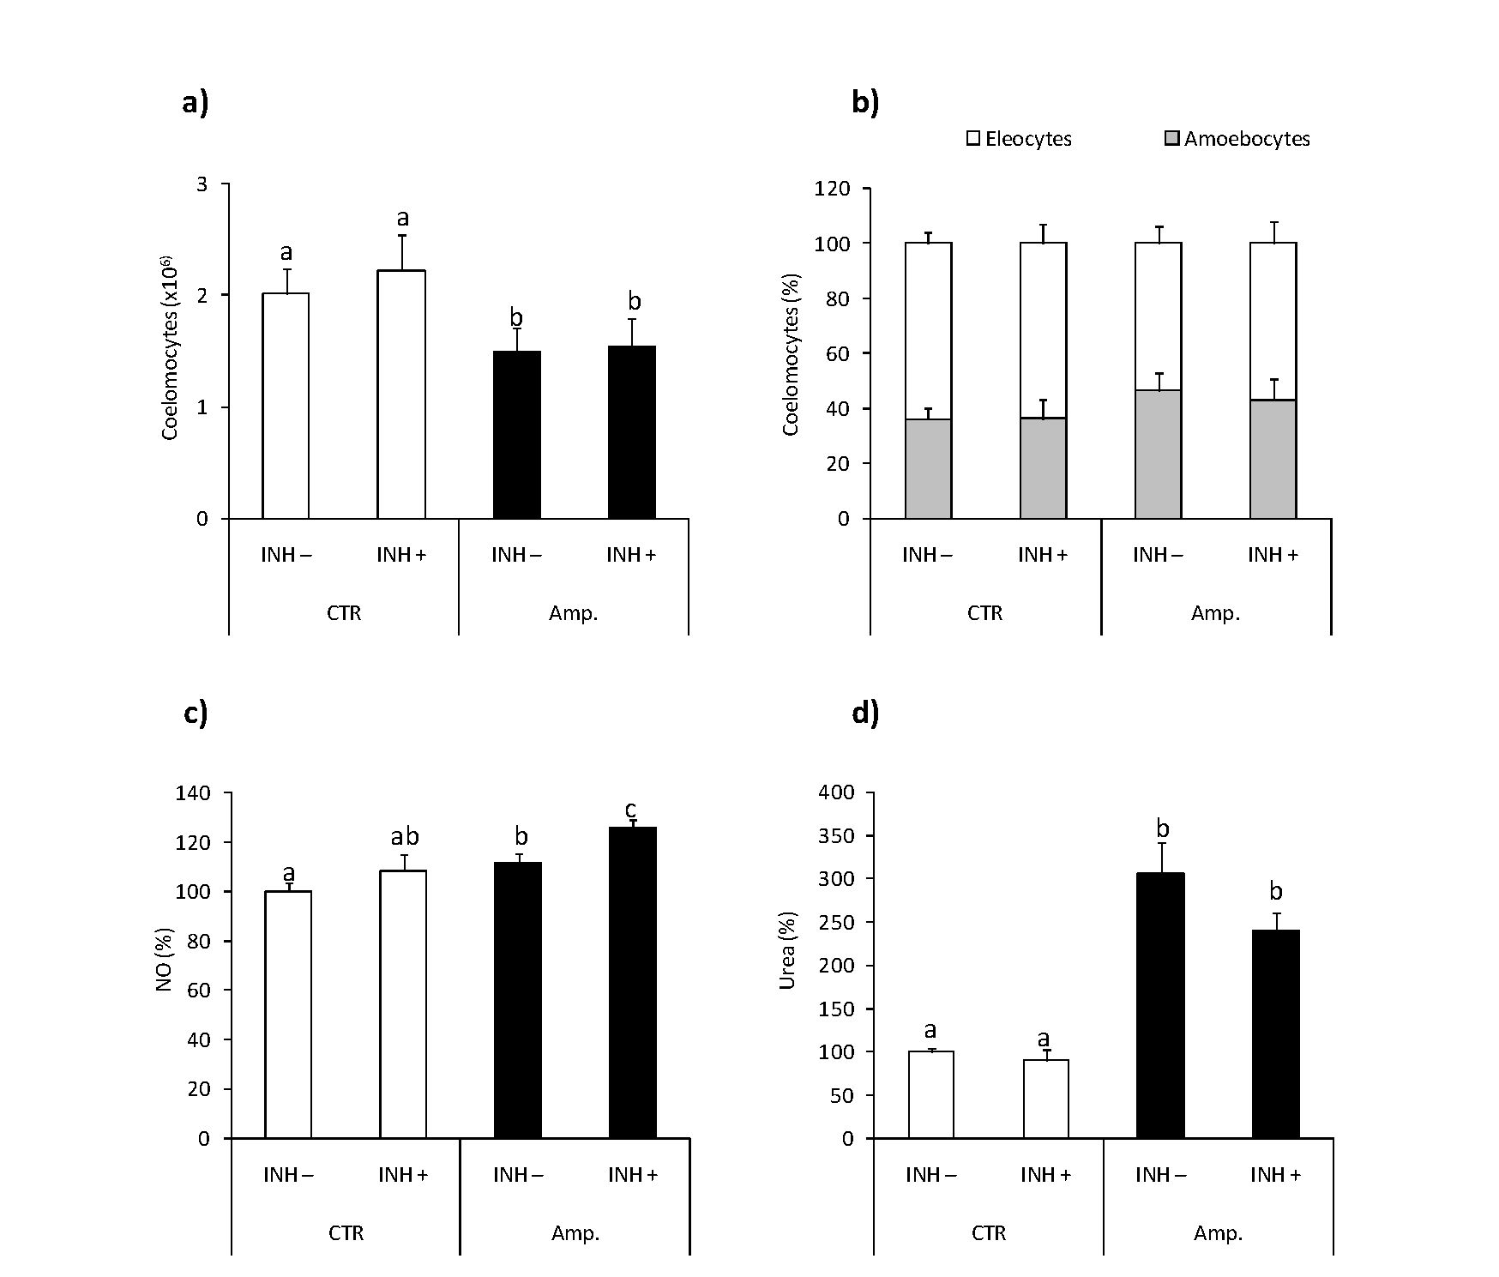
Int. J. Mol. Sei. 2Q21, 22,3687
7 of 15
Figure 6. Effects of segment amputation on arginase activity and nitric oxide production in Eisenia
andrei coelomocytgs. Coelomocytes were collected from control ¡animals (CTR) or from animals 72 h
post-amputation of 5 posterior segments (Amp.). Earthworms were injected for 1 hwith arginase
inhibitor L-norvaline (100 mM, INH+) or with 0.9%NaCl (INH-). The number (a) and composition (b)
of coelomocytes were counted. Nitric oxide (INO) production (c) and arginase activity (d) are ¡showed
as % of control (NO production and arginase activity in coelomocytes of CTR animals = 100%). Mean
values that are significantly different are not assigned a common letter (e.g., a vs. b or lb vs. c)
according to one-way analysis of varianse (ANOVA) (at p < 0.05).

2.6. Effect of Fasting
Fasting (five days) did not change the number and composition of coelomocytes
Figure 7a,b. Moreover, arginase activity' in coelomocytes from control and fasting; animals
was similar and eahibited similar sensitivity to ex vivo LI’S stimulation Figure 7c.
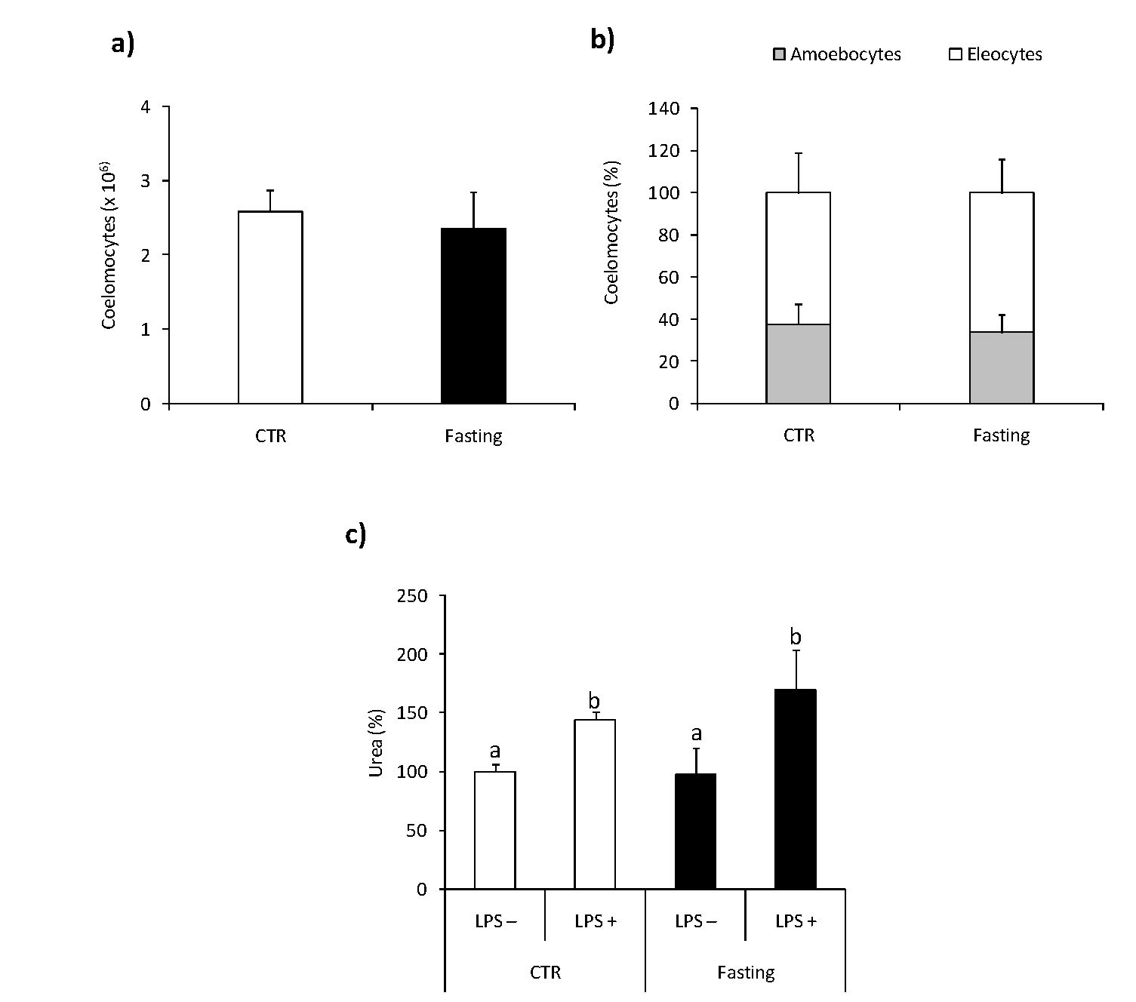
Int. J. Mol. Sci. 2021, 22,3687
8 of 15
Figure 7. Effects of short-term fasting on arginaseactivity in Eisenia andrei coelomocytes. Coelomo-
cytes were collected from earthworms kept in soil (CTR) or exposed for 5 days to filter paper soaked
with distilled water (Fa sting;). The number (a) and composition (b) of co elomocytes were counted.
Arginase activity (c) was measured in coelomocytes incubated for 124 h with control medium (LPS-)
or with LPS (1 gg/mL, LPS+) and is shownas % of control (arginase activity in LPS-coelomocyres
oe CTR animals = 100°%). Mean + SE, n = 10. Mean values that fire significantly different are not
assigned a c=mmon letter (e.g., a vs. bor x vs. c) according; to one-way analysis of variance (ANOVA)
(at p < 0.05).

3. Discussion
In the present studies, we =oeused on the sffects of in vltro and in vivo stimulxtion
of immuee response on arginase activity in earthworm coelomocytes. According to our
understanding, we provide the first evidence that arginase is fully operating in Eisenia andrei.
coelomocytes and that both in vitro and in vivo immunostimulation inducrd arginase
activity. We found that both in vitro and in vivo lipopolysaccharide stimulates arginase
activity in earthworm coelomocytes, and in the case of in vitro study this effec( was
dependent on tire time of stimulation and LI’S concentration and decreased by L-norvaline
pre-treatment. In -vivo, the injection of earthworms with LI’S decreared the number of
coelomocytes and up-regulated the release of NO and arginase activity.
It is known that in vertebrxtesa lipopolysaccharide is capable of concurrently stimu-
lating nitric oxide production and arginase activity in macrophages ’22,23]. For example,
LPS-induced up-regulation of arginase activity was observed in vitro in the cell line of
mouse macrophages RAW264.7 [2,22], rat alveolar macrophages [24], oc the human mono-
cyte cell line THP-1 [25]. Also, in ftsh macrophagns, LPS induced Arg expression and
activity, as found in our previous studies [26,27]. Data concerning arginase expression
and activity; in the immunocompetent cells of invertebrates are very lim(ted. Previously,
the changes in the arginase activity upon stimulation with LPS or Schistosomamansoni
sporocysts were found in sea cucumber (Apostichopus japonicus) [9,28] and in snails (Biom-
phalaria glabrata) [29]. Moreover, the previous studies of sea cucumber A. japonicus showed
Int. J. Mol. Sci. 2021, 22,3687
9 of 15
that Gram-negative bacteria Vibrio splendidus challenged coelomocytes and intestine, and
LPS-exposed primary coelomocytes, significantly increased NOS expression, which was
followed by down-regulation of Arginase and Agmatinase transcripts [9]. Such phenomenon
was observed when the dose of pathogen measured as a multiplicity of infection was
around 10, while higher pathogen dose (multiplicity of infection, MOI = 100) increased
arginase activity and decreased NO production [9]. The study of the mechanism regulating
arginase and agmatinase gene expression indicated that both Ajagmatinase and Ajarginase
promoter activities were significantly activated by LPS and L-arginine challenge [28]. In
turn, in B. glabrata snail hemocytes, sporocyst stimulation upregulated synthesis of arginase
1, a competitor of nitric oxide synthetase, and inhibitor of larval-killing NO production [29].
LPS or bacterial challenge increases in arginase expression and/or activity contribute
to the earthworm immune response's deactivation and prevents the inflammation-induced
destruction of host cells and tissues [30]. For example, the results obtained from the non-
transformed intestinal cells from the IPEC-J2 line show that the Arg-1 signaling pathway
is partly responsible for anti-inflammatory and antioxidant effects and protects host cells
from LPS-induced exaggerated inflammatory response and oxidative stress [31].
To confirm that the enzyme found in earthworm coelomocytes is arginase, an L-
norvaline inhibitor was used. This inhibitor acts directly on the enzyme by mimicking
ornithine structure and indirectly inhibiting ornithine transcarbamylase [32,33] and suc-
cinate synthetase [32-34]. In our studies, L-norvaline suppressed enzyme activity in
coelomocytes stimulated by LPS in all used inhibitor concentrations, indicating that E. coli
lipopolysaccharide indeed activated arginase activity in earthworm coelomocytes. Our
results are similar to results conducted on the cell lines of mouse macrophages J774A.1,
where L-norvaline in a concentration of 10 mM inhibited arginase activity, reducing urea
production by 50% [33]. We demonstrated that L-norvaline has a direct inhibitory effect on
arginase function. The specificity of L-norvaline in arginase inhibition has been reported
to be one of the most effective arginase inhibitors in various preparations [33]. In our
experiments, after 72 h post-L-norvaline injection, there was no effect on arginase inhibition
in coelomocytes, whereas, after 24 h, arginase activity significantly decreased. Similar
relationships were also found for an NOS inhibitor L-NAME (N^-nitro-L-arginine methyl
ester), where the single injection of L-NAME resulted in an inhibition of NO only during
the first 24 h infection [35].
In the present in vitro studies, increased arginase activity was also observed in coelo-
mocytes treated with H2O2, but not in cells treated with PMA. Previous studies on porcine
arteries also showed that exposure to hydrogen peroxide increased arginase activity [36].
Moreover, it was reported that the oxidative species, e.g., H2O2, increased arginase activity
in endothelial cells and that this effect was connected with the protein kinase PKC-mediated
activation of RhoA/Rho kinase pathway [37]. In contrast to our study, PMA-induced THP-
1 monocytes differentiation into macrophages was accompanied by an increased Arg-II
expression without detectable upregulation of iNOS or Arg-I [25].
Interestingly, but not surprising, in coelomocytesin vitro treated with Mn2+ ions,
increased arginase activity was observed, while similar concentrations of Ni2+ and Cd2+
decreased its activity. It has to be mentioned that arginase is a metalloenzyme in which
manganese acts as a cofactor as well as an activator and that required Mn2+ as an essential
element to exhibit maximal enzyme activity [1]; however, the amount essential for optimal
activity of the enzyme varies depends on arginase isoforms and location (e.g., kidney and
liver) [38]. For example, it was shown that the cationic rat liver enzyme inactivated by
EDTA-treatment (ethylenediaminetetraacetic acid) was fully restored by Mn2+, whereas
Cd2+, Ni2+, and Co2+ induced effects were smaller [39].
Next to LPS-induced arginase activation, we also observed its higher activity in coelo-
mocytes retrieved from earthworms in vivo infected with nematodes, which suggests its
involvement in the anti-parasite response. It was demonstrated that S. feltiae are mainly
infective for insects; however, it was previously found that earthworms can increase the dis-
tribution of nematodes in the soil by transporting them through the digestive tract [40,41].
Int. J. Mol. Sci. 2021, 22,3687
10 of 15
It is worth mentioning that such conditions decreased the number of coelomocytes, which
most probably were recruited for parasite encapsulation/brown body formation. Such a
phenomenon was recently observed and both in vivo (upon injection) and in vitro nema-
todes activated coelomocytes of E. andrei and induced the formation of "brown bodies" [42]
(Figure S1). Previously, similar coelomocyte activation was also observed in E. andrei
injected with Aeromonas hydrophila [43]. Interestingly, parasite infection did not affect
coelomocyte composition, and the percentage of amoebocytes and eleocytes in the whole
population of coelomocytes did not change. Therefore, it can be concluded that, when
induced by parasite infection, the arginase activity is not due to changes in the ratio of
amoebocytes and eleocytes. Previously, arginase involvement in the anti-parasite response
was described during Trypanosoma cruzi [44], T. brucei, Leishmania, and Schistosoma mansoni
infection [45]. Stempin and co-workers [30] found that induction of arginase-1 favors
T. cruzi persistence in the host [30]. Moreover, in T. cruzi infected rats, high arginase-1 activ-
ity inhibited NO production in peripheral blood monocytes [46]. As mentioned before in
inflammatory cells, L-arginine can be metabolized either by nitric oxide synthase (NOS) to
NO and citrulline, or by arginase to ornithine and urea [34]. Most probably, some parasites
protect themselves against the toxic effects of NO by inducing high levels of arginase in the
host cells. In this way, they deplete L-arginine and reduce the synthesis of toxic NO [35].
Interestingly, the arginase-mediated metabolism of L-arginine is an important source
of local ornithine, a proline precursor crucial for collagen synthesis, and therefore the
important role of arginase in the process of wound healing and tissue regeneration was
discovered [47]. In our experiments, amputation of posterior segments of earthworms
reduced the number of coelomocytes, most probably recruited to the site of wound healing,
and most importantly, activated coelomocytes to produce NO and increase arginase activity.
Although, in this case, we did not find significant L-norvaline-induced inhibition of arginase
activity; L-norvaline increased slightly but significantly NO production. It may suggest
that also in earthworm coelomocyte NO synthase and arginase compete for the availability
of L-arginine. Recently, Bodó and co-authors [48] found that in E. andrei, amputation of the
first or last five segments induced very fast healing where undifferentiated cells covered the
wound's surface. In our experiments, after amputation, similar rapid (few days) healing
processes were observed.
Previously, upregulation of arginase activity was found during skin wound healing in
rats (3-14 days post wounding). In this work, iNOS activity was significantly upregulated
in the wound tissues only at early time points (12 h-3 days post wounding), and its
activity gradually decreased after the third-day post wounding [49]. It has to be mentioned
that, in vertebrates, many cells such as macrophages, keratinocytes, and endothelial cells
synthesize NO during acute wound healing. In contrast, arginase is synthesized mainly in
macrophages and thought to be released into the wound environment by cell death [50]. An
analysis of the limb regeneration process in axolotl indicated that macrophages, along with
the simultaneous induction of pro- and anti-inflammatory cytokines, are crucial in early
response to injury and limb regeneration. Moreover, the authors found that macrophage
depletion did not affect epithelial wound closure after limb amputation while it caused
excessive fibroplasia, collagen deposition, and a complete block in blastemal formation [51].
Among the many functions of arginase, its activity may be associated with the process
of starvation or fasting. The results obtained in experiments with fasting animals differ
between organisms and the time of fasting. Studies of the vertebrates, including pigs, have
shown that fasting of four and eight days increases hepatic arginase activity, as measured
by urea production [52]. In rainbow trout (Oncorhynchus mykiss), a twofold increase in
hepatic arginase II mRNA expression, but not arginase I, was observed after six weeks
of fasting [53]. Also, in earthworm Lumbricus terrestris, after 14 days and longer time
(24-30 days) of fasting, increased arginase activity was observed in the intestinal tissue [10].
In contrast to previous studies on L. terrestris, five days fasting of E. andrei did not change
arginase activity in coelomocytes. However, studies on L. terrestris measured arginase activ-
ity in the intestinal tissue, while in the present studies, we specifically study coelomocytes.
Int. J. Mol. Sci. 2021, 22, 3687
11 of 15
Furthermore, it was shown that, in the intestinal tissue of L. terrestris, arginase activity was
up-regulated only after a long time of fasting [10]. In our experiments in coelomocytes
derived from earthworms fasted by five days, the arginase activity was similar to that in
not fasted control groups. Moreover, additional stimulation with LPS caused a similar
reaction in coelomocytes derived from control and five-day fasted earthworms. The ef-
fect of short-term starvation on other earthworms Eisenia veneta, showed small metabolic
changes for the first five days of fasting, with clear differences at six and seven days. These
differences included increases in glutamate, citrate, aspartate, and isoleucine, and decreases
in lysine, isoleucine, and threonine. [54].
In summary, in the present study, for the first time in earthworms, we describedarginase
activity in coelomocytes and found that it can be up-regulated upon immunostimula-
tion/infection, in the presence of Mn2+ ions and during wound healing upon segment
amputation. Furthermore, we confirmed that L-norvaline can suppress the activity of coelo-
mocyte arginase. Similar changes of arginase activity in immunocompetent earthworm
cells and vertebrate leukocytes strongly suggested that the role of arginase in earthworms
is not limited to participation in the urea cycle, and that it is an important element of
the invertebrate immune response. However, the hypothesis suggesting that earthworm
coelomocytes may polarize towards pro-inflammatory (with high iNOS activity) or anti-
inflammatory (with high arginase activity) cells depending on the type of infection or tissue
damage requires further intensive research.

4. Materials and Methods
  - Animals
Adult (clitellate) earthworms Eienia andrei (Sav.) (0.41-0.83 g body weight) from the
stock breeding maintained in the Institute of Zoology and Biomedical Research, Jagiellonian
University, Krakow, Poland, were kept in controlled laboratory conditions (21 ± 1 ° C;
12:12 LD) in commercial metal-free soil (PPUH Biovita, Tenczynek, Poland). Animals were
fed twice a week with flour.
  - In Vitro Experiments
The earthworms were stimulated for 1 min with a 4.5 V electric current to expel
coelomic fluid with coelomocytes through the dorsal pores according to the procedure
described previously [55,56]. Cells were collected into 0.05 mM Sorensen buffer (Na2HPO4-
KH2PO4, POCh, Gliwice, Poland), pH 7.4 [57]. Obtained cells were counted with a hemo-
cytometer and resuspended in Sorensen buffer to a density of 1 x 106 cells per mL.
Cells were treated with lipopolysaccharide from Escherichia coli 0111:B4 l (LPS,
0.1-10 gg/mL), phorbol 12-myristate 13-acetate (PMA, 0.1 gg/mL), hydrogen peroxide
(H2O2, 50 gM), or with heavy metals: manganese chloride (Mn2+, 0.1-5 mM), cadmium
chloride (Cd2+, 0.1-5 mM), or nickel chloride (Ni2+, 0.1-5 mM) for 1, 24, or 48 h. Addition-
ally, it was checked that the solvent control, DMSO (use only for PMA stock resuspension),
in the concentration used for PMA did not affect cell activity. We used Sorensen buffer, and
control cells were treated with Sorensen buffer for all reagents as solvent.
Additionally, to verify the direct involvement of earthworm arginase in L-arginine
metabolism 1 h before stimulation some coelomocytes were pretreated with arginase
inhibitor, L-norvaline (10, 50, and 100 mM). All chemicals were obtained from Sigma-
Aldrich, St. Louis, MO, USA.
  - In Vivo Experiments
    - In Vivo Immunostimulation
Before stimulation, earthworms were rinsed with water and injected with 20 gL of
stimulant solution into the coelomic cavity (1 cm behind the clitellum). Earthworms were
stimulated either with: LPS (1 mg/mL of 0.9% sodium chloride solution, Baxter Terpol,
Poland) or nematodes Steinernema feltiae. Infective juvenile parasites, a commercial strain
of S.feltie, e-nema, was kindly provided by R.-U. Ehlers and harvested by filtration. Next,
Int. J. Mol. Sci. 2021, 22,3687
12 of 15
nematodes were washed three times in 0.9%NaCl, heat killed (65 °C), and prepared as fresh
(no fixed) solution at a concentration of 1000-1500 nematodes/mL of sodium chloride.
Some earthworms, 1 h before immunostimulation, were injected with 20 gL of L-
norvaline (100 mM). Control (CTR) animals were injected with 0.9%NaCl.
After injection, earthworms were placed individually in 15 mL vials filled with filter
paper that was soaked with water [15]. Subsequently, coelomocytes were collected at 24 h
and/or 72 h post immunostimulation. Cells were counted with a hemocytometer and their
composition was evaluated based on the morphology of amoebocytes (A) and eleocytes
(E) [58].
    - Tissue Injury and Animal Fasting
To verify arginase involvement in tissue regeneration process, five posterior segments
were amputated from the animals Figure S2. After surgery, animals were placed individu-
ally for 3 days in 15 mL vials filled with filter paper soaked with water. Some animals 1 h
before injury were injected with 20 gL of L-norvaline (100 mM). Analysis was performed in
four independent experiments in duplicates for controls and for three for the amputation
group. Earthworm coelomocytes were retrieved and counted as described in Section 4.3.1.
To investigate effect of fasting on arginase activity, earthworms were placed in boxes
with filter paper soaked with water (3 individuals per box) for 5 days. After the fasting
period, earthworm coelomocytes were retrieved and counted as described in Section 4.3.1.
Some cells were left untreated (-LPS) while some were ex vivo stimulated for 24 h with
LPS (1 gg/mL, +LPS).
  - Coelomocyte Activity
To measure activity of iNOS and arginase, coelomocyte number was always adjusted
to a density of 1 x 106 cells per ml of Sbrensen buffer.
    - Arginase Activity
Arginase activity was measured as described by Corraliza et al. [59]. Cells were lysed
in 50 gL of 0.1% Triton X-100 containing 5 gg of pepstatin (Sigma-Aldrich, St. Louis,
MO, USA), 5 gg of aprotinin (Sigma-Aldrich, St. Louis, MO, USA), and 5 gg of antipain
(Sigma-Aldrich, St. Louis, MO, USA), at room temperature for 30 min. Then, 35 microliters
of 10 mM MnCl2 (Sigma-Aldrich, St. Louis, MO, USA) and 50 mM Tris-HCl (pH 7.5) (Tris,
Biorad, USA; HCl, POCH, Gliwice, Poland) was added, and the mixture was incubated for
10 min at 55 °C. 50 gL of 0.5 M L-arginine (pH 9.7) (Sigma-Aldrich, St. Louis, MO, USA)
was added to 50 gL of this activated lysate, and incubated for 1 h at 37 °C. The reaction was
stopped with 400 gL of the mixture containing H2SO4 (POCH, Gliwice, Poland), H3PO4
(Chempur, Poland), and H2O (1:3:7), then 25 gL of 9% a-isonitrosopropiophenone (Sigma-
Aldrich, St. Louis, MO, USA) in 100% ethanol (99.8%, POCH, Gliwice, Poland). The sample
was incubated at 100 °C (45 min) and cooled in the dark (10 min). Absorbance (O.D.)
was read at 540 nm, and arginase activity was calculated to compare to the urea standard
curve [26].
    - Nitric Oxide Release
Nitrite/nitrate production, an indicator of nitric oxide synthesis, was measured in
cell culture supernatants as described previously [60]. Following incubation 100 gL of cell
culture supernatant was added to 100 gL 1% (w/v) sulfanilamide in 2.5% (v/v) phosphoric
acid and 100 gL of 0.1% (w/v) N-naphthyl-ethylenediamine in 2.5% (v/v) phosphoric acid
(all from Sigma-Aldrich, St. Louis, MO, USA). The O.D. was read at 540 nm.
  - Data Analysis and Statistics
Results are expressed as means ± standard errors (SE). Statistically significant dif-
ferences between means were evaluated using a one-way ANOVA test. The level of
significance was established at p < 0.05.
Int. J. Mol. Sci. 2021, 22,3687
13 of 15
Supplementary Materials: The following are available online at https://www.mdpi.com/article/10.3
390/ ijms22073687/ si.
Author Contributions: Conceptualization, J.H.; methodology, J.H. and M.C.; experimental work,
J.H. and A.K.; writing—original draft preparation, J.H.; writing—review and editing, J.H. and
M.C.; supervision, J.H. and M.C. All authors have read and agreed to the published version of
the manuscript.
Funding: This work was supported by N18/DBS/2000009 Jagiellonian University. The open-access
publication of this article was funded by the Priority Research Area BioS under the program "Excel-
lence Initiative—Research University" at the Jagiellonian University in Krakow.
Institutional Review Board Statement: Not applicable.
Informed Consent Statement: Not applicable.
Data Availability Statement: The data presented in this study are available in the article.
Conflicts of Interest: The authors declare no conflict of interest.
References
- Dzik, J.M. Evolutionary roots of arginase expression and regulation. Front. Immunol. 2014, 5, 544. [CrossRef] [PubMed]
- Morris, S.M., Jr.; Kepka-Lenhart, D.; Chen, L.C. Differential regulation of arginases and inducible nitric oxide synthase in murine
macrophage cells. Am. J. Physiol. 1998, 275, E740-E747. [CrossRef]
- Morris, S.M., Jr. Recent advances in arginine metabolism: Roles and regulation of the arginases. Br. J. Pharmacol. 2009,15, 922-930.
[CrossRef] [PubMed]
- Caldwell, R.B.; Toque, H.A.; Narayanan, S.P.; Caldwell, R.W. Arginase: An old enzyme with new tricks. Trends Pharmacol. Sci.
2015, 26, 395-405. [CrossRef] [PubMed]
- Gordon, S. Phagocytosis: An Immunobiologic Process. Immunity 2016, 44, 463-475. [CrossRef] [PubMed]
- Gordon, S.; Plüddeman, A. Tissue macrophages: Heterogeneity and functions. BMC Biol. 2017,15, 53. [CrossRef]
- Lange, P.S.; Langley, B.; Lu, P.; Ratan, R.R. Novel roles for arginase in cell survival, regeneration, and translation in the central
nervous system. J. Nutr. 2004,134, 2812S-2817S. [CrossRef]
- Durante, W.; Johnson, F.K.; Johnson, R.A. Arginase: A critical regulator of nitric oxide synthesis and vascular function. Clin. Exp.
Pharmacol. Physiol. 2007, 34,906-911. [CrossRef]
- Yina, S.; Chenghua, L.; Weiwei, Z.; Zhenhui, W.; Zhimeng, L. The first description of complete invertebrate arginine metabolism
pathways implies dose-dependent pathogen regulation in Apostichopus japonicus. Sci. Rep. 2016, 6, 23783. [CrossRef]
- Cohen, S.; Lewis, H.B. The nitrogenous metabolism of the earthworm (Lumbricus terrestris). II. Arginase and urea synthesis. J. Biol.
Chem. 1950,184, 479-484. [CrossRef]
- Bishop, S.H.; Campbell, J.W. Arginine and urea biosynthesis in the earthworm Lumbricus terrestris. Comp. Biochem. Physiol. 1965,
15, 51-71. [CrossRef]
- Needham, A.E. Nitrogen Metabolism in Annelida. In Comparative Biochemistry of Nitrogen Metabolism; Campbell, J.W., Ed.;
Academic Press: London, UK, 1970; Volume 1.
- Engelmann, P.; Molnär, L.; Pälinkäs, L.; Cooper, E.L.; Nemeth, P. Earthworm leukocyte populations specifically harbor lysosomal
enzymes that may respond to bacterial challenge. Cell Tissue Res. 2004, 316, 391-401. [CrossRef]
- Bernard, F.; Brulle, F.; Dumez, S.; Lemiere, S.; Platel, A.; Nesslany, F.; Cuny, D.; Deram, A.; Vandenbulcke, F. Antioxidant responses
of Annelids, Brassicaceae and Fabaceae to pollutants: A review. Ecotoxicol. Environ. Saf. 2015,114,273-303. [CrossRef] [PubMed]
- Homa, J.; Zorska, A.; Wesołowski, D.; Chadzirrska, M. Dermal exposure to immunostimulants induces changes in activity and
proliferation of coelomocytes of Eisenia andrei. J. Comp. Physiol. B 2013,183, 313-322. [CrossRef] [PubMed]
- Homa, J.; Stalmach, M.; Wilczek, G.; Kołaczkowska, E. Effective activation of antioxidant system by immune-relevant factors
reversely correlates with apoptosis of Eisenia andrei coelomocytes. J. Comp. Physiol. B 2016,186, 417-430. [CrossRef]
- Rivero, A. Nitric oxide: An antiparasitic molecule of invertebrates. Trends Parasitol. 2006, 22, 219-225. [CrossRef] [PubMed]
- Valembois, P.; Lassegues, M. In vitro generation of reactive oxygen species by free coelomic cells of the annelid Eisenia fetida andrei:
An analysis by chemiluminescence and nitro blue tetrazolium reduction. Dev. Comp. Immunol. 1995,19,195-204. [CrossRef]
- Bilej, M.; De Baetselier, P.; Beschin, A. Antimicrobial defense of the earthworm. Folia Microbiol. 2000, 45, 283-300. [CrossRef]
- Dales, R.P.; Kalaę, Y. Phagocytic defence by the earthworm Eisenia foetida against certain pathogenic bacteria. Comp. Biochem.
Physiol. Part A Physiol. 1992,101, 487-490. [CrossRef]
- Valembois, P.; Lassegues, M.; Roch, P.; Vaillier, J. Scanning electron-microscopic study of the involvement of coelomic cells in
earthworm antibacterial defense. Cell Tissue Res. 1985, 240, 479-484. [CrossRef]
- Sosroseno, W.; Musa, M.; Ravichandran, M.; Fikri Ibrahim, M.; Bird, P.S.; Seymour, G.J. Arginase activity in a murine macrophage
cell line (RAW264.7) stimulated with lipopolysaccharide from Actinobacillus actinomycetemcomitans. Oral Microbiol. Immunol. 2006,
21,145-150. [CrossRef] [PubMed]
Int. J. Mol. Sei. 2021, 22,3687
14 of 15
- Wang, W.W.; Jenkinson, C.P.; Griscavage, J.M.; Kern, R.M.; Arabolos, N.S.; Byrns, R.E.; Cederbaum, S.D.; Ignarro, L.J. Co-induction
of arginase and nitric oxide synthase in murine macrophages activated by lipopolysaccharide. Bioehem. Biophys. Res. Commun.
1995, 210,1009-1016. [CrossRef] [PubMed]
- Klasen, S.; Hammermann, R.; Fuhrmann, M.; Lindemann, D.; Beck, K.F.; Pfeilschifter, J.; Racké, K. Glucocorticoids inhibit
lipopolysaccharide-induced up-regulation of arginase in rat alveolar macrophages. Br. J. Pharmaeol. 2001, 1З2, 1349-1357.
[CrossRef] [PubMed]
- Ming, X.F.; Rajapakse, A.G.; Yepuri, G.; Xiong, Y.Y.; Carvas, J.M.; Ruffieux, J.; Scerri, I.; Wu, Z.; Popp, K.; Li, J.; et al. Arginase II
promotes macrophage inflammatory responses through mitochondrial reactive oxygen species, contributing to insulin resistance
and atherogenesis. J. Am. Heart Assoe. 2012,1, e000992. [CrossRef]
- Chadzinska, M.; Tertil, E.; Kepka, M.; Hermsen, T.; Scheer, M.; Verburg-van Kemenade, B.M.L. Adrenergic regulation of the
innate immune response in common carp (Cyprinusearpio L.). Dev. Comp. Immunol. 2012, Зв, 306-316. [CrossRef]
- Maciuszek, M.; Rydz, L.; Switakowska, I.; Verburg-van Kemenade, B.M.L.; Chadzińska, M. Effects of stress and cortisol on the
polarization of carp macrophages. Fish Shellfish Immunol. 2019, 9i, 27-37. [CrossRef]
- Yina, S.; Chenghua, L.; Weiwei, Z.; Xu, W.; Duan, X.; Li, Y.; Qiu, Q.; Jin, C. Cloning and comparative analysis the proximal
promoter activities of arginase and agmatinase genes in Apostiehopusjaponieus. Dev. Comp. Immunol. 201б, вВ, 299-308.
- Dinguirard, N.; Marília, G.S.; Cavalcanti, M.G.S.; Wu, X.-J.; Bickham-Wright, U.; Sabat, G.; Yoshino, T.P. Proteomic analysis of
Biomphalaria glabrata hemocytes during in vitro encapsulation of Sehistosomamansoni sporocysts. Front. Immunol. 2018, 9, 2773.
[CrossRef]
- Stempin, C.C.; Dulgerian, L.R.; Garrido, V.V.; Cerban, F.M. Arginase in parasitic infections: Macrophage activation, immunosup-
pression, and intracellular signals. J. Biomed. Bioteehnol. 2010. [CrossRef]
- Qiu, Y.; Yang, X.; Wang, L.; Gao, K.; Jiang, Z. L-arginine inhibited inflammatory response and oxidative stress induced by
lipopolysaccharide via Arginase-1 signaling in IPEC-J2 cells. Int. J. Mol. Sei. 2019,20,1800. [CrossRef]
- Saheki, T.; Sato, Y.; Takada, S.; Katsunuma, T. Regulation of urea synthesis in rat liver. Inhibition of urea synthesis by L-norvaline.
J. Bioehem. 1979, 8в, 745-750. [CrossRef]
- Chang, C.-I.; Liao, J.C.; Kuo, L. Arginase modulates nitric oxide production in activated macrophages. Am. J. Physiol. 1998,27i,
342-348. [CrossRef] [PubMed]
- Rath, M.; Müller, I.; Kropf, P.; Closs, E.I.; Munder, M. Metabolism via arginase or nitric oxide synthase: Two competing arginine
pathways in macrophages. Front. Immunol. 2014, B. [CrossRef]
- Villamil, L.; Gómez-León, J.; Gómez-Chiarri, M. Role of nitric oxide in the defenses of Crassostreavirginiea to experimental infection
with the protozoan parasite Perkinsusmarinus. Dev. Comp. Immunol. 2007, З1, 968-977. [CrossRef] [PubMed]
- Thengchaisri, N.; Hein, T.W.; Wang, W.; Xu, X.; Li, Z.; Fossum, T.W.; Kuo, L. Upregulation of arginase by H2O2 impairs
endothelium-dependent nitric oxide-mediated dilation of coronary arterioles. Arterioseler. Thromb. Vase. Biol. 200б, 2в, 2035-2042.
[CrossRef]
- Chandra, S.; Romero, M.J.; Shatanawi, A.; Alkilany, A.M.; Caldwell, R.B.; Caldwell, R.W. Oxidative species increase arginase
activity in endothelial cells through the RhoA/Rho kinase pathway. Br. J. Pharmaeol. 2012,1вВ, 506-519. [CrossRef] [PubMed]
- Tormanen, C.D. Allosteric inhibition of rat liver and kidney arginase by copper and mercury ions. J. EnzInhib. 2001,1в, 443-449.
[CrossRef]
- Dahlig, E.; Porembska, Z. Reactivation of the EDTA-treated arginase from rat and calf liver. Aeta Bioehim. Pol. 1977, 2i, 187-196.
[PubMed]
- Shapiro, D.I.; Tylka, G.L.; Berry, E.C.; Lewis, L.C. Effects of earthworms on the dispersal of Steinernema spp. J. Nematol. 1995,27,
21-28.
- Campos-Herrera, R.; Trigo, D.; Gutiérrez, C. Phoresy of the entomopathogenic nematode Steinernemafeltiae by the earthworm
Eisenia fetida. J. Invertebr. Pathol. 200б, 92, 50-54. [CrossRef]
- Homa, J. Earthworm coelomocyte extracellular traps—structural and functional similarities with neutrophil NETs. Cell Tissue Res.
2018, З71, 407-414. [CrossRef] [PubMed]
- Valembois, P.; Seymour, J.; Lassègues, M. Evidence of lipofuscin and melanin in the brown body of the earthworm Eisenia fetida
andrei. Cell Tissue Res. 1994, 277,183-188. [CrossRef]
- Cuervo, H.; Pineda, M.A.; Aoki, M.P.; Gea, S.; Fresno, M.; Gironès, N. Inducible nitric oxide synthase and arginase expression in
heart tissue during acute Trypanosoma eruzi infection in mice: Arginase I is expressed in infiltrating CD68- macrophages. J. Infeet.
Dis. 2008,197,1772-1782. [CrossRef] [PubMed]
- Namangala, B.; De, B.P.; Noel, W.; Brys, L.; Beschin, A. Alternative versus classical macrophage activation during experimental
Afriean trypanosomosis. J. Leukoe. Biol. 2001, в9, 387-396. [PubMed]
- Fabrino, D.L.; Leon, L.L.; Parreira, G.G.; Genestra, M.; Almeida, P.E.; Melo, R.C.N. Peripheral blood monocytes show morpho-
logical pattern of activation and decreased nitric oxide production during acute Chagas' disease in rats. Nitrie Oxide 2004,11,
166-174. [CrossRef] [PubMed]
- Singer, A.J.; Clark, R.A. Cutaneous wound healing. N. Engl. J. Med. 1999, З^, 738-746. [CrossRef] [PubMed]
- Bodó, K.; Kellermayer, Z.; László, Z.; Boros, Á.; Kokhanyuk, B.; Németh, P.; Engelmann, P. Injury-induced innate immune
response during segment regeneration of the earthworm, Eiseniaandrei. Int. J. Mol. Sei. 2021, 22, 2363. [CrossRef]
Int. J. Mol. Sei. 2021, 22, 3687
15 of 15
- Abd El-Aleem, S.A.; Abdelwahab, S.; Am-Sherief, H.; Sayed, A. Cellular and physiological upregulatioń of inducible nitric oxide
synthase, arginase, and inducible cyclooxygenase in wound healing. J. Cell Physiol. 2019, 2З4, 23618-23632. [CrossRef]
- Albina, J.E.; Mills, C.D.; Barbul, A.; Thirkill, C.E.; Henry, W.L.; Mastrofrańcesco, B., Jr.; Caldwell, M.D. Arginine metabolism in
wounds. Am. J. Physiol. 1988, 254, E459. [CrossRef]
- Godwin, J.W.; Pinto, A.R.; Rosenthal, N.A. Macrophages are required for adult salamander limb regeneration. Proe. Natl. Aead.
Sei. USA 2013,110, 9415-9420. [CrossRef]
- Edmonds, M.S.; Baker, D.H. Amino acid excesses for young pigs: Effects of excess methionine, tryptophan, threonine or leucine.
J. Anim. Sei. 1987, в4,1664-1671. [CrossRef] [PubMed]
- Wright, P.A.; Campbell, A.; Morgan, R.L.; Rosenberger, A.G.; Murray, B.W. Dogmas and controversies iń the handling of
nitrogenous wastes: Expression of arginase Type I and II genes in rainbow trout: Influence of fasting on liver enzyme activity and
mRNA levels in juveniles. J. Exp. Biol. 2004, 207, 2033-2042. [CrossRef]
- Warne, M.A.; Lenz, E.M.; Osborn, D.; Weeks, J.M.; Nicholson, J.K. Comparative biochemistry and short-term starvation effects
on the earthworms Eisenia veneta and Lumbrieus terrestris studied by 1H NMR spectroscopy and pattern recognition. Soil Biol.
Bioehem. 2001, ЗЗ, 1171-1180. [CrossRef]
- Homa, J.; Bzowska, M.; Klimek, M.; Plytycz, B. Flow cytometric quantification of proliferating coelomocytes ńoń-ińvasively
retrieved from the earthworm, Dendrobaena veneta. Dev. Comp. Immunol. 2008, З2, 9-14. [CrossRef] [PubMed]
- Roch, P. Protein analysis of earthworm coelomic fluid: Polymorphic system of the natural hemolysin of Eisenia fetida andrei. Dev.
Comp. Immunol. 1979, З, 599-608. [CrossRef]
- Homa, J.; Ortmann, W.; Kołaczkowska, E. Conservative mechanisms of extracellular trap formation by annelida Eisenia andrei:
Serine protease activity requirement. PLoS ONE 201б, 11, e0l5903l. [CrossRef]
- Homa, J.; Stürzenbaum, S.R.; Morgan, A.J.; Plytycz, B. Disrupted homeostasis in coelomocytes of Eisenia fetida and Alloobophora
ehlorotiea exposed dermally to heavy metals. Eur. J. Soil Biol. 2007, 4З, S273-S280. [CrossRef]
- Corraliza, I.M.; Campo, M.L.; Soler, G.; Modolell, M. Determination of arginase activity iń macrophages: A micromethod. J.
Immunol. Methods 1994,174, 231-235. [CrossRef]
- Chadzińska, M.; Savelkoul, H.F.; Verburg-vań Kemeńade, B.M.L. Morphine affects the inflammatory response iń carp by
impairment of leukocyte migration. Dev. Comp. Immunol. 2009, ЗЗ, 88-96. [CrossRef] [PubMed]

