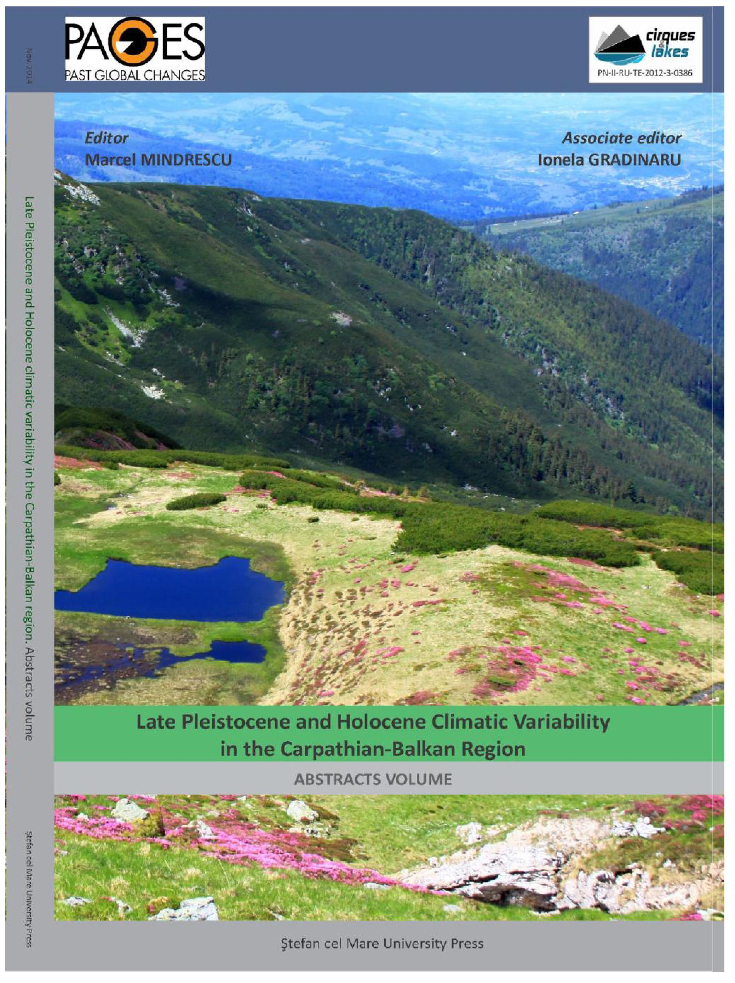

137
ABSTRACTS VOLUME

Regional distribution and relevance in paleonvironmental studies of lakes in
the Tatra Mts. (Western Carpathians)
Joanna Pociask-Karteczka, Agnieszka Gajda and Paweł Franczak
Institute of Geography and Spatial Management, Jagiellonian University, Gronostajowa 7, 30 387 Kraków,
Poland, Joanna.pociask-karteczka@uj.edu.pl, agnieszka.gaida@ui.edu.pl, franczak.p@op.pl

Introduction
Scientific limnological research in the Tatra Mountains were initiated by Stanislaw Staszic in the
early XIX century. After the World War II, the evolution of Tatra lakes was investigated by
Kondracki, Klimaszewski, Baumgart-Kotarba and. Extensive paleolimnological investigations in
the Tatra Mountains were started by the group of scientists led by K. Starmach in the beginning
of the second half of the 20th century.
There has been not much research concerned to the regional distribution of lakes and their
properties in the Tatra Mountains (Pociask-Karteczka 2013). Very early division of lakes
presented A. Gadomski (1922), which distinguished four types of lakes: a) tarns (cirque lake or
corrie loch), b) bedrock-dammed lakes, c) moraine lakes. This division was concerned in
subsequent publications (Choiński 2007). M. Luknis (1973, 1985) recognized additional types:
kettles and landslide-dammed lakes and M. Klimaszewski (1988) - inter-sheepback lakes. J. Pacl
and K. Wit-Jóźwik in Klima Tatier (Pacl, Wit-Jóźwik 1974) were focused on the temperature of
water in lakes in Polish and Slovak parts and M. Borowiak (2000a,b) provided a comprehensive
analysis of types, dimensions, temperature and chemical composition of water in lakes in the
Tatra Mountains.
According to present day state of knowledge, one may distinguish following genetic types of
lakes: I) glacial, II) not-glacial. There are four types of the glacial origin lakes in the Tatra
Mountains (Fig. 1): a) tarns (cirque lakes or corrie loch), b) bedrock-moraine dammed lakes, c)
inter-sheepback lakes, d) moraine lakes, e) kettles.
Most of lakes in the Tatra Mountains are tarns and bedrock-moraine dammed lakes, and they are
located at the elevation over 1400 m a.s.l. in the Western Tatra Mountains, and over 1600 m
a.s.l. in the High Tatra Mountains. Some of them are paternoster lakes - a series of stair-stepped
lakes formed in individual rock basins aligned down the course of a glaciated valley. Lakes in the
Five Polish Lakes Valley is an example of such type. The inter-sheepback lakes occur at higher
elevations (e.g. Wyżnie Mnichowe Stawki, Zamrznute oka). There is a little number of moraine
lakes in the Tatra Mountains (e.g. Smreczyński, Toporowy Niżni) and kettles (e.g. Śtrbske Pleso,
Kotlinowy Stawek). Some lakes are located among rock debris or rock debris and moraine
material (Dwoisty Staw Gąsienicowy, Anitino ocko) - they are of polygenetic origin.
GEOREVIEW
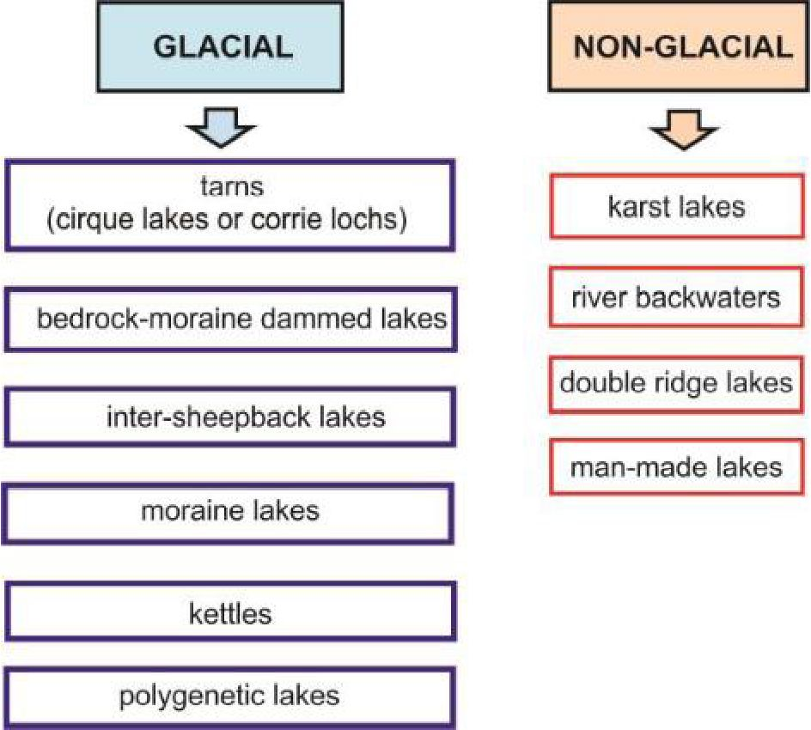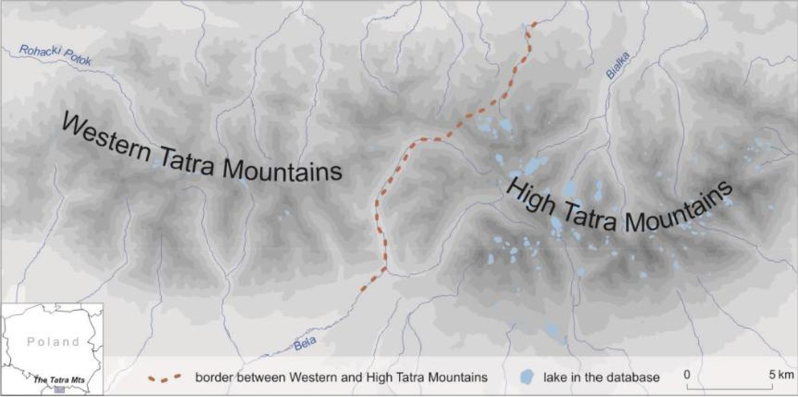
LATE PLEISTOCENE AND HOLOCENE CLIMATIC VARIABILITY IN THE CARPATHIAN-BALKAN REGION 2014
138

Fig. 1 Types of lakes in the Tatra Mountains
There is a diversity of not-glacial lakes in the Tatra Mountains, as follows: karst lakes (Mokra
Jama, Tiche pleso), river backwaters (Rybie Stawki), lake at double ridge (the Kasne Pass) and
man-made lakes (Nove Strbske pleso, the reservoir on the Bystra Creek, ponds at the outlet of
the Olczyska valley).

The aim and methods
The aim of the paper is to contribute to regional characteristics of glacial lakes, which are
prevailing in the Tatra Mountains - the highest part of the Carpathian Mountain chain - and to
gather information about paleoenvironmental studies of their sediments. The Tatra Mountains
are divided into Western Tatra and High Tatra Mountains (Fig. 2). The presented topic constitutes
a background for further research aiming at use sediments of lakes as paleoenvironmental
research.

Fig. 2 The investigation area
GEOREVIEW
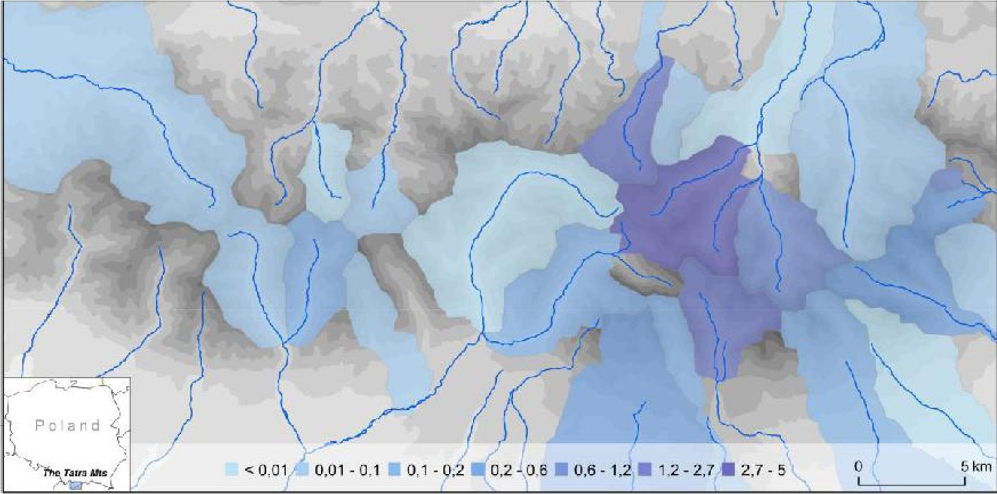
139
ABSTRACTS VOLUME
There is a scarce of papers about entire Tatra region, which had been divided into Polish and
Slovak parts for many years and these parts were treated separately in most of scientific projects.
Five types of lakes were taken into consideration in the Western Tatra Mountains and the High
Tatra Mountains: 1a) major glacial lakes, 1b) minor glacial lakes, 2) shallow glacial lakes, and 3)
peat bogs with pool.
The created lake-geodatabase contains various physiographic characteristics, as altitude, depth,
area, aspect, geology, rocks as well as geometry (polygons) saved in UTM Zone 34N projection.
On the basis of the database, the shares of lakes in river catchments and 500x500 m grid cells
were calculated. The watersheds in the Polish Tatra Mountains were delineated according to the
Map of Hydrographic Division of Poland (Czarnecka 2005), and in the Slovaks part of the
mountains - was delineated on the basis of the SRTM using Hydrology toolbox in ArcGIS 10.2.2.
(Jarvis et al. 2008).

Regional analysis - spatial and vertical distribution of lakes
The Tatra Mountains occupy an area of 785 square kilometres, of which about 610 square
kilometres (77.7%) occur within Slovakia and the rest - on the territory of Poland. There are 298
lakes; eight of them exceed area of 0.1 square kilometr and most of them lie in Polish Tatras.
Lakes occupy the area of about 3.23 square kilometres (0.41%). The lake-geodatabase considered
in the paper includes 188 lakes (3.22 square kilometres). There is no data for about 30% of very
small lakes, so they have been omitted in the lake-geodatabase; most of them are seasonal,
undersized water bodies with the area of no more than of 0,01 square kilometr.
There is a significant difference in spatial lakes' distribution in the Tatra Mountains (Fig. 3). Great
majority of lakes is located in the High Tatra Mountains (156 out of 188 in total) whereas only 32
are located in the Western Tatra Mountains (Table 1). The share of lakes in the upper part of the
Białka River amounts 2.7-5.0% (the High Tatra Mountains), whereas there are no lakes in most of
river catchments in the Western Tatra Mountains (Fig. 1). Majority of lakes in the High Tatra
Mountains (64%) splits into two altitudinal zones between 1600-1799 and 1800-1999 m a.s.l.
(Table 1). Most of them represents shallow glacial lake type (54.5%) likewise in the Western Tatra
Mountains.

Fig. 3 Share of lakes [%] in river catchments in the Tatra Mountains
GEOREVIEW
Table 1 Number of lakes in altitudinal zones in the Tatra Mountains
Altitude [m a.s.l.] | 800-  999 | 1000-  1199 | 1200-  1399 | 1400-  1599 | 1600-  1799 | 1800-  1999 | 2000-  2199 | £2200 | Total
High Tatra Mts. |  | 2 | 9 | 12 | 48 | 51 | 33 | 1 | 156
Major glacial lake |  |  | 1 | 3 | 10 | 3 | 3 |  | 20
Minor glacial lake |  | 1 | 1 | 3 | 6 | 14 | 11 |  | 36
Shallow glacial lake |  |  | 2 | 4 | 26 | 33 | 19 | 1 | 85
Peat bog with pool |  | 1 | 5 | 2 | 6 | 1 |  |  | 15
Western Tatra Mts. | 1 |  | 2 | 8 | 14 | 7 |  |  | 32
Major glacial lake
Minor glacial lake |  |  |  | 1 | 3 | 1 |  |  | 5
Shallow glacial lake | 1 |  | 2 | 5 | 8 | 5 |  |  | 21
Peat bog with pool |  |  |  | 2 | 3 | 1 |  |  | 6
Total | 1 | 2 | 11 | 19 | 62 | 59 | 33 | 1 | 188
There are no major glacial lakes in the Western Tatra Mountains. The number of minor and
shallow glacial lakes equals respectively 5 and 21, i.e. 81.25% of all lakes in this part of the
mountains. Most of them lies in 1600-1799 m a.s.l. altitudinal zone.
The number of grid cells (500x500 m) containing surface of a lake reaches 179 (of 2117 total) in
the High Tatra Mountains and merely 29 (2489 of total) in the Western Tatra Mountains. The
maximal share of lakes in the Western Tatra Mountains does not exceed 5%, whereas it may
reach even about 65% in the High Tatra Mountains.

Sediments in lakes-as paleoclimate indicators
Lake sediments provide a useful means of monitoring and tracking pollutants and the long-term
evolution of the environment in local and regional scale. K. Pasternak (1965) presented chemical
composition of sediments in some Tatra lakes and primary comments on their origin. In the years
1974-1978 a team of Warsaw geographers conducted paleolimnological investigations (Kondracki
1984). Bottom sediments of twelve lakes were sampled. The sickness of lacustrine deposits in the
investigated lakes amounts 1-3 m, and the accumulation rate is diminished with the increasing
elevation (Więckowski 1984). Palynologic analyses and the radiocarbon dating revealed that the
lakes located in cirque lakes were formed in the oldest Dryas (or earlier) whereas moraine lakes
located at lower altitudes emerged at Boreal and the early Atlantic period (Skierski 1984, Stasiak
1984, Wicik 1984). The Cladocera remnants in the lacustrine sediments indicate their oligotrophic
type (Szeroczyńska 1984).
In the 90. of the 20th century, a team of Cracow geomorphologists and geophysicists used
geophysical methods to determine the thickness of sediments in the Morskie Oko Lake. They
found the maximum thickness 7.5 m of postglacial sediments (Baumgart-Kotarba et al., 1996).
The thickness of sediments accumulated in other lakes does not exceed 2.5 m (Baumgart-
Kotarba, Kotarba 1993). The smaller thickness of bottom sediments in the Morskie Oko Lake (less
than 4 m) were identified in the northern part of it. It has been caused probably by intensive
delivery of mineral material from slightly forested slopes (Baumgart-Kotarba et al. 2003).
GEOREVIEW
141
ABSTRACTS VOLUME
The role of the slopes in the transport of mineral material to the lake was investigated by A.
Kotarba (1996). He distinguished three types of lakes: i) lakes without contact with active slopes,
ii) lakes with limited direct contact with active rock slopes, and iii) lakes with contact with the
active slopes. The rate of sedimentation in the first type of lake reaches 0.10 mm per year, and in
the lakes of the third may reach even 0.50 mm per year. Furthermore the rate of sedimentation
in the Holocene has been varied from 0.13 mm per year during the early phase of the Subatlantic
phase to 0.36 mm per year during the Little Ice Age in the Zielony Staw Lake (Kotarba 1992). The
greater variability can be observed in the Morskie Oko Lake, where the rate of sedimentation has
been ranging from 0.10 to 1.29 mm per year (Kotarba 1996).
Research focused on acidification and eutrophication of the Tatra lake ecosystems was
conducted within international environment projects of the European Commission: AL:PE2,
MOLAR and EMERGE in the 90. of 20th and in the beginning of the 21st centuries. As a part of
these research bottom sediments of the lakes were studied also. Sediment cores from nine lakes
were dated radiometrically by ²¹⁰Pb and ¹³⁷Cs. Cores from all lakes had good records of the fallout
radionuclides from which it was possible to construct reliable chronologies of the recent
sediments. Radionuclide inventories and sedimentation rates may vary significantly over even
small areas of the lake. At most study sites there were significant discrepancies between the
atmospheric fluxes of fallout radionuclides and their supply rates to the lake sediments; these
discrepancies are not clear, but are presumably related to predominant fallout during the winter
as snow when it is liable to substantial redistribution by the strong winds experienced in these
environments (Appley, Piliposian 2006). As far bottom sediments of forty selected alpine and
forest lakes were examined to determine their chemistry, correlates with lake water
composition, and to provide data on changes under elevated atmospheric pollution in the second
half of the 20nd century. Sediments in alpine lakes reflect more closely soil composition than
more productive forest lakes. The chemical composition of modern sediments (0-1 cm) differ
from deeper ones due to elevated input of atmospheric pollutants during the second half of the
₂₀th
century, especially in oligotrophic alpine lakes (Kopaćek et al. 2006, Stuchlfk et al. 2006).
Analysis of the post-glacial environmental change on the base of the lake sediments presented
A. Obidowicz (1996), K. Wołowski et al. (2002), Stuchlfk et al. (2002) and Bitusfk et al. (2009).

Conclusions
There are about 300 lakes in the Tatra Mountains and they have a glacial origin. The vast majority
of them (83%) occur in the High Tatra Mountains. This area is supposed to represent at least
disturbed environment in Europe, and lake sediments allow investigate long-term climate and
environmental variability and change. The results of limnological research in the Tatra Mountains
are of great importance to reveal the paleogeography of the Carpathian Mountains.

Acknowledgements
Authors thank to the Department of Spatial Data Management, the Tatra National Park for access to
the GIS-database.
GEOREVIEW
LATE PLEISTOCENE AND HOLOCENE CLIMATIC VARIABILITY IN THE CARPATHIAN-BALKAN REGION 2014
142

References
Appley P.G., Piliposian G.T, 2006, Radiometric dating of sediment records from mountain lakes in the
Tatra Mountains, Biologia, Section Zoology, 61/Suppl. 18, Limnology of lakes in the Tatra
Mountains, S51-S64.
Baumgart-Kotarba M., Dec J., Kotarba A., Ślusarczyk R., 1996, Cechy geomorfologiczne i
sedymentologiczne misy jeziornej Morskiego Oka i górnej części Doliny Rybiego Potoku w świetle
badań geofizycznych, Dokumentacja Geograficzna, 4, 9-31.
Baumgart-Kotarba M., 1993, Późnoglacjalne i holoceńskie osady czarnego Stawu Gąsienicowego w
Tatrach, Dokumentacja Geograficzna, 4-5, 9-30.
Baumgart-Kotarba M., Kotarba A., Dec J., Ślusarczyk R., 2003, Geomorfologiczne poznanie Tatr w
świetle badań geofizycznych, Przegląd Geograficzny, 75(4), 509-524.
Bituśik P., Kubovcfk V., Stefkova E., Appleby P.B., Svitok M., 2009, Subfossil diatoms and chironomids
along an altitudinal gradient in the High Tatra Mountain lakes: a multi-proxy record of past
environmental trends, Hydrobiologia, 631, 1, 65-85.
Buczko K., Magyasi E.K., Bituśik P.,Wacnik A., 2009, Review of late Quaternary paleolilmnological
records in the Carpathian Region, east-central Europe, Hydrobiologia, 631, 3-28.
Borowiak M., 2000a, Jeziora tatrzańskie w świetle dotychczasowych badań [in:] J.T. Czochański, D.
Borowiak D., ed. 2000, Z badań geograficznych w Tatrach Polskich, Wydawnictwo Naukowe UG,
Gdańsk, 2777.
Borowiak D., 2000b, Uzupełniające pomiary batymetryczne jezior tatrzańskich [in:] J.T. Czochański, D.
Borowiak D., ed. 2000, Z badań geograficznych w Tatrach Polskich, Wydawnictwo Naukowe UG,
Gdańsk, 81-96.
Czarnecka H., 2005, Atlas podziału hydrograficznego Polski, IMGW, Warszawa.
Choiński A., 2007, Limnologia fizyczna Polski, Wyd. Naukowe UAM, Poznań.
Gadomski A., 1922, O nowym typie stawów upłazowych, Przegląd Geograficzny 1920-1921, II, 150-
152.
Jarvis A., H.I. Reuter, A. Nelson, E. Guevara, 2008, Hole-filled seamless SRTM data V4, International
Centre for Tropical Agriculture (CIAT), available from http://srtm.csi.cgiar.org.
Kondracki J., 1984, Badania paleolimnologiczne w Tatrach w latach 1974-1978 (Paleolimnological
investigations in the Tatra Mountains in the years 1974-1978), Prace i Studia Geograficzne, 5, 25-
37.
Kopacek J., Borovec J., Hejzlar J., Kotorova I., Stuchlfk E., Vasely J., 2006, Chemical composition of
odern and pre-acidification sediments in the Tatra Mountains, Biologia, Section Zoology,
61/Suppl. 18, Limnology of lakes in the Tatra Mountains, S77-S90.
Kotarba A., 1992, Mountain slope dynamic due to debris-flow activity in the High Tatra Mountains,
Poland, Bulletin de I'Association de Geographes Franęais, Paris, 257-259.
Kotarba A., 1996, Osady jeziorne jako wskaźnik przemian środowiska naturalnego Tatr Wysokich [in:]
A. Kotarba, ed., Z badań fizykogeograficznych w Tatrach, Dokumentacja Geograficzna, 4, 33-47.
Klimaszewski M., 1988, Rzeźba Tatr Polskich, PWN, Warszawa.
Lukniś M., 1973, Relief Vysokych Tatier a ich predpolia, SAV, Bratislava.
GEOREVIEW
143
ABSTRACTS VOLUME
Luknis M., 1985, Prispevok ku geografii tatranskych jazier, Acta FRNUC, Geographica, 25, 113-135.
Obidowicz A., 1996, A late glacial-holocen history of the formation of vegetation belts in the Tatra
Mts., Acta Palaeobotanica, 36(2), 152-206.
Pacl J., Wit-Jóźwik K., 1974, Teplota vod [w:] M. Koncek (red.), Klima Tatier, Slovenska Akademia Vied,
Bratislava.
Pasternak K., 1965,The chemical composition of sediments in some Tatra lakes [in:] K. Starmach, ed.,
Limnological investigations in the Tatra Mountains and Dunajec River Basin, Komitet
Zagospodarowania Ziem Górskich, 11, Polish Academy of Sciences, Kraków, 59-73.
Pociask-Karteczka J., 2013, Badania hydrologiczne w polskich Tatrach po II wojnie światowej [in:] J.
Pociask-Karteczka, ed., On hydrological research in the Tatra Mountains, Tatra National Park,
Institute of Geography and Spatial Management, Jagiellonian University, Zakopane, 35-52. (in
Polish)
Skierski Z., 1984, Wiek i geneza Smreczyńskiego Stawu, Prace i Studia Geograficzne, 5, 81-91.
Stasiak J., 1984, Wiek i ewolucja Szczyrbskiego Jeziora, Prace i Studia Geograficzne, 5, 71-80.
Stuchlfk E., Appleby P., Bituśik P., Curtis C., Fott J., Kopaćek J., Prazakova M., Rose N., Strunecky O.,
Wright R.F., 2002, Reconstruction of Long-Term Changes in Lake water Chemistry, Zooplankton
and Benthos of a Small, Acidified High-Mountain Lake: Magic Modelling and Palaeolimnogical
Analysis Water, Air, and Soil Pollution, Focus, 2, 2, 127-138.
Stuchlfk E., Kopacek J., Fott J., Horicka Z., 2006, Chemical composition of the Tatra Mountain lakes:
Response to acidification, Biologia, Section Zoology, 61/Suppl. 18, Limnology of lakes in the Tatra
Mountains, S11-S20.
Szeroczyńska K., 1984, Analiza Cladocera w osadach niektórych jezior tatrzańskich, Prace i Studia
Geograficzne, 5, 93-102.
Wicik B., 1984, Osady jezior tatrzańskich i etapy ich akumulacji, Prace i Studia Geograficzne, 5, 55-69.
Więckowski K., 1984, Makroskopowa charakterystyka osadów dennych jezior tatrzańskich, Prace i
Studia Geograficzne, 5, 39-54.
Wołowski K., Obidowicz A., Wawrzycka I, 2002, Pediastrum species (Chlorophyceae) in Quaternary
sediments of "Żabie Oko" peat bog in the Tatra Mts., Acta Palaeobotanica, 42(1), 51-61.
GEOREVIEW

