


Dalton Transactions
Magnetic interactions controlled by light in the family of Fe(II)–M(IV) (M = Mo, W, Nb) hybrid organic–inorganic frameworks†
Cite this: Dalton Trans., 2022, 51,
8885
Michał Magott, *a Magdalena Ceglarska, b Michał Rams,
b
Barbara Sieklucka a and Dawid Pinkowicz
a
Three new hybrid organic–inorganic frameworks employing octacyanidometallates and 4,4’-bypiridine dioxide (4,4’-bpdo) as bridging molecules were prepared and characterized. The three-dimensional coordination frameworks {[FeII(µ-4,4’-bpdo)(H2O)2]2[MIV(CN)8]·9H2O}n (Fe2Mo, Fe2W and Fe2Nb; M = Mo, W and Nb) are composed of cyanido-bridged chains, which are interconnected by the organic linkers. Magnetic measurements for Fe2Nb show a two-step transition to the antiferromagnetic state, which results from the cooperation of antiferromagnetic intra- and inter-chain interactions. Fe2Mo and Fe2W, on the other hand, behave as paramagnets at 2 K because of the diamagnetic character of the corres- ponding octacyanidometallate(IV) building units. However, after 450 nm light irradiation they show tran- sition to the metastable high spin MoIV or WIV states, respectively, with distinct ferromagnetic intrachain spin interactions, as opposed to the antiferromagnetic ones observed in the Fe2Nb framework.
Received 11th March 2022, Accepted 19th May 2022
DOI: 10.1039/d2dt00777k
rsc.li/dalton
Introduction
One-dimensional coordination polymers play a central role in the field of molecular magnetism, which emerged with studies of chain assemblies based on radical molecules1,2 and later
suitable building units into 1-D coordination polymers led to the discovery of photo-switchable chain compounds showing light-induced changes in the paramagnetic properties25–27 and in some cases slow magnetic relaxation triggered by UV-vis irradiation.28–32
Herein we demonstrate three analogous cyanido-bridged chains based on iron(II) and three diﬀerent octacyanidometal- lates(IV), which are organized into a three-dimensional (3D) architecture by an organic linker molecule – 4,4′-bipyridine
expanded (SCMs),3–8
with the discovery of Single one-dimensional analogues of
Chain Single
Magnets Molecule
Magnets (SMMs).9 These materials are expected to enable high-density information storage in future devices, due to their molecular character.10–12 However, in order to achieve
(4,4′-bpdo): {[FeII(µ-4,4′-bpdo)(H2O)2]2[MIV(CN)8]·
dioxide
functional control over these units, the appropriate chemical tools need to be developed. In the case of SMMs, ordered molecular architectures were prepared by embedding such molecules in metal–organic frameworks.13–16 Among SCMs, a similar strategy was employed for cobalt(II) compounds17 and only a few examples of iron(II) chains ‘trapped’ inside higher
9H2O}n (M = Mo, W and Nb; Fe2Mo, Fe2W and Fe2Nb). In the
case of Fe2Nb, the intrachain antiferromagnetic (AF) exchange interactions mediated by the cyanido ligands between the NbIV and centers, and interactions transmitted through the long 4,4′-bpdo molecules linking centres and through space, cause a transition to the AF phase below 5.6 K. On the other hand, for compounds comprising diamagnetic octacya- nidomolybdate(IV) (Fe2Mo) or octacyanidotungstate(IV) (Fe2W), the irradiation by 450 nm light activates ferromagnetic intra- chain interactions. To our knowledge, this is the first demon- stration of the octacyanidometallate-centred photomagnetism in FeII–M(CN)8 coordination polymers.
FeII
FeII
far.18–20
dimensional frameworks were described so
The
alternative approach to future magnetic memory devices is based on photo-switchable assemblies, where multiple mag- netic states may be addressed with light.21–24 Introduction of
aFaculty of Chemistry, Jagiellonian University, Gronostajowa 2, 30-387 Kraków,
Poland. E-mail: michal.magott@uj.edu.pl
bJagiellonian University, Institute of Physics, Łojasiewicza 11, 30-348 Kraków, Poland
† Electronic supplementary information (ESI) available: Experimental details, powder X-ray diﬀraction patterns, magnetic measurements, UV-vis and IR spectra, and CIF files. CCDC 2155441–2155443. For ESI and crystallographic data in CIF or other electronic format see DOI: https://doi.org/10.1039/ d2dt00777k
Experimental section
K [NbIV(CN) ]·2H O,33 K [MoIV(CN) ]·2H O,33 K [WIV(CN) ]·
4
8 2
4
8 2
4
8
2H2O34 and 4,4′-bypiridine dioxide35 (4,4′-bpdo) were obtained
Dalton Trans., 2022, 51, 8885–8892 | 8885
This journal is © The Royal Society of Chemistry 2022
Open Access Article. Published on 24 May 2022.
This article is licensed under a Creative Commons Attribution 3.0 Unported Licence.
PAPER View Article Online
View Journal | View Issue

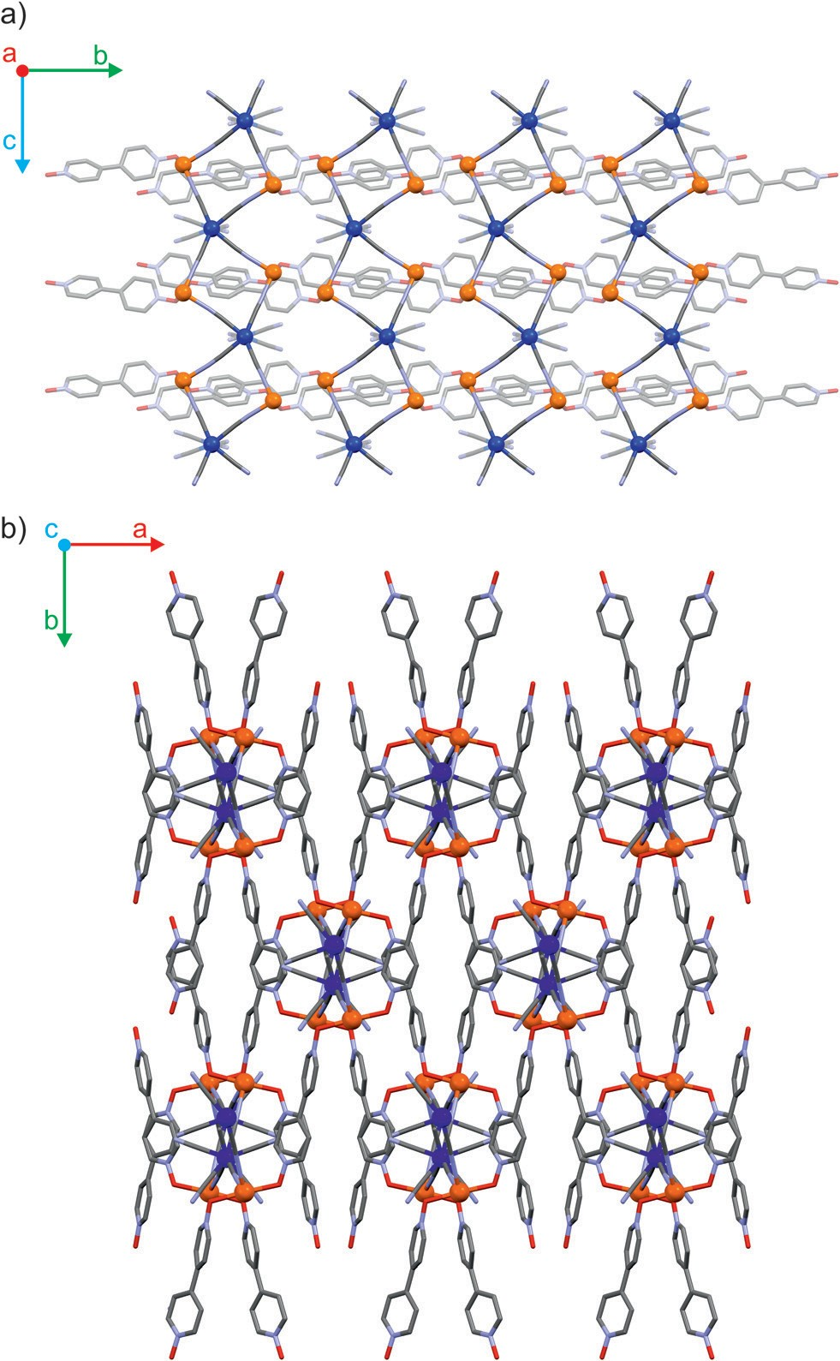
View Article Online
Paper
Dalton Transactions
according to published procedures. All other reagents purchased from Sigma-Aldrich and used as supplied.
were
{[FeII(µ-4,4′-bpdo)(H2O)2]2[MIV(CN)8]·9H2O}n (Fe2Mo for M =
Mo, Fe2W for M = W, and Fe2Nb for M = Nb)
A solution of Fe(NH4)2(SO4)2·6H2O (0.084 mmol, 33 mg) and 4,4′-bypiridine dioxide hemihydrate (0.4 mmol, 80 mg) in
12 mL of water was dropwise added to a solution of the respective potassium octacyanidometallate(IV) (0.05 mmol,
25 mg for octacyanidomolybdate(IV) and octacyanidoniobate (IV), 28 mg for octacyanidotungstate(IV)) dissolved in 10 mL of water. After 24 hours needle-shaped crystals were collected by decantation. Typical yield in 10 repetitions: 15–20 mg (30–40% based on Fe). Sample purity was confirmed by powder X-ray diﬀraction (Fig. S1–3†) and elemental analysis. EA Found for
Fe2Mo: C 32.69, H 3.93, N 16.31; calculated
Fe2MoC28N12O17H42: C 32.77, H 4.12, N 16.38. Found
Fe2W: C 29.74, H 4.08, N 15.05; calculated
for for for
Fe2WC28N12O17H42: C 30.18, H 3.80, N 15.08. Found for Fe2Nb:
C 32.95, H 3.88, N 16.52; calculated for Fe2NbC28N12O17H42: C
32.83, H 4.14, N 16.43. The infrared spectra of the three com- pounds are demonstrated in the ESI (Fig. S4–6†).
Results and discussion
Crystal structures
The three coordination polymers Fe2Mo, Fe2W and Fe2Nb are isomorphous and crystallize in a self-assembly process as needle-shaped crystals in C2/c space group (Table S1† in the ESI†). Iron(II) cations are linked by octacyanidometallate(IV) anions to form vertex-sharing coordination chains (Fig. 1a).
Within each chain, the [MIV(CN)8]4− moieties form four coordi- nation bridges to four iron(II) centres, while the four remaining cyanido ligands are engaged in hydrogen bonds with crystalli- zation water molecules. The coordination sphere of Fe(II) con- sists of two nitrogen atoms of the bridging CN− ligands, two oxygen atoms of 4,4′-bipyridine dioxide molecules in the trans geometry and is completed by two water molecules in the cis configuration (Fig. S7†). Organic linkers bridge iron(II) cations in the anti-configuration,36 connecting inorganic {FeII–NC–
Fig. 1 Schematic representation of cyanido-bridged coordination chains along crystallographic a axis (a) and coordination layers formed by 4,4’-bpdo linker molecules along crystallographic c direction (b) in the structure of Fe2Mo.

substitution of Mo/W with Nb or by a larger electron density at the N3 atom of the [NbIV(CN)8] moiety in Fe2Nb. The presence of these structural motifs may indicate a significant role of anion–pi interactions in the self-assembly process, which was previously studied for other cyanidometallate-based assem- blies with π-deficient molecules/ligands.39,40
MIV}
I1O2
chains into a three-dimensional organic–inorganic
framework37 depicted in Fig. 1b. In all three reported com- pounds, the octacyanidometallate moiety attains a dodecahe- dral geometry and the iron(II) centres exhibit a slightly dis-
torted octahedral environment, as verified by the continuous symmetry measures using SHAPE software38 (Table S2†). The coordination frameworks are stabilized by numerous hydrogen bonds between the water molecules, nitrogen atoms of term- inal cyanides and oxygen atoms of 4,4′-bipyridine dioxide. Interestingly, there are also relatively short contacts between terminal cyanides and centroids of bpdo aromatic rings (Fig. S8†). The corresponding N3–centroid distances are 3.290
(3) Å for Fe2Mo and Fe2W, and 3.230(2) Å for Fe2Nb. The diﬀer- ence of 0.06 Å may be explained by the elongation of the appropriate MIV–CN bond from 2.160(3) Å to 2.255(3) Å upon
Magnetic properties
Fe2Mo and Fe2W comprise paramagnetic iron(II) centres linked by diamagnetic octacyanidometallates(IV). At 250 K they show the χT product of 7.4 cm3 K mol−1 (Fig. 2), indicating that both iron(II) cations are in the high spin state, as can be anticipated for the N2O4 coordination environment of FeII based on the structural data. Below 50 K, these compounds show a distinct decrease of χT, down to 2.0 cm3 K mol−1 at 1.8 K for Fe2Mo and 2.3 cm3 K mol−1 at 1.8 K for Fe2W due to the zero field splitting (zfs) eﬀect and antiferromagnetic interactions
8886 | Dalton Trans., 2022, 51, 8885–8892
This journal is © The Royal Society of Chemistry 2022
Open Access Article. Published on 24 May 2022.
This article is licensed under a Creative Commons Attribution 3.0 Unported Licence.

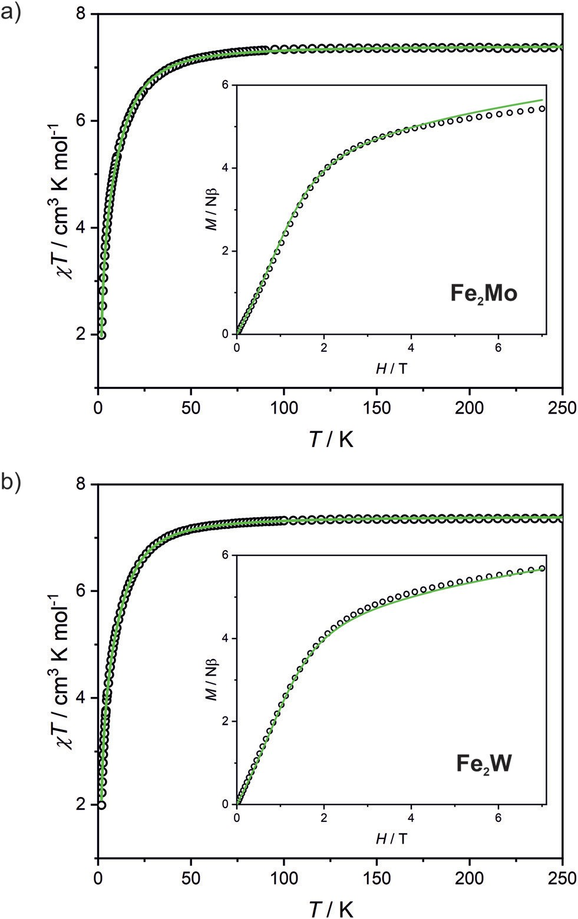
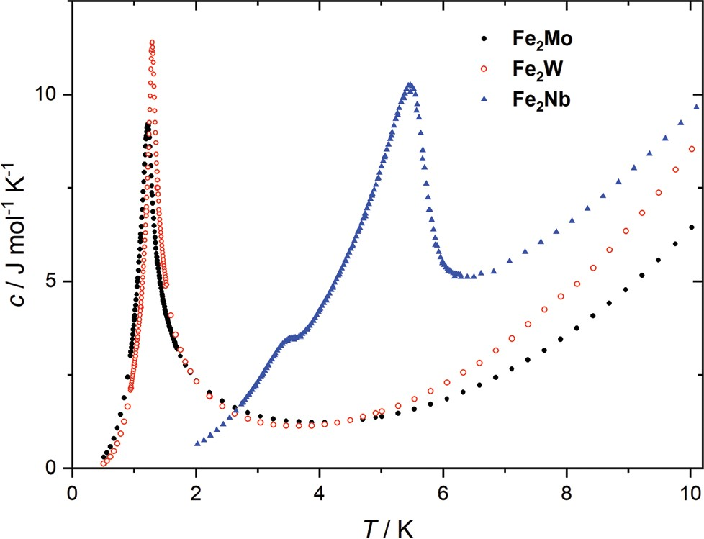
View Article Online
Dalton Transactions
Paper
Table 1 Parameters derived from simultaneous ﬁtting of χT (T ) and
M(H) dependence for the paramagnetic frameworks Fe2Mo and Fe2W
D/cm−1
JFeFe/cm−1
Compound
g
Fe2Mo Fe2W
2.22(3)
2.22(2)
−10.1(1)
−10.0(1)
−0.073(5)
−0.069(3)
meters falling in the expected range for iron(II) systems.44–47 Nonetheless, the obtained J and D should be treated rather as approximate values, as our model does not account for super- exchange interactions transferred by long [–NC–MIV(CN)6–CN–] linkers and dipole–dipole interactions between neighbouring iron(II) ions.
The peaks of specific heat (Fig. 3), observed at Tc = 1.20 K and 1.30 K for Fe2Mo and Fe2W, respectively, demonstrate the magnetic ordering of these compounds. The entropy change for Fe2Mo is 5.71 J mol−1 K−1 from 0.5 to 5 K, which is very close to Rln 2 corresponding to ordering of a spin doublet system, such as the ground state Sz = ±2 doublet of in Fe2Mo. In both cases, over 60% of the entropy change is observed above Tc, in line with the dominant exchange within Fe-bpdo-Fe chains, and much weaker inter-chain inter- actions.48 As aforementioned, the iron(II) cations in Fe2Mo and Fe2W are connected via diamagnetic octacyanidomolybdate(IV) and octacyanidotungstate(IV) linkers. For the Fe2Nb analogue, the presence of the spin s = 1/2 of the octacyanidoniobate(IV), results in higher χT = 7.6 cm3 K mol−1 at 250 K and most importantly, leads to the decrease of χT that starts already below 100 K, indicating antiferromagnetic exchange, JFeNb, via FeII–NC–NbIV bridges (Fig. S9†). Upon further temperature decrease, the χ(T ) measured in fields below 0.8 T reaches a maximum at Tc2 = 5.6 K (Fig. 4a), and another inflection at Tc1
= 3.7 K is observed, resulting in the even faster susceptibility decrease. The specific heat of Fe2Nb (Fig. 3) shows a λ-shaped peak typical for 3D ordering at 5.50 K and also a small feature
FeII
and magnetic ﬁeld
Fig. 2 Temperature dependence of χT at 0.1 T
dependence of magnetization at 1.8 K (inset) recorded for Fe2Mo (a) and
Fe2W (b). Green lines demonstrate the result of χT (T ) and M(H) ﬁtting.
between the FeII centres. The magnetization versus field curves recorded at 1.8 K reach at 7 T values 5.4 Nβ and 5.7 Nβ for Fe2Mo and Fe2W, respectively (Fig. 2, insets). These values are far from the saturation value of 8.8 Nβ expected for two iron(II) ions with g = 2.2, and such behaviour is in line with zfs eﬀect. Measured dependences were quantitatively analysed with the following Hamiltonian:
X
~
~
2
~~
H ¼ ½-
ˆ
2J S
- S
þ Dð
S - 2
g βHS ]
Þþ
FeFe n n
þ1
nz
Fe n
n
assuming that the iron(II) cations with S = 2, as linked by bpdo ligands, are AF coupled into chains. To facilitate calculations, a finite model of a ring comprising 4 such spins was used to fit simultaneously χT (T ) and M(H) dependences using
MAGPACK41 based program. The best fit parameters
JFeFe
(superexchange coupling constant) and D (zfs parameter) sum-
marized in Table 1 are similar for both compounds. The
reported
values are in line with previous studies of
JFeFe
Fig. 3 Speciﬁc heat of Fe2Mo, Fe2W and Fe2Nb, measured at zero mag- netic ﬁeld.
systems bridged by the 4,4′-bpdo linker,42,43 as well as D para-
Dalton Trans., 2022, 51, 8885–8892 | 8887
This journal is © The Royal Society of Chemistry 2022
Open Access Article. Published on 24 May 2022.
This article is licensed under a Creative Commons Attribution 3.0 Unported Licence.

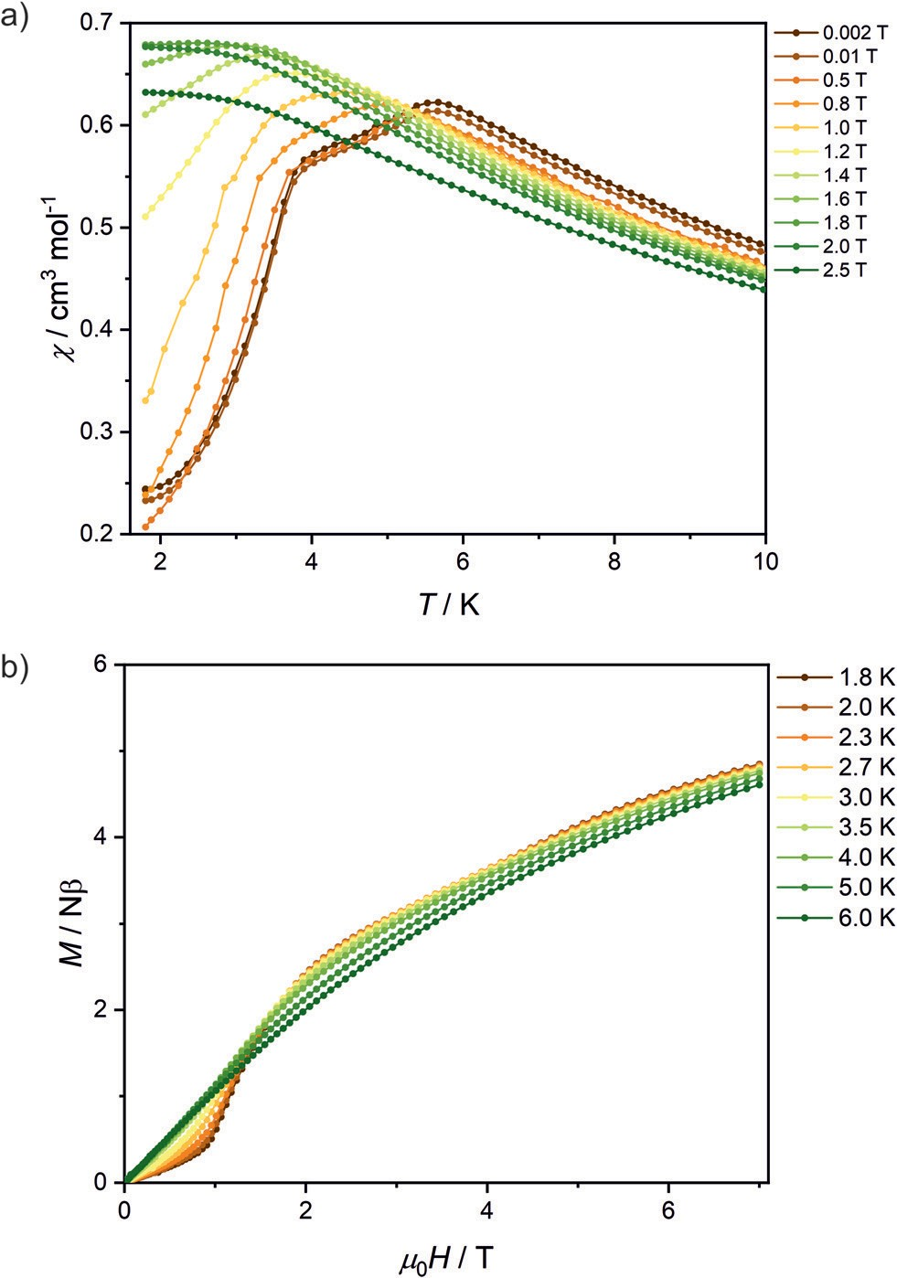
View Article Online
Paper
Dalton Transactions
A smaller M(H) step at Hc2 remains to be related to flipping of Nb spins when the field overcomes the JFeNb interaction. A similar estimation as before leads to JFeNb = −0.24 cm−1 using
−4zJFeNbSs = 2βgNbHc2s for s = 1/2 and z = 4.
Assuming similar zfs in Fe2Nb as in Fe2Mo, the excited zfs state of Fe(II) is above 30 cm−1, which excludes its direct inter- fering with the ground magnetic state in the measured field range. However, still more complicated scenarios of magnetic structures sequence are possible, such as spin rearrangement, because the AF structure is expected to be non-collinear, due to presence of two diﬀerent orientations of Fe(II) in the crystal lattice, and anisotropic zfs ground state of Fe(II).
Photomagnetic properties
Octacyanidomolybdate(IV) and octacyanidotungstate(IV) were demonstrated to behave as photomagnetic chromophores
units).27,49–52
(intrinsic photomagnetic
As aforementioned,
both [MoIV(CN)8]4− and [WIV(CN)8]4− are characterized by dia- magnetic S = 0 ground state, where d2 electrons are paired on a single lowest lying orbital. However, after blue light irradiation
MoIV and may be excited to the metastable S = 1 state, which in the case of K4[MoIV(CN)8]·2H2O was demonstrated to
WIV
arise from the photoinduced cyanide dissociation, yielding heptacyanidomolybdate(IV).53 The initial diamagnetic state may be recovered by heating the sample above a certain temp- erature at which the thermal relaxation is very fast.
In order to test the possibility of a photomagnetic switching in Fe2Mo and Fe2W, the samples of both compounds were cooled to 10 K and subjected to 450 nm light irradiation. This irradiation wavelength was selected based on UV-vis spectra of
Fig. 4 Temperature dependence of χ for various magnetic ﬁelds (a) and magnetic ﬁeld dependence of magnetization at various temperatures (b) recorded for Fe2Nb. Solid lines are guides for an eye.
Fe Mo and Fe W depicted in Fig. S14.† Both compounds show
2
2
broad transition in 450–650 nm range. This band is associated with iron(II)–centred d–d transitions and the d–d transition of the [MoIV(CN)8] and [WIV(CN)8] moieties, respectively.27,53,54 After turning the light on, the sudden drop of the χT is observed (Fig. S15†), which is related to the heating of the samples by ca. 2 K due to the light absorption. Upon contin- ued irradiation, the χT slowly increases as the octacyanidome- tallate(IV) moieties are gradually converted from the S = 0 to the photoexcited S = 1 state. However, even after prolonged irradiation (20 h and nearly 40 h for Fe2Mo and Fe2W, respect- ively) no saturation has been observed, indicating that the photo-conversion to the high-spin state could not be fully com- pleted. Finally, turning the light oﬀ leads to the sudden increase of the χT, resulting from the sample temperature equi- libration. For Fe2Mo, a total increase of χT from 5.4 to
11.4 cm3 K mol−1 is observed after 23 hours of 450 nm irradiation at 10 K, while in the case of Fe2W, the χT product changes from 5.4 to 9.4 cm3 K mol−1 as a result of 39 hours of light exposure. After turning the light oﬀ both compounds show no evolution of the magnetic signal (within 30 minutes). Therefore, both Fe2Mo and Fe2W clearly show light-induced transition to the metastable state with negligible relaxation at 10 K.
After light irradiation at 10 K both Fe2Mo and Fe2W were cooled to 2 K and magnetic field dependence of magnetization
at 3.55 K. Zero-field cooled (zfc) and field cooled (fc) magneti- zation curves for Fe2Nb show no divergence (Fig. S10†), there is no frequency dependence of AC magnetic signal (Fig. S11†) and magnetic hysteresis loop is not observed at 1.8 K (Fig. S12†). A two-step transition is also present in the magne- tization field dependence (Fig. 4b). The first step is visible around μ0Hc1 = 0.95 T at 1.8 K, while a more subtle step starts around μ0Hc2 = 3.8 T (Fig. S13†). All these measurements con- sistently show that Fe2Nb has an AF ground state magnetic structure, but there is also another ordered structure between
Tc1
and Tc2, that is also fully compensated AF at H =
0.
An
identification of involved metamagnetic processes can be inferred by comparison with Fe2Mo, where at a field 0.5 T a
similar step in M(H) curve starts to form (Fig. 2a, inset). This suggests that the transition at Hc1 in Fe2Nb is caused by over- coming of JFeFe interaction by external field, i.e. flipping spins of whole Fe2Nb chains. The condition for such spin–flip:
−4zJFeFeS2 = 2βHc1(2gFeS − gNbs) takes into account z = 4 spin
per one Fe2Nb unit, and eﬀectively
interaction paths
JFeFe
Ising-like exchange in the zfs ground state. This, for S = 2, gFe =
2.2 and gNb = 2.0, leads to JFeFe = −0.10 cm−1, slightly stronger than for Fe2Mo.
8888 | Dalton Trans., 2022, 51, 8885–8892
This journal is © The Royal Society of Chemistry 2022
Open Access Article. Published on 24 May 2022.
This article is licensed under a Creative Commons Attribution 3.0 Unported Licence.

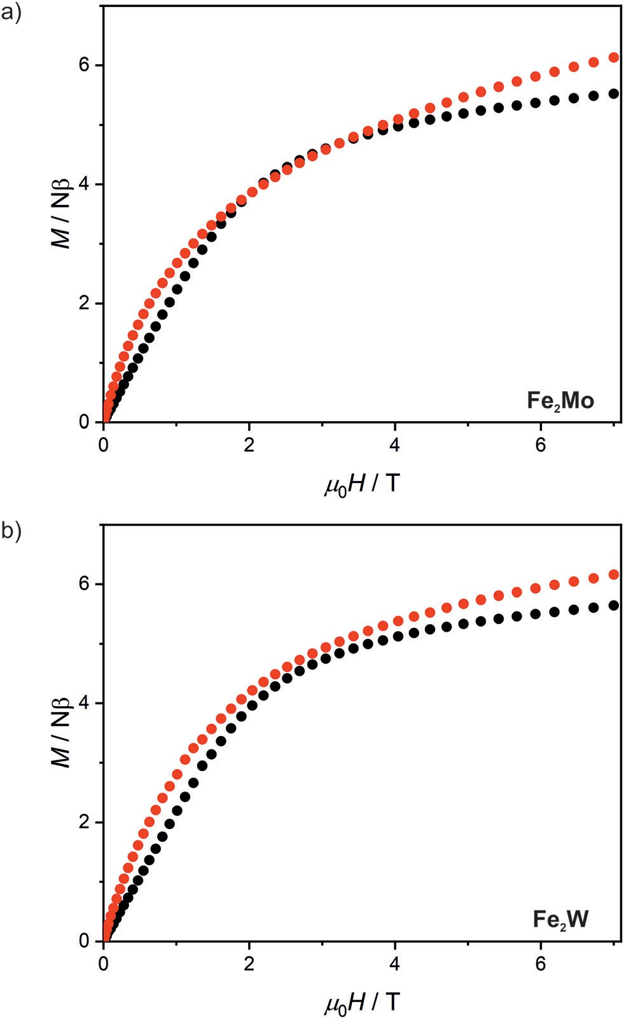
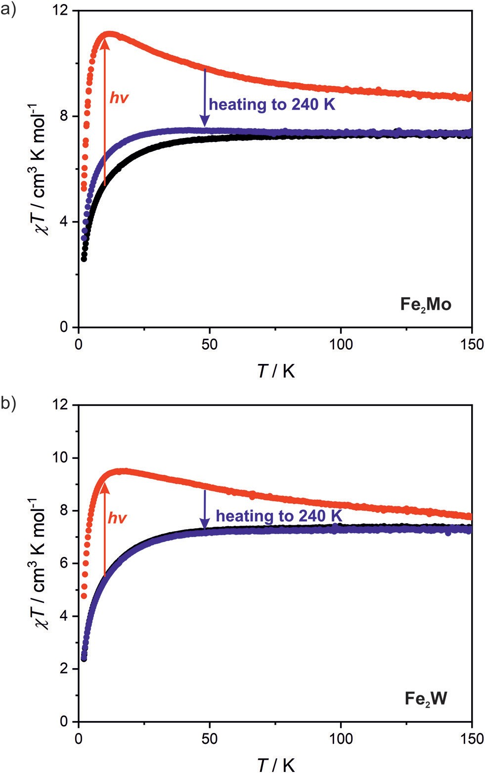
View Article Online
Dalton Transactions
Paper
was recorded (Fig. 5). In the case of Fe2W, the magnetization after irradiation is higher in the whole 0–7 T magnetic field range, reaching 6.15 Nβ as compared to 5.65 Nβ at 7 T before irradiation. The M(H) dependence with M values higher in the whole 0–7 T magnetic field range as compared with the “dark” initial state, indicates ferromagnetic superexchange inter- actions between the FeII and photo-induced S = 1 WIV centres, as opposed to antiferromagnetic superexchange observed in Fe2Nb. The M(H) curve for Fe2Mo also shows higher magneti- zation values after irradiation, with the value at saturation of
6.1 Nβ at 7 T as compared to 5.5 Nβ for the initial “dark” state. However, in the 2–3.5 T magnetic field range there is a distinct overlap of the experimental points recorded before and after light irradiation. This might result from the unaccounted an- isotropy of the photo-induced S =1 MoIV centres53 and/or anti- ferromagnetic interactions between the photo-induced chain fragments in Fe2Mo, which seem to be responsible for the long-range antiferromagnetic ordering in Fe2Nb.
Measurements of magnetization field dependence after blue light irradiation were followed by χT (T ) measurements at
0.1 T in 2–150 K range, which are depicted in Fig. 6 (above 150 K the signal of the sample is almost completely obscured by the diamagnetism of the sample holder, hence, the measurements were stopped at this temperature). The χT for the irradiated states of both compounds shows a significant increase upon heating starting from 2 K and reaching the maximum value of 11.1 cm3 K mol−1 at 11 K for Fe2Mo and
9.5 cm3 K mol−1 at 15 K for Fe2W. The appearance of the maximum indicates ferromagnetic intra-chain interactions via cyanido bridges that compete with the antiferromagnetic inter- chain ones via 4,4′-bpdo linkers. Further heating leads to the gradual decrease of χT for both compounds, at 150 K reaching
8.7 and 7.6 cm3 K mol−1 for Fe2Mo and Fe2W, respectively. Both values are noticeably higher than 7.3 cm3 K mol−1 observed before irradiation, indicating that at 150 K the thermal relaxation is still slow and the initial state is not fully
Fig. 6 Temperature dependence of χT at 0.1 T recorded for Fe2Mo (a) and Fe2W (b) before light irradiation (black points), after 450 nm light irradiation (red points) and after thermal relaxation at 240 K (blue points).
Fig. 5 Magnetic ﬁeld dependence of magnetization at 2.0 K recorded for Fe2Mo (a) and Fe2W (b) before light irradiation (black points) and after 450 nm light irradiation (red points).
Dalton Trans., 2022, 51, 8885–8892 | 8889
This journal is © The Royal Society of Chemistry 2022
Open Access Article. Published on 24 May 2022.
This article is licensed under a Creative Commons Attribution 3.0 Unported Licence.

View Article Online
Paper
Dalton Transactions
This is in line with our previous studies of MoIV/WIV photo- magnetic assemblies55,56 and may indicate better reversibility of the photomagnetic eﬀects in octacyanidotungstate(IV)-based compounds.
restored. The analysis of the slope of the χT curves after irradiation presented in Fig. 6 suggests that Fe2W undergoes thermal relaxation more readily than Fe2Mo. In order to enforce complete restoration of the initial state, both com- pounds were heated to 240 K and kept at this temperature for 1 hour (higher temperatures were avoided to prevent dehydra- tion of the compounds). The χT (T ) curve obtained for Fe2Mo after thermal relaxation still does not overlap perfectly with the initial one below 80 K, indicating the presence of the “remnant” paramagnetic molybdenum centres still present after the irradiation. The χT (T ) curve recorded after the thermal relaxation for Fe2W, on the other hand, shows perfect agreement with that recorded before the irradiation experi- ment. This indicates that octacyanidotungstate(IV) either shows better reversibility of the photo-induced transition or under- goes thermal relaxation in lower temperature range than the octacyanidomolybdate(IV), which is in line with similar pre- vious observations for {[MnII(imH)]2[MIV(CN)8]}n (M = Mo, W) compounds.55,56
Author contributions
M. Magott: conceptualization, investigation, writing – original draft, writing – review & editing; M. Ceglarska: investigation, funding acquisition; M. Rams: investigation, writing – review & editing; B. Sieklucka: funding acquisition, supervision, writing
– review & editing; D. Pinkowicz: conceptualization, funding acquisition, project administration, supervision, writing – review & editing. All authors reviewed and agreed to the final version of the manuscript.
Conﬂicts of interest
There are no conflicts to declare.
Conclusions
We have designed, obtained and characterized three new hybrid organic–inorganic I1O2 coordination frameworks com- posed of inorganic cyanido-bridged chains interconnected by organic linker molecules to form a 3D coordination architec- ture. In the case of octacyanidomolybdate(IV)- and octacyanido- tungstate(IV)-based Fe2Mo and Fe2W compounds, the iron(II) centres are only weakly interacting through the 4,4′-bpdo ligands and their magnetic behaviour is governed mainly by
Acknowledgements
This work was financed by the National Science Centre (Poland) within the OPUS-20 project (Grant No. 2020/39/B/ST5/ 02815). MC thanks Priority Research Area SciMat under the program Excellence Initiative – Research University at the Jagiellonian University in Kraków. The single crystal X-ray diﬀr- action experiments for Fe2Nb were performed on beamline BM01 at the European Synchrotron Radiation Facility (ESRF), Grenoble, France (experiment no. SC-4651). We are grateful to Dr Vadim Dyadkin at the ESRF for providing assistance in using the beamline BM01.
significant zero-field splitting eﬀects associated with FeII.
In
the case of Fe2Nb, the magnetic interactions between spins of iron(II) and niobium(IV) transmitted through the short CN- bridges lead to the emergence of an antiferromagnetic order- ing below 5.6 K with an additional magnetic transition. The complex magnetic behaviour of Fe2Nb results most probably from the hybrid organic–inorganic architecture of this com- pound with the antiferromagnetic FeII–NC–NbIV interactions giving rise to the long-range ferrimagnetic correlation along the inorganic chains, which are further antiferromagnetically coupled to yield a complex 3D magnetic structure. Fe2Mo and Fe2W, on the other hand, show photomagnetic behaviour. The
Notes and references
1
G. A. Candela, L. J. Swartzendruber, J. S. Miller and M. J. Rice, J. Am. Chem. Soc., 1979, 101, 2755–2756.
A. H. Reis, L. D. Preston, J. M. Williams, S. W. Peterson,
G. A. Candela, L. J. Swartzendruber and J. S. Miller, J. Am. Chem. Soc., 1979, 101, 2756–2758.
A. Caneschi, D. Gatteschi, N. Lalioti, C. Sangregorio,
R. Sessoli, G. Venturi, A. Vindigni, A. Rettori, M. G. Pini and M. A. Novak, Angew. Chem., Int. Ed., 2001, 40, 1760– 1763.
R. Clérac, H. Miyasaka, M. Yamashita and C. Coulon, J. Am. Chem. Soc., 2002, 124, 12837–12844.
R. Lescouëzec, J. Vaissermann, C. Ruiz-Pérez, F. Lloret,
R. Carrasco, M. Julve, M. Verdaguer, Y. Dromzee,
D. Gatteschi and W. Wernsdorfer, Angew. Chem., Int. Ed., 2003, 42, 1483–1486.
M. Ferbinteanu, H. Miyasaka, W. Wernsdorfer, K. Nakata, K.-i. Sugiura, M. Yamashita, C. Coulon and R. Clérac, J. Am. Chem. Soc., 2005, 127, 3090–3099.
2
MoIV WIV
light-induced activation of high spin
or
centres,
3
respectively, leads to the appearance of ferromagnetic FeII–NC–
MoIV/WIV superexchange interactions. Therefore, by the appro- priate combination of the chemical design and physical stimuli (light and temperature) one can achieve paramagnetic
4
(Fe2Mo and (Fe2Nb) and
Fe2W before irradiation), antiferromagnetic ferromagnetically-coupled states (Fe2Mo and irradiation) within the {[FeII(µ-4,4′-bpdo)
5
Fe2W after
(H2O)2]2[MIV(CN)8]·9H2O}n (M = Nb, Mo, W) family of com-
pounds. Moreover, when the photo-irradiated Fe2Mo and Fe2W are heated to 240 K in order to reverse the photo-induced changes, the ground diamagnetic state of the octacyanidome- tallate(IV) chromophores can be fully recovered only for Fe2W.
6
8890 | Dalton Trans., 2022, 51, 8885–8892
This journal is © The Royal Society of Chemistry 2022
Open Access Article. Published on 24 May 2022.
This article is licensed under a Creative Commons Attribution 3.0 Unported Licence.
View Article Online
Dalton Transactions
Paper
7
H. Miyasaka, M. Julve, M. Yamashita and R. Clérac, Inorg. Chem., 2009, 48, 3420–3437.
R.-M. Wei, F. Cao, J. Li, L. Yang, Y. Han, X.-L. Zhang,
29
R. Ababei, C. Pichon, O. Roubeau, Y.-G. Li, N. Bréfuel,
L. Buisson, P. Guionneau, C. Mathonière and R. Clérac,
J. Am. Chem. Soc., 2013, 135, 14840–14853.
T. Liu, H. Zheng, S. Kang, Y. Shiota, S. Hayami, M. Mito,
O. Sato, K. Yoshizawa, S. Kanegawa and C. Duan, Nat. Commun., 2013, 4, 2826.
M. Hojorat, H. Al Sabea, L. Norel, K. Bernot, T. Roisnel,
F. Gendron, B. L. Guennic, E. Trzop, E. Collet,
J. R. Long and S. Rigaut, J. Am. Chem. Soc., 2020, 142, 931–936.
Y.-J. Ma, J.-X. Hu, S.-D. Han, J. Pan, J.-H. Li and G.-M. Wang, J. Am. Chem. Soc., 2020, 142, 2682–2689.
G. Handzlik, M. Magott, B. Sieklucka and D. Pinkowicz,
Eur. J. Inorg. Chem., 2016, 2016, 4872–4877.
D. Matoga, J. Szklarzewicz and M. Mikuriya, Inorg. Chem., 2006, 45, 7100–7104.
D. Wang, W. E. Crowe, R. M. Strongin and M. Sibrian- Vazquez, Chem. Commun., 2009, 1876–1878.
J. Jia, A. J. Blake, N. R. Champness, P. Hubberstey,
C. Wilson and M. Schröder, Inorg. Chem., 2008, 47, 8652– 8664.
A. K. Cheetham, C. N. R. Rao and R. K. Feller, Chem. Commun., 2006, 4780–4795.
P. Alemany, D. Casanova, S. Alvarez, C. Dryzun and
D. Avnir, in Reviews in Computational Chemistry, 2017, pp. 289–352.
- Podgajny, D. Pinkowicz, B. Czarnecki, M. Kozieł,
- Chorąży, M. Wis, W. Nitek, M. Rams and B. Sieklucka,
Cryst. Growth Des., 2014, 14, 4030–4040.
E. Kuzniak-Glanowska, J. Kobylarczyk, K. Jedrzejowska,
D. Glosz and R. Podgajny, Dalton Trans., 2021, 50, 10999– 11015.
J. J. Borrás-Almenar, J. M. Clemente-Juan, E. Coronado and
B. S. Tsukerblat, J. Comput. Chem., 2001, 22, 985–991.
M. Yuan, S. Gao, F. Zhao, W. Zhang and Z. Wang, Sci. China, Ser. B: Chem., 2009, 52, 266–275.
D. Pinkowicz, M. Rams, W. Nitek, B. Czarnecki and
B. Sieklucka, Chem. Commun., 2012, 48, 8323– 8325.
R. Boča, Coord. Chem. Rev., 2004, 248, 757–815.
A. Ozarowski, S. A. Zvyagin, W. M. Reiﬀ, J. Telser, L.-C. Brunel and J. Krzystek, J. Am. Chem. Soc., 2004, 126, 6574–6575.
G. Novitchi, S. Jiang, S. Shova, F. Rida, I. Hlavička,
- Orlita, W. Wernsdorfer, R. Hamze, C. Martins,
- Suaud, N. Guihéry, A.-L. Barra and C. Train, Inorg. Chem., 2017, 56, 14809–14822.
C. Rojas-Dotti, N. Moliner, R. González and J. Martínez- Lillo, J. Coord. Chem., 2018, 71, 737–747.
R. L. Carlin, Magnetochemistry, Springer, Berlin, Heidelberg, 1986.
N. Bridonneau, J. Long, J. L. Cantin, J. von Bardeleben,
- Pillet, E. E. Bendeif, D. Aravena, E. Ruiz and V. Marvaud,
Chem. Commun., 2015, 51, 8229–8232.
- Korzeniak, R. Jankowski, M. Kozieł, D. Pinkowicz and B. Sieklucka, Inorg. Chem., 2017, 56, 12914–12919.
8
Z. Zhang, X.-Y. Wang and Y. Song, 24372.
Sci. Rep., 2016, 6,
30
9
S. M. J. Aubin, M. W. Wemple, D. M. Adams, H.-L. Tsai,
G. Christou and D. N. Hendrickson, J. Am.
1996, 118, 7746–7754.
Chem. Soc.,
31
10
R. Sessoli, D. Gatteschi, A. Caneschi and M. A. Novak,
Nature, 1993, 365, 141–143.
L. Bogani, A. Vindigni, R. Sessoli and D. Gatteschi, J. Mater. Chem., 2008, 18, 4750–4758.
J. M. Frost, K. L. M. Harriman and M. Murugesu, Chem. Sci., 2016, 7, 2470–2491.
G. Huang, G. Fernandez-Garcia, I. Badiane, M. Camarra,
- Freslon, O. Guillou, C. Daiguebonne, F. Totti, O. Cador,
- Guizouarn, B. Le Guennic and K. Bernot, Chem. – Eur. J., 2018, 24, 6983–6991.
L. H. G. Kalinke, D. Cangussu, M. Mon, R. Bruno,
E. Tiburcio, F. Lloret, D. Armentano, E. Pardo and J. Ferrando-Soria, Inorg. Chem., 2019, 58, 14498–14506.
D. Aulakh, L. Liu, J. R. Varghese, H. Xie, T. Islamoglu,
K. Duell, C.-W. Kung, C.-E. Hsiung, Y. Zhang, R. J. Drout,
O. K. Farha, K. R. Dunbar, Y. Han and M. Wriedt, J. Am. Chem. Soc., 2019, 141, 2997–3005.
S. Chorazy, R. Podgajny, W. Nitek, M. Rams, S.-i. Ohkoshi and B. Sieklucka, Cryst. Growth Des., 2013, 13, 3036–3045.
M. Wang, X. Gou, W. Shi and P. Cheng, Chem. Commun., 2019, 55, 11000–11012.
Y.-Z. Zheng, W. Xue, M.-L. Tong, X.-M. Chen, F. Grandjean and G. J. Long, Inorg. Chem., 2008, 47, 4077–4087.
Y.-Q. Wang, Q. Yue, Y. Qi, K. Wang, Q. Sun and E.-Q. Gao,
Inorg. Chem., 2013, 52, 4259–4268.
J. Chen, Y. Sekine, Y. Komatsumaru, S. Hayami and
H. Miyasaka, Angew. Chem., Int. Ed., 2018, 57, 12043– 12047.
N. O. Moussa, G. Molnár, S. Bonhommeau, A. Zwick,
- Mouri, K. Tanaka, J. A. Real and A. Bousseksou, Phys. Rev. Lett., 2005, 94, 107205.
- Matsumoto, G. N. Newton, T. Shiga, S. Hayami,
Y. Matsui, H. Okamoto, R. Kumai, Y. Murakami and
H. Oshio, Nat. Commun., 2014, 5, 3865.
M. Arczyński, J. Stanek, B. Sieklucka, K. R. Dunbar and D. Pinkowicz, J. Am. Chem. Soc., 2019, 141, 19067–19077.
J.-P. Launay and M. Verdaguer, Electrons in Molecules: From Basic Principles to Molecular Electronics, Oxford University Press, 2014.
J. Long, L.-M. Chamoreau, C. Mathonière and V. Marvaud,
Inorg. Chem., 2009, 48, 22–24.
T. Korzeniak, S. Sasmal, D. Pinkowicz, W. Nitek, R. Pełka,
D. Czernia, O. Stefańczyk and B. Sieklucka, Inorg. Chem., 2020, 59, 5872–5882.
M. Magott, O. Stefańczyk, B. Sieklucka and D. Pinkowicz,
Angew. Chem., Int. Ed., 2017, 56, 13283–13287.
T. Liu, Y.-J. Zhang, S. Kanegawa and O. Sato, J. Am. Chem. Soc., 2010, 132, 8250–8251.
11
32
12
33
13
34
35
14
36
15
37
38
16
39
17
18
40
19
41
20
42
21
43
22
44
45
23
46
24
25
47
26
48
49
27
28
50
Dalton Trans., 2022, 51, 8885–8892 | 8891
This journal is © The Royal Society of Chemistry 2022
Open Access Article. Published on 24 May 2022.
This article is licensed under a Creative Commons Attribution 3.0 Unported Licence.
View Article Online
Paper
Dalton Transactions
- M. Magott, M. Sarewicz, S. Buda and D. Pinkowicz, Inorg. Chem., 2020, 59, 8925–8934.
- X. Qi, P. Guionneau, E. Lafon, S. Perot, B. Kauﬀmann and
C. Mathonière, Magnetochemistry, 2021, 7, 97.
- X. Qi, S. Pillet, C. de Graaf, M. Magott, E.-E. Bendeif,
P. Guionneau, M. Rouzières, V. Marvaud, O. Stefańczyk,
D. Pinkowicz and C. Mathonière, Angew. Chem., Int. Ed., 2020, 59, 3117–3121.
54 M. F. A. Hendrickx, V. S. Mironov, L. F. Chibotaru and A. Ceulemans, Inorg. Chem., 2004, 43, 3142–3150.
- M. Magott, M. Reczyński, B.
D. Pinkowicz, J. Am. Chem.
15882.
- M. Magott, B. Gaweł, M.
Gaweł, B. Sieklucka and
Soc., 2018, 140, 15876–
Sarewicz, M. Reczyński,
K. Ogorzały, W. Makowski and D. Pinkowicz, Chem. Sci., 2021, 12, 9176–9188.
8892 | Dalton Trans., 2022, 51, 8885–8892
This journal is © The Royal Society of Chemistry 2022
Open Access Article. Published on 24 May 2022.
This article is licensed under a Creative Commons Attribution 3.0 Unported Licence.

