



This is an open access article published under a Creative Commons Attribution (CC-BY) License, which permits unrestricted use, distribution and reproduction in any medium, provided the author and source are cited.

http://pubs.acs.org/journal/acsodf

Impact of Doxorubicin on Self-Organization of Congo Red: Quantum Chemical Calculations and Molecular Dynamics Simulations
Article


Klaudia Kwiecinśka, Anna Stachowicz-Kusńierz, Anna Jagusiak, Irena Roterman, and Jacek Korchowiec*
Cite This: ACS Omega 2020, 5, 19377−19384

ACCESS Metrics & More Article Recommendations *sı Supporting Information

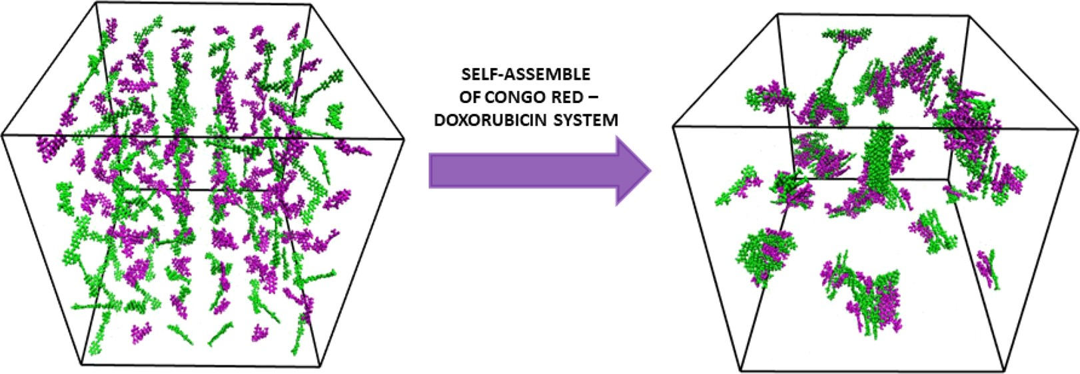
ABSTRACT: Quantum-chemical calculations and molecular dynamics simulation were applied to a model self-organization process of Congo red (CR) molecules in aqueous solution and the impact of doxorubicin (DOX) molecules on such a process. It was demonstrated that both pure CR/CR and mixed CR/DOX dimers were stable. Van der Waals interactions between aromatic units were responsible for a stacked dimer formation. An important source of stabilization in the CR/CR dimer was the polarization energy. In the CR/DOX mixed dimer long range, electrostatic interactions were the main driving force leading to complexation. An implicit solvent model showed that the formation of the CR/CR dimer was favored over the CR/DOX one. Molecular dynamics simulations demonstrated rapid complexation. In the pure CR system, short sequences of ribbon-like structures were formed. Such structures might be glued by hydrogen bonds to form bigger complexes. It was shown that the aromatic part of the DOX molecule enters CR ribbons with the sugar part covering the CR ribbons. These ﬁndings demonstrated that CR may ﬁnd applications as a carrier in delivering DOX molecules; however, further more extensive investigations are required.

INTRODUCTION
Development of supramolecular chemistry opens up new
horizons for many ﬁelds of science. The chemistry of such molecular systems is ruled by weak intermolecular interactions,
e.g., van der Waals forces, hydrogen bonds, and π−π and
electrostatic interactions. The presence of noncovalent
interactions between organic molecules allows the formation of large self-assembled supramolecular structures.1−3 This kind
of multimolecular structure is characterized by high elasticity and a large surface area. These properties enabled some supramolecular associates to form complexes with proteins,
which in general are compounds that are unable to interact at sites other than the active site.4
Congo red (CR) is an example of a self-assembling supramolecular compound creating ribbon-like structures related to the association of ﬂat, polyaromatic parts of these molecules. It belongs to the azo dye group, and it is used especially as an indicator and biological stain. CR has been used for over a century to demonstrate the presence of
amyloidal deposits in tissue, e.g., in brain tissue, or in the heart5 or kidneys6 in the diagnosis of Alzheimer’s disease.

Amyloid ﬁbers bind to Congo red, giving the eﬀect of apple- green birefringence under a polarized light microscope, which remains the gold standard in recognizing amyloid deposits.7,8 Congo red is also often used as a model dye in evaluating the eﬀectiveness of various materials that catalyze the degradation of organic pollutants in water.9,10 The structure of Congo red is symmetrical. Its central part consists of a biphenyl ring linked through azo bonds with naphthalene rings substituted with sulfone and amino groups. Individual molecules interact with each other to form larger supramolecular, ribbon-like structures. The polyaromatic structure of Congo red enables
intercalation of various compounds with planar groups, e.g., the doxorubicin (DOX) drug.

Received: March 11, 2020
Accepted: July 14, 2020
Published: July 27, 2020


© 2020 American Chemical Society

19377
https://dx.doi.org/10.1021/acsomega.0c01095
ACS Omega 2020, 5, 19377−19384

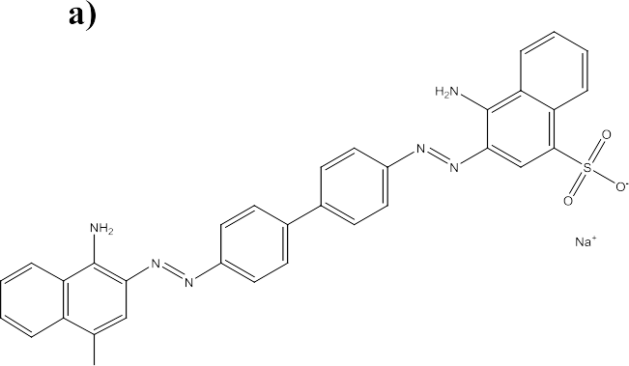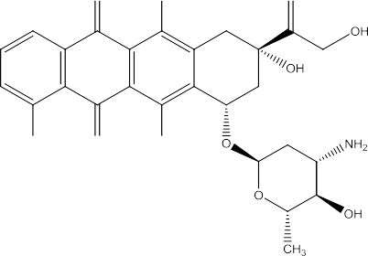

Figure 1. Structure of (a) Congo red and (b) doxorubicin.

Doxorubicin is an anthracycline antibiotic commonly used as an anticancer drug. The mechanism of doxorubicin action is associated with the formation of a stable complex with DNA, thus inhibiting further cell division ultimately causing its death. Unfortunately, chemotherapy is not an ideal treatment method. Cytostatics used in this treatment destroy all rapidly dividing cells, including normal cells, which causes numerous side eﬀects for the human body. Currently, new solutions are sought in order to reduce the therapeutic dose of the drug while maintaining its eﬀectiveness and reducing its toxicity to normal cells. One of these possible solutions is the use of drug carriers.
The self-assembled ribbon-like structures that form elongated Congo red systems owing to their unique properties are used in targeted drug delivery to cancer tissue.10 Such systems are an example of a new type of ligand for proteins to
which they bind using a nonclassical mode of interaction.4 An example is binding to antigen−antibody complexes while not binding to free antibodies.11 This interaction is the basis for the use of such systems in immunotargeting.12 At the same time, CR systems eﬀectively bind to various molecules, including drugs, to form co-micelles with them.13 Research
to date has demonstrated the possibility of using CR systems in vivo as potential drug carriers. These systems easily bound to the immune complexes formed in the body and then were gradually removed. This gives the potential for use in immunotargeting, and an additional advantage is the easy removal of excess unused drug from the body.11 In this work, the formation of Congo red supramolecular assemblies is investigated and its possible use as a carrier system for doxorubicin, a model anticancer drug, is considered. We focus on the microscopic description of CR and CR/DOX clusters,

B3LYP/6-311G(d,p) level of theory. All located minima on the energy surface were veriﬁed by vibration frequency analysis. The nature of interactions was characterized by a self- consistent charge and conﬁguration method for subsystems (SCCCMS).16
The SCCCMS scheme has been described elsewhere.16,17 The scheme is based on a simple model of mutual interactions among reactants. The molecular system M = AB is partitioned into reactants A and B. The calculations for reactant A (B) are performed in the presence of the reaction partner B (A) emulated by its charge distribution. The charges ﬁtted to the
molecular electrostatic potential were employed (CHELP scheme). Calculations are terminated after the convergence in electronic structures and charge distributions is achieved. The SCCCMS calculations are performed for diﬀerent oxidation states of A and B. In such a way, the energy surface spanning the population space (NA, NB) is constructed. The idea of SCCCMS is shown in Figure 2 that illustrates the cut of the

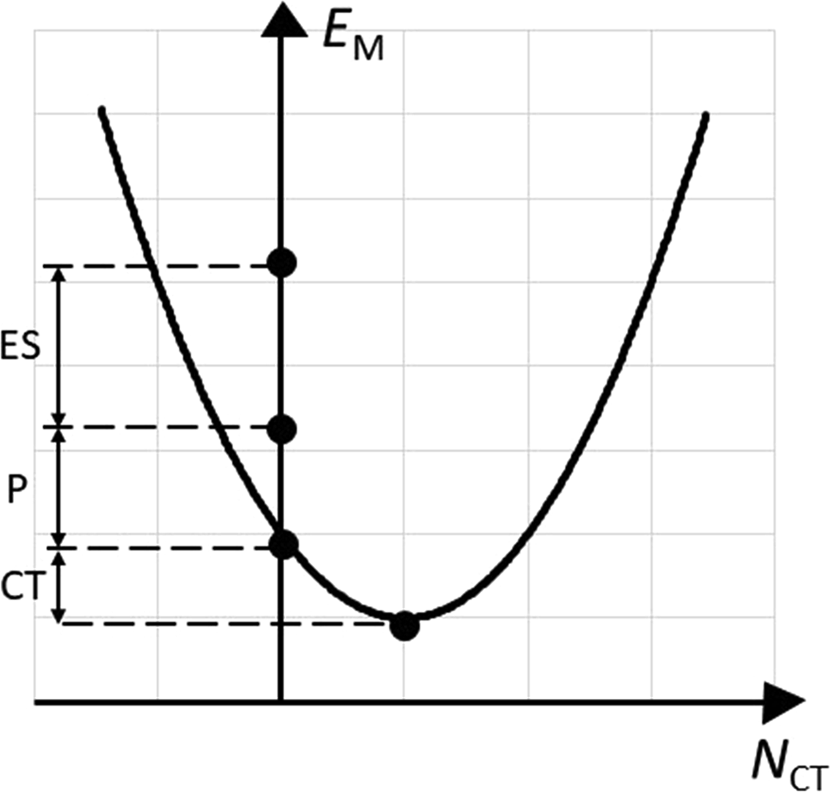
Figure 2. Cut of the energy surface along the isoelectronic line, E =
including interactions responsible for dimer stabilization, the
inﬂuence of solvent (water), and the mechanism of the
EM(N
CT), together with hypothetical stages of charge
M
reorganization
clustering process in aqueous solution.

COMPUTATIONAL DETAILS
All quantum-chemical calculations were carried out using the
Gaussian 09 suite of programs.14 The structures of DOX and CR (see Figure 1) were located at the density functional level of theory, i.e., the hybrid B3LYP functional with a 6-311G(d,p) basis set. The Grimme dispersion correction was taken into account.15 The located optimum structures of the monomers
within the SCCCMS scheme, marked by closed circles. ES, P, and CT denote electrostatic, polarization, and charge transfer energies, respectively.

energy surface along the charge-transfer (CT) direction, NCT = dNA = − dNB > 0. The circles correspond to hypothetical stages of the charge reorganization: (i) isolated (non-
interacting), (ii) rigid (interacting), (iii) polarized, and (iv) open reactants. The energy change along the isoelectronic line
is given as ΔEM = EM − E 0 = μCTNCT + 1 ηCTN2T. The
M 2 C
CT
were used to prepare the initial structures of CR/CR and CR/ DOX dimers. These structures were further optimized at the
CT chemical potential and hardness are deﬁned as μCT = (∂EM/∂NCT)v = μB − μA ≤ 0 and ηCT = (∂2EM/∂N2 ) = ηAA +
ηBB − 2ηAB > 0. The reactant chemical potentials (μA and μB) and hardness values (ηAA, ηBB, and ηAB) are given by the following partial derivatives: μA = (∂EM/∂NA)N , v, μB = (∂EM/
B
∂NB)N , v, ηAA = (∂2EM/∂N2 )N , v, ηBB = (∂2EM/∂N2 )N , v, and
on a cube grid. A random orientation of each molecule was used. The CR anions were neutralized by sodium cations. Simulations at constant temperature (T = 293 K) and pressure (pn = 1 bar) were employed. These simulations were preceded
A A B
BB A
by energy minimization and 10 ns canonical (NVT, number of
ηAB = (∂2EM/∂NA∂NB)v, respectively. The additional constraint imposed on derivatives, v = v(r)⃗, is the external potential due to nuclei. Here, we do not consider derivatives with respect to v(r)⃗. In other words, the positions of nuclei were ﬁxed. Notice that the ﬁrst (electron density) and second-order energy derivatives (linear response function) with respect to the
external potential as well as the mixed second-order derivatives (Fukui function) are of special importance in the theory of chemical reactivity. For details, see the excellent works in the
particles, volume, and temperature) ensemble simulations. The (NpnT) ensemble was applied for 120 ns. The ratio of the x and y box sizes was constant. Five independent trajectories were computed for each molecular system, and their average is reported as the ﬁnal result.

RESULTS
■
In Table 1, we have listed the interaction (INT) energies and their components for dimer systems. To the best of our
ﬁeld of conceptual density functional theory.18−20 The
SCCCMS scheme utilizes the polarization approximation. The energy diﬀerence among hypothetical stages deﬁnes electrostatic (ES), polarization (P), and charge-transfer (CT) energies. Due to polarization approximation, the minimum of the parabola does not correspond to energy of the super- molecule. The diﬀerence, depending on the level of theory,
includes exchange (Hartree−Fock method) or exchange and correlation (Kohn−Sham and post-Hartree−Fock methods)
contributions. In addition, it contains Grimme dispersion corrections. For this reason, it will be called van der Waals
(VdW) energy. Notice that only two points shown in Figure 2 have a clear physical meaning. The ﬁrst point corresponds to the intra-reactant equilibrium [point of the parabola at EM(NCT
Table 1. Interaction Energies and Their Components Computed at the B3LYP/6-311G(d,p) Level of Theory for CR/CR (Second Column) and CR/DOX (Third Column)
Dimers; All Values Are in kcal/mol
energy CR/CR CR/DOX
INT 19.2 −60.5
ES 73.9 −25.0
P −31.5 −11.8
CT −0.0 −0.4
VdW −23.2 −23.3
DEF 16.8 11.4
b 36.0 −49.1
= 0) = EP , polarized reactants before CT, M = (A | B)], μA =
M
μA(r)⃗≠ μB = μB(r)⃗, and the second point corresponds to the global equilibrium [the minimum of the parabola, open reactants in supermolecule M = (A⋮B)], μA = μA(r)⃗= μB = μB(r)⃗= μM. The information from the energy surface can be utilized to compute for the charge reorganization accompany-
ing P and CT processes as well as the CT Fukui function and its components.21
Additional information regarding aﬃnity of CR and DOX toward self-organization was derived from molecular dynamics (MD) simulations. The CR/DOX systems were previously
knowledge, CR/CR and CR/DOX dimers were not described previously in the literature. The interaction energy was
computed using a supermolecular approach: EINT = EAB −
EA − EB where the energies EA and EB are calculated for
monomers having the same geometry as in the dimer. The
basis set superposition error was eliminated using the counterpoise method of Boys and Bernardi.30 The total binding (b) energy should be supplemented by the deformation energy (shown in the last row of Table 1), EDEF
= EA + EB − E0 − E0 ≥ 0. This term is positive, and the
discussed by Jagusiak and Panczyk;22 however, the AMBER
A
energies of the
B
in the minimum structures E0 and E0
reactants A B
force-ﬁeld parameterization of CR did not support self- organization of these molecules, which was observed experimentally.23 This divergence can be attributed to the charge distribution that in the AMBER force ﬁeld is derived by ﬁtting to the molecular electrostatic potential of the isolated molecule. For this reason, CR and DOX molecules were parameterized in the CHARMM force ﬁeld using a force ﬁeld toolkit of VMD graphical software.24 In contrast to the AMBER charges, the CHARMM charges are derived by reproducing the interaction energies of hydrogen donor and hydrogen acceptor atoms of the CR or DOX molecule with water molecules. It can be expected that this will improve the description of CR and CR/DOX aggregates.
The MD calculations were carried out using the NAMD package25 with periodic boundary conditions imposed on the system. An all-atom CHARMM force ﬁeld26,27 was used. The TIP3P model28 was adopted for water. The VMD software was applied to visualize the trajectories and compute selected quantities. Density-based cluster analysis of the trajectories was performed with the dbcscan function of the R package.29
In all calculations, the number of atoms (N) in the simulation box was greater than 200,000. The initial conﬁguration was obtained by placing the target molecules
are more negative than in dimer geometries. As one would expect, P and CT energies are stabilizing (negative) while DEF is destabilizing (positive). The highest destabilization con- tribution to the INT energy in the CR/CR system is the ES term. This behavior was not surprising because the CR is negatively charged. This energy term in a mixed CR/DOX system is negative; therefore, the ES term should enhance the self-organization of molecules or at least promote the incorporation of DOX molecules into ribbon-like supra- molecular structures of CR. The polarization energy is the most stabilizing eﬀect in the CR/CR dimer. The polarization contribution in CR/CR is almost three times higher than in the CR/DOX dimer. The second highest is VdW energy. Except DEF energy, the remaining contribution to CR/DOX stabilizes the dimer formation.
Dimerization enthalpies and Gibbs free energies are summarized in Table 2. Data corresponding to vacuum and the implicit solvent model, namely, the polarizable continuum model (PCM),31 are reported. The temperature and entropy eﬀects did not change the trends observed in INT (b) energies.
Binding enthalpy and Gibbs free energies collected in Table 2 favor the formation of a CR/DOX dimer. This picture changes for the PCM water model. The formation of a CR/CR dimer is
Table 2. Binding Enthalpy and Gibbs Free Energy in Vacuum and the Implicit Solvent Model (PCM) Computed at the B3LYP/6-311G(d,p) Level of Theory for T = 293 K and p = 1 bar; All Energies Are in kcal/mol

molecular system | ΔH | vacuum | ΔG | PCM model
 |  |  |  | ΔH | ΔG
CR/CR 19.3 44.8 −56.1 −30.6
CR/DOX −61.0 −40.2 −38.6 −17.3

now preferred. This observation supports the self-organizing ability of CR in water. To check whether these conclusions do not depend on the functional type, the binding enthalpy and binding free enthalpy were calculated at the M062X/6- 311(d,p) level of theory. The calculated data are collected in Table S1. The same conclusions follow from reported data, namely, the reverse of stability of CR/DOX and CR/CR dimers when going from vacuum to the implicit water model. Additional support for the observed reverse in stability of CR/ DOX and CR/CR dimers when going from vacuum to the implicit water model results from polarization (Table 1). The stabilization due to polarization energy in CR/CR dimers is three times greater than in the CR/DOX dimer. The self- consistency in PCM calculations, namely, the polarization of solute and backpolarization of dielectric medium, will depend on this particular feature of charge distribution.
To understand the nature of stabilization in dimers, quantum theory of atoms in molecules (QTAIM) was applied. Topological properties of electron density have been shown to correlate with the strength of intermolecular interactions.32,33
Here, bond critical points (BCPs) were used to detect the bonding pattern. The existence of bond paths between the atoms of diﬀerent monomers is a clear indicator of bonding contacts. Further classiﬁcation can be done by the value of the electron density at the BCP, ρBCP. In the CR/CR system, there are 28 BCPs between CR monomers. The value of the electron density at BCPs ranges from 0.004 to 0.031 a.u. In this variety

of BCPs, there are four hydrogen bonds of the N−H O type (ρBCP ≈ 0.03 a.u.) and four hydrogen-like bonds of the C− H O type involving aromatic carbon atoms (ρBCP ≈ 0.01

a.u.). The Laplacian of the electron density at the hydrogen bonds is within the 0.038−0.105 a.u. range. Both sets of data at bond critical points are in agreement with topological criteria
of the existence of hydrogen bonding as proposed by Koch and Popelier.33 In accordance with these rules, there is a loss of electron density in the area of hydrogen atoms. It is reﬂected by negative isosurfaces ΔρP(r)⃗= ρP(r)⃗− ρ0(r)⃗shown in Figure S1 of the Supporting Information. There is no charge ﬂow due to charge transfer, so the change in density is dominated by polarization process: ΔρM(r)⃗= ρM(r)⃗− ρ0(r)⃗≈ ΔρP(r)⃗. The charge distribution in the CR/CR dimer is softer than in the CR/DOX dimer. Namely, the changes in ΔρM(r)⃗ (CR/CR dimer) are spread over the whole system, while in the
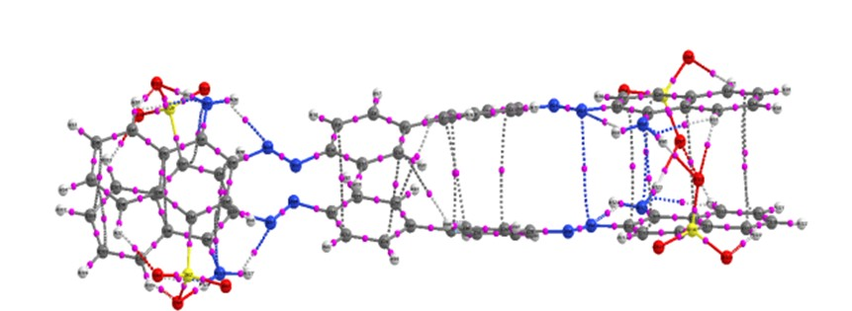

Figure 3. Inter-reactant bond paths for (a) CR (a) and (b) CR/DOX.
mixed dimer, they have a more local character. This observation also supports the reverse of stability of CR/DOX and CR/CR dimers in the implicit water model compared to vacuum. The remaining contacts are of van der Waals nature: 4
N C (ρBCP ≈ 0.007 a.u.), 13 C C, 2 H C, and 1 N N
   
contacts with the Laplacian of the electron density positive and
lower than 0.02 a.u. Majority of detected contacts are responsible for stacking interactions. The number of bonding paths in the CR/DOX dimer is equal to 22: one relatively

strong O−H O hydrogen bond (ρBCP ≈ 0.04 a.u., ΔρBCP≈
   
  - a.u.), six H O, ﬁve H N, three C C, three C H,
   
one N O, one N C, one C O, and one H H contacts. The value of the electron density at the remaining contacts ranges from 0.003 to 0.014 a.u. Molecular graphs obtained from QTAIM analysis for both dimers are depicted in Figure 3. Molecular Dynamics Simulations. Vacuum and PCM calculations performed for both dimers indicate the increasing ability of CR to form organized structures in water. Such ﬁndings are qualitative since no explicit water molecules were taken into account. This was the main reason for using molecular dynamics simulations. For both systems (CR/CR and CR/DOX), the initial conﬁguration was random without any self-organizing pattern. Practically from the beginning of simulations, the formation of dimers could be observed, which subsequently aggregated into larger clusters. Clustering patterns for the last frames of selected CR/CR and CR/ DOX trajectories are shown in Figure 4. Panel a corresponds to the pure CR system, while panel b corresponds to the mixed equimolar CR/DOX molecular system. Clusters of diﬀerent sizes can be observed. Sample clusters, corresponding to the sizes of 8 and 13 molecules, are highlighted with red surfaces and drawn in detail in panels c and d. In the case of the CR system, the molecules form two ribbon-like substructures that are glued by hydrogen bonds. A qualitatively similar picture is observed in a mixed CR/DOX system. Ribbon-like structures are also present with the sugar moiety of DOX molecules protruding to the surface and the aromatic moiety built into CR ribbons. The clustering patterns for the remaining CR and CR/DOX systems are shown in Figures S2 and S3,
respectively.
Changes in the average number of monomers forming a cluster during the courses of both types of simulations are presented in Figure 5. The resultant curves were averaged over ﬁve trajectories. Deviations from the average values are shown in the Supporting Information (Figures S4 and S5). Two approaches were employed to deﬁne the center of mass (CM) of DOX molecules in the CR/DOX system. In the ﬁrst one (red line in Figure 5), the CM was computed as the center of mass of the whole DOX molecule. In the second case (green line), only the aromatic part of a DOX molecule was taken into account. The diﬀerences are associated with the mechanism of the clustering process; the aromatic part of the DOX molecule is incorporated into the ribbon while the sugar part protrudes
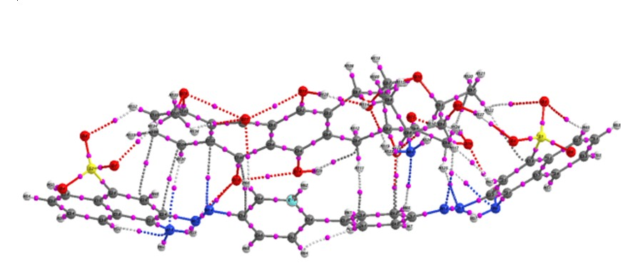
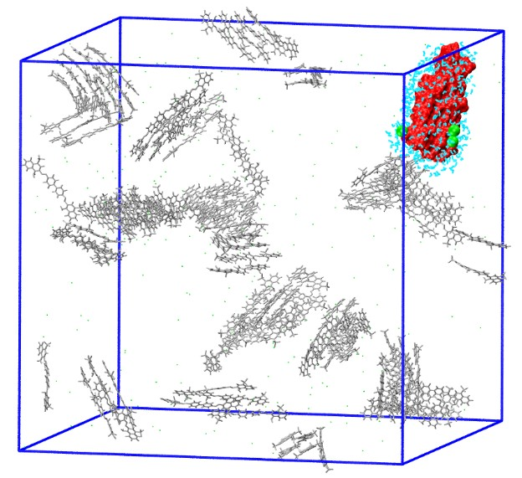
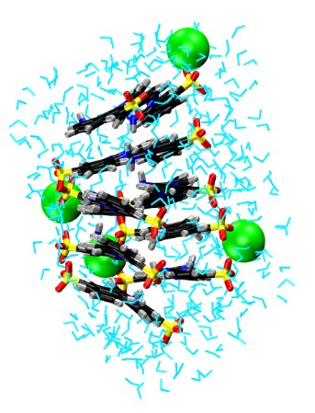
They are connected with greater mobility of DOX molecules associated with the surface of larger clusters whose aromatic parts are not incorporated into the ribbons. Fluctuations observed between the successive points indicate that the monomer can detach from the aggregate. However, eye examination of the trajectories reveals that this detachment is only temporary and the displaced molecules quickly return to the clusters. Such temporary dissociation is more frequent for the mixed CR/DOX system than for the CR one due to the presence of a hydrophilic sugar group in DOX and a more disordered structure of CR/DOX clusters.
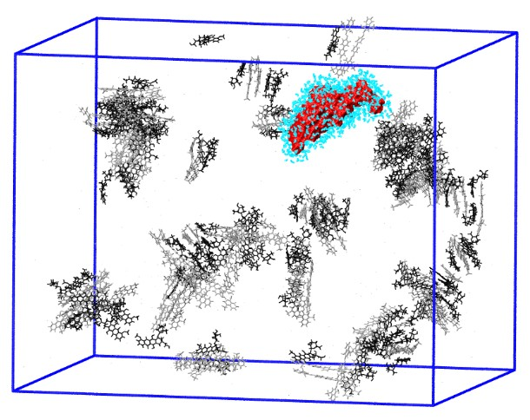
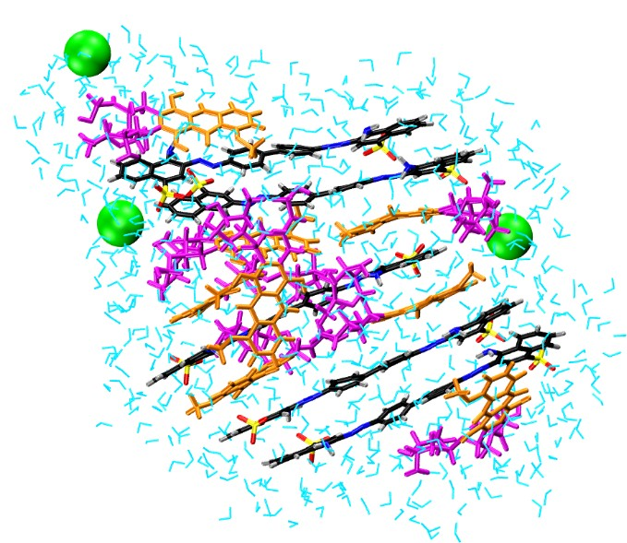
The clustering process is summarized in Figure 6. The histogram illustrates the formation of clusters of various sizes.

Figure 4. Visualization of the last MD simulation frames for (a) pure CR and (b) mixed CR/DOX molecular systems. Example clusters, marked in red color, are depicted in panels (c) and (d) together with all water molecules (cyan color) and Na+ cations (green balls) within a 10 Å distance from the cluster. In panels (a) and (b), CR molecules are drawn in gray and DOX molecules in black. In panels (c) and (d), CR molecules are colored according to atom names (C - black, O - red, N - blue, S - yellow, and H - gray). In DOX molecules, the aromatic part is drawn in orange and the sugar part in magenta.
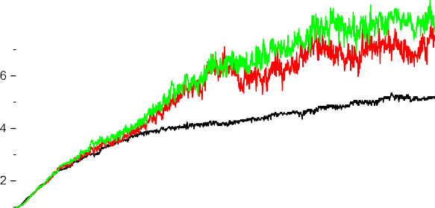

Figure 5. Average number of monomers in clusters formed during MD simulations. The black line corresponds to the pure CR system, while green and red lines correspond to the mixed CR/DOX system with two diﬀerent deﬁnitions of CM (see main text for details).

from the ribbon surface. For CR molecules, both approaches give the same result. In both systems, a saturation eﬀect can be observed. After saturation, in the CR system, there are on average ﬁve CR molecules in the ribbon. For a mixed CR/ DOX system, the average number of molecules is higher and amounts to 7 or 8 molecules depending on the approach employed to calculate the center of mass. For this system, larger ﬂuctuations in the average cluster size can be observed.

Figure 6. Histogram illustrating the cluster size distribution for pure CR (red), mixed CR/DOX based on the center of mass (CM) of whole DOX molecules (green), and mixed CR/DOX based on the CM of aromatic rings (blue).

Data is acquired from the terminal parts (after saturation, Figure 5 and Figures S4 and S5) of all ﬁve trajectories obtained for each system. In summary, ca. 1500 frames were gathered for both CR and CR/DOX systems. Histograms for individual runs are shown in Figures S6 and S7 of the Supporting Information. Again, two approaches were used to calculate CM of DOX molecules. In the case of the CR system, clusters composed of 2 to 17 molecules can be observed. The distribution of cluster sizes is relatively narrow and exhibits a clear maximum at the value of four molecules in a cluster. In this system, free monomers are practically not observed. In contrast, the cluster size distribution in the CR/DOX system is broader and extends toward larger clusters. The largest cluster observed in the simulations consisted of as many as 31 molecules. Surprisingly, free monomers also occur in this system. In the calculations employing CMs of whole DOX molecules, they are the most abundant entity in the system. However, eye examination of the trajectories reveals that these are not free monomers but molecules (mostly DOX) loosely associated with the surface of larger clusters. Among aggregates, the most populated number of molecules in a cluster is 4. However, the maximum is less pronounced than in the CR system and larger clusters are also present. Two approaches used in cluster analysis give qualitatively similar predictions. A higher green bar than a blue one indicates that whole DOX molecules cover the ribbon and the aromatic part

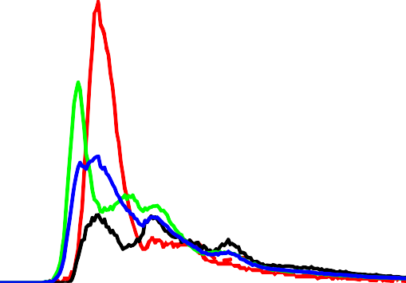
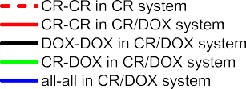
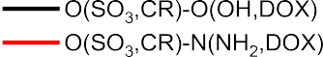

Figure 7. Radial distribution functions: (a) between CMs of CR/CR (red), CR/DOX (green and blue), and DOX/DOX (black) in a mixed CR/ DOX system (solid lines), together with CR/CR (red broken line) in a pure CR system; (b) between oxygen of SO3 groups of CR molecules and OH (black) or NH2 (red) of DOX molecules.
is completely immersed in water. This can be considered as the
ﬁrst step in incorporating DOX molecules into CR ribbons.
In cluster analysis, information about the source of stabilization is lost. To get some information regarding the nature of stabilization (bonding contacts) in clusters, the radial distribution function (RDF) was plotted. The RDFs between the center of mass in pure and mixed systems are shown in Figure 7a. In this graph, the CM of the aromatic part of DOX molecules was taken into account as the plots based on the CM of the whole molecule do not provide an accurate picture of the interactions between the aromatic parts of the molecules. Panel b in Figure 7 presents the RDF describing the ability of the formation of hydrogen bonds between the oxygen atoms from the SO3 group and DOX oxygen and nitrogen atoms. In Figure 7a, an oscillatory pattern is observed. This indicates the formation of ribbon-like structures. Such stacked structures are stabilized by van der Waals interactions as demonstrated by the bond critical paths shown in Figure 3 for CR/CR and CR/DOX dimers. This type of interaction occurs in pure CR (dashed red line) as well as in a mixed CR/ DOX system. In a mixed system, the RDF for CMs of CR/CR, CR/DOX, and DOX/DOX molecules is plotted. Hydrogen bonds are another important source of stability between CR and DOX molecules. Panel b in Figure 7 indicates the

formation of hydrogen bonds between O(SO3) H−O and O(SO3) H−N. The former hydrogen bonds are particularly strong due to the ﬂexibility of the DOX sugar unit. The BCP in

the CR/DOX dimer has the highest value of electron density (0.04). The later hydrogen bonds are weaker with a ρBCP close to 0.01.
■

CONCLUSIONS
It was demonstrated that Congo red molecules self-assemble in water in accordance with experimental data. This indicates that proper force-ﬁeld parameters for CR were obtained. Ribbon- like structures of varying lengths are formed. These ﬂat stacked structures are stabilized by van der Waals contacts. Hydrogen bonds are responsible for gluing short ribbons of CR. In the mixed CR/DOX system, doxorubicin is easily incorporated
into the CR ribbons. The aromatic parts of DOX penetrate the CR ribbon, while the sugar part covers the surface of the ribbon. Hydrogen bonds are responsible for covering the CR ribbon. In the mixed CR/DOX system, larger clusters are formed than in a pure CR system. Weak intermolecular interactions are responsible for complexation. Self-assembled CR structures can be used as carriers for DOX molecules.

ASSOCIATED CONTENT
*sı Supporting Information
The Supporting Information is available free of charge at https://pubs.acs.org/doi/10.1021/acsomega.0c01095.
Table S1: binding enthalpies and Gibbs free energies computed at the M062X/6-311G(d,p) level of theory; Figure S1: isosurfaces illustrating the polarization process in CR/CR and CR/DOX dimers; Figure S2: clustering patterns for the remaining four CR trajectories; Figure S3: clustering patterns for the remaining four CR/DOX trajectories; Figure S4: average number of monomers in CR clusters; Figure S5: the average number of monomers in CR/DOX clusters; Figure S6: cluster size distribution in CR systems; and Figure S7: cluster size distribution in CR/DOX systems (PDF)

AUTHOR INFORMATION
Corresponding Author
Jacek Korchowiec − Faculty of Chemistry, K. Guminśki Department of Theoretical Chemistry, Jagiellonian University, 30-387 Krakoẃ, Poland; orcid.org/0000-0002-9698-7369; Phone: +48 (12) 6862379; Email: korchow@ chemia.uj.edu.pl
Authors
Klaudia Kwiecińska − Faculty of Chemistry, K. Guminśki Department of Theoretical Chemistry, Jagiellonian University, 30-387 Krakoẃ, Poland
Anna Stachowicz-Kusńierz − Faculty of Chemistry, K. Guminśki Department of Theoretical Chemistry, Jagiellonian University, 30-387 Krakoẃ, Poland
Anna Jagusiak − Medical College, Chair of Medical Biochemistry, Jagiellonian University, 31-034 Krakoẃ, Poland
Irena Roterman − Medical College, Department of Bioinformatics and Telemedicine, Jagiellonian University, 31- 530 Krakoẃ, Poland
Complete contact information is available at: https://pubs.acs.org/10.1021/acsomega.0c01095

Author Contributions
A.J. and I.R. conceived the work. J.K. planned all the calculations. K.K. performed quantum-chemical calculations and part of molecular dynamics simulations. A.S.-K. performed part of molecular dynamics calculations and conducted all the works connected with analyzing MD trajectories. K.K., A.S.-K., and J.K. wrote the manuscript draft. All authors reviewed and discussed the manuscript.
Notes
The authors declare no competing ﬁnancial interest.
■

ACKNOWLEDGMENTS
The calculations were carried out at the Faculty of Chemistry of the Jagiellonian University and on the PL-Grid infra- structure at ACK CYFRONET with the support of the project “HPC Infrastructure for Grand Challenges of Science and Engineering”. A.J. acknowledges the support from the Polish National Science Centre, project no. 2016/21/D/NZ1/02763.
K.K. acknowledges the support of PhD InterDokMed Project no. POWR.03.02.00-00-I013/16.
■

REFERENCES
- Ferreira, Q.; Delfino, C.; Morgado, J.; Alcaćer, L. Bottom-up Self-Assembled Supramolecular Structures Built by Stm at the Solid/ Liquid Interface. Materials 2019, 12, 382.
- Sathya, P.; Pugazhendhi, S.; Gopalakrishnan, R. Self-Assembled Supramolecular Structure of 4-Dimethylaminopyridinium P-Hydroxy Benzoate Pentahydrate: Synthesis, Growth Optical and Biological
Properties. RSC Adv. 2016, 6, 44588−44598.
- Tu, Y.; Peng, F.; Adawy, A.; Men, Y.; Abdelmohsen, L. K. E. A.;
Wilson, D. A. Mimicking the Cell: Bio-Inspired Functions of Supramolecular Assemblies. Chem. Rev 2016, 116, 2023−2078.
- Rybarska, J.; Piekarska, B.; Stopa, B.; Zemanek, G.; Konieczny, L.; Roterman, I. Supramolecular Systems as Protein Ligands. In Self- Assembled Molecules − New Kind of Protein Ligands, Roterman, I.; Konieczny, L. Eds.; Springer, 2018.
- Banypersad, S. M.; Moon, J. C.; Whelan, C.; Hawkins, P. N.; Wechalekar, A. D. Updates in Cardiac Amyloidosis: A Review. J. Am. Heart Assoc. 2012, 1, No. e000364.
- Dember, L. M. Amyloidosis-Associated Kidney Disease. J. Am. Soc. Nephrol. 2006, 17, 3458−3471.
- Kemp, P. J.; Peers, C. Assessment of Oxygen Sensing by Model Airway and Arterial Chemoreceptors. Methods Enzymol. 2004, 381, 3−25.
- Prabhu, S. M.; Khan, A.; Hasmath Farzana, M.; Hwang, G. C.;
Lee, W.; Lee, G. Synthesis and Characterization of Graphene Oxide- Doped Nano-Hydroxyapatite and Its Adsorption Performance of Toxic Diazo Dyes from Aqueous Solution. J. Mol. Liq. 2018, 269,
746−754.
- Saleh, R.; Taufik, A. Degradation of Methylene Blue and Congo-
Red Dyes Using Fenton, Photo-Fenton, Sono-Fenton, and Sonophoto-Fenton Methods in the Presence of Iron(Ii,Iii) Oxide/ Zinc Oxide/Graphene (Fe3o4/Zno/Graphene) Composites. Sep.
Purif. Technol. 2019, 210, 563−573.
- Jagusiak, A.; Chłopas,́K.; Zemanek, G.; Jemioła-Rzeminśka, M.; Piekarska, B.; Stopa, B.; Panćzyk, T. Self-Assembled Supramolecular Ribbon-Like Structures Complexed to Single Walled Carbon Nanotubes as Possible Anticancer Drug Delivery Systems. Int.J. Mol. Sci. 2019, 20, 2064.
- Jagusiak, A.; Rybarska, J.; Piekarska, B.; Stopa, B.; Konieczny, L. Supramolecular Congo Red as Speciﬁc Ligand of Antibodies Engaged. In Immune Complex in Self-Assembled Molecules − New Kind of Protein Ligands, Roterman, I.; Konieczny, L. Eds.; Springer, 2018.
- Piekarska, B.; Konieczny, L.; Rybarska, J.; Stopa, B.; Zemanek, G.; Szneler, E.; Kroĺ, M.; Nowak, M.; Roterman, I. Heat-Induced Formation of a Specific Binding Site for Self-Assembled Congo Red in the V Domain of Immunoglobulin L Chain Lambda. Biopolymers
2001, 59, 446−456.
- Konieczny, L.; Piekarska, B.; Rybarska, J.; Stopa, B.; Krzykwa,
B.; Noworolski, J.; Pawlicki, R.; Roterman, I. Bis Azo Dye Liquid
Crystalline Micelles as Possible Drug Carriers in Immunotargeting Technique. J. Physiol. Pharmacol. 1994, 45, 441−454.
- Gaussian 09, R. A., Gaussian Inc.: Wallingford, CT, 2009.
- Grimme, S. Semiempirical Gga-Type Density Functional Constructed with a Long-Range Dispersion Correction. J. Comput. Chem. 2006, 27, 1787−1799.
- Korchowiec, J.; Uchimaru, T. New Energy Partitioning Scheme
Based on the Self-Consistent Charge and Configuration Method for Subsystems: Application to Water Dimer System. J. Chem. Phys. 2000, 112, 1623−1633.
- Korchowiec, J.; Uchimaru, T. Mechanism of Addition of
Fluoromethyl Radicals to Fluoroethylenes. J. Phys. Chem. A 1998, 102, 6682−6689.
- Geerlings, P.; De Proft, F.; Langenaeker, W. Conceptual Density Functional Theory. Chem. Rev. 2003, 103, 1793−1874.
- Geerlings, P.; Fias, S.; Boisdenghien, Z.; De Proft, F.
Conceptual Dft: Chemistry from the Linear Response Function.
Chem. Soc. Rev. 2014, 43, 4989−5008.
- Anderson, J. S. M.; Melin, J.; Ayers, P. W. Conceptual Density-
Functional Theory for General Chemical Reactions, Including Those That Are Neither Charge- nor Frontier-Orbital-Controlled. 1. Theory and Derivation of a General-Purpose Reactivity Indicator. J. Chem.
Theory Comput. 2007, 3, 358−374.
- Korchowiec, J.; Uchimaru, T. The Charge Transfer Fukui
Function: Extension of the Finite-Difference Approach to Reactive Systems. J. Phys. Chem. A 1998, 102, 10167−10172.
- Jagusiak, A.; Panćzyk, T. Interaction of Congo Red, Evans Blue
and Titan Yellow with Doxorubicin in Aqueous Solutions. A Molecular Dynamics Study. J. Mol. Liq. 2019, 279, 640−648.
- Al-Thabaiti, S. A.; Aazam, E. S.; Khan, Z.; Bashir, O.
Aggregation of Congo Red with Surfactants and Ag-Nanoparticles in an Aqueous Solution. Spectrochim. Acta, Part A 2016, 156, 28−35.
- Humphrey, W.; Dalke, A.; Schulten, K. Vmd: Visual Molecular Dynamics. J. Mol. Graphics 1996, 14, 33−38.
- Phillips, J. C.; Braun, R.; Wang, W.; Gumbart, J.; Tajkhorshid, E.; Villa, E.; Chipot, C.; Skeel, R. D.; Kale,́L.; Schulten, K. Scalable Molecular Dynamics with Namd. J. Comput. Chem 2005, 26, 1781− 1802.
- Klauda, J. B.; Venable, R. M.; Freites, J. A.; O’Connor, J. W.;
Tobias, D. J.; Mondragon-Ramirez, C.; Vorobyov, I.; MacKerell, A. D., Jr.; Pastor, R. W. Update of the Charmm All-Atom Additive Force Field for Lipids: Validation on Six Lipid Types. J. Phys. Chem. B 2010,
114, 7830−7843.
- Vanommeslaeghe, K.; et al. Charmm General Force Field: A
Force Field for Drug-Like Molecules Compatible with the Charmm All-Atom Additive Biological Force Fields. J. Comput. Chem. 2010, 31, 671−690.
- Jorgensen, W. L.; Chandrasekhar, J.; Madura, J. D.; Impey, R.
W.; Klein, M. L. Comparison of Simple Potential Functions for Simulating Liquid Water. J. Chem. Phys. 1983, 79, 926−935.
- R Core Team R: A language and environment for statistical
computing; R Foundation for Statistical Computing: Vienna, Austria, 2019.
- Boys, S. F.; Bernardi, F. The Calculation of Small Molecular
Interactions by the Differences of Separate Total Energies. Some Procedures with Reduced Errors. Mol. Phys. 1970, 19, 553−566.
- Tomasi, J.; Mennucci, B.; Cammi, R. Quantum Mechanical Continuum Solvation Models. Chem. Rev. 2005, 105, 2999−3094.
- Grabowski, S. J. Ab Initio Calculations on Conventional and
Unconventional Hydrogen Bondsstudy of the Hydrogen Bond Strength. J. Phys.Chem. A 2001, 105, 10739−10746.
- Koch, U.; Popelier, P. L. A. Characterization of C-H-O Hydrogen-Bonds on the Basis of the Charge-Density. J. Phys. Chem. 1995, 99, 9747−9754.

