Karol Dzięgielewski
EXPANSION OFTHE POMERANIAN CULTURE IN POLAND DURING THE EARLY IRON AGE: REMARKS ON THE MEC HANI SM AND POSSIBLE CAUSES
ABSTRACT: First migratory explanations of characteristic manner of spreading of the Po-
meranian culture remains in Polish lowland were expressed at the turn of the 19,h and 20,h century. Since then, they have been continuously supported by newer arguments, despite the fact that parallel strong anti-migrationist current was being developed. The author of the present study gathers arguments pro and contra migration, concluding that scenario assuming people movement (the extent of which is hard to evaluate) explains in the most complex way the phenomenon of so-called Pomeranian culture expansion. In the second part of the article, the author discusses possible conditions for occurring migration in studied case. Due to the revision of chronology of cultural and palaeoclimatic events, the role of climatic changes around the Sub-Boreal/Sub-Atlantic transi- tion as a factor of presumed migration is proposed to be seriously limited. Even- tually, an attempt is madę to apply some elements of socio-cultural models of prehistorie migrations to the Pomeranian culture case study.
STRESZCZENIE: Wykorzystanie teorii migracyjnych dla wyjaśnienia charakterystycznego rozprzestrzenienia stanowisk kultury pomorskiej na niżu polskim po raz pierwszy zaproponowano na przełomie XIX i XX w. Od tego czasu teorie te były sukcesywnie wspierane coraz nowszymi argumentami, mimo równoległego funkcjonowania odmiennego, antymigracyjnego trendu. Autor niniejszego szkicu zbiera argumenty za i przeciw migracji, dochodząc do wniosku, iż hipoteza, dopuszczająca przesunięcia ludnościowe najlepiej tłumaczy całokształt zjawisk związanych z tzw. ekspansją kultury pomorskiej. Skala tych ruchów jest jednak niezwykle trudna do oceny. W dalszej części artykułu autor rozważa możliwe uwarunkowania dla zaistnienia migracji w omawianym przypadku. Zestawiając najnowsze dane z zakresu paleoklimatologii ze zweryfikowaną chronologią wczesnej epoki żelaza, proponuje ograniczyć przypisywanie zmianom klimatycznym roli czynnika sprawczego domniemanej migracji. Ponadto podejmuje próbę zaaplikowania w omawianym przykładzie elementów społeczno-kulturowych teorii migracji.
KEYWORDS: Early Iron Age Poland, Pomeranian culture, expansion of culture, migration, Sub-
-Boreal/Sub-Atlantic transition

174

INTRODUCTION
In the twentieth century, succeeding schools of archaeological thought took different positions with regard to migration. It depended mostly on current paradigms as well as socio-political trends (Chapman 1997; Harke 1998). Independently of those “fash- ions”, migration as explanatory model still played a significant role in the culture- -historical (traditional) school. Migratory explanations were presented in almost all handbooks of European prehistory. One of the examples was an application of the vision (it is hard to cali it a model) of development and expansion of societies inhabit- ing Polish Pomerania in the Early Iron Age. Since the first theories involving migration were expressed at the tum of 19lh and 20lh century (e.g. Kossinna 1917: 125-126; Kostrzewski 1923: 120, 133; Tackenberg 1926: 154-155; Petersen 1929: 126;seealso: van den Boom 1980/1981: 225-232), they have been continuously supported by newer arguments (e.g. Łuka 1979; Podgórski 1992; Czopek 1992; Gedl 1995), despite the fact that opposite approach was being developed by some prominent scholars (e.g. Hensel 1958: 85-86; 1969; 1971: 68-75; 1988: 367; Malinowski 1963; 1989a). The present study aims to gather the arguments to the advantage and disadvantage of migration (derived from both, archaeology and palaeoecology) and reconsider them in a broader socio-cultural framework.

THE POMERANIAN CULTURE CASE - GENERAŁ INFORMATION
Migratory explanation was employed with regards to distribution of the Pomeranian culture due to a specific manner of its spreading. The oldest sites (from 9lh-8lh century BC) were located exclusively in Pomerania, whilst the younger ones (5lh-3rd century BC) were encountered far beyond this region, in Greater Poland, Silesia, central Poland, and southem and south-eastem Poland (Fig. 1). During the youngest phase of its develop- ment, hardly any traits of the culture in question existed in the area of Pomerania. The oldest phase was strongly connected with the Late Bronze local branch of the Umfield culture (Kashubian group of the Lusatian culture). Beginnings of cultural transforma- tion can be dated to the 9lh century BC, when the transitory phase (Wielka Wieś-phase) could be distinguished. Its dating to the end of the Late Bronze Age (Montelius Per. V) is indicated, for example, by the occurrence of pins with smali, vase-like heads. However, the most distinctive cultural features appear in the 8lh-7lh century, which should be re- lated to the beginnings of the Hallstatt C period (Podgórski 1992). One of these features is the occurrence of so-called eye- and house ums (Malinowski 1995; Podgórski 1997; Sabatini 2007). The classical phase of the Pomeranian culture developed in the course of Hallstatt D, around the half of the 7th century. Among typical cultural elements, face ums and chest graves, encountered mostly in the northem part of the Pomeranian culture area, can be mentioned. Beside a certain number of elements specific to this culture, there occur interregional forms, such as the late Hallstatt brooches and bronze vessels. At the end of the Hallstatt D period, materials described as Pomeranian appear in vast areas

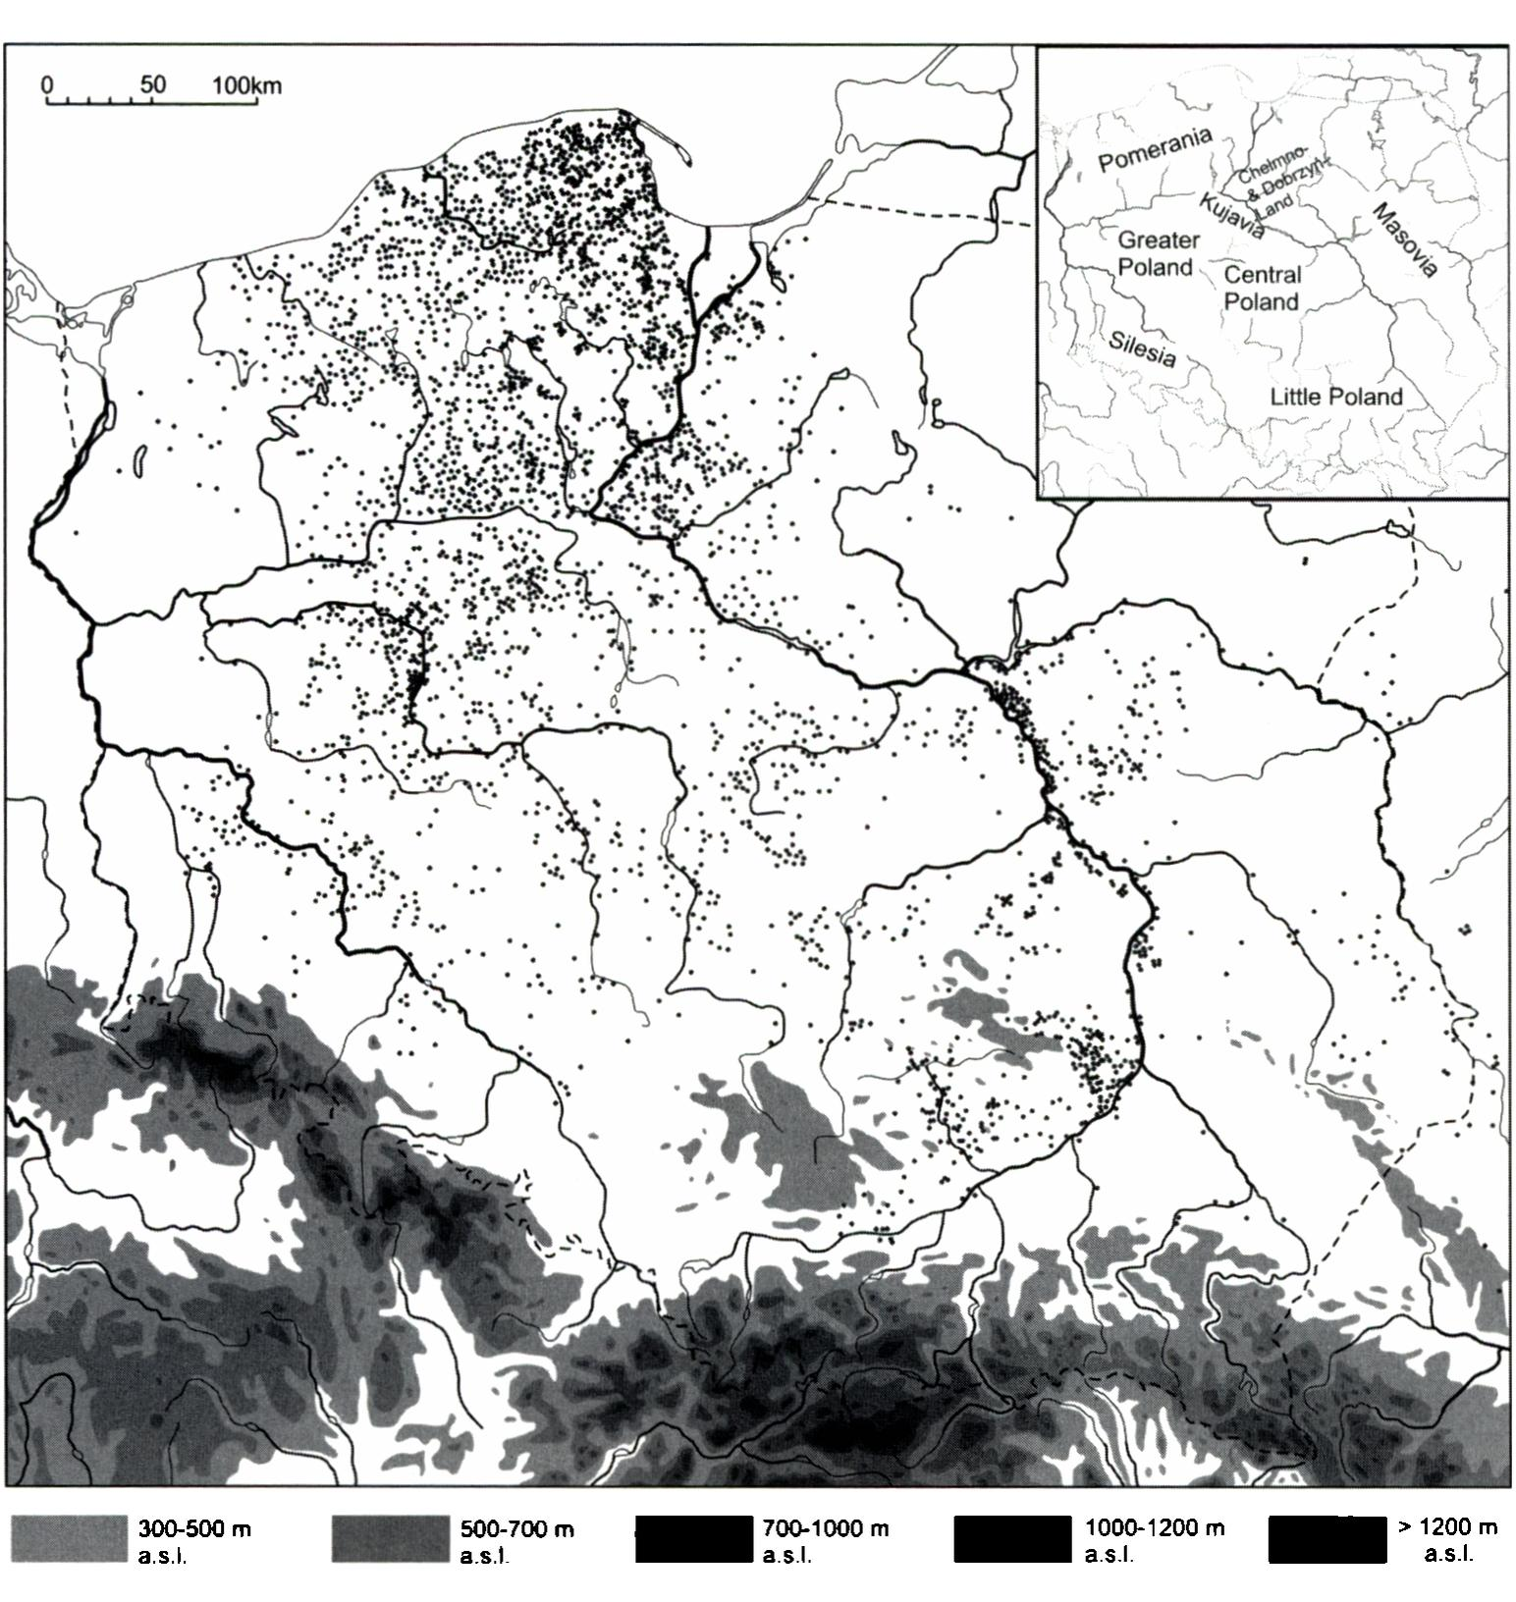
175
Fig. 1. Distribution of Pomeranian culture sites in Poland (all chronological stages). Map in- cludes the so-called ‘Cloche Graves'culture, but excludes several dozens of sites in Volhyn and Podolia. Sites known from surface surveys (Polish Archaeological Record) were only included for peripheries of the Pomeranian culture extent. One dot may represent several sites within the boundaries of one locality (especially in the territory of Pomerania)
of Polish lowland (Malinowski 1989a). A succeeding, younger phase is characterised by an occurrence of brooches and belt clasps of the early La Tene style. In funeral practices a form of so-called “cloche grave” is predominant. During the early La Tene period the materials ascribed to the culture in question appear in uplands of southem Poland, reach- ing the border of the Carpathian Foreland (Fig. 1). Simultaneously, in Pomerania and northem Greater Poland, gradual disappearing of the materials dated later than to the early La Tene period can be observed.

It was quite early when this specific spreading of materiał traits was noticed (for his- tory of the research, see: van den Boom 1980/1981). Early attempts explained it with migration, which could be caused mainly by climate changes towards cooler and wetter conditions and by the resulting collapse of subsistence bases due to poor soil cover (Ko- strzewski 1946: 28-29). The only argument employed in order to support this theory was the distribution of artefacts. At that time, migratory approach was closely linked with ethnic identification of the culture - for German and Polish pre-historians, materials in ąuestion were ascribed either to early Germans (Vandals or Bastamae), Balts, or ancient Slavs (for references to the whole discussion see: van den Boom 1980/1981: 224-232). According to those approaches, southward expansion was of military naturę and was believed to be one of the main causes for the decline of the Lusatian culture (cf. Malinowski 1989a).
Migratory model in explaining cultural changes in the Early Iron Age has never been totally abandoned in Polish literaturę, despite the fact that “official”, anti-migration cur- rent dominated from the 1960s to the 1980s (Hensel 1969; 1971; 1988; Malinowski 1963; 1989a). This theory described the discussed processes in terms of alterations in superstructure, which had had to occur among the communities of the Lusatian culture. It was rather a consequence of applying the Marxist theory, which perceived factors of cultural change in class conflict and changing of economic conditions, than joining a broader trend of “retreat from migrationism”, announced by the New Archaeology (Chapman, Hamerow 1997).

ARGUMENTS FROM POMERANIA
Trying to test a migratory explanation, I would like to propose a modification of the main question that has frequently been asked up to datę. Therefore, I do not query whether the people, who left materiał remains described as ‘the Pomeranian culture’ on vast parts of Polish lowland outside Pomerania, were newcomers. 1 would rather ask what hap- pened with the communities that inhabited Pomerania - presumed as the motherland of migrating people - and look closer into the rhythm of development of the Early Iron Age communities in this area.
Studies of artefacts regarded as precise dating markers play a crucial role in the discussion of dynamics of settlement atrophy in this area. The last period of the settlement in Pomerania clearly confirmed by the distribution of such artefacts is the end of the Hallstatt period, evidenced by the late Hallstatt brooches (especially of Wymysłowo-, Wojszyce- and Tłukomy types, see: Gedl 2004, PI. 86-88) (Fig. 2:A). Afterwards, only few brooches and belt clasps madę in the early La Tene (LT A) style are known from the entire region of northem Poland (Fig. 2:B). This fact was noticed for the first time by E. Petersen (1929: 126), but has been neglected for years sińce many authors claimed that in Pomerania, interregional forms were lacking due to some conservatism and the decline of interregional links typical of the Hallstatt period (e.g. Ostoja-Zagórski 1982: 127). Such a thesis is very unlikely, regarding the fact that contemporary sites of the Pomeranian culture in Greater Poland or Silesia have yielded many well dating artefacts (Fig. 2:B), which indicates that ‘Pomeranian’ societies took part in interregional

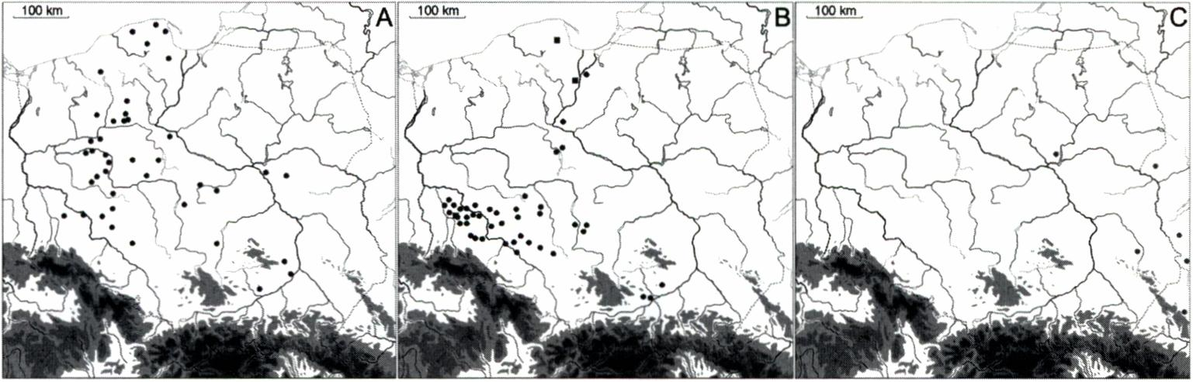
177
Fig. 2. Distribution of well-dated artefacts on Pomeranian culture sites: A - brooches of the late Hallstatt construction; B - brooches (dots) and belt clasps (rectangles) of the early La Tene style; C - brooches of the middle La Tene style (after Woźniak 1995; Gedl 2004; updated by theauthor)
Bibl. Jag.
exchange networks at the beginning of the early La Tene period as well (Woźniak 1979; 1995; Wołągiewicz 1979; Podgórski 1992). There exists no evidence, in terms of well dated items. for inhabiting Pomerania in later phases of the La Tene period (LT B or C phases) (Fig. 2:C).
If a significant depopulation had taken place there, as suggested by the distribution of archaeological finds, one may expect that it would be recorded also in the pollen dia- grams. Current state of palynological research entitles us to draw some conclusions about human settlement in Pomerania (Latałowa 1997; Nalepka 2004, Fig. 107). Many pollen spectra from Pomerania show significant increase of human impact indicators around the Sub-Boreal/Sub-Atlantic transition (Fig. 3: 1). Percentage values of human activity indicators are sometimes surprisingly high, exceeding in particular cases those from the Roman period (Fig. 3: 1) (especially: Latałowa 1982, Fig. 11; Bogaczewicz-Adamczak, Miotk-Szpiganowicz 1987; Berglund et al. 1990, Fig. 3; Miotk-Szpiganowicz 1992, Fig. 23, 24; Latałowa, Tobolski 1989). One should be cautious in attempting to deter- mine a detailed chronology of this changes, sińce the ąuoted profiles are chiefly not of high-resolution type. Nonetheless, with the greatest probability, peaks of human ac- tivity recorded in the above-mentioned profiles should be attributed to the Lusatian/ Pomeranian transitory phase (Wielka Wieś-phase) and/or the Pomeranian culture itself. Palaeobotanists connect these peaks with the entire Late Bronze and Early Iron Age se- quence of cultural development of Pomerania (i.e. the Lusatian and Pomeranian cultures) (Latałowa 1997; 2007). In my opinion, the Late Bronze Age societies are less likely to be responsible for this recorded impact on natural environment due to their lower number (e.g. Ostoja-Zagórski 1982: 122-127; Łuka 1983: 10-18; Dzięgielewski 2005, Fig. 4-5). This violent increase in human indicators is followed by an eąually fast decrease of pollen evidence of human activity, especially cultivated plants. It led, in the case of most profiles, to almost complete disappearance of human impact evidence (Fig. 3). It is worth mentioning that such a rhythm of changes does not characterise all regions of Poland, and the decrease of human economy indicators during the La Tene period is not as rapid as in Eastem Pomerania (compare e.g. Western Pomerania - Latałowa 1992, Fig. 26). In

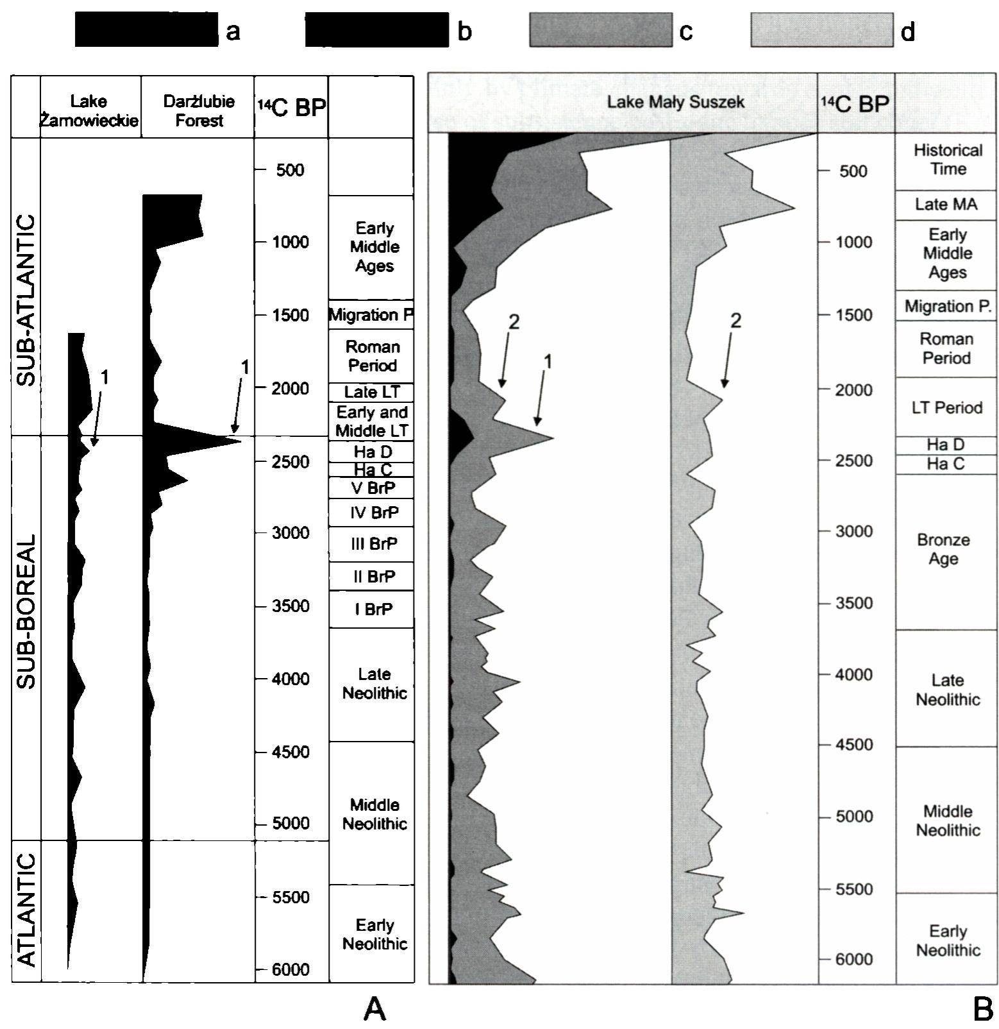
178
Fig. 3. Humań impact indicators in chosen pollen diagramsfrom Pomerania: Lakę Żarnowieckie; Darżlubie Forest; Lakę Mały Suszek, a - generał human impact; b - Cerealia (cereals); c - other groupsof human impact indicators; d - Gramineae (grasses). 1,2- peaks discussed in the text. A - after Latałowa 1982, Fig. 11; B - after Miotk-Szpiganowicz 1992, Fig. 23 (correlation with archaeological periods after the original publications)
Little Poland, for instance, it is much weaker. A comparable decline in this territory may be linked only with the Migration Period (Nalepka 2003, Fig. 3).
The alleged decrease of Pomeranian population during early La Tene period should re- sult in deep differences in settlement structures between the Pomeranian culture and the suc- ceeding, well evidenced phase, connected with the Oksywie culture (younger Pre-Roman period). Indeed, re-colonisation of the area of eastem Pomerania is noticeable both at macro- and micro-regional level (Wołągiewicz 1979: 57; Dzięgielewski 2005: 394, Fig. 9).

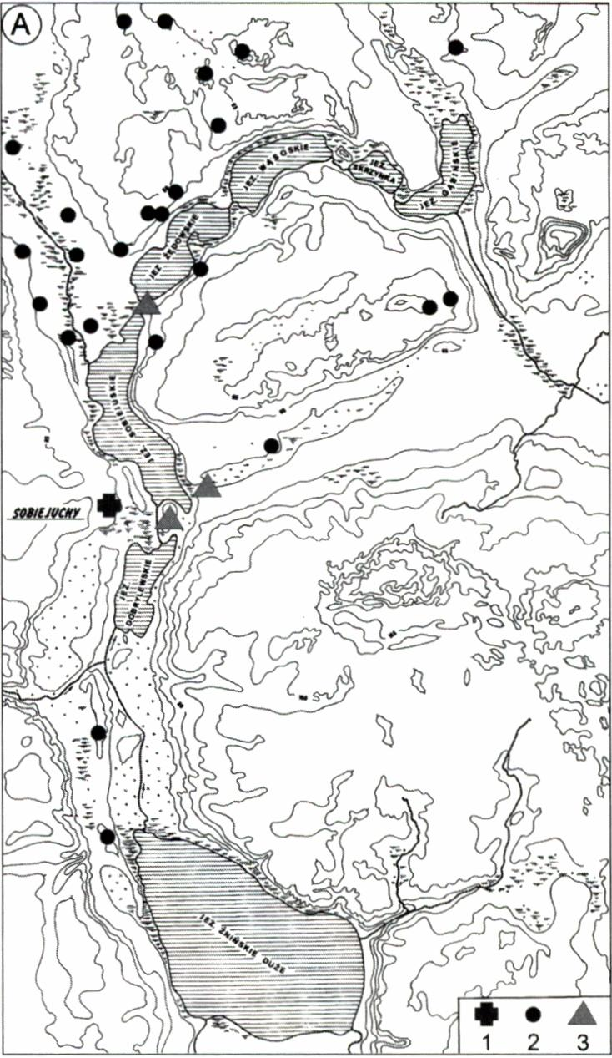
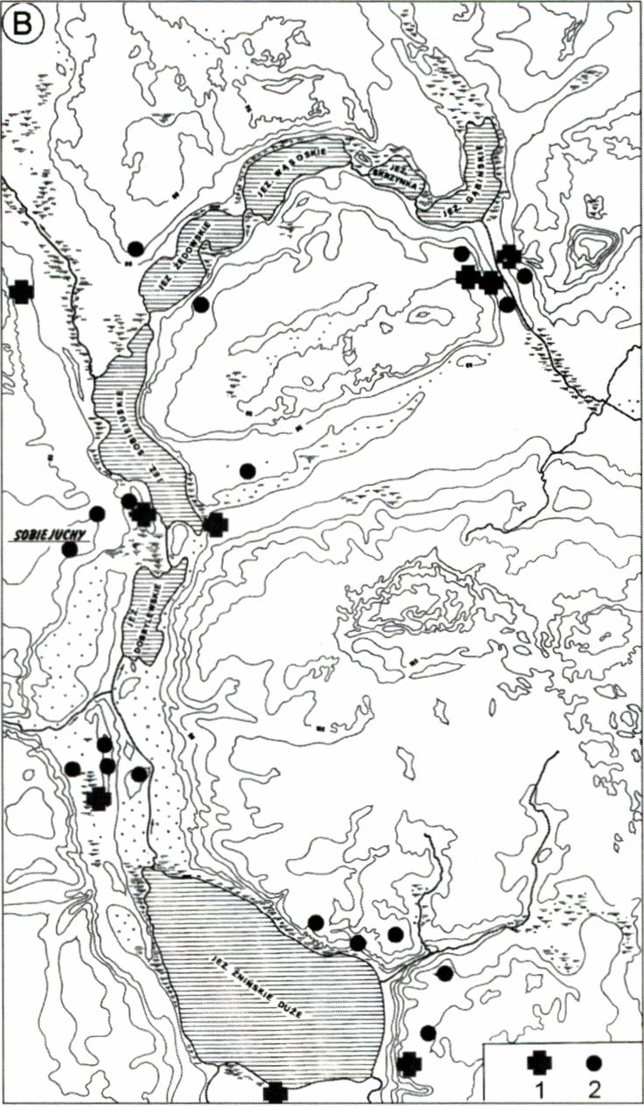
179
Fig. 4. The mesoregion of Sobiejuchy (Pałuki/Kujavia). A - distribution of late Lusatian culture sites (Hallstatt C - C/D period); B - distribution of Pomeranian culture sites (Hallstatt D - early La Tene period) (after Ostoja-Zagórski 1993). 1 - cemetery, 2 - settlement tracę, 3 - settlement
Summarising, the following arguments can support the hypothesis about migration from Pomerania: 1) lack ofwell dated archaeological artefacts younger than early La Tene period in Pomerania; 2) strong oreven drastic decline of human indicators in pollen diagrams in Pomerania following the period of increased human impact; 3) lack of traces of continu- ity between the Pomeranian and succeeding Oksywie culture; 4) simultaneous occurrence of cemeteries of the Pomeranian type in central Poland, Greater Poland, Silesia etc.; 5) distribution of settlement, which becomes sparser with the distance from Pomerania (Fig. 1). The last argument, obviously, could also be employed by a diffusionist approach.

ARGUMENTS FROM BEYOND POMERANIA
Assuming that people movement from Pomerania indeed took place, we may expect that settlement representing Pomerania type in new areas would resemble the pattems from the motherland territory. 1 will focus on these pattems instead of referring to the differences

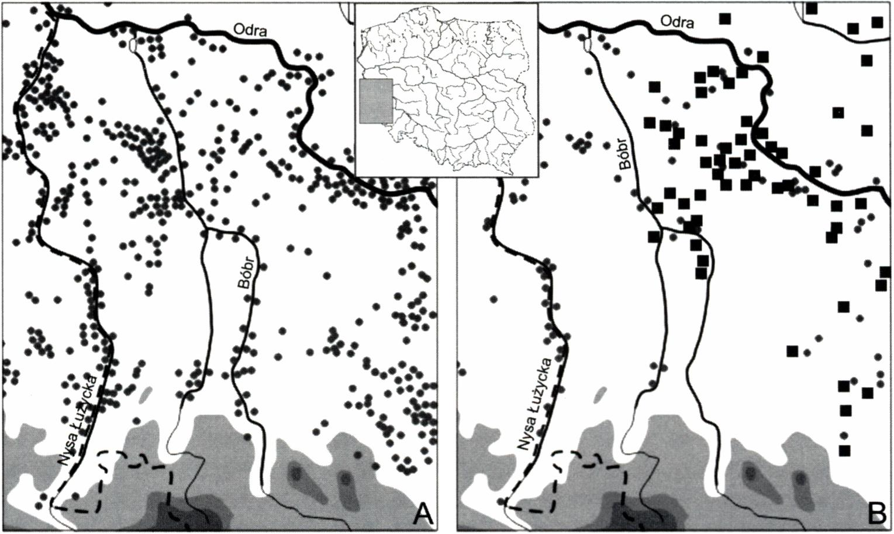
180
Fig. 5. The Bóbr River basin (between Nysa Łużycka river and Odra river). A - distribution of the late Lusatian culture sites (Hallstatt C period); B - distribution of the late Lusatian (dots) and Pomeranian culture (rectangles) sites (Hallstatt D - early LaTene period) (after Buck 1979; Mierzwiński 1994; Kaczmarek 1999; 2007)
in materiał culture between the earlier (the Lusatian) and later (the Pomeranian culture) phases of settlement beyond Pomerania. Such differences exist, as is best indicated by the fact that archaeologists distinguished two separate cultures (the Lusatian and Pomeranian). Unfortunately, there are not many case-studies for settlement structures of the Pomeranian culture outside the Pomerania. Situation recorded e.g. in the Kujavia region, in the surroundings of Sobiejuchy, clearly confirm deep differences between the old and new cultural phenomena in terms of the settlement Structure (Ostoja-Zagórski 1993, Maps 2-3). In the Hallstatt period, the Lusatian societies inhabited a central, fortified settlement with a large cemetery, both located near to Lakę Sobiejuskie shore (Fig. 4: A). During the late Hallstatt and early La Tene period traces of the Pomeranian culture dominated over the cultural landscape of the region. However, the pattem of their distribution was quite different from the Lusatian one - many smali cemeteries (or even single chest-graves) were dispersed in different parts of the area and so were the remains of settlements (Fig. 4: B). It resembled the structures known from Pomerania (Wiącek 1972; Szymańska 1981, Fig. 6; Dzięgielewski 2005). Thus, the changes in culture of the area in question included: materiał culture, burial customs, settlement sructure and pattems of land use.
An interesting observation is provided by analysis of the south-westem periphery of the Pomeranian culture. In the middle Oder basin, in the western part of Lower Silesia, we can notice dense settlement network of the Lusatian culture at the beginning of the Early Iron Age (Fig. 5: A) (Buck 1979: 144-145, Fig. 104; Mierzwiński 1994, maps 6-7). The situation changed during the Hallstatt D period when a decrease of the settlement is

181
observed. Simultaneously, at the end of that period, the first, quite abundant sites of the Pomeranian culture emerged, but they did not cross the Bóbr River (Fig. 5: B) (Pazda 1970; Kaczmarek 1999). Westwards to this river, the Białowice- (Billendorf-) group communities of the Lusatian culture continued their development. Therefore, a question arises about the naturę of the ‘Pomeranian’ traits in south-westem Poland. If their appearance had been of endogenous character among the Lusatian societies, as many authors claim (e.g. Hensel 1971; Malinowski 1989a), why these processes did not encompass terrains to the west from the Bóbr River? On the other hand, distinct differentiation of the south- -westem periphery of the Pomeranian culture in terms of materiał culture (e.g. burial pot- tery) (Gedl 1995), may testify that local elements were of great importance to the genesis of this cultural phenomena in the studied area (cf. Mierzwiński 1994: 122).
In southem Poland, settlements of the late Lusatian culture, representing many re- gional variants (groups), occupied both the territories of lowlands (Sandomierz Basin) and uplands (Małopolska Upland), as well as the Carpathian Foreland (Fig. 6). The Pomeranian culture, the oldest traces of which appeared in the area in question probably at the end of the Hallstatt Period (Nosek 1946; Grygiel et al. 2009; Dzięgielewski, in press), avoided higher, elevated location. The Carpathian Foreland threshold, visible with the naked eye, as well as any terrain located over 300 meters above the sea level, were an in- superable barrier for communities of the culture in question, which prevented them from expanding further to the south. It may indicate that their model of culture was typical of lowlands and that they were not able to transform it after confrontation with a different geosystem (Dzięgielewski, in press). Geographers and anthropologists underline that inhabiting sub-mountain territories is not only a question of different geomorphologic or economical conditions, but it is often a question of mentality of the inhabitants, who create different cultural landscape (Łanczont, Wojtanowicz 2005: 44). For those, who were accustomed to lowland landscape, the perspective of the upland occupation might constitute serious obstacle for further expansion.
As it might have become elear so far, some arguments from beyond Pomerania may also support the thesis, which assumes that new cultural phenomenon emerged as a re- sult of some (limited?) movements of people. When rejecting the migration hypothesis one should assume unprecedented changes within Lusatian culture communities, encom- passing almost all areas of life.
An additional, frequently quoted argument in favour of migration is that the entire rangę of the Pomeranian culture was characterized by unusually uniform materiał culture (e.g. Mierzwiński 1994: 122; Czopek 2005: 226), although there existed two main prov- inces (north-westem and south-eastem), differing mainly by burial rituals (Malinowski 1989a; Węgrzynowicz 1995). On the contrary, the preceding Lusatian culture was signif- icantly divided into many local groups differentiated e.g. by ceramic style. Similarities between the materiał remains (especially pottery) from northemmost and southemmost peripheries of Pomeranian culture are astonishing (Dzięgielewski, in press). Such degree of uniformity seems hardly possible to be gained without a direct involvement of at least some representatives of given society on the acculturated area. Of course, I am far from the opinion that all of the traces ascribed to the Pomeranian culture outside Pomerania are remains of migrants from this limited area, but to some extent, they must have been. This question will be further explored in a morę detailed way.

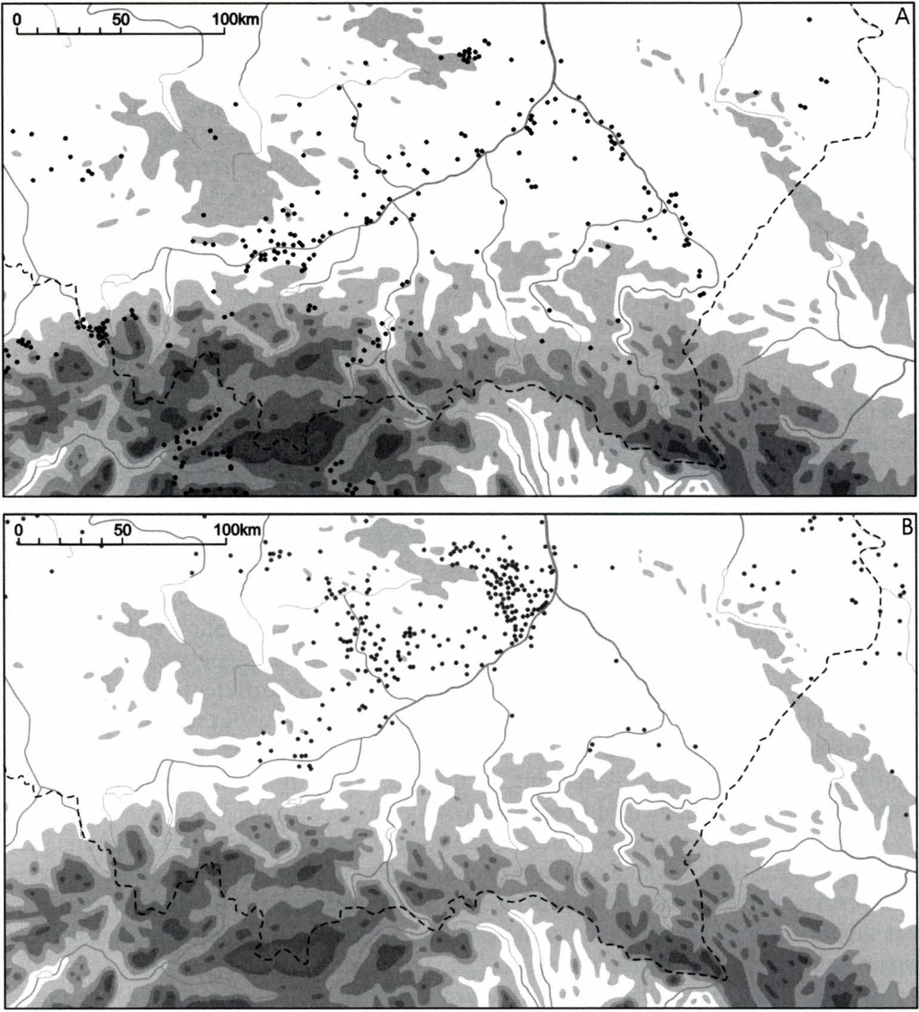
182
Fig. 6. Southern part of Poland (Little Poland and part of Upper Silesia). A - distribution of sites of the late phase of Lusatian culture (Hallstatt C/D, Hallstatt D; early La Tene?); B - distribution of Pomeranian culture sites (late Hallstatt D - early La Tene) (after Dzięgielewski, in press)

POSSIBLE REASONS FOR MIGRATION
Many authors claim that seeking possible causes of prehistorie migration is hopeless (Burmeister 2000; Prien 2005). On the other hand, we are forced to determine possible reasons when trying to use classical paradigm of “push-pull factors” according to Eve- rett Lee (cf. Anthony 1990; Prien 2005; Przybyła, in this volume). Probably the most

183
accurate opinion conceming a potential of archaeology in this matter was expressed by David W. Anthony: ‘ ...proximate causes of prehistorie migrations are probably lost forever - we can only hope to identify structural conditions that madę migration morę or less likely to occur...' (Anthony 1992: 174). Now, let me focus on possible structural conditions that might have enabled inereased mobility in the studied area at the transition of the Bronze and Iron Age.

The development of Pomeranian societies as reflected by climate changes
Climate change was quoted as one of the main reasons for the Pomeranian culture expan- sion (e.g. Tackenberg 1926: 154; Łuka 1965: 52-54; Czopek 2005: 225; Chochorowski 2005: 495-497). Cooling and wetting of climate were, however, treated rather like a slogan. The improvement of calendartime-scales for both: the Holocene climate changes and the chronology of the Hallstatt period enabled, in recent years, analyses of their mutual relation in a morę detailed way. The beginning of climatic changes is currently correlated with the phase of a sudden and sharp decrease of solar activity, which probably resulted in the inerease of radiocarbon concentration in the atmosphere, which began at about 850 cal BC (van Geel et al. 1996; van Geel et al. 1998; Maise 1998: 219-220; Speranza et al. 2002; van Geel et al. 2004: 152-153). In northem Europę climate changed towards morę oceanie type and lakę levels started to rise. On the other hand, indications derived from dendrochronologically dated archaeological contexts, confirm that the beginnings of the Hallstatt C period should be placed shortly after this datę (Friedrich, Hennig 1995; Trachsel 2004: 151). The unfavourable climatic tendency changed after about 100 years (Maise 1998: 220, Fig. 22). A significant change towards better (warmer) conditions at about 650 BC was evidenced e.g. by dendroclimatology (Tinner et al. 2003: 1456, Fig. 5B), but it was not recorded in mid-European lake-levels fluctuations (Magny 2004). This phase should be most likely connected with the beginnings of the Hallstatt D period (cf. Trachsel 2004: 152). The next cooler oscillation, although not as violent as the previ- ous one, took place at about 450 BC (Maise 1998: 220).
The synchronisation of cultural development in the studied area with the above- -mentioned climate changes might be as follows (Fig. 7): a shift from the Lusatian, eco- nomically and culturally stable model towards a new, less conservative one, coincided with a phase of rapid cooling. To some extent, cultural transformations could have been accelerated by climate changes. However, the economic model of the Wielka Wieś phase was hardly different from that of the preceding Lusatian culture. During the Hallstatt C period, the settlement of the Wielka Wieś phase did not exceed the boundaries of Pomerania (Podgórski 1992, Fig. 10; Kaczmarek 2005: 160). It seems unreasonable to suspect any larger people movements in regard to this period (for the discussion see: van den Boom 1980/1981: 225-226; Podgórski 1992: 208-209; Pietrzak, Podgórski 2005: 29; Malinowski 2007: 13). The first well-dated assemblages of the Pomeranian type outside the Pomerania are not recorded before the middle of the Hallstatt D period (Malinowski 1989a: 572; Kaczmarek 2005; Muzolf, Lorkiewicz 2005: 208-210). Therefore, the ex- pansion could have started not earlier than in the middle of a warmer oscillation (that

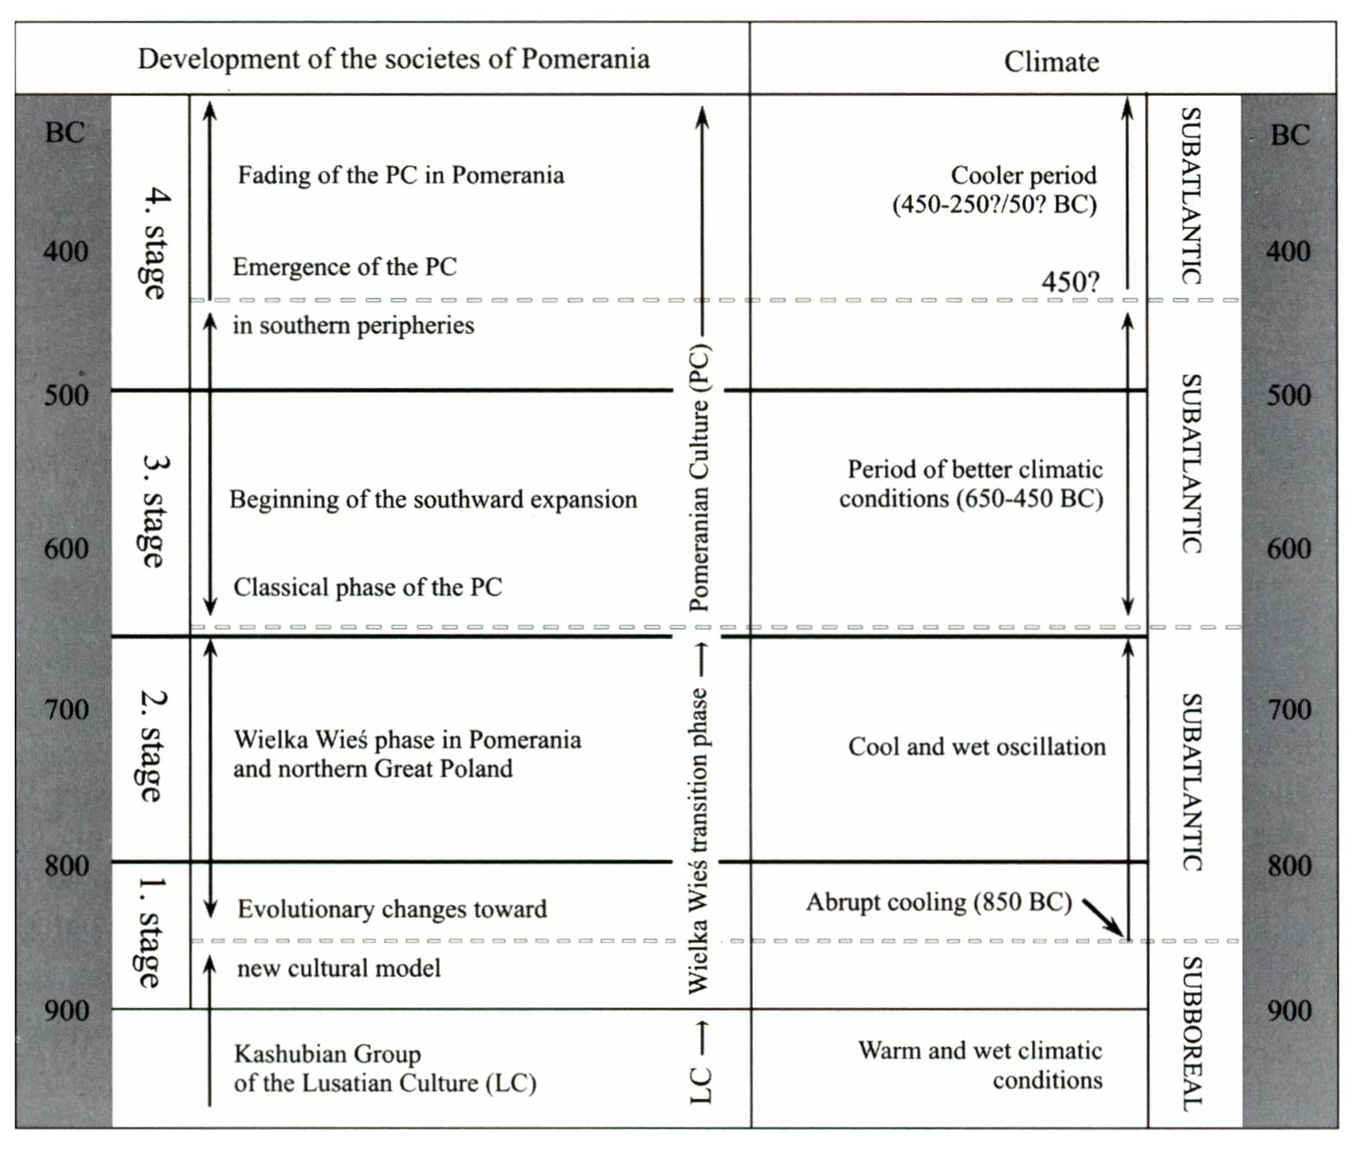
184
Fig. 7. Correlation between the stages of cultural development of Pomerania during Early Iron Age and phases of Late Holocene climate (climatic data after Maise 1998;Tinner et al. 2003; van Geel et al. 2004)
emerged gradually from ca 750 BC, but especially after 650 BC - Maise 1998; Tinner et al. 2003), and must have continued until its end. Before the next deterioration of climate took place at about 450 BC, the traits connected with the Pomeranian culture had spread almost over its entire rangę (Fig. 1).
The deterioration of climate cannot be considered a reason of the Pomeranian culture migration in the classic phase as this latter event is much later than the first. Of course, one should not exclude the role of short-term climatic events, such as one or morę years of “bad crops”, which - by hitting the economic basis of farming community - might cause far reaching consequences. However, this situation refers to any segment of prehistory.
Nevertheless, as the chronological chart (Fig. 7) suggests, we should rather consider a possibility that climate changes were responsible for creating conditions which enabled the emergence of the Wielka Wieś phase. However, taking into account that cultural traits such as burial customs, ceramic styles, and first of all - settlement preferences were not substan- tially altered, it is difficult to prove that they caused this cultural change. Arguments derived

185
from settlement geography did not confirm the thesis of fundamental changes in eastem Pomerania at the tum of the Bronze and Early Iron Age (Szymańska 1981; Dzięgielewski 2005). Settlement network became morę dense, but remained essentially unchanged. In my opinion, in this case we should rather take into account long-distance contacts manifested e.g. by the occurrence of house ums (Sabatini 2007) and evidences of amber trade (Bukowski 2002: 109-110). It is worth mentioning that other groups of the western part of the Lusatian cultural circle were also changing at the beginning of Hallstatt C period due to factors other than climatic (cf. Chochorowski 2005: 493; Gediga 2008).

Other aspects of alleged migration
As it was mentioned above, the southward expansion of the Pomeranian culture took place as early as middle/end of Hallstatt period. Therefore, the next cooler climate oscil- lation, which began at about 450 BC, could not have been responsible for depopulation of Pomerania during the La Tene period. We should try to find other possible reasons. An old hypothesis of Józef Kostrzewski (1946), in which overpopulation of Pomerania was assumed, was based on high density of Pomeranian culture sites, especially in eastem Pomerania (Łuka 1979). Such view may find a surprising confirmation in pollen spectra. Unprecedentedly high values of human activity indicators in many pollen profiles from Pomerania coincided with significant destruction of forests observed in the same profiles (Latałowa 1982; 1997; 2007; Miotk-Szpiganowicz 1992), which seems to suggest an unparalleled increase in local population in the Early Iron Age (Fig. 3: 1). In sediments of Lakę Gościąż, southwards to Pomerania, the peaks of human indicators for the period in question are significantly lower (Ralska-Jasiewiczowa, van Geel 1998, Fig. 9.17). It corresponds with far scarcer archaeological evidence of the Pomeranian culture in this area (Pelisiak, Rybicka 1998: 264, Fig. 9.5).
Unfortunately, estimations of Pomeranian population, performed by J. Ostoja- -Zagórski (1982), seem not very accurate at the moment, mainly due to problems with chronology of specific sites as well as smali number of anthropological examinations (only less than 10% of known cemeteries were analysed). Newer, morę complex stud- ies - both archaeological and anthropological - show that local populations must have been underestimated in previous attempts. As it is suggested by recent monographs of the Pomeranian culture cemeteries (e.g. Fudziński, Rożnowski 1997; 2002; Fudziński, Gładykowska-Rzeczycka 2000; Kuczkowski 2001), the average number of graves in cemeteries of the Pomeranian culture in Pomerania was probably larger than it was presumed earlier. Taking this into consideration, together with the revised chronology of the culture in question (especially the fact that many sites considered as the early La Tene are suggested to be dated within classic phase - Hallstatt D - Podgórski 1992), we can assume a rapid increase in Pomeranian population at the tum of the Bronze and Early Iron Age. A drastic decline occurred during the early La Tene period. The first of the above population changes cannot be easily explained as yet. Demographic laws do not foresee such growth of any population (especially prehistorie one) without significant changes in economical conditions, but we have not identified them at the Lu- satian/Wielka Wieś phase transition. Some indices of generał economic changes were

186
recorded, however, at the transition from the Wielka Wieś phase to the Pomeranian culture. 1 will discuss these changes later in text, although I do not consider them as the sole reason of population fluctuations. Explanation of the ‘unnatural’ population growth may be connected, to some extent, with our problems with chronology of the analysed period. As for the succeeding decline of the Pomeranian population, it may be explained (at least partially) by migration.
The above-mentioned socio-economical changes are evidenced by the decline of stable, long-occupied settlements in Pomerania during so-called classic phase of the Pomeranian culture (Hallstatt D period). The youngest big settlements, typical of stable, ‘Umfield’ so- cieties, are to be linked with the Wielka Wieś phase (e.g. Podgórski 1972; Informator Archeologiczny 1977: 91-92; 1984: 104-106; Kwapiński, Ruta 2003). Until recently, archae- ologists could not be surę if this lack of settlements did not stem from the state of research. However, it has found its confirmation in the results of the excavations preceding construc- tion of the motorway Al, which intersects Pomerania (e.g. Paner et al. 2003, Fig. 1). During these and other rescue excavations in Pomerania, only few settlements of the examined culture were found (e.g. Swiętosławski et al. 1999; Bednarczyk 2003; Fudziński et al. 2005). All of them were relatively smali and yielded few remains (both mobile and immo- bile), contrary to settlements of the Lusatian culture or Wielka Wieś phase.
Moreover, pollen evidence indicates, that the phase of significant increase in hu- man economic activities, documented especially by the rise of cereals and destruction of forests (Latałowa 1997), was followed by the period when pollen of the cultivated plants dropped to minimum values. The presence of human groups was indicated, at least in some pollen diagrams, by high values of ruderals and plants of various grassland type, which may suggest morę pastorał economy (Latałowa 1982; Ralska-Jasiewiczowa, van Geel 1998). Only afiter this period a total decrease of human impact factors took place. However, we should once again underline that the precise, absolute dating of the above-mentioned palaeoecological facts is hardly possible. Due to Iow resolution of the analysed pollen spectra, we are not able to prove that, in specific profiles, the peaks of agriculture indicators always correspond to the late Lusatian and Wielka Wieś phases, and the increased values of husbandry indicators are always to be connected with the Pomeranian culture. The examination of this question is a task for futurę, multidisciplinary (archeological and palaeoecological) research in micro-regional scalę.
The mobility of the Pomeranian societies may be inferred from increasing role of the horse in symbolic practices, especially in burial customs. The Pomeranian communities started to treat this animal in a special way - like many nomadic tribes. Incised images of a horse on ums are spread mainly in Pomerania (Kwapiński 1995), whereas the distribution of burials, containing - besides human - also bumt horse bones, follows a completely different pattem (Abłamowicz 2005, Fig. 1). Such burials are spread along the routes of supposed migration (Fig. 8). It may indicate time and place when the horse gained such an important position that it became part of the sacral (funeral) sphere. In this context, use of carts among the societies in question is worth mentioning, although these heavy vehicles had probably never been used for longer distances (Kwapiński 1993; Harding 2000: 167). A question of short-distance mobility of a given society becomes crucial when consider- ing possible migration, because it is well documented by anthropology that morę mobile communities are morę likely to generate migrations (e.g. Anthony 1990: 905).

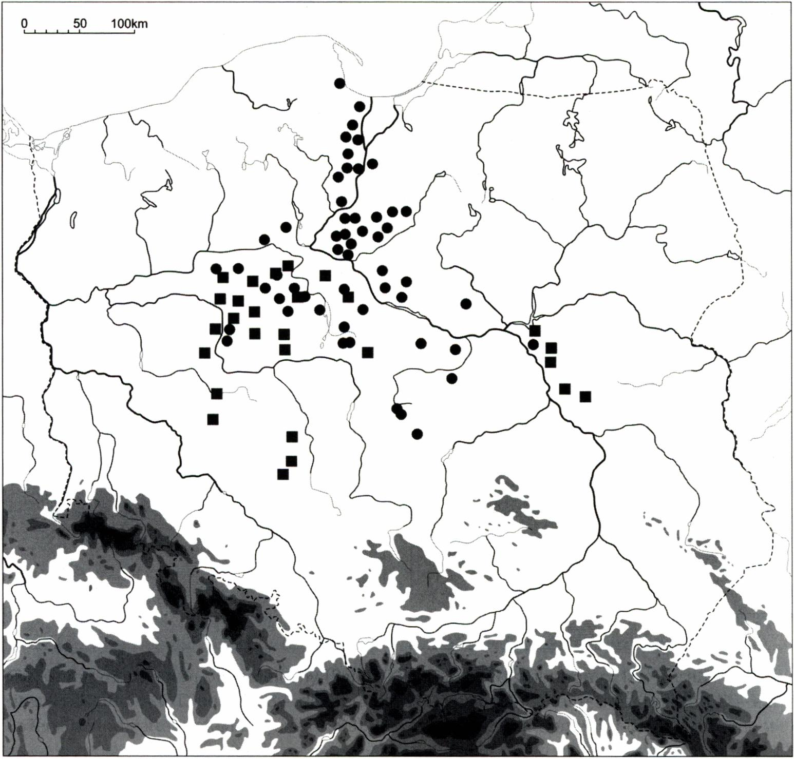
187
Fig. 8. Distribution of collective chestgraves (containing morethan 15cinerary urns) (dots)and graves with horse cremains (animal, human/animal or human-with-horse-bone-admixture) (rectangles) in Pomeranian culture (after Malinowski 1969; Muzolf, Lorkiewicz 2005; updated by author; Abłamowicz 2005)
Simultaneously with a shift of economic bases of the Pomeranian communities, deeply reaching changes of social Structure took place. They are reflected by replac- ing single burials, typical of the Lusatian culture and the Wielka Wieś phase by chest graves, containing from several to over 100 cinerary urns, interpreted as family or elan burials (Malinowski 1969: 47-58). In common opinion of archaeologists, this indicates the inereasing role of a single family. The total disintegration of other social links, pre- sumed especially in older literaturę, seems unlikely. It was derived from the false ob- servation that cemeteries of the classic stage of the Pomeranian culture were signifi- cantly smaller than those from previous period (the Wielka Wieś phase) and represented burial places of only one elan. However, as it has already been mentioned, newer field

188
data do not confirm this assumption (e.g. Fudziński, Rożnowski 1997; 2002; Fudziński, Gładykowska-Rzeczycka 2000; Kuczkowski 2001). A role of the family apparently in- creased but it still functioned within broader social frames.
Based on cemetery studies, we can suppose that the decision about migration was taken at a family, or rather a elan, level. Separate families could consolidate into broader units in order to ensure a success in reaching the destination area. Such a possibility is suggested by the distribution of the largest chest-graves in Polish lowland (represent- ing large kin level?), which may coincide with the main routes of alleged migration (Malinowski 1969, maps 11, 13; Muzolf, Lorkiewicz 2005, Fig. 6) (Fig. 8). If making the decision of leaving homeland was taken on a family or elan level (what seems com- mon for most prehistorie societies), then the observed “wavy” or “fluent” influx of the Pomeranian culture sites on the Polish lowland becomes easier to understand. Probably another well-known mechanism of migration played a significant role in this case, which means the presence of relatives in the destination area. It might have stimulated further families to follow (Anthony 1990: 903).
In the destination area, burial customs seem to be the most durable element (cf. Bur- meister 2000; Prien 2005), whilst economical strategies began to change towards morę stable, agricultural ones. It is an interesting feature of the Pomeranian culture settlements outside the Pomerania that they started to resemble typical settlements of the Lusatian complex (e.g. Muzolf 2002). Such a situation, in which those who have migrated are able to fit their economical pattems to new conditions, is confirmed by sociology. It took place in case of nearly all historical migrations (e.g. Anthony 2007: 113). It is a crucial observa- tion sińce it can indicate one of possible goals of migration: economic stabilisation as one of puli factors.
In many areas of Polish lowland and upland (Little Poland, Central Poland, Lower Silesia) it is possible to distinguish at least two types of sites or assemblages: the first are characterised by direct accordance with the Pomeranian culture type and the sec- ond are of‘mixed’ (Lusatian/Pomeranian) character (e.g. Poleska 2006: 26-33; Muzolf 2002; Andrzejowska 2005; Szamałek 2006). They may reflect complex local relations, resulting from older and new-coming cultural elements. Besides, we should remember that different regional variants of the Pomeranian culture (Fig. 1) were shaped - on one hand - by differentiated Lusatian background (regional groups), and on the other hand, by various extemal influences (e.g. Petersen 1929; Nikitina 1965; Czopek 1992; Gedl 1995). The formation of the Pomeranian cultural model in the areas beyond Pomerania was a long-term process. During that time, local societies characterised by Pomeranian model naturally maintained extemal contacts. These phenomena are far from being ex- plained and exceed the rangę of current study.

CONCLUSIONS
In this review, I was trying to present indices suggesting that in the late phase of the Early Iron Age (Hallstatt D period) migration could have taken place from Pomerania southwards. The destination territories were in some regions settled by communities of the late Lusatian culture, while the rest was unoccupied (due to the generał decline of

189
the Lusatian population during Hallstatt D period). The flow of information between Pomerania and southem territories, which is essential for migration, is evidenced during the Bronze Age and Early Iron Age, among other things, by the presence of long-distance trade routes (Bukowski 1993; 1998; Łuka 1985).
Generał conditions for migration were generated by the fact that the Pomeranian societies tumed towards less stable, extensive subsistence strategy. It led, at the begin- ning, to rapid demographic increase, but during the Hallstatt D / early La Tene period, it resulted in the local over-exploitation of natural environment (e.g. destruction of forests - Latałowa 1982; 1997). There are some substantial difficulties in determining direct ‘push’ and ‘puli’ factors, but is seems that the main cause for migration at the level of a specific family or kin might be connected with local economic decline and lack of ac- cess to agricultural products (cf. Kadrów 1995: 126; Renfrew 2001: 180-181; Czopek 2005: 225-226). Another important factor might result from social changes - we cannot exclude that mobility was the only way for specific members of the society to gain a de- sired social status. Therefore, social competition might have catalysed migratory tenden- cies (cf. Anthony 1997: 22-23; 2007: 110-111).
In my opinion, in the studied case, both the supporters and opponents of the migration scenario are partially right, just like in the famous dispute on Anglo-Saxon migration to England (Harke 1998: 19). Indeed, it is hardly possible that either the whole population left Pomerania, or all traits in central, eastem or southem Poland, identified by archaeologists as ‘Pomeranian’, were the remains of migrants from a limited region in the north. The processes were unquestionably morę complex, embracing such phe- nomena as acculturation. However, all the recollected arguments speak for the thesis that cultural changes towards ‘Pomeranian’ model among the late Lusatian societies were catalysed in the whole rangę of the Pomeranian culture by physical presence of bearers of this culture. The number of those migrants and their direct provenance in specific areas remain undetectable, but it is reasonable to assume that the further from Pomerania, the less numerous they were. Some regions, however, which probably of- fered better conditions, might have become secondary centres of redistribution of cultural traits (Fig. 1).

References:
Abłamowicz, R.
2005 Koń w obrzędowości społeczeństw kultury pomorskiej, in: Aktualne problemy kultury pomorskiej, edited by M. Fudziński and H. Paner, Gdańsk, pp. 259-269.
Andrzejowska, M.
2005 Nekropola w Dziecinowie, pow. otwocki na tle problematyki cmentarzysk pomorsko-kloszowych na Mazowszu, in: Aktualne problemy kultury pomorskiej, edited by M. Fudziński and H. Paner, Gdańsk, pp. 125-143.
Anthony, D.W.
1990 Migration and Archeology. The Baby and the Bathwater, American Anthropologist 92: 895- -914.
- The Bath Refilled. Migration in Archaeology Again, American Anthropologist 94: 174-176.

190
- Prehistorie Migration as Social Process, in: Migrations and Invasions in Archaeological Ex- planation, edited by J. Chapman and H. Hamerow (British Archaeological Reports Interna- tional Series 664), Oxford, pp. 21-32.
- The Horse, the Wheel and Language. How Bronze-Age Riders from the Eurasian Steppes Shaped the Modern World, Princeton-Oxford.
Bednarczyk, J.
- Ratownicze badania wykopaliskowe osady wielokulturowej w Juszkowie-Rusocinie, stanowisko
28, województwo pomorskie, in: XIII Sesja Pomorzoznawcza, vol. 1: Od epoki kamienia do okresu rzymskiego, edited by M. Fudziński and H. Paner, Gdańsk, pp. 191-199.
Berglund, B.E., Hjelmroos-Ericsson, M., Bogaczewicz-Adamczak, B. and Miotk, G.
1990 The Human impact in Bory Tucholskie, North Poland. A Polish-Swedish Palaeoecological Re- search Project, Acta Universitatis Lodziensis. Folia Archaeologica 13: 3-11.
Bogaczewicz-Adamczak, B. and Miotk-Szpiganowicz, G.
- Historia Jeziora Godziszewskiego i obszarów przyległych w holocenie. Zeszyty Naukowe Wydziału Biologii, Geografii i Oceanologii Uniwersytetu Gdańskiego. Geografia 16: 145-150.
Buck D.-W.
1979 Die Billendorfer Gruppe, Teil 2: Text, Verdffentlichungen des Museums fur Ur- und Friihge- schichte Potsdam 13: 3-219.
Bukowski, Z.
- Tak zwany szlak bursztynowy z wczesnej epoki żelaza w międzyrzeczu Łaby i Wisły w świetle skarbów z importami i bursztynem, in: Miscellanea archaeologica Thaddaeo Malinowski dedi- cata quae Fransicus Rożnowski redigendum curavit, edited by F. Rożnowski, Słupsk-Poznań, pp. 73-93.
- Pomorze w epoce brązu w świetle dalekosiężnych kontaktów wymiennych, Gdańsk.
- Znaleziska bursztynu w zespołach z epoki brązu i wczesnej epoki żelaza z dorzecza Odry oraz Wisły, Warszawa.
Burmeister, S.
- Archaeology and Migration. Approaches to an Archaeological Proof of Migration, Current Anthropology 41 (4): 539-553.
Chapman, J.
- The Impact of Modern Invasions and Migrations on Archaeological Explanation, in: Migrations and Invasions in Archaeological Explanation, edited by J. Chapman and H. Hamerow (British Archaeological Reports International Series 664), Oxford, pp. 11-20.
Chapman, J. and Hamerow, H.
1997 On the Move Again. Migrations and lnvasions in Archaeological Explanation, in: Migrations and Invasions in Archaeological Explanation, edited by J. Chapman and H. Hamerow (British Archaeological Reports International Series 664), Oxford, pp. 1-10.
Chochorowski, J.
2005 Społeczności epoki brązu i wczesnej epoki żelaza, in: Wielka historia świata, vol. 2: Stary i Nowy Świat. Od “rewolucji" neolitycznej do podbojów Aleksandra Wielkiego, edited by J. Śliwa, Kraków, pp. 377-500.
Czopek, S.
1992 Południowo-wschodnia strefa kultury pomorskiej, Rzeszów.
2005 Czy (praj historia lubi się powtarzać? Uwagi o znaczeniu i interpretacji kultury pomorskiej, in: Aktualne problemy kultury pomorskiej, edited by M. Fudziński and H. Paner, Gdańsk, pp. 223- -230.

191
Dzięgielewski, K.
2005 Zarys procesów osadniczych kultury pomorskiej w mikroregionach Pradoliny Kaszubskiej i Kępy Oksywskiej, in: Aktualne problemy kultury pomorskiej, edited by M. Fudziński and H. Paner, Gdańsk, pp. 385-404.
in press Południowa rubież osadnictwa kultury pomorskiej w świetle badań na stanowisku 17 w Podłężu, powiat Wieliczka, in: Via Archaeologica. Źródła z badań wykopaliskowych na trasie autostrady A4 w Malopolsce, edited by J. Chochorowski, Kraków.
Friedrich, M. and Hennig, H.
1995 Dendrochronologische Untersuchung der Hólzer des hallstattzeitlichen Wagengrabes 8 aus Wehringen, Lkr. Augsburg undandereAbsolutdaten zur Hallstattzeit, Bayerische Vorgeschichts- blatter 60: 289-300.
Fudziński, M., Adamska, E. and Fudziński, P.
2005 Badania ratownicze na osadzie z wczesnej epoki żelaza w Straszynie, gm. Pruszcz Gdański, in: XIV Sesja Pomorzoznawcza, vol. 1: Od epoki kamienia do okresu rzymskiego, edited by M. Fudziński and H. Paner, Gdańsk, pp. 327-341.
Fudziński, M. and Gładykowska-Rzeczycka, J J.
- Cmentarzysko ludności kultury pomorskiej w Rątach, gmina Somonino, Gdańsk.
Fudziński, M. and Rożnowski, F.
- Cmentarzysko ludności kultury pomorskiej w Zaworach, gmina Chmielno. Studium archeolo- giczno-antropologiczne, Gdańsk.
- Cmentarzysko ludności kultury pomorskiej w Rębie, gmina Przodkowo, Gdańsk.
Gediga, B.
- Nowe przesłanki do badań struktury społecznej ludności kultury łużyckiej w okresie halsztackim, in: Opera ex aere. Studia z epoki brązu i wczesnej epoki żelaza dedykowane profesorowi Janowi Dąbrowskiemu, edited by M. Mogielnicka-Urban, Warszawa, pp. 169-176.
Gedl, M.
1995 Południowo-zachodnie peryferie zasięgu kultury pomorskiej, in: Kultura pomorska i kultura grobów kloszowych - razem czy osobno? Materiały z konferencji w dniach 24-26 listopada 1993, edited by T. Węgrzynowicz et al., Warszawa, pp. 189-200.
- Die Fibeln in Polen (Prahistorische Bronzefunde, Abt. XIV, Bd. 10), Stuttgart.
Grygiel, M., Pikulski, J. and Trojan, M.
- The Research on the Multicultural Site no. 1 in Zagórzyce, com. Kazimierza Wielka, voiv. Świętokrzyskie During the Years 2003-2004, Recherches Archeologiąues S.N. 1: 199-275.
Harding, A.F.
2000 European Societies in the Bronze Age {Cambridge World Archaeology), Cambridge.
Harke, H.
- Archaeologists and Migration. A Problem of Attitude?, Current Anthropology 39(1): 19-45.
Hensel, W.
1958 Poznań w zaraniu dziejów {Popularnonaukowa Biblioteka Archeologiczna 2), Wrocław.
1969 Do dyskusji nad rozprzestrzenianiem się archeologicznej kultury ‘‘pomorskiej’’, Swiatowit 30: 225-228.
1971 Archeologia i prahistoria. Studia i szkice, Wrocław.
- Polska starożytna, Wrocław.
Informator Archeologiczny,
1977 Informator Archeologiczny. Badania rok 1976, Warszawa.
1984 Informator Archeologiczny. Badania rok 1983, Warszawa.

192
Kaczmarek, M.
- Aktualne problemy badań nad kulturą pomorską w Wielkopolsce, Folia Praehistorica Pos- naniensia9: 135-172.
- Uwagi o wczesnej fazie kultury pomorskiej w Wielkopolsce, in: Aktualne problemy kultury pomorskiej, edited by M. Fudziński and H. Paner, Gdańsk, pp. 159-181.
Kadrów, S.
1995 Gospodarka i społeczeństwo. Wczesny okres epoki brązu w Małopolsce, Kraków.
Kossinna, G.
1917 Die goldenen "Eidringe " unddie jungere Bronzezeit in Ostdeutschland, Mannus 8: 1-133.
Kostrzewski, J.
1923 Wielkopolska w czasach przedhistorycznych, Poznań.
1946 Prasłowiańszczyzna. Zarys dziejów i kultury Praslowian, Poznań.
Kuczkowski, W.
- Cmentarzysko ludności kultury wschodniopomorskiej w Koziej Górze, gm. Mrocza, woj. kujawsko-pomorskie, stan. I, Pomorania Antiąua 18: 187-230.
Kwapiński, A. and Ruta, A.
- Badania ratownicze na stanowisku 9 w Kamionce, gmina Smętowo Graniczne, in: XIII Sesja Pomorzoznawcza, vol. 1: Od epoki kamienia do okresu rzymskiego, edited by M. Fudziński and H. Paner, Gdańsk, pp. 117-124.
Kwapiński, M.
1993 Wozy w kulturze pomorskiej, Pomorania Antiąua 15: 1-28.
1995 Zwierzęta w gospodarce i wierzeniach kultury pomorskiej, in: Kultura pomorska i kultura grobów kloszowych. Razem czy osobno? Materiały z konferencji w dniach 24-26 listopada 1993, edited by T. Węgrzynowicz et al., Warszawa, pp. 361-367.
Latałowa, M.
1982 Postglacial Cegetalional Changes in the Eastern Baltic Coastal Zonę of Poland, Acta Palaeo- botanica 22 (2): 179-249.
1992 Man and Cegetation in the Pollen Diagrams from Wolin Island (NW Poland), Acta Palaeobo- tanica 32(1): 123-249.
1997 Wpływ osadnictwa schyłku epoki brązu i wczesnej epoki żelaza na późnoholoceńską historię lasów na Pobrzeżu, in: Dynamika i ochrona roślinności Pomorza. Materiały z sympozjum. Gdańsk, 28-30 września 1995 r., edited by W. Fałtynowicz, M. Latałowa and J. Szmeja, Gdańsk-Poznań, pp. 113-124.
2007 Gospodarka człowieka w diagramach pyłkowych, in: Studia interdyscyplinarne nad środowiskiem i kulturą w Polsce, edited by M. Makohonienko, D. Makowiecki and Z. Kurnatowska {Środowisko - Człowiek - Cywilizacja 1), Poznań, pp. 171-187.
Latałowa, M. and Tobolski, K.
- Type Region P-u. Baltic Shore, Acta Palaeobotanica 29 (2): 109-114.
Łanczont, M. and Wojtanowicz, J.
2005 Uwarunkowania przyrodnicze rozwoju osadnictwa pradziejowego w Kotlinie Sandomierskiej, in: Archeologia Kotliny Sandomierskiej, edited by M. Kuraś (Rocznik Muzeum Regionalnego w Stalowej Woli 4), Stalowa Wola, pp. 39-55.
Łuka, L.J.
1965 Kilka uwag o kontaktach łączących kulturę pomorską z kulturą łużycką we wczesnej epoce żelaza, Pomerania Antiąua 1: 51-58.

193
1979 Kultura wejherowsko-krotoszyńska, in: Prahistoria ziem polskich, vol. 4: Od środkowej epoki brązu do środkowego okresu lateńskiego, edited by J. Dąbrowski and Z. Rajewski, Wrocław.
1983 Kształtowanie się osadnictwa na Pomorzu Wschodnim na przełomie epoki brązu i żelaza, Po- morania Antiąua 11: 7-29.
1985 Kontakty wymienne ludności grupy kaszubskiej i grupy chełmińskiej kultury łużyckiej w świetle znalezisk gromadnych, Pomorania Antiąua 12: 17-59.
Magny, M.
- Holocene Climate Variability as Reflected by Mid-European Lake-Level Fluctuations and Its Probable Impact on Prehistorie Human Settlements, Quatemary Intemational 113: 65-79.
Maise, Ch.
1998 Archaoklimatologie - Vom Einfluss nacheiszeitlicher Klimavariabilitat in der Ur- und Friih- geschichte, Jahrbuch der Schweizerischen Gesellschaft fur Ur- und Friihgeschichte 81: 197- -235.
Malinowski, T.
1963 Uwagi na temat zbieżności pomiędzy kierunkami rozwoju niektórych form obrządku pogrzebowego ludności kultury łużyckiej w Polsce i ekspansji kultury pomorskiej, in: Munera ar- chaeologica Iosepho Kostrzewski, edited by K. Jażdżewski, W. Hensel and W. Koćka, Poznań, pp. 201-229.
1969 Obrządek pogrzebowy ludności kultury pomorskiej, Wrocław.
1989a Ekspansja kultury pomorskiej i charakter tej ekspansji, in: Pradzieje ziem polskich, vol. 1: Od paleolitu do środkowego okresu lateńskiego, part 2: Epoka brązu i początki epoki żelaza, edited by J. Kmieciński, Warszawa-Łódź, pp. 570-573.
1989b Kultura pomorska wraz z tzw. kulturą grobów podkloszowych, in: Pradzieje ziem polskich, vol.l: Od paleolitu do środkowego okresu lateńskiego, part 2: Epoka brązu i początki epoki żelaza, edited by J. Kmieciński, Warszawa-Łódź, pp. 573-582.
1995 Niektóre zagadnienia rozwoju kulturowego u schyłku epoki brązu i we wczesnej epoce żelaza w Europie Środkowej, in: Kultura pomorska i kultura grobów kloszowych. Razem czy osobno? Materiały z konferencji dniach 24-26 listopada 1993, edited by T. Węgrzynowicz et al.. Warszawa, pp. 19-35.
2007 Refleksje na temat kultury łużyckiej na Pomorzu, in: Aktualne problemy kultury łużyckiej na Pomorzu, edited by M. Fudziński and H. Paner, Gdańsk, pp. 11-20.
Mierzwiński, A.
- Przemiany osadnicze społeczności kultury łużyckiej na Śląsku, Wrocław.
Miotk-Szpiganowicz, G.
1992 The History of the Tegetation of Bory Tucholskie and the Role of Man in the Light of Palyno- logical Investigations, Acta Palaeobotanica 32 (1): 39-122.
Muzolf, B.
- Wyniki ratowniczych badań archeologicznych na terenie odkrywki "Szczerców" KWB “Bełchatów" S.A. na stan. 12 w Grabku, gm. Szczerców, woj. łódzkie. Kompleks osadniczy z okresów halsztackiego i lateńskiego, in: Badania archeologiczne na terenie odkrywki “Szczerców” Kopalni Węgla Brunatnego “Bełchatów"S.A., vol. 2, edited by R. Grygiel, Łódź, pp. 121- -384.
Muzolf, B. and Lorkiewicz, W.
- Cmentarzyska w Konstantynowie Ignacewie st. 18 oraz Grabku st. II, woj. łódzkie na tle cmentarzysk pomorsko-kloszowych z terenów Polski Środkowej, in: Aktualne problemy kultury pomorskiej, edited by M. Fudziński and H. Paner, Gdańsk, pp. 183-222.

194
Nalepka, D.
- Prehistorie and Historie Settlement Recorded in a Terrestrial Pollen Profile. Boreal to Subat- lantic Forest Succession in a 60 cm Thick Sediment in Stanislawice (Southern Poland), Acta Palaeobotanica 43 (1): 101-112.
- Sites Used For Drawing the Isopollen Maps of Poland, in: Late Glacial andHolocene History of Vegetation in Poland Based on Isopollen Maps, edited by M. Ralska-Jasiewiczowa et al., Kraków, pp. 417-423.
Nikitina, V.B.
1965 Pamyatniki pomorskoi kul 'tyrui v Belorussii i na Ukrainę, Sovetskaya Arkheologiya 1: 194-205.
Nosek, S.
1946 Kultura grobów skrzynkowych i podkloszowych w Polsce południowo-zachodniej (Prace Prehistoryczne PAU3), Kraków.
Ostoja-Zagórski, J.
1982 Przemiany osadnicze, demograficzne i gospodarcze w okresie halsztackim na Pomorzu, Wrocław.
1993 Mezoregion Sobiejuchy na Pałukach. Dynamika procesów zasiedlania w starożytności, Warszawa-Żnin.
Paner, H., Fudziński, M. and Godon, K.
- Ratownicze badania archeologiczne w obrębie autostrady Al na terenie województwa pomorskiego w roku 2000, Pomorania Antiqua 19: 7-36.
Pazda, S.
1970 Ze studiów nad kulturą wschodniopomorską na Dolnym Śląsku, Archeologia Polski 15(1): 89- -113.
Pelisiak, A. and Rybicka, M.
1998 Archaeological Evidence of Prehistorie Settlement in the Area Near Lakę Gościąż, in: Lakę Gościąż, Central Poland. A monographic study, part 1, edited by M. Ralska-Jasiewiczowa et al., Kraków, pp. 259-265.
Petersen, E.
1929 Die friihgermanische Kultur in Ostdeutschland und Polen (Yorgeschichtliche Forschungen 2), Berlin.
Pietrzak, M. and Podgórski, J.T.
- Chlapowo 2, powiat pucki woj. pomorskie. Cmentarzysko fazy wielkowiejskiej kultury pomorskiej, Gdańsk.
Podgórski, J.T.
1972 Tymczasowe wyniki badań wykopaliskowych prowadzonych w 1969 r. na stanowisku 3 wJusz- kowie, w pow. gdańskim, Pomorania Antiąua 4: 205-234.
1992 Fazy cmentarzysk kultury łużyckiej i pomorskiej na Pomorzu Wschodnim, in: Ziemie polskie we wczesnej epoce żelaza i ich powiązania z innymi terenami, edited by S. Czopek, Rzeszów, pp. 199-214.
1997 Forschungen zum Wohnbau und tiber Hausurnen der ausgehenden Bronze- und friihen Eisen- zeit in Pommerellen, in: Haus und Hof in ur- und frilhgeschichtlicher Zeit, edited by H. Beck and H. Jankuhn, Góttingen, pp. 193-219.
Poleska, P.
- Celtycki mikroregion osadniczy w rejonie podkrakowskim (Biblioteka Muzeum Archeologicznego w Krakowie 2), Kraków.

195
Prien, R.
- Archdologie und Migration. Vergleichende Studien zur archaologischen Nachweisbarkeit von Wanderungsbewegungen (Universitatsforschungen zur prahistorischen Archdologie 120), Bonn.
Ralska-Jasiewiczowa, M. and van Geel, B.
- Human Impact on the Tegetation of the Lakę Gościąż Surroundings in Prehistorie and Early- -Historic Times, in: Lakę Gościąż, Central Poland. A monographic study, part 1, edited by M. Ralska-Jasiewiczowa et al., Kraków, pp. 267-294.
Renfrew, C.
- Archeologia i język: łamigłówka pochodzenia Indoeuropejczyków [Archaeology and Language. A puzzle of Indo-European Origins], translated by E. Wilczyńska and A. Marciniak, Warszawa.
Sabatini, S.
- House Urns. A European Lale Bronze Age Trans-Cultural Phenomenon (Gotarc Series B. Goth- enburg Archaeological Theses 47), Góteborg.
Speranza, A., van Geel, B. and van der Plicht, J.
- Evidence for Solar Forcing of Climate Change at ca. 850 cal BC from a Czech Peat Seąuence, Global and Planetary Change 35: 51-65.
Szamałek, K.
- Zagadnienie ciągłości zasiedlenia w cyklu łużyckim i okresie łużycko-pomorskiej transformacji kulturowej w świetle badań na wschodniowielkopolsko-kujawskim odcinku gazociągu tranzytowego, in: Z badań nad osadnictwem epoki brązu i wczesnej epoki żelaza w Europie Środkowej, edited by W. Blajer, Kraków, pp. 35-62.
Szymańska, A.
1981 Wstępne uwagi nad osadnictwem na Wysoczyżnie Siemirowickiej na przełomie epoki brązu i żelaza (w związku z badaniami w Siemirowicach, gm. Cewice), Pomorania Antiqua 10: 7-24.
Swiętosławski, W., Kurasiński, T. and Wojtyła, J.
- Wyniki badań ratowniczych wielokulturowego stanowiska nr 13 w Nowym Dworze, woj. pomorskie, Łódzkie Sprawozdania Archeologiczne 5: 21-101.
Tackenberg, K.
1926 Diefriihgermanische Kultur in Schlesien, Altschlesien 1: 121-156.
Tinner, W., Lotter, A.F., Ammann, B., Conedera, M., Hubschmid, R, van Leeuwen, J.F.N. and Wehrli, M.
- Climatic change and contemporaneous land-usephases north andsouth of the Alps 2300 BC to 800 AD, Quatemary Science Reviews 22: 1447-1460.
Trachsel, M.
- Untersuchungen zur relativen und absoluten Chronologie der Hallstattzeit, vol. 1 (Univer- sitatsforschungen zur prahistorischen Archdologie 104), Bonn.
van den Boom, H.
1980/1981 Die Pommerellische Gesichtsurnenkultur. Ein Bericht zum Stand der Forschung, Acta Praehislorica et Archaeologica 11/12: 219-304.
van Geel, B., Buurman, J., Waterbolk, H.T.,
1996 Archaeological and Palaeological Indications of an Abrupt Climate Change in The Nether- lands, and Evidence for Climatological Teleconnections Around 2650 BP, Joumal of Quater- nary Science 11/6: 451-460.

196
van Geel, B., Bokovenko, N.A., Burova, N.D., Chugunov, K.V., Dergachev, V.A., Dirksen, V.G., Kulkova, M., Nagler, A., Parzinger, H., van der Plicht, J., Vasiliev, S.S. and Zaitseva, G.I.
- The Sun, Climate Change and the Ezpansion of the Scythian Culture After 850 BC, in: Impact of the Emironment on Human Migration in Eurasia, edited by E.M. Scott, A.Y. Alekseev and G. Zaitseva (NATO Science Series, 4, Earth andEnvironmental Sciences 42), Dordrecht, pp. 151-158.
van Geel, B., Raspopov, O.M. and Renssen, H.
1998 Solar Forcing of Abrupt Climate Change Around850 Calendar Years BC, in: Natural Catastro- phes During Bronze Age Civilisations. Archaeological, Geological, Astronomical and Cultural Perspectives, edited by BJ. Peiser, T. Palmer and M.E. Bailey (British Archaeological Reports International Series 728), Oxford, pp. 162-168.
Węgrzynowicz, T.
- O potrzebie dyskusji nad wzajemnym stosunkiem kultury pomorskiej i kultury grobów kloszowych, in: Kultura pomorska i kultura grobów kloszowych. Razem czy osobno? Materiały z konferencji w dniach 24-26 listopada 1993, edited by T. Węgrzynowicz et al., Warszawa, pp. 11-18.
Wiącek, B.
1972 Z badań nad osadnictwem z wczesnej epoki żelaza na terenie Luzina, pow. wejherowski, Pomo- rania Antiqua 4: 247-288.
Wołągiewicz, R.
1979 Kultura pomorska a kultura oksywska, in: Problemy kultury pomorskiej, edited by T. Malinowski, Koszalin, pp. 33-69.
Woźniak, Z.
1979 Chronologia młodszej fazy kultury pomorskiej w świetle importów i naśladownictw zabytków pochodzenia południowego, in: Problemy kultury pomorskiej, edited by T. Malinowski, Koszalin, pp. 125-148.
1995 Kultura pomorska a kultura lateńska, in: Kultura pomorska i kultura grobów kloszowych. Razem czy osobno? Materiały z konferencji w dniach 24-26 listopada 1993, edited by T. Węgrzynowicz et al., Warszawa, pp. 201-212.

