GEOLOGICA CARPATHICA, APRIL 2009, 60, 2, 151— 164 doi: 10.2478/v10096-009-0010-7

The clasts of Cretaceous marls in the conglomerates of the Konradsheim Formation
(Pöchlau quarry, Gresten Klippen Zone, Austria)

ANDRZEJ ŚLĄCZKA1, M. ADAM GASIŃSKI1, MARTA BĄK1 and GODFRID WESSELY2

1Jagiellonian University, Institute of Geological Sciences, Oleandry 2a, 30-063 Kraków, Poland; andrzej.slaczka@uj.edu.pl
2Siebenbrunnengasse 29,1050 Wien, Austria

(Manuscript received November 14, 2007; accepted in revised form October 23, 2008)

Abstract: Investigations were carried out on foraminiferids and radiolaria from redeposited clasts within the conglomer- ates of the Konradsheim Formation (Gresten Klippen Zone) in the area of the Pöchlau hill, east of Maria Neustift. These shales and marls are of Middle to Late Jurassic and Early Cretaceous age. In the latter clasts, foraminiferal assemblages with Tritaxia ex gr. gaultina as well as radiolaria species Angulobracchia portmanni Baumgartner, Dictyomitra communis (Squinabol), Hiscocapsa asseni (Tan), Pseudodictyomitra lodogaensis Pessagno, Pseudoeucyrtis hanni (Tan), Rhopalosyringium fossile (Squinabol) were found. In one block from the uppermost part of the sequence there is an assemblage with Caudammina (H) gigantea, Rotalipora appenninica and Globotruncana bulloides. However, the brecci- ated character of this block and occurrence near a fault suggest that it was probably wedged into the conglomerates of the Konradsheim Formation during tectonic movements. In pelitic siliceous limestones below the Konradsheim Limestone radiolarian assemblages of Middle Callovian to Early Tithonian age were found. They enable correlation with the Scheibbsbach Formation. In a marly sequence, above the conglomeratic limestone, the foraminiferal assemblages contain taxa from mid-Cretaceous up to Paleocene. The present biostratigraphic investigation confirmed the previous stratigraphic assignments and imply clearly that the sedimentation of deposits similar to the Konradsheim Formation also occurred at the end of the Early Cretaceous and deposition of conglomeratic limestones within the Gresten Klippen Zone, and espe- cially within the Konradsheim Formation, was repeated several times during the Late Jurassic and Early Cretaceous.

Key words: Cretaceous, Paleogene, Austria, Gresten Klippen Zone, Konradsheim Formation, biostratigraphy.

Introduction

The Gresten Klippen Zone is part of the Ultra-Helvetic realm ranging in Austria – apart from Vorarlberg – from Salzburg in the West to the Wienerwald (Vienna Forest, Lower Austria) in the East. The rocks are divided into “Cores” and “Enve- lopes”. The former contain blocks of granites and sediments ranging from Lower Jurassic to Lower Cretaceous. They form the characteristic klippes. The envelope lithology is represented by the “Buntmergel” Formation ranging from Upper Creta- ceous to Eocene. Despite long-lasting stratigraphic investiga- tions (Aberer 1951; Schnabel 1970, 1992; Faupl 1975; Widder 1988; Slączka & Höck 2000; Höck & Slaczka 2001; Höck et al. 2003, 2005; Ślączka et al. 2006) a lot of problems remain, in- cluding the age of the Konradsheim Formation and its accom- panying rocks (see also Widder 1988). Many of the earlier findings, indicating only Jurassic ages, are not consistent with our data. Because of the stratigraphic importance of the Konrad- sheim Formation for the Ultra-Helvetic but also for the neigh- bouring Penninic realm we report new biostratigraphic results from two quarries at the Pöchlau hill in Lower Austria.

Geological setting

The Gresten Klippen Zone is situated at present in front of the Northern Calcareous Alps, generally to the South of the
Rheno-Danubian Flysch Zone (Fig. 1). Further to the East it prolongs into the Hauptklippenzone between the Laab and Greifenstein Nappes (Schnabel 2002). Generally the older, Ju- rassic and Cretaceous part of lithostratigraphic succession of the Gresten Klippen Zone is represented by separate blocks (klippes) from tens to hundreds of meters in diameter which are covered by variegated marls and shales of Late Cretaceous

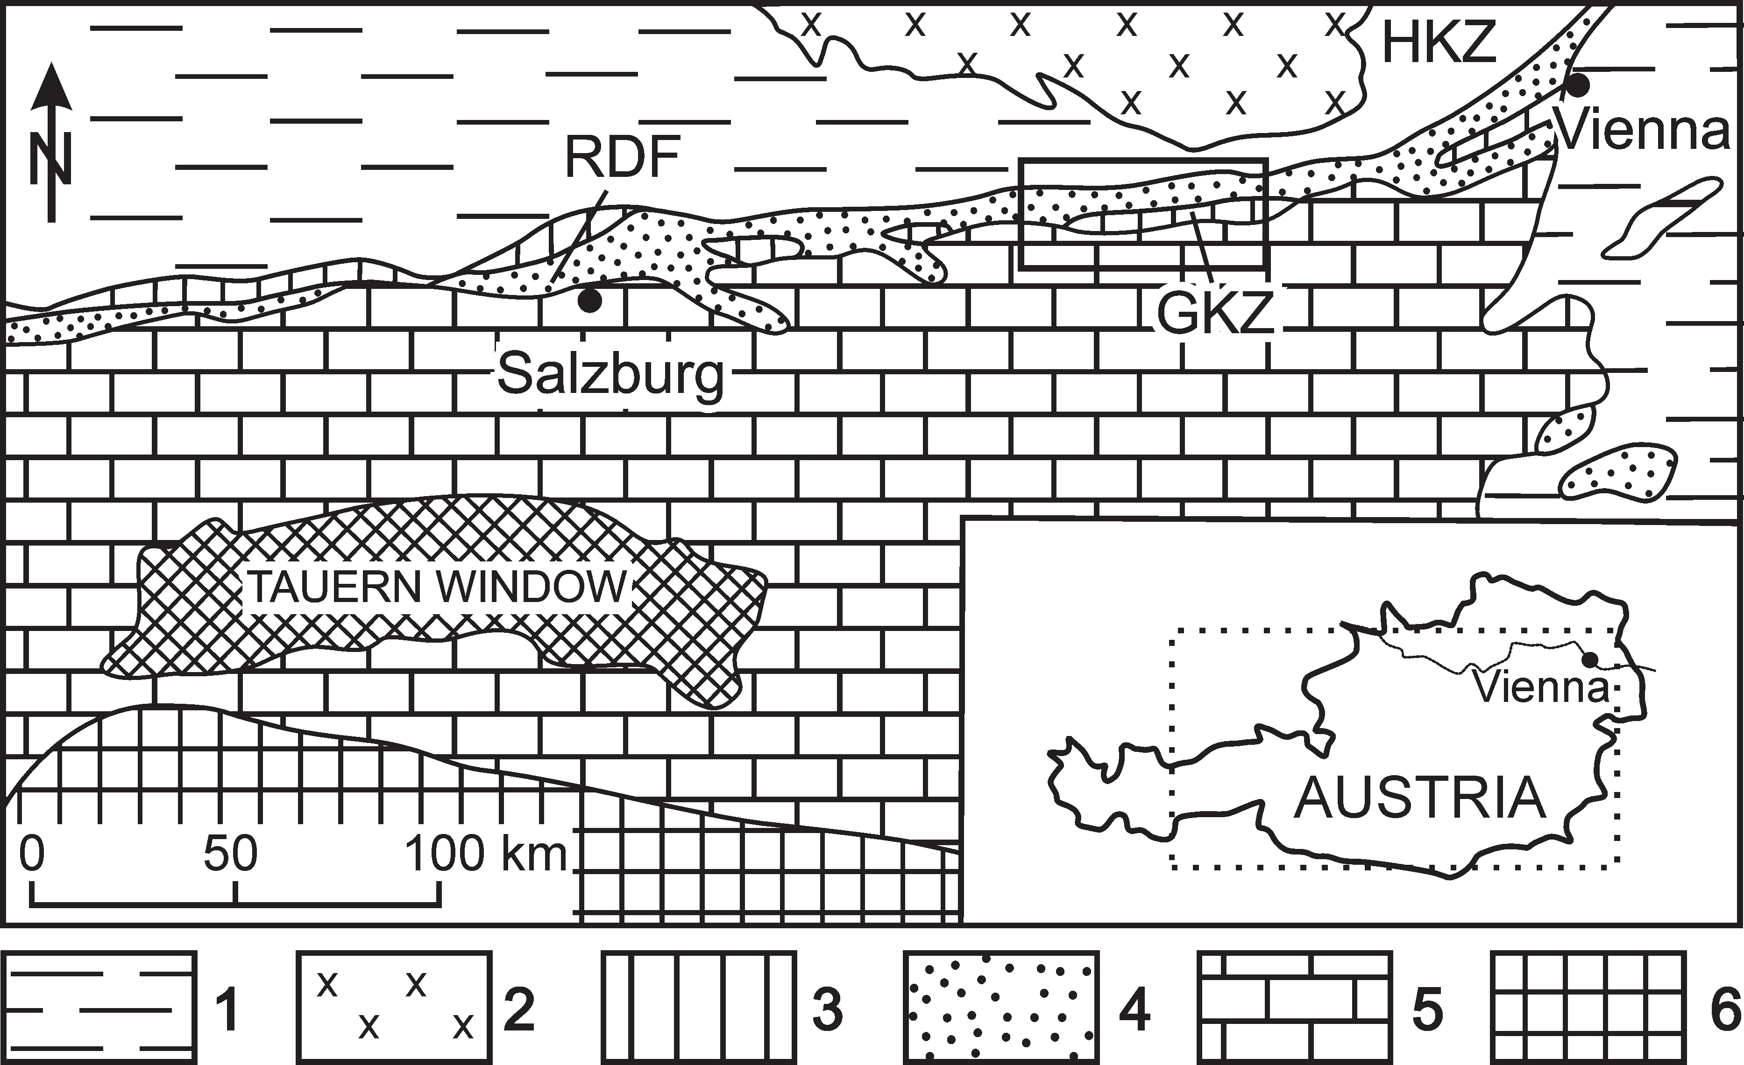

Fig. 1. Geological sketch map of the Eastern Alps with depicted area of study shown in detail in Fig. 2. 1 – Alpine Foredeep, 2 – Bohe- mian Massif, 3 – Helvetic zone including the Grestem Klippen Zone (GKZ) and the Hauptklippen Zone (HKZ), 4 – Rheno-Danubian Flysch (RDF), 5 – Austroalpine nappes, 6 – Southern Alps.

www.geologicacarpathica.sk

to Paleogene age which create the klippes mantle (Aberer 1951; Widder 1989). Usually only a part of the succession is visible in individual klippe.
The most characteristic lithofacies of the Gresten Klippen Zone is the Gresten Formation of Early Jurassic age with arkos- es, sandstones and shales intercalated by coal in the lower part (Hettangian), and calcareous deposits in the upper part (Sine- murian—Toarcian). The Gresten Formation is followed by a suc- cession beginning with spotted marls (Aalenian), which pass upwards into the Posidonia Marls (Bajocian—Callovian) and cherty limestones with radiolarites (Oxfordian, Lampelsberg Formation). The Malmian and Neocomian are represented mainly by turbiditic siliceous limestones (Scheibbsbach Forma- tion), micritic Arthof Limestones, Aptychus limestones (Lower Blassenstein Formation) and spotted marls (Upper Blassenstein Formation) that are lasted till the Barremian—Aptian (Wessely 2006) similar to the deposits known in the Pieniny Klippen Belt (Pieniny Limestone Formation; Birkenmajer 1977) and in the Northern Calcareous Alps (Oberalm Formation, Aptychen- kalk). The characteristic sediments in the higher part of this suc- cession include the lenses of conglomerates named the Konradsheim Limestone (Konradsheim Beds according to Decker 1987, Ruttner & Schnabel 1988, lately Konradsheim Formation of Piller et al. 2004) that created several intercala- tions within the Scheibbsbach Formation, Arthof Limestones and probably Blassenstein Formation during a period from Late Oxfordian to earliest Cretaceous (Berriasian; Trauth 1950; Aberer 1951; Schnabel 1970; Oberhauser 1980; Decker 1987;
Widder 1988; Höck et al. 2003; Wessely 2006). However, Schnabel (1970) mentioned the occurrence of the Cretaceous foraminifers Hormosina ovulum (Grzybowski) in marly interca- lations within the conglomerates of the Konradsheim Lime- stones type near Konradsheim village. Recent investigations (Höck et al. 2003, 2005) carried out in the locus typicus of the conglomeratic part of the Konradsheim Formation near Kon- radsheim village and in the Pechgraben area south of Maria Neustift village suggest that sedimentation of the conglomerates of the Konradsheim Formation also took place during the high- er part of the Early Cretaceous.
The original paleogeographic position of the Gresten suc- cession is thought (Oberhauser 1980; Decker 1987; Schnabel 1992) to have been north of the Rheno-Danubian Flysch Basin on the southern margin of the Bohemian Massif, which is a part of the European plate. However the Jurassic and Creta- ceous sediments, apart from the Gresten Formation, encoun- tered above the Bohemian Massif in the boreholes, below the Molasse Zone, generally differ from the sediments of the Gresten Klippen Zone.
The Gresten Formation, which lay unconformably on the crystalline and Paleozoic rocks of the southern part of the Bo- hemian Massif consists of deltaic clastics with coal beds and of prodeltaic shales similar to those from the Gresten Klippen Zone. Their age, however, in the basement of the Molasse Zone is younger than in the Gresten Klippen Zone (Wessely 2006) and they represent the Middle Jurassic (?Aalenian—Ba- thonian). They are covered by dolomitic and quartzitic sand- stones with cherts of Callovian age (Nikolčice-Höflein Formation). The Upper Jurassic is represented by dolomitic limestones, bioclastic limestones (Vranovice Formation; Ox-
fordian), platform carbonates including sponge and coral reefs (Altenmark Formation), dark grey marls (Mikulov Formation; Oxfordian—Tithonian), calcarenites (Kurdejov Formation; Ti- thonian) and limestones, dolomites and marly limestones with cherts at the base (Ernstbrunn Formation; Tithonian). A simi- lar Upper Jurassic facies as described above is also known from the Waschberg Unit, which is overthrust from the South onto the Bohemian Massif. They are represented mainly by grey marly limestones with cherts and grey sandy clays with ammonites and belemnites (Klentnice Formation; Kimmerid- gian—Tithonian; Hanzliková & Andrusov 1983), as in the more northern area by limestones of the Ernstbrunn Forma- tion. Further to the West, the Jurassic deposits of the Bohemi- an Massif, which consist of the Doggerian sandstones and Malmian limestones (Wessely 1988), were found beneath the Molasse in the borehole Grünau 1, situated SW from Steyr. According to the mineralogical investigations of Faupl (1975), granitoids found within the Gresten Klippen Zone, mainly in the mantle envelope, show an affinity to the Bohemian Massif and the Brunovistulicum. Generally, the Upper Jurassic sedi- ments known from the Bohemian Massif and Waschberg Zone represent shelf and slope facies of the southern slope of the European Platform, whereas neritic lithofacies known from the Gresten Klippen Zone strongly resemble the open sea Alpine facies. It should be noted that the Gresten Formation is known not only from the southern margin of the Bohemian Massif. Lower Jurassic coarse sandstones and conglomerates with intercalations of limestones regarded as similar to Grest- en Formation, covered by limestones and Posidonia Forma- tion, were described from the western part of the Pieniny Klippen Belt in Slovakia (Andrusov 1959). The higher, Upper Jurassic sediments with radiolarites and cherty limestones (Pieniny Limestone Formation) also show similarities to the deposits of the Gresten Klippen Zone of the same age. The Gresten Formation with coal deposits is also known from the Mecsek Mts in Hungary (Haas 2001). Gresten sandstones are developed in the Bihor Zone of the Northern Apuseni Mts (Ianovici et al. 1976) and in the Southern Carpathians (Burch- field 1976) of Romania, but the Upper Jurassic sediments are represented generally by shallow water limestones. The occur- rence of the Gresten sandstones was recently mentioned from the Pieniny Klippen Belt (Józsa & Aubrecht 2008). These oc- currences of the Gresten Formations in different areas of the Alpine-Carpathian range suggests that this litho-facies was widespread in that realm. Areas chracterized by sedimentation of the Gresten Formation probably represent fragments of the southern part of the European plate which separated from the main part of this plate during Jurassic rifting and record the development of a sedimentary basin of the Alpine realm.

Area of investigations and its geology

Our studies were carried out in quarries at the Pöchlau hill, which is situated between the villages Konradsheim and Maria Neustift (Figs. 2, 3). According to Aberer (1951) this hill was built up of the Malmkalk klippe enveloped by the Gresten Formation from the North and Upper Cretaceous marls from the South.

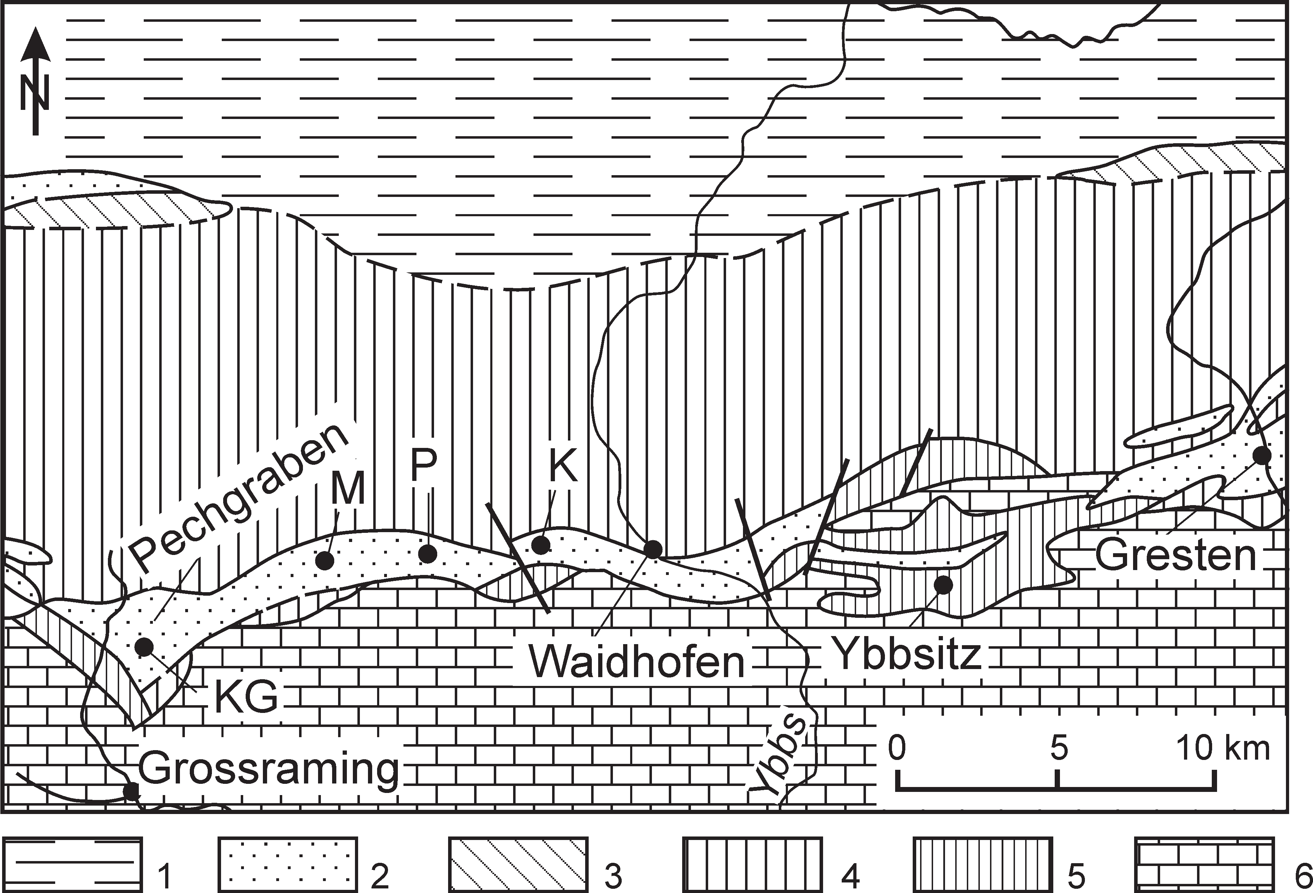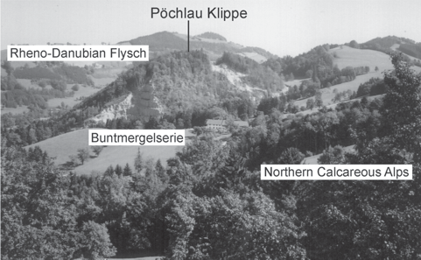

Fig. 2. Sketch map of the Klippen Zone and adjacent areas between Gresten and Pechgraben based on Schnabel (1992). 1 – Alpine Fore- land, 2 – Gresten Klippen Zone, 3 – Helvetic Zone, 4 – Rheno- Danubian Flysch Zone, 5 – Ybbsitz Klippen Zone, 6 – Northern Calcareous Alps; P – Pöchlau Klippe; K – Konradsheim, M – Maria Neustift, KG – Kohlgraben.

Recent research shows that this klippe (approximately 550 meters long and 250 meters wide, Fig. 4), includes a succes- sion of dark, siliceous shales (Fig. 4) with radiolaria of not preciselly determined Jurassic age probably representing the transition between the Lampelsberg and Scheibbsbach Forma-
Fig. 3. General view of the Pöchlau Klippe. Two quarries are visi- ble, lower on the left and higher on the right.

tions. They are covered by a complex 25 m thick, of thin- to medium-bedded, grey, pelitic and graded siliceous limestones, marls and sporadic cherts, which shows similarities to the Scheibbsbach Formation of Widder (1988). Locally, thin in- tercalations of red limestones and radiolarites occur. A few layers of micritic limestones appear at the top of this succes- sion. Within the upper part of the succession there are a few intercalations of locally developed conglomeratic layers, that are lithologically similar to the conglomerates of the Konrad- sheim Formation (see also Widder 1988). They could repre-
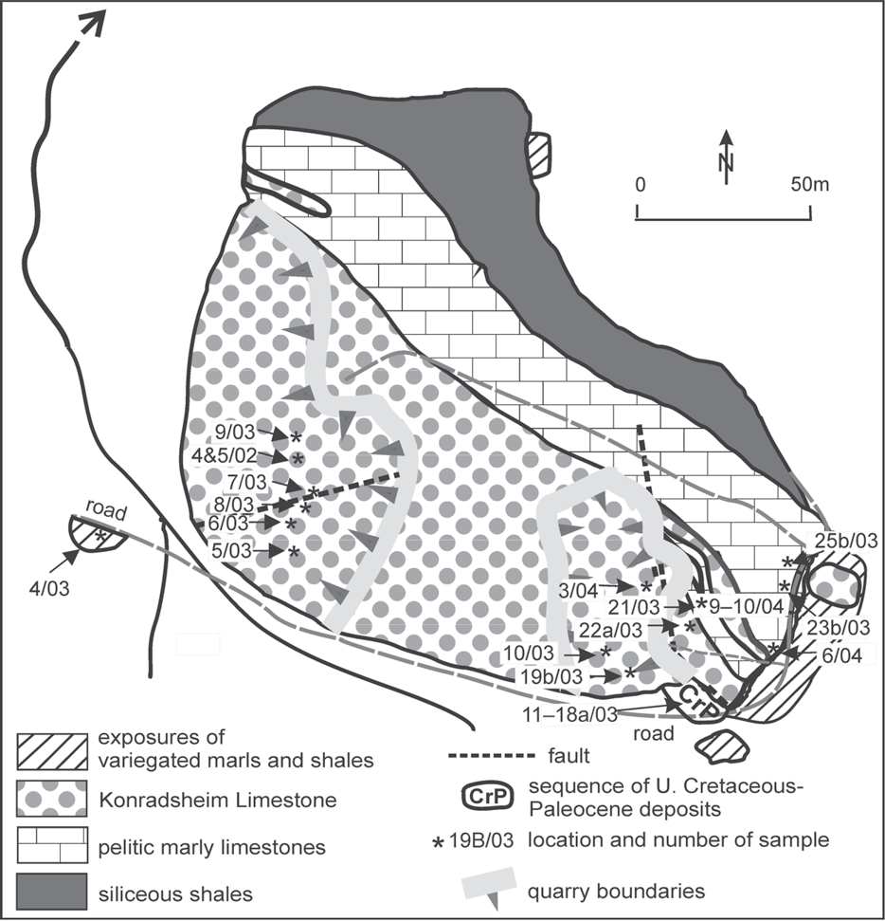
sent primary intercalations and/or a tec- tonic repetition caused by local thrust faults or/and refolding. An example of re- folding is visible in an exposure in the eastern part of the klippe (Fig. 5.1).
In the higher part of the succession, the klippe is built up of complex clast-sup- ported conglomerates and sedimentary breccias, up to 80 meters thick. Small ero- sional channels mark the boundary to the underlying pelitic limestones (Fig. 5.2). The character of these deposits corre- sponds to the conglomerates of the Kon- radsheim Formation. They are developed as very thick, usually amalgamated, clast- and matrix-supported conglomerates and sedimentary breccias, often displaying gradation (comp. Faupl 1975; Decker 1987). Pelitic intercalations are very rare and thin. Characteristic is the occurrence of clasts of black, grey and greenish marls and shales. These clasts vary in diameter from a few centimeters to more than one meter (Fig. 5.2, 5.3). They are rounded and subrounded. One clast of black shale contains tiny shells of Bositra. The sedi- mentary structures indicate that these sed- iments represent deposits of debris flows. Generally, coarser sediments with blocks of conglomeratic limestones and excep- tionally big marly clasts exist in the lower
Fig. 4. Geological sketch-map of the Pöchlau hill, according to Wessely (state in 2005).
part of the sequence that is exposed in the

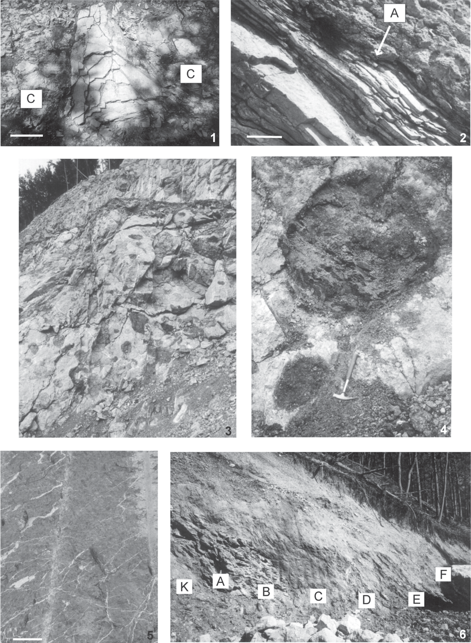

Fig. 5. Pictures of exposures: 1 – Local fold. Light grey pelitic and arenaceous limestones in crest of anticline and conglomerates (C) on the limbs. Length of bar 0.5 m. Road along eastern border of the klippe. 2 – Contact between light grey limestones and debris flow (Konradsheim Limestone). A small erosional channel is visible (A). Length of bar 0.5 m. Upper quarry. 3 – Lower part of the Konradsheim Limestone. Sub- marine slump, several meters thick, with pelitic clasts, up to 1.5 meters in diameter. Lower quarry. 4 – Detailed picture of the Konradsheim Limestone breccia with clasts. Lower quarry. Length of hammer is 45 cm. 5 – Upper part of the Konradsheim Limestone. Fine-grained con- glomerate with clasts up to 20 cm in length. Length of bar 0.2 m. Length of hammer is 45 cm. 6 – Sequence of the Late Cretaceous-Paleocene marls and shales. A – dark grey and black shales (samples 11—13/03), B – green marls (sample 14/03), C – red marls (sample 15/03), D – grey-green marls (sample 16/03), E – sandy shales (sample 17/03), F – green-grey marls (sample 18/03). On the left a contact with the Konradsheim Limestones is visible (K). East wall of entrance to the higher quarry.

lower quarry (Fig. 5.3). In the upper part of the sequence small marly clasts prevail (Fig. 5.4). In the lower quarry the com- plex of conglomerates is cut by a fault dipping to the South.
The klippe is partly enveloped by variegated marls and shales of Late Cretaceous age. Only in one place, along the en- trance to the higher quarry (Fig. 5.6) a different succession, several meters long, was found between the klippe and the en- velope. The succession starts with black and green marls, part- ly tectonized. They are followed by red marls, green-grey marls, sandy shales with intercalations of medium-bedded conglomeratic sandstones and terminated by olive marly sand- stones. This succession is lying directly on the conglomerates of the Konradsheim Formation with a sharp and tectonized boundary and probably represents the immediate cover of the Pöchlau klippe. The upper contact is also tectonic.

Methods and material

To establish the age of the conglomeratic limestones and their substratum, several samples were taken for micropaleon- tological investigations from the lower and upper quarry and from their vicinty (Fig. 4):
- 4 samples were taken from the grey, pelitic siliceous lime- stones (Scheibbsbach Formation) below the complex of con- glomeratic limestones (samples: 19b/03, 21/03, 23/03, 25b/03);
- 14 samples were taken from the clasts within the con- glomerates of the Konradsheim Formation (samples: 4/02 – dark grey marl, 5/02 – black marl, 6/03 – greenish-grey marl, 7/03 – brecciated greenish marl, 8/03 – dark grey marl, 9/03 – dark grey marl, 10/03 – black marls, 22/03 – brownish marl) and 3/04 – brown marl);
- 8 samples were taken from the succession along the en- trance to the higher quarry (with samples: 12/03 – black marls, 14/03 – green marls, 15/03 – red marls, 16/03 – green-grey marls, 17/03 – sandy shales with intercalations of medium-bedded conglomeratic sandstones, 18/03 – olive marly sandstones);
- 1 sample was taken from the variegated marls and shales from the variegated marls (Buntmergelserie) envelope (4/03);
–1 sample was taken from green marls from a contact be- tween the klippe and its envelope (6/04).
Unfortunately due to the progress of the exploitation of both quarries the sites of the samples from the quarries are not pre- served any more.
The samples were analysed for foraminiferal (4/03, 6/03, 7/ 03, 8/03/, 9/03, 22/03, 10-18/03), radiolarian (4/02, 5/02, 19B/03, 21/03, 23/03, 25B/03) and nannoplankton (Kg. 1—8/
04) content.
Standard processing methods (Glauber’s salt, multiple heat- ing and freezing) were applied for the analyses of the foramin- iferal content. The dried residuum was sieved, with a final sieve size of 63 µm. Some samples, due to their hardness, have been analysed only in thin sections. The taxa were identi- fied using both stereoscope microscope and SEM. In general, samples contain relatively numerous microfauna, however a part of them were almost barren without identifiable taxa.
Radiolarian samples were prepared by standard chemical cleaning procedures for marl and shale using hot Glauber’s
salt solution, and sieving with a 63 µm sieve. The nanno- plankton samples were prepared as standard smear slides.

Micropaleontological analysis and results

Foraminiferida

The assemblages of microfauna represent the Late Jurassic, Late Cretaceous and Paleogene ages (see Figs. 6, 7. 8 and 9). Samples from Lampelsberg/Scheibbsbach Formations (below the Konradsheim Formation) contain only Middle Callovian- Early Tithonian radiolarians. The foraminiferal assemblages from the dark grey, brownish and black marly clasts from the Konradsheim Formation mainly contain calcareous benthic taxa such as Paalzovella, Spirillina and Trocholina of Late Ju- rassic—Early Cretacous age. Clasts of brecciated greenish marls of the Konradsheim Formation contain mainly Late Cre- taceous agglutinated foraminiferids with admixture of calcare- ous benthic taxa. Samples collected from the variegated, green, red and grey olive marls of Buntmergelserie are mainly composed of Late Cretaceous—Paleogene index planktonic as well as of calcareous and agglutinated benthic foraminiferids (see Fig. 6).

Radiolaria

Six samples contained radiolarian assemblages with identi- fiable species suitable for biostratigraphic study. Radiolarians are common and abundant in all the samples but poorly pre- served. Surface features of many of the tests are intensively re- crystallized or further obscured by pyritization or calcitization. Only a small number of moderate to well-preserved specimens occur.
The radiolarian assemblages identified in samples 19b/03, 21/03, 23b/03, 25b/03 from the siliceous limestones below the Konradsheim Formation are dominated by spumellarians, many of which remain undifferentiated due to poor preserva- tion. The recognizable species: Gongylothorax favosus Dumi- trica, Homoeoparonaella(?) gigantea Baumgartner, Mirifusus dianae minor Baumgartner, Obesacapsula bullata Steiger, Parahsuum stanleyense (Pessagno), Paronaella broenni- manni Pessagno, Parvicingula altissima (Rust), Sethocapsa funatoensis Aita, Spongocapsula palmerae Pessagno, Spon- gocapsula perampla (Rust), Williriedellum carpathicum Dumitrica, allow a correlation with the Middle Callovian through the Early Tithonian Unitary Associations (UA 8—12) of Baumgartner et al. (1995). For the list of identified taxa see Fig. 6. The particular species are presented on Figs. 10 and 11. The majority of the species have been identified in the sec- ond radiolarian assemblage from clasts of the Konradsheim Formation (samples 4/02 and 5/02), which contains mostly nassellarians. Representatives of the families Archaeodictyo- mitridae, Pseudodictyomitridae and Dorypylidae (sensu O’Dogherty 1994) (Fig. 12) are dominant both in terms of abundance and diversity. The presence of species Angulo- bracchia portmanni Baumgartner, Dictyomitra communis (Squinabol), Hiscocapsa asseni (Tan), Pseudodictyomitra lodogaensis Pessagno, Pseudoeucyrtis hanni (Tan), Rhopalo-

Sample No. | Formations and samples lithology | Microfossils (selected) | Age (approx.)
19b/03 | Lampelsberg/Scheibbs- bach Fms, dark grey marls | R: Homoeoparonaella (?) gigantea, Paronaella broennimanni | Middle Callovian – Early Kimmeridgian
21/03 | Lampelsberg/Scheibbs- bach Fms, dark grey marls | R: Parvicingula altissima, Homoeoparonaella (?) gigantea, Paronaella broennimanni | Middle Callovian – Early Tithonian
23b/03 | Lampelsberg/Scheibbs- bach Fms, dark grey marls | R: Spongocapsula perampla, Spongocapsula palmerae, Mirifusus dianae minor, Obesacapsula bullata, Sethocapsa aff. S. trachyostraca, Gongylothorax favosus | Middle Callovian – Early Tithonian
25b/03 | Lampelsberg/Scheibbs- bach Fms, dark grey marls | R: Parahsuum stanleyense, Stichocapsa robusta, Williriedellum carpathicum, Sethocapsa funatoensis, Paronaella broennimanni, Gongylothorax favosus | Middle Callovian – Early Tithonian
4/02 | Konradsheim Formation (clast) black, grey and greenish marl | R: Dictyomitra communis, Pseudodictyomitra lodogaensis, Halesium biscutum, Angulobracchia portmanni, Rhopalosyringium fossile, Stichocapsa pulchella | Early Aptian
5/02 | Konradsheim Formation (clast) black, grey and greenish marl | R: Dictyomitra communis, Halesium biscutum, Pseudodictyomitra lodogaensis, Obeliscoites cf. O. vinassai, Pseudoeucyrtis hanni, Hiscocapsa asseni, Rhopalosyringium fossile, Paronaella trifoliacea, Angulobracchia portmanni, Sethocapsa simplex, Thanarla pseudodecora, Paronaella tubulata | Early Aptian
6/03 | Konradsheim Formation  (clast) greenish marl | unidentified | unknown
7/03 | Konradsheim Formation (clast) brecciated greenish marl | F: Haplophragmoides sp., Caudammina gigantea, Astacolus sp., Ramulina sp.,  Lenticulina sp., ?Contusotruncana sp. | Late Cretaceous
8/03 | Konradsheim Formation  (clast) dark grey marl | F: Heterohelix striata, Gansserina gansseri, Planoglobulina acervulinoides, Guembelitria sp., Bulimina sp. | Campanian – Maastrichtian
9/03 | Konradsheim Formation  (clast) dark grey marl | F: Paalzovella sp., Spirillina sp., Trocholina sp. | Jurassic – E Cretaceous
10/03 | Konradsheim Formation  (clast) black marl | F: Paalzovella sp., Spirillina sp., Trocholina sp. | Jurassic – E Cretaceous
22a/03 | Konradsheim Formation  (clast) brownish marl | F: Paalzovella sp., Spirillina sp., Trocholina sp. | Jurassic – E Cretaceous
3/04 | Konradsheim Formation  (clast) brown shale | unidentified piritized Radiolaria moulds | unknown
4/03 | Buntmergelserie  variegated marl | F: mixed? microfauna: Ammobaculites sp., Haplophragmoides sp., Trochammina sp., Trochamminoides div. sp., Tritaxia ex gr. gaultina, Gaudryina sp., Caudammina gigantea, Uvigerinammina cf. jankoi, Lenticulina sp., Subbotina triloculinoides, Globigerina sp. | Cretaceous – Paleogene
11/03 | Buntmergelserie  dark grey marl | F: Tritaxia ex gr. gaultina, Karrerulina sp., Gaudryina sp. | mid-Late Cretaceous
12a/03 | Buntmergelserie  black marl | F: Piritized specimens: Caudammina gigantea, Tritaxia sp., Trochammina sp.,  Gaudryina sp., Lenticulina sp., Dentalina sp., Globotruncana sp. | Late Cretaceous
13/03 | Buntmergelserie  black shale | unidentified microfauna | unknown
14a/03 | Buntmergelserie  green marl | F: mixed microfauna: Globotruncana ex gr. lapparenti, G.bulloides, Rotalipora appenninica, R. cf. cushmani | Cretaceous (Albian – Maastrichtian)
15/03 | Buntmergelserie  red marl | F: Tritaxia ex gr. gaultina, Textularia sp., Recurvoides sp., ?Karrerulina sp., Caudammina ovulum, Arenobulimina sp., Spiroplectammina sp., Globigerinelloides sp. | Late Cretaceous
16/03 | Buntmergelserie  green-grey marl | F: Ammobaculites sp., Tritaxia ex gr. gaultina, Gaudryina sp., Caudammina gigantea, Dentalina sp., Pleurostomella sp., Lenticulina sp., Cibicides sp.,  ?Contusotruncana sp. | Late Cretaceous
17a/03 | Buntmergelserie  olive marl | F: Marssonela oxycona, Spiroplectammina sp., Triloculina sp., Morozovella aequa, Subbotina triloculinoides, Pullenia sp., Nummulites sp. | Late Paleocene
18a/03 | Buntmergelserie  olive-grey marl | F: Marssonela oxycona, Triloculina sp., Morozovella aequa, Subbotina triloculinoides, Pullenia sp. | Late Paleocene
6/04 | Buntmergelserie  green marl | F: Ammobaculites sp., Trochammina sp., Trochamminoides sp., Haplophragmoides sp., Recurvoides sp., Karrerulina sp., Hormosina ovulum, Spiroplectammina cf. navarroana, Lenticulina sp., Neoflabellina sp.,  ?Globigerina sp. | Paleogene

Fig. 6. Samples lithology, selected microfossils and approximate age based on foraminiferids and radiolaria from the studied formations: F – for- aminiferida, R – radiolaria. Stratigraphic ranges of agglutinated foraminiferids after Geroch & Nowak (1984) and planktonic species after Caron (1985), Robaszynski & Caron (1995), Premoli-Silva et al. (2002, 2004). Radiolarian stratigraphic ranges are based on Baumgartner et al. (1995).

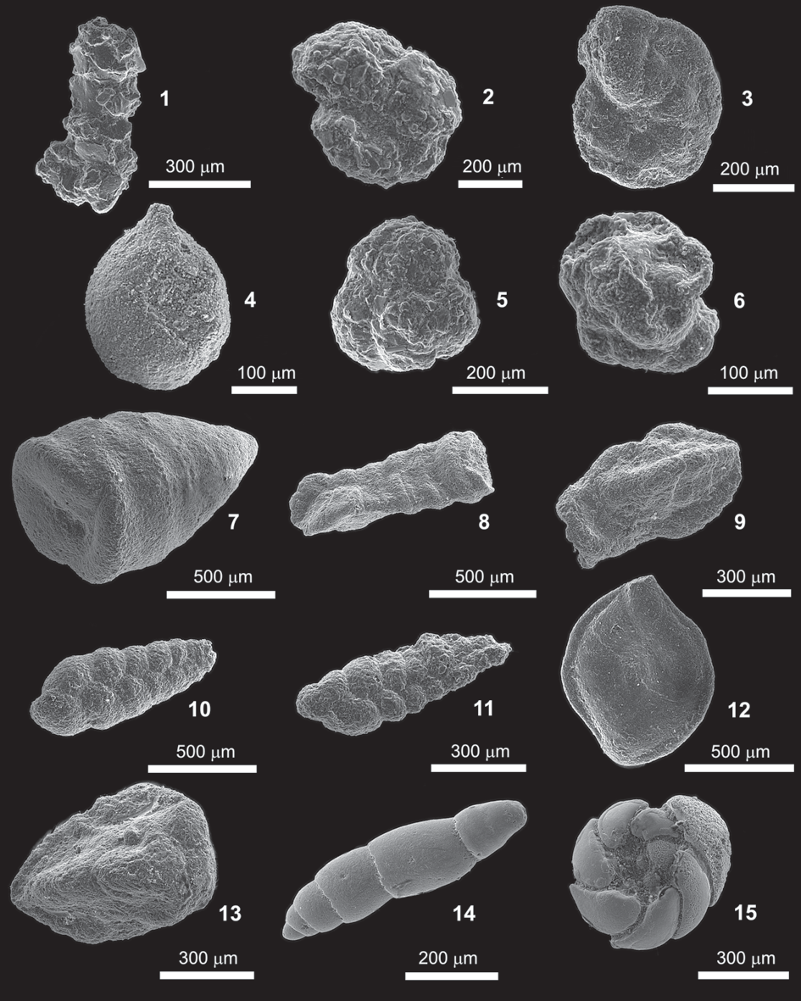

Fig. 7. (Bars have different values.) 1 – Ammobaculites sp., sample 4/03; 2 – Haplophragmoides sp., sample 4/03; 3 – Haplophragmoides sp., sample 7/03; 4 – Caudammina ovulum (Grzybowski), sample 15/03; 5 – Trochammina sp., sample 4/03; 6 – Trochamminoides sp., sample 4/03; 7 – Marssonella oxycona (Reuss), sample 18a/03; 8, 9 – Tritaxia ex gr. gaultina (Morozova), sample 11/03; 10 – Karrerulina sp., sample 11/03; 11 – Karrerulina sp., sample 6/04; 12 – Triloculina sp., sample 18a/03; 13 – Gaudryina sp., sample 11/03; 14 – Den- talina sp. (internal mould), sample 16/03; 15 – internal mould of Cibicides s.l., sample 16/03.

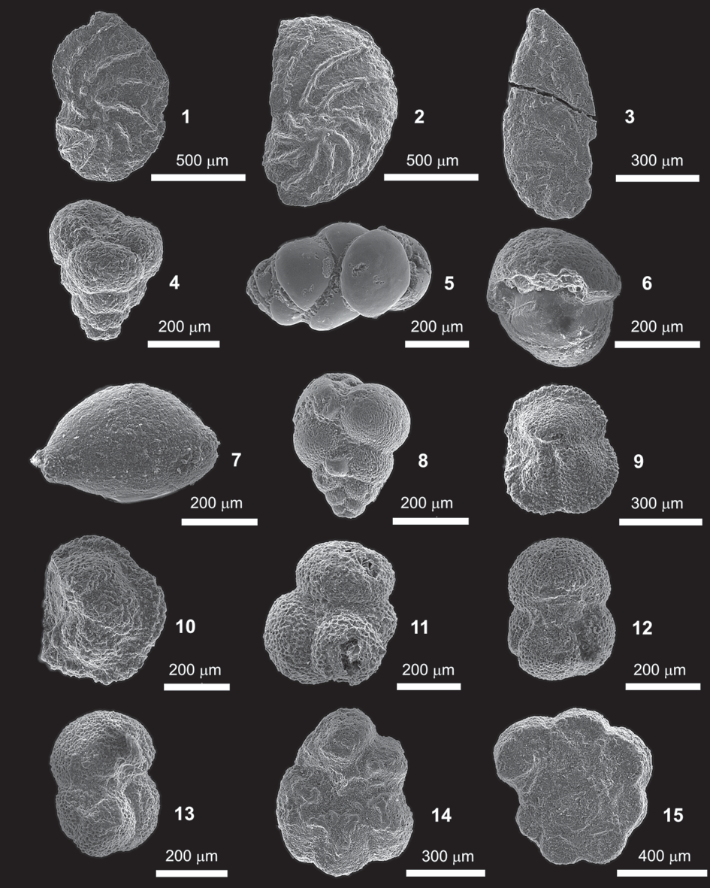

Fig. 8. (Bars have different values.) 1, 2 – Lenticulina sp., sample 4/03; 3 – Astacolus sp., sample 7/03; 4 – Guembelitria sp., sample8/03; 5 – Bulimina sp. (internal mould), sample 8/03; 6 – Pullenia sp., sample 18a/03; 7 – Ramulina sp., sample 7/03; 8 – Heterohelix striata (Ehrenberg), sample 8/03; 9 – Morozovella aequa (Cushman & Renz), sample 18a/03; 10 – Morozovella sp., sample 17a/03; 11 – Subboti- na triloculinoides (Plummer), sample 18a/03; 12, 13 – Subbotina cf. triloculinoides (Plummer), sample 18a/03; 14 – Rotalipora cf. appen- ninica (Renz), sample 14a/03; 15 – Globotruncana ex gr. lapparenti (Brotzen), sample 14a/03.

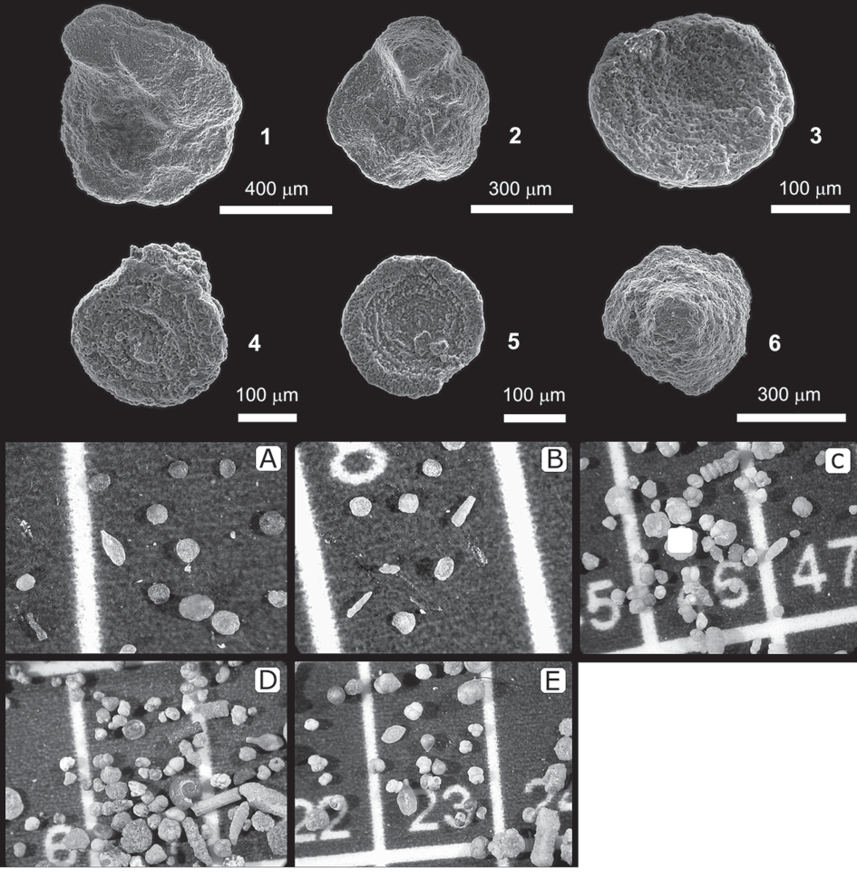

Fig. 9. (Bars have different values.) 1 – Globotruncana bulloides Vogler, sample 14a/03; 2 – Rotalipora appenninica (Renz), sample 14a/03; 3, 4 – Sprillina sp., sample 9/03; 5, 6 – Spirillina sp., sample 22a/03. Foraminiferal assemblages: A – sample 9/03 (Ju- rassic—Early Cretaceous); B – sample 22a/03 (Jurassic—Early Cretaceous); C – sample 14a/03 (mixed mid-Late Cretaceous—Paleogene microfauna); D – sample 17a/03 (Paleocene); E – sample 18a/03 (Late Paleocene).

syringium fossile (Squinabol) are particularly important as they allow correlation with the radiolarian costata Subzone of Turbocapsula.
The radiolarian assemblages listed by Ožvoldová & Faupl (1993) from Jurassic chert formations of the Gresten and Ybb- sitz Klippen Belt (Eastern Alps, Lower Austria) are different in composition from the above mentioned assemblages.

Nannoplankton

Eight samples numbered as Kg 1—8 from dark grey clasts of the Konradsheim Formation were treated for nannoflora by Stjepan Coric (Austrian Geological Survey). All of them ex-
cept sample Kg 4 which was barren, were generally rich in
Watznaueria species:
Kg 1: Watznaueria fossacincta (Black, 1971), W. britanni- ca (Stradner, 1963) Reinardt, 1964, W. manivitae Bukry, 1973, W. barnesae (Black, 1959), Perch-Nielsen, 1968. Kg 2: Watznaueria fossacincta (Black, 1971), W. britannica (Strad- ner, 1963) Reinardt, 1964, W. manivitae Bukry, 1973. Kg 3: Watznaueria fossacincta (Black, 1971), W. britannica (Strad- ner, 1963) Reinardt, 1964. Kg 5: Watznaueria fossacincta (Black, 1971), W. barnesae (Black, 1959), Perch-Nielsen, 1968. Kg 6: Watznaueria fossacincta (Black, 1971), W. bri- tannica (Stradner, 1963) Reinardt, 1964, W. manivitae Bukry, 1973, W. barnesae (Black, 1959), Perch-Nielsen, 1968. Kg 7:

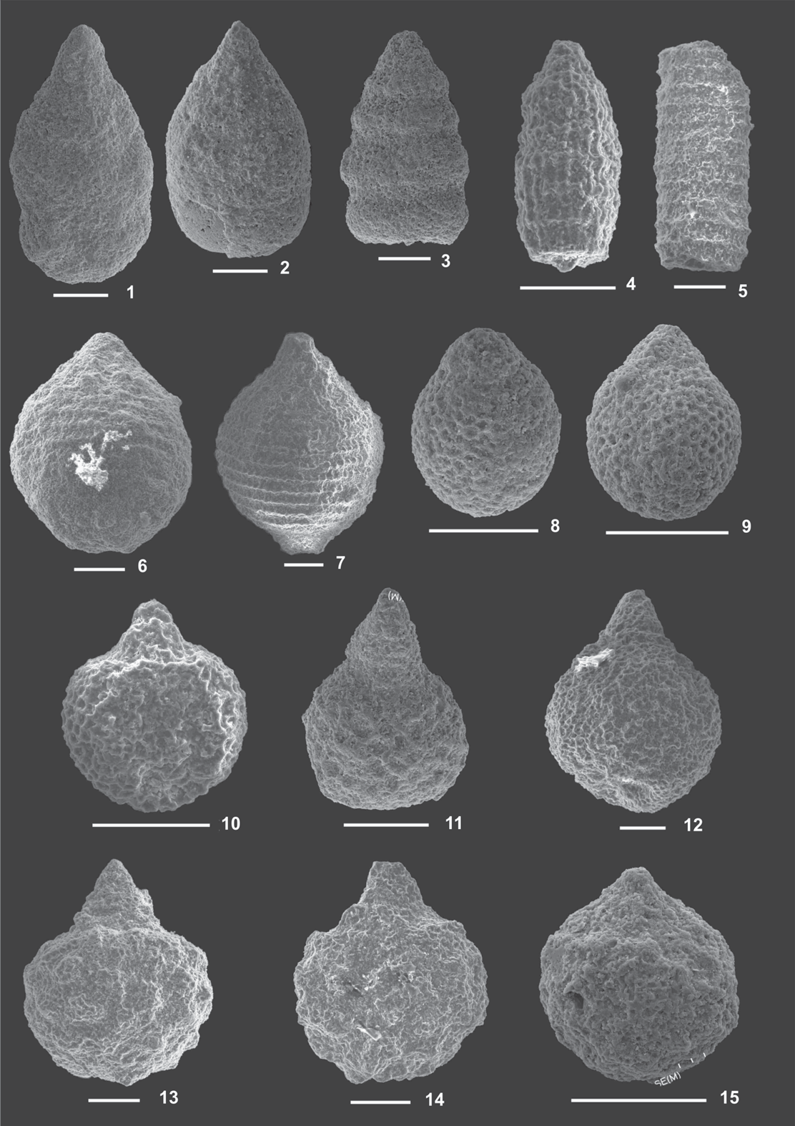
Fig. 10. 1, 2 – Spongocapsula perampla (Rust), sample 23b/03; 3 – Spongocapsula palmerae Pessagno, sample 23b/03; 4 – Para- hsuum stanleyense (Pessagno), sample 25b/03; 5 – Parvicingula altissima (Rust), sample 21/03; 6, 7 – Mirifusus dianae minor Baum- gartner, sample 23b/03; 8, 9 – Stichocapsa robusta Matsuoka, sample 25b/03; 10 – Williriedellum carpathicum Dumitrica, sample 25b/03; 11 – Sethocapsa sp., sample 23b/03; 12 – Obesacapsula bullata Steiger, sample 23b/03; 13, 14 – Sethocapsa funatoensis Aita, sample 25b/03; 15 – Sethocapsa aff. S. trachyostraca Foreman, sample 23b/03. Scale bar 100 micrometers.

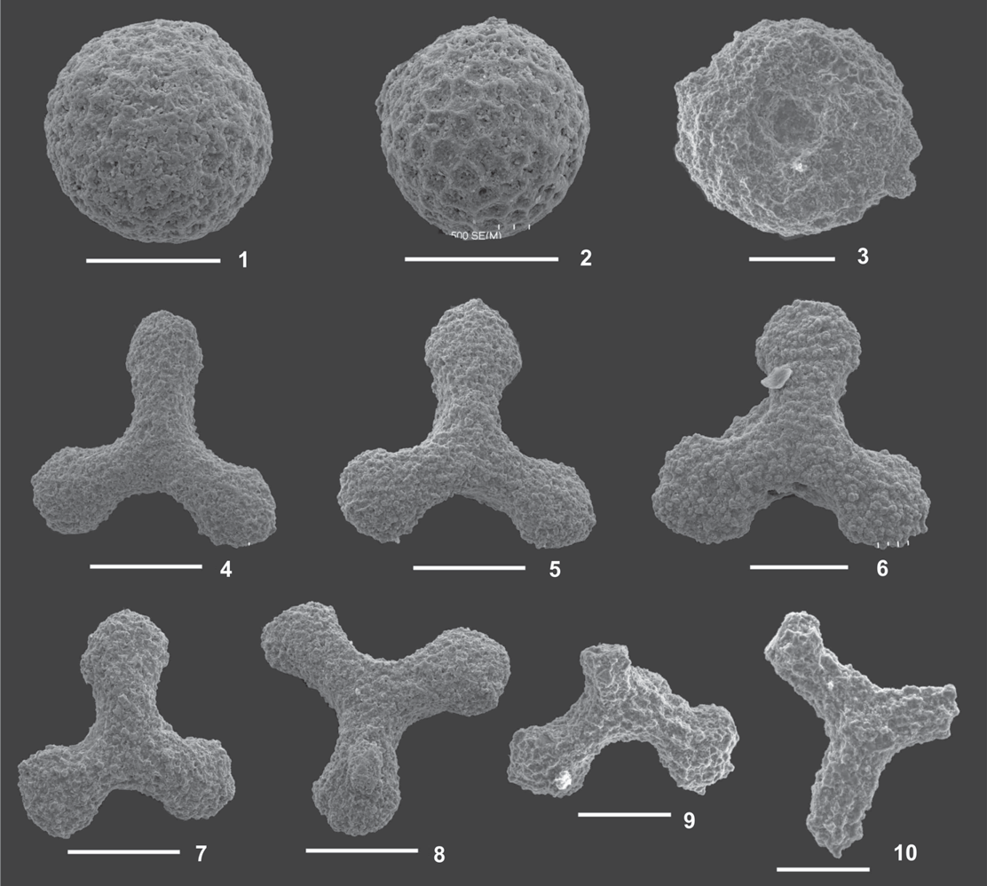
Fig. 11. 1, 2 – Gongylothorax favosus Dumitrica, sample 23b/03; 3 – Orbiculiforma sp., sample 25b/03; 4—6 – Homoeoparonaella(?) gigantea Baumgartner, sample 19b/03; 7—9 – Paronaella broennimanni Pessagno, samples: 19b/03, 25b/03; 10 – Halesium sp., sample 25b/03. Scale bar 100 micrometers.

Watznaueria fossacincta (Black, 1971), W. britannica (Strad- ner, 1963) Reinardt, 1964. Kg 8: Watznaueria fossacincta (Black, 1971), W. britannica (Stradner, 1963) Reinardt, 1964,
W. manivitae Bukry, 1973, W. barnesae (Black, 1959), Perch- Nielsen, 1968.
These species are typical of the Middle—Late Jurassic. How- ever, zonal marker species were not found, and they have a wide stratigraphic range: Watznaueria barnesae and W. bri- tannica were also found in mid-Cretaceous deposits and W. fossacincta and W. manivitae from Lower Hauterivian depos- its (e.g. Bown 1982).

Mollusca

One of the clasts of black shale (sample 19B/03) contains abundant tiny molluscs similar to Bositra sp. This clast also
contains radiolarians of Middle Callovian—Tithonian age (sample 19B/03).

Discussion

The radiolarian assemblages in the grey turbiditic siliceous limestones which can be correlated with Scheibbsbach Forma- tion display a broad stratigraphic range from Middle Callov- ian to Early Tithonian.
The majority of samples from the redeposited clasts within the conglomerates of the Konradsheim Formation in the Pöchlau klippe contain foraminifers and radiolarians charac- teristic of the upper part of the Early Cretaceous, only a few of the redeposited clasts contains assemblages of the Mid- dle—Late Jurassic. The one sample which contains the Late

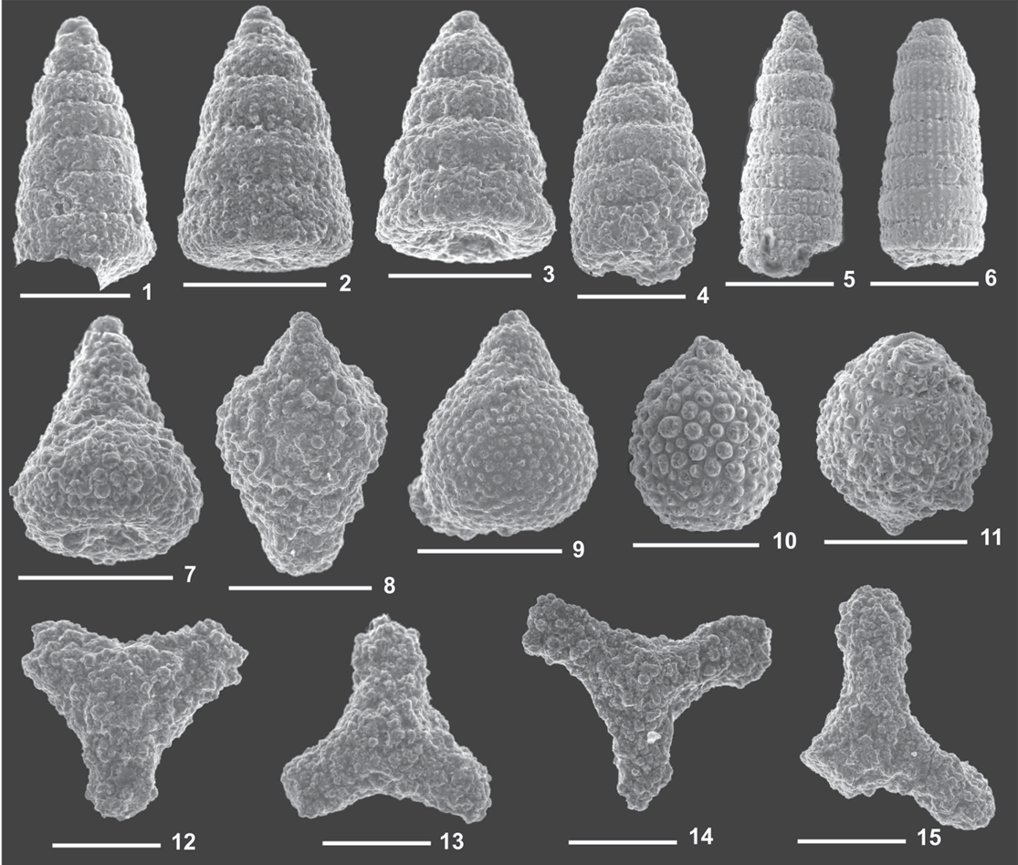
Fig. 12. 1—3 – Dictyomitra communis (Squinabol), samples: 5/2, 4/02; 4—6 – Pseudodictyomitra lodogaensis Pessagno, samples: 5/02, 4/02; 7 – Obeliscoites cf. O. vinassai (Squinabol), sample 5/02; 8 – Pseudoeucyrtis hanni (Tan), sample 5/02; 9 – Hiscocapsa asseni (Tan), sample 5/02; 10—11 – Rhopalosyringium fossile (Squinabol), sample 5/02; 12—14 – Paronaella trifoliacea Ožvoldová, sample 5/02; 15 – Angulobracchia portmanni Baumgartner, sample 5/02. Scale bar 100 micrometers.

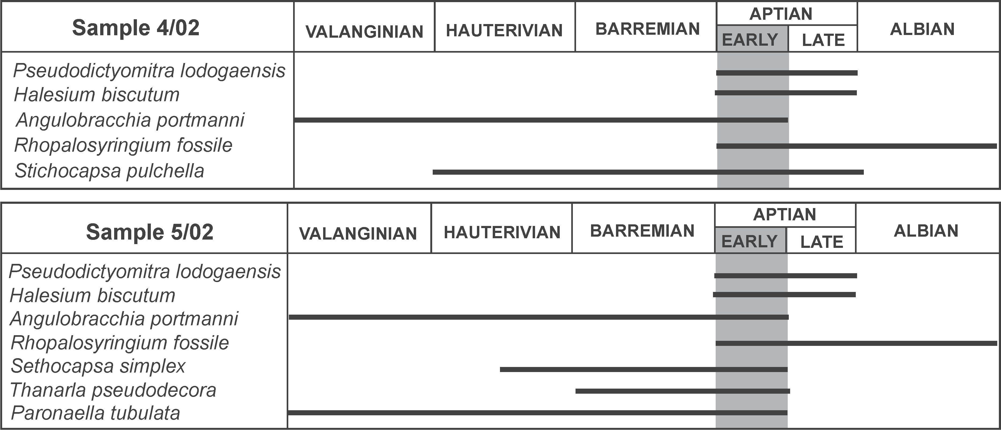

Fig. 13. Ranges of radiolarian species found in samples: 4/02 and 5/02.

Cretaceous was taken from the brecciated block of greenish marl situated in vicinity of the fault, which cut the lower quarry, therefore it probably represents a tectonic block of younger sediments incorporated into the conglomerates of the Konradsheim Formation during younger tectonic move- ments. Therefore, the sampled part of the conglomerates of the Konradsheim Formation within the Pöchlau klippe can- not be older than Barremian-Aptian and, most probably, their age is mid-Cretaceous. The existence of conglomeratic deposits of similar age is known from the Calcareous Alps (e.g. synorogenic conglomerates of the Rossfeld Forma- tion– Decker et al. 1987; Losenstein Formation–Schnabel ed. 2002) and recently described by Józsa & Aubrecht (2008), from the western part of the Pieniny Klippen Belt (Tvrdošín Breccia Member). The position of the unique, Up- per Cretaceous-Paleogene mainly pelitic sequence above the conglomerates of the Konradsheim Formation, exposed at the entrance to the higher quarry is not clear. The conglom- eratic sandstones could correspond to the conglomerates de- scribed by Faupl & Schnabel (1987) from the vicinity of Scheibbs. However, if this sequence is the primary cover of the conglomerates of the Konradsheim Formation, this con- firms its Early Cretaceous age.
The similar, mid-Cretaceous age of the conglomerates of the Konradsheim Formation was found in the locus typicus near the Konradsheim village as well as in Kohlgraben (Höck et al. 2005). The existence of conglomeratic limestone com- plexes within the Upper Jurassic sediments (Decker 1987; Widder 1988) similar to those from the vicinity of the locus typicus, show that sedimentation of the conglomeratic lime- stones of the Konradsheim Limestone type started already during the Late Jurassic and was repeated several times. As a result several separated lenses of conglomeratic sediments ex- isted within the Upper Jurassic—Lower Cretaceous sediments of the Gresten Klippen Zone. Observed erosional surfaces be- low some complexes of these deposits in the Pöchlau klippe as well as near Arthof (Höck et al. 2005) imply that intercalated, probably more pelitic sediments dividing the conglomeratic ones were eroded by dense turbiditic currents which deposited the conglomeratic limestones and/or were squeezed out dur- ing the tectonic movements. The existence of the erosion dur- ing the sedimentation of the conglomeratic limestones is also confirmed by the co-existence of clasts of different age, from Jurassic to Early Cretaceous, in the conglomerates of the Kon- radsheim Formation.
The repeated sedimentation of conglomeratic limestones similar to the conglomerates of the Konradsheim Formation from the Late Jurassic up to the Early Cretaceous can give a new insight into the paleogeography (see Höck et al. 2005) of the discussed area and show the recurrent activity of the source area for the conglomeratic limestone during that time.

Acknowledgments: The authors would like to thank Prof. Volker Höck (Salzburg University), Prof. Michael Wagreich (Vienna University) and Dr. Hans Egger (Geological Survey of Austria) for their kind reviews, comments and valuable re- marks greatly improving the text. Dr. Stjepan Coric (Geologi- cal Survey of Austria) is sincerely acknowledged for determination of the nannoplankton. Anna Łatkiewicz, An-
drzej Świąder, Waldemar Obcowski and Irena Chodyń (Insti- tute of Geological Sciences, Jagiellonian University) are ac- knowledged for their technical help.

References

Aberer F. 1951: Beiträge zur Stratigraphie und Tektonik der Rand- zonen der nördlichen Kalkalpen zwischen Neustift und Konrad- shaim. Mitt. Geol. Ges. Wien 39—41 (1946—1948), 1—73.
Andrusov D. 1959: Gresten Beds. In: Andrusov D. & Samuel O. (Eds.): Stratigraphical dictionary of the Western Carpathians. GÚDŠ, Bratislava, 1, 317—318 (in Slovak).
Baumgartner P.O., O’Dogherty L., Goričan Š., Dumitrică-Jud R., Dumitrică P., Pillevuit A., Urquhart E., Matsuoka A., Danelian T., Bartolini A., Catrer E.S., De Wever P., Kito N., Marcucci M. & Steigner T. 1995: Radiolarian catalogue and systematics of Middle Jurassic to Early Cretaceous Tethyan genera and species. In: Baumgartner P.O., O’Dogherty L., Goričan Š. et al. (Eds.): Middle Jurassic to Lower Cretaceous Radiolaria of Tethys: Oc- currences, systematics, biochronology. Mém. Géol., Lausanne 23, 37—685.
Birkenmajer K. 1977: Jurassic and Cretaceous lithostratigraphic units of the Pieniny Klippen Belt, Carpathians, Poland. Stud. Geol. Pol. 65, 1—158.
Bown P.R. 1982: New calcareous nannofossil taxa from the Jurassic/ Cretaceous boundary interval of sites 765 and 261, Argo Abys- sal Plain. In: Gradstein F.M., Ladden J.N. et al. (Eds.): Proc. ODP Sci. Res. 123, 369—374.
Burchfield B.C. 1976: Geology of Romania. Geol. Soc. Amer., Spec.
Pap. 158, 1—82.
Caron M. 1985: Cretaceous planktonic foraminifera. In: Bolli H.M., Saunders J. & Perch-Nielesn K. (Eds.): Plankton stratigraphy. Cambridge University Press, Cambridge, 17—86.
Decker K. 1987: Faziesanalyse der Oberjura- und Neokomschicht- folgen der Grestener- und Ybbsitzer Klippenzone im westli- chen Niederösterreich. Unpubl. Thesis, Geol. Inst. Univ. Wien., 1—248.
Decker K., Faupl P. & Müller A. 1987: Synorogenic sedimentation on the Northern Alps during the Early Cretaceous. In: Flügel
H.W. & Faupl P. (Eds.): Geodynamics of the Eastern Alps. Det- icke, Vienna, 126—141.
Faupl P. 1975: Kristallinvorkommen und terrigene Sedimentgesteine in der Grestener Klippenzone (Lias-Neokom) von Ober- und Niederösterreich. Jb. Geol. B.—A. (Wien) 118, 1—74.
Faupl P. & Schnabel W. 1987: Ein Breccienvorkommen bei Scheibbs (Niederösterreich). Zur Kenntnis paläogener Grobklastika aus der Buntmergelserie. Jb. Geol. B.—A. (Wien) 130, 153—161.
Geroch S. & Nowak W. 1984: Proposal of zonation for the Late Ti- thonian—Late Eocene based upon arenaceous foraminifera from the Outer Carpathians, Poland. In: Oertli (Ed.): Benthos ’83. 2nd International Symposium on Benthic Foraminifera (Pau, France), 225—239.
Haas J. (Ed.) 2001: Geology of Hungary. Eötvös University Press, Budapest, 1—317.
Hanzliková E. & Andrusov D. 1983: Kletnické beds. In: Andrusov D. & Samuel O. (Eds.): Stratigraphical dictionary of the Western Carpathians. GÚDŠ, Bratislava, 1, 402—403 (in Slovak).
Höck V. & Ślączka A. 2001: Sedimentary structures in metamorphic rocks, a case study from the Tauren Window (Alps, Austria). Biul. Państw. Inst. Geol. 396, 64.
Höck V., Ślączka A., Gasiński M.A. & Bąk M. 2003: The age of the Konradsheim Limestone (Gresten Unit, Austria). Mitt. Österr. Mineral. Ges. 148,169—170.
Höck V., Ślączka A., Gasiński M.A. & Bąk M. 2005: Konradsheim

Limestone of the Gresten Klippen Zone (Austria): New insight into its stratigraphic and paleogeographic setting. Geol. Car- pathica 56, 237—244.
Ianovici V., Borcos M., Bleahu M., Patrulius D., Lupu M., Dimitres- cu R. & Savu H. 1976: The geology of the Apuseni Mountains. Edit. Acad. Rep. Soc. România, Bucure�ti, 1—631 (in Romanian). Józsa Š. & Aubrecht R. 2008: Barremian—Aptian erosion of the Kysuca-Pieniny trough margin (Pieniny Klippen Belt, Western
Carpathians). Geol. Carpathica 59, 103—116.
Oberhauser R. (Ed.) 1980: Der Geologische Aufbau Österreichs.
Springer—Verlag, Wien, New York, 1—695.
O’Dogherty L. 1994: Biochronology and paleontology of mid-Creta- ceous radiolarians from Northern Apennines (Italy) and betic Cordillera (Spain). Mém. Géol. 21, 415.
Ožvoldová L. & Faupl P. 1993: Radiolarien aus kieseligen Schicht- gliedern des Juras der Grestener und Ybbsitzer Klippenzone (Os- talpen, Niederösterreich). Jb. Geol. B.—A. Wien 136, 479—494.
Piller W.E., Egger H., Erhart C.W., Gross M., Harzhauser M., Hub- mann B., Van Husen D., Krenmayr H.-G., Krystyn L., Lein R., Lukeneder A., Mandl G.W., Rögl F., Roetzel R., Rupp C., Schnabel W., Schönlaub H.P., Summesberger H., Wagreich M. & Wessely G. 2004: Die stratigraphische Tabelle von Österreich 2004 (sedimentare Schichtfolgen).
Premoli-Silva I. & Rettori R. (Eds.) 2002: Practical manual of Creta- ceous Planktonic Foraminifera. International School on Plank- tonic Foraminifera, Perugia 18—22 February, 2002. Dip. Sci. della Terra, Universita di Perugia, 1—462.
Premoli-Silva I. & Verga D. 2004: Practical manual of Cretaceous Planktonic Foraminifera. International School on Planktonic Foraminifera. In: Verga & Rettori (Eds.): 30 Course: Creta- ceous. Universites of Perugia and Milano. Tipografia Pontfelci-
no, Perugia, 1—283.
Robaszynski F. & Caron M. 1995: Foraminifères planctoniques du Crétacé: commentaire de la zonation Europe-Méditerrané. Bull. Soc. Géol. France 6, 681—692.
Ruttner A. & Schnabel W. 1988: Geologische Karte der Republik Ös- terreich, Blatt 71 Ybbsitz, 1 : 50,000. Geol. Bundesanst., Wien.
Schnabel W. 1970: Zur Geologie des Kalkalpennordrandes in der Umgebung von Waidhofen/Ybbs, Niederösterreich. Mitt. Geol. Ges. Bergbaustud. Österr. 19, 131—188.
Schnabel W. 1992: New data on the Flysch Zone of the Eastern Alps in the Austrian sector and new aspects concerning the transition to the Flysch Zone of the Carpathians. Cretaceous Research 13, 405—419.
Schnabel W. (Ed.) 2002: Legende und kurze Erläuterung. Geolo- gische Karte von Niederösterreich 1 : 200,000. Geol. Bundes- anst., Wien, 1—47.
Slaczka A. & Höck V. 2000: Fans in the NE-Tauern Window (Aus- tria). Mitt. Geol. Ges. Bergbaustud. Österr. 43, 127.
Ślączka A., Gasiński M.A., Bąk M. & Wessely G. 2006: The Creta- ceous of the Konradsheim Limestone from Pöchlau quarry (Gresten Unit, Austria). Proceedings of XVIII th Congress of the Carpathian-Balkan Geological Association, 563—565.
Trauth F. 1950: Die fazielle Ausbildung des Oberjura Becken den Nördlichen Ostalpen. Verh. Geol. B.—A. Jg. 1948, 145—218.
Widder R.W. 1988: Zur Stratigraphie, Fazies und Tektonik der Grest- ener Klippenzone zwischen Maria Neustift und Pechgraben / O.Ö. Mitt. Geol. Ges. Bergbaustud. Österr. 34, 35, 79—133.
Wessely G. 1988: Der Tiefenanschluss im Wiener Becken und der Molassezone als Ausgangspunkt für die Alpenexploration in Ös- terreich. Erdöl Erdgas Kohle 104, 440-446.
Wessely G. 2006: Niederösterreich. Geol. Bundesanst., Wien, 1—413.

