Annals of Parasitology 2013, 59(4) 203–205
Copyright© 2013 Polish Parasitological Society
Short notes
Occurrence of internal parasites in stone martens (Martes foina) from Cracow and suburbs1
Sławomir Kornaś1, Izabela A. Wierzbowska2, Paweł Górski3, Henryk Okarma2
1Department of Zoology and Ecology, University of Agriculture in Cracow, Mickiewicza 24/28, 30-059 Cracow 2Institute of Environmental Sciences, Jagiellonian University, Gronostajowa 7, 30-387 Cracow; Poland 3Division of Parasitology and Parasitic Diseases, Department of Preclinical Sciences, Warsaw University of Life Sciences, Ciszewskiego 8, 02-786 Warsaw, Poland
Corresponding author: Sławomir Kornaś; e-mail: skornas@ur.krakow.pl
ABSTRACT. The pine marten Martes martes and the stone marten Martes foina are the only representatives of the genus Martes in Poland. During the last few decades, an intensive synurbisation of stone martens has been recorded. The aim of the study was to assess the level of infection by internal parasites of Martes foina in the Cracow urban area. Eleven necropsies were performed of stone martens killed during animal-vehicle collisions. Additionally, coprological examination of 129 stone marten scats was included. For further analysis, two standard methods, i.e. flotation and decantation, were used. The intensity of infection by parasites was low. Taenia martis was found to be present in one marten individual by necropsy, while Taeniidae helminths and two genera of nematodes, Capillaria and Toxocara, were identified during coprodiagnosis. The diet analysis of stone marten scats revealed a high proportion of two food categories. Percentage frequency of occurrence for plant material and anthropogenic was calculated as 42.3% and 15.4%, respectively. This type of food composition might suggest lower infection by internal parasites in particular species, especially with an indirect life cycle.
Key words: Martes foina, parasites, necropsy, coproscopic examination
Introduction
For several decades, an intense synurbanization of a wide range of different species has been observed. The stone marten (Martes foina) is an example of a carnivore which has successfully occupied cities and adapted to this new, man-made environment.
The main aims of the study were to examine the prevalence and intensity of internal parasites of stone martens from the Cracow metropolitan area
Poland. The total study area is 1556 km2, and the core area (city centre) is 327 km2. The human population density varies between 197.88 ind./km2 in suburban areas and 2314 ind./km2 in the city centre (www.bip.krakow.pl).
From 2008 to 2009, 11 individual stone martens were collected as road kills and examined in the laboratory. If available, the age and sex were recorded: 9 adults and 2 young animals, 6 males and 5 females. The obtained digestive tracts were frozen at –80°C for 10 days in order to destroy the parasites in developmental stages [1–2]. The digestive tracts were dissected, as were the lung, kidney, heart and liver, according to Eckert et al. [3–4]. The parasitological examination of the digestive tract and organs of stone martens was performed by cutting the small intestine lengthwise into small pieces. After removal of the content, the intestinal mucosa was examined macroscopically. The organs
and also to assess the potential transmission to humans.
risk
of their
Materials and Methods
The study area comprises
the
Cracow
metropolitan area and its neighbouring districts, all
lying within 50º03’41”N and 19º56’8”E in southern
1The study was partially founded by the Ministry of Science and Higher Education, Grant: 2P04F07230 and the Jagiellonian University: DS 756, and WRBW/12/INOŚ/2006.

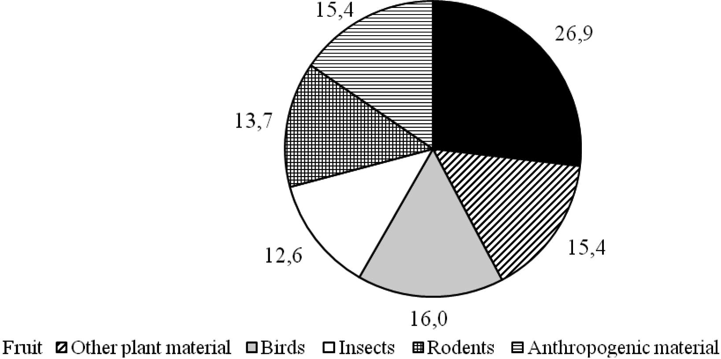
204
S. Kornaœ et al.
15.4
26.9
13.7
15.4
12.6
16.0
Fig. 1. Diet of stone marten based on scat analysis (%)
were rinsed and squeezed in saline to search for any other parasites. All parasite specimens found were preserved in 70% alcohol with 5% glycerol for clarification. In addition, smears were prepared from the individual parts of the intestinal mucosa.
Additionally, 129 faecal samples from stone martens collected in the Cracow area were examined with standard flotation and decantation methods [5]. On the basis of the obtained results, the prevalence (%) and intensity of infection (EPG – eggs per gram) were evaluated.
A randomly chosen, small piece (ca 2 g) of each scat was examined with standard procedure for diet analysis. Percentage frequency of occurrence was calculated for each food category [6].
Taenia martis, T. hydatigena or Hydatigera taeniaeformis, which have been reported previously from stone martens [7]. The most commonly found nematode eggs were from the genus Capillaria (11.6%). In two samples, ascaris eggs were found, whereas dead ascarid nematode specimens were present in one sample. Taenia martis, a typical tapeworm for martens, was found in the intestine of only one of the eleven dissected animals.
The eggs of Capillaria, were probably eggs of C. mustelorum, which is known to infect stone martens in Poland [8]. Unfortunately, one ascarid nematode specimen could not be identified to a species because of the decayed and dried condition of the material. However, it may have belonged to Ascaris devosi or Toxocara cati, as reported previously from Martes foina [7].
The analysis of the diet of the stone martens based on scat content revealed a significant proportion of plant (fruit and other plant material) and anthropogenic fractions, comprising 42.3 % and 15.4%, respectively (Fig. 1).
Results
The results of the coproscopic
examination
indicate that eggs of tapeworms from the Taeniidae
family were present in three samples (Table 1). The unidentified tapeworm eggs could be produced by
Table. 1. Prevalence (%) and range (EPG) of parasite infection of examined stone martens
Methods/parasites
Taeniidae
Capillaria sp.
Ascaridida
coproscopic examination n scats = 129
2.3
11.6 (1–21 EPG)
2.3 (3–10 EPG)
Necropsy n = 11
9.1
0
0

Occurrence of internal parasites
205
Discussion
The prevalence of parasite infections identified by both coproscopic methods and dissections, was found to be rather low. It is typical of stone martens to be much less intensively infected by parasites than other mustelids, such as the pine marten – Martes martes [9]. This difference is probably based on the feeding habits of the two marten species. The stone marten is more of a herbivore than the pine marten, and so has fewer opportunities to consume the potential intermediate hosts of parasites [10]. This is confirmed by the analysis of the stone marten diet in the present study, where plant
References
- Deplazes P., Eckert J., Jenkins D., Ewald D., Jimenez- Palacios S. 1992. Diagnostic detection of Echinoco- ccus coproantigens by enzyme-linked immunosorbent assay in dogs, dingoes and foxes. Infection in final host. Parasitology Research 78: 303-308.
- Deplazes P., Alther P., Tanner I., Thomson R.C.A., Eckert J. 1999. Echinococcus multilocularis copro- antigen detection by ELISA in fox, dogs and cats population. Journal of Parasitology 85: 115-121.
- Eckert J., Kutzer E., Rommel M., Burger H.J., Korting W. 1992. Veterinarmedizinische Parasito- logie. Verlag Paul Parey, Berlin and Hamburg.
- Eckert J., Deplazes P., Ewald D., Gottstein B. 1991. Parasitologische und immunologische Methoden zum Nachweis von E. multilocularis bei Fuchsen. Mitteilungen der Osterreichischen Gesellschaft für Tropenmedizin und Parasitologie 13: 25-30.
- Anonym 1986. Manual of veterinary parasitological laboratory techniques. Reference Book 418. Ministry of Agriculture, Fisheries and Food, London.
- Posłuszny M., Pilot M., Goszczyński J., Gralak B. 2007. Diet of sympatric pine marten (Martes martes) and stone marten (Martes foina) identified by genotyping of DNA from faeces. Annales Zoologici Fennici 44: 269-284.
- Kontrimavichus V.L. 1985. Helminths of mustelids and trends in their evolution. Amerind Publishing Co. Pvt. Ltd. New Delhi, Bombay, Calcutta, New York.
- Malczewski A. 1964. Przyczynek do znajomości helmintofauny Mustelidae w Polsce. Wiadomości Parazytologiczne 10: 565-567.
- Górski P., Zalewski A., Łakomy M. 2006. Parasites of carnivorous mammals in Białowieża Primeval Forest. Wiadomości Parazytologiczne 52: 49-53.
- Sumiński P., Goszczyński J. Romanowski J. 1993. Ssaki drapieżne Europy. Państwowe Wydawnictwo Rolnicze i Leśne, Warszawa.
- Millán J., Ferroglio E. 2001. Helminth parasites in stone martens (Martes foina) from Italy. Zeitschrift für Jagdwissenschaft 47: 229-231.
- Ribas A., Milazzao C., Foronda P., Casanova J.C. 2004. New data on helminthes of stone marten, Martes foina (Carnivora, Mustelidae) in Italy. Helminthologia 41: 59-61.
- Kamieniarz R., Panek M. 2008. Zwierzęta łowne na przełomie XX i XI wieku. Stacja Badawcza–OHZ PZŁ, Czempiń.
material was found component.
to be
the most common
Investigations carried out
in other European diverse parasite
countries
revealed more
compositions in the assessed material. In Italy,
Millán and Ferroglio [11] confirmed the presence of Taenia martis, Molineus patens and Capillaria sp. in ten dissected stone martens. In Spain, Ribas et al.
[12] found 10 different parasite species in only one
investigated
individual
(Platyhelminthes:
Brachylaima sp., Taenia martis, Mesocestoides sp.,
Oochoristica sp.; Nematoda: Personema (Capi- llaria) plica, Eucoleus aerophilus, Aonchotheca putorii, Molineus patens, Crenosoma petrowi and Sobolevingylus petrowi).
The results of our research are comparable with those of studies carried out in northern Poland between 2003–2004 [9]. In this study, based on faecal examination only, nematodes from the genus Capillaria were found in stone martens. In comparison, the parasitic fauna of pine marten faeces in the same investigation was much richer and included Coccidia, Trematoda and Nematoda from the genera Toxocara, Trichuris, Uncinaria and Capillaria.
In the present study, species of parasites dangerous to humans were not found in stone martens, and the prevalence and intensity of infection seen in the examined animals were low. However, as the numbers of stone and pine martens are increasing [13], this area requires further study.
Received 1 November 2013
Accepted 15 November 2013

