
Signature:©PolJRadiol,2010;75(1):84-87
CASEREPORT
OsteogenesisimperfectatypeV,spotdiagnosis
Received:2009.05.29
Accepted:2009.09.02
KazimierzKozlowski
HonoraryRadiologist,NewChildren’sHospital,Westmead,Australia
Author’saddress:K.Kozlowski,NewChildren’sHospitalatWestmead,NSW2145,Australia,e-mail:kazimiek@chw.edu.au
Summary
ThefirstcaseofOsteogenesisImperfectaTypeVinthePolishliteratureisreported.
Skeletalsurveyofan8yearoldgirlwithahistoryofmultiplefracturesandbilateraldislocationofradialheadswasreceivedforconsultation.
Generalisedosteoporosiswithmultiplefractures,periostealthickeningandbilateraldislocationoftheradialheadsarecharacteristicsignsofosteogenesisimperfectaTypeV.TheNosologyandClassificationofGeneticSkeletalDisorders2006RevisionclassifiedOsteogenesisImperfectainto8majortypes.TypeVisrecognizableonthebasisofskeletalsurveyalone.
Background:
CaseReport:
Conclusions:
Keywords:
osteoporosis•fractures•radialheaddislocation•periostealthickening•ectopicossification•osteogenesisimperfecta
PDFfile:
http://www.polradiol.com/fulltxt.php?ICID=878438
Background
Coenegrachtet al.[8] as “Diaphysealaclasia combined withfragilitasossium”representadvancedcasesofOITypeV.
Osteogenesisimperfecta(OI)isagroupofdifferentdis-orderscharacterizedbyabnormalphenotypeofvariableexpressivity,increasedbonefragility,hyperextensibilityofthejoints,bluescleraeanddentinogenesisimperfecta.Thecharacteristicradiographicfindingsincludeosteopenia,multiplefractures,andusuallyWormianbones[1,3]
ThisauthorbelievesthatincorporationofOITypeVintoOIgroupiserroneousbecauseofnormalphenotypeanddifferentradiographicfindings–longbonesfracturesarecloseto metaphyses,thereis bilateralradialheaddis-location,distinctiveasymmetricallocalizedhyperplas-ticperiostealthickeningandabsenceofWormianbones.Additionallyabnormalbone-modelingmarkers[2,9]arenotobservedinTypesOITypesI-IV,VI,VIIandVIII.DiagnosisofOITypeViseasyifthediseaseisknowntotheobserver[2,5].
Sillence[4]classifiedOIinfourtypesI-IVonthebasisofclinicalandradiographicfindings.LaterTypeIIcharacter-izedbymultiplefracturesandseveredeformitieswassub-dividedinTypesA,B,andC.TypesVandVIwereinclud-edbyGlorieuxetal.[5]duetosimilarityofmicroscopicappearancestotypesI–IV.TypeVIIwasaddedinaSeminaronOIpublishedbyLancet[6]andTypeVIIIbyCabraletal.[7]becauseofrecessivetypeofinheritanceanddistinctivegeneabnormalities(Table1).
OthertypesofOIwhichcanbediagnosedonradiograph-icexaminationaloneareOITypeIIA(lethal,thickbonevariety)and OITypeIIC(lethal thinbonevariety)[3].ThesevereTypeIIBpresentswithosteoporosisandvari-ablepatternoffracturesanddeformities.DiagnosisoftheremainingtypesofOIrequiresotherclinicalinformation.Clinicalhistory(inheritance)andphenotypicevaluationaremostimportant,butbonehistomorphologyandDNAinves-tigationsmaybenecessaryinsomepatients.
Discussion
Skeletalsurveyofourpatientshowedallthefeatures-osteoporosis,anisospondyly,bilateraldislocationoftheradialheadsandlocalisedhyperplasticcallusformation
–of“Unclassifieddemineralizingbonedisease–newenti-ty”,asreportedbyKozlowskiandBittnerin1981[2]andrenamedOITypeVbyGlorieuxetal.in2000[5].Ectopicinterosseousmembranecalcificationappearsinolderindi-viduals.Itispossiblethatthetwosiblingsreportedby
ThedifferentialdiagnosisofOITypeVvarieswiththeageofthepatient.TheearlystagesofOIVareunknownasallthereportedcasesarechildreninschoolage.Ineverychildwithgrosslynormalphenotypeandlimitationofelbowmovementsand/orbilateralradialheaddislocationsOI
84

©PolJRadiol,2010;75(1):84-87
KozlowskiK–OsteogenesisimperfectatypeV,spotdiagnosis
Table1.Classificationofosteogenesisimperfecta2009[1].
Type
Severity
Mutation
Inheritance
Biochemicalmarkers
Radiology
OII
+/++
COL1A1
AD
–
+/++
OIII
A
+++
COL1A1/2
AD
–
+++Diagnostic
COL1A1/2CRTAPLEPRE1
ADAR
B
+++
–
+++
C
+++
?
AD
–
+++Diagnostic
OIIII
++/+++
COL1A1/2
AD
–
++/+++
OIIV
+/++
COL1A1/2
AD
–
+/++
OIV
+
?
AD
+
+Diagnostic
OIVI
++/+++
?
AR
+/–
++/+++
OIVII
+/++
CRTAP
AR
–
+/++
OIVIII
+/++
LEPRE1
AR
–
+/++
+mildtomoderate;++moderatetosevere;+++severe,usuallylethal;+/–alkphosphatasemayberaised;AD–autosomaldominant;AR–autosomalrecessive.
Table2.DifferentialdiagnosisofOITypeV.
Clinicaldiagnosticcharacteristics
Radiographicdiagnosticcharacteristics
Disorder
Phenotype
Inheritance
Geneticdefect
Osteopenia,fractures,periostealcallusformation.Radialheaddislocation
OIV
AD
Radialheaddislocation
-
?
Deformities,bluesclerae,dentinogenesis
imperfecta,thinskin,hypotonia
COL1A1COL1A2CRTAPLEPRE1
Osteopenia,fractures,slenderbones,deformities,large head,wormianbones
ADAR
OIothertypes
+/-
Idiopathicosteoporosis
–
?
–
Osteopenia,Fractures
?
Childabusesyndrome
–
-
Softtissuesinjuries
Fractures–differentstages
-
Osteopenia,fractures,slenderbones,deformities,wormianbones
Bonespecifictelopeptidelysilhydroxylase
Congentaljointcontractures,pterygia
Brucksyndrome
+
AR
Osteoporosispsudogliomasyndrome
Ocularabnormalities,blindness
Osteopenia,fractures
+
AR
LRP5
Cole-Carpentersyndrome
Orbitalhypoplasia,ocularproptosis
Osteopenia,fractures,cranio-synostosis
+
?
?
TypeVshouldbeconsidered.Duringchildhoodthediffer-entialdiagnosisiswithalldiseasespresentingsomeofthefeaturesofOIVsuchasosteoporosis,anisospondyly,multi-plefractures,periostealthickenimgandradialheaddisloca-tion.TheseincludespredominantlyothertypesofOI.Noneofthemshowsasymmetricalhyperplasticcallus,bilateralsymmetricalradialheaddislocationorcalcifiedinteros-seousmembrane.IdiopathicosteoporosisshowssomefeaturesofOIsuchasosteoporosis,anisospondylyand
fractures,butlocalizedasymmetricalhyperplasticcallus,interosseouscalcificationandbilateralradialheaddisloca-tionsarenotfeaturesofIO.Childabuseinjury(Batteredbabysyndrome)presentingwithosteoporosisandmulti-plefracturesmaybemisdiagnosedasOI,especiallywhenadultsinchargeofthechild,denychildabuse.Howeverperiostealreactioninbatteredbabysyndromeshowsdiffer-entstagesofevolution,extraosseoussofttissueslesionsareusuallypresentandWormianbonesareabsent.
85

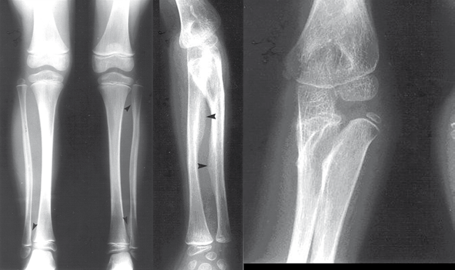
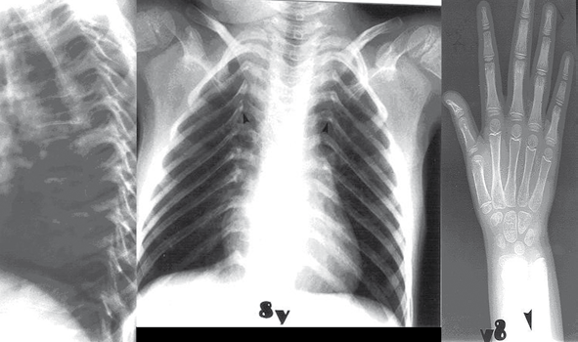
CaseReport
©PolJRadiol,2010;75(1):84-87
Figure1.Girl8yearsold.Generalisedadvancedosteoporosis.(A,B)Localisedperiostealthickening(arrowed).Noteabsenceofricketslikechanges!(C)Bilateralradialheaddislocation.(D)Thoracicspine
–anisospondyly.(E)Thin,obliquelypositionedribs.(F)Normalboneage.Localisedperiostealthickening–arrowed.
OthercongenitalsyndromesassociatedwithosteoporosisandbonefragilitysuchasBrucksyndrome[10],osteopo-rosis-psudogliomasyndome[11]andCole-Carpentersyn-drome[12]areunlikelytocauseconfusioniftheradio-graphicfindingsarecorrelatedwithphenotypeandclinicalhistoryofthepatient(Table2),
secondarytotrauma,bleedingdisorders,ormesodermaldysplasiacanoccur.MR,CTand/ornuclearscanmaybehelpfulinthedifferentialdiagnosis[13].
InadultsthediagnosisofOITypeVmaybemorediffi-cultbecauseofsuperimposedtraumaticandosteoarthriticchanges.
DisorderscausingperiostealreactionwithorwithoutosteoporosisandfracturessuchasMelnick-Needlessyn-drome,periostealtumours,bleedingdisorders–andjuxta-corticalmyositisossificansareunlikelytobemisdiagnosed.Theyshowdifferentpatternsofperiostealreactionandusuallyhaveadefinitepositiveetiologicalclinicalhistory.
Conclusions
An8year-oldgirlwithOITypeVisreported.Radiographicexaminationdocumentedosteoporosis,anisospondyly,frac-tures,bilateralradial headdislocation andhyperplasticcal-lus.PresenceofthistypeofmalformationpatternallowsaspotdiagnosisofOITypeVandmakesotherdiagnostictestsunnecessary.
Ininstanceswhenonlyonex-rayispresentedfordiag-nosis,confusionwithcorticalorparostealosteosarcoma,periostitis,myositisossificans,subperiostealhematoma
References:
- Superti-FurgaA,UngerS:Nosologygroupofgeneticskeletaldisorders:2006revision.AmJMedGenetPartA,2007;143A:1–18
- KozlowskiK,BittnerK:Unclassifieddemineralisingbonediseaseunan8yearsoldgirl(reportofacase).AustRadiol,1981;25:76–80
- SprangerJW,BrillPW,PoznanskiAetal:Anatlasofgeneticdisordersofskeletaldevelopment.2-ndedUSA.OxfordUniversityPress,2002
- SillenceD,SennA,DanksD:GeneticheterogeneityInosteogenesisimperfecta.JMedGenet,1979;16:101–6
- GlorieuxFH,RauchF,PlotkinHetal:TypeVosteogenesisimperfecta:anewformofbrittlebonedisease.JBoneMinRes,2000;15:1650–58
- RauchF,GloorieuxF:Osteogenesisimperfecta.Lancet,2004;363:1377–85
- CabralW,ChangW,BarnesAetal:Protyl3-hydroxylase1deficiencycausesarecessivemetabolicdisorderresemblinglethal/severeosteogenesisimperfecta.NatGen,2007;39:359–65
- CoenegrachtDJ:Diafysaireaclasie,gecombineerdmetfragilitasossium.NetTGeneesk,1958;102:1398–405
- FlemingF,WoodheadHJ,BriodyJNetal:CyclicbisphosphonatetherapyinosteogenesisimperfectatypeV.JPediatrChildHealth,2005;41:1–5
86
A B C

D E F

©PolJRadiol,2010;75(1):84-87
KozlowskiK–OsteogenesisimperfectatypeV,spotdiagnosis
- ViljoenD,VersfeldG,BeightonP:Osteogenesisimperfectawithcongenitaljointcontractures(Brucksyndrome).ClinGenet,1989;36:122–26
- McDowellCL,MoreJD:Multiplefracturesinachild:theosteoporosispseudogliomasyndrome.JBoneJtSurg,1992;74A:1247–49
- ColeDEC,CarpenterTO:Bonefragility,craniosynostosis,ocularproptosis,hydrocephalusanddistinctivefacialfeatures:anewlyrecognizedtypeofosteogenesisimperfecta.JPediatr,1987;100:76–80
- CheungMS,AzouzEM,GlorieuxFHetal:HyperplasticcallusformationinosteogenesisimperfectatypeV:follow-upofthreegenerationsovertenyears.SkeletalRadiol,2008;37:465–67
87

