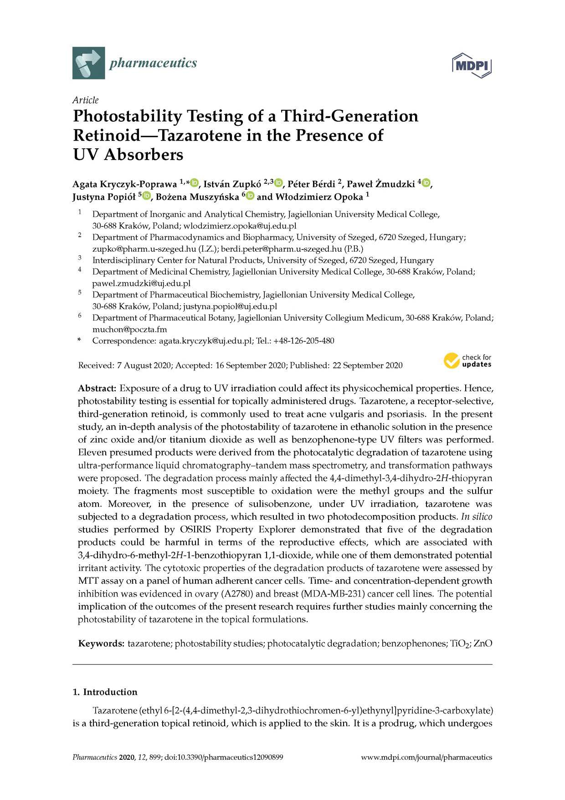

pharmaceutics

Article
Photostability Testing of a Third-Generation Retinoid—Tazarotene in the Presence of
UV Absorbers
Agata K ryczyk-Popraw a 1'* , Istvan Zupkó 2,3 , Peter Berdi 2, Paweł Z m u d zk i4 , Justyna P o p ió ł 5 , Bożena M uszyńska 6 and W łodzim ierz Opoka 1
1 Department of Inorganic and Analytical Chemistry, Jagiellonian University Medical College, 30-688 Kraków, Poland; wlodzimierz.opoka@uj.edu.pl
2 Department of Pharmacodynamics and Biopharmacy, University of Szeged, 6720 Szeged, Hungary; zupko@pharm.u-szeged.hu (I.Z.); berdi.peter@pharm.u-szeged.hu (P.B.)
3 Interdisciplinary Center for Natural Products, University of Szeged, 6720 Szeged, Hungary
4 Department of Medicinal Chemistry, Jagiellonian University Medical College, 30-688 Kraków, Poland; pawel.zmudzki@uj.edu.pl
5 Department of Pharmaceutical Biochemistry, Jagiellonian University Medical College, 30-688 Kraków, Poland; justyna.popiol@uj.edu.pl
6 Department of Pharmaceutical Botany, Jagiellonian University Collegium Medicum, 30-688 Kraków, Poland; muchon@poczta.fm
* Correspondence: agata.kryczyk@uj.edu.pl; Tel.: +48-126-205-480
^ x ©check for
updates

Abstract: Exposure of a drug to U V irradiation could affect its physicochem ical properties. H ence, photostability testing is essential for topically adm inistered drugs. Tazarotene, a receptor-selective, third-generation retinoid, is com m only used to treat acne vulgaris and psoriasis. In the present study, an in-depth analysis of the photostability of tazarotene in ethanolic solution in the presence of zinc oxide and/or titanium dioxide as w ell as benzophenone-type U V filters w as perform ed. Eleven presum ed products w ere derived from the photocatalytic degradation of tazarotene using ultra-perform ance liquid chrom atography-tandem mass spectrometry, and transform ation pathways w ere proposed. The degradation process m ainly affected the 4,4-dim ethyl-3,4-dihydro-2H -thiopyran moiety. The fragm ents m ost susceptible to oxidation w ere the m ethyl groups and the sulfur atom . M oreover, in the presence of sulisobenzone, under U V irradiation, tazarotene w as subjected to a degradation process, w hich resulted in tw o photodecom position products. In silico studies perform ed by O SIR IS Property Explorer dem onstrated that five of the degradation products could be harm ful in term s of the reproductive effects, w hich are associated w ith 3,4-dihydro-6-m ethyl-2H -1-benzothiopyran 1,1-dioxide, w hile one of them dem onstrated potential irritant activity. The cytotoxic properties of the degradation products of tazarotene w ere assessed by M TT assay on a panel of hum an adherent cancer cells. Tim e- and concentration-dependent grow th inhibition w as evidenced in ovary (A 2780) and breast (MDA-M B-231) cancer cell lines. The potential im plication of the outcom es of the present research requires further studies m ainly concerning the photostability of tazarotene in the topical form ulations.

Keyw ords: tazarotene; photostability studies; photocatalytic degradation; benzophenones; TiO 2; ZnO

1. Introduction
Tazarotene (ethyl 6-[2-(4,4-dim ethyl-2,3-dihydrothiochrom en-6-yl)ethynyl]pyridine-3-carboxylate) is a third-generation topical retinoid, w hich is applied to the skin. It is a prodrug, w hich undergoes

Pharmaceutics 2020,1 2 , 899; doi:10.3390/pharmaceutics12090899 www.mdpi.com/journal/pharmaceutics
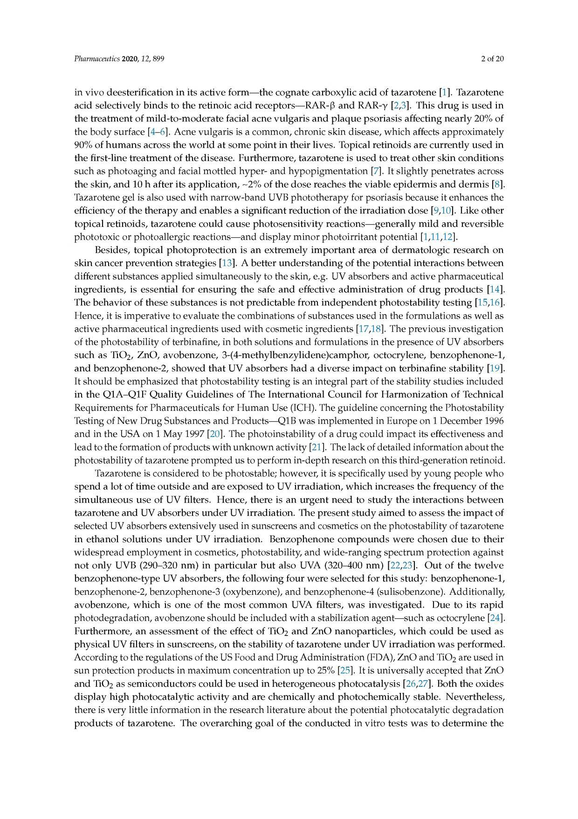

in vivo d eesterification in its active form — the cognate carboxylic acid of tazarotene [1]. Tazarotene acid selectively binds to the retinoic acid receptors— R A R -ß and R A R -y [2,3 ]. This drug is used in the treatm ent of m ild-to-m oderate facial acne vulgaris and plaque psoriasis affecting nearly 20 % of the body surface [4- 6 ]. Acne vulgaris is a com m on, chronic skin disease, w hich affects approxim ately 90% of hum ans across the w orld at som e p oint in their lives. Topical retinoids are currently used in the first-line treatm ent of the disease. Furtherm ore, tazarotene is used to treat other skin conditions such as photoaging and facial m ottled hyper- and hypopigm entation [7]. It slightly penetrates across the skin, and 10 h after its application, ~ 2 % of the dose reaches the viable epiderm is and derm is [8 ]. Tazarotene gel is also used w ith narrow-band UVB phototherapy for psoriasis because it enhances the efficiency of the therapy and enables a significant reduction of the irradiation dose [9, 10]. Like other topical retinoids, tazarotene could cause photosensitivity reactions— generally m ild and reversible phototoxic or photoallergic reactions— and display m inor photoirritant potential [1, 11, 12].
Besides, topical photoprotection is an extrem ely im portant area of derm atologic research on skin cancer prevention strategies [13]. A better understanding of the potential interactions betw een different substances applied sim ultaneously to the skin, e.g. UV absorbers and active pharm aceutical ingredients, is essential for ensuring the safe and effective adm inistration of drug products [14]. The behavior of these substances is not predictable from independent photostability testing [15, 16]. H ence, it is im perative to evaluate the com binations of substances used in the form ulations as w ell as active pharm aceutical ingredients used w ith cosm etic ingredients [17, 18]. The previous investigation of the photostability of terbinafine, in both solutions and formulations in the presence of UV absorbers such as TiO 2, Zn O , avobenzone, 3 -(4 -m ethylbenzylidene)cam phor, octocrylene, benzophenone-1 , and benzophenone-2 , show ed that U V absorbers had a diverse im pact on terbinafine stability [19]. It should be em phasized that photostability testing is an integral part of the stability studies included in the Q 1 A -Q 1 F Q uality G uidelines of The International C ouncil for H arm onization of Technical Requirem ents for Pharm aceuticals for Hum an Use (ICH). The guideline concerning the Photostability Testing of N ew Drug Substances and Products— Q 1B was im plemented in Europe on 1 Decem ber 1996 and in the USA on 1 M ay 1997 [20 ]. The photoinstability of a drug could im pact its effectiveness and lead to the formation of products w ith unknown activity [21 ]. The lack of detailed inform ation about the photostability of tazarotene prompted us to perform in-depth research on this third-generation retinoid.
Tazarotene is considered to be photostable; however, it is specifically used by young people who spend a lot of tim e outside and are exposed to U V irradiation, w hich increases the frequency of the sim ultaneous use of U V filters. H ence, there is an urgent need to study the interactions betw een tazarotene and U V absorbers under U V irradiation. The present study aim ed to assess the im pact of selected UV absorbers extensively used in sunscreens and cosmetics on the photostability of tazarotene in ethanol solutions under U V irradiation. Benzophenone com pounds w ere chosen due to their w idespread em ploym ent in cosm etics, photostability, and w ide-ranging spectrum protection against not only U V B ( 290 -320 nm ) in particular bu t also UVA (32 0 -4 0 0 nm ) [22,23 ]. O ut of the tw elve benzophenone-type U V absorbers, the follow ing four w ere selected for this study: benzophenone-1, benzophenone-2, benzophenone-3 (oxybenzone), and benzophenone-4 (sulisobenzone). Additionally, avobenzone, w hich is one of the m ost com m on UVA filters, w as investigated. D ue to its rapid photodegradation, avobenzone should be included w ith a stabilization agent— such as octocrylene [24 ]. Furtherm ore, an assessm ent of the effect of TiO 2 and Zn O nanoparticles, w hich could be used as physical U V filters in sunscreens, on the stability of tazarotene under U V irradiation w as perform ed. According to the regulations of the US Food and Drug Adm inistration (FDA), ZnO and TiO 2 are used in sun protection products in maximum concentration up to 25% [25 ]. It is universally accepted that ZnO and TiO 2 as sem iconductors could be used in heterogeneous photocatalysis [ 26, 27]. Both the oxides display high photocatalytic activity and are chem ically and photochem ically stable. N evertheless, there is very little inform ation in the research literature about the potential photocatalytic degradation products of tazarotene. The overarching goal of the conducted in vitro tests w as to determ ine the
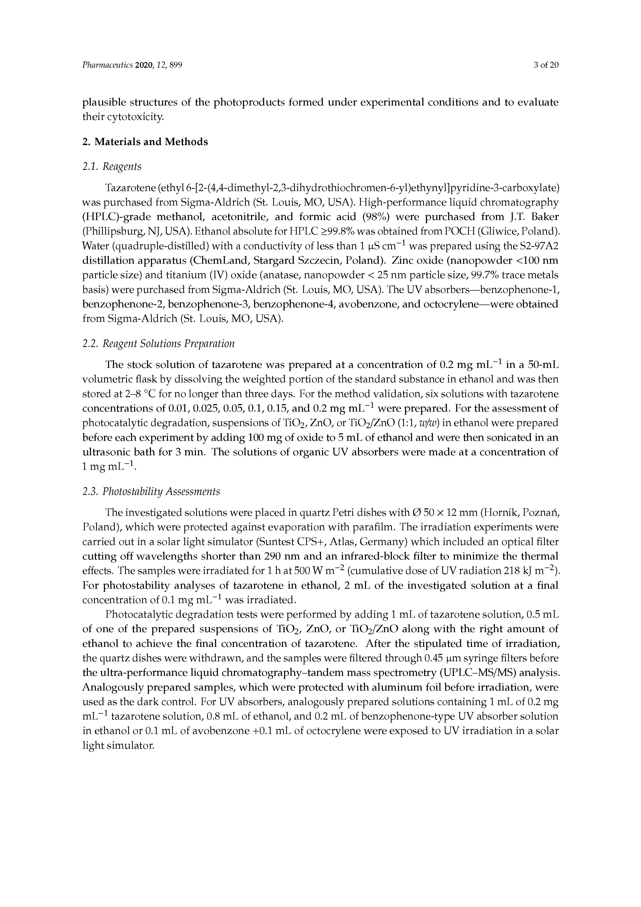

plausible structures of the photoproducts form ed u nder experim ental conditions and to evaluate their cytotoxicity.
2. M aterials and M ethods

2.1. Reagents
Tazarotene (ethyl 6-[2-(4,4-dim ethyl-2,3-dihydrothiochrom en-6-yl)ethynyl]pyridine-3-carboxylate) w as purchased from Sigm a-Aldrich (St. Louis, M O, USA). H igh-perform ance liquid chrom atography (H PLC )-grade m ethanol, acetonitrile, and form ic acid (98 % ) w ere purchased from J.T. Baker (Phillipsburg, NJ, USA). Ethanol absolute for HPLC > 99 .8 % w as obtained from POCH (Gliwice, Poland). Water (quadruple-distilled) with a conductivity of less than 1 gS cm -1 was prepared using the S2-97A 2 distillation apparatus (C hem Land, Stargard Szczecin, Poland). Zinc oxide (nanopow der < 1 0 0 nm particle size) and titanium (IV) oxide (anatase, nanopow der < 25 nm particle size, 99.7% trace m etals basis) were purchased from Sigm a-Aldrich (St. Louis, M O, USA). The UV absorbers— benzophenone-1, benzophenone-2 , benzophenone-3 , benzophenone-4 , avobenzone, and octocrylene— w ere obtained from Sigm a-A ldrich (St. Louis, M O, USA).

2.2. Reagent Solutions Preparation
The stock solution of tazarotene w as prepared at a concentration of 0.2 m g m L -1 in a 50 -m L volumetric flask by dissolving the w eighted portion of the standard substance in ethanol and was then stored at 2 -8 °C for no longer than three days. For the method validation, six solutions w ith tazarotene concentrations of 0.01, 0.025, 0.05, 0.1, 0.15, and 0.2 m g m L -1 w ere prepared. For the assessm ent of photocatalytic degradation, suspensions of TiO 2, ZnO, or TiO 2/Zn O (1:1, w/w) in ethanol were prepared before each experim ent by adding 100 m g of oxide to 5 m L of ethanol and w ere then sonicated in an ultrasonic bath for 3 m in. The solutions of organic U V absorbers w ere m ade at a concentration of 1 m g m L- 1 .

2.3. Photostability Assessments
The investigated solutions were placed in quartz Petri dishes w ith 0 50 X 12 mm (Hornik, Poznan, Poland), w hich w ere protected against evaporation w ith parafilm . The irradiation experim ents w ere carried out in a solar light sim ulator (Suntest C P S+, Atlas, Germ any) w hich included an optical filter cutting off w avelengths shorter than 290 nm and an infrared-block filter to m inim ize the therm al effects. The samples w ere irradiated for 1 h at 500 W m -2 (cumulative dose of UV radiation 218 kJ m - 2 ). For photostability analyses of tazarotene in ethanol, 2 m L of the investigated solution at a final concentration of 0.1 m g m L-1 w as irradiated.
Photocatalytic degradation tests w ere perform ed by adding 1 m L of tazarotene solution, 0 .5 m L of one of the prepared suspensions of TiO 2, Zn O , or TiO 2/Z n O along w ith the right am ount of ethanol to achieve the final concentration of tazarotene. A fter the stipulated tim e of irradiation, the quartz dishes were w ithdrawn, and the samples w ere filtered through 0.45 gm syringe filters before the ultra-perform ance liquid chrom atography-tand em m ass spectrom etry (U PLC -M S/M S) analysis. A nalogously prepared sam ples, w hich w ere protected w ith alum inum foil before irradiation, w ere used as the dark control. For UV absorbers, analogously prepared solutions containing 1 m L of 0.2 mg m L-1 tazarotene solution, 0.8 m L of ethanol, and 0.2 m L of benzophenone-type U V absorber solution in ethanol or 0.1 m L of avobenzone + 0 .1 m L of octocrylene w ere exposed to UV irradiation in a solar light simulator.
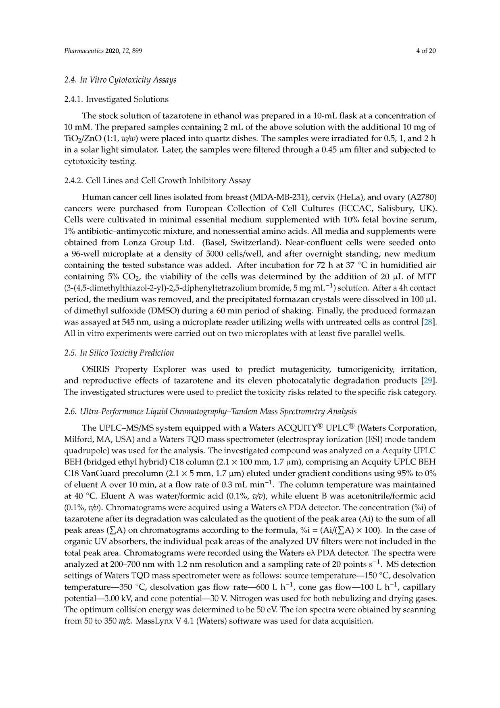

2.4. In Vitro Cytotoxicity Assays

2.4.1. Investigated Solutions
The stock solution of tazarotene in ethanol w as prepared in a 10-m L flask at a concentration of 10 m M . The prepared sam ples containing 2 m L of the above solution w ith the additional 10 m g of TiO 2/Z n O (1:1, w/w) w ere placed into quartz dishes. The sam ples w ere irradiated for 0 .5 ,1 , and 2 h in a solar light sim ulator. Later, the sam ples w ere filtered through a 0.45 gm filter and subjected to cytotoxicity testing.
2.4.2. Cell Lines and Cell G row th Inhibitory A ssay
H um an cancer cell lines isolated from breast (M D A -M B-231), cervix (H eLa), and ovary (A 2780) cancers w ere purchased from European C ollection of Cell Cultures (EC C A C, Salisbury, UK). C ells w ere cultivated in m inim al essential m edium supplem ented w ith 10% fetal bovine serum , 1% antibiotic-antim ycotic m ixture, and nonessential am ino acids. A ll m edia and supplem ents w ere obtained from Lonza G roup Ltd. (Basel, Sw itzerland). N ear-confluent cells w ere seeded onto a 96 -w ell m icroplate at a density of 5000 cells/w ell, and after overnight standing, new m edium containing the tested substance w as added. A fter incubation for 72 h at 37 ° C in hum idified air containing 5% C O 2, the viability of the cells w as determ ined by the addition of 20 g L of M TT (3-(4,5-dim ethylthiazol-2-yl)-2,5-diphenyltetrazolium bromide, 5 mg m L- 1 ) solution. After a 4h contact period, the m edium w as rem oved, and the precipitated form azan crystals w ere dissolved in 100 g L of dim ethyl sulfoxide (D M SO ) during a 60 m in period of shaking. Finally, the produced form azan w as assayed at 545 nm , using a m icroplate reader utilizing w ells w ith untreated cells as control [ 28] . A ll in vitro experim ents w ere carried out on two m icroplates w ith at least five parallel w ells.

2.5. In Silico Toxicity Prediction
O SIR IS Property Explorer w as used to predict m utagenicity, tum origenicity, irritation, and reproductive effects of tazarotene and its eleven photocatalytic degradation products [29 ]. The investigated structures w ere used to predict the toxicity risks related to the specific risk category.
2.6. Ultra-Performance Liquid Chromatography-Tandem M ass Spectrometry Analysis
The U P L C -M S/M S system equipped w ith a W aters A C Q U ITY® U PLC® (W aters C orporation, M ilford, M A, USA) and a Waters TQD mass spectrom eter (electrospray ionization (ESI) m ode tandem quadrupole) w as used for the analysis. The investigated compound w as analyzed on a Acquity UPLC BEH (bridged ethyl hybrid) C 18 colum n (2.1 X 100 m m , 1.7 gm ), com prising an A cquity U PLC BEH C 18 Van Guard precolum n (2.1 X 5 m m , 1.7 gm ) eluted under gradient conditions using 95% to 0% of eluent A over 10 m in, at a flow rate of 0.3 m L m in- 1 . The colum n tem perature w as m aintained at 40 °C. Eluent A w as w ater/form ic acid (0.1% , v/v), w hile eluent B w as acetonitrile/form ic acid (0.1%, v/v). Chrom atogram s w ere acquired using a W aters eA PDA detector. The concentration (%i) of tazarotene after its degradation w as calculated as the quotient of the peak area (Ai) to the sum of all peak areas (£ A ) on chrom atogram s according to the form ula, % i = ( A i/(£ A ) X 100). In the case of organic U V absorbers, the individual peak areas of the analyzed U V filters w ere not included in the total peak area. Chrom atogram s w ere recorded using the W aters eA PD A detector. The spectra w ere analyzed at 2 0 0 -700 nm w ith 1.2 nm resolution and a sam pling rate of 20 points s- 1 . M S detection settings of W aters TQ D mass spectrom eter w ere as follows: source tem perature— 150 °C, desolvation tem perature— 350 °C, desolvation gas flow rate— 600 L h - 1 , cone gas flow — 100 L h - 1 , capillary potential— 3.00 kV, and cone potential— 30 V. Nitrogen was used for both nebulizing and drying gases. The optimum collision energy was determined to be 50 eV. The ion spectra w ere obtained by scanning from 50 to 350 m/z. M assLynx V 4.1 (Waters) softw are w as used for data acquisition.
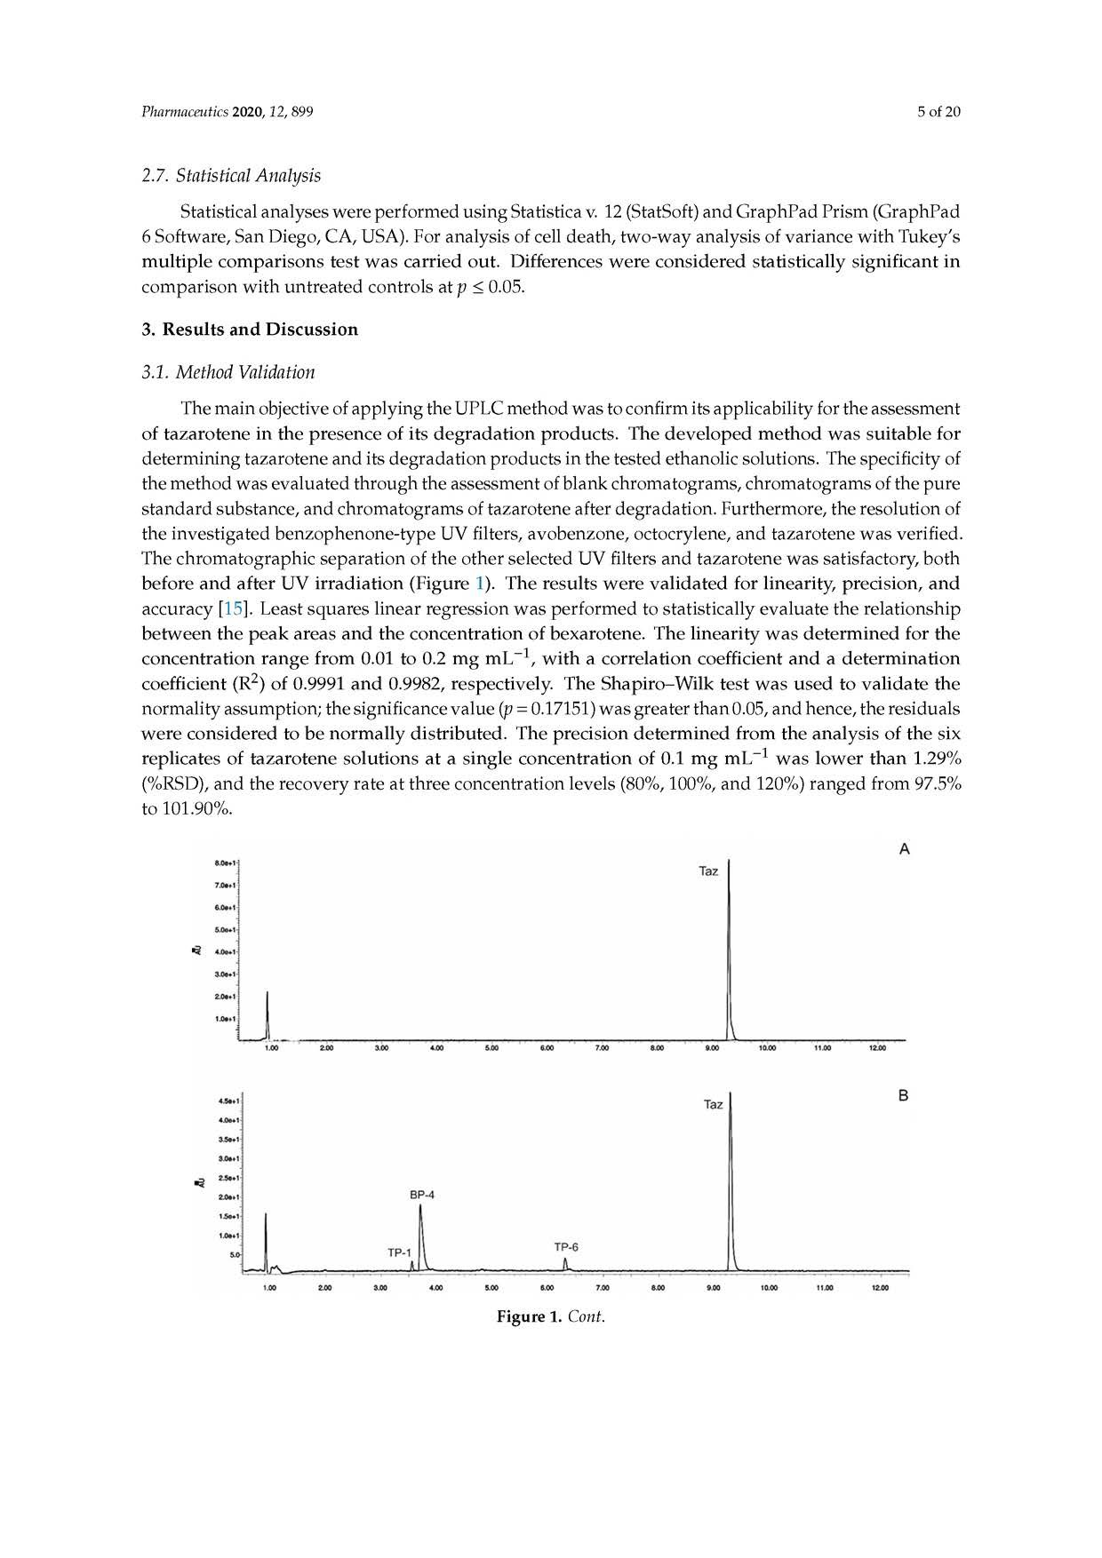

2.7. Statistical Analysis
Statistical onalyses were performed using Statistics v. 12 (StatSoft) and GraphP ad Prism (CGraphPad 6 Software, S in Diego, CA, USA). For analysis of cell deoth, two-way analysis of variance w ith Tukey's m ultiple com parisons test w as carried out. D ifferences w ere considered statistically significant in com parison w ith untreated controls at p < 0.05.
3. Results and D iscussion

3.1. M ethod Validation
The main objective of applying the UPLC method was to confirm its applicabilify for the assessm eni of tazarotene in the presence of fts degradation products. The developed meShod w as suftable for determining tazarotene and fts degradation products in the tested efhanolic solutions. The specificity of the method was evaluated through the assessment of blank chromatogroms, chromatograms of the pure standard substance, and chrom atograms of tazarotene after degradation. Furthermore, tire resolution of the investiga ted benzophenone-iype UV filters, avobenzone, octocrylene, and -azarotene w as verified. The chrom atographic sepatation of the other selected UV filters and tazasotene wab satisfactory, both before and affer U V irradiation (Figure t ). The results w ere validated for linearity, precision, and accuracy [S5 ] . L rast squares linear regreesion was; perform ed to statistically evaluafe the relationship betw een the pea k areas and the concentration of bexarotene. "The iinearity w as determ ined for the concentration oange from 0.01 So 0.2 m g m L - 1 , w ith a correlation coefiesient and a determ ination coefficient (R 2l of n.9991 and 0.9982, respectively. Tire Shapiro-W ilk trst w as used to validate the; norm ality assumption; the significance value (p = 0. 1715f) w as greater than 0.05, and hencet the residualf w ere considered to be norm ally distributed. The precision determ ined from the analysis o l the rix replicates of tazarotene sotutions a l a single concentration of 0.1 m g m L“ 1 w as low er than 1.29% (% RSD), otid the recovery rate at three concenlration levels (80%, !00 % , and 120%) ranged from 97.5% to 101.90%.
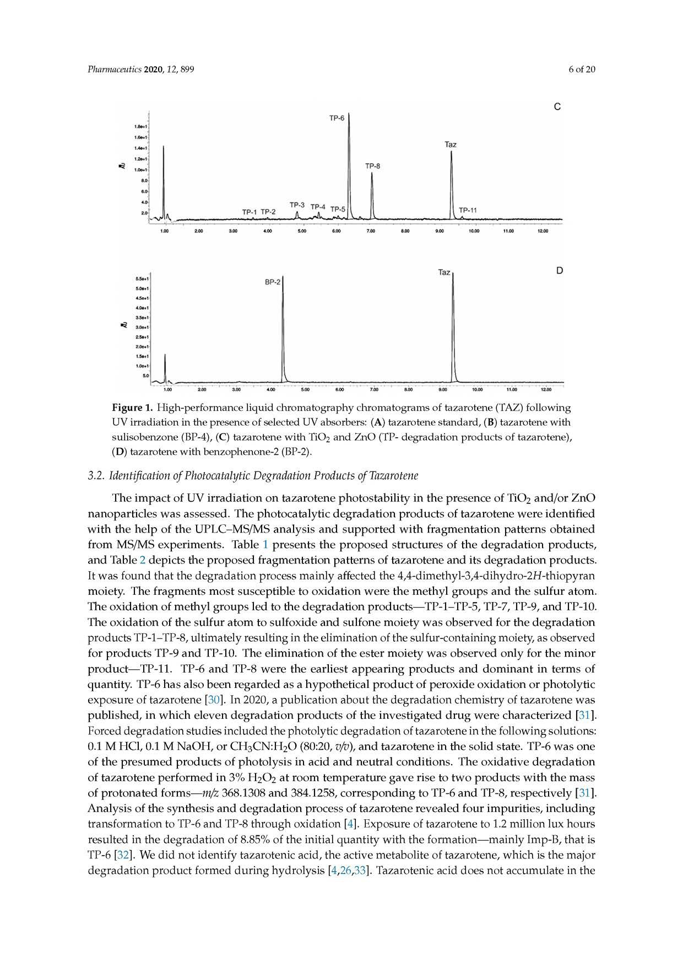

Figure 1. High-performance liquid chromatography chromatograms of tazarotene (TAZ) following UV irradiation in the presence of selected UV absorbers: (A) tazarotene standard, (B) tazarotene with sulisobenzone (BP-4), (C) tazarotene with TiO2 and ZnO (TP- degradation products of tazarotene),
(D) tazarotene with benzophenone-2 (BP-2).
3.2. Identification o f Photocatalytic Degradation Products o f Tazarotene
The im pact of U V irradiation on tazarotene photostability in the presence of TiO 2 and/or Zn O nanoparticles w as asses sed. The photocatalytic degradotion products of tazarotene w ere identified w ith the help of the U P L C -M S/M S analysis and supported w ith fragm entation patterns obtained from M S/M S experim ents. Table 1 presents the proposed structures of the degradation products, and Table 2 depicts the proposed fragm entation patterns of tazarotene and its degradation products. It w as found that the degrada tion process ma inly affected the 4,4-tlim ethyls3,4-dihydro-2 H -thiopyran moiety. The fragm ents m ost susceptible to oxidation w ere the m ethyl groups and the sulfur atom . The; oxidation of m ethyl groups led to the degradatinn products— TP-1 -T P - 5 , TP-7, TP-9, and TP-10. The oxidation of the sulfur atom td su lfoxide and sulfone m oiety w as observed for the degra dation products T P H - T P ^ ultimately resulting; in the alimination oTthe sulfur-containing moisty, as observetl for products TP-9 find TP-10. The elim ination erf the ester m oiety w as observed only for the m inar product— TP-11. TP -6 and TP-8 w ere the earliest appearing produces and dom inant in term s of ejfuantity. TP-6 has also been regarded as a hypothetica 1 product of p ersxid e oxid atien or photolytis expusure of tazarotene [30 ]. In 2020, a publication about the degradation chem istry of tazarotene was published, in w hich eleven degradation products of the investigated drug w ere characterized [31 ] . Furced degradation studies included the photolytic degradation of tazarotene in the following solutions:
0.1 M H Cl, 0.1 la1 N aO H , or C H 3C N U 2O (8 °:20 , v/vl, and tazarotene in the solid state. TP-6 w at one of the presum ed products of photolysis in acid and neutral conthtions. The oxidative degradation of tazaootene perform ed in 3% H 2O 2 at room tem perature gave rise to tw o jnsodurfs w ith the m ass of protona ted form s— m/z 368.1308 and 384.1258., corresponding to TP -6 and TP-8, respectively [31 ] . A nalysis of the synthesis and degradation process of tazarotene revealed four im purities, including transform ation to TP-6 and TP-81 through exidation [4 ]. Exposure of tazarotene to 1.2 milfion lux hourr resulted in the degradation of 8.85% of the initial quantity w ith the form ation— m ainly Im p-B, that is TP-6 [32 ]. We did not identify tazarotenir acid, the active m etabolite of taearotene, w hich is the m ajor degradation product formed during hydrolysis [4 , 26,33 ] . Tazarotenic acid does not accum ulate in the
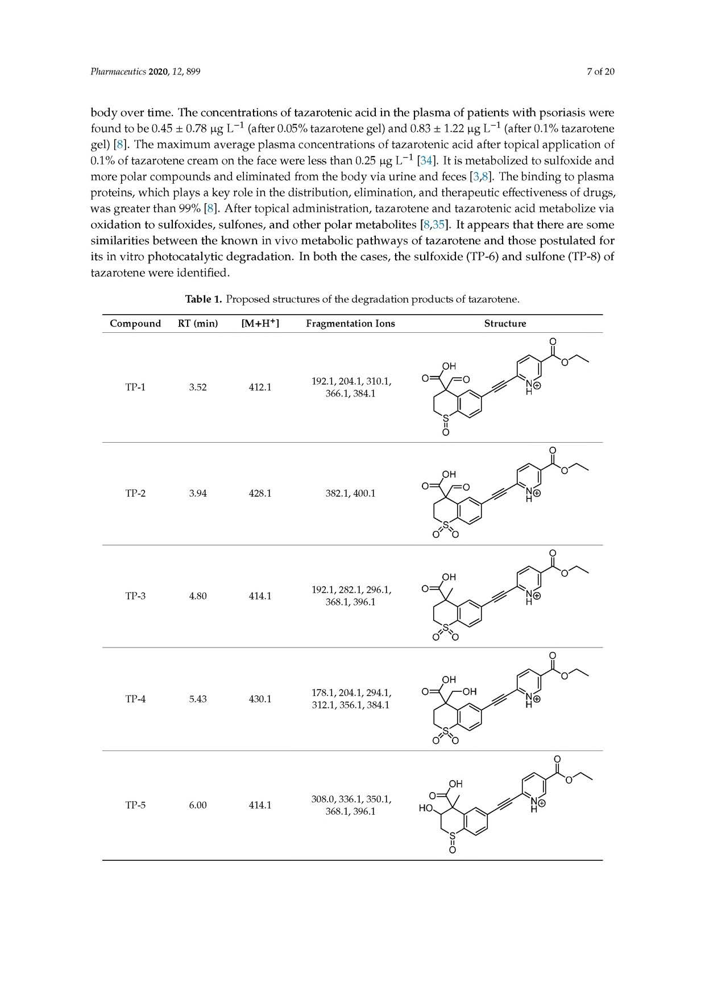

body over tim e. The concentrations of tazarotenic acid in the plasm a of patients w ith psoriasis w ere found to be 0.45 ± 0.78 pg L-1 (after 0.05% tazarotene gel) and 0.83 ± 1.22 pg L-1 (after 0.1% tazarotene gel) [8 ] . The m axim um average plasm a concentrations of tazarotenic acid after topical applic ation of 0.1% of tazarotene cream on the face w ere less than 0.25 pg L-1 [34 ]. It is metabolized to sulfoxide and more polar compounds and eliminated from the body via urine and feces [3,8 ]. The binding to plasma proteins, w hich plays a key role in the distribution, elimination, and therapeutic effectiveness of drugs, w as greater than 99% [8 ]. After topical adm inistration, iazarotrne and tazarotenic acid m etabolize via oxidation to sulfoxides, sulfonee, and other polar m etebolites [8,35 ] . lit appears that there are som e sim ilarities betw oen tiret know n in vivo m etabolic pathw ays of tnzaaotene and those pontulatad for its in vitro photocaialytic degradation. In both the caaes, the sulfoxide (TP-6 i and sulfone (TP-8 ) of tazarotene w ere identified.
Table 1. Proposed structures of the degradation products of tazarotent.
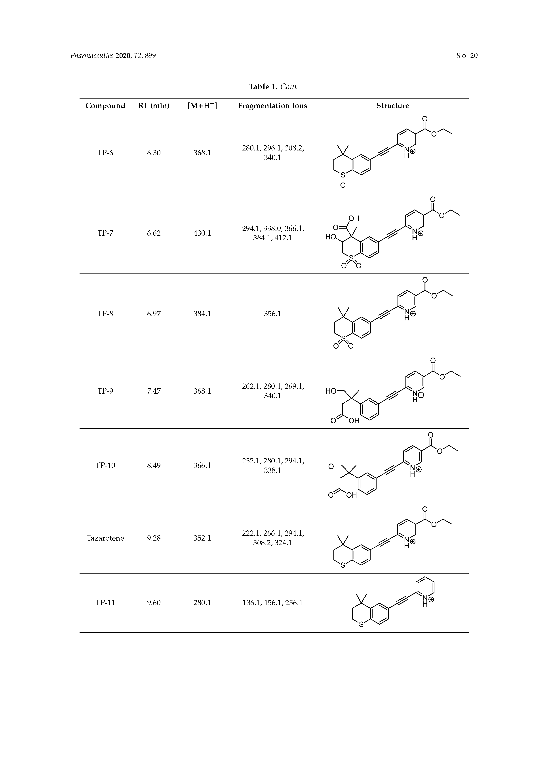

Compound RT (min) [M+H+] Fragmentation Ions Structure

TP-6 6.30 368.1 280.1,296.1, 308.2,
340.1

TP-7 6.62 430.1 294.1,338.0, 366.1,
384.1,412.1

TP-8 6.97 384.1 356.1

TP-9 7.47 36(5.1 262.1,280.1, 269.1,
340.1

TP-10 8.49 366.1 252.1,280.1, 294.1,
338.1

Tazarotene 9.28 352.1 222. 1,266.1, 294.1,
308.2, 324.1

TP-11 9.60 280.1 136.2, 156.1,236.1
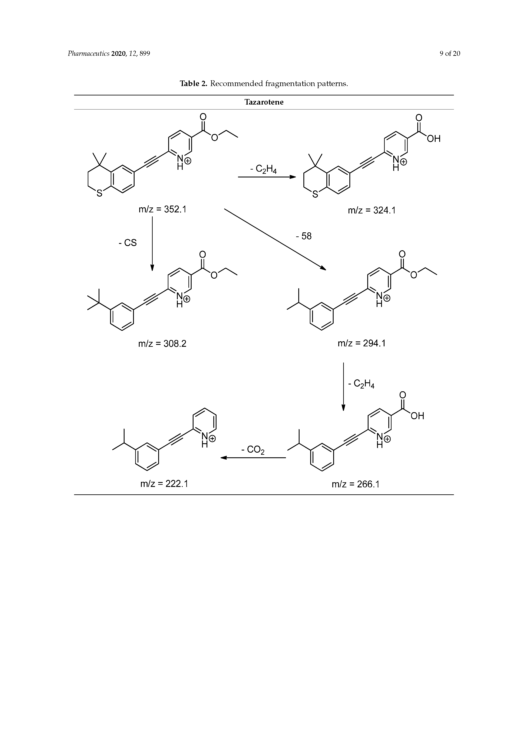

Tazarotene
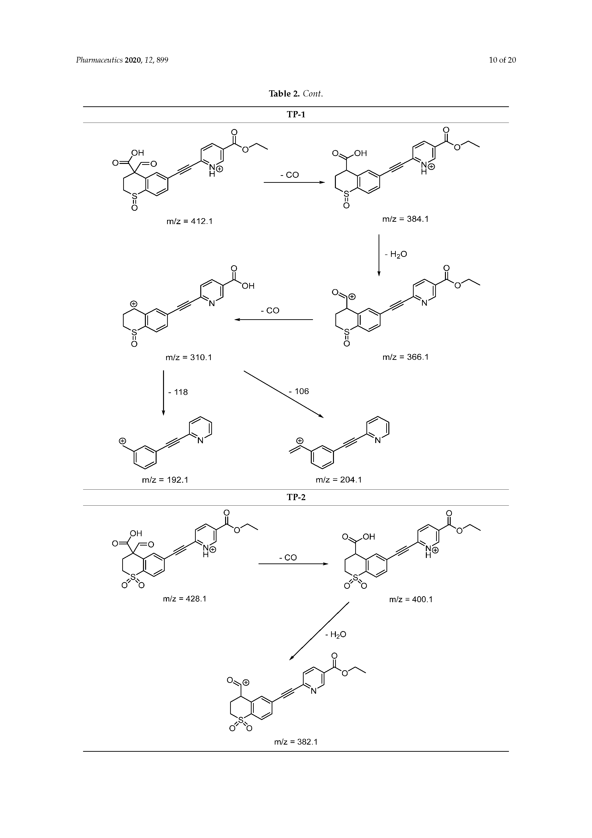

TP-1

m/z = 412.1 m/z = 384.1
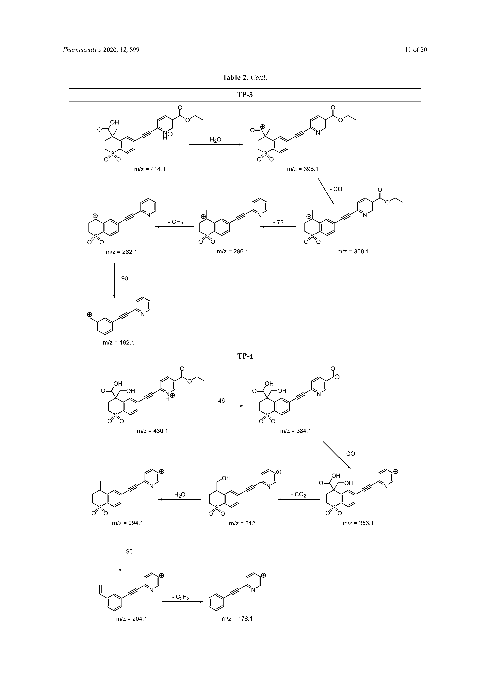

TP-3
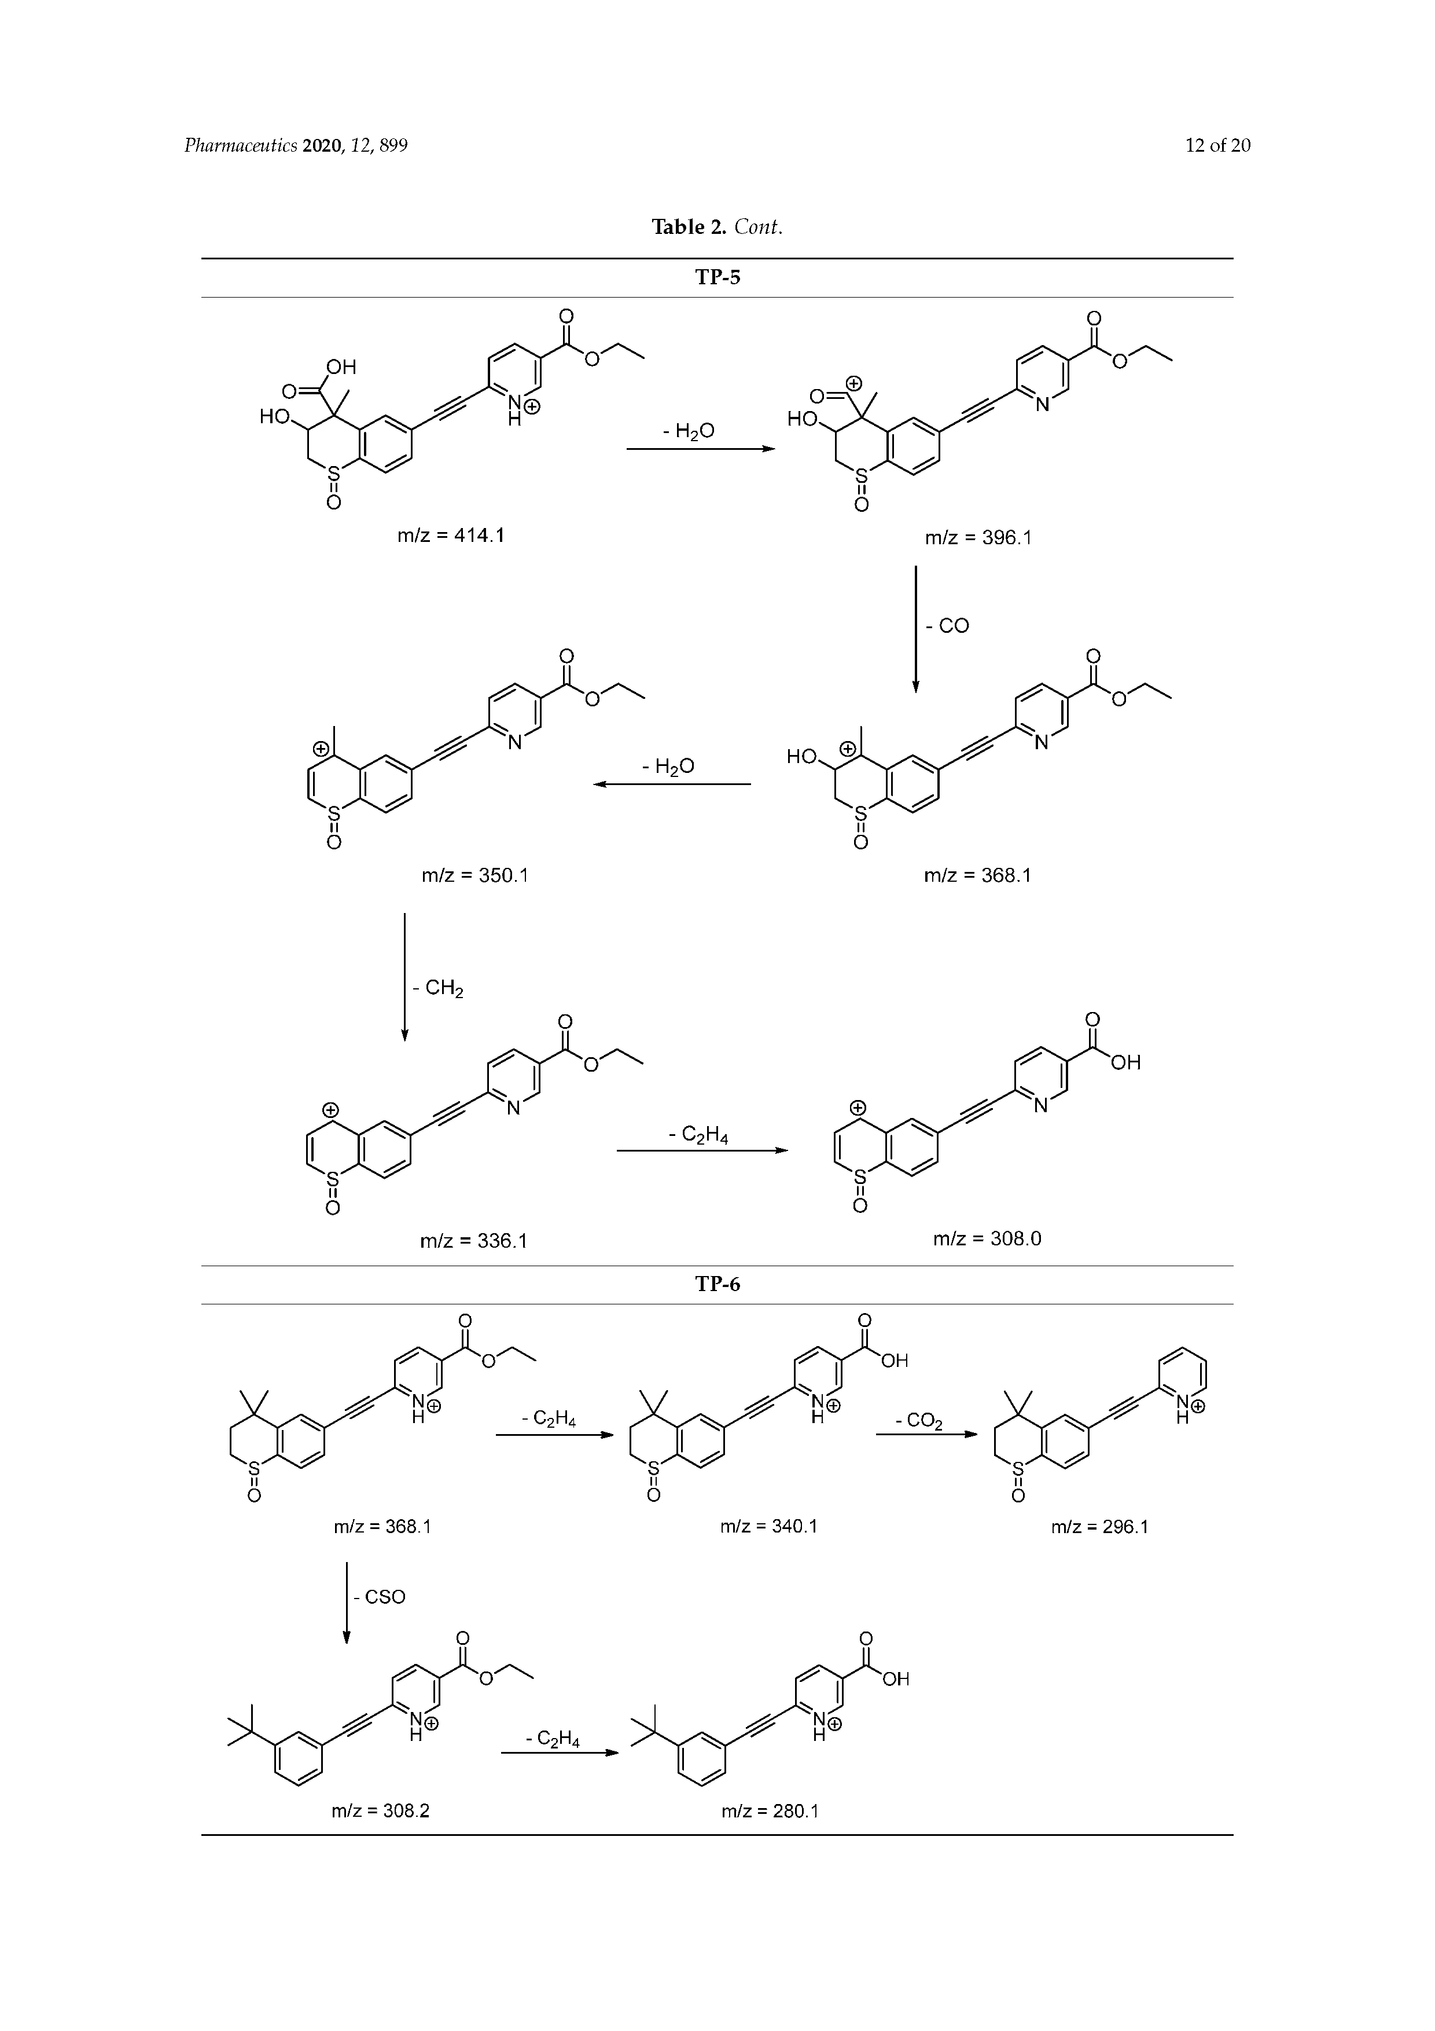

TP-5
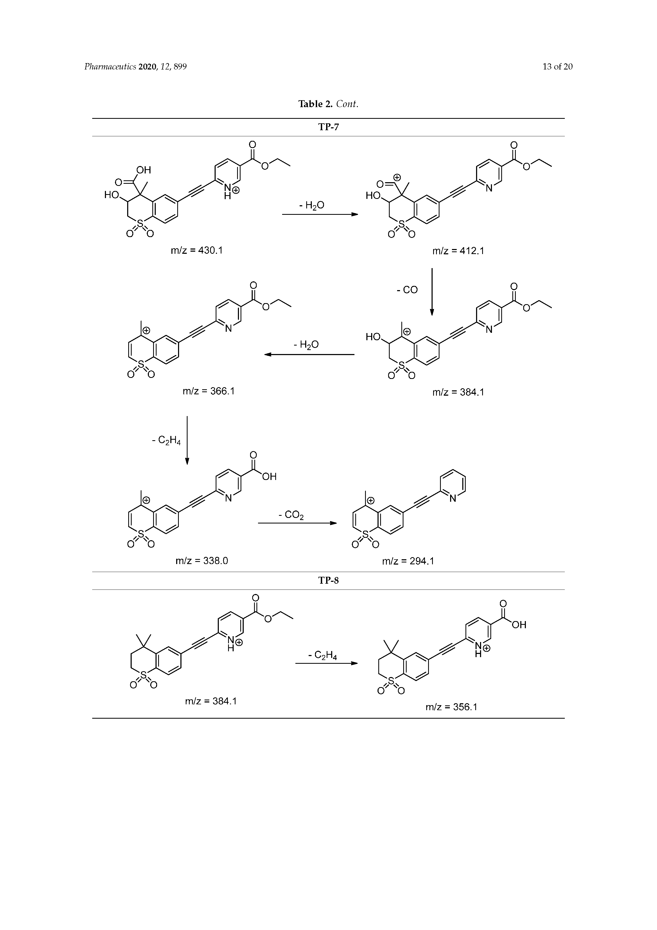

TP-7
Pharmace:utics 2020, 12, 899 14 of 20

Table 2. Cant.

o

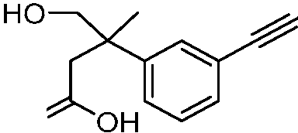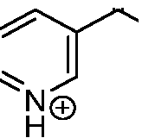
o
m/z = 368.1

o/'-...

TP-9

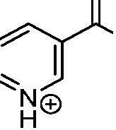
o
OH
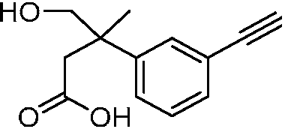
m/z = 340.1

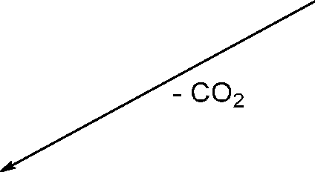
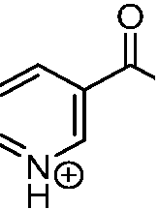
- 60

OH

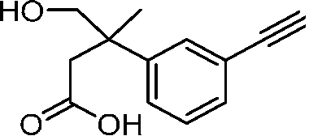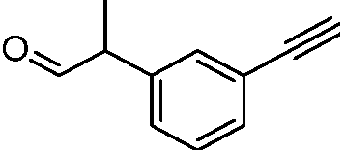
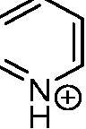
m/z = 296.1
m/z = 280.1

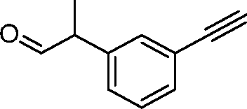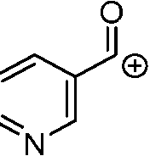

o

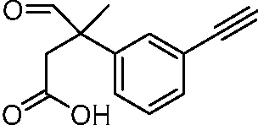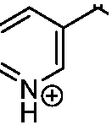
m/z = 366.1

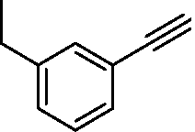
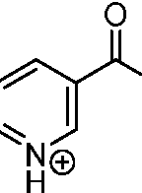
OH

-CO

o/'--......

TP-10

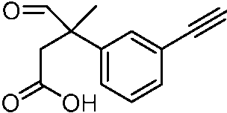

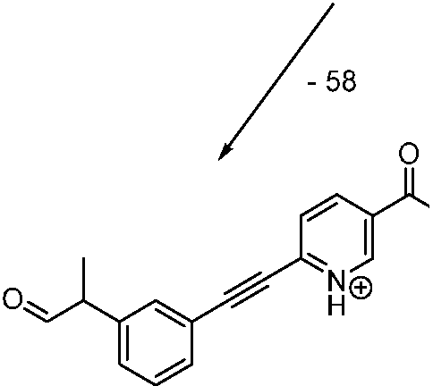
OH
m/z = 262.1

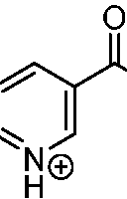
OH

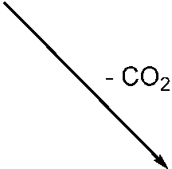

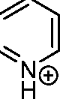

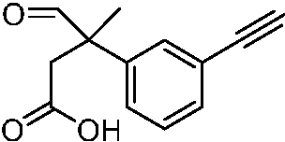
m/z = 252.1
m/z = 280.1

m/z = 294.1

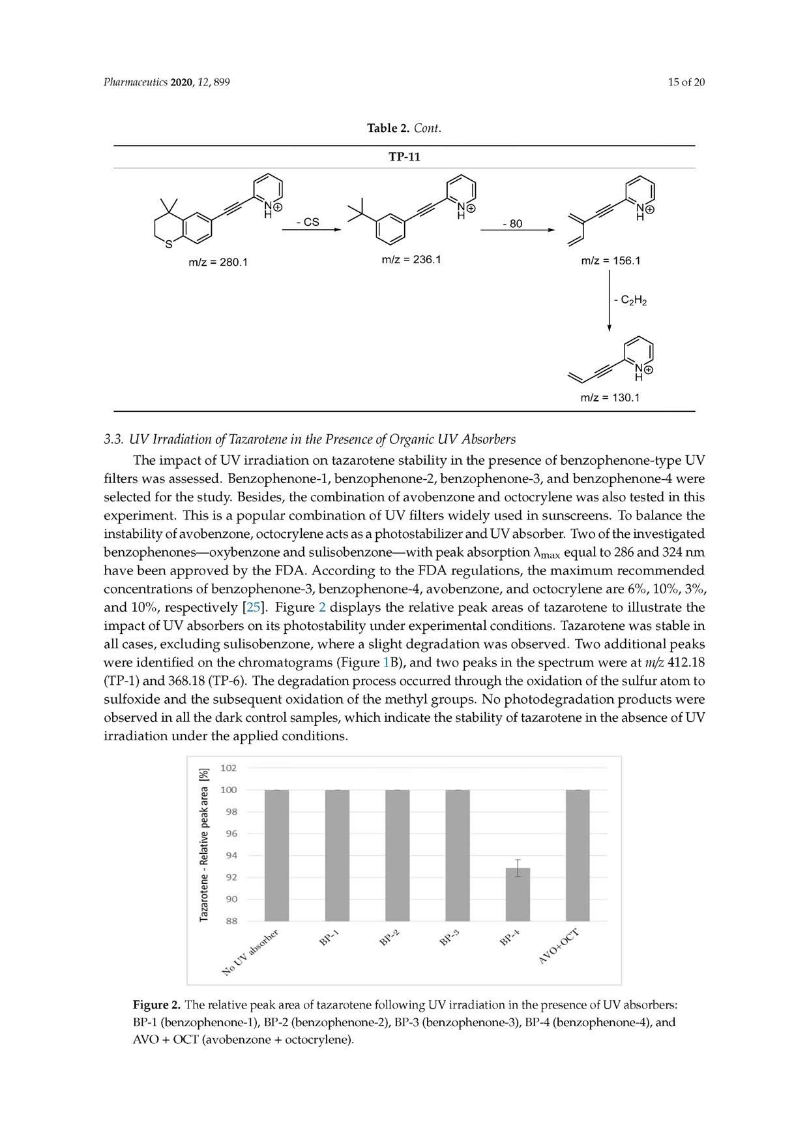

3.3. UV Irradiation o f Tazarotene in the Presence o f Organic U V Absorbers
The im pact of U V irradiation on tazarotene stability in the presence of benzophenone-type UV filters w as assessed. Benzophenone-1, benzophenone-2, benzophenone-3, and benzophenone-4 were selected for the study. Besides, the com bination of avobenzone and octocrylene w as also tested in this experim ent. This is a popular com bination of U V filters w id ely used in sunscreens. To balance the instabitity of avobenzone, octocrylene acts as a photostabilizar and UV absorber. Two ef the investigated benzophenones— oxybenzono and sufisobenzone— w ith peak absorption Amsx equal to 286 and 324 nm have been approved by the FDA. A ccording So She FD A regulations, the m axim um recom m ended concentrations of benzophenone-3 , benzophenone-4 , avobenzone, and octocrylene are 6%, 10%, 3%, and 10% , respectively t25 ]. Figuro 2 displays the relative peak areae of tazarotene to ifiustrate the im pact of U V absorbers on its y hotostability under experim enial conditions . Tazarotene w as stable in all cases, excluding tulisobenzone, w here a slight degradation w as observsd. Two additional peaks w ere identified on the chrom atogram s (Figure IB ), and tw o peaks in the spettcum w ere at m/z 412.18 (TP-1) and 368.18 (TP-6 ). 'Tire degradation procets occursed throughthe oxidation of ihe sulfur atom to sulfoxide and fire subsequenS oxidation of tho m ethyl groups. N o p h o tod eg rtd atio n products w ere observed in all the dark centrol samples, w hich indicote the stability ot tazerotene in the absence of UV irradiation under the applied conditions.

Figure 2. The relative peak area of tazarotene following UV firsdiation in the presence of UV absorbers: BP-1 (benzophenone-1), BP-2 (btnzophenone-2), BP-3 (benzsphenone-3), BP-4 (benzophenone-4), and AVO + OCT (avobenzone + octocrylene).
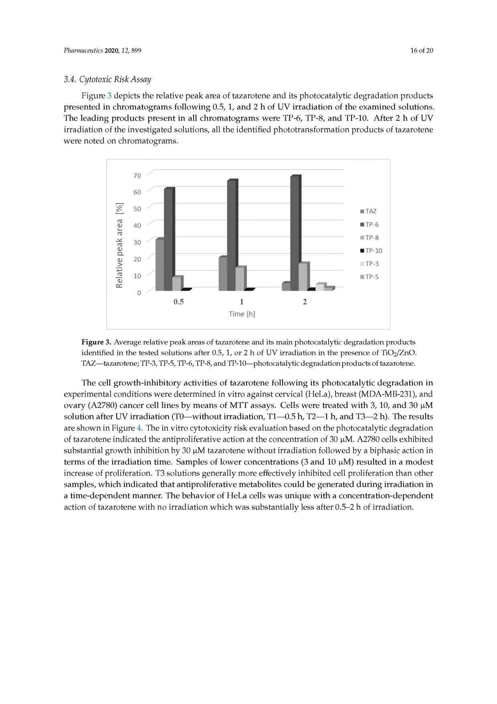

3.4. Cytotoxic Risk Assay
Figure 3 depicts the relative peak area of tazarotene and its photocatalytic degradation products presented in chrom atogram s follow ing 0.5, 1, and 2 h of U V irradiation of the exam ined solutions. The leading products present in all chrom atogram s w ere TIP-6, TP -8 , and TIP-10. A fter 2 h of U V irradiation of the investigated solutions, all the identified phototransform ation products of tazarotene w zre noted on chrom atogram s.

Figure 3. Average relative peak areas of tazarotene and its main photocatalytic degradation products identified in the tested solutions after 0.5, 1, or 2 h of UV irradiation in the presence of TiO2/ZnO. TAZ—tazarotene; TP-3, TP-5, TP-6, TP-8, and TP-10—photocatalytic degradation products of tazarotene.

The cell grow th-inhibitory activities of tazarotene follow ing its photocatalytic degradation in experim ental conditions w ere determ ined in vitro against cervical (HeLa), boeast (M DA-M B-231), and ovary (A 2780) cancer cell lines by m eans of M TT assays. Cella w ere treated w ith 3, 10, and 30 pM solution ćifter UV/- ireadiation (T 0— w ithout irradiation, T 1— e.5 h, T 2— 1 h, and T 3— 2 h). The 3esults are shown in Figure 4 . The in -vitro cytotoxicity risk: evaluation bahed on the photocatalytic degradation of tazarotene indicated the antiproliferative action at the concentration of 30 dM. A 2780 cells exhibited substantial growth inhibition by 30 pM tazarotene withoua irradiation followed by a biphasic action in term s of the irradiation tim e. Sam ples of lnw er concentrations (3 and 10 pM) resuhed ln d m ode st increase of proliferation. T3 solu tions genera lly more effectively inhib ited cell proliferation th an other sam ples, w hich indicated that antiproliferative m etabolites could be generated, duriny irradiation in a tim e-depe n d e n m anner. The behavior of H e La cells w as untque w ith a concenarationsdependent actien of tazarotene w ith no irradiation w hich wns substantially lesh after 0 .5 -2 h of irradiation
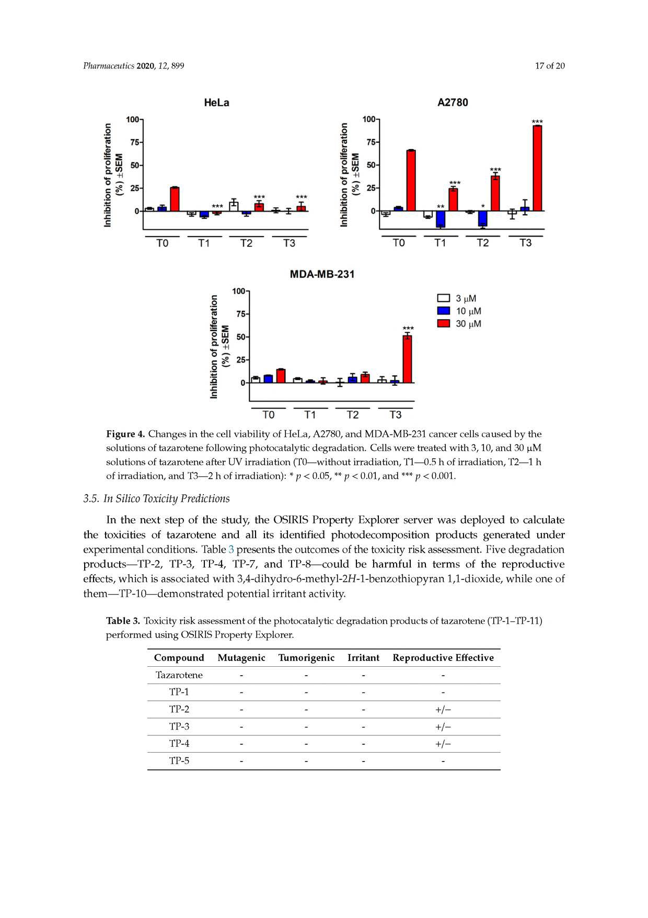

Figure 4. Changes in the cell viability of HeLa, A2780, and MDA-MB-231 cancer cells caused by the solutions of tazarotene following photocatalytic degradation. Cells ‘were treated with 3,10, anti 30 <iM solutions of tazarotene after UV irradiation (TO—without irradiation, T1—0.5 h of irradiation, T2— l h of irradiation, and T3— 2 h of irradiation): * p < 0.05, ** p < 0.01, and *** p < 0.001.
3.5. In Silico Toxicity Predictions
In the next step of the; study, the O SIRIS Iro p erty Explorer server w as daployed to calculate the toxicities of taaarotene and all its identified photodecom position products generated under experimental conditions. Table 3 presents the outcomes of the toxicity risk assessmsnt. Five degradation products— TP-2 k TP-3, TP-4, TP-7, and TP -8— could be harm ful in termo of the reproductive effects, w hich it atsociated w ith 3 ,4-dihydro-6-methyl-2Hl-1-benzothiopyran lf- d to x id e , w hile gne of them — TP-10— dem onstrated potential irritant activity.

Table 3. Toxicity risk assessment of the photocatalytic degradation products of tazarotene (TP-1-TP-11) performed using OSIRIS Property Explorer.
Compound Mutagenic Tumorigenic Irritant Reproductive Effective Tazarotene - - - -
TP-1 - - - -
TP-2 - - - + / -
TP-3 - - - + / -
TP-4 - - - + / -
TP-5 - - - -
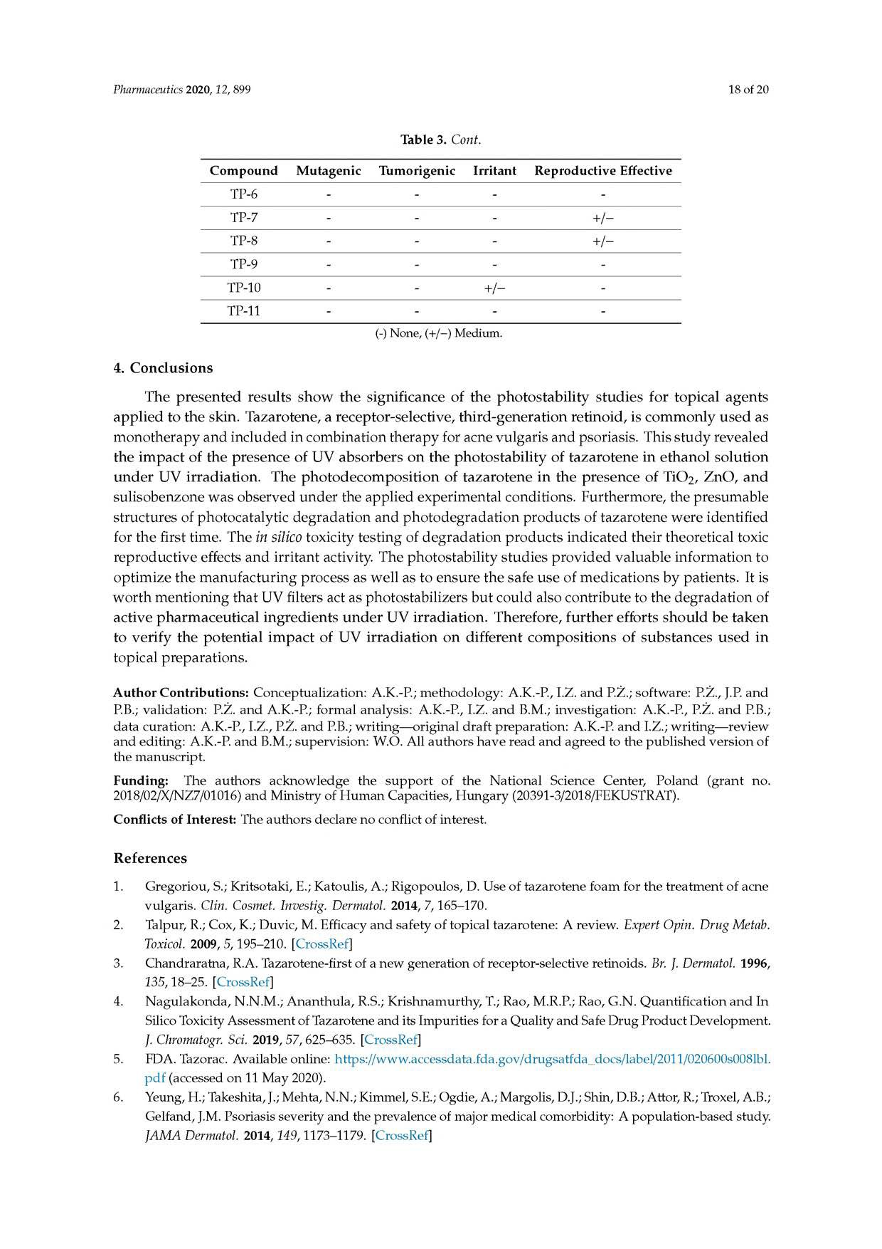

Compound Mutagenic Tumorigenic Irritant Reproductive Effective TP-6 - - - -
TP-7 - - - + / -
TP-8 - - - + / -
TP-9 - - - -
TP-10 - - + / - -
TP-11 - - - -
(-) None, (+/-) Medium.

4. Conclusions
The presented results show the significance of the photostability studies for topical agents applied to the skin. Tazarotene, a receptor-selective, third-generation retinoid, is com m only used as m onotherapy and included in com bination therapy for acne vulgaris and psoriasis. This study revealed the im pact of the presence of U V absorbers on the photostability of tazarotene in ethanol solution under U V irradiation. The photodecom position of tazarotene in the presence of TiO 2, Zn O , and sulisobenzone w as observed under the applied experimental conditions. Furtherm ore, the presumable structures of photocatalytic degradation and photodegradation products of tazarotene w ere identified for the first time. The in silico toxicity testing of degradation products indicated their theoretical toxic reproductive effects and irritant activity. The photostability studies provided valuable inform ation to optim ize the m anufacturing process as w ell as to ensure the safe use of m edications by patients. It is w orth mentioning that UV filters act as photostabilizers but could also contribute to the degradation of active pharm aceutical ingredients u nder U V irradiation. Therefore, further efforts should be taken to verify the potential im pact of U V irradiation on different com positions of substances used in topical preparations.

Author Contributions: Conceptualization: A.K.-P.; methodology: A.K.-P., I.Z. and P.Z.; software: P.Z., J.P. and P.B.; validation: P.Z. and A.K.-P.; formal analysis: A.K.-P., I.Z. and B.M.; investigation: A.K.-P., P.Z. and P.B.; data curation: A.K.-P., I.Z., P.Z. and P.B.; writing— original draft preparation: A.K.-P. and I.Z.; writing— review and editing: A.K.-P. and B.M.; supervision: W.O. All authors have read and agreed to the published version of the manuscript.
Funding: The authors acknowledge the support of the National Science Center, Poland (grant no. 2018/02/X/NZ7/01016) and Ministry of Human Capacities, Hungary (20391-3/2018/FEKUSTRAT).
Conflicts of Interest: The authors declare no conflict of interest.

References
1. Gregoriou, S.; Kritsotaki, E.; Katoulis, A.; Rigopoulos, D. Use of tazarotene foam for the treatment of acne vulgaris. Clin. Cosmet. Investig. Dermatol. 2014, 7,165-170.
2. Talpur, R.; Cox, K.; Duvic, M. Efficacy and safety of topical tazarotene: A review. Expert Opin. Drug Metab. Toxicol. 2009, 5,195-210. [CrossRef]
3. Chandraratna, R.A. Tazarotene-first of a new generation of receptor-selective retinoids. Br. J. Dermatol. 1996,
135 ,18-25. [CrossRef]
4. Nagulakonda, N.N.M.; Ananthula, R.S.; Krishnamurthy, T.; Rao, M.R.P.; Rao, G.N. Quantification and In Silico Toxicity Assessment of Tazarotene and its Impurities for a Quality and Safe Drug Product Development.
J. Chromatogr. Sci. 2019, 57, 625-635. [CrossRef]
5. FDA. Tazorac. Available online: https://www.accessdata.fda.gov/drugsatfda_docs/label/2011/020600s008lbl. pdf (accessed on 11 May 2020).
6 . Yeung, H.; Takeshita, J.; Mehta, N.N.; Kimmel, S.E.; Ogdie, A.; Margolis, D.J.; Shin, D.B.; Attor, R.; Troxel, A.B.; Gelfand, J.M. Psoriasis severity and the prevalence of major medical comorbidity: A population-based study. JAMA Dermatol. 2014,149 ,1173-1179. [CrossRef]
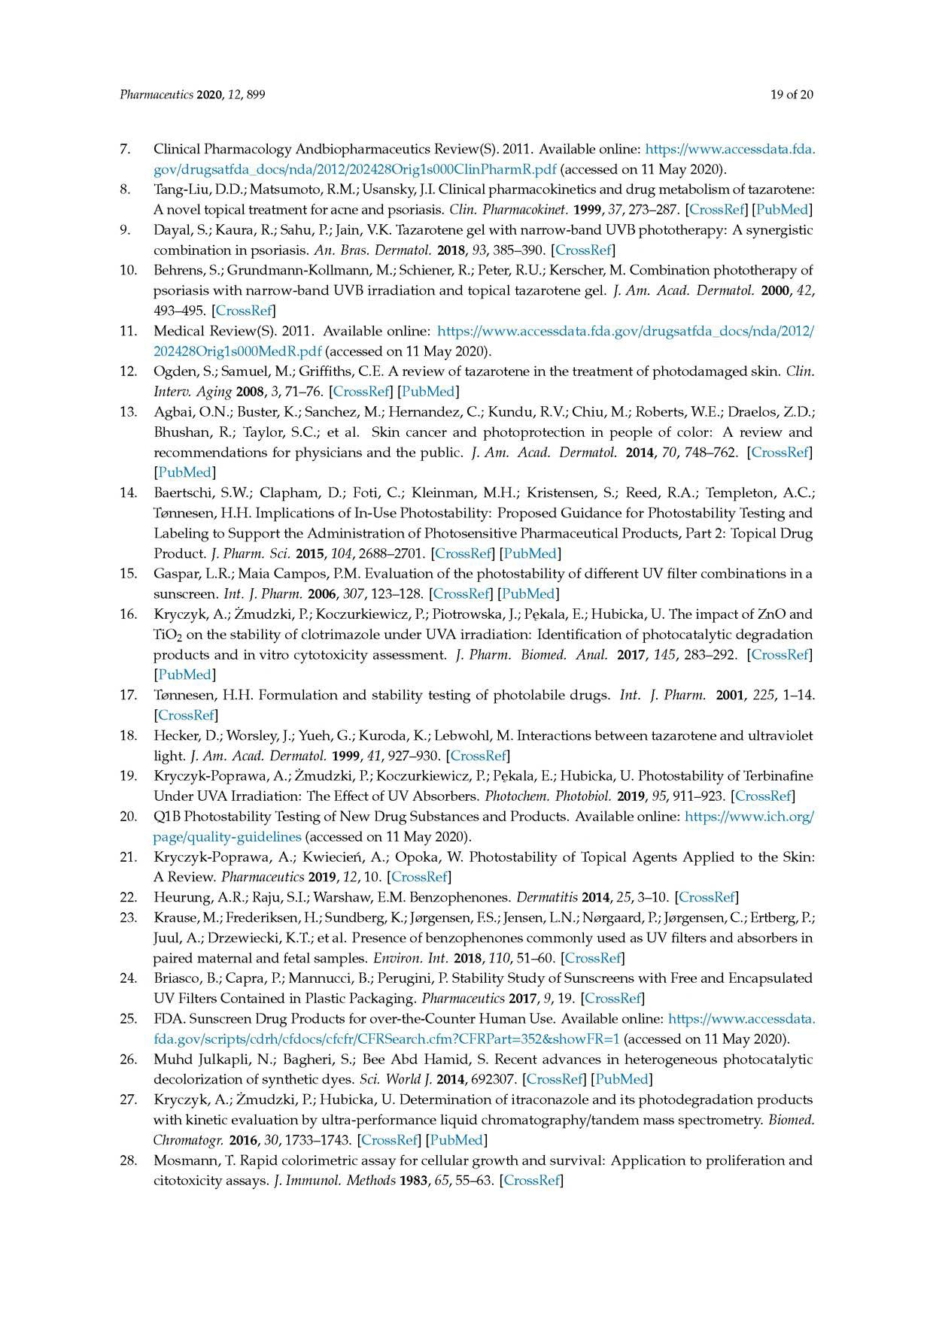

7. Clinical Pharmacology Andbiopharmaceutics Review(S). 2011. Available online: https://www.accessdata.fda. gov/drugsatfda_docs/nda/2012/202428Orig1s000ClinPharmR.pdf (accessed on 11 May 2020).
8 . Tang-Liu, D.D.; Matsumoto, R.M.; Usansky, J.I. Clinical pharmacokinetics and drug metabolism of tazarotene: A novel topical treatment for acne and psoriasis. Clin. Pharmacokinet. 1999, 37, 273-287. [CrossRef] [PubMed]
9. Dayal, S.; Kaura, R.; Sahu, P.; Jain, V.K. Tazarotene gel with narrow-band UVB phototherapy: A synergistic combination in psoriasis. An. Bras. Dermatol. 2018, 93, 385-390. [CrossRef]
10. Behrens, S.; Grundmann-Kollmann, M.; Schiener, R.; Peter, R.U.; Kerscher, M. Combination phototherapy of psoriasis with narrow-band UVB irradiation and topical tazarotene gel. J. Am. Acad. Dermatol. 2000, 42, 493-495. [CrossRef]
11. Medical Review(S). 2011. Available online: https://www.accessdata.fda.gov/drugsatfda_docs/nda/2012/ 202428Orig1s000MedR.pdf (accessed on 11 May 2020).
12. Ogden, S.; Samuel, M.; Griffiths, C.E. A review of tazarotene in the treatment of photodamaged skin. Clin. Interv. Aging 2008, 3, 71-76. [CrossRef] [PubMed]
13. Agbai, O.N.; Buster, K.; Sanchez, M.; Hernandez, C.; Kundu, R.V.; Chiu, M.; Roberts, W.E.; Draelos, Z.D.; Bhushan, R.; Taylor, S.C.; et al. Skin cancer and photoprotection in people of color: A review and recommendations for physicians and the public. J. Am. Acad. Dermatol. 2014, 70, 748-762. [CrossRef] [PubMed]
14. Baertschi, S.W.; Clapham, D.; Foti, C.; Kleinman, M.H.; Kristensen, S.; Reed, R.A.; Templeton, A.C.; T0 nnesen, H.H. Implications of In-Use Photostability: Proposed Guidance for Photostability Testing and Labeling to Support the Administration of Photosensitive Pharmaceutical Products, Part 2: Topical Drug Product. J. Pharm. Sci. 2015,104, 2688-2701. [CrossRef] [PubMed]
15. Gaspar, L.R.; Maia Campos, P.M. Evaluation of the photostability of different UV filter combinations in a sunscreen. Int. J. Pharm. 2006, 307 ,123-128. [CrossRef] [PubMed]
16. Kryczyk, A.; Zmudzki, P.; Koczurkiewicz, P.; Piotrowska, J.; Pekala, E.; Hubicka, U. The impact of ZnO and TiO2 on the stability of clotrimazole under UVA irradiation: Identification of photocatalytic degradation products and in vitro cytotoxicity assessment. J. Pharm. Biomed. Anal. 2017, 145, 283-292. [CrossRef] [PubMed]
17. T0 nnesen, H.H. Formulation and stability testing of photolabile drugs. Int. J. Pharm. 2001, 225, 1-14. [CrossRef]
18. Hecker, D.; Worsley, J.; Yueh, G.; Kuroda, K.; Lebwohl, M. Interactions between tazarotene and ultraviolet light. J. Am. Acad. Dermatol. 1999, 41, 927-930. [CrossRef]
19. Kryczyk-Poprawa, A.; Zmudzki, P.; Koczurkiewicz, P.; Pekala, E.; Hubicka, U. Photostability of Terbinafine Under UVA Irradiation: The Effect of UV Absorbers. Photochem. Photobiol. 2019, 95,911-923. [CrossRef]
20. Q1B Photostability Testing of New Drug Substances and Products. Available online: https://www.ich.org/ page/quality-guidelines (accessed on 11 May 2020).
21. Kryczyk-Poprawa, A.; Kwiecień, A.; Opoka, W. Photostability of Topical Agents Applied to the Skin: A Review. Pharmaceutics 2019,12 ,10. [CrossRef]
22. Heurung, A.R.; Raju, S.I.; Warshaw, E.M. Benzophenones. Dermatitis 2014,25, 3-10. [CrossRef]
23. Krause, M.; Frederiksen, H.; Sundberg, K.; Jurgensen, F.S.; Jensen, L.N.; Nurgaard, P.; Jurgensen, C.; Ertberg, P.; Juul, A.; Drzewiecki, K.T.; et al. Presence of benzophenones commonly used as UV filters and absorbers in paired maternal and fetal samples. Environ. Int. 2018,110, 51-60. [CrossRef]
24. Briasco, B.; Capra, P.; Mannucci, B.; Perugini, P. Stability Study of Sunscreens with Free and Encapsulated UV Filters Contained in Plastic Packaging. Pharmaceutics 2017, 9,19. [CrossRef]
25. FDA. Sunscreen Drug Products for over-the-Counter Human Use. Available online: https://www.accessdata. fda.gov/scripts/cdrh/cfdocs/cfcfr/CFRSearch.cfm?CFRPart=352&showFR=1 (accessed on 11 May 2020).
26. Muhd Julkapli, N.; Bagheri, S.; Bee Abd Hamid, S. Recent advances in heterogeneous photocatalytic decolorization of synthetic dyes. Sci. World J. 2014, 692307. [CrossRef] [PubMed]
27. Kryczyk, A.; Zmudzki, P.; Hubicka, U. Determination of itraconazole and its photodegradation products with kinetic evaluation by ultra-performance liquid chromatography/tandem mass spectrometry. Biomed. Chromatogr. 2016, 30,1733-1743. [CrossRef] [PubMed]
28. Mosmann, T. Rapid colorimetric assay for cellular growth and survival: Application to proliferation and citotoxicity assays. J. Immunol. Methods 1983, 65, 55-63. [CrossRef]
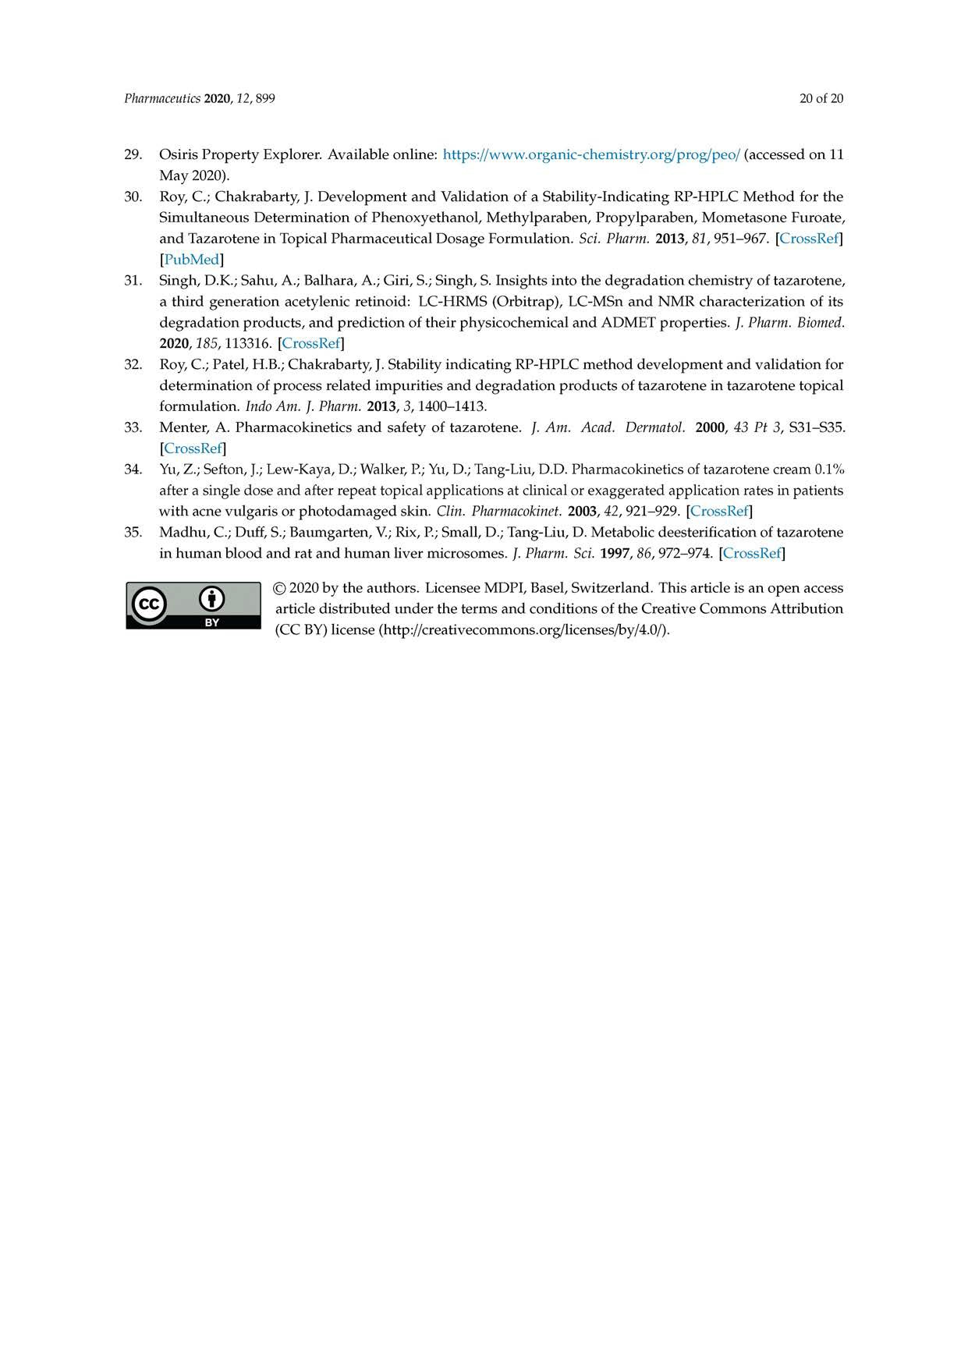

29. Osiris Property Explorer. Available online: https://www.organic-chemistry.org/prog/peo/ (accessed on 11 May 2020).
30. Roy, C.; Chakrabarty, J. Development and Validation of a Stability-Indicating RP-HPLC Method for the Simultaneous Determination of Phenoxyethanol, Methylparaben, Propylparaben, Mometasone Furoate, and Tazarotene in Topical Pharmaceutical Dosage Formulation. Sci. Pharm. 2013, 81, 951-967. [CrossRef] [PubMed]
31. Singh, D.K.; Sahu, A.; Balhara, A.; Giri, S.; Singh, S. Insights into the degradation chemistry of tazarotene, a third generation acetylenic retinoid: LC-HRMS (Orbitrap), LC-MSn and NMR characterization of its degradation products, and prediction of their physicochemical and ADMET properties. J. Pharm. Biomed. 2020,185 ,113316. [CrossRef]
32. Roy, C.; Patel, H.B.; Chakrabarty, J. Stability indicating RP-HPLC method development and validation for determination of process related impurities and degradation products of tazarotene in tazarotene topical formulation. Indo Am. J. Pharm. 2013, 3,1400-1413.
33. Menter, A. Pharmacokinetics and safety of tazarotene. J. Am. Acad. Dermatol. 2000, 43 Pt 3, S31-S35. [CrossRef]
34. Yu, Z.; Sefton, J.; Lew-Kaya, D.; Walker, P.; Yu, D.; Tang-Liu, D.D. Pharmacokinetics of tazarotene cream 0.1% after a single dose and after repeat topical applications at clinical or exaggerated application rates in patients with acne vulgaris or photodamaged skin. Clin. Pharmacokinet. 2003, 42, 921-929. [CrossRef]
35. Madhu, C.; Duff, S.; Baumgarten, V.; Rix, P.; Small, D.; Tang-Liu, D. Metabolic deesterification of tazarotene in human blood and rat and human liver microsomes. J. Pharm. Sci. 1997, 86, 972-974. [CrossRef]
© 2020 by the authors. Licensee MDPI, Basel, Switzerland. This article is an open access article distributed under the terms and conditions of the Creative Commons Attribution (CC BY) license (http://creativecommons.org/licenses/by/4.0/).

