Annales Societatis Geologorum Poloniae (2005), vol. 75: 155-169.

FACIES AND SEDIMENTARY ENVIRONMENTS OF THE UPPER
SCYTHIAN-CARNIAN SUCCESSION FROM THE BELANSKE
TATRY MTS., SLOVAKIA
Tomasz RYCHLIŃSKI & Joachim SZULC
Institute of Geological Sciences, Jagiellonian University, Oleandry 2a, 30-063 Krakow, Poland;
e-mail: rychlin@ing.uj.edu.pl, szulc@ing.uj.edu.pl
Rychliński, T. & Szulc, J., 2005. Facies and sedimentary environments of the Upper Scythian-Camian succession
from the Belanske Tatry Mts., Slovakia. Annales Societatis Geologorum Poloniae, 155-169.
Abstract: The Triassic Fatricum basin studied in the Belanske Tatry Mts. (Slovakia) was a relatively stable and
restricted platform area influenced by eustatic and climatic fluctuations. During the early Triassic the platform was
influenced by continental clastic sedimentation intermittent with shallow marine transgressions when carbonate
sediments formed. Common occurrence of carbonized plat debris suggests relatively humid climatic conditions
dominating during this interval (Werfenian facies). Significant climate aridisation was concurrent with the
beginning of the Middle Triassic transgression as indicated by evaporitic fabrics common within the entire Middle
Triassic carbonate succession. The Middle Triassic has been divided into several lithofacies complexes reflecting
the interplays between the eustatic and climatic fluctuations. The lower Middle Triassic complex (lower-middle
Anisian?) displays dominance of calcareous sediments indicating free communication with the open ocean. The
subsequent intervals are rather uniform facies assemblage composed by dolomites and evaporites formed in a
restricted and stagnant basin. The basin has been strongly influenced by subtropical storms, particularly common
in the late Anisian. Transgression pulse in the early Ladinian involved growth of microbial colonies building
thrombolitic biostromes. Final shallowing by the end of Ladinian led to replacement of carbonate sediments by
continental clastics of the Carpathian Keuper. These sediments, mostly of alluvial nature, comprise plant debris
what suggests climate pluvialisation in Carnian times.
Key words: facies, paleoenvironments, late Scythian-Carnian, Belanske Tatry Mts.
Manuscript received 27 July 2004, accepted 30 June 2005

INTRODUCTION
The Triassic rocks of the Belanske Tatry Mts. (Slova-
kia; Fig.1), represent sediments formed within the Fatricum
basin. These sediments are recently incorporated into the
Krfzna Nappe (Fig. 2). Triassic sedimentary facies, evolu-
tion of the basin and its controls are poorly recognized as-
pects of the basin history. The only exception is the Rhae-
tian where detailed paleontological and facies studies have
been done (Gaździcki, 1974; Gaździcki et al., 1979). The
section of the Belanske Tatry Mts. comprises some 100 m
thick profile of the late Scythian and less than 400 m thick
succession of the Middle Triassic. Definite thickness of the
Carnian succession is uncertain but exceeds 50 m.
Scarcity of index fossils hinders precise stratigraphic
division of the succession. The only attempt of stratigraphi-
cal division was done by Kotański (1958) who divided the
Middle Triassic into the Anisian stage that comprises dado-
crinids and the Ladinian stage with Encrinus sp.
The present paper focuses on sedimentological charac-
teristics and facies analysis of the Triassic succession from
the upper Lower Triassic to lower Upper Triassic (“Carpa-
thian Keuper”). This succession corresponds approximately
to the late Scythian-Carnian interval. The inferring recon-
struction of the basin evolution should give rise for future
refining of chronostratigraphic resolution by means of se-
quence stratigraphy.

GOALS AND METHODS
A composite measured section has been done for the
study area. Particular sedimentological field works (Rych-
liński, 2001) encompassed southern slopes of the Hlupy
(Szalony Wierch; Fig. 3) and Zdiarska Vidla Mt. (Płaczliwa
Skała), belonging to the Havran unit. The sedimentological
study have been supplemented by the microfacies and stable
isotopes examination. The values of S¹³C and S¹⁸O were
measured with the mass spectrometre SUMY, at the Insti-
tute of Geological Sciences, National Academy of Sciences
of Belarus at Minsk. The samples were treated with 100%
orthophosphoric acid, next carbon dioxide was collected in
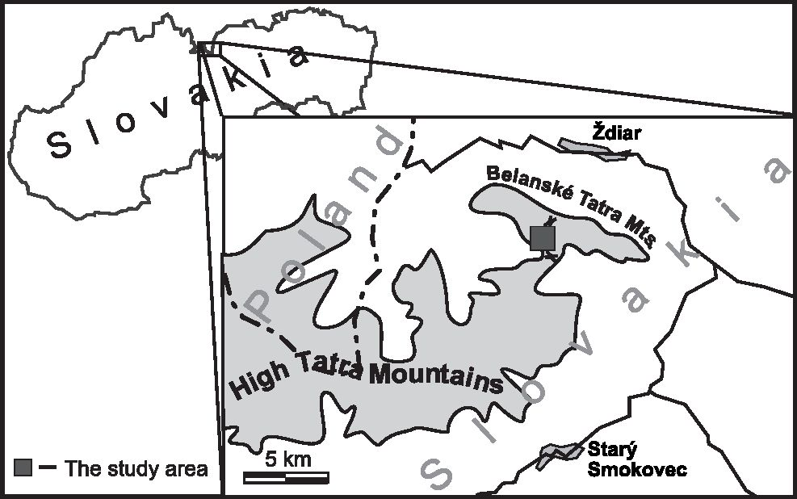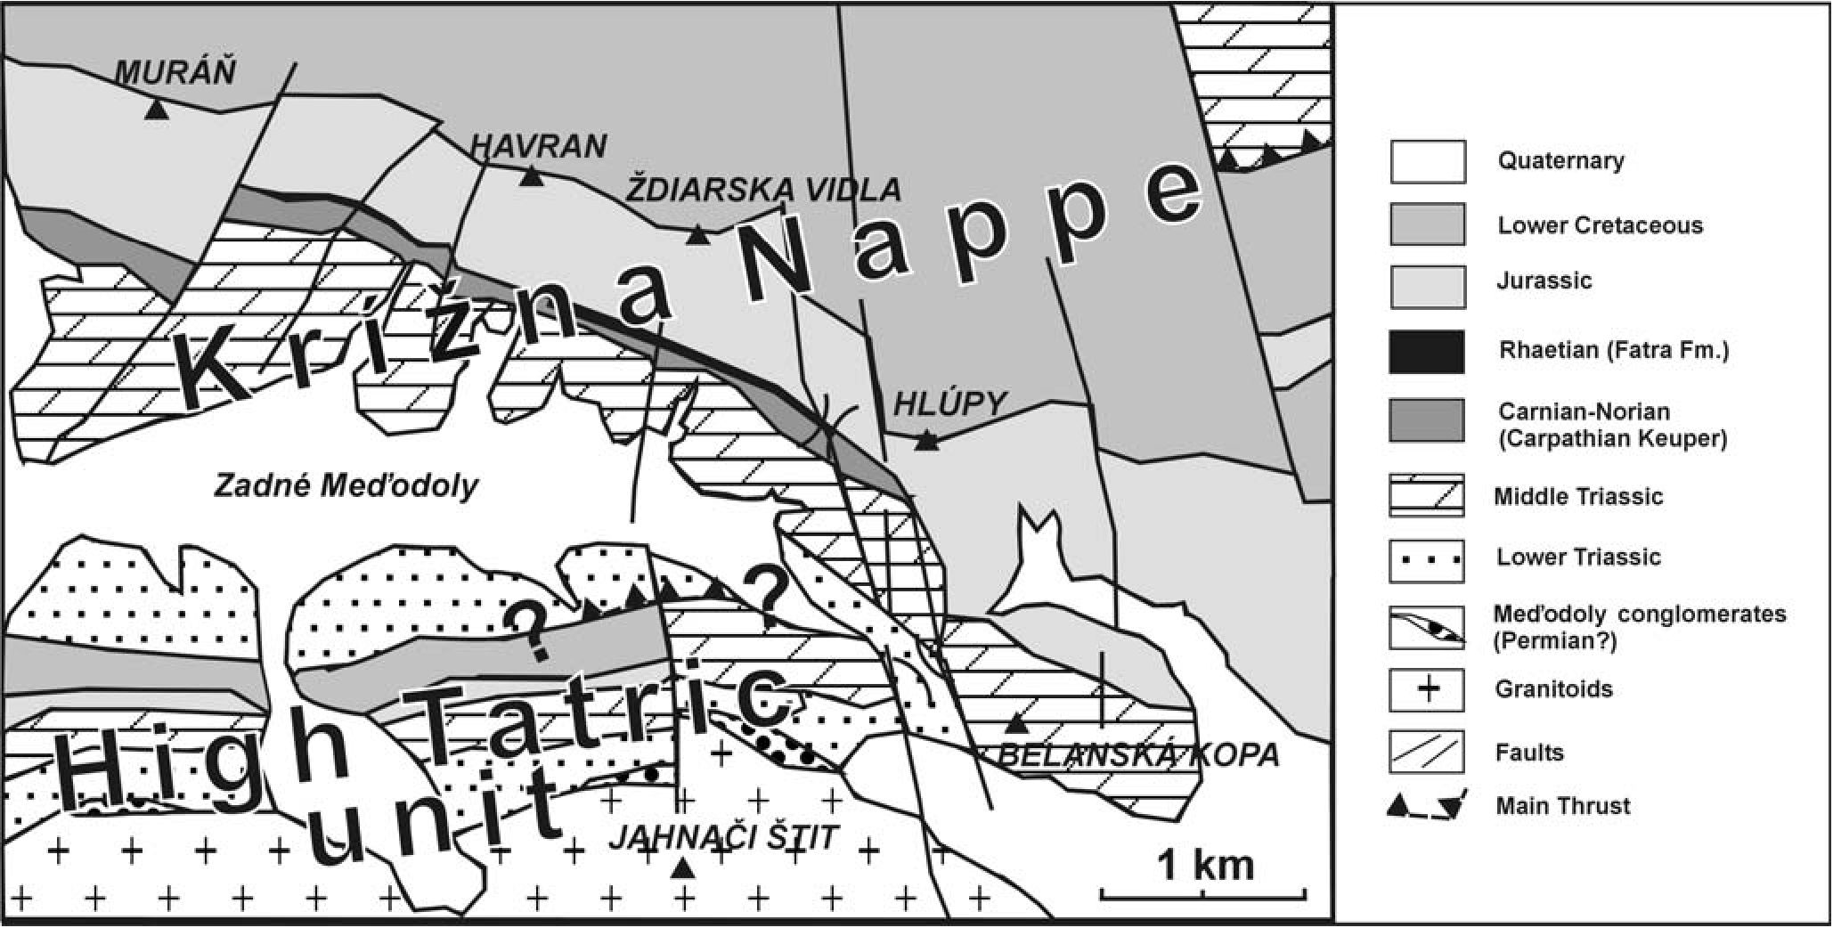
156
T. RYCHLIŃSKI & J. SZULC

Fig. 1. The location of the studied section
a trap with liquid nitrogen and purified in vacuum. An error
of measurement was about ±0.2%o. In the paper all the stable
isotopes ratios in carbonate samples are presented with ref-
erence to the PDB standard.
Because of the poor knowledge about sedimentary en-
vironments of the middle Triassic from the Havran unit the
main goal of our paper is reconstruction of the sedimentary
environments and basin conditions as well as theirs influ-
ences on the facies development during late Scythian-Car-
nian times. Finally we compare the Fatricum basin with
other Triassic basins from the Western Tethys domain.

GEOLOGICAL SETTING
AND STRATIGRAPHICAL UNITS
Sedimentary series in the Tatra Mts. represent generally
two different types of tectonic components. The first one -
Wierchowa unit (so called autochthonous series) lying di-
rectly on the crystalline basement, built of Paleozoic igne-
ous and metamorphic rocks. The second one is composed of
several nappes, which represent Tethys palinspastic units
(Haas et al., 1995; Rakus et al., 1998) and cover the auto-
chthonous series. In the Tatra Mts. have been distinguished:
the lowermost - KriZna Nappe which represents palinspas-
tic Fatricum unit, the middle - Choc Nappe that corresponds
to the Hronicum, and the uppermost - StraZov Nappe (as
suggest Kotański, 1979) that corresponds to the Silicicum.
The described section belongs to the KriZna Nappe. The
basic geological and tectonic outline of the Belanske Tatra
Mts. has been presented by Andrusov (1936, 1959) and by
Sokołowski (1948). Their tectonic observations has been re-
cently completed by Lefeld (1999). According to Lefeld
(1999) the KriZna unit in the Belanske Tatry Mts. has been
divided into three tectonic units. The lower one, Subtatric
partial nappe, corresponds to the Suchy Wierch unit of the
Zakopane Subtatric area and is better exposed in the western
part of the Belanske Tatry Mts. The middle one - the
Havran partial nappe (Sokołowski, 1948) - builds the south-
ern slopes and main ridge of the Belanske Tatry Mts.,
whereas the higher one - the Bujaci (Bujaczy) partial nappe
- builds the northern slopes. The petrographical study of the
Belanske Tatry Mts. done by Borza (1958, 1959) concerned
mainly the continental clastics of the Lower and Upper Tri-
assic and younger sediments. Some microfacies data for the
Triassic carbonates of the Havran partial nappe have been
discussed by Misik (1972).
We use the stratigraphical nomenclature for Triassic of
the Belanske Tatry Mts introduced by Mello and Wieczorek
(1993a) and Michalik (1997a). The oldest Triassic sedi-
ments of the studied area are quartzite sandstones, which
have been defined as LuZna Formation. According to
Sokołowski (1948) and Kotański (1958) it belongs to Sei-

Fig. 2. Geological sketch of the study area (after Michalik et al., 1997, simplified)
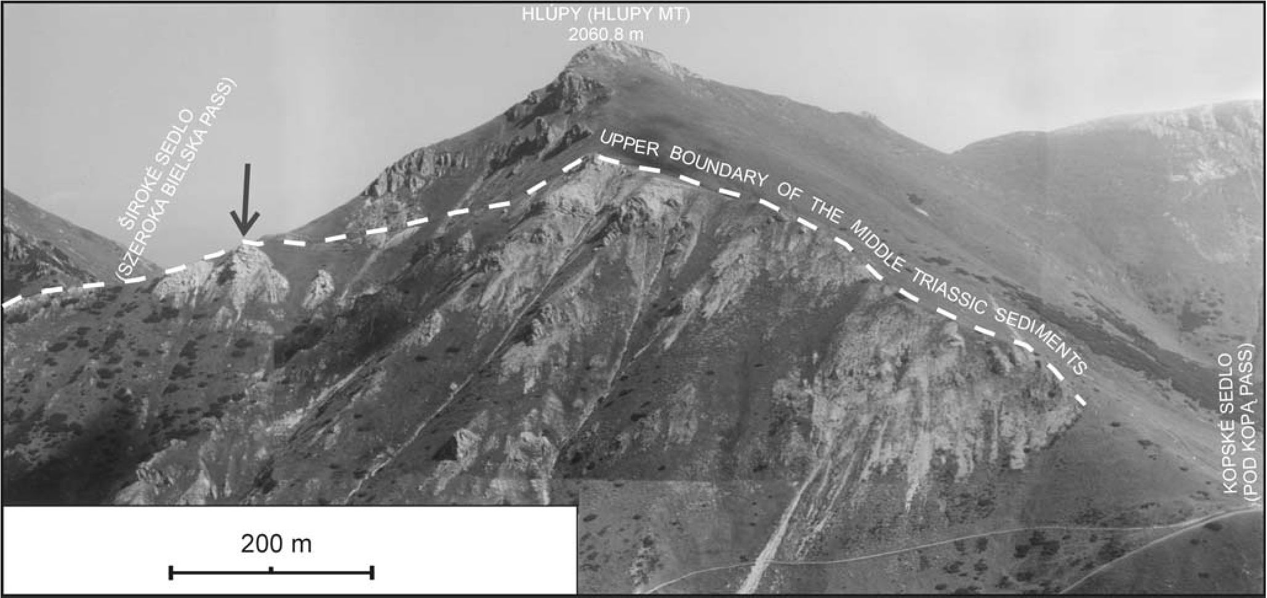
UPPER SCYTHIAN-CARNIAN SUCCESSION, TATRA MTS.
157

Fig. 3. View of the Middle Triassic section of the Hlupy Mt. Arrow indicates karst site presented in Fig. 12A, B
sian of the Havran Unit, but it may be a part of the lower-
most tectonical units as proposed by Lefeld (1999). How-
ever the latter suggested also, that within the Havran - Jah-
naci (Jagnięcy) elevation only the Havran unit is more or
less preserved (cf. Fig. 2). The overlying mixed clastic-
carbonates sediments with rauhwackes belong to Sunava
Formation. In the Polish Tatra Mts. the rauhwacke carbon-
ates have been described as informal Myophoria beds (Ko-
tański, 1963). The Middle Triassic carbonates have been di-
vided into Gutenstein Formation (including dolomites and
limestones of Anisian age) and Ramsau Formation that in-
cludes light grey dolomites of the Upper Anisian-Ladinian
(and Carnian?) age (Plasienka et al., 1997). The Upper Tri-
assic of the study area called Carpathian Keuper (Carnian
and Norian) is dominated by shales and sandstones with in-
tercalations of dolomites. The uppermost Triassic (Fatra
Formation - Michalik & Jendrejakova, 1978) is built mainly
of limestones with benthic fauna (Gaździcki, 1971, 1974).

DESCRIPTION OF THE SECTION
Lower Triassic
The studied section begins with yellow cavernous dolo-
mites (rauhwackes) directly covered by greenish quartzite
sandstones. The sandstones are replaced by variegated mud-
stones and yellow dolomitic marls rich in carbonized or-
ganic matter (Fig. 4C). The next sequence begins again with
cross-stratified, fluvial sandstones with variegated mud-
stones (Fig. 4A) that are followed by dark-coloured bitumi-
nous limestones and dolomites (Fig. 4B). Clasts of these
limestones and dolomites along with flakes of mudstones
occur within the overlying, poorly outcropped cavernous
horizon (Fig. 4D).
The subsequent sediments are fine-grained dolomites
and limestones, comprising sulphate pseudomorphs. Upsec-
tion the pseudomorphs disappear and the carbonates be-
come coarser-grained. Kotański (1958) called these sedi-
ments as “Myophoria beds” and ascribed them to the
Campilian, that is to the late Scythian. Thickness of the
Lower Triassic series reaches ca. 80 m.
Middle Triassic
Scarcity of fossils, in particular the index ones, makes
the stratigraphic resolution of the Middle Triassic very
vague. The only fossils of stratigraphic significance are rare
crinoids reported by Kotański (1958). Considering however
modern taxonomy of crinoids, this determination seems to
be uncertain. The above discussed, recently introduced for-
mal units (Mello & Wieczorek, 1993a; Michalik, 1997a) are
lacking precisely defined boundaries. Therefore we have
tentatively divided the Middle Triassic succession into sedi-
mentary complexes after their outstanding sedimentary fea-
tures, which reflect most pronounced changes in sedimen-
tary environments during the Middle Triassic. The supposed
age is ascribed after the mentioned crinoids and by way of
comparing of the section with other, better resolved Triassic
sections of the Fatricum basin.
Limestone Complex (Lower Anisian)
The dolomitic “Myophoria beds” grade into dololutites
pierced by internal breccias. The following deposits are cal-
carenites intercalated with grey bioturbated calcilutites
(“Wursterkalke", “vermicular limestones”). The calcare-
nites that display thinning and fining upward trend are re-
placed by light coloured dolomites including sulphate pseu-
domorphs (Fig. 5B-D). After the evaporitic episode the cal-
careous deposition reestablished. The limestones show de-
formations evidently related to contemporaneous tectonic
activity: synsedimentary faults (up to several centimetres;
Fig. 6C) and slumps (Rychliński, 2004). The calcarenites
comprise bivalve and gastropod shell debris (Fig. 7A-D)
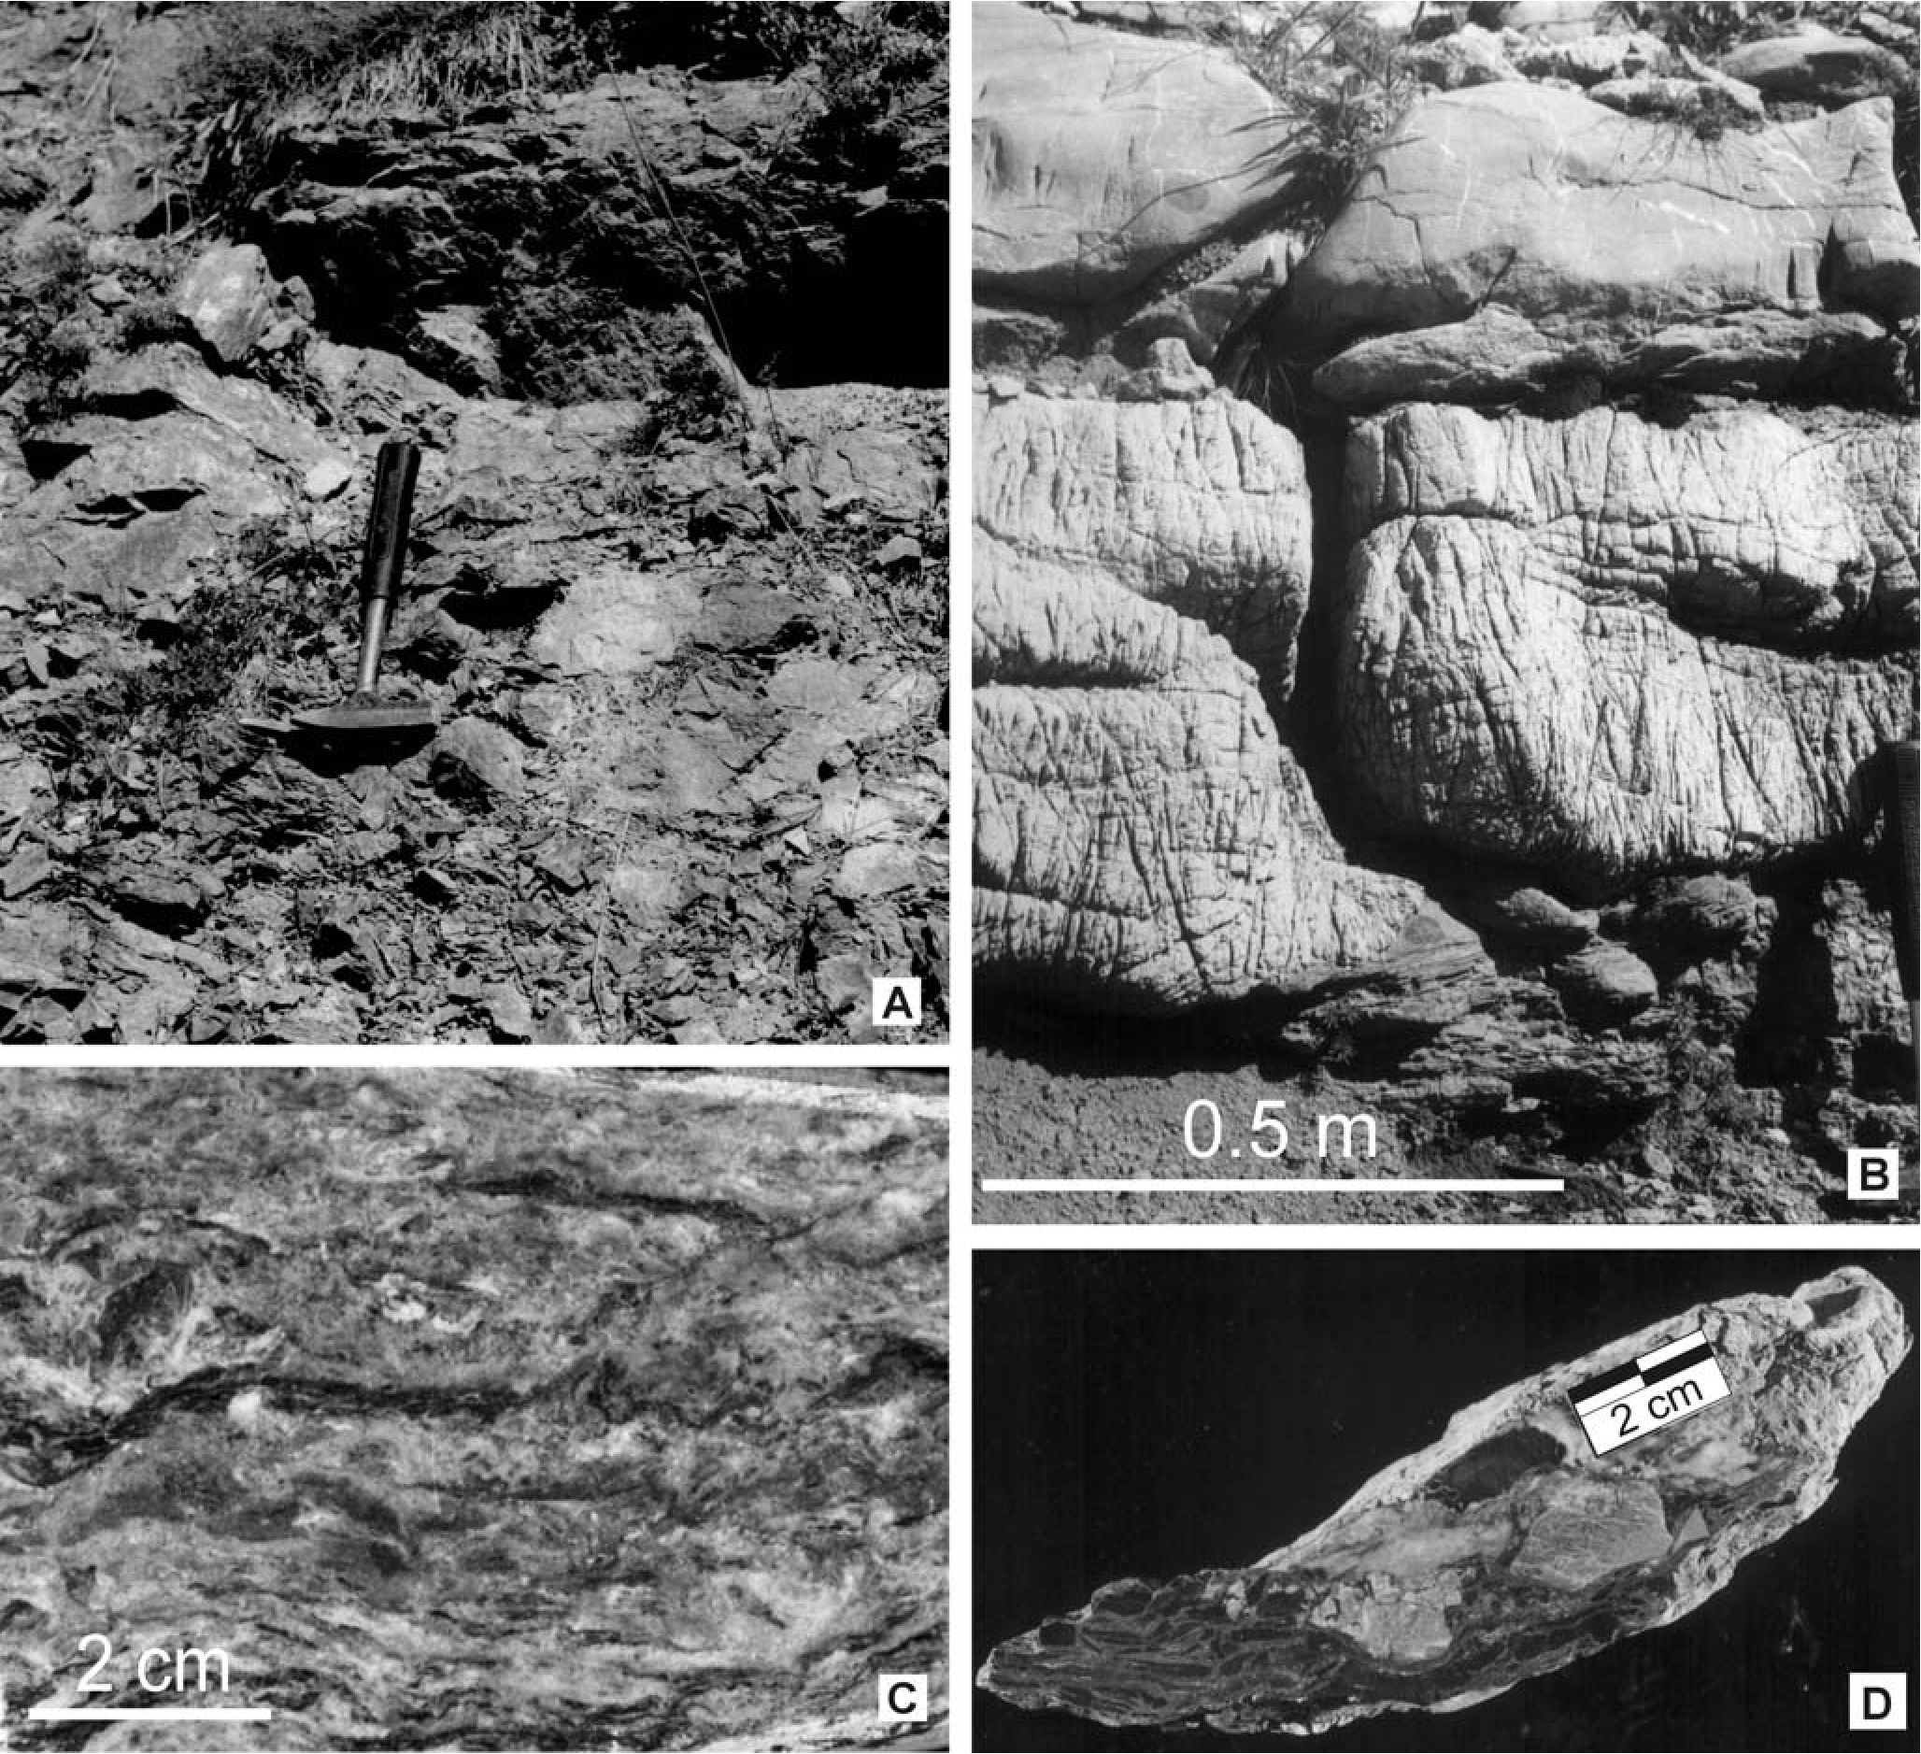
158
T. RYCHLIŃSKI & J. SZULC

Fig. 4. Lower Triassic sediments. A - Red sandstones and brecciated variegated mudstones of the Upper Scythian; B - Limestones and
dolomites of the uppermost Scythian (“Myophoria beds”); C - Yellow bituminous-rich limestones, Upper Scythian; D - Intraformational
limestone breccia, Upper Scythian
and display flat and cross stratification (Fig. 8A, B). In the
upper part of the sequence one may observe cherts that fill
the bioturbations (Fig. 5A). According to dadocrinid rem-
nants found in these sediments Kotański (1958) has dated
them as lower Anisian. Thickness of the Lower Anisian suc-
cession reaches 80 m.
Tempestite Complex (Upper Anisian ?)
This interval is dominated by grey dolarenites alter-
nated with dark dololutites. Most of the coarser grained beds
display features of storm reworking (e.g., hummocky cross
stratification (HCS), intraclasts, erosional scours). The do-
larenites display also synsedimentary cracks that are healed
with fine-grained sediments (Fig. 6A, B, D). The dololutitic
beds comprise sulphate pseudomorphs and solution brec-
cias.
Part of the section is poorly outcropped however one
may observe that proportion of the sulphate-bearing dolo-
mites increases upsection, and these dolomites are accom-
panied by thin intercalations of dolomitic shales. Thickness
of the interval is ca. 140 m.
Microbialite Complex (Lower Ladinian ?)
The exact position of the boundary between the Anisian
and Ladinian is uncertain and we assume it just below the
onset of the obviously shallower facies assemblage evi-
denced by stromatolites, desiccation cracks and substantial
contribution of dolomitic shales, as in other Fatric sections
(see e.g., Szulc et al., 2004). The Lower Ladinian complex
begins with light-coloured thin to medium bedded dololu-
tites overlain by darker dolomites including sulphate pseu-
domorphs and interlayered with bioclastic tempestites (Fig.
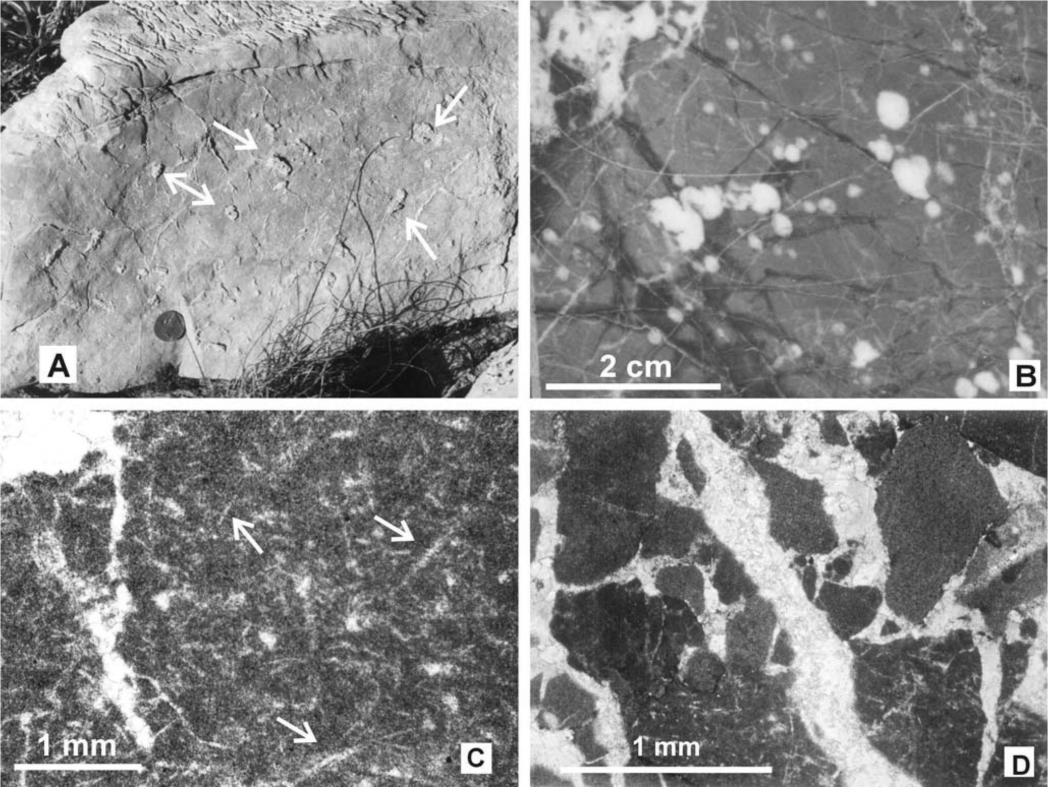
UPPER SCYTHIAN-CARNIAN SUCCESSION, TATRA MTS.
159

Fig. 5. Evaporites and postevaporitic collapse breccia fabrics. A - Calcilutites with cherts (arrows) that follow bioturbations. Limestone
Complex, Lower Anisian, coin 10 mm across; B - Cracked dololutites with sulphate pseudomorphs, Limestone Complex, Lower Anisian;
C - Halite pseudomorphs (“hoppers” - arrows) in dolomicrite, Microbialite Complex, Lower Ladinian; D - Dark grey dolosiltites with
collapse breccias, Limestone Complex, Lower Anisian
7F). They grade to the first tepee complex (Fig. 9A, B) and
then into an assemblage of shales and dolomite beds that
may reach up to 2 m in thickness. Thin dolomite beds com-
prise microbial mats with small spongean colonies (Fig.
10A-C). Such a sponge-microbial assemblages have been
found so far in other parts of the Western Tethys domain
(Szulc, 1997) and they are believed to represent a lilliputian
metazoan-bacterial buildups, enabling survive and recovery
of the regular sponge buildups after P/T crisis (Szulc, 2003).
The upper part of the Lower Ladinian series is built by
7m- thick complex of medium bedded thrombolitic dolo-
mites comprising pelecypods and encrusting foraminiferas
(Fig. 10D). The thrombolitic layers are intermittently de-
graded by storm events (Fig. 8E). The Lower Ladinian suc-
cession is 90 m thick.
Tepee Complex (Upper Ladinian)
The lower part of the Upper Ladinian series is com-
posed of three shallowing upward sequences composed of
thick-bedded, sulphate-bearing dolomites that grade into
thin bedded dolomites with tepee structures and shales (Figs
7E, G, H, 8C, D). This cyclic sequence is succeeded by stro-
matolitic complex (Fig. 11A, B). The uppermost part of the
Ladinian succession is composed by brecciated dololutites
rich in silicified sulphate pseudomorphs. The top of the Lad-
inian dolomites is featured by common pedogenic fabrics
and paleokarst phenomena (Fig. 12A-F; Rychliński &
Jaglarz, 2004). Total thickness of the Upper Ladinian suc-
cession is 60 m.
Upper Triassic
The karstified top surface of the Ladinian series dolo-
mites is covered by the Upper Triassic yellowish mudstones
that penetrate also the karstic cavities (Fig. 12B). Upsection
the mudstones are interlayered with coarse-grained sand-
stones and conglomerates and their color changes to red-
dish. The upper part of the Carpathian Keuper is dominated
by dolomitic mudstones that gave way to normal marine,
fossil rich limestones of the Rhaetian. Thickness of the Up-
per Triassic succession exceeds 50 m.
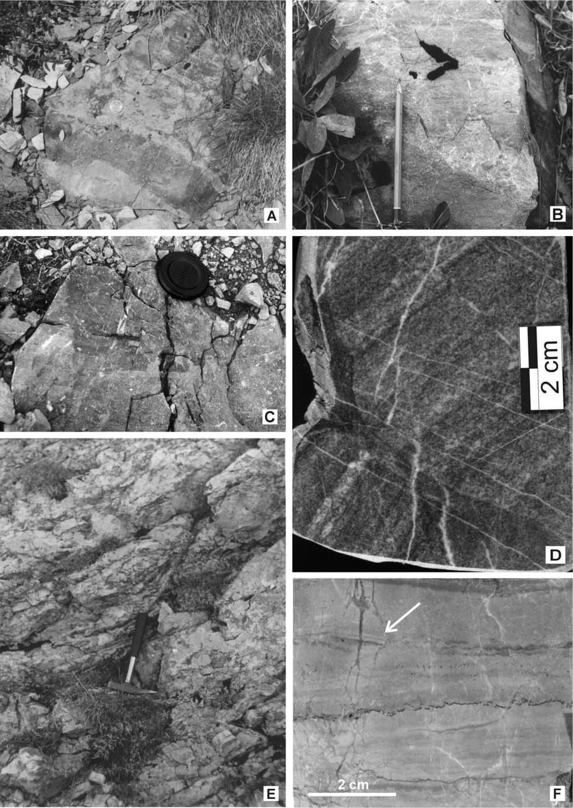
160
T. RYCHLIŃSKI & J. SZULC

Fig. 6. Synsedimentary faults related to Triassic tectonic activity in the Fatricum basin. A, B - Tempestite Complex, Upper Anisian,
coin in A 10 mm across; C - Limestone Complex, Lower Anisian, (camera cap for scale); D - Tempestite Complex, Upper Anisian, note
the rotation of dolarenitic blocks; E - Microbialite Complex, Lower Ladinian; F - small scale faults (arrow) in dololutites, Tepee Com-
plex, Upper Ladinian
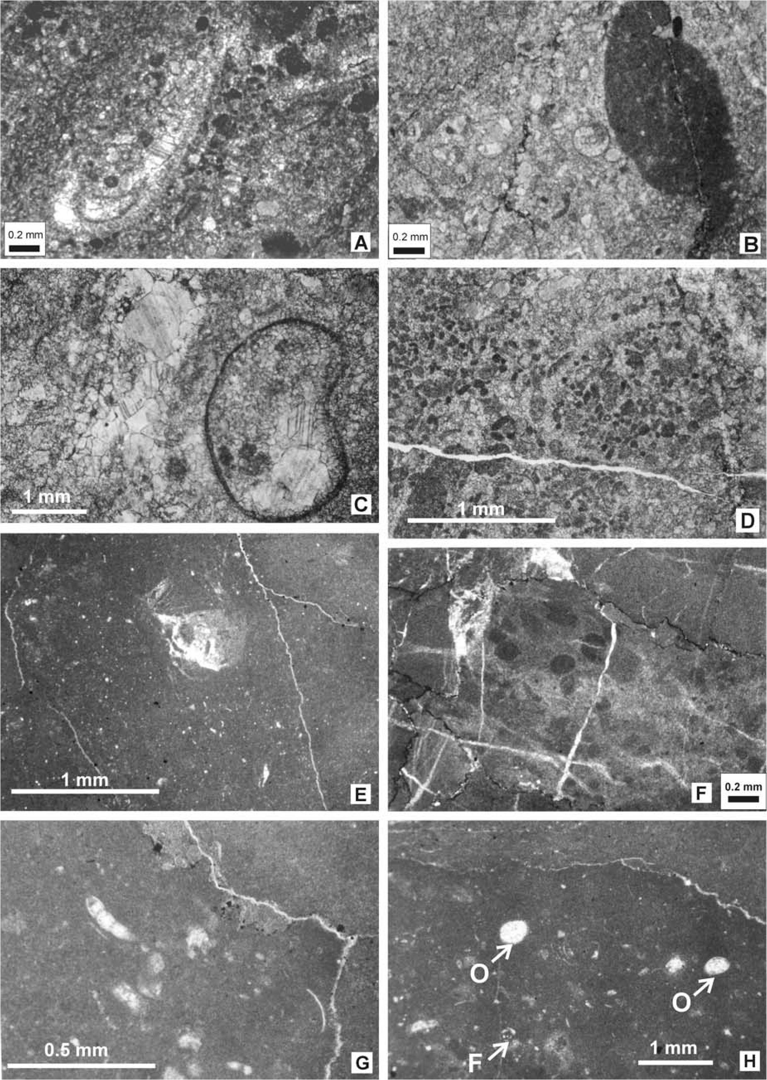
UPPER SCYTHIAN-CARNIAN SUCCESSION, TATRA MTS.
161

Fig. 7. Chosen microfacies aspects of the Middle Triassic carbonates. A - Biopelsparitic limestones with pelecypod dissolved shell,
Limestone Complex, Lower Anisian; B - Biosparitic limestones with pelecypod and gastropod shells, Limestone Complex, Lower Ani-
sian; C - Biopelsparitic limestones with ostracod shell, Limestone Complex, Lower Anisian; D - Pelsparitic limestones, Limestone Com-
plex, Lower Anisian; E - Bioturbated dolomictrite, Tepee Complex, Upper Ladinian; F - Dolomicrite with fecal pellets of crabs,
Microbialite Complex, Lower Ladinian; G - Dolomicrite with foraminifera and thin shelled pelecypods, Tepee Complex, Upper Ladinian;
H - Dolomicrite with ostracods (O) and foraminifera (F), Tepee Complex, Upper Ladinian
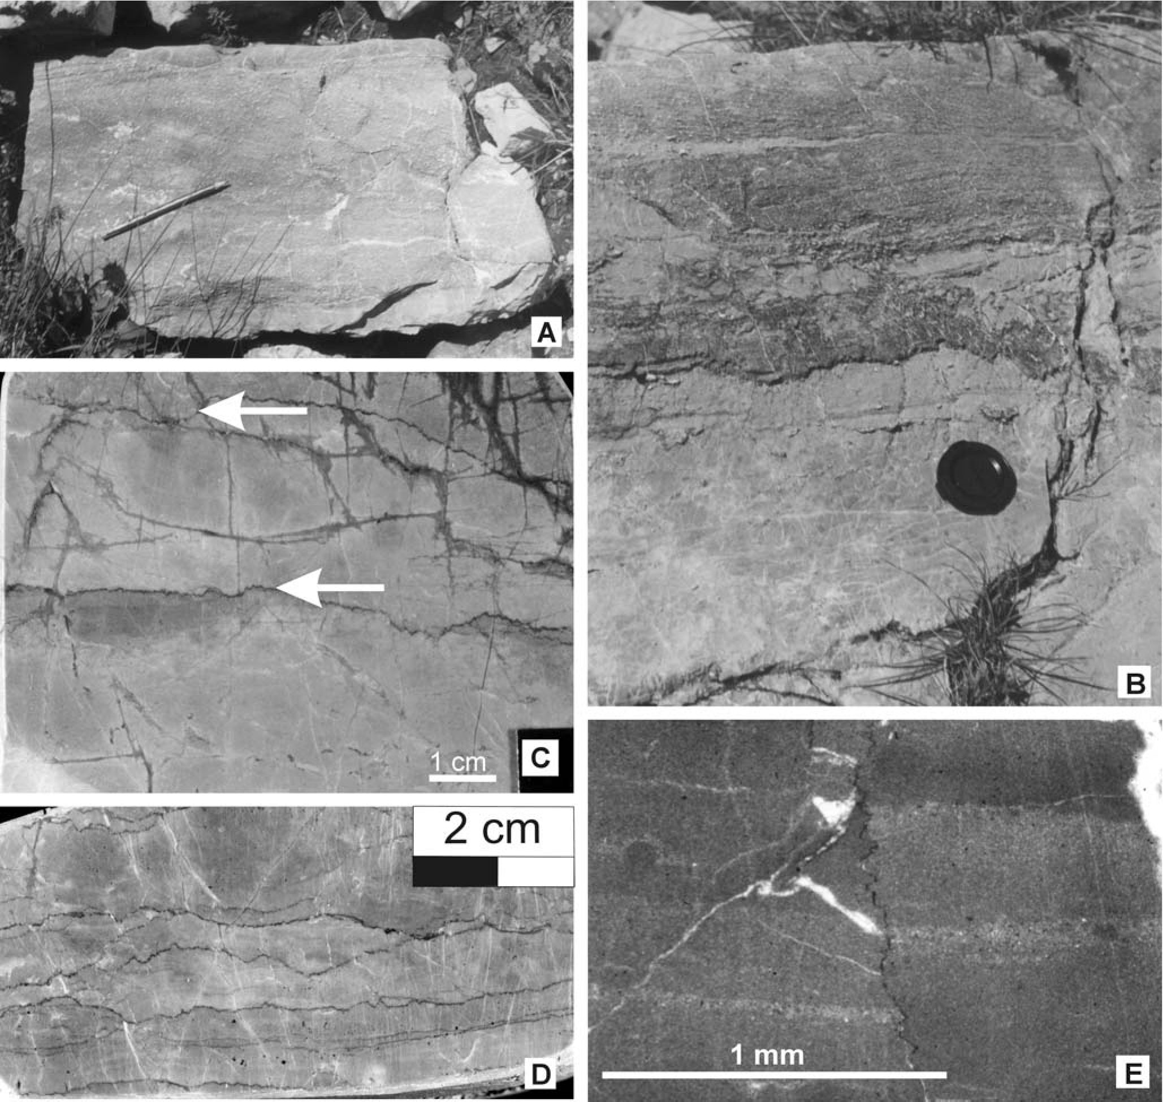
162
T. RYCHLIŃSKI & J. SZULC

Fig. 8. Chosen sedimentary structures typical for the Middle Triassic carbonates of the Belanske Tatry Mts. A - HCS calcarenites with
intraclasts (pencil 15 cm long), Tempestite Complex, Upper Anisian; B - Vermicular limestones covered by tempestitic, partly amalga-
mated calcarenites (camera cap for scale), Tempestite Complex, Upper Anisian; C - Dololutites with small scale tempestite deposits
marked by stylolites (arrows), Tepee Complex, Upper Ladinian; D - Stylolitised hummocky cross stratified dololutites, Tepee Complex,
Upper Ladinian; E - Microtempestites in dolomicrite, Microbialite Complex, Lower Ladinian

INTERPRETATION
The Lower Triassic section is composed of three up-
ward-deepening cycles. Two of them started with fluvial
sandstones, the third one begun with rauhwackes. We inter-
pret these cycles as result of eustatic 3rd order fluctuations.
Considering significant proportion of carbonized plant de-
bris both in fluvial clastics and in marine carbonates (cf. Fig.
4C), one may assume a relatively humid palaeoclimate dur-
ing this time. Nonetheless, the presence of evaporitic fabrics
in the succession indicates general subtropical paleoposition
of the Fatricum basin in early Triassic times. It is worthy to
note a very fast progress of the second transgression as one
may infer from the direct replacement of the fluvial sand-
stones by marine limestones.
The Lower Anisian succession consists of two
upward-shallowing cycles. The limestones formed in shal-
low but normal marine waters as indicated by fauna rem-
nants (Fig. 7A-C) and common bioturbations (Fig. 5A).
Episodic storm events ameliorated oxic conditions in the
basin. The thin-bedded dark coloured dolomites, overlying
the limestones, mark the periods of stagnation and shallow-
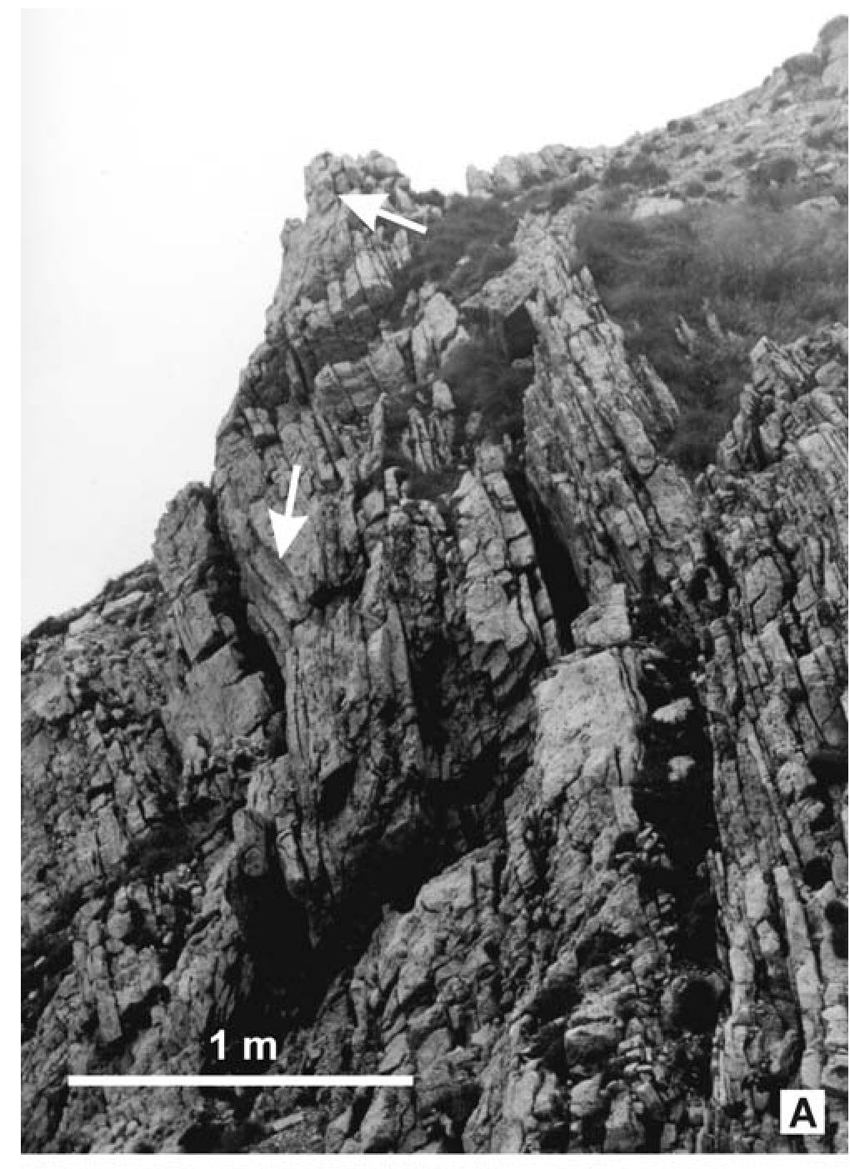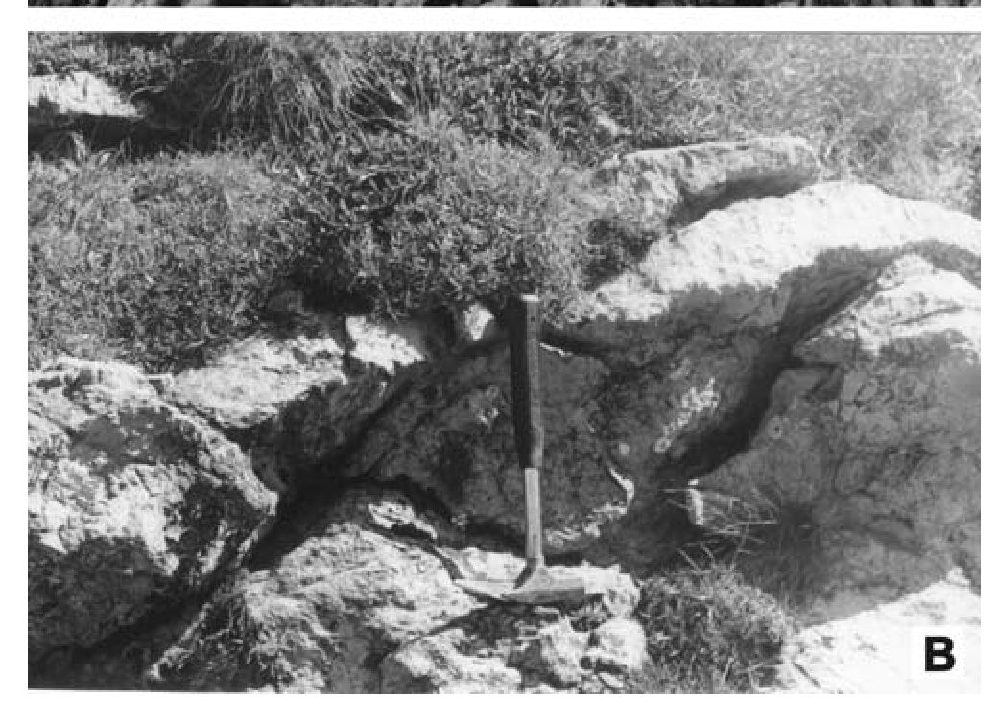
UPPER SCYTHIAN-CARNIAN SUCCESSION, TATRA MTS.
163
ing of the basin up to the phase when the evaporated brine
was concentrated enough to involve early diagenetic dolo-
mitisation of the ambient limestones.
The Upper Anisian carbonate sedimentation progressed
under stabilized shallow water conditions. Periods of re-
stricted circulation are recorded by dololutite packages with
sulphate pseudomorphs. Growing contribution of the evap-
oritic facies and appearance of shale intercalations indicate
gradual shallowing of the basin by the end of Anisian.
A very pronounced contribution of sedimentary fabrics
related to storm activity indicates that during this time the
basin was situated within the pathway of the subtropical cy-
clones.
Next transgressive pulse opens the Ladinian succession
that starts with bioclastic coarse grained carbonates, dis-
playing still features of storm activity. This transgression
halted soon as indicated by tepee complex overlying the
high energy deposits. After the emersion, that resulted in
origin of tepee structures (Fig. 9), the next ingression led to
origin of thrombolitic fabrics forming biostromal horizons
(cf. Fig. 10D).
The Upper Ladinian succession is composed of
cyclically-arranged extremely shallow-water facies ranging
from evaporite-rich dolomite to supralittoral deposits with
tepee and pedogenic fabrics. The final emersion is recorded
by a pronounced karst surface (Fig. 12) featuring the top of
the Ladinian dolomites.
The Upper Triassic succession is dominated by conti-
nental variegated mudstones and sandstones formed upon
peneplanized mudflat-sandflat area (Rychliński & Szulc,
2004). The final Triassic transgression began with dolo-
mites and climaxed with open marine, bioclastic limestones
of the Rhaetian.

GEOCHEMICAL INDICATORS
OF THE BASIN EVOLUTION
Stable isotopes signals of S¹³C and S¹⁸O values meas-
ured from the uppermost Scythian to Ladinian, enabled a
more refined reconstruction of basin evolution in terms of
the complex interplays of marine vs. meteoric water influx
and the evaporation effect. Therefore it is necessary to refer
and interpret the stable isotopes to the general paleoenviron-
mental context.
Considering the studied profile one may find that the in-
cursions of normal marine water as evidenced by the onset
of calcareous deposition and the appearance of benthic
fauna are coincidental with negative shifts of S¹³C values
(cf. samples 17, 21, 25; Fig. 13). By way of contrast the
positive excursions of S¹³C values are linked to evaporite-
rich dolomites. This indicates the evaporation as a main fac-
tor controlling isotopes fractionation within the Fatricum
basin in Triassic times. The situation changed only during
late Ladinian (Tepee Complex, samples 8, 4 to 1) when the
subaerially-exposed marine carbonate sediments underwent
pronounced influence of the early meteoric diagenesis ap-
parently recorded in negative shift of both isotopes. The
S¹⁸O trend in the Ladinian goes in hand with growing con-
tribution of evaporite pseudomorphs (cf. Fig. 5C).

COMPARISON OF THE FATRICUM
BASIN WITH OTHER TETHYAN
TRIASSIC BASINS
During the Early Triassic and early Middle Triassic Fa-
tricum basin was a part of the large carbonate ramp, situated
on the southern shelf of the Palaeo-Europe (Fig. 14;
Michalik, 1993, 1994; Rüffer & Zühlke, 1995). The ramp
became a carbonate platform during the Ladinian. Therefore
there are some similarities between the Fatricum and other
Tethys carbonate platforms.
The Lower Triassic succession of the Fatricum basin
displays a very close similarity to the eastern part of the
Fig. 9. A, B - Tepee deformations (arrows) from the Lower
Ladinian

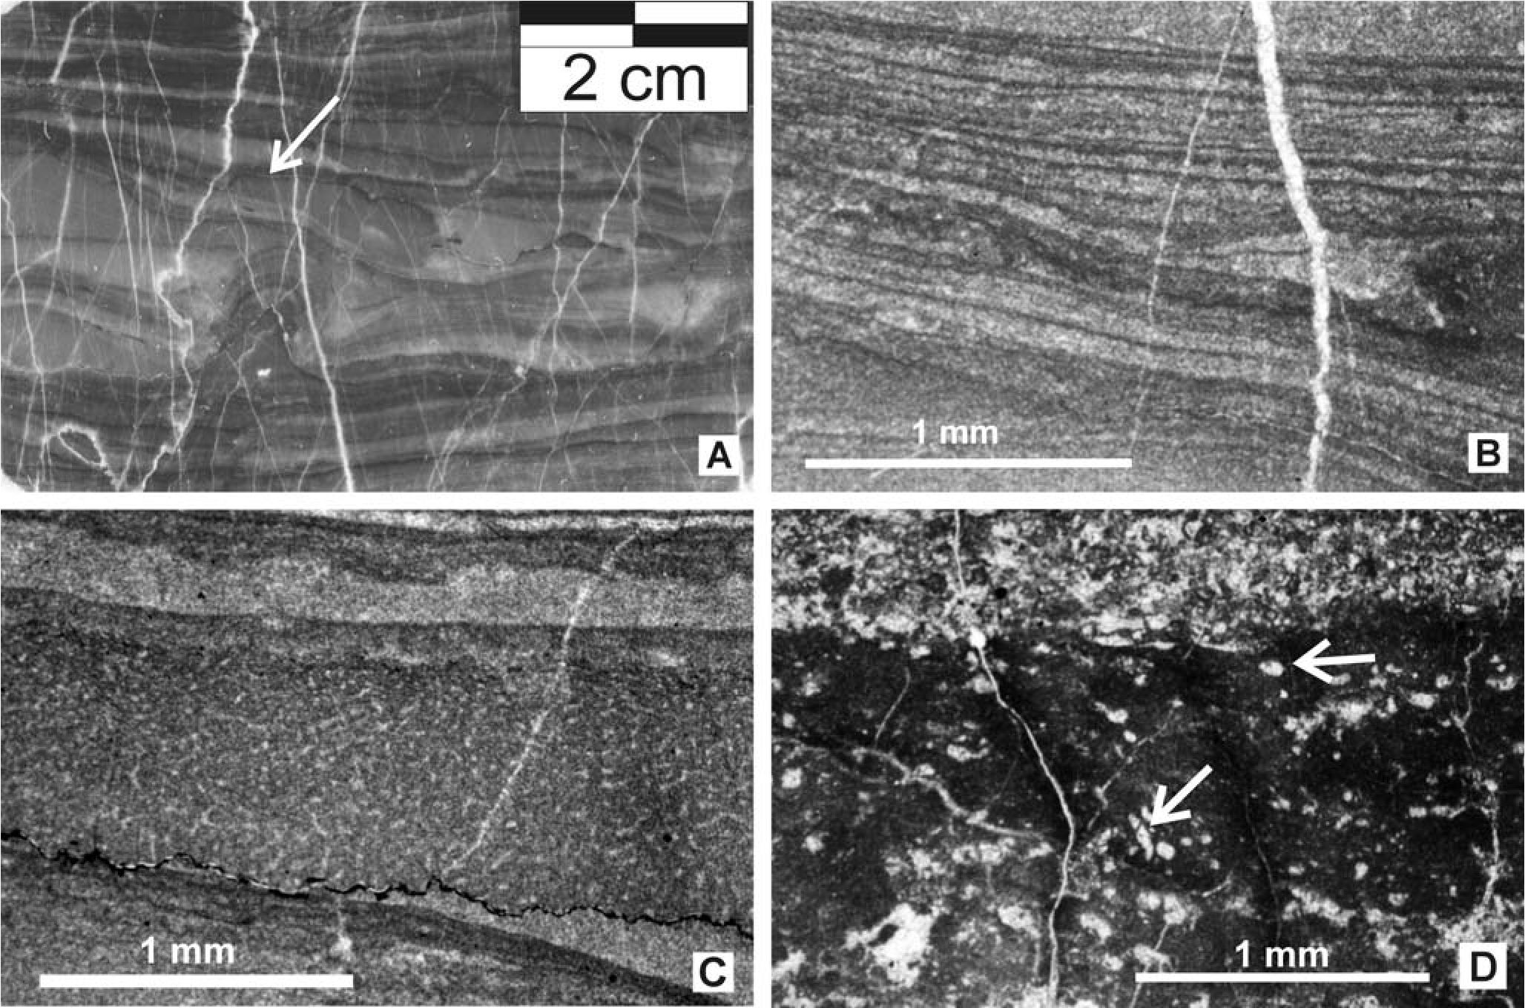
164
T. RYCHLIŃSKI & J. SZULC

Fig. 10. Microbial and sponge fabrics (Microbialite Complex, Lower Ladinian). A - Sponge-microbial colony (arrow) within micro-
bially laminated sediments; B - Microbial microfabrics, detail from A; C - Sponge microfabrics, detail from A; D - Thrombolitic struc-
tures with encrusting foraminifera (arrows)
Northern Calcareous Alps (NCA) where the mixed conti-
nental clastic and shallow marine carbonate facies with
evaporites built the Werfen Formation (Mostler & Rossner,
1984; Krainer, 1987). However, the equivalent of the Fa-
tricum basin differs from its alpine counterparts with ex-
treme paucity of fossils. The only genus Costatoria costata
and Gervillea sp. have been found by Limanowski (1901) in
the Suchy Wierch unit of the Polish Tatra Mts., what makes
this stage of Fatricum history similar to the Tatricum one,
where the Lower Triassic is built by alternated mudstones
and dololutites (Jaglarz & Szulc, 2003).
The postevaporitic vuggy dolomites (rauhwackes) at
the Scythian/Anisian boundary are typical also for other
sections of the Fatricum basin (Kotański, 1963; Szulc et al.,
2004) and they are common also in the Tatricum and the al-
pine Triassic (Reichenhaller Formation) from the NCA
(Spötl, 1988).
The Lower Anisian limestones intensively affected by
infauna activity (“vermicular limestones”) and by storm
events are typical for the whole Fatricum basin. It has been
lately described from the Vysoka Nappe from Male Karpaty
Mts. as the Geldek Member (Michalik, 1997b). Both are
equivalents of the Gutenstein Fm. from NCA.
With the early Anisian, the similar development of the
Fatricum and the NCA basins finished. The Fatricum basin
stayed very shallow, restricted platform with monotonous
carbonates sedimentation interrupted only by the storms
episodes, whereas the NCA basin started to disintegrate and
apart the shallow water facies (Wetterstein Formation, Ste-
inalm Formation), deep water facies appeared (e.g., Reifling
Formation, Partnach Formation). The Middle Triassic from
the Fatricum differs also from other Western Carpathian
Units. In the Hronicum from the Nizke Tatry Mts, within
Anisian sequence occur calcareous megabreccia (Farkasovo
Formation; Michalik, 1979; Kochanova& Michalik, 1986),
which clearly records synsedimentary tectonic activity.
During Anisian time some tensional basins formed at the
carbonate platform in the Hronicum basin (Fig. 14; Mi-
chalik, 1993), and they were filled by deep water sediments.
Hronicum Unit differs from the Fatricum also with common
occurrence of fossils (cf. Mello & Wieczorek, 1993b), that
indicates better environmental condition (oxygen regime,
contact with fresh marine water etc.). The intense rifting af-
fecting the NCA basins is only slightly recorded in the Fa-
tricum basin in form of seismically-induced deformations,
such as slumps from the Nizke Tatra Mts. (Misik, 1972), or
tsunamites from Vysoka Formation in the Male Karpaty
Mts. (Michalik, 1997b). This opposite tendency continued
up to the late Triassic when the global transgression encom-
passed finally also the Fatricum basin.
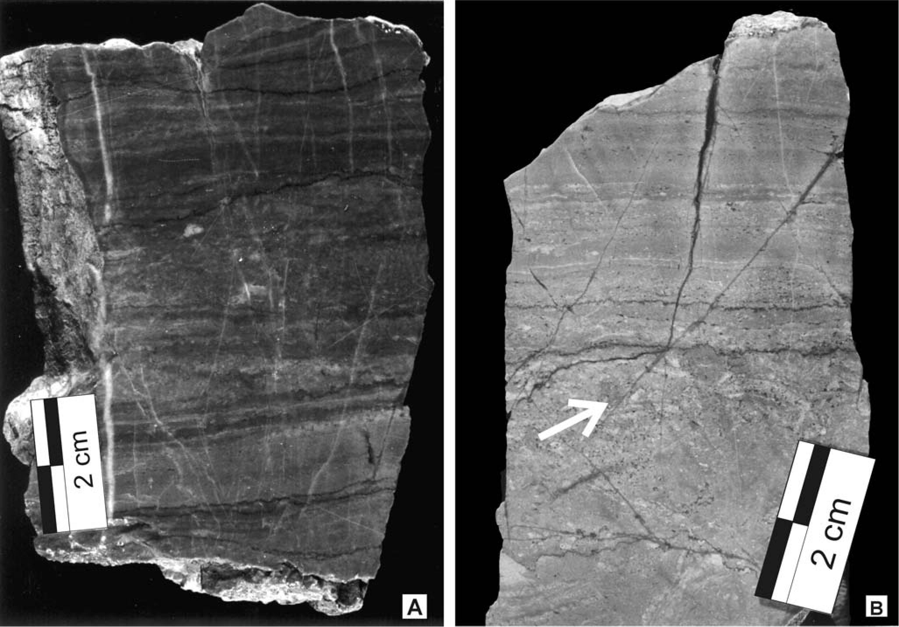
UPPER SCYTHIAN-CARNIAN SUCCESSION, TATRA MTS.
165

DEPOSITIONAL SEQUENCES
OF THE LATE SCYTHIAN-LADINIAN
(CARNIAN?) OF THE FATRICUM BASIN
The application of the sequence stratigraphy procedure
is difficult since the primary prerequisite of the method that
is the sequence boundaries are vague and hardly to point
out. Nevertheless, one may find at least four distinct trans-
gressive events that could be interpreted as maximum flood-
ing zones (mfz - see Fig. 13). The first three are visible in
the Anisian succession where they are marked by limestone
intervals with benthic fauna. The last one in Ladinian is
again marked by appearance of the benthic pelecypods and
foraminifera. The third Anisian mfz could be related to the
Pelsonian trangressive event of a global scale (cf. Rüffer &
Zühlke, 1995). Also the Ladinian mfz may be related to
global Fassanian transgression. The depositional sequences
are quite clear in the Lower Triassic succession where they
are well defined by the erosional sequence boundaries (see
also above). To define the other depositional sequences, in
particular in the Middle Triassic, one needs more detailed
studies on the lower-order cyclicity (5th and 4th order), that
should give way for deciphering the 3rd - order sequences.
Tentatively for the Fatricum of the Havran unit some of
the tepee horizons, pedogenic and karstic phenomenon or
evaporites solution phenomena (solution breccias, rauh-
wackes) common in the Middle Triassic, seem to be good
candidates for the sequence boundaries.
The 3rd - order depositional sequence framework for
the Triassic in NCA is not definite, since some synsedimen-
tary movements have been observed there (Satterley, 1996).
Nevertheless the role of local controls, including tectonics,
was subdued as indicated by good correlation of the Alpine
framework with its counterparts from the other Triassic ba-
sins (Rüffer & Zühlke, 1995). So we assume too the eustatic
fluctuations as the main factor controlling the facies chan-
ges in the Triassic Fatricum basin. Some short-lived chan-
ges may be however resulted from local tectonic causes.

CONCLUSIONS AND FINAL REMARKS
During the Triassic, the Fatricum basin was an exten-
sive flat platform area influenced by eustatic and climatic
fluctuations. The role of synsedimentary tectonics was sub-
dued.
The Lower Triassic is characterised by mixed continen-
tal-shallow marine sedimentation. During the regressive pe-
riods the basin was dominated by sandy and silty sedimenta-
tion proceeding over a sandflat-mudflat area. During the
transgressive phases a shallow, restricted basin formed as
indicated by bituminous rich marls and calcilutitic sedi-

Fig. 11. Intertidal deposits. A - Microbial mat-tempestite sets, Tepee Complex, Upper Ladinian; B - Microbial mat covering the intra-
clastic level (arrow), Tepee Complex, Upper Ladinian
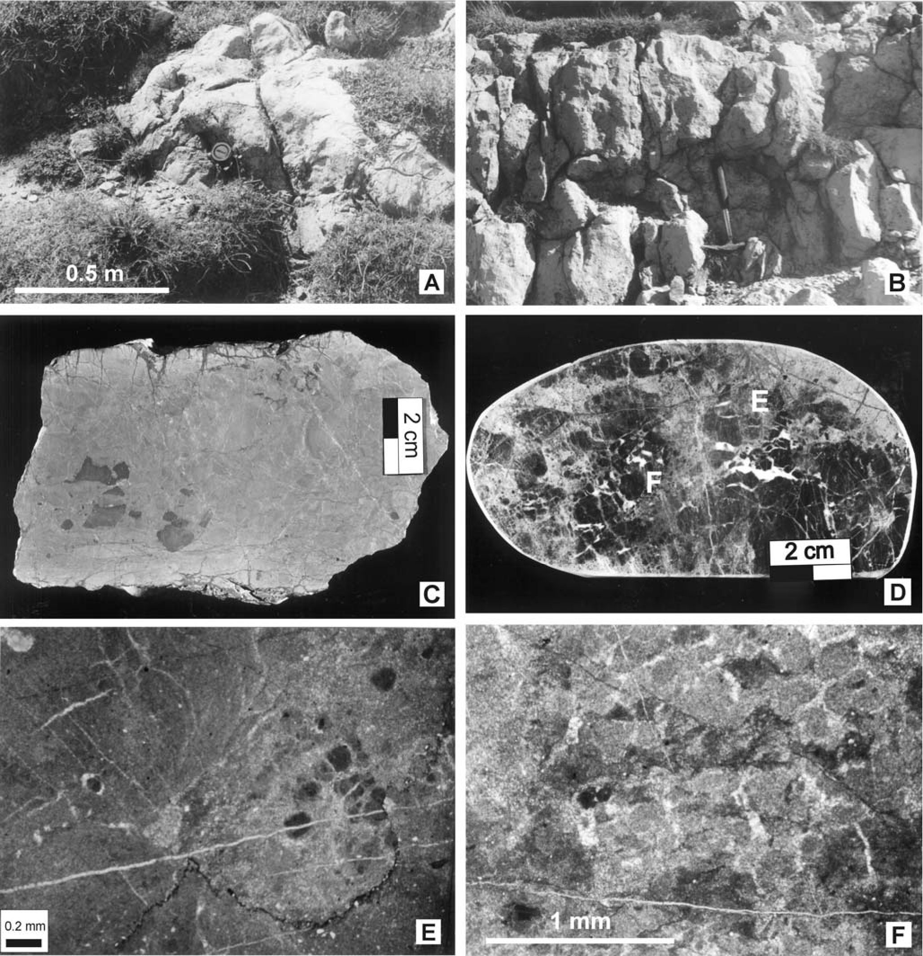
166
T. RYCHLIŃSKI & J. SZULC

Fig. 12. Palaeokarst features of the Upper Ladinian (Tepee Complex). A, B - Karstified top of the Ladinian dolomites; C - Initial pedo-
genic structure (“black pebbles”) in dololutites; D - Karst breccia from the topmost part of the Ladinian, the letters indicate location of thin
sections from E and F; E - Detail from D, note the dark initial pedogenic structure; F - Microbreccias in krastified dolomites, detail from D
ments. Common occurrence of carbonized plat debris sug-
gests relatively humid climatic conditions.
The climate became hot and arid as one may infer from
evaporitic fabrics featuring the Scythian/Anisian boundary.
Similar arid climate characterised also the early Ani-
sian, however due to prominent recurring sea level rises the
evaporitic regime has been attenuated.
The succession from the Lower Anisian onwards dis-
plays uniform sedimentary facies development what sug-
gests that the subsidence kept pace with eustatic fluctua-
tions. The dolomitic and evaporitic sedimentation prevailed.
The stagnant and restricted basin has been occasionally agi-
tated by subtropical storms, particularly common in the late
Anisian.
Slight ingression in early Ladinian involved growth of
microbial colonies forming a complex of thrombolitic bios-
tromes.
Continual shallowing in late Ladinian led to emersion
of the Fatricum platform and to replacement of carbonate
sediments by continental clastics of the Carpathian Keuper.
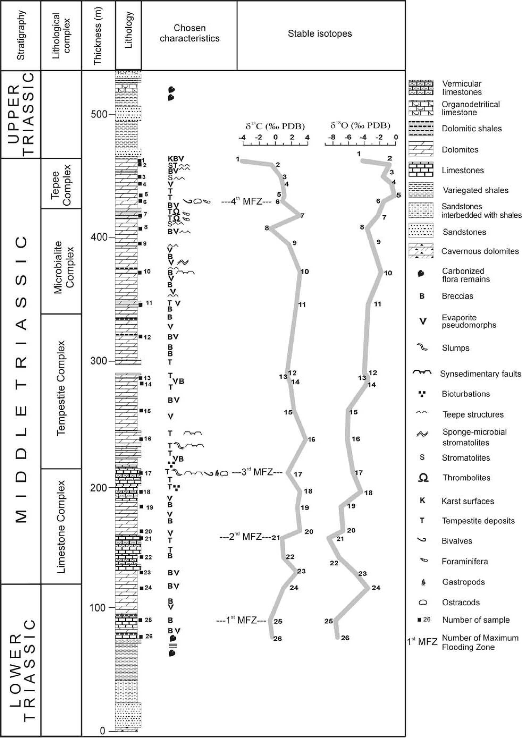
UPPER SCYTHIAN-CARNIAN SUCCESSION, TATRA MTS.
167

Fig. 13. Synthetic section, lithological complexes and stable isotopes curves of the lower-upper Triassic succession of the Fatricum from
the Belanske Tatry Mts.
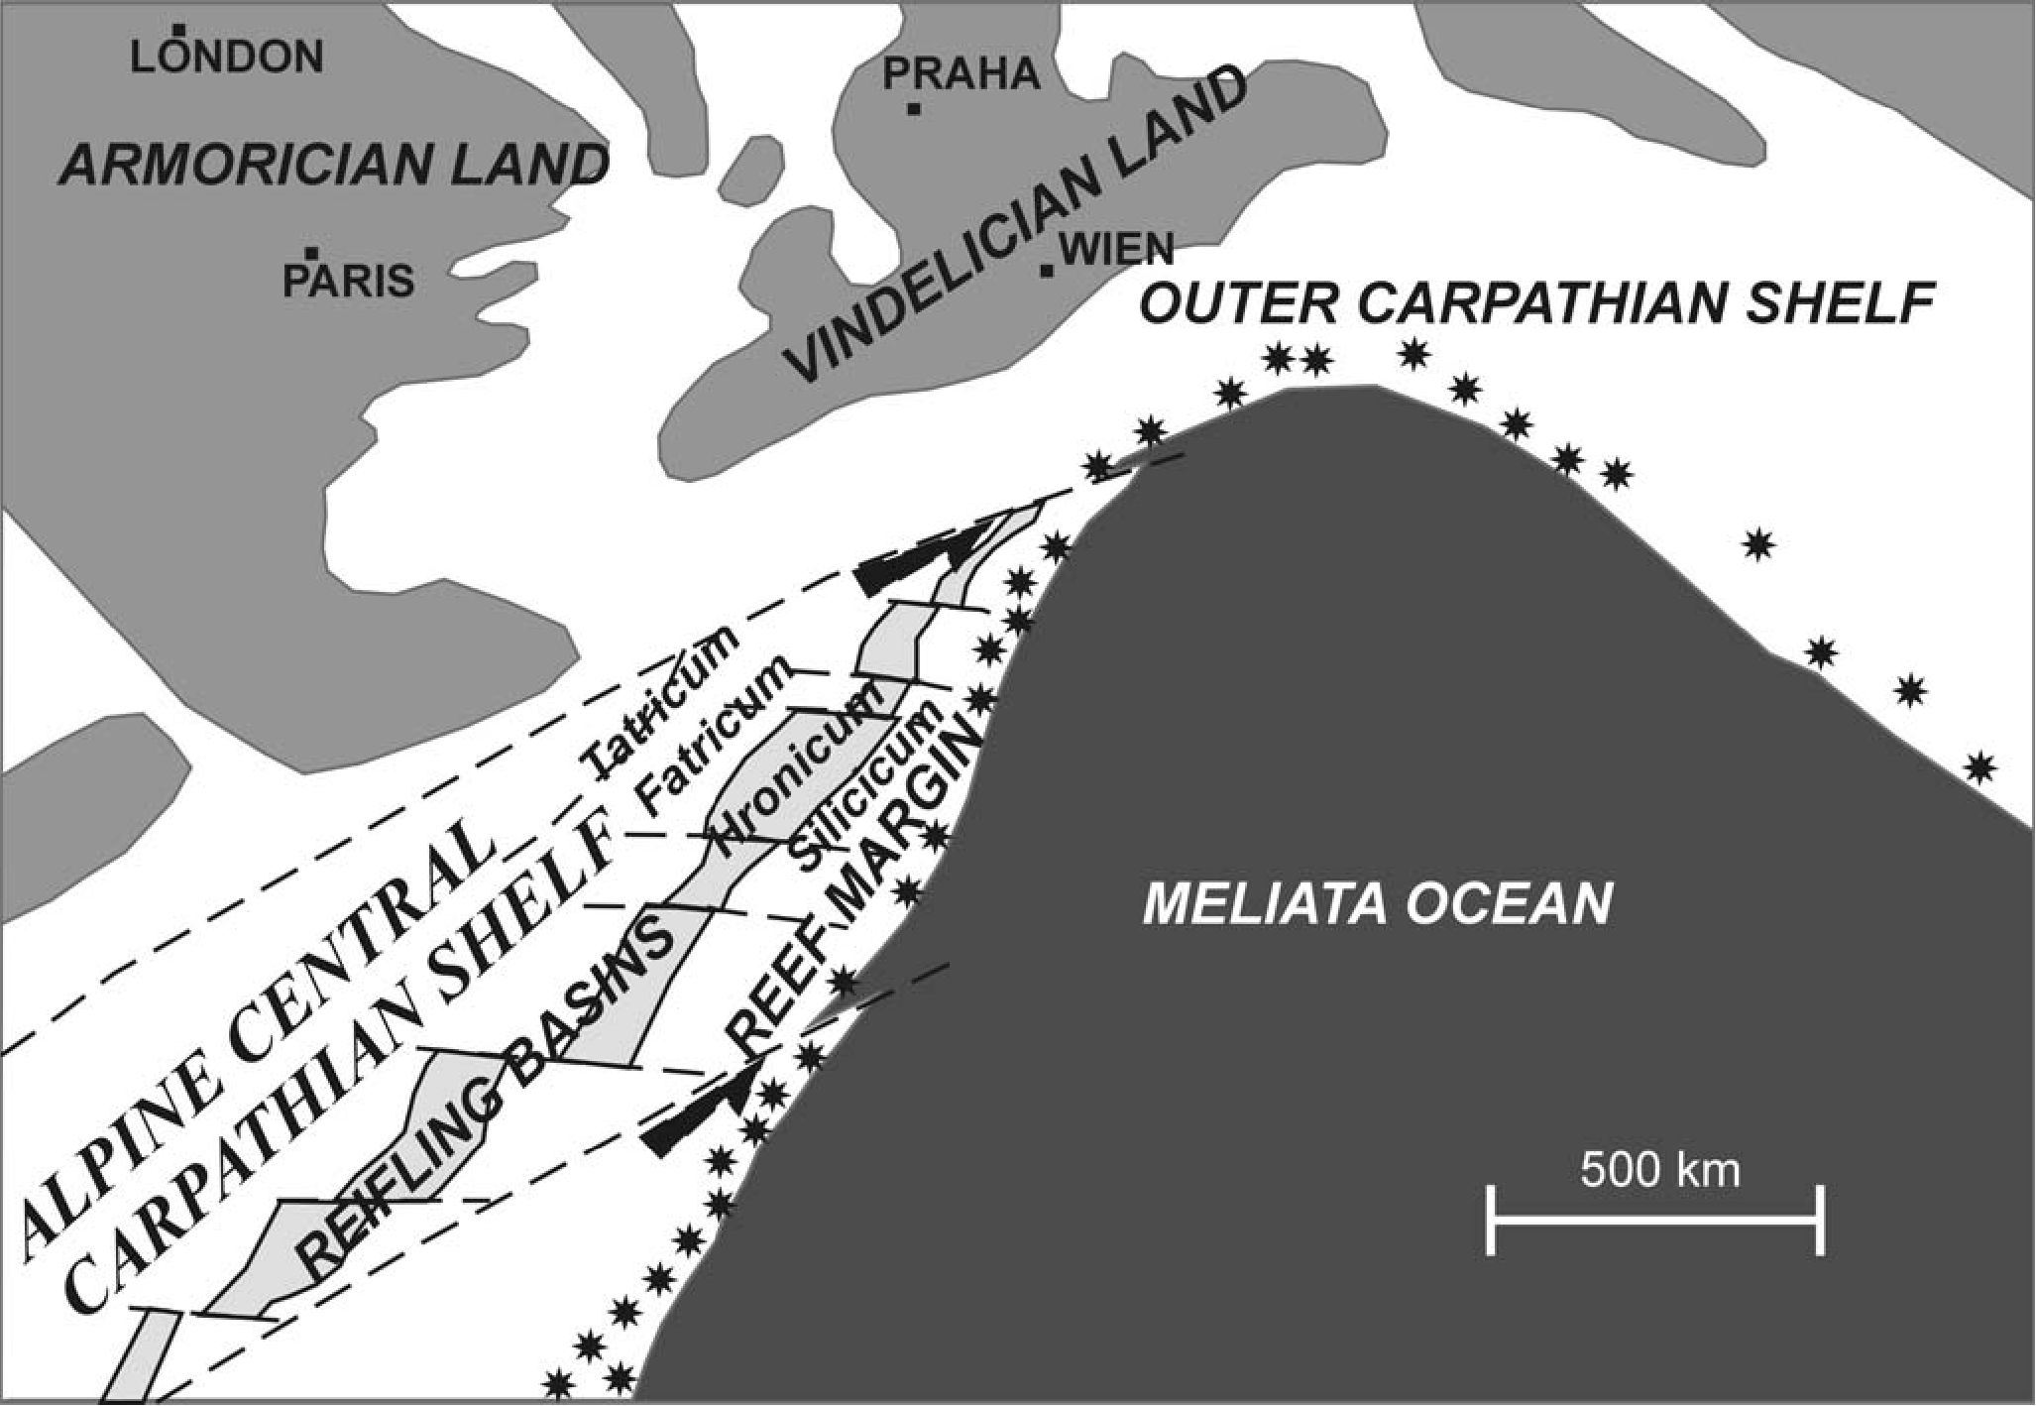
168
T. RYCHLIŃSKI & J. SZULC

Fig. 14. Palaeogeographical sketch of the southern Palaeo-European shelf during the Ladinian (after Michalik, 1993)
Since these sediments are mostly alluvial and they comprise
plant debris (in the upper interval), a significant climate plu-
vialisation is suggested.
Acknowledgments
Kind permission for the field works has been provided by the
Authorities of the Tatra National Park (TANAP) at Tatranska
Lomnica (Slovak Republic). We thank Jozef Michalik (Bratislava)
and Tadeusz Peryt (Warsaw) for their constructive comments and
suggestions.

REFERENCES
Andrusov, D., 1936. Subdivision des nappes subtatriques sur le
versant nord de la Haute Tatra. Bulletin de l’Association.
Russe pour les Recherches Scientifiques, 4: 125-134.
Andrusov, D., 1959. Prehlad stratigrafie a tektoniky druhohörneho
pasma masivu Vysokych Tatier na uzemi Slovenska. Geo-
logicky Sbornik Slovvenskej Akademie Vied, 10: 97-132.
Borza, K., 1958. Triassic and Liassic quartzites of Belanske Tatra
Mts. (In Slovak). Geologicky Sbornik Slovvenskej Akademie
Vied, 9: 52-65.
Borza, K., 1959. Geologicko-petrograficke pomery mezozoika
Belanskych Tatier masivu Sirokej. (In Slovak). Geologicky
Sbornik Slovenskej Akademie Vied (Bratislava), 10: 133-170.
Gaździcki, A., 1971. Megalodon limestones in the sub-tatric Rhae-
tian of the Tatra Mts. Acta Geologica Polonica, 21: 387-398.
Gaździcki, A., 1974. Rhaetian microfacies, stratigraphy and facial
development in the Tatra Mts. Acta Geologica Polonica, 24:
17-96.
Gaździcki, A., Michalik, J., Planderova, E. & Sykora, M., 1979.
An Upper Triassic-Lower Jurassic sequence in the KriZna
nappe (West Tatra Mts, West Carpathians, Czechoslovakia).
Zapadnę Karpaty, Seria Geologia, 5: 119-148.
Haas, J., Kovacs, S., Krystyn, L. & Lein, R., 1995. Significance of
Late Permian-Triassic facies zones in terrane reconstructions
in the Alpine-North Pannonian domain. Tectonophysics, 242:
19-40.
Jaglarz, P. & Szulc, J., 2003. Middle Triassic evolution of the Ta-
tricum sedimentary basin: an attempt of seqence stratigraphy
to the Wierchowa Unit in the Polish Tatra Mountains. Annales
Societatis Geologorum Poloniae, 73: 169-182.
Kochanova, M. & Michalik, J., 1986. Stratigraphy and macrofauna
of the Zamostie Limestones (Upper Pelsonian-Lower Illy-
rian) of the Choc Nappe at the southern slopes of the Nizke
Tatry Mts. (West Carpathians). Geologicky Zbornik Geolo-
gica Carpathica, 37: 501-531.
Kotański, Z., 1958. Stratigraphic and paleogeographic position of
the Triassic in the Bielanskie Tatra Mts. Bulletin de l’Acade-
mie Polonaise des Sciences, Serie des Sciences Chimiques
Geologiques et Geographiques, 8: 559-565.
Kotański, Z., 1963. Stratigraphie et lithologie du Trias Subtatrique
de la region de Zakopane. (In Polish, French summary). Acta
Geologica Polonica, 13: 317-372.
Kotański, Z., 1979. The position of Tatra Mountains in the West-
ern Carpathian. (In Polish, English summary). Przegląd Geo-
logiczny, 27: 359-369.
UPPER SCYTHIAN-CARNIAN SUCCESSION, TATRA MTS.
169
Krainer, K., 1987. Zur Sedimentologie des Alpinen Buntsand-
steins und der Werfener Schichten (Skyth) Kärntens. Geolo-
gisch-Paläontologische Mitteilungen Innsbruck, 14: 21-81.
Lefeld, J., 1999. Tectonic of the Subtatric Units, Eastern Tatra
Mts. Studia Geologica Polonica, 115: 139-166.
Limanowski, M., 1901. Fauna werfeńska w Tatrach. O wysepkach
pratatrzańskich. (In Polish). Kosmos, 26: 15-17.
Mello, J. & Wieczorek, J., 1993a. KrfZnansky prikrov (ve-
poricum). In: Nemcok, J. (ed.), Vysvetlivky ku Geologickej
Mape Tatier, 1:50 000. Geologicky Ustav Dionyza Stura,
Bratislava, pp. 50-57.
Mello, J. & Wieczorek, J., 1993b. Chocsky prikrov (hronicum). In:
Nemcok, J. (ed.), Vysvetlivky ku Geologickej Mape Tatier,
1:50 000. Geologicky Ustav Dionyza Stura Bratislava, pp.
50-57.
Michalik, J., 1979. Podmorske zosuvanie v oblasti hronika
(chocsky prikrov) Zapadnych Karpat na hranici anisu a lad-
inu. (In Slovak, English summary). Mineralia Slovaca, 11:
299-309.
Michalik, J., 1993. Mesozoic tensional basin in the Alpine-
Carpathian shelf. Acta Geologica Hungarica, 36: 395-403.
Michalik, J., 1994. Notes on the paleogeography and paleotecton-
ics of the Western Carpathians area during the Mesozoic. Mit-
teilungen der Österreichischen Geologischen Gesellschaft,
86: 101-110.
Michalik, J., 1997a. Stop 1, Mt. Zdiarska Vidla section. Mineralia
Slovaca, 29: 359.
Michalik, J., 1997b. Tsunamites in a storm-dominated Anisian car-
bonate ramp (Vysoka Formation, Male Karpaty Mts., West-
ern Carpathians). Geologica Carpathica, 48: 221-229.
Michalik, J., Gaździcki, A., Lefeld, J. & Sykora, M., 1997. Trasa
B-2. (In Polish). In: Gaździcki, A. & Lefeld, J., (eds) Prze-
wodnik LXVIII Zjazdu Polskiego Towarzystwa Geologicz-
nego, Zakopane, 2-4 października 1997. Polskie Towarzy-
stwo Geologiczne, Warszawa, pp. 165-171.
Michalik, J. & Jendrejakova, O., 1978. Organism communities and
biofacies of the Fatra Formation (Uppermost Triassic, Fatric)
in the Western Carpathians. Geologicky Sbornik Geologica
Carpathica, 29: 113-133.
Misik, M., 1972. Lithologische und Analyse der mittleren Trias
der Kerngebirge der Westkarpaten. Acta Geologica et Geo-
graphica Universitatis Comenianae, Geologica, 22: 5-168.
Mostler, H. & Rossner, R., 1984. Mikrofazies und Paläoekologie
der höheren Werfener Schichten (Untertrias) der Nördlichen
Kalkalpen. Facies, 10: 87-144.
Plasienka, D., Havrila, M., Michalik, J., Putis, M. & Rehakova, D.,
1997. Nappe structure of the western part of the Central Car-
pathians. In: International conference: Alpine evolution of the
Western Carpathians and related areas. September 11-14,
1997, Bratislava, Slovakia. Abstracts and introductory arti-
cles to the excursion. pp. 139-161.
Rakus, M., Potfaj, M. & Vozarova, A., 1998. Basic palaeographic
and palaeotectonic units of the Western Carpathians. In:
Rakus, M. (ed.), Geodynamic development of the Western
Carpathians. Dionyz Stur Publishers, Bratislava, pp. 15-26.
Rüffer, T. & Zühlke, R., 1995. Sequence stratigraphy and sea-level
changes in Early to Middle Triassic of the Alps: A Global
Comparison. In: Haq, B. U. (ed.), Sequence Stratigraphy and
Depositional Response to Eustatic, Tectonic and Climatic
Forcing, Kluwer, Dordrecht, pp. 161s207.
Rychliński, T., 2001. Studium sedymentologiczne utworów środ-
kowego triasu Tatr Bielskich (Słowacja). (In Polish). Unpub-
lished MSc. Thesis, Jagiellonian University, 81 pp.
Rychliński, T., 2004. Analiza paleośrodowiskowa środkowego
triasu Fatricum w jednostce Hawrania w Tatrach Bielskich.
(In Polish). In: Kędzierski, M., Leszczyński, S. & Uchman, A.
(eds), Polska Konferencja Sedymentologiczna - VIIIKrajowe
Spotkanie Sedymentologów. Geologia Tatr: ponadregionalny
kontekst sedymentologiczny, Zakopane 21-24 czerwca 2004.
Materiały Konferencyjne. Polskie Towarzystwo Geologiczne,
Kraków, p. 118
Rychliński, T. & Jaglarz, P., 2004. Horyzonty paleokrasu w utwo-
rach środkowego triasu Tatr Zachodnich w Polsce oraz Tatr
Bielskich na Słowacji. (In Polish). In: Gradziński, M. &
Szelerewicz, M. (eds), Materiały 38 Sympozjum Speleo-
logicznego, Zakopane, 07-10 października 2004. Sekcja
Speleologiczna Polskiego Towarzystwa Przyrodników im.
Kopernika, Kraków, p. 70.
Rychliński, T. & Szulc J., 2004. Introduction to the Carpathian
Keuper deposits. In: Sliva, L., Rychliński, T. & Szulc J. Field
Session E. Shallow marine and continental clastic/carbonate
mixed deposits of the Carpathian Keuper (Upper Triassic).
Facies and sedimentation of the Central Carpathian Paleo-
gene. In: Kędzierski, M., Leszczyński, S. & Uchman, A.
(eds), Polska Konferencja Sedymentologiczna - VIIIKrajowe
Spotkanie Sedymentologów. Geologia Tatr: ponadregionalny
kontekst sedymentologiczny, Zakopane 21-24 czerwca 2004.
Materiały Konferencyjne. Polskie Towarzystwo Geologiczne,
Kraków, pp. 65-77.
Satterley, A., 1996. The interpretation of cyclic succession of the
Middle and Upper Triassic of the Northern and Southern
Alps. Earth-Science Reviews, 40: 181-207.
Sokołowski, S., 1948. Les Tatry Bielskie. La geologie de leurs
Versants Meridionaux. (In Polish, French summary). Prace
Instytutu Geologicznego, 4: 1-56.
Spötl, C., 1988. Evaporitische Fazies der Reichenhaller Formation
(Skyth/Anis) im Haller Salzberg (Nördliche Kalkalpen, Ti-
rol). Jahrbuch der Geologischen Bundesanstalt, 131:
153-168.
Szulc, J., 1997. Middle Triassic (Muschelkalk) sponge-microbial
stromatolites, diplopores and Girvanella-oncoids from the
Silesian Cracow Uppland. In: 3rd Regional Symposium of In-
ternational Fossil Algae Associations and 3rd International
Meeting of IGCP 380, Guidebook and Abstract, Cracow, In-
stitute of geological sciences, Jagiellonian University,
Kraków, pp.10-15.
Szulc, J., 2003. Sponge-microbial stromatolites and coral-sponge
reefs recovery in the Triassic of Western Tethys and Northern
Peri-Tethys basins. In: 9th Intern. Symposia on Fossil Cni-
daria and Porifera. Berichte des Institute für Geologie und
Paläontologie der Karl-Franzens Universität, Graz, 7: 108.
Szulc, J., Rychliński, T., Götz, A. & Ruckwied, K., 2004. Field
session A. Triassic evolution of the Fatricum basin. The Trias-
sic sediments of the KriZna Unit. Skupniów Upłaz - Boczań
section, Polish Tatra Mts. In: Kędzierski, M., Leszczyński, S.
& Uchman, A. (eds), Polska Konferencja Sedymentologiczna
- VIII Krajowe Spotkanie Sedymentologów. Geologia Tatr:
ponadregionalny kontekst sedymentologiczny, Zakopane 21-
24 czerwca 2004. Materiały Konferencyjne. Polskie Towa-
rzystwo Geologiczne, Kraków, pp. 25-29.

